🏋️ Gym App UI
📖 Project Overview
The Gym Booking App UI is a mobile application interface designed using Figma. The application provides users with a simple and attractive interface to browse gyms, book classes and training sessions, track workouts, and manage their fitness membership.
This project uses four colour red , blue , accent , neutral black

🎯 Objective
To design a modern, user-friendly, and visually appealing mobile application for discovering gyms, booking fitness classes, and tracking personal workout progress.

## 🛠️ Tools Used
- Figma

## 🖼️ Screenshots
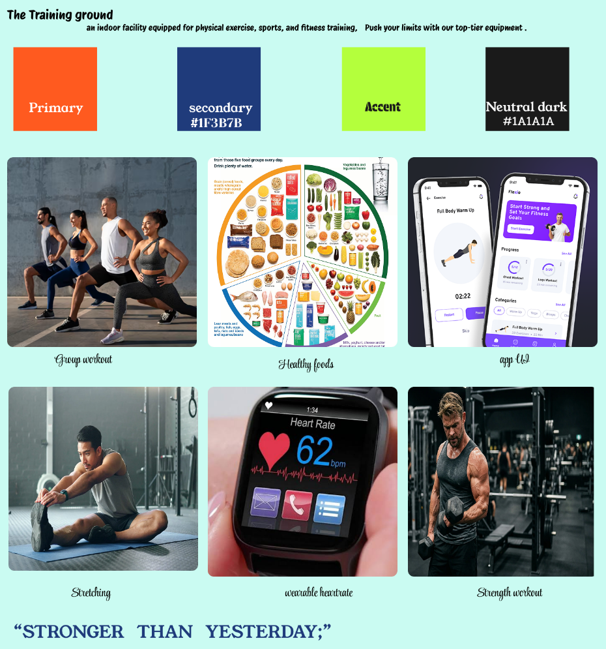
## 🎨 Design Highlights

- Simple and clean user interface
- Consistent color palette

## 🔗 Figma Prototype

https://www.figma.com/proto/XobpwNphKkSoxtX5Hq176M/Untitled?node-id=0-1&t=HiKzoXXOXx9CqZS7-1

## 👨‍💻 Developed By

**Student Name:** - A . John samuel
**Register Number:** - 2617008
**Department:** - BCA-A
**College:** -kamaraj college ,thoothukudi
---

## 📜 License

This project is created for educational purposes only.

