|  |
| --- |
| Private |
| Functional Specification Document |
| Qzine mobile application |

|  |
| --- |
| Sathe, Manish  4/16/2014 |

Table of Contents

1. Introduction 2

1.1. Purpose 2

1.2. Definitions, Acronyms, Abbreviations 2

1.3. Requirements 2

1.4. Assumptions 2

2. Functional and Design Specifications 3

2.1. First Layout 3

2.2. Login screen 4

2.3 Sign-Up Screen 6

2.4 Lunch Truck List 8

2.5 Lunch Truck Image Screen 9

2.6 Lunch Truck Menu List 10

# Introduction

## Purpose

The purpose of this document is to provide the design and functional specifications required for the development of the Qzine mobile application. This document will define the road map for development of the application.

## Definitions, Acronyms, Abbreviations

* 1. CSS – Cascade Style Sheet
  2. UI – User Interface
  3. JQuery – JavaScript plugin
  4. HTML – Hypertext mark-up language
  5. iOS – iPhone Operating Systems developed by Apple.

## Requirements

The entire development of the application is divided into different phases; the following are the development phases.

* + Phase 1 – Designing of the application layouts.
  + Phase 2 – Development of iOS version of the application for iPhone.
  + Phase 3 – Development of the web application (backend server).
  + Phase 4 – Development of the mobile app for Android (or any other) Mobile.

## Assumptions

# Functional and Design Specifications

## First Layout

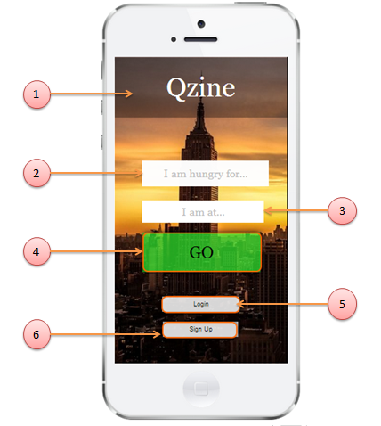

Figure

|  |  |  |  |  |  |
| --- | --- | --- | --- | --- | --- |
| Element Number | Element Name | Description | Default state and value | Rules  *(Functionality related guidelines/specifications)* | Requirement Type  *(Function/Non Functional)* |
| 1 | Logo | This area will display the Qzine logo. | Visible | 1. This will be a PNG image of the logo. | Non Functional |
| 1. The logo image will always centre aligned. | Non Functional |
| 2 | Textbox “I am hungry for…” | This will be a textbox with the watermark “I am hungry for…”, The textbox will allow user to input the item that he/she would like to eat. | Visible | 1. This will be a textbox with a water mark “I am hungry for…” | Functional |
| 1. The watermark will disappear when the user tap on the textbox | Functional |
| 1. The textbox will accept alphanumeric characters and special characters. | Functional |
| 1. The max length will be 20 characters. | Functional |
| 1. The watermark will be displayed if the text box is empty and not in focus. | Functional |
| 3 | Textbox “I am at...” | This will be a textbox with the watermark “I am at…” This textbox will allow user to enter his/her location. | Visible | 1. This will be a textbox with a water mark “I am at…” | Functional |
| 1. The watermark will disappear when the user tap on the textbox | Functional |
| 1. The textbox will accept alphanumeric characters and special characters. | Functional |
| 1. The max length will be 20 characters. | Functional |
| 1. The watermark will be displayed if the text box is empty and not in focus. | Functional |
| 4 | “Go” Button | This button will start searching lunch trucks based on item or location | Visible, Disabled | 1. This button will be enabled only if “I am hungry for…” or “I am at…” textbox has content. | Functional |
| 1. On tapping: - the application will start searching the lunch truck and navigation to next layout. | Functional |
| 5 | “Login” button | This button will take the user to login screen | Visible | 1. On tapping:- the user will be taken to “Login” screen | Functional |
| 6 | “Sign Up” button | This button will take the user of signup screen | Visible | 1. On tapping:- the user will be taken to “Sign up” screen | Functional |

## Login screen

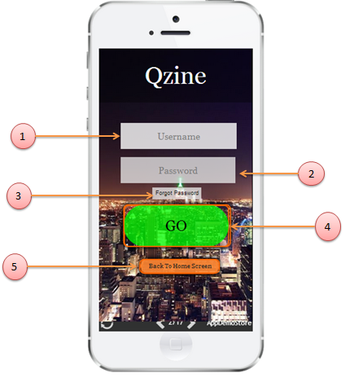

Figure

|  |  |  |  |  |  |
| --- | --- | --- | --- | --- | --- |
| Element Number | Element Name | Description | Default state and value | Rules  *(Functionality related guidelines/specifications)* | Requirement Type  *(Function/Non Functional)* |
| 1 | Textbox “Username” | This will be a textbox with the watermark “Username” The textbox will allow user to input username. | Visible | 1. This will be a textbox with a water mark “Username” | Functional |
| 1. The watermark will disappear when the user tap on the textbox | Functional |
| 1. The textbox will accept alphanumeric characters and special characters. | Functional |
| 1. The max length will be 20 characters. | Functional |
| 1. The watermark will be displayed if the text box is empty and not in focus. | Functional |
| 2 | Textbox “Password” | This will be a textbox with the watermark “Password” This textbox will allow user to enter his/her password. | Visible | 1. This will be a textbox with a water mark “Password”. | Functional |
| 1. The watermark will disappear when the user tap on the textbox | Functional |
| 1. The textbox will accept alphanumeric characters and special characters. | Functional |
| 1. The max length will be 20 characters. | Functional |
| 1. The watermark will be displayed if the text box is empty and not in focus. | Functional |
| 3 | “Forgot Password” button | This button will display the forgot password screen | Visible | 1. On tapping: - The forgot password layout will be displayed. | Functional |
| 4 | “Go” Button | This button will start login process | Visible, Disabled | 1. This button will be enabled only if “username” and “password” textbox has content. | Functional |
| 1. On tapping: - the application will authenticate the username and password | Functional |
| 1. On success:- the user will be taken to the home screen | Functional |
| 1. On error:- the user will be displayed with the error message saying “Invalid username and password” | Functional |
| 5 | “Back to home screen” button | This button will take the user to first layout | Visible | 1. On tapping:- the user will be taken to “First layout” screen | Functional |

## 2.3 Sign-Up Screen

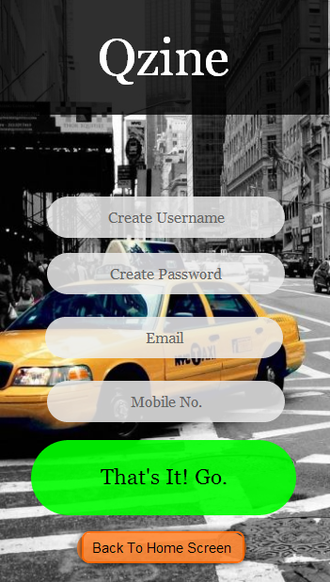

|  |  |  |  |  |  |
| --- | --- | --- | --- | --- | --- |
| Element Number | Element Name | Description | Default state and value | Rules  *(Functionality related guidelines/specifications)* | Requirement Type  *(Function/Non Functional)* |
| 1 | Textbox “Create Username” | This will be a textbox with the watermark “Create Username: The textbox will allow user to input desired username for login | Visible | 1. This will be a textbox with a water mark “ Create Username” | Functional |
| 1. The watermark will disappear when the user tap on the textbox | Functional |
| 1. The textbox will accept alphanumeric characters and special characters. | Functional |
| 1. The max length will be 20 characters. | Functional |
| 1. The watermark will be displayed if the text box is empty and not in focus. | Functional |
| 2 | Textbox “Create Password” | This will be a textbox with the watermark “Create Password” This textbox will allow user to enter his/her desired password. | Visible | 1. This will be a textbox with a water mark “Create Password”. | Functional |
| 1. The watermark will disappear when the user tap on the textbox | Functional |
| 1. The textbox will accept alphanumeric characters and special characters. | Functional |
| 1. The max length will be 20 characters. Minimum of 6 | Functional |
| 1. The watermark will be displayed if the text box is empty and not in focus. | Functional |
| 3 | Textbox “Email” | This will be a textbox with the watermark “Email” This textbox will allow user to enter his/her personal email address. | Visible | 1. This will be a textbox with a water mark “Email”. | Functional |
| 1. The watermark will disappear when the user tap on the textbox | Functional |
| 1. The textbox will accept alphanumeric characters and special characters. | Functional |
| 1. Max length? | Functional |
| 1. The watermark will be displayed if the text box is empty and not in focus. | Functional |
| 4 | Textbox “Mobile No.” | This will be a textbox with the watermark “Mobile No.” This textbox will allow user to enter his/her personal mobile no. | Visible, | 1. This will be a textbox with a water mark “Mobile No”. | Functional |
| 1. The watermark will disappear when the user tap on the textbox | Functional |
| 1. The textbox will accept only numeric characters and special characters. | Functional |
| 1. Max length will be 10 characters | Functional |
| 1. After first three characters, “-“ appears. Second three characters “-“ appears. Format: 123-456-7890 | Functional |
| 5 | “That’s It! Go” button | This button will start the sign-up process | Visible | 1. 1. This button will be enabled only if “Create Username”, “Create Password”, “Email” and “Mobile No.” Text Boxes have content. | Functional |
| 1. On tapping: - the application will authenticate the availability of the username and whether requirements of password are met. | Functional |
| 1. Confirmation will be sent as message to User’s Mobile No. inputted. | Functional |
| 1. If approved will be redirected to home screen. |  |
| 1. Confirmation with details will be e-mailed to inputted e-mail address | Functional |
| 6 | “Back to home screen” button | This button will take the user to first layout | Visible | 1. On tapping:- the user will be taken to “First layout” screen | Functional |

## 2.4 Lunch Truck List

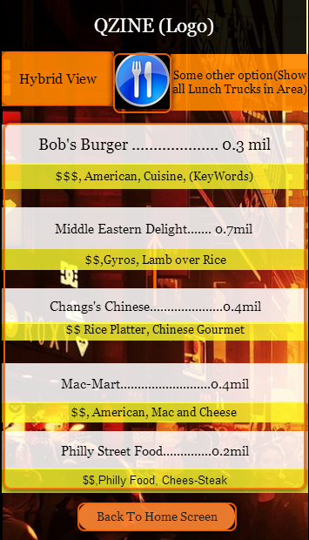

|  |  |  |  |  |  |
| --- | --- | --- | --- | --- | --- |
| Element Number | Element Name | Description | Default state and value | Rules  *(Functionality related guidelines/specifications)* | Requirement Type  *(Function/Non Functional)* |
| 1 | “Hybrid View” Button | This button will execute the hybrid View. Which will show both list and map view | Visible | On Tapping this will be taken to the Hybrid View Screen. | Functional |
| 2 | Lunch Truck Menu List | This list contains the list of all Lunch Trucks based on Cuisine. | Visible | 1. Selecting an Item would redirect to corresponding screen with Lunch Truck Image Screen | Functional |
| 1. Lunch Truck would be listed on the basis of Cuisine and Keywords. | Functional |
| 1. The Closest Lunch Truck matching Cuisine would be listed on the top. | Functional |
|  | Functional |
|  | Functional |
| 3 | “Back to home screen” button | This button will take the user to first layout | Visible | 1. On tapping:- the user will be taken to “First layout” screen | Functional |
|  |  |  |  |  |  |

|  |  |  |  |  |  |
| --- | --- | --- | --- | --- | --- |
| 4 | (Undecided button)  Potential, “Show All Lunch Trucks” | This button will show all the lunch trucks in the area | Visible | 1. This button will no longer show all the lunch trucks in the area based on cuisine. But will show all lunch trucks based on Distance | Functional |
| 2. |
|  |
| 5. | Menu Icon | This button will show additional options that a User can access | Visible | 1. This will be a drop down menu | Functional |
| 2. Log Out Menu |  |
| 3. Return to Main Screen |
| 4.Change Cuisine |
| 5. Change Location |
| 6. (other) |
|  |
|  |  |  |  |  |  |
|  |  |  |  |  |  |
|  |  |  |  |  |  |
|  |  |  |  |  |  |

## 2.5 Lunch Truck Image Screen

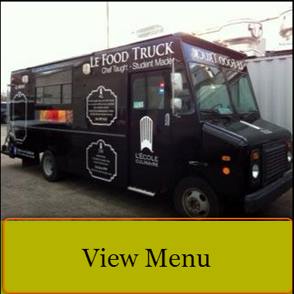

|  |  |  |  |  |  |
| --- | --- | --- | --- | --- | --- |
| Element Number | Element Name | Description | Default state and value | Rules  *(Functionality related guidelines/specifications)* | Requirement Type  *(Function/Non Functional)* |
| 1 | Selected Lunch Truck Image | PNG image of the lunch truck they selected would be uploaded. | Visible | Cannot Select | Non-Functional |
| 2 | “View Menu” button | This button will show the next screen which contains the Menu and Price of lunch truck items. | Visible | 1. On tapping this will take to selected Lunch Truck’s Menu | Functional |
| 1. Lunch Truck would be listed on the basis of Cuisine and Keywords. | Functional |
| 1. The Closest Lunch Truck matching Cuisine would be listed on the top. | Functional |
|  | Functional |
|  | Functional |
| 3 | “Back to home screen” button | This button will take the user to first layout | Visible | 1. On tapping:- the user will be taken to “First layout” screen | Functional |
|  |  |  |  |  |  |

## 2.6 Lunch Truck Menu List

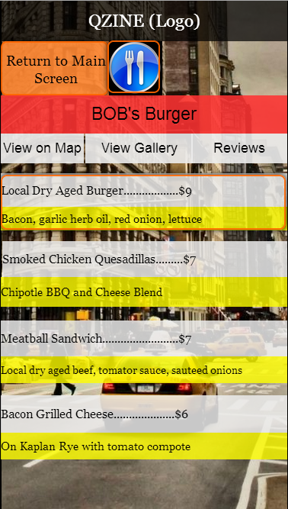

|  |  |  |  |  |  |
| --- | --- | --- | --- | --- | --- |
| Element Number | Element Name | Description | Default state and value | Rules  *(Functionality related guidelines/specifications)* | Requirement Type  *(Function/Non Functional)* |
| 1 | “Return to Main Screen” Button | PNG image of the lunch truck they selected would be uploaded. | Visible | Cannot Select | Non-Functional |
| 2 | “Menu Icon” Button to open Drop down for Additional Options | This button will show the next screen which contains the Menu and Price of lunch truck items. | Visible | 1. On tapping this will take to selected Lunch Truck’s Menu | Functional |
| 1. Lunch Truck would be listed on the basis of Cuisine and Keywords. | Functional |
| 1. The Closest Lunch Truck matching Cuisine would be listed on the top. | Functional |
|  | Functional |
|  | Functional |
| 3 | Image or Text Saying the Name of the Lunch Truck | This button will take the user to first layout | Visible | 1. On tapping:- the user will be taken to “First layout” screen | Functional |
| 4 | “View On Map” button | This button will take user to a screen showing position of lunch truck relative to current position. | Visible | 1. This will take them to screen with |  |
| 2. |
|  |
| 5 | “Reviews” Button | This button will take user to a screen showing all the reviews that members have made for this lunch truck | Visible |  |  |
| 6 | “View Gallery” Button | This button will take user to a screen containing a gallery with images/uploads by the lunch truck | Visible |  |  |
| 7 | Lunch Menu List | This list contains the selected lunch truck’s Menu. | Visible |  |  |