CPE301 – SPRING 2019

Design Assignment 1A

Student Name: Benjamin Johnson

Student #: 5003284489

Student Email: johnsb18@unlv.nevada.edu

Primary Github address: https://github.com/johnsb18/ClassRepository.git

Directory: (I don’t know what to put here.)

Submit the following for all Labs:

1. In the document, for each task submit the modified or included code (only) with highlights and justifications of the modifications. Also, include the comments.
2. Use the previously create a Github repository with a random name (no CPE/301, Lastname, Firstname). Place all labs under the root folder ESD301/DA, sub-folder named LABXX, with one document and one video link file for each lab, place modified asm/c files named as LabXX-TYY.asm/c.
3. If multiple asm/c files or other libraries are used, create a folder LabXX-TYY and place these files inside the folder.
4. The folder should have a) Word document (see template), b) source code file(s) and other include files, c) text file with youtube video links (see template).

1. **COMPONENTS LIST AND CONNECTION BLOCK DIAGRAM w/ PINS**
2. **INITIAL/MODIFIED/DEVELOPED CODE OF TASK 1/A**

.org 0 ; burn into ROM starting at 0

ldi R25, 0xFF ; load upper 8 bits of multiplicand

ldi R24, 0xFF ; load lower 8 bits of multiplicand (d'449)

ldi R22, 0xFF ; load 8 bit multiplier (d'5)

ldi R18, 0 ; initialize result register to zero

ldi R19, 0 ; initialize result register to zero

ldi R20, 0 ; initialize result register to zero

ldi R21, 0 ; used to add carry into R20

LOOP:

add R18, R24 ; add lower 8 bits

adc R19, R25 ; add upper 8 bits

adc R20, R21 ; add carry

dec R22 ; decrement counter (multiplier)

brne LOOP ; loop while counter > 0

END:

jmp END ; end program

1. **DEVELOPED MODIFIED CODE OF TASK 2/A from TASK 1/A**
2. **SCHEMATICS**
3. **SCREENSHOTS OF EACH TASK OUTPUT (ATMEL STUDIO OUTPUT)**

Atmel before running:

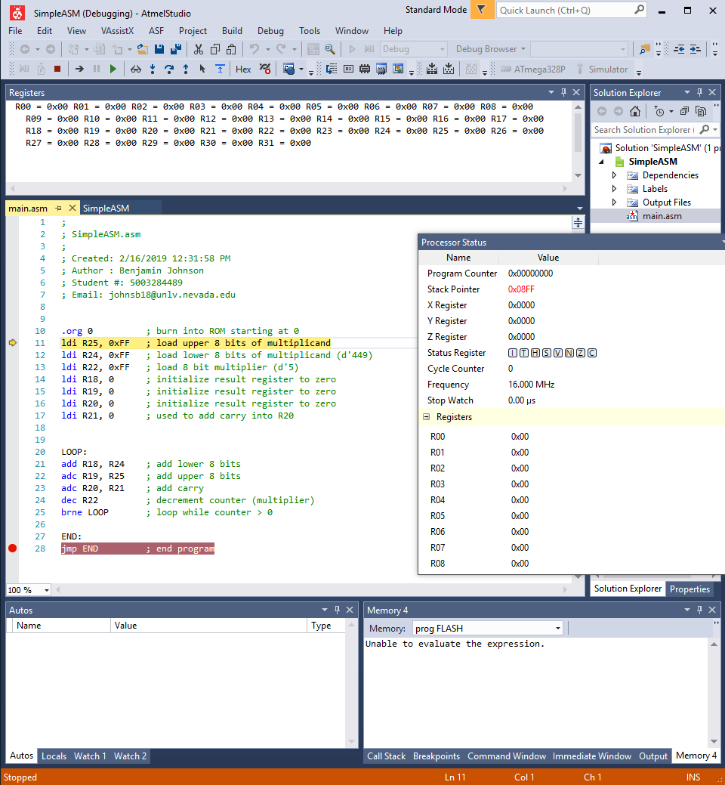

Atmel after running:

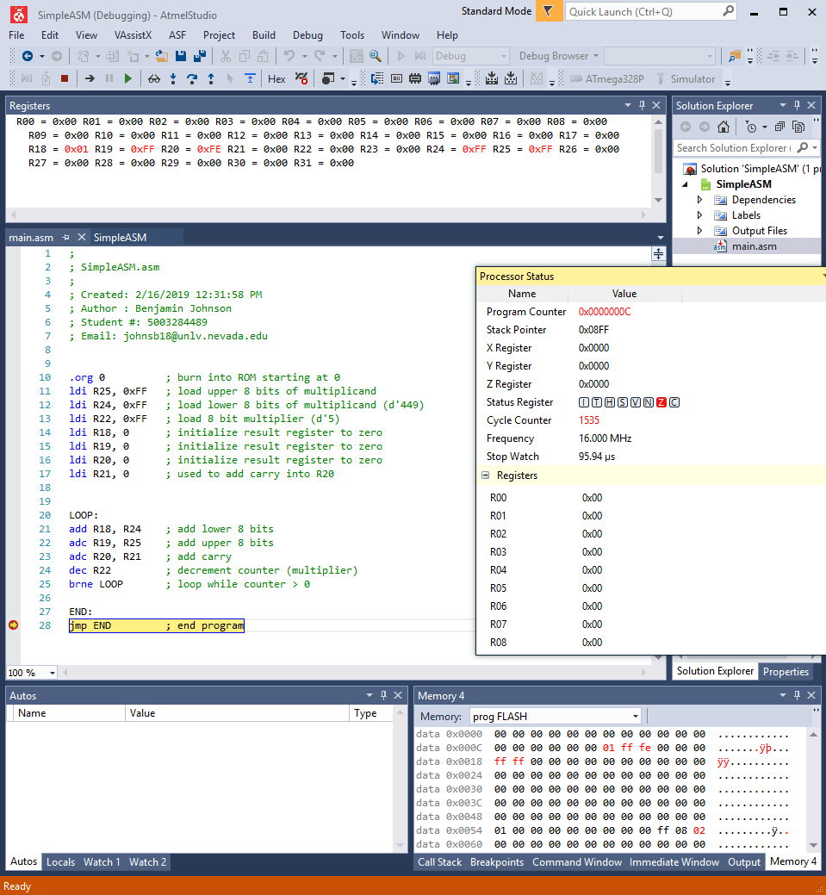

Verification of results:

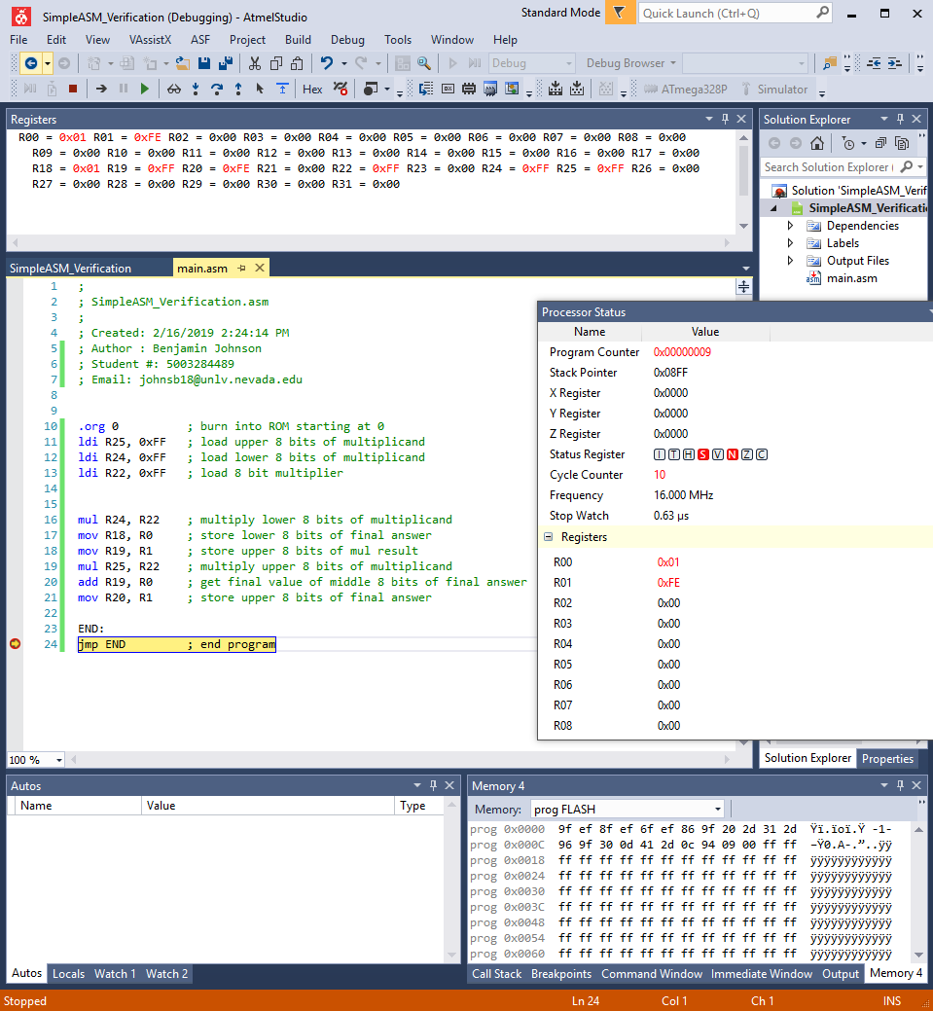

1. **SCREENSHOT OF EACH DEMO (BOARD SETUP)**
2. **VIDEO LINKS OF EACH DEMO**
3. **GITHUB LINK OF THIS DA**

https://github.com/johnsb18/ClassRepository.git

**Student Academic Misconduct Policy**

<http://studentconduct.unlv.edu/misconduct/policy.html>

“This assignment submission is my own, original work”.

Benjamin Johnson