CPE301 – SPRING 2019

Design Assignment 2A

Student Name: Benjamin Johnson

Student #: 5003284489

Student Email: johnsb18@unlv.nevada.edu

Primary Github address: https://github.com/johnsb18/ClassRepository

Directory:

Submit the following for all Labs:

1. In the document, for each task submit the modified or included code (only) with highlights and justifications of the modifications. Also, include the comments.
2. Use the previously create a Github repository with a random name (no CPE/301, Lastname, Firstname). Place all labs under the root folder ESD301/DA, sub-folder named LABXX, with one document and one video link file for each lab, place modified asm/c files named as LabXX-TYY.asm/c.
3. If multiple asm/c files or other libraries are used, create a folder LabXX-TYY and place these files inside the folder.
4. The folder should have a) Word document (see template), b) source code file(s) and other include files, c) text file with youtube video links (see template).

1. **COMPONENTS LIST AND CONNECTION BLOCK DIAGRAM w/ PINS**

List of Components used

Block diagram with pins used in the Atmega328P

1. **INITIAL/MODIFIED/DEVELOPED CODE OF TASK 1/A**

; GPIOs_Part1_ASM.asm

.org 0

sbi DDRB, 2 ; set PORTB.2 as output

sbi PORTB, 2 ; set LED off

; generate waveform with 60% DC and .725 sec period

BEGIN:

cbi PORTB, 2 ; set LED on

; Delay 6 960 000 cycles

; 435ms at 16 MHz

ldi r18, 36

ldi r19, 79

ldi r20, 221

L1: dec r20

brne L1

dec r19

brne L1

dec r18

brne L1

nop

sbi PORTB, 2 ; set LED off

; Delay 4 640 000 cycles

; 290ms at 16 MHz

ldi r18, 24

ldi r19, 138

ldi r20, 232

L2: dec r20

brne L2

dec r19

brne L2

dec r18

brne L2

rjmp PC+1

jmp BEGIN

-------------------------------------------------------------------------------

// GPIOs_Part1_C.c

#define *F_CPU* 16000000UL

#include <avr/io.h>

#include <util/delay.h>

int main(void)

{

DDRB |= (1<<2); // set PORTB.2 for output

while (1)

{

*_delay_ms*(435); // delay for 60% DC

PORTB &= ~(1<<2); // set LED on

*_delay_ms*(290); // delay for remaining 40%

PORTB |= (1<<2); // set LED off

}

}

-------------------------------------------------------------------------------

; GPIOs_Part2_ASM.asm

.org 0

cbi DDRC, 2 ; set PORTC.2 as input

sbi PORTC, 2 ; enable pull up

sbi DDRB, 2 ; set PORTB.2 as output

sbi PORTB, 2 ; set LED off

WHILE:

sbic PINC, 2 ; skip next instr if PINC is low

jmp SKIP ; jump when PINC is high

cbi PORTB, 2 ; set LED on

; Delay 20 000 000 cycles

; 1s 250ms at 16 MHz

ldi r18, 102

ldi r19, 118

ldi r20, 194

L1: dec r20

brne L1

dec r19

brne L1

dec r18

brne L1

jmp WHILE

SKIP:

sbi PORTB, 2 ; set LED off

jmp WHILE

-------------------------------------------------------------------------------

// GPIOs_Part2_C.c

#define *F_CPU* 16000000UL

#include <avr/io.h>

#include <util/delay.h>

int main(void)

{

DDRC &= (0<<2); // connect PORTC.2 to switch as input

PORTC |= (1<<2); // enable pull-up

DDRB |= (1<<2); // set PORTB.2 for output (LED)

while(1){

if(!(PINC & (1<<PINC2))){ // check if pin is low

PORTB &= ~(1<<2); // set LED on

*_delay_ms*(1250); // set delay of 1.25 sec

}

else{ // otherwise (pin is high)

PORTB |= (1<<2); // set LED off

}

}

return 0;

}

1. **DEVELOPED MODIFIED CODE OF TASK 2/A from TASK 1/A**

Insert only the modified sections here

1. **SCHEMATICS**
2. **SCREENSHOTS OF EACH TASK OUTPUT (ATMEL STUDIO OUTPUT)**

Task 1 ASM:

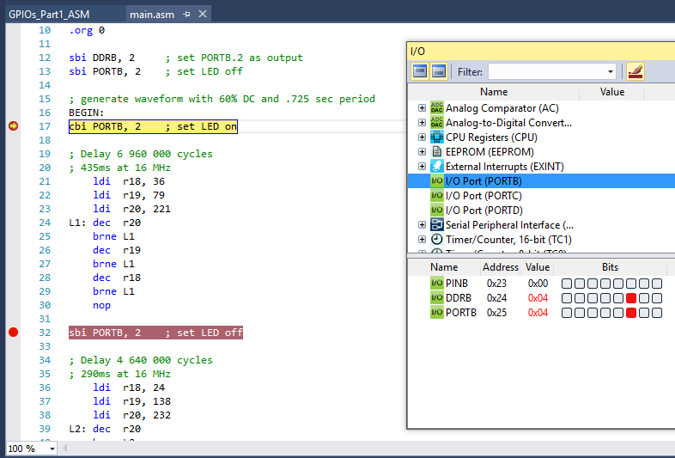

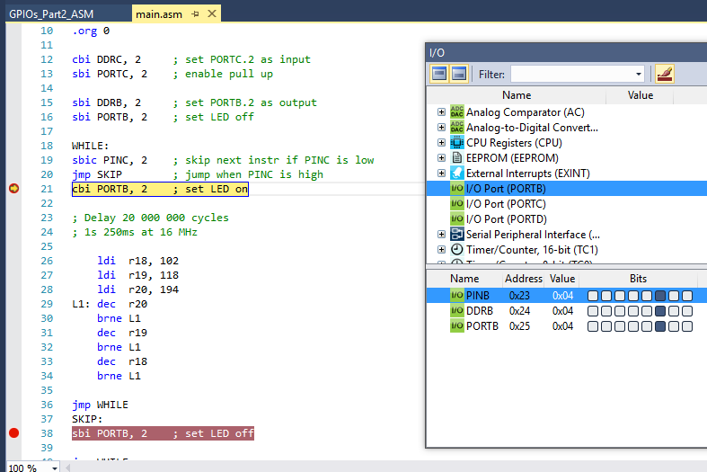Task 2 ASM:

For some reason I could not step through my C programs with the debugger, but I was able to confirm on the hardware that both of my C programs worked properly.

1. **SCREENSHOT OF EACH DEMO (BOARD SETUP)**
2. **VIDEO LINKS OF EACH DEMO**

Task 1: https://youtu.be/VJN2HO1jwDo

Task 2: https://youtu.be/zTb-qJ5IVRo

1. **GITHUB LINK OF THIS DA**

https://github.com/johnsb18/ClassRepository/tree/master/DesignAssignments/DA2A

**Student Academic Misconduct Policy**

<http://studentconduct.unlv.edu/misconduct/policy.html>

“This assignment submission is my own, original work”.

Benjamin Johnson