CPE301 – SPRING 2019

Design Assignment 3A

Student Name: Benjamin Johnson

Student #: 5003284489

Student Email: johnsb18@unlv.nevada.edu

Primary Github address: https://github.com/johnsb18/ClassRepository

Directory:

Submit the following for all Labs:

1. In the document, for each task submit the modified or included code (only) with highlights and justifications of the modifications. Also, include the comments.
2. Use the previously create a Github repository with a random name (no CPE/301, Lastname, Firstname). Place all labs under the root folder ESD301/DA, sub-folder named LABXX, with one document and one video link file for each lab, place modified asm/c files named as LabXX-TYY.asm/c.
3. If multiple asm/c files or other libraries are used, create a folder LabXX-TYY and place these files inside the folder.
4. The folder should have a) Word document (see template), b) source code file(s) and other include files, c) text file with youtube video links (see template).

1. **COMPONENTS LIST AND CONNECTION BLOCK DIAGRAM w/ PINS**

* Atmega328P
* FTDI Chip

1. **INITIAL/MODIFIED/DEVELOPED CODE OF TASK 1/A**

/*

* UART.cpp

*

* Created: 3/27/2019 3:31:10 PM

* Author: Benjamin Johnson

* Student #: 5003284489

* Email: johnsb18@unlv.nevada.edu

*/

#define BAUD 9600

#define *F_CPU* 16000000UL

#include <avr/io.h>

#include <avr/interrupt.h>

#include <stdio.h>

#include <util/setbaud.h>

void USART_init(void); // initializes analog to digital

void USART_tx_string(char*data); // prints a string

void USART_tx_char (char integer); // prints a character

char nextLine[] = "\n"; // declare next line string

volatile float usart_temp = 3.14; // declare float

char outs[20]; // allocate memory space for float

int main(void)

{

USART_init(); // initialize analog to digital

TCCR1B |= (1<<CS12) | (1<<CS10); // prescaler = 1024

TIMSK1 = (1<<TOIE1); // enable overflow flag

TCNT1 = 49911; // reset timer (65535 - 15624)

sei(); // enable interrupts

while (1) {} // wait for timer interrupt

}

void USART_init (void)

{

UBRR0H = *UBRRH_VALUE*;

UBRR0L = *UBRRL_VALUE*;

UCSR0C = _BV(UCSZ01) | _BV(UCSZ00); // 8-bit data

UCSR0B = _BV(RXEN0) | _BV(TXEN0); // enable RX and TX

}

ISR (TIMER1_OVF_vect)

{

USART_tx_string(nextLine); // next line

USART_tx_string("This is working!"); // print string

USART_tx_string(nextLine); // next line

USART_tx_char('3'); // print int

USART_tx_string(nextLine); // next line

*snprintf*(outs, sizeof(outs), "%f\r\n", usart_temp); // store float in outs

USART_tx_string(outs); // print float

USART_tx_string(nextLine); // next line

TCNT1 = 49911; // reset timer

}

void USART_tx_string (char*data)

{

while ((*data != '\0')){ // iterate through entire string

while (!(UCSR0A & (1<<UDRE0))); // wait for UDRE0 flag to go high

UDR0 = *data; // set USART I/O data register to string

data++; // iterate through string

}

}

void USART_tx_char (char integer)

{

while (!(UCSR0A & (1<<UDRE0))); // wait for UDRE0 flag to go high

UDR0 = integer; // set USART I/O data register to int as char

}

1. **DEVELOPED MODIFIED CODE OF TASK 2/A from TASK 1/A**
2. **SCHEMATICS**
3. **SCREENSHOTS OF EACH TASK OUTPUT (ATMEL STUDIO OUTPUT)**

I was unable to get my terminal to render output.

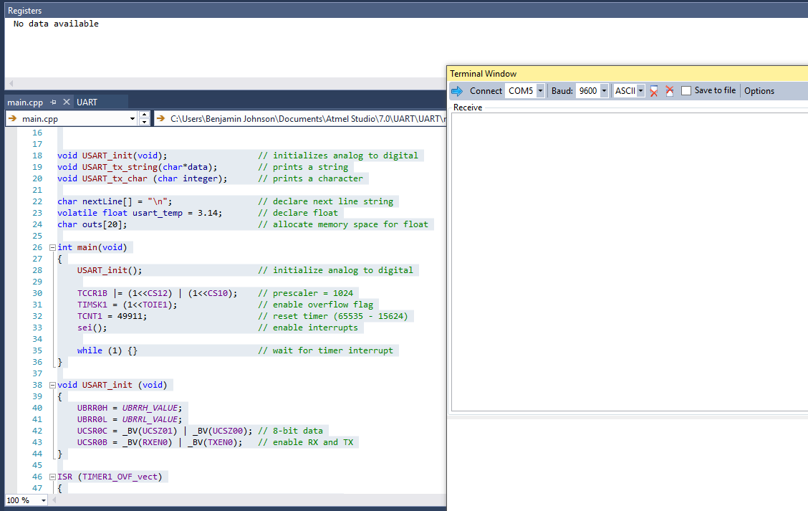

1. **SCREENSHOT OF EACH DEMO (BOARD SETUP)**

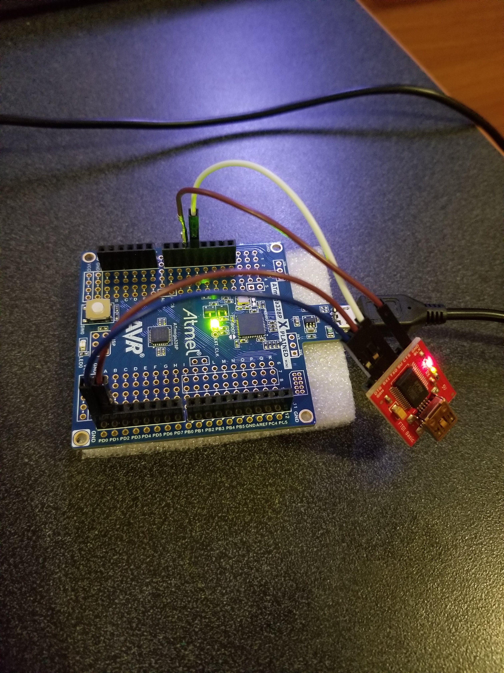

1. **VIDEO LINKS OF EACH DEMO**
2. **GITHUB LINK OF THIS DA**

https://github.com/johnsb18/ClassRepository/tree/master/DesignAssignments/DA3A

**Student Academic Misconduct Policy**

<http://studentconduct.unlv.edu/misconduct/policy.html>

“This assignment submission is my own, original work”.

Benjamin Johnson