CPE301 – SPRING 2019

Design Assignment 3B

Student Name: Benjamin Johnson

Student #: 5003284489

Student Email: johnsb18@unlv.nevada.edu

Primary Github address: https://github.com/johnsb18/ClassRepository

Directory:

Submit the following for all Labs:

1. In the document, for each task submit the modified or included code (only) with highlights and justifications of the modifications. Also, include the comments.
2. Use the previously create a Github repository with a random name (no CPE/301, Lastname, Firstname). Place all labs under the root folder ESD301/DA, sub-folder named LABXX, with one document and one video link file for each lab, place modified asm/c files named as LabXX-TYY.asm/c.
3. If multiple asm/c files or other libraries are used, create a folder LabXX-TYY and place these files inside the folder.
4. The folder should have a) Word document (see template), b) source code file(s) and other include files, c) text file with youtube video links (see template).

1. **COMPONENTS LIST AND CONNECTION BLOCK DIAGRAM w/ PINS**

Atmega328P

FTDI Chip

Shield

Temperature Sensor

1. **INITIAL/MODIFIED/DEVELOPED CODE OF TASK 1/A**

#define *F_CPU* 16000000UL

#include <avr/io.h>

#include <avr/interrupt.h>

#include <util/delay.h>

#include <stdio.h>

#define BAUDRATE 9600

#define BAUD_PRESCALER (*F_CPU* /BAUDRATE/16 - 1)

void USART_init(unsigned int ubrr);

void ADC_init(void);

void read_ADC (void);

void USART_tx_string(char *data);

volatile unsigned int ADC_temp;

char outs[20];

int main(void)

{

ADC_init(); // initialize ADC

USART_init(BAUD_PRESCALER); // initialize analog to digital

USART_tx_string("Connected!\r\n"); // program working so far

*_delay_ms*(125); // some delay before starting

sei(); // enable interrupts

while (1) {}; // wait for interrupt

}

ISR (TIMER1_OVF_vect)

{

read_ADC(); // read ADC

*snprintf*(outs,sizeof(outs),"3f\r\n", ADC_temp); // print float

USART_tx_string(outs); // output to terminal

TCNT1 = 49911; // reset timer

}

void USART_init (unsigned int ubrr)

{

UBRR0H = (unsigned char)(ubrr>>8);

UBRR0L = (unsigned char)ubrr;

UCSR0C = (1 << TXEN0); // enable Rx, TX & Rx interrupt

UCSR0B = (3 << UCSZ00); // asynchronous 8 N 1

}

void ADC_init (void)

{

ADMUX = (0<<REFS1)| // reference selection bits

(1<<REFS0)| // AVcc - external cap at AREF

(0<<ADLAR)| // ADC Left Adjust Result

(1<<MUX2)| // Analog Channel Selection Bits

(0<<MUX1)| // ADC0 (PC0 PIN23)

(0<<MUX0);

ADCSRA = (1<<ADEN)| // ADC Enable

(0<<ADSC)| // ADC Start Conversion

(0<<ADATE)| // ADC Auto Trigger Enable

(0<<ADIF)| // ADC Interrupt Flag

(0<<ADIE)| // ADC Interrupt Enable

(1<<ADPS2)| // ADC Prescaler Select Bits

(0<<ADPS1)|

(1<<ADPS0);

TCCR1B |= (1<<CS12) | (1<<CS10); // prescaler = 1024

TIMSK1 = (1<<TOIE1); // enable overflow flag

TCNT1 = 49911; // reset timer (65535 - 15624)

}

void read_ADC (void) // read ADC pins

{

unsigned char i=4;

ADC_temp = 0;

while (i--){

ADCSRA |= (1<<ADSC);

while(ADCSRA & (1<<ADSC));

ADC_temp += ADC;

*_delay_ms*(50);

}

ADC_temp = (ADC_temp / 4); // average a few samples

}

void USART_tx_string (char *data)

{

while ((*data != '\0')){ // iterate through entire string

while (!(UCSR0A & (1 << UDRE0))); // wait for UDRE0 flag to go high

UDR0 = *data; // set USART I/O data register to string

data++; // iterate through string

}

}

1. **DEVELOPED MODIFIED CODE OF TASK 2/A from TASK 1/A**
2. **SCHEMATICS**
3. **SCREENSHOTS OF EACH TASK OUTPUT (ATMEL STUDIO OUTPUT)**

I didn’t have any output because I couldn’t get the terminal to work properly. My code should work 100% correctly.

1. **SCREENSHOT OF EACH DEMO (BOARD SETUP)**

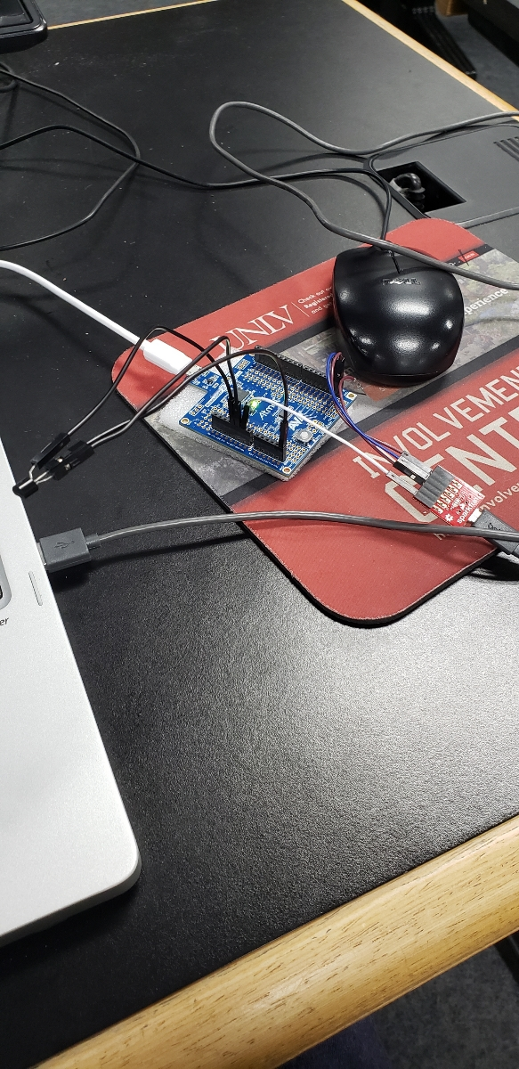

1. **VIDEO LINKS OF EACH DEMO**
2. **GITHUB LINK OF THIS DA**

<https://github.com/johnsb18/ClassRepository/tree/master/DesignAssignments/DA3B/ADC%2BUART>

**Student Academic Misconduct Policy**

<http://studentconduct.unlv.edu/misconduct/policy.html>

“This assignment submission is my own, original work”.

Benjamin Johnson