CPE301 – SPRING 2019

Design Assignment 4A

Student Name: Benjamin Johnson

Student #: 5003284489

Student Email: johnsb18@unlv.nevada.edu

Primary Github address: https://github.com/johnsb18/ClassRepository

Directory:

Submit the following for all Labs:

1. In the document, for each task submit the modified or included code (only) with highlights and justifications of the modifications. Also, include the comments.
2. Use the previously create a Github repository with a random name (no CPE/301, Lastname, Firstname). Place all labs under the root folder ESD301/DA, sub-folder named LABXX, with one document and one video link file for each lab, place modified asm/c files named as LabXX-TYY.asm/c.
3. If multiple asm/c files or other libraries are used, create a folder LabXX-TYY and place these files inside the folder.
4. The folder should have a) Word document (see template), b) source code file(s) and other include files, c) text file with youtube video links (see template).

*I was unable to make a video for my project because for some reason my set up was not working. I was able to confirm my code works by having a friend test it on their machine, and I know my components work because a friend borrowed them. But when I tried to run my code on my components, it did not work. Thus I don’t have a video for this assignment.

1. **COMPONENTS LIST AND CONNECTION BLOCK DIAGRAM w/ PINS**

Atmega328P

TB6612FNG Dual Motor Driver Carrier

Lab board (for VCC input)

DC motor

1. **INITIAL/MODIFIED/DEVELOPED CODE OF TASK 1/A**

/*

* PWM DC Motor.c

*

* Created: 4/10/2019 5:30:46 PM

* Author : Benjamin Johnson

* Student #: 5003284489

* Email: johnsb18@unlv.nevada.edu

*/

#define *F_CPU* 16000000UL

#include <avr/io.h>

#include <avr/interrupt.h>

#include <util/delay.h>

int togMotor = 0; // motor on/off toggle

int main(void)

{

DDRD = 0x40; // PD6 is output

DDRC = 0x02; // set PC0 as input, PC1 as output for interrupts, INT1 for interrupt

PORTC |= (1<<1); // enable pull-up

TCCR0A |= (1<<COM0A1)|(1<<WGM01)|(1<<WGM00); // clear OC0A on compare match, fast PWM

TCCR0B |= (1<<CS02)|(1<<CS00); // prescaler = 1024

PCICR |= (1<<PCIE1); // enable pin change interrupt 1

PCMSK1 |= (1<<PCINT9); // enable pin change on PC1

ADMUX |= (1<<REFS0); // use ref voltage at Aref

ADCSRA |= (1<<ADEN)|(1<<ADSC)|(1<<ADATE)|(ADPS2)|(1<<ADPS1)|(1<<ADPS0);

sei();

while (1) { } // run while waiting for interrupt

}

ISR (PCINT1_vect) { // toggle interrupt

if (!(PINC & (1<<PINC1))) {

if (togMotor == 0) { // turn motor off

OCR0A = 0;

PORTB &= ~(1<<PORTB2);

}

if (togMotor == 1) { // turn motor on

while ((ADCSRA & (1<<ADIF)) == 0); // process ADC

OCR0A = ADC;

PORTB |= (1<<PORTB2);

}

*_delay_ms*(500);

togMotor ^= 1; // toggle motor control on/off

}

}

1. **DEVELOPED MODIFIED CODE OF TASK 2/A from TASK 1/A**
2. **SCHEMATICS**
3. **SCREENSHOTS OF EACH TASK OUTPUT (ATMEL STUDIO OUTPUT)**
4. **SCREENSHOT OF EACH DEMO (BOARD SETUP)**

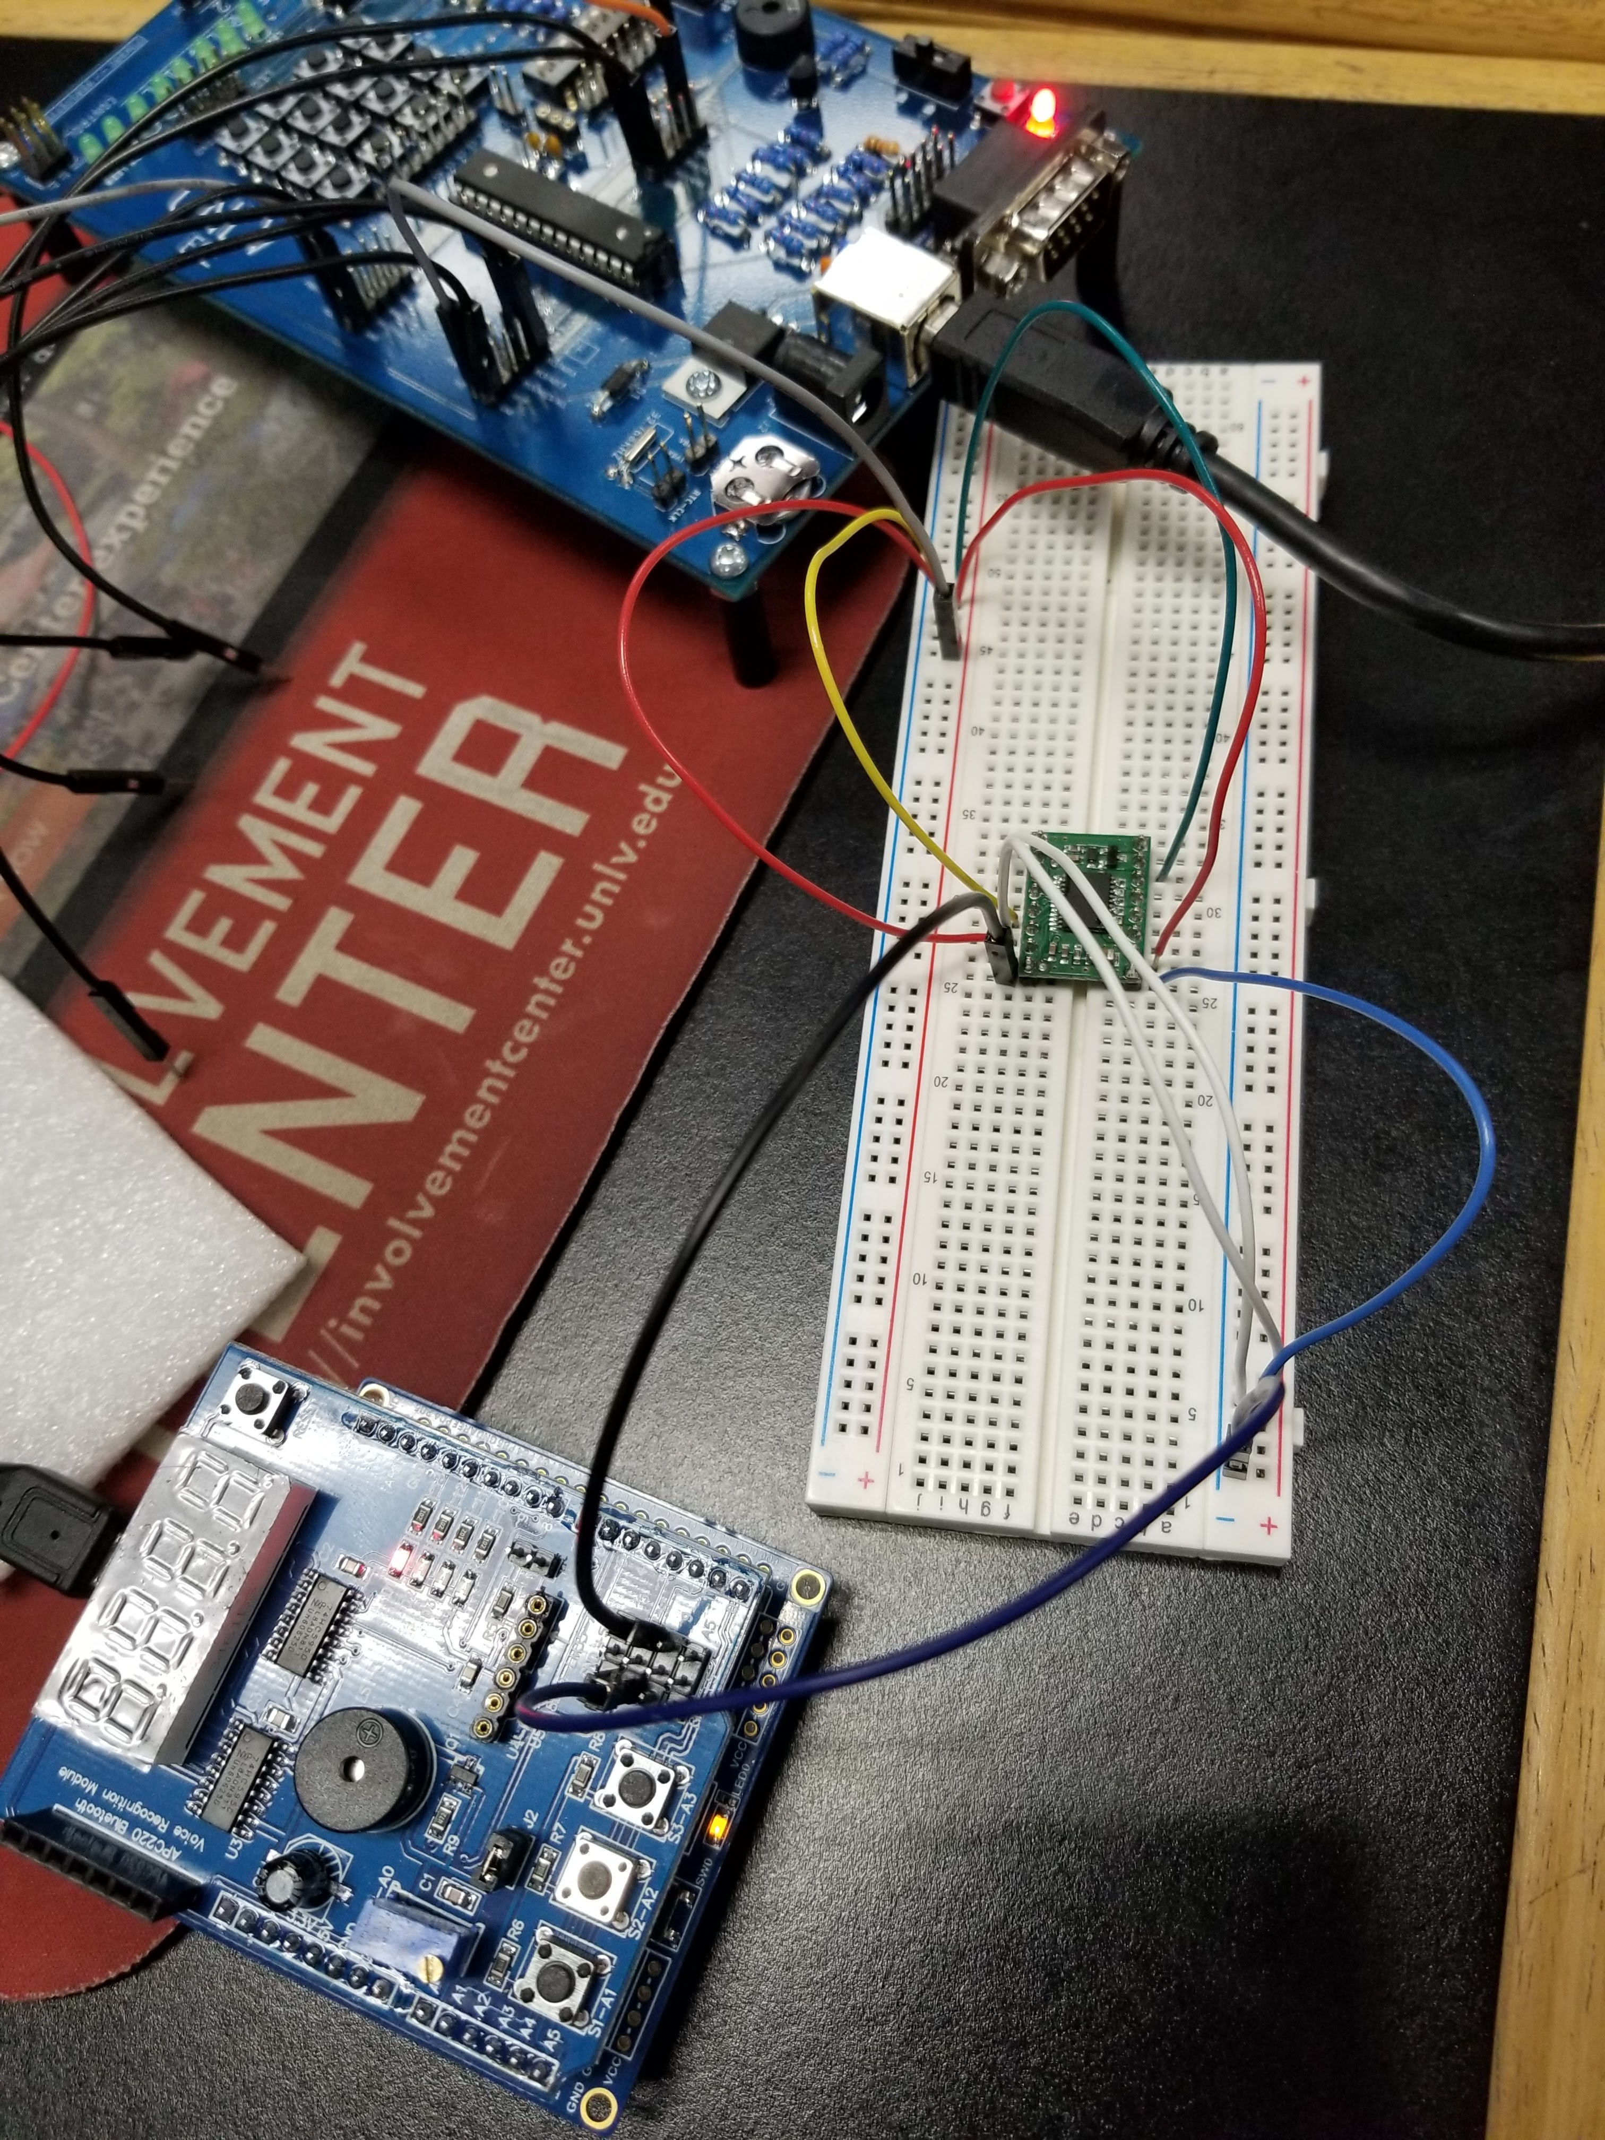

1. **VIDEO LINKS OF EACH DEMO**

*Refer to note at the top of the second page.

1. **GITHUB LINK OF THIS DA**

<https://github.com/johnsb18/ClassRepository/tree/master/DesignAssignments/DA4A>

**Student Academic Misconduct Policy**

<http://studentconduct.unlv.edu/misconduct/policy.html>

“This assignment submission is my own, original work”.

Benjamin Johnson