CPE301 – SPRING 2019

Design Assignment 4B

Student Name: Benjamin Johnson

Student #: 5003284489

Student Email: johnsb18@unlv.nevada.edu

Primary Github address: https://github.com/johnsb18/ClassRepository

Directory:

Submit the following for all Labs:

1. In the document, for each task submit the modified or included code (only) with highlights and justifications of the modifications. Also, include the comments.
2. Use the previously create a Github repository with a random name (no CPE/301, Lastname, Firstname). Place all labs under the root folder ESD301/DA, sub-folder named LABXX, with one document and one video link file for each lab, place modified asm/c files named as LabXX-TYY.asm/c.
3. If multiple asm/c files or other libraries are used, create a folder LabXX-TYY and place these files inside the folder.
4. The folder should have a) Word document (see template), b) source code file(s) and other include files, c) text file with youtube video links (see template).

1. **COMPONENTS LIST AND CONNECTION BLOCK DIAGRAM w/ PINS**

Atmega328P

Unipolar stepper motor

ULN2003

Servo motor

1. **INITIAL/MODIFIED/DEVELOPED CODE OF TASK 1/A**

/*

* Stepper Motor.c

*

* Created: 4/22/2019 4:32:32 PM

* Author : Benjamin Johnson

* Student #: 5003284489

* Email: johnsb18@unlv.nevada.edu

*/

#define *F_CPU* 16000000UL

#include <avr/io.h>

#include <avr/interrupt.h>

int main(void)

{

DDRD = 0x0F; // PORTD lower pins are output

TCCR1A |= (1<<WGM01); // CTC mode

TCCR1B |= (1<<WGM12)|(1<< CS12)|(1<<CS10); // prescaler = 1024

ADMUX |= (1<<REFS0); // use ref voltage at Aref

ADCSRA |= (1<<ADEN)|(1<<ADSC)|(1<<ADATE)|(ADPS2)|(1<<ADPS1)|(1<<ADPS0);

while (1) // timer set for .1 second (65536 - 1562)

{

while ((ADCSRA & (1<<ADIF)) == 0); // process ADC

OCR1A = ADC; // set new limit

TCNT1 = 0; // reset timer

while (TCNT0 != OCR1A) {} // delay

PORTD = 0x09; // rotate motor

TCNT1 = 0; // reset timer

while (TCNT0 != OCR1A) {} // delay

PORTD = 0x03; // rotate motor

TCNT1 = 0; // reset timer

while (TCNT0 != OCR1A) {} // delay

PORTD = 0x06; // rotate motor

TCNT1 = 0; // reset timer

while (TCNT0 != OCR1A) {} // delay

PORTD = 0x0C; // rotate motor

}

}

/*

* Servo Motor.c

*

* Created: 4/22/2019 6:20:52 PM

* Author : Benjamin Johnson

* Student #: 5003284489

* Email: johnsb18@unlv.nevada.edu

*/

#define *F_CPU* 16000000UL

#include <avr/io.h>

#include <util/delay.h>

int main(void)

{

TCCR1A |= (1<<COM1A1)|(1<<COM1B1)|(1<<WGM11); // non-inverted PWM

TCCR1B |= (1<<WGM13)|(1<<WGM12)|(1<<CS11)|(1<<CS10); // prescaler 64, mode 14 fast PWM

DDRB = 0x02; // set PB1 to output

DDRD = 0x40; // PD6 as output

ADMUX |= (1<<REFS0); // use ref voltage at Aref

ADCSRA |= (1<<ADEN)|(1<<ADSC)|(1<<ADATE)|(ADPS2)|(1<<ADPS1)|(1<<ADPS0);

while (1)

{

while ((ADCSRA & (1<<ADIF)) == 0); // process ADC

OCR1A = ADC;

}

}

1. **DEVELOPED MODIFIED CODE OF TASK 2/A from TASK 1/A**
2. **SCHEMATICS**
3. **SCREENSHOTS OF EACH TASK OUTPUT (ATMEL STUDIO OUTPUT)**
4. **SCREENSHOT OF EACH DEMO (BOARD SETUP)**

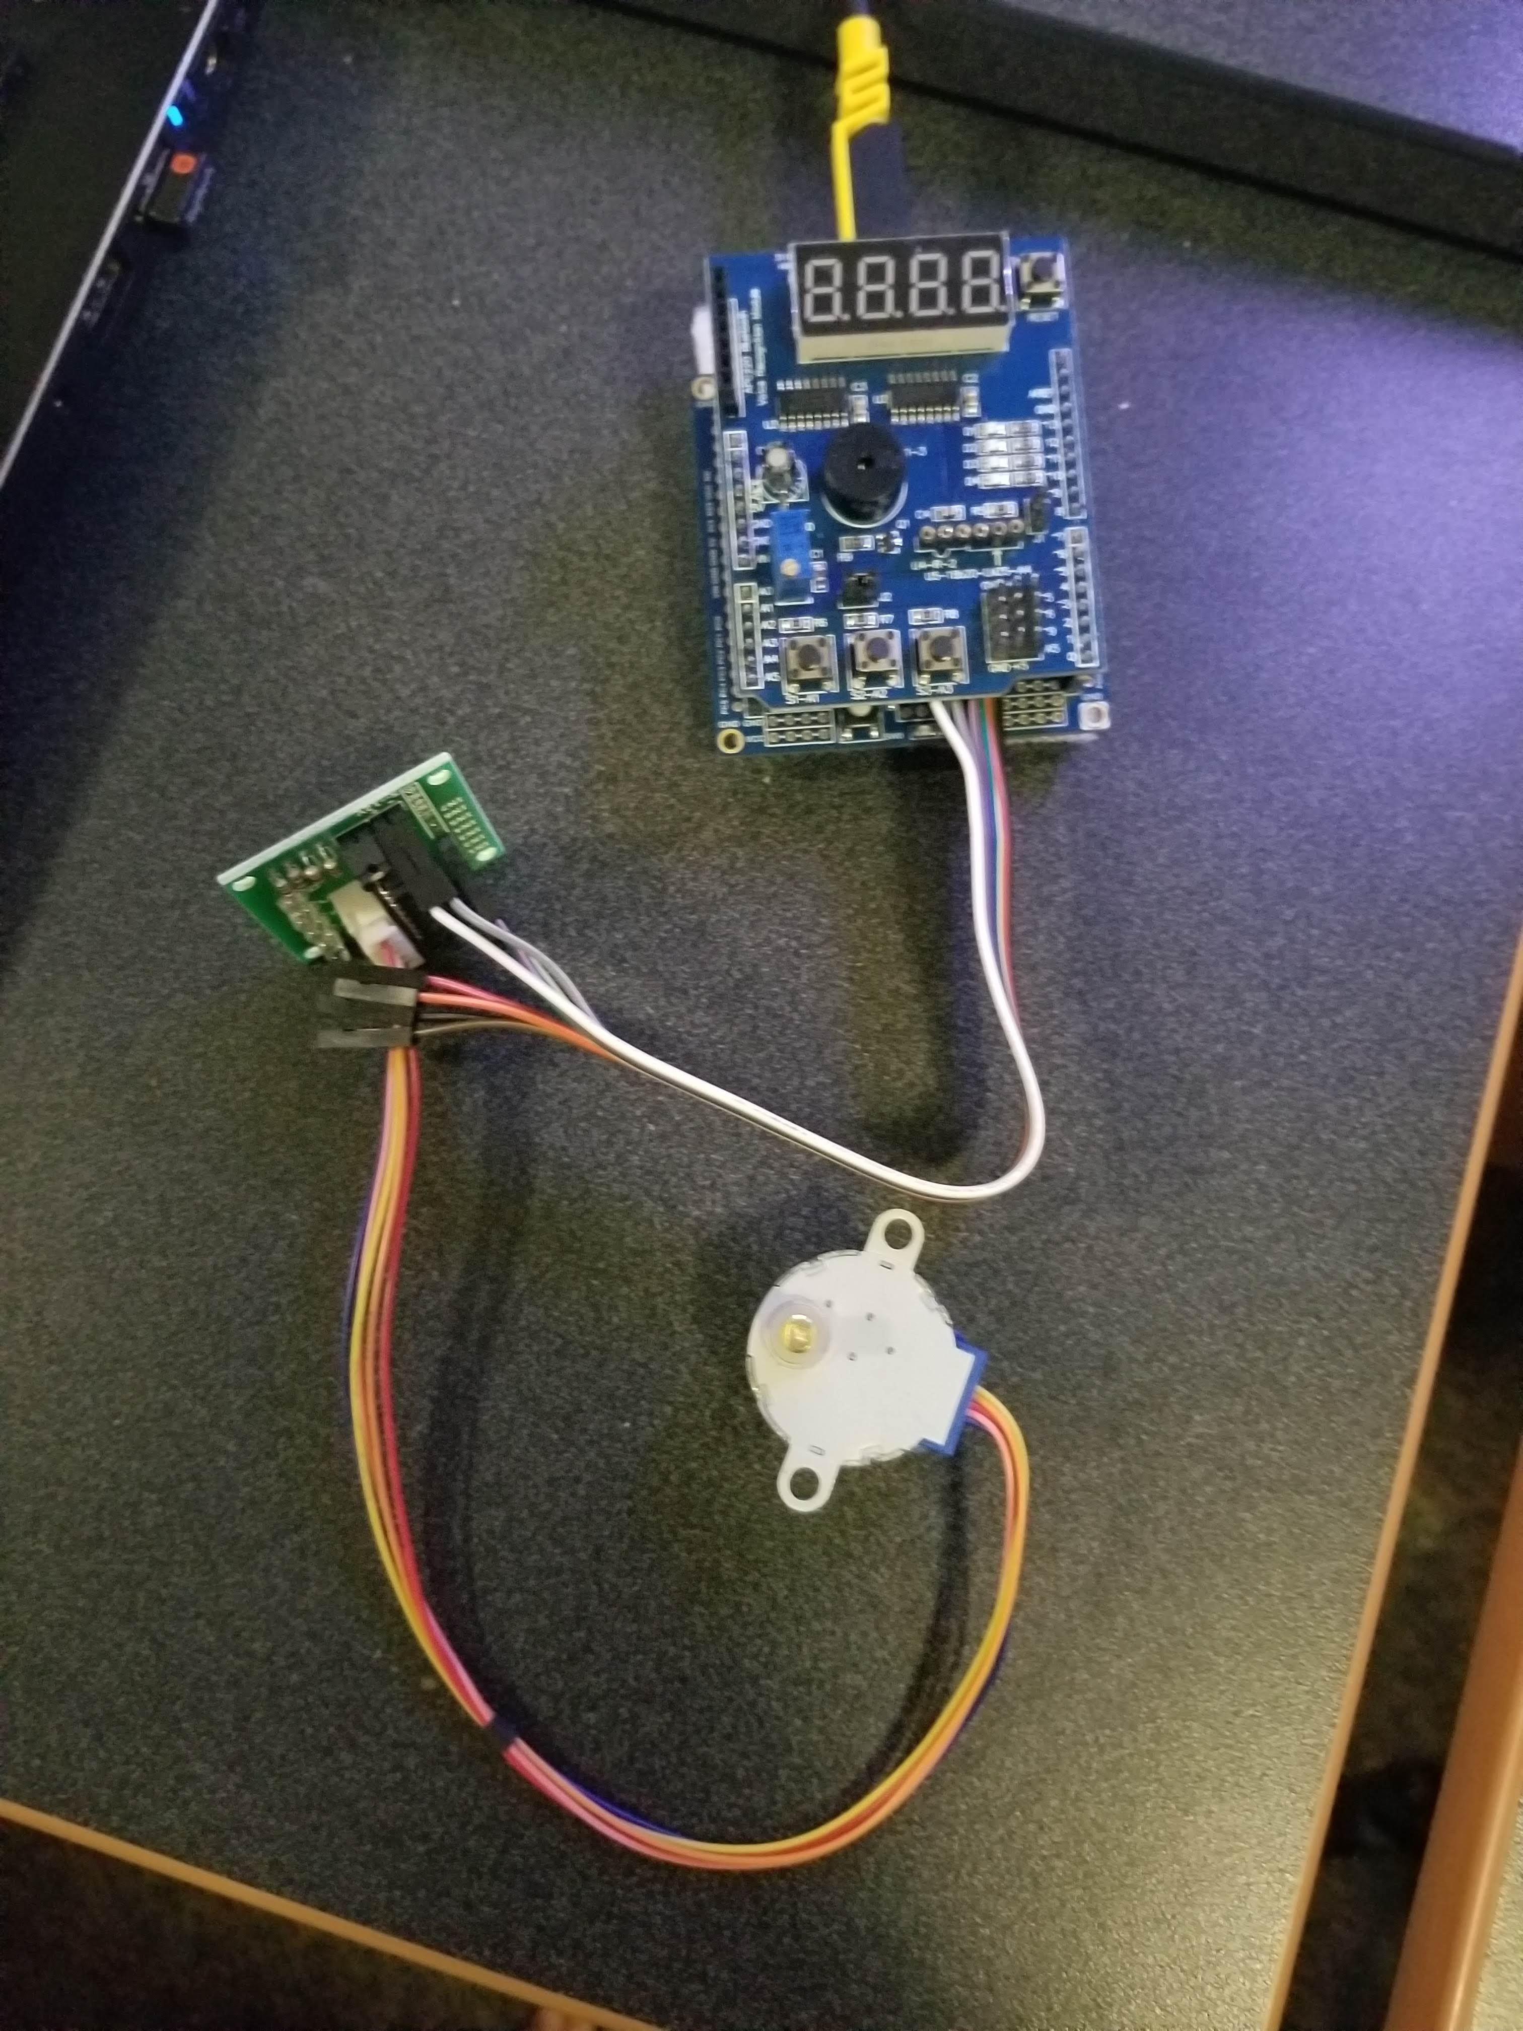

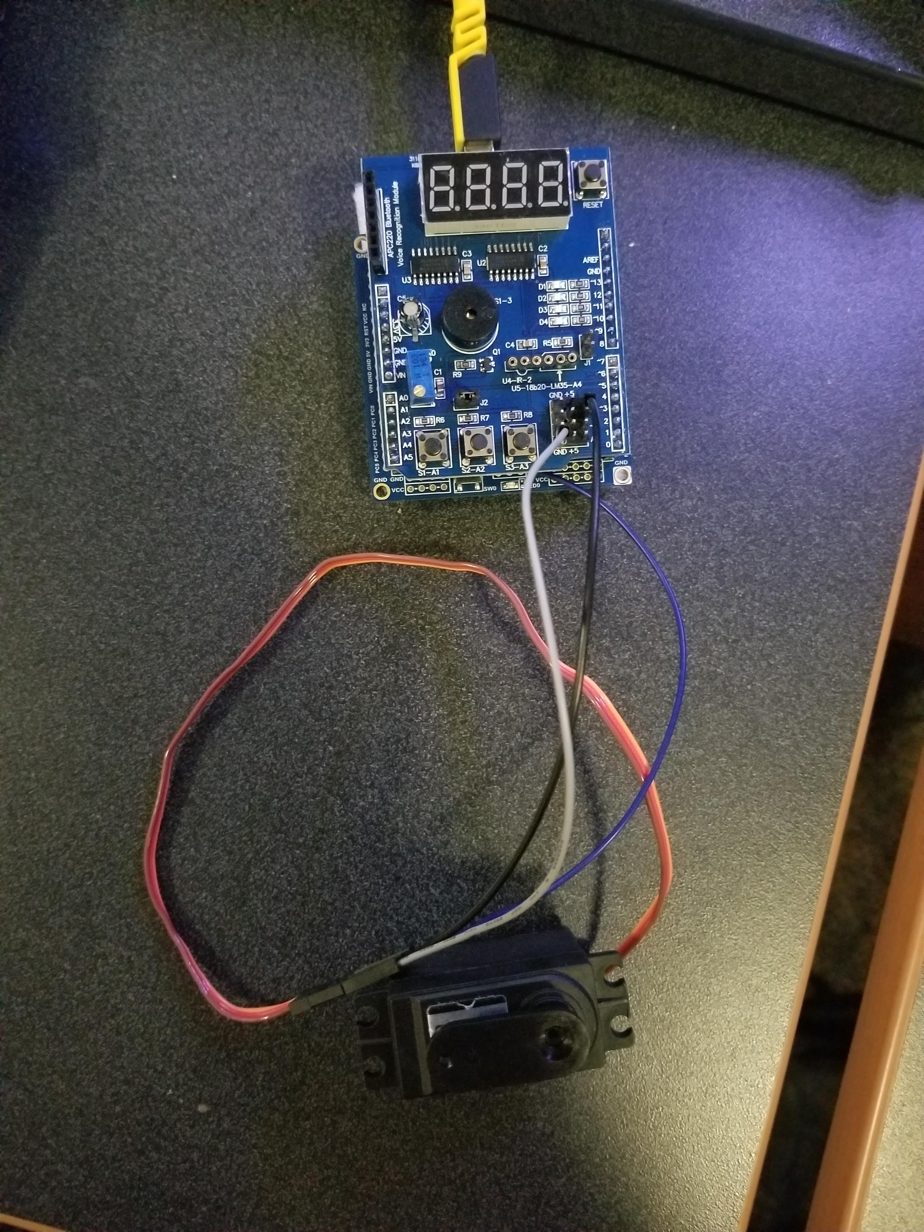

1. **VIDEO LINKS OF EACH DEMO**
2. **GITHUB LINK OF THIS DA**

<https://github.com/johnsb18/ClassRepository/tree/master/DesignAssignments/DA4B>

**Student Academic Misconduct Policy**

<http://studentconduct.unlv.edu/misconduct/policy.html>

“This assignment submission is my own, original work”.

Benjamin Johnson