**

Centralized Traffic Control Graphical User Interface Help Guide

Version 1.0

April 26, 2012

PAAC Demonstration System

|  |  |  |
| --- | --- | --- |
| List Of Revisions | | |
| Date | Name | Description |
| 4/25/2012 | Jeremy Nelson | Initial help guide |

# Table of Contents

List Of Revisions 2

Table of Contents 2

1 Introduction 3

1.1 Purpose 3

1.2 Scope 3

1.3 Reference 3

1.4 Definitions and Abbreviations 3

2 Test Items 3

3 Features to be Tested 3

4 Testing Strategy 4

4.1 Unit Testing 4

4.2 Module Testing 4

4.3 Item Pass/Fail Criteria 5

4.4 Test Deliverables 5

4.5 Responsibilities 5

# Introduction

## Purpose

The purpose of this document is to provide instructions and guidance for using the Bazinga Centralized Traffic Control (CTC) Graphical User Interface (GUI).

## Scope

This document describes the basic use and features of the CTC Office GUI.

## Reference

1. Centralized Traffic Control Graphical User Interface Software Requirements Specification

## Definitions and Abbreviations

**Authority** – the distance a train is permitted to travel.

**Block** – a section of a railway line

**CTC** – Centralized Traffic Control

**GUI** – graphical user interface

# System Summary

The CTC GUI demonstration application is designed to enable a dispatcher to monitor and control the state of the transit system. The dispatcher can control the system in three primary methods: Setting a block speed limit, setting a block authority, and opening or closing a block. Some extra features are added solely for simulation purposes, such as spawning trains to move around the track and mimicking failure scenarios.

# Installation

To Install the CTC Office GUI application, open the installer application (BazingaInstaller.msi). Follow the on-screen instructions and specify the installation directory. The installation may take a few minutes to complete. Once it is finished, exit the installer.

# Getting Started

To open the CTC Office GUI, navigate to the installation output directory. Open CTCOfficeGUI.exe. A dialog window will appear prompting for a username and password. The default credentials are:

**Username**: admin

**Password:** Bazinga!

Once successfully authenticated, the Main Screen will open.

# Using the GUI

## Main Screen

The main screen consists of three main controls: the track layout, the information panel, and the command panel. To load a track layout, go to File -> Load Track Layout and select the layout .xml file to restore. If successful, the layout will be displayed on the screen. The track layout displays a geographical view of the track with lengths proportional to the actual block length. The color of the block indicates the current signal of the block (red, yellow, green, super green). Individual blocks can be selected by clicking on them. Once selected, the block will blink, the information display will show detailed information about the track block, and the command display will show a list of possible commands to execute.

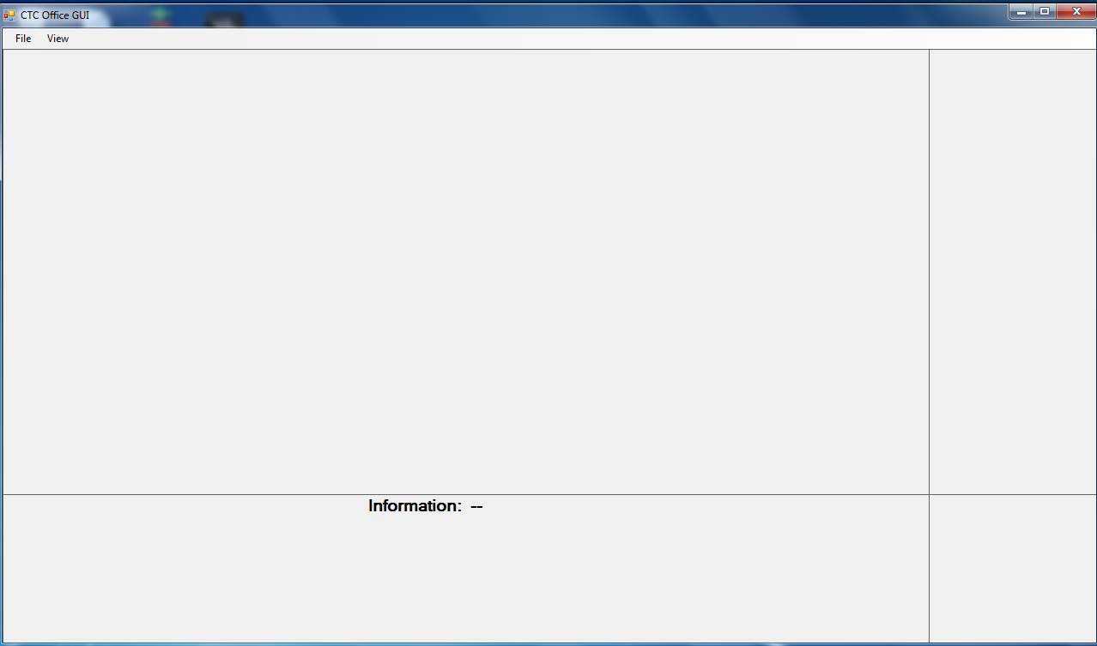

Figure : main Screen

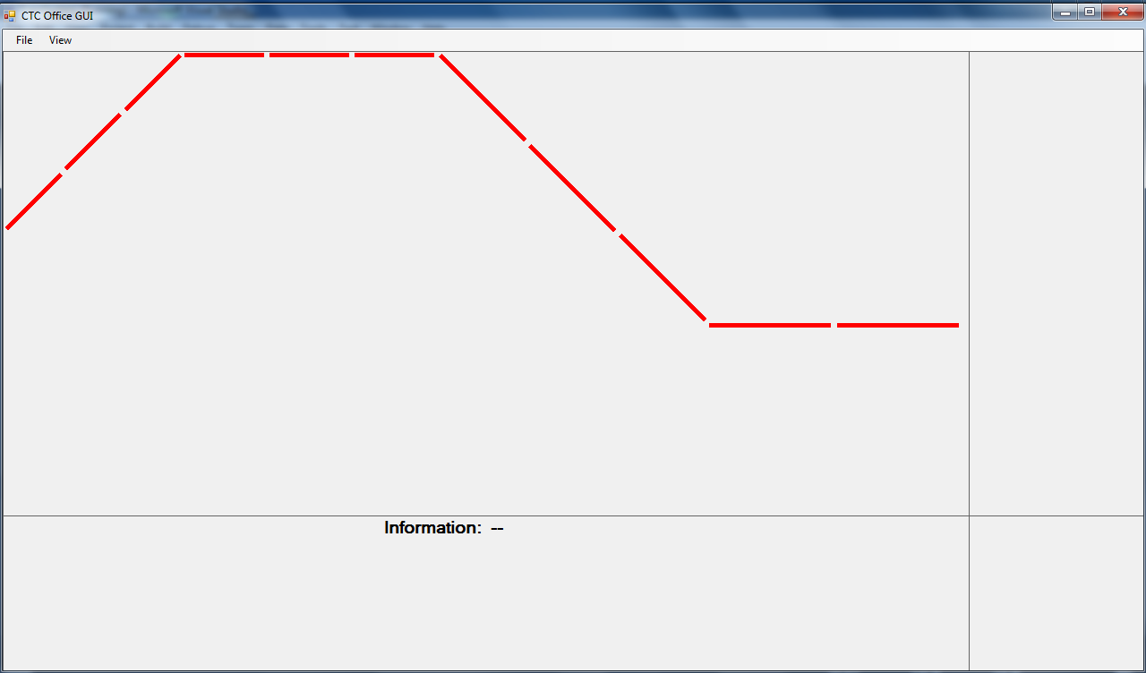

Figure : Layout Loaded

### Sending track block commands

To send a block command such as set speed limit, set authority, or open/close block, select the desired track block. Click the desired command button in the command panel. If setting the speed limit or authority, a dialog window will appear to enter the desired speed limit or authority, respectively. Once pressing ok, the speed limit or authority will be sent to the track controller which owns the track block. If the value is within the acceptable range, the new speed limit or authority will be set. To open or close a track block, simply click the open or close block command.

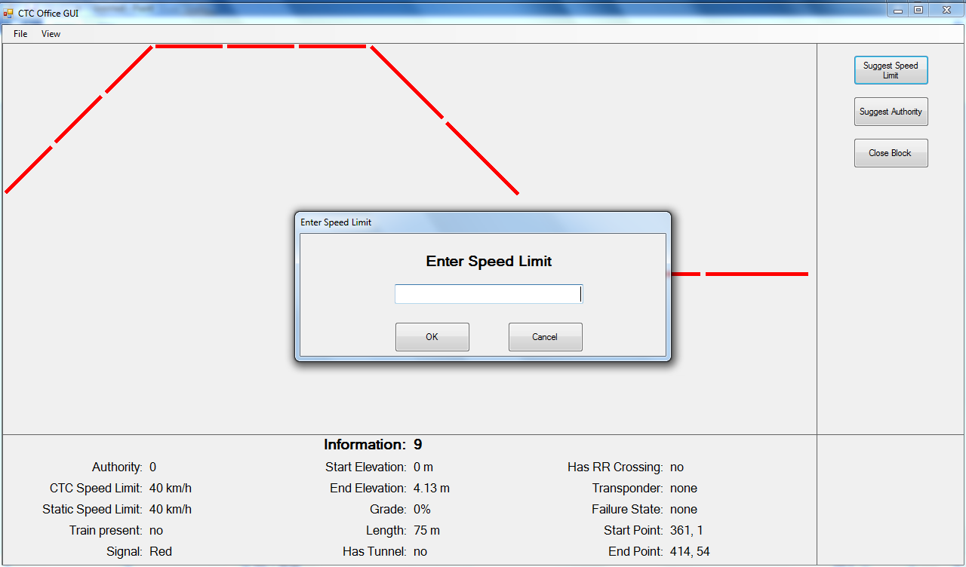

Figure : Set Speed Limit

### Spawning Trains

To send a train onto the track, select a block containing the keyword “YARD”. The command window will then display a button “Spawn train.” Once clicked, a dialog window will appear to enter a name for the new train. Once pressing ok, a new train will enter the track on the selected train yard. The train will automatically be scheduled with the appropriate scheduling information for that track (e.g. Red Line or Green Line).

## Simulator Window

The simulator window is automatically open in the Windows taskbar when the program initializes. If the simulator window is closed, it can be re-opened by clicking View -> Simulator Window in the Main Screen. The Simulator window displays a check box for running the simulation, and a text input box for setting the simulation speed. The simulation time will not step forward while the Run checkbox is not checked. The simulation speed is 1 by default (real time) and cannot be lower than 1. To speed up the simulation, enter the new simulation speed and click Set Simulation Speed. For example, to move the simulation 10 times faster than real time, enter 10. When a track block is selected, three more checkboxes appear for Broken Rail, Circuit Failure, and Power Failure. Checking any one of these boxes will simulate a failure mode on the selected track block, to which the transit simulation system should respond.

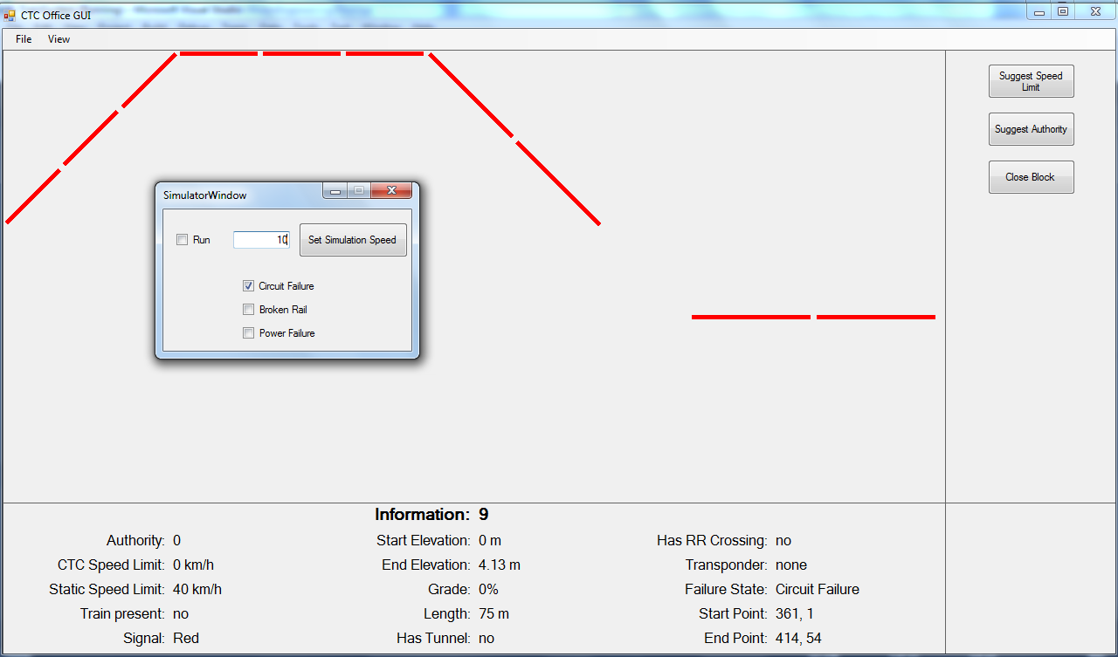

Figure : Simulator Window

## Closing the simulation

To exit the CTC GUI, click File -> Exit or the Close button in the top right corner.