Name: Johns George

Course: Computer Science 2

Module: Web Authoring

Tutor: Ciaran McNulty

Submission Date: 07/04/14

Contents

Introduction 3

Presentation of content 4

Design 5

Site Objectives 6

Potential target audience 7

Access speed 8

Site structure and map 9

Navigation solutions 10

GUI 11

Browser compatibility 12

Level of feedback and interactivity 13

Conclusion 14

Introduction

This project is to develop a website which will meet the criteria set out. The project is to design and construct a website for an identified audience.
Candidates must demonstrate the correct use of HTML in the following process; text formatting, graphics, page layout, links and anchors, image maps, lists, table, comment and meta tags, m multimedia tags, symbol codes, RGB colour system to produce web safe colour, forms and use of scripts
A correct use of scripting language to implement for at least eight of following: Rollovers, status bar message, browser plug-in detection, cycling animation, dynamic frames, forms verification, new windows, cookies and dynamic web page updates.

Presentation of content
.
I designed my website with the help of the web editor Adobe Dreamweaver, so it was easy enough to create a temple for the website first before creating pages.
When the template was made, to give a stylish look, I placed the Lotus motorbike itself as the background image. A PNG format logo has been placed on the top centre of the website and the Spry Menu bar widget has been placed below. The navigation colour has been made white and the background colour will be made transparent. The main section has been given a small bending on all four sides and the section’s background colour is also transparent with slight black colour so that it will be dark translucent colour.
Then I created each page from the template with some changes been made in each pages.

Design

Before I started creating this website, I drew out a plan on how this website should look like. As I am a person who is very much interested in motorbikes, I had an idea on what kind of design can attack the target audience. So that why I gave a black background colour and half the image of the Lotus Motorbike as the background image, which will give the customers a quick stylish look on the product and their curiosity to see and know about the design will make them go in all the pages.
I used the PNG image format for placing the logo in the top centre, so that it will be transparent to the website. In the menu bar, white colour has been given for the navigation with background colour made it to be transparent. When on Mouseover on the each navigation, the transparent background colour changes to black.
The first heading colour was given to be similar to logo colour and the links colour was given – blue (normal), white (when clicked), dark red (after clicked), red (mouseover). The section’s height was given a black, so that the designer will be able to create more flexible sections on each page.

Site objectives

This website's objective is to give a brief information to the customers on the product and this website fulfils of criteria for these information. It has given the motorcycle's specification, good look of the motorbike (gallery), about both the designer and the company and all the contact details.

Suitability for potential target audience

Target audience for this website will be people who are motorcycle lovers of Lotus motors or any motor bikes in general. But the person should also be in a good financial background as some analysts believe the cost of this Lotus motorbike will be more than €50000 because it is a collector’s edition bike.
The USP (Unique Selling Point) for this motorbike is its look. The design has been inspired by the bikes used in movie Tron: legacy. So, I believe the same USP should be used in for the website design. That’s why the website was given a stylish unique look to attract the target audience. With a great background image and a transparent main section, the audience will be coming back again for further news updates.
Browser compatibility

This website is created to be compatible to all browsers, it works perfectly fine and same with all of them including Google Chrome, Internet Explorer, Mozilla Firefox, Opera and Safari. The following screen shots will prove that the websites looks same on all browsers:
Google Chrome:
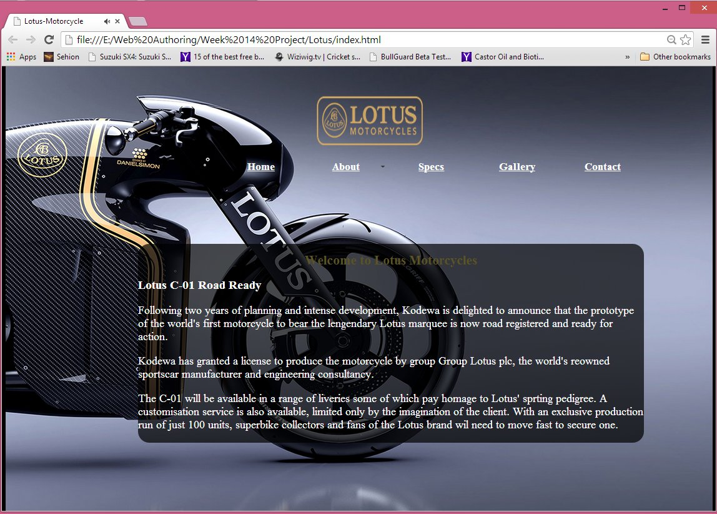

Internet Explorer:
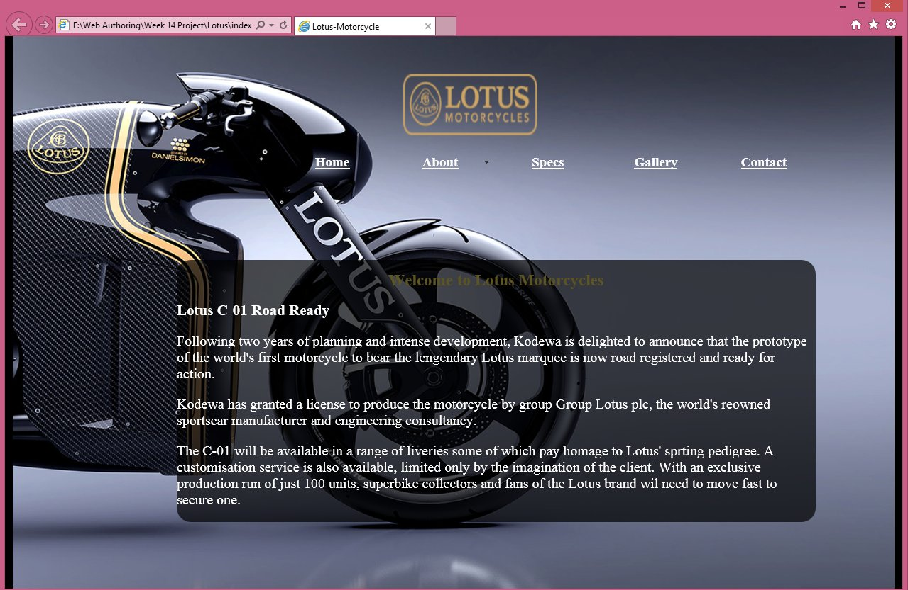
Mozilla Firefox:
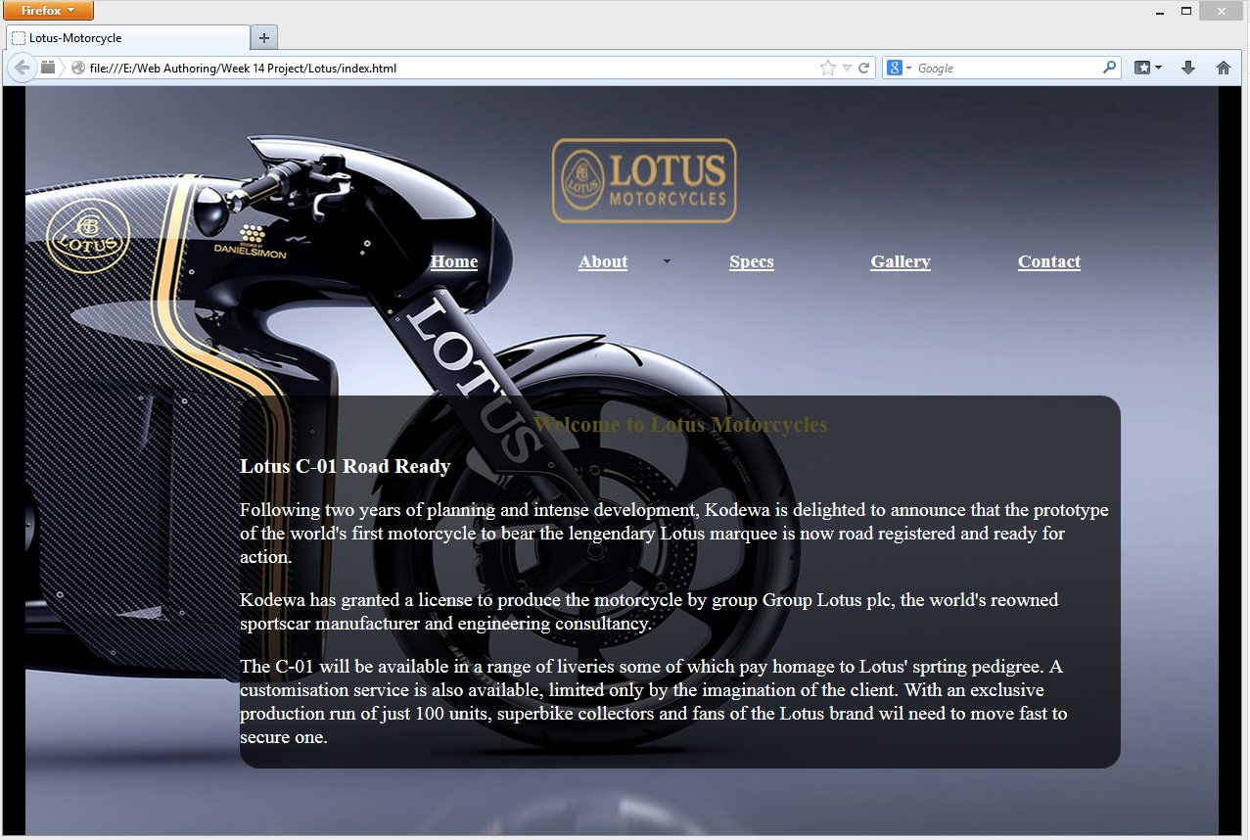

Opera:
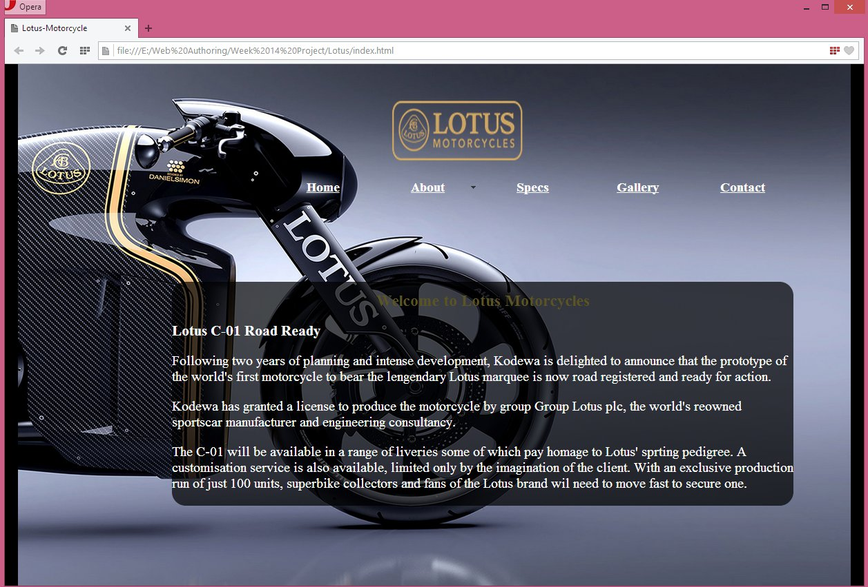

Safari:
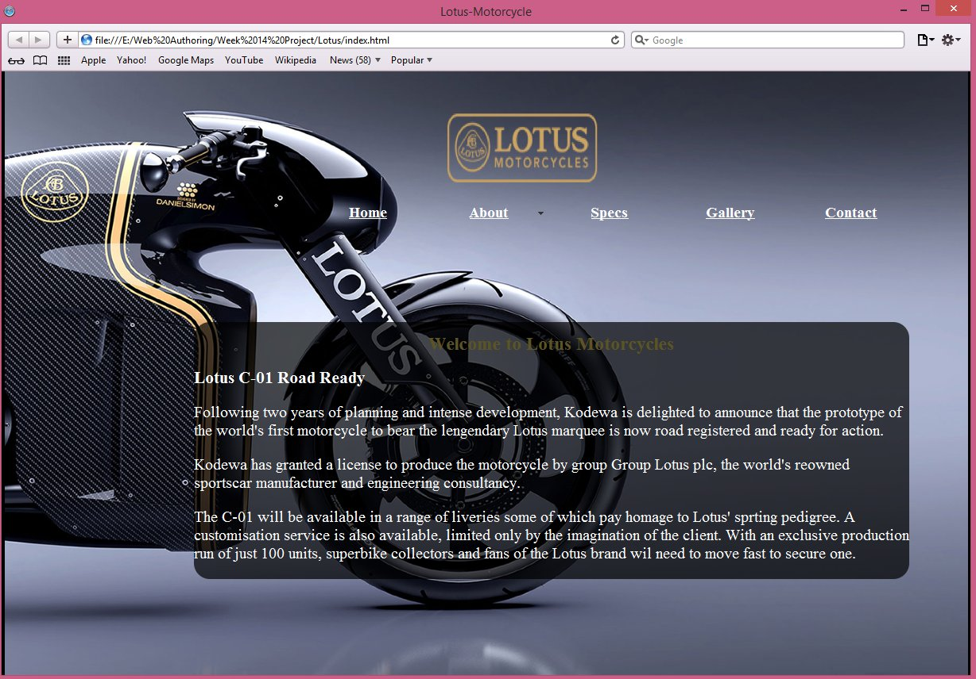

Site structure and map

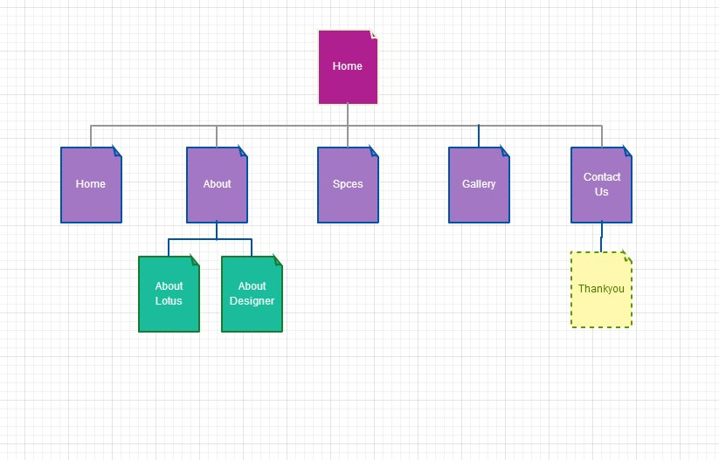

As you can see in the above image, the first page opened will be the home page. Since then the user can navigate through all the other pages. The next menu option for the user, is the ‘About’ in Menu bar. This is a two page layout, as the user can either select About Louts or About designer from the Menu bar itself.
Then the user is able to select Specs page where all the information about the motorbike specification is available. In the next page, which is the Gallery, all the images and the video of this bike are placed.
The contact page is the last page in the Menu and inside this page when the user uses enquire form and select send button in the form, the site will then be forwarded to the ‘Thank You’ page. In the above image, ‘Thank You’ page is having different format than other pages because it only opens if the user uses that specific form.

Access Speed

Nowadays people don’t like to wait for a website to load. They want it to load instantly when they select each page, link or widgets. That is the reason I designed my website with 7.7mb of file size (4mb without audio in the website). The lessen size of the file was mainly because of the images used in the site was resized in the Photoshop to decrease the size without affecting its quality.
Because of this, the users will not have any sort of waiting time and will open all the website pages, external and internal links and widget instantly the moment the user selects each.
The only waiting time that may take is when, the user select ‘Visit Lotus Website’ in About Lotus page. This is a JavaScript which will open the official Lotus motor website in a new window. Due to their website’s size and contents it may take time to load and there is nothing I could do about it.

Navigation solution

My each pages are as follows:
index:
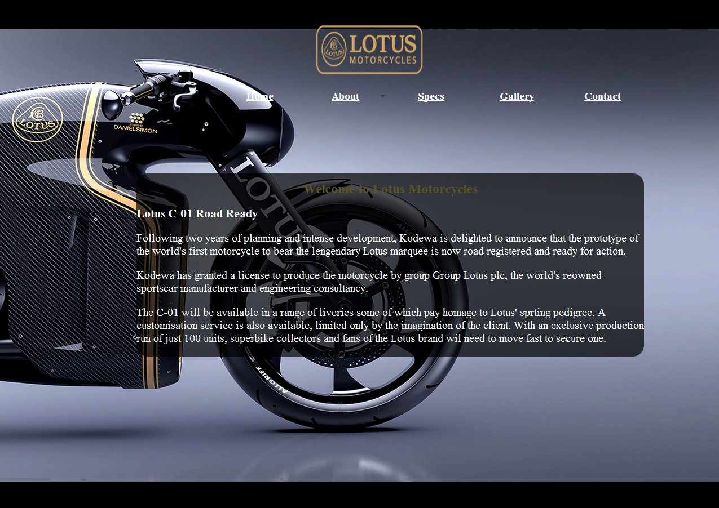
This page has a small Lotus logo with menu bar below it. The section is contain a small description on what their customers must look forward to.
The page has background music. There are no controls given for this music.

About Lotus:
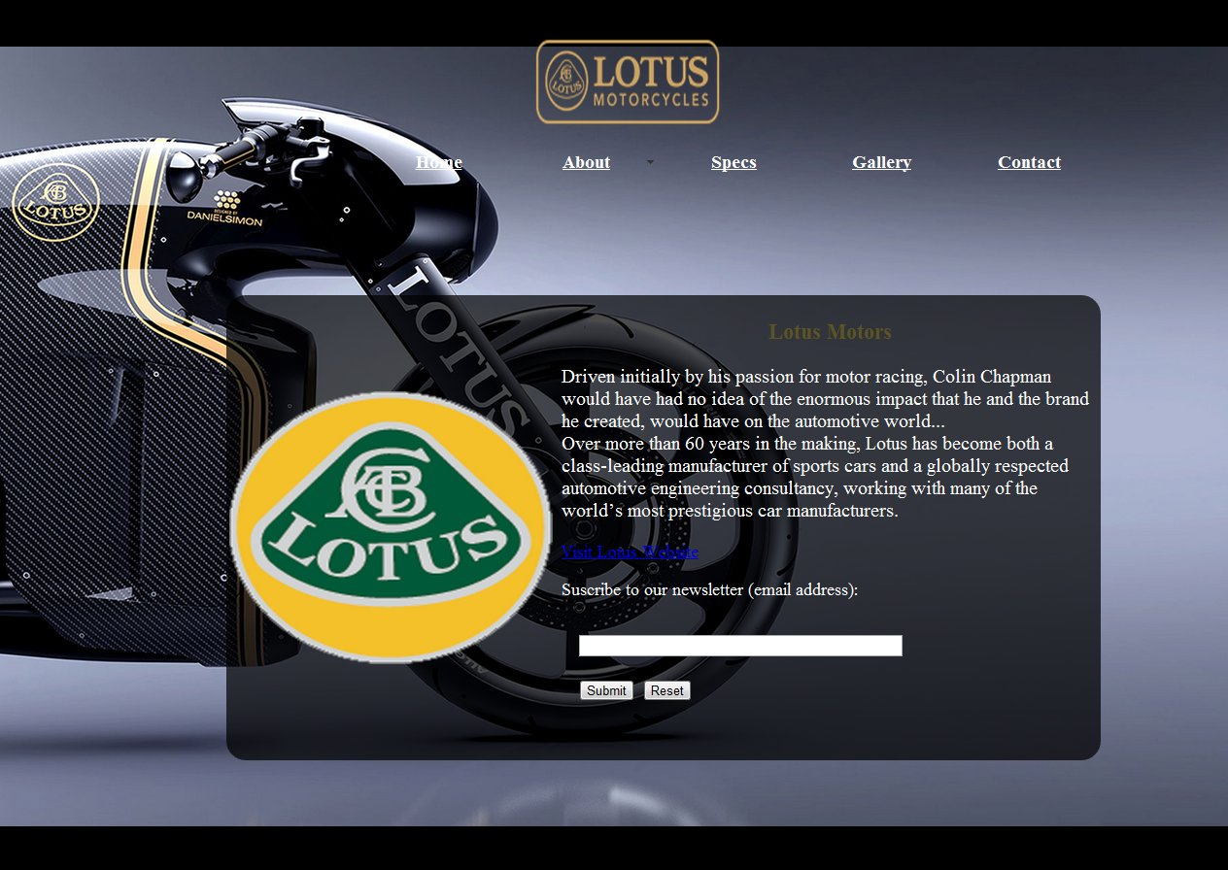
This page’s section has been divided with table column. The table border has been made 0, so that the user will not be able to see the table. The left side of which contain the Lotus motor logo which is clickable and is then navigated to Lotus Motor’s page in Wikipedia in an external tab in the browser.
In the right side of the table small information of this company has been given and below is the link to visit the official website of Lotus motors in a new window (this has been made with a JavaScript).
The page also contains a form which is used to subscribe the monthly newsletter. This form has been created with JavaScript. This JavaScript will only accept email address and if the user gives an invalid email, the website will notify the user about it. And when the user gives and valid email, the site then navigates to thank you page.

About Designer:
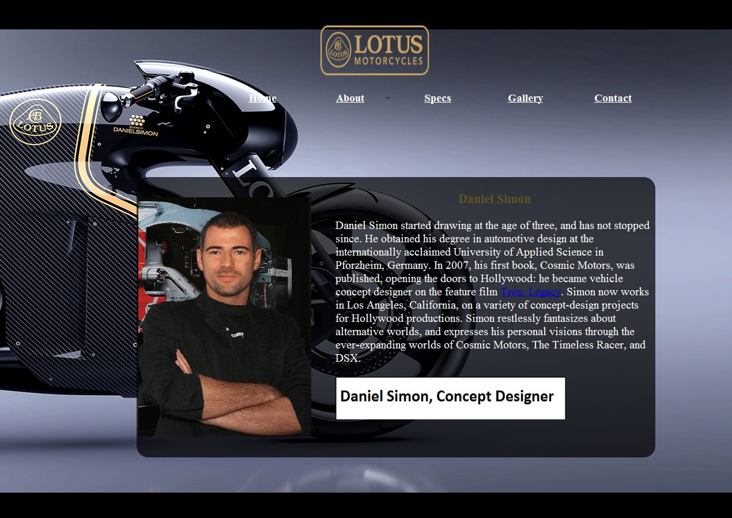
This page’s section is also divided with table column just like the About Lotus page. The right side of the page is an image of the designer. This is a rollover image (JavaScript). This rollover has been made clickable, and is then navigated to the official website of the Daniel Simon.
The right side of the section contain with a small description on the designer. On this description there is a link for ‘Tron: Legacy’, which is a movie that Daniel Simon assisted to designs. This link will navigate the user to the Tron’s movie page in Wikipedia. This link is placed with a status bar message JavaScript. There is a cycling animation contain a brief information on who Daniel Simon is.

Specs:
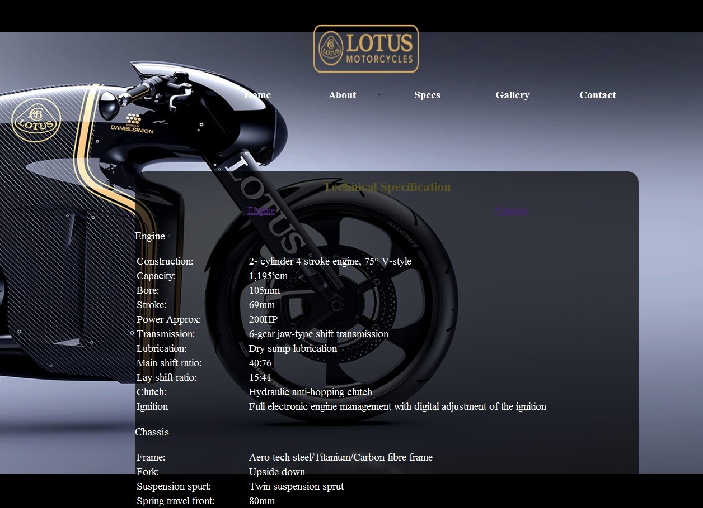
In the Specs’ section, there is information on the specification about this motorbike. On the top of the section there are links given for both Engine and Chassis. These acts like an anchor which will take the user to the exact area in the page where both are located. There is also an anchor for ‘back to top’ in the very bottom of this website.

Gallery:
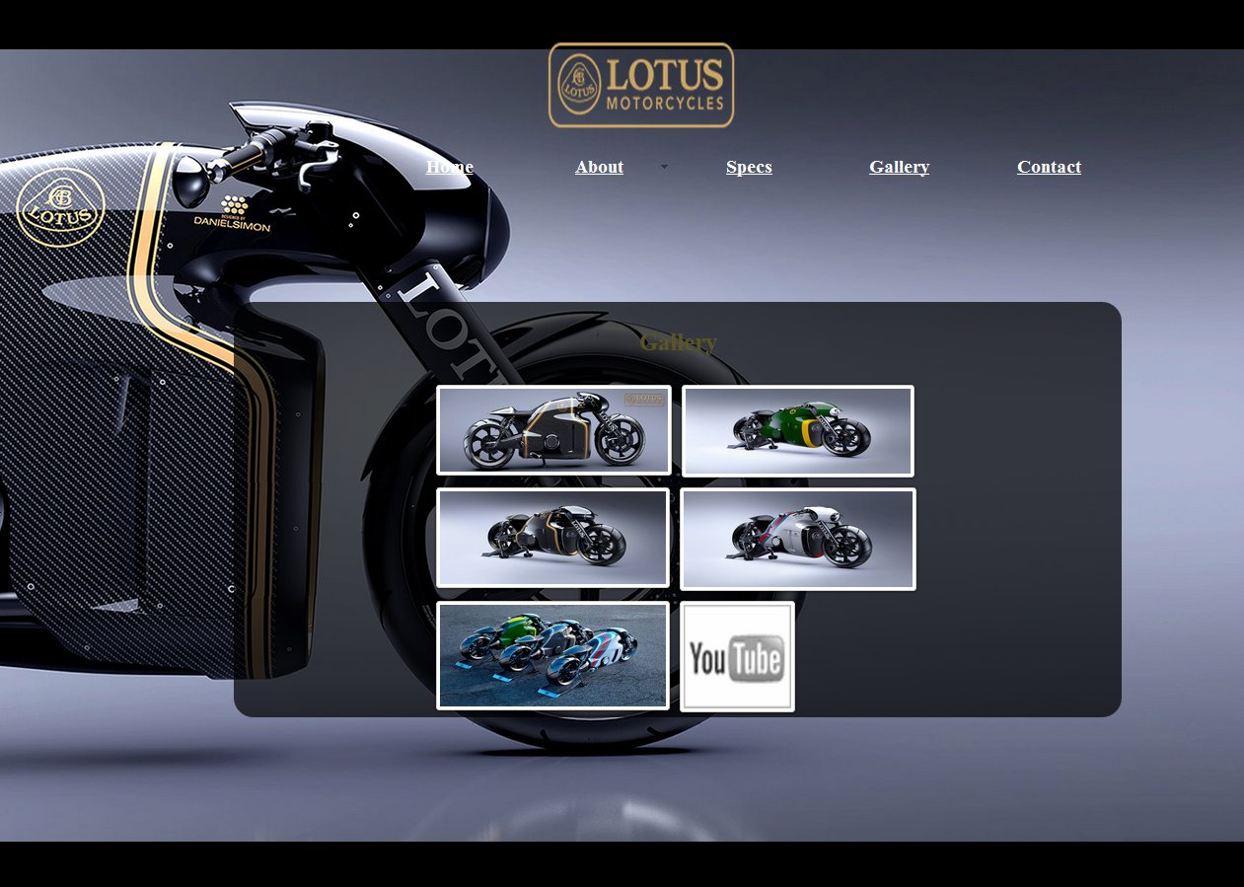
In this page’s section, it only contains ‘ClearBox LighBox’ widget. This widget is used for a stylish gallery view. When the user clicks on each image, it will open and will give a small description for each image. The user will be giver option to navigate between these images or to view all images in a slideshow.
The reason for using this is because this widget accepts all formats of images, videos, audios and also contain text document, information from other website and even a YouTube video. This is one of the best widget available in the market for gallery.

Contact:
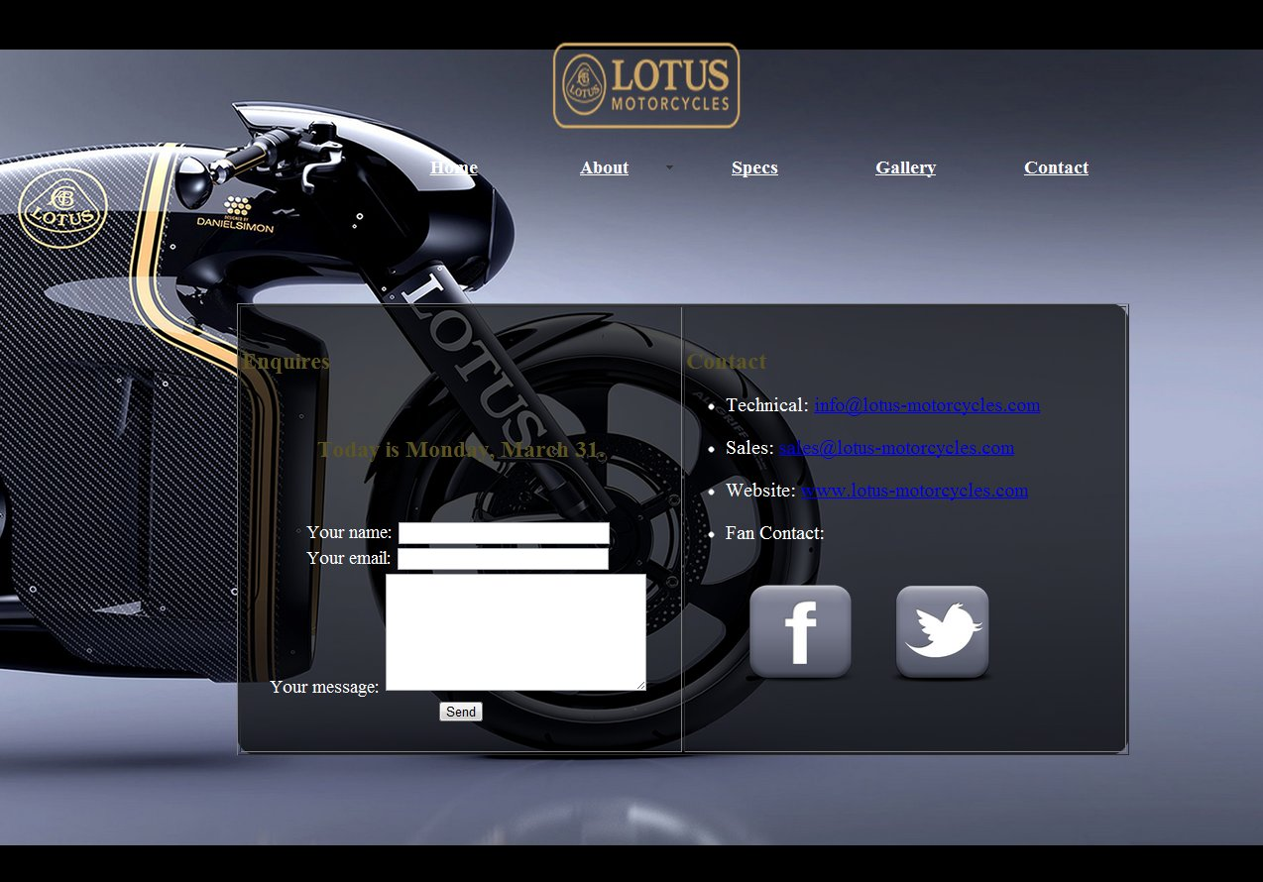
This page’s section is divided into tables. On the right side, it contains basic contact information for this company and also image links for the company’s Facebook and Twitter pages that will be directed to an external tab.
On the left side of the section, it contains a dynamic web page update of JavaScript (current date/time) and below this, it is a form for general enquires. When the user presses the ‘Send’ button, the site will then navigate to ‘Thank You’ page.

Thankyou: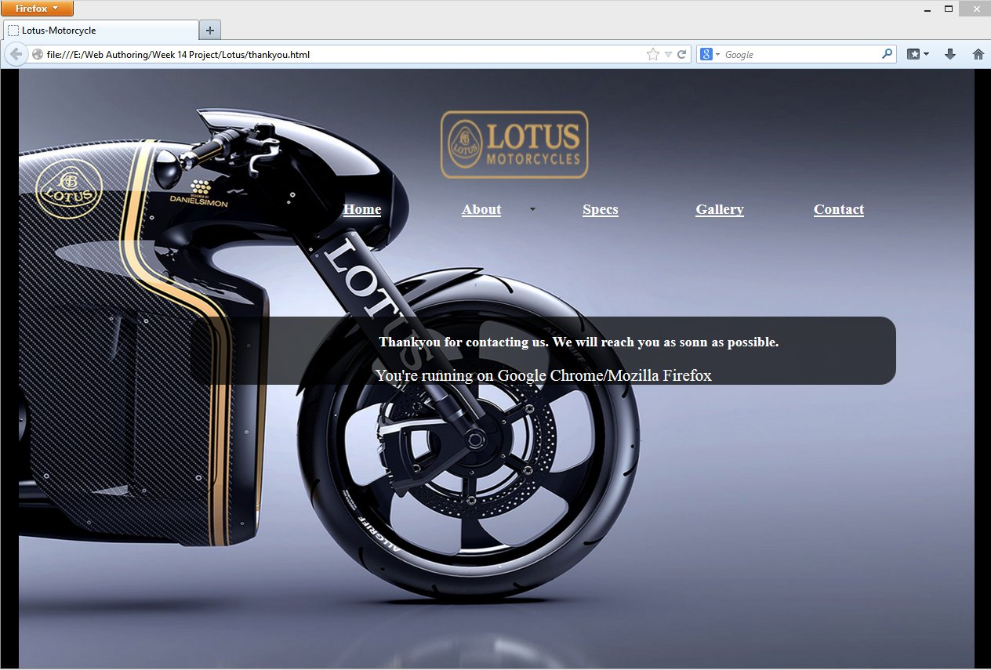This page’s section contains a marquee code that will move from right side to the left by thanking the user for contacting them. There is also a JavaScript for browser plug-in detection, which will notify the user what browser the user is using.

GUI

The GUI for my website is mainly links, images and forms. In the About Lotus page, there is a link for ‘Visit Lotus Website’, which will take users to the official website of Lotus motors in a new window. In the same page on the right side of the section, it is a clickable image of Lotus motors which will be forwarded to Lotus motors page in Wikipedia. There is also a JavaScript for form verification is for users to subscribe for company’s monthly newsletters and when the user presses ‘Submit’, the JavaScript make sure it is a email and if it is, it will then be forwarded to ‘Thank You’ page. And if the user enter ‘Reset’ button, then the characters the user have entered will be erased.
The About Designer page’s section is also divided with table column just like the About Lotus page. The right side of the page is an image of the designer. This is a rollover image (JavaScript). This rollover has been made clickable, and is then navigated to the official website of the Daniel Simon.
The right side of the section contain a small description of the designer. On this description there is a link for ‘Tron: Legacy’, which is a movie that Daniel Simon assisted in designs. This link will navigate the user to the Tron page in Wikipedia. This link is placed with a status bar message JavaScript. There is cycling animation that contains brief information about Daniel Simon.
In the Specs page, other than the specification of the website there is only anchors for Engine, Chassis and Back to the top. And in the gallery page, the ClearBox LightBox widget has been used to viewing the motorbike images. The user has an option to navigate between the images or to view the images by slideshow.
In the contact page, all the basis contact information for the customers has been created has a link. There is also image links for the company’s Facebook and Twitter pages that will be directed to an external tab. On the left side of the section there is a form for general enquires. When the user press the ‘Send’ button, the site will then navigate to ‘Thank You’ page.

Level of Feedback and interactivity

I showed this website to more than a dozen people and they were all very pleased with the design and contents. The only recommendations I received was for a change of colours of links in all the pages to make it more visible.

JavaScript used

The JavaScript that was used for the websites are as follows:
- Rollovers – in About Designers
- Status bar message – in About Designers (status bar message for link “Tron: Legacy’)
- Browser plug-in detection – in Thank you (will notify the browser the user uses in thank you page after using the enquire form in contact page)
- Cycling animation – in About Designers (cycling animation shows brief information on Daniel Simon)
- Form verification – in About Lotus (used to subscribe monthly newsletter and when clicked on submit button, it will forward the used to Thank you page)
- New window – in About Lotus (used to open the official website of Lotus motors in a new window)
- Cookies – in index page
- Dynamic web page updates – in Contact (on the top of the enquire form to notify the user about the current date)

