Regular Expressions
https://www.tutorialspoint.com/python/python_reg_expressions.htm
https://www.youtube.com/watch?v=paOPoZyjzdg
- When you want to perform string matching operations that are more complex than the operations, you use regular expressions.
- A regular expression is a special sequence of characters that helps you match or find other strings or sets of strings, using a specialized syntax held in a pattern. Regular expressions are widely used in UNIX world.
- The module re provides full support for Perl-like regular expressions in Python. The re module raises the exception re.error if an error occurs while compiling or using a regular expression.

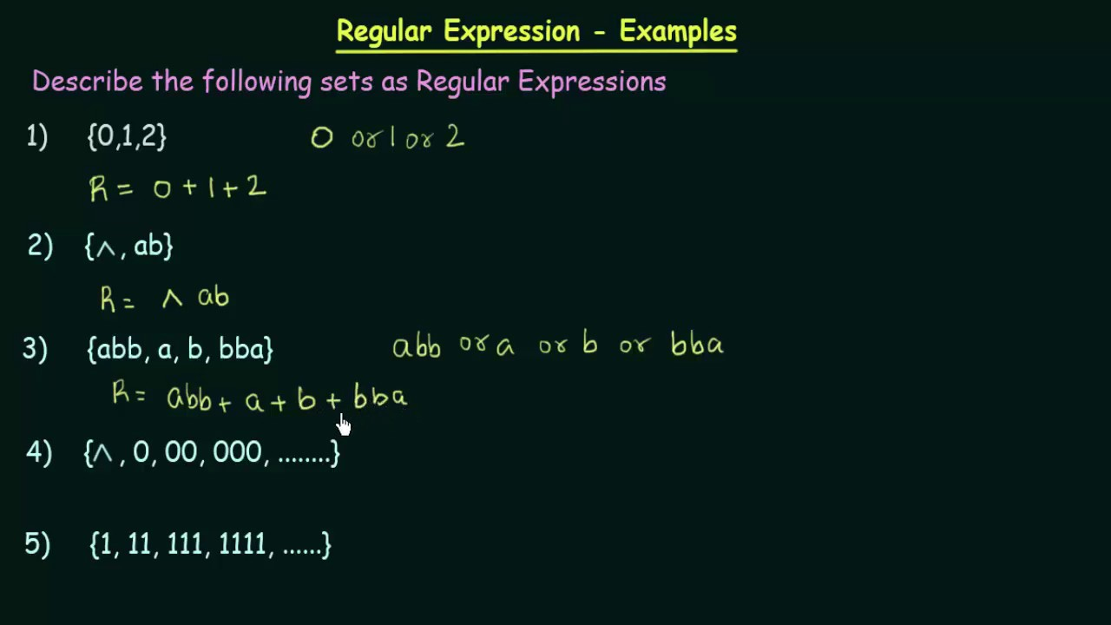

Shunting Yard Algorithm
http://www.oxfordmathcenter.com/drupal7/node/628
http://www.martinbroadhurst.com/shunting-yard-algorithm-in-python.html
https://rosettacode.org/wiki/Parsing/Shunting-yard_algorithm
https://web.microsoftstream.com/video/a29536d4-e975-4172-a470-40b4fe28866e
- Edsger Dijkstra developed his "Shunting Yard" algorithm to convert an infix expression into a postfix expression. It uses a stack; but in this case, the stack is used to hold operators rather than numbers. The purpose of the stack is to reverse the order of the operators in the expression. It also serves as a storage structure, since no operator can be printed until both of its operands have appeared.
Shunting Yard Algorithm done by hand

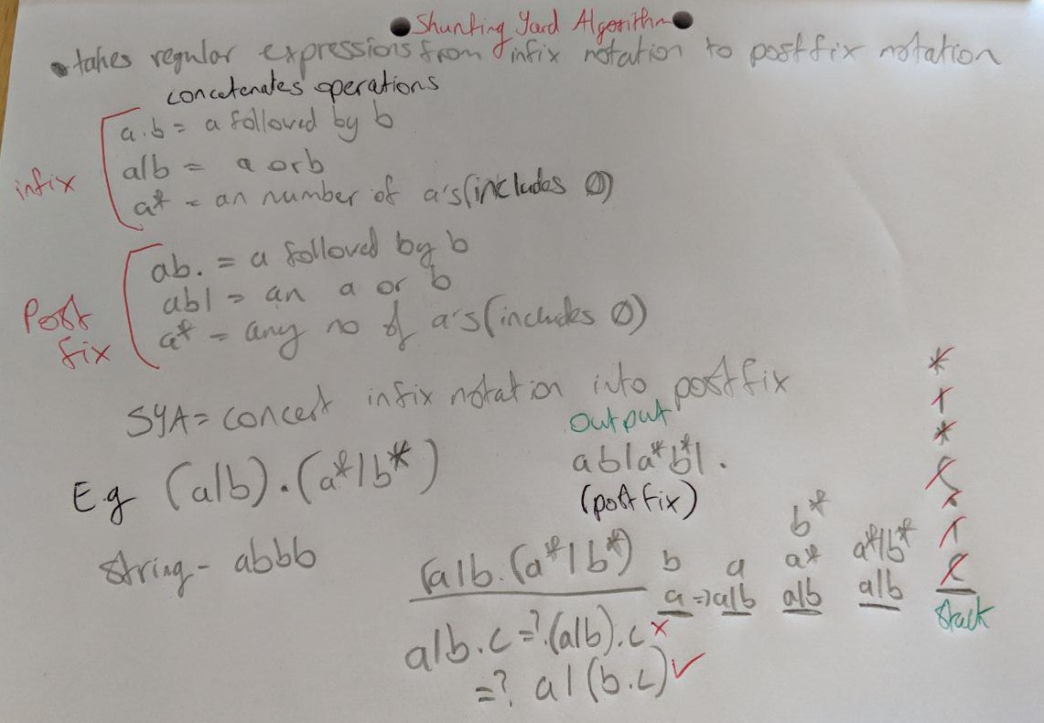

Thompson's Construction
https://en.wikipedia.org/wiki/Thompson%27s_construction
https://web.microsoftstream.com/video/29de6c7c-9379-46d3-99e8-8a3dbafe391f
- In computer science, Thompson's construction algorithm, also called the McNaughton-Yamada-Thompson algorithm, is a method of transforming a regular expression into an equivalent nondeterministic finite automaton (NFA). This NFA can be used to match strings against the regular expression. This algorithm is credited to Ken Thompson.
- Regular expressions and nondeterministic finite automata are two representations of formal languages. For instance, text processing utilities use regular expressions to describe advanced search patterns, but NFAs are better suited for execution on a computer. Hence, this algorithm is of practical interest, since it can compile regular expressions into NFAs. From a theoretical point of view, this algorithm is a part of the proof that they both accept exactly the same languages, that is, the regular languages.

Thompson's Construction done by hand
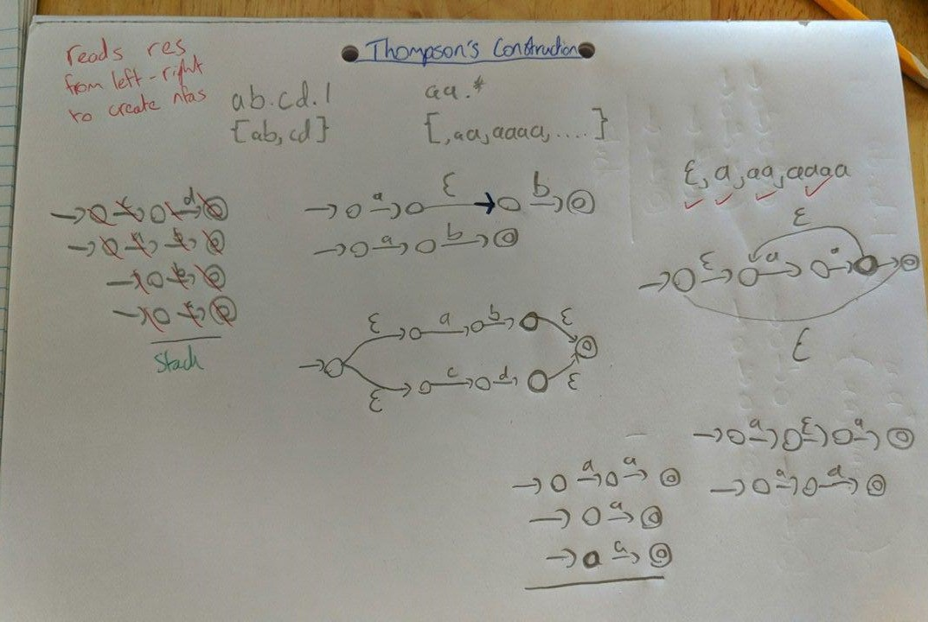

Matching
https://www.tutorialspoint.com/python/python_reg_expressions.htm
https://swtch.com/~rsc/regexp/regexp1.html
https://web.microsoftstream.com/video/1b3e7f4f-69e0-4316-853f-c63b14f9c36a
- The match function attempts to match RE pattern to string with optional flags.
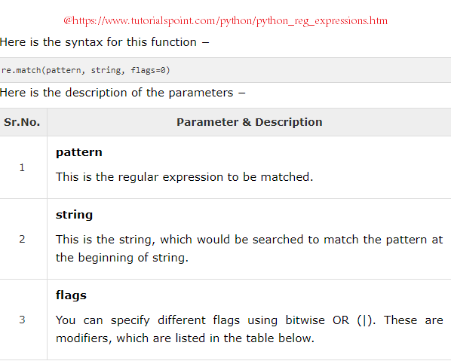
- The re.match function returns a match object on success, None on failure. We usegroup(num) or groups() function of match object to get matched expression.
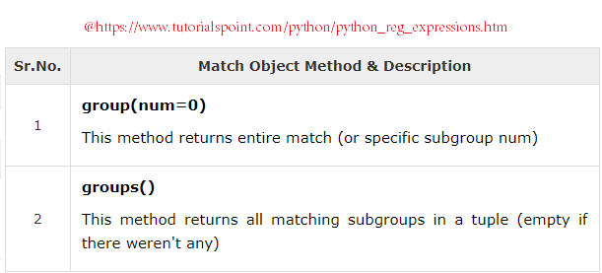
Matching done by hand
