**Unsupervised Learning and Dimensionality Reduction Analysis**

John Seon Keun Yi

CS4641

**Introduction**

This project explores various clustering and dimensionality reduction algorithms. The two datasets used for this analysis are

* **Heart Disease Dataset**

This is the dataset used in Assignment 1. This is the Cleveland database that contains only part of the entire data. This dataset contains 13 attributes on various health conditions of the subject and a target field of 0 (no heart disease) and 1. (presence of the disease) This dataset has 303 instances, of which 138 (46%) are 0 and 165 (54%) are 1. The binary outputs of the target data were changed to ‘yes’ and ‘no’ to adjust to the needs of the WEKA Explorer. This dataset was obtained from the UCI machine learning repository.

* **Breast Cancer Wisconsin Database**

This dataset works to predict breast cancer from features computed from digitized images of a fine needle aspirate of a breast mass. The features in this dataset are characteristics of the cell nuclei present in the images. This dataset contains 30 attributes such as mean radius and mean smoothness. All values in the attributes are numerical. They were normalized using the WEKA normalize tool. It has a total of 569 instances with no missing values present. This dataset was retrieved from the UCI machine learning repository.

I chose to use these two datasets because I wanted to compare results of binary classification datasets with different number of attributes. The breast cancer dataset had 30 attributes, which was more than twice the number of attributes in the heart disease dataset. I thought it would be interesting to compare the clustering results of the two datasets both before and after applying dimensionality reduction. The centers of the clusters aim to minimize the sum of squared errors in the clusters.

1. **Clustering**

Here we apply two clustering algorithms -k-means clustering and expectation maximization (EM)- and determine which algorithm is more optimal in both datasets.

**K-means Clustering**

K-means clustering (K-means in short) algorithm clusters samples into k groups of equal variance. It randomly picks k centers which claim closest points based on the mean squared errors. Then it recomputes the centers by averaging the points in each cluster.

Although we already know the number of clusters that should form for both datasets, (two because binary classification) since this is an unsupervised learning problem, we attempt to find the optimal k-value, which is the number of clusters. For both datasets I varied the value of k from 2 to 20. The SimpleKMeans clusterer was used in WEKA using the Euclidean distance as the distance function. Then I saw how the sum of squared error (SSE) turned out for different k values. Figure 1 and 2 are the plotted graphs for k value to SSE. To evaluate the performance of the clustering, first I attempted to use the elbow method. The elbow method is a visual identification method where an elbow -a point where the SSE starts to even out and stop changing rapidly- is found. From the plot for the Heart Disease dataset in Figure 1 we can easily identify the ‘elbow point’, at . However, it is hard to visually distinguish the elbow point for the Breast Cancer dataset in Figure 2.

Figure 2. Sum of squared error (SSE) to k-value of the Breast Cancer dataset.

Figure 1. Sum of squared error (SSE) to k-value of the Heart Disease dataset.

As an alternative, I used the Silhouette method for this dataset. The silhouette method is a cluster performance 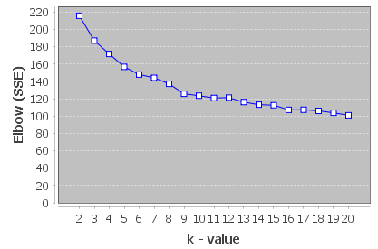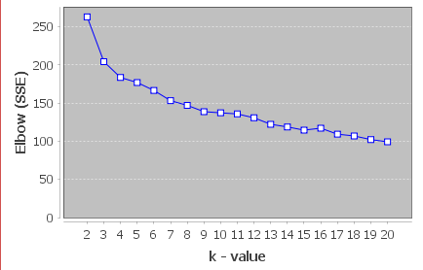evaluation method where the silhouette coefficient is compared. The silhouette coefficient s is calculated as follows:

‘a’ is the mean distance between a sample and other points in the same cluster, and ‘b’ is the mean distance between the sample and all other points in the nearest next cluster. This measures how closely the sample is matched to the data within its cluster and how loosely it is matched to the data of the next closest cluster. s ranges between 1 and -1, where an s close to 1 indicate that the sample is in the appropriate cluster.

I applied the silhouette method using the KValid package downloaded to WEKA. As a result, the optimal k value for the Breast Cancer dataset turned out to be when .

When run with the optimal k values, the K-means algorithm incorrectly clustered 49% of instances on the Heart Disease dataset, and 7.2% of the instances on the Breast Cancer dataset.

**Expected Maximization (EM)**

Expected Maximization (EM) clustering algorithm is a soft clustering algorithm that allows some points to be shared between multiple clusters. Unlike hard clustering such as k-means, where a point is either in a cluster or not, EM assigns to each point probabilities for that point to be in some cluster.

For this algorithm, first I ran both datasets on the EM clusterer in WEKA with a default setting. In such setting, WEKA finds the optimal number of clusters through cross validation. The k value for the Heart Disease dataset turned out to be 5 with a log likelihood of 8.17947. The percentage of incorrectly clustered instances was 56.43%. I compared this with EM run on which was found with the kmeans algorithm. EM with had a log likelihood of 1.86526 with 43.56% of incorrectly clustered instances. While it seems logical to pick as the optimal k value due to its higher log likelihood, it is highly likely that achieved a higher score by overfitting. This is supported by that fact that despite a lower log likelihood, EM with has a lower percentage of incorrectly clustered instances. Thus, we can say that is the optimal hyperparameter.

This is a similar situation with the Breast Cancer dataset. EM run on default parameters returns a k of 14 with a log likelihood of 41.73165 and 76% of incorrectly clustered instances. EM run with , found using kmeans algorithm returns a log likelihood of 29.17844 and only 8% of incorrectly clustered instances. As in the other dataset, although has the higher log likelihood, it makes one hard to believe that this is the optimal k value seen that has a significantly less percentage of falsely clustered instances. Again, we can conclude that is the optimal k value for this dataset, and overfitted.

Figures 3 and 4 display the EM clusters using the optimal k values determined from above. One can see 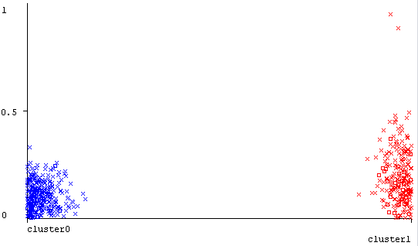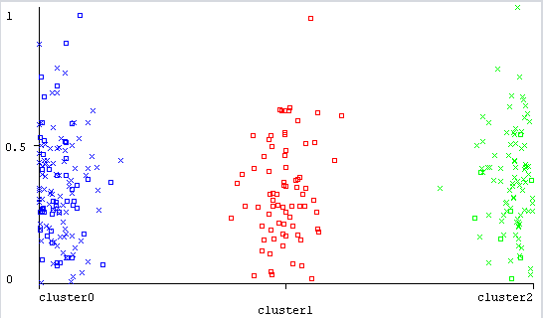that the instances converge neatly to 3 and 2 clusters. The running time of EM to determine the optimal k value was 0.75 seconds for the first dataset, and 55.56 seconds for the second dataset. We can assume the running time of EM increases with more attributes.

Figure 3. Clusters of EM algorithm for Heart Disease dataset. Optimal k value is 3.

Figure 4. Clusters of EM algorithm for Breast Cancer dataset. Optimal k value is 2.

**Table 1.** Optimal k-values for two clustering algorithms on two datasets.

|  |  |  |
| --- | --- | --- |
| k-value | Heart Disease | Breast Cancer |
| k-means | k=3 | k=2 |
| EM | k=5 | k=14 |
| EM-optimal | k=3 | k=2 |

**Table 2.** Percentage of incorrectly clustered instances for each algorithm in two datasets.

|  |  |  |
| --- | --- | --- |
| % | Heart Disease | Breast Cancer |
| k-means | 49.1749 | 7.2056 |
| EM | 56.4356 | 75.9227 |
| EM-optimal | 43.5644 | 8.7873 |

The tables above outline the k-values and percentage of incorrectly clustered instances for each clustering algorithms performed on the two datasets. We can see that the predicted optimal k values from EM algorithms were not optimal, and following the k values found from the k-means algorithms turned out to be more accurately representative of the clusters. Also we can see that the Heart Disease had a lower percentage of error for the EM algorithm compared to k-means, while for the Breast Cancer database k-means had a slightly lower error. We can deduce from this that the first algorithm had more suited domains for the expectation maximization algorithm.

Overall, for these two datasets, I would trust k-means algorithm to find the optimal k value. Although expectation maximization may have less error in some cases, k-means took much less computing time and its performance evaluation turned up optimal k values that were close to the true number of clusters.

1. **Dimensionality Reduction**

Dimensionality reduction

**Principal Components Analysis (PCA)**

|  |  |  |
| --- | --- | --- |
| k-value | Heart Disease | Breast Cancer |
| k-means | k=10 | k=2 |
| EM | k=2 | k=6 |

|  |  |  |
| --- | --- | --- |
| % | Heart Disease | Breast Cancer |
| k-means | 76.5677 | 8.2601 |
| EM | 33.3333 | 43.2337 |