training_iterations = 5e3,lr=1e-5,total_timesteps = 250
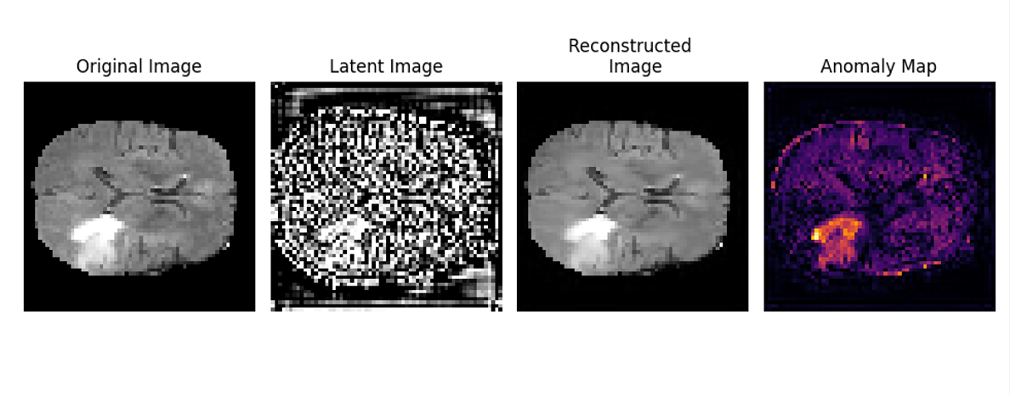

training_iterations = 5e3,lr=1e-5,total_timesteps = 500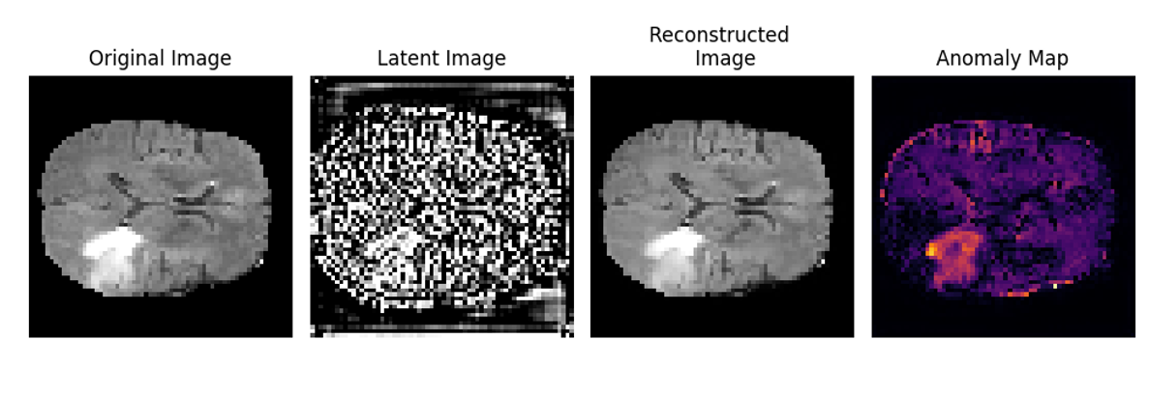
training_iterations = 5e3,lr=1e-5,total_timesteps = 1000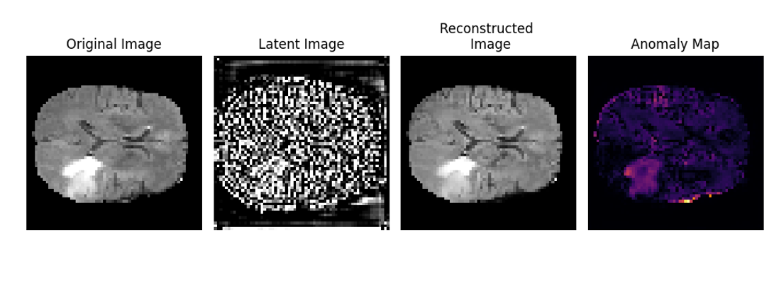

training_iterations = 2.5e3,lr=1e-5,total_timesteps = 250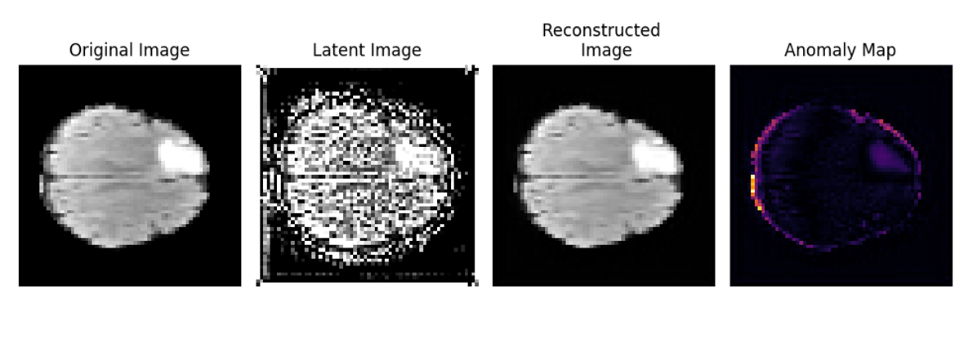

training_iterations = 2.5e3,lr=1e-5,total_timesteps = 500
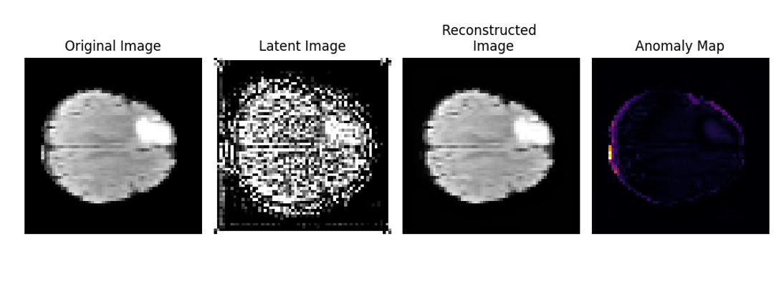

training_iterations = 2.5e3,lr=1e-5,total_timesteps = 1000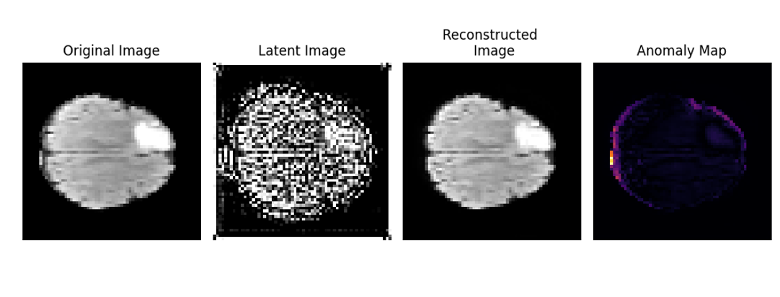
training_iterations = 1e4,lr=1e-5,total_timesteps = 250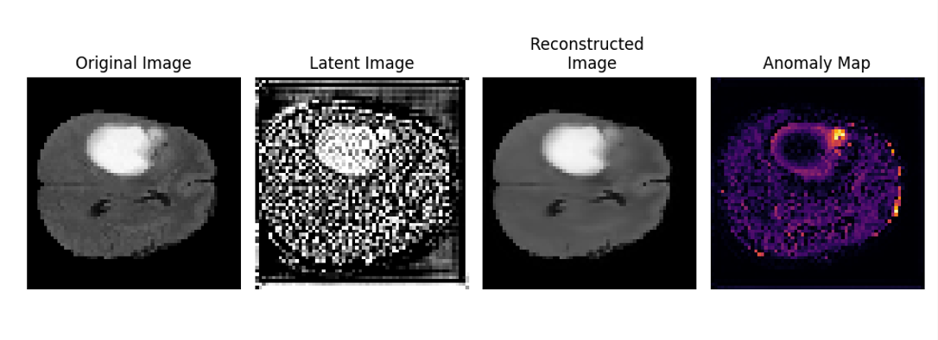

training_iterations = 1e4,lr=1e-5,total_timesteps = 500

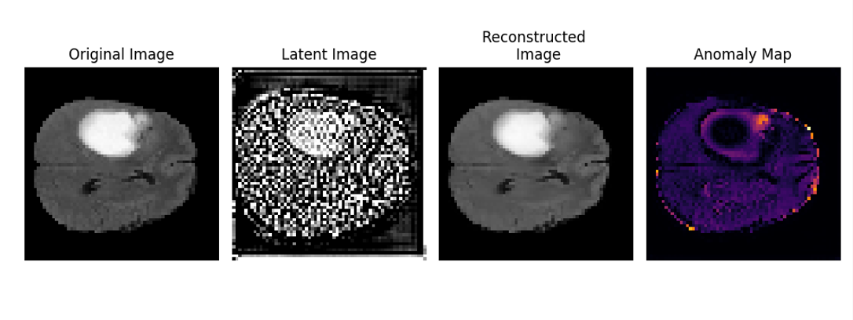

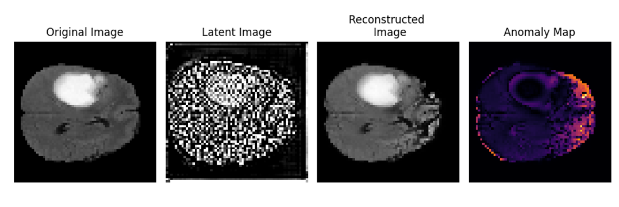
training_iterations = 1e4,lr=1e-5,total_timesteps = 1000
training_iterations = 5e3,lr=1e-4,total_timesteps = 250
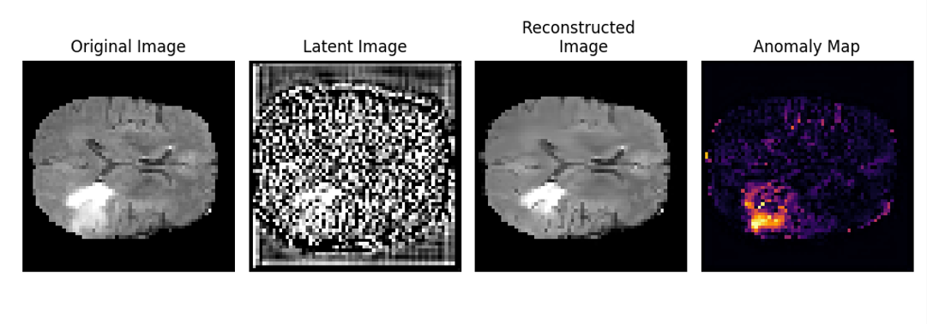

training_iterations = 5e3,lr=1e-4,total_timesteps = 500
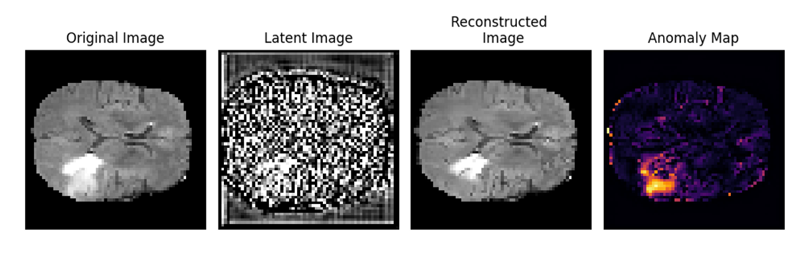

training_iterations = 5e3,lr=1e-4,total_timesteps = 1000
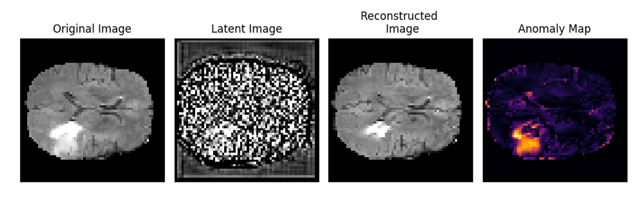

training_iterations = 5e3,lr=1e-3,total_timesteps = 250
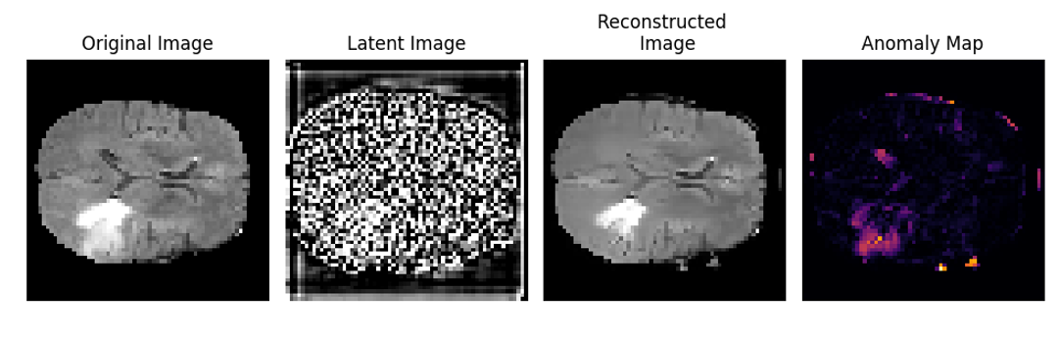

training_iterations = 5e3,lr=1e-3,total_timesteps = 500
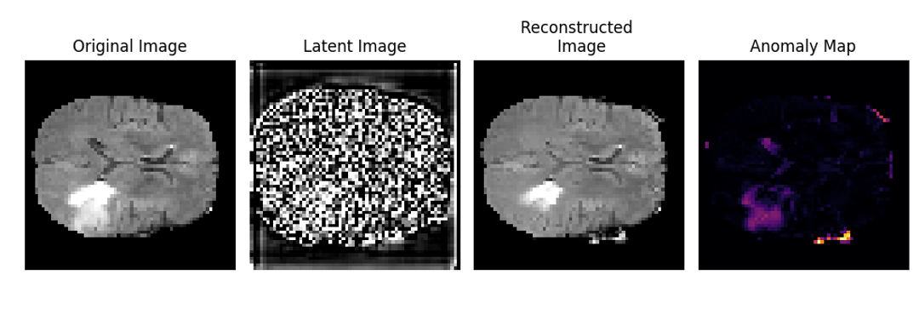

training_iterations = 5e3,lr=1e-3,total_timesteps = 1000
