LAB CYCLE 2

1.Create an html page to display the following nested list

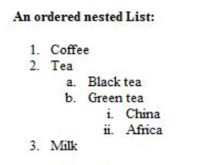

CODE

<!DOCTYPE html>

<html>

<head>

</head>

<body>

<b>An ordered nested List :</b>

<ol>

<li>Coffee</li>

<li>Tea</li>

<ol TYPE="a">

<li>Black tea</li>

<li>Green tea</li>

<ol TYPE="i">

<li>China</li>

<li>Africa</li>

</ol>

</ol>

<li>Milk</li>

</body>

</html>

OUTPUT

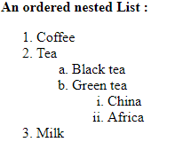

2. Create links to three different pages on three different websites that should all open in a new window

CODE

<!DOCTYPE html>

<html>

<head>

</head>

<body>

<br><br>

<a href="https://www.youtube.com/" target="_blank">Youtube</a>

<br><br>

<a href="http://www.weather.com/" target="_blank">Weather Report</a>

<br><br>

<a href="https://www.google.com/" target="_blank">Google</a>

</body>

</html>

Output

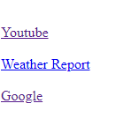

3. Create a page with a link at the top of it that when clicked will jump all the way to the bottom of the page.

Code

<!DOCTYPE html>

<html>

<head>

</head>

<body>

<a href="#bottom">Click here to jump to the bottom of the page.</a>

<br>

one<br>

two<br>

three<br>

four<br>

five<br>

six<br>

seven<br>

eight<br>

nine<br>

ten<br>

eleven<br>

twelve<br>

thirteen<br>

fourteen<br>

fifteen<br>

six<br>

fourteen<br>

two<br>

three<br>

five<br>

nine<br>

seven<br>

one<br>

two<br>

three<br>

four<br>

five<br>

six<br>

seven<br>

eight<br>

nine<br>

ten<br>

eleven<br>

twelve<br>

thirteen<br>

fourteen<br>

fifteen<br>

six<br>

fourteen<br>

two<br>

three<br>

five<br>

nine<br>

seven<br>

<a name="bottom">The bottom of the page.</a>

</body>

</html>

Output

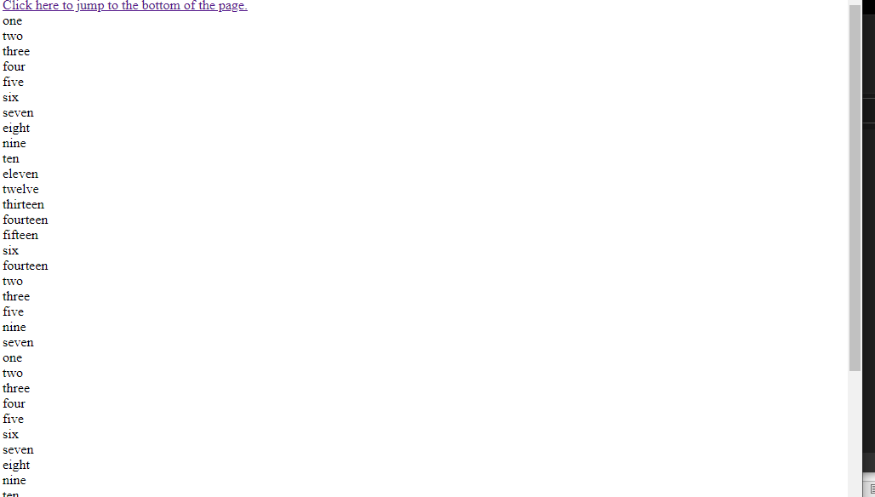

4. Display three different images. Skip two lines between each image. Each image should have a heading.

Code

<!DOCTYPE html>

<html>

<head>

</head>

<body>

<br><br>

<img src="auba.jpg" alt="auba" title="Aubameyang"/>

<br><br>

<img src="xhaka.jpg" alt="xhaka" title="Xhaka"/>

<br><br>

<img src="leno.jpg" alt="leno" title="Leno"/>

</body>

</html>

Output

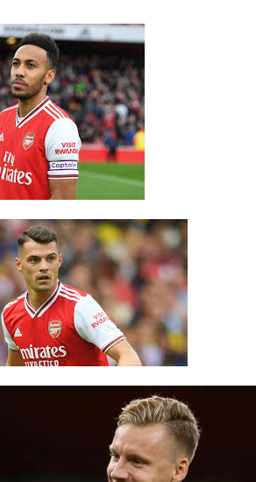

5. Display an image that when clicked will link to a search engine of your choice in a different window

Code

<!DOCTYPE html>

<html>

<head>

</head>

<body>

<br><br>

<center>

<a href="https://www.google.com/" target="_blank">

<img src="google.jpeg" alt="GOOGLE"/>

</a>

<p>Click on the image to be taken to the Google search engine.</p>

</center>

</body>

</html>

Output



6.Create the following Html Page using appropriate form controls

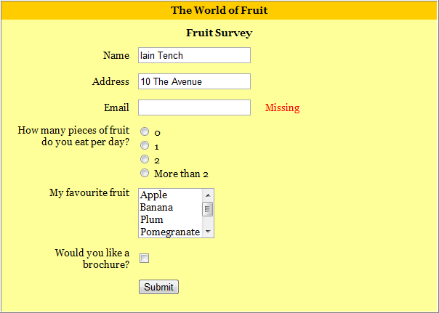

Code

<!DOCTYPE html>

<html>

<head>

<style>

.div_1{ background-color:orange; margin:10px; }

.div_2{ background-color:yellow; margin:10px; }

</style>

</head>

<body>

<center>

<div class="div_2">

<div class="div_1"><font size="4" face="Cooper"><h1>The World of Fruit</h1></font></div>

<form method="post">

<font size="4" face="Cooper"><h1 align="center" >Fruit Survey</h1></font>

<table align="center" cellpadding ="20" >

<tr>

<th>Name</th>

<td><input type="text" name="name" style="width:400px;" class="form-control" required=""></td>

</tr>

<tr>

<th>Address</th>

<td><input type="text" name="address" style="width:400px;" class="form-control" required=""></td>

</tr>

<tr>

<th>Email</th>

<td><input type="text" name="address" style="width:400px;" class="form-control" required=""></td>

<td><label style="color:red;"><b>Missing</b></label></td>

</tr>

<tr>

<th>How many pieces of fruit<br>do you eat per day?</th>

<td><input type="radio" name="0" value="0" >0<br><input type="radio" name="1" value="1">1<br><input type="radio" name="2" value="2" >2<br><input type="radio" name="More than 2" value="More than 2">More than 2</td>

</tr>

<tr>

<th>My favorite fruit</th>

<td><textarea rows="4" cols="12" name="favorite fruit">Apple Banana Plum Pomegranate Orange </textarea>

</td>

</tr>

<tr>

<th>Would you like a<br>brochure?</th>

<td><input type="checkbox" name="yes" value="on"></td>

</tr>

<tr>

<td align="center" colspan="2"><input type="submit" name="submit" value="submit"></td>

</tr>

</table>

</form>

</div>

</center>

</body>

</html>

Output

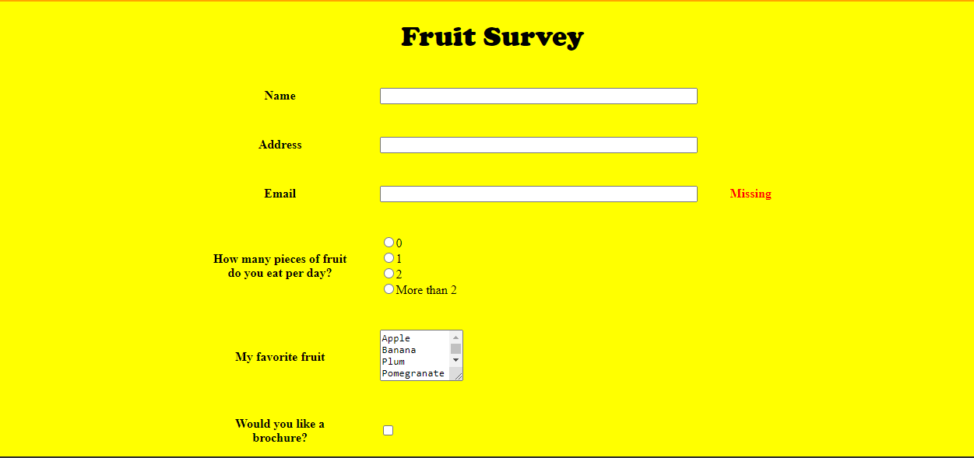

7.Create an image map for ‘Kerala Map’. Map at least 3 districts so that when you click on that particular district the details regarding that district(**eg: population, Area, Tourist Spots(with images), Monuments, Interesting Facts )** should be displayed on a new page.

Code

**<!DOCTYPE html>**

**<html>**

**<head>**

**</head>**

**<body>**

**<center>**

**<h1><u><font color="grey" face="Cooper">KERALA MAP</font></u></h1>**

**<map name="kerala">**

**<area shape="circle" coords="353,456,50" href="kottayam.html"/>**

**<area shape="circle" coords="270,159,50" href="wayanad.html"/>**

**<area shape="circle" coords="411,407,50" href="iduki.html"/>**

**</map>**

**<img src="kerala.jpeg" alt="kerala" usemap="#kerala"/>**

**</center>**

**</body>**

**</html>**

**Output**

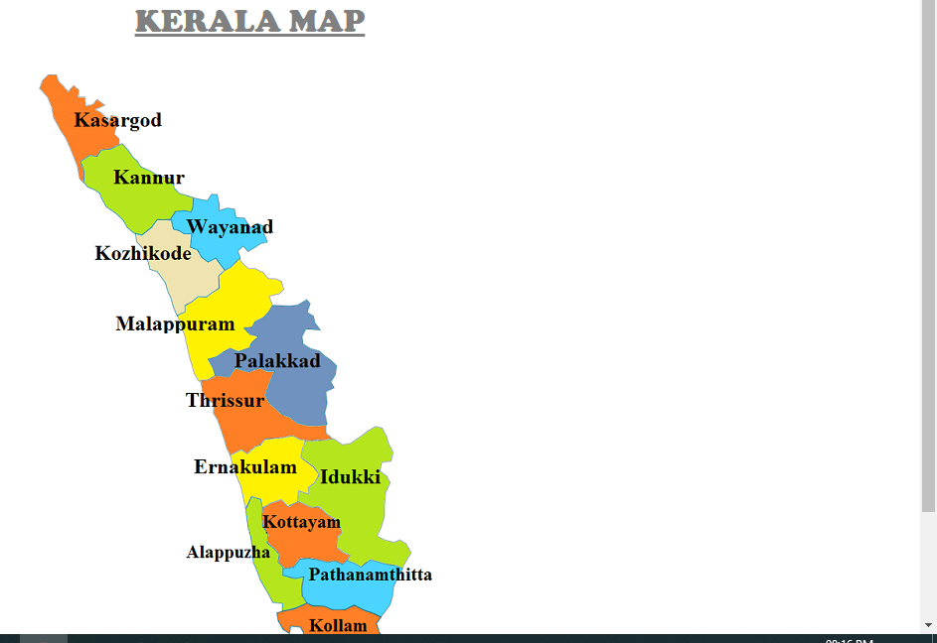

**8** Construct this puzzle looking thing

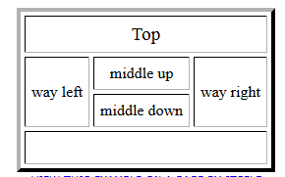

**Code**

**<!DOCTYPE html>**

**<html>**

**<head>**

**</head>**

**<body>**

**<br><br>**

**<table align="center" border="2" cellpadding="15" cellspacing="4">**

**<tr>**

**<th colspan="6"> Top </th>**

**</tr>**

**<tr>**

**<th rowspan="2"> way left </th>**

**<th colspan="2"> middle up </th>**

**<th rowspan="2"> way right </th>**

**</tr>**

**<tr>**

**<th colspan="2"> middle down </th>**

**</tr>**

**<tr>**

**<th colspan="6"> &nbsp; </th>**

**</tr>**

**</table>**

**</body>**

**</html>**

**Output**



9.Make up three image links for 3 web browsers and put them in a borderless table. Construct the table so that there is just a little space between the images.

Code

<!DOCTYPE html>

<html>

<head>

</head>

<body>

<br><br>

<table align="center" style= "border-collapse : collapse;">

<tr>

<td><a href="https://www.firefox.com/" target="_blank">

<img src="firefox.jpeg" alt="firefox" height="220" width="220"/>

</td>

</tr>

<tr>

<td><a href="https://www.google.com/chrome/" target="_blank">

<img src="chrome.jpeg" alt="chrome" height="220" width="220"/>

</td>

</tr>

<tr>

<td><a href="https://microsoft.com" target="_blank">

<img src="edge.jpeg" alt="chrome" height="200" width="220"/>

</td>

</tr>

</table>

</body>

</html>

Output



1. 10. **Create the following html page using frames**

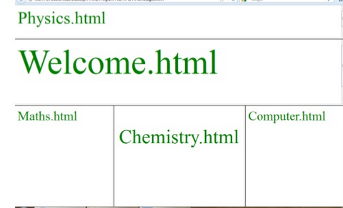

Code

<html>

<head></head>

<frameset rows="20%,30%,*" border="6">

<frame src="Physics.html" name="Physics.html" />

<frame src="Welcome.html" name="Welcome.html"/>

<frameset cols="25%,50%,*" frameborder="6">

<frame src="Maths.html" name="Maths.html"/>

<frame src="Chemistry.html" name="middle down"/>

<frame src="Computer.html"name="Computer.html"/>

</frameset>

</frameset>

</html>

<!DOCTYPE html>

<html>

<head>

<body>

<br>

<h1><font color="green" size="6">Physics.html</font></h1>

</body>

</head>

</html>

<!DOCTYPE html>

<html>

<head>

<body>

<br><br>

<h1><font color="green" size="7">Welcome.html</font></h1>

</body>

</head>

</html>

<!DOCTYPE html>

<html>

<head>

<body>

<h1><font color="green" size="6">Maths.html</font></h1>

</body>

</head>

</html>

<!DOCTYPE html>

<html>

<head>

<body>

<h1><font color="green" size="6">Computer.html</font></h1>

</body>

</head>

</html>

<!DOCTYPE html>

<html>

<head>

<body>

<br><br>

<h1 align="center"><font color="green" size="7">Chemistry.html</font></h1>

</body>

</head>

</html>

Output



12. **Create an HTML page using frames which is similar to the following one.**

**In the left frame provide hyperlinks to 3 important monuments in world. On clicking that hyperlink an image of the monument should be displayed in right frame with suitable description**

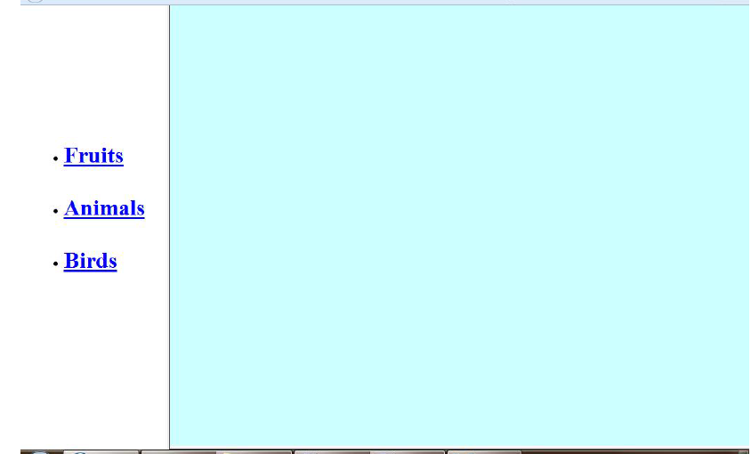

**Code**

**<!DOCTYPE html>**

**<html>**

**<head>**

**<title> navigation </title>**

**</head>**

**<frameset cols="25%,*">**

**<frame src="link.html"/>**

**<frame src="home.html"name="z"/>**

**</frameset>**

**<body>**

**</body>**

**</html>**

**<!DOCTYPE html>**

**<html>**

**<head>**

**<title> index </title>**

**<style>**

**.div_1{ background-color:yellow; margin:20px; }**

**.div_2{ background-color:grey; margin:20px; }**

**</style>**

**</head>**

**<body>**

**<center>**

**<br>**

**<div class="div_1"><h1><font color="green" size="6" face="Cooper">FAMOUS MONUMENTS</font></h1></div>**

**<div class="div_2"><font color="white" size="6" face="Cooper">**

**<ul>**

**<li>India Gate</li>**

**<li>Qutub Minar</li>**

**<li>Taj Mahal</li>**

**</ul>**

**</div>**

**</center>**

**</body>**

**</html>**

**<!DOCTYPE html>**

**<html>**

**<head>**

**<title> index </title>**

**</head>**

**<body>**

**<h1 align="center"><font face="Cooper" color="green" size="6">NAVIGATION</font></h1>**

**<a href="home.html" target="z">HOME</a>**

**<br><br>**

**<a href="IndiaGate.html" target="z">INDIA GATE</a>**

**<br><br>**

**<a href="QutubMinar.html" target="z">QUTUB MINAR</a>**

**<br><br>**

**<a href="TajMahal.html" target="z">TAJ MAHAL</a>**

**</body>**

**</html>**

**<!DOCTYPE html>**

**<html>**

**<head>**

**<style>**

**.div_1{ background-color:orange; margin:20px; }**

**.div_2{ background-color:yellow; margin:20px; }**

**</style>**

**</head>**

**<body>**

**<center>**

**<br>**

**<div class="div_1"><h1><font color="green" size="6" face="Cooper">INDIA GATE</font></h1></div>**

**<div class="div_2">**

**<img src="indiaGate.jpeg" alt="INDIA GATE" height="300" width="450"/>**

**<p>The India Gate (originally the All India War Memorial) is a war memorial located astride the Rajpath, on the eastern edge of the "ceremonial axis" of New Delhi,[1] formal called Kingsway .It stands as a memorial to 70,000 soldiers of the British Indian Army who died in between 1914 and 1921 in the First World War, in France, Flanders, Mesopotamia, Persia, East Africa, Gallipoli and elsewhere in the Near and the Far East, and the third Anglo-Afghan War. 13,300 servicemen's names, including some soldiers and officers from the United Kingdom, are inscribed on the gate.[2] Designed by Sir Edwin Lutyens, the gate evokes the architectural style of the triumphal arch such as the Arch of Constantine, in Rome, and is often compared to the Arc de Triomphe in Paris, and the Gateway of India in Mumbai.</p>**

**<p>Following the Bangladesh Liberation war in 1972, a structure consisting of a black marble plinth with a reversed rifle, capped by a war helmet and bounded by four eternal flames, was built beneath the archway. This structure, called Amar Jawan Jyoti (Flame of the Immortal Soldier), has since 1971 served as India's tomb of the unknown soldier. India Gate is counted amongst the largest war memorials in India and every Republic Day, the Prime Minister visits the gate to pay their tributes to the Amar Jawan Jyoti, following which the Republic Day parade starts. The memorial-gate is also a popular spot for protests by the civil society in New Delhi.</p>**

**</div>**

**</body>**

**</html>**

**<!DOCTYPE html>**

**<html>**

**<head>**

**<style>**

**.div_1{ background-color:orange; margin:20px; }**

**.div_2{ background-color:yellow; margin:20px; }**

**</style>**

**</head>**

**<body>**

**<center>**

**<br>**

**<div class="div_1"><h1><font color="green" size="6" face="Cooper">QUTUB MINAR</font></h1></div>**

**<div class="div_2">**

**<img src="qutub.jpeg" alt="QUTUB MINAR" height="300" width="450"/>**

**<p>The Qutb Minar, also spelled as Qutub Minar and Qutab Minar, is a minaret and "victory tower" that forms part of the Qutb complex, a UNESCO World Heritage Site in the Mehrauli area of New Delhi, India. The height of Qutb Minar is 72.5 meters, making it the tallest minaret in the world built of bricks. The tower tapers, and has a 14.3 metres (47 feet) base diameter, reducing to 2.7 metres (9 feet) at the top of the peak. It contains a spiral staircase of 379 steps.</p>**

**<p>Its closest comparator is the 62-metre all-brick Minaret of Jam in Afghanistan, of c.1190, a decade or so before the probable start of the Delhi tower. The surfaces of both are elaborately decorated with inscriptions and geometric patterns; in Delhi the shaft is fluted with "superb stalactite bracketing under the balconies" at the top of each stage. In general minarets were slow to be used in India, and are often detached from the main mosque where they exist.</p>**

**</div>**

**</body>**

**</html>**

**<!DOCTYPE html>**

**<html>**

**<head>**

**<style>**

**.div_1{ background-color:orange; margin:20px; }**

**.div_2{ background-color:yellow; margin:20px; }**

**</style>**

**</head>**

**<body>**

**<center>**

**<br>**

**<div class="div_1"><h1><font color="green" size="6" face="Cooper">TAJ MAHAL</font></h1></div>**

**<div class="div_2">**

**<img src="Tajmahal.jpeg" alt="TAJMAHAL" height="300" width="450"/>**

**<p>The Taj Mahal is an ivory-white marble mausoleum on the southern bank of the river Yamuna in the Indian city of Agra. It was commissioned in 1632 by the Mughal emperor Shah Jahan (reigned from 1628 to 1658) to house the tomb of his favourite wife, Mumtaz Mahal; it also houses the tomb of Shah Jahan himself. The tomb is the centrepiece of a 17-hectare (42-acre) complex, which includes a mosque and a guest house, and is set in formal gardens bounded on three sides by a crenellated wall.</p>**

**<p>Construction of the mausoleum was essentially completed in 1643, but work continued on other phases of the project for another 10 years. The Taj Mahal complex is believed to have been completed in its entirety in 1653 at a cost estimated at the time to be around 32 million rupees, which in 2020 would be approximately 70 billion rupees (about U.S. $916 million). The construction project employed some 20,000 artisans under the guidance of a board of architects led by the court architect to the emperor, Ustad Ahmad Lahauri.</p>**

**<p>The Taj Mahal was designated as a UNESCO World Heritage Site in 1983 for being "the jewel of Muslim art in India and one of the universally admired masterpieces of the world's heritage". It is regarded by many as the best example of Mughal architecture and a symbol of India's rich history. The Taj Mahal attracts 7–8 million visitors a year and in 2007, it was declared a winner of the New 7 Wonders of the World (2000–2007) initiative.</p>**

**</div>**

**</body>**

**</html>**

**Output**

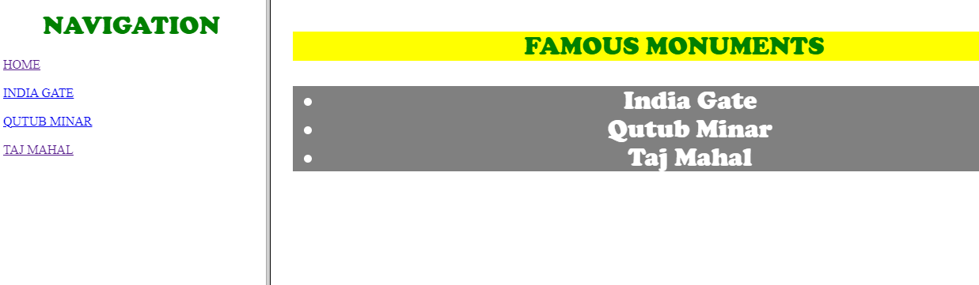

**SUBMITTED BY JOHNS JOSE**