Part 5 – Signal_Project
  - Lara Johns

Screenshot of successful unit tests:
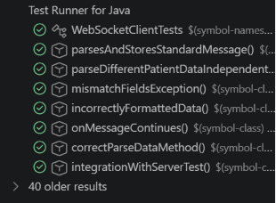
Screenshot proving correct connection to test server:
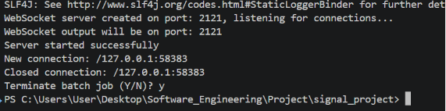
Added integration testing from Part 3 and 5:
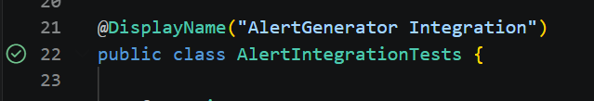
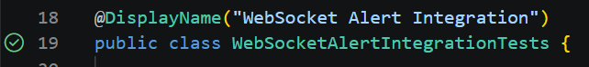

I conducted a final code coverage report to compare to one created in Part 3. As seen below the percentage of code covered has increased overall. The cardio data generators are still not covered as they are tested indirectly through tests on DataStorage, AlertGenerator, and so on. With more time I would have created a few unit tests for the AlertDecorators.
