Part 5 – Signal_Project
  - Lara Johns

Screenshot of successful unit tests:
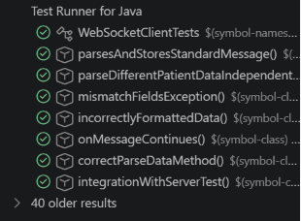
Screenshot proving correct connection to test server:
