Part 3 – Signal_Project
  - Lara Johns

Screenshot of code coverage report:
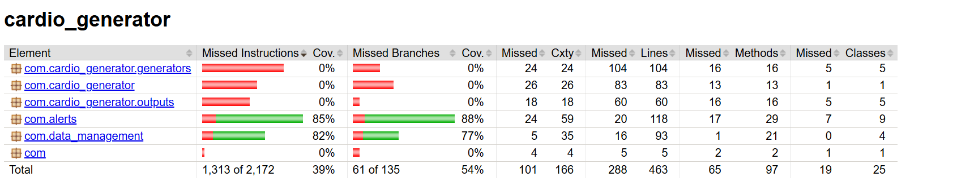
The tests cover the functionalities added for this part of the report, but not the cardio data generators. The reason for this is that they produce the data read used by the DataReader, DataStorage, and AlertGenerator. Thus, any issues with their code would be flagged by the unit tests created as the added functionalities would not work as expected.
Screenshots showing all unit tests passed successfully:
