SiWiR 2 – Exercise 01
Team Members:
Vignesh Suryaprakash – 21960986
Ion Mosnoi- 22069917
Rahul Reddy Jayaram Reddy – 21942884

Grid Size | L2 Error Norm
1/8 | 0.196641
1/16 | 0.0994112
1/32 | 0.498367
1/64 | 0.0249345
1/128 | 0.0124692
1/256 | 0.00623487
Table Showing Grid size and corresponding Error norm in L2

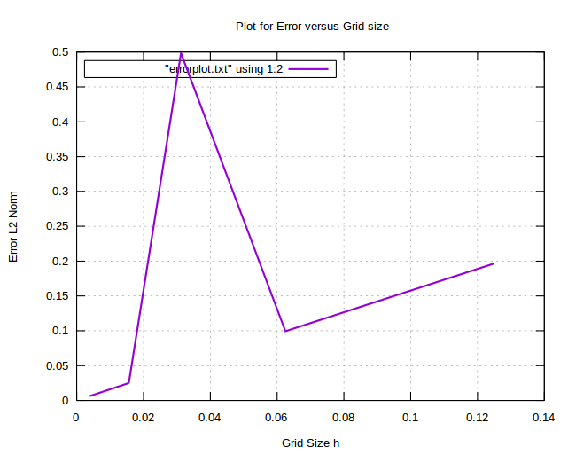
Plot showing Grid size versus Error Norm in L2

The above measurements have been taken after performing sufficient V-cycles i.e after a satisfactory convergence has been observed. We noticed that after a fixed number of iterations, the error norms does not show any significant change for any further increase in the number of V-cycles.

Comments from the above observations:

We see from the graph that for the grid size 1/256 the error norm is the lowest whereas it is the higest for the grid size 1/8. The error norm is seen to reduce from grid size 1/8 to 1/16 but it increases at the grid size 1/32. However it again starts to decrease and continues to decrease upto the grid size 1/256.

