Capstone Project

## CIS 1500 – Java Programming I – Fall 2019 Oakland Community College – OR

Ms. Jane Tucker

Due: **Tues, December 10,** 2019 at 11:59 p.m.

# Objectives

* To provide a culmination of the skills learned in CIS 1500
* To use File I/O
* To create a simple user interface using JavaFX
* To fulfill the **common course assignment** for all CIS 1500 students cross-college

# Instructions

Create a Java GUI class named IceCreamOrder that helps you to determine the cost of one ice cream order. The application should have the following appearance:

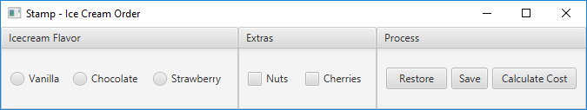

The user can select flavor and any number of extras. When they press the Calculate Cost button, then a dialog box with the following style of content it presented to the user:

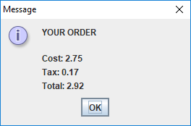

All ice cream flavors are $2.25. Each extra is $0.50. So, the in the example above, the cone is $2.25, nuts are $0.50 and cherries are $0.50, for a total of $3.25. The Michigan 6% tax is added on for a total of $3.45.

One specific order can be **saved** at any time. When an order is saved, the information stored on the disk is the flavor and the extras. The file should be named **icecream.txt**, and the file will ***always have exactly three lines of text***, of the general format:

Flavor

Nuts Status Cherries Status

* The first line is either "Vanilla", "Chocolate" or "Strawberry".
* The second line is always "With_Nuts" or "Without_Nuts".
* The third line is always "With_Cherries" or "Without_Cherries".

So, for example, a saved order might with chocolate ice cream, no nuts, with cherries would look like this in the file:

Chocolate Without_Nuts With_Cherries

At any point in time the user can press the **Restore** button, and the last saved order will be displayed on the user interface. If there is no file available (nothing has been saved yet) and the user presses Restore, then have a dialog box report "Error opening data file".

# Deliverables

You will upload your .java source file(s) to Dropbox in D2L.