HBOI-FAU Specialty License Plate Fund
FY2012 Annual Request for Proposals

Molecular responses of coral larvae to ultraviolet radiation, elevated temperature, and decreased salinity

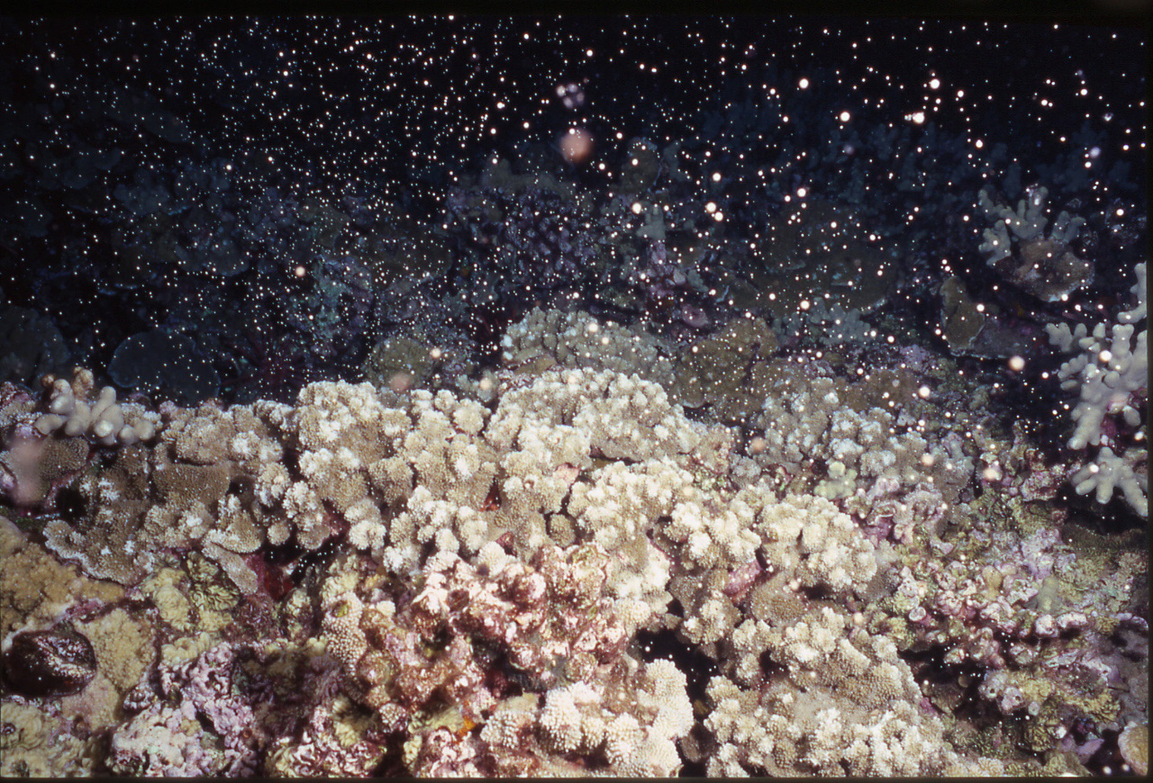
U.S. Geological Survey/photo by John Gorman, Maui Ocean Center

Principal Investigator: Dr. Sara Edge
July 2011 to June 2012
Amount of request
SLP source of funds: Save Our Seas
Project summary
Global and local disturbances, such as climate change and pollution from runoff, are threatening long-term survival of coral reef ecosystems. Coral larvae are an important source of recruitment for reefs, yet are sensitive to environmental changes. This project will characterize responses of coral larvae at the molecular level to sublethal stressors influenced by climate change, such as salinity, UV radiation (UVR), and sea surface temperature. These data will enable future diagnoses of stressed populations to aid in the implementation of adaptive management strategies for the mitigation of local disturbances. Molecular gene expression profiles of 75 exposed coral larvae samples will be obtained using microarray and transcriptome sequencing technology and validated using quantitative real-time PCR and protein expression experiments.
No previous SLP funds have been received by the PI of this proposal.
Rationale
Coral reefs are economically and ecologically important resources in Florida, providing valuable ecosystem services in terms of productivity, diversity, tourism, fishing, and coastal protection.¹ Climate change and anthropogenic stressors have contributed to a decline in coral reefs worldwide, with 80% loss of coral cover in Florida and the Caribbean since the 1970s.² Dramatic land-use changes in Florida have occurred over the past 100 years, resulting in increased run-off of pollution, nutrients, and freshwater, exposing coral to further anthropogenic stressors.³ By 2100, sea surface temperatures in Florida are expected to increase by 2-5ºC, and an increase in the frequency and intensity of storm events is predicted, exposing coral to higher temperatures and lower salinity.⁴
Traditionally, environmental monitoring and physiological measurements have been used to quantify the responses of adult coral colonies to stress. However, physiological mechanisms such as bleaching, respiration, and osmoregulation are poorly understood in coral larvae. Larvae are important to healthy coral reefs, acting as sources of recruitment for reef populations. Planula larvae spend hours to days at the surface following release⁵, potentially exposing them to elevated temperatures, lower salinity and excessive UV radiation (UVR). Decreased salinity has been demonstrated to increase pre- and post-settlement mortality and alter larval behavior and substrate choice.⁵ Increases in UVR have been shown to affect larval swimming behavior and survivorship.⁶ Larvae are also vulnerable to prolonged exposure to temperature changes.⁷ Although some molecular studies have been done on coral larvae, the majority are on Pacific corals, with relatively few on native Floridian or Caribbean corals.⁸ There is a need to understand coral larvae responses to different stressors at the molecular level. This project will produce valuable information regarding the molecular mechanisms behind stress responses in several coral larvae species.
Research and Associated impacts
Our research focuses on developing and implementing advanced quantitative molecular technologies to (1) determine the mechanisms of coral responses to stressors, (2) function as diagnostic tools for profiling disease states and sub-lethal stress responses of corals, and (3) provide data for improved adaptive resource management strategies. Past studies have resulted in the development and verification of a Cnidarian-specific stress gene microarray.⁹ This microarray contains gene sequences encoding proteins that participate in metabolic pathways activated during stress conditions and enables the quantification of the relative expression of coral transcripts.
The sensitivity of the microarray as a diagnostic tool is strengthened by increased data sets and verification experiments. It is important to develop a gene expression profile library with multiple developmental stages and stress conditions so that the spectrum of responses can be better understood and mapped out. Past data sets collected have included responses of adult corals to temperature, ultraviolet radiation (UVR), salinity, algal competition, exposure to copper and other heavy metals.⁹ In addition, data have been collected from anemones following exposure to oil, dispersant and sunscreen. For this research we propose to analyze coral larvae exposed to UVR, increased temperature, and decreased salinity from different coral species including Acropora palmata, Montastraea faveolata, Porites astreoides, and Diploria strigosa.
Leverage for other competitive funding and funding outlook
The funding outlook for this type of research is strong. Many institutions have programs specifically focusing on the impacts of biotic and abiotic stressors on marine organisms, i.e. Mote Marine Laboratory, the National Science Foundation (NSF), National Oceanic and Atmospheric Administration (NOAA), Environmental Protection Agency (EPA), and Sea Grant. Additionally, many RFPs focus on investigating molecular and cellular responses since these are precursors to phenotypic, behavioral and adaptive responses. Dr. Edge will be applying for a grant through NSF in September, 2011 which focuses on "projects aimed at understanding and predicting the molecular and cellular underpinnings of phenotypic variation and adaptation to environmental change" (NSF 11-545; Division of Molecular and Cellular Biosciences: Investigator-initiated research projects). Data collected from this project will greatly improve our chances of receiving future funding by showing proof of concept and initial success with coral larvae genomic analyses.
Sustainability and enhancement of current research program
We propose to complete the analysis of samples collected after an already-completed experiment exposing coral larvae from four different species, A. palmata, M. faveolata, P. astreoides, and D. strigosa, to UVR, increased temperature, and decreased salinity. This experiment was designed and executed at the University of Miami-Rosential School of Marine and Atmospheric Science (RSMAS). By studying responses of coral larvae to stressors at the molecular level, this experiment broadens the current scope of our research at HBOI to include an additional, important life stage of coral.
Protocols for new methods developed during this study will be available for future use in our lab and in collaborations on future projects. A quantitative real-time PCR (qPCR) assay and a protein assay will be developed and used to validate gene expression measured with the microarray. Pooled Porities astreoides larvae samples from treatment groups will be sent for transcriptome sequencing. This species was chosen because it commonly grows in the Caribbean, has been used extensively in other studies,¹⁰ is under-represented in the NCBI nucleotide sequence database, and has been considered as a potential “model” coral species for coral genome sequencing by a panel of coral reef scientists (Edge, personal communication). New suites of genetic biomarkers will be selected from the P. astreoides transcriptome to further study and characterize changes in coral immunity, resiliency, and life history. We anticipate presenting the results from this experiment in peer-reviewed publications and international scientific conferences.
Collaborative opportunities
Collaborations on this project include the University of Miami-RSMAS. Future collaborative opportunities potentially include researchers who currently work with coral larvae, e.g. Raphael Williams and Valerie Paul (Smithsonian Institution), and also use molecular techniques as diagnostic tools, e.g. Margaret Miller (NOAA).
Objectives
The overall goal of this project is to characterize the sub-cellular effects of decreases salinity, UVR exposure, and increased temperature on planula larvae. This will be done by: (1) characterizing gene expression profiles for coral larvae samples using microarray technology; (2) the development and optimization of qPCR and protein expression assays for gene expression validation; and (3) transcriptome sequencing of P. astreoides larvae.
Methods
Treatment groups include P. astreoides exposed to salinity concentrations of 25, 30, 35 ppt, A. palmata, M. faveolata, and P. astreoides exposed to UVR (PAR and UVR) or (PAR only, >380 nm) combined with ambient temperature (25º-26ºC) or warm temperature (30º-31ºC). Batches of larvae (250+) were placed in plastic cups of seawater (35 ppt) and kept in a water bath maintained at the exposure temperatures (see above). Cups were shielded with a UV-transparent or absorbing acrylic filter and exposed to natural light for eight hours. For the salinity experiment, P. astreoides larvae were transferred to containers of treatment water (25, 30, 35 ppt) at ambient temperature for 24 hours. All samples were placed in an organic preservative and stored at -80ºC until further laboratory analyses.
Samples of P. astreoides larvae in salinity and UVR/temperature exposures will be pooled and sent for transcriptome sequencing to the University of Florida’s Interdisciplinary Center for Biotechnology Research (ICBR) using a Genome Analyzer, GAIIx platform (Illumina).For microarray gene expression profiling, total RNA will be extracted from coral samples and labeled with a fluorescent Cy3 dye (Agilent). RNA has already been extracted from 59 out of the 75 samples and six of these samples have been verified as intact and pure RNA (Figure 1). The quality of the remaining RNA samples needs to be verified and the rest of the larvae samples will be extracted. Labeled cRNA will be quantified and hybridized to the coral microarray consisting of 1,695 gene sequences representing over 100 biomolecular pathways in 50 stony coral and Symbiodinium species. Replicate probes for each gene will be averaged and significant differences in gene expression signal intensities will be quantified using JMP® Genomics statistical software (SAS Institute, Inc.).
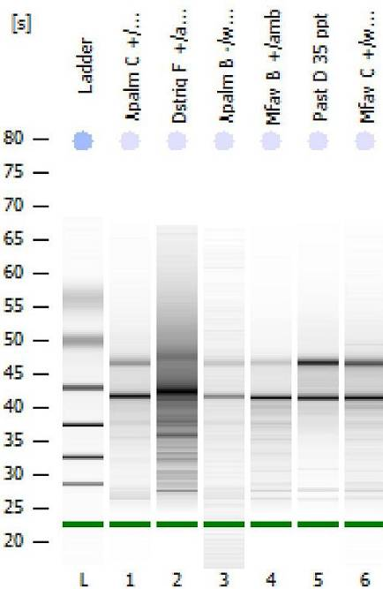
Expression of transcripts observed on the microarray will be verified at the nucleic acid level with quantitative real-time PCR (qPCR) using primers designed for a subset of differentially expressed genes. Amplicons will be quantified in real time during PCRto measurem relative levels of transcription (iCycler, Bio-Rad). Protein assays will be used to verify the down-stream products of gene expression. Western blotting will verify the presence and relative amounts of specific proteins.¹¹ Extracted proteins from the coral larvae samples will be separated with polyacrylamide gel electrophoresis and transferred onto a membrane. Binding of antibodies with specific amino acid sequences will reveal dark banding patterns, indicating the presence of a specific protein in the sample under investigation. Antibody binding will be confirmed with chemiluminscent detection. Development of these protein methods could enable future investigations in our lab assigning functions to unknown proteins identified with transcriptome sequencing.
Figure 1. RNA from coral larvae showing quality and quantity (Agilent Bioanalyzer 6000)
Deliverables and broader impact
The proposed deliverables for this project includes: (1) molecular biomarkers of coral larvae responses to environmental stressors , (2) transcriptome sequence of a new coral species and life-history stage to be submitted to the NCBI nucleotide database, (3) development of new molecular protocols for molecular diagnostics of coral health, (4) dissemination of data and technology to reef managers and other researchers to mitigate damage/loss of coral reefs, (5) at least two publications submitted in peer-reviewed journals.
Timeline
Calendar Year | 2011 |  | 2012
Annual calendar quarters | 3 | 4 | 1 | 2
Microarray printing and protein lab setup | X
Microarray lab work | X | X
Microarray Data Analysis and Statistical Analyses |  | X | X
Prep samples and send for RNA sequencing |  | X
De novo contig assembly and annotation of transcriptome |  |  | X | X
qPCR optimization and Analysis |  | X | X | X
Protein and Enzyme Assays and Optimization |  | X | X | X
Report and manuscript submissions |  |  |  | X
Budget Justification ($ Total)
Senior Personnel – Dr. Sara Edge (1.5 months, $7,725) will be responsible for project management and coordination, technician supervision and molecular data analysis and interpretation.
Other Personnel – Support for a technician (SP) is requested for molecular analyses (2.5 months, $7,154).
Fringe Benefits - The fringe benefit rate is 29.8% of the PI salary ($2,302) and 42.2% of the SP salary ($3,019).
Travel - Travel to present results at international and national meetings ($900).
Supplies – Expendable laboratory and sample processing supplies ($1,400); Microarray gene expression profiling supplies and reagents ($10,500); Transcriptome sequencing ($8,000); Protein lab set-up ($2,100); qPCR and protein validation supplies ($6,000); Enzymatic analysis supplies ($900).
References
- Birkeland, C. 1997. Life and Death of Coral Reefs. Birkeland (Ed.) Chapman & Hall.
- Gardner et al. 2003. Science. 301: 958-960.
- Kautz et al. 2007. Agriculture and Natural Resource Sciences. 1: 12-23.
- Christensen et al. 2007. IPCC 4th Assessment Report. Cambridge University Press.
- Vermeij et al. 2006. Mar. Ecol. Prog. Ser. 310: 119-128.
- Wellington and Fitt. 2003. Mar. Biol. 143: 1185-1192.
- Edmunds et al. 2005. Invertebr. Biol. 124(3): 185-193.
- Polato et al. 2010. PLoS One. 5(6): e11221.
- Edge, S.E. 2007. Doctor of Philosophy in Biology, Georgia Institute of Technology.
- Shearer and Coffroth. 2004. Mol. Ecol. Notes. 4: 435-437.
- Chen et al. 2005. Biochem. Biophys. Res. Comm. 338: 1607-1616.

