3GPP TR 22.821 V16.1.0 (2018-06)

Technical Report

3rd Generation Partnership Project;

Technical Specification Group Services and System Aspects;

Feasibility Study on LAN Support in 5G

(Release 16)

** 

The present document has been developed within the 3rd Generation Partnership Project (3GPP TM) and may be further elaborated for the purposes of 3GPP.  
The present document has not been subject to any approval process by the 3GPPOrganizational Partners and shall not be implemented.  
This Report is provided for future development work within 3GPPonly. The Organizational Partners accept no liability for any use of this Specification.  
Specifications and Reports for implementation of the 3GPP TM system should be obtained via the 3GPP Organizational Partners' Publications Offices.

Keywords

LAN, 5G

***3GPP***

Postal address

3GPP support office address

650 Route des Lucioles - Sophia Antipolis

Valbonne - FRANCE

Tel.: +33 4 92 94 42 00 Fax: +33 4 93 65 47 16

Internet

http://www.3gpp.org

***Copyright Notification***

No part may be reproduced except as authorized by written permission.  
The copyright and the foregoing restriction extend to reproduction in all media.

© 2018, 3GPP Organizational Partners (ARIB, ATIS, CCSA, ETSI, TSDSI, TTA, TTC).

All rights reserved.

UMTS™ is a Trade Mark of ETSI registered for the benefit of its members

3GPP™ is a Trade Mark of ETSI registered for the benefit of its Members and of the 3GPP Organizational Partners  
LTE™ is a Trade Mark of ETSI registered for the benefit of its Members and of the 3GPP Organizational Partners

GSM® and the GSM logo are registered and owned by the GSM Association

Contents

Foreword 7

1 Scope 8

2 References 8

3 Definitions, symbols and abbreviations 9

3.1 Definitions 9

3.2 Abbreviations 9

4 Overview 10

4.1 General Concepts 10

The present document describes new use cases and potential requirements to support 5G LAN-type services with a 5G system. In this context, 5G LAN-type services with 5G capabilities (e.g. performance, long distance access, mobility, security) allow a restricted set of UEs to communicate amongst each other. This document also describes 5G LAN-type service support for an ethernet transport service.4.2 Possible Deployment Scenarios 10

4.2.1 Residential environment 10

4.2.2 Enterprise environment 10

4.2.3 Industrial Automation environment 10

5 Use Cases 11

5.1 Use case for enterprise 5G PVN 11

5.1.1 Description 11

5.1.2 Scenario 11

5.1.3 Potential service requirements 11

5.1.4 Potential operational requirements 12

5.2 Use case for bring your own device 12

5.2.1 Description 12

5.2.2 Scenario 12

5.2.3 Potential service requirements 12

5.2.4 Potential operational requirements 13

5.3 Use case on private communication with UEs of different MNOs 13

5.3.1 Overall Description 13

5.3.2 Preconditions 13

5.3.3 Service flows 13

5.3.4 Post-conditions 13

5.3.5 Potential Impacts or Interactions with Existing Services/Features 13

5.3.6 Potential Requirements 13

5.4 Private data communication service in a residential setting 13

5.4.1 Description 13

5.4.2 Pre-conditions 14

5.4.3 Service Flows 14

5.4.4 Post-conditions 14

5.4.5 Potential Impacts or Interactions with Existing Services/Features 14

5.4.6 Potential Requirements 14

5.5 Private data communication service in an office setting 15

5.5.1 Description 15

5.5.2 Pre-conditions 15

5.5.3 Service Flows 15

5.5.4 Post-conditions 15

5.5.5 Potential Impacts or Interactions with Existing Services/Features 15

5.5.6 Potential Requirements 15

5.6 Private data communication service in a large scale industrial setting 16

5.6.1 Description 16

5.6.2 Pre-conditions 16

5.6.3 Service Flows 16

5.6.4 Post-conditions 16

5.6.5 Potential Impacts or Interactions with Existing Services/Features 16

5.6.6 Potential Requirements 16

5.7 Private P2P data communication using on-demand connections 16

5.7.1 Description 16

5.7.2 Pre-conditions 17

5.7.3 Service Flows 17

5.7.4 Post-conditions 18

5.7.5 Potential Impacts or Interactions with Existing Services/Features 18

5.7.6 Potential Requirements 18

5.8 Residential 5G PVN 18

5.8.1 Description 18

5.8.2 Pre-conditions 18

5.8.3 Service Flows 19

5.8.4 Post-conditions 19

5.8.5 Potential requirements 20

5.9 Use case on Addition of UE in a 3GPP private group communications 20

5.9.1 Description 20

5.9.2 Preconditions 20

5.9.3 Service flows 20

5.9.4 Post-conditions 21

5.9.5 Potential Impacts or Interactions with Existing Services/Features 21

5.9.6 Potential Requirements 21

5.10 Use case for Removal of UE from a private group communication 21

5.10.1 Description 21

5.10.2 Preconditions 21

5.10.3 Service flows 21

5.10.4 Post-conditions 21

5.10.5 Potential Impacts or Interactions with Existing Services/Features 21

5.10.6 Potential Requirements 22

5.11 Use case for UE part of multiple private communications 22

5.11.1 Description 22

5.11.2 Preconditions 22

5.11.3 Service flows 22

5.11.4 Post-conditions 22

5.11.5 Potential Impacts or Interactions with Existing Services/Features 23

5.11.6 Potential Requirements 23

5.12 Use Case for enabling Ethernet-based private communication in 3GPP 23

5.12.1 Description 23

5.12.2 Preconditions 23

5.12.3 Service flows 23

5.12.4 Post-conditions 23

5.12.5 Potential Impacts or Interactions with Existing Services/Features 23

5.12.6 Potential Requirements 23

5.13 Use Case for Service Continuity in private group communication 24

5.13.1 Description 24

5.13.2 Preconditions 24

5.13.3 Service flows 24

5.13.4 Post-conditions 24

5.13.5 Potential Impacts or Interactions with Existing Services/Features 24

5.13.6 Potential Requirements 24

5.14 Private data communication service using semi-permanent connections 24

5.14.1 Description 24

5.14.2 Pre-conditions 25

5.14.3 Service Flows 25

5.14.4 Post-conditions 25

5.14.5 Potential Impacts or Interactions with Existing Services/Features 25

5.14.6 Potential Requirements 26

5.15 Use case for multiple private communications in the same network 26

5.15.1 Description 26

5.15.2 Preconditions 27

5.15.3 Service flows 27

5.15.4 Post-conditions 27

5.15.5 Potential Impacts or Interactions with Existing Services/Features 27

5.15.6 Potential Requirements 27

5.16 Use case on service management 27

5.16.1 Overall Description 27

5.16.2 Description 27

5.16.2 Preconditions 28

5.16.3 Service flows 28

5.16.4 Post-conditions 28

5.16.5 Potential Impacts or Interactions with Existing Services/Features 28

5.16.6 Potential Requirements 28

5.17.5.1 Routing based on Ethernet headers 29

5.17.5.2 Broadcast 29

5.17.5.3 Spanning Tree 30

5.17.5.4 Virtual LAN 30

5.17.5.5 QoS 30

5.18 Use case on Industry Communication with stable latency needs 31

5.18.1 Description 31

5.18.2 Preconditions 31

5.18.3 Service flows 31

5.18.4 Post-conditions 32

5.18.5 Potential Impacts or Interactions with Existing Services/Features 32

5.18.6 Potential Requirements 32

5.19 Use case for accessing 5GLAN via Relay UE 32

5.19.1 Description 32

5.19.2 Preconditions 32

5.19.3 Service flows 32

5.19.4 Post-conditions 32

5.19.5 Potential Impacts or Interactions with Existing Services/Features 32

5.19.6 Potential Requirements 32

5.20 Use case for 5G PVN with private addressing 33

5.20.1 Description 33

5.20.2 Scenario 33

5.20.3 Potential service requirements 33

5.21 High Performance Manufacturing 33

5.22 Device Management and Onboarding 37

5.22.1 Description 37

5.22.2 Preconditions 37

5.22.3 Service flows 37

5.22.4 Post-conditions 37

5.22.5 Potential Impacts or Interactions with Existing Services/Features 37

5.22.6 Potential Requirements 37

5.23 User identification and reachability 37

5.23.1 Description 37

5.23.2 Pre-conditions 37

5.23.3 Service Flows 38

5.23.4 Post-conditions 38

5.23.5 Potential impacts or interactions 38

5.23.6 Potential requirements 38

5.24 Use case for 5G PVN virtual office 38

5.24.1 Description 38

5.24.2 Scenario 39

5.24.3 Potential service requirements 39

5.24.4 Potential operational requirements 39

5.25 Use case on service exposure of 5G LAN-style service 39

5.25.1 Description 39

5.25.2 Preconditions 39

5.25.3 Service flows 40

5.25.4 Post-conditions 40

5.25.5 Potential Impacts or Interactions with Existing Services/Features 40

5.25.6 Potential Requirements 40

5.26 Use case for minimizing massive paging in 5GLAN for address discovery 40

5.26.1 Description 40

5.26.2 Preconditions 40

5.26.3 Service flows 40

5.26.4 Post-conditions 40

5.26.5 Potential Impacts or Interactions with Existing Services/Features 41

5.26.6 Potential Requirements 41

5.27 Use case on discovery mechanism 41

5.27.1 Description 41

5.27.2 Pre-conditions 41

5.27.3 Service Flows 41

5.27.4 Post-conditions 41

5.27.6 Potential Requirements 41

5.28 Use case of scaling up/down the 5G PVN 41

5.28.1 Description 41

5.28.2 Preconditions 42

5.28.3 Service flows 42

5.28.4 Post-conditions 42

5.28.5 Potential Impacts or Interactions with Existing Services/Features 42

5.28.6 Potential Requirements 43

5.29 Use case for restricting UE to a 3GPP private communication group based on UE's location 43

5.29.1 Description 43

5.29.2 Preconditions 43

5.29.3 Service flows 43

5.29.4 Post-conditions 43

5.29.5 Potential Impacts or Interactions with Existing Services/Features 43

5.29.6 Potential Requirements 43

5.30 Use case on creating and joining private multicast communication 44

5.30.1 Description 44

5.30.2 Preconditions 44

5.30.3 Service flows 44

5.30.4 Post-conditions 44

5.30.5 Potential Impacts or Interactions with Existing Services/Features 44

5.30.6 Potential Requirements 44

6 Considerations 44

6.1 Considerations on security 44

6.2 Considerations on charging 45

7 Potential Requirements 45

7.1 General 45

7.2 5G PVN 46

7.3 Creation and management 46

7.4 Authorization 47

7.5 Privacy 47

7.6 Traffic types 47

7.7 Indirect communication mode 48

7.8 Service exposure 48

7.9 Ethernet 48

8 Conclusion and Recommendations 49

Annex A (informative): Industrial Networking Model 50

A.1 Performance Requirements 50

A.2 Networking Model 50

A.3 Network Topology 50

Annex B: Change history 52

# Foreword

This Technical Report has been produced by the 3rd Generation Partnership Project (3GPP).

The contents of the present document are subject to continuing work within the TSG and may change following formal TSG approval. Should the TSG modify the contents of the present document, it will be re-released by the TSG with an identifying change of release date and an increase in version number as follows:

Version x.y.z

where:

x the first digit:

1 presented to TSG for information;

2 presented to TSG for approval;

3 or greater indicates TSG approved document under change control.

y the second digit is incremented for all changes of substance, i.e. technical enhancements, corrections, updates, etc.

z the third digit is incremented when editorial only changes have been incorporated in the document.

# 1 Scope

The present document describes new use cases and potential requirements applicable to the 5G system for a 3GPP network operator to support 5G LAN-type services over the 5G system (i.e. UE, RAN, Core Network, and potential application to manage the LAN-style service). In this context, 5G LAN-type services with 5G capabilities (e.g. performance, long distance access, mobility, security) allow a restricted set of UEs to communicate amongst each other.

# 2 References

The following documents contain provisions which, through reference in this text, constitute provisions of the present document.

- References are either specific (identified by date of publication, edition number, version number, etc.) or non‑specific.

- For a specific reference, subsequent revisions do not apply.

- For a non-specific reference, the latest version applies. In the case of a reference to a 3GPP document (including a GSM document), a non-specific reference implicitly refers to the latest version of that document *in the same Release as the present document*.

[1] 3GPP TR 21.905: "Vocabulary for 3GPP Specifications".

[2] 3GPP TR 41.001: "GSM Release specifications".

[3] IEC 61784-2 (Ed. 3): “Industrial communication networks – Profiles – Part 2: Additional fieldbus profiles for real-time networks based on ISO/IEC 8802-3,” 2014.

[4] M. D. Johas Teener et al.: “Heterogeneous Networks for Audio and Video: Using IEEE 802.1 Audio Video Bridging,” Proceedings of the IEEE, vol. 101, no. 11, pp. 2339-2354, Nov. 2013.

[5] J. Farkas: “Introduction to IEEE 802.1: Focus on the Time-Sensitive Networking Task Group,” <http://www.ieee802.org/1/files/public/docs2017/tsn-farkas-intro-0517-v01.pdf>, 2017.

[6] B. Noseworthy: “Time Sensitive Networks (TSN) Overview,” <https://www.iol.unh.edu/sites/default/files/knowledgebase/UNH-IOL_TSN-Overview.pdf>, 2015.

[7] 3GPP TR 22.862: “Feasibility study on new services and markets technology enablers for critical communications; Stage 1,” 2016.

[8] 3GPP TS 22.261: “Service requirements for the 5G system: Stage 1”, Release 15, 2017.

[9] IEC 61784-1 (Ed. 4): “Industrial communication networks – Profiles – Part 1: Fieldbus profiles,” 2014.

[10] B. Galloway and G. P. Hancke: “Introduction to Industrial Control Networks,” IEEE Communications Surveys & Tutorials, vol. 15, no. 2, pp. 860-880, Second Quarter 2013.

[11] IEEE 802.1AS-2011: “Timing and Synchronization for Time-Sensitive Applications in Bridged Local Area Networks”, 2011

[12] IEEE 802.1Q-2014: “IEEE Standard for Local and Metropolitan Area Networks -- Bridges and Bridged Networks - Amendment 25: Enhancements for Scheduled Traffic”

[13] IEEE 802.1Q-2014: “IEEE Standard for Local and Metropolitan Area Networks -- Bridges and Bridged Networks - Amendment 26: Enhancements for Frame Pre-emption”

[14] IEEE 802.1Qbv “802.1Qbv - Enhancements for Scheduled Traffic”. <http://www.ieee802.org/1/pages/802.1bv.html>

# 3 Definitions, symbols and abbreviations

## 3.1 Definitions

For the purposes of the present document, the terms and definitions given in 3GPP TR 21.905 [1] and the following apply. A term defined in the present document takes precedence over the definition of the same term, if any, in 3GPP TR 21.905 [1].

**5G LAN-type service**: a service over the 5G system offering private communication using IP and/or non-IP type communications.

**5G PVN**: a private virtual network capable of supporting 5G LAN-type service.

**exclusive network**: a 3GPP network deployment that is not for public use and may interact with a public network. This network uses only 3GPP authentication methods, identities, and credentials for network access.

**private communication**: a communication between two or more UEs belonging to a restricted set of UEs.

Editor’s note: the terminology for set for 5G LAN-type service is to be aligned in the TR.

Editor’s note: Definition of private network is FFS.

## 3.2 Abbreviations

For the purposes of the present document, the abbreviations given in 3GPP TR 21.905 [1] and the following apply.   
An abbreviation defined in the present document takes precedence over the definition of the same abbreviation, if any, in 3GPP TR 21.905 [1].

EPON Ethernet Passive Optical Network

LAN Local Area Network

PVN Private Virtual Network

SRP Stream Reservation Protocol

TSN Time Sensitive Networking

VLAN Virtual LAN

# 4 Overview

## 4.1 General Concepts

## The present document describes new use cases and potential requirements to support 5G LAN-type services with a 5G system. In this context, 5G LAN-type services with 5G capabilities (e.g. performance, long distance access, mobility, security) allow a restricted set of UEs to communicate amongst each other. This document also describes 5G LAN-type service support for an ethernet transport service.4.2 Possible Deployment Scenarios

### 4.2.1 Residential environment

One of the promises of 5G is the convergence of fixed and mobile networks. This situation is especially challenging in residential environment (also known as “inHome” environment) where in some cases 5G will even augment or displace the existing infrastructures. The introduction of the 5G in the residential environment will solve many coverage and QoS problems that home owners are suffering with the current solutions.

In order to achieve this goal, 3GPP network operators should support LAN-style services over the 5G system. Home owners will demand at least the same functionality and levels of privacy and security that current solutions provide for their home networks (e.g. privacy, communication within a set of devices).

### 4.2.2 Enterprise environment

A 5G PVN provides many benefits for the enterprise environment. The two main areas of impact are in providing a LAN emulation capability that will interwork with and enhance existing WLAN and fixed LANs in the enterprise and as a replacement LAN technology that eliminates the need for other WLAN and fixed LAN deployments. In a LAN emulation scenario, an existing WLAN or fixed LAN is enhanced for wider area coverage using the cellular radio and greater mobility for UEs. In a LAN replacement scenario, the 5G PVN provides all 5G LAN-type services, without the need for other wireless or fixed LAN installations, with all of the additional benefits of having access to the 5G PVN via a PLMN.

Since the 5G PVN uses the same technology as the PLMN, access to 5G LAN-type services is no longer restricted to low range wireless or fixed proximity. A UE can communicate with any other UE that is a member of the 5G PVN from anywhere there is 5G service. This means users do not have to be in the same location to access files, databases, or other office equipment, allowing the flexibility to work remotely, including from a customer premise or other off-site location. Employees of a large multi-site company can access equipment in their home office even while visiting other locations.

A 5G PVN can support devices that have subscriptions from various network operators, allowing an enterprise the flexibility for employees to use their own devices for both personal and work related communications. Using a 5G PVN allows the enterprise to further minimize equipment needs for employees who will be enabled to use their smartphone, tablet, or laptop to both access other devices on the 5G PVN, including printers, databases, cloud storage, that they use to contact their customers and suppliers that are not members of the 5G PVN. This flexibility increases employee productivity in a cost effective manner.

### 4.2.3 Industrial Automation environment

Industrial automation can use tight closed-loop control in applications such as manufacturing, machine control, packaging, and printing. In these applications, a controller interacts with many sensor and actuator devices, located within a small area (up to 100 m x 100 m) [7, 8]. This results in a high device density in the local network. Applications have high performance requirements such as low latency, high reliability, and deterministic delivery of messages. The combination of high density of devices and stringent performance requirements makes this meeting the demands of this environment challenging.

There is a desire to replace the wired links with wireless links in some scenarios, e.g., devices are mobile, cables need to go through hazardous areas, a rotating part in a machine needs connectivity. Further, providing wireless connectivity can enable rapid reconfiguration of a factory, which can yield improvement in productivity. A 5G LAN-type service can be provided that could enhance existing WLAN and/or fixed LANs deployed in the factory and also could be a replacement LAN technology that eliminate the need for other WLAN and fixed LAN deployments.

One of the fundamental aspects of this deployment scenario is that the existing controllers, switches, sensors, and actuators must be supported transparently by the communication medium. This means that the behaviour of any replacement to the existing transport system must fulfil the service and performance requirements expected by the endpoints to replicate the functionality of the wired system.

# 5 Use Cases

## 5.1 Use case for enterprise 5G PVN

### 5.1.1 Description

Enterprises today use a variety of technologies to provide constant connectivity within an office or campus. For example, computers may have a fixed connection to the enterprise intranet to access local printers and copiers. WLAN may be used to provide intranet access from conference rooms or hallways as employees move about a building. Cellular access may be used to provide intranet access as employees move between buildings on a campus.

While 5G is designed to manage movement between access technologies, and even simultaneous connections to different access technologies as efficiently as possible, some challenges yet remain. Different access technologies are subject to different QoS constraints, which can impact service quality when a UE moves from one to another. Fixed access is subject to physical constraints that are not conducive to today’s mobile workplace. Service continuity is a goal rather than a requirement when moving between 3GPP and non-3GPP access technologies.

Several technological advances have come together to make a 5G PVN feasible and practical. The emerging MIoT market is introducing office equipment that supports multiple access technology. For example, most new printers and scanners support at least a wireless access and optionally a wired access. As more IoT enabled office equipment is developed and deployed, the potential benefits of a 5G PVN are readily accessible. 3GPP 5G enhancements such as support for exclusive networks and network slicing enable scalable use by a range of customers, from home offices to large multi-building office campus’ and everything in between. A large business may deploy a exclusive network. A smaller business may opt for a dedicated network slice. A home office may use a 5G PVN home network. Other enhancements such as increased support for use of both licensed and unlicensed spectrum provide an attractive environment both large scale and localized radio connectivity. Furthermore, 3GPP’s 5G technology offers many security enhancements beyond what is currently available from other wireless technologies.

### 5.1.2 Scenario

A mid-size enterprise decides to replace their existing wired and wireless LANs in the office with a 5G PVN using NR radio in unlicensed spectrum. The enterprise wants to be able to control and manage the equipment that is able to access the 5G PVN, e.g., printers, scanners, company database, phones, computers, to allow only specified equipment to have access and block access from non-company equipment (e.g., a visitor’s phone). While in the office, employees will be able to use their cell phones and computers to communicate with other office equipment such printers, scanners, and video conference displays as well as to access company files and databases that are only available to employees.

### 5.1.3 Potential service requirements

[PR 5.1.3-1] A 5G LAN-type service shall have scalable capacity, able to efficiently support a range of UEs from single digits to tens of thousands.

[PR 5.1.3-2] A 5G LAN-type service shall provide a mechanism for an authorized 5G PVN administrator to enable or disable a UE from accessing the 5G PVN.

[PR 5.1.3-3] A 5G LAN-type service shall provide a mechanism to authorize a 5G PVN administrator.

[PR 5.1.3-4] A UE shall be able to select a 5G PVN for service.

[PR 5.1.3-5] A 5G LAN-type service shall provide a mechanism to identify an authorized UE.

[PR 5.1.3-6] A 5G PVN shall support use of unlicensed as well as licensed spectrum.

[PR 5.1.3-7] A 5G LAN-type service shall support all media types (e.g., voice, data, multimedia).

### 5.1.4 Potential operational requirements

[PR 5.1.4-1] A 5G LAN-type service shall provide a mechanism to collect charging information based on resource usage (e.g., licensed or unlicensed spectrum, QoS, applications).

[PR 5.1.4-1] A 5G LAN-type service shall support regulatory requirements.

## 5.2 Use case for bring your own device

### 5.2.1 Description

Many enterprises are turning to a “bring your own device” (BYOD) operation mode to provide access to enterprise networks for an increasingly mobile workforce. As the employees incorporate IoT into their tool set (e.g., smart watches, tablets), a number of challenges arise as different employees may subscribe to different service providers, indeed an individual may have multiple devices with subscriptions to different service providers. The enterprise needs a flexible solution to provide intranet access to all the devices used by its employees. This solution must provide the same accessibility and security as if all devices were under a single corporate subscription.

An enterprise 5G PVN can provide this service. By hosting a multi-operator 5G PVN, the enterprise can provide mobile broadband services to all devices (e.g., smartphone, tablet, smartwatch) used in the work place, while also providing a secure intranet for access to all enterprise systems (e.g., printers, databases, software tools). Additionally, this support can be provided by the 5G PVN without the need for multiple operators to provide concurrent coverage while minimizing interference.

### 5.2.2 Scenario

An enterprise with a 5G PVN wants to increase the ability of its mobile employees to remain connected and productive as they work within the corporate campus. Employees are encouraged to bring their own devices: laptops, tablets, smartphones, whatever helps them be the most productive. Even though each employee makes his or her own decision on service providers for the primary subscription for these devices, the 5G PVN needs to be able to provide service for all the devices. Some devices may have a 3GPP subscription, some may not. The 5G PVN will need to ensure that all devices are authorized and authenticated before providing access to avoid giving access to enterprise information to unintended devices. The 5G PVN will need to provide a consistent QoE for all devices, to ensure employee productivity is maintained.

### 5.2.3 Potential service requirements

[PR 5.2.3-1] The 5G PVN shall support a mechanism to provide consistent QoE to UEs independent of the UEs’ MNO.

[PR 5.2.3-2] The 5G LAN-type service shall support authorized UEs, independent of the 3GPP subscription a UE may have.

[PR 5.2.3-3] The 5G LAN-type service shall support a 3GPP supported mechanism to authenticate legacy non-3GPP devices for 5G PVN access.

### 5.2.4 Potential operational requirements

[PR 5.2.4-1] The 5G LAN-type service shall provide a mechanism to provide local area coverage while minimizing interference from multi-channel UEs.

[PR 5.2.4-2] The 5G LAN-type service shall support a mechanism to collect charging information based on a UE’s MNO.

## 5.3 Use case on private communication with UEs of different MNOs

### 5.3.1 Overall Description

This use cases describes the case that a restricted set of UEs to communicate privately amongst each other even if these UEs are subscribers to different MNOs.

### 5.3.2 Preconditions

Charlie is subscriber to 3GPP MNO A.

The MNO A provides the communication services that enable the equipment such as printer and smartphone could communicate privately amongst each other.

David is a relative of Charlie but is a subscriber of 3GPP MNO B.

David comes to Charlie’s home.

### 5.3.3 Service flows

David wishes to communicate with Charlie’s printer in Charlie’s home and some other equipments of Charlie’s home.

The MNO authorize David the use of the communication services inside Charlie’s home.

### 5.3.4 Post-conditions

David can communicate privately with Charlie’s printer or other equipment of Charlie’s home.

### 5.3.5 Potential Impacts or Interactions with Existing Services/Features

None identified.

### 5.3.6 Potential Requirements

[PR 5.2.6-1] The 5G network shall support a restricted set of UEs to communicate privately amongst each other even if these UEs are subscribers to different MNOs.

## 5.4 Private data communication service in a residential setting

### 5.4.1 Description

MNO-X is providing fixed-mobile converged Internet access through a 5G network. Depending on the situation, different network architectures may be used to provide Internet access.

Examples are:

* Fibre-To-The-Home (FTTH) where the residential gateway is seen as a UE. Indirect communication with the residential gateway as relay may be used to connect other UEs in the house.
* Fibre-To-The-Home (FTTH) where one or more 5G small cells (femto cells) are connected to the residential gateway.
* Outdoor to indoor coverage from small cells e.g. at streetlights. Indirect communication via relay UEs may be used to improve coverage in the house.

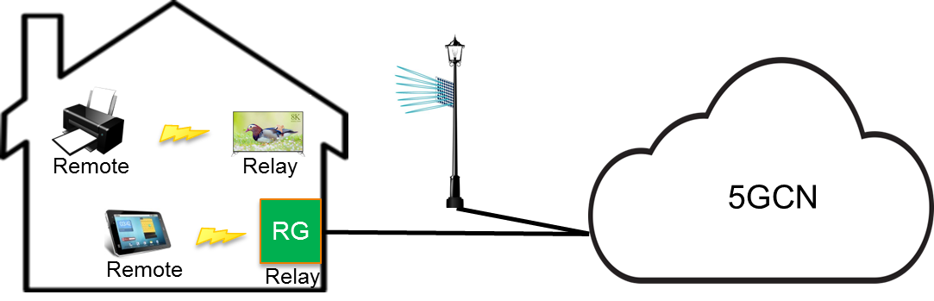

Figure 5.4-1: Different connection scenarios for residential

Which connection scenario works best depends on local conditions (e.g. type of houses, available cable networks, et cetera). As the residential home owners have little or no choice in what scenario MNO-X deploys for their residential area, MNO-X wants to harmonise its service offering over all the scenarios. The user experience should not depend on the connectivity scenario.

### 5.4.2 Pre-conditions

MNO-X provides fixed mobile converged internet access using a 5GCN. The connectivity scenario depends on local conditions.

### 5.4.3 Service Flows

User A wants to be able to:

* access the Internet using any of his normal devices (e.g. mobile phone, tablet), regardless of whether at home or mobile
* communicate with devices within the home, e.g. send documents to a printer wirelessly, stream music from a phone to a wireless HiFi device, control the heating/airco with a phone, remotely switch on/off devices, get alarms from smoke/fire/intrusion detectors.

This is made possible by the 3GPP private data communication service, which works independently from the connectivity scenario.

### 5.4.4 Post-conditions

None

### 5.4.5 Potential Impacts or Interactions with Existing Services/Features

None identified.

### 5.4.6 Potential Requirements

[PR 5.4.6-1] For residential scenarios, the 3GPP System shall enable the MNO to provide the same 3GPP private data communication service to any 5G UE, regardless of whether it is connected via public base stations, indoor small base stations connected via fixed access, or via relay UEs connected to either of these two types of base stations.

[PR 5.4.6-2] For residential scenarios, the 3GPP private data communication service shall support traffic scenarios typically found in a home setting (from sensors to video streaming, relatively low amount of UEs per group, many devices are used only occasionally).

## 5.5 Private data communication service in an office setting

### 5.5.1 Description

OfficeSpace is a company that provides office space for rent. OfficeSpace owns the building, and rents out fully furnished and equipped office space to SMEs. Next to providing toilets, reception services, coffee and lunch facilities, office rental companies also have to ensure that their customers can use IT facilities and have excellent (mobile) Internet access.

OfficeSpace has decided to fully rely on mobile communication for the internal Internet access and IT services (printers, beamers, et cetera). All devices are connected via PLMN communication. All servers et cetera are in the cloud. This saves greatly on the amount of cabling needed in the office. Furthermore, it provides the flexibility needed with the ever changing tenants.

OfficeSpace’s customers may use any of the mobile networks. And with the addition of visitors it is clear that OfficeSpace needs to ensure there is coverage for all mobile users, regardless of subscription. Because of the high frequencies needed to provide sufficient capacity for an in office mobile network, indoor small cell base stations are used to cover the office floors and various meeting rooms. Because installing a separate indoor infrastructure for each of the mobile operators would be too costly, OfficeSpace together with the mobile operators has implemented a shared radio access network. Implementing a shared radio access network implies that there is only one set of indoor base stations (plus the required connectivity of these base stations) for all operators.

### 5.5.2 Pre-conditions

All the tenants of OfficeSpace are subscribers of a private data communication service from their favourite mobile network operator.

Upon request, OfficeSpace has registered available beamers, printers, TV screens et cetera to the private data communication service from the tenant(s) that is/are using these devices. OfficeSpace may use any mobile network operators to connect these devices.

### 5.5.3 Service Flows

Employees from the OfficeSpace tenants and visitors can use mobile Internet services or cloud based services on all their devices as if in the public mobile network.

Employees from the OfficeSpace tenants can also use their handset, tablets, or laptops to connect to the devices such as printers, beamers, TV screens that have been assigned to them by OfficeSpace.

OfficeSpace can use the indoor mobile infrastructure to connect building automation sensors and actuators (e.g. temperature sensors, climate control, security sensors).

### 5.5.4 Post-conditions

None

### 5.5.5 Potential Impacts or Interactions with Existing Services/Features

None identified.

### 5.5.6 Potential Requirements

[PR 5.5.6-1] The 3GPP private data communication service shall work with shared Radio Access Network configurations.

Editor’s note: it is FFS whether other parts of network infrastructure (e.g. local server hosting/mobile edge computing) can be also shared in this scenario.

[PR 5.5.6-2] The 3GPP private data communication service shall support traffic scenarios typically found in an office setting (from sensors to very high data rates e.g. for conferencing, medium amount of UEs per group).

## 5.6 Private data communication service in a large scale industrial setting

### 5.6.1 Description

Oil&Gas is a company that owns the rights to exploit oil and gas field. The size of a typical field where they are pumping up oil or natural gas would be several thousands of square kilometres. Throughout this area Oil&Gas would deploy an infrastructure of pumps, pipelines, valves, compressors, et cetera. Often this equipment is deployed in rural/remote areas, where there is limited availability of electricity and cable infrastructure.

Oil&Gas has equipped their entire infrastructure with sensors and actuators which are connected via a mobile network. Using a mobile network allows Oil&Gas to more flexibly deploy its infrastructure.

The different sensors and actuators communicate using typical industrial data communication protocols as if they are connected to the same Local Area Network. The difference is that the “Local” Area Network, now spans a very large area. When including oil and gas transport pipelines, the network may even span multiple countries; a pressure sensor in one country communicates with a valve in another country on the other side of the pipeline.

### 5.6.2 Pre-conditions

Oil&Gas subscribes to a private data communication service from their favourite mobile network operator.

All sensors and actuators are configured to be part of one or more private network groups.

### 5.6.3 Service Flows

All sensors and actuators can communicate with other sensors and actuators on their private network group.

### 5.6.4 Post-conditions

None

### 5.6.5 Potential Impacts or Interactions with Existing Services/Features

None identified.

### 5.6.6 Potential Requirements

[PR 5.6.6-1] The 3GPP private data communication service shall work over a wide area mobile network.

[PR 5.6.6-1] The 3GPP private data communication service shall support traffic scenarios typically found in an industrial setting (from sensors to remote control, large amount of UEs per group).

## 5.7 Private P2P data communication using on-demand connections

### 5.7.1 Description

Joe is a service engineer for farming equipment. He services various kinds of equipment for his customers the farmers. As technology evolves, farming equipment is increasingly becoming smart. This implies that servicing equipment generally implies hooking up his computer to the equipment to see what may be wrong. A great benefit of mobile communication is that he can now also remotely connect to the equipment, regardless of where he or the farm equipment is located.

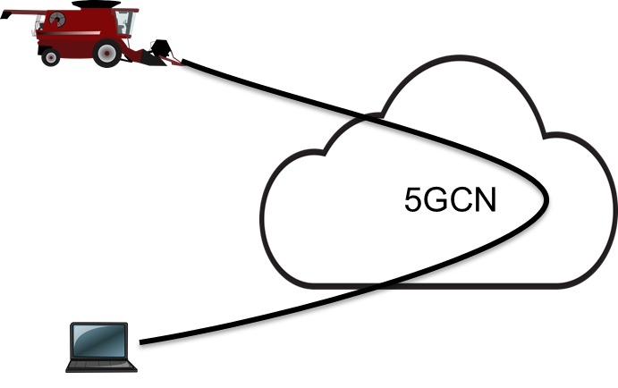

Figure 5.7-1: On-demand private data communication between two UEs

### 5.7.2 Pre-conditions

Farmer X has equipped all his farm equipment with 3GPP private data communication.

Farmer X has provisioned a private group of other UEs that are allowed to remotely contact his farm equipment. For UE1 (his harvester) he has indicated that communication from other UEs in the private group is always allowed. For UE2 (his tractor), he has indicated that data communication can only be established if additionally he specifically authorises the specific data communication establishment request. Farmer X has provisioned the private data communication service with information on how to obtain authorization (i.e. which UEs to contact for authorization).

UE-A, the laptop used by service engineer Joe, is provisioned to be part of the private group.

### 5.7.3 Service Flows

When UE-A wants to establish private data communication with UE1, it sends a request to the 3GPP network for an on-demand private data communication connection to UE1. UE-A can also indicate what type of data communication it wants (e.g. IP, Ethernet or other).

The 3GPP network checks whether UE-A and UE1 are in the same private group and are authorised to communicate with each other.

After positive authorization, the 3GPP network establishes the desired end-to-end private data communication connection and ensures that data transfer is enabled (e.g. configuration of firewalls).

The 3GPP network ensures that no other UEs or network entities can send data packets to UE1 or UE-A via the established private data communication connection.

UE-A then wants to establish private data communication with UE2. For this additional authorization from Farmer X is needed.

UEA sends a request to the 3GPP network for an on-demand private data communication connection to UE2 and indicates what type of data communication it wants (e.g. IP, Ethernet or other).

The 3GPP network checks whether UE-A and UE2 are in the same private group and are authorised to communicate with each other.

The 3GPP network then sends an authorization request to the UEs that Farmer X has provisioned for authorization (e.g. his phone and his tablet).

Upon receiving the authorization, the 3GPP network establishes the desired end-to-end private data communication connection and ensures that data transfer is enabled (e.g. configuration of firewalls).

After performing remote diagnostics, service engineer Joe terminates the private data communication connections from his laptop to the farm equipment.

### 5.7.4 Post-conditions

With the on-demand private data communication connection no longer present, there is no data communication between the UEs. Any data that the farm equipment may generate (e.g. keep alive messages, diagnostics messages, service discovery messages) are no longer sent to Joe’s laptop. This way Joe saves a lot of battery power on his laptop and avoids overloading his mobile data connection. For Farmer X the benefit is that he can keep control of who is accessing his equipment at what time.

### 5.7.5 Potential Impacts or Interactions with Existing Services/Features

ProSe communication offers similar communication between two UEs. However, here data communication takes place via the network, potentially over large distance.

Support for interconnection between operators is needed. It should be possible that UE-A has a subscription from a different operator than UE1 or UE2.

Roaming needs to be supported.

### 5.7.6 Potential Requirements

[PR 5.7.6-1] The 3GPP System shall support the on-demand establishment of UE to UE private data communication connections.

[PR 5.7.6-2] The 3GPP System shall support on-demand UE to UE private data communication connections with multiple types of data communication. At least IP and Ethernet should be supported.

[PR 5.7.6-3] The 3GPP 5G network shall enable the MNO to pre-authorize on-demand UE to UE private data communication connections through definition of a private group. Only on-demand private data communication requests from other members of the private group are authorized.

[PR 5.7.6-4] The 3GPP 5G network shall enable the MNO to authorize on-demand UE to UE data connection subject to third party authorization. The on-demand private data communication connection will be established only in case of positive authorization by the third party (e.g, the owner of a UE).

[PR 5.7.6-5] The 3GPP System shall ensure that no other UEs, even in the same private group, can interfere with the UE to UE private data communication.

## 5.8 Residential 5G PVN

### 5.8.1 Description

In this use case a residential 5G PVN is initially formed with two devices. The two devices are physically located in the home and they connect to the 3GPP network via two separate UEs (UE1 and UE2). The home owner wants to add sensors to the residential 5G PVN in order to be able to securely control the sensors using the home computer which is already connected to the 5G PVN.

### 5.8.2 Pre-conditions

A residential 5G PVN is established with two devices: a printer connected to the 3GPP network via UE1 and a home computer connected to the 3GPP network via UE2. Both devices in the 5G PVN communicate securely.



Figure 5.8.2-1 Residential 5G PVN with two UEs

### 5.8.3 Service Flows

The home owner purchases a set of sensors to be installed in the residence. The home owner installs the sensors in the house and the sensors are connected to UE3 via WLAN.

UE3’s subscription allows for UE3 to receive 5G PVN services from the 3GPP network.

UE3 registers with the 3GPP network.

The 3GPP network receives a request to add UE3 to the residential 5G PVN.

### 5.8.4 Post-conditions

The 3GPP network adds UE3 to the residential 5G PVN.

The sensors can communicate securely with the other devices in the residential 5G PVN via UE3.



Figure 5.8.4-1 Residential 5G PVN after UE3 is added

### 5.8.5 Potential requirements

[PR 5.8.5-1] The 5G network shall enable the MNO to create a 5G PVN for one or more UEs.

[PR 5.8.5-2] The 5G network shall enable the MNO to add one or more UEs to an existing 5G PVN.

## 5.9 Use case on Addition of UE in a 3GPP private group communications

### 5.9.1 Description

This use case describes the addition of new equipment into an existing 3GPP private group communications with automatic private group update, i.e. as soon as equipment is added in the company.

### 5.9.2 Preconditions

Bob hires a new employee and gives to him a new mobile/smartphone D and a new computer E on a desktop of the office building.

A 3GPP private group communications is already enabled for the communication between equipment A, B and C of the company.

Bob configures the private group information to add smartphone D and the laptop E and to identify which 3GPP private group communications they are part of.

### 5.9.3 Service flows

The smartphone D and the laptop E initiate communication via the 3GPP network to the 3GPP private group communications management function of the 3GPP MNO to join a specific 3GPP private group communication of the company.

The MNO’s management function checks D and E are allowed to join the 3GPP private group communications.

The MNO’s management function adds D and E into the member group of this 3GPP private group communications.

The MNO correctly configure the network such that the private group communications between D and E, and with other UEs (e.g., A, B and C) within the same private group communications is enabled.

### 5.9.4 Post-conditions

The new smartphone D and new laptop E can communicate with A, B and C that are in the same private group communications.

Equipment outside of this private group communications cannot interfere with the communication between A, B, C, D, and E.

### 5.9.5 Potential Impacts or Interactions with Existing Services/Features

None identified.

### 5.9.6 Potential Requirements

[PR 5.9.6-1] The 5G network shall enable the MNO to authorize the dynamic addition of a UE into a specific group of UEs that are members of a specific private group communications.

[PR 5.9.6-2] The 5G network shall enable the new UE to communicate with other UEs within the same private group communications.

[PR 5.9.6-3] The 5G network shall be able to verify the identity of a UE requesting to join a specific private group communications.

[PR 5.9.6-4] The 5G LAN-type service shall be able to collect charging information when a UE joins a specific private communication.

## 5.10 Use case for Removal of UE from a private group communication

### 5.10.1 Description

This use case describes the removal of equipment from an existing private group communications.

### 5.10.2 Preconditions

A private group communications is already enabled for the communication between equipment A, B and C.

### 5.10.3 Service flows

Bob requests to the MNO to remove laptop B from the existing private group communications

The MNO’s management function removes B from the member group of this private group communications.

### 5.10.4 Post-conditions

Laptop B cannot interact with A and/or C via the private group communications any more.

### 5.10.5 Potential Impacts or Interactions with Existing Services/Features

None identified.

### 5.10.6 Potential Requirements

[PR 5.10.6-1] The 5G network shall enable the MNO to remove a UE from a specific group of UEs of a private group communications.

[PR 5.10.6-2] The 5G network shall ensure that the removed UE has no interference with the private group communications that the UE has been removed from.

[PR 5.10.6-3] The 5G network shall ensure that removal of UE from a particular private group communication has no impact on other private group communications including the same UE.

## 5.11 Use case for UE part of multiple private communications

### 5.11.1 Description

In the enterprise, some equipment may be common for usage by different departments, e.g., a server and a printer can be common to multiple departments.

Bob needs multiple independent communications between UEs of different departments but also want some common equipment to be used by equipments of different departments.



Figure 5.11-1: Use of a common single printer from 2 departments of the enterprise

### 5.11.2 Preconditions

Several UEs (mobile smartphones, computers or mobile laptops, printers…) are available in multiple departments of a company for companies’ employees.

### 5.11.3 Service flows

The MNO provides 3GPP private communication for some of the company’s equipment (e.g., A, B, C) of one department, and provides another 3GPP private communication for some of the company’s other equipment (e.g., D, E, F) for another department.

Bob want a specific printer (e.g., P) to be used by equipment of both departments.

Bob gives the unique identification of this equipment P (e.g., IMSI) to the MNO.

The 3GPP MNO updates 3GPP LAN service to enable communication between A, B, C and P, and between D, E, F and P.

### 5.11.4 Post-conditions

The 3GPP private communication services between A, B, C and P are enabled. Company equipment A, B and C could use the local printer P.

Then 3GPP private communication services between D, E, F and P are also enabled, Company equipment D, E and F could use the local printer P simultaneously.

Equipment out of these two 3GPP LAN groups cannot use the local printer P.

The communication between A, B, C and P cannot interfere with the communication between D, E, F and P, and vice versa.

### 5.11.5 Potential Impacts or Interactions with Existing Services/Features

None identified.

### 5.11.6 Potential Requirements

[PR 5.11.6-1] The 5G system shall enable the MNO to assign a UE to multiple independent 3GPP private communications group.

## 5.12 Use Case for enabling Ethernet-based private communication in 3GPP

### 5.12.1 Description

The sensors and actuators are using Non-IP transport services (e.g., Ethernet) to transport control signalling in legacy LANs of industry factories.

This use case is about the 3GPP system to consider Ethernet-based protocol for private communications between UEs.

### 5.12.2 Preconditions

The sensors and actuators of packaging and printing system are deployed in an industrial factory, and are defined by the MNO as being the valid member of a group for 3GPP private communication.

The sensors detect a product coming from the assembly line and send control signalling to the actuators using non-IP transport services (e.g., Ethernet) via 3GPP network.

### 5.12.3 Service flows

The non-IP packets of control signalling are directly forwarded from the sensors to the actuators via the MNO’s network.

The required QoS for the non-IP packet are applied by the MNO’s network.

### 5.12.4 Post-conditions

The actuators of packaging and printing system perform actions for the product correctly and in time.

### 5.12.5 Potential Impacts or Interactions with Existing Services/Features

None identified.

### 5.12.6 Potential Requirements

[PR 5.12.6-1] The 5G network shall support the routing of non-IP packet (e.g., Ethernet frame) efficiently for private communication between UEs.

[PR 5.12.6-2] The 5G network shall be able to provide the required QoS (e.g., reliability, latency, and bandwidth) for non-IP packet (e.g. Ethernet frame) for private communication between UEs.

## 5.13 Use Case for Service Continuity in private group communication

### 5.13.1 Description

This use case describes continuity of 3GPP private group communication during UE’s mobility.



Figure 5.13-1: Service continuity within the 3GPP private group when the UE moves

### 5.13.2 Preconditions

UEs (A, B and C) are defined by the MNO for being part a same private group.

UE C is on a moving car and having video conference call with A and B in the office via 3GPP network.

### 5.13.3 Service flows

The MNO keeps the 3GPP communication traffic uninterrupted while UE C is moving in the PLMN.

### 5.13.4 Post-conditions

The video conference call between A, B and C is uninterrupted.

### 5.13.5 Potential Impacts or Interactions with Existing Services/Features

None identified.

### 5.13.6 Potential Requirements

[PR 5.13.6-1] The 5G network support 3GPP service continuity for 5G LAN-type service, i.e., the private communication between UEs shall not be interrupted when one or more UEs of the private communication move within the same PLMN that provides the 5G LAN-type service.

## 5.14 Private data communication service using semi-permanent connections

### 5.14.1 Description

Farmer X has a large area of land where he grows potatoes. As an innovative farmer, Farmer X has deployed various sensors to continuously measure the condition of his crop. For example, sensors measure the moisture level of the soil and provide this information to an irrigation system. Automatically, movable sprinklers are deployed to provide water in the right areas. Also this sprinkler system uses various sensors (e.g. water pressure) and actuators (e.g. valves). All these sensors and actuators are connected via a 3GPP private data communication service.

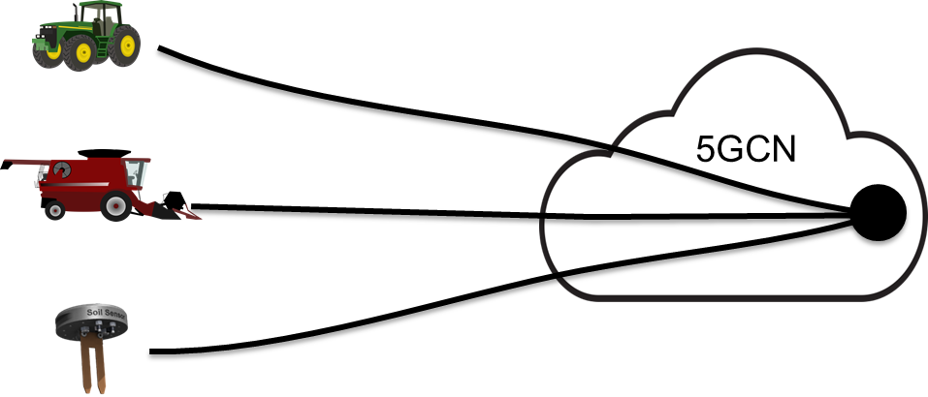

Figure 5.14-1: Private data communication with semi-permanent data connections to a private data network

### 5.14.2 Pre-conditions

Farmer X has subscribed to a private data communication service from MNO-X. His subscription includes a number of private groups.

Farmer X has all its sensors and actuators subscribed to use the 3GPP private data communications service provided by MNO-X.

Farmer X uses different private groups for the different sensors and actuators (e.g. he also has a 3GPP private network group connecting his tractor and various other farm equipment). For security reasons, not all sensors and actuators are allowed to communicate with each other.

Farmer X has configured all the sensors and actuators on which private group(s) they should use.

Through MNO-X, Farmer X has configured the 3GPP private data communications service with the different groups of sensors and actuators that are allowed to communicate with each other.

Through MNO-X, Farmer X has pre-configured what type of data communication is to be used on each private group (e.g. IP, Ethernet, or other). All UEs on the same private group need to use the same type of data communication.

### 5.14.3 Service Flows

UE1, UE2, and UE3 each establish a UE-to-network data connection to a Data Network representing the private group.

The 3GPP System checks whether these UEs belong to the private group and authorised to set up a communication with the group.

When the connection is established an address assignment procedure takes place to issue addresses for each of the UEs in the private group.

### 5.14.4 Post-conditions

After the data connections are established, these data connections are maintained semi permanently. The UE1, UE2, and UE3 can use point-to-point addresses when they want to send a data packet to a particular other UE. They can also use multicast/broadcast addresses to send a packet to all other UEs in the group.

Note that UE4 which also belongs to Farmer X, but which is in a different group, is not able to send data to UE1, UE2, and UE3. If UE4 knows an address of UE1, UE2, or UE3, sending a packet to that address via the data connection for its own private group will not work.

### 5.14.5 Potential Impacts or Interactions with Existing Services/Features

The functionality in this use case could be provided with existing functionality of selecting a corporate APN, or by selecting a specific private DN in 5G. However:

- Current procedures do not support checking whether the UE is part of the private group (and e.g. do not support disconnecting the UE when it is removed from the private group).

- The existing mechanisms behind APNs do not really scale to the extent of multiple private groups per SME, or even consumers. Unsure if the 5G DN concept scales sufficiently.

- The MNO needs standardised support for managing a large amount of private Data Networks. The intention is not to leave the management of such a Data Network to SMEs or consumers.

Multi-operator support is needed. It should be possible that UE2 has a subscription from a different operator than UE1 and the operator providing / hosting the data network for the 3GPP private communication service.

Roaming needs to be supported. It is acceptable that roaming is based on home routing.

### 5.14.6 Potential Requirements

[PR 5.14.6-1] The 3GPP System shall support the establishment and control of communication from a UE to its private group.

[PR 5.14.6-2] Only UEs that are part of the private network group shall be able to establish or maintain communication to a private group.

[PR 5.14.6-3] The 3GPP network shall enable the network operator to ensure confidentiality and isolation of communications for the private group.

[PR 5.14.6-4] The 3GPP 5G network shall enable the network operator to ensure UEs that belong to a different private group cannot send data to any or all of the UEs in the group.

[PR 5.14.6-5] The 3GPP network shall enable the network operator to support point-to-point addressing as well as multicast addressing between the different UEs in a private group. It is assumed that all UEs in a same private group use the same type of addresses (e.g. IP, Ethernet or other).

[PR 5.14.6-6] The 3GPP network shall enable the network operator to create, manage, and remove private groups including their related functionality (subscription data, routing and addressing functionality).

## 5.15 Use case for multiple private communications in the same network

### 5.15.1 Description

In the enterprise, there are several departments, and the head, Bob, needs multiple independent groups of UEs communicating together for each department .



Figure 5.15-1: Two independent groups of UEs communications for the same enterprise

### 5.15.2 Preconditions

Several UEs (mobile smartphones, computers or mobile laptops, printers…) are available in multiple departments of a company for companies’ employees.

### 5.15.3 Service flows

Bob requests to the 3GPP MNO to provide 3GPP private communications for some of the company’s equipment (e.g., A, B, C) of one department, and to provide another 3GPP private communications for some of the company’s other equipment (e.g., D, E, F) of another department. Bob gives the unique identifiers of these equipments to the MNO.

The 3GPP MNO provides 3GPP private communications for A, B, C and provides another for D, E, F.

### 5.15.4 Post-conditions

The 3GPP private communication service between A, B and C is enabled, and also the 3GPP private communication service between D, E and F is enabled. Equipment A, B and C (and also D, E and F) can communicate amongst each other (e.g., file sharing, neighbour discovery).

Equipment outside these two UE groups cannot interfere with the communication between A, B and C and the communication between D, E and F.

The communication between A, B and C cannot interfere with the communication between D, E and F, and vice versa.

### 5.15.5 Potential Impacts or Interactions with Existing Services/Features

None identified.

### 5.15.6 Potential Requirements

[PR 5.15.6-1] The 5G network shall enable the MNO to provide independent private communications between UEs for different groups of UEs.

[PR 5.15.6-2] The 5G network shall support independent private communications between UEs for different groups of UEs.

## 5.16 Use case on service management

### 5.16.1 Overall Description

3GPP MNO enables private communications, i.e., enable a restricted set of UEs to communicate amongst each other via 3GPP network in order to support enterprise, residential homes and industry equipment communications.

### 5.16.2 Description

Bob is the head of a company who has to face enterprise network building and maintenance expenditure. Bob needs private communications between its employees’ office equipments (computers, printers…) and with employees’ mobile equipments (laptops, smartphones…).

Bob does not want to configure a LAN and prefers to offload the private communication management with work of configuration, maintenance and control that communication is only allowed amongst the UEs of his enterprise, to 3GPP MNO.



Figure 5.16-1: Private communications in an Enterprise

### 5.16.2 Preconditions

Several UEs (mobile smartphones, computers or mobile laptops, printers…) are available to a company. These UEs may be in any of multiple office buildings of that company or may be brought outside the office buildings by company employees.

### 5.16.3 Service flows

Bob requests to the MNO to provide private communication service for some of its company’s equipments. Bob gives a unique identification of these equipments (A, B, C) (e.g., IMSI) to the 3GPP MNO.

The MNO defines the group members for this enterprise 3GPP LAN as A, B and C.

### 5.16.4 Post-conditions

The 3GPP private communications between A, B and C is enabled. Equipment A, B and C can communicate amongst each other (e.g., file sharing, neighbour discovery, LAN game).

UEs out of this private group cannot interfere with the communication between A, B and C.

### 5.16.5 Potential Impacts or Interactions with Existing Services/Features

None identified.

### 5.16.6 Potential Requirements

[PR 5.16.6-1] The 5G network shall enable the 3GPP network operator to define set of UEs allowed to communicate together in a secured way.

[PR 5.16.6-2] The 5G system shall ensure the 3GPP communication between UEs of a defined set of UEs with no impact with communications of other UEs not belonging to this set.

5.17 Factory Automation

5.17.1 Description

In this use case a factory producing electronic goods using highly precise automated robots co-ordinated by tight closed-loop control has used 5G replace some of the wired Ethernet connections. There are several drivers to replace wired links with wireless links. For example, devices are mobile, cables need to go through hazardous areas, or moving parts in a machine need connectivity. Further, providing wireless connectivity can enable rapid reconfiguration of a factory, which can yield improvements in productivity. Figure 5.17-1 describes a small section of the factory deployment where 5G is used to connect devices T, C and S.

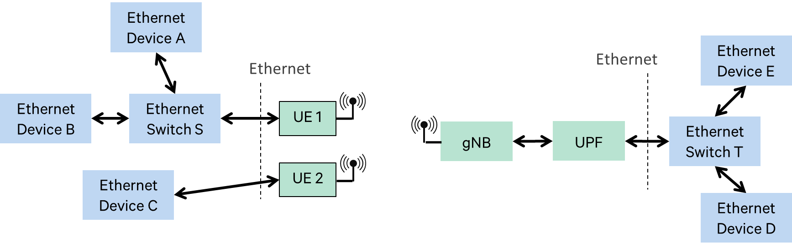

Figure 5.17-1: Factory Automation

Note: Factory automation uses tight closed-loop control in applications such as industrial manufacturing, machine control, packaging, and printing. In these applications, a controller interacts with many sensor and actuator devices, located within a small area (up to 100 m x 100 m).

5.17.2 Pre-conditions

A factory producing electronic goods using highly precise automated robots co-ordinated by tight closed-loop control has used 5G to replace some of the wired Ethernet connections.

The factory robots currently support real-time Ethernet according to IEC 61784 [3] along with a suite of features for industrial automation. These features support the fast routing, broadcast, support of virtual LANs, and Ethernet QoS classification.

5.17.3 Service Flows

Ethernet switches/devices T, E, and D can transmit Ethernet frames to Ethernet switches/devices A, B, C, and S. These frames are sent with Ethernet-based routing and transmission information based on real-time Ethernet according to IEC 61784 [3] and the suite of features supported at the Ethernet switches/devices. These Ethernet frames are transported by the 5G network and routed to the correct destination 5G UE before being unpacked and forwarded to the correct Ethernet switch/device

5.17.4 Post-conditions

The factory robots operate in an accurately controlled manner and perform the exact duties as defined by the factory operator.

5.17.5 Potential Impacts or Interactions with Existing Services/Features

##### 5.17.5.1 Routing based on Ethernet headers

Consider the scenario where Device D sends an Ethernet frame with destination address as the Ethernet MAC address of Device A or Device B. In this case, the Ethernet frame must be routed to UE 1. UE 1 should then forward the frame to the Ethernet switch S. Note that the Ethernet frame must not be sent to UE 2. Thus, the 3GPP system must support the routing functionality based on Ethernet frame header information.

##### 5.17.5.2 Broadcast

Consider the case where Device D sends an Ethernet frame with destination address as the broadcast address. In this case, the frame should be forwarded to both UE 1 and UE 2. Thus, the 3GPP system must support Ethernet broadcast frames.

##### 5.17.5.3 Spanning Tree

Suppose that in Figure 5.17-1, Device C was also connected to Switch S. Then Device C, Switch S, UE 1 and UE 2 will form a loop. A spanning tree algorithm (e.g., RSTP) allows the switches in an Ethernet network to negotiate a single path to each entity. This is instantiated by the Ethernet network blocking certain ports. In this example, the algorithm may result in blocking transmissions to Device C via one of the UEs (either UE1 or UE2), depending on the result of the algorithm path calculations. This is because the spanning tree algorithm finds the shortest path between a selected root node and the device of interest (in this case Device C), and blocks the other paths to that same device. Once a path is chosen, and other paths are blocked, in order to enforce this outcome, a broadcast frame must not be forwarded through the blocked path. This means that broadcast frames must not be forwarded to the blocked UE. Thus, routing of Ethernet frames in the 5G system must be based on the outcome of spanning tree algorithm run by the Ethernet network being served.

The way the paths are found is via Ethernet switches sending of Bridge Protocol Data Units (BDPUs) with information on available ports. As Ethernet devices other than switches do not send BPDUs, in order to find out the network topology behind the UE it is necessary to limit to a single Ethernet device connected to the UE. If there is a desire to connect multiple Ethernet devices to a UE, then a switch can be connected to the UE and multiple Ethernet devices can be connected to the switch, as it is shown in UE1 in Figure 5.17-1.

##### 5.17.5.4 Virtual LAN

Consider the case where UE 1 belongs to VLAN V1 and UE 2 belongs to VLAN V2. If a broadcast frame is received by the PDN marked for VLAN V1, it must be forwarded to UE 1 but not to UE 2. Thus, the routing of Ethernet frames must be based on the VLAN ID.

##### 5.17.5.5 QoS

Ethernet traffic flow classification must be based on Ethernet headers – Source and Destination MAC address, Ethertype (including multiple Ethertypes in double-tagging), VLAN tags including VLAN ID and PCP, in addition to the existing fields used in Traffic Flow Templates (TFT). Thus, packet filtering and choice of 5QI should be based on Ethernet header information.

IEEE Time Sensitive Networking (TSN) Task Group is developing the TSN standard, whose goal is to provide deterministic services through IEEE 802 networks. TSN provides many of the services needed in factory automation applications, e.g., time synchronization, and ultra-reliability through redundancy [4, 5, 6]. The Stream Reservation Protocol (SRP) in TSN requires resource reservation at each intermediate device.

As described earlier, Factory Automation applications have stringent requirements on latency, jitter and error rate. Further study may be needed to determine how these requirements can be met in a 3GPP system.

5.17.6 Potential Requirements

[PR.5.17.6-1] The 3GPP system shall be able to support an Ethernet transport service.

[PR.5.17.6-2] The Ethernet transport service shall support routing based on information extracted from Ethernet frame headers by the 3GPP system.

[PR.5.17.6-3] The Ethernet transport service shall support routing based on information extracted from Virtual LAN (VLAN) ID by the 3GPP system.

[PR.5.17.6-4] The Ethernet transport service shall support routing based on information extracted by the 3GPP system from the Bridge Protocol Data Units created in the Ethernet network based on a Spanning Tree Protocol (e.g. RSTP).

[PR.5.17.6-5] The Ethernet transport service shall support the transport of Ethernet frames between UEs that an Ethernet device connected to it.

NOTE: If more than one Ethernet devices need to be connected to a UE, they can be connected using an Ethernet switch between the devices and the UE.

[PR.5.17.6-6] The Ethernet transport service shall support the transport of Ethernet broadcast frames.

[PR.5.17.6-7] The Ethernet transport service shall support traffic filtering and prioritization based on source and destination MAC addresses.

[PR.5.17.6-8] The Ethernet transport service shall support traffic filtering and prioritization based on Ethertype (including multiple Ethertypes in double-tagging)

[PR.5.17.6-9] The Ethernet transport service shall support traffic filtering and prioritization based on 802.1Q VLAN tags (including double tagging).

[PR.5.17.6-10] The 3GPP system shall support sufficient QoS capabilities to be able to meet the request in the Ethernet header information.

## 5.18 Use case on Industry Communication with stable latency needs

### 5.18.1 Description

Factory manager, Bob, has deployed a traditional factory network for connecting sensors, actuators and controllers.

A motion controller periodically sends desired set points to one or several actuators which thereupon perform a corresponding action on one or several processes. This is done in a strictly cyclic and deterministic manner. In order to avoid a later transmission arrives before an older one, the actual latency for each packet delivery should be stable, i.e., not too early nor too late. In factory network, Industrial Ethernet technologies can be used, such as 802.1Qbv based Ethernet Switch, which guarantee latency for each Ethernet packet delivery is stable inside the Enterprise network.

Now as an innovative farmer, Bob deploys new type of actuators with 5G capability and 5G subscription to measure the condition of the product. These actuators are connected to 3GPP network and communicate with the factory network.



Figure 5.18-1: industry communcation between Actuator A and Controller B in factory network

### 5.18.2 Preconditions

A controller B in Ethernet based factory network is connected to the factory network by using fixed wireline, WiFi, etc.

A new type of actuator A using the 5G LAN-style services provided by MNO X, establishes a UE-to-network data connection and accesses the factory network via the 3GPP network.

### 5.18.3 Service flows

Controller B sends data (e.g., desired set points) to Actuator A.

The data is transferred to the 3GPP network through 802.1Qbv based Ethernet Switch.

3GPP network forwards the data containing the Ethernet packet to Actuator A while guaranteeing stable latency of each Ethernet packet.

### 5.18.4 Post-conditions

Actuator A receives data from Controller B and performs action in time.

### 5.18.5 Potential Impacts or Interactions with Existing Services/Features

None identified.

### 5.18.6 Potential Requirements

[PR 5.18.6-1] The 5G system shall provide a mechanism to ensure the jitter for transporting Ethernet packets is limited by a certain time boundaries.

Note: the value of the time boundaries is TBD.

[PR 5.18.6-2] The 5G system shall be able to provide an Ethernet transport service.

[PR 5.18.6-3] The Ethernet transport service shall support routing based on information extracted from the Ethernet header information created based on 802.1Qbv.

[PR 5.18.6-4] The Ethernet transport service shall support traffic filtering and prioritization based on information extracted from the Ethernet header information created based on 802.1Qbv.

## 5.19 Use case for accessing 5GLAN via Relay UE

### 5.19.1 Description

Remote UE access to 5G LAN-style service is not considered in 5GLAN TR currently while it should be possible to allow a devices to use 5G LAN-style services and be under MNO control even when such device connects to 3GPP network via a relay UE (the relay UE could be either part of 5GLAN or not).

### 5.19.2 Preconditions

Mike has several home devices connected to the 3GPP network offered by the MNO.

Mike has his laptop connected to one of the home devices and want to use the 5G LAN-style service in his office, i.e., communicate with the PCs in the office.

### 5.19.3 Service flows

Mike requests the MNO to join with his laptop the private group made of the PCs in the office.

The MNO authorize Mike’s laptop and add it to the private group of the office.

### 5.19.4 Post-conditions

The laptop could communicate with the PCs in the office via the home device, with the same service level as if the laptop was in the office, i.e., required QoS for the Ethernet packets transferred between the laptop and PCs in the office, service continuity when the laptop changes the connection from one home device to another.

### 5.19.5 Potential Impacts or Interactions with Existing Services/Features

None identified.

### 5.19.6 Potential Requirements

[PR 5.19.6-1] The 5G network shall enable the MNO to authenticate and authorize a remote UE in indirect mode under a relay UE to use 5G LAN-type service.

[PR 5.19.6-2] The 5G network shall allow the MNO to add/move a remote UE in indirect mode to/from a private set for a 5G LAN-type service.

[PR 5.19.6-3] The 5G network shall be able to provide a remote UE using 5G LAN type service via a relay UE with same level of service as if the remote UE would be in direct mode (i.e. provide required QoS for the Ethernet packets transferred between remote UE and relay UE if they using 3GPP access).

[PR 5.19.6-4] The 5G network shall be able to support service continuity for the communication between a remote UE with other UEs belonging to the same private communication of 5G LAN-type service, when the remote UE changes from one relay UE to another or when the UE changes between direct and indirect mode.

## 5.20 Use case for 5G PVN with private addressing

### 5.20.1 Description

Use of 3GPP technology for a 5G PVN allows expansion from only 5G LAN-type services to also encompass services previously considered similar to what a PBX might provide. This is a significant advantage for a multi-site enterprise. For example, in a multi-site enterprise, all sites could be connected to a common 5G PVN for 5G LAN-type services and also use the 5G PVN to communicate among employees across sites using a private addressing scheme that simplifies addressing within the enterprise. The common 5G LAN-type services allow employees to enjoy the same access to all of their files, applications, equipment, and colleagues regardless of which site they might be at physically. The private addressing scheme allows employees on the 5G PVN to contact each other directly using the simplified corporate addresses.

Use of a private addressing scheme within a 5G PVN does not preclude a UE from communicating outside of the 5G PVN using its public address.

### 5.20.2 Scenario

An large enterprise with many office sites establishes a 5G PVN to provide 5G LAN-type services at all enterprise office locations. To facilitate communication between the office sites, the enterprise provides its own addressing scheme for UEs that are authorized as members of the 5G PVN. An appropriate address is assigned to every UE that is authorized for use on the 5G PVN. Once the address is established, that UE can be reached by other UEs that are members of the 5G PVN, regardless of location, with that address. This allows, for example, an employee who is away from her office to send a file from her smart phone to the office printer using the private address provided for the printer. Employees at different sites can also call, text, or email each other using the private addresses.

When an employee needs to communicate with a UE that is not a member of the 5G PVN, the private address is not used.

### 5.20.3 Potential service requirements

[PR 5.20.3-1] The 5G PVN shall support a suitable mechanism for a 5G PVN application to assign a private address to a UE for use within the 5G PVN, and to subsequently modify or remove that assignment.

Editor’s note: it is FFS which types of addresses.

[PR 5.20.3-2] A 5G PVN shall support routing based on a private addressing scheme.

## 5.21 High Performance Manufacturing

5.21.1 Description

Multiple use cases in manufacturing apply sequence-control mechanisms with highly deterministic and periodic (or cyclic) message exchanges that have stringent requirements on latency, reliability and isochronism. The following use cases discussed in Communications for Automation in Vertical Domains (TR 22.803) fall into this category:

* Motion control,
* Control-to-control communications,
* Mobile robots,
* Massive wireless sensor networks.

These use cases rely on industrial Ethernet for communications among the various nodes such as sensors, actuators, controllers, bridges and gateways. The Ethernet network might support different, use-case- or deployment-specific topologies such as ring, star, tree or mesh. From the Ethernet perspective, the various communications nodes group into end stations and bridges.

The Time-Sensitive Networking (TSN) framework establishes a set of specifications to meet the strict performance requirements of high performance manufacturing. For the present use cases, the following TSN features are relevant:

* Clock synchronization among all Ethernet nodes (IEEE 802.1AS, which leverages Precision-Time-Protocol PTP defined by IEEE 1588)
* Time-aware scheduling for hard real-time (RT) traffic (IEEE 802.1Qbv, integrated into IEEEE 802.1Q-2014)
* Frame pre-emption to manage coexistence of less performance-constraint traffic with hard-RT traffic (IEEE 802.1Qbu, integrated into IEEE 802.1Q-2014).

**Network-wide Clock Synchronization**

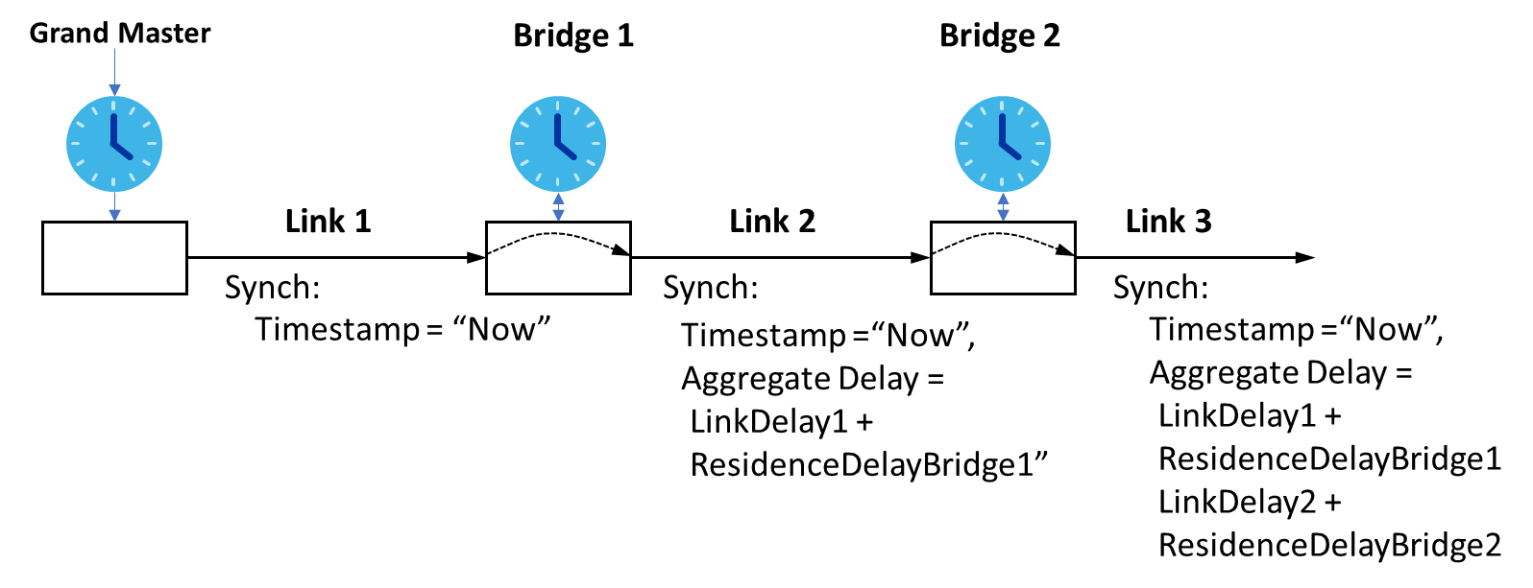

Figure 5.21-1: IEEE 802.1AS clock synchronization

IEEE 802.1AS achieves network-wide clock synchronization by propagating a synchronization message with a timestamp generated by a grand master (GM) hop-by-hop across the network (Figure 1). Bridges receive time information on one port and propagate it on all other ports. In addition, the aggregate delay of the Synch message since departure from the GM is updated at each hop and forwarded, too. The update includes link delay, which is due to propagation across the link, as well as residence delay, which is due to processing inside the bridge. IEEE 802.1AS determines link-delay via an RTT-measurement on Ethernet layer, which leverages precise timing information from the underlying physical layer.

The IEEE 802.1AS specification assumes that the link delay is symmetric and deterministic. In case it is not symmetric, adjustments have to be taken on lower layers to make it appear symmetric to IEEE 802.1AS.

Since the GM can reside on any node in the Ethernet topology, propagation of IEEE 802.1AS messages and delay measurements may have to be supported in both directions of the Ethernet link.

**Time-aware Scheduling**

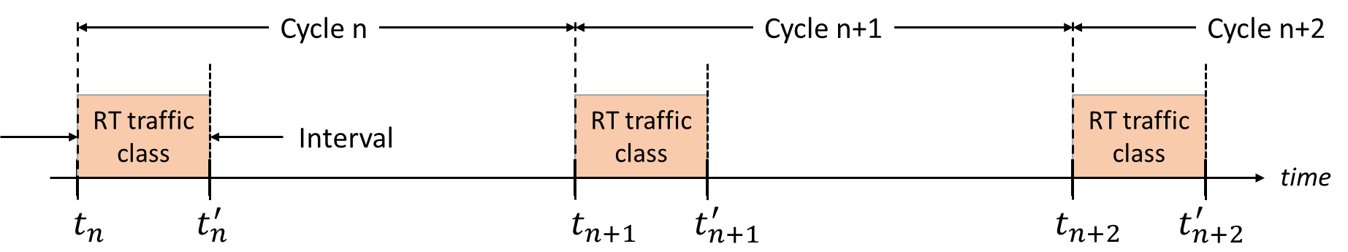

Figure 5.21-2: Example for time-aware scheduling with absolute time bounds

Time-aware scheduling defined by IEEE 802.1Qbv introduces absolute, periodic time bounds to the data delivery for hard-RT applications (Figure 5.21-2). The traffic bounds are referenced to the transmitting node’s clock, which is also used by the hard-RT application. In this manner, hard-RT delivery guarantees can be met across the whole protocol stack. The periodic pattern of the time-aware schedule further matches the cyclic nature of the overarching manufacturing application.

When network nodes are clock-synchronized via IEEE 802.1AS, time-aware scheduling can be extended over multiple hops. IEEE 802.1AS therefore represents a prerequisite for time-aware scheduling

For the use cases defined in TR 22.803, resource reservation for hard-RT traffic typically spans time intervals between 500µs and 10ms.

IEEE 802.1Qbv also defines managed objects for Ethernet nodes to enable remote configuration of parameters associated with time-aware scheduling.

**Frame Pre-emption**

Frame pre-emption defined by IEEE 802.1Qbu regulates the transport of lower-priority traffic in presence of time-aware schedules configured for hard-RT traffic. It introduces explicit solutions on Ethernet layer such as guard time intervals and frame interruption to circumvent the periodic traffic intervals reserved for hard-RT traffic. Frame pre-emption only considers resource partitioning in the time domain. It further assumes that lower layers lack autonomous frame-segmentation methods or are not aware of the time-interval boundaries configured.

**Integration of 5G into high-performance manufacturing**

For incremental wireline-to-wireless migration in high-performance manufacturing, one can expect that individual wireline links or stars in the Ethernet network are replaced with 5G. From the perspective of the Ethernet network, the end-points of the 5G PDU-session align with the end points of the Ethernet link. Therefore, TSN specifications logically apply to the end-to-end PDU-session.

As Ethernet nodes support managed objects for the configuration of time-aware scheduling, the corresponding enhancements for the configuration of time-aware scheduling for 5G are necessary.

5.21.2 Pre-conditions

An Ethernet network in a high-performance manufacturing location has mesh topology, where one or various links use 5G. The Ethernet network enforces TSN features defined by IEEE 802.1AS, IEEE 802.1Qbv and IEEE 802.1Qbu to support a set of coexisting hard-RT and lower-priority traffic classes. One Ethernet node runs a GM for clock synchronization. Various links are configured to perform time-aware scheduling for a set of the hard-RT traffic classes. The Ethernet nodes interconnected by 5G PDU sessions have means to appropriately conduct clock synchronization across the 5G link.

5.21.3 Service Flows

Periodically, synchronization messages are propagated by the GM throughout the Ethernet network. These messages may traverse the 5G links in either direction. The 5G technology ensures sufficiently accurate determination and propagation of link delay and residence delay.

Based on clock synchronization and time-aware schedules, hard-RT traffic propagates across the network without colliding with lower priority traffic. At the same time, lower priority traffic propagates in resource-efficient manner.

On the 5G links, forwarding of hard-RT traffic is conducted in compliance with the time bounds configured via time-aware scheduling. Further, lower-priority traffic is forwarded in resource-efficient manner across the 5G links, without impacting the stringent performance targets of hard-RT traffic. Hard-RT and lower-priority traffic may flow in both directions across the 5G links.

5.21.4 Post-conditions

The performance targets for hard-RT traffic are met. All hard-RT traffic frames can be delivered with expected reliability within the absolute time bounds configured. Further, remaining resources are efficiently used for transport of lower priority traffic.

5.21.5 Potential Impacts or Interactions with Existing Services/Features

**Clock synchronization**

IEEE 802.1AS defines an explicit handshake on Ethernet-layer for determination of link delay, which relies on accurate frame departure and -arrival measurements on physical layer. The procedure assumes that link delay is symmetric and deterministic. These assumptions are not met for the 5G access link. The 5G access link, however, supports separate mechanisms to synchronize the frame boundaries between UE and gNB with high level of accuracy. These aspects may be considered in the adaptation of IEEE 802.1AS for 5G.

The achievable accuracy of access-link delay measurements depends on channel delay spread and the shortest-path measurement mechanisms applied. IEEE 802.1AS further supports a mechanism to determine relative clock drift between link end-points. Adaptation of this feature should also be considered for the 5G-links.

**Time-aware Scheduling**

The concept of absolute cyclic time boundaries to scheduling should build on the existing QoS frameworks for delay sensitive traffic (e.g. voice) that is already available in 3GPP.

**Frame Pre-emption**

Frame pre-emption aims to accommodate lower-priority traffic together with hard-RT traffic by considering only the time domain. 5G also supports other dimensions such as the frequency or space, which allows simultaneous scheduling of different traffic classes.

Frame pre-emption further builds on the assumption that lower-priority transmissions, once they have started, cannot be interrupted when higher priority data arrive. URLLC developed in Rel-15, for instance, is not bound to such a stringent paradigm. Hence, there might be opportunities for further optimization on the 5G access link.

5.21.6 Potential Requirements

[PR 5.21.6-1] For infrastructure dedicated to high performance Ethernet applications, the 3GPP system shall support clock synchronization defined by IEEE 802.1AS across 5G-based Ethernet links with PDU-session type Ethernet.

[PR 5.21.6-2] For infrastructure dedicated to high performance Ethernet applications, the 3GPP system shall support clock synchronization defined by IEEE 802.1AS across 5G-based Ethernet links and other ethernet transports such as wired and optical (EPON.)

[PR 5.21.6-3] For infrastructure dedicated to high performance Ethernet applications, the accuracy of clock synchronization should be below 1µs.

[PR 5.21.6-4] For infrastructure dedicated to high performance Ethernet applications, the 3GPP system shall support time-aware scheduling with absolute cyclic time boundaries defined by IEEE 802.1Qbv for 5G-based Ethernet links with PDU sessions type Ethernet.

[PR 5.21.6-5] For infrastructure dedicated to high performance Ethernet applications, absolute cyclic time boundaries shall be configurable for flows in DL direction and UL direction.

[PR 5.21.6-6] For infrastructure dedicated to high performance Ethernet applications, the 3GPP system shall support coexistence of hard-RT traffic following a time-aware schedule and lower priority traffic. The lower priority traffic cannot have a performance degrading impact on the hard-RT traffic.

## 5.22 Device Management and Onboarding

### 5.22.1 Description

Grace is responsible for installing networked devices in a new production cell at a factory. She needs to unpack, configure, install, and test devices, and work with her colleagues to get the production process running smoothly.

### 5.22.2 Preconditions

Grace’s devices include sensors, actuators, and controllers that communicate using a 5G LAN service. In this deployment, her factory owns and deploys a private network using 3GPP technology, and serves as the network operator.

### 5.22.3 Service flows

Grace uses tools to securely configure devices for service on the factory 5G LAN system.

### 5.22.4 Post-conditions

Devices can communicate on the network, 3GPP 5G LAN service between devices is enabled. The level of security has been decided in this case by the local operator. Operator will include features to support required security level from IEC-62443.

### 5.22.5 Potential Impacts or Interactions with Existing Services/Features

None identified.

### 5.22.6 Potential Requirements

[PR 5.22.6-1] The 5G system shall support a secure mechanism for an operator to provision 3GPP credentials to industrial IoT devices for 5G LAN-type services.

## 5.23 User identification and reachability

### 5.23.1 Description

This use case describes a scenario where the 3GPP system sets up a 5GLAN connection between a requesting UE and a reachable requested UE without exposing personal identifying information to either. The requesting device is notified if the requested device is not reachable.

### 5.23.2 Pre-conditions

An operator offers a service which makes use of the 5G LAN feature.

John owns an expensive harvester which has an onboard UE that is 5GLAN capable. Peter is a technician who works for Harvests Co. who also has a 5GLAN capable UE.

Both UEs have an installed app that is capable of communicating with an application server that authorizes them for the 5GLAN service, e.g. by being a part of the same 5GLAN service set.

John and Peter have permission to communicate with each other under the 5GLAN service by being part of the same 5GLAN set.

### 5.23.3 Service Flows

Peter indicates a wish to communicate with John’s harvester.

If the UE on the harvester is not reachable then a notice is provided to Peter’s UE.

An authorized application server is able to know of UEs availability in a 5GLAN set it has defined

### 5.23.4 Post-conditions

An optimal communication path is set up between the UEs if both are reachable.

A requesting UE or an application server or both are aware of the reachability of the requested UE (and can take corrective action).

Neither UE is aware of any identifying information of the other UEs (e.g. MS-ISDN) except as may be provided by the application.

### 5.23.5 Potential impacts or interactions

### 5.23.6 Potential requirements

**General**

[PR 5.23.6-1] Based on operator policy and user permission the 5G system shall enable a UE to be aware whether or not a specific UE in the same 5GLAN set is available for communication, regardless of whether none, either or both UEs are roaming.

[PR 5.23.6-2] Based on operator policy and user permission the system shall enable an authorized application server to know whether a UE is reachable for communication whether or not the UE is roaming.

**Security considerations**

[PR 5.23.6-3] The 3GPP 5G system shall enable the MNO to protect personally identifying information of the 5GLAN service users including from members of the same private set while allowing members to address each other to enable communications.

[PR 5.23.6-4] The 3GPP 5G system shall be capable of exchanging with an application sufficient information to identify UEs for the purpose of granting permission to communicate via 5GLAN.

## 5.24 Use case for 5G PVN virtual office

### 5.24.1 Description

An advantage a 5G PVN has over existing LANs is the ability to interwork with the larger public network and provide access beyond a limited geographic boundary. This is a significant advantage for an enterprise with a wide spread customer base or with employees who work remotely. It is also well suited to today’s sharing economy in which the work is done by contractors working in their own time and space rather than for fixed periods in an office. In all of these cases, the workers need to have access to the enterprise 5G PVN from where ever they are working, be it at home, on the road, or on a customer premises.

Since the 5G PVN uses 3GPP technology, it can be used to provide a virtual office environment with 5G LAN-type services for all workers, regardless of location. Using a smartphone or tablet, workers can access the company databases, office equipment, and their colleagues using the 5G LAN-type service from their own home or customer premises at any time of the day or night.

An additional benefit of using 3GPP technology is that workers can use their same smart phone to access both other devices on the 5G PVN and other UEs that are not on the 5G PVN such as customers or suppliers. This minimizes the equipment needed by the workers as one smartphone can serve all their communication needs wherever they are. At the same time, some devices such as printers may be restricted to only communicating with other devices that are members of the 5G PVN.

### 5.24.2 Scenario

A small sales business employees several individuals who work from their own homes rather than in an office. This allows the employees the flexibility to work when and where there is demand (e.g., early mornings, daytime, evenings) and to freely travel to customer premises for sales and support. In this arrangement, the business needs all employees to have access to product databases, sales reporting databases, shipping information, etc., and to be able to communicate among themselves as they would if they were in the same office space. The business uses a 5G PVN to provide this type of communication service for all employees.

The 5G PVN provides a virtual office, enabling each employee to access the company databases, office equipment, and their colleagues using the 5G LAN-type service from their own home or customer premises. For example, a sales rep visiting a customer premises can use a tablet to access the 5G PVN from the remote location to access a product database and share the product information with the client. Using the 5G PVN enables a secure and trusted connection between the sales rep’s tablet and the database. When the client selects a product for purchase, the sales rep is again able to use a secure connection over the 5G PVN to immediately place the order and process payment information. The sales rep is able to have the order details printed out on her home printer for her records while still at the customer site.

A benefit of using a 5G PVN in this case is that the employee needs only a single smartphone to conduct business at the customer site as they used to make the appointment with the customer in the first place. The same UE can be used to contact devices that are not members of the 5G PVN (e.g., call the customer) and to contact UEs that are also members of the 5G PVN (e.g., the printer). At the same time, the security and integrity of the 5G PVN can be protected by restricting some devices (e.g., printers) to only being able to communicate with other devices that are members of the 5G PVN.

### 5.24.3 Potential service requirements

[PR 5.24.3-1] A 5G PVN may be available to UEs served by one or more PLMNs.

[PR 5.24.3-2] A 5G PVN shall provide integrity protection for communications between authorized UEs.

[PR 5.24.3-3] A 5G PVN shall provide privacy on communications between authorized UEs.

[PR 5.24.3-4] A 5G PVN shall support a mechanism to restrict service for a UE that is a member of a 5G PVN to only communicate with other UEs that are members of the same PVN.

### 5.24.4 Potential operational requirements

[PR 5.24.4-1] The 5G LAN-type service shall support a mechanism to collect charging information for both home and roaming UEs.

## 5.25 Use case on service exposure of 5G LAN-style service

### 5.25.1 Description

An enterprise manager needs a quick and efficient way to provide information regarding devices in his enterprise and the group which these devices should belong to, to the MNO. Traditional approach such as phone call and email, would take more time thus is not efficient, and also is not convenient for manager each time when adding a new device into its enterprise or creating a new private group.

### 5.25.2 Preconditions

A 5G LAN-style service is already enabled by the MNO for the communication between the UEs inside the enterprise.

A new UE is deployed by the manager in his enterprise.

The manager wants to add a UE to a newly created group for 5GLAN service.

### 5.25.3 Service flows

The manager uses an application which is based on the APIs provided by the MNO to create a new private group.

The manager also uses the application based on the APIs provided by the MNO to add this UE to the specific private group.

### 5.25.4 Post-conditions

The 3GPP network has created a new private group, and added the new UE to the new private group.

### 5.25.5 Potential Impacts or Interactions with Existing Services/Features

None identified.

### 5.25.6 Potential Requirements

[PR 5.25.6-1] Based on MNO policy, the 5G network shall provide suitable APIs to allow a trusted 3rd party application to add/remove a UE to/from a specific set for 5G LAN type-service.

[PR 5.25.6-1] Based on MNO policy, the 5G network shall provide suitable APIs to allow a trusted 3rd party application to create a new set for 5G LAN-type service.

## 5.26 Use case for minimizing massive paging in 5GLAN for address discovery

### 5.26.1 Description

For traditional Ethernet communication, a device needs to find out the MAC address of its peer device. The device, according to the destination IP address XXX derived from the IP packet that needs to be delivered, would initiate a enquiry “who has the IP address XXX”, and this enquiry is broadcasted to all the devices belonging to a same LAN. The device who has this IP address will response and provide its MAC address to the requesting device.

For 5GLAN case, it is essential to allow a UE to obtain the identifiers of other UEs in the same private communication of 5G LAN-type service for application communication use. However, the above traditional broadcast-and-response approach does not fit for mobile system, since a massive paging signalling would take place if many UEs belonging to the same 5GLAN are in IDLE mode.

### 5.26.2 Preconditions

UE X and Y are already members of a private communication of 5G LAN-type service provided by the MNO.

A new UE Z is added into the same private communication.

### 5.26.3 Service flows

UE Z gets the identifiers of UE X and UE Y by using 3GPP mechanisms.

### 5.26.4 Post-conditions

The UE Z could sends data to UE X and/or UE Y.

### 5.26.5 Potential Impacts or Interactions with Existing Services/Features

None identified.

### 5.26.6 Potential Requirements

[PR 5.26.6-1] The 3GPP network operator shall provide an efficient mechanism to allow the application layer of a UE to get the identifiers of other UEs in the same set for 5G LAN-type service that may be used for application communication needs.

## 5.27 Use case on discovery mechanism

### 5.27.1 Description

In LAN networks, devices make use of discovery mechanism (e.g Bonjour, UPNP) to discover other devices online to be used and their characteristics. This discovery mechanism makes use of the multicast capabilities of the network. Therefore, it is important that 5G LAN support discovery mechanisms.

### 5.27.2 Pre-conditions

Bob is using 5GLAN-type services at his home.

Bob buys a new 5G LAN-type printer that he installed and added to the 5GLAN group of devices at this house.

### 5.27.3 Service Flows

Bob is on his couch reading the media at his table when he comes across to a newspaper article that he wants to print on his new fancy 5G LAN-type printer. However, Bob cannot find the printer with his tablet.

### 5.27.4 Post-conditions

Bob goes to the attic and discover that the printer is off. Once the printer is on, the discovery mechanisms allows the tablet to find the printer and Bob can print his article.

### 5.27.6 Potential Requirements

[PR 5.27.6-1] The 3GPP 5GLAN-type service shall be able to support LAN discovery mechanism.

## 5.28 Use case of scaling up/down the 5G PVN

### 5.28.1 Description

In this use case, the Power Grid Corporation A subscribes to Ethernet-based private data communication service from MNO X. The MNO X uses a 5G PVN to connect the Control Center and all the Smart Terminal Unit (STU) the Power Grid Corporation A has deployed.

The STUs can detect the failure events and develop failure reports which can be sent to the neighbour STUs or the Control Center. After failure detection, the STUs can perform fault isolation. The distance between the neighbour STUs can be up to several kilometres, and the whole procedure (from the failure detection to fault isolation) should be completed within for example in 180ms.

A Development Company B has new development (e.g., development of new residential area, & demolition of obsolete factory) that requires the Power Grid Corporation A to deploy/ dismantle the power system (including the STUs) in the development zone. While deploying /dismantling the power system, the Power Grid Corporation A requests for addition/removal of these STUs into/from the private data communication service. Hence, the MNO X needs to extend/reduce the 5G PVN’s coverage and capacity to serve the new STUs or to exclude the old STUs.

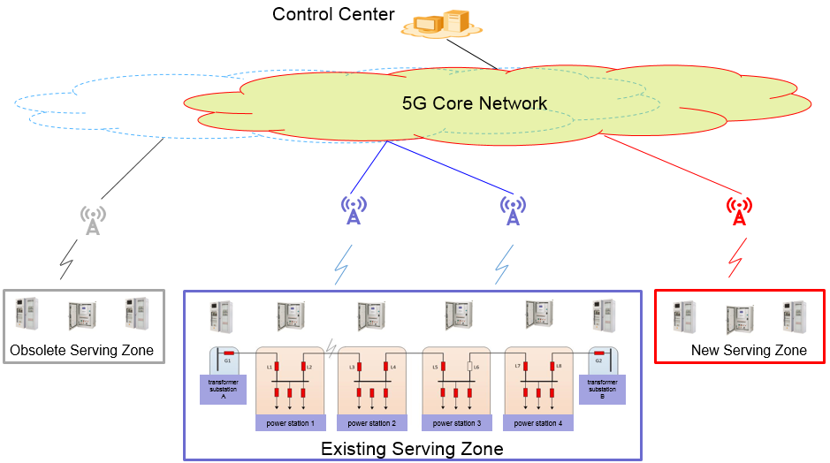

Figure 5.28-1: Scale up and down the 5G PVN’s coverage and capacity

### 5.28.2 Preconditions

The Power Grid Corporation A subscribes to private data communication service from Operator X.

The Operator X establishes (sets up) the 5G PVN to provide the data communication between the Control Center and STUs the Power Grid Corporation A has deployed.

The STUs can perform the “fault isolation” procedure in a required time-frame (e.g. 180ms).

### 5.28.3 Service flows

Development Company B developing a new residential area, and this area has an obsolete factory that has to be demolished.

Development Company B requires Power Grid Corporation A to provide the power in the new residential area, and remove the old STUs from the factory.

Power Grid Corporation A installs the power system and new STUs in the new residential area, and dismantles the old power system and STUs from the factory.

Power Grid Corporation A requests Operator X to add the new STUs into the private data communication service and remove the old STUs from the private data communication service.

The Operator X scales the 5G PVN’s coverage to provide data communication service for the new STUs and removes the resources that provided data communication service for the old STUs.

### 5.28.4 Post-conditions

Power Grid Corporation A provides the power to the new developed residential area. The 3GPP private communication service between new STUs and Control Center is enabled. The new STUs can complete the “fault isolation” procedure in the required time (e.g. 180ms). The STUs can use the multicast/broadcast addresses to send the failure reports or fault isolation results to the neighbour STUs and Control Center.

### 5.28.5 Potential Impacts or Interactions with Existing Services/Features

None identified.

### 5.28.6 Potential Requirements

[PR 5.28.6-1] The 5G network shall support the routing of non-IP packet (e.g. Ethernet packet) efficiently for private communication between UEs and Control Center (UE) .

[PR 5.28.6-2] The 5G network shall enable the network operator to scale up/down the 5G PVN, e.g., the coverage, capacity for efficient consumption of network resources.

[PR 5.28.6-3] The 5G network shall allow the operator to add/remove UEs to/from a 5G LAN-type service.

[PR 5.28.6-4] The 5G network shall enable the UEs to use the multicast/broadcast addresses to communicate with other UEs with required latency (e.g. 180ms).

## 5.29 Use case for restricting UE to a 3GPP private communication group based on UE's location

### 5.29.1 Description

In the enterprise, some equipment may be confidential, e.g., a server stores company’s confidential data.

This use case describes the restriction of UE to a specific 5G-LAN type service based on the UE’s location.

### 5.29.2 Preconditions

Bob are in the enterprise building and has multiple independent communications between UEs in the enterprise building. One of them is the communication between the confidential server.

### 5.29.3 Service flows

The MNO defines the group members for this enterprise 3GPP LAN as A, B and C (for the confidential server).

Bob requests to the 3GPP MNO to provide 5G-LAN type services to connect to some of its company’s equipments.

Bob is added to the LAN A, B and C.

### 5.29.4 Post-conditions

When Bob moves out of the office building, the 3GPP MNO disable Bob from LAN C. Bob is out of LAN C and cannot access to the confidential server any more.

Bob is still alive in LAN A and LAN B.

### 5.29.5 Potential Impacts or Interactions with Existing Services/Features

None identified.

### 5.29.6 Potential Requirements

[PR 5.29.6-1] The 5G system shall support to disable a UE from a 5G-LAN type service based on the UE’s location (e.g. when UE moves out the area where a particular 5G-LAN type service is allowed).

[PR 5.29.6-2] The 5G system shall ensure that disablement of a UE from a 5G-LAN type service has no impact on other 5G-LAN type services provided to the same UE.

[PR 5.29.6-3] The 5G system shall support to enable a UE for a 5G-LAN type service based on the UE’s location (e.g. when UE moves back to the area where the 5G-LAN type service is allowed).

## 5.30 Use case on creating and joining private multicast communication

### 5.30.1 Description

This use case describes the on-demand establishment of a multicast communications within subset of UEs that are members of the 5G PVN, e.g. equipment A create a multicast on demand and B and C joins this multicast to receive A’s multicast messages.

### 5.30.2 Preconditions

Equipment A, B, C, D and E are members of 5G PVN.Equipment A has been allocated a multicast address for multicast message.

Equipment B and C are interested in joining equipment A’ multicast.

### 5.30.3 Service flows

Equipment A create a on demand multicast communication.

Equipment B and C joins the multicast communications with A The MNO configures the network such that the multicast communications between A, B & C is enabled.

### 5.30.4 Post-conditions

Equipment B and C can receive A’ multicast message.

### 5.30.5 Potential Impacts or Interactions with Existing Services/Features

None identified.

### 5.30.6 Potential Requirements

[PR 5.30.6-1] The 5G system shall support on-demand establishment of a multicast session over a 5G PVN. .

[PR 5.30.6-2] The 5G system shall allow UEs to join the multicast within a 5G PVN.

# 6 Considerations

## 6.1 Considerations on security

[PR 5.1.4-1] A 5G LAN-type service shall support regulatory requirements.

[PR 5.2.3-3] The 5G LAN-type service shall support a 3GPP supported mechanism to authenticate legacy non-3GPP devices for 5G PVN access.

[PR 5.9.6-3] The 5G network shall be able to verify the identity of a UE requesting to join a specific private group communications.

[PR 5.19.6-1] The 5G network shall enable the MNO to authenticate and authorize a remote UE in indirect mode under a relay UE to use 5G LAN-type service.

[PR 5.22.6-1] The 5G system shall support a secure mechanism for an operator to provision 3GPP credentials to industrial IoT devices for 5G LAN-type services.

[PR 5.24.3.2] A 5G PVN shall provide integrity protection for communications between authorized UEs.

## 6.2 Considerations on charging

[PR 5.1.4-1] A 5G LAN-type service shall provide a mechanism to collect charging information based on resource usage (e.g., licensed or unlicensed spectrum, QoS, applications).

[PR 5.2.4-2] The 5G LAN-type service shall support a mechanism to collect charging information based on a UE’s MNO.

[PR 5.9.6-4] The 5G LAN-type service shall be able to collect charging information when a UE joins a specific private communication.

[PR 5.24.4.1] The 5G LAN-type service shall support a mechanism to collect charging information for both home and roaming UEs.

# 7 Potential Requirements

## 7.1 General

[PR 5.1.3-1] A 5G network shall be able to support a 5G LAN-type service with scalable capacity that is able to support a range of UEs from single digits to tens of thousands.

[PR 5.2.3-2] The 5G LAN-type service shall support authorized UEs, independent of the 3GPP subscription a UE may have.

[PR 5.2.4-1] The 5G LAN-type service shall provide a mechanism to provide local area coverage while minimizing interference from multi-channel UE.

[PR 5.5.6-1] The 3GPP 5G LAN-type service shall work with shared Radio Access Network configurations.

Editor’s note: it is FFS whether other parts of network infrastructure (e.g. local server hosting/mobile edge computing) can be also shared in this scenario.

[PR 5.6.6-1] The 3GPP 5G LAN-type service shall work over a wide area mobile network.

[PR 5.7.6-1] The 3GPP System shall support the on-demand establishment of UE to UE private data communication connections.

[PR 5.7.6-2] The 3GPP System shall support on-demand UE to UE private data communication connections with multiple types of data communication. At least IP and Ethernet should be supported.

[PR 5.13.6-1] The 5G network shall support 3GPP service continuity for 5G LAN-type service, i.e., the private communication between UEs shall not be interrupted when one or more UEs of the private communication move within the same PLMN that provides the 5G LAN-type service.

[PR 5.23.6-1] Based on operator policy and user permission the 5G system shall enable a UE to be aware whether or not a specific UE in the same 5G LAN-type service is available for communication, regardless of whether none, either or both UEs are roaming.

[PR 5.27.6-1] The 3GPP 5GLAN-type service shall be able to support LAN discovery mechanism.

[PR 5.28.6-1] The 5G network shall support the routing of non-IP packet (e.g. Ethernet packet) efficiently for private communication between UEs and Control Center (UE) .

[PR 5.28.6-2] The 5G network shall enable the network operator to scale up/down the 5G PVN, e.g., the coverage, capacity for efficient consumption of network resources.

[PR 5.28.6-3] The 5G network shall allow the operator to add/remove UEs to/from a 5G LAN-type service.

[PR 5.28.6-4] The 5G network shall enable the UEs to use the multicast/broadcast addresses to communicate with other UEs with required latency (e.g. 180ms).

[PR 5.29.6-1] The 5G system shall support to disable a UE from a 5G-LAN type service based on the UE’s location (e.g. when UE moves out the area where a particular 5G-LAN type service is allowed).

[PR 5.29.6-2] The 5G system shall ensure that disablement of a UE from a 5G-LAN type service has no impact on other 5G-LAN type services provided to the same UE.

[PR 5.29.6-3] The 5G system shall support to enable a UE for a 5G-LAN type service based on the UE’s location (e.g. when UE moves back to the area where the 5G-LAN type service is allowed).

## 7.2 5G PVN

[PR 5.1.3-4] A UE shall be able to select a 5G PVN for service.

[PR 5.1.3-6] A 5G PVN shall support use of unlicensed as well as licensed spectrum.

[PR 5.2.3-1] The 5G PVN shall support a mechanism to provide consistent QoE to UEs independent of the UEs’ MNO.

[PR 5.20.3-1] The 5G PVN shall support a suitable mechanism for a 5G PVN application to assign a private address to a UE for use within the 5G PVN, and to subsequently modify or remove that assignment.

[PR 5.20.3-2] A 5G PVN shall support routing based on a private addressing scheme within the 5G PVN.

[PR 5.24.3.1] A 5G PVN may have member UEs that are subscribed to different PLMNs, e.g., a 5G PVN may span multiple countries and have member UEs that have a subscription to a PLMN in their home country.

[PR 5.30.6-1] The 5G system shall support on-demand establishment of a multicast session over a 5G PVN.

[PR 5.30.6-2] The 5G system shall allow UEs to join the multicast within a 5G PVN.

## 7.3 Creation and management

[PR 5.8.5-1] The 5G network shall enable the MNO to create a 5G PVN for one or more UEs.

[PR 5.8.5-2] The 5G network shall enable the MNO to add one or more UEs to an existing 5G PVN.

[PR 5.8.5-2a] The 5G network shall enable the MNO to remove one or more UEs from an existing 5G PVN.

[PR 5.9.6-1] The 5G network shall enable the MNO to authorize the dynamic addition of a UE into a 5G LAN-type service.

[PR 5.9.6-2] The 5G network shall enable the new UE to communicate with other UEs within the same 5G LAN-type service.

[PR 5.10.6-1] The 5G network shall enable the MNO to remove a UE from a 5G LAN-type service.

[PR 5.10.6-2] The 5G network shall ensure that the removed UE has no interference with the 5G LAN-type service that the UE has been removed from.

[PR 5.10.6-3] The 5G network shall ensure that removal of UE from a particular 5G LAN-type service has no impact on other 5G LAN-type services including the same UE.

[PR 5.11.6-1] The 5G system shall enable the MNO to assign a UE to multiple independent 5G LAN-type services.

[PR 5.14.6-5] The 3GPP network shall enable the network operator to support point-to-point addressing as well as multicast addressing between the different UEs in a 5G LAN-type service. It is assumed that all UEs in a 5G LAN-type service use the same type of addresses (e.g. IP, Ethernet or other).

[PR 5.14.6-6] The 3GPP network shall enable the network operator to create, manage, and remove 5G LAN-type services including their related functionality (subscription data, routing and addressing functionality).

[PR 5.16.6-1] The 5G network shall enable the 3GPP network operator to define set of UEs allowed to communicate together in a secured way.

[PR 5.24.3-4] A 5G PVN shall support a mechanism to restrict service for a UE that is a member of a 5G PVN to only communicate with other UEs that are members of the same PVN.

## 7.4 Authorization

[PR 5.1.3-2] A 5G system shall provide a mechanism for an authorized 5G PVN administrator to enable or disable a UE from accessing the 5G PVN.

[PR 5.7.6-3] The 3GPP 5G network shall enable the MNO to pre-authorize on-demand UE to UE private communication connections through definition of a 5G LAN-type service. Only on-demand private communication requests from other members of the 5G LAN-type service are authorized.

[PR 5.7.6-4] The 3GPP 5G network shall enable the MNO to authorize on-demand UE to UE private communication connection within a 5G LAN-type service subject to third party authorization. The on-demand private communication connection will be established only in case of positive authorization by the third party (e.g. the owner of a UE).

## 7.5 Privacy

[PR 5.3.6-1] The 5G network shall support a restricted set of UEs to communicate privately amongst each other within a 5G LAN-type service even if these UEs are subscribers to different MNOs.

[PR 5.4.6-1] For residential scenarios, the 3GPP System shall enable the MNO to provide the same 3GPP 5G LAN-type service to any 5G UE, regardless of whether it is connected via public base stations, indoor small base stations connected via fixed access, or via relay UEs connected to either of these two types of base stations.

[PR 5.7.6-5] The 3GPP System shall ensure that no other UEs, even in the same 5G LAN-type service, can interfere with the UE to UE private communication.

[PR 5.14.6-3] The 3GPP network shall enable the network operator to ensure confidentiality and isolation of communications for the private group.

[PR 5.14.6-2] Only UEs that are members of the 5G LAN-type service shall be able to establish or maintain communication within a 5G LAN-type service.

[PR 5.14.6-3] The 3GPP network shall enable the network operator to ensure confidentiality and isolation of communications for the 5G LAN-type service.

[PR 5.16.6-2] The 5G system shall ensure the 3GPP communication between UEs of a 5G LAN-type service with no impact with communications of other UEs not belonging to this 5G LAN-type service.

[PR 5.23.6-3] The 3GPP 5G system shall enable the MNO to protect personally identifying information of the 5G LAN-type service users including from members of the same 5G LAN-type service while allowing members to address each other to enable communications.

[PR 5.24.3-3] A 5G PVN shall provide privacy on communications between authorized UEs.

## 7.6 Traffic types

[PR 5.1.3-2] A 5G LAN-type service shall support all media types (e.g., voice, data, multimedia).

[PR 5.4.6-2] For residential scenarios, the 3GPP 5G LAN-type service shall support traffic scenarios typically found in a home setting (from sensors to video streaming, relatively low amount of UEs per group, many devices are used only occasionally).

[PR 5.5.6-2] The 3GPP 5G LAN-type service shall support traffic scenarios typically found in an office setting (from sensors to very high data rates e.g. for conferencing, medium amount of UEs per group).

[PR 5.6.6-2] The 3GPP 5G LAN-type service shall support traffic scenarios typically found in an industrial setting (from sensors to remote control, large amount of UEs per group).

## 7.7 Indirect communication mode

[PR 5.19.6-2] The 5G network shall allow the MNO to add/remove a remote UE in indirect mode to/from a 5G LAN-type service.

[PR 5.19.6-3] The 5G network shall be able to provide a remote UE using 5G LAN-type service via a relay UE with same level of service as if the remote UE would be in direct mode (i.e. provide required QoS for the Ethernet packets transferred between remote UE and relay UE if they using 3GPP access).

[PR 5.19.6-4] The 5G network shall be able to support service continuity for the communication between a remote UE with other UEs belonging to the same private communication of a 5G LAN-type service, when the remote UE changes from one relay UE to another or when the UE changes between direct and indirect mode.

## 7.8 Service exposure

[PR 5.23.6-2] Based on operator policy and user permission the system shall enable an authorized 5G LAN-type service to know whether a UE is reachable for communication whether or not the UE is roaming.

[PR 5.23.6-4] The 3GPP 5G system shall be capable of exchanging with an application sufficient information to identify UEs for the purpose of granting permission to communicate via a 5G LAN-type service.

[PR 5.25.6-1] Based on MNO policy, the 5G network shall provide suitable APIs to allow a trusted 3rd party application to add/remove a UE to/from a specific 5G LAN type-service.

[PR 5.25.6-2] Based on MNO policy, the 5G network shall provide suitable APIs to allow a trusted 3rd party application to create a new 5G LAN-type service.

[PR 5.26.6-1] The 3GPP network operator shall provide an efficient mechanism to allow the application layer of a UE to get the identifiers of other UEs in the same set for 5G LAN-type service that may be used for application communication needs.

## 7.9 Ethernet

[PR.5.12.6-1] The 5G network shall support the routing of non-IP packet (e.g., Ethernet frame) efficiently for private communication between UEs within a 5G LAN-type service.

[PR.5.12.6-2] The 5G network shall be able to provide the required QoS (e.g., reliability, latency, and bandwidth) for non-IP packet (e.g. Ethernet frame) for private communication between UEs within a 5G LAN-type service.

[PR.5.17.6-001] The 3GPP system shall be able to support an Ethernet transport service.

[PR.5.17.6-003] The Ethernet transport service shall support routing based on information extracted from Virtual LAN (VLAN) ID by the 3GPP system.

[PR.5.17.6-004] The Ethernet transport service shall support routing based on information extracted by the 3GPP system from the Bridge Protocol Data Units created in the Ethernet network based on a Spanning Tree Protocol (e.g. RSTP).

[PR.5.17.6-005] The Ethernet transport service shall support the transport of Ethernet frames between UEs that an Ethernet device is connected to.

NOTE 1: If more than one Ethernet devices need to be connected to a UE, they can be connected using an Ethernet switch between the devices and the UE.

[PR.5.17.6-006] The Ethernet transport service shall support the transport of Ethernet broadcast frames.

[PR.5.17.6-007] The Ethernet transport service shall support traffic filtering and prioritization based on source and destination MAC addresses

[PR.5.17.6-008] The Ethernet transport service shall support traffic filtering and prioritization based on Ethertype (including multiple Ethertypes in double-tagging)

[PR.5.17.6-009] The Ethernet transport service shall support traffic filtering and prioritization based on 802.1Q VLAN tags (including double tagging).

[PR.5.18.6-1] The 5G system shall provide a mechanism to ensure the jitter for transporting Ethernet packets is limited by a certain time boundaries.

NOTE 2: The value of the time boundaries is TBD.

[PR.5.18.6-3] The Ethernet transport service shall support routing based on information extracted from the Ethernet header information created based on 802.1Qbv.

[PR.5.21.6-1] For infrastructure dedicated to high performance Ethernet applications, the 3GPP system shall support clock synchronization defined by IEEE 802.1AS across 5G-based Ethernet links with PDU-session type Ethernet.

[PR.5.21.6-2] For infrastructure dedicated to high performance Ethernet applications, the 3GPP system shall support clock synchronization defined by IEEE 802.1AS across 5G-based Ethernet links and other ethernet transports such as wired and optical (EPON.)

[PR.5.21.6-3] For infrastructure dedicated to high performance Ethernet applications, the accuracy of clock synchronization should be below 1µs.

[PR.5.21.6-4] For infrastructure dedicated to high performance Ethernet applications, the 3GPP system shall support time-aware scheduling with absolute cyclic time boundaries defined by IEEE 802.1Qbv [14] for 5G-based Ethernet links with PDU sessions type Ethernet.

[PR.5.21.6-5] For infrastructure dedicated to high performance Ethernet applications, absolute cyclic time boundaries shall be configurable for flows in DL direction and UL direction.

[PR.5.21.6-6] For infrastructure dedicated to high performance Ethernet applications, the 3GPP system shall support coexistence of hard-RT traffic following a time-aware schedule and lower priority traffic. The lower priority traffic cannot have a performance degrading impact on the hard-RT traffic.

# 8 Conclusion and Recommendations

The present study identified use cases and potential requirements for the application of 5G technology in Local Area Networks. A normative phase should follow. Note that there is some overlap with the FS_CAV study in the industrial LAN use cases. Therefore, the common parts of these two studies should be merged in the normative work.

Annex A (informative): Industrial Networking Model

## A.1 Performance Requirements

Some closed-loop applications typically rely on deterministic and periodic communication, where the controller sends commands to sensors and actuators periodically and the devices respond within a short cycle time. Performance requirements for critical-communication use cases have been specified in [8]. For example, for motion control, a cycle time of up to 2 ms is specified, which imposes a constraint of 1 ms on the delivery time. Further, a tight constraint of 1 s is specified for jitter.

To achieve these requirements, LAN design requires careful design for medium access, scheduling, etc. To achieve stringent latency and jitter requirements, packet routing is done at OSI layer 2 (Ethernet) instead of the OSI layer 3 (IP). Other important requirements, e.g., communication service availability and communication service reliability, require additional design considerations. For example, redundancy schemes are designed to achieve extremely high communication service availability.

## A.2 Networking Model

Most fieldbuses operate according to a reduced three-layer networking model. Figure A-1 shows a comparison between the OSI reference model and a fieldbus reference model [9, 10]. The fieldbus reference model has three layers – Physical Layer, Data Link Layer and Application Layer. All of the fieldbuses defined in IEC 61784 operate according to this model [9]. In a reduced model, there are fewer interfaces between different networking layers, and therefore, delays due to passing information between the layers can be reduced. This model tends to make the implementation robust. Further, delays due to per- layer processing can be reduced [10]. In a reduced model, network layer functionality can be implemented in either the Data Link Layer, or the Application Layer. For example, the Ethernet Data Link Layer can perform routing in a LAN.

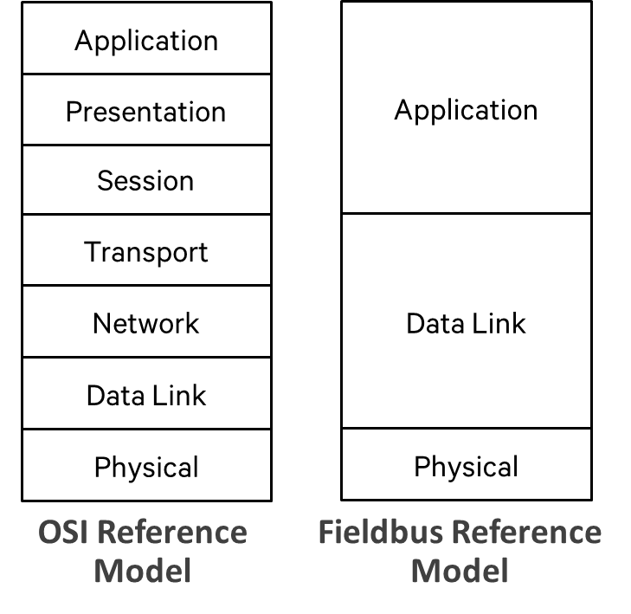

Figure A-1: OSI and fieldbus reference model [9, 10].

## A.3 Network Topology

A typical factory network contains controllers, I/O devices, Ethernet switches, and network management and configuration servers. Figure A-2 shows two examples of network topologies.

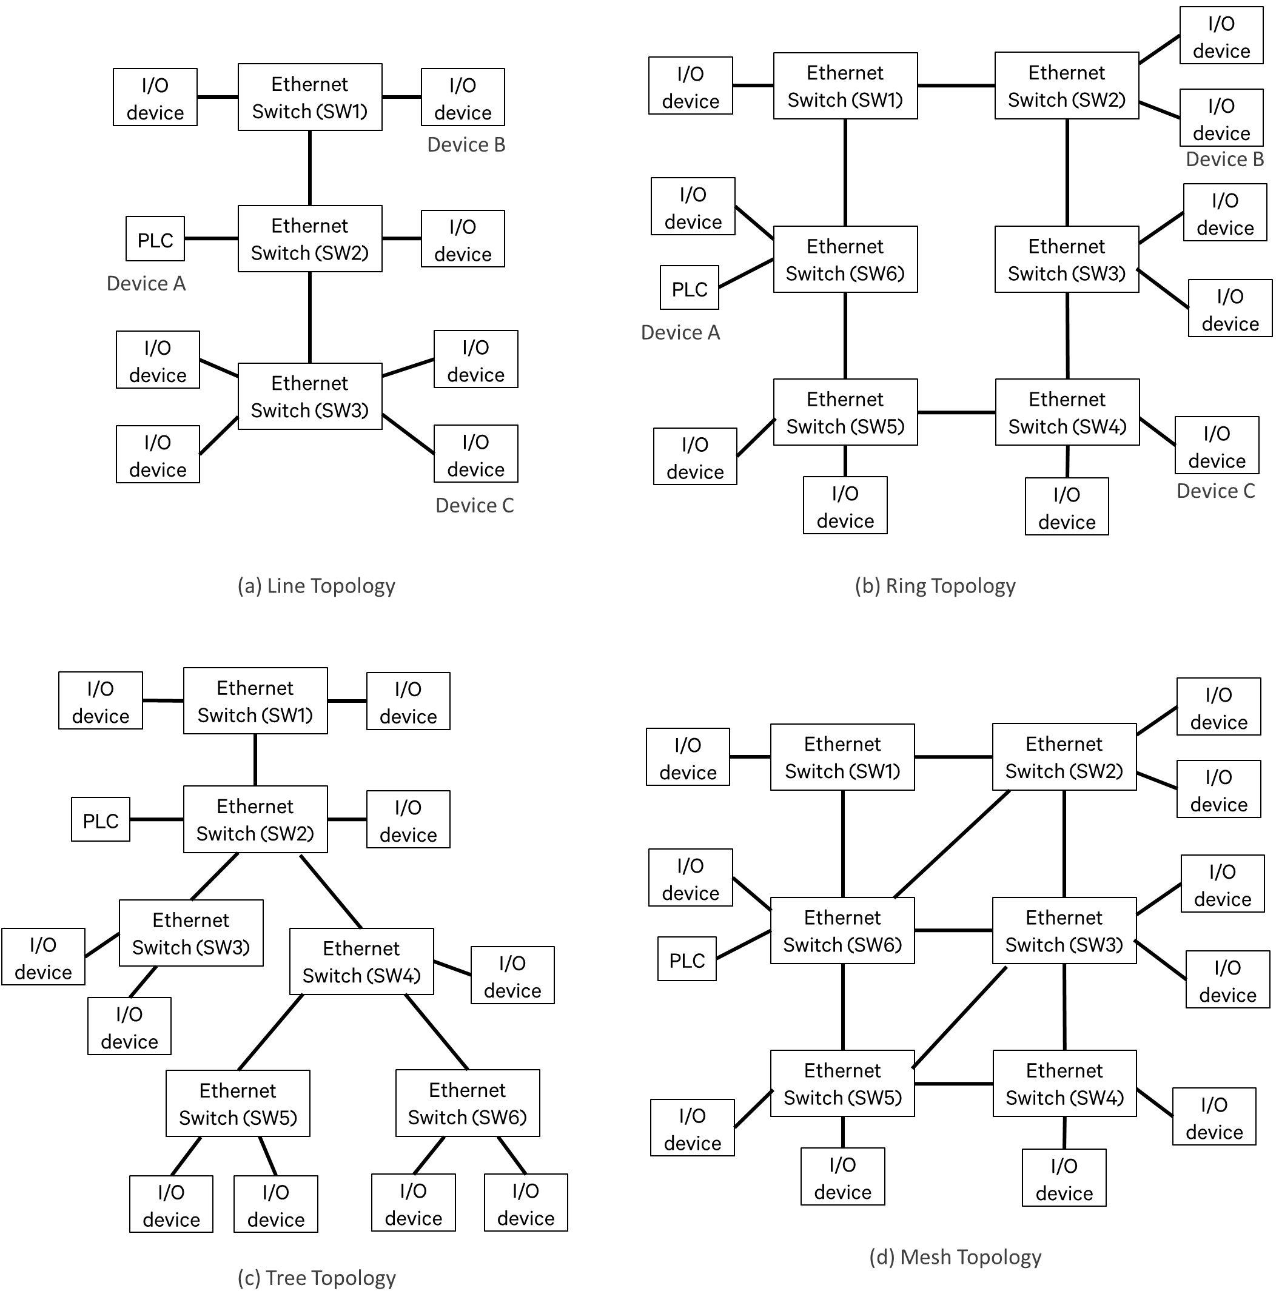Figure A-2: Network topology examples.

**Annex B:**  
Change history

|  |  |  |  |  |  |  |  |  |  |  |  |
| --- | --- | --- | --- | --- | --- | --- | --- | --- | --- | --- | --- |
| Change history | | | | | | | | | | | |
| **TSG SA#** | **SA Doc.** | **SA1 Doc** | **Spec** | **CR** | **Rev** | **Rel** | **Cat** | **Subject/Comment** | **Old** | **New** | **WI** |
| [SP-80](http://portal.3gpp.org/desktopmodules/Specifications/SpecificationDetails.aspx?specificationId=3281) | SP-180333 | [S1-181567](http://www.3gpp.org/ftp/tsg_sa/WG1_Serv/TSGS1_82_Dubrovnik/Docs/S1-181567.zip) | [22.821](http://portal.3gpp.org/desktopmodules/Specifications/SpecificationDetails.aspx?specificationId=3281) | 0002 | 1 | [Rel-16](http://portal.3gpp.org/desktopmodules/Release/ReleaseDetails.aspx?releaseId=191) | F | Section 4.1 of 5GLAN TR22.821 | 16.0.0 | 16.1.0 | [FS_5GLAN](http://portal.3gpp.org/desktopmodules/WorkItem/WorkItemDetails.aspx?workitemId=760007) |