3GPP TR 22.822 V16.0.0 (2018-06)

Technical Report

3rd Generation Partnership Project;

Technical Specification Group Services and System Aspects;

Study on using Satellite Access in 5G;

Stage 1

(Release 16)

** 

The present document has been developed within the 3rd Generation Partnership Project (3GPP TM) and may be further elaborated for the purposes of 3GPP.  
The present document has not been subject to any approval process by the 3GPPOrganizational Partners and shall not be implemented.  
This Report is provided for future development work within 3GPPonly. The Organizational Partners accept no liability for any use of this Specification.  
Specifications and Reports for implementation of the 3GPP TM system should be obtained via the 3GPP Organizational Partners' Publications Offices.

Keywords

Satellite, Access

***3GPP***

Postal address

3GPP support office address

650 Route des Lucioles - Sophia Antipolis

Valbonne - FRANCE

Tel.: +33 4 92 94 42 00 Fax: +33 4 93 65 47 16

Internet

http://www.3gpp.org

***Copyright Notification***

No part may be reproduced except as authorized by written permission.  
The copyright and the foregoing restriction extend to reproduction in all media.

© 2018, 3GPP Organizational Partners (ARIB, ATIS, CCSA, ETSI, TSDSI, TTA, TTC).

All rights reserved.

UMTS™ is a Trade Mark of ETSI registered for the benefit of its members

3GPP™ is a Trade Mark of ETSI registered for the benefit of its Members and of the 3GPP Organizational Partners  
LTE™ is a Trade Mark of ETSI registered for the benefit of its Members and of the 3GPP Organizational Partners

GSM® and the GSM logo are registered and owned by the GSM Association

Contents

Foreword 6

1 Scope 7

2 References 7

3 Definitions, symbols and abbreviations 7

3.1 Definitions 7

3.2 Abbreviations 8

4 Categorisation of use cases for satellite access in 5G 8

4.1 Introduction 8

4.2 “Service Continuity” Category 9

4.3 “Service Ubiquity” Category 9

4.4 “Service Scalability” Category 9

5 Use Cases 9

5.1 Roaming between terrestrial and satellite networks 9

5.1.1 Description 9

5.1.2 Pre-conditions 10

5.1.3 Service Flows 10

5.1.4 Post-conditions 11

5.1.5 Potential Requirements 11

5.2 Broadcast and multicast with a satellite overlay 11

5.2.1 Description 11

5.2.2 Pre-conditions 11

5.2.3 Service Flows 11

5.2.4 Post-conditions 12

5.2.5 Potential Impacts or Interactions with Existing Services/Features 12

5.2.6 Potential Requirements 12

5.3 Internet of Things with a satellite network 12

5.3.1 Description 12

5.3.2 Pre-conditions 12

5.3.3 Service Flows 12

5.3.4 Post-conditions 12

5.3.5 Potential Impacts or Interactions with Existing Services/Features 13

5.3.6 Potential Requirements 13

5.4 Temporary use of a satellite component 13

5.4.1 Description 13

5.4.2 Pre-conditions 13

5.4.3 Service Flows 13

5.4.4 Post-conditions 14

5.4.5 Potential Impacts or Interactions with Existing Services/Features 14

5.4.6 Potential Requirements 14

5.5 Optimal routing or steering over a satellite 14

5.5.1 Description 14

5.5.2 Pre-conditions 14

5.5.3 Service Flows 14

5.5.4 Post-conditions 15

5.5.5 Potential Impacts or Interactions with Existing Services/Features 15

5.5.6 Potential Requirements 15

5.6 Satellite transborder service continuity 15

5.6.1 Description 15

5.6.2 Pre-conditions 16

5.6.3 Service Flows 16

5.6.4 Post-conditions 16

5.6.5 Potential Impacts or Interactions with Existing Services/Features 17

5.6.6 Potential Requirements 17

5.7 Global satellite overlay 17

5.7.1 Description 17

5.7.2 Pre-conditions 18

5.7.3 Service Flows 18

5.7.4 Post-conditions 18

5.7.5 Potential Impacts or Interactions with Existing Services/Features 18

5.7.6 Potential Requirements 18

5.8 Indirect connection through a 5G satellite access network 18

5.8.1 Description 18

5.8.2 Pre-conditions 19

5.8.3 Service Flows 20

5.8.4 Post-conditions 20

5.8.5 Potential Impacts or Interactions with Existing Services/Features 20

5.8.6 Potential Requirements 20

5.9 5G Fixed Backhaul between NR and the 5G Core 21

5.9.1 Description 21

5.9.2 Pre-conditions 21

5.9.3 Service Flows 21

5.9.4 Post Conditions 21

5.9.5 Potential Impacts or Interactions with Existing Services/Features 21

5.9.6 Potential Requirements 22

5.10 5G Moving Platform Backhaul 22

5.10.1 Description 22

5.10.2 Pre-conditions 22

5.10.3 Service Flows 22

5.10.4 Post-conditions 22

5.10.5 Potential Impacts or Interactions with Existing Services/Features 22

5.10.6 Potential Requirements 22

5.11 5G to Premises 23

5.11.1 Description 23

5.11.2 Pre-conditions 23

5.11.3 Service Flows 23

5.11.4 Post-conditions 23

5.11.5 Potential Impacts or Interactions with Existing Services/Features 23

5.11.6 Potential Requirements 23

5.12 Satellite connection of remote service centre to off-shore wind farm 24

5.12.1 Description 24

5.12.2 Pre-conditions 24

5.12.3 Service Flows 24

5.12.4 Post-conditions 25

5.12.5 Potential Impacts or Interactions with Existing Services/Features 25

5.12.6 Potential Requirements 25

6 5QI for a 5G system with satellite access 25

6.1 Background 25

6.2 Potential Requirements 26

7 Considerations 26

7.1 Considerations on security 26

7.2 Considerations on charging 26

7.3 Considerations on roaming 27

7.4 Other considerations 27

8 Potential Requirements 27

8.1 Connectivity related requirements 27

8.2 Roaming related requirements 27

8.3 QoS related requirements 28

8.4 UE related requirements 28

8.5 Security related requirements 29

8.5.1 Regulatory requirements 29

9 Conclusion and Recommendations 29

Annex A: Main characteristics of 5G satellite components 30

A.1 Main characteristics of 5G satellite access networks 30

A.1.1. General 30

A.1.2 Class of orbit 30

A.1.3 Geometrical coverage of satellite and propagation delay 31

A.1.3 Radio coverage 33

A.2 5G Satellite network-based architectures 33

Annex B: Change history 35

# Foreword

This Technical Report has been produced by the 3rd Generation Partnership Project (3GPP).

The contents of the present document are subject to continuing work within the TSG and may change following formal TSG approval. Should the TSG modify the contents of the present document, it will be re-released by the TSG with an identifying change of release date and an increase in version number as follows:

Version x.y.z

where:

x the first digit:

1 presented to TSG for information;

2 presented to TSG for approval;

3 or greater indicates TSG approved document under change control.

y the second digit is incremented for all changes of substance, i.e. technical enhancements, corrections, updates, etc.

z the third digit is incremented when editorial only changes have been incorporated in the document.

# 1 Scope

TS 22.261 (Service requirements for next generation new services and markets) requires that the 5G system shall be able to provide services using satellite access. It further specifies that the 5G system shall support service continuity between land based 5G access and satellite based access networks owned by the same operator or by an agreement between operators.

The present document presents the results of a study on using satellite access in 5G. Use cases for the provision of services when considering the integration of 5G satellite-based access components in the 5G system are identified. This leads to the associated identification of existing / planned, as well for new, services and the corresponding modified or new requirements. The requirements on set-up / configuration / maintenance of the features of UE’s when using satellite components combined with other components from the 5G system are addressed as well as regulatory requirements when moving to (or from) satellite from (or to) terrestrial networks

# 2 References

The following documents contain provisions which, through reference in this text, constitute provisions of the present document.

- References are either specific (identified by date of publication, edition number, version number, etc.) or non‑specific.

- For a specific reference, subsequent revisions do not apply.

- For a non-specific reference, the latest version applies. In the case of a reference to a 3GPP document (including a GSM document), a non-specific reference implicitly refers to the latest version of that document *in the same Release as the present document*.

[1] 3GPP TR 21.905: "Vocabulary for 3GPP Specifications".

[2] 3GPP TS 22.261: ”Service requirements for next generation new services and markets”.

[3] 3GPP TS 23.501: ”System Architecture for the 5G System”.

# 3 Definitions, symbols and abbreviations

## 3.1 Definitions

For the purposes of the present document, the terms and definitions given in 3GPP TR 21.905 [1] and the following apply. A term defined in the present document takes precedence over the definition of the same term, if any, in 3GPP TR 21.905 [1].

The definitions given in [2] are also applicable in this report.

The definitions given in [3] are also applicable in this report

**Satellite**: a space-borne vehicle embarking a bent pipe payload or a regenerative payload telecommunication transmitter, placed into Low-Earth Orbit (LEO) typically at an altitude between 500 km to 2000 km, Medium-Earth Orbit (MEO) typically at an altitude between 8000 to 20000 lm, or Geostationary satellite Earth Orbit (GEO) at 35 786 km altitude.

**Satellite network:** Network, or segments of network, using a space-borne vehicle to embark a transmission equipment relay node or base station.

**Satellite RAT**: a RAT defined to support at least one satellite.

**5G Satellite RAT**: a Satellite RAT defined as part of the New Radio.

**5G satellite access network**: 5G access network using at least one satellite.

**Terrestrial:** located at the surface of Earth.

**Terrestrial network:** Network, or segments of a network located at the surface of the Earth.

## 3.2 Abbreviations

For the purposes of the present document, the abbreviations given in 3GPP TR 21.905 [1] and the following apply. An abbreviation defined in the present document takes precedence over the definition of the same abbreviation, if any, in 3GPP TR 21.905 [1].

5QI 5G QoS Identifier

ALM Additive Layer Manufacturing

AMF Access and mobility Management Function

CN Core Network

D2D Device to Device

eMBB enhanced Mobile Broadband

eMBMS enhanced Multimedia Broadcast & Multimedia System over LTE

FFS For Further Study

GEO Geostationary Earth Orbit

gNB next Generation Node B

GSM Global System for Mobile

HEO Highly Elliptical Orbit

HFT High Frequency Trading

HQ Head Quarter

IoT Internet of Things

LEO Low Earth Orbit

LI Lawful Intercept

LTE Long Term Evolution

MEO Medium Earth Orbiting

mMTC massive Machine Type Communications

MNO Mobile Network Operator

Nb-IoT Narrow band Internet Of Things

NGSO Non-Geostationary Satellite Orbit

NR New Radio

QI Quality Indicator

QoS Quality of Service

RAN Radio Access Network

RAT Radio Access Technology

SE Stock Exchange

SMF Session Management Function

SNO Satellite Network Operator

TR Technical Report

TS Technical Specification

TV Television

UE User Equipment

VIP Very Important Person

# 4 Categorisation of use cases for satellite access in 5G

## 4.1 Introduction

On the basis of the analysis of the characteristics of satellite networks, it is possible to define 3 main categories that will be used in the following parts of the documents. Categories are not exclusive from each other: a use case may contribute to one or more categories.

The following sub-clauses define and illustrate the corresponding categories:

## 4.2 “Service Continuity” Category

The deployment of terrestrial networks can be driven by the coverage of population centres rather than by the coverage of geographical areas. This can lead to the creation of geographical areas where access to the 5G services through the radio coverage of a terrestrial network will not be possible

In such cases, UE’s whether associated with pedestrian users, or embarked on moving land mobile terrestrial platforms (e.g. a car, a coach, a truck, a train), airborne platforms (e.g. a commercial or a private jet) or maritime platforms (e.g. a maritime vessel) can experience conditions where 5G services cannot be offered continuously by a single or a combination of terrestrial networks during the journey of the UE.

Use cases described under this category will address the opportunity for users to be provided a continuous access to services granted by the 5G system, whilst moving between terrestrial and satellite networks. Use cases including fleets of such UE’s (whether dispersed or locally grouped) would also be included in this category.

## 4.3 “Service Ubiquity” Category

Terrestrial networks may not be available due either to economic rationales (expectation for revenues not meeting the minimum threshold for profitability), or disasters (e.g. Earthquakes, floods) leading to a temporary outage or total destruction of the terrestrial network infrastructures that need to be restored.

A number of potential users may wish to access 5G services in these “un-served” or “underserved” areas by terrestrial networks, but will be prevented to do so, unless 5G satellite access networks provide such a service.

Example uses cases are:

- Internet of Things (for Agriculture, Critical Infrastructures Metering & Control –pipelines, Asset Tracking/Tracing)

- Public Safety and associated emergency networks

- Home access

## 4.4 “Service Scalability” Category

In comparison with terrestrial networks, satellite networks have a large coverage, typically corresponding to tens of thousands of cells of a terrestrial network. Satellites are therefore efficient in multicasting or broadcasting a similar content over a large area, and potentially directly to user equipment. Similarly, a satellite network can also contribute to off-loading traffic from terrestrial networks during the busy hours by multicasting or broadcasting non time sensitive data in non-busy hours.

Use cases associated to this category would be for instance the distribution of rich to very rich TV content due to new media encoding format (e.g. 3D, Ultra High Definition).

# 5 Use Cases

## 5.1 Roaming between terrestrial and satellite networks

### 5.1.1 Description

Shipping company Worldwide wants to track and trace containers. In order to do so, it has installed a UE on the containers that can report location and other parameters (e.g. temperature in the container) to a central server.

[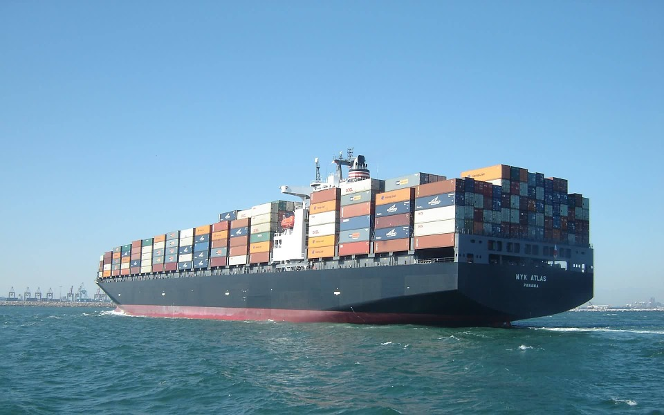](https://www.google.nl/url?sa=i&rct=j&q=&esrc=s&source=images&cd=&cad=rja&uact=8&ved=0ahUKEwiX19SMg8HXAhVRZlAKHXBZBTIQjRwIBw&url=https%3A%2F%2Fpixabay.com%2Fen%2Fcontainer-ship-cargo-ship-cargo-560789%2F&psig=AOvVaw3baPHK7ENnK2oOozPAs6Zv&ust=1510850495206913)

Figure 5.1.1-1: Need for tracking and tracing of containers

Shipping company Worldwide has equipped the UEs with subscriptions of terrestrial operator TerrA. TerrA has roaming contracts with most terrestrial operators worldwide in order to enable shipping company Worldwide to track and trace containers wherever there is terrestrial coverage.

As containers also travel in areas where there is no terrestrial coverage, shipping company Worldwide has ensured that the UEs on the containers are also equipped with satellite access capabilities. This implies that containers can e.g. be tracked when they are on-board of a ship on the ocean or are travelling by train/truck through remote areas without terrestrial network coverage.

Operator TerrA recognises the importance of worldwide roaming and therefore also has established roaming agreements with satellite network operators such a SatA.

The satellite access for the UEs on the containers requires direct line of sight. That is not always available (e.g. when a container is at the bottom of a stack on a container ship). Therefore, the UE on the container can connect to the network as a Remote UE, using the UE on another container with direct line of sight as Relay. Alternatively, the container ship provides one or more Relay UEs.

### 5.1.2 Pre-conditions

UE on the container has a subscription with TerrA.

TerrA has roaming agreements with terrestrial operator TerrB and satellite operator SatA.

### 5.1.3 Service Flows

A container from Shipping company Worldwide is loaded onto a ship in Rotterdam harbour. The container is connected via network operator TerrA for tracking and tracing

The ship leaves Rotterdam harbour and moves out of coverage of TerrA.

The UE now selects the network of SatA to provide connectivity.

When needed, the UE can use a Relay UE to connect to the SatA network.

After a few weeks at sea, the ship approaches Shanghai harbour.

Even though there is still network coverage from SatA, the network selection policy for the UE on the container indicates that the terrestrial network from TerrB is preferred. Therefore, the UE selects TerrB.

After the container is unloaded from the ship, it is loaded onto a train. Whilst the train travels to its destination in China connectivity for tracking and tracing is provided by TerrB.

### 5.1.4 Post-conditions

The UE has worldwide connectivity via terrestrial and/or satellite networks. Where there are both terrestrial and satellite networks available, it can select the optimal network.

### 5.1.5 Potential Requirements

[PR 5.1.5-001] The 5G system shall provide connectivity with a 5G satellite access network.

[PR 5.1.5-002] A 5G system with satellite access, shall enable roaming between 5G satellite access networks and 5G terrestrial access networks.

[PR 5.1.5-003] A 5G system with satellite access shall support network reselection based on home operator policy, even when a UE is still in coverage of its current network.

NOTE: It is assumed that the home operator agrees on a network selection policy with its customer.

## 5.2 Broadcast and multicast with a satellite overlay

### 5.2.1 Description

In Release 14, 3GPP has specified features to enable mobile network deliver television services in new and improved way. Television and content providers may directly provide their services over standardized interfaces. Among many enhancements to the system, highlights include e.g. greater radio broadcast range, free-to-air services and transparent mode delivery of digital video signals. Advances in Release 14 allow improved support for television services to both mobile devices and stationary TV sets over eMBMS (enhanced multimedia broadcast and multicast system over LTE) and unicast. Advances made include a standardized interface between mobile network operators and service providers used for media delivery and control, radio enhancements for improved broadcast support and system enhancements to allow delivery of free-to-air receive-only services. This approach can be extended to a satellite overlay, addressing not only video content but also any form of digital content that would need to be distributed towards several UEs taking into account the benefits of the large geographical coverage of satellite networks, with a stand-alone receive only mode, or as a complement to a two-way mode of operation.

### 5.2.2 Pre-conditions

Consider a use case where a mobile network operator (MNO) provides services over a radio coverage M. M mainly addresses urban and sub-urban areas. MNO has included in its service package the distribution of television channels or video streaming services. The demand for these distribution services is increasing steadily with the number of programs available, as well as with the quality of the content. This leads in some cases to the saturation of the transmission capabilities of MNO, yet UEs being subscribed to the service shall receive the corresponding content.

A satellite network operator SNO provides services over a radio coverage S. S might includes M. S can also address UEs that are located beyond M.

At any given time, UEs being subscribed to the services of MNO may be in the radio coverage a) M and S simultaneously, b)solely S or, c) solely M (e.g. indoor).

### 5.2.3 Service Flows

Content to be delivered to the UEs is broadcast over the satellite network SNO.

UEs that are not within S (i.e. out of reach of SNO), but are within M (within the reach of MNO)are provided the content through the mobile network.

UEs combine the data flows received either from the MNO or from the SNO.

### 5.2.4 Post-conditions

MNO has maintained the QoS of the content delivery for UEs being subscribed to the content delivery service, while MNO has been able to cope with the increasing traffic on its infrastructure.

MNO has offered an improved QoS of the content delivery for some UEs, without increasing unduly the traffic on its mobile network infrastructure.

### 5.2.5 Potential Impacts or Interactions with Existing Services/Features

None identified.

### 5.2.6 Potential Requirements

[PR 5.2.6-001] A 5G system supporting satellite access shall be able to optimise the delivery of content when using the 5G satellite access network.

[PR 5.2.6-002] A UE supporting satellite access shall be able to send and receive in parallel via a satellite access network and a terrestrial access network.

## 5.3 Internet of Things with a satellite network

### 5.3.1 Description

A 5G satellite network can be based a constellation of one or multiple satellites. The satellites are placed in LEO to allow connectivity of UEs with limited RF and energy capabilities. The constellation of satellites may offer a continuous service, with a satellite covering any UE with a continuous global coverage.

An IoT (Internet of Things) service provider delivers connectivity for its customers throughout a given area thanks to the access to the 5G system and several associated mobile networks and wishes to guarantee geographic coverage extension.The satellite component may provide:

- A5G satellite access network to allow a radio coverage extension to the terrestrial networks.

- As a 5G satellite network, providing extension to other 5G terrestrial networks through a roaming agreement.

### 5.3.2 Pre-conditions

A fleet of vehicles transporting VIP’s will be moving from Point A to Point B. The trip of the VIP’s has been organised in a nice area in order to provide comfort and pleasure to each of the participants. The position of the vehicles transporting the VIP’s has to be continuously reported automatically to a security officer. However, before the planning of this event the existing 5G terrestrial networks or technologies could not provide 100% continuous coverage.

A LEO satellite network is available. The area of service of this satellite network includes the area of unavailability of the cellular networks where the VIPs will be transported.

### 5.3.3 Service Flows

UEs are placed on the vehicles with the VIP’s.

When within reach of a cellular network, UEs report position through this network.

When within reach of the satellite network, but outside reach of a terrestrial network, UEs report position through this network.

### 5.3.4 Post-conditions

The position of the VIPs is reported on a continuous basis to the security officer.

### 5.3.5 Potential Impacts or Interactions with Existing Services/Features

The 5G system shall define conditions to avoid instability of the offered Quality of services when switching from the 5G satellite access network to/and from the terrestrial access network.

### 5.3.6 Potential Requirements

[PR 5.3.6.001] A 5G system supporting satellite access and mMTC and/or Nb-IoT services shall also support mMTC and/or Nb-IoT services on the 5G satellite access.

[PR 5.3.6.002] A 5G system with satellite access shall allow optimal selection of a 5G satellite access network or of a 5G terrestrial access network.

NOTE: Selection between satellite and terrestrial access networks can be based on e.g. operator policy, subscription settings, or QoS settings.

[PR 5.3.6.003] A UE supporting satellite access and mMTC and/or Nb-IoT services in 5G networks shall also be able to support mMTC and/or Nb-IoT services through the satellite access network.

## 5.4 Temporary use of a satellite component

### 5.4.1 Description

(A) network operator(s) ha(s) deployed 5G terrestrial RATs as part of the 5G system over a given geographical area. The geographical area may encompass several countries, and the infrastructure where the 5G terrestrial network is deployed includes RANs as well as CNs.

A crisis occurs: a significant earthquake, a flood, or a war. Elements of the RATs are partially or completely destroyed. Accesses to the services that are normally delivered by the terrestrial network are not available anymore.

At the same time, the crisis leads to a situation of urgency for the population, as well for the public institution in order to provide first aid support, and to restore security and to organise logistics support.

Alice is a 5G field engineer. She is located in the area of the crisis, where she is deploying and maintaining 5G terrestrial infrastructures. Alice wants to be provided with support from remote HQ to help restore the 5G infrastructure.

Bob is a Crisis Management Officer. He is in charge of a Search & Rescue team. He needs to interact with deployed and spread teams to coordinate actions: the search area goes beyond Device to Device (D2D) capabilities, or deployable on field capabilities for 5G terrestrial coverage.

### 5.4.2 Pre-conditions

(A) 5G satellite RAT(s) is also deployed with a radio coverage addressing the same geographical area.

Alice and Bob are equipped with UEs with satellite access capabilities.

### 5.4.3 Service Flows

Alice and Bob have lost access to their nominal 5G terrestrial networks.

A number of network operators with access to the satellite component grant access to their network with a minimum set of service (such as voice, messaging, mail) so as to provide to each UEs under the satellite coverage a guaranteed access.

Public and professional users such as Alice are provided with a network slice that guarantees a certain percentage of the allowable traffic; a policy is put in place to adjust offer with respect to demand.

Mission critical forces to which Bob belongs are provided another slice with another part of the allowable traffic so as to guarantee the support to their mission.

### 5.4.4 Post-conditions

During a transition period, before restoration to a normal situation with their nominal 5G terrestrial networks,

- Alice has access to a minimum set of communication services.

- Bob has access to a minimum set of communication services to perform his duty.

### 5.4.5 Potential Impacts or Interactions with Existing Services/Features

For the purpose of mission critical services, the 5G system shall have the capability to enable connectivity through (a) 5G satellite RAT(s).

For non-mission critical services, the 5G system shall have the capability to route some traffic through (a) 5G satellite RAT(s) to deliver a minimum set of services (such a voice, data traffic) for specific sets of users.

### 5.4.6 Potential Requirements

[PR 5.4.6.001] A 5G system with satellite access shall support at least one 5G satellite RAT.

[PR 5.4.6.002] In a 5G system with satellite access, UEs with satellite access shall support at least one 5G satellite RAT.

## 5.5 Optimal routing or steering over a satellite

### 5.5.1 Description

Alice owns a factory to produce mechanical parts under Additive Layer Manufacturing processes. Thanks to an attractive financing scheme, Alice has installed a first factory FF in a rather remote area, the factory is at the edge of the radio coverage of a 5G terrestrial RAT, the performance of eMBB services can be somewhat limited at a certain time of the day. Alice has also installed a second factory SF, in a further remote area, with an even more interesting financing scheme, however there is no 5G terrestrial access network in this area.

The factories are almost fully automated, with a minimum number of staff allocated to operations, maintenance and surveillance of the production. Each machine is being uploaded with ALM electronic files for the production of pieces to be manufactured. With the success of ALM processes, the complexity of ALM pieces and the volume of ALM electronic files have increased over time. For FF & SF, delays to transfer ALM files are increasing, saturating resources that could be used otherwise.

Alice would like also to buy new machines to further automate its processes and command and monitor the machines from the remote HQ, with a requirement that video control and reactivity are mandatory.

### 5.5.2 Pre-conditions

FF & SF are placed under the radio coverage of a 5G satellite access network,

If needed UEs located within the factory can access the satellite network through relay nodes being in direct visibility with the satellites.

### 5.5.3 Service Flows

Services are differentiated in the following with respect to unconstrained (or constrained) latency, when the use of the satellite route is acceptable (or not).

The following flows can be offered for each of the factories:

Table 1: Possible 5G Satellite or 5G terrestrial connectivity according to latency requirements

|  |  |  |  |  |
| --- | --- | --- | --- | --- |
| Connection | Characteristics | Path | Path | Path |
| Satellite | Non Latency Constrained |  | Down | Down |
| Terrestrial | Latency Constrained | Down |  |  |
| Satellite | Non Latency Constrained |  |  | Up |
| Terrestrial | Latency Constrained | Up | Up |  |
| Factory |  | **FF** | **FF** | **FF,SF** |

### 5.5.4 Post-conditions

The ALM files can be delivered to FF and SF.

For FF the delivery of the files can also be performed without saturating communication services that can be used for other services that are more latency sensitive.

### 5.5.5 Potential Impacts or Interactions with Existing Services/Features

The 5G system shall be capable of combining available terrestrial and satellite networks to optimise the connectivity of UE in accordance with the requested QoS.

### 5.5.6 Potential Requirements

[PR 5.5.6.001] In a 5G system with satellite access, UEs with terrestrial access and supporting satellite access networks shall be capable of dual connectivity with a satellite access network and a terrestrial access network.

[PR 5.5.6.002] A 5G system with satellite access shall be capable of establishing independently uplink and downlink connectivity through the satellite and terrestrial access networks.

NOTE: Decisions on routing between satellite and terrestrial access networks can be based on e.g. operator policy, subscription settings, or QoS settings.

## 5.6 Satellite transborder service continuity

### 5.6.1 Description

The radio coverage of a 5G terrestrial network associated to operator TA in country A. is made of a number of areas matching its deployment schedule. The same approach is followed by network operator TB in country B.

A satellite SA, which radio coverage partially overlaps the coverage of TA & TB, is deployed.

A satellite SB, which radio coverage partially overlaps the coverage of TA & TB, is deployed.

UEs having access to TA & TB can also have access to SA and SB.

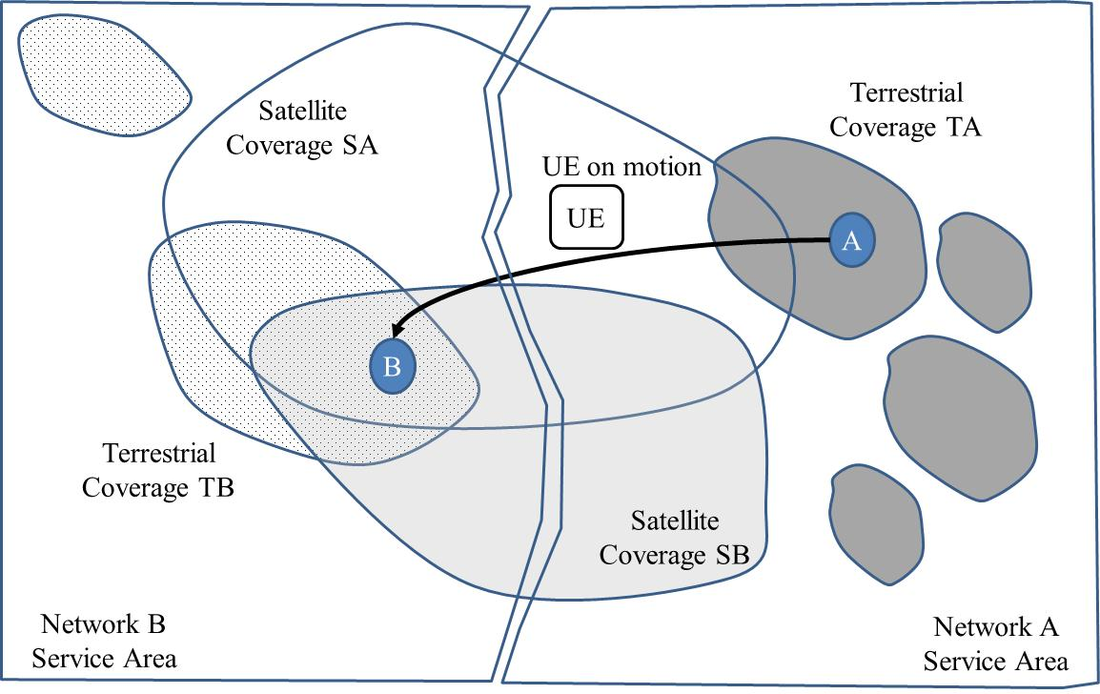

Figure 1: Multiple countries and multiple terrestrial networks that include satellite access

The satellite component may be a satellite access network with one of the following configurations:

- A 5G satellite RAT, providing a radio coverage extension of an available 5G access network of TA or TB.

- A satellite access network providing connection to 5G CN of TA or TB.

- A stand-alone 5G network, with independent access network and core capabilities, with roaming agreements with TA and TB.

### 5.6.2 Pre-conditions

Alice leaves home in the capital city of A to go visiting her dear friend Bob in the capital city of B.

Alice and Bob are well known experts from the 5G industry. Alice wants to report to Bob on the last updates of the sector, and she wants to takes the opportunity of the travel to download the latest news from the 3GPP web site, as well as from other technical and scientific electronic libraries.

### 5.6.3 Service Flows

- During the trip of Alice, her UE is connected first to the 5G terrestrial network of TA.

- Then, since TA has established an agreement to use also a satellite component, Alice’s UE is connected to TA’s network through the SA satellite component when the terrestrial component of TA becomes unavailable. This connectivity of Alice’s UE can be achieved through a relay node UE located on board the train platform;

- Following, the train leaves the Service Area of Operator A and enters the Service Area of Network B. Still, no terrestrial coverage is available, and Satellite coverage of SA is the only one available. The UE of Alice is still connected through SA.

- Following, terrestrial coverage is still not available; satellite coverages SA and SB are available to Network operator B. The UE of Alice is connected through either of these.

- Following, Alice’s UE can be covered by both of Satellite SB and a terrestrial network, the latest is selected.

- Finally, Alice’s arrives in capital city of B and is welcomed by Bob when leaving the train.

### 5.6.4 Post-conditions

Bob is very pleased with the report on the 5G evolution as provided by Alice.

### 5.6.5 Potential Impacts or Interactions with Existing Services/Features

In a 5G system with satellite access, mobility management shall take into account satellite radio access network(s).

### 5.6.6 Potential Requirements

[PR 5.6.6.001] In a 5G system with satellite access network, a 5G satellite access network shall support 5G access network sharing

[PR 5.6.6.002] In a 5G system with satellite access network, a 5G satellite access network shall support 5G CN sharing and it shall support MNOs of different countries attached to the same 5G satellite network.

[PR 5.6.6.003] A satellite access network belonging to different 5G systems of different countries shall be able to meet the corresponding regulatory requirements (e.g. LI).

[PR 5.6.6.004] A 5G system with satellite access shall support the management of a 5G satellite network as a radio extension of the 5G terrestrial network with QoS capability.

[PR 5.6.6.005] A 5G system with satellite access network shall support roaming between a 5G satellite network and a 5G terrestrial network.

[PR 5.6.6.006] A 5G system with satellite access can appear in different configurations including the following ones:

1. A 5G satellite RAT.

2. A 5G satellite RAN.

3. A 5G satellite access network.

4. A 5G satellite network

## 5.7 Global satellite overlay

### 5.7.1 Description

As indicated in TR 22.891, the propagation delay is limited by physics, i.e. the speed of light (299 792 458 meters per second) in air and 2/3 of the speed of light in fibre connection. With these limits, 1ms one way transmission latency can be mapped to 300 km air propagation or 200 km for fibre based transmission.

When the distance between 2 sites increases (several thousands of kilometres), the difference in latency between air and optical fibre transmission media may become critical for such applications and hence it is worth considering alternative network options compared to optical fibre based network.

A constellation of Low-Earth orbiting satellites, where each spacecraft is equipped with a gNB and interconnected with other neighbouring spacecraft’s via Inter Satellite Links, provides access to UEs. Such a type of constellation system would provide an overlay mesh network for users that have a need for long distance connectivity with improved latency performance or specific end to end security.

The constellation of satellites can be considered as contributing to a single overlay 5G system, or as contributing a many 5G systems as many countries covered by the Constellations for instance.

Global organisations with distributed sites around the world may require long distance connectivity between the sites with critical requirements including low latency, reliability and/or end-to-end security to support critical application domains such as High Frequency Trading (HFT), Banking or Corporate communications.

An organisation is structured on a set of distributed sites throughout the globe that needs to be interconnected. This organisation has strong requirements with respect to security as well as with respect to Quality of Service (QoS), both for bandwidth and latency, since operations are related to these metrics: for mining or oil & gas exploitation, for trading, etc. The case of High Frequency Trading is addressed here.

### 5.7.2 Pre-conditions

The organisation purchases services with a network operator, with a number of UE’s:

- UE A is located in Paris Stock Exchange. Computers are connected to UE A for HFT.

- UE B is located in Tokyo Stock Exchange. UEs including Computers are connected to UE B for HFT.

- UE C is located in New York City Stock Exchange. Computers are connected to UE C for HFT.

- UEs for other Stock Exchanges London, Chicago, etc. are also connected to the network.

The trading computers need to share information for improving their efficiency. Buy/sell orders need also to be exchanged between trading computers, the optimum route through the overlay mesh network with lowest latency has to be selected to maximise the performance of the organisation.

### 5.7.3 Service Flows

The operator has access to a number of routes, whether terrestrial or satellite-based, in order to guarantee an end-to-end performance for its customers. Based on the monitoring of the performances (latency influenced by the delay as well as the network load) of the different routes, the satellite network overlay is selected for some UE to UE connectivity case (for instance Paris SE to Tokyo SE, Paris SE to Chicago SE). For other shorter distance cases (Paris SE to London SE), the terrestrial routes may be preferred.

### 5.7.4 Post-conditions

The organisation is offered the highest end-to-end QoS performance for global connectivity, with optimal routes that can be established for each path, including through the satellite overlay.

### 5.7.5 Potential Impacts or Interactions with Existing Services/Features

When considering the delivery of services, with the possibility of global extension of coverage considering some QoS constraints, a satellite global overlay may be considered.

### 5.7.6 Potential Requirements

[PR 5.7.6.001] A 5G system with global satellite overlay access shall be able to select the communication link providing the UEs with the suitable quality with respect to latency, jitter and required bit rates.

[PR 5.7.6.002] Two 5G systems with satellite access connected to each other shall be able to select the communication link(s) providing the UEs with the suitable quality with respect to latency, jitter and required bit rates.

[PR 5.7.6.003] A 5G system shall be able to support meshed connectivity between satellites based on 5G RAT.

## 5.8 Indirect connection through a 5G satellite access network

### 5.8.1 Description

When considering the class of “service continuity” use cases as described in the existing version of TR 22.822, a number of potential remote users could be located in areas with no connectivity to 5G services through any 5G terrestrial access networks, either temporarily due to the motion of the platform (aeronautical, maritime or land – car, train -) or due to economic circumstances. These platforms could also be moving platforms, such as command cards, when considering mission critical communications.

To cope with this situation, a 5G satellite network could offer an answer to the connectivity requirement: Remote UE’s, either on motion, or on station or fixed, possibly with no satellite access capability or out of reach of a satellite access (due to blocking of the direct access), would be interconnected with a satellite enabled UE that would be also a Relay UE.

The Relay UE would provide indirect connectivity between associated Remote UEs and the 5G Core Network through the 5G satellite access.

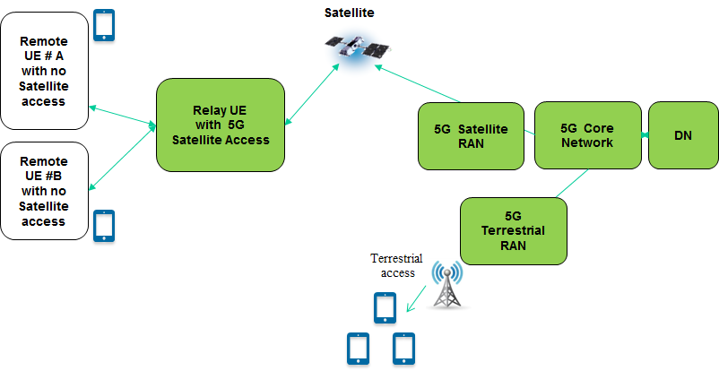

Figure 5.8.1-1: Interconnection of UE to a 5G network through a bent pipe satellite enabled and relay enabled UE

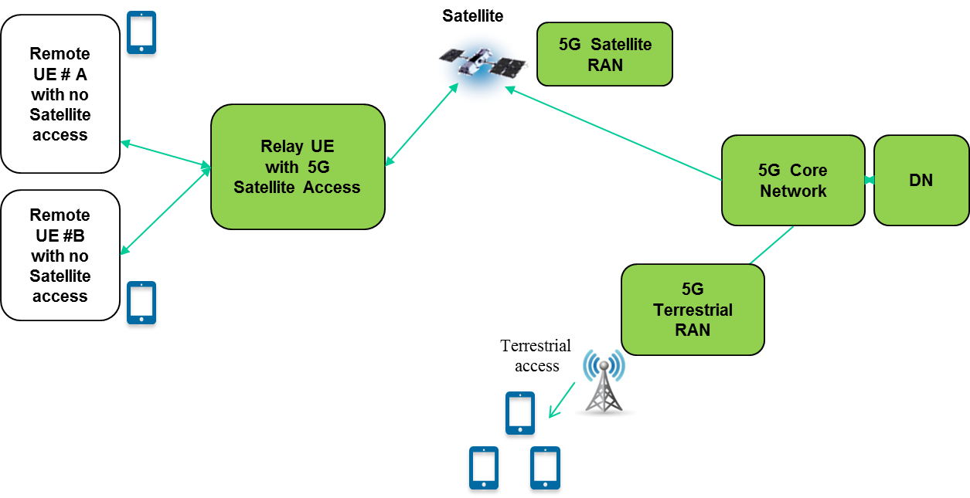

Figure 5.8.1-2: Interconnection of UE to a 5G network through a 5G satellite enabled and relay enabled UE

Some Relay UEs may be located in different countries, some other Relay UEs, due to the motion of the associated platform (long haul aircraft or ships) could be moving from one country to the other during the connectivity session of the associated remote UEs.

The number of remote UEs attached to a single Relay UEs is related to the local conditions: from a few is a remote area, to several hundred (commercial jet) or thousands (maritime cruise vessel) for instance.

### 5.8.2 Pre-conditions

Subscribers of remote UEs attached to the Relay UEs are expecting similar connectivity services as if they were located within direct reach of a 5G terrestrial access.

### 5.8.3 Service Flows

Alix purchases a 5G subscription together with a UE. Her subscription includes a service coverage extension within designated areas (commercial, jets, commercial cruise lines). When Alix embarked on a flight from Paris to Tokyo, she checked that she could browse with her smartphone through the Internet, she was guaranteed she would be able to do so.

Pauline, a civil servant for the civil protection is also provided a UE. Pauline can be asked to operate far in the forest to support of Mr S.C. who can get lost and needs help, in particular in winter time. When requested to intervene, Pauline boards on a snow car equipped with a satellite enabled UE. Her smartphone gets connected directly with the satellite enabling her satellite UE to act as a relay UE.

Alix and Pauline UEs are not satellite enabled.

A minimum list of services (data transfer, messaging, voice, low rate video) and associated QoS are designated by the service providers of Alix and Pauline for their corresponding service subscriptions.

### 5.8.4 Post-conditions

Whenever within reach of a relay UE that is satellite capable and that is associated with the 5G system with satellite access, Pauline and Alix have been offered connectivity to the subscribed list of services which include:

- Alix embarked in aircraft with a relay UE that is satellite capable. During the flight, the relay UE has been capable to access to several satellites, and the connectivity of the relay of the UE has been managed accordingly with no interruption.

- This is also the case for the connectivity of Pauline UE’s with her 5G network. Pauline could help Mr S.C as she was tasked correctly by her commander to head in the right direction avoiding in real time potential difficult weather conditions. She could also report in real time on the local situation of Mr S.C..

- Providing mission critical services subscribed with appropriate priority, pre-emption, and Quality of Service (QoS).

### 5.8.5 Potential Impacts or Interactions with Existing Services/Features

The following interaction with or impact to the following aspects need to be highlighted:

- Roaming functions can be impacted since UE’s can be roaming during the motion of the Relay UE from one country to another one, while the UE is attached to the Relay UE. This is FFS.

- The impact on charging should also be addressed in conjunction with the roaming topic as above.

- The Relay UE that is shared among several UEs could be in view at the same time of more than one 5G terrestrial systems with satellite access. Conditions on the Relay UE with satellite access may be restricted by the number of simultaneous 5G terrestrial systems it is connected with and the associated selection criteria.

- The definition of the minimum set of services to be provided through a Relay with 5G Satellite Access should be defined, as the delay performances for 5G satellite access are different from a 5G terrestrial access. In some cases the requirements could be relaxed, in some other cases access to these services may not be possible. The impact should be addressed from the point of view of the different interfaces and functions of the 5G system.

- Security mechanisms of the 5G system shall be implemented seamlessly all the way through the 5G satellite network to ensure that the remote UEs are offered the same security performances as for any other UEs served within the same 5G system. This is FFS.

### 5.8.6 Potential Requirements

[PR 5.8.6.001] A 5G system with satellite access shall be able to support Relay UE’s with 5G satellite access.

[PR 5.8.6.002] A 5G system with satellite access shall support roaming of Relay UEs and the remote UEs connected to the relay UE between 5G networks.

[PR 5.8.6.003] A 5G system with satellite RAT shall support service continuity for Relay UEs and the remote UEs connected to the relay UE when a Relay UE is moving between different 5G RANs in the same 5G network.

## 5.9 5G Fixed Backhaul between NR and the 5G Core

### 5.9.1 Description

Alice and Barbara live in Aville and Bville, two small villages in the country about 5km apart connected by a main road. The surrounding area has a low population density, just farms and a disused quarry.

The two villages do not currently enjoy modern communication services. DSL connectivity is poor because of the distance to the next small town, Cville, where the mobile operators also have good coverage, but it hardly reaches the two villages. The mobile operators have decided to place a shared cell tower between the villages. They are home to 300 families, with more in the summer due to holiday accommodation. The road can occasionally be busy with holiday traffic but is usually quiet.

Alice and Barbara enjoy using their mobile phones when they leave school in Cville, but the signal becomes unusable before they arrive home.

### 5.9.2 Pre-conditions

The satellite operator S has been working with one of the mobile operators on another project and has excellent coverage of Aville and Bville.

The mobile operators have decided to start up by using a satellite backhaul to the new cell tower. This can be arranged quickly and there is no need for any construction work, beyond the site of the cell tower.

### 5.9.3 Service Flows

The two cells on the new tower provide all the usual services of the mobile operators, using the satellite network of S to provide the connectivity between the cell tower and the mobile operator’s core networks.

The interfaces between the 5G Core and NR are transported directly over the satellite link.

Network functions delocalization could improve overall quality of service in certain scenarios (e.g. AMF/SMF delocalization to improve/enhance local communications within the backhauled area where significant user density is foreseen).

### 5.9.4 Post Conditions

Alice and Barbara are able to use their phones in their own villages just as well as in Cville.

The operators of the mobile and satellite networks are happy with the solution and are working on copying it for five other locations. From the end user’s point of view, the response of the network is now far better than the poor DSL or the distance terrestrial mobile cells.

One of the larger farms close to Bville has run a successful mMTC trial.

### 5.9.5 Potential Impacts or Interactions with Existing Services/Features

The main advantage of using satellite for backhaul is that locations which are otherwise difficult to provide with terrestrial network coverage for geographical or economic reasons can easily be reached. This comes at a cost of propagation delay, which has to be mitigated as far as possible, and is detailed in Figure A.4 in the Annex.

It is anticipated that there will be some changes needed to handle these latencies between the NR radio base stations and the core network.

### 5.9.6 Potential Requirements

[PR 5.9.6.001] The 5G system shall support the use of satellite links between the radio access network and core network and within the core network, by enhancing the 3GPP system to handle the latencies introduced by satellite backhaul.

## 5.10 5G Moving Platform Backhaul

### 5.10.1 Description

A train operator TO is opening a new 1000 km high speed line across the country. TO wishes to provide specific entertainment services (with no or low uplink traffic and high downlink) for all passengers and general internet services for those passengers who pay a supplement. It is also necessary to provide non-critical operational data for TO’s internal use.

### 5.10.2 Pre-conditions

TO has good arrangements with the terrestrial mobile operators in the country.

The coverage of the mobile operators is excellent in urban and most sub-urban areas throughout the country. In the densely populated areas of the country the mobile networks can be overloaded at certain times of day at specific locations.

However, in the middle of the country there is about 200 km of track with no coverage at all.

TO has started to work together with a satellite operator SO that is able to provide good coverage throughout the country and an exceptionally good throughput in the downlink. SO also has good reciprocal cooperation with all of the mobile operators to ensure good service is available to TO’s customers.

TO will work with the mobile operators to place 5G base stations on the trains.

### 5.10.3 Service Flows

The terrestrial mobile operators can unicast / multicast / broadcast entertainment content over their existing terrestrial base stations and or/and over the base stations on the train.

When the train passes through the middle of the country there will be a long period where only the satellite connectivity can be used.

Frequently used content can be stored in TO’s local infrastructure and updated as needed.

UEs entitled to general internet services can also use both access networks, combined or singly.

TO’s internal services can use the networks as necessary.

### 5.10.4 Post-conditions

UEs using TO’s entertainment services are served efficiently, independent of their location. Frequently consumed services are stored locally, enabling almost instantaneous delivery

Entitled UEs can use general internet services as required.

### 5.10.5 Potential Impacts or Interactions with Existing Services/Features

### 5.10.6 Potential Requirements

[PR 5.10.6.001] The 5G system shall support the use of satellite links between the radio access network and core network and within the core network, by enhancing the 3GPP system to handle the latencies introduced by satellite backhaul.

## 5.11 5G to Premises

### 5.11.1 Description

Neudorf is a village built in the foothills of the alps in the 1970s. There are about 80 dwellings. At the time it was built as a holiday village, the location chosen because of the nearby ski lift. With global warming the lift went bankrupt, but the area is now popular (as a primary residence) because of the alternative lifestyle away from the city. When it was built telecommunications meant having a phone and nothing else. Today the old exchange is too far away to give good DSL and cellular coverage varies greatly because of the hills and is not really very good in general. The inhabitants are divided, some want modern communications and others show little interest.

There are no cable companies operating at this rather remote location and many of the premises have been using Satellite for Broadcast TV reception for a long time.

### 5.11.2 Pre-conditions

A new satellite operator S has deployed a component operating in this geographical area and beyond. The satellite component can be used to optimise access to available spectrum and network resources.

The Terrestrial cellular operator T decides to work with S to provide better services for its customers in the area, using a new home/office gateway unit to combine the available signals from S and T, and to present good WIFI coverage within the premises.

### 5.11.3 Service Flows

Terrestrial operator T broadcasts and multicasts media content over its satellite component. Caching can be done on the gateway and T has a flexible means of organising this to provide excellent performance for frequently accessed content.

In general, unicast will use the cellular route. If low latency is not needed for a service, the satellite component should be used.

T is also investigating how gateways in a favourable geographical position could provide coverage for subscribers close by, but in an unfavourable position due to the lay of the land.

### 5.11.4 Post-conditions

The customers of T have greatly improved service.

### 5.11.5 Potential Impacts or Interactions with Existing Services/Features

The 5G system needs to have the capability to implement broadcast/multicast service through a satellite component.

### 5.11.6 Potential Requirements

[PR 5.11.6.001] The 5G system shall support the use of satellite links between the radio access network and core network and within the core network, by enhancing the 3GPP system to handle the latencies introduced by satellite backhaul.

[PR 5.11.6.002] UEs shall have the capability for simultaneous dual mode of operation, supporting a 5G satellite access and a terrestrial access at the same time.

[PR 5.11.6.003] A 5G system supporting a 5G satellite access and a 5G terrestrial access shall be able to optimally distribute user traffic over both types of access.

NOTE: Distributing traffic between a 5G satellite and a 5G terrestrial access can be based on e.g. operator policy, subscription settings, or QoS settings.

## 5.12 Satellite connection of remote service centre to off-shore wind farm

### 5.12.1 Description

The wind power plant communication network at an off-shore wind farm connects to the on-shore and inland remote service centre via 5G satellite connection (see Figure 5.L.1-1).



Figure 5.12.1-1: Example of off-shore wind power plant communication network connected to inland remote service centre via 5G satellite connection

Figure 4 shows two settings of how the remote service centre can connect to the satellite:

- The remote service centre uses a 5G satellite UE directly (on-shore satellite connection A).

- The remote service centre connects to a PLMN that includes a 5G satellite connection (on-shore satellite connection B).

### 5.12.2 Pre-conditions

The local control centre in the wind power plant communication network includes a 5G satellite UE. A LEO satellite 5G network is available.

### 5.12.3 Service Flows

The 5G satellite connection is used for remote service communication between the off-shore wind farm and the remote service centre. Examples of included communication services are:

- Remote monitoring and non-time-critical control of wind farm operation: moderate data volume, low satellite communication latency (LEO satellites);

- Continuous data upload for, e.g., data analytics at remote service centre: high uplink data volume (from wind power plant communication network to satellite), no restriction on satellite communication latency;

- Video surveillance during on-demand maintenance at wind turbine: high-definition video transmission (uplink from wind power plant communication network to satellite), low satellite communication latency (LEO satellites);

- On-demand download of bulk sensor data for remote analysis: high uplink data volume (from wind power plant communication network to satellite), no restriction on satellite communication latency;

- On-demand provision of support information from remote service centre to on-site service personnel by remote service centre: high downlink data volume (from satellite to wind power plant communication network), no restriction on satellite communication latency.

### 5.12.4 Post-conditions

Same as before service flows.

### 5.12.5 Potential Impacts or Interactions with Existing Services/Features

Communication service continuity between 5G satellite connection and terrestrial PLMN (especially with on-shore satellite connection A).

### 5.12.6 Potential Requirements

[PR 5.12.6.001] The 5G system with satellite access shall support high uplink data rates for 5G satellite UEs.

[PR 5.12.6.002] The 5G system with satellite access shall support high downlink data rates for 5G satellite UEs.

[PR 5.12.6.003] The 5G system with satellite access shall provide suitable interfaces for QoS monitoring of the 5G satellite connection at the 5G satellite UE.

[PR 5.12.6.004] The 5G system with satellite access shall enable the selection of the satellite access per communication service based on QoS requirements (e.g. latency).

[PR 5.12.6.005] The 5G system with satellite access shall support communication service availabilities of at least 99.99%.

# 6 5QI for a 5G system with satellite access

## 6.1 Background

Satellite access networks are based on infrastructures integrated on a minimum of satellites that can be placed in either GEO, MEO or LEO (see Annex of this Technical Report).

The propagation delay associated (see Annex of this Technical Report) with these orbits ranges, for the UE to the satellite path, can be summarized in the following table:

Table 2: UE to satellite propagation delay

|  |  |  |  |
| --- | --- | --- | --- |
|  | UE to satellite Delay [ms] | | One-Way Max propagation delay [ms] |
|  | Min | Max |
| LEO | 3 | 15 | 30 |
| MEO | 27 | 43 | 90 |
| GEO | 120 | 140 | 280 |

Further, requirements on Packet Delay Budget between the UE and the UPF are listed in table 5.7.4-1 “Standardized 5QI to QoS characteristics mapping” as specified in [3].

These 5QI do not make reference to the specific requirements from [2]:

- The 5G system shall be able to provide services using satellite access.

- The 5G system shall support service continuity between land based 5G access and satellite based access networks owned by the same operator or by an agreement between operators.

- To provide services using satellite access, the air interface of the 5G system shall support a one-way latency of up to 280 ms.

Use cases have been identified where the 5G system provides services through a satellite access only, or through a mix of satellite access and terrestrial access. As indicated above, the satellite access can be through LEO, MEO or GEO. The QoS characteristics of a 5G system with satellite access should therefore be mapped against specific 5QI taking into account the nature of the satellite access.

## 6.2 Potential Requirements

[PR 6.2.001] A 5G system providing service with satellite access shall be able to support quality of service indicators adapted to the GEO based satellite access with up to 285 ms end-to-end latency.

NOTE 1: 5 ms network latency is assumed and added to satellite one way delay.

[PR 6.2.002] A 5G system providing service with satellite access shall be able to support quality of service indicators adapted to the MEO based satellite access with up to 95 ms end-to-end latency.

NOTE 2: 5 ms network latency is assumed and added to satellite one way delay.

[PR 6.2.003] A 5G system providing service with satellite access shall be able to support quality of service indicators adapted to the LEO based satellite access with up to 35 ms end-to-end latency.

NOTE 3: 5 ms network latency is assumed and added to satellite one way delay.

[PR 6.2.004] A 5G system shall support negotiation on quality of service taking into account latency penalty to optimise the QoE for UE.

[PR 6.2.005] A UE with satellite access shall have the capability to accept or reject connections with the satellite on the basis on the quality of class of indicators that are supported, and on the basis of the available accesses.

[PR 6.2.006] A 5G system with multiple access shall be able to select the combination of access technologies to serve a UE on the basis of the targeted priority, pre-emption, QoS parameters and access technology availability.

# 7 Considerations

## 7.1 Considerations on security

Potential Requirements addressing security are identified in Section 8 of this document, including considerations on regulatory requirements.

No further specific security considerations have been identified.

## 7.2 Considerations on charging

[PR 7.2.001] In a 5G system with satellite access, the 5G system shall be able of generating charging data records identifying separately charging data records associated with the satellite access(es).

[PR 7.2.002] In a 5G system with satellite access, charging call records associated with satellite access(es) shall include the location of the associated UE(s) during the corresponding session.

NOTE: The precision of the location of the UE can be based on the capabilities of the UE or of the RAN.

## 7.3 Considerations on roaming

Potential Requirements addressing roaming are identified in Section 8 of this document.

No further specific considerations have been identified for what concerns roaming.

## 7.4 Other considerations

[PR 7.4.001] In a 5G system with satellite access, mobility management shall take into account any available satellite (radio) access.

# 8 Potential Requirements

## 8.1 Connectivity related requirements

[PR 5.2.6.001] A 5G system supporting satellite access shall be able to optimise the delivery of content when using the 5G satellite access network.

[PR 5.3.6.002] A 5G system with satellite access shall allow optimal selection of 5G satellite access network or 5G terrestrial access network.

[PR 5.5.6.002] A 5G system with satellite access shall be capable of establishing independently uplink and downlink connectivity through the satellite and terrestrial access networks.

[PR 5.11.6.003] A 5G system supporting a 5G satellite access and a 5G terrestrial access shall be able to optimally distribute user traffic over both types of access.

[PR 5.6.6.001] In a 5G system with satellite access network, a 5G satellite access network shall support 5G access network sharing.

[PR 5.6.6.002] In a 5G system with satellite access network, a 5G satellite access network shall support 5G CN sharing and it shall support MNOs of different countries attached to the same 5G satellite network.

[PR 5.6.6.006] A 5G system with satellite access can appear in different configurations, including the following ones:

1. A 5G satellite RAT

2. A 5G satellite RAN

3. A 5G satellite access network

4. A 5G satellite network

[PR 5.7.6.003] A 5G system shall be able to support meshed connectivity between satellites based on 5G RAT.

## 8.2 Roaming related requirements

[PR 5.1.6-002] A 5G system with satellite access shall enable roaming between 5G satellite access networks and 5G terrestrial access networks.

[PR 5.1.6-003] A 5G system with satellite access shall support network reselection based on home operator policy, even when a UE is still in coverage of its current network.

NOTE: It is assumed that the home operator agrees on a network selection policy with its customer.

## 8.3 QoS related requirements

[PR 5.6.6.004] A 5G system with satellite access shall support the management of a 5G satellite network as a radio extension of the 5G terrestrial network with QoS capability.

[PR 5.7.6.001] A 5G system with global satellite overlay access shall be able to select the communication link providing the UEs the best 5QI with respect to jitter or required bit rates.

[PR 5.7.6.002] Two 5G systems with satellite access connected to each other shall be able to select the communication link(s) providing the UEs the best 5QI with respect to jitter or required bit rates.

[PR 5.9.6.001] The 5G system shall support the use of satellite links between the radio access network and core network and within the core network, by enhancing the 3GPP system to handle the latencies introduced by satellite backhaul.

[PR 6.2.001] A 5G system providing service with satellite access shall be able to support quality of service indicators adapted to the GEO based satellite access with up to 285 ms end-to-end latency.

NOTE: 5 ms network latency is assumed and added to satellite one way delay.

[PR 6.2.002] A 5G system providing service with satellite access shall be able to support quality of service indicators adapted to the MEO based satellite access with up to 95 ms end-to-end latency.

NOTE: 5 ms network latency is assumed and added to satellite one way delay.

[PR 6.2.003] A 5G system providing service with satellite access shall be able to support quality of service indicators adapted to the LEO based satellite access with up to 35 ms end-to-end latency.

NOTE: 5 ms network latency is assumed and added to satellite one way delay.

[PR 6.2.004] A 5G system shall support negotiation on quality of service taking into account latency penalty to optimise the QoE for UE.

[PR 5.12.6.004] The 5G system with satellite access shall enable the selection of the satellite access per communication service based on QoS requirements (e.g. latency).

[PR 6.2.006] A 5G system with multiple access shall be able to select the combination of access technologies to serve a UE on the basis of the targeted priority, pre-emption, QoS parameters and access technology availability

[PR 5.12.6.003] The 5G system with satellite access shall provide suitable interfaces for QoS monitoring of the 5G satellite connection at the 5G satellite UE.

[PR 5.12.6.001] The 5G system with satellite access shall support high uplink data rates for 5G satellite UEs.

[PR 5.12.6.002] The 5G system with satellite access shall support high downlink data rates for 5G satellite UEs.

[PR 5.12.6.005] The 5G system with satellite access shall support communication service availabilities of at least 99.99%.

## 8.4 UE related requirements

[PR 5.1.6-001] The 5G system shall provide connectivity with a 5G satellite access network.

[PR 5.3.6.001] A 5G system supporting satellite access and mMTC and/or Nb-IoT services shall also support mMTC and/or Nb-IoT services on the 5G satellite access.

[PR 5.8.6.003] A 5G system with satellite RAT shall support mobility management of Relay UEs and the remote UEs connected to the relay UE between 5G RANs

[PR 5.8.6.001] A 5G system with satellite access shall be able to support Relay UE’s with 5G satellite access.

[PR 5.8.6.002] A 5G system with satellite access shall support roaming of Relay UEs and the remote UEs connected to the relay UE between 5G networks.

[PR 5.2.6-002] A UE supporting satellite access shall be able to send and receive in parallel via a satellite access network and a terrestrial access network.

[PR 5.3.6.003] A UE supporting satellite access and MTC and/or Nb-IoT services in 5G networks shall also be able to support mMTC and/or NB-IoT services through the satellite access network.

[PR 5.4.6.002] In a 5G system with satellite access, UEs with satellite access shall support at least one 5G satellite RAT.

[PR 5.5.6.001] In a 5G system with satellite access, UEs with terrestrial access and supporting satellite access networks shall be capable of dual connectivity with a satellite access network and a terrestrial access network.

[PR 5.8.6.004] Relay UEs with satellite access shall be able to provide a minimum set of services with associated QoS to remote UEs

[PR 5.11.6.002] UEs shall have the capability for simultaneous dual mode of operation, supporting a 5G satellite access and a terrestrial access at the same time.

## 8.5 Security related requirements

### 8.5.1 Regulatory requirements

[PR 5.6.6.003] A satellite access network belonging to different 5G systems of different countries shall be able to meet the corresponding regulatory requirements (e.g. LI).

# 9 Conclusion and Recommendations

The Feasibility Study on using satellite access in 5G analyses a number of use cases, proposing potential requirements based on those use cases.

The use cases developed for satellite access are the following:

- Roaming between terrestrial and satellite networks

- Broadcast and multicast with a satellite overlay

- Internet of Things with a satellite network

- Temporary use of a satellite component

- Optimal routing or steering over a satellite

- Satellite trans-border service continuity

- Global satellite overlay

- Indirect connection through a 5G satellite access network

- 5G Fixed Backhaul between NR and the 5G Core

- 5G Moving Platform Backhaul

- 5G to Premises

- Off-shore Wind Farms

Potential requirements have been identified for each of these use cases, and were then consolidated in a single list of potential requirements. Furthermore, considerations on security, charging and roaming were provided.

To complement the initial specification of TS 22.261 (Service requirements for next generation new services and markets) requiring that the 5G system shall be able to provide services using satellite access, it is recommended to proceed with normative work based on the potential requirements and the considerations on security, charging and roaming identified in this report.

The text of the present document will not be updated to align with normative specifications.

Annex A:  
Main characteristics of 5G satellite components

# A.1 Main characteristics of 5G satellite access networks

## A.1.1. General

This Annex describes the main characteristics of satellite networks when considering their integration with the 5G system.

## A.1.2 Class of orbit

On the one hand, our planet attracts as a main body the much smaller satellite, which motion is dictated as a consequence by the laws of Kepler. On the other hand, the environment of Earth can be also constraining: the higher density of the atmosphere, debris from launchers and former satellites in the lower altitudes, as well as higher energy particles trapped in the Van Allen belts between 2000 and 8000 km’s altitudes are to be avoided. These two constraints contribute to defining several classes of orbits that are used for communication satellites:

**- GEOstationary**- (GEO) satellites, located precisely in the plane of the Equator at an altitude of 35 786 km, these satellites rotate at the same rate as the Earth’s rotation: a GEO satellite stands still with respect to Earth. Thanks to this property, a single GEO satellite is sufficient to create a continuous coverage.

**- Non-Geostationary Orbiting** (NGSO) satellites: NGSO satellites do not stand still with respect to Earth. Should service continuity be required over time, a number of satellites (a constellation) is required to meet this requirement; the lower the altitude the higher the number of satellites

Different classes of NGSO satellites are listed below:

**- Low-Earth Orbiting** (LEO) satellites, with altitude ranging 500 km and 2000 km, and with inclination angle of the orbital plane ranging from 0 to more than 90 degrees. These constellations are placed above the International Space Station and debris, and below the first Van Allen belt.

**- Medium-Earth Orbiting** (MEO) satellites, with altitude ranging from 8000 to 20,000 km. The inclination angle of the orbital plane ranges from 0 to more than 90 degrees. These constellations are placed above the Van Allen belts.

**- Highly-Eccentric Orbiting** (HEO) satellites, with a range of operational altitudes (the orbit of such satellites being designed for the spacecraft to be exploited when the vehicle is closer to its apogee – the higher part of the orbit -) between 7,000 km and more than 45,000 km. The inclination angle is selected so as to compensate, completely or partially, the relative motion of Earth with respect to the orbital plane, allowing the satellite to cover successively different parts of Northern land masses (e.g. Western Europe, North America, and Northern Asia).

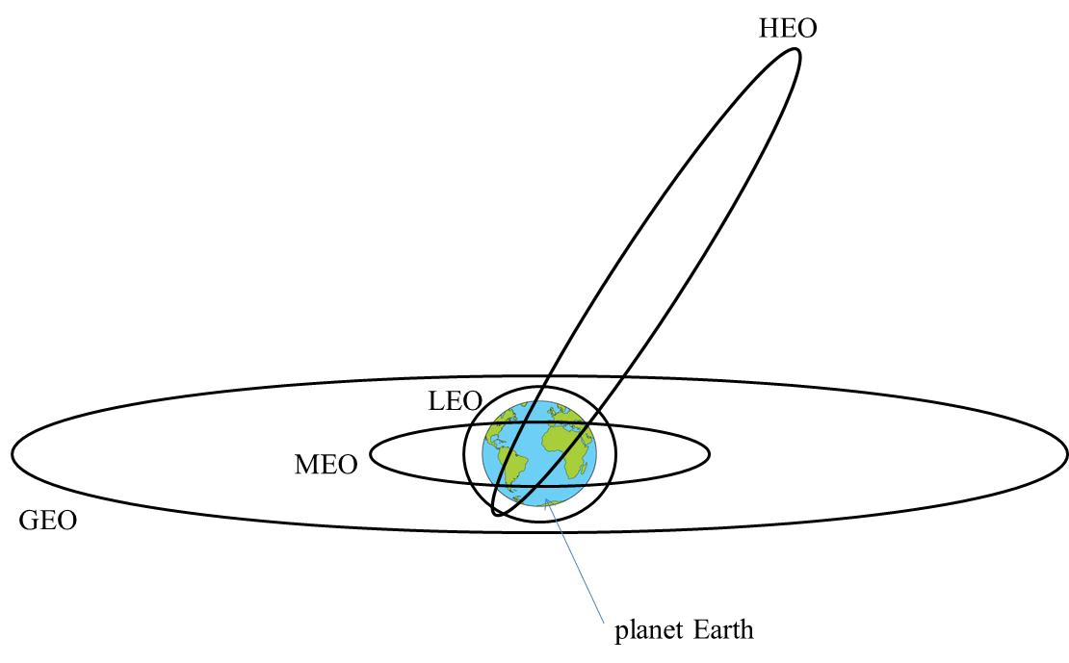

Figure A.1: Illustration of the classes of orbits of satellites

## A.1.3 Geometrical coverage of satellite and propagation delay

As depicted in the following figure, the theoretical geometrical coverage of a satellite is associated to its altitude and the minimum elevation angle under which the satellite is seen by the UE above the horizon.

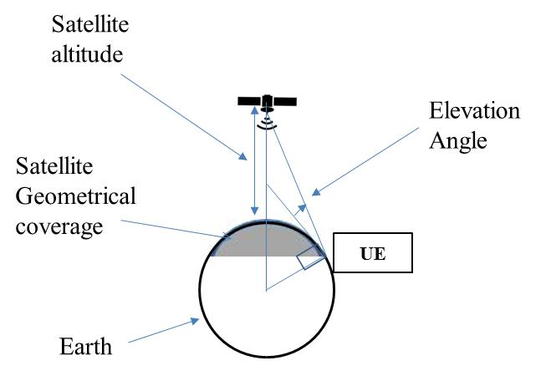

Figure A.2: Illustration of the geometrical coverage of a satellite

The following figure illustrates the geometrical coverage for a LEO satellite and for geostationary-satellites:

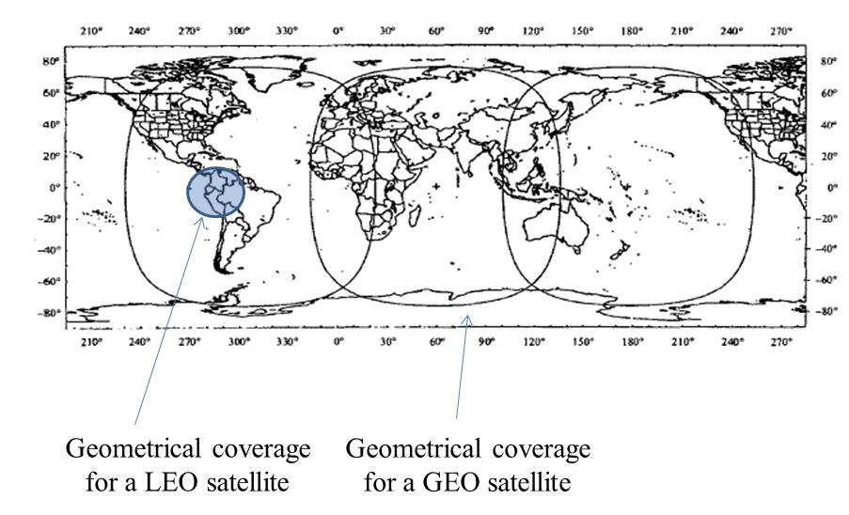

Figure A.3: Illustration of the geometrical coverage of a LEO satellite and of GEO satellites

The following tables provide elevation, distance and geometrical coverage related figures for different classes of satellites:

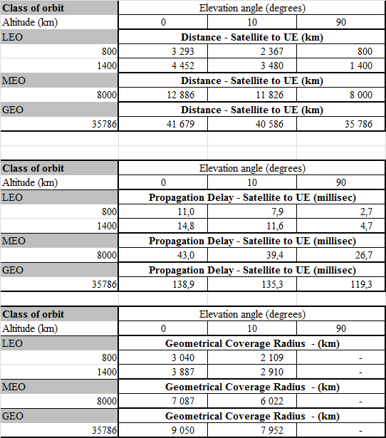

Figure A.4: Geometrical coverage radius, propagation distance and delay for different classes of orbit

The following table illustrates the number of satellites that are necessary for a constellation of satellites to provide continuous coverage for an elevation angle ranging from 5 to 10 degrees. Global coverage may not be fully achieved for MEO or GEO satellite, however in this case the vast majority of the world population is covered.



Figure A.5: Illustration of number satellites in a constellation for continuous Earth coverage

## A.1.3 Radio coverage

A spacecraft is delivered in orbit by a launcher which performances are constrained by its mass. It consists of a platform and a payload. The platform maintains the spacecraft at the right orbital position with the right attitude, generates power from solar panels or from energy stored in batteries, and dissipates thermal power. The payload receives radio signals transmitted by transmitters located on ground as part of the RAN or from the UEs, and transmits after amplification, frequency conversion, and possibly signal demodulation, routing and remodulation. The payload of the spacecraft is power limited, and it would not be economically viable for a satellite network designer to offer such margins that would allow a satellite signal to penetrate directly into buildings.

To optimise the delivery of information the radio coverage of the satellites is reduced with respect to the geometrical coverage thanks to antenna design optimisation. Antenna steering, switching or routing between beams can also be used to achieve coverage flexibility.

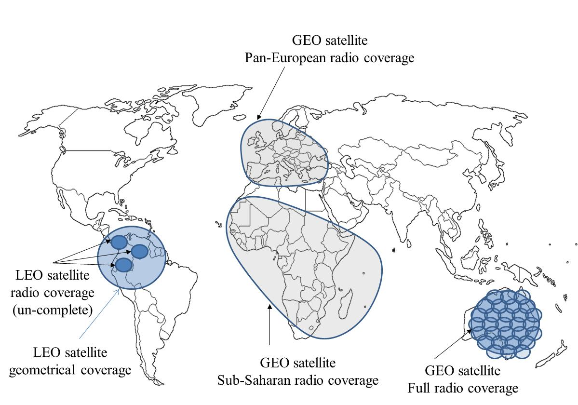

Figure A.6: Illustration of satellite radio-coverage

# A.2 5G Satellite network-based architectures

In this technical report, a satellite network refers to the combination of a radio access network provided through a satellite-based infrastructure and a core network.

NOTE: The core network can be connected to other RANs besides the satellite access network.

Editor’s Note: Satellite networks need to be define in the document

The following figure depicts possible architectures that can be implemented with bent-pipe satellites (transparent, with no on-board processing capabilities) and regenerative satellites (with on-board processing capabilities).

The following figure describes a 5G satellite access network which is an access network that comprises a non-3GPP satellite access network connected to the 5G Core Network. In this case the satellite is a bent pipe satellite: the same radio protocols are used between the UE and the satellite, and between the satellite and the satellite hub.

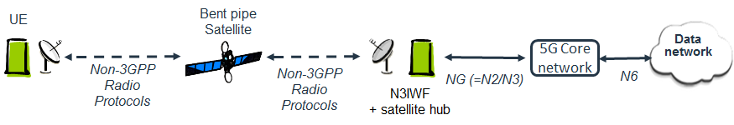

Figure A.7: 5G Satellite access network with a Non-3GPP access network and 5G Core Network

The following figure describes a 5G satellite access network which is an access network (that comprises a 5G satellite access network connected to the 5G Core Network. In this case the satellite is a bent pipe satellite or a regenerative satellite: the NR radio protocols are used between the UE and the satellite, the F1 interface is used between the satellite and the gNB.

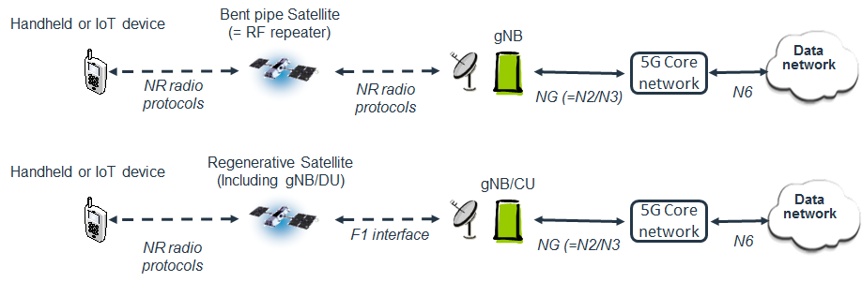

Figure A.8: 5G Satellite access networks with a 5G RAN and 5G Core Network

Annex B:  
Change history

|  |  |  |  |  |  |  |  |
| --- | --- | --- | --- | --- | --- | --- | --- |
| **Change history** | | | | | | | |
| **Date** | **Meeting** | **TDoc** | **CR** | **Rev** | **Cat** | **Subject/Comment** | **New version** |
| 2017-12 | SA1#80 | S1-174439 |  |  |  | Skeleton created | 0.0.0 |
| 2017-12 | SA1#80 | S1-174283 |  |  |  | Addition of scope, 6 use cases, Annex A | 0.1.0 |
| 2018-02 | SA1#81 | S1-180248 |  |  |  | Addition of definitions in Section 3  Existing text edited and clarified.  5 use cases added (5.7, 5,8, 5.9, 5.10, 5.11)  3 sections added (6, 7,8)  Annex A modified | 0.2.0 |
| 2018-05 | SA1#82 | S1-181289 |  |  |  | Edition of Section 2  Addition of Abbreviations in Section 3.  Update of location of titles of Table (above, instead of below).  1 use case on Off-Shore Wind Farms (5.12) added.  Removal of Editor’s notes and update of fewer Potential Requirements.  Some potential requirements edited in Section 5 consistently with PR adopted in Section 8.  Text added for Section 7 (Considerations),8 (Potential Requirements) and 9 (Conclusion and Recommendations) | 0.3.0 |
| 2018-05 | SA#80 | SP-180335 |  |  |  | MCC Clean-up for one-step approval to SA | 1.0.0 |
| 2018-06 | SA#80 | SP-180335 |  |  |  | Raised to v.16.0.0 following one-step-approval at SA | 16.0.0 |