3GPP TS 25.300 V16.1.0 (2020-07)

Technical Specification

3rd Generation Partnership Project;

Technical Specification Group Radio Access Network;

Universal Terrestrial Radio Access Network (UTRAN);  
General description;  
Stage 2

(Release 16)



The present document has been developed within the 3rd Generation Partnership Project (3GPP TM) and may be further elaborated for the purposes of 3GPP..  
The present document has not been subject to any approval process by the 3GPPOrganizational Partners and shall not be implemented.  
This Specification is provided for future development work within 3GPPonly. The Organizational Partners accept no liability for any use of this Specification.  
Specifications and Reports for implementation of the 3GPP TM system should be obtained via the 3GPP Organizational Partners' Publications Offices.

Keywords

UTRAN

***3GPP***

Postal address

3GPP support office address

650 Route des Lucioles - Sophia Antipolis

Valbonne - FRANCE

Tel.: +33 4 92 94 42 00 Fax: +33 4 93 65 47 16

Internet

[http://www.3gpp.org](http://www.3gpp.org/)

***Copyright Notification***

No part may be reproduced except as authorized by written permission.  
The copyright and the foregoing restriction extend to reproduction in all media.

© 2020, 3GPP Organizational Partners (ARIB, ATIS, CCSA, ETSI, TSDSI, TTA, TTC).

All rights reserved.

UMTS™ is a Trade Mark of ETSI registered for the benefit of its members

3GPP™ is a Trade Mark of ETSI registered for the benefit of its Members and of the 3GPP Organizational Partners  
LTE™ is a Trade Mark of ETSI registered for the benefit of its Members and of the 3GPP Organizational Partners

GSM® and the GSM logo are registered and owned by the GSM Association

Contents

Foreword 5

1 Scope 6

2 References 6

3 Definitions, symbols and abbreviations 7

3.1 Definitions 7

3.2 Symbols 7

3.3 Abbreviations 7

4 Heterogeneous Networks Mobility Enhancements 7

5 Heterogeneous Networks Enhancements 7

6 DCH Enhancements (FDD only) 8

6.1 DL overhead optimization 8

6.2 Enhanced rate matching and transport channel multiplexing 8

6.3 DL frame early termination (DL FET) and UL DPCCH with DL FET ACK 9

6.3.1 DL FET Full mode (Mode 1) 9

6.3.2 DL FET Basic mode (Mode 0) 9

6.4 Uplink DPDCH dynamic 10ms transmission 9

7 Access Control in Connected Mode (CELL_FACH, CELL_PCH and URA_PCH) 10

8 Access control enhancements 10

8.1 DSAC and PPAC update for the UE in CELL_DCH state 10

9 Enhanced Broadcast of System Information 10

9.1 Second system information broadcast channel 10

9.2 Scheduling information overhead reduction 12

9.3 MIB and Cell Value Tag range extension 12

10 RAN assisted WLAN interworking 12

10.1 General principles 12

10.2 Access network selection and traffic steering rules 13

11 Increased minimum number of carriers to monitor 13

12 Extended DRX in Idle mode 13

13 L2 and L3 Downlink enhancements for UMTS 14

13.1 Retrievable configurations 14

13.2 URA_PCH with seamless transition 14

13.3 Optimization from IDLE to CONNECTED state 14

13.4 Blind HARQ retransmissions for HSDPA 15

13.5 Enhanced state transition 15

13.6 Improved synchronized RRC procedures 15

14 Downlink TPC enhancements for UMTS 15

15 NAICS offloading (FDD only) 15

16 ACDC in Idle Mode 15

17 RRC optimization 16

17.1 RRC measurement events for UPH reporting 16

17.2 Simultaneous Setup and Release of RABs and RBs 16

18 HS-SCCH DRX in CELL_FACH state (FDD only) 16

19 Dual Cell E-DCH operation enhancements 16

20 QoE Measurement Collection 16

21 DL Interference Mitigation (FDD only) 17

22 Simplified HS-SCCH type 1 operation 17

23 NR SRVCC to UTRAN 17

Annex A (informative): Change history 18

# Foreword

This Technical Specification has been produced by the 3rd Generation Partnership Project (3GPP).

The contents of the present document are subject to continuing work within the TSG and may change following formal TSG approval. Should the TSG modify the contents of the present document, it will be re-released by the TSG with an identifying change of release date and an increase in version number as follows:

Version x.y.z

where:

x the first digit:

1 presented to TSG for information;

2 presented to TSG for approval;

3 or greater indicates TSG approved document under change control.

y the second digit is incremented for all changes of substance, i.e. technical enhancements, corrections, updates, etc.

z the third digit is incremented when editorial only changes have been incorporated in the document.

# 1 Scope

The present document provides an overview and overall description of the UTRA radio interface functionalities from Release 12 onwards which are not covered by the Technical Specifications TS 25.308 [2] or TS 25.319 [3].

# 2 References

The following documents contain provisions which, through reference in this text, constitute provisions of the present document.

- References are either specific (identified by date of publication, edition number, version number, etc.) or non‑specific.

- For a specific reference, subsequent revisions do not apply.

- For a non-specific reference, the latest version applies. In the case of a reference to a 3GPP document (including a GSM document), a non-specific reference implicitly refers to the latest version of that document *in the same Release as the present document*.

[1] 3GPP TR 21.905: "Vocabulary for 3GPP Specifications".

[2] 3GPP TS 25.308: "UTRA HSDPA: UTRAN Overall Description (Stage 2) ".

[3] 3GPP TS 25.319: "Enhanced Uplink: Overall description (Stage 2) ".

[4] 3GPP TS 24.008: "Mobile radio interface layer 3 specification, Core Network Protocols - Stage 3".

[5] 3GPP TS 23.060: "General Packet Radio Service (GPRS); Service description; Stage 2".

[6] 3GPP TS 23.682: "Architecture enhancements to facilitate communications with packet data networks and applications".

[7] 3GPP TR 25.704: "Study on enhanced broadcast of system information".

[8] 3GPP TS 24.312: "Access Network Discovery and Selection Function (ANDSF) Management Object (MO)".

[9] 3GPP TS 25.304: "User Equipment (UE) procedures in idle mode and procedures for cell reselection in connected mode".

[10] 3GPP TS 23.402: "Architecture enhancements for non-3GPP accesses".

[11] 3GPP TS 25.133: "Requirements for support of radio resource management (FDD)".

[12] 3GPP TS 25.331: "Radio Resource Control (RRC)".

[13] 3GPP TR 25.993: "Typical examples of Radio Access Bearers (RABs) and Radio Bearers (RBs) supported by Universal Terrestrial Radio Access (UTRA)".

[14] 3GPP TS 37.320: "Universal Terrestrial Radio Access (UTRA) and Evolved Universal Terrestrial Radio Access (E-UTRA); Radio measurement collection for Minimization of Drive Tests (MDT); Overall description; Stage 2".

[15] 3GPP TS 23.216: "Single Radio Voice Call Continuity (SRVCC); Stage 2".

[16] 3GPP TS 38.300: "NR; Overall description; Stage 2".

[17] 3GPP TS 25.413: "UTRAN Iu Interface RANAP Signalling".

# 3 Definitions, symbols and abbreviations

## 3.1 Definitions

For the purposes of the present document, the terms and definitions given in TR 21.905 [1] and the following apply. A term defined in the present document takes precedence over the definition of the same term, if any, in TR 21.905 [1].

**Power saving mode:** Mode configured and controlled by NAS that allows the UE to reduce its power consumption, as defined in TS 24.008 [4], TS 23.060 [5], TS 23.682 [6].

## 3.2 Symbols

For the purposes of the present document, the following symbols apply:

<symbol> <Explanation>

## 3.3 Abbreviations

For the purposes of the present document, the abbreviations given in TR 21.905 [1] and the following apply. An abbreviation defined in the present document takes precedence over the definition of the same abbreviation, if any, in TR 21.905 [1].

ACDC Application specific Congestion control for Data Communication

ANDSF Access Network Discovery and Selection Function

DPCCH2 Dedicated Physical Control Channel 2

NCL Neighbour Cell List

NR NR Radio Access

OPI Offload Preference Indicator

PSM Power Saving Mode

SRVCC Single Radio Voice Call Continuity

QoE Quality of Experience

WLAN Wireless Local Area Network

# 4 Heterogeneous Networks Mobility Enhancements

Neighbour Cell List (NCL) extension

- The size of the inter-frequency neighbour cell list is extended for CELL_DCH, CELL_FACH, CELL_PCH, URA_PCH states and Idle mode, so that network could configure more inter-frequency neighbour cells than 32 for UE to monitor and detect under massive small cell deployment scenario.

Change of best cell on a configured secondary downlink frequency (event 2g)

- Event 2g is an inter-frequency measurement event. It is applicable only to the secondary downlink frequency with configured HS-DSCH operation, and it can be configured on more than one secondary downlink frequency.

Enhanced Serving Cell Change for Event 1C

- The enhanced Serving Cell Change procedure could also be applied to Event 1C, which is defined in TS 25.308 [2].

# 5 Heterogeneous Networks Enhancements

Serving E-DCH cell decoupling

- Serving E-DCH cell decoupling is introduced in order to improve the quality of reception of the uplink E-DCH control channels and the E-DCH SI in the presence of strong uplink/downlink imbalance. The UE is configured with different serving HS-DSCH cell and serving E-DCH cell.

Radio Links without DPCH/F-DPCH

- The UE is configured with a subset of non-serving E-DCH radio links in the UE's E-DCH active set to operate in the absence of DPCH/F-DPCH. However, a UE is allowed to only receive either E-HICH or both E-HICH and E-RGCH from these non-serving E-DCH cells to mitigate uplink interference to a cell that is unable to power control a UE in the presence of strong uplink/downlink imbalance.

DPCCH2 transmission

- In order to improve the quality of reception of the HS-DPCCH in the presence of strong uplink/imbalance, a new secondary uplink pilot channel (DPCCH2) is introduced in the serving HS-DSCH cell as the reference for the HS-DPCCH channel power.

# 6 DCH Enhancements (FDD only)

DCH enhancements aims at improving the link efficiency and UE battery performance for voice calls compared to R99 DCH. DCH enhancements constitutes of the following sub-features:

- DL overhead optimization

- Enhanced rate matching and transport channel multiplexing

- DL Frame Early Termination (DL FET)

- Uplink DPCCH with DL FET ACK

- Uplink DPDCH dynamic 10ms transmission

DCH enhancements supports two modes (Basic and Full). The mode choice controls how the DL Frame Early Termination sub-feature operates, as described in 6.3. All other sub-features are active in both modes.

DCH enhancements is only applicable if the TTI of all DCH transport channels on both downlink and uplink is at least 20 ms.

If a UE is configured with both CS and PS mapped to the DCH transport channel (in uplink or downlink or both), then DCH enhancements may be configured only when PS has UL:0 and DL:0kbps RAB configuration (3GPP TR 25.993 [13]).

## 6.1 DL overhead optimization

This sub-feature introduces new DL DPCH slot format by removing the dedicated pilot bits from DL DPCCH and reusing them for DL DPDCH instead.

The R99 downlink physical channel (DPCH) consists of 0.66ms slots that contain 2 groups of data (DPDCH) symbols and 3 groups of control (DPCCH) symbols. The size of the groups is determined by the slot format. The control symbol groups are TPC - controlling uplink transmit power, TFCI - specifying the downlink packet type, and dedicated pilot - supporting channel estimation for DL power control and closed-loop transmit diversity. While the TFCI group may be empty in certain slot formats, the pilot and TPC are currently always non-empty. The dedicated pilot bits are used for estimation of DL SIR. With this sub-feature, new DL DPCH slot formats are introduced by removing the dedicated pilot bits and reusing the TPC bits instead for estimating the DL SIR. Correspondingly, the number of data symbols in a slot is increased leading to less control channel overhead on the downlink.

DL closed-loop transmit diversity is not supported when this sub-feature is configured.

## 6.2 Enhanced rate matching and transport channel multiplexing

The physical layer in R99 is designed to carry potentially a large variety of transport blocks with different sizes. The drawback for this design is the rate matching may not be efficient when some transport format combinations are not frequently used. For example, DCCH channel carries non-zero transport blocks not as often as voice DTCH channel. The enhanced rate matching and transport channel multiplexing sub-feature sets a zero rate matching attribute for DCCH, whenever DCCH channel does not carry a transport block together with DTCH channel. The DCCH bit fields are used to transmit DTCH transport channels instead. This potentially improves link efficiency due to less puncturing and better rate matching of the transport block with the available physical channel resources.

## 6.3 DL frame early termination (DL FET) and UL DPCCH with DL FET ACK

In a power-controlled system such as R99 DCH, inefficiencies in the power-control loop, such as limited granularity, delays and errors in the feedback, result in the presence of excess SINR at the receiver. This means that packets such as the voice packets which have a long (20ms) transmission time interval (TTI) can often be early-decoded, i.e, decoded prior to reception of all the data symbols in a TTI by running the channel decoder at multiple time instants during the TTI instead of only once at the end of the TTI. This is referred to as Frame Early Termination (FET). As described below, DCH enhancements introduces new mechanisms to R99 DCH in order to support DL FET.

A new design of UL DPCCH is introduced to support DL FET. With the new design, TFCI information is carried in the first 10 slots of each 20ms TTI for the uplink. Sending the TFCI information early in each 20ms TTI allows sending of DL FET ACK or NACK information using the TFCI bits in remaining UL DPCCH slots that do not carry TFCI.

Furthermore, there are two modes of operation introduced with support for DL FET in DCH enhancements as described below.

### 6.3.1 DL FET Full mode (Mode 1)

In the Full mode of operation:

- The UE acknowledges successful early decoding of a DL packet via a DL FET ACK on the newly designed UL DPCCH channel, which then allows the NodeB to stop transmission of the packet.

- AMR Class A, B, C transport channels are concatenated on the DL which further helps in early decoding of DL DPDCH.

### 6.3.2 DL FET Basic mode (Mode 0)

In the Basic mode of operation:

- DL FET is achieved by applying the DL BLER target at slot 14 (10ms) in each 20ms TTI duration. The NodeB may decide to stop transmission of the DL voice packet at slot 14 provided that the Uplink is in 10ms transmission mode (see sub-clause 6.4). The UE does not indicate successful decoding of the DL packet via the DL FET ACK or NACK field in UL DPCCH.

- AMR Class A, B, C transport channels are not concatenated on the downlink.

## 6.4 Uplink DPDCH dynamic 10ms transmission

The R99 DCH transport channels for a voice call are typically configured with 20ms TTI. However, the transport block sizes for a voice call could potentially be transmitted over a shorter duration. The sub-feature of uplink DPDCH dynamic 10ms transmission allows for dynamically selecting a shorter transmission time, i.e. 10ms, at the physical layer to transmit a voice packet on the uplink. The UE selects on whether to use a 10ms or 20ms transmission duration based on considerations such as the power headroom at the UE. The UE also discontinues the transmission of UL DPCCH for the remaining duration of the TTI when both UL transport block has been completed transmitted and DL has been successfully decoded early.

With 20ms TTI transmission at the physical layer, the pilot channel (UL DPCCH) is sent for the entire 20ms duration. This sub-feature potentially improves link efficiency due to reduction in UL DPCCH overhead as well as improves UE battery performance by allowing the UE to turn off its transceiver once the reception and transmission has been completed before the end of a 20ms TTI.

# 7 Access Control in Connected Mode (CELL_FACH, CELL_PCH and URA_PCH)

For FDD, certain categories of UEs may be configured for Access Control in connected mode. This feature allows for a network to differentiate and control accesses of UE for DTCH transmission in CELL_FACH state and for DCCH/CCCH due to uplink data transmission in CELL_PCH state or URA_PCH state, when uplink congestion is being experienced.

The network may differentiate among the UE population by assigning UEs to one of 16 defined Access Groups. The network can indicate the identity of the access group to which the UE is assigned via RRC dedicated signalling.

For each network assigned Access Group, the network can indicate in System Information whether the UEs in CELL_FACH state, CELL_PCH state or URA_PCH state in that group are Blocked or Unblocked for DTCH data transmission and for DCCH/CCCH due to uplink data transmission. The System Information Block containing the Access Group information is scheduled by the network only during periods of uplink congestion. A UE in CELL_FACH state, CELL_PCH state or URA_PCH state which has data to transmit and has an access group identity will reacquire the System Information Block containing the Access Group information based on the expiration of a timer.

UEs in CELL_PCH (without seamless transition to CELL_FACH state) or URA_PCH (without seamless transition to CELL_FACH) are not allowed to initiate Cell Update procedure triggered due to DTCH data transmission with cause "uplink data transmission" when the Access Group of the UE is Blocked.

UEs in CELL_PCH (with seamless transition to CELL_FACH state) or URA_PCH (with seamless transition to CELL_FACH state) are not allowed to initiate Measurement Report procedure triggered due to DTCH data transmission when the Access Group of the UE is Blocked.

A UE in CELL_FACH state, CELL_PCH state or URA_PCH state which is blocked for DTCH transmission and for DCCH/CCCH due to data transmission in the uplink is permitted to transmit uplink RLC Control PDUs.

# 8 Access control enhancements

# 8.1 DSAC and PPAC update for the UE in CELL_DCH state

In CELL_DCH state, it allows the network to indicate to the UE about the DSAC and PPAC parameters through dedicated signalling so that the UE can obtain the updated DSAC and PPAC information.

# 9 Enhanced Broadcast of System Information

## 9.1 Second system information broadcast channel

In order to increase system information capacity (see TR 25.704 [7]) a second system information broadcast channel on SCCPCH can be configured, in addition to the system information broadcast channel on PCCPCH.

The second system information broadcast channel is mapped to a separate SCCPCH, which is different from the SCCPCH used for paging and FACH/CTCH, as depicted in Figure 9.1-1.

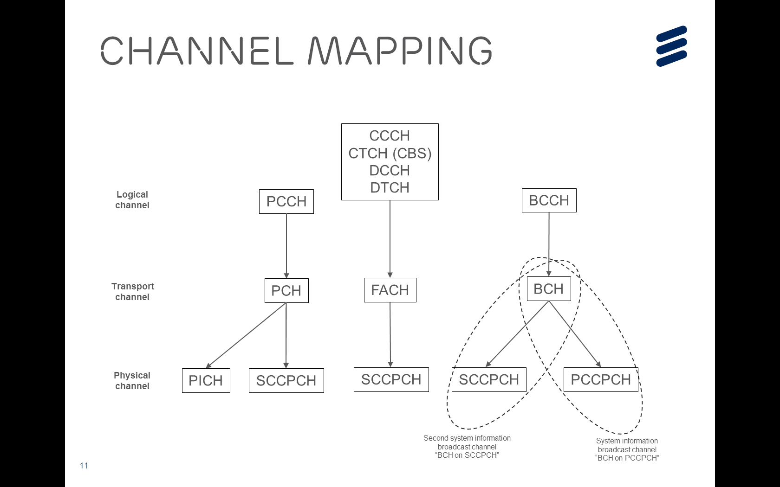

Figure 9.1-1: Channel mapping of system information broadcast channel and second system information broadcast channel.

The UE should be able to monitor at least two SCCPCHs simultaneously, but the UE may skip reading the second system information broadcast channel during CTCH occasions in Idle mode and CELL_PCH/URA_PCH state. When HS-DSCH in CELL_FACH is used, a UE supporting second system information broadcast channel monitors the corresponding SCCPCH while listening to HS-DSCH.

REL-12 and later SIBs are introduced on both the system information broadcast channel as well as the second system information broadcast channel. Pre-REL-12 SIBs may be broadcasted on the second system information broadcast channel in addition to the system information broadcast channel. Any SIB type may be scheduled simultaneously on system information broadcast channel and second system information broadcast channel provided that the content is the same.

Most of the existing principles and procedures for system information reading are retained for the second system information broadcast channel. To reduce the latency to acquire the system information on both system information broadcast channel and second system information broadcast channel, the UE acquires the system information on both channels simultaneously. The simultaneous acquisition of system information on both system information broadcast channel and second system information broadcast channel is depicted in Figure 9.1-2.

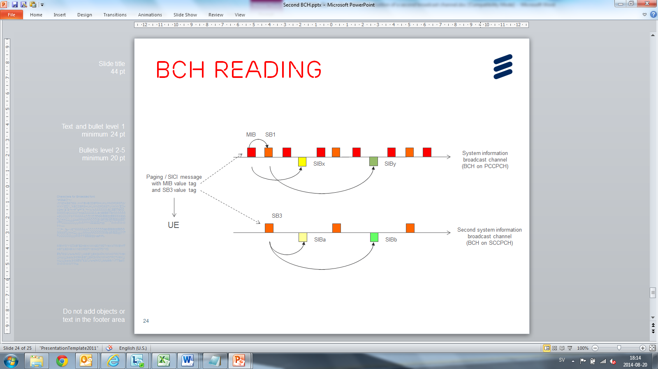

Figure 9.1-2: System information acquisition on system information broadcast channel and second system information broadcast channel.

When the SB3 value tag in PAGING TYPE 1 or SYSTEM INFORMATION CHANGE INDICATION (SICI) message is updated the UE supporting second system information broadcast channel is required to re-acquire the system information on the second system information broadcast channel. When the SB3 value tag is updated, but the MIB value tag is not, the UE supporting second system information broadcast channel is only required to re-acquire the system information on the second system information broadcast channel.

The scheduling block 3 (SB3) contains the scheduling information for the system information on the second system information broadcast channel. This scheduling information uses the SFN of the PCCPCH.

The SB3 is broadcasted with a pre-defined offset (40 ms) from the start of the frame containing the MIB, as depicted in the Figure 9.1-3. The MIB on BCH mapped on PCCPCH contains the channelization code of the second system information broadcast channel, the repetition interval of SB3 and the number of segments of SB3. The remaining configuration parameters of the second system information broadcast channel are pre-defined.

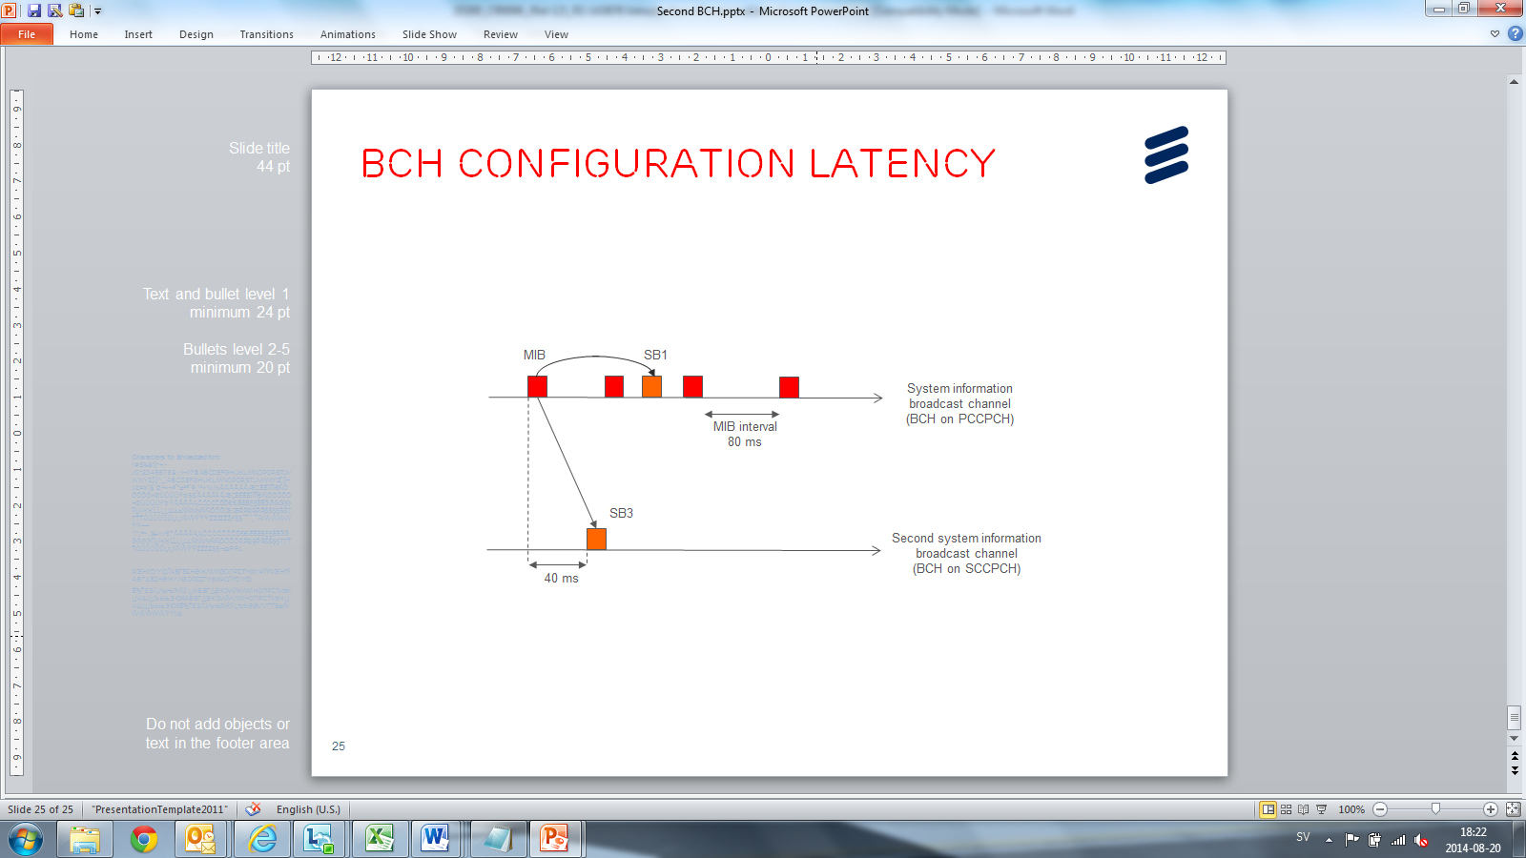

Figure 9.1-3: SB3 pre-defined offset from the start of the frame containing the MIB.

## 9.2 Scheduling information overhead reduction

To reduce the overhead of SIB scheduling information, included in MIB and Scheduling Blocks, the network may use mandatory default values for SIB_OFF and SEG_COUNT (when SIB_POS offset info is included) for SIBs of REL-12 or later.

## 9.3 MIB and Cell Value Tag range extension

To reduce the risk of Cell Value Tag wrap around, the network may broadcast a range extension (1..16) of the Cell Value Tag for SIB3, SIB5, SIB5bis, SIB21 and SIB22. The network may also extend the MIB value tag range (1..16). For UEs supporting these extensions the SIBs and MIB wrap around at 16, while for UEs not supporting this feature the SIBs wraps around at 4 (and MIB at 8). SIBs of REL-12 or later use the extended Cell Value Tag range (1..16).

# 10 RAN assisted WLAN interworking

This clause describes the mechanisms to support traffic steering between UTRAN and WLAN.

## 10.1 General principles

This version of the specification supports UTRAN assisted UE based bi-directional traffic steering between UTRAN and WLAN for UEs in Idle mode and CELL_DCH, CELL_FACH, CELL_PCH and URA_PCH states.

UTRAN provides assistance parameters via broadcast and dedicated RRC signalling to the UE. The RAN assistance parameters may include UTRAN signal strength thresholds, WLAN channel utilization thresholds, WLAN backhaul data rate thresholds, WLAN signal strength thresholds and Offload Preference Indicator (OPI). UTRAN can also provide a list of WLAN identifiers to the UE via broadcast and dedicated signalling.

The UE uses the RAN assistance parameters in the evaluation of:

- access network selection and traffic steering rules defined in TS 25.304 [9]; or

- ANDSF policies defined in TS 24.312 [8]

for traffic steering decisions between UTRAN and WLAN as specified in TS 23.402 [10].

The OPI is only used in ANDSF policies as specified in TS 24.312 [8].

WLAN identifiers are only used in access network selection and traffic steering rules defined in TS 25.304 [9].

If the UE is provisioned with ANDSF policies it shall forward the received RAN assistance parameters to upper layers, otherwise it shall use them in the access network selection and traffic steering rules defined in subclause 10.2 and TS 25.304 [9]. The access network selection and traffic steering rules defined in subclause 10.2 and TS 25.304 [9] are applied only to the WLANs of which identifiers are provided by the UTRAN.

The UE in CELL_DCH state shall apply the parameters obtained via dedicated signalling, and shall keep those parameters during handover if they are not reconfigured or deleted; the UE shall discard the parameters obtained via dedicated signalling at SRNS relocation.

The UE in CELL_FACH state shall apply the parameters obtained via dedicated signalling if such have been received from the serving cell; otherwise the UE shall apply the parameters obtained via broadcast signalling. Upon cell selection/reselection the UE shall discard the dedicated parameters.

The UE in Idle mode, CELL_PCH or URA_PCH state shall keep and apply the parameters obtained via dedicated signalling until selection/reselection of another cell than the one where these parameters were received or a timer has expired since the UE moved from CELL_DCH or CELL_FACH to Idle mode, CELL_PCH or URA_PCH state, upon which the UE shall discard the dedicated parameters and apply the parameters obtained via broadcast signalling.

In the case of RAN sharing, each PLMN sharing the RAN can broadcast independent sets of RAN assistance parameters.

## 10.2 Access network selection and traffic steering rules

The UE indicates to upper layers when (and for which WLAN identifiers) access network selection and traffic steering rules defined in TS 25.304 [9] are fulfilled. The selection among WLANs that fulfil the access network selection and traffic steering rules is up to UE implementation.

When the UE applies the access network selection and traffic steering rules defined in TS 25.304 [9], higher layers perform traffic steering between UTRAN and WLAN.

# 11 Increased minimum number of carriers to monitor

The increased number of carrier monitoring feature allows a UE to monitor more UMTS and LTE frequencies in all RRC states.

When increased carrier monitoring is used, the network signals whether a carrier should be measured with "reduced measurement performance" together with a scaling factor applicable for CELL_DCH and CELL_FACH states. In Idle mode, CELL_PCH and URA_PCH states a fixed scaling factor is used. When a carrier does not belong to the "reduced measurement performance" group, it belongs to the "normal measurement performance" group.

The value and the use of scaling factor are specified in [11].

# 12 Extended DRX in Idle mode

The extended DRX (eDRX) feature enables DRX 10,24 seconds up to 2621.44 seconds (~44 minutes) in Idle mode for the PS domain.

The eDRX feature in Idle mode uses the Paging Occasions (PO) as determined by the CN domain specific DRX cycle length coefficient (PS domain) in SIB1 [12] and specified by the Discontinuous Reception for Paging [9]. However the UE is not required to monitor every PO, but only the POs that belong to the Paging Transmission Window (PTW):

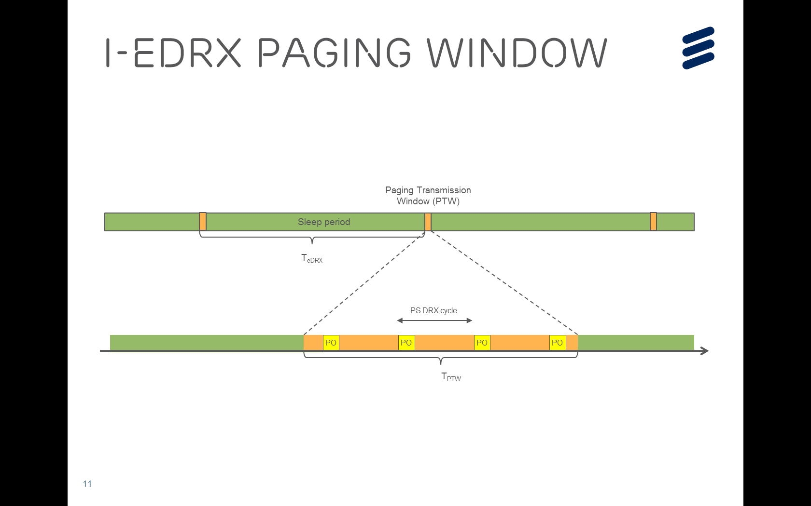

Figure 12-1: Extended DRX in Idle mode

The eDRX parameter in Idle mode values, i.e. timer values for TeDRX and TPTW are negotiated and configured during ATTACH and RAU procedure ([4] and [5]). Timer TeDRX is (re-)started when upper layers indicate successful completion of the ATTACH/RAU procedure, including eDRX parameters in Idle mode. When timer TeDRX expires, the UE wakes-up from sleep, it checks the MIB for any system information changes and it starts monitoring the paging occasions in the PS DRX in Idle mode. When timer TeDRX expires it is re-started, and timer TPTW is started. When timer TPTW expires the UE stops monitoring paging occasions in the PS DRX in Idle mode. The timer TeDRX and TPTW do not stop/reset when the UE transitions from Idle to Connected or transitions from Connected to Idle. The timers TeDRX and TPTW are stopped, if running, when upper layer indicates that the eDRX parameters in Idle mode are not included in the ATTACH/RAU complete. The timers TeDRX and TPTW are reset when upper layer indicates that a new value is configured in ATTACH/RAU complete. The value of TeDRX is signaled in IE “eDRX value” in ATTACH/RAU [4] for timer T331 in RRC [12]. The value of TPTW is signaled in IE “Paging Time Window” in ATTACH/RAU [4] for timer T332 in RRC [12].

# 13 L2 and L3 Downlink enhancements for UMTS

## 13.1 Retrievable configurations

The retrievable configurations feature allows the UE to store configurations together with an identity. When the network invokes a retrievable configuration, it needs to signal only its identity. A retrievable configuration can be signalled to a UE in any state except for idle. Retrievable configurations are cleared when entering idle mode and at SRNS relocation.

There are two ways of signalling the retrievable configurations: one way is that as a result of an RRC signalling procedure, the UE stores the received configuration as a retrievable configuration, and the other way is that the network preconfigures the UE with at least one retrievable configuration. The network can signal a delta to a stored configuration for either of the two ways. The UE validates a retrievable configuration when it invokes it.

## 13.2 URA_PCH with seamless transition

The feature URA_PCH with seamless transition to CELL_FACH is described in 3GPP TS 25.319 [3].

## 13.3 Optimization from IDLE to CONNECTED state

If the UE supports "NodeB triggered HS-DPCCH transmission", the RNC can issue the indication to trigger acquisition of the common E-DCH resource or to release the allocated common E-DCH resource for the particular UE.

## 13.4 Blind HARQ retransmissions for HSDPA

The feature blind HARQ retransmissions for HSDPA is described in 3GPP TS 25.308 [2].

## 13.5 Enhanced state transition

This feature allows the UE to move to a more power efficient state without explicit RRC reconfiguration. The UE sends the RRC indication to the RNC and moves to the target state upon reception of the RLC ACK from the RNC. The state transition is applicable to the following cases: from CELL_DCH to CELL_FACH, from CELL_FACH to CELL_PCH/URA_PCH, and from CELL_DCH to CELL_PCH/URA_PCH.

While configuring a UE with enhanced state transition, the RNC can provide RRC configuration that will be applied once the UE enters the target state.

## 13.6 Improved synchronized RRC procedures

In improved synchronized RRC procedures, firstly the UE receives an RRC reconfiguration message for a synchronized RRC procedure indicating that the activation time shall be dynamically determined. Then, when the UE is ready to switch to the new configuration indicated in the RRC message, it sends a MAC Control Information to the Node B. On reception of the HARQ ACK to the MAC Control Information, the UE calculates the activation time by adding an offset to the current CFN. The UE reconfigures at the calculated activation time and sends an RRC configuration complete message upon successful completion of the procedure.

The network can also indicate a legacy activation time, at which the switch to the new configuration latest shall occur. The UE will choose the smallest value of the legacy activation time and the calculated activation time as the final activation time.

# 14 Downlink TPC enhancements for UMTS

In CELL_DCH state, the network can configure a UE with power control Algorithm 3 when the F-DPCH is also configured. For this algorithm, the TPC command is transmitted only once in a certain number of consecutive slots, and other TPC commands are DTXed in the remaining slots. The number of consecutive slots can be configured with 3 or 5 slots.  
  
If a UE is configured with Algorithm 3 on any of the radio links, then all the radio links within the same RLS must have power control Algorithm 3. If power control Algorithm 3 is configured in one RLS, and any of the legacy algorithms is configured in another RLS, then the UE will behave as per Algorithm 3 to determine transmission power under such configuration.   
  
For generation of TPC in uplink DPCCH, the UE will generate and transmit TPC command as per the algorithm configured on the serving radio link.

# 15 NAICS offloading (FDD only)

In this offloading mechanism, the UE is configured with the Multiflow operation 3GPP TS 25.308 [2], which allows the UE to measure and send CQIs for cells belonging to a different Node B. Based on received channel quality information, the UE can be offloaded from the serving Node B HS-DSCH cell(s) to HS-DSCH cell(s) belonging to a different Node B through the network specific behaviour, e.g. serving cell change procedure.

# 16 ACDC in Idle Mode

The ACDC feature allows network to control new PS domain access attempts from particular applications in the UE in idle mode to prevent/mitigate overload of the access network and/or the core network.

The applications on the UE may be associated with an ACDC category. At subscription, at least four ACDC categories, and up to 16 ACDC categories, are allocated to the subscriber and stored in the ACDC Management Object (MO) or USIM [9].

The access barring information for each ACDC category is broadcast in SIB. The ACDC capable UE controls the access attempt for a certain application based on the broadcast barring information and the configuration of ACDC categories in the UE.

The following guidelines define the behaviour of a UE configured with ACDC when other access control mechanisms (ACB, EAB and DSAC) are co-existing:

- When DSAC and ACDC are configured together, the PS domain DSAC will be ignored by the UEs.

- When EAB and ACDC are configured together, the UE will first check EAB and then check ACDC.

- For UEs configured with ACDC, ACB is ignored.

# 17 RRC optimization

## 17.1 RRC measurement events for UPH reporting

The RRC measurement events for UPH reporting allow the UE to perform measurements on UE Power Headroom (UPH) and signal measurement events when the UPH becomes larger or less than an absolute threshold respectively. The thresholds are configurable, as well as hysteresis, time-to-trigger, filter coefficient and pending time after trigger for each of the events.

## 17.2 Simultaneous Setup and Release of RABs and RBs

The simultaneous setup and release of RABs and RBs enhancement allows setup, release and reconfiguration of radio access bearers and radio bearers in the same RRC message.

# 18 HS-SCCH DRX in CELL_FACH state (FDD only)

With the feature HS-SCCH DRX in CELL_FACH state, the UE discontinuously receives only HS-SCCH orders without decoding HS-DSCH in CELL_FACH state. Details could be referred in 3GPP TS 25.308 [2].

# 19 Dual Cell E-DCH operation enhancements

This feature Dual Cell E-DCH operation enhancements is described in 3GPP TS 25.319 [3].

# 20 QoE Measurement Collection

With this feature, the network can configure collection of measurements from the UE. The feature defines QoE measurement configuration and measurement reporting containers, and the feature uses the MDT framework [14]. QoE measurement configuration received from OAM or CN is encapsulated in a container, which is inserted in a Measurement Control message and forwarded to the UE transparently. QoE measurements received from UE higher layer are inserted in a container in a Measurement Report message and sent over SRB4.

The supported service types for QoE Measurement Collection are QoE Measurement Collection for streaming services and QoE Measurement Collection for MTSI services.

The QoE measurement configuration is supported in CELL_DCH and CELL_FACH states, whereas the QoE measurement reporting is supported in CELL_DCH state only.

Both signalling based and management based initiation cases are allowed. For the signalling based case, the QoE Measurement Collection is initiated towards a specific UE from CN nodes using the MDT mechanism as described in clause 5.1.3 [14]; for the management based case, the QoE Measurement Collection is initiated from OAM targeting an area (without targeting a specific UE).

# 21 DL Interference Mitigation (FDD only)

The feature DL interference mitigation enables the UE to receive an indication about a potential increase in the DL adjacent channel interference level (e.g. due to adjacent GSM carriers). The corresponding signalling indication is conveyed in broadcast messages SIB5, SIB5bis and SIB6. The UE may use this indication to mitigate the DL interference, e.g. by using optimized Rx filtering.

# 22 Simplified HS-SCCH type 1 operation

This feature Simplified HS-SCCH type 1 operation is described in 3GPP TS 25.308 [2].

# 23 NR SRVCC to UTRAN

The feature NR SRVCC to UTRAN enables a UE to perform a SRVCC procedure from NR only to UTRAN FDD. The SRVCC architecture and signalling flow have been defined in TS 23.216 [15]. In TS 38.300 [16], inter-RAT mobility procedure on NR SRVCC to UTRAN FDD has been defined. The UE receives in the handover to UTRAN command security information which is used to derive both ciphering and integrity protection keys for operation in UTRAN, as specified in TS 38.300 [16]. During the handover, as specfied in TS 25.413 [17], the target RNC node receives the SRVCC source RAT indication from the source NR node. After the UE completes the IMS voice service in UTRAN FDD, the security mode control procedure is performed to activate the integrity protection for the voice service in the CS domain. When and how to perform the return procedure from UTRAN to NR after the UE completes the voice service depends on UE implementation.

Annex A (informative):  
Change history

|  |  |  |  |  |  |  |  |
| --- | --- | --- | --- | --- | --- | --- | --- |
| **Change history** | | | | | | | |
| **Date** | **TSG #** | **TSG Doc.** | **CR** | **Rev** | **Cat** | **Subject/Comment** | **New** |
| 02/2014 | R2-85 | R2-140618 | - | - |  | Initial Skeleton Document | 0.0.1 |
| 02/2014 | R2-85 | R2-140860 | - | - |  | Updates after review. Removal of section 4, updated wording of the scope | 0.0.2 |
| 02/2014 | R2-85 | R2-140895 | - | - |  | TS version 0.1.0 as agreed | 0.1.0 |
| 05/2014 | R2-86 | R2-142782 | - | - |  | Incorporating the Hetnet stage 2 description | 0.1.1 |
|  | R2-86 | R2-142925 | - | - |  | TS version 0.2.0 as agreed by email discussion [86#11] after RAN2 #86 | 0.2.0 |
|  | R2-86 | R2-142926 | - | - |  | TS version 1.0.0 as agreed by email discussion [86#11] after RAN2 #86 | 1.0.0 |
| 06/2014 | RP-64 | RP-140844 | - | - |  | TS version 1.0.0 submitted to RAN#64 for 1-step approval  Approved as 12.0.0 at RAN#64 and MCC clean-up | 12.0.0 |
|  | RP-64 | RP-140882 | 0001 | - |  | Stage 2 description of Power Saving Mode feature for UMTS | 12.1.0 |
| 09/2014 | RP-65 | RP-141504 | 0002 | - |  | Stage-2 details of WLAN/3GPP Radio Interworking for UMTS | 12.2.0 |
|  | RP-65 | RP-141503 | 0008 | 1 |  | Introduction of DSAC and PPAC update in CELL_DCH | 12.2.0 |
|  | RP-65 | RP-141500 | 0007 | 1 |  | Introduction of DCH Enhancements | 12.2.0 |
|  | RP-65 | RP-141503 | 0003 | 1 |  | Introduction of Further EUL enhancements | 12.2.0 |
|  | RP-65 | RP-141502 | 0006 | 2 |  | Introduction of a second broadcast channel | 12.2.0 |
|  | RP-65 | RP-141501 | 0005 | - |  | CR to 25.300 on the introduction of Heterogeneous Networks Enhancements | 12.2.0 |
| 12/2014 | RP-66 | RP-142127 | 0009 | - |  | Cleanup corrections for Access group mechanism | 12.3.0 |
|  | RP-66 | RP-142122 | 0011 | - |  | Clarification on handling of dedicated parameters upon cell selection&reselection | 12.3.0 |
|  | RP-66 | RP-142126 | 0010 | 1 |  | CR to 25.300 on the correction of Second Broadcast Channel | 12.3.0 |
|  | RP-66 | RP-142128 | 0013 | 1 |  | Introduction of increased UE carrier monitoring | 12.3.0 |
| 06/2015 | RP-68 | RP-150919 | 0014 | - |  | Clarification for Access Group based access control | 12.4.0 |
| 12/2015 | RP-70 | RP-152064 | 0032 | - |  | Introduction of NAICS for UMTS | 13.0.0 |
|  | RP-70 | RP-152060 | 0031 | 1 |  | CR to 25.300 on the introduction of Downlink TPC enhancements for UMTS | 13.0.0 |
|  | RP-70 | RP-152061 | 0025 | 1 |  | Introduction of retrievable configurations | 13.0.0 |
|  | RP-70 | RP-152061 | 0026 | 1 |  | Introduction of URA_PCH with seamless transition | 13.0.0 |
|  | RP-70 | RP-152061 | 0027 | 1 |  | Introduction of improved synchronized RRC procedures | 13.0.0 |
|  | RP-70 | RP-152061 | 0030 | 1 |  | Introduction of blind HARQ retransmissions for HSDPA | 13.0.0 |
|  | RP-70 | RP-152062 | 0029 | 1 |  | Introduction of enhanced state transition | 13.0.0 |
|  | RP-70 | RP-152061 | 0028 | 1 |  | Introduction of optimization from IDLE to CONNECTED state | 13.0.0 |
|  | RP-70 | RP-152063 | 0022 | 1 |  | Introduction of extended DRX in Idle mode | 13.0.0 |
|  | RP-70 | RP-152066 | 0033 | 1 |  | Introduction of Application specific Congestion control for Data Communication (ACDC) in UTRAN | 13.0.0 |
| 03/2016 | RP-71 | RP-160466 | 0035 | 2 |  | Correction on signalling transmission control due to access group blocking of DTCH | 13.1.0 |
| 06/2016 | RP-72 | R2-164343 | 0040 | 1 |  | Correction on DCH enhancements | 13.2.0 |
| 09/2016 | RP-73 | RP-161748 | 0045 | 1 |  | Introduction of RRC events for UPH reporting | 14.0.0 |
|  | RP-73 | RP-161748 | 0046 | 1 |  | Introduction of simultaneous setup and release of RABs and RBs | 14.0.0 |
| 12/2016 | RP-74 | RP-162330 | 0047 | 1 |  | Introduction of HS-SCCH DRX operation in CELL_FACH state | 14.1.0 |
|  | RP-74 | RP-162331 | 0048 | 1 |  | Introduction of Dual Cell E-DCH operation enhancements | 14.1.0 |
| 03/2017 | RP-75 | RP-170654 | 0053 | - | A | Correction for traffic steering granularity for RAN assisted WLAN interworking | 14.2.0 |
| 03/2017 | RP-75 | RP-170648 | 0054 | 1 | B | Introduction of QoE Measurement Collection for streaming services | 14.2.0 |
| 06/2017 | RP-76 | RP-171240 | 0056 | 2 | B | Introduction of DL interference mitigation | 14.3.0 |
| 09/2017 | RP-77 | RP-171591 | 0058 | 1 | F | Corrections for DL Interference Mitigation | 14.4.0 |
| 09/2017 | RP-77 | RP-171592 | 0057 | - | B | Introduction of Simplified HS-SCCH type 1 operation for UMTS | 15.0.0 |
| 03/2018 | RP-79 | RP-180067 | 0059 | 1 | C | Introduction of QoE Measurement Collection for MTSI services | 15.1.0 |
| 03/2020 | RP-87e | RP-200051 | 0060 | 2 | B | Introduction of NR SRVCC to UTRAN | 16.0.0 |
| 07/2020 | RP-88e | RP-200573 | 0061 | - | F | Correction on ciphering for NR SRVCC to UTRAN | 16.1.0 |