3GPP TR 25.963 V16.0.0 (2020-06)

Technical Report

3rd Generation Partnership Project;

Technical Specification Group Radio Access Network;

Feasibility study on interference cancellation for UTRA FDD

User Equipment (UE)

(Release 16)



The present document has been developed within the 3rd Generation Partnership Project (3GPP TM) and may be further elaborated for the purposes of 3GPP..  
The present document has not been subject to any approval process by the 3GPPOrganizational Partners and shall not be implemented.  
This Specification is provided for future development work within 3GPPonly. The Organizational Partners accept no liability for any use of this Specification.  
Specifications and Reports for implementation of the 3GPP TM system should be obtained via the 3GPP Organizational Partners' Publications Offices.

***3GPP***

Postal address

3GPP support office address

650 Route des Lucioles - Sophia Antipolis

Valbonne - FRANCE

Tel.: +33 4 92 94 42 00 Fax: +33 4 93 65 47 16

Internet

http://www.3gpp.org

***Copyright Notification***

No part may be reproduced except as authorized by written permission.  
The copyright and the foregoing restriction extend to reproduction in all media.

© 2020, 3GPP Organizational Partners (ARIB, ATIS, CCSA, ETSI, TSDSI, TTA, TTC).

All rights reserved.

UMTS™ is a Trade Mark of ETSI registered for the benefit of its members

3GPP™ is a Trade Mark of ETSI registered for the benefit of its Members and of the 3GPP Organizational Partners  
LTE™ is a Trade Mark of ETSI registered for the benefit of its Members and of the 3GPP Organizational Partners

GSM® and the GSM logo are registered and owned by the GSM Association

Contents

Foreword 5

Introduction 5

1 Scope 7

2 References 7

3 Abbreviations 10

4 Receiver methods 10

4.1 Two-branch interference mitigation 10

4.2 One-branch interference mitigation 12

5 Network scenarios 12

6 Interference modelling 13

6.1 General 13

6.2 Statistical measures 14

6.2 Interference profile based on median values 14

6.3 Interference profiles based on weighted average throughput gain 22

6.3.0 General 22

6.3.1 0 dB geometry 23

6.3.2 -3 dB geometry 23

6.4 Interference profiles based on field data 24

6.5 Summary 25

7 Transmitted code/power characteristics 26

7.0 General 26

7.1 Transmitted code and power characteristic in case of HSDPA 26

7.1.1 Common channels for serving and interfering cells 26

7.1.2 Serving cell 27

7.1.2.1 Transmitted code and power characteristics for HSDPA+R’99 scenario 27

7.1.2.2 Transmitted code and power characteristics for HSDPA-only scenario 28

7.1.3 Interfering cells 29

7.1.3.1 Transmitted code and power characteristics for HSDPA+R’99 scenario 29

7.1.3.2 Transmitted code and power characteristics for HSDPA-only scenario 30

7.1.4 Model for the power control sequence generation 31

8 Link performance characterization 31

8.0 General 31

8.1 Overview 31

8.2 Simulation results 32

8.2.1 Types 2 and 2i - median DIP values 32

8.2.2 Types 3 and 3i - median DIP values 33

8.2.3 Weighted DIPS: geometries -3 & 0 dB 34

8.2.4 Revised DIP: geometry -3 dB 35

8.2.5 Power control 35

8.2.6 Field based DIP 35

8.2.7 Types 2i / 2 receivers: weighted & revised DIPS 36

8.3 Appendix 36

9 System performance characterization 58

9.0 General 58

9.1 First system-level study (Ericsson) 58

9.1.1 Simulation setup 58

9.1.2 Simulation results 59

9.2 Second system-level study (Nokia) 61

9.2.1 Simulation setup for second study 61

9.2.2 Simulation results for second study 63

9.3 Conclusions 66

10 Receiver implementation issues 66

11 Conclusions 67

Annex A: Change history 69

# Foreword

This Technical Report has been produced by the 3rd Generation Partnership Project (3GPP).

The contents of the present document are subject to continuing work within the TSG and may change following formal TSG approval. Should the TSG modify the contents of the present document, it will be re-released by the TSG with an identifying change of release date and an increase in version number as follows:

Version x.y.z

where:

x the first digit:

1 presented to TSG for information;

2 presented to TSG for approval;

3 or greater indicates TSG approved document under change control.

y the second digit is incremented for all changes of substance, i.e. technical enhancements, corrections, updates, etc.

z the third digit is incremented when editorial only changes have been incorporated in the document.

# Introduction

A study item for further improved minimum performance requirements for UMTS/HSDPA UE (FDD) was approved at the 3GPP RAN #30 meeting [1]. This technical report summarizes the work that RAN4 has accomplished in this study item to assess the feasibility of both one-branch and two-branch interference cancellation/mitigation UE receivers. These receivers attempt to cancel the interference that arises from users operating outside the serving cell. This type of interference is also referred to as 'other-cell' interference. In past link level evaluations, this type of interference has been modelled as AWGN, and as such can not be cancelled. The study item has developed models for this interference in terms of the number of interfering Node Bs to consider, and their powers relative to the total other cell interference power, the latter ratios referred to as Dominant Interferer Proportion (DIP) ratios. DIP ratios have been defined based on three criteria; median values of the corresponding cumulative density functions, weighted average throughput gain, and field data. In addition, two network scenarios are defined, one based solely on HSDPA traffic (HSDPA-only), and the other based on a mixture of HSDPA and Rel. 99 voice traffic (HSDPA+R99).

Interference aware receivers, referred to as type 2i and type 3i, were defined as extensions of the existing type 2 and type 3 receivers, respectively. The basic receiver structure is that of an LMMSE sub-chip level equalizer which takes into account not only the channel response matrix of the serving cell, but also the channel response matrices of the most significant interfering cells. HSDPA throughput estimates are developed using link level simulations, which include the other-cell interference model plus OCNS models for the serving and interfering cells based on the two network scenarios considered. In addition, system level performance is assessed to determine the gains that interference cancellation/mitigation receiver might provide in throughput and coverage. Complexity issues associated with implementing these types of receivers are also discussed. The content of each specific clause of the report is briefly described as follows.

Clause 1 of this document defines the scope and objectives of this feasibility study. Clause 4 describes the receiver methods that can be applied to one-branch and two-branch Interference Cancellation (IC) receivers. The reference receivers for the type 2i and type 3i are defined, both of which are based on LMMSE sub-chip level equalizers with interference-aware capabilities. Clause 5 describes the two network scenarios that were defined and used to generate the interference statistics, which were then used to develop the interference models described in clause 6. Clause 6 defines the interference models/profiles that were developed in order to assess the link level performance of IC receivers. The DIP ratio is defined as a key statistical measure, which forms the basis of the three types of interference profiles considered.

Clause 7 defines the code and power characteristics of the signals transmitted by the serving and interfering cells for the two network scenarios defined in clause 5. These latter definitions essentially define the signal characteristics of the desired user, the common channels and the OCNS for both serving and interfering cells. Clause 8 summarizes the link level simulation results based on the assumptions developed in clauses 6 and 7, while clause 9 summarizes the system level performance characterization. Clause 10 discusses the possible receiver implementation losses for a two-branch, sub-chip based LMMSE equalizer with interference aware capabilities. Finally, clause 11 provides the relevant conclusions that can be taken from this study.

# 1 Scope

The objective of this study is to evaluate the feasibility and potential performance improvements of interference cancellation/mitigation techniques for UTRA FDD UE receivers, based on realistic network scenarios. Scope of the work includes:

- Determine realistic network scenarios.

- Determine suitable interference models for 'other cell' interference.

- Evaluate the feasibility of two-branch interference cancellation receivers through link and system level analysis and simulations.

- Evaluate feasibility of one-branch interference cancellation receivers through link and system level analysis and simulations.

# 2 References

The following documents contain provisions which, through reference in this text, constitute provisions of the present document.

- References are either specific (identified by date of publication, edition number, version number, etc.) or non‑specific.

- For a specific reference, subsequent revisions do not apply.

- For a non-specific reference, the latest version applies. In the case of a reference to a 3GPP document (including a GSM document), a non-specific reference implicitly refers to the latest version of that document *in the same Release as the present document*.

[1] RP-050764, "New Study Item Proposal: Further Improved Performance Requirements for UMTS/HSDPA UE", Cingular Wireless, RAN #30.

[2] R4-060514, "Reference structure for interference mitigation simulations with HSDPA and receiver diversity", Nokia, RAN4 #39.

[3] R4-060364, "Minutes of Ad Hoc on Further Improved Performance Requirements for UMTS/HSDPA UE (FDD)", Nokia, RAN4 #38.

[4] R4-060117, "Analysis for simulation scenario definition to interference mitigation studies", Nokia, RAN4#38.

[5] R4-060180, "Network Scenarios and Associated Interference Profiles for Evaluation of Generalized Interference Cancellation (IC) Receivers", Cingular, RAN4 #38.

[6] TR 25.848 v4.0.0, "Physical layer aspects of UTRA High Speed Downlink Packet Access (Release 4)".

[7] TR 25.896 V6.0.0 (2004-3), "Feasibility Study for Enhanced Uplink for UTRA FDD (Release 6)".

[8] R4-060959, "Throughput simulation results for Type 3 and Type 3i receivers with shadow fading and realistic DIP values for Ior/Ioc=0 dB", InterDigital, RAN4 #40.

[9] R4-061068, "Some observations on DIP values as a function of network geometries", TensorComm, RAN4 #40.

[10] R4-060512, "Analysis simulation results for scenario definition to interference mitigation studies", Nokia, RAN4 #39.

[11] R4-060391, "HSDPA Network Scenario and Associated Interference Profile for Evaluation of Generalized Interference Cancellation (IC) Receivers", Cingular/AT&T, RAN4 #39.

[12] R4-060369, "Observations on Other-Cell Interference Modelling", Motorola, RAN4 #39.

[13] R4-060492, "Interferer Statistics for the UE IC Study Item," Qualcomm, RAN4 #39.

[14] TR 45.903, "Feasibility Study on Single Antenna Interference Cancellation (SAIC) for GSM Networks (Release 6)".

[15] R4-060648, "Minutes of Wednesday Evening Ad Hoc on Interference Mitigation", Cingular/AT&T, RAN4 #39.

[16] 3GPP RAN4 reflector e-mail, "Correction in DIPi and AWGN/Ioc values shown in R4-060648", May 31, 2006.

[17] R4-061080, "Minutes of Interference Cancellation Ad Hoc", Cingular/AT&T, RAN4 #40.

[18] R4-061183, "Throughput simulation results for type 3 and type 3i receivers based on an alternative method for determining DIP values", AT&T Labs, Inc. & Cingular Wireless, RAN4 #41.

[19] R4-070042, Throughput simulation results for type 3 and type 3i receivers for Ior/Ioc = -3 dB based on an alternative method for determining DIP values, AT&T Labs, Inc. & Cingular Wireless, RAN4 #42.

[20] R4-061241, "HSDPA Simulation Results for Type 3i with Weighted DIP Values", Motorola, RAN4 #41.

[21] R4-070041, Minutes of interim conference call on interference cancellation study item, AT&T Labs, Inc. & Cingular Wireless, RAN4 #42.

[22] R4-061315, "Interference data collection on a live UMTS network", Orange, RAN4 #41.

[23] R4-061309, "Interference Statistics Based on Field Measurements from an Operational UMTS/HSDPA Market", Cingular, AT&T and TensorComm, RAN4 #41.

[24] R4-061316, "Scenario definition for interference cancellation evaluation based on measurements taken in 3 UK's operational network", 3, RAN4 #41.

[25] R4-060593, "Further Thoughts on Scenario Definition for Studying Link Performance of Generalized IC Receivers", Ericsson, RAN4 #39.

[26] R4-060638, "Code Structure of Serving and Interfering Base Stations", Motorola, RAN4 #39.

[27] R4-060494, "Details of the Code Structure and Power Allocation for the HSDPA UE IC Case", Qualcomm, RAN4 #39.

[28] R4-060513, "Modelling of transmission for interference mitigation studies", Nokia, RAN4 #39.

[29] R4-060649, "Modelling of the code structure in serving and interfering base station for HSDPA", Nokia, RAN4, 39.

[30] R4-060885, "Discussion of realistic scenarios for Interference Cancellation", Ericsson, RAN4 #40.

[31] R4-070129, "Modelling of power control behaviour for OCNS", Nokia, RAN4 #42.

[32] R4-060841, Simulation Results for Type 2 and 2i Receivers for HSDPA+R99 Scenario, Motorola, RAN4 #40.

[33] R4-060842, Simulation Results for Type 3 and 3i Receivers for HSDPA+R99 Scenario, Motorola, RAN4 #40.

[34] R4-060884, Simulation results for Interference Cancellation (IC0 study item, Ericsson, RAN4 #40.

[35] R4-060953, HSDPA type 3i receiver simulation results, Fujitsu, RAN4 #40.

[36] R4-060954, HSDPA type 2i receiver simulation results, Fujitsu, RAN4 #40.

[37] R4-060957, Simulation results for agreed median DIP values, InterDigital Communications Corporation, RAN4 #40.

[38] R4-060981, Simulation Results for HSDPA Type 2i and Type 3i Receivers, Intel Corp., RAN4 #40.

[39] R4-060983, Simulation Results for Type 2 and 2i Receivers for HSDPA Scenario, Motorola, RAN4 #40.

[40] R4-060984, Simulation Results for Type 3 and 3i Receivers for HSDPA Scenario, Motorola, RAN4 #40.

[41] R4-060909, Initial simulation results for HSDPA+R99 scenario, Nokia, RAN4 #40.

[42] R4-060939, Initial Simulation Results for Type 3i Receiver in HSDPA+R99 scenario, Panasonic, RAN4 #40.

[43] R4-061080, Minutes of Interference Cancellation Ad Hoc, Cingular Wireless / AT&T, RAN4 #40.

[44] R4-061176, Simulation results for HSDPA-Only scenario using Type 3 and Type 3i receivers, Ericsson, RAN4 #41.

[45] R4-061185, Ideal simulation results for HSDPA+R99 scenario, Nokia, RAN4 #41.

[46] R4-061186, Ideal simulation results for HSDPA-only scenario, Nokia, RAN4 #41.

[47] R4-061198, Simulation Results for Type 3i Receiver in HSDPA scenario, Panasonic, RAN4 #41.

[48] R4-061234, Simulation Results for Type 3 and 3i Receivers for the HSDPA scenario, Ior/Ioc=-3and 0 dB, InterDigital, RAN4 #41.

[49] R4-061246, Simulation results for Type 3 and Type 3i Receivers for HSDPA + R99 Scenario, Agere Systems, RAN4 #41.

[50] R4-061247, Simulation results for Type 3 and Type 3i Receivers for HSDPA Scenario, Agere Systems, RAN4 #41.

[51] R4-061260, HSDPA type3i receiver simulation results, Fujitsu, RAN4 #41.

[52] R4-0601279, Simulation Results for HSDPA Type 3i Receivers, Intel Corp., RAN4 #41.

[53] R4-061356, HSDPA Simulation Results for Type 3i with Weighted DIP Values, Motorola, RAN4 #41.

[54] R4-070044, Additional Link Level Simulation Results for Type 3 and Type 3i Receivers, AT&T/Cingular, RAN4 #42.

[55] R4-070045, Evaluation of Power Control Algorithms, AT&T/Cingular, RAN4 #42.

[56] R4-070061, HSDPA Simulation Results for Type 3i / 3 Receivers, Motorola, RAN4 #42.

[57] R4-070073, Simulation results for HSDP-only scenario using Type 3 and Type 3i receivers, LG Electronics, RAN4 #42.

[58] R4-070074, Simulation results for HSDPA+R'99 scenario using Type 3 and Type 3i receivers, LG Electronics, RAN4 #42.

[59] R4-070089, Simulation results for Type 3i receiver for Ior/Ioc = -3dB, Fujitsu, RAN4 #42.

[60] R4-070136, Simulation Results for Type 3 and 3i Receivers for the HSDPA scenario, Ior/Ioc=-3, InterDigital, RAN4 #42.

[61] R4-070232, Simulation Results for HSDPA Type 3i Receiver at Ior/Ioc=-3dB, Marvell, RAN4 #42.

[62] R4-070271, Simulation results for HSDPA-only scenario, Nokia, RAN4 #42.

[63] R4-070272, Simulation results for R'99 scenario, Nokia, RAN4 #42.

[64] R4-070282, HSDPA Simulation Results for Type 2i /2 Receivers, Tensorcomm, RAN4 #42.

[65] R4-070334, HSDPA Simulation Results for Type 3i / 3 Receivers with Power Control, Motorola, RAN4 #42.

[66] R4-070186, "Text proposal for interference cancellation SI TR, Section 9", Ericsson, Nokia, RAN4 #42.

[67] TS 25.101 V7.1.0 (2005-09), "User Equipment (UE) radio transmission and reception (Release 7)".

[68] TR 25.848 V4.0.0 (2001-03), "Physical layer aspects of UTRA High Speed Downlink Packet Access (Release 4)".

[69] TR 101 112 V3.2.0 (1998-04), "UMTS; Selection procedures for choice of radio transmission technologies of the UMTS (UMTS 30.03 version 3.2.0)".

[70] Globetrotter GT MAX 7.2 Ready Data Card from Option.

[71] R4-050728, "Simulation Assumptions for Rx Diversity + LMMSE Equalizer Enhanced HSDPA Receiver (Type 3), Qualcomm, RAN4 #36.

# 3 Abbreviations

For the purposes of the present document, the following abbreviations apply:

DIP Dominant Interferer Proportion

IC Interference Cancellation

LMMSE Linear Minimum Mean Squared Error

UE User Equipment

UTRA UMTS Terrestrial Radio Access

# 4 Receiver methods

In this clause we give the system equations for the LMMSE chip-level equalizer with and without receive diversity for evaluating the benefits for interference mitigation [2]. In the assumptions used in earlier work for enhanced performance requirements Type 2 and Type 3 the interference structure was assumed to be white and the variance to be ideally known. In the structure presented in following clauses the interference structure is now assumed to be colored and the covariance matrix is structured based on ideal knowledge of the channel matrices of the interfering base stations. This enables the evaluation of benefits of interference mitigation in the equalizer structure while the approach to derive (estimate) the interference covariance matrix does not need to be defined.

## 4.1 Two-branch interference mitigation

The received signal is assumed to be expressed as a sum of "own" signal, interfering signals and the white noise:

$\underset{\text{received} \text{signal} \text{vector}}{\underbrace{r}}=\underset{\text{own} \text{signal}}{\underbrace{M^{{}_{0}}d_{0}}}\underset{\text{coloured} \text{noise}}{\underbrace{+\sum_{j=1}^{N_{\text{BS}}}{M^{{}_{j}}d_{j}}}}\underset{\text{white} \text{noise}}{\underbrace{+n}}$, (1)

where $M^{{}_{j}},j=$ represents the channel matrix corresponding to BS *j*, containing the contribution from both receive antenna branches. The $M^{j}\overset{Δ}{= }\left[\begin{matrix}(H_{1}^{j})^{H} \\ (H_{2}^{j})^{H}\end{matrix}\right]$ where $H_{i}$ equals channel-matrix for the i-th receiver antenna.

As a general concept, the equalizer consists of two FIR filters w1 and w2 of length FNs:

(2)

where the Ns is the number of samples per chip and F is the length of the equalizer in units of chips. The sampled received vectors at two antennas are denoted by

$r_{i}(m)={\left[\begin{matrix}r_{i}((m+D+1)⋅N_{s}−1) & & ⋯ & r_{i}(m⋅N_{s}) & ⋯ & & r_{i}((m+D−F+1)⋅N_{s})\end{matrix}\right]}^{T},i=1,2,$ (3)

where D is a delay parameter ($0≤D≤F+L'$). The equalization operation amounts to obtaining the filtered signal

$y(m)=w_{1^{T}}⋅r_{1}(m)+w_{2^{T}}⋅r_{2}(m)$. (4)

The received signal **r**i(m) can be expressed as

$r_{i}(m)=H_{i}^{0^{T}}⋅d_{0}(m)+\sum_{j=1}^{N_{\text{BS}}}{H_{i}^{j^{T}}⋅d_{j}(m)}+n_{i}(m)$, (5)

where

$H_{i}={\left[\begin{matrix}h_{N_{s}×(L'+1)}^{i} & 0_{N_{s}×1} & 0_{N_{s}×1} & ⋯ & 0_{N_{s}×1} \\ 0_{N_{s}×1} & h_{N_{s}×(L'+1)}^{i} & 0_{N_{s}×1} & ⋯ & 0_{N_{s}×1} \\ 0_{N_{s}×1} & 0_{N_{s}×1} & h_{N_{s}×(L'+1)}^{i} & ⋱ & ⋮ \\ 0_{N_{s}×1} & 0_{N_{s}×1} & 0_{N_{s}×1} & ⋱ & 0_{N_{s}×1} \\ 0_{N_{s}×1} & 0_{N_{s}×1} & ⋯ & 0_{N_{s}×1} & h_{N_{s}×(L'+1)}^{i}\end{matrix}\right]}^{T}$ (6)

is the (F+L') x FNs channel-matrix for the i-th antenna with

$h_{N_{s}×(L'+1)}^{i}=\left[\begin{matrix}h_{i}(N_{s}−1) & h_{i}(2N_{s}−1) & ⋯ & h_{i}\left((L'+1)N_{s}−1\right) \\ h_{i}(N_{s}−2) & h_{i}(2N_{s}−2) & ⋯ & h_{i}\left((L'+1)N_{s}−2\right) \\ ⋮ & ⋮ & ⋱ & ⋮ \\ h_{i}(0) & h_{i}(N_{s}) & ⋯ & h_{i}\left(L'N_{s}\right)\end{matrix}\right]$ (7)

where $L'=\left\lfloor L/N_{s}\right\rfloor$ is the delay spread normalized by the chip interval. Moreover,

$d_{j}(m)={\left[\begin{matrix}d_{j}(m+D) & & ⋯ & d_{j}(m) & ⋯ & & d_{j}(m+D−F−L'+1)\end{matrix}\right]}^{T}$ (8)

is the m-th subsequence of the transmitted chip-rate sequence, and **n**i(*m)Error: Reference source not found* is the corresponding noise vector. Under the assumptions that the noise is colored and the total transmit power from own cell is 1, the LMMSE equalizer taps can be calculated as follows

$\begin{matrix}\left(\begin{matrix}w_{1} \\ w_{2}\end{matrix}\right) & & \underset{\text{received} \text{sig} \text{cov} \text{matrix}}{\underbrace{C_{\text{rr}}^{−1}}}⋅\left(\begin{matrix}(H_{1}^{0})^{H}δ_{D} \\ (H_{2}^{0})^{H}δ_{D}\end{matrix}\right)\end{matrix}=C_{\text{rr}}^{−1}\underset{(M^{0})^{H}− \text{own} \text{matrix} }{\underbrace{\left[\begin{matrix}(H_{1}^{0})^{H} \\ (H_{2}^{0})^{H}\end{matrix}\right]}}δ_{D}$ (9)

where the notation **X***D* means the D-th column of the matrix **X**. The is based on the known propagation channels only, i.e. $M^{{}_{j}},j=$ is based on the ideal channel coefficients. Thus the $C_{\text{rr}}$ matrix is constructed as:

$C_{\text{rr}}=\left(M^{0}(M^{0})^{H}+\sum_{j=1}^{N_{\text{BS}}}{P_{j}M^{{}_{j}}(M^{j})^{H}+σ_{n}^{2}I}\right)$, (10)

where the $P_{j},j=\left\{1,\text{.}\text{.}\text{.},N_{\text{BS}}\right\}$ represent the transmission power of the BS *j* taking into account that the transmission power of the own base station is normalized to unity[1]. *n*2 is the variance of the noise vector **n**i(*m)*, which is assumed to be same for *i*=1,2. The above equation also assumes that the noises at different antennas are independent.

## 4.2 One-branch interference mitigation

In previous clause 4.1, the system equations were presented assuming two receiver branches. These equations can be modified for single branch receiver.

The signal model in equation (1) can be used by assuming that the channel matrix equals $M^{j}\overset{Δ}{= }(H_{1}^{j})^{H}$ for single receive antenna equalizer.

Using the same assumptions, the LMMSE equalizer taps can be calculated as follows

$\begin{matrix}w_{1} & & \underset{\text{received} \text{sig} \text{cov} \text{matrix}}{\underbrace{C_{\text{rr}}^{−1}}}⋅(H_{1}^{0})^{H}δ_{D}\end{matrix}$ (11)

where the notation **X***D* means the D-th column of the matrix **X**. The is based on the known propagation channels only, i.e. $M^{{}_{j}},j=$ is based on the ideal channel coefficients. Thus, the $C_{\text{rr}}$ matrix is constructed as:

$C_{\text{rr}}=\left(M^{0}M^{0H}+\sum_{j=1}^{N_{\text{BS}}}{P_{j}M^{{}_{j}}(M^{j})^{H}+σ_{n}^{2}I}\right)$, (12)

where the $P_{j},j=\left\{1,\text{.}\text{.}\text{.},N_{\text{BS}}\right\}$ represent the transmission power of the BS *j* taking into account that the transmission power of the own base station is normalized to unity. *n*2 is the variance of the noise vector **n**i(*m)*.

# 5 Network scenarios

To estimate the link gain that UE Interference Cancellation (IC) receivers might provide for UMTS/HSDPA downlinks it is necessary to first define the network scenarios under which the receivers must operate. A network scenario for downlink performance evaluation is typically defined in terms of Node B transmit characteristics, UE receive characteristics, traffic mix, inter-site distance, path loss model, etc. Once the network scenario(s) is defined one can then determine the associated interference profile/model that will be used in the actual link level characterization. This clause describes the network scenarios agreed to in this study, while the following clause defines the interference models that were developed based on system level simulations of these network scenarios.

Two network scenarios have been defined in this feasibility study as shown in Table 5.1, with one scenario focusing on HSDPA-only traffic, and the second scenario focusing on HSDPA + Release 99 voice traffic.

Table 5.1: Network Scenarios

|  |  |  |
| --- | --- | --- |
|  | Network Scenario 1 | Network Scenario 2 |
| Traffic | HSDPA-only | HSDPA  +  Release 99 voice |

The main system level assumptions are identical for each scenario, and are summarized in Table 5.2. This amounts to defining two network scenarios which are identical except for the traffic assumed. The system parameters and their associated values provided in Table 5.2 were initially defined in [3], which summarized the results of an ad-hoc meeting held during TSG RAN WG4 #38. These assumptions were based on the merging of information provided in [4] and [5]. The vast majority of these assumptions are based on prior work within 3GPP RAN WG4 including [6] and [7]. In some of these latter studies a second inter-site distance of 2800 m was also considered in addition to the 1000 m specified in Table 5.2, but since we are primarily interested in interference-limited environments the group felt that the 1000 m condition alone was sufficient.

For HSDPA traffic the full-buffer traffic assumption was made to ensure that all cells were fully loaded. Also, since the purpose of these system level simulations was to generate statistics to accurately characterize the interference in the system, a round-robin packet scheduler was recommended for the system simulations to ensure that all UEs had an equal chance of being scheduled. This type of scheduler ensured that when the system simulator was executed over many iterations, that interference statistics were collected uniformly over the entire simulated area. Choosing a scheduler such as ‘Max C/I’ would skew the generated statistics because a Max C/I scheduler tends to schedule UEs that are closer in to the cell site (due to better C/I at closer-in locations).

System level simulations were then conducted based on the above assumptions for the purposes of collecting interference statistics. Static system level simulators were deemed sufficient for this exercise, and are preferred over dynamic simulators since they are typically easier to develop and require less computation time. For every ‘iteration’ in the static simulator UEs are randomly distributed across the simulated area and the relevant statistics collected. From these collected statistics certain key measures are developed, which provide some insight into how well an interference cancellation receiver might work. These key measures and the resulting interference modelling required for link level performance characterization are discussed in the next clause.

Table 5.2: System level assumptions for network scenarios

|  |  |
| --- | --- |
| Parameter | Assumption as in [5] |
| Cellular layout | Hexagonal grid, 19 sites with 3 sectors |
| Site to site distance | 1000 m |
| Propagation Model | *L*= 128.1 + 37.6*Log*10(Rkm) |
| Std. of slow fading | 8 dB |
| Correlation between sectors | 1.0 |
| Correlation between sites | 0.5 |
| Carrier frequency | 2000MHz |
| MCL | 70 dB |
| BS antenna gain | 14dB |
| BS antenna pattern | $θ$ is defined as the angle between the direction of interest and the boresight of the antenna, $θ_{3\text{dB}}$ is the 3dB beamwidth in degrees, and Am is the maximum attenuation. Front-to-back ratio, Am, is set to 20dB. $θ_{3\text{dB}}$ used is 70 degrees . |
| BS total TX power | 20W |
| UE antenna gain | 0dBi |
| UE noise figure | 9dB |

# 6 Interference modelling

## 6.1 General

In this clause we define the interference models/profiles that were developed in order to assess the link level performance of Interference Cancellation (IC) receivers. Clause 6.2 defines a number of statistical measures that were defined during the study, and which provide useful insight into understanding the complex interference environment. One of these measures, referred to as the Dominant Interferer Proportion (DIP) ratio, was agreed to in [3] as a key parameter for defining the interference profiles. System level simulations were conducted to generate results for the statistical measures defined in clause 6.2. Based on these simulation results interference profiles were developed, which were used in the link level performance characterization described in clause 8.

For the HSDPA-only network scenario, the working group defined the following types of interference profiles:

i) Interference profile based on median values

ii) Interference profiles based on weighted average throughput gain

iii) Interference profiles based on field data

Initially, the group defined an interference profile based on median DIP values. However, after the initial link level characterization, there were some in the group that thought this profile was too pessimistic. This led the group to explore other methods that might be more representative of the gains that an IC receiver would actually provide. Subsequently, profiles conditioned on geometry were defined based on the ‘weighted average throughput gain’ method as described in [8]. There were some that even thought that this latter method was too pessimistic when compared to field data [9], but the majority of the group felt that it was a good compromise between the profile based on median values and one based on field data. Clauses 6.3, 6.4, and 6.5 present the interference characterization results leading to the development of the above three types of interference profiles respectively.

For the HSDPA + R99 network scenario, the group decided to use the same interference profiles as the HSDPA-only network scenario to assess link level performance of IC receivers.

Finally, clause 6.6 presents a summary of all the interference profiles developed for this study item.

## 6.2 Statistical measures

Network interference statistics are computed using the following defined measures. Geometry G is defined as

$G=\frac{{\hat{I}}_{\text{or}1}}{I_{\text{oc}}}=\frac{{\hat{I}}_{\text{or}1}}{\sum_{j=2}^{N_{\text{BS}}}{{\hat{I}}_{\text{orj}}}+N}$,

where *Î*or*j* is the average received power from the *j-*th strongest base station (*Î*or*1* implies serving cell), *N* is the thermal noise power over the received bandwidth, and NBS is the total number of base stations considered including the serving cell.

The Dominant Interferer Proportion (DIP) defines the ratio of the power of a given interfering base station over the total other cell interference power. It was defined in [3], and can be written as,

${\text{DIP}}_{i}=\frac{{\hat{I}}_{\text{or}(i+1)}}{I_{\text{oc}}}$,

where $I_{\text{oc}}=\sum_{j=2}^{N_{\text{BS}}}{{\hat{I}}_{\text{orj}}+N}$.

Note that power from the serving cell, *Î*or1, is never included in any DIP calculation.

Results for the Dominant Interferer Ratio (DIR) were also presented in the working group meetings to characterize the interference environment. However, in [1] it was agreed that DIP ratios would be used to define the interference profiles and to serve as the interface between system level simulation results and link level performance characterization. Hence, results for DIR statistics are not included in this feasibility study report. The reader is referred to references [10] and [11] for DIR definitions and results.

## 6.2 Interference profile based on median values

This clause presents interference characterization results leading to the development of the interference profile based on median DIP values. This clause first presents geometry statistics obtained from system level simulations. This is followed by results from contributions, which attempt to determine the number of interfering base stations which should be considered for proper link level characterization. These latter results indicated that five interfering cells should be modelled in the interference profile. DIP ratio statistics are presented after that showing unconditional DIP CDFs and conditional median DIP values, the latter conditioned on various geometry values. This led to the group selecting an interference profile defined by a single set of median DIP values for all geometries.

Figures 6.1 to 6.4 show the cumulative distribution functions (CDFs) of geometry (*Î*or1/Ioc) generated by various companies for the HSDPA-only network scenario. The maximum value of geometry is limited to 17 dB due to the 20 dB front-to-back ratio of the antenna specified in clause 5. These figures show good agreement between results. For example the median value is about -2.5 dB for all of the curves. This close agreement verifies to some extent, proper operation of each company’s static system level simulator.

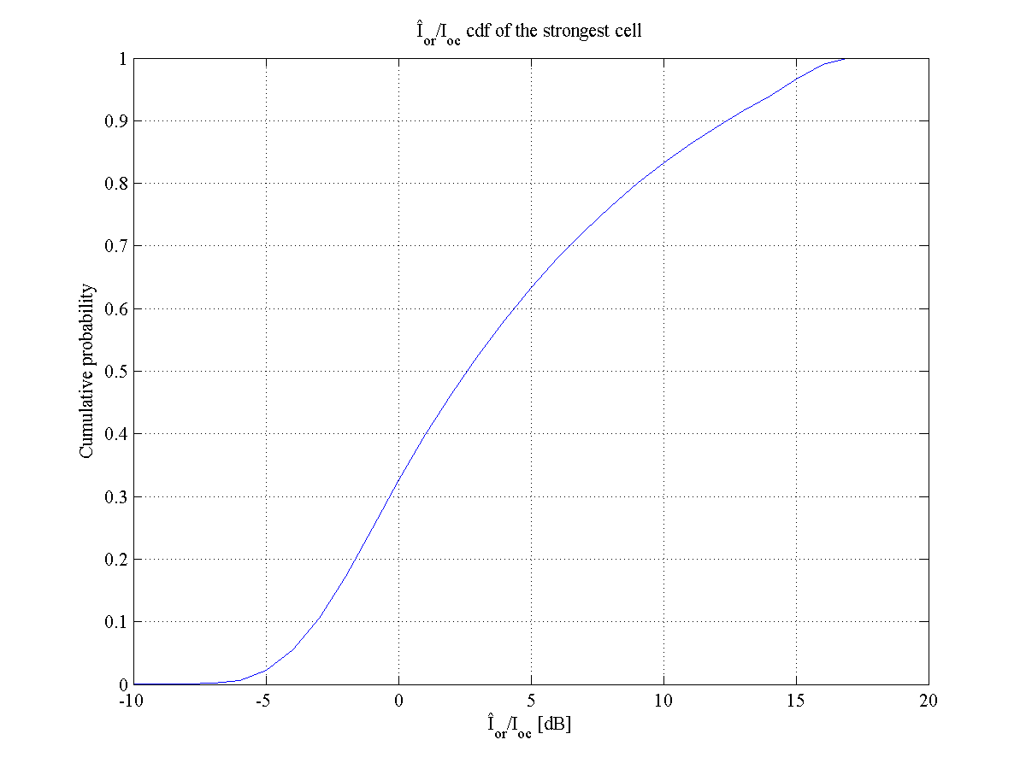

Figure 6.1: Geometry CDF [10]



Figure 6.2: Geometry CDF [11]

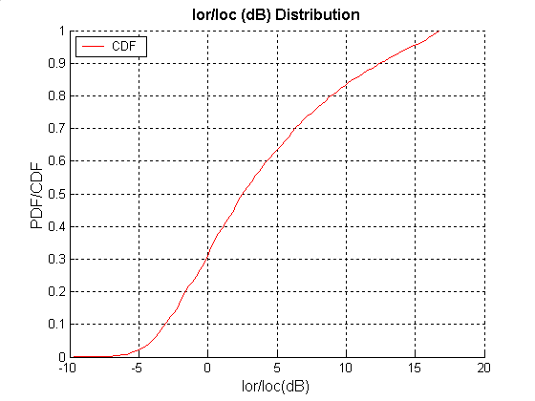

Figure 6.3: Geometry CDF [12]



Figure 6.4: Geometry CDF [13]

In order to decide the appropriate number of interferers to model for link level characterization, it was agreed [3] to initially evaluate interference statistics for the eight strongest interfering cells. There is a trade-off - a larger number of modeled interferers in the profile makes link level characterization simulations and eventual testing more complex, but it also makes the interference model more accurate. After reviewing results for measured statistics, the group decided [14] that an appropriate trade-off between complexity and accuracy can be achieved by defining the interference profile with five strongest interfering base stations plus a filtered AWGN component to model the residual interference. Figures 6.5 to 6.8 present results generated by various companies to show the contribution of the eight strongest interfering cells to the total interference in the system. Here, the term total interference refers to *Ioc* as defined in Clause 6.2. It can be observed that the five strongest interferers contribute a large majority of the total interference.

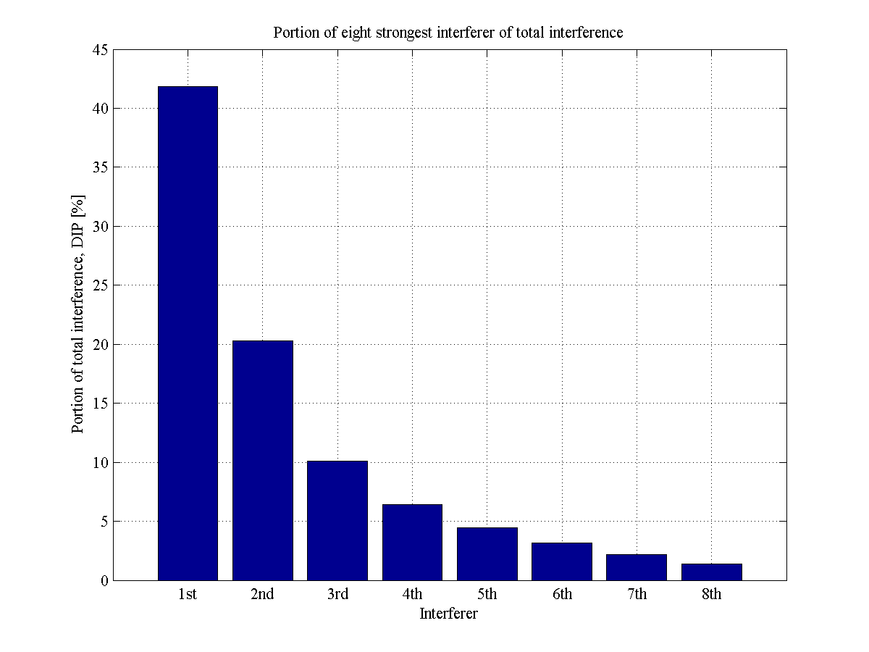

Figure 6.5: 8 Strongest Interferers [9]



Figure 6.6: 8 Strongest Interferers [10]



Figure 6.7: 8 Strongest Interferers [11]



Figure 6.8: 8 Strongest Interferers [12]

The group evaluated unconditional DIP values for the eight strongest interfering cells, as well as conditional DIP values conditioned on -3 dB, 0 dB, 5 dB, and 10 dB values of geometry. Figures 6.9 to 6.12 show CDFs of unconditional DIPi for the eight strongest interferers. Figures 6.13 to 6.15 show median values of conditional DIPi for different values of geometry. Based on these DIP results at that time the group decided that since there was not a large variability in DIP values for different geometries, the group could simplify the number of simulation scenarios by defining an interference profile with a single set of median DIP values for all geometries.

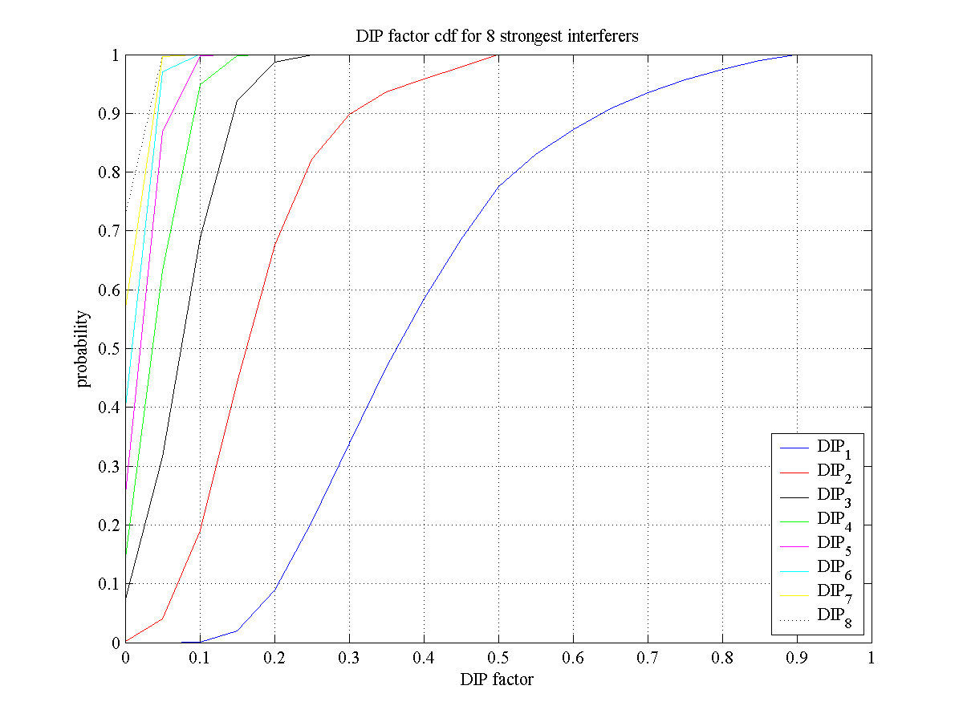

Figure 6.9: Unconditional DIP CDFs [10]

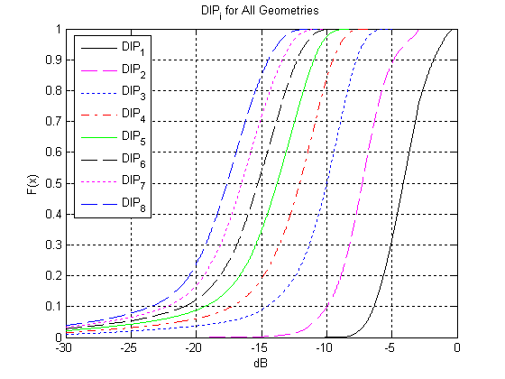

Figure 6.10: Unconditional DIP CDFs [11]



Figure 6.11: Unconditional DIP CDFs [12]



Figure 6.12: Unconditional DIP CDFs [13]



Figure 6.13: Conditional Median DIPs [10]



Figure 6.14: Conditional Median DIPs [12]



Figure 6.15: Conditional Median DIPs [11]

Thus, an interference profile was defined on the basis of averaging unconditional median DIP values submitted by four companies as shown in Table 6.1. It was agreed [15] that the interference profile would consist of the averaged set of five median DIP values and one residual interferer to model the remaining interference. It was also agreed that the residual interferer would be modeled as filtered AWGN. Based on the DIP values shown in Table 6.1, the ratio AWGN/Ioc should be set to -5.8 dB, which is equivalent to about 26% of the total other cell interference power. The AWGN source should be filtered using the pulse shaping filter defined in TS 25.104 to insure correct spectral properties. These median DIP values plus the residual AWGN were to be used with each of the geometries considered in the initial link level characterization. The geometry values used in that initial characterization were -3 dB, 0 dB, 5 dB and 10 dB, see clause 8.

Table 6.1: Interference Profile Based on Averaged Set of Unconditional Median DIP Values [14]

|  |  |  |  |  |  |
| --- | --- | --- | --- | --- | --- |
|  | Cingular | Qualcomm | Motorola | Nokia | **Average** |
| DIP1 | -4.1 | -4.1 | -4.4 | -4.4 | **-4.2** |
| DIP2 | -7.3 | -7.3 | -7.6 | -8.0 | **-7.5** |
| DIP3 | -10.0 | -10.0 | -10.5 | -11.5 | **-10.5** |
| DIP4 | -12.1 | -12.0 | -12.5 | -14.0 | **-12.6** |
| DIP5 | -13.8 | -13.6 | -14.1 | -17.0 | **-14.4** |
| AWGN/Ioc | -6.6 | -6.7 | -5.6 | -4.6 | **-5.8** |
|  | 22% | 21% | 28% | 35% | **26%** |

## 6.3 Interference profiles based on weighted average throughput gain

### 6.3.0 General

Upon reviewing the initial link level performance results for the interference profile based on median DIP values, some companies expressed concern that these values were too conservative, and led to under-estimation of the benefits of IC receivers. This led to the development of an alternative method for calculating DIP values based on what is called the ‘weighted average throughput gain’ as described in [8]. This method develops multiple sets of DIP ratios, the resulting throughputs of which are averaged to find an average throughput gain. The set of DIP ratios closest to this average is then selected as the interference profile. Two profiles were ultimately defined, one for 0 dB geometry, and the other for -3 dB geometry. The remainder of this clause describes the methodology used to define these two interference profiles along with their associated values. Note since the initial link level gains were negligible for the higher geometries (5 and 10 dB), the group agreed to focus on performance at the lower geometries, which is intuitively where an IC receiver is going to provide benefit.

### 6.3.1 0 dB geometry

The 0 dB geometry profile based on weighted average throughput gain was defined based on a methodology presented in [8] and explained further as follows. In the static system simulator, UEs were randomly placed throughout the simulated cells of interest. All of the randomly placed UEs with a geometry of near Ior1/Ioc = 0dB (0.2 dB) were chosen and their DIP values were saved. This process was repeated for multiple realizations, until a significant number of samples were obtained. Then, the saved DIP values were sorted by DIP1 and then binned in 5-percentile bands. One random sample was drawn from each 5-percentile band to obtain a total of 20 representative DIP ratio sets. Table 6.2 shows the 20 representative DIP ratio sets that were used to define the interference profile for the 0 dB case.

Table 6.2: DIP ratios for Ior1/Ioc = 0dB [8]

|  |  |  |  |  |  |  |  |
| --- | --- | --- | --- | --- | --- | --- | --- |
| # | Ior1/Ioc | DIP1 | DIP2 | DIP3 | DIP4 | DIP5 | Ioc |
| 1 | -0.08 | -8.22 | -9.39 | -9.99 | -10.11 | -10.73 | -61.62 |
| 2 | 0.07 | -6.35 | -7.85 | -8.09 | -8.61 | -9.47 | -68.37 |
| 3 | -0.01 | -5.74 | -6.41 | -10.70 | -11.19 | -11.50 | -54.74 |
| 4 | 0.05 | -5.38 | -7.48 | -7.57 | -7.68 | -15.79 | -60.59 |
| 5 | -0.01 | -4.94 | -5.30 | -8.05 | -13.64 | -14.11 | -65.75 |
| 6 | -0.09 | -4.68 | -5.73 | -8.11 | -12.38 | -15.16 | -57.44 |
| 7 | -0.09 | -4.40 | -5.38 | -8.73 | -13.72 | -13.80 | -49.08 |
| 8 | 0.01 | -4.14 | -9.26 | -10.12 | -11.85 | -13.54 | -54.25 |
| 9 | -0.06 | -3.93 | -8.89 | -10.65 | -11.50 | -12.78 | -65.95 |
| 10 | 0.09 | -3.65 | -7.36 | -9.25 | -12.49 | -13.58 | -63.34 |
| 11 | 0.02 | -3.43 | -8.55 | -8.72 | -11.52 | -15.01 | -63.50 |
| 12 | -0.04 | -3.17 | -4.33 | -14.32 | -15.99 | -18.96 | -58.68 |
| 13 | 0.04 | -3.00 | -4.66 | -13.34 | -17.61 | -20.61 | -56.81 |
| 14 | 0.00 | -2.75 | -7.64 | -8.68 | -13.71 | -14.59 | -41.51 |
| 15 | -0.05 | -2.40 | -4.99 | -12.37 | -18.32 | -18.70 | -47.09 |
| 16 | -0.01 | -2.12 | -8.97 | -9.13 | -15.77 | -17.90 | -63.01 |
| 17 | -0.03 | -1.79 | -11.42 | -12.07 | -14.54 | -14.95 | -65.39 |
| 18 | 0.04 | -1.37 | -9.47 | -15.28 | -16.42 | -17.83 | -69.25 |
| 19 | 0.07 | -0.84 | -14.86 | -15.80 | -16.01 | -17.27 | -51.90 |
| 20 | 0.08 | -0.50 | -11.39 | -19.44 | -21.55 | -24.07 | -53.99 |

Link level simulations were conducted for each of the above 20 representative sets of DIP ratios to obtain link level throughputs for each set. The average throughput gain over all 20 sets was then calculated. The DIP ratio set whose individual throughput gain was closest to the average throughput gain was then chosen as the DIP ratio set for the interference profile. For the data in Table 6.2, the DIP ratio set corresponding to row #14 was found to be the one with throughput gain closest to the average. The corresponding DIP values for this row are repeated in Table 6.3. These values were used in a second round of link level characterization for the 0 dB geometry case as described in clause 8.

Table 6.3 Interference Profile Based on Weighted Average Throughput for 0 dB Geometry [8]

|  |  |  |  |  |
| --- | --- | --- | --- | --- |
| DIP1 [dB] | DIP2 [dB] | DIP3 [dB] | DIP4 [dB] | DIP5 [dB] |
| -2.75 | -7.64 | -8.68 | -13.71 | -14.59 |

### 6.3.2 -3 dB geometry

In the methodology used to define the interference profile for the 0 dB geometry case in clause 6.3.1 a random sample was drawn from each of the 20 5-percentile bins to obtain the 20 sets of representative DIP ratios. It was pointed out in [18] that due to this random draw, the interference profile defined in clause 6.3.1 was not repeatable by other companies. If repeatability is desired, an alternative method of obtaining 20 representative DIP ratio sets based on bin-averaging was proposed in [18]. According to this alternative method the DIP values calculated for each 5 percentile interval are based on the average of all of the values that fall within that bin. For example, for the Ior1/Ioc = -3 dB case, all UEs whose DIP1 value is equal to -3 dB (0.2 dB) are sorted according to DIP1 and sampled at 5 percentile intervals to yield 20 groups. The 20 representative DIP values are the average of the DIP values observed by all UEs that fall within each of these 20 groups. The 20 sets of DIP values, calculated using the bin-averaging method for the -3 dB geometry case are shown in Table 6.4.

Table 6.4 DIP values for Ior/Ioc = -3 dB, sorted on 5th percentile increments. [19]

|  |  |  |  |  |  |  |
| --- | --- | --- | --- | --- | --- | --- |
| Bin # | Ior/Ioc | DIP1 | DIP2 | DIP3 | DIP4 | DIP5 |
| 1 | -2.998 | -6.937 | -7.659 | -8.454 | -9.608 | -10.972 |
| 2 | -2.994 | -6.135 | -7.058 | -8.320 | -9.880 | -11.729 |
| 3 | -3.007 | -5.755 | -6.761 | -8.203 | -10.258 | -12.123 |
| 4 | -3.003 | -5.481 | -6.616 | -8.414 | -10.446 | -12.231 |
| 5 | -3.016 | -5.238 | -6.392 | -8.339 | -10.864 | -12.762 |
| 6 | -2.992 | -5.043 | -6.398 | -8.617 | -10.961 | -12.975 |
| 7 | -3.003 | -4.866 | -6.498 | -8.647 | -11.006 | -12.908 |
| 8 | -3.001 | -4.697 | -6.423 | -8.928 | -11.357 | -13.136 |
| 9 | -2.983 | -4.524 | -6.180 | -8.960 | -11.626 | -13.544 |
| 10 | -2.993 | -4.370 | -6.210 | -9.245 | -11.654 | -13.750 |
| 11 | -2.984 | -4.218 | -6.148 | -9.594 | -11.979 | -13.862 |
| 12 | -2.996 | -4.088 | -6.202 | -9.508 | -12.007 | -14.064 |
| 13 | -3.001 | -3.959 | -6.205 | -9.537 | -12.151 | -14.229 |
| 14 | -3.002 | -3.830 | -6.435 | -10.064 | -12.304 | -13.839 |
| 15 | -2.996 | -3.699 | -6.537 | -9.879 | -12.378 | -14.146 |
| 16 | -2.994 | -3.556 | -6.362 | -10.123 | -12.648 | -14.409 |
| 17 | -3.007 | -3.423 | -6.515 | -10.314 | -12.788 | -14.436 |
| 18 | -2.998 | -3.300 | -6.598 | -10.454 | -12.785 | -14.702 |
| 19 | -2.975 | -3.174 | -6.772 | -10.619 | -12.882 | -14.717 |
| 20 | -2.897 | -3.003 | -7.078 | -10.791 | -13.061 | -14.689 |

It was shown in [18], that both the random draw and bin-averaging methods produce the same throughput gains for the 0 dB geometry case and thus, either method was deemed acceptable for this case. However, this was not found to be the case for the -3 dB geometry condition, where in [19] there was shown to be a significant difference between the throughput gains for the two methods. A significant difference was also observed in [20] where throughput gains were compared using just the random draw method. Based on all of this, the group decided [21] to adopt the alternative method based on bin-averaging for the -3 dB geometry case, but to leave the interference profile defined for the 0 dB case in clause 6.3.1 unchanged since there was no significant difference in link level throughput results for this latter case.

Applying the ‘weighted average throughput gain’ method to the data of Table 6.4 results in the selection of row #10 as the interference profile for the -3 dB geometry case. For clarity, the selected DIP values of row #10 are repeated in Table 6.5 below. Note in [19] the DIP ratio set is actually selected based on the weighted average throughput as opposed to the weighted average throughput gain, but the two methods were found to be nearly equivalent for the data analyzed, and in fact the former method gave a more consistent answer.

Table 6.5: Interference Profile based on Weighted Average Throughput for Ior1/Ioc = -3 dB [19]

|  |  |  |  |  |
| --- | --- | --- | --- | --- |
| DIP1 [dB] | DIP2 [dB] | DIP3 [dB] | DIP4 [dB] | DIP5 [dB] |
| -4.37 | -6.21 | -9.25 | -11.65 | -13.75 |

## 6.4 Interference profiles based on field data

The interference profiles defined in clauses 6.3 and 6.4 are all based on the use of static system level simulators. These simulators are based on a homogeneous layout of hexagonal cells with uniformly distributed users. Thus, they fail to capture a number of real-world effects including non-homogeneity of cells, buildings/terrain, and non-uniform distribution of users, just to name a few. Even with these shortcomings, system level simulations are still extremely valuable since the results developed are typically repeatable and one can precisely control the environment. However, it is also very important to consider actual field data when attempting to determine the feasibility of an advanced UE receiver that is attempting to cancel interference from other cells as is being considered in this study item. To this end, several contributions were submitted during this effort, which describe a number of field measurements [9] [22] [23] [24]. These measurements provide additional insight into how well an IC receiver might actually perform in a real network. In addition, interference profiles conditioned on geometry were defined based on one of the sets of field data. Link level characterization using this latter set is described in clause 8. The following briefly describes some of the main observations that can be drawn from the field data plus the specifics of the field-based interference profiles.

In [22] interference data collected in a live UMTS network in Paris is described. The major observations from these measurements are as follows:

- For mobiles at the cell edge, there are in general no more than 3 interfering cells seen by the UE. In about 65% of the time, there are only 2 interferers detected.

- DIP 1 values are fairly high (when compared to other DIP values) and not too spread out, ranging between 0 and -4 dB, at geometry Ior/Ioc = 0.

- DIP 2 and DIP 3 values are more spread out.

- There are not enough 4th interferers detected to include in a meaningful statistical analysis.

- A 3-D representation of data confirmed the spread of DIP 2 in particular over a large range of values: from -2dB to about -13 dB.

In [23] field measurements are provided for an operational UMTS/HSDPA network in parts of greater and downtown Chicago. The results from these measurements indicate that for the 0 dB geometry case that most of the interfering energy when measured at the median points of the DIP CDF curves is contained in the first two interfering cells (78%). For -3 dB geometry, most of the interfering energy is in the first three interfering cells (coincidentally 78%).

Field measurements of DIP values recorded in central London are presented in [24]. DIP measurements were taken conditioned on the following values of geometry: -3, 0, 5, and 10 dB. Based on these measurements, DIP profiles were defined as shown in Table 6.6. These values are based on taking the median value of each respective DIP value for each of the geometries considered. Even though this approach (taking the median value) is thought to be conservative, the values in Table 6.6 are still more optimistic from an IC performance perspective than the other profiles previously defined, see clause 6.6. If one were to apply the ‘weighted average throughput gain’ method to this field data, the results would be even more optimistic. Link level results based on the DIP ratios corresponding to -3 and 0 dB geometries are provided in clause 8.

One of the conclusions that can be drawn from all of the field measurements is that most of the interference is contained in the first two interfering cells with some energy in the third depending upon geometry. Very little energy was detected in the fourth and beyond, and thus, the use of five interfering cells in the simulation-based profiles may be bit of an over kill. The second conclusion is that field-based profiles are more optimistic than the simulation-based profiles and thus, performance in the real world (at least in those locations where the field data was collected) should be better than that predicted by the simulations.

Table 6.6: Interference Profiles Based on Field Data [24]

|  |  |  |  |  |
| --- | --- | --- | --- | --- |
|  | *Î*or1/*I*oc | | | |
| DIP*i* | -3dB | 0dB | 5dB | 10dB |
| DIP1 | -4.1 | -1.9 | -1.8 | -1.8 |
| DIP2 | -6.3 | -8.7 | -8.5 | -9.4 |
| DIP3 | -9.1 | -14.6 | -15.8 | -14.9 |
| DIP4 | -12.1 | -20.6 | -21.7 | -20.2 |
| DIP5 | -15.3 | -29.8 | -31 | -31 |

## 6.5 Summary

In summary, Table 6.7 shows the interference profiles that have been defined as part of this feasibility study to assess link level performance of IC receivers. The top entry reflects the median DIP values, which are to be used for all geometries considered. The next entry defines the two DIP profiles that were defined based on the weighted average throughput gain method for the 0 dB and -3 dB geometries, respectively. The last entry shows the DIP entries based on field data where we have limited the geometries to 0 and -3 dB once since there is where gain for IC receivers is expected. It is interesting to note when comparing these profiles that the median profile is actually quite close to both of the profiles conditioned on -3 dB geometry, and how really close the latter two are to each other. This suggests that the median profile probably should have only been used for the -3 dB geometry condition, and that it is important to condition the DIP ratios on geometry to obtain meaningful results. Link level performance results based on these interference profiles are presented in clause 8.

Table 6.7: Summary of Defined Interference Profiles

|  |  |  |  |  |  |
| --- | --- | --- | --- | --- | --- |
| Profile | DIP1 | DIP2 | DIP3 | DIP4 | DIP5 |
| Based on median values | -4.2 | -7.5 | -10.5 | -12.6 | -14.4 |
| Based on weighted average throughput gain |  |  |  |  |  |
| 0 dB geometry | -2.75 | -7.64 | -8.68 | -13.71 | -14.59 |
| -3 dB geometry | -4.37 | -6.21 | -9.25 | -11.65 | -13.75 |
| Based on field data |  |  |  |  |  |
| 0 dB geometry | -1.9 | -8.7 | -14.6 | -20.6 | -29.8 |
| -3 dB geometry | -4.1 | -6.3 | -9.1 | -12.1 | -15.3 |

# 7 Transmitted code/power characteristics

## 7.0 General

This clause describes the modelling methods and assumed characteristics of desired and interfering signals for this study.

## 7.1 Transmitted code and power characteristic in case of HSDPA

In the following clauses the modelling of code and power characteristics for serving and interfering cells is presented. The text is based on [29] aiming to merge the proposals presented in documents [25][26][27][28] accounting also the discussions held during RAN4#39. Also additional changes proposed in [30] and [31] were accounted as agreed in interim teleconference held between RAN4 meetings #41 and #42 [21].

For modelling the transmitted code and power domain characteristics in case of HSDPA, two difference scenarios are determined; the ‘HSDPA-only’ and ‘HSDPA+R’99’. The scenarios described in this clause are separated by the used HS-PDSCH power allocation and modelling of the associated dedicated channels. For ‘HSDPA-only’, 66% HS-PDSCH power allocation is assumed with associated channels modeled as F-DPCH, and for ‘HSDPA+R’99’ 50% and 25% allocations are assumed together with dedicated channels assumed as DPCH.

### 7.1.1 Common channels for serving and interfering cells

The common downlink channels and corresponding powers used in RAN4 HSDPA demodulation requirements with single transmit antenna are listed in the Table C.8 of TS25.101 [2]. Similar definitions exist also for open and closed loop transmit diversity requirements in Tables C.9 and C.10 in [2]. Table 7.1 below summarizes the common downlink physical channels for single transmit antenna case. As these figures can be considered to be quite representative, it is seen that these could be used also for the evaluation, for both, serving cell and interfering cells, in case of single transmit antenna.

Table 7.1: Downlink Physical Channels transmitted during a connection for HSDPA

|  |  |  |
| --- | --- | --- |
| Physical Channel | Power ratio | NOTE |
| P-CPICH | P-CPICH_Ec/Ior = -10 dB | Use of P-CPICH or S‑CPICH as phase reference is specified for each requirement and is also set by higher layer signalling. |
| P-CCPCH | P-CCPCH_Ec/Ior = -12 dB | When BCH performance is tested the P-CCPCH_Ec/Ior is test dependent |
| SCH | SCH_Ec/Ior = -12 dB | This power shall be divided equally between Primary and Secondary Synchronous channels |
| PICH | PICH_Ec/Ior = -15 dB |  |

### 7.1.2 Serving cell

In this clause the definition of transmitted code and power characteristics are given for the serving cell.

#### 7.1.2.1 Transmitted code and power characteristics for HSDPA+R’99 scenario

The assumed downlink physical channel code allocations for HSDPA+R’99 scenario is given in Table 7.2. Table 7.3 summarizes the power allocations of different channels for the serving cell in ‘HSDPA+R’99’ scenario for 50 % or 25 % HS-PDSCH power allocation.

Ten HS-PDSCH codes have been reserved for user of interest in Table 7.2. Depending on the used fixed reference channel definition, H-SET3 or H-SET6, part of these may be left unused.

In total 46 SF=128 codes have been reserved for other users channels (OCNS). For HSDPA+R’99 scenario the (associated) dedicated channels of other users are modeled as DPCH. The amount of users present is dependent on the power remaining available after HSDPA allocation. For HSDPA power allocation of 50%, 18 users were fitted to cell. Correspondingly with HSDPA allocation of 25%, 34 users were fitted to the cell. The definition of the other user orthogonal channels and channel powers are given in Table 7.4 and Table 7.5. Power control behavior of the other users is introduced as described in Clause 7.1.4.

Table 7.2: Downlink physical channel code allocation for HSDPA+R’99

|  |  |
| --- | --- |
| Channelization Code at SF=128 | Note |
| 0, 1 | P-CPICH, P-CCPCH and PICH on SF=256 |
| 2…7 | 6 SF=128 codes free for OCNS |
| 8…87 | 10 HS-PDSCH codes at SF=16 |
| 88…127 | 40 SF=128 codes free for OCNS |

Table 7.3: Summary of modelling approach for the serving cell in HSDPA+R’99 scenarios

|  |  |  |
| --- | --- | --- |
|  | Serving cell | |
| Common channels | 0.195 (-7.1dB)  As given in Table 7.1 | |
| HS-PDSCH transport format | H-SET3 or H-SET6 | |
| HS-PDSCH power allocation [Ec/Ior] | 0.5  (-3dB) | 0.25  (-6dB) |
| Other users channels | 0.305  (-5.16dB)  Set as given in Table 7.4 | 0.555  (-2.58dB)  Set as given in Table 7.5 |
| NOTE: The values given in decibel are only for information. | | |

Table 7.4: Definition of 18 other users orthogonal channels on downlink scenario with 50% HS-PDSCH power allocation

|  |  |  |  |  |  |
| --- | --- | --- | --- | --- | --- |
| Channelization Code Cch,SF,k | Ec/Ior | Channelization Code Cch,SF,k | Ec/Ior | Channelization Code Cch,SF,k | Ec/Ior |
| Cch,128,2 | 0.0204 | Cch,128,98 | 0.0269 | Cch,64,58 | 0.0294 |
| Cch,128,4 | 0.0105 | Cch,128,100 | 0.0170 | Cch,128,121 | 0.0269 |
| Cch,128,6 | 0.0115 | Cch,128,102 | 0.0091 | Cch,128,123 | 0.0204 |
| Cch,128,88 | 0.0110 | Cch,64,52 | 0.0232 | Cch,128,125 | 0.0069 |
| Cch,128,91 | 0.0112 | Cch,128,109 | 0.0129 |  |  |
| Cch,128,93 | 0.0110 | Cch,128,111 | 0.0178 |  |  |
| Cch,128,95 | 0.0316 | Cch,128,114 | 0.0072 |  |  |

Table 7.5: Definition of 34 other users orthogonal channels on downlink scenario with 25% HS-PDSCH power allocation

|  |  |  |  |  |  |
| --- | --- | --- | --- | --- | --- |
| Channelization Code Cch,SF,k | Ec/Ior | Channelization Code Cch,SF,k | Ec/Ior | Channelization Code Cch,SF,k | Ec/Ior |
| Cch,128,2 | 0.0229 | Cch,128,98 | 0.0129 | Cch,128,114 | 0.0110 |
| Cch,128,3 | 0.0182 | Cch,128,99 | 0.0162 | Cch,128,115 | 0.0110 |
| Cch,128,4 | 0.0076 | Cch,128,100 | 0.0170 | Cch,128,116 | 0.0110 |
| Cch,128,5 | 0.0155 | Cch,128,101 | 0.0102 | Cch,128,118 | 0.0316 |
| Cch,128,6 | 0.0245 | Cch,128,103 | 0.0182 | Cch,128,119 | 0.0269 |
| Cch,64,44 | 0.0304 | Cch,64,52 | 0.0379 | Cch,64,60 | 0.0261 |
| Cch,128,90 | 0.0081 | Cch,128,106 | 0.0132 | Cch,128,123 | 0.0120 |
| Cch,128,91 | 0.0065 | Cch,128,108 | 0.0229 | Cch,128,124 | 0.0115 |
| Cch,128,93 | 0.0069 | Cch,128,109 | 0.0145 | Cch,128,125 | 0.0132 |
| Cch,128,94 | 0.0110 | Cch,128,110 | 0.0115 | Cch,128,126 | 0.0110 |
| Cch,128,95 | 0.0135 | Cch,128,111 | 0.0200 |  |  |
| Cch,128,96 | 0.0200 | Cch,128,113 | 0.0102 |  |  |

#### 7.1.2.2 Transmitted code and power characteristics for HSDPA-only scenario

The assumed downlink physical channel code allocations for the HSDPA-only scenario is given in Table 7.6. In the Table 7.7 power allocations for the serving cell is presented for HSDPA-only scenario.

For HSDPA-only scenario, as in Table 7.6, 14 codes are made available for the HS-DSCH as all the associated dedicated channels use F-DPCH. Depending on the used fixed reference channel definition, H-SET3 or H-SET6, part of these may be left unused. In order to permit comparable simulations to be performed using existing FRC definitions, an additional code multiplexed user is introduced to the serving cell of HSDPA-only scenario. As H-SET6 requires a maximum of 10 codes and H-SET3 requires 5 codes, additional code multiplexed user is defined in case of the serving cell. This additional code multiplexed user utilizes the rest of the available codes assumed to be available for HSDPA. The code channels intended for the additional code multiplexed user shall have equal power and common modulation. The power per code for H-SET6 shall be either 0.04 (-14 dB) when HS-DSCH Ec/Ior allocated for the DUT is 50%, or 0.1025 (-9.9 dB) when HS-DSCH Ec/Ior allocated for the DUT is 25%. The respective per code power allocations for H-SET3 are 0.01777 (-17.5 dB) and 0.04555 (-13.4 dB), see Tables 7.8 and 7.9. Used common modulation (QPSK or 16QAM) should be randomly selected with equal probability.

The definition of other users orthogonal channels is given in Table 7.10. The channelization code indices, Cch,256,x and Cch,256,y given at same row are considered as pair. At any given symbol instant, only symbol from either code channel is transmitted with the Ec/Ior given in the last column of the same row. The other code channel is DTX’ed. The code channel transmitted is selected randomly with even probability. This is done to account the structure of the F-DPCH.

Table 7.6: Downlink physical channel code allocation for HSDPA-only scenario

|  |  |
| --- | --- |
| Channelization Code at SF=128 | Note |
| 0 | P-CPICH, P-CCPCH and PICH on SF=256 |
| 1 |
| 2…7 | 6 SF=128 codes free for OCNS |
| 8…119 | 14 HS-PDSCH codes at SF=16 |
| 120…127 | 8 SF=128 codes free for OCNS |

Table 7.7: Summary of the modelling approach for the serving cell in HSDPA-only scenarios

|  |  |
| --- | --- |
|  | Serving cell |
| Common channels | 0.195 (-7.1dB)  As given in Table 7.1 |
| HS-PDSCH transport format | H-SET3 or H-SET6 for user of interest.  Additional other HSDPA users code allocation is based on Table 7.8 for H-SET3 or Table 7.9 for H-SET6. |
| Total HS-PDSCH power allocation [Ec/Ior] | 0.66  (-1.8dB) |
| HS-PDSCH power allocation for DUT (of the total) [Ec/Ior] | [0.5, 0.25]  ([-3dB, -6dB]) |
| Other users dedicated channels | 0.14  (-8.54dB)  Set according to Table 7.10. |
| NOTE: The values given in decibel are only for information. | |

Table 7.8: Definition of additional code multiplexed users orthogonal channel for HSDPA-only scenario (H-SET3)

|  |  |  |  |  |  |
| --- | --- | --- | --- | --- | --- |
| Channelization Code Cch,SF,k | Ec/Ior [dB] | Channelization Code Cch,SF,k | Ec/Ior [dB] | Channelization Code Cch,SF,k | Ec/Ior [dB] |
| Cch,16,6 | Note1 | Cch,16,7 | Note1 | Cch,16,8 | Note1 |
| Cch,16,9 | Note1 | Cch,16,10 | Note1 | Cch,16,11 | Note1 |
| Cch,16,12 | Note1 | Cch,16,13 | Note1 | Cch,16,14 | Note1 |
| NOTE 1: Used common modulation should be randomly selected for codes with equal probability. The code channels shall have equal power, either 0.01777 (-17.5 dB) when HS-DSCH Ec/Ior allocated for the DUT is -3dB or 0.04555 (-13.4 dB) when HS-DSCH Ec/Ior allocated for the DUT is -6dB. | | | | | |

Table 7.9: Definition of additional code multiplexed users orthogonal channel for HSDPA-only scenario (H-SET6)

|  |  |  |  |  |  |
| --- | --- | --- | --- | --- | --- |
| Channelization Code Cch,SF,k | Ec/Ior [dB] | Channelization Code Cch,SF,k | Ec/Ior [dB] | Channelization Code Cch,SF,k | Ec/Ior [dB] |
| Cch,16,11 | Note2 | Cch,16,12 | Note2 | Cch,16,13 | Note2 |
| Cch,16,14 | Note2 |  |  |  |  |
| NOTE 2: Used common modulation should be randomly selected for codes with equal probability. The code channels shall have equal power, either 0.04 (-14 dB) when HS-DSCH Ec/Ior allocated for the DUT is -3dB or 0.1025 (-9.9 dB) when HS-DSCH Ec/Ior allocated for the DUT is -6dB. | | | | | |

Table 7.10: Definition of other users orthogonal channels on downlink for HSDPA-only scenario

|  |  |  |
| --- | --- | --- |
| Channelization Code Cch,SF,x | Channelization Code Cch,SF,y | Ec/Ior |
| Cch,256,4 | Cch,256,243 | 0.0135 |
| Cch,256,5 | Cch,256,244 | 0.0200 |
| Cch,256,249 | Cch,256,246 | 0.0129 |
| Cch,245,8 | Cch,256,247 | 0.0166 |
| Cch,256,9 | Cch,256,6 | 0.0170 |
| Cch,256,11 | Cch,256,250 | 0.0102 |
| Cch,256,240 | Cch,256,253 | 0.0182 |
| Cch,256,242 | Cch,256,255 | 0.0316 |

### 7.1.3 Interfering cells

In this clause the definition of transmitted code and power characteristics are given for the interfering cells.

#### 7.1.3.1 Transmitted code and power characteristics for HSDPA+R’99 scenario

For the interfering cells in HSDPA+R’99 scenario, same downlink physical channel code allocations are assumed as given in Table 7.2. The modelling is summarized in Table 7.11 for HSDPA+R’99 scenario for interfering cells.

Table 7.11: Summary of modelling approach for the interfering cells in HSDPA+R’99 scenarios with power allocation of 50% and 25%

|  |  |
| --- | --- |
|  | Interfering cell(s) |
| Common channels | 0.195 (-7.1dB)  As given in Table 7.1 |
| HS-PDSCH transport format | Selected randomly from Table 7.12. Independent for each interferer. |
| HS-PDSCH power allocation [Ec/Ior] | 0.5  (-3dB) |
| Other users channels | 0.305  (-5.16dB)  Set according to Table 7.4. |
| NOTE: The values given in decibel are only for information. | |

The HS-PDSCH transmission for interfering cells is modelled to have randomly varying modulation and number of codes to model the actual dynamic system behaviour to some extent. The predefined modulation and code allocations are given in Table 7.12. The transmission from each interfering cell is randomly and independently selected every HSDPA sub-TTI among the four options given in the table.

Table 7.12: Predefined interferer transmission for HSDPA+R’99 scenario

|  |  |
| --- | --- |
| # | Used modulation and number of HS-PDSCH codes |
| 1 | QPSK with 5 codes |
| 2 | 16QAM with 5 codes |
| 3 | QPSK with 10 codes |
| 4 | 16QAM, with 10 codes |

The modelling of the other users dedicated channels is done in same way as in the case of the serving cell. The definition of the other users’ orthogonal channels and channel powers are given in Table 7.4. As fixed HSDPA power allocation (50%) is assumed for interfering cells, only one definition set is enough.

#### 7.1.3.2 Transmitted code and power characteristics for HSDPA-only scenario

Same downlink physical channel code allocations as for serving cell, given Table 7.6, are used for the interfering cells in HSDPA-only scenario. The modelling of the transmission of the interfering cells for HSDPA-only scenario is summarized in Table 7.13.

Table 7.13: Summary of modelling approach for the interfering cells in HSDPA-only scenarios

|  |  |
| --- | --- |
|  | Interfering cell(s) |
| Common channels | 0.195 (-7.1dB)  As given in Table 7.1 |
| HS-PDSCH transport format | Selected randomly from Table 7.14. Independent for each interferer. |
| Total HS-PDSCH power allocation [Ec/Ior] | 0.66  (-1.8dB) |
| Other users channels | 0.14  (-8.54 dB)  Set according to the Table 7.10 |
| Note: The values given in decibel are only for information. | |

Similarly as in case of HSDPA+R’99 scenario the HS-PDSCH transmission is modeled as having varying modulation and allocation of codes. This is done by selecting a code and modulation format from a group of predefined sets, as given in Table 7.14. Three different options are determined, with one option including code multiplexing. In case of the code multiplexing for the interfering HS-DSCH transmission (e.g. option #3) the power is divided equally between the two assumed users having different modulation.

Table 7.14: Predefined interferer transmission for HSDPA-only scenario

|  |  |
| --- | --- |
| # | Used modulation and number of HS-PDSCH codes |
| 1 | QPSK with 14 codes |
| 2 | 16QAM, with 14 codes |
| 3 | QPSK with 7 codes and 16QAM with 7 codes |

### 7.1.4 Model for the power control sequence generation

In this clause the modelling of power control behavior for the other users channels is given. In the assumed approach the power of each user, *i* at slot *n*, equals $P_{n}^{i}$ in dB. The power is varied randomly, either by increasing or decreasing it by 1dB steps in each slot, i.e. $P_{n}^{i}=P_{n−1}^{i}+Δ$, where $Δ∈\left\{−1,+1\right\}$. The probability of  having a value of +1 for the *i*th user at time instant *n* can be determined as

${\text{Pr}}_{n}^{i}(Δ\text{=+}1)=0\text{.}5−(P_{n−1}^{i}−P_{0}^{i})\frac{0\text{.}5}{L}$, (1)

where, $P_{n−1}^{i}$ is the transmitted power at time instant *n*-1 and $P_{0}^{i}$ is the initial value of the *i*th users power in dB. The initial transmit power values $P_{0}^{i}$ for different users are given in Tables 7.4 and 7.5 in absolute values. *L* is a scaling factor which can be used to determine the range to which the variation of power is confined. The value of *L* is set to 10, leading to variance of 5 dB.

In order to minimize the impact to test equipment due to power control modelling the total OCNS power is intended to be normalized. Thus the power control sequence for each user is generated as described above. The actual applied transmit power ${\hat{P}}_{n}^{i}$ (in linear domain) for the *i*th user would still be normalized by the total sum power of different users, defined as

${\hat{P}}_{n}^{i}=\frac{P_{\text{lin},n}^{i}}{\sum_{i}{P_{\text{lin},n}^{i}}}\sum_{i}{P_{\text{lin},0}^{i}}$. (2)

where is the transmitted power at time instant n and is the initial value of the ith user’s power in linear domain. The normalization has implications to the power variation of each user.

# 8 Link performance characterization

## 8.0 General

The purpose of this clause is to summarize the link-level simulation results that were provided by the companies that supported this study item. Emphasis is on results that were based on agreed set of simulation parameters. However, a complete list of results is given in the appendix of this clause.

## 8.1 Overview

This overview is meant to be a brief synopsis of the framework in which link-level simulations were performed. More detailed information regarding such topics as code modelling, system scenarios, and interference modelling are available elsewhere in this report. As described in clause 6 system simulations were performed by participating companies in order to reach an agreement on link-level simulation parameters. The main focus of this work was determining the number of interfering Node-Bs and associated set of DIP values and geometries to be used. Based on these simulation studies it was decided to set the number of interfering Node-Bs to five. Also, a single set of median DIP values would be used for selected geometries. See Table 8.1 for these and other referenced DIP values. In the course of this study it was proposed that median DIP values might give a pessimistic assessment of the potential gain that a LMMSE receiver with interference cancellation capability might provide. It was decided that the DIP values should be modified to take into account the potential gains at low geometries. Consequently a 2nd set of DIP values were accepted for link-level simulation purposes. In this case the DIP values are a function of the operating geometry; 0 or -3 dB. Afterwards, there was discussion regarding the method of generation of these DIP values. Subsequently it was decided to accept a modified DIP for geometry -3 dB. Contributions that investigated the DIP issue based on field measurements were also presented; simulations using these derived values were presented.

Table 8.1: DIP values (dB) used during progression of SI

|  |  |  |  |  |  |  |
| --- | --- | --- | --- | --- | --- | --- |
| Evolution | DIP1 | DIP2 | DIP3 | DIP4 | DIP5 | Status |
| Median | -4.2 | -7.5 | -10.5 | -12.6 | -14.4 | Obsolete |
| Weighted G=0 | -2.75 | -7.64 | -8.68 | -13.71 | -14.59 | Active |
| Weighted G=-3 | -3.21 | -5.56 | -10.01 | -12.67 | -15.53 | Obsolete |
| Revised Weighted G=-3 | -4.37 | -6.21 | -9.25 | -11.65 | -13.75 | Active |
| Field Measurement G=0 | -1.9 | -8.7 | -14.6 | -20.6 | -29.8 | Information |
| Field Measurement G=-3 | -4.1 | -6.3 | -9.1 | -12.1 | -15.3 | Information |

## 8.2 Simulation results

The following clauses 8.2.1 - 8.2.3 show the average relative gains as demonstrated by a type 2i over a type 2 receiver or a type 3i over a type 3 receiver. (As noted in clause 8.2.1, it was eventually decided that this SI would concentrate on the type 3 / 3i configuration. However, the type 2 / 2i results are given for completeness; similarly like simulation results for the obsolete DIP sets.) For a given simulation condition, average relative gain is defined as the ratio of the FRC throughput of the type 2i or 3i receiver to the throughput of the type 2 or 3 receiver, respectively. This "normalized" numerical result allows for a readily discernable evaluation of the efficacy of the type 2i / 3i receiver. However, this single quantity may not tell the complete story. If for example, the relative gain for a given channel condition is shown to be 7.0 for a 16QAM configuration, while the relative gain is 1.3 for QPSK under the same condition, the utility of the 16QAM value is of little practical importance if the actual throughput values are 7 Kb/s and 1 Kb/s for the type i and non type i receivers. Whereas, if for the same channel condition the QPSK throughput values are 195 Kb/s and 150 Kb/s for the different receivers, these values might be considered substantial and useful gains. Therefore, the corresponding average FRC throughput values are shown - expressed as ratio of integers - for all relative gains[2].

### 8.2.1 Types 2 and 2i - median DIP values

Tables 8.2 and 8.3 show the relative average gains and throughputs of the type 2i / 2 receivers for the various signal levels and channel conditions as indicated for the HSet-6 HSDPA+R99 QPSK and 16QAM scenarios, respectively. These sets of statistics are based on the contributions of six companies; see Appendix, Tables 8.A1 - 8.A2[3]

Table 8.2: HSet-6 QPSK gains and throughputs for types 2i / 2 receivers for HSDPA+R99 with median DIP values

|  |  |  |  |  |  |  |
| --- | --- | --- | --- | --- | --- | --- |
| QPSK HSet6 | PB3 | | | VA30 | | |
| Signal Level  Ec/Ior (dB) | G (dB) | G(dB) | G (dB) | G (dB) | G (dB) | G (dB) |
| 0 | 5 | 10 | 0 | 5 | 10 |
| -6 | 1.22  179 / 146 | 1.04  973 / 933 | 1.01  1645 / 1635 | 1.44  130 / 91 | 1.05  1040 / 992 | 1.01  1707 / 1693 |
| -3 | 1.08  785 / 728 | 1.03  1626 / 1583 | 1.00  2594 / 2587 | 1.10  838 / 764 | 1.02  1636 / 1600 | 1.00  2505 / 2493 |

Table 8.3: HSet-6 16 QAM gains and throughputs for types 2i / 2 receivers for HSDPA+R99 with median DIP values

|  |  |  |  |  |  |  |
| --- | --- | --- | --- | --- | --- | --- |
| 16QAM HSet6 | PB3 | | | VA30 | | |
| Signal Level  Ec/Ior (dB) | G (dB) | G(dB) | G (dB) | G (dB) | G (dB) | G (dB) |
| 0 | 5 | 10 | 0 | 5 | 10 |
| -6 | 2.03  7 / 5 | 1.09  394 / 362 | 1.01  1375 / 1363 | 1.00  1 / 1 | 1.19  373 / 312 | 1.02  1560 / 1490 |
| -3 | 1.22  247/202 | 1.04  1355 / 1303 | 1.01  2188 / 2176 | 1.30  166 / 132 | 1.04  1422 / 1360 | 1.01  2288 / 2260 |

Tables 8.4 and 8.5 give simulation results similar to above but for HSet-3. In this case the statistics are based on two contributing companies; see Appendix, Table 8.A4 and 8.A5.

Table 8.4: HSet-3 QPSK gains and throughputs for types 2i / 2 receiver for HSDPA+R99 with median DIP values

|  |  |  |  |  |  |  |
| --- | --- | --- | --- | --- | --- | --- |
| QPSK HSet3 | PB3 | | | VA30 | | |
| Signal Level  Ec/Ior (dB) | G (dB) | G(dB) | G (dB) | G (dB) | G (dB) | G (dB) |
| 0 | 5 | 10 | 0 | 5 | 10 |
| -6 | 1.06  407 / 382 | 1.02  809 / 825 | 0.99  1301 / 1311 | 1.06  435 / 410 | 1.01  735 / 728 | 1.00  1277 / 1270 |
| -3 | 1.04  738 / 712 | 1.01  1305 / 1294 | 0.96  1520 / 1579 | 1.03  732 / 712 | 1.00  1097 / 1094 | 1.00  1546 / 1546 |

Table 8.5: HSet-3 16QAM Gains and throughputs for types 2i / 2 receiver for HSDPA+R99 with median DIP values

|  |  |  |  |  |  |  |
| --- | --- | --- | --- | --- | --- | --- |
| 16QAM HSet3 | PB3 | | | VA30 | | |
| Signal Level  Ec/Ior (dB) | G (dB) | G(dB) | G (dB) | G (dB) | G (dB) | G (dB) |
| 0 | 5 | 10 | 0 | 5 | 10 |
| -6 | 1.23  146 / 120 | 1.02  725 / 712 | 1.01  1150 / 1138 | 1.46  127 / 89 | 1.05  770 / 735 | 1.01  1217 / 1200 |
| -3 | 1.07  599 / 562 | 1.02  1124 / 1104 | 1.01  1724 / 1707 | 1.07  618 / 576 | 1.02  1148 / 1127 | 1.01  1795 / 1682 |

From the above tables it can be observed that for geometries of 5 or 10 dB the gains are generally small, with all gains less than 1.10 except for one case where the gain is 1.19. The average of the gains for geometries 5 and 10 dB is 1.02. This average is based on all modulation types, signal levels, channels, and scenarios. The average relative gain for geometry 0 dB is 1.10 when the average is computed only over the better performing modulation scheme for a given channel and signal level; this is always QPSK in these cases.

### 8.2.2 Types 3 and 3i - median DIP values

Tables 8.6 and 8.7 give the relative gains and absolute ratios for receiver types 3 and 3i for HSet-6 and the indicated modulation with the use of the median DIP values. These statistics are based on appendix Tables 8.A10 and 8.A11.

Table 8.6: HSet-6 QPSK gains and throughputs for types 3i / 3 receivers for HSDPA+R99 with median DIP values

|  |  |  |  |  |  |  |
| --- | --- | --- | --- | --- | --- | --- |
| QPSK HSet6 | PB3 | | | VA30 | | |
| Signal Level  Ec/Ior (dB) | G (dB) | G(dB) | G (dB) | G (dB) | G (dB) | G (dB) |
| 0 | 5 | 10 | 0 | 5 | 10 |
| -6 | 1.16  1001/861 | 1.04  1865 / 1790 | 1.00  3005 / 2994 | 1.15  1042 / 908 | 1.05  1845 / 1759 | 1.01  2880 / 2850 |
| -3 | 1.09  1630 / 1490 | 1.03  2941 / 2854 | 1.00  3218 / 3217 | 1.09  1619 / 1485 | 1.04  2771 / 2660 | 1.00  3212 /3209 |

Table 8.7: HSet-6 16QAM gains and throughputs for types 3i / 3 receivers for HSDPA+R99 with median DIP values

|  |  |  |  |  |  |  |
| --- | --- | --- | --- | --- | --- | --- |
| 16QAM HSet6 | PB3 | | | VA30 | | |
| Signal Level  Ec/Ior (dB) | G (dB) | G(dB) | G (dB) | G (dB) | G (dB) | G (dB) |
| 0 | 5 | 10 | 0 | 5 | 10 |
| -6 | 1.66  360 / 217 | 1.05  1643 / 1560 | 1.03  2541 / 2469 | 2.41  311 / 128 | 1.06  1673 / 1577 | 1.02  2530 / 2466 |
| -3 | 1.16  1393 / 1201 | 1.03  2384 / 2303 | 1.01  3915 / 3862 | 1.17  1436 / 1230 | 1.04  2409 / 2320 | 1.02  3676 / 3607 |

From the tables for types 3i and 3 receivers simulated under the median DIP set, the average gain computed over geometries 5 and 10 dB is 1.03. Based on these results, including the type 2i / 2 receivers, it was decided to limit the study item to lower geometries, specifically -3 and 0 dB.

The average relative gain for geometry 0 dB is 1.13 when the average is computed only over the better performing modulation scheme for a given channel and signal level; like the types 2i / 2 case, this is for QPSK modulation. It was decided that only the type 3i / 3 case would be further studied. This decision was not based solely on the gain of 1.13 of the type 3i / 3 compared to the 1.10 gain of the type 2i / 2, as the performance gains are somewhat comparable. However, when the absolute throughput values at geometry 0 dB are compared for both receiver groups, the larger throughputs of the 3i receiver influenced the decision to limit the study item to the 3i / 3 case.

### 8.2.3 Weighted DIPS: geometries -3 & 0 dB

As indicated in the Overview of this clause the study group decided to use a set of weighted DIP values rather than median DIP values in order to more realistically determine the potential gain of the type 3i receiver under low geometry conditions. Tables 8.8 and 8.9 show the results when these weighted DIPs were used for simulation. In this case these tables represent the combined results of the HSDPA+R99 and HSDPA only scenarios. Specifically, there were 6 independent contributions for the HSDPA+R99 scenario, and 2 to 4 independent contributions, dependent upon the channel condition and geometry, for the HSDPA only scenario. In order to maximize the number of samples for averaging the results of both scenarios were combined. However, if a company contributed to HSDPA+R99 and HSDPA scenario, then just the HSDPA only scenario was used in the averaging. Because of the very close values for HSDPA+R99 and HSDPA only scenarios as observed when a given company submitted for both sets - this and prior simulations - it is believed that this is valid statistic. See appendix Tables 8.A16 through 8.A21

Tables 8.8 and 8.9 show the substantial relative gain that a type 3i receiver may realize over a type 3 at the low geometries of 0 and -3 dB. Also, it should be noted that these gains are at very useful throughput values. Again QPSK shows the better performance, though at geometry 0 dB and Ec/Ior = -3 dB, the difference between QPSK and 16QAM is fairly close.

Table 8.8: HSet-6 QPSK gains and throughputs for types 3i / 3 receivers with weighted DIP values

|  |  |  |  |  |
| --- | --- | --- | --- | --- |
| QPSK HSet6 | PB3 | | VA30 | |
| Signal Level  Ec/Ior (dB) | G (dB) | G (dB) | G (dB) | G (dB) |
| -3 | 0 | -3 | 0 |
| -6 | 2.79  508 / 209 | 1.32  1113 / 852 | 3.81  618 / 177 | 1.30  1171 / 904 |
| -3 | 1.38  1224 / 894 | 1.18  1780 / 1509 | 1.31  1292 / 983 | 1.20  1805 / 1498 |

Table 8.9: HSet-6 16QAM gains and throughputs for types 3i / 3 receivers with weighted DIP values

|  |  |  |  |  |
| --- | --- | --- | --- | --- |
| 16QAM HSet6 | PB3 | | VA30 | |
| Signal Level  Ec/Ior (dB) | G (dB) | G (dB) | G (dB) | G (dB) |
| -3 | 0 | -3 | 0 |
| -6 | 5.46  34 / 7 | 2.51  439 / 189 | 30.50  16 /1 | 4.54  480 / 106 |
| -3 | 2.58  721 / 297 | 1.32  1516 / 1147 | 4.14  837 / 229 | 1.30  1590 / 1225 |

### 8.2.4 Revised DIP: geometry -3 dB

As discussed in Clause 6.3.2 it was decided to use a revised weighted DIP value for geometry -3 dB. Tables 8.10 and 8.11 show the average throughput and gain values based on the contributions that incorporated this modified DIP set. Again, these statistics are based on a combined set of HSDPA and HSDPA+R99 results. These simulations also include the modified set of OCNS codes that were concurrently agreed to when the revised DIP for geometry -3 dB was established. The tables show that for geometry -3 dB there is a small reduction in the average relative gains due to the revised DIP; compare to Tables 8.8 and 8.9.Whereas for a geometry of 0 dB there is a lesser degradation in the gains, especially for the QPSK values which tend to represent the more useful modulation scheme for these signal levels and geometries. (Only at geometry 0 dB and Ec/Ior = - 3 dB does 16QAM approach the QPSK average throughput values.) Because the DIP value was not changed for 0 dB it is to be expected that there should be little change in the prior results as shown in Tables 8.8 and 8.9 compared to those of 8.10 and 8.11 at 0 dB. Probably most of the change is due to the sample size for geometry 0 dB. In this case there were only 3 and 2 sets of independent simulation results for PB3 and VA30, respectively. Whereas for geometry - 3 dB there are 7 and 6 sets for PB3 and VA30. See appendix Tables 8.A22 - 8.A31 for the complete set of simulation results, which include similar contributions for H-Set 3.

Table 8.10: HSet-6 QPSK gains and throughputs for types 3i / 3 receivers with revised DIP values

|  |  |  |  |  |
| --- | --- | --- | --- | --- |
| QPSK HSet6 | PB3 | | VA30 | |
| Signal Level  Ec/Ior (dB) | G (dB) | G (dB) | G (dB) | G (dB) |
| -3 | 0 | -3 | 0 |
| -6 | 2.05  406 / 201 | 1.36  1216 / 889 | 3.02  409 / 142 | 1.30  1177 / 911 |
| -3 | 1.24  1159 / 932 | 1.20  1857 / 1542 | 1.22  1175 / 964 | 1.20  1811 / 1514 |

Table 8.11: HSet-6 16QAM gains and throughputs for types 3i / 3 receivers with revised DIP values

|  |  |  |  |  |
| --- | --- | --- | --- | --- |
| 16QAM HSet6 | PB3 | | VA30 | |
| Signal Level  Ec/Ior (dB) | G (dB) | G (dB) | G (dB) | G (dB) |
| -3 | 0 | -3 | 0 |
| -6 | 3.98  20 / 5 | 2.18  570 / 262 | 5.00  4 / 1 | 4.14  571 / 144 |
| -3 | 2.01  537 / 269 | 1.31  1641 / 1239 | 3.15  567 / 185 | 1.29  1613 / 1254 |

### 8.2.5 Power control

As explained in Clause 7 it was decided to investigate two methods to model the effects of power control. These two methods are referred to "normalized" and "un-normalized" power control. Based on the contributions by participating companies the simulation results showed that power control had relatively little effect on the average throughput and relative gains; see appendix Table 8.A32 - 8.A39, For example, based on appendix Table 8.A32, for H-Set 6 QPSK HSDPA+R99 scenario with geometry -3 dB and propagation channel PB3 the average un-normalized throughput relative to no power control was 0.93, and for normalized it was 1.04. For the same conditions for geometry 0 dB the relative un-normalized throughput is 0.97, while the normalized is 1.00. Note: this is based on only two independent sets of simulation results, but there is a strong similar consistency throughout the submitted data[4]. Consequently the relative throughput gains due to interference cancellation are only negligibly modified by power control. This is due to the structure of the reference receiver, the LMMSE. This statement of course may not hold in general when other types of receivers may be subjected to power controlled signals. Finally, it is reasonable to conjecture that the un-normalized power control induces instances of larger interference compared to the normalized power control. Therefore, there is somewhat greater degradation due to un-normalized power control.

### 8.2.6 Field based DIP

As outlined in clause 6.4 there were contributions addressing the modelling of DIP values based on field measurements. Subsequently, simulation results utilizing these field measurements were contributed. Table 8.1 gives the DIP sets for geometries 0 and -3 dB based on certain field measurements. Tables 8.12 and 8.13 give the simulated average throughput and relative gains for the stated conditions using these DIP values. The relative gain results for the QPSK H-Set 6 in Table 8.12 are within 15% or less of the similar values for the weighted revised DIP values shown in Table 8:10. The same comment is true regarding the corresponding 16QAM values shown in Tables 8.13 and 8.11. The results in this clause are based on appendix Tables 8.A40 and 8.A41.

Table 8.12: QPSK gains and throughputs for types 3i / 3 receivers with field based DIP values for propagation channel PB3 and HSDPA only scenario

|  |  |  |  |  |
| --- | --- | --- | --- | --- |
| QPSK | H-Set 6 | | H-Set 3 | |
| Signal Level  Ec/Ior (dB) | G (dB) | G (dB) | G (dB) | G (dB) |
| -3 | 0 | -3 | 0 |
| -6 | 2.33  511 / 220 | 1.50  1388 / 928 | 1.31  675 / 514 | 1.28  1033 / 808 |
| -3 | 1.31  1331 / 1013 | 1.26  2030 / 1608 | 1.16  954 / 821 | 1.24  1505 / 1217 |

Table 8.13: 16QAM gains and throughputs for types 3i / 3 receivers with field based DIP values for propagation channel PB3 and HSDPA only scenario

|  |  |  |
| --- | --- | --- |
| 16QAM | H-Set 6 | H-Set 3 |
| Signal Level  Ec/Ior (dB) | G (dB) | G (dB) |
| 0 | 0 |
| -6 | NA | 1.38  939 / 678 |
| -3 | 1.41  1855 / 1313 | 1.24  1346 / 1085 |

### 8.2.7 Types 2i / 2 receivers: weighted & revised DIPS

As this SI progressed there was a group decision to limit this SI to types 3i and 3 receivers [R4-061080]. However, there was one set of simulation results that reported throughput values and relative gains for types 2i / 2 receivers using the revised DIP for geometry -3 dB, and the weighted DIP for geometry 0 dB. Tables 8.14 and 8.15 show the results for H-Set 6 under the stated conditions. A comparison of these tables with Tables 8.10 and 8.11 show similar relative gains for conditions that lead to non-negligible throughput values; that is primarily corresponding to QPSK and Ec/Ior = - 3dB conditions. See appendix Tables 8.A42 - 8.A45 for the complete set of data.

Table 8.14: HSet-6 QPSK gains and throughputs for types 2i / 2 receivers with revised DIP values

|  |  |  |  |  |
| --- | --- | --- | --- | --- |
| QPSK HSet6 | PB3 | | VA30 | |
| Signal Level  Ec/Ior (dB) | G (dB) | G (dB) | G (dB) | G (dB) |
| -3 | 0 | -3 | 0 |
| -6 | 1.55  17 / 11 | 1.97  333 / 169 | 4.00  4 / 1 | 2.79  243 / 87 |
| -3 | 1.36  367 / 269 | 1.33  942 / 707 | 1.64  275 / 168 | 1.35  1023 / 757 |

Table 8.15: HSet-6 16QAM gains and throughputs for types 2i / 2 receivers with revised DIP values

|  |  |  |  |  |
| --- | --- | --- | --- | --- |
| 16QAM HSet6 | PB3 | | VA30 | |
| Signal Level  Ec/Ior (dB) | G (dB) | G (dB) | G (dB) | G (dB) |
| -3 | 0 | -3 | 0 |
| -6 | NA  0 / 0 | 1.69  22 / 13 | NA  0 / 0 | NA  1 / 0 |
| -3 | 1.06  17 / 16 | 1.98  441 / 223 | NA  3 / 0 | 2.98  295 / 99 |

## 8.3 Appendix

The tables contained in this appendix represent the totality of the simulations results contributed by the participating parties. It also shows the values that were used for computing the statistics in clauses 8.2. The following tables are contained herein:

Table 8.A1 Type 2i / 2, HSDPA + R99, PB3, H-Set6, Median DIP

Table 8.A2 Type 2i / 2, HSDPA + R99, VA30, H-Set 6, Median DIP

Table 8.A3 Type 2i / 2, HSDPA + R99, PA3, H-Set 6, Median DIP

Table 8.A4 Type 2i / 2, HSDPA + R99, PB3, H-Set 3, Median DIP

Table 8.A5 Type 2i / 2, HSDPA + R99, VA30, H-Set 3, Median DIP

Table 8.A6 Type 2i / 2, HSDPA + R99, PA3, H-Set 3, Median DIP

Table 8.A7 Type 3i / 3, HSDPA + R99, PB3, H-Set 3, Median DIP

Table 8.A8 Type 3i / 3, HSDPA + R99, VA30, H-Set 3, Median DIP

Table 8.A9 Type 3i / 3, HSDPA + R99, PA3, H-Set 3, Median DIP

Table 8.A10 Type 3i / 3, HSDPA + R99, PB3, H-Set 6, Median DIP

Table 8.A11 Type 3i / 3, HSDPA + R99, VA30, H-Set 6, Median DIP

Table 8.A12 Type 3i / 3, HSDPA + R99, PA3, H-Set 6, Median DIP

Table 8.A13 Type 3i / 3, HSDPA only, PB3, H-Set 6, Median DIP

Table 8.A14 Type 3i / 3, HSDPA only, VA30, H-Set 6, Median DIP

Table 8.A15 Type 3i / 3, HSDPA only, PB3, H-Set 3, Median DIP

Table 8.A16 Type 3i / 3, HSDPA + R99, PB3, H-Set 6, Weighted DIPS

Table 8.A17 Type 3i / 3, HSDPA + R99, VA30, H-Set 6, Weighted DIPS

Table 8.A18 Type 3i / 3, HSDPA, PB3, H-Set 6, Weighted DIPS

Table 8.A19 Type 3i / 3, HSDPA, VA30, H-Set 6, Weighted DIPS

Table 8.A20 Type 3i / 3, Combined HSDPA & HSDPA+R99 PB3, H-Set 6, Weighted DIPS

Table 8.A21 Type 3i / 3, Combined HSDPA & HSDPA+R99, VA30, H-Set 6, Weighted DIPS

Table 8.A22 Type 3i / 3, HSDPA + R99, PB3, H-Set 6, Revised G= -3 DIP & Codes

Table 8.A23 Type 3i / 3, HSDPA + R99, VA30, H-Set 6, Revised G= -3 DIP & Codes

Table 8.A24 Type 3i / 3, HSDPA + R99, PB3, H-Set 3, Revised G= -3 DIP & Codes

Table 8.A25 Type 3i / 3, HSDPA + R99, VA30, H-Set 3, Revised G= -3 DIP & Codes

Table 8.A26 Type 3i / 3, HSDPA only, PB3, H-Set 6, Revised G= -3 DIP & Codes

Table 8.A27 Type 3i / 3, HSDPA only, VA30, H-Set 6, Revised G= -3 DIP & Codes

Table 8.A28 Type 3i / 3, HSDPA only, PB3, H-Set 3, Revised G= -3 DIP & Codes

Table 8.A29 Type 3i / 3, HSDPA only, VA30, H-Set 3, Revised G= -3 DIP & Codes

Table 8.A30 Type 3i / 3, Combined HSDPA & HSDPA + R99, PB3, H-Set 6, Revised G= -3 DIP & Codes

Table 8.A31 Type 3i / 3, Combined HSDPA & HSDPA + R99, VA30, H-Set 6, Revised G= -3 DIP & Codes

Table 8.A32 Type 3i / 3, HSDPA + R99, PB3, H-Set 6, Revised G= -3 DIP & Codes with Power Control

Table 8.A33 Type 3i / 3, HSDPA + R99, VA30, H-Set 6, Revised G= -3 DIP & Codes with Power Control

Table 8.A34 Type 3i / 3, HSDPA + R99, PB3, H-Set 3, Revised G= -3 DIP & Codes with Power Control

Table 8.A35 Type 3i / 3, HSDPA + R99, VA30, H-Set 3, Revised G= -3 DIP & Codes with Power Control

Table 8.A36 Type 3i / 3, HSDPA only, PB3, H-Set 6, Revised G= -3 DIP & Codes with Unnormalized Power Control

Table 8.A37 Type 3i / 3, HSDPA only, VA30, H-Set 6, Revised G= -3 DIP & Codes with Power Control

Table 8.A38 Type 3i / 3, HSDPA only, PB3, H-Set 3, Revised G= -3 DIP & Codes with Power Control

Table 8.A39 Type 3i / 3, HSDPA only, VA30, H-Set 3, Revised G= -3 DIP & Codes with Power Control

Table 8.A40 Type 3i / 3, HSDPA only, PB3, H-Set 6, Field Derived DIP Values

Table 8.A41 Type 3i / 3, HSDPA only, PB3, H-Set 3, Field Derived DIP Values

Table 8.A42 Type 2i / 2, HSDPA+R99, PB3, H-Set 6, Revised G= -3 DIP & Codes

Table 8.A43 Type 2i / 2, HSDPA+R99, VA30, H-Set 6, Revised G= -3 DIP & Codes

Table 8.A44 Type 2i / 2, HSDPA+R99, PB3, H-Set 3, Revised G= -3 DIP & Codes

Table 8.A45 Type 2i / 2, HSDPA+R99, VA30, H-Set 3, Revised G= -3 DIP & Codes

Table 8.A1: Type 2i / 2, HSDPA + R99, PB3, H-Set6, Median DIP

|  |  |  |  |  |  |  |  |  |  |  |  |  |  |
| --- | --- | --- | --- | --- | --- | --- | --- | --- | --- | --- | --- | --- | --- |
| Rx Type | 2 | 2 | 2i | 2i | 2 | 2 | 2i | 2i | Gain | Gain | Gain | Gain | Reference |
| Modulation | QPSK | QPSK | QPSK | QPSK | 16QAM | 16QAM | 16QAM | 16QAM | QPSK | QPSK | 16QAM | 16QAM |  |
| Ec/Ior (dB) | -6 | -3 | -6 | -3 | -6 | -3 | -6 | -3 | -6 | -3 | -6 | -3 |  |
| G = -3 dB |  |  |  |  |  |  |  |  |  |  |  |  |  |
| Motorola | 9 | 198 | 11 | 244 | 0 | 12 | 0 | 14 | 1.22 | 1.23 | NA | 1.17 | R4-060841 |
| Average | 9 | 198 | 11 | 244 | 0 | 12 | 0 | 14 | 1.22 | 1.23 | NA | 1.17 |  |
|  |  |  |  |  |  |  |  |  |  |  |  |  |  |
| G = 0 dB |  |  |  |  |  |  |  |  |  |  |  |  |  |
| Ericsson | 157 | 749 | 186 | 792 | 0 | 278 | 0 | 323 | 1.18 | 1.06 | NA | 1.16 | R4-060884 |
| Fujitsu | 134 | 745 | 177 | 781 | 1 | 167 | 5 | 222 | 1.32 | 1.05 | 5.00 | 1.33 | R4-060954 |
| Intel | 137 | 712 | 142 | 740 | 5 | 175 | 6 | 185 | 1.04 | 1.04 | 1.20 | 1.06 | R4-060981 |
| Motorola | 131 | 692 | 156 | 763 | 5 | 161 | 6 | 194 | 1.19 | 1.10 | 1.20 | 1.20 | R4-060841 |
| Nokia | 158 | 743 | 206 | 833 | 5 | 229 | 8 | 302 | 1.30 | 1.12 | 1.60 | 1.32 | R4-060909 |
| Tensorcomm | 160 | 725 | 205 | 803 | 12 | 203 | 14 | 258 | 1.28 | 1.11 | 1.17 | 1.27 | R4-070282 |
| Average gain | 146 | 728 | 179 | 785 | 5 | 202 | 7 | 247 | 1.22 | 1.08 | 2.03 | 1.22 |  |
|  |  |  |  |  |  |  |  |  |  |  |  |  |  |
| G= 5 dB |  |  |  |  |  |  |  |  |  |  |  |  |  |
| Ericsson | 959 | 1585 | 1007 | 1632 | 428 | 1446 | 454 | 1497 | 1.05 | 1.03 | 1.06 | 1.04 | R4-060884 |
| Fujitsu | 939 | 1602 | 959 | 1618 | 304 | 1269 | 352 | 1302 | 1.02 | 1.01 | 1.16 | 1.03 | R4-060954 |
| Intel | 890 | 1556 | 905 | 1569 | 289 | 1224 | 288 | 1224 | 1.02 | 1.01 | 1.00 | 1.00 | R4-060981 |
| Motorola | 908 | 1578 | 965 | 1633 | 306 | 1191 | 342 | 1269 | 1.06 | 1.03 | 1.12 | 1.07 | R4-060841 |
| Nokia | 960 | 1633 | 1005 | 1676 | 407 | 1372 | 452 | 1440 | 1.05 | 1.03 | 1.11 | 1.05 | R4-060909 |
| Tensorcomm | 940 | 1544 | 998 | 1629 | 440 | 1313 | 474 | 1396 | 1.06 | 1.06 | 1.08 | 1.06 | R4-070282 |
| Average gain | 933 | 1583 | 973 | 1626 | 362 | 1303 | 394 | 1355 | 1.04 | 1.03 | 1.09 | 1.04 |  |
|  |  |  |  |  |  |  |  |  |  |  |  |  |  |
| G = 10 dB |  |  |  |  |  |  |  |  |  |  |  |  |  |
| Ericsson | 1661 | 2554 | 1699 | 2593 | 1493 | 2255 | 1514 | 2290 | 1.02 | 1.02 | 1.01 | 1.02 | R4-060884 |
| Fujitsu | 1630 | 2659 | 1624 | 2640 | 1344 | 2170 | 1350 | 2175 | 1.00 | 0.99 | 1.00 | 1.00 | R4-060954 |
| Intel | 1543 | 2453 | 1545 | 2465 | 1201 | 2060 | 1198 | 2064 | 1.00 | 1.00 | 1.00 | 1.00 | R4-060981 |
| Motorola | 1661 | 2610 | 1691 | 2656 | 1313 | 2138 | 1357 | 2168 | 1.02 | 1.02 | 1.03 | 1.01 | R4-060841 |
| Nokia | 1680 | 2658 | 1664 | 2616 | 1464 | 2256 | 1456 | 2244 | 0.99 | 0.98 | 0.99 | 0.99 | R4-060909 |
| Average gain | 1635 | 2587 | 1645 | 2594 | 1363 | 2176 | 1375 | 2188 | 1.01 | 1.00 | 1.01 | 1.01 |  |

Table 8.A2: Type 2i / 2, HSDPA + R99, VA30, H-Set 6, Median DIP

|  |  |  |  |  |  |  |  |  |  |  |  |  |  |
| --- | --- | --- | --- | --- | --- | --- | --- | --- | --- | --- | --- | --- | --- |
| Rx Type | 2 | 2 | 2i | 2i | 2 | 2 | 2i | 2i | Gain | Gain | Gain | Gain | Reference |
| Modulation | QPSK | QPSK | QPSK | QPSK | 16QAM | 16QAM | 16QAM | 16QAM | QPSK | QPSK | 16QAM | 16QAM |  |
| Ec/Ior (dB) | -6 | -3 | -6 | -3 | -6 | -3 | -6 | -3 | -6 | -3 | -6 | -3 |  |
| G = -3 dB |  |  |  |  |  |  |  |  |  |  |  |  |  |
| Motorola | 3 | 137 | 4 | 177 | 0 | 3 | 0 | 4 | 1.33 | 1.29 | NA | 1.33 | R4-060841 |
| Average gain | 3 | 137 | 4 | 177 | 0 | 3 | 0 | 4 | 1.33 | 1.29 | NA | 1.33 |  |
|  |  |  |  |  |  |  |  |  |  |  |  |  |  |
| G = 0 dB |  |  |  |  |  |  |  |  |  |  |  |  |  |
| Ericsson | 140 | 888 | 199 | 956 | 2 | 213 | 2 | 297 | 1.42 | 1.08 | 1.00 | 1.39 | R4-060884 |
| Fujitsu | 73 | 717 | 110 | 739 | 1 | 167 | 0 | 123 | 1.51 | 1.03 | NA | 0.74 | R4-060954 |
| Intel | 105 | 755 | 105 | 774 | 1 | 123 | 1 | 133 | 1.00 | 1.03 | 1.00 | 1.08 | R4-060981 |
| Motorola | 84 | 720 | 116 | 797 | 2 | 98 | 2 | 128 | 1.38 | 1.11 | 1.00 | 1.31 | R4-060841 |
| Nokia | 81 | 754 | 152 | 920 | 0 | 114 | 0 | 212 | 1.88 | 1.22 | NA | 1.86 | R4-060909 |
| Tensorcomm | 65 | 748 | 96 | 841 | 0 | 74 | 0 | 104 | 1.48 | 1.12 | NA | 1.41 | R4-070282 |
| Average gain | 91 | 764 | 130 | 838 | 1 | 132 | 1 | 166 | 1.44 | 1.10 | 1.00 | 1.30 |  |
|  |  |  |  |  |  |  |  |  |  |  |  |  |  |
| G= 5 dB |  |  |  |  |  |  |  |  |  |  |  |  |  |
| Ericsson | 1102 | 1696 | 1166 | 1746 | 557 | 1586 | 669 | 1663 | 1.06 | 1.03 | 1.20 | 1.05 | R4-060884 |
| Fujitsu | 929 | 1548 | 934 | 1552 | 224 | 1228 | 257 | 1252 | 1.01 | 1.00 | 1.15 | 1.02 | R4-060954 |
| Intel | 971 | 1574 | 977 | 1577 | 285 | 1307 | 286 | 1312 | 1.01 | 1.00 | 1.00 | 1.00 | R4-060981 |
| Motorola | 960 | 1581 | 1032 | 1635 | 255 | 1271 | 323 | 1354 | 1.08 | 1.03 | 1.27 | 1.07 | R4-060841 |
| Nokia | 995 | 1605 | 1079 | 1675 | 305 | 1402 | 409 | 1525 | 1.08 | 1.04 | 1.34 | 1.09 | R4-060909 |
| Tensorcomm | 996 | 1596 | 1051 | 1631 | 248 | 1364 | 291 | 1425 | 1.06 | 1.02 | 1.17 | 1.04 | R4-070282 |
| Average gain | 992 | 1600 | 1040 | 1636 | 312 | 1360 | 373 | 1422 | 1.05 | 1.02 | 1.19 | 1.04 |  |
|  |  |  |  |  |  |  |  |  |  |  |  |  |  |
| G = 10 dB |  |  |  |  |  |  |  |  |  |  |  |  |  |
| Ericsson | 1879 | 2673 | 1915 | 2702 | 1808 | 2543 | 1865 | 2602 | 1.02 | 1.01 | 1.03 | 1.02 | R4-060884 |
| Fujitsu | 1573 | 2395 | 1565 | 2368 | 1305 | 2105 | 1301 | 2118 | 0.99 | 0.99 | 1.00 | 1.01 | R4-060954 |
| Intel | 1608 | 2389 | 1605 | 2396 | 1386 | 2150 | 1378 | 2155 | 1.00 | 1.00 | 0.99 | 1.00 | R4-060981 |
| Motorola | 1692 | 2485 | 1738 | 2527 | 1396 | 2173 | 1458 | 2232 | 1.03 | 1.02 | 1.04 | 1.03 | R4-060841 |
| Nokia | 1713 | 2523 | 1712 | 2532 | 1553 | 2327 | 1580 | 2334 | 1.00 | 1.00 | 1.02 | 1.00 | R4-060909 |
| Average gain | 1693 | 2493 | 1707 | 2505 | 1490 | 2260 | 1516 | 2288 | 1.01 | 1.00 | 1.02 | 1.01 |  |

Table 8.A3: Type 2i / 2, HSDPA + R99, PA3, H-Set 6, Median DIP

|  |  |  |  |  |  |  |  |  |  |  |  |  |  |
| --- | --- | --- | --- | --- | --- | --- | --- | --- | --- | --- | --- | --- | --- |
| Rx Type | 2 | 2 | 2i | 2i | 2 | 2 | 2i | 2i | Gain | Gain | Gain | Gain | Reference |
| Modulation | QPSK | QPSK | QPSK | QPSK | 16QAM | 16QAM | 16QAM | 16QAM | QPSK | QPSK | 16QAM | 16QAM |  |
| Ec/Ior (dB) | -6 | -3 | -6 | -3 | -6 | -3 | -6 | -3 | -6 | -3 | -6 | -3 |  |
|  |  |  |  |  |  |  |  |  |  |  |  |  |  |
| G = 0 dB |  |  |  |  |  |  |  |  |  |  |  |  |  |
| Fujitsu | 378 | 834 | 422 | 893 | 113 | 486 | 161 | 547 | 1.12 | 1.07 | 1.42 | 1.13 | R4-060954 |
|  |  |  |  |  |  |  |  |  |  |  |  |  |  |
| G= 5 dB |  |  |  |  |  |  |  |  |  |  |  |  |  |
| Fujitsu | 1181 | 1914 | 1197 | 1892 | 782 | 1476 | 823 | 1535 | 1.01 | 0.99 | 1.05 | 1.04 | R4-060954 |
|  |  |  |  |  |  |  |  |  |  |  |  |  |  |
| G = 10 dB |  |  |  |  |  |  |  |  |  |  |  |  |  |
| Fujitsu | 2173 | 2633 | 2113 | 2596 | 1806 | 2878 | 1816 | 2852 | 0.97 | 0.99 | 1.01 | 0.99 | R4-060954 |

Table 8.A4: Type 2i / 2, HSDPA + R99, PB3, H-Set 3, Median DIP

|  |  |  |  |  |  |  |  |  |  |  |  |  |  |
| --- | --- | --- | --- | --- | --- | --- | --- | --- | --- | --- | --- | --- | --- |
| Rx Type | 2 | 2 | 2i | 2i | 2 | 2 | 2i | 2i | Gain | Gain | Gain | Gain | Reference |
| Modulation | QPSK | QPSK | QPSK | QPSK | 16QAM | 16QAM | 16QAM | 16QAM | QPSK | QPSK | 16QAM | 16QAM |  |
| Ec/Ior (dB) | -6 | -3 | -6 | -3 | -6 | -3 | -6 | -3 | -6 | -3 | -6 | -3 |  |
|  |  |  |  |  |  |  |  |  |  |  |  |  |  |
| G = 0 dB |  |  |  |  |  |  |  |  |  |  |  |  |  |
| Ericsson | 380 | 714 | 413 | 745 | 143 | 581 | 166 | 631 | 1.09 | 1.04 | 1.16 | 1.09 | R4-060884 |
| Fujitsu | 384 | 710 | 400 | 730 | 96 | 543 | 125 | 567 | 1.04 | 1.03 | 1.30 | 1.04 | R4-060954 |
| Average gain | 382 | 712 | 407 | 738 | 120 | 562 | 146 | 599 | 1.06 | 1.04 | 1.23 | 1.07 |  |
|  |  |  |  |  |  |  |  |  |  |  |  |  |  |
| G= 5 dB |  |  |  |  |  |  |  |  |  |  |  |  |  |
| Ericsson | 810 | 1277 | 831 | 1301 | 740 | 1107 | 755 | 1129 | 1.03 | 1.02 | 1.02 | 1.02 | R4-060884 |
| Fujitsu | 808 | 1311 | 819 | 1309 | 683 | 1101 | 695 | 1118 | 1.01 | 1.00 | 1.02 | 1.02 | R4-060954 |
| Average gain | 809 | 1294 | 825 | 1305 | 712 | 1104 | 725 | 1124 | 1.02 | 1.01 | 1.02 | 1.02 |  |
|  |  |  |  |  |  |  |  |  |  |  |  |  |  |
| G = 10 dB |  |  |  |  |  |  |  |  |  |  |  |  |  |
| Ericsson | 1285 | 1582 | 1301 | 1586 | 1142 | 1706 | 1166 | 1725 | 1.01 | 1.00 | 1.02 | 1.01 | R4-060884 |
| Fujitsu | 1337 | 1576 | 1300 | 1454 | 1133 | 1708 | 1134 | 1723 | 0.97 | 0.92 | 1.00 | 1.01 | R4-060954 |
| Average gain | 1311 | 1579 | 1301 | 1520 | 1138 | 1707 | 1150 | 1724 | 0.99 | 0.96 | 1.01 | 1.01 |  |

Table 8.A5: Type 2i / 2, HSDPA + R99, VA30, H-Set 3, Median DIP

|  |  |  |  |  |  |  |  |  |  |  |  |  |  |
| --- | --- | --- | --- | --- | --- | --- | --- | --- | --- | --- | --- | --- | --- |
| Rx Type | 2 | 2 | 2i | 2i | 2 | 2 | 2i | 2i | Gain | Gain | Gain | Gain | Reference |
| Modulation | QPSK | QPSK | QPSK | QPSK | 16QAM | 16QAM | 16QAM | 16QAM | QPSK | QPSK | 16QAM | 16QAM |  |
| Ec/Ior (dB) | -6 | -3 | -6 | -3 | -6 | -3 | -6 | -3 | -6 | -3 | -6 | -3 |  |
|  |  |  |  |  |  |  |  |  |  |  |  |  |  |
| G = 0 dB |  |  |  |  |  |  |  |  |  |  |  |  |  |
| Ericsson | 451 | 733 | 486 | 763 | 129 | 653 | 179 | 708 | 1.08 | 1.04 | 1.39 | 1.08 | R4-060884 |
| Fujitsu | 369 | 690 | 384 | 700 | 49 | 499 | 75 | 528 | 1.04 | 1.01 | 1.53 | 1.06 | R4-060954 |
| Average gain | 410 | 712 | 435 | 732 | 89 | 576 | 127 | 618 | 1.06 | 1.03 | 1.46 | 1.07 |  |
|  |  |  |  |  |  |  |  |  |  |  |  |  |  |
| G= 5 dB |  |  |  |  |  |  |  |  |  |  |  |  |  |
| Ericsson | 676 | 1001 | 685 | 1015 | 815 | 1180 | 845 | 1211 | 1.01 | 1.01 | 1.04 | 1.03 | R4-060884 |
| Fujitsu | 780 | 1187 | 784 | 1178 | 654 | 1073 | 695 | 1085 | 1.01 | 0.99 | 1.06 | 1.01 | R4-060954 |
| Average gain | 728 | 1094 | 735 | 1097 | 735 | 1127 | 770 | 1148 | 1.01 | 1.00 | 1.05 | 1.02 |  |
|  |  |  |  |  |  |  |  |  |  |  |  |  |  |
| G = 10 dB |  |  |  |  |  |  |  |  |  |  |  |  |  |
| Ericsson | 1335 | 1563 | 1365 | 1575 | 1293 | 1786 | 1324 | 1830 | 1.02 | 1.01 | 1.02 | 1.02 | R4-060884 |
| Fujitsu | 1205 | 1528 | 1189 | 1516 | 1107 | 1577 | 1110 | 1579 | 0.99 | 0.99 | 1.00 | 1.00 | R4-060954 |
| Average gain | 1270 | 1546 | 1277 | 1546 | 1200 | 1682 | 1217 | 1705 | 1.00 | 1.00 | 1.01 | 1.01 |  |

Table 8.A6: Type 2i / 2, HSDPA + R99, PA3, H-Set 3, Median DIP

|  |  |  |  |  |  |  |  |  |  |  |  |  |  |
| --- | --- | --- | --- | --- | --- | --- | --- | --- | --- | --- | --- | --- | --- |
| Rx Type | 3 | 3 | 3i | 3i | 3 | 3 | 3i | 3i | Gain | Gain | Gain | Gain | Reference |
| Modulation | QPSK | QPSK | QPSK | QPSK | 16QAM | 16QAM | 16QAM | 16QAM | QPSK | QPSK | 16QAM | 16QAM |  |
| Ec/Ior (dB) | -6 | -3 | -6 | -3 | -6 | -3 | -6 | -3 | -6 | -3 | -6 | -3 |  |
|  |  |  |  |  |  |  |  |  |  |  |  |  |  |
| G = 0 dB |  |  |  |  |  |  |  |  |  |  |  |  |  |
| Fujitsu | 424 | 771 | 458 | 773 | 260 | 569 | 299 | 614 | 1.08 | 1.00 | 1.15 | 1.08 | R4-060954 |
|  |  |  |  |  |  |  |  |  |  |  |  |  |  |
| G= 5 dB |  |  |  |  |  |  |  |  |  |  |  |  |  |
| Fujitsu | 964 | 1232 | 955 | 1213 | 787 | 1289 | 814 | 1303 | 0.99 | 0.98 | 1.03 | 1.01 | R4-060954 |
|  |  |  |  |  |  |  |  |  |  |  |  |  |  |
| G = 10 dB |  |  |  |  |  |  |  |  |  |  |  |  |  |
| Fujitsu | 1317 | 1468 | 1300 | 1454 | 1484 | 1856 | 1467 | 1837 | 0.99 | 0.99 | 0.99 | 0.99 | R4-060954 |

Table 8.A7: Type 3i / 3, HSDPA + R99, PB3, H-Set 3, Median DIP

|  |  |  |  |  |  |  |  |  |  |  |  |  |  |
| --- | --- | --- | --- | --- | --- | --- | --- | --- | --- | --- | --- | --- | --- |
| Rx Type | 3 | 3 | 3i | 3i | 3 | 3 | 3i | 3i | Gain | Gain | Gain | Gain | Reference |
| Modulation | QPSK | QPSK | QPSK | QPSK | 16QAM | 16QAM | 16QAM | 16QAM | QPSK | QPSK | 16QAM | 16QAM |  |
| Ec/Ior (dB) | -6 | -3 | -6 | -3 | -6 | -3 | -6 | -3 | -6 | -3 | -6 | -3 |  |
|  |  |  |  |  |  |  |  |  |  |  |  |  |  |
| G = 0 dB |  |  |  |  |  |  |  |  |  |  |  |  |  |
| Ericsson | 781 | 1264 | 890 | 1408 | 703 | 1075 | 817 | 1164 | 1.14 | 1.11 | 1.16 | 1.08 | R4-060884 |
| Fujitsu | 747 | 1272 | 799 | 1337 | 632 | 1058 | 705 | 1105 | 1.07 | 1.05 | 1.12 | 1.04 | R4-060953 |
| Average gain | 764 | 1268 | 845 | 1373 | 668 | 1067 | 761 | 1135 | 1.10 | 1.08 | 1.14 | 1.06 |  |
|  |  |  |  |  |  |  |  |  |  |  |  |  |  |
| G= 5 dB |  |  |  |  |  |  |  |  |  |  |  |  |  |
| Ericsson | 1455 | 1600 | 1524 | 1601 | 1272 | 1957 | 1379 | 2102 | 1.05 | 1.00 | 1.08 | 1.07 | R4-060884 |
| Fujitsu | 1452 | 1597 | 1461 | 1597 | 1163 | 1877 | 1190 | 1879 | 1.01 | 1.00 | 1.02 | 1.00 | R4-060953 |
| Average gain | 1454 | 1599 | 1493 | 1599 | 1218 | 1917 | 1285 | 1991 | 1.03 | 1.00 | 1.05 | 1.04 |  |
|  |  |  |  |  |  |  |  |  |  |  |  |  |  |
| G = 10 dB |  |  |  |  |  |  |  |  |  |  |  |  |  |
| Ericsson | 1601 | 1601 | 1601 | 1601 | 2137 | 2332 | 2218 | 2332 | 1.00 | 1.00 | 1.04 | 1.00 | R4-060884 |
| Fujitsu | 1600 | 1601 | 1599 | 1601 | 1960 | 2324 | 1972 | 2323 | 1.00 | 1.00 | 1.01 | 1.00 | R4-060953 |
| Average gain | 1601 | 1601 | 1600 | 1601 | 2049 | 2328 | 2095 | 2328 | 1.00 | 1.00 | 1.02 | 1.00 |  |

Table 8.A8: Type 3i / 3, HSDPA + R99, VA30, H-Set 3, Median DIP

|  |  |  |  |  |  |  |  |  |  |  |  |  |  |
| --- | --- | --- | --- | --- | --- | --- | --- | --- | --- | --- | --- | --- | --- |
| Rx Type | 3 | 3 | 3i | 3i | 3 | 3 | 3i | 3i | Gain | Gain | Gain | Gain | Reference |
| Modulation | QPSK | QPSK | QPSK | QPSK | 16QAM | 16QAM | 16QAM | 16QAM | QPSK | QPSK | 16QAM | 16QAM |  |
| Ec/Ior (dB) | -6 | -3 | -6 | -3 | -6 | -3 | -6 | -3 | -6 | -3 | -6 | -3 |  |
|  |  |  |  |  |  |  |  |  |  |  |  |  |  |
| G = 0 dB |  |  |  |  |  |  |  |  |  |  |  |  |  |
| Ericsson | 788 | 1182 | 890 | 1315 | 740 | 1116 | 845 | 1214 | 1.13 | 1.11 | 1.14 | 1.09 | R4-060884 |
| Fujitsu | 734 | 1154 | 781 | 1212 | 626 | 1038 | 701 | 1093 | 1.06 | 1.05 | 1.12 | 1.05 | R4-060953 |
| Average gain | 761 | 1168 | 836 | 1264 | 683 | 1077 | 773 | 1154 | 1.10 | 1.08 | 1.13 | 1.07 |  |
|  |  |  |  |  |  |  |  |  |  |  |  |  |  |
| G= 5 dB |  |  |  |  |  |  |  |  |  |  |  |  |  |
| Ericsson | 1113 | 1524 | 1168 | 1547 | 1299 | 1850 | 1402 | 2012 | 1.05 | 1.02 | 1.08 | 1.09 | R4-060884 |
| Fujitsu | 1329 | 1586 | 1327 | 1586 | 1158 | 1701 | 1184 | 1718 | 1.00 | 1.00 | 1.02 | 1.01 | R4-060953 |
| Average gain | 1221 | 1555 | 1248 | 1567 | 1229 | 1776 | 1293 | 1865 | 1.02 | 1.01 | 1.05 | 1.05 |  |
|  |  |  |  |  |  |  |  |  |  |  |  |  |  |
| G = 10 dB |  |  |  |  |  |  |  |  |  |  |  |  |  |
| Ericsson | 1601 | 1601 | 1601 | 1601 | 2084 | 2322 | 2211 | 2332 | 1.00 | 1.00 | 1.06 | 1.00 | R4-060884 |
| Fujitsu | 1594 | 1601 | 1591 | 1601 | 1705 | 2293 | 1761 | 2288 | 1.00 | 1.00 | 1.03 | 1.00 | R4-060953 |
| Average gain | 1598 | 1601 | 1596 | 1601 | 1895 | 2308 | 1986 | 2310 | 1.00 | 1.00 | 1.05 | 1.00 |  |

Table 8.A9: Type 3i / 3, HSDPA + R99, PA3, H-Set 3, Median DIP

|  |  |  |  |  |  |  |  |  |  |  |  |  |  |
| --- | --- | --- | --- | --- | --- | --- | --- | --- | --- | --- | --- | --- | --- |
| Rx Type | 3 | 3 | 3i | 3i | 3 | 3 | 3i | 3i | Gain | Gain | Gain | Gain | Reference |
| Modulation | QPSK | QPSK | QPSK | QPSK | 16QAM | 16QAM | 16QAM | 16QAM | QPSK | QPSK | 16QAM | 16QAM |  |
| Ec/Ior (dB) | -6 | -3 | -6 | -3 | -6 | -3 | -6 | -3 | -6 | -3 | -6 | -3 |  |
|  |  |  |  |  |  |  |  |  |  |  |  |  |  |
| G = 0 dB |  |  |  |  |  |  |  |  |  |  |  |  |  |
| Fujitsu | 845 | 1240 | 947 | 1293 | 652 | 1092 | 754 | 1242 | 1.12 | 1.04 | 1.16 | 1.14 | R4-060953 |
|  |  |  |  |  |  |  |  |  |  |  |  |  |  |
| G= 5 dB |  |  |  |  |  |  |  |  |  |  |  |  |  |
| Fujitsu | 1404 | 1554 | 1420 | 1554 | 1397 | 1932 | 1502 | 1977 | 1.01 | 1.00 | 1.08 | 1.02 | R4-060953 |
|  |  |  |  |  |  |  |  |  |  |  |  |  |  |
| G = 10 dB |  |  |  |  |  |  |  |  |  |  |  |  |  |
| Fujitsu | 1578 | 1599 | 1576 | 1598 | 2093 | 2276 | 2084 | 2276 | 1.00 | 1.00 | 1.00 | 1.00 | R4-060953 |

Table 8.A10: Type 3i / 3, HSDPA + R99, PB3, H-Set 6, Median DIP

|  |  |  |  |  |  |  |  |  |  |  |  |  |  |
| --- | --- | --- | --- | --- | --- | --- | --- | --- | --- | --- | --- | --- | --- |
| Rx Type | 3 | 3 | 3i | 3i | 3 | 3 | 3i | 3i | Gain | Gain | Gain | Gain | Reference |
| Modulation | QPSK | QPSK | QPSK | QPSK | 16QAM | 16QAM | 16QAM | 16QAM | QPSK | QPSK | 16QAM | 16QAM |  |
| Ec/Ior (dB) | -6 | -3 | -6 | -3 | -6 | -3 | -6 | -3 | -6 | -3 | -6 | -3 |  |
| G = -3 dB |  |  |  |  |  |  |  |  |  |  |  |  |  |
| Motorola | 188 | 886 | 336 | 1079 | 1 | 233 | 5 | 440 | 1.79 | 1.22 | 5.00 | 1.89 | R4-060842 |
| Average gain | 188 | 886 | 336 | 1079 | 1 | 233 | 5 | 440 | 1.79 | 1.22 | 5.00 | 1.89 |  |
|  |  |  |  |  |  |  |  |  |  |  |  |  |  |
| G = 0 dB |  |  |  |  |  |  |  |  |  |  |  |  |  |
| Fujitsu | 873 | 1476 | 968 | 1583 | 148 | 1179 | 267 | 1314 | 1.11 | 1.07 | 1.80 | 1.11 | R4-060953 |
| Ericsson | 928 | 1537 | 1095 | 1751 | 349 | 1373 | 594 | 1612 | 1.18 | 1.14 | 1.70 | 1.17 | R4-060884 |
| Intel | 836 | 1490 | 927 | 1561 | 207 | 1129 | 252 | 1251 | 1.11 | 1.05 | 1.22 | 1.11 | R4-060981 |
| Motorola | 821 | 1471 | 982 | 1609 | 167 | 1102 | 293 | 1302 | 1.20 | 1.09 | 1.75 | 1.18 | R4-060842 |
| Nokia | 848 | 1475 | 1032 | 1645 | 216 | 1222 | 393 | 1485 | 1.22 | 1.12 | 1.82 | 1.22 | R4-060909 |
| Panasonic |  |  |  |  |  |  |  |  |  |  |  |  |  |
| Average gain | 861 | 1490 | 1001 | 1630 | 217 | 1201 | 360 | 1393 | 1.16 | 1.09 | 1.66 | 1.16 |  |
|  |  |  |  |  |  |  |  |  |  |  |  |  |  |
| G= 5 dB |  |  |  |  |  |  |  |  |  |  |  |  |  |
| Fujitsu | 1713 | 2890 | 1709 | 2906 | 1504 | 2245 | 1527 | 2267 | 1.00 | 1.01 | 1.02 | 1.01 | R4-060953 |
| Ericsson | 1911 | 2899 | 2120 | 3052 | 1750 | 2466 | 1911 | 2672 | 1.11 | 1.05 | 1.09 | 1.08 | R4-060884 |
| Intel | 1774 | 2796 | 1744 | 2832 | 1492 | 2273 | 1487 | 2244 | 0.98 | 1.01 | 1.00 | 0.99 | R4-060981 |
| Motorola | 1778 | 2825 | 1878 | 2966 | 1451 | 2221 | 1586 | 2312 | 1.06 | 1.05 | 1.09 | 1.04 | R4-060842 |
| Nokia | 1772 | 2858 | 1876 | 2950 | 1601 | 2311 | 1704 | 2423 | 1.06 | 1.03 | 1.06 | 1.05 | R4-060909 |
| Panasonic |  |  |  |  |  |  |  |  |  |  |  |  |  |
| Average gain | 1790 | 2854 | 1865 | 2941 | 1560 | 2303 | 1643 | 2384 | 1.04 | 1.03 | 1.05 | 1.03 |  |
|  |  |  |  |  |  |  |  |  |  |  |  |  |  |
| G = 10 dB |  |  |  |  |  |  |  |  |  |  |  |  |  |
| Fujitsu | 2978 | 3218 | 2950 | 3215 | 2279 | 3700 | 2315 | 3777 | 0.99 | 1.00 | 1.02 | 1.02 | R4-060953 |
| Ericsson | 3092 | 3219 | 3145 | 3219 | 2859 | 4225 | 3107 | 4370 | 1.02 | 1.00 | 1.09 | 1.03 | R4-060884 |
| Intel | 2874 | 3207 | 2875 | 3209 | 2387 | 3650 | 2352 | 3617 | 1.00 | 1.00 | 0.99 | 0.99 | R4-060981 |
| Motorola | 3018 | 3226 | 3073 | 3229 | 2400 | 3850 | 2427 | 3962 | 1.02 | 1.00 | 1.01 | 1.03 | R4-060842 |
| Nokia | 3007 | 3217 | 2983 | 3219 | 2418 | 3885 | 2504 | 3850 | 0.99 | 1.00 | 1.04 | 0.99 | R4-060909 |
| Panasonic |  |  |  |  |  |  |  |  |  |  |  |  |  |
| Average gain | 2994 | 3217 | 3005 | 3218 | 2469 | 3862 | 2541 | 3915 | 1.00 | 1.00 | 1.03 | 1.01 |  |

Table 8.A11: Type 3i / 3, HSDPA + R99, VA30, H-Set 6, Median DIP

|  |  |  |  |  |  |  |  |  |  |  |  |  |  |
| --- | --- | --- | --- | --- | --- | --- | --- | --- | --- | --- | --- | --- | --- |
| Rx Type | 3 | 3 | 3i | 3i | 3 | 3 | 3i | 3i | Gain | Gain | Gain | Gain | Reference |
| Modulation | QPSK | QPSK | QPSK | QPSK | 16QAM | 16QAM | 16QAM | 16QAM | QPSK | QPSK | 16QAM | 16QAM |  |
| Ec/Ior (dB) | -6 | -3 | -6 | -3 | -6 | -3 | -6 | -3 | -6 | -3 | -6 | -3 |  |
| G = -3 dB |  |  |  |  |  |  |  |  |  |  |  |  |  |
| Motorola | 97 | 885 | 218 | 1040 | 0 | 108 | 0 | 252 | 2.25 | 1.18 | NA | 2.33 | R4-060842 |
| Average gain | 97 | 885 | 218 | 1040 | 0 | 108 | 0 | 252 | 2.25 | 1.18 | NA | 2.33 |  |
|  |  |  |  |  |  |  |  |  |  |  |  |  |  |
| G = 0 dB |  |  |  |  |  |  |  |  |  |  |  |  |  |
| Fujitsu | 886 | 1453 | 981 | 1542 | 73 | 1178 | 176 | 1321 | 1.11 | 1.06 | 2.41 | 1.12 | R4-060953 |
| Ericsson | 1000 | 1600 | 1152 | 1765 | 278 | 1434 | 683 | 1670 | 1.15 | 1.10 | 2.46 | 1.16 | R4-060884 |
| Intel | 895 | 1481 | 1020 | 1589 | 126 | 1198 | 233 | 1364 | 1.14 | 1.07 | 1.85 | 1.14 | R4-060981 |
| Motorola | 883 | 1428 | 967 | 1536 | 69 | 1096 | 122 | 1284 | 1.10 | 1.08 | 1.77 | 1.17 | R4-060842 |
| Nokia | 876 | 1461 | 1088 | 1663 | 96 | 1243 | 341 | 1539 | 1.24 | 1.14 | 3.55 | 1.24 | R4-060909 |
| Panasonic |  |  |  |  |  |  |  |  |  |  |  |  |  |
| Average gain | 908 | 1485 | 1042 | 1619 | 128 | 1230 | 311 | 1436 | 1.15 | 1.09 | 2.41 | 1.17 |  |
|  |  |  |  |  |  |  |  |  |  |  |  |  |  |
| G= 5 dB |  |  |  |  |  |  |  |  |  |  |  |  |  |
| Fujitsu | 1679 | 2634 | 1698 | 2615 | 1478 | 2226 | 1510 | 2270 | 1.01 | 0.99 | 1.02 | 1.02 | R4-060953 |
| Ericsson | 1902 | 2748 | 2106 | 2952 | 1816 | 2541 | 2026 | 2721 | 1.11 | 1.07 | 1.12 | 1.07 | R4-060884 |
| Intel | 1745 | 2641 | 1809 | 2744 | 1542 | 2301 | 1615 | 2370 | 1.04 | 1.04 | 1.05 | 1.03 | R4-060981 |
| Motorola | 1708 | 2612 | 1737 | 2712 | 1436 | 2175 | 1478 | 2220 | 1.02 | 1.04 | 1.03 | 1.02 | R4-060842 |
| Nokia | 1759 | 2664 | 1875 | 2834 | 1615 | 2356 | 1738 | 2465 | 1.07 | 1.06 | 1.08 | 1.05 | R4-060909 |
| Panasonic |  |  |  |  |  |  |  |  |  |  |  |  |  |
| Average gain | 1759 | 2660 | 1845 | 2771 | 1577 | 2320 | 1673 | 2409 | 1.05 | 1.04 | 1.06 | 1.04 |  |
|  |  |  |  |  |  |  |  |  |  |  |  |  |  |
| G = 10 dB |  |  |  |  |  |  |  |  |  |  |  |  |  |
| Fujitsu | 2654 | 3202 | 2670 | 3196 | 2218 | 3229 | 2283 | 3372 | 1.01 | 1.00 | 1.03 | 1.04 | R4-060953 |
| Ericsson | 3036 | 3214 | 3137 | 3219 | 2915 | 4071 | 3156 | 4342 | 1.03 | 1.00 | 1.08 | 1.07 | R4-060884 |
| Intel | 2799 | 3206 | 2826 | 3209 | 2406 | 3534 | 2392 | 3547 | 1.01 | 1.00 | 0.99 | 1.00 | R4-060981 |
| Motorola | 2840 | 3215 | 2862 | 3223 | 2289 | 3473 | 2269 | 3437 | 1.01 | 1.00 | 0.99 | 0.99 | R4-060842 |
| Nokia | 2920 | 3210 | 2904 | 3214 | 2500 | 3726 | 2549 | 3684 | 0.99 | 1.00 | 1.02 | 0.99 | R4-060909 |
| Panasonic |  |  |  |  |  |  |  |  |  |  |  |  |  |
| Average gain | 2850 | 3209 | 2880 | 3212 | 2466 | 3607 | 2530 | 3676 | 1.01 | 1.00 | 1.02 | 1.02 |  |

Table 8.A12: Type 3i / 3, HSDPA + R99, PA3, H-Set 6, Median DIP

|  |  |  |  |  |  |  |  |  |  |  |  |  |  |
| --- | --- | --- | --- | --- | --- | --- | --- | --- | --- | --- | --- | --- | --- |
| Rx Type | 3 | 3 | 3i | 3i | 3 | 3 | 3i | 3i | Gain | Gain | Gain | Gain | Reference |
| Modulation | QPSK | QPSK | QPSK | QPSK | 16QAM | 16QAM | 16QAM | 16QAM | QPSK | QPSK | 16QAM | 16QAM |  |
| Ec/Ior (dB) | -6 | -3 | -6 | -3 | -6 | -3 | -6 | -3 | -6 | -3 | -6 | -3 |  |
|  |  |  |  |  |  |  |  |  |  |  |  |  |  |
| G = 0 dB |  |  |  |  |  |  |  |  |  |  |  |  |  |
| Fujitsu | 906 | 1664 | 1080 | 1870 | 443 | 1213 | 649 | 1418 | 1.19 | 1.12 | 1.47 | 1.17 | R4-060953 |
|  |  |  |  |  |  |  |  |  |  |  |  |  |  |
| G= 5 dB |  |  |  |  |  |  |  |  |  |  |  |  |  |
| Fujitsu | 2119 | 2806 | 2230 | 2838 | 1669 | 2660 | 1790 | 2869 | 1.05 | 1.01 | 1.07 | 1.08 | R4-060953 |
|  |  |  |  |  |  |  |  |  |  |  |  |  |  |
| G = 10 dB |  |  |  |  |  |  |  |  |  |  |  |  |  |
| Fujitsu | 2990 | 3170 | 2972 | 3165 | 2950 | 4120 | 3149 | 4123 | 0.99 | 1.00 | 1.07 | 1.00 | R4-060953 |

Table 8.A13: Type 3i / 3, HSDPA only, PB3, H-Set 6, Median DIP

Rx Type: 3:3:3i:3i:3:3:3i:3i:Gain:Gain:Gain:Gain:Reference

|  |  |  |  |  |  |  |  |  |  |  |  |  |  |
| --- | --- | --- | --- | --- | --- | --- | --- | --- | --- | --- | --- | --- | --- |
| Modulation | QPSK | QPSK | QPSK | QPSK | 16QAM | 16QAM | 16QAM | 16QAM | QPSK | QPSK | 16QAM | 16QAM |  |
| Ec/Ior (dB) | -6 | -3 | -6 | -3 | -6 | -3 | -6 | -3 | -6 | -3 | -6 | -3 |  |
|  |  |  |  |  |  |  |  |  |  |  |  |  |  |
| G = -3 dB |  |  |  |  |  |  |  |  |  |  |  |  |  |
| AT&T | 220 | 1027 | 449 | 1273 |  |  |  |  | 2.04 | 1.24 |  |  | R4-070044 |
| Motorola | 189 | 889 | 342 | 1083 | 1 | 238 | 4 | 443 | 1.81 | 1.22 | 4.00 | 1.86 | R4-060984 |
| Average gain | 205 | 958 | 396 | 1178 | 1 | 238 | 4 | 443 | 1.93 | 1.23 | 4.00 | 1.86 |  |
|  |  |  |  |  |  |  |  |  |  |  |  |  |  |
| G = 0 dB |  |  |  |  |  |  |  |  |  |  |  |  |  |
| AT&T | 920 | 1561 | 1156 | 1719 |  | 1281 |  | 1538 | 1.26 | 1.10 |  | 1.20 | R4-070044 |
| Motorola | 822 | 1473 | 983 | 1606 | 167 | 1108 | 290 | 1312 | 1.20 | 1.09 | 1.74 | 1.18 | R4-060984 |
| Average gain | 871 | 1517 | 1070 | 1663 | 167 | 1195 | 290 | 1425 | 1.23 | 1.10 | 1.74 | 1.19 |  |
|  |  |  |  |  |  |  |  |  |  |  |  |  |  |
| G= 5 dB |  |  |  |  |  |  |  |  |  |  |  |  |  |
| Motorola | 1778 | 2824 | 1885 | 2970 | 1453 | 2228 | 1585 | 2306 | 1.06 | 1.05 | 1.09 | 1.04 | R4-060984 |
| Average gain | 1778 | 2824 | 1885 | 2970 | 1453 | 2228 | 1585 | 2306 | 1.06 | 1.05 | 1.09 | 1.04 |  |
|  |  |  |  |  |  |  |  |  |  |  |  |  |  |
| G = 10 dB |  |  |  |  |  |  |  |  |  |  |  |  |  |
| Motorola | 3016 | 3226 | 3076 | 3229 | 2397 | 3862 | 2418 | 3958 | 1.02 | 1.00 | 1.01 | 1.02 | R4-060984 |
| Average gain | 3016 | 3226 | 3076 | 3229 | 2397 | 3862 | 2418 | 3958 | 1.02 | 1.00 | 1.01 | 1.02 |  |

Table 8.A14: Type 3i / 3, HSDPA only, VA30, H-Set 6, Median DIP

|  |  |  |  |  |  |  |  |  |  |  |  |  |  |
| --- | --- | --- | --- | --- | --- | --- | --- | --- | --- | --- | --- | --- | --- |
| Rx Type | 3 | 3 | 3i | 3i | 3 | 3 | 3i | 3i | Gain | Gain | Gain | Gain | Reference |
| Modulation | QPSK | QPSK | QPSK | QPSK | 16QAM | 16QAM | 16QAM | 16QAM | QPSK | QPSK | 16QAM | 16QAM |  |
| Ec/Ior (dB) | -6 | -3 | -6 | -3 | -6 | -3 | -6 | -3 | -6 | -3 | -6 | -3 |  |
|  |  |  |  |  |  |  |  |  |  |  |  |  |  |
| G = -3 dB |  |  |  |  |  |  |  |  |  |  |  |  |  |
| Motorola | 100 | 889 | 221 | 1046 | 0 | 111 | 0 | 254 | 2.21 | 1.18 | NA | 2.29 | R4-060984 |
| Average gain | 100 | 889 | 221 | 1046 | 0 | 111 | 0 | 254 | 2.21 | 1.18 | NA | 2.29 |  |
|  |  |  |  |  |  |  |  |  |  |  |  |  |  |
| G = - 2dB |  |  |  |  |  |  |  |  |  |  |  |  |  |
| InterDigital | 310 | 1089 | 484 | 1206 | 0.5 | 336 | 28 | 576 | 1.56 | 1.11 | 56.00 | 1.71 |  |
| Average gain | 310 | 1089 | 484 | 1206 | 1 | 336 | 28 | 576 | 1.56 | 1.11 | 56.00 | 1.71 |  |
|  |  |  |  |  |  |  |  |  |  |  |  |  |  |
| G = 0 dB |  |  |  |  |  |  |  |  |  |  |  |  |  |
| Motorola | 839 | 1434 | 970 | 1538 | 69 | 1097 | 121 | 1288 | 1.16 | 1.07 | 1.75 | 1.17 | R4-060984 |
| InterDigital | 986 | 1579 | 1112 | 1711 | 180 | 1264 | 332 | 1441 | 1.13 | 1.08 | 1.84 | 1.14 |  |
| Average gain | 913 | 1507 | 1041 | 1625 | 125 | 1181 | 227 | 1365 | 1.14 | 1.08 | 1.80 | 1.16 |  |
|  |  |  |  |  |  |  |  |  |  |  |  |  |  |
| G= 5 dB |  |  |  |  |  |  |  |  |  |  |  |  |  |
| Motorola | 1703 | 2615 | 1737 | 2714 | 1437 | 2182 | 1484 | 2226 | 1.02 | 1.04 | 1.03 | 1.02 | R4-060984 |
| Average gain | 1703 | 2615 | 1737 | 2714 | 1437 | 2182 | 1484 | 2226 | 1.02 | 1.04 | 1.03 | 1.02 |  |
|  |  |  |  |  |  |  |  |  |  |  |  |  |  |
| G = 10 dB |  |  |  |  |  |  |  |  |  |  |  |  |  |
| Motorola | 2843 | 3214 | 2811 | 3214 | 2289 | 3474 | 2271 | 3446 | 0.99 | 1.00 | 0.99 | 0.99 | R4-060984 |
| Average gain | 2843 | 3214 | 2811 | 3214 | 2289 | 3474 | 2271 | 3446 | 0.99 | 1.00 | 0.99 | 0.99 |  |

Table 8.A15: Type 3i / 3, HSDPA only, PB3, H-Set 3, Median DIP

|  |  |  |  |  |  |  |  |  |  |  |  |  |  |
| --- | --- | --- | --- | --- | --- | --- | --- | --- | --- | --- | --- | --- | --- |
| Rx Type | 3 | 3 | 3i | 3i | 3 | 3 | 3i | 3i | Gain | Gain | Gain | Gain | Reference |
| Modulation | QPSK | QPSK | QPSK | QPSK | 16QAM | 16QAM | 16QAM | 16QAM | QPSK | QPSK | 16QAM | 16QAM |  |
| Ec/Ior (dB) | -6 | -3 | -6 | -3 | -6 | -3 | -6 | -3 | -6 | -3 | -6 | -3 |  |
|  |  |  |  |  |  |  |  |  |  |  |  |  |  |
| G = -3 dB |  |  |  |  |  |  |  |  |  |  |  |  |  |
| AT&T | 518 | 819 | 643 | 911 |  |  |  |  | 1.24 | 1.11 |  |  | R4-070044 |
|  |  |  |  |  |  |  |  |  |  |  |  |  |  |
| G = 0 dB |  |  |  |  |  |  |  |  |  |  |  |  |  |
| AT&T | 783 | 1215 | 859 | 1367 | 657 | 1069 | 785 | 1153 | 1.10 | 1.13 | 1.19 | 1.08 | R4-070044 |

Table 8.A16: Type 3i / 3, HSDPA + R99, PB3, H-Set 6, Weighted DIPS

|  |  |  |  |  |  |  |  |  |  |  |  |  |  |
| --- | --- | --- | --- | --- | --- | --- | --- | --- | --- | --- | --- | --- | --- |
| Rx Type | 3 | 3 | 3i | 3i | 3 | 3 | 3i | 3i | Gain | Gain | Gain | Gain | Reference |
| Modulation | QPSK | QPSK | QPSK | QPSK | 16QAM | 16QAM | 16QAM | 16QAM | QPSK | QPSK | 16QAM | 16QAM |  |
| Ec/Ior (dB) | -6 | -3 | -6 | -3 | -6 | -3 | -6 | -3 | -6 | -3 | -6 | -3 |  |
|  |  |  |  |  |  |  |  |  |  |  |  |  |  |
| G = -3 dB |  |  |  |  |  |  |  |  |  |  |  |  |  |
| Agere | 63 | 758 | 314 | 1127 | 0 | 142 | 17 | 535 | 4.98 | 1.49 | NA | 3.77 | R4-061246 |
| Intel | 254 | 952 | 538 | 1229 | 19 | 329 | 45 | 736 | 1.28 | 1.14 | 1.96 | 1.27 | R4-061279 |
| Average gain | 159 | 855 | 426 | 1178 | 10 | 236 | 31 | 636 | 3.13 | 1.32 | 1.96 | 2.52 |  |
|  |  |  |  |  |  |  |  |  |  |  |  |  |  |
| G = 0 dB |  |  |  |  |  |  |  |  |  |  |  |  |  |
| Agere | 674 | 1446 | 1016 | 1776 | 93 | 1026 | 395 | 1423 | 1.51 | 1.23 | 4.25 | 1.39 | R4-061246 |
| Fujitsu | 873 | 1476 | 1111 | 1753 | 148 | 1179 | 479 | 1527 | 1.27 | 1.19 | 3.24 | 1.30 | R4-061260 |
| Intel | 868 | 1512 | 1108 | 1730 | 245 | 1177 | 481 | 1490 | 1.28 | 1.14 | 1.96 | 1.27 | R4-061279 |
| Nokia | 850 | 1496 | 1133 | 1798 | 251 | 1299 | 575 | 1621 | 1.33 | 1.20 | 2.29 | 1.25 | R4-061185 |
| Average gain | 816 | 1483 | 1092 | 1764 | 184 | 1170 | 483 | 1515 | 1.35 | 1.19 | 2.93 | 1.30 |  |

Table 8.A17: Type 3i / 3, HSDPA + R99, VA30, H-Set 6, Weighted DIPS

|  |  |  |  |  |  |  |  |  |  |  |  |  |  |
| --- | --- | --- | --- | --- | --- | --- | --- | --- | --- | --- | --- | --- | --- |
| Rx Type | 3 | 3 | 3i | 3i | 3 | 3 | 3i | 3i | Gain | Gain | Gain | Gain | Reference |
| Modulation | QPSK | QPSK | QPSK | QPSK | 16QAM | 16QAM | 16QAM | 16QAM | QPSK | QPSK | 16QAM | 16QAM |  |
| Ec/Ior (dB) | -6 | -3 | -6 | -3 | -6 | -3 | -6 | -3 | -6 | -3 | -6 | -3 |  |
|  |  |  |  |  |  |  |  |  |  |  |  |  |  |
| G = -3 dB |  |  |  |  |  |  |  |  |  |  |  |  |  |
| Agere | 68 | 932 | 412 | 1202 | 0 | 89 | 1 | 596 | 6.06 | 1.29 | NA | 6.70 | R4-061246 |
| Intel | 234 | 1018 | 696 | 1322 | 1 | 288 | 35 | 924 | 2.97 | 1.30 | 35.00 | 3.21 | R4-061279 |
| Average gain | 151 | 975 | 554 | 1262 | 1 | 189 | 18 | 760 | 4.52 | 1.29 | 35.00 | 4.95 |  |
|  |  |  |  |  |  |  |  |  |  |  |  |  |  |
| G = 0 dB |  |  |  |  |  |  |  |  |  |  |  |  |  |
| Agere | 871 | 1480 | 1141 | 1763 | 68 | 1212 | 402 | 1512 | 1.31 | 1.19 | 5.91 | 1.25 | R4-061246 |
| Fujitsu | 886 | 1453 | 1111 | 1715 | 73 | 1178 | 419 | 1521 | 1.25 | 1.18 | 5.74 | 1.29 | R4-061260 |
| Intel | 956 | 1538 | 1235 | 1855 | 210 | 1274 | 708 | 1680 | 1.29 | 1.21 | 3.37 | 1.32 | R4-061279 |
| Nokia | 875 | 1473 | 1179 | 1796 | 114 | 1238 | 623 | 1674 | 1.35 | 1.22 | 5.46 | 1.35 | R4-061185 |
| Average gain | 897 | 1486 | 1167 | 1782 | 116 | 1226 | 538 | 1597 | 1.30 | 1.20 | 5.12 | 1.30 |  |

Table 8.A18: Type 3i / 3, HSDPA, PB3, H-Set 6, Weighted DIPS

|  |  |  |  |  |  |  |  |  |  |  |  |  |  |
| --- | --- | --- | --- | --- | --- | --- | --- | --- | --- | --- | --- | --- | --- |
| Rx Type | 3 | 3 | 3i | 3i | 3 | 3 | 3i | 3i | Gain | Gain | Gain | Gain | Reference |
| Modulation | QPSK | QPSK | QPSK | QPSK | 16QAM | 16QAM | 16QAM | 16QAM | QPSK | QPSK | 16QAM | 16QAM |  |
| Ec/Ior (dB) | -6 | -3 | -6 | -3 | -6 | -3 | -6 | -3 | -6 | -3 | -6 | -3 |  |
|  |  |  |  |  |  |  |  |  |  |  |  |  |  |
| G = -3 dB |  |  |  |  |  |  |  |  |  |  |  |  |  |
| Agere | 63 | 758 | 303 | 1135 | 0 | 142 | 15 | 526 | 4.81 | 1.50 | NA | 3.70 | R4-061247 |
| Ericsson | 276 | 993 | 671 | 1316 |  | 452 |  | 1032 | 2.43 | 1.33 | NA | 2.28 | R4-061176 |
| InterDigital | 179 | 801 | 419 | 1143 | 3 | 215 | 18 | 512 | 2.34 | 1.43 | 6.00 | 2.38 | R4-061234 |
| Motorola | 271 | 968 | 611 | 1299 | 7 | 345 | 56 | 797 | 2.25 | 1.34 | 8.00 | 2.31 | R4-061356 |
| Average gain | 197 | 880 | 501 | 1223 | 3 | 289 | 30 | 717 | 2.96 | 1.40 | 7.00 | 2.67 |  |
|  |  |  |  |  |  |  |  |  |  |  |  |  |  |
| G = 0 dB |  |  |  |  |  |  |  |  |  |  |  |  |  |
| Agere | 665 | 1444 | 1022 | 1774 | 93 | 1016 | 395 | 1425 | 1.54 | 1.23 | 4.25 | 1.40 | R4-061247 |
| Ericsson | 904 | 1571 | 1230 | 1982 |  | 1355 |  | 1822 | 1.36 | 1.26 | NA | 1.34 | R4-061176 |
| InterDigital | 789 | 1458 | 1054 | 1695 | 178 | 1009 | 344 | 1370 | 1.34 | 1.16 | 1.93 | 1.36 | R4-061234 |
| Motorola | 894 | 1545 | 1150 | 1830 | 261 | 1180 | 543 | 1507 | 1.29 | 1.18 | 2.08 | 1.28 | R4-061356 |
| Nokia | 854 | 1496 | 1134 | 1794 | 251 | 1228 | 573 | 1624 | 1.33 | 1.20 | 2.28 | 1.32 | R4-061186 |
| Panasonic | 969 | 1571 | 1094 | 1685 | 144 | 1033 | 261 | 1360 | 1.13 | 1.07 | 1.81 | 1.32 | R4-061198 |
| Average gain | 846 | 1514 | 1114 | 1793 | 185 | 1137 | 423 | 1518 | 1.33 | 1.18 | 2.47 | 1.34 |  |

Table 8.A19: Type 3i / 3, HSDPA, VA30, H-Set 6, Weighted DIPS

|  |  |  |  |  |  |  |  |  |  |  |  |  |  |
| --- | --- | --- | --- | --- | --- | --- | --- | --- | --- | --- | --- | --- | --- |
| Rx Type | 3 | 3 | 3i | 3i | 3 | 3 | 3i | 3i | Gain | Gain | Gain | Gain | Reference |
| Modulation | QPSK | QPSK | QPSK | QPSK | 16QAM | 16QAM | 16QAM | 16QAM | QPSK | QPSK | 16QAM | 16QAM |  |
| Ec/Ior (dB) | -6 | -3 | -6 | -3 | -6 | -3 | -6 | -3 | -6 | -3 | -6 | -3 |  |
|  |  |  |  |  |  |  |  |  |  |  |  |  |  |
| G = -3 dB |  |  |  |  |  |  |  |  |  |  |  |  |  |
| Agere | 68 | 932 | 394 | 1198 | 0 | 89 | 1 | 597 | 5.79 | 1.29 | NA | 6.71 | R4-061247 |
| Ericsson | 241 | 1057 | 864 | 1428 |  | 384 |  | 1235 | 3.59 | 1.35 | NA | 3.22 | R4-061176 |
| InterDigital | 132 | 901 | 458 | 1194 | 0 | 133 | 2 | 539 | 3.47 | 1.33 | #DIV/0! | 4.05 | R4-061234 |
| Motorola | 208 | 1006 | 676 | 1320 | 1 | 252 | 26 | 892 | 3.25 | 1.31 | 26.00 | 3.54 | R4-061356 |
| Average gain | 162 | 974 | 598 | 1285 | 0 | 215 | 10 | 816 | 4.02 | 1.32 | #DIV/0! | 4.38 |  |
|  |  |  |  |  |  |  |  |  |  |  |  |  |  |
| G = 0 dB |  |  |  |  |  |  |  |  |  |  |  |  |  |
| Agere | 871 | 1480 | 1124 | 1744 | 68 | 1212 | 435 | 1495 | 1.29 | 1.18 | 6.40 | 1.23 | R4-061247 |
| Ericsson | 999 | 1560 | 1335 | 2006 |  | 1434 |  | 1916 | 1.34 | 1.29 | NA | 1.34 | R4-061176 |
| InterDigital | 897 | 1500 | 1115 | 1719 | 106 | 1151 | 344 | 1442 | 1.24 | 1.15 | 3.25 | 1.25 | R4-061234 |
| Motorola | 945 | 1554 | 1173 | 1835 | 167 | 1258 | 521 | 1550 | 1.24 | 1.18 | 3.12 | 1.23 | R4-061356 |
| Nokia | 871 | 1472 | 1179 | 1794 | 117 | 1236 | 627 | 1669 | 1.35 | 1.22 | 5.36 | 1.35 | R4-061186 |
| Panasonic | 805 | 1425 | 1094 | 1685 | 0 | 1060 | 308 | 1449 | 1.36 | 1.18 | NA | 1.37 | R4-061198 |
| Average gain | 898 | 1498.5 | 1170 | 1797.167 | 91.6 | 1225.167 | 447 | 1586.833 | 1.30 | 1.20 | 4.53 | 1.30 |  |

Table 8.A20: Type 3i / 3, Combined HSDPA, & HSDPA+R99 PB3, H-Set 6, Weighted DIPS

|  |  |  |  |  |  |  |  |  |  |  |  |  |  |  |
| --- | --- | --- | --- | --- | --- | --- | --- | --- | --- | --- | --- | --- | --- | --- |
| Rx Type | Scenario | 3 | 3 | 3i | 3i | 3 | 3 | 3i | 3i | Gain | Gain | Gain | Gain | Reference |
| Modulation |  | QPSK | QPSK | QPSK | QPSK | 16QAM | 16QAM | 16QAM | 16QAM | QPSK | QPSK | 16QAM | 16QAM |  |
| Ec/Ior (dB) |  | -6 | -3 | -6 | -3 | -6 | -3 | -6 | -3 | -6 | -3 | -6 | -3 |  |
|  |  |  |  |  |  |  |  |  |  |  |  |  |  |  |
| G = -3 dB |  |  |  |  |  |  |  |  |  |  |  |  |  |  |
| Agere | H | 63 | 758 | 303 | 1135 | 0 | 142 | 15 | 526 | 4.81 | 1.50 | NA | 3.70 | R4-061247 |
| Ericsson | H | 276 | 993 | 671 | 1316 |  | 452 |  | 1032 | 2.43 | 1.33 | NA | 2.28 | R4-061176 |
| Intel | R99 | 254 | 952 | 538 | 1229 | 19 | 329 | 45 | 736 | 2.12 | 1.29 | 2.37 | 2.24 | R4-061279 |
| InterDigital | H | 179 | 801 | 419 | 1143 | 3 | 215 | 18 | 512 | 2.34 | 1.43 | 6.00 | 2.38 | R4-061234 |
| Motorola | H | 271 | 968 | 611 | 1299 | 7 | 345 | 56 | 797 | 2.25 | 1.34 | 8.00 | 2.31 | R4-061356 |
| Average gain | | 209 | 894 | 508 | 1224 | 7 | 297 | 34 | 721 | 2.79 | 1.38 | 5.46 | 2.58 |  |
|  |  |  |  |  |  |  |  |  |  |  |  |  |  |  |
| G = 0 dB |  |  |  |  |  |  |  |  |  |  |  |  |  |  |
| Agere | H | 665 | 1444 | 1022 | 1774 | 93 | 1016 | 395 | 1425 | 1.54 | 1.23 | 4.25 | 1.40 | R4-061247 |
| Ericsson | H | 904 | 1571 | 1230 | 1982 |  | 1355 |  | 1822 | 1.36 | 1.26 | NA | 1.34 | R4-061176 |
| Fujitsu | R99 | 873 | 1476 | 1111 | 1753 | 148 | 1179 | 479 | 1527 | 1.27 | 1.19 | 3.24 | 1.30 | R4-061260 |
| Intel | R99 | 868 | 1512 | 1108 | 1730 | 245 | 1177 | 481 | 1490 | 1.28 | 1.14 | 1.96 | 1.27 | R4-061279 |
| InterDigital | H | 789 | 1458 | 1054 | 1695 | 178 | 1009 | 344 | 1370 | 1.34 | 1.16 | 1.93 | 1.36 | R4-061234 |
| Motorola | H | 894 | 1545 | 1150 | 1830 | 261 | 1180 | 543 | 1507 | 1.29 | 1.18 | 2.08 | 1.28 | R4-061356 |
| Nokia | H | 854 | 1496 | 1134 | 1794 | 251 | 1228 | 573 | 1624 | 1.33 | 1.20 | 2.28 | 1.32 | R4-061186 |
| Panasonic | H | 969 | 1571 | 1094 | 1685 | 144 | 1033 | 261 | 1360 | 1.13 | 1.07 | 1.81 | 1.32 | R4-061198 |
| Average gain | | 852 | 1509 | 1113 | 1780 | 189 | 1147 | 439 | 1516 | 1.32 | 1.18 | 2.51 | 1.32 |  |

Table 8.A21: Type 3i / 3, Combined HSDPA & HSDPA+R99, VA30, H-Set 6, Weighted DIPS

|  |  |  |  |  |  |  |  |  |  |  |  |  |  |  |
| --- | --- | --- | --- | --- | --- | --- | --- | --- | --- | --- | --- | --- | --- | --- |
| Rx Type |  | 3 | 3 | 3i | 3i | 3 | 3 | 3i | 3i | Gain | Gain | Gain | Gain | Reference |
| Modulation | | QPSK | QPSK | QPSK | QPSK | 16QAM | 16QAM | 16QAM | 16QAM | QPSK | QPSK | 16QAM | 16QAM |  |
| Ec/Ior (dB) | | -6 | -3 | -6 | -3 | -6 | -3 | -6 | -3 | -6 | -3 | -6 | -3 |  |
|  |  |  |  |  |  |  |  |  |  |  |  |  |  |  |
| G = -3 dB |  |  |  |  |  |  |  |  |  |  |  |  |  |  |
| Agere | H | 68 | 932 | 394 | 1198 | 0 | 89 | 1 | 597 | 5.79 | 1.29 | NA | 6.71 | R4-061247 |
| Ericsson | H | 241 | 1057 | 864 | 1428 |  | 384 |  | 1235 | 3.59 | 1.35 | NA | 3.22 | R4-061176 |
| Intel | R99 | 234 | 1018 | 696 | 1322 | 1 | 288 | 35 | 924 | 2.97 | 1.30 | 35.00 | 3.21 | R4-061279 |
| InterDigital | H | 132 | 901 | 458 | 1194 | 0 | 133 | 2 | 539 | 3.47 | 1.33 | NA | 4.05 | R4-061234 |
| Motorola | H | 208 | 1006 | 676 | 1320 | 1 | 252 | 26 | 892 | 3.25 | 1.31 | 26.00 | 3.54 | R4-061356 |
| Average gain | | 177 | 983 | 618 | 1292 | 1 | 229 | 16 | 837 | 3.81 | 1.31 | 30.50 | 4.14 |  |
|  |  |  |  |  |  |  |  |  |  |  |  |  |  |  |
| G = 0 dB |  |  |  |  |  |  |  |  |  |  |  |  |  |  |
| Agere | H | 871 | 1480 | 1124 | 1744 | 68 | 1212 | 435 | 1495 | 1.29 | 1.18 | 6.40 | 1.23 | R4-061247 |
| Ericsson | H | 999 | 1560 | 1335 | 2006 |  | 1434 |  | 1916 | 1.34 | 1.29 | NA | 1.34 | R4-061176 |
| Fujitsu | R99 | 886 | 1453 | 1111 | 1715 | 73 | 1178 | 419 | 1521 | 1.25 | 1.18 | 5.74 | 1.29 | R4-061260 |
| Intel | R99 | 956 | 1538 | 1235 | 1855 | 210 | 1274 | 708 | 1680 | 1.29 | 1.21 | 3.37 | 1.32 | R4-061279 |
| InterDigital | H | 897 | 1500 | 1115 | 1719 | 106 | 1151 | 344 | 1442 | 1.24 | 1.15 | 3.25 | 1.25 | R4-061234 |
| Motorola | H | 945 | 1554 | 1173 | 1835 | 167 | 1258 | 521 | 1550 | 1.24 | 1.18 | 3.12 | 1.23 | R4-061356 |
| Nokia | H | 871 | 1472 | 1179 | 1794 | 117 | 1236 | 627 | 1669 | 1.35 | 1.22 | 5.36 | 1.35 | R4-061186 |
| Panasonic | H | 805 | 1425 | 1094 | 1685 | 0 | 1060 | 308 | 1449 | 1.36 | 1.18 | NA | 1.37 | R4-061198 |
| Average gain | | 904 | 1498 | 1171 | 1794 | 106 | 1225 | 480 | 1590 | 1.30 | 1.20 | 4.54 | 1.30 |  |

Table 8.A22: Type 3i / 3, HSDPA + R99, PB3, H-Set 6, Revised G= -3 DIP & Codes

|  |  |  |  |  |  |  |  |  |  |  |  |  |  |
| --- | --- | --- | --- | --- | --- | --- | --- | --- | --- | --- | --- | --- | --- |
| Rx Type | 3 | 3 | 3i | 3i | 3 | 3 | 3i | 3i | Gain | Gain | Gain | Gain | Reference |
| Modulation | QPSK | QPSK | QPSK | QPSK | 16QAM | 16QAM | 16QAM | 16QAM | QPSK | QPSK | 16QAM | 16QAM |  |
| Ec/Ior (dB) | -6 | -3 | -6 | -3 | -6 | -3 | -6 | -3 | -6 | -3 | -6 | -3 |  |
|  |  |  |  |  |  |  |  |  |  |  |  |  |  |
| G = -3 dB |  |  |  |  |  |  |  |  |  |  |  |  |  |
| LG Electronics | 200 | 1006 | 434 | 1229 | 2 | 249 | 19 | 555 | 2.17 | 1.22 | 9.5 | 2.23 | R4-070074 |
| Marvell | 248 | 948 | 426 | 1143 | 13 | 318 | 23 | 563 | 1.72 | 1.21 | 1.77 | 1.77 | R4-070232 |
| Motorola | 236 | 959 | 438 | 1182 | 5 | 284 | 17 | 557 | 1.86 | 1.23 | 3.4 | 1.92 | R4-070334 |
| Average gain | 228 | 971 | 433 | 1185 | 7 | 284 | 20 | 558 | 1.92 | 1.22 | 4.89 | 1.97 |  |
|  |  |  |  |  |  |  |  |  |  |  |  |  |  |
| G = 0 dB |  |  |  |  |  |  |  |  |  |  |  |  |  |
| AT&T | 919 | 1577 | 1346 | 1941 |  | 1300 |  | 1781 | 1.46 | 1.24 |  | 1.37 | R4-070045 |
| Motorola | 886 | 1551 | 1149 | 1835 | 240 | 1172 | 506 | 1501 | 1.30 | 1.18 | 2.11 | 1.28 | R4-070334 |
| Average gain | 903 | 1564 | 1248 | 1888 | 240 | 1236 | 506 | 1641 | 1.38 | 1.21 | 2.11 | 1.33 |  |

Table 8.A23: Type 3i / 3, HSDPA + R99, VA30, H-Set 6, Revised G= -3 DIP & Codes

|  |  |  |  |  |  |  |  |  |  |  |  |  |  |
| --- | --- | --- | --- | --- | --- | --- | --- | --- | --- | --- | --- | --- | --- |
| Rx Type | 3 | 3 | 3i | 3i | 3 | 3 | 3i | 3i | Gain | Gain | Gain | Gain | Reference |
| Modulation | QPSK | QPSK | QPSK | QPSK | 16QAM | 16QAM | 16QAM | 16QAM | QPSK | QPSK | 16QAM | 16QAM |  |
| Ec/Ior (dB) | -6 | -3 | -6 | -3 | -6 | -3 | -6 | -3 | -6 | -3 | -6 | -3 |  |
|  |  |  |  |  |  |  |  |  |  |  |  |  |  |
| G = -3 dB |  |  |  |  |  |  |  |  |  |  |  |  |  |
| LG Electronics | 139 | 1024 | 497 | 1277 | 0 | 169 | 2 | 580 | 3.58 | 1.25 | NA | 3.43 | R4-070074 |
| Marvell | 221 | 1018 | 511 | 1215 | 1 | 275 | 6 | 675 | 2.31 | 1.19 | 6.00 | 2.45 | R4-070232 |
| Motorola | 182 | 1001 | 460 | 1200 | 0 | 206 | 5 | 580 | 2.53 | 1.20 | NA | 2.82 | R4-070334 |
| Average gain | 181 | 1014 | 489 | 1231 | 0 | 217 | 4 | 612 | 2.81 | 1.21 | 6.00 | 2.90 |  |
|  |  |  |  |  |  |  |  |  |  |  |  |  |  |
| G = 0 dB |  |  |  |  |  |  |  |  |  |  |  |  |  |
| Motorola | 934 | 1554 | 1169 | 1827 | 162 | 1234 | 495 | 1540 | 1.25 | 1.18 | 3.06 | 1.25 | R4-070334 |
| Average gain | 934 | 1554 | 1169 | 1827 | 162 | 1234 | 495 | 1540 | 1.25 | 1.18 | 3.06 | 1.25 |  |

Table 8.A24: Type 3i / 3, HSDPA + R99, PB3, H-Set 3, Revised G= -3 DIP & Codes

|  |  |  |  |  |  |  |  |  |  |  |  |  |  |
| --- | --- | --- | --- | --- | --- | --- | --- | --- | --- | --- | --- | --- | --- |
| Rx Type | 3 | 3 | 3i | 3i | 3 | 3 | 3i | 3i | Gain | Gain | Gain | Gain | Reference |
| Modulation | QPSK | QPSK | QPSK | QPSK | 16QAM | 16QAM | 16QAM | 16QAM | QPSK | QPSK | 16QAM | 16QAM |  |
| Ec/Ior (dB) | -6 | -3 | -6 | -3 | -6 | -3 | -6 | -3 | -6 | -3 | -6 | -3 |  |
|  |  |  |  |  |  |  |  |  |  |  |  |  |  |
| G = -3 dB |  |  |  |  |  |  |  |  |  |  |  |  |  |
| LG Electronics | 512 | 836 | 622 | 959 | 145 | 682 | 304 | 859 | 1.21 | 1.15 | 2.10 | 1.26 | R4-070074 |
| Motorola | 491 | 818 | 599 | 950 | 163 | 674 | 306 | 830 | 1.22 | 1.16 | 1.88 | 1.23 | R4-070334 |
| Average gain | 502 | 827 | 611 | 955 | 154 | 678 | 305 | 845 | 1.22 | 1.16 | 1.99 | 1.25 |  |
|  |  |  |  |  |  |  |  |  |  |  |  |  |  |
| G = 0 dB |  |  |  |  |  |  |  |  |  |  |  |  |  |
| Motorola | 790 | 1268 | 933 | 1440 | 626 | 1056 | 808 | 1195 | 1.18 | 1.14 | 1.29 | 1.13 | R4-070334 |
| Average gain | 790 | 1268 | 933 | 1440 | 626 | 1056 | 808 | 1195 | 1 | 1.14 | 1.29 | 1.13 |  |

Table 8.A25: Type 3i / 3, HSDPA + R99, VA30, H-Set 3, Revised G= -3 DIP & Codes

|  |  |  |  |  |  |  |  |  |  |  |  |  |  |
| --- | --- | --- | --- | --- | --- | --- | --- | --- | --- | --- | --- | --- | --- |
| Rx Type | 3 | 3 | 3i | 3i | 3 | 3 | 3i | 3i | Gain | Gain | Gain | Gain | Reference |
| Modulation | QPSK | QPSK | QPSK | QPSK | 16QAM | 16QAM | 16QAM | 16QAM | QPSK | QPSK | 16QAM | 16QAM |  |
| Ec/Ior (dB) | -6 | -3 | -6 | -3 | -6 | -3 | -6 | -3 | -6 | -3 | -6 | -3 |  |
|  |  |  |  |  |  |  |  |  |  |  |  |  |  |
| G = -3 dB |  |  |  |  |  |  |  |  |  |  |  |  |  |
| LG Electronics | 511 | 815 | 637 | 928 | 111 | 698 | 325 | 898 | 1.25 | 1.14 | 2.93 | 1.29 | R4-070074 |
| Motorola | 511 | 815 | 610 | 933 | 126 | 697 | 323 | 846 | 1.19 | 1.14 | 2.56 | 1.21 | R4-070334 |
| Average gain | 511 | 815 | 624 | 931 | 119 | 698 | 324 | 872 | 1.22 | 1.14 | 2.75 | 1.25 |  |
|  |  |  |  |  |  |  |  |  |  |  |  |  |  |
| G = 0 dB |  |  |  |  |  |  |  |  |  |  |  |  |  |
| Motorola | 790 | 1193 | 929 | 1366 | 657 | 1070 | 824 | 1217 | 1.18 | 1.15 | 1.25 | 1.14 | R4-070334 |
| Average gain | 790 | 1193 | 929 | 1366 | 657 | 1070 | 824 | 1217 | 1.18 | 1.15 | 1.25 | 1.14 |  |

Table 8.A26: Type 3i / 3, HSDPA only, PB3, H-Set 6, Revised G= -3 DIP & Codes

|  |  |  |  |  |  |  |  |  |  |  |  |  |  |
| --- | --- | --- | --- | --- | --- | --- | --- | --- | --- | --- | --- | --- | --- |
| Rx Type | 3 | 3 | 3i | 3i | 3 | 3 | 3i | 3i | Gain | Gain | Gain | Gain | Reference |
| Modulation | QPSK | QPSK | QPSK | QPSK | 16QAM | 16QAM | 16QAM | 16QAM | QPSK | QPSK | 16QAM | 16QAM |  |
| Ec/Ior (dB) | -6 | -3 | -6 | -3 | -6 | -3 | -6 | -3 | -6 | -3 | -6 | -3 |  |
|  |  |  |  |  |  |  |  |  |  |  |  |  |  |
| G = -3 dB |  |  |  |  |  |  |  |  |  |  |  |  |  |
| AT&T | 219 | 1009 | 488 | 1317 |  |  |  |  | 2.33 | 1.25 |  |  | R4-070044 |
| Fujitsu | 141 | 896 | 304 | 1054 |  |  |  |  | 2.16 | 1.18 |  |  | R4-070089 |
| InterDigital | 155 | 804 | 297 | 1035 |  | 183 |  | 359 | 1.92 | 1.29 |  | 1.96 | R4-070136 |
| LG Electronics | 204 | 1006 | 448 | 1219 | 0 | 249 | 20 | 552 | 2.20 | 1.21 |  | 2.22 | R4-070073 |
| Motorola | 237 | 959 | 438 | 1181 | 4 | 291 | 18 | 560 | 1.85 | 1.23 | 4.5 | 1.92 | R4-070061 |
| Nokia | 203 | 903 | 441 | 1166 | 3 | 304 | 17 | 652 | 2.18 | 1.29 | 5.67 | 2.16 | R4-070271 |
| Average gain | 193 | 930 | 403 | 1162 | 2 | 257 | 18 | 531 | 2.11 | 1.24 | 5.09 | 2.07 |  |
|  |  |  |  |  |  |  |  |  |  |  |  |  |  |
| G = 0 dB |  |  |  |  |  |  |  |  |  |  |  |  |  |
| AT&T | 925 | 1581 | 1353 | 1940 |  | 1313 |  | 1786 | 1.46 | 1.23 |  | 1.31 | R4-070044 |
| Motorola | 894 | 1545 | 1154 | 1827 | 261 | 1180 | 543 | 1507 | 1.29 | 1.18 | 2.08 | 1.28 | R4-070061 |
| Nokia | 847 | 1500 | 1142 | 1805 | 262 | 1224 | 596 | 1630 | 1.34 | 1.20 | 2.27 | 1.33 | R4-070271 |
| Average gain | 889 | 1542 | 1216 | 1857 | 262 | 1239 | 570 | 1641 | 1.36 | 1.20 | 2.18 | 1.31 |  |

Table 8.A27: Type 3i / 3, HSDPA only, VA30, H-Set 6, Revised G= -3 DIP & Codes

|  |  |  |  |  |  |  |  |  |  |  |  |  |  |
| --- | --- | --- | --- | --- | --- | --- | --- | --- | --- | --- | --- | --- | --- |
| Rx Type | 3 | 3 | 3i | 3i | 3 | 3 | 3i | 3i | Gain | Gain | Gain | Gain | Reference |
| Modulation | QPSK | QPSK | QPSK | QPSK | 16QAM | 16QAM | 16QAM | 16QAM | QPSK | QPSK | 16QAM | 16QAM |  |
| Ec/Ior (dB) | -6 | -3 | -6 | -3 | -6 | -3 | -6 | -3 | -6 | -3 | -6 | -3 |  |
|  |  |  |  |  |  |  |  |  |  |  |  |  |  |
| G = -3 dB |  |  |  |  |  |  |  |  |  |  |  |  |  |
| Fujitsu | 91 | 924 | 288 | 1085 |  |  |  |  | 3.17 | 1.17 |  |  | R4-070089 |
| InterDigital | 104 | 875 | 258 | 1082 |  | 102 |  | 309 | 2.48 | 1.24 |  | 3.03 | R4-070136 |
| LG Electronics | 139 | 1028 | 464 | 1272 | 0 | 169 | 2 | 573 | 3.34 | 1.24 | NA | 3.39 | R4-070073 |
| Motorola | 186 | 1004 | 464 | 1201 | 1 | 211 | 4 | 581 | 2.49 | 1.20 | 4.0 | 2.75 | R4-070061 |
| Nokia | 108 | 932 | 469 | 1197 | 0 | 169 | 2 | 695 | 4.35 | 1.28 | NA | 4.11 | R4-070271 |
| Average gain | 126 | 953 | 389 | 1167 | 0 | 163 | 3 | 540 | 3.17 | 1.23 | 4.00 | 3.32 |  |
|  |  |  |  |  |  |  |  |  |  |  |  |  |  |
| G = 0 dB |  |  |  |  |  |  |  |  |  |  |  |  |  |
| Motorola | 945 | 1557 | 1173 | 1829 | 168 | 1261 | 518 | 1551 | 1.24 | 1.17 | 3.08 | 1.23 | R4-070061 |
| Nokia | 877 | 1470 | 1181 | 1793 | 120 | 1246 | 623 | 1674 | 1.35 | 1.22 | 5.19 | 1.34 | R4-070271 |
| Average gain | 911 | 1514 | 1177 | 1811 | 144 | 1254 | 571 | 1613 | 1.30 | 1.20 | 4.14 | 1.29 |  |

Table 8.A28: Type 3i / 3, HSDPA only, PB3, H-Set 3, Revised G= -3 DIP & Codes

|  |  |  |  |  |  |  |  |  |  |  |  |  |  |
| --- | --- | --- | --- | --- | --- | --- | --- | --- | --- | --- | --- | --- | --- |
| Rx Type | 3 | 3 | 3i | 3i | 3 | 3 | 3i | 3i | Gain | Gain | Gain | Gain | Reference |
| Modulation | QPSK | QPSK | QPSK | QPSK | 16QAM | 16QAM | 16QAM | 16QAM | QPSK | QPSK | 16QAM | 16QAM |  |
| Ec/Ior (dB) | -6 | -3 | -6 | -3 | -6 | -3 | -6 | -3 | -6 | -3 | -6 | -3 |  |
|  |  |  |  |  |  |  |  |  |  |  |  |  |  |
| G = -3 dB |  |  |  |  |  |  |  |  |  |  |  |  |  |
| AT&T | 515 | 820 | 666 | 946 |  |  |  |  | 1.29 | 1.15 |  |  | R4-070044 |
| Fujitsu | 456 | 757 | 537 | 856 |  |  |  |  | 1.18 | 1.13 |  |  | R4-070089 |
| LG Electronics | 511 | 831 | 614 | 966 | 140 | 700 | 306 | 857 | 1.20 | 1.16 | 2.19 | 1.22 | R4-070073 |
| Motorola | 495 | 820 | 601 | 954 | 166 | 676 | 307 | 833 | 1.21 | 1.16 | 1.85 | 1.23 | R4-070061 |
| Average gain | 494 | 807 | 605 | 931 | 153 | 688 | 307 | 845 | 1.22 | 1.15 | 2.02 | 1.23 |  |
|  |  |  |  |  |  |  |  |  |  |  |  |  |  |
| G = 0 dB |  |  |  |  |  |  |  |  |  |  |  |  |  |
| AT&T | 794 | 1227 | 977 | 1474 | 670 | 1078 | 914 | 1298 | 1.23 | 1.20 | 1.36 | 1.20 | R4-070044 |
| Motorola | 787 | 1265 | 931 | 1438 | 628 | 1053 | 815 | 1192 | 1.18 | 1.14 | 1.30 | 1.13 | R4-070061 |
| Average gain | 791 | 1246 | 954 | 1456 | 649 | 1066 | 865 | 1245 | 1.21 | 1.17 | 1.33 | 1.17 |  |

Table 8.A29: Type 3i / 3, HSDPA only, VA30, H-Set 3, Revised G= -3 DIP & Codes

|  |  |  |  |  |  |  |  |  |  |  |  |  |  |
| --- | --- | --- | --- | --- | --- | --- | --- | --- | --- | --- | --- | --- | --- |
| Rx Type | 3 | 3 | 3i | 3i | 3 | 3 | 3i | 3i | Gain | Gain | Gain | Gain | Reference |
| Modulation | QPSK | QPSK | QPSK | QPSK | 16QAM | 16QAM | 16QAM | 16QAM | QPSK | QPSK | 16QAM | 16QAM |  |
| Ec/Ior (dB) | -6 | -3 | -6 | -3 | -6 | -3 | -6 | -3 | -6 | -3 | -6 | -3 |  |
|  |  |  |  |  |  |  |  |  |  |  |  |  |  |
| G = -3 dB |  |  |  |  |  |  |  |  |  |  |  |  |  |
| Fujitsu | 469 | 750 | 548 | 849 |  |  |  |  | 1.17 | 1.13 |  |  | R4-070089 |
| LG Electronics | 519 | 814 | 643 | 928 | 109 | 702 | 328 | 904 | 1.24 | 1.14 | 3.01 | 1.29 | R4-070073 |
| Motorola | 513 | 817 | 609 | 933 | 126 | 702 | 328 | 847 | 1.19 | 1.14 | 2.60 | 1.21 | R4-070061 |
| Average gain | 500 | 794 | 600 | 903 | 118 | 702 | 328 | 876 | 1.20 | 1.14 | 2.81 | 1.25 |  |
|  |  |  |  |  |  |  |  |  |  |  |  |  |  |
| G = 0 dB |  |  |  |  |  |  |  |  |  |  |  |  |  |
| Motorola | 791 | 1197 | 931 | 1366 | 666 | 1070 | 831 | 1216 | 1.18 | 1.14 | 1.25 | 1.14 | R4-070061 |
| Average gain | 791 | 1197 | 931 | 1366 | 666 | 1070 | 831 | 1216 | 1.18 | 1.14 | 1.25 | 1.14 |  |

Table 8.A30: Type 3i / 3, Combined HSDPA & HSDPA + R99, PB3, H-Set 6, Revised G= -3 DIP & Codes

|  |  |  |  |  |  |  |  |  |  |  |  |  |  |  |
| --- | --- | --- | --- | --- | --- | --- | --- | --- | --- | --- | --- | --- | --- | --- |
| Rx Type |  | 3 | 3 | 3i | 3i | 3 | 3 | 3i | 3i | Gain | Gain | Gain | Gain | Reference |
| Modulation | | QPSK | QPSK | QPSK | QPSK | 16QAM | 16QAM | 16QAM | 16QAM | QPSK | QPSK | 16QAM | 16QAM |  |
| Ec/Ior (dB) | | -6 | -3 | -6 | -3 | -6 | -3 | -6 | -3 | -6 | -3 | -6 | -3 |  |
|  |  |  |  |  |  |  |  |  |  |  |  |  |  |  |
| G = -3 dB |  |  |  |  |  |  |  |  |  |  |  |  |  |  |
| AT&T | H | 219 | 1009 | 488 | 1317 |  |  |  |  | 2.33 | 1.25 |  |  | R4-070044 |
| Fujitsu | H | 141 | 896 | 304 | 1054 |  |  |  |  | 2.16 | 1.18 |  |  | R4-070089 |
| Marvell | R99 | 248 | 948 | 426 | 1143 | 13 | 318 | 23 | 563 | 1.72 | 1.21 | 1.77 | 1.77 | R4-070232 |
| InterDigital | H | 155 | 804 | 297 | 1035 |  | 183 |  | 359 | 1.92 | 1.29 |  | 1.96 | R4-070136 |
| LG Electronics | H | 204 | 1006 | 448 | 1219 | 0 | 249 | 20 | 552 | 2.20 | 1.21 |  | 2.22 | R4-070073 |
| Motorola | H | 237 | 959 | 438 | 1181 | 4 | 291 | 18 | 560 | 1.85 | 1.23 | 4.5 | 1.92 | R4-070061 |
| Nokia | H | 203 | 903 | 441 | 1166 | 3 | 304 | 17 | 652 | 2.18 | 1.29 | 5.67 | 2.16 | R4-070271 |
| Average gain | | 201 | 932 | 406 | 1159 | 5 | 269 | 20 | 537 | 2.05 | 1.24 | 3.98 | 2.01 |  |
|  |  |  |  |  |  |  |  |  |  |  |  |  |  |  |
| G = 0 dB |  |  |  |  |  |  |  |  |  |  |  |  |  |  |
| AT&T | H | 925 | 1581 | 1353 | 1940 |  | 1313 |  | 1786 | 1.46 | 1.23 |  | 1.31 | R4-070044 |
| Motorola | H | 894 | 1545 | 1154 | 1827 | 261 | 1180 | 543 | 1507 | 1.29 | 1.18 | 2.08 | 1.28 | R4-070061 |
| Nokia | H | 847 | 1500 | 1142 | 1805 | 262 | 1224 | 596 | 1630 | 1.34 | 1.20 | 2.27 | 1.33 | R4-070271 |
| Average gain | | 889 | 1542 | 1216 | 1857 | 262 | 1239 | 570 | 1641 | 1.36 | 1.20 | 2.18 | 1.31 |  |

Table 8.A31: Type 3i / 3, Combined HSDPA & HSDPA + R99, VA30, H-Set 6, Revised G= -3 DIP & Codes

|  |  |  |  |  |  |  |  |  |  |  |  |  |  |  |
| --- | --- | --- | --- | --- | --- | --- | --- | --- | --- | --- | --- | --- | --- | --- |
| Rx Type |  | 3 | 3 | 3i | 3i | 3 | 3 | 3i | 3i | Gain | Gain | Gain | Gain | Reference |
| Modulation | | QPSK | QPSK | QPSK | QPSK | 16QAM | 16QAM | 16QAM | 16QAM | QPSK | QPSK | 16QAM | 16QAM |  |
| Ec/Ior (dB) | | -6 | -3 | -6 | -3 | -6 | -3 | -6 | -3 | -6 | -3 | -6 | -3 |  |
|  |  |  |  |  |  |  |  |  |  |  |  |  |  |  |
| G = -3 dB |  |  |  |  |  |  |  |  |  |  |  |  |  |  |
| Fujitsu | H | 91 | 924 | 288 | 1085 |  |  |  |  | 3.17 | 1.17 |  |  | R4-070089 |
| Marvell | R99 | 221 | 1018 | 511 | 1215 | 1 | 275 | 6 | 675 | 2.31 | 1.19 | 6.00 | 2.45 | R4-070232 |
| InterDigital | H | 104 | 875 | 258 | 1082 |  | 102 |  | 309 | 2.48 | 1.24 |  | 3.03 | R4-070136 |
| LG Electronics | H | 139 | 1028 | 464 | 1272 | 0 | 169 | 2 | 573 | 3.34 | 1.24 | NA | 3.39 | R4-070073 |
| Motorola | H | 186 | 1004 | 464 | 1201 | 1 | 211 | 4 | 581 | 2.49 | 1.20 | 4.0 | 2.75 | R4-070061 |
| Nokia | H | 108 | 932 | 469 | 1197 | 0 | 169 | 2 | 695 | 4.35 | 1.28 | NA | 4.11 | R4-070271 |
| Average gain | | 142 | 964 | 409 | 1175 | 1 | 185 | 4 | 567 | 3.02 | 1.22 | 5.00 | 3.15 |  |
|  |  |  |  |  |  |  |  |  |  |  |  |  |  |  |
| G = 0 dB |  |  |  |  |  |  |  |  |  |  |  |  |  |  |
| Motorola | H | 945 | 1557 | 1173 | 1829 | 168 | 1261 | 518 | 1551 | 1.24 | 1.17 | 3.08 | 1.23 | R4-070061 |
| Nokia | H | 877 | 1470 | 1181 | 1793 | 120 | 1246 | 623 | 1674 | 1.35 | 1.22 | 5.19 | 1.34 | R4-070271 |
| Average gain | | 911 | 1514 | 1177 | 1811 | 144 | 1254 | 571 | 1613 | 1.30 | 1.20 | 4.14 | 1.29 |  |

Table 8.A32: Type 3i / 3, HSDPA + R99, PB3, H-Set 6, Revised G= -3 DIP & Codes with Power Control

|  |  |  |  |  |  |  |  |  |  |  |  |  |  |
| --- | --- | --- | --- | --- | --- | --- | --- | --- | --- | --- | --- | --- | --- |
| Rx Type | 3 | 3 | 3i | 3i | 3 | 3 | 3i | 3i | Gain | Gain | Gain | Gain | Reference |
| Modulation | QPSK | QPSK | QPSK | QPSK | 16QAM | 16QAM | 16QAM | 16QAM | QPSK | QPSK | 16QAM | 16QAM |  |
| Ec/Ior (dB) | -6 | -3 | -6 | -3 | -6 | -3 | -6 | -3 | -6 | -3 | -6 | -3 |  |
|  |  |  |  |  |  |  |  |  |  |  |  |  |  |
| G = -3 dB |  |  |  |  |  |  |  |  |  |  |  |  |  |
| LG Elec. (No PC) | 200 | 1006 | 434 | 1229 | 2 | 249 | 19 | 555 | 2.17 | 1.22 | 9.5 | 2.23 | R4-070074 |
| LG Elec. (Un PC) | 179 | 955 | 401 | 1194 | 0 | 215 | 12 | 500 | 2.24 | 1.25 | NA | 2.33 | R4-070074 |
| LG Elec. (Nm PC) | 203 | 995 | 445 | 1226 | 0 | 245 | 18 | 535 | 2.19 | 1.23 | NA | 2.18 | R4-070074 |
| Motorola (No PC) | 236 | 959 | 438 | 1182 | 5 | 284 | 17 | 557 | 1.86 | 1.23 | 3.4 | 1.92 | R4-070334 |
| Motorola (Un PC) | 208 | 922 | 397 | 1147 | 3 | 252 | 16 | 508 | 1.91 | 1.24 | 5.33 | 2.02 | R4-070334 |
| Motorola (Nm PC) | 234 | 958 | 441 | 1178 | 4 | 290 | 18 | 551 | 1.88 | 1.23 | 4.5 | 1.90 | R4-070334 |
|  |  |  |  |  |  |  |  |  |  |  |  |  |  |
| Nokia (Un PC) | 195 | 859 | 426 | 1137 | 2 | 268 | 13 | 594 | 2.18 | 1.32 | 6.5 | 2.22 | R4-070272 |
| Nokia (Nm PC) | 204 | 899 | 444 | 1164 | 10 | 303 | 18 | 656 | 2.17 | 1.29 | 1.80 | 2.17 | R4-070272 |
|  |  |  |  |  |  |  |  |  |  |  |  |  |  |
| G = 0 dB |  |  |  |  |  |  |  |  |  |  |  |  |  |
| AT&T (No PC) | 919 | 1577 | 1346 | 1941 |  | 1300 |  | 1781 | 1.46 | 1.24 |  | 1.37 | R4-070045 |
| AT&T (Un PC) | 876 | 1550 | 1309 | 1885 |  | 1260 |  | 1744 | 1.49 | 1.22 |  | 1.38 | R4-070045 |
| AT&T (Nm PC) | 917 | 1583 | 1346 | 1934 |  | 1295 |  | 1783 | 1.46 | 1.23 |  | 1.38 | R4-070045 |
| Motorola (No PC) | 886 | 1551 | 1149 | 1835 | 240 | 1172 | 506 | 1501 | 1.30 | 1.18 | 2.11 | 1.28 | R4-070334 |
| Motorola (Un PC) | 847 | 1512 | 1108 | 1792 | 202 | 1120 | 453 | 1461 | 1.31 | 1.19 | 2.24 | 1.30 | R4-070334 |
| Motorola (Nm PC) | 887 | 1551 | 1149 | 1832 | 236 | 1172 | 511 | 1502 | 1.30 | 1.18 | 2.17 | 1.28 | R4-070334 |
|  |  |  |  |  |  |  |  |  |  |  |  |  |  |
| Nokia (Un PC) | 803 | 1459 | 1103 | 1758 | 215 | 1161 | 531 | 1588 | 1.37 | 1.20 | 2.47 | 1.37 | R4-070272 |
| Nokia (Nm PC) | 849 | 1490 | 1143 | 1804 | 259 | 1227 | 593 | 1633 | 1.35 | 1.21 | 2.29 | 1.33 | R4-070272 |

Table 8.A33: Type 3i / 3, HSDPA + R99, VA30, H-Set 6, Revised G= -3 DIP & Codes with Power Control

|  |  |  |  |  |  |  |  |  |  |  |  |  |  |
| --- | --- | --- | --- | --- | --- | --- | --- | --- | --- | --- | --- | --- | --- |
| Rx Type | 3 | 3 | 3i | 3i | 3 | 3 | 3i | 3i | Gain | Gain | Gain | Gain | Reference |
| Modulation | QPSK | QPSK | QPSK | QPSK | 16QAM | 16QAM | 16QAM | 16QAM | QPSK | QPSK | 16QAM | 16QAM |  |
| Ec/Ior (dB) | -6 | -3 | -6 | -3 | -6 | -3 | -6 | -3 | -6 | -3 | -6 | -3 |  |
|  |  |  |  |  |  |  |  |  |  |  |  |  |  |
| G = -3 dB |  |  |  |  |  |  |  |  |  |  |  |  |  |
| LG Elec. (No PC) | 139 | 1024 | 497 | 1277 | 0 | 169 | 2 | 580 | 3.58 | 1.25 | NA | 3.43 | R4-070074 |
| LG Elec. (Un PC) | 103 | 990 | 432 | 1235 | 0 | 139 | 0 | 542 | 4.19 | 1.25 | NA | 3.90 | R4-070074 |
| LG Elec. (Nm PC) | 132 | 1040 | 487 | 1262 | 0 | 178 | 2 | 594 | 3.69 | 1.21 | NA | 3.34 | R4-070074 |
| Motorola (No PC) | 182 | 1001 | 460 | 1200 | 0 | 206 | 5 | 580 | 2.53 | 1.20 | NA | 2.82 | R4-070334 |
| Motorola (Un PC) | 149 | 968 | 415 | 1177 | 0 | 170 | 3 | 516 | 2.79 | 1.22 | NA | 3.04 | R4-070334 |
| Motorola (Nm PC) | 182 | 1000 | 461 | 1200 | 0 | 207 | 5 | 577 | 2.53 | 1.20 | NA | 2.79 | R4-070334 |
|  |  |  |  |  |  |  |  |  |  |  |  |  |  |
| Nokia (Un PC) | 104 | 892 | 450 | 1174 | 0 | 131 | 2 | 622 | 4.33 | 1.32 | NA | 4.75 | R4-070272 |
| Nokia(Nm PC) | 111 | 925 | 471 | 1196 | 0 | 163 | 2 | 690 | 4.24 | 1.29 | NA | 4.23 | R4-070272 |
|  |  |  |  |  |  |  |  |  |  |  |  |  |  |
| G = 0 dB |  |  |  |  |  |  |  |  |  |  |  |  |  |
| Motorola (No PC) | 934 | 1554 | 1169 | 1827 | 162 | 1234 | 495 | 1540 | 1.25 | 1.18 | 3.06 | 1.25 | R4-070334 |
| Motorola (Un PC) | 899 | 1518 | 1142 | 1788 | 130 | 1183 | 433 | 1504 | 1.27 | 1.18 | 3.33 | 1.27 | R4-070334 |
| Motorola (Nm PC) | 939 | 1551 | 1172 | 1826 | 161 | 1239 | 497 | 1541 | 1.25 | 1.18 | 3.09 | 1.24 | R4-070334 |
|  |  |  |  |  |  |  |  |  |  |  |  |  |  |
| Nokia (Un PC) | 823 | 1435 | 1149 | 1752 | 86 | 1183 | 536 | 1636 | 1.40 | 1.22 | 6.23 | 1.38 | R4-070272 |
| Nokia (Nm PC) | 875 | 1472 | 1178 | 1790 | 117 | 1240 | 628 | 1675 | 1.35 | 1.22 | 5.37 | 1.35 | R4-070272 |

Table 8.A34: Type 3i / 3, HSDPA + R99, PB3, H-Set 3, Revised G= -3 DIP & Codes with Power Control

|  |  |  |  |  |  |  |  |  |  |  |  |  |  |
| --- | --- | --- | --- | --- | --- | --- | --- | --- | --- | --- | --- | --- | --- |
| Rx Type | 3 | 3 | 3i | 3i | 3 | 3 | 3i | 3i | Gain | Gain | Gain | Gain | Reference |
| Modulation | QPSK | QPSK | QPSK | QPSK | 16QAM | 16QAM | 16QAM | 16QAM | QPSK | QPSK | 16QAM | 16QAM |  |
| Ec/Ior (dB) | -6 | -3 | -6 | -3 | -6 | -3 | -6 | -3 | -6 | -3 | -6 | -3 |  |
|  |  |  |  |  |  |  |  |  |  |  |  |  |  |
| G = -3 dB |  |  |  |  |  |  |  |  |  |  |  |  |  |
| LG Elec. (No PC) | 512 | 836 | 622 | 959 | 145 | 682 | 304 | 859 | 1.21 | 1.15 | 2.10 | 1.26 | R4-070074 |
| LG Elec. (Un PC) | 488 | 817 | 605 | 942 | 120 | 660 | 273 | 828 | 1.24 | 1.15 | 2.28 | 1.25 | R4-070074 |
| LG Elec. (Nm PC) | 506 | 838 | 619 | 961 | 144 | 698 | 325 | 898 | 1.22 | 1.15 | 2.09 | 1.22 | R4-070074 |
| Motorola (No PC) | 491 | 818 | 599 | 950 | 163 | 674 | 306 | 830 | 1.22 | 1.16 | 1.88 | 1.23 | R4-070334 |
| Motorola (Un PC) | 469 | 799 | 583 | 929 | 140 | 647 | 281 | 810 | 1.24 | 1.16 | 2.01 | 1.25 | R4-070334 |
| Motorola (Nm PC) | 490 | 819 | 599 | 950 | 164 | 676 | 307 | 829 | 1.22 | 1.16 | 1.88 | 1.23 | R4-070334 |
|  |  |  |  |  |  |  |  |  |  |  |  |  |  |
| G = 0 dB |  |  |  |  |  |  |  |  |  |  |  |  |  |
| Motorola (No PC) | 790 | 1268 | 933 | 1440 | 626 | 1056 | 808 | 1195 | 1.18 | 1.14 | 1.29 | 1.13 | R4-070334 |
| Motorola (Un PC) | 767 | 1239 | 909 | 1418 | 598 | 1035 | 781 | 1176 | 1.19 | 1.14 | 1.31 | 1.14 | R4-070334 |
| Motorola (Nm PC) | 789 | 1266 | 933 | 1440 | 628 | 1056 | 807 | 1197 | 1.18 | 1.14 | 1.29 | 1.13 | R4-070334 |

Table 8.A35: Type 3i / 3, HSDPA + R99, VA30, H-Set 3, Revised G= -3 DIP & Codes with Power Control

|  |  |  |  |  |  |  |  |  |  |  |  |  |  |
| --- | --- | --- | --- | --- | --- | --- | --- | --- | --- | --- | --- | --- | --- |
| Rx Type | 3 | 3 | 3i | 3i | 3 | 3 | 3i | 3i | Gain | Gain | Gain | Gain | Reference |
| Modulation | QPSK | QPSK | QPSK | QPSK | 16QAM | 16QAM | 16QAM | 16QAM | QPSK | QPSK | 16QAM | 16QAM |  |
| Ec/Ior (dB) | -6 | -3 | -6 | -3 | -6 | -3 | -6 | -3 | -6 | -3 | -6 | -3 |  |
|  |  |  |  |  |  |  |  |  |  |  |  |  |  |
| G = -3 dB |  |  |  |  |  |  |  |  |  |  |  |  |  |
| LG Elec. (No PC) | 511 | 815 | 637 | 928 | 111 | 698 | 325 | 898 | 1.25 | 1.14 | 2.93 | 1.29 | R4-070074 |
| LG Elec. (Un PC) | 503 | 803 | 632 | 911 | 76 | 684 | 300 | 873 | 1.26 | 1.13 | 3.95 | 1.28 | R4-070074 |
| LG Elec. (Nm PC) | 517 | 822 | 639 | 931 | 100 | 706 | 329 | 890 | 1.24 | 1.13 | 3.29 | 1.26 | R4-070074 |
| Motorola (No PC) | 511 | 815 | 610 | 933 | 126 | 697 | 323 | 846 | 1.19 | 1.14 | 2.56 | 1.21 | R4-070334 |
| Motorola (Un PC) | 494 | 797 | 595 | 916 | 103 | 673 | 286 | 825 | 1.20 | 1.15 | 2.78 | 1.23 | R4-070334 |
| Motorola (Un PC) | 512 | 814 | 608 | 935 | 124 | 697 | 322 | 844 | 1.19 | 1.15 | 2.60 | 1.21 | R4-070334 |
|  |  |  |  |  |  |  |  |  |  |  |  |  |  |
| G = 0 dB |  |  |  |  |  |  |  |  |  |  |  |  |  |
| Motorola (No PC) | 790 | 1193 | 929 | 1366 | 657 | 1070 | 824 | 1217 | 1.18 | 1.15 | 1.25 | 1.14 | R4-070334 |
| Motorola (Un PC) | 769 | 1167 | 906 | 1342 | 631 | 1045 | 803 | 1197 | 1.18 | 1.15 | 1.27 | 1.15 | R4-070334 |
| Motorola (Nm PC) | 790 | 1194 | 927 | 1364 | 657 | 1067 | 824 | 1217 | 1.17 | 1.14 | 1.25 | 1.14 | R4-070334 |

Table 8.A36: Type 3i / 3, HSDPA only, PB3, H-Set 6, Revised G= -3 DIP & Codes with Power Control

|  |  |  |  |  |  |  |  |  |  |  |  |  |  |
| --- | --- | --- | --- | --- | --- | --- | --- | --- | --- | --- | --- | --- | --- |
| Rx Type | 3 | 3 | 3i | 3i | 3 | 3 | 3i | 3i | Gain | Gain | Gain | Gain | Reference |
| Modulation | QPSK | QPSK | QPSK | QPSK | 16QAM | 16QAM | 16QAM | 16QAM | QPSK | QPSK | 16QAM | 16QAM |  |
| Ec/Ior (dB) | -6 | -3 | -6 | -3 | -6 | -3 | -6 | -3 | -6 | -3 | -6 | -3 |  |
|  |  |  |  |  |  |  |  |  |  |  |  |  |  |
| G = -3 dB |  |  |  |  |  |  |  |  |  |  |  |  |  |
| LG Elec. (No PC) | 204 | 1006 | 448 | 1219 | 0 | 249 | 20 | 552 | 2.20 | 1.21 |  | 2.22 | R4-070073 |
| LG Elec. (Un PC) | 192 | 987 | 432 | 1205 | 0 | 226 | 18 | 503 | 2.25 | 1.22 | NA | 2.23 | R4-070073 |
| LG Elec. (Nm PC) | 204 | 1009 | 441 | 1209 | 0 | 243 | 22 | 547 | 2.16 | 1.20 | NA | 2.25 | R4-070073 |
|  |  |  |  |  |  |  |  |  |  |  |  |  |  |
| G = 0 dB |  |  |  |  |  |  |  |  |  |  |  |  |  |
| AT&T (No PC) | 925 | 1581 | 1353 | 1940 |  | 1313 |  | 1786 | 1.46 | 1.23 |  | 1.31 | R4-070045 |
| AT&T (Un PC) | 906 | 1568 | 1329 | 1922 |  | 1292 |  | 1759 | 1.47 | 1.23 |  | 1.36 | R4-070045 |
| AT&T (Nm PC) | 930 | 1583 | 1351 | 1941 |  | 1315 |  | 1787 | 1.45 | 1.23 |  | 1.36 | R4-070045 |

Table 8.A37: Type 3i / 3, HSDPA only, VA30, H-Set 6, Revised G= -3 DIP & Codes with Power Control

|  |  |  |  |  |  |  |  |  |  |  |  |  |  |
| --- | --- | --- | --- | --- | --- | --- | --- | --- | --- | --- | --- | --- | --- |
| Rx Type | 3 | 3 | 3i | 3i | 3 | 3 | 3i | 3i | Gain | Gain | Gain | Gain | Reference |
| Modulation | QPSK | QPSK | QPSK | QPSK | 16QAM | 16QAM | 16QAM | 16QAM | QPSK | QPSK | 16QAM | 16QAM |  |
| Ec/Ior (dB) | -6 | -3 | -6 | -3 | -6 | -3 | -6 | -3 | -6 | -3 | -6 | -3 |  |
|  |  |  |  |  |  |  |  |  |  |  |  |  |  |
| G = -3 dB |  |  |  |  |  |  |  |  |  |  |  |  |  |
| LG Elec. (No PC) | 139 | 1028 | 464 | 1272 | 0 | 169 | 2 | 573 | 3.34 | 1.24 | NA | 3.39 | R4-070073 |
| LG Elec. (Un PC) | 116 | 1019 | 482 | 1254 | 0 | 162 | 2 | 559 | 4.16 | 1.23 | NA | 3.45 | R4-070073 |
| LG Elec. (Nm PC) | 142 | 1022 | 506 | 1256 | 0 | 171 | 2 | 568 | 3.56 | 1.23 | NA | 3.32 | R4-070073 |

Table 8.A38: Type 3i / 3, HSDPA only, PB3, H-Set 3, Revised G= -3 DIP & Codes with Power Control

|  |  |  |  |  |  |  |  |  |  |  |  |  |  |
| --- | --- | --- | --- | --- | --- | --- | --- | --- | --- | --- | --- | --- | --- |
| Rx Type | 3 | 3 | 3i | 3i | 3 | 3 | 3i | 3i | Gain | Gain | Gain | Gain | Reference |
| Modulation | QPSK | QPSK | QPSK | QPSK | 16QAM | 16QAM | 16QAM | 16QAM | QPSK | QPSK | 16QAM | 16QAM |  |
| Ec/Ior (dB) | -6 | -3 | -6 | -3 | -6 | -3 | -6 | -3 | -6 | -3 | -6 | -3 |  |
|  |  |  |  |  |  |  |  |  |  |  |  |  |  |
| G = -3 dB |  |  |  |  |  |  |  |  |  |  |  |  |  |
| LG Elec. (No PC) | 511 | 831 | 614 | 966 | 140 | 700 | 306 | 857 | 1.20 | 1.16 | 2.19 | 1.22 | R4-070073 |
| LG Elec. (Un PC) | 507 | 825 | 608 | 957 | 135 | 688 | 295 | 855 | 1.20 | 1.16 | 2.19 | 1.24 | R4-070073 |
| LG Elec. (Nm PC) | 506 | 833 | 614 | 966 | 142 | 683 | 305 | 859 | 1.21 | 1.16 | 2.15 | 1.26 | R4-070073 |

Table 8.A39: Type 3i / 3, HSDPA only, VA30, H-Set 3, Revised G= -3 DIP & Codes with Power Control

|  |  |  |  |  |  |  |  |  |  |  |  |  |  |
| --- | --- | --- | --- | --- | --- | --- | --- | --- | --- | --- | --- | --- | --- |
| Rx Type | 3 | 3 | 3i | 3i | 3 | 3 | 3i | 3i | Gain | Gain | Gain | Gain |  |
| Modulation | QPSK | QPSK | QPSK | QPSK | 16QAM | 16QAM | 16QAM | 16QAM | QPSK | QPSK | 16QAM | 16QAM |  |
| Ec/Ior (dB) | -6 | -3 | -6 | -3 | -6 | -3 | -6 | -3 | -6 | -3 | -6 | -3 |  |
|  |  |  |  |  |  |  |  |  |  |  |  |  |  |
| G = -3 dB |  |  |  |  |  |  |  |  |  |  |  |  |  |
| LG Elec. (No PC) | 519 | 814 | 643 | 928 | 109 | 702 | 328 | 904 | 1.24 | 1.14 | 3.01 | 1.29 | R4-070073 |
| LG Elec. (Un PC) | 511 | 809 | 629 | 924 | 99 | 696 | 327 | 892 | 1.23 | 1.14 | 3.30 | 1.28 | R4-070073 |
| LG Elec. (Nm PC) | 519 | 820 | 635 | 928 | 104 | 699 | 330 | 893 | 1.22 | 1.13 | 3.17 | 1.28 | R4-070073 |

Table 8.A40: Type 3i / 3, HSDPA only, PB3, H-Set 6, Field Derived DIP Values

|  |  |  |  |  |  |  |  |  |  |  |  |  |  |
| --- | --- | --- | --- | --- | --- | --- | --- | --- | --- | --- | --- | --- | --- |
| Rx Type | 3 | 3 | 3i | 3i | 3 | 3 | 3i | 3i | Gain | Gain | Gain | Gain | Reference |
| Modulation | QPSK | QPSK | QPSK | QPSK | 16QAM | 16QAM | 16QAM | 16QAM | QPSK | QPSK | 16QAM | 16QAM |  |
| Ec/Ior (dB) | -6 | -3 | -6 | -3 | -6 | -3 | -6 | -3 | -6 | -3 | -6 | -3 |  |
|  |  |  |  |  |  |  |  |  |  |  |  |  |  |
| G = -3 dB |  |  |  |  |  |  |  |  |  |  |  |  |  |
| AT&T | 220 | 1013 | 511 | 1331 |  |  |  |  | 2.33 | 1.31 |  |  | R4-070044 |
|  |  |  |  |  |  |  |  |  |  |  |  |  |  |
| G = 0 dB |  |  |  |  |  |  |  |  |  |  |  |  |  |
| AT&T | 928 | 1608 | 1388 | 2030 |  | 1313 |  | 1855 | 1.50 | 1.26 |  | 1.41 | R4-070044 |

Table 8.A41: Type 3i / 3, HSDPA only, PB3, H-Set 3, Field Derived DIP Values

|  |  |  |  |  |  |  |  |  |  |  |  |  |  |
| --- | --- | --- | --- | --- | --- | --- | --- | --- | --- | --- | --- | --- | --- |
| Rx Type | 3 | 3 | 3i | 3i | 3 | 3 | 3i | 3i | Gain | Gain | Gain | Gain | Reference |
| Modulation | QPSK | QPSK | QPSK | QPSK | 16QAM | 16QAM | 16QAM | 16QAM | QPSK | QPSK | 16QAM | 16QAM |  |
| Ec/Ior (dB) | -6 | -3 | -6 | -3 | -6 | -3 | -6 | -3 | -6 | -3 | -6 | -3 |  |
|  |  |  |  |  |  |  |  |  |  |  |  |  |  |
| G = -3 dB |  |  |  |  |  |  |  |  |  |  |  |  |  |
| AT&T | 514 | 821 | 675 | 954 |  |  |  |  | 1.31 | 1.16 |  |  | R4-070044 |
|  |  |  |  |  |  |  |  |  |  |  |  |  |  |
| G = 0 dB |  |  |  |  |  |  |  |  |  |  |  |  |  |
| AT&T | 808 | 1217 | 1033 | 1505 | 678 | 1085 | 939 | 1346 | 1.28 | 1.24 | 1.38 | 1.24 | R4-070044 |

Table 8.A42: Type 2i / 2, HSDPA+R99, PB3, H-Set 6, Revised G= -3 DIP & Codes

|  |  |  |  |  |  |  |  |  |  |  |  |  |  |
| --- | --- | --- | --- | --- | --- | --- | --- | --- | --- | --- | --- | --- | --- |
| Rx Type | 3 | 3 | 3i | 3i | 3 | 3 | 3i | 3i | Gain | Gain | Gain | Gain | Reference |
| Modulation | QPSK | QPSK | QPSK | QPSK | 16QAM | 16QAM | 16QAM | 16QAM | QPSK | QPSK | 16QAM | 16QAM |  |
| Ec/Ior (dB) | -6 | -3 | -6 | -3 | -6 | -3 | -6 | -3 | -6 | -3 | -6 | -3 |  |
|  |  |  |  |  |  |  |  |  |  |  |  |  |  |
| G = -3 dB |  |  |  |  |  |  |  |  |  |  |  |  |  |
| Tensorcomm | 11 | 269 | 17 | 367 | 0 | 16 | 0 | 17 | 1.55 | 1.36 | NA | 1.06 | R4-070282 |
|  |  |  |  |  |  |  |  |  |  |  |  |  |  |
| G = 0 dB |  |  |  |  |  |  |  |  |  |  |  |  |  |
| Tensorcomm | 169 | 707 | 333 | 942 | 13 | 223 | 22 | 441 | 1.97 | 1.33 | 1.69 | 1.98 | R4-070282 |

Table 8.A43: Type 2i / 2, HSDPA+R99, VA30, H-Set 6, Revised G= -3 DIP & Codes

|  |  |  |  |  |  |  |  |  |  |  |  |  |  |
| --- | --- | --- | --- | --- | --- | --- | --- | --- | --- | --- | --- | --- | --- |
| Rx Type | 3 | 3 | 3i | 3i | 3 | 3 | 3i | 3i | Gain | Gain | Gain | Gain | Reference |
| Modulation | QPSK | QPSK | QPSK | QPSK | 16QAM | 16QAM | 16QAM | 16QAM | QPSK | QPSK | 16QAM | 16QAM |  |
| Ec/Ior (dB) | -6 | -3 | -6 | -3 | -6 | -3 | -6 | -3 | -6 | -3 | -6 | -3 |  |
|  |  |  |  |  |  |  |  |  |  |  |  |  |  |
| G = -3 dB |  |  |  |  |  |  |  |  |  |  |  |  |  |
| Tensorcomm | 1 | 168 | 4 | 275 | 0 | 0 | 0 | 3 | 4.00 | 1.64 | NA | NA | R4-070282 |
|  |  |  |  |  |  |  |  |  |  |  |  |  |  |
| G = 0 dB |  |  |  |  |  |  |  |  |  |  |  |  |  |
| Tensorcomm | 87 | 757 | 243 | 1023 | 0 | 99 | 1 | 295 | 2.79 | 1.35 | NA | 2.98 | R4-070282 |

Table 8.A44: Type 2i / 2, HSDPA+R99, PB3, H-Set 3, Revised G= -3 DIP & Codes

|  |  |  |  |  |  |  |  |  |  |  |  |  |  |
| --- | --- | --- | --- | --- | --- | --- | --- | --- | --- | --- | --- | --- | --- |
| Rx Type | 3 | 3 | 3i | 3i | 3 | 3 | 3i | 3i | Gain | Gain | Gain | Gain | Reference |
| Modulation | QPSK | QPSK | QPSK | QPSK | 16QAM | 16QAM | 16QAM | 16QAM | QPSK | QPSK | 16QAM | 16QAM |  |
| Ec/Ior (dB) | -6 | -3 | -6 | -3 | -6 | -3 | -6 | -3 | -6 | -3 | -6 | -3 |  |
|  |  |  |  |  |  |  |  |  |  |  |  |  |  |
| G = -3 dB |  |  |  |  |  |  |  |  |  |  |  |  |  |
| Tensorcomm | 140 | 433 | 187 | 494 | 8 | 185 | 11 | 259 | 1.34 | 1.14 | 1.38 | 1.40 | R4-070282 |
|  |  |  |  |  |  |  |  |  |  |  |  |  |  |
| G = 0 dB |  |  |  |  |  |  |  |  |  |  |  |  |  |
| Tensorcomm | 358 | 659 | 475 | 781 | 124 | 490 | 234 | 663 | 1.33 | 1.19 | 1.89 | 1.35 | R4-070282 |

Table 8.A45: Type 2i / 2, HSDPA+R99, VA30, H-Set 3, Revised G= -3 DIP & Codes

|  |  |  |  |  |  |  |  |  |  |  |  |  |  |
| --- | --- | --- | --- | --- | --- | --- | --- | --- | --- | --- | --- | --- | --- |
| Rx Type | 3 | 3 | 3i | 3i | 3 | 3 | 3i | 3i | Gain | Gain | Gain | Gain | Reference |
| Modulation | QPSK | QPSK | QPSK | QPSK | 16QAM | 16QAM | 16QAM | 16QAM | QPSK | QPSK | 16QAM | 16QAM |  |
| Ec/Ior (dB) | -6 | -3 | -6 | -3 | -6 | -3 | -6 | -3 | -6 | -3 | -6 | -3 |  |
|  |  |  |  |  |  |  |  |  |  |  |  |  |  |
| G = -3 dB |  |  |  |  |  |  |  |  |  |  |  |  |  |
| Tensorcomm | 91 | 466 | 150 | 531 | 0 | 107 | 1 | 176 | 1.65 | 1.14 | NA | 1.64 | R4-070282 |
|  |  |  |  |  |  |  |  |  |  |  |  |  |  |
| G = 0 dB |  |  |  |  |  |  |  |  |  |  |  |  |  |
| Tensorcomm | 389 | 701 | 517 | 805 | 58 | 521 | 159 | 710 | 1.33 | 1.15 | 2.74 | 1.36 | R4-070282 |

# 9 System performance characterization

## 9.0 General

This chapter discusses the benefits of Type 3i receivers from a system performance perspective. Two different simulation studies were made within the Study Item, both showing significant benefit when using interference cancellation for users at cell borders [66]. Details concerning the two studies that were made can be found in clauses 9.1 and 9.2. Conclusions can be found in clause 9.3.

## 9.1 First system-level study (Ericsson)

### 9.1.1 Simulation setup

We model a macro-cell environment, where the site deployment consists of a uniform hexagonal pattern containing 19 base station sites, each serving 3 cells. The site-to-site distance is 3000 m. We use a 2-D sectorization antenna model which has antenna gains as shown in Fig.1. Antenna tilting is not considered in our simulations. The transmit power of the base station is 20 watt per carrier per cell. The path loss model is 128.1+37.6*log(*r*) in dB, where *r* is the distance in km from the mobile to the base station. The shadowing loss is log-normal with a standard deviation of 8 dB. The receiver is assumed to operate at 9 dB noise figure. To simplify our analysis, we assume that all the radio links have the same power delay profile. All the mobiles in the system are moving at 3 km/h. Two multipath models are considered, a heavily dispersive model and a mildly dispersive model. The heavily dispersive model consists of four chip-spaced rays with exponential power delay profile. The average relative powers for the four paths are 0, -3, -6 and -9 dB, respectively. This power delay profile is identical to the power delay profile of the Case3 channel specified in [67]. Hence, we will refer to this channel as simply the Case3 channel. The mildly dispersive model has three chip-spaced paths with average relative power of 0, -12.5, and -24.7 dB. This channel model resembles the Pedestrian A channel model in [67].

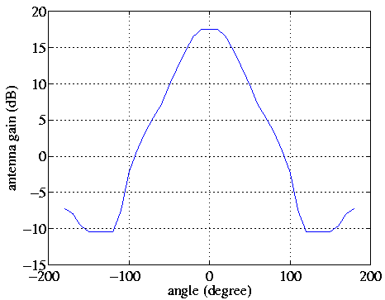

Figure 9.1: 2-D sectorization antenna pattern used in our simulations

For link adaptation, we use a MCS table based on link simulation results of an ideal receiver in AWGN. The MCS table is shown in Table 1. The SINR in Table 1 is for every HS-PDSCH symbol (16 chips) per code. The SINR range is determined to achieve less than 10% block error rate for the 1st transmission. In system-level simulations however, we include a 2 dB implementation loss for both Type 3 and Type 3i receivers. We use the same finger positions for Type 3 and Type 3i receivers.

In our simulations, we further assume that 15 codes and 75% of base station power are available for serving the desired user’s HS-DPDCH. Code and power allocations however do not impact the relative performance between Type 3 and Type 3i receivers.

Table 9.1: MCS table used for link adaptation

|  |  |
| --- | --- |
| SINR (dB) range | bits/HS-PDSCH symbol/code |
| [-11.5, -10.5] | 0.0626 |
| [-10.5, -9.5] | 0.0758 |
| [-9.5, -8.5] | 0.0990 |
| [-8.5, -7.5] | 0.1253 |
| [-7.5, -6.5] | 0.1516 |
| [-6.5, -5.5] | 0.1980 |
| [-5.5, -4.5] | 0.2506 |
| [-4.5, -3.5] | 0.3032 |
| [-3.5, -2.5] | 0.3958 |
| [-2.5, -1.5] | 0.5011 |
| [-1.5, -0.5] | 0.6063 |
| [-0.5, 0.5] | 0.7116 |
| [0.5, 1.5] | 0.8814 |
| [1.5, 2.5] | 1.0427 |
| [2.5, 3.5] | 1.2041 |
| [3.5, 4.5] | 1.3654 |
| [4.5, 5.5] | 1.5267 |
| [5.5, 6.5] | 1.6881 |
| [6.5, 7.5] | 1.8494 |
| [7.5, 8.5] | 2.0108 |
| [8.5, 9.5] | 2.5135 |
| [9.5, 10.5] | 2.7659 |
| [10.5, 11.5] | 3.0182 |
| [11.5, 12.5] | 3.2705 |
| [12.5, 13.5] | 3.5228 |
| [13.5, 14.5] | 3.7751 |
| 14.5 and above | 4.0000 |

### 9.1.2 Simulation results

We evaluate distributions of achievable data rates over fading realizations for users at a certain distance from the serving base station. Each of these distributions is equivalent to the distribution of CQI reports collected from users at the same distance away from the base station. Simulation results for the Case 3 (heavily dispersive) channel are shown in Fig. 9.2 and Fig. 9.3, for 10th percentile and median data rate, respectively. The 10th percentile data rate is achieved by 90% of the users, and it is an important indicator for coverage. From Fig. 9.2, we see that Type 3i receiver improves coverage significantly. The improvement is around 25-35% in data rate depending on the user location. It is interesting to see that Type 3i also improves the 10th percentile data rate when users are close to the base station. In fact, the gains of Type 3i are higher for users close to the base station. This is because those users close to the base station experience other-cell interference mainly due to inter-sector interference, and Type 3i is effective in suppressing few (most likely one) inter-sector interference. From Fig. 9.3, we observe the gains for median data rates are moderate.

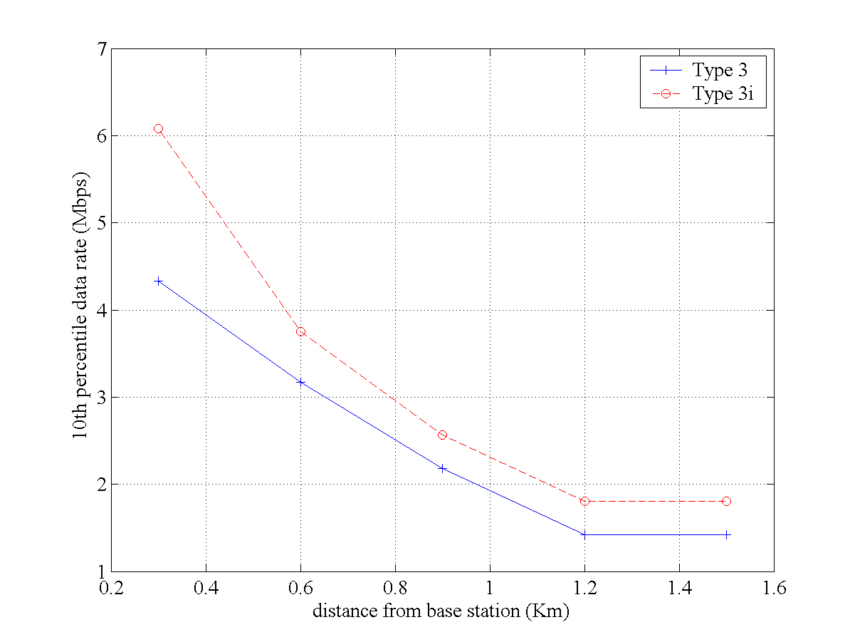

Figure 9.2: 10th percentile data rate for users in a highly dispersive channel

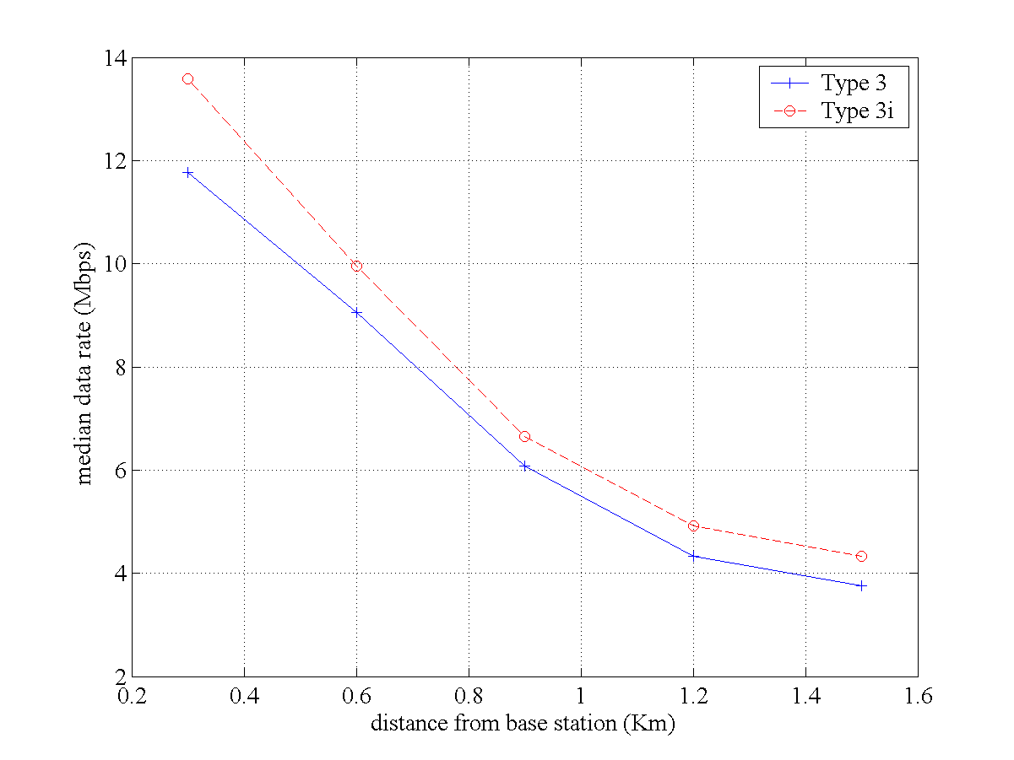

Figure 9.3: Median data rate for users in a highly dispersive channel

Simulation results for the mildly dispersive channel are shown in Fig. 9.4 and Fig. 9.5, for 10th percentile and median data rate, respectively. The improvement for the 10th percentile data rate is in the range of 20-55% throughout the cell coverage area. On the other hand, we observe that the gains for median data rates are moderate.

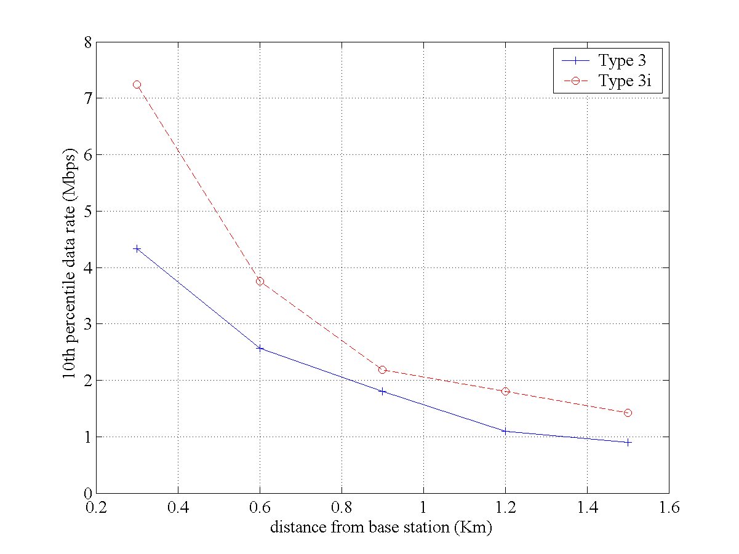

Figure 9.4: 10th percentile data rate for users in a mildly dispersive channel

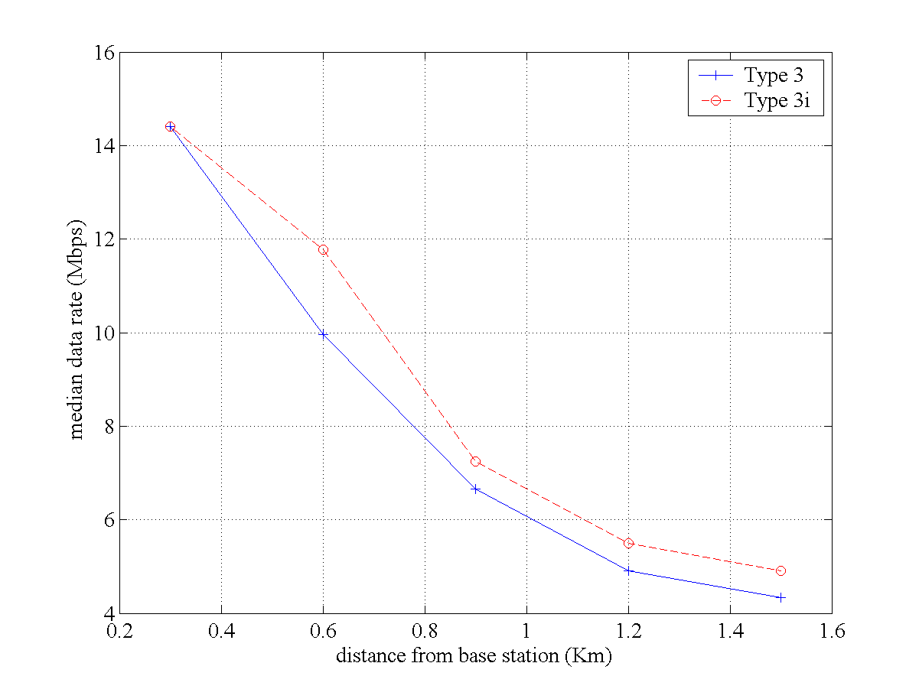

Figure 9.5: Median data rate for users in a mildly dispersive channel

## 9.2 Second system-level study (Nokia)

### 9.2.1 Simulation setup for second study

The simulations were performed in a macro cell scenario, which consists of 7 Node Bs and 21 hexagonal cells (sectors) of radius of 933 meters. Thus the site-to-site distance was 2800 m, which differs from the 1000 m, used in [4]. Propagation model was based on [7] and log-normally distributed slow fading with an 8 dB standard deviation and a spatial correlation distance of 50 meters were assumed. The evaluated channel profiles was modified Vehicular A. The power delay profiles were modified from the original ITU power delay profiles so that the tap delays are integer chips. Average path powers were [-3.1, -5.0, -10.4, -13.4, -13.9, -20.4] dB in Vehicular A channel.

MAC-hs packet scheduling based on Proportional Fair scheduling algorithms was used without code-multiplexing, i.e. only one UE is scheduled per TTI. The maximum numbers of HS-DSCH codes was 10 with spreading factor 16. HS-DSCH power allocation was 14 W, which is 70% of the total base station transmission power. One code was allocated for HS-SCCH with spreading factor of 128. HS-SCCH was power controlled so that the power follows the average power over the last TTI of the associated DCH with an offset. Realistic reception of HS-SCCH was considered. Six parallel stop-and-wait (SAW) channels were used for the Hybrid ARQ. At the maximum 4 retransmissions were allowed per transport block. Chase Combining was used for the retransmissions [68].

HS-DSCH link adaptation was based on the UE reported channel quality indicators (CQI's) (inner loop) and UE reported Ack/Nacks from past retransmissions (outer loop). Aimed residual block error rate (BLER) after the second transmission was 1% and link adaptation outer loop was used to control the BLER target. The MCS tables used in Node B were throughput optimized. CQI reporting granularity of 1dB was accounted. CQI reporting error, which was modeled as log-normally distributed with standard deviation of 1 dB, was included in the simulations. The CQI’s reported by UE’s were always based on normal (or noninterference aware) LMMSE chip level equalizer. The link adaptation outer loop was set to account the difference between normal LMMSE and interference aware LMMSE equalizer in SINR calculation.

Mobility and traffic models were based on UMTS 30.03 [69]. UE velocity was 3km/h. Modified web browsing traffic model, in which the users do not have a reading time during a download session i.e. they only have one packet call per session, was used. The total simulation time was 6 minutes. The call arrival rate in the network was 140 calls per second and the average packet call size was 112 kilobytes. Thus, the total average offered load per cell can be calculated as A * B / C, where A is the call arrival rate, B is the average packet call size and C is the number of cells in the network. In these simulations the average offered load per cell was approximately 6 Mbps. New calls were generated according to homogeneous Poisson process. The offered traffic was high enough to have almost 100 % utilization of the HS-DSCH. Admission control allowed up to 16 HSDPA users per cell.

The LMMSE equalizer and interference aware LMMSE equalizer were used for HS-DSCH with and without Rx diversity. For determining the SINR used with the interference aware LMMSE equalizer under study (i.e. either Type 2i or Type 3i) the interference seen from strongest interfering cells was explicitly accounted by modelling the actual channel matrices of the cells [2]. The calculation of noise covariance matrix in SINR calculation was thus done in the assumption that the channel matrices of the strongest interfering cells are ideally known at the receiver. Three strongest interfering other cells were accounted in the calculation as it was noticed that considering fourth strongest interferer or lower did not affect the results significantly. The main simulation parameters are also listed in Table 9.2 below.

Table 9.2: System Simulation Parameters

|  |  |  |
| --- | --- | --- |
| Parameter | Explanation/Assumption | Comments |
| Cellular layout | Hexagonal cell grid, wrap-around | 7 Node-Bs and 21 sectors |
| Cell radius | 933 m | Corresponds to a Node-B to Node-B distance of 2800 m. |
| Propagation Model | *L*= 128.1 + 37.6*Log*10(Rkm) |  |
| Radio propagation condition | Vehicular A with 3 km/h |  |
| Std. deviation of slow fading | 8 dB |  |
| Correlation between sectors | 1.0 | The correlation in the slow fading between the sectors. The UE experiences the same kind of slow fading in the area of the correlating sectors, i.e. the fading is not entirely random. |
| Correlation between Node-Bs | 0.5 | The correlation in the slow fading between the Node-Bs. |
| Correlation distance of slow fading | 50 m | This parameter defines the maximum distance within which the UE experiences correlated slow fading to a sector. |
| Minimum path loss | 70 dB |  |
| BS antenna gain | 18 dB |  |
| Antenna front to back ratio | -20 dB |  |
| Node-B total Tx power | 43 dBm | Corresponds to 20 W. |
| Power resource for HS-DSCH | 14 W |  |
| HSDPA packet scheduling algorithm | Proportional fair |  |
| Used Redundancy Version | Chase Combining |  |
| Maximum number of retransmissions | 4 | Maximum number of retransmission before the corresponding HARQ channel is cleared |
| Traffic model | Web browsing without reading time | Average packet call size was 112 kbytes |
| HSDPA RLC PDU size | 320 bits |  |
| Code resource for HS-DSCH | 10 | SF=16 |
| UE HS-DSCH receiver | LMMSE equalizer or interference aware LMMSE equalizer with and without receiver diversity. | Type2/3 and Type2i/3i |
| Number Of HARQ channels in UE | 6 |  |

### 9.2.2 Simulation results for second study

In Figure 9.6 the CDF of cell throughput obtained with different receivers is presented. In Figure 9.7 the scheduled user Es/N0 is depicted.

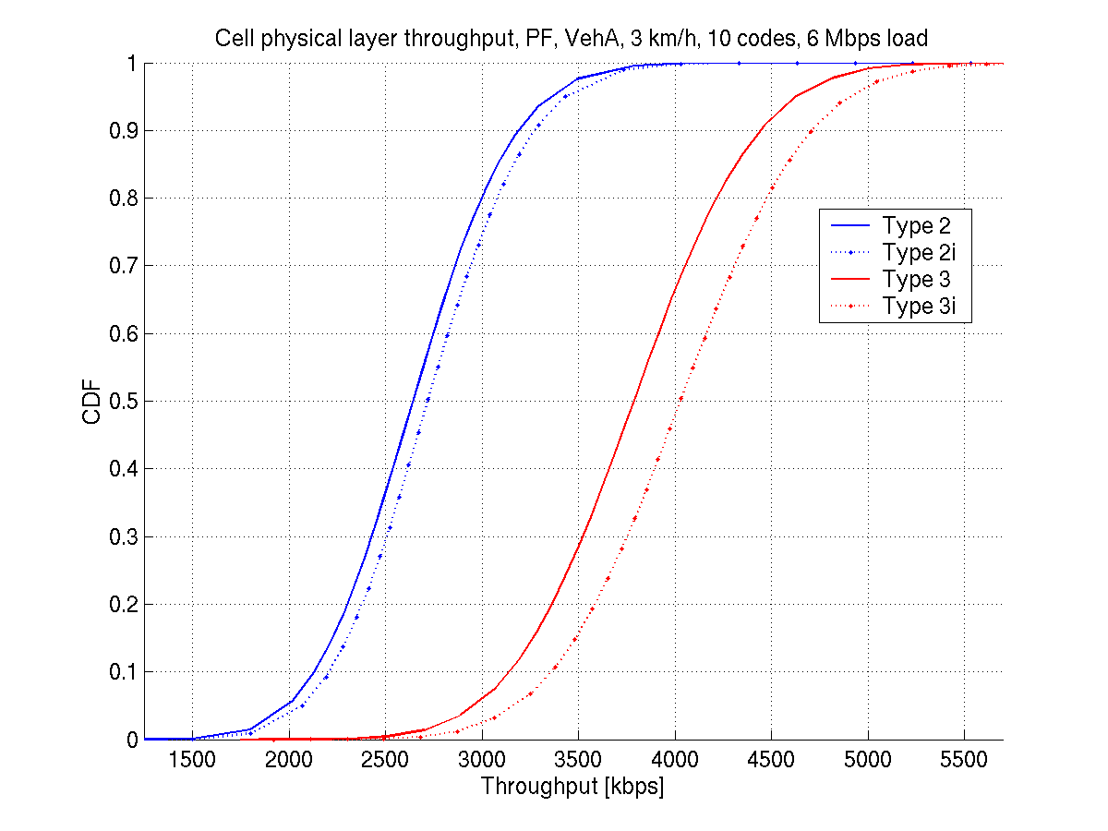

Figure 9.6: Cell throughput

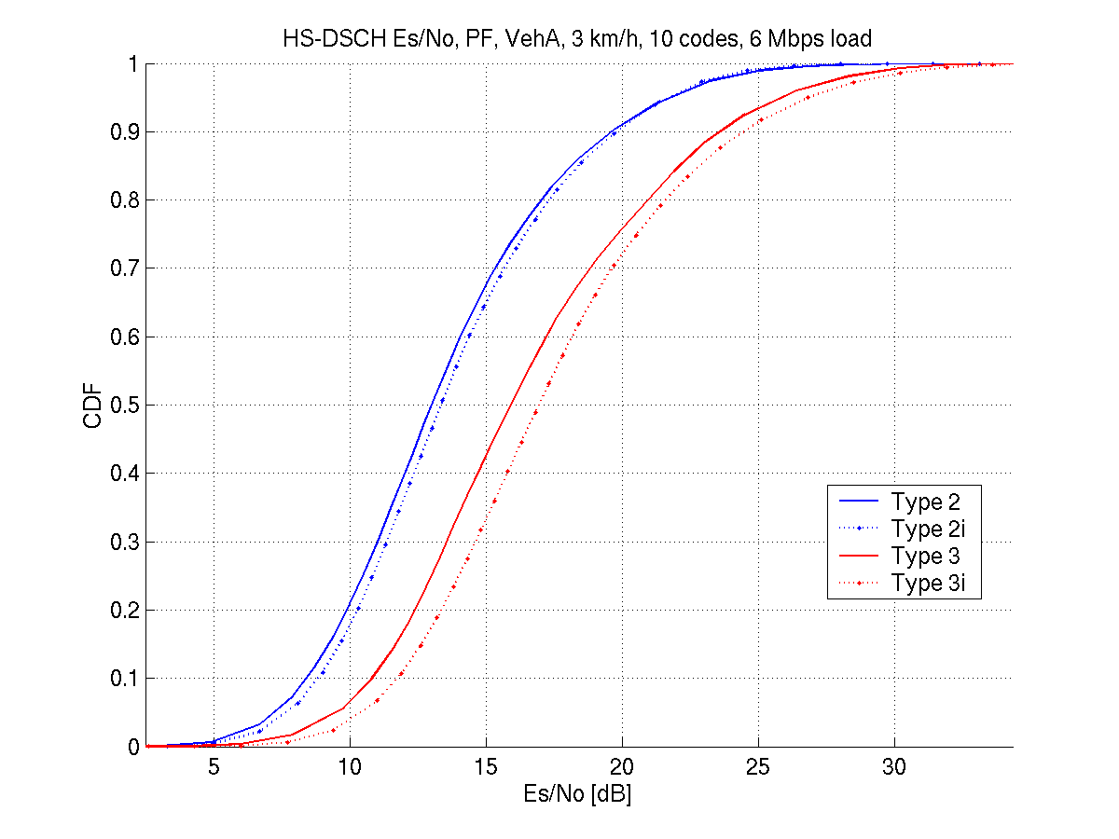

Figure 9.7: HS-DSCH *Es/N0* distribution of scheduled user

In order to more accurately evaluate the receiver gains and the effect of different network situations to them, more specific throughput statistics were gathered. As interference aware LMMSE equalizer is assumed to provide gain specifically when a strong interferer is present, this effect was attempted to be captured by collecting statistics from UEs with cells of different strength in their vicinity. As the existence of a cell in UEs active set is a good measure of the strength of the cell, the throughput statistics were gathered from UEs in different DCH soft handover states. Statistics for two different handover states were considered. First, the statistics were collected separately for users in DCH soft handover e.g. UEs that have more than one cell in active set and all the cells do not belong to the same Node B. Second state consisted of users that were in softer handover e.g. UEs that have exactly two cells (sectors) in their active set and both are from the same Node B.

Figure 9.8 presents the spatial distribution of users in DCH soft handover and in Figure 9.9 the distribution of users in softer handover is depicted. The terms "soft handover" and "softer handover" refer to DCH handover states and they are only used to refer to the area of interest in the cell.

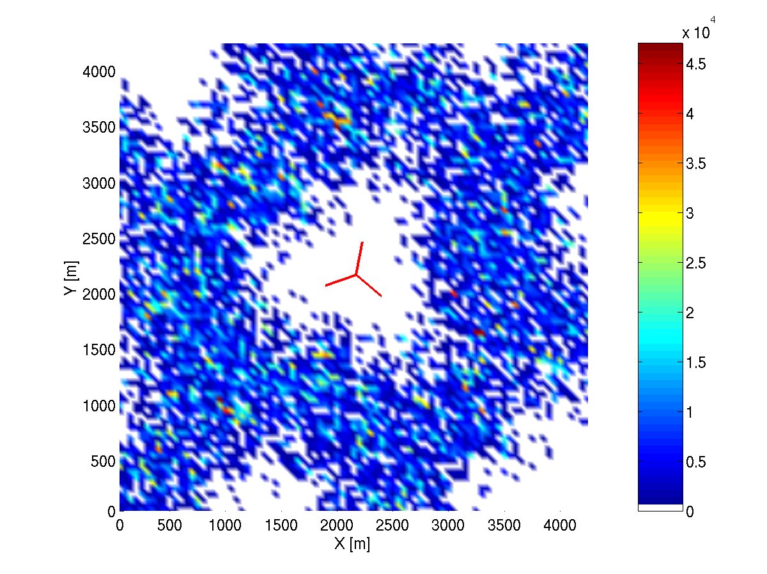

Figure 9.8: Spatial distribution of users in DCH soft handover in respect to the serving Node B

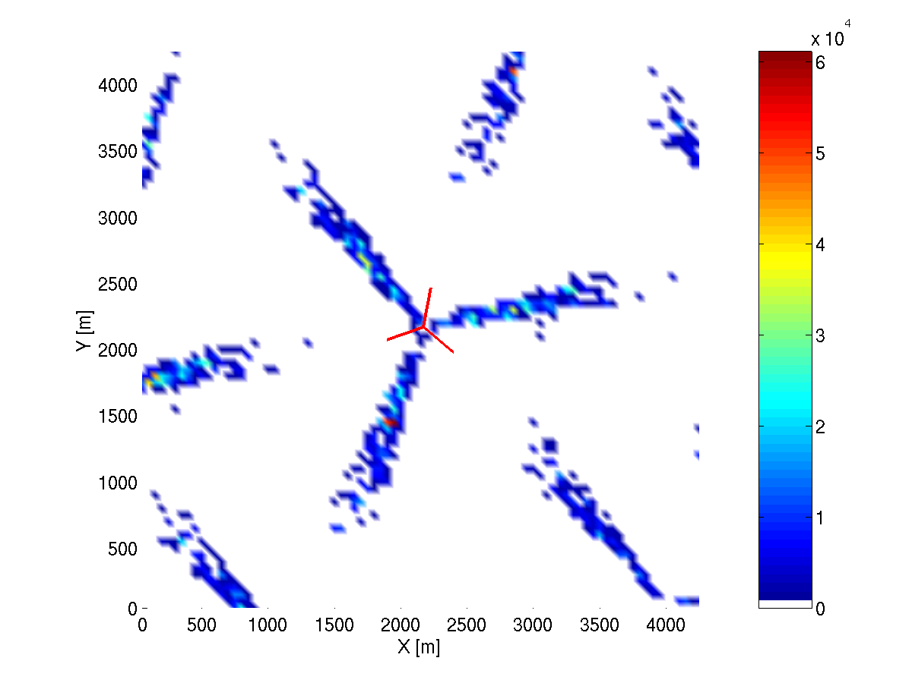

Figure 9.9: Spatial distribution of users in DCH softer handover in respect to the serving Node B

In Table 9.3 the average call throughputs of users in different DCH soft handover states is presented. It can be observed that the benefit of Type 3i receivers is largest at the border regions, the largest gains observed for the soft and softer handover ranging from 22% to 21%. Thus the Type 3i interference aware receivers seems to provide some benefits for the cell edge users, roughly increasing the obtained user throughput by 50kbps. For Type 2i receiver some gain can be seen also for the cell border regions, but for all users a slight loss is seen. As the performance of the cell border users is improved, leading to increased scheduling probability, resulting slight decrease in overall user throughput. The DCH soft handover state of the user used in statistics collecting is determined at the end of the call to be the one in which UE has been longest time during a whole call, thus there may be some variance in the observed call throughputs.

In Table 9.4 the average instantaneous HS-DSCH TTI throughputs of users in the aforementioned states are presented for different receivers evaluated. It can be seen that similarly as in case of the call throughputs, the gain of Type 2i and Type 3i receivers is the highest in the border regions between two cells of a three sector Node B. As the overall gain, considering all users, is 3 % with Type 2i and 6 % with Type 3i, the corresponding gains in the border regions between two sectors is 4 % and 19 %.

The small effect of the higher gains to the total average gains is due to low percentage of the users in the given regions. Only 3-4 % of the scheduled users are located between sector borders, as can be seen in Table 9.5. It should be noted that the percentages shown in Table 9.5 do not necessarily reflect the actual percentage of scheduled users in the different handover areas. There could be also users being scheduled in the same geographical area with only one cell in the active set. The values given in Table 9.5 do however give an insight of the actual percentages.

The users in the outer border regions of the cell realize 5 % and 13 % gains using Type 2i and Type 3i receivers, respectively. Their portion of all users is much larger compared to the users in sector borders. Approximately one of four users is at this region. The significance of these users in overall observed gains is therefore much greater than the users between two sectors of the same Node B.

Table 9.3: Average call throughput of UEs in different DCH SHO states

|  |  |  |  |  |  |  |
| --- | --- | --- | --- | --- | --- | --- |
|  | All UEs | | UE DCH is in soft handover | | UE DCH in softer handover | |
| Throughput [kbps] | Gain over LMMSE [%] | Throughput [kbps] | Gain over LMMSE [%] | Throughput [kbps] | Gain over LMMSE [%] |
| Type 2 | 569 | 0% | 99 | 0% | 130 | 0% |
| Type 2i | 565 | -1% | 103 | 4% | 136 | 5% |
| Type 3 | 875 | 0% | 196 | 0% | 247 | 0% |
| Type 3i | 975 | 11% | 240 | 22% | 297 | 21% |

Table 9.4: Average instantaneous HS-DSCH TTI throughput of UEs in different DCH SHO states

|  |  |  |  |  |  |  |
| --- | --- | --- | --- | --- | --- | --- |
|  | All UEs | | UE DCH is in soft handover | | UE DCH in softer handover | |
| Throughput [kbps] | Gain over LMMSE [%] | Throughput [kbps] | Gain over LMMSE [%] | Throughput [kbps] | Gain over LMMSE [%] |
| Type 2 | 2659 | 0% | 1485 | 0% | 1897 | 0% |
| Type 2i | 2737 | 3% | 1560 | 5% | 1968 | 4% |
| Type 3 | 3795 | 0% | 2223 | 0% | 2705 | 0% |
| Type 3i | 4037 | 6% | 2513 | 13% | 3209 | 19% |

Table 9.5: Percentage of user in different SHO states

|  |  |  |
| --- | --- | --- |
|  | Pct of scheduled users in DCH soft handover [%] | Pct of scheduled users in DCH softer handover [%] |
| Type 2 | 24.2 % | 3.6 % |
| Type 2i | 23.8 % | 3.6 % |
| Type 3 | 23.8 % | 3.7 % |
| Type 3i | 23.5 % | 3.5 % |

## 9.3 Conclusions

Two different system level simulation studies have been conducted within the study item, both trying to evaluate the benefits of the Type 3i receiver.

The first study concluded that there is indeed an increase in throughput to be seen for the 10th percentile users, which is in the order of 20-55% for mildly dispersive channels and 25-35% for heavily dispersive channels. The second study divided the users into two different groups depending on their DCH handover states, where the first group collected users in soft handover (between cells), and the second group collected users in softer handover (between sectors of the same cell). It was concluded that the Type 3i receiver would seem to provide benefits for the users in these two groups, increasing their throughput by slightly over 20%.

In summary, two different system level simulation studies have been made, both showing benefit for the cell edge users through use of Type3i receivers.

# 10 Receiver implementation issues

In this clause, receiver implementation issues are discussed that are relevant to the type 3i receiver along with the impact these issues might have on the feasibility of realizing an actual UE implementation. The main issues discussed are the requirement for two ‘receive’ paths or branches, and the complexity of the LMMSE processing as described in clause 4.

With regards to the requirement for two branches, this is an issue that has had quite a bit of history in the evolution of mobile terminals. The main concerns have been the physical realization of two branches (where does one find the space for a second path), and performance issues due to correlation and gain mismatch between paths. 3GPP has already defined performance requirements for two types of enhanced receivers, which require two branches: the type 1 which is based on a conventional rake, and the type 3, which is equalizer based. Thus, there is no need to justify the feasibility of implementing two branches since it is generally accepted that this can be accomplished as further evidenced by the commercial availability of a two-branch, equalized receiver [70]. Certainly, wireless data or PC cards are potentially more amenable to two branch solutions because of additional space that may be available to implement two branches with low amounts of correlation and path mismatch between paths. However, improvements in antenna and RF front-end design are also paving the way for solutions in conventional handsets as well. Even though there might be higher levels of correlation and mismatch between paths in these latter solutions, it seems reasonable to assume that there will still be sufficient gain particularly in interference-limited environments. Thus, though there may be issues with including the second antenna and associated RF front-end electronics, it appears that advancements in technology are enabling both data card and mobile handset implementations.

The LMMSE reference receiver defined for the type 3i receiver is described in detail in clause 4 and [2]. The processing is nearly identical to that defined for the type 3 as defined in [71] except that the type 3i calculates an additional ‘interference aware’ term. What this means is that the received signal covariance matrix for the type 3i is given by



where the first term is the contribution from the desired signal (serving cell), the second term is the contribution from the interfering base stations, and the third term accounts for any residual interference plus thermal noise collectively modeled as AWGN. Note all of these terms have been previously defined in clause 4 and [2]. The presence of the second term is what makes the type 3i interference aware.

The corresponding equation for the Type 3 receiver is



where now all of the interference is accounted for in the second term, which is an estimate of the variance of the total interference plus any thermal noise.

The remaining processing to calculate the weights of the equalizer filters is identical for both receiver types. Thus, the only additional processing performed by the type 3i receiver is the calculation of the interference aware term. To calculate this latter term, the type 3i receiver must estimate the channel response matrix and the average power for each of the interfering node Bs (see clause 4), which in this study was assumed to be a maximum of five. Note in an actual receiver implementation the channel response matrix will only be calculated for those interfering cells that are determined to have sufficient energy. Data from field measurements would tend to indicate that the signals from only three interfering node Bs might need to be processed, but a conservative implementation might over bound that with the value of five used in the study. Be that as it may, the processing required to calculate each of the interfering cell channel matrices is identical to the CPICH-based channel estimation processing that the type 3 currently performs for the serving cell. But now in addition to processing the serving cell CPICH, the type 3i receiver will also have to process the CPICHs from each of the interfering cells. Note there may be other methods used to perform channel estimation, but processing the CPICH is one of the most common. Thus, we can conclude that the processing required for the type 3i reference receiver is incremental over that required for a type 3, and thus, quite doable with existing processing capabilities.

# 11 Conclusions

In this technical report we have documented the work that was accomplished by RAN4 as part of the feasibility study on interference cancellation for UTRA FDD UE. Receiver methods and structures based on an LMMSE sub-chip level equalizer were defined for interference-aware receivers for both two-branch and one-branch implementations. This type of receiver attempts to cancel the interference that arises from users operating outside the serving cell, which is also referred to as other-cell interference. Interference models/profiles were developed for this other-cell interference in terms of the number of interfering Node Bs to consider, and their powers relative to the total other cell interference power, the latter ratios referred to as Dominant Interferer Proportion (DIP) ratios. For the purposes of this study it was determined that five interfering Node Bs should be taken into account in the interference models. DIP ratios were defined based on three criteria; median values of the corresponding cumulative density functions, weighted average throughput gain, and field data. Of these criteria, the one based on the ‘weighted average’ was felt to offer a compromise between the conservative, median value criteria and the more optimistic field data criteria. In addition, two network scenarios were defined, one based solely on HSDPA traffic (HSDPA-only), and the other based on a mixture of HSDPA and Rel. 99 voice traffic (HSDPA+R99).

HSDPA throughput estimates were then developed using link level simulations, which included the other-cell interference models plus OCNS models for the serving and interfering cells based on the two network scenarios considered. The two-branch reference receiver, referred to as a type 3i receiver, was found to offer significant gains in throughput primarily at or near the cell edge. Link level results were developed for a wide range of operating conditions including such factors as transport format, network scenario, modulation, and channel model. For example, the gains for the DIP ratios based on the weighted average ranged from a factor of 1.2 to 2.05 for QPSK H-SET6 PB3, and from 1.2 to 3.02 for VA30 for network geometries of -3 and 0 dB. This complements the performance of existing two-branch equalizers (type 3), which typically provide gain at high geometries, and thus, the combination of the two will lead to a much better user experience over the entire cell.

In addition, a system level study was conducted that indicated that a type 3i receiver provided gains in coverage ranging from 20-55% for mildly dispersive channels, and 25-35% for heavily dispersive channels, the exact value of which depends upon user location. A second system level study divided the users into two different groups depending on their DCH handover states, where the first group collected users in soft handover (between cells), and the second group collected users in softer handover (between sectors of the same cell). The results of this second study indicate that the Type 3i receiver will provide benefits for users in these two groups, increasing their throughput by slightly over 20%. With regards to implementation issues, it was felt that the type 3i receiver is based upon known and mature signal processing techniques, and thus, the complexity is minimized. With two-branch, equalizer-based receivers already available in today’s marketplace, it appears quite doable to develop a two-branch equalizer with interference cancellation/mitigation capabilities. Given all of the above, RAN4 has concluded that two-branch interference cancellation receivers are feasible for HSDPA. However, no such conclusion has yet been reached for the type 2i one-branch receiver.

Annex A:  
Change history

|  |  |  |  |  |  |  |  |  |
| --- | --- | --- | --- | --- | --- | --- | --- | --- |
| **Change history** | | | | | | | | |
| **Date** | **TSG #** | **TSG Doc.** | **CR** | **Rev** | **Cat** | **Subject/Comment** | **Old** | **New** |
| 2007-03 | 35 |  |  |  |  | First version approved |  | 7.0.0 |
| 2008-12 | 42 |  |  |  |  | Upgraded unchanged from Rel 7 |  | 8.0.0 |
| 2009-12 | 46 |  |  |  |  | Upgraded unchanged from Rel 8 |  | 9.0.0 |
|  | 51 |  |  |  |  | Upgraded unchanged from Rel-9 | 9.0.0 | 10.0.0 |
| 2012-09 | - | - | - | - | - | Update to Rel-11 version (MCC) | 10.0.0 | 11.0.0 |
| 2014-09 | SP-65 | - | - | - | - | Update to Rel-12 version (MCC) | 11.0.0 | 12.0.0 |
| 2016-01 | SP-70 | - | - | - | - | Update to Rel-13 version (MCC) | 12.0.0 | 13.0.0 |
| 2017-03 | RP-75 | - | - | - | - | Update to Rel-14 version (MCC) | 13.0.0 | 14.0.0 |

|  |  |  |  |  |  |  |  |
| --- | --- | --- | --- | --- | --- | --- | --- |
| **Change history** | | | | | | | |
| **Date** | **Meeting** | **TDoc** | **CR** | **Rev** | **Cat** | **Subject/Comment** | **New version** |
| 2018-06 | SA#80 | - | - | - | - | Update to Rel-15 version (MCC) | 15.0.0 |
| 2020-06 | SA#88 | - | - | - | - | Update to Rel-16 version (MCC) | **16.0.0** |

1.
2. It should be noted that the relative gains and ratio of throughput values may not be equal. This is due to the fact that average of a set of ratios, is not equal to the average of the numerators divided by the average of the denominators.
3. Due to the nature of this section, where a considerable number of contributions are condensed into a single statistic, direct reference is not made to the contribution(s). Rather, the “raw data” of the contributions are given in a set of tables in the appendix; the tables give the RAN4 TD numbers for the individual values, this TD may be cross-referenced in the Reference section for the complete title and date.
4. The reason for the small sample size of averaged data is due to the lack of multiple data sets that share the same set of conditions.