3GPP TS 28.306 V16.0.0 (2020-07)

Technical Specification

3rd Generation Partnership Project;

Technical Specification Group Services and System Aspects;

Control and monitoring of Power, Energy and Environmental (PEE) parameters Integration Reference Point (IRP);

Solution Set (SS) definitions

(Release 16)

** 

The present document has been developed within the 3rd Generation Partnership Project (3GPP TM) and may be further elaborated for the purposes of 3GPP..  
The present document has not been subject to any approval process by the 3GPPOrganizational Partners and shall not be implemented.  
This Specification is provided for future development work within 3GPPonly. The Organizational Partners accept no liability for any use of this Specification.  
Specifications and Reports for implementation of the 3GPP TM system should be obtained via the 3GPP Organizational Partners' Publications Offices.

Keywords

energy efficiency, network management

***3GPP***

Postal address

3GPP support office address

650 Route des Lucioles - Sophia Antipolis

Valbonne - FRANCE

Tel.: +33 4 92 94 42 00 Fax: +33 4 93 65 47 16

Internet

http://www.3gpp.org

***Copyright Notification***

No part may be reproduced except as authorized by written permission.  
The copyright and the foregoing restriction extend to reproduction in all media.

© 2020, 3GPP Organizational Partners (ARIB, ATIS, CCSA, ETSI, TSDSI, TTA, TTC).

All rights reserved.

UMTS™ is a Trade Mark of ETSI registered for the benefit of its members

3GPP™ is a Trade Mark of ETSI registered for the benefit of its Members and of the 3GPP Organizational Partners  
LTE™ is a Trade Mark of ETSI registered for the benefit of its Members and of the 3GPP Organizational Partners

GSM® and the GSM logo are registered and owned by the GSM Association

Contents

Foreword 6

Introduction 6

1 Scope 7

2 References 7

3 Definitions and abbreviations 8

3.1 Definitions 8

3.2 Abbreviations 8

4 Solution Set Definitions 8

Annex A (normative): Solution Set definitions for solution 1 9

A.1 CORBA Solution Set 9

A.2 SOAP Solution Set and XML Definitions 9

A.3 REST Solution Set 9

Annex B (normative): Solution Set definitions for solution 2 10

B.1 CORBA Solution Set 10

B.2 SOAP Solution Set 10

B.3 REST Solution Set 10

B.3.0 Introduction 10

B.3.1 Architectural Features 10

B.3.2 Mapping 10

B.3.2.1 Operation mapping 10

B.3.2.2 Notification mapping 11

B.3.3 CMONOperations_1 interface 11

B.3.3.1 Description 11

B.3.3.2 Resource structure and methods 11

B.3.3.3 Sequence diagrams (informative) 12

B.3.3.3.1 Flow of the readMEDescription operation 12

B.3.3.3.2 Flow of the writeMEDescription operation 12

B.3.3.4 Resources 13

B.3.3.4.1 Introduction 13

B.3.3.4.2 Resource: Individual monitored entity 13

B.3.3.4.2.1 Description 13

B.3.3.4.2.2 Resource definition 13

B.3.3.4.2.3 Resource methods 13

B.3.3.4.2.3.1 GET 13

B.3.3.4.2.3.2 PATCH 14

B.3.3.5 Data Model 14

B.3.3.5.1 Introduction 14

B.3.3.5.2 Resource and notification data types 14

B.3.3.5.2.1 Introduction 14

B.3.3.5.2.2 Type: AttributeNameList 14

B.3.3.5.2.3 Type: AttNameValueList 15

B.3.4 CMONOperations_2 interface 15

B.3.4.1 Description 15

B.3.4.2 Resource structure and attributes 15

B.3.4.3 Sequence diagrams (informative) 15

B.3.4.3.1 Flow of the readMEConfiguration operation 15

B.3.4.3.2 Flow of the writeMEConfiguration operation 16

B.3.4.4 Resources 17

B.3.4.4.1 Introduction 17

B.3.4.4.2 Resource: Individual monitored entity 17

B.3.4.4.2.1 Description 17

B.3.4.4.2.2 Resource definition 17

B.3.4.4.2.3 Resource methods 17

B.3.4.4.2.3.1 GET 17

B.3.4.4.2.3.2 PUT 17

B.3.4.5 Data Model 18

B.3.4.5.1 Introduction 18

B.3.4.5.2 Resource and notification data types 18

B.3.4.5.2.1 Introduction 18

B.3.4.5.2.2 Type: ThresholdNameValueList 18

B.3.5 CMONOperations_3 interface 18

B.3.5.0 Introduction 18

B.3.5.1 createCMONPMJob operation 18

B.3.5.1.1 Description 18

B.3.5.1.2 Resource structure and attributes 18

B.3.5.1.3 Flow of the createCMONPMJob operation 19

B.3.5.1.4 Resource: cmonpmjobs 19

B.3.5.1.4.1 Description 19

B.3.5.1.4.2 Resource definition 19

B.3.5.1.4.3 Resource method: POST 19

B.3.5.1.5 Data Model 20

B.3.5.1.5.1 Introduction 20

B.3.5.1.5.2 Data Type: MeIdList 20

B.3.5.1.5.3 Data Type: MeasurementNameList 20

B.3.5.1.5.4 Data Type: GranularityPeriod 20

B.3.5.1.5.5 Data Type: ServerJobId 20

B.3.5.2 stopCMONPMJob operation 21

B.3.5.2.1 Description 21

B.3.5.2.2 Resource structure and attributes 21

B.3.5.2.3 Flow of the stopCMONPMJob operation 21

B.3.5.2.4 Resource: individual cmonpmjob instance 22

B.3.5.2.4.1 Description 22

B.3.5.2.4.2 Resource definition 22

B.3.5.2.4.3 Resource method: DELETE 22

B.3.5.2.5 Data Model 22

B.3.5.2.5.1 Introduction 22

B.3.5.2.5.2 Data Type: CmonPmJobId 22

B.3.6 CMONNotifications_1 interface 22

B.3.6.0 Introduction 22

B.3.6.1 notifyMeasurementData notification 22

B.3.6.1.1 Description 22

B.3.6.1.2 Resource structure and attributes 23

B.3.6.1.3 Flow of the notifyMeasurementData notification 23

B.3.6.1.4 Resource: notification endpoint 23

B.3.6.1.4.1 Description 23

B.3.6.1.4.2 Resource definition 23

B.3.6.1.4.3 Resource method: POST 24

B.3.6.1.5 Data Model 24

B.3.6.1.5.1 Introduction 24

B.3.6.1.5.2 Data Type: NotificationHeader 24

B.3.6.1.5.3 Data Type: MeasDataCollection 25

B.3.7 CMONNotifications_2 interface 25

B.3.7.0 Introduction 25

B.3.7.1 notifyAlarm notification 25

B.3.7.1.1 Description 25

B.3.7.1.2 Resource structure and attributes 25

B.3.7.1.3 Flow of the notifyAlarm notification 25

B.3.7.1.4 Resource: notification endpoint 26

B.3.7.1.4.1 Description 26

B.3.7.1.4.2 Resource definition 26

B.3.7.1.4.3 Resource method: POST 26

B.3.7.1.5 Data Model 27

B.3.7.1.5.1 Introduction 27

B.3.7.1.5.2 Data Type: NotificationHeader 27

B.3.7.1.5.3 Data Type: AlarmInformation 27

B.3.8 CMONNotifications_3 interface 27

B.3.8.0 Introduction 27

B.3.8.1 notifyConfigurationChange notification 27

B.3.8.1.1 Description 27

B.3.8.1.2 Resource structure and attributes 28

B.3.8.1.3 Flow of the notifyConfigurationChange notification 28

B.3.8.1.4 Resource: notification endpoint 28

B.3.8.1.4.1 Description 28

B.3.8.1.4.2 Resource definition 28

B.3.8.1.4.3 Resource method: POST 29

B.3.8.1.5 Data Model 29

B.3.8.1.5.1 Introduction 29

B.3.8.1.5.2 Data Type: NotificationHeader 29

B.3.8.1.5.3 Data Type: ConfigurationChangeInformation 29

B.3.9 CMONNotifications_4 interface 29

B.3.9.0 Introduction 29

B.3.9.1 notifyThresholdCrossingOrReaching notification 30

B.3.9.1.1 Description 30

B.3.9.1.2 Resource structure and attributes 30

B.3.9.1.3 Flow of the notifyThresholdCrossingOrReaching notification 30

B.3.9.1.4 Resource: notification endpoint 31

B.3.9.1.4.1 Description 31

B.3.9.1.4.2 Resource definition 31

B.3.9.1.4.3 Resource method: POST 31

B.3.9.1.5 Data Model 31

B.3.9.1.5.1 Introduction 31

B.3.9.1.5.2 Data Type: NotificationHeader 31

B.3.9.1.5.3 Data Type: ThresholdCrossingOrReachingInformation 32

B.3.10 URI structure and supported content formats 32

B.3.11 Solution Set definitions 32

B.3.11.1 Solution set definition structure 32

B.3.11.2 OpenAPI definition "CMONOperations_1.json" 33

B.3.11.3 OpenAPI definition "CMONOperations_2.json" 35

B.3.11.4 OpenAPI definition "CMONOperations_3.json" 38

B.3.11.5 OpenAPI definition "CMONNotifications_1.json" 40

B.3.11.6 OpenAPI definition "CMONNotifications_2.json" 42

B.3.11.7 OpenAPI definition "CMONNotifications_3.json" 43

B.3.11.8 OpenAPI definition "CMONNotifications_4.json" 45

Annex C (informative): Change history 47

# Foreword

This Technical Specification has been produced by the 3rd Generation Partnership Project (3GPP).

The contents of the present document are subject to continuing work within the TSG and may change following formal TSG approval. Should the TSG modify the contents of the present document, it will be re-released by the TSG with an identifying change of release date and an increase in version number as follows:

Version x.y.z

where:

x the first digit:

1 presented to TSG for information;

2 presented to TSG for approval;

3 or greater indicates TSG approved document under change control.

y the second digit is incremented for all changes of substance, i.e. technical enhancements, corrections, updates, etc.

z the third digit is incremented when editorial only changes have been incorporated in the document.

# Introduction

The present document is part of a TS-family covering the 3rd Generation Partnership Project, Technical Specification Group Services and System Aspects, Telecommunication management; as identified below:

TS 28.304 Control and monitoring of Power, Energy and Environmental (PEE) Integration Reference Point (IRP); Requirements

TS 28.305 Control and monitoring of Power, Energy and Environmental (PEE) parameters Integration Reference Point (IRP); Information Service (IS)

**TS 28.306 Control and monitoring of Power, Energy and Environmental (PEE) parameters Integration Reference Point (IRP); Solution Set (SS) definitions**

# 1 Scope

The present document specifies the Solution Set definitions for the control and monitoring of Power, Energy and Environmental (PEE) parameters Integration Reference Point (IRP).

The Solution Set definitions are related to 3GPP TS 28.305 V15.0.X [2].

# 2 References

The following documents contain provisions which, through reference in this text, constitute provisions of the present document.

- References are either specific (identified by date of publication, edition number, version number, etc.) or non‑specific.

- For a specific reference, subsequent revisions do not apply.

- For a non-specific reference, the latest version applies. In the case of a reference to a 3GPP document (including a GSM document), a non-specific reference implicitly refers to the latest version of that document *in the same Release as the present document*.

[1] 3GPP TR 21.905: "Vocabulary for 3GPP Specifications".

[2] 3GPP TS 28.305: "Control and monitoring of Power, Energy and Environmental (PEE) parameters Integration Reference Point (IRP); Information Service (IS)".

[3] 3GPP TS 32.616: "Telecommunication management; Configuration Management (CM); Bulk CM Integration Reference Point (IRP); Solution Set (SS) definitions".

[4] 3GPP TS 32.606: "Telecommunication management; Configuration Management (CM); Basic CM Integration Reference Point (IRP); Solution Set (SS) definitions".

[5] 3GPP TS 32.300: "Telecommunication management; Configuration Management (CM); Name convention for Managed Objects".

[6] 3GPP TS 28.623: "Telecommunication management; Generic Network Resource Model (NRM) Integration Reference Point (IRP); Solution Set (SS) definitions".

[7] 3GPP TS 32.416: "Telecommunication management; Performance Management (PM) Integration Reference Point (IRP); Solution Set (SS) definitions".

[8] 3GPP TS 32.111-6: "Telecommunication management; Fault Management; Part 6: Alarm Integration Reference Point (IRP): Solution Set (SS) definitions".[9] IETF RFC 7159: "The JavaScript Object Notation (JSON) Data Interchange Format".

[10] IETF RFC 2818: "HTTP Over TLS".

[11] IETF RFC 5246: "The Transport Layer Security (TLS) Protocol Version 1.2".

[12] 3GPP TS 33 310: "Network Domain Security (NDS); Authentication Framework (AF)".

[13] IETF RFC 3986: "Uniform Resource Identifier (URI): Generic Syntax".

# 3 Definitions and abbreviations

## 3.1 Definitions

For the purposes of the present document, the terms and definitions given in 3GPP TR 21.905 [1] and the following apply. A term defined in the present document takes precedence over the definition of the same term, if any, in 3GPP TR 21.905 [1].

## 3.2 Abbreviations

For the purposes of the present document, the abbreviations given in 3GPP TR 21.905 [1] and the following apply. An abbreviation defined in the present document takes precedence over the definition of the same abbreviation, if any, in 3GPP TR 21.905 [1].

# 4 Solution Set Definitions

The present document defines the following Solution Set definitions:

- Annex A provides the Solution Set definitions for solution 1.

- Annex B provides the Solution Set definitions for solution 2.

Annex A (normative):   
Solution Set definitions for solution 1

# A.1 CORBA Solution Set

This clause specifies the CORBA Solution Set for the solution 1 of this IRP whose semantics are specified in 3GPP TS 28.305 [2] – clauses 5.1 and 6.1.

The CORBA Solution Set for solution 1 is based on Corba Solution Sets defined in TS 28.623 [6], TS 32.606 [4], TS 32.616 [3], TS 32.416 [7], TS 32.111-6 [8].

# A.2 SOAP Solution Set and XML Definitions

This clause specifies the SOAP Solution Set and XML definitions for the solution 1 of this IRP whose semantics are specified in 3GPP TS 28.305 [2] – clauses 5.1 and 6.1.

The SOAP Solution Set and XML definitions for solution 1 are based on:

- XML definitions in TS 28.623 [6],

- SOAP Solution Sets defined in TS 32.606 [4], TS 32.616 [3], TS 32.416 [7], TS 32.111-6 [8].

# A.3 REST Solution Set

The REST Solution Set is not applicable to the solution 1 of this IRP.

Annex B (normative):   
Solution Set definitions for solution 2

# B.1 CORBA Solution Set

The CORBA Solution Set is not applicable to the solution 2 of this IRP.

# B.2 SOAP Solution Set

The SOAP Solution Set is not applicable to the solution 2 of this IRP.

# B.3 REST Solution Set

## B.3.0 Introduction

This annex specifies the REST Solution Set for the solution 2 of this IRP whose semantics are specified in 3GPP TS 28.305 [2] – clauses 5.2 and 6.2.

## B.3.1 Architectural Features

The overall architectural feature of PEECMON IRP solution 2 is specified in 3GPP TS 28.305 [2].

This clause specifies features that are specific to the REST SS.

## B.3.2 Mapping

### B.3.2.1 Operation mapping

PEECMON IRP IS (3GPP TS 28.305 [2]) defines semantics of operation and notification visible across the PEECMON IRP. Tables B.3.2.1.1 to B.3.2.2.4 indicate, per interface, the mapping of operations and notifications to their equivalents defined in this SS.

Table B.3.2.1.1: Mapping for CMONOperations_1 interface

|  |  |  |  |
| --- | --- | --- | --- |
| IS Operations/ notifications in  3GPP TS 28.305 [2] | HTTP Method | Resource URI | Qualifier |
| readMEDescription | GET | /peemonitoredentities/{meid} | M |
| writeMEDescription | PATCH | /peemonitoredentities/{meid} | M |

Table B.3.2.1.2: Mapping for CMONOperations_2 interface

|  |  |  |  |
| --- | --- | --- | --- |
| IS Operations/ notifications in  **3GPP TS 28.305 [2]** | **HTTP Method** | **Resource URI** | **Qualifier** |
| readMEConfiguration | GET | /peemonitoredentities/{meid} | M |
| writeMEConfiguration | PUT | /peemonitoredentities/{meid} | M |

Table B.3.2.1.3: Mapping for CMONOperations_3 interface

|  |  |  |  |
| --- | --- | --- | --- |
| IS Operations/ notifications in  3GPP TS 28.305 [2] | HTTP Method | Resource URI | Qualifier |
| createCMONPMJob | POST | /cmonpmjobs | M |
| stopCMONPMJob | DELETE | /cmonpmjobs/{/pmjobid} | M |

### B.3.2.2 Notification mapping

Table B.3.2.2.1: Mapping for CMONNotifications_1 interface

|  |  |  |  |
| --- | --- | --- | --- |
| IS Operations/ notifications in  3GPP TS 28.305 [2] | HTTP Method | Resource URI | Qualifier |
| notifyMeasurementData | POST | Notification endpoint (client provided) | M |

Table B.3.2.2.2: Mapping for CMONNotifications_2 interface

|  |  |  |  |
| --- | --- | --- | --- |
| IS Operations/ notifications in  3GPP TS 28.305 [2] | HTTP Method | Resource URI | Qualifier |
| notifyAlarm | POST | Notification endpoint (client provided) | M |

Table B.3.2.2.3: Mapping for CMONNotifications_3 interface

|  |  |  |  |
| --- | --- | --- | --- |
| IS Operations/ notifications in  3GPP TS 28.305 [2] | HTTP Method | Resource URI | Qualifier |
| notifyConfigurationChange | POST | Notification endpoint (client provided) | M |

Table B.3.2.2.4: Mapping for CMONNotifications_4 interface

|  |  |  |  |
| --- | --- | --- | --- |
| IS Operations/ notifications in  3GPP TS 28.305 [2] | HTTP Method | Resource URI | Qualifier |
| notifyThresholdCrossing | POST | Notification endpoint (client provided) | M |

### B.3.3 CMONOperations_1 interface

#### B.3.3.1 Description

The semantics of this interface is described in 3GPP TS 28.305 [2] – clause 6.2.3.1.

#### B.3.3.2 Resource structure and methods

All resource URIs of the API shall use the base URI specification defined in clause XXX. The string "cmonoperations_1" shall be used to represent {apiName}. The {apiVersion} shall be set to "v1" for the present document. All resource URIs in the clauses below are defined relative to the above base URI.

Figure B.3.3.2.1 shows the overall resource URI structure defined for the CMONOperations_1 interface.

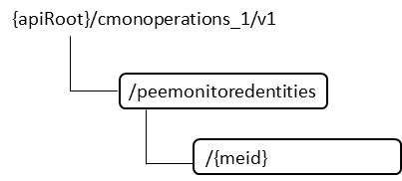

Figure B.3.3.2.1: Resource URI structure of the CMONOperations_1 interface

#### B.3.3.3 Sequence diagrams (informative)

##### B.3.3.3.1 Flow of the readMEDescription operation

This clause describes a sequence flow for reading all attribute values of an individual monitored entity.

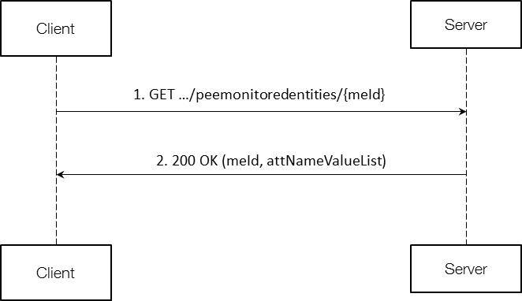

Figure B.3.3.3.1.1: Flow of the readMEDescription operation

NOTE: In figure B.3.3.3.1.1, the Client is the NM-RMS and the Server can be the XCU/DGU or VS-RMS or DM/EM.

This operation consists of the following steps:

1. Client sends a GET request to an individual monitored entity resource, addressed by the appropriate monitored entity identifier in its resource URI.

2. Server returns a "200 OK" response to the NM-RMS, and includes the monitored entity Id and a data structure of type "attNameValueList" in the payload body.

##### B.3.3.3.2 Flow of the writeMEDescription operation

This clause describes a sequence flow for modifying a list of attribute values of an individual monitored entity.

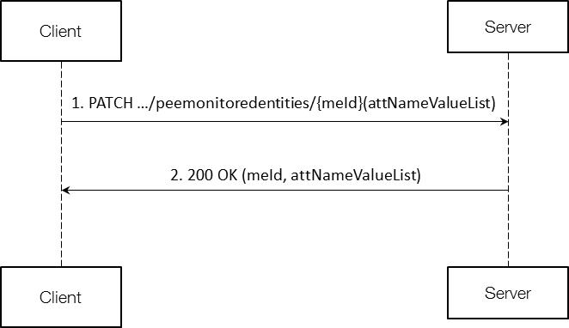

Figure B.3.3.3.2.1: Flow of the writeMEDescription operation

NOTE: In figure B.3.3.3.2.1, the Client is the NM-RMS and the Server can be the XCU/DGU or VS-RMS or DM/EM.

This operation consists of the following steps:

1. Client sends a PATCH request to an individual monitored entity resource, addressed by the appropriate monitored entity identifier in its resource URI, which includes in the payload body a data structure of type "attNameValueList", containing the list of attribute name and value pairs corresponding to attributes to be modified.

2. Server returns a "200 OK" response to the NM-RMS, and includes the monitored entity Id and a data structure of type "attNameValueList" in the payload body, containing the list of attribute name and value pairs corresponding to attributes whose values have been modified.

#### B.3.3.4 Resources

##### B.3.3.4.1 Introduction

This clause defines all the resources and methods provided by the CMONOperations_1 interface.

##### B.3.3.4.2 Resource: Individual monitored entity

###### B.3.3.4.2.1 Description

This resource represents an individual monitored entity.

###### B.3.3.4.2.2 Resource definition

###### B.3.3.4.2.3 Resource methods

B.3.3.4.2.3.1 GET

The client can use this method to get the value of all attributes of an individual monitored entity.

Table B.3.3.4.2.3.1-1: Details of the GET request on this resource

|  |  |  |
| --- | --- | --- |
| Data type | Cardinality | Description |
| meId | 1 | The Id of the monitored entity. |

Table B.3.3.4.2.3.1-2: Details of the GET response on this resource

|  |  |  |  |
| --- | --- | --- | --- |
| Data type | Cardinality | Response codes | Description |
| meId | 1 | 200 OK | The request was accepted and completed.  The response body shall contain the monitored entity Id and attribute name and value pairs for the monitored entity. |
| AttNameValueList | 1 |

B.3.3.4.2.3.2 PATCH

The client can use this method to write the value of a list of attributes of an individual monitored entity.

Table B.3.3.4.2.3.2-1: Details of the PATCH request on this resource

|  |  |  |
| --- | --- | --- |
| Data type | Cardinality | Description |
| meId | 1 | The Id of the monitored entity. |
| AttNameValueList | 1 | The list of names and values of attributes to be modified. |

Table B.3.3.4.2.3.1-2: Details of the PATCH response on this resource

|  |  |  |  |
| --- | --- | --- | --- |
| Data type | Cardinality | Response codes | Description |
| meId | 1 | 200 OK | The request was accepted and completed.  The response body shall contain the monitored entity Id and attribute modifications for themonitored entity. |
| AttNameValueList | 1 |

#### B.3.3.5 Data Model

##### B.3.3.5.1 Introduction

This clause defines the request and response data structures of the CMONOperations_1 interface. If a request or response contains attributes not defined in the present document, a receiving functional block that does not understand these attributes shall not treat their presence as an error, and may choose to ignore them.

##### B.3.3.5.2 Resource and notification data types

###### B.3.3.5.2.1 Introduction

This clause defines the data structures to be used in the resource representations and notifications for the CMONOperations_1 interface.

###### B.3.3.5.2.2 Type: AttributeNameList

Table B.3.3.5.2.2-1: Definition of the AttributeNameList data type

|  |  |  |  |
| --- | --- | --- | --- |
| Attribute name | Data type | Cardinality | Description |
| attributeName | String | 0..N | Name of the attribute whose value is queried. |

###### B.3.3.5.2.3 Type: AttNameValueList

Table B.3.3.5.2.3-1: Definition of the AttNameValueList data type

|  |  |  |  |
| --- | --- | --- | --- |
| Attribute name | Data type | Cardinality | Description |
| attributeNameValue | Structure (inlined) | 0..N | Pair of name+value of an attribute. |
| > attributeName | String | 1 | Name of the attribute. |
| > attributeValue | Any | 1 | Value of the attribute. |

### B.3.4 CMONOperations_2 interface

#### B.3.4.1 Description

The semantics of this interface is described in 3GPP TS 28.305 [2] – clause 6.2.4.

#### B.3.4.2 Resource structure and attributes

All resource URIs of the API shall use the base URI specification defined in clause B.3.10. The string "cmonoperations_2" shall be used to represent {apiName}. The {apiVersion} shall be set to "v1" for the present document. All resource URIs in the clauses below are defined relatively to the above base URI.

Figure B.3.4.3.2.1 shows the overall resource URI structure defined for the CMONOperations_2 interface.

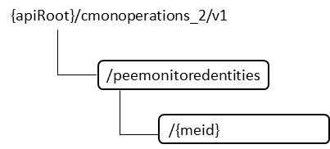

Figure B.3.4.3.2.1: Resource URI structure of the CMONOperations_2 interface

#### B.3.4.3 Sequence diagrams (informative)

##### B.3.4.3.1 Flow of the readMEConfiguration operation

This clause describes a sequence flow for reading threshold values of an individual monitored entity instance.

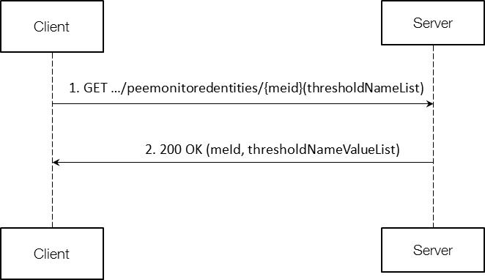

Figure B.3.4.3.1.1: Flow of the readMEConfiguration operation

NOTE: in figure B.3.4.3.1.1, the Client is the NM-RMS and the Server can be the XCU/DGU or VS-RMS or DM/EM.

This operation consists of the following steps:

1. Client sends a GET request to an individual monitored entity resource, addressed by the appropriate monitored entity identifier in its resource URI.

2. Server returns a "200 OK" response to Client, and includes the monitored entity Id and a data structure of type "thresholdNameValueList" in the payload body.

##### B.3.4.3.2 Flow of the writeMEConfiguration operation

This clause describes a sequence flow for writing threshold values of an individual monitored entity instance.

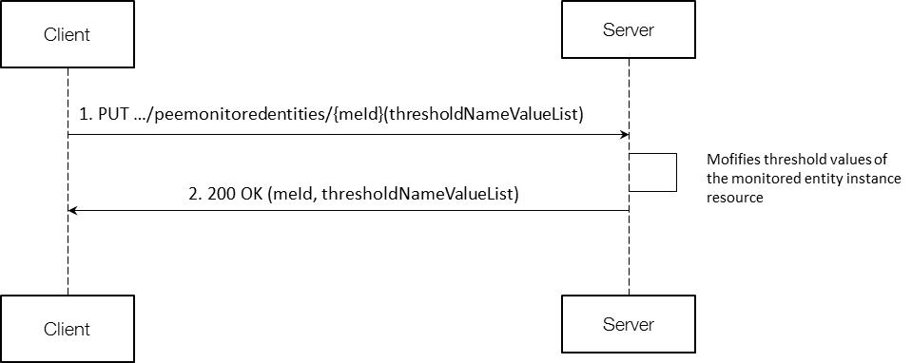

Figure B.3.4.3.2.1: Flow of the writeMEConfiguration operation

NOTE: in figure B.3.4.3.2.1, the Client is the NM-RMS and the Server can be the XCU/DGU or VS-RMS or DM/EM.

This operation consists of the following steps:

1. The Client sends a PUT request to the individual monitored entity instance resource;

2. The Server modifies values of the thresholds of the monitored entity instance resource;

3. The Server returns a “200 OK” response to the Client, with a payload body containing the monitored entity Id and the actual values of the thresholds in a data structure of type “thresholdNameValueList”.

#### B.3.4.4 Resources

##### B.3.4.4.1 Introduction

This clause defines all the resources and methods provided by the CMONOperations_2 interface.

##### B.3.4.4.2 Resource: Individual monitored entity

###### B.3.4.4.2.1 Description

This resource represents an individual monitored entity.

###### B.3.4.4.2.2 Resource definition

###### B.3.4.4.2.3 Resource methods

B.3.4.4.2.3.1 GET

The client can use this method to get the value of all threshold values of an individual monitored entity.

Table B.3.4.4.2.3.1-1: Details of the GET request on this resource

|  |  |  |
| --- | --- | --- |
| Data type | Cardinality | Description |
| meId | 1 | The monitored entity Id. |

Table B.3.4.4.2.3.1-2: Details of the GET response on this resource

|  |  |  |  |
| --- | --- | --- | --- |
| Data type | Cardinality | Response codes | Description |
| meId  ThresholdNameValueList | 1 | 200 OK | The request was accepted and completed.  The response body shall contain the monitored entity Id and threshold name and value pairs of the monitored entity. |

B.3.4.4.2.3.2 PUT

The client can use this method to write the value of a list of thresholds of an individual monitored entity.

Table B.3.3.4.2.3.2-1: Details of the PUT request on this resource

|  |  |  |
| --- | --- | --- |
| Data type | Cardinality | Description |
| meId | 1 | The monitored entity Id |
| ThresholdNameValueList | 1 | The list of names and values of thresholds to be modified. |

Table B.3.4.4.2.3.1-2: Details of the PUT response on this resource

|  |  |  |  |
| --- | --- | --- | --- |
| Data type | Cardinality | Response codes | Description |
| meId  ThresholdNameValueList | 1 | 200 OK | The request was accepted and completed.  The response body shall contain the monitored entity Id and threshold modifications for the monitored entity. |

#### B.3.4.5 Data Model

##### B.3.4.5.1 Introduction

This clause defines the request and response data structures of the CMONOperations_2 interface. If a request or response contains attributes not defined in the present document, a receiving functional block that does not understand these attributes shall not treat their presence as an error, and may choose to ignore them.

##### B.3.4.5.2 Resource and notification data types

###### B.3.4.5.2.1 Introduction

This clause defines the data structures to be used in the resource representations and notifications for the CMONOperations_2 interface.

###### B.3.4.5.2.2 Type: ThresholdNameValueList

Table B.3.4.5.2.2-1: Definition of the ThresholdNameValueList data type

|  |  |  |  |
| --- | --- | --- | --- |
| Attribute name | Data type | Cardinality | Description |
| thresholdNameValue | Structure (inlined) | 0..N | Pair of name+value of a threshold. |
| > thresholdName | String | 1 | Name of the threshold. |
| > thresholdValue | Any | 1 | Value of the threshold. |

### B.3.5 CMONOperations_3 interface

#### B.3.5.0 Introduction

The semantics of this interface is described in 3GPP TS 28.305 [2] – clause 6.2.5.

#### B.3.5.1 createCMONPMJob operation

##### B.3.5.1.1 Description

The semantics of this operation is described in 3GPP TS 28.305 [2] – clause 6.2.5.1.

##### B.3.5.1.2 Resource structure and attributes

All resource URIs of the API shall use the base URI specification defined in clause B.3.10. The string "cmonoperations_3" shall be used to represent {apiName}. The {apiVersion} shall be set to "v1" for the present document. All resource URIs in the clauses below are defined relative to the above base URI.

Figure B.3.5.1.2.1 shows the overall resource URI structure defined for the createCMONPMJob operation.

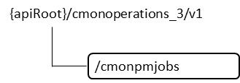

Figure B.3.5.1.2.1: Resource URI structure of the createCMONPMJob operation

##### B.3.5.1.3 Flow of the createCMONPMJob operation

This clause describes a sequence flow for creating an individual cmonpmjob instance.

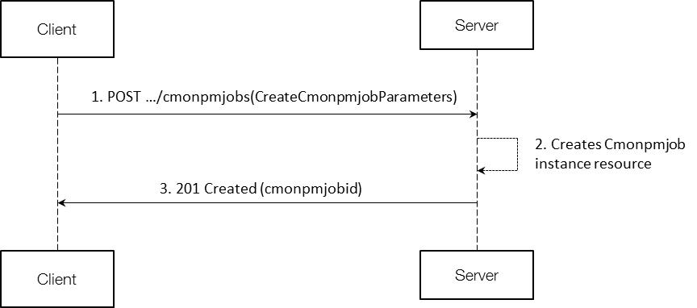

Figure B.3.5.1.3.1: Flow of the createCMONPMJob operation

NOTE: in figure B.3.4.1.3.1, the Client is the NM-RMS and the Server can be the XCU/DGU or VS-RMS or DM/EM.

This operation consists of the following steps:

1. The Client sends a POST request to the cmonpmjobs resource, including in the payload body a data structure of type “Createcmonpmjobparamaters”;

2. The Server creates a new Cmonpmjob instance, and the associated Cmonpmjob instance identifier;

3. The Server returns a “201 Created” response to the Client, containing a representation of the Cmonpmjob instance resource just created by the Server, and provides the URI of the newly created resource in the “Location” HTTP header.

##### B.3.5.1.4 Resource: cmonpmjobs

###### B.3.5.1.4.1 Description

This resource represents cmonpmjobs. The client can use this resource to request the creation of a new instance of cmonpmjob.

###### B.3.5.1.4.2 Resource definition

The resource URI is: {apiRoot}/cmonoperations_3/v1/cmonpmjobs

###### B.3.5.1.4.3 Resource method: POST

The client can use this method to create an individual cmonpmjob instance.

Table B.3.5.1.4.3-1: Details of the POST request on this resource

|  |  |  |
| --- | --- | --- |
| Data type | Cardinality | Description |
| MeIdList | 1 | The list of mEIds of PEEMonitoredEntity instances on which measurements are to be collected. |
| MeasurementNameList | 1 | The list of names of measurements to be collected. |
| GranularityPeriod | 1 | The granularity period. |

Table B.3.5.1.4.3-2: Details of the POST response on this resource

|  |  |  |  |
| --- | --- | --- | --- |
| Data type | Cardinality | Response codes | Description |
| CmonPmJobId | 1 | 201 Created (cmonpmjobid) | The request was accepted. The new instance of cmonpmjob is created by Server and its Id is sent to Client. |

##### B.3.5.1.5 Data Model

###### B.3.5.1.5.1 Introduction

This clause defines the request and response data structures of the createCMONPMJob operation. If a request or response contains attributes not defined in the present document, a receiving functional block that does not understand these attributes shall not treat their presence as an error, and may choose to ignore them.

###### B.3.5.1.5.2 Data Type: MeIdList

Table B.3.5.1.5.2-1: Definition of the MeIdList data type

|  |  |  |  |
| --- | --- | --- | --- |
| Attribute name | Data type | Cardinality | Description |
| mEId | Identifier | 1..N | Identifier of monitored entity instance. |

###### B.3.5.1.5.3 Data Type: MeasurementNameList

Table B.3.5.1.5.3-1: Definition of the MeasurementNameList data type

|  |  |  |  |
| --- | --- | --- | --- |
| Attribute name | Data type | Cardinality | Description |
| measurementName | String | 1..N | Name of the the measurement. It shall correspond to an attribute name of PEEMeasurementData. |

###### B.3.5.1.5.4 Data Type: GranularityPeriod

Table B.3.5.1.5.4-1: Definition of the GranularityPeriod data type

|  |  |  |  |
| --- | --- | --- | --- |
| Attribute name | Data type | Cardinality | Description |
| granularityPeriod | Integer | 1 | It specifies the period between two successive measurements. Expressed in munutes. |

###### B.3.5.1.5.5 Data Type: ServerJobId

Table B.3.5.1.5.6-1: Definition of the CmonPmJobId data type

|  |  |  |  |
| --- | --- | --- | --- |
| Attribute name | Data type | Cardinality | Description |
| cmonmjobid | Identifier | 1 | Identifier of cmonpmjob instance, assigned by Server. |

#### B.3.5.2 stopCMONPMJob operation

##### B.3.5.2.1 Description

The semantics of this operation is described in 3GPP TS 28.305 [2] – clause 6.2.5.2.

##### B.3.5.2.2 Resource structure and attributes

All resource URIs of the API shall use the base URI specification defined in clause B.3.10. The string "cmonoperations_3" shall be used to represent {apiName}. The {apiVersion} shall be set to "v1" for the present document. All resource URIs in the clauses below are defined relative to the above base URI.

Figure B.3.5.2.2.1 shows the overall resource URI structure defined for the stopCMONPMJob operation.

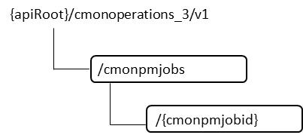

Figure B.3.5.2.2.1: Resource URI structure of the stopCMONPMJob operation

##### B.3.5.2.3 Flow of the stopCMONPMJob operation

This clause describes a sequence flow for stopping an individual cmonpmjob.

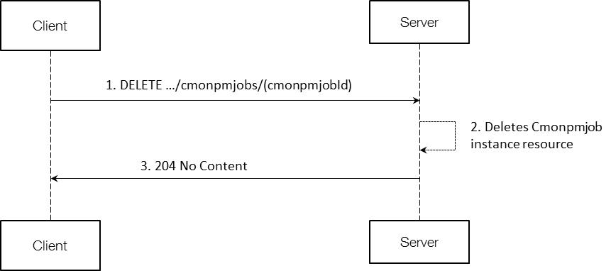

Figure B.3.5.2.3.1: Flow of the stopCMONPMJob operation

NOTE: in figure B.3.5.2.3.1, the Client is the NM-RMS and the Server can be the XCU/DGU or VS-RMS or DM/EM.

This operation consists of the following steps:

1. The Client sends a DELETE request to the individual cmonpmjob instance resource;

2. The Server deletes the cmonpmjob instance resource, and the associated cmonpmjob instance identifier;

3. The Server returns a “204 No Content” response to the Client, with an empty payload body.

##### B.3.5.2.4 Resource: individual cmonpmjob instance

###### B.3.5.2.4.1 Description

This resource represents an individual cmonpmjob instance.

###### B.3.5.2.4.2 Resource definition

The resource URI is: {apiRoot}/cmonoperations_3/v1/cmonpmjobs/{cmonpmjobId}

###### B.3.5.2.4.3 Resource method: DELETE

The client can use this method to delete an individual cmonpmjob instance.

Table B.3.5.2.4.3-1: Details of the DELETE request on this resource

|  |  |  |
| --- | --- | --- |
| Data type | Cardinality | Description |
| CmonPmJobId | 1 | The Id of the cmonpmjob instance. |

Table B.3.5.2.4.3-2: Details of the DELETE response on this resource

|  |  |  |  |
| --- | --- | --- | --- |
| Data type | Cardinality | Response codes | Description |
| N/A |  | 204 | The request was accepted. The cmonpmjob instance is deleted by Server. |

##### B.3.5.2.5 Data Model

###### B.3.5.2.5.1 Introduction

This clause defines the request and response data structures of the stopCMONPMJob operation. If a request or response contains attributes not defined in the present document, a receiving functional block that does not understand these attributes shall not treat their presence as an error, and may choose to ignore them.

###### B.3.5.2.5.2 Data Type: CmonPmJobId

Table B.3.5.2.5.2-1: Definition of the CmonPmJobId data type

|  |  |  |  |
| --- | --- | --- | --- |
| Attribute name | Data type | Cardinality | Description |
| cmonpmjobid | Identifier | 1 | Identifier of a cmonpmjob instance. |

### B.3.6 CMONNotifications_1 interface

#### B.3.6.0 Introduction

The semantics of this interface is described in 3GPP TS 28.305 [2] – clause 6.2.6.

#### B.3.6.1 notifyMeasurementData notification

##### B.3.6.1.1 Description

The semantics of this notification is described in 3GPP TS 28.305 [2] – clause 6.2.6.1.

##### B.3.6.1.2 Resource structure and attributes

All resource URIs of the API shall use the base URI specification defined in clause B.3.10. The string "cmonnotifications_1" shall be used to represent {apiName}. The {apiVersion} shall be set to "v1" for the present document. All resource URIs in the clauses below are defined relatively to the above base URI.

NOTE: This version of the specification does not define how the Client URL is provisioned to the Server.

##### B.3.6.1.3 Flow of the notifyMeasurementData notification

This clause describes a sequence flow for notifying measurement data.

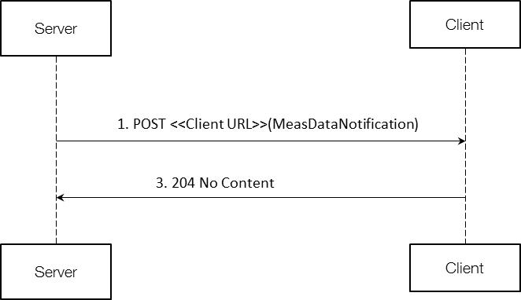

Figure B.3.6.1.3.1: Flow of the notifyMeasurementData notification

NOTE: in figure B.3.6.1.3.1, the Client is the NM-RMS and the Server can be the XCU/DGU or VS-RMS or DM/EM.

This operation consists of the following steps:

1. The Server generates a notification which includes measurement data, and sends it in the body of a POST request to the Client URI;

2. The Client acknowledges the successful delivery of the notification by returning a “204 No Content” response.

##### B.3.6.1.4 Resource: notification endpoint

###### B.3.6.1.4.1 Description

This resource represents a notification endpoint. The Server can use this resource to send notifications to the Client, which has provided the URI of this resource.

###### B.3.6.1.4.2 Resource definition

The resource URI has been provided by the Client.

###### B.3.6.1.4.3 Resource method: POST

The Server can use this method to send a notification to the Client.

Table B.3.6.1.4.3-1: Details of the POST request on this resource

|  |  |  |
| --- | --- | --- |
| Data type | Cardinality | Description |
| NotificationHeader | 1 | The header of the notification. |
| MeasDataCollection | 1 | The collection of measurement data. |

Table B.3.6.1.4.3-2: Details of the POST response on this resource

|  |  |  |  |
| --- | --- | --- | --- |
| Data type | Cardinality | Response codes | Description |
| None |  | 204 | The notification was delivered successfully. |

##### B.3.6.1.5 Data Model

###### B.3.6.1.5.1 Introduction

This clause defines the request and response data structures of the notifyMeasurementData notification. If a request or response contains attributes not defined in the present document, a receiving functional block that does not understand these attributes shall not treat their presence as an error, and may choose to ignore them.

###### B.3.6.1.5.2 Data Type: NotificationHeader

Table B.3.6.1.5.2-1: Definition of the NotificationHeader data type

|  |  |  |  |
| --- | --- | --- | --- |
| Attribute name | Data type | Cardinality | Description |
| notificationId | Identifier | 1 | Identifier of the notification instance. |
| notificationType | String | 1 | The type of notification (=”MeasDataNotification”). |
| senderInfo | Structure  (inlined) | 1 | Information about the sender of the notification. |
| >senderName | String | 1 | The name of the sender. |
| >senderType | String | 1 | The type of the sender. |
| >vendorName | String | 1 | The name of the vendor of the sender. |

###### B.3.6.1.5.3 Data Type: MeasDataCollection

Table B.3.6.1.5.3-1: Definition of the MeasDataCollection data type

|  |  |  |  |
| --- | --- | --- | --- |
| Attribute name | Data type | Cardinality | Description |
| MeasHeader | Structure  (inlined) | 1 | The measurement header. |
| >measFormatVersion | String | 1 | The format version of the measurement data collection |
| >collectionBeginTime | DateTime | 1 | The start of the measurement collection interval (granularity period) for the collected measurement data. |
| >jobId | Identifier | 1 | The identifier of the cmonpmjob thanks to which these measurement data are collected. |
|  |  |  |  |
| MeasData | Structure  (inlined) | 1..N | The measurement data. |
| >mEId | Identifier |  | Identifier of the monitored entity instance |
| >measInfo | Structure  (inlined) | 1..N | The sequence of measurements, values and related information. |
| >>measName | String | 1 | The name of the measurement |
| >>measValue | Any | 1 | The value of the measurement |
| MeasFooter | Structure  (inlined) | 1 | The measurement footer. |
| >collectionEndTime | DateTime | 1 | The end of the measurement collection interval (granularity period) for the collected measurement data. |

### B.3.7 CMONNotifications_2 interface

#### B.3.7.0 Introduction

The semantics of this interface is described in 3GPP TS 28.305 [2] – clause 6.2.7.

#### B.3.7.1 notifyAlarm notification

##### B.3.7.1.1 Description

The semantics of this notification is described in 3GPP TS 28.305 [2] – clause 6.2.7.1.

##### B.3.7.1.2 Resource structure and attributes

All resource URIs of the API shall use the base URI specification defined in clause B.3.10. The string "cmonnotifications_2" shall be used to represent {apiName}. The {apiVersion} shall be set to "v1" for the present document. All resource URIs in the clauses below are defined relative to the above base URI.

NOTE: This version of the specification does not define how the Client URL is provisioned to the Server.

##### B.3.7.1.3 Flow of the notifyAlarm notification

This clause describes a sequence flow for notifying an alarm.

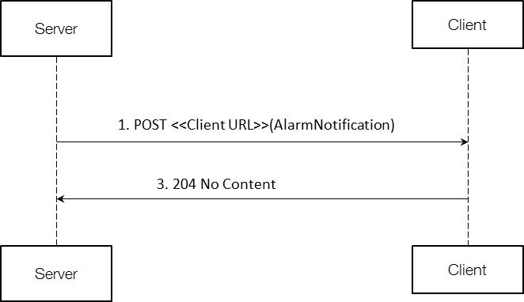

Figure B.3.7.1.3.1: Flow of the notifyAlarm notification

NOTE: in figure B.3.6.1.3.1, the Client is the NM-RMS and the Server can be the XCU/DGU or VS-RMS or DM/EM.

This operation consists of the following steps:

1. The Client generates a notification which includes alarm data, and sends it in the body of a POST request to the Server URI;

2. The Server acknowledges the successful delivery of the notification by returning a “204 No Content” response.

##### B.3.7.1.4 Resource: notification endpoint

###### B.3.7.1.4.1 Description

This resource represents a notification endpoint. The Server can use this resource to send notifications to the Client, which has provided the URI of this resource.

###### B.3.7.1.4.2 Resource definition

The resource URI has been provided by the Client.

###### B.3.7.1.4.3 Resource method: POST

The Server can use this method to send a notification to the Client.

Table B.3.7.1.4.3-1: Details of the POST request on this resource

|  |  |  |
| --- | --- | --- |
| Data type | Cardinality | Description |
| NotificationHeader | 1 | The header of the notification. |
| AlarmInformation | 1 | The information about the alarm. |

Table B.3.7.1.4.3-2: Details of the POST response on this resource

|  |  |  |  |
| --- | --- | --- | --- |
| Data type | Cardinality | Response codes | Description |
| None |  | 204 | The notification was delivered successfully. |

##### B.3.7.1.5 Data Model

###### B.3.7.1.5.1 Introduction

This clause defines the request and response data structures of the notifyAlarm notification. If a request or response contains attributes not defined in the present document, a receiving functional block that does not understand these attributes shall not treat their presence as an error, and may choose to ignore them.

###### B.3.7.1.5.2 Data Type: NotificationHeader

Table B.3.7.1.5.2-1: Definition of the NotificationHeader data type

|  |  |  |  |
| --- | --- | --- | --- |
| Attribute name | Data type | Cardinality | Description |
| notificationId | Identifier | 1 | Identifier of the notification instance. |
| notificationType | String | 1 | The type of notification (=”AlarmNotification”). |
| senderInfo | Structure  (inlined) | 1 | Information about the sender of the notification. |
| >senderName | String | 1 | The name of the sender. |
| >senderType | String | 1 | The type of the sender. |
| >vendorName | String | 1 | The name of the vendor of the sender. |

###### B.3.7.1.5.3 Data Type: AlarmInformation

Table B.3.7.1.5.3-1: Definition of the AlarmInformation data type

|  |  |  |  |
| --- | --- | --- | --- |
| Attribute name | Data type | Cardinality | Description |
| alarmId | Identifier | 1 | See 3GPP TS 28.305 [2] – clause 6.2.7.1.2. |
| alarmTime | DateTime | 1 | See 3GPP TS 28.305 [2] – clause 6.2.7.1.2. |
| alarmType | String | 1 | See 3GPP TS 28.305 [2] – clause 6.2.7.1.2. |
| perceivedSeverity | String | 1 | See 3GPP TS 28.305 [2] – clause 6.2.7.1.2. |
| probableCause | String | 1 | See 3GPP TS 28.305 [2] – clause 6.2.7.1.2. |
| additionalText | String | 0..1 | See 3GPP TS 28.305 [2] – clause 6.2.7.1.2. |

### B.3.8 CMONNotifications_3 interface

#### B.3.8.0 Introduction

The semantics of this interface is described in 3GPP TS 28.305 [2] – clause 6.2.8.

#### B.3.8.1 notifyConfigurationChange notification

##### B.3.8.1.1 Description

The semantics of this notification is described in 3GPP TS 28.305 [2] – clause 6.2.8.1.

##### B.3.8.1.2 Resource structure and attributes

All resource URIs of the API shall use the base URI specification defined in clause B.3.10. The string "cmonnotifications_3" shall be used to represent {apiName}. The {apiVersion} shall be set to "v1" for the present document. All resource URIs in the clauses below are defined relatively to the above base URI.

NOTE: This version of the specification does not define how the Client URL is provisioned to the Server.

##### B.3.8.1.3 Flow of the notifyConfigurationChange notification

This clause describes a sequence flow for notifying a configuration change.

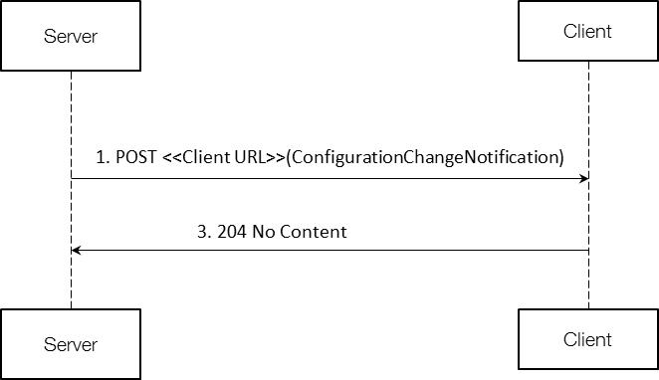

Figure B.3.8.1.3.1: Flow of the notifyConfigurationChange notification

NOTE: in figure B.3.8.1.3.1, the Client is the NM-RMS and the Server can be the XCU/DGU or VS-RMS or DM/EM.

This operation consists of the following steps:

1. The Client generates a notification which includes configuration change data, and sends it in the body of a POST request to the Server URI;

2. The Server acknowledges the successful delivery of the notification by returning a “204 No Content” response.

##### B.3.8.1.4 Resource: notification endpoint

###### B.3.8.1.4.1 Description

This resource represents a notification endpoint. The Server can use this resource to send notifications to the Client, which has provided the URI of this resource.

###### B.3.8.1.4.2 Resource definition

The resource URI has been provided by the Client.

###### B.3.8.1.4.3 Resource method: POST

The Server can use this method to send a notification to the Client.

Table B.3.8.1.4.3-1: Details of the POST request on this resource

|  |  |  |
| --- | --- | --- |
| Data type | Cardinality | Description |
| NotificationHeader | 1 | The header of the notification. |
| ConfigurationChangeInformation | 1 | The information about the configuration change. |

Table B.3.8.1.4.3-2: Details of the POST response on this resource

|  |  |  |  |
| --- | --- | --- | --- |
| Data type | Cardinality | Response codes | Description |
| None |  | 204 | The notification was delivered successfully. |

##### B.3.8.1.5 Data Model

###### B.3.8.1.5.1 Introduction

This clause defines the request and response data structures of the notifyConfigurationChange notification. If a request or response contains attributes not defined in the present document, a receiving functional block that does not understand these attributes shall not treat their presence as an error, and may choose to ignore them.

###### B.3.8.1.5.2 Data Type: NotificationHeader

Table B.3.8.1.5.2-1: Definition of the NotificationHeader data type

|  |  |  |  |
| --- | --- | --- | --- |
| Attribute name | Data type | Cardinality | Description |
| notificationId | Identifier | 1 | Identifier of the notification instance. |
| notificationType | String | 1 | The type of notification (=”ConfigurationChangeNotification”). |
| senderInfo | Structure  (inlined) | 1 | Information about the sender of the notification. |
| >senderName | String | 1 | The name of the sender. |
| >senderType | String | 1 | The type of the sender. |
| >vendorName | String | 1 | The name of the vendor of the sender. |

###### B.3.8.1.5.3 Data Type: ConfigurationChangeInformation

Table B.3.8.1.5.3-1: Definition of the ConfigurationChangeInformation data type

|  |  |  |  |
| --- | --- | --- | --- |
| Attribute name | Data type | Cardinality | Description |
| mEId | Identifier | 1 | See 3GPP TS 28.305 [2] – clause 6.2.8.1.2. |
| attNameValueList | KeyValuePairs | 1..N | See 3GPP TS 28.305 [2] – clause 6.2.8.1.2. |

### B.3.9 CMONNotifications_4 interface

#### B.3.9.0 Introduction

The semantics of this interface is described in 3GPP TS 28.305 [2] – clause 6.2.9.

#### B.3.9.1 notifyThresholdCrossingOrReaching notification

##### B.3.9.1.1 Description

The semantics of this notification is described in 3GPP TS 28.305 [2] – clause 6.2.9.1.

##### B.3.9.1.2 Resource structure and attributes

All resource URIs of the API shall use the base URI specification defined in clause B.3.10. The string "cmonnotifications_4" shall be used to represent {apiName}. The {apiVersion} shall be set to "v1" for the present document. All resource URIs in the clauses below are defined relative to the above base URI.

NOTE: This version of the specification does not define how the Client URL is provisioned to the Server.

##### B.3.9.1.3 Flow of the notifyThresholdCrossingOrReaching notification

This clause describes a sequence flow for notifying that a threshold has been crossed or reached.

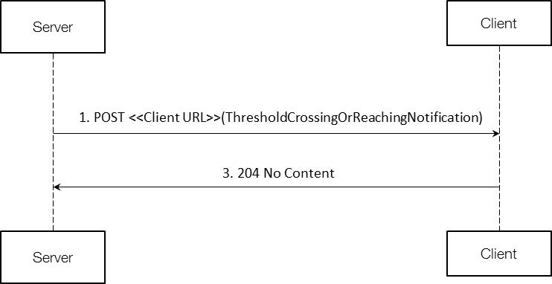

Figure B.3.9.1.3.1: Flow of the notifyThresholdCrossingOrReaching notification

NOTE: in figure B.3.9.1.3.1, the Client is the NM-RMS and the Server can be the XCU/DGU or VS-RMS or DM/EM.

This operation consists of the following steps:

1. The Client generates a notification which includes threshold crossing information, and sends it in the body of a POST request to the Server URI;

2. The Server acknowledges the successful delivery of the notification by returning a “204 No Content” response.

##### B.3.9.1.4 Resource: notification endpoint

###### B.3.9.1.4.1 Description

This resource represents a notification endpoint. The Server can use this resource to send notifications to the Client, which has provided the URI of this resource.

###### B.3.9.1.4.2 Resource definition

The resource URI has been provided by the Client.

###### B.3.9.1.4.3 Resource method: POST

The Server can use this method to send a notification to the Client.

Table B.3.9.1.4.3-1: Details of the POST request on this resource

|  |  |  |
| --- | --- | --- |
| Data type | Cardinality | Description |
| NotificationHeader | 1 | The header of the notification. |
| ThesholdCrossingOrReachingInformation | 1 | The information about the threshold crossing / reaching. |

Table B.3.9.1.4.3-2: Details of the POST response on this resource

|  |  |  |  |
| --- | --- | --- | --- |
| Data type | Cardinality | Response codes | Description |
| None |  | 204 | The notification was delivered successfully. |

##### B.3.9.1.5 Data Model

###### B.3.9.1.5.1 Introduction

This clause defines the request and response data structures of the notifyThresholdCrossingOrReaching notification. If a request or response contains attributes not defined in the present document, a receiving functional block that does not understand these attributes shall not treat their presence as an error, and may choose to ignore them.

###### B.3.9.1.5.2 Data Type: NotificationHeader

Table B.3.9.1.5.2-1: Definition of the NotificationHeader data type

|  |  |  |  |
| --- | --- | --- | --- |
| Attribute name | Data type | Cardinality | Description |
| notificationId | Identifier | 1 | Identifier of the notification instance. |
| notificationType | String | 1 | The type of notification (=”ThresholdCrossingOrReachingNotification”). |
| senderInfo | Structure  (inlined) | 1 | Information about the sender of the notification. |
| >senderName | String | 1 | The name of the sender. |
| >senderType | String | 1 | The type of the sender. |
| >vendorName | String | 1 | The name of the vendor of the sender. |

###### B.3.9.1.5.3 Data Type: ThresholdCrossingOrReachingInformation

Table B.3.9.1.5.3-1: Definition of the ThresholdCrossingInformation data type

|  |  |  |  |
| --- | --- | --- | --- |
| Attribute name | Data type | Cardinality | Description |
| mEId | Identifier | 1 | See 3GPP TS 28.305 [2] – clause 6.2.9.1.2. |
| thresholdInfo | Structure  (inlined) | 1..N | See 3GPP TS 28.305 [2] – clause 6.2.9.1.2. |
| >thresholdName | String | 1 | See 3GPP TS 28.305 [2] – clause 6.2.9.1.2. |
| >thresholdValue | (any type) | 1 | See 3GPP TS 28.305 [2] – clause 6.2.9.1.2. |
| >thresholdObservedValue | (any type) | 1 | See 3GPP TS 28.305 [2] – clause 6.2.9.1.2. |

### B.3.10 URI structure and supported content formats

This clause specifies the URI prefix and the supported formats applicable to the APIs defined in the present document.

All resource URIs of the APIs shall have the following prefix:

{apiRoot}/{apiName}/{apiVersion}/

where:

{apiRoot} indicates the scheme ("http" or "https"), the host name and optional port, and an optional prefix path.

{apiName} indicates the interface name in an abbreviated form. The {apiName} of each interface is defined in the clause specifying the corresponding interface.

{apiVersion} indicates the current version of the API and is defined in the clause specifying the corresponding interface.

For HTTP requests and responses that have a body, the content format JSON (see IETF RFC 7159 [9]) shall be supported. The JSON format shall be signalled by the content type "application/json".

All APIs shall support and use HTTP over TLS (also known as HTTPS) (see IETF RFC 2818 [10]). TLS version 1.2 as defined by IETF RFC 5246 [11] shall be supported.

NOTE 1: The HTTP protocol elements mentioned in the present document originate from the HTTP specification; HTTPS runs the HTTP protocol in a TLS layer. The present document therefore uses the statement above to mention "HTTP request", "HTTP header", etc., without explicitly calling out whether or not these are run over TLS.

NOTE 2: There are a number of best practices and guidelines how to configure and implement TLS 1.2 in a secure manner, as security threats evolve. A detailed specification of those is beyond the scope of the present document; the reader is referred to external documentation such as Annex E of 3GPP TS 33 310 [12].

All resource URIs of the API shall comply with the URI syntax as defined in IETF RFC 3986 [13]. An implementation that dynamically generates resource URI parts (path segments, query parameter values) shall ensure that these parts only use the character set that is allowed by IETF RFC 3986 [13] for these parts.

NOTE 3: This means that characters which are not part of this allowed set need to be escaped using percentencoding as defined by IETF RFC 3986 [13].

### B.3.11 Solution Set definitions

#### B.3.11.1 Solution set definition structure

B.3.11.2 of the present document defines the OpenAPI schema CMONOperations_1.json for the CMONOperations_1 interface defined in 3GPP TS 28.305 [2].

Note: To conform to RESTful principles, B.3.11.2 defines the following additional operation which is not described in 3GPP TS 28.305 [2]

GET /cmonoperations_1/v1/peemonitoredentities

B.3.11.3 of the present document defines the OpenAPI schema CMONOperations_2.json for the CMONOperations_2 interface defined in 3GPP TS 28.305 [2].

Note: To conform to RESTful principles, B.3.11.3 defines the following additional operation which is not described in 3GPP TS 28.305 [2]

GET /cmonoperations_2/v1/peemonitoredentities

B.3.11.4 of the present document defines the OpenAPI schema CMONOperations_3.json for the CMONOperations_3 interface defined in 3GPP TS 28.305 [2].

Note: To conform to RESTful principles, B.3.11.4 defines the following additional operations which are not described in 3GPP TS 28.305 [2]

GET /cmonoperations_3/v1/cmonpmjobs

GET /cmonoperations_3/v1/cmonpmjobs/{CMONPMJobId}

B.3.11.5 of the present document defines the OpenAPI schema CMONNotifications_1.json for the CMONNotifications_1 interface defined in 3GPP TS 28.305 [2].

B.3.11.6 of the present document defines the OpenAPI schema CMONNotifications_2.json for the CMONNotifications_2 interface defined in 3GPP TS 28.305 [2].

B.3.11.7 of the present document defines the OpenAPI schema CMONNotifications_3.json for the CMONNotifications_3 interface defined in 3GPP TS 28.305 [2].

B.3.11.8 of the present document defines the OpenAPI schema CMONNotifications_4.json for the CMONNotifications_4 interface defined in 3GPP TS 28.305 [2].

#### B.3.11.2 OpenAPI definition "CMONOperations_1.json"

{

"swagger": "2.0",

"info": {

"title": "CMONOperations_1 Interface",

"description": "PEE Monitoring",

"version": "1.0.0"

},

"host": "www.example.org",

"schemes": [

"http",

"https"

],

"basePath": "/cmonoperations_1/v1",

"produces": [

"application/json"

],

"paths": {

"/peemonitoredentities": {

"get": {

"summary": "Read descriptions for all monitored entities",

"description": "The client can use this method to get a list of all monitored entities and their descriptions.",

"responses": {

"200": {

"description": "The request was accepted and completed",

"schema": {

"type": "array",

"items": {

"type": "object",

"properties": {

"meid": {

"type": "string",

"description": "Monitored entity ID"

},

"Description": {

"$ref": "#/definitions/PEEMEDescription"

}

}

}

}

},

"default": {

"description": "Unexpected error",

"schema": {

"$ref": "#/definitions/Error"

}

}

}

}

},

"/peemonitoredentities/{meid}": {

"get": {

"summary": "Read description for a monitored entity",

"description": "The client can use this method to get the description of an individual monitored entity.",

"parameters": [

{

"in": "path",

"name": "meid",

"description": "Monitored Entity ID",

"required": true,

"type": "string"

}

],

"responses": {

"200": {

"description": "The request was accepted and completed",

"schema": {

"type": "object",

"properties": {

"meid": {

"type": "string",

"description": "Monitored entity ID"

},

"Description": {

"$ref": "#/definitions/PEEMEDescription"

}

}

}

},

"404": {

"description": "Invalid identifier"

},

"default": {

"description": "Unexpected error",

"schema": {

"$ref": "#/definitions/Error"

}

}

}

},

"patch": {

"summary": "Modify description for a monitored entity",

"description": "The client can use this method to modify the description of an individual monitored entity.",

"parameters": [

{

"in": "path",

"name": "meid",

"description": "Monitored Entity ID",

"required": true,

"type": "string"

},

{

"in": "body",

"name": "Description",

"description": "Attributes of an individual monitored entity.",

"schema": {

"$ref": "#/definitions/PEEMEDescription"

}

}

],

"responses": {

"200": {

"description": "The request was accepted and completed",

"schema": {

"type": "object",

"properties": {

"meid": {

"type": "string",

"description": "Monitored entity ID"

},

"Description": {

"$ref": "#/definitions/PEEMEDescription"

}

}

}

},

"404": {

"description": "Invalid identifier"

},

"default": {

"description": "Unexpected error",

"schema": {

"$ref": "#/definitions/Error"

}

}

}

}

}

},

"definitions": {

"PEEMEDescription": {

"type": "object",

"properties": {

"siteIdentification": {

"type": "string",

"description": "Identification of the site of the monitored entity."

},

"siteLatitude": {

"type": "string",

"description": "The latitude of the site location."

},

"siteLongitude": {

"type": "string",

"description": "The longitude of the site location."

},

"siteDescription": {

"type": "string",

"description": "Description of the site of the monitored entity."

},

"equipmentType": {

"type": "string",

"description": "Indicates the type of equipment of the monitored entity."

},

"environmentType": {

"type": "string",

"description": "Indicates the type of environment of the monitored entity."

},

"powerInterface": {

"type": "string",

"description": "Indicates the type of power interface of the monitored entity."

},

"xcuDguDescription": {

"type": "string",

"description": "Description of the XCU/DGU."

},

"sensorDescription": {

"type": "string",

"description": "Description of the sensor."

},

"vSRmsDescription": {

"type": "string",

"description": "Description of the VS-RMS."

}

}

},

"Error": {

"type": "object",

"properties": {

"message": {

"type": "string"

}

}

}

}

}

#### B.3.11.3 OpenAPI definition "CMONOperations_2.json"

{

"swagger": "2.0",

"info": {

"title": "CMONOperations_2 Interface",

"description": "PEE Configurations",

"version": "1.0.0"

},

"host": "www.example.org",

"schemes": [

"http",

"https"

],

"basePath": "/cmonoperations_2/v1",

"produces": [

"application/json"

],

"paths": {

"/peemonitoredentities": {

"get": {

"summary": "Read configurations for all monitored entities",

"description": "The client can use this method to get a list of all monitored entities and their configurations.",

"responses": {

"200": {

"description": "The request was accepted and completed",

"schema": {

"type": "array",

"items": {

"type": "object",

"properties": {

"meid": {

"type": "string",

"description": "Monitored entity ID"

},

"Configuration": {

"$ref": "#/definitions/PEEMEConfiguration"

}

}

}

}

},

"default": {

"description": "Unexpected error",

"schema": {

"$ref": "#/definitions/Error"

}

}

}

}

},

"/peemonitoredentities/{meid}": {

"get": {

"summary": "Read configuration for a monitored entity",

"description": "The client can use this method to get the configuration of an individual monitored entity",

"parameters": [

{

"in": "path",

"name": "meid",

"description": "Monitored Entity ID",

"required": true,

"type": "string"

}

],

"responses": {

"200": {

"description": "The request was accepted and completed",

"schema": {

"type": "object",

"properties": {

"meid": {

"type": "string",

"description": "Monitored entity ID"

},

"Configuration": {

"$ref": "#/definitions/PEEMEConfiguration"

}

}

}

},

"404": {

"description": "Invalid identifier"

},

"default": {

"description": "Unexpected error",

"schema": {

"$ref": "#/definitions/Error"

}

}

}

},

"put": {

"summary": "Modify configuration for a monitored entity",

"description": "The client can use this method to modify the configuration of an individual monitored entity.",

"parameters": [

{

"in": "path",

"name": "meid",

"description": "Monitored Entity ID",

"required": true,

"type": "string"

},

{

"in": "body",

"name": "PEEMEConfigurationData",

"description": "Configuration data.",

"schema": {

"$ref": "#/definitions/PEEMEConfiguration"

}

}

],

"responses": {

"200": {

"description": "The request was accepted and completed",

"schema": {

"$ref": "#/definitions/PEEMEConfiguration"

}

},

"default": {

"description": "Unexpected error",

"schema": {

"$ref": "#/definitions/Error"

}

}

}

}

}

},

"definitions": {

"PEEMEConfiguration": {

"type": "object",

"description": "Threshold values. Threshold monitoring is disabled for an attribute if the threshold is empty or undefined.",

"properties": {

"powerMinThreshold": {

"type": "string",

"description": "Threshold value for minimum power usage"

},

"powerMaxThreshold": {

"type": "string",

"description": "Threshold value for maximum power usage"

},

"temperatureMinThreshold": {

"type": "string",

"description": "Threshold value for minimum temperature"

},

"temperatureMaxThreshold": {

"type": "string",

"description": "Threshold value for maximum temperature"

},

"voltageMinThreshold": {

"type": "string",

"description": "Threshold value for minimum voltage"

},

"voltageMaxThreshold": {

"type": "string",

"description": "Threshold value for maximum voltage"

},

"currentMinThreshold": {

"type": "string",

"description": "Threshold value for minimum current"

},

"currentMaxThreshold": {

"type": "string",

"description": "Threshold value for maximum current"

},

"humidityMinThreshold": {

"type": "string",

"description": "Threshold value for minimum humidity"

},

"humidityMaxThreshold": {

"type": "string",

"description": "Threshold value for maximum humidity"

},

"reportingURL": {

"type": "string",

"description": "The URL where notifications should be sent when any threshold is reached or crossed"

}

}

},

"Error": {

"type": "object",

"properties": {

"message": {

"type": "string"

}

}

}

}

}

#### B.3.11.4 OpenAPI definition "CMONOperations_3.json"

{

"swagger": "2.0",

"info": {

"title": "CMONOperations_3 Interface",

"description": "PEE Performance Monitoring",

"version": "1.0.0"

},

"host": "www.example.org",

"schemes": [

"http",

"https"

],

"basePath": "/cmonoperations_3/v1",

"produces": [

"application/json"

],

"paths": {

"/cmonpmjobs": {

"get": {

"summary": "Read list of performance monitoring jobs",

"description": "Read a list of all performance monitoring jobs and their attributes.",

"responses": {

"200": {

"description": "The request was accepted and completed",

"schema": {

"type": "array",

"items": {

"type": "object",

"properties": {

"cmonpmjobid": {

"type": "string",

"description": "The performance monitoring job ID."

},

"CMONPMJobData": {

"$ref": "#/definitions/CMONPMJob"

}

}

}

}

},

"default": {

"description": "Unexpected error",

"schema": {

"$ref": "#/definitions/Error"

}

}

}

},

"post": {

"summary": "Create new performance monitoring job",

"description": "The client can use this method to create a new performance monitoring job.",

"parameters": [

{

"in": "body",

"name": "CMONPMJobData",

"description": "Measurement configuration for CMON PM job.",

"schema": {

"$ref": "#/definitions/CMONPMJob"

}

}

],

"responses": {

"201": {

"description": "Created",

"headers": {

"Location": {

"description": "Link to new performance monitoring job",

"type": "string"

}

},

"schema": {

"type": "object",

"properties": {

"cmonpmjobid": {

"type": "string",

"description": "The performance monitoring job ID."

},

"CMONPMJobData": {

"$ref": "#/definitions/CMONPMJob"

}

}

}

},

"default": {

"description": "Unexpected error",

"schema": {

"$ref": "#/definitions/Error"

}

}

}

}

},

"/cmonpmjobs/{CMONPMJobId}": {

"get": {

"summary": "Read a single performance monitoring job",

"description": "Read the value of all attributes of an individual performance monitoring job.",

"parameters": [

{

"in": "path",

"name": "CMONPMJobId",

"description": "Performance monitoring job ID",

"required": true,

"type": "string"

}

],

"responses": {

"200": {

"description": "The request was accepted and completed",

"schema": {

"type": "object",

"properties": {

"cmonpmjobid": {

"type": "string",

"description": "The performance monitoring job ID."

},

"CMONPMJobData": {

"$ref": "#/definitions/CMONPMJob"

}

}

}

},

"404": {

"description": "Invalid identifier"

},

"default": {

"description": "Unexpected error",

"schema": {

"$ref": "#/definitions/Error"

}

}

}

},

"delete": {

"summary": "Delete a single performance monitoring job",

"description": "The client can use this method to delete a performance monitoring job.",

"parameters": [

{

"in": "path",

"name": "CMONPMJobId",

"description": "Performance monitoring job ID",

"required": true,

"type": "string"

}

],

"responses": {

"204": {

"description": "The resource was deleted"

},

"404": {

"description": "Invalid identifier"

},

"default": {

"description": "Unexpected error",

"schema": {

"$ref": "#/definitions/Error"

}

}

}

}

}

},

"definitions": {

"CMONPMJob": {

"type": "object",

"properties": {

"meIdList": {

"type": "array",

"description": "List of monitored entities",

"items": {

"type": "string",

"description": "Identification of monitored entity."

}

},

"measurementNames": {

"type": "array",

"description": "List of measurements",

"items": {

"type": "string",

"description": "Measurement name.",

"enum": [

"powerAverage",

"powerMin",

"powerMax",

"energyConsumption",

"temperatureAverage",

"temperatureMin",

"voltageAverage",

"voltageMin",

"voltageMax",

"currentAverage",

"currentMin",

"currentMax",

"humidityAverage",

"humidityMin",

"humidityMax"

]

}

},

"granularityPeriod": {

"type": "integer",

"description": "The period (in minutes) between two successive measurements.",

"enum": [ 5, 15, 30, 60, 720, 1440 ]

},

"reportingURL": {

"type": "string",

"description": "The URL where notifications should be sent."

}

}

},

"Error": {

"type": "object",

"properties": {

"message": {

"type": "string"

}

}

}

}

}

#### B.3.11.5 OpenAPI definition "CMONNotifications_1.json"

{

"swagger": "2.0",

"info": {

"title": "CMONNotifications_1 Interface",

"description": "PEE Performance Measurement Reporting",

"version": "1.0.0"

},

"host": "www.example.org",

"schemes": [

"http",

"https"

],

"basePath": "/cmonnotifications_1/v1",

"produces": [

"application/json"

],

"paths": {

"/": {

"post": {

"summary": "New performance measurement report",

"description": "The client can use this method to submit a new performance measurement report.",

"parameters": [

{

"in": "body",

"name": "CMONPMReport",

"description": "Measurement report for CMON PM job.",

"schema": {

"$ref": "#/definitions/CMONPMReport"

}

}

],

"responses": {

"204": {

"description": "Created"

},

"default": {

"description": "Unexpected error",

"schema": {

"$ref": "#/definitions/Error"

}

}

}

}

}

},

"definitions": {

"CMONPMReport": {

"type": "object",

"properties": {

"notificationHeader": {

"description": "Header information for the notification",

"properties": {

"notificationId": {

"type": "string",

"description": "Unique identifier of the notification"

},

"senderInfo": {

"description": "Information about the sender of the notification",

"properties": {

"senderName": {

"type": "string",

"description": "The name of the sender"

},

"senderType": {

"type": "string",

"description": "The type of the sender"

},

"vendorName": {

"type": "string",

"description": "The name of the vendor of the sender"

}

}

}

}

},

"measurementHeader": {

"description": "Header information for the measurement",

"properties": {

"measFormatVersion": {

"type": "string",

"description": "The format version of the measurement data collection"

},

"collectionBeginTime": {

"type": "string",

"description": "The start of the measurement collection interval "

},

"cmonpmjobid": {

"type": "string",

"description": "The performance monitoring job ID"

}

}

},

"measurementData": {

"type": "array",

"items": {

"type": "object",

"properties": {

"meId": {

"type": "string",

"description": "Identification of monitored entity."

},

"measurementInfo": {

"type": "array",

"items": {

"$ref": "#/definitions/MeasurementInfo"

}

}

}

}

},

"measurementFooter": {

"description": "Footer information for the measurement",

"properties": {

"collectionEndTime": {

"type": "string",

"description": "The end of the measurement collection interval"

}

}

}

}

},

"MeasurementInfo": {

"type": "object",

"properties": {

"measurementName": {

"type": "string",

"description": "Measurement name.",

"enum": [

"powerAverage",

"powerMin",

"powerMax",

"energyConsumption",

"temperatureAverage",

"temperatureMin",

"voltageAverage",

"voltageMin",

"voltageMax",

"currentAverage",

"currentMin",

"currentMax",

"humidityAverage",

"humidityMin",

"humidityMax"

]

},

"measurementValue": {

"type": "string",

"description": "Measurement value."

}

}

},

"Error": {

"type": "object",

"properties": {

"message": {

"type": "string"

}

}

}

}

}

#### B.3.11.6 OpenAPI definition "CMONNotifications_2.json"

{

"swagger": "2.0",

"info": {

"title": "CMONNotifications_2 Interface",

"description": "PEE Fault Reporting",

"version": "1.0.0"

},

"host": "www.example.org",

"schemes": [

"http",

"https"

],

"basePath": "/cmonnotifications_2/v1",

"produces": [

"application/json"

],

"paths": {

"/": {

"post": {

"summary": "New fault notification",

"description": "The client can use this method to submit a new fault report.",

"parameters": [

{

"in": "body",

"name": "CMONAlarm",

"description": "Fault notification for CMON alarm.",

"schema": {

"$ref": "#/definitions/CMONAlarm"

}

}

],

"responses": {

"204": {

"description": "Created"

},

"default": {

"description": "Unexpected error",

"schema": {

"$ref": "#/definitions/Error"

}

}

}

}

}

},

"definitions": {

"CMONAlarm": {

"type": "object",

"properties": {

"notificationHeader": {

"description": "Header information for the notification",

"properties": {

"notificationId": {

"type": "string",

"description": "Unique identifier of the notification"

},

"senderInfo": {

"description": "Information about the sender of the notification",

"properties": {

"senderName": {

"type": "string",

"description": "The name of the sender"

},

"senderType": {

"type": "string",

"description": "The type of the sender"

},

"vendorName": {

"type": "string",

"description": "The name of the vendor of the sender"

}

}

}

}

},

"alarmInformation": {

"description": "Alarm details",

"properties": {

"alarmId": {

"type": "string",

"description": "The fault report ID"

},

"alarmTime": {

"type": "string",

"description": "Time at which the alarm was raised"

},

"alarmType": {

"type": "string",

"description": "See Event Types in TS 32.111-2 – Annex A"

},

"perceivedSeverity": {

"type": "string",

"description": "Alarm severity, see ITU-T Recommendation X.733",

"enum": [

"Critical",

"Major",

"Minor",

"Warning",

"Cleared"

]

},

"probableCause": {

"type": "string",

"description": "See Probable Causes in TS 32.111-2 – Annex B"

},

"additionalText": {

"type": "string",

"description": "Further information on the alarm"

}

}

}

}

},

"Error": {

"type": "object",

"properties": {

"message": {

"type": "string"

}

}

}

}

}

#### B.3.11.7 OpenAPI definition "CMONNotifications_3.json"

{

"swagger": "2.0",

"info": {

"title": "CMONNotifications_3 Interface",

"description": "PEE Configuration Change Reporting",

"version": "1.0.0"

},

"host": "www.example.org",

"schemes": [

"http",

"https"

],

"basePath": "/cmonnotifications_3/v1",

"produces": [

"application/json"

],

"paths": {

"/": {

"post": {

"summary": "New configuration change notification",

"description": "The client can use this method to submit a new configuration change report.",

"parameters": [

{

"in": "body",

"name": "CMONConfigChange",

"description": "Configuration change notification.",

"schema": {

"$ref": "#/definitions/CMONConfigChange"

}

}

],

"responses": {

"204": {

"description": "Created"

},

"default": {

"description": "Unexpected error",

"schema": {

"$ref": "#/definitions/Error"

}

}

}

}

}

},

"definitions": {

"CMONConfigChange": {

"type": "object",

"properties": {

"notificationHeader": {

"description": "Header information for the notification",

"properties": {

"notificationId": {

"type": "string",

"description": "Unique identifier of the notification"

},

"senderInfo": {

"description": "Information about the sender of the notification",

"properties": {

"senderName": {

"type": "string",

"description": "The name of the sender"

},

"senderType": {

"type": "string",

"description": "The type of the sender"

},

"vendorName": {

"type": "string",

"description": "The name of the vendor of the sender"

}

}

}

}

},

"configurationChangeInformation": {

"description": "Configuration change details",

"properties": {

"meId": {

"type": "string",

"description": "Monitored entity ID"

},

"attributes": {

"type": "array",

"items": {

"type": "object",

"properties": {

"attributeName": {

"type": "string",

"description": "Name of the PEEMEDescription attribute which has changed",

"enum": [

"siteIdentification",

"siteLatitude",

"siteLongitude",

"siteDescription",

"equipmentType",

"environmentType",

"powerInterface",

"xcuDguDescription",

"sensorDescription",

"vSRmsDescription"

]

},

"attributeValue": {

"type": "string",

"description": "New value of the attribute"

}

}

}

}

}

}

}

},

"Error": {

"type": "object",

"properties": {

"message": {

"type": "string"

}

}

}

}

}

#### B.3.11.8 OpenAPI definition "CMONNotifications_4.json"

{

"swagger": "2.0",

"info": {

"title": "CMONNotifications_4 Interface",

"description": "PEE Threshold Reporting",

"version": "1.0.0"

},

"host": "www.example.org",

"schemes": [

"http",

"https"

],

"basePath": "/cmonnotifications_4/v1",

"produces": [

"application/json"

],

"paths": {

"/": {

"post": {

"summary": "New threshold notification",

"description": "The client can use this method to submit a new threshold report.",

"parameters": [

{

"in": "body",

"name": "CMONThreshold",

"description": "Threshold notification.",

"schema": {

"$ref": "#/definitions/CMONThreshold"

}

}

],

"responses": {

"204": {

"description": "Created"

},

"default": {

"description": "Unexpected error",

"schema": {

"$ref": "#/definitions/Error"

}

}

}

}

}

},

"definitions": {

"CMONThreshold": {

"type": "object",

"properties": {

"notificationHeader": {

"description": "Header information for the notification",

"properties": {

"notificationId": {

"type": "string",

"description": "Unique identifier of the notification"

},

"senderInfo": {

"description": "Information about the sender of the notification",

"properties": {

"senderName": {

"type": "string",

"description": "The name of the sender"

},

"senderType": {

"type": "string",

"description": "The type of the sender"

},

"vendorName": {

"type": "string",

"description": "The name of the vendor of the sender"

}

}

}

}

},

"thresholdEventInformation": {

"description": "Threshold event details",

"properties": {

"meId": {

"type": "string",

"description": "Monitored entity ID"

},

"thresholdInfo": {

"description": "Threshold event details",

"properties": {

"thresholdName": {

"type": "string",

"description": "Name of the threshold which has been reached or crossed",

"enum": [

"powerMinThreshold",

"powerMaxThreshold",

"temperatureMinThreshold",

"temperatureMaxThreshold",

"voltageMinThreshold",

"voltageMaxThreshold",

"currentMinThreshold",

"currentMaxThreshold",

"humidityMinThreshold",

"humidityMaxThreshold"

]

},

"thresholdValue": {

"type": "string",

"description": "Configured threshold value"

},

"observedValue": {

"type": "string",

"description": "Actual value of the attribute"

}

}

}

}

}

}

},

"Error": {

"type": "object",

"properties": {

"message": {

"type": "string"

}

}

}

}

}

Annex C (informative):  
Change history

|  |  |  |  |  |  |  |  |
| --- | --- | --- | --- | --- | --- | --- | --- |
| **Change history** | | | | | | | |
| **Date** | **Meeting** | **TDoc** | **CR** | **Rev** | **Cat** | **Subject/Comment** | **New version** |
| 2018-03 | SA#79 | SP-180073 |  |  |  | Presented for approval | 2.0.0 |
| 2018-03 | SA#79 |  |  |  |  | Upgrade to change control version | 15.0.0 |
| 2020-07 | - | - | - | - | - | Update to Rel-16 version (MCC) | **16.0.0** |