3GPP TS 28.531 V16.16.0 (2023-09)

Technical Specification

3rd Generation Partnership Project;

Technical Specification Group Services and System Aspects;

Management and orchestration;

Provisioning;

(Release 16)

** 

The present document has been developed within the 3rd Generation Partnership Project (3GPP TM) and may be further elaborated for the purposes of 3GPP.  
The present document has not been subject to any approval process by the 3GPPOrganizational Partners and shall not be implemented.  
This Specification is provided for future development work within 3GPPonly. The Organizational Partners accept no liability for any use of this Specification.  
Specifications and Reports for implementation of the 3GPP TM system should be obtained via the 3GPP Organizational Partners' Publications Offices.

Keywords

5G, Network Slicing, Slice, Provisioning

***3GPP***

Postal address

3GPP support office address

650 Route des Lucioles - Sophia Antipolis

Valbonne - FRANCE

Tel.: +33 4 92 94 42 00 Fax: +33 4 93 65 47 16

Internet

http://www.3gpp.org

***Copyright Notification***

No part may be reproduced except as authorized by written permission.  
The copyright and the foregoing restriction extend to reproduction in all media.

© 2023, 3GPP Organizational Partners (ARIB, ATIS, CCSA, ETSI, TSDSI, TTA, TTC).

All rights reserved.

UMTS™ is a Trade Mark of ETSI registered for the benefit of its members

3GPP™ is a Trade Mark of ETSI registered for the benefit of its Members and of the 3GPP Organizational Partners  
LTE™ is a Trade Mark of ETSI registered for the benefit of its Members and of the 3GPP Organizational Partners

GSM® and the GSM logo are registered and owned by the GSM Association

Contents

Foreword 6

1 Scope 7

2 References 7

3 Definitions and abbreviations 7

3.1 Definitions 7

3.2 Abbreviations 8

4 General 8

4.1 Overview 8

4.2 Configuration information for the constituents of an NSI 9

4.3 General information for network slice instance 10

4.4 General information for network slice subnet instance 10

4.5 Void 10

4.6 Void 10

5 Specification level requirements 11

5.1 Use cases 11

5.1.1 Network slice instance allocation 11

5.1.2 Network slice subnet instance allocation 13

5.1.3 Network slice instance deallocation 14

5.1.4 Network slice subnet instance deallocation 15

5.1.5 Obtaining network slice subnet instance information 16

5.1.6 Network slice feasibility check 17

5.1.7 Network slice instance activation 18

5.1.8 Network slice instance deactivation 19

5.1.9 Network slice instance modification 20

5.1.10 Network slice subnet instance activation 21

5.1.11 Network slice subnet instance deactivation 22

5.1.12 Network slice subnet instance modification 23

5.1.13 Network slice subnet configuration 24

5.1.14 Exposure of network slice management data 25

5.1.15 Exposure of network slice management capability 25

5.1.16 Network slice subnet instance management capability exposure 26

5.1.17 Creation of a 3GPP NF 27

5.1.18 Configuration of a 3GPP NF instance 28

5.1.19 Creation of a 3GPP sub-network 29

5.1.20 Configuration of a 3GPP sub-network 30

5.1.21 Network slice subnet feasibility check 31

5.1.22 Network slice resource capacity planning 32

5.1.23 Network slice subnet management with assigned priority 33

5.1.24 Management interaction with NFV MANO for network service priority 33

5.2 Requirements 34

5.2.1 Requirements for network slice provisioning service 34

5.2.2 Requirements for network slice subnet provisioning service 34

5.2.3 Requirements for NF provisioning service 35

5.2.4 Requirements for sub-network provisioning service 35

6 Management services for provisioning of networks and network slicing 36

6.1 Management services for network slice provisioning 36

6.2 Management services for network slice subnet provisioning 38

6.3 Management services for network function provisioning 39

6.4 Management services for network and sub-network provisioning 40

6.5. Operations of provisioning 41

6.5.1 AllocateNsi operation 41

6.5.1.1 Description 41

6.5.1.2 Input parameters 42

6.5.1.3 Output parameters 42

6.5.2 AllocateNssi operation 42

6.5.2.1 Description 42

6.5.2.2 Input parameters 42

6.5.2.3 Output parameters 42

6.5.3 DeallocateNsi operation 43

6.5.3.1 Description 43

6.5.3.2 Input parameters 43

6.5.3.3 Output parameters 43

6.5.4 DeallocateNssi operation 43

6.5.4.1 Description 43

6.5.4.2 Input parameters 43

6.5.4.3 Output parameters 43

6.5.5 AllocateNetwork operation 44

6.5.5.1 Description 44

6.5.5.2 Input parameters 44

6.5.5.3 Output parameters 44

7 Provisioning procedures of networks and network slicing 44

7.1 General 44

7.2 Procedure of Network Slice Instance Allocation 44

7.3 Procedure of Network Slice Subnet Instance Allocation 46

7.4 Procedure of Network Slice Instance Deallocation 48

7.5 Procedure of network slice subnet instance deallocation 49

7.6 Procedure of Network Slice Instance Modification 51

7.7 Procedure of Network Slice Subnet Instance Modification 52

7.8 Procedure of Obtaining Network Slice Subnet Capability 53

7.8.1 Introduction 53

7.8.2 Querying Network Slice Subnet Capability Information 53

7.8.3 Void 54

7.9 Procedure of TN coordination supporting network slicing 54

7.9.1 Introduction 54

7.9.2 Interaction with NFVO as TN Manager 54

7.10 Procedure of NF instance creation 54

7.11 Procedure of NF instance modification 56

7.12 Procedure of NF instance deletion 56

7.13 Procedure of reservation and checking feasibility of NSI 57

7.14 Procedure of reservation and checking feasibility of network slice subnet 58

7.15 Void 59

7.16 Procedure of allocating network with or without slicing for communication services 59

8 RESTful HTTP-based solution set of provisioning 61

8.1 Mapping of operations 61

8.1.1 Introduction 61

8.1.2 Operation AllocateNsi 61

8.1.3 Operation AllocateNssi 61

8.1.4 Operation DeallocateNsi 62

8.1.5 Operation DeallocateNssi 62

8.1.6 Operation AllocateNetwork 62

8.2 Resources 63

8.2.1 Resource definitions 63

8.2.1.1 Resource ObjectManagement/NS/ServiceProfiles 63

8.2.1.1.1 Description 63

8.2.1.1.2 URI 63

8.2.1.1.3 HTTP methods 63

8.2.1.2 Resource ObjectManagement/NSS/SliceProfiles 64

8.2.1.2.1 Description 64

8.2.1.2.2 URI 64

8.2.1.2.3 HTTP methods 64

8.2.1.3 Resource ObjectManagement/ServiceProfiles 65

8.2.1.3.1 Description 65

8.2.1.3.2 URI 65

8.2.1.3.3 HTTP methods 65

Annex A (informative): A network slice journey example 66

Annex B (informative): General information for network slice related identifiers 70

Annex C (informative): Change history 71

# Foreword

This Technical Specification has been produced by the 3rd Generation Partnership Project (3GPP).

The contents of the present document are subject to continuing work within the TSG and may change following formal TSG approval. Should the TSG modify the contents of the present document, it will be re-released by the TSG with an identifying change of release date and an increase in version number as follows:

Version x.y.z

where:

x the first digit:

1 presented to TSG for information;

2 presented to TSG for approval;

3 or greater indicates TSG approved document under change control.

y the second digit is incremented for all changes of substance, i.e. technical enhancements, corrections, updates, etc.

z the third digit is incremented when editorial only changes have been incorporated in the document.

# 1 Scope

The present document specifies use cases, requirements, management services and procedures for provisioning of 5G networks.

# 2 References

The following documents contain provisions which, through reference in this text, constitute provisions of the present document.

- References are either specific (identified by date of publication, edition number, version number, etc.) or non‑specific.

- For a specific reference, subsequent revisions do not apply.

- For a non-specific reference, the latest version applies. In the case of a reference to a 3GPP document (including a GSM document), a non-specific reference implicitly refers to the latest version of that document *in the same Release as the present document*.

[1] 3GPP TR 21.905: "Vocabulary for 3GPP Specifications".

[2] 3GPP TS 28.525: "Telecommunication management; Life Cycle Management (LCM) for mobile networks that include virtualized network functions; Requirements".

[3] ETSI GS NFV-IFA 013 (V2.4.1) (2018-02): "Network Function Virtualisation (NFV); Release 2; Management and Orchestration; Os-Ma-nfvo reference point - Interface and Information Model Specification".

[4] 3GPP TS 28.530: "Management and orchestration; Concepts, use cases and requirements".

[5] 3GPP TS 22.261 "Service requirements for next generation new services and markets".

[6] 3GPP TS 28.541: "Management and orchestration; 5G Network Resource Model (NRM); Stage 2 and stage 3".

[7] 3GPP TS 28.526: "Life Cycle Management (LCM) for mobile networks that include virtualized network functions; Procedures".

[8] 3GPP TS 28.532: "Management and orchestration; Generic management services".

[9] GSMA NG.116 Generic Network Slice Template v1.0 (2019-05-23) - [https://www.gsma.com/newsroom/wp-content/uploads//NG.116-v1.0-4.pdf](https://www.gsma.com/newsroom/wp-content/uploads/NG.116-v1.0-4.pdf).

[10] 3GPP TS 23.501: "Technical Specification Group Services and System Aspects;System Architecture for the 5G System;Stage 2"

[11] 3GPP TS 38.300: "Technical Specification Group Radio Access Network;NR; NR and NG-RAN Overall Description;Stage 2"

# 3 Definitions and abbreviations

## 3.1 Definitions

For the purposes of the present document, the terms and definitions given in TR 21.905 [1], TS 28.530 [4] and the following apply. A term defined in the present document takes precedence over the definition of the same term, if any, in TR 21.905 [1] and TS 28.530 [4].

## 3.2 Abbreviations

For the purposes of the present document, the abbreviations given in TR 21.905 [1], TS 28.530 [4] and the following apply. An abbreviation defined in the present document takes precedence over the definition of the same abbreviation, if any, in TR 21.905 [1].

5GAA 5G Automative Association

5G-ACIA 5G Association for Connected Industries and Automation

5GC 5G Core Network

AMF Access and Mobility Management Function

CSC Communication Service Customer

CSP Communication Service Provider

CP Control Plane

GST Generic Slice Template

IOC Information Object Class

MANO Management and Orchestration

MnS Management Service

NEST Network Slice Type

NF Network Function

NFV Network Functions Virtualisation

NRM Network Resource Model

NSaaS Network Slice as a Service

NSC Network Slice Customer

NSI Network Slice Instance

NSP Network Slice Provider

NSSI Network Slice Subnet Instance

P-NEST Private NEST

S-NEST Standardized NEST

TN Transport Network

VNF Virtualized Network Function

UP User Plane

# 4 General

## 4.1 Overview

A 5G system consists of a 5G Access Network (AN), and a 5G Core Network (5GC). Network slicing is one of the key 5G features.

The management aspects of a Network Slice Instance (NSI) are described by the four phases shown in Figure 4.3.1.1 of TS 28.530 [4].

The provisioning of network slicing includes the four phases which are preparation, commissioning, operation and decommissioning:

- In the preparation phase the NSI does not exist. The preparation phase includes network slice design, on-boarding, evaluation of the network slice requirements, preparing the network environment and other necessary preparations required to be done before the creation of an NSI.

- During the NSI lifecycle stage which include commissioning phase, operation phase and decommissioning phase, the NSI provisioning operations include:

- Create an NSI;

- Activate an NSI;

- Deactivate an NSI;

- Modify an NSI;

- Terminate an NSI.

The operations of the provisioning of an NSI occurs during different phases of a NSI:

a) During the commissioning phase:

- Create an NSI.

During NSI creation all resources to the NSI have been created and configured to satisfy the network slice requirements. NSI creation may trigger NSSI(s) creation or using existing NSSI(s) and setting up the corresponding associations.

b) During the operation phase:

- Activate an NSI;

- Modify an NSI;

- Deactivate an NSI.

NSI activation includes any actions that make the NSI active to provide communication services. NSI activation may trigger NSSI activation.

NSI modification in operation phase could map to several workflows, e.g. changes of NSI capacity, changes of NSI topology, NSI reconfiguration. NSI modification can be triggered by receiving new network slice related requirements, new communication service requirements, or the result of NSI supervision automatically. NSI modification may trigger NSSI modification.

The NSI deactivation operation may be needed before NSI modification operation and the NSI activation operation may be needed after the NSI modification operation. NSI deactivation includes any actions that make the NSI inactive and not providing any communication services. NSI deactivation trigger NSSI deactivation to deactivate constituent NSSI(s) which is not used by other NSI(s). Operator may decide to keep the NSI without termination after deactivation and reactivate it when receives new communication service request.

c) During the decommissioning phase:

- Terminate an NSI.

NSI termination step includes any action that make the NSI does not exist anymore and release resources that are not used by other NSI(s). NSI termination may trigger NSSI termination to terminate constituent NSSI(s) which is not used by other NSI(s).

Similarly, provisioning for network slice subnet instance includes the following operations:

- Create an NSSI;

- Activate an NSSI and associate it with certain NSI to be used by the NSI;

- Disassociate the NSSI with certain NSI and deactivate the NSSI if it’s not associated with any NSI;

- Modify an NSSI;

- Terminate an NSSI.

## 4.2 Configuration information for the constituents of an NSI

To use network slice to support communication service or deliver a network slice as a service, the 3GPP defined constituents of the NSI should be configured by 3GPP management system according to the types and requirements of the network slice so that the NSI can be operated and maintained.

The configuration information of these components may include:

*- Information on the requirements to be applied to every NSI constituent to satisfy the requirements of multiple NSIs* if the constituent is shared by multiple NSIs;

*- Network function selection information:* Information on the selection of the NFs (e.g., AMF) according to the requirements of this NSI;

*- Connection information*: The information of the logical links to carry the NSI’s CP and UP data between the component and other NFs and NSSIs belonging to the NSI.

NOTE 1: The list of information above is not exhaustive.

NOTE 2: The list of information above is not all necessary for an NSI.

## 4.3 General information for network slice instance

The general information used to describe a network slice instance may include:

- Resource model information, which describes the static parameters and functional components of network slice, includes service profile, network slice type (e.g. eMBB), additional system feature (e.g. multicast, Edge Computing), priority.

- Management model information, which describes the information model that is used for network slice lifecycle management, includes configuration profile (e.g. application configuration parameters).

- Capability model information, which describes the capability including supported communication service characteristic information (e.g. service type, UE mobility level, density of users, traffic density), QoS attributes (e.g. bandwidth, latency, throughput and so on) and capacity (e.g. maximum number of UEs), can be exposed to CSC .

## 4.4 General information for network slice subnet instance

The general information used to describe a network slice subnet instance may include:

- Resource model information, which describes the static parameters and functional component of network slice subnet, includes slice profile, network slice subnet type (e.g. RAN eMBB, CN eMBB), additional system feature (e.g. multicast, Edge Computing), priority, QoS attributes (e.g. bandwidth, latency, number of subscribers and so on), NSD ID.

- Management model information, which describes the information model that is used for network slice subnet lifecycle management, includes configuration profile (e.g. application configuration parameters).

- Capability model information, which describes the capability including supported communication service characteristic information (e.g. service type, UE mobility level, density of users, traffic density), QoS attributes (e.g. bandwidth, latency, throughput and so on) and capacity (e.g. maximum number of UEs).

## 4.5 Void

## 4.6 Void

# 5 Specification level requirements

## 5.1 Use cases

### 5.1.1 Network slice instance allocation

| Use case stage | Evolution/Specification | <<Uses>> Related use |
| --- | --- | --- |
| **Goal** | To satisfy request for allocation of a network slice instance with certain characteristics, by creation of new or using existing network slice instance. |  |
| **Actors and Roles** | A network slice provisioniong management service consumer. |  |
| **Telecom resources** | Network slice instance Network slice subnet instance Transport network A network slice provisioning management service provider. A network slice subnet provisioning management service provider. |  |
| **Assumptions** | N/A |  |
| **Pre-conditions** | N/A |  |
| **Begins when** | The network slice provisioning management service provider receives the request for allocation of the network slice instance with network slice related requirements.. |  |
| **Step 1 (M)** | If the requested NSI can be shared and if an existing NSI can be used, the network slice provisioning management service provider decides to use the existing NSI. Modification of the existing NSI may be needed to satisfy the network slice instance related requirements. Use case is completed go to “Step 8". Otherwise, the network slice provisioning management service provider triggers to create a new NSI, for which the following steps 2 – 8 are needed. |  |
| **Step 2 (M)** | The network slice provisioning management service provider decides on the constituent NSSIs and the topology of the NSI to be created using the information from service profile [6]. For the constituent NSSIs, the network slice provisioning management service provider derives network slice subnet related requirements from the network slice related requirements. If reconfiguration of the transport network is needed, the network slice provisioning management service provider derives transport network related requirements (e.g., latency, bandwidth) from the network slice related requirements. |  |
| **Step 3 (M)** | For the required NSSI(s), the network slice provisioning management service provider sends network slice subnet related requirements to the network slice subnet provisioning management service provider to request allocation of the required NSSI(s). | Network slice subnet instance allocation use case |
| **Step 4 (M)** | The network slice provisioning management service provider receives the information of the allocated NSSI(s) (e.g., the management identifier of NSSI, service access point information of NSSI, external connection point information of NSSI) from NSSMF. |  |
| **Step 5 (M)** | The network slice provisioning management service provider, via the network slice subnet provisioning management service provider, sends the transport network related requirements (e.g., external connection point, latency and bandwidth) to the TN Manager. The TN manager reconfigures the TN accordingly and responds to the network slice provisioning management service provider via the network slice subnet provisioning management service provider. |  |
| **Step 6 (M)** | The network slice provisioning management service provider receives the response from TN Manager via the network slice subnet provisioning management service provider. |  |
| **Step 7 (M)** | The network slice provisioning management service provider associates the NSSI(s) with the corresponding NSI (e.g., allocation of the management identifier of NSI and mapping the management identifier of NSI with the received management Identifier of NSSI(s)) and triggers to establish the links between the service access points of the NSSI(s). |  |
| **Step 8 (M)** | The network slice provisioning management service provider notifies the network slice instance information of NSI (e.g., the management identifier of NSI). |  |
| **Ends when** | All the steps identified above are successfully completed. |  |
| **Exceptions** | One of the steps identified above fails. |  |
| **Post-conditions** | An NSI is ready to satisfy the network slice related requirements. |  |
| **Traceability** | REQ-PRO_NSSI-FUN-1, REQ-PRO_NSI-FUN-3. |  |

### 5.1.2 Network slice subnet instance allocation

| Use case stage | Evolution/Specification | <<Uses>> Related use |
| --- | --- | --- |
| **Goal** | Create a new network slice subnet instance or use an existing network slice subnet instance to satisfy the network slice subnet related requirements; provide the provisioning service consumer with identity of the NFVO which the consumer can use for further access to the information of the involved VNFs, PNFs and NSs. |  |
| **Actors and Roles** | A network slice subnet provisioning management service consumer. |  |
| **Telecom resources** | Network Slice Subnet instance Network Service instance A network slice subnet provisioning management service provider. The operator deployed NFVO to manage the lifecycle of VNFs and interconnection between the VNFs and PNFs in terms of the NS instances. |  |
| **Assumptions** | Network slice subnet instance may include network functions which are virtualized. |  |
| **Pre-conditions** | VNF Packages for virtualized network functions to be included in the network slice subnet instance have been already on-boarded. |  |
| **Begins when** | The network slice subnet provisioning management service consumer sends to the network slice subnet provisioning management service provider a request for an NSSI to be associated with the NSI; the request contains network slice subnet related requirements in TS 28.541 [6].  The network slice subnet provisioning management service provider receives request for a network slice subnet instance. The request contains network slice subnet related requirements. The request may also include query of the identity of the NFVO to be used. |  |
| **Step 1 (M)** | Based on the network slice subnet related requirements received, the network slice subnet provisioning management service provider decides to create a new NSSI or use an existing NSSI. |  |
| **Step 2 (M)** | If an existing network slice subnet instance is decided to be used, the network slice subnet provisioning management service provider may trigger to modify the existing network slice subnet instance to satisfy the network slice subnet related requirements. Go to “Step 8”. Otherwise, the network slice subnet provisioning management service provider triggers to create a new NSSI, the following steps are needed. |  |
| **Step 3 (O)** | If the required NSSI contains constituent NSSI(s) managed by other network slice subnet provisioning management service provider (s), the first network slice subnet provisioning management service provider derives the requirements for the constituent NSSI(s) and sends those requirements to the corresponding network slice subnet provisioning management service provider (s) which manages the constituent NSSI(s).  The first network slice subnet provisioning management service provider receives the constituent NSSI information from the other network slice subnet provisioning management service provider (s) and associates the constituent NSSI(s) with the required NSSI. |  |
| **Step 4 (M)** | Based on the network slice subnet related requirements received and SliceProfile [6], the network slice subnet provisioning management service provider decides that to satisfy the NSSI requirements, the part of the network controlled by certain NFVO should be involved. The network slice subnet provisioning management service provider determines the NS related requirements (i.e., information about the target NSD and additional parameterization for the specific NS to instantiate, see clause 7.3.3 in ETSI GS NFV-IFA013 [3]). |  |
| **Step 5 (M)** | Based on the NS related requirements, the network slice subnet provisioning management service provider triggers corresponding NS instantiation request to NFVO via Os-Ma-nfvo interface as described in clause 6.4.3 in TS 28.525 [2], and the NFVO performs NS instantiation (see note). | TS 28.525 [2] Clause 6.4.3 NS instance use cases |
| **Step 6 (M)** | The network slice subnet provisioning management service provider associates the NS instance with corresponding network slice subnet instance (e.g., allocation of the management identifier of NSSI and mapping with the corresponding identifiers). |  |
| **Step 7 (M)** | The network slice subnet provisioning management service provider is using the NF provisioning service to configure the NSSI constituents.  In case of RAN NSSI, the configuration contains RRM policy information for individual Radio cells. In the cells shared by multiple NSSIs such policy includes guidance for split of Radio resources between the NSSIs. | NF provisioning service |
| **Step 8 (M)** | The network slice subnet provisioning management service provider notifies the provisioning service consumer with the NSSI information (e.g. the management identifier of NSSI). The network slice provisioning management service provider associates the NSSI with the NSI. |  |
| **Ends when** | All the steps identified above are successfully completed. |  |
| **Exceptions** | One of the steps identified above fails. |  |
| **Post-conditions** | A NSSI is ready to satisfy the network slice subnet related requirements. |  |
| **Traceability** | REQ-PRO_NSSI-FUN-2, REQ-PRO_NSSI-FUN-3, REQ-PRO_NSSI-FUN-4, REQ-PRO_NSSI-FUN-5, REQ-PRO_NSSI-FUN-6, REQ-PRO_NSSI-FUN-14. |  |
| NOTE: According to the TS 28.525 [2], for the PNFs, NS instantiation includes only establishment of interconnection with other NFs. | | |

### 5.1.3 Network slice instance deallocation

| Use case stage | Evolution/Specification | <<Uses>> Related use |
| --- | --- | --- |
| **Goal** | To deallocate a network slice instance. |  |
| **Actors and Roles** | A network slice provisioning management service consumer. |  |
| **Telecom resources** | Network slice instance Network slice subnet instances A network slice provisioning management service provider. A network slice subnet provisioning management service provider. |  |
| **Assumptions** | N/A |  |
| **Pre-conditions** | N/A |  |
| **Begins when** | The network slice provisioning management service provider receives the request indicating that an existing NSI is no longer needed to support a particular service (identified by service profile Id). The NSI identification is included in the request. |  |
| **Step 1 (M)** | Based on the request, the network slice provisioning management service provider deletes the corresponding slice profile and checks if there are other services to be supported by the NSI. If there are none the network slice provisioning management service provider may decide to terminate the NSI; then proceed to Step 2. Otherwise, the network slice provisioning management service provider may decide to trigger to modify the NSI or to do nothing. The use case is completed; go to step 5. | NSI modification use case |
| **Step 2 (M)** | If the NSI to be terminated is active, the network slice provisioning management service provider de-activates the NSI. Then, the NSI to be terminated is inactive. | NSI de-activation use case |
| **Step 3 (M)** | The network slice provisioning management service provider identifies the network slice subnet instances used by the NSI, and for every such NSSI sends the request to the corresponding network slice subnet provisioning management service provider (s) indicating that the NSSI(s) are no longer needed for the NSI. The network slice subnet provisioning management service provider (s) may decide to terminate or modify the NSSI(s) based on the request and disassociates them with the NSI. |  |
| **Step 4 (M)** | The network slice provisioning management service provider receives the response from the network slice subnet provisioning management service provider (s) and terminates the NSI. |  |
| **Step 5 (M)** | The network slice provisioning management service provider notifies its consumer of the deallocation of the service profile. |  |
| **Ends when** | All the steps identified above are successfully completed or skipped per condition in the Step 1. |  |
| **Exceptions** | One of the steps identified above fails. |  |
| **Post-conditions** | The NSI has been deallocated. |  |
| **Traceability** | REQ-PRO_NSI-FUN-3 |  |

### 5.1.4 Network slice subnet instance deallocation

| Use case stage | Evolution/Specification | <<Uses>> Related use |
| --- | --- | --- |
| **Goal** | To deallocate a network slice subnet instance. |  |
| **Actors and Roles** | Network slice subnet provisioning management service consumer. |  |
| **Telecom resources** | Network slice subnet instance Network slice subnet provisioning management service provider. |  |
| **Assumptions** | N/A |  |
| **Pre-conditions** | N/A |  |
| **Begins when** | The network slice subnet provisioning management service provider receives network slice subnet related request from its authorized consumer indicating that an existing NSSI is no longer needed to support a particular set of network slice subnet requirements identified by a slice profile id). The NSSI identification is included in the request. |  |
| **Step 1 (M)** | Based on the request, the network slice subnet provisioning management service provider decides whether the NSSI should be terminated.  If the decision is the NSSI should be terminated, go to the Step 2.  If the decision is that the NSSI should not be terminated (e.g., the NSSI is shared or the network slice subnet provisioning management service provider decides to keep the NSSI for later use), the network slice subnet provisioning management service provider disassociates the NSSI from its consumer and provides feedback to the authorized consumer, maybe with removing its consumer’s configuration or not. Go to Step 5. |  |
| **Step 2 (M)** | If the NSSI consists of constituent NSSIs that are not managed directly by the network slice subnet provisioning management service provider, the network slice subnet provisioning management service provider sends a request to other network slice subnet provisioning management service provider(s) indicating that the constituent NSSIs are no longer needed for the NSSI. |  |
| **Step 3 (M)** | If the NSSI is associated with NSI, the network slice subnet provisioning management service provider disassociates the NSI from the NSSI to be terminated, and the network slice subnet provisioning management service provider may trigger request to NFVO for terminating or updating (e.g. scaling-in) the NS instance. . (see note). |  |
| **Step 4 (M)** | If there exists a transport network segment used by the NSSI, the network slice subnet provisioning management service provider may indicate that the transport network segment is no longer needed to support the NSSI. |  |
| **Step 5 (M)** | The network slice subnet provisioning management service provider sends response to its consumer. |  |
| **Ends when** | All the steps identified above are successfully completed. |  |
| **Exceptions** | One of the steps identified above fails. |  |
| **Post-conditions** | The NSSI has been deallocated. |  |
| **Traceability** | REQ-PRO_NSSI-FUN-8, REQ-PRO_NSSI-FUN-11 |  |
| NOTE: In case where the NS instance is not dedicated for the NSSI, the network slice subnet provisioning management service provider does not terminate the NS instance. | | |

### 5.1.5 Obtaining network slice subnet instance information

| Use case stage | Evolution/Specification | <<Uses>> Related use |
| --- | --- | --- |
| **Goal** | Enable the network slice subnet provisioning management service consumer to obtain network slice subnet instance information (e.g. Slice/Service type, network slice subnet capability information). |  |
| **Actors and Roles** | Network slice subnet provisioning management service consumer. |  |
| **Telecom resources** | Network slice subnet instance Network slice subnet provisioning management service provider. |  |
| **Assumptions** | The network slice subnet provisioning management service consumer is authorized to obtain the network slice subnet instance information from the network slice subnet provisioning management service provider. |  |
| **Pre-conditions** | NSSI is created. |  |
| **Begins when** | The network slice subnet provisioning management service consumer wants to obtain the network slice subnet instance information. |  |
| **Step 1 (M)** | The network slice subnet provisioning management service consumer sends a request to the network slice subnet provisioning management service provider to obtain the network slice subnet instance information.  The indication on which information needs to be obtained may be included in the request. |  |
| **Step 2 (M)** | The network slice subnet provisioning management service provider processes this request. |  |
| **Step 3 (M)** | The network slice subnet provisioning management service provider sends the result of network slice subnet instance information to the network slice subnet provisioning management service consumer. |  |
| **Ends when** | All the steps identified above are successfully completed. |  |
| **Exceptions** | One of the steps identified above fails. |  |
| **Post-conditions** | The network slice subnet provisioning management service consumer has obtained the network slice subnet instance information. |  |
| **Traceability** | REQ-PRO_NSSI-FUN-7. |  |

### 5.1.6 Network slice feasibility check

| Use case stage | Evolution/Specification | <<Uses>> Related use |
| --- | --- | --- |
| **Goal** | To check the feasibility of provisioning a network slice to determine whether the network slice requirements can be satisfied at a particular point in time (e.g., in terms of resources) |  |
| **Actors and Roles** | Network slice management service consumer. For example, CSP providing NSaaS plays the role of network slice management service consumer. |  |
| **Telecom resources** | Network slice management service provider. |  |
| **Assumptions** | Network slice management service consumer has decided to check the feasibility of provisioning a network slice based on, for example, internal decision or to facilitate an external service requests. |  |
| **Pre-conditions** | Network slice requirements have been derived or received by network slice management service consumer. |  |
| **Begins when** | Network slice management service provider receives the request to evaluate the feasibility of provisioning a network slice according to the network slice requirements at a particular point in time. |  |
| **Step 1 (M)** | Network slice management service provider identifies the network slice subnets according to the requirements. |  |
| **Step 2 (M)** | Network slice management service provider obtains the information necessary to evaluate the feasibility of provisioning a network slice by requesting the network slice subnet service provider(s) to evaluate the availability of resources under their contol. |  |
| **Step 3 (M)** | Network slice subnet management service provider(s) checks the feasibility of provisioning a slice subnet(s) by analysing network constituents to ensure that their capabilities, e.g., resources, management services, etc. are (or will be) adequate to provision network slice subnet instance, satisfying all requirements without impacting existing services. For the purpose of checking the feasibility of provisioning a network slice subnet(s) of the network slice , network slice subnet management service provider(s) may obtain information from the network (e.g., current or predicted load level information from the NWDAF). | 5.1.21 Network slice subnet feasibility check |
| **Ends when** | Feasibility check results have been provided to network slice management service consumer. |  |
| **Exceptions** | One of the mandatory steps fails. |  |
| **Post-conditions** | N/A |  |
| **Traceability** | REQ-PRO_NSSI-FUN-12, REQ-PRO_NSSI-FUN-13, REQ-PRO_NSI-FUN-8. |  |

### 5.1.7 Network slice instance activation

| **Use case stage** | **Evolution/Specification** | **<<Uses>> Related use** |
| --- | --- | --- |
| **Goal** | To activate an existing network slice instance which is inactive |  |
| **Actors and Roles** | Network slice provisioning management service consumer. For example, CSP providing NSaaS plays the role of Network slice management service consumer. |  |
| **Telecom resources** | Network slice instance Network slice provisioning management service provider.  Network slice subnet provisioning management service provider. |  |
| **Assumptions** | N/A |  |
| **Pre-conditions** | An NSI has already been created and it is inactive. |  |
| **Begins when** | The network slice provisioning management service provider decides to activate an NSI based on the received network slice related request from its authorized consumer. |  |
| **Step 1 (M)** | The network slice provisioning management service provider checks whether NSSIs associated with the NSI are all active, if there is an inactive NSSI, the network slice provisioning management service provider requests the network slice subnet provisioning management service provider to activate the corresponding NSSI. | Network slice subnet instance activation use case |
| **Step 2 (M)** | The network slice provisioning management service provider receives response from the network slice subnet provisioning management service provider indicating that the NSSI is active. |  |
| **Step 3 (M)** | The network slice provisioning management service provider activates the NSI and sends response to the requesting consumer. |  |
| **Ends when** | All the steps identified above are successfully completed. |  |
| **Exceptions** | One of the steps identified above fails. |  |
| **Post-conditions** | An NSI has been activated. |  |
| **Traceability** | REQ-PRO_NSI–FUN-4 |  |

### 5.1.8 Network slice instance deactivation

| **Use case stage** | **Evolution/Specification** | **<<Uses>> Related use** |
| --- | --- | --- |
| **Goal** | To deactivate an existing network slice instance which is active. |  |
| **Actors and Roles** | Network slice provisioning management service consumer. For example, CSP providing NSaaS plays the role of network slice provisioning management service consumer. |  |
| **Telecom resources** | Network slice instance Network slice provisioning management service provider.  Network slice subnet provisioning management service provider. |  |
| **Assumptions** | N/A |  |
| **Pre-conditions** | NSI has already been created and it is active. |  |
| **Begins when** | The network slice provisioning management service provider decides to deactivate an NSI based on the received network slice related request from its authorized consumer. |  |
| **Step 1 (M)** | The network slice provisioning management service provider stops the NSI serving its subscribers. |  |
| **Step 2 (M)** | The network slice provisioning management service provider checks whether NSSIs associated with the NSI are all inactive. If there is an active NSSI, the network slice provisioning management service provider requests the network slice subnet provisioning management service provider to deactivate the corresponding NSSI. The network slice subnet provisioning management service provider receives the request and decides if the NSSI will be disassociated and deactivated. | Network slice subnet instance deactivation use case |
| **Step 3 (M)** | The network slice provisioning management service provider receives response from the network slice subnet provisioning management service provider that the NSSI deactivation request has been processed. |  |
| **Step 4 (M)** | The network slice provisioning management service provider deactivates the NSI and sends response to its authorized consumer. |  |
| **Ends when** | All the steps identified above are successfully completed. |  |
| **Exceptions** | One of the steps identified above fails. |  |
| **Post-conditions** | An NSI has been deactivated. |  |
| **Traceability** | REQ-PRO_NSI–FUN-5 |  |

### 5.1.9 Network slice instance modification

| Use case stage | Evolution/Specification | <<Uses>> Related use |
| --- | --- | --- |
| **Goal** | To modify an existing network slice instance |  |
| **Actors and Roles** | Network slice provisioning management service consumer. See NOTE. |  |
| **Telecom resources** | Network slice instance Network slice provisioning management service provider. |  |
| **Assumptions** | N/A |  |
| **Pre-conditions** | N/A. |  |
| **Begins when** | The network slice provisioning management service provider receives request from its authorized customer with new set of network slice related requirements and decides to modify an existing NSI. |  |
| **Step 1 (M)** | The network slice provisioning management service provider identifies the NSSI(s) associated with the NSI to be modified and generates network slice subnet related requirements for the NSSI(s). |  |
| **Step 2 (M)** | The network slice provisioning management service provider sends requests to the network slice subnet provisioning management service provider with new sets of network slice subnet related requirements.  The network slice provisioning management service provider receives request and decides whether the NSSI needs to be modified. | Network slice subnet instance modification use case |
| **Step 3 (M)** | The network slice provisioning management service provider receives the response from the network slice subnet provisioning management service provider. If the NSSI modification request cannot be satisfied by the network slice subnet provisioning management service provider, the network slice provisioning management service provider may re-generate the network slice subnet related requirements for the NSSI and go to step 2, or the network slice provisioning management service provider may decide the modification request cannot be satisfied. |  |
| **Step 4 (M)** | The network slice provisioning management service provider sends response to its authorized consumer. |  |
| **Ends when** | All the steps identified above are successfully completed. |  |
| **Exceptions** | One of the steps identified above fails. |  |
| **Post-conditions** | The NSI is modified. |  |
| **Traceability** | REQ-PRO_NSI-FUN-6 |  |
| NOTE: Examples of roles and actors for this use case can be found in TS 28.530 [4]. | | |

### 5.1.10 Network slice subnet instance activation

| **Use case stage** | **Evolution/Specification** | **<<Uses>> Related use** |
| --- | --- | --- |
| **Goal** | To activate an existing network slice subnet instance which is inactive. |  |
| **Actors and Roles** | Network slice subnet provisioning management service consumer. |  |
| **Telecom resources** | Network slice subnet instance Network slice subnet provisioning management service provider. |  |
| **Assumptions** | N/A |  |
| **Pre-conditions** | An NSSI has already been created and it is inactive. |  |
| **Begins when** | The network slice subnet provisioning management service provider decides to activate an NSSI based on the received network slice subnet related request from its authorized consumer. |  |
| **Step 1 (M)** | The network slice subnet provisioning management service provider identifies inactive constituents (e.g. NSSI, NF) of the NSSI and decides to activate those constituents. |  |
| **Step 2 (M)** | If the constituent of NSSI is managed directly by the the network slice subnet provisioning management service provider, the network slice subnet provisioning management service provider activates the NSSI constituent directly. |  |
| **Step 3 (M)** | If an NSSI constituent is managed by other network slice subnet provisioning management service provider, the network slice subnet provisioning management service provider requests other network slice subnet provisioning management service provider to activate the constituent NSSI. |  |
| **Step 4 (M)** | If an NSSI constituent is an NF managed by NF related provisioning management service provider, the network slice subnet provisioning management service provider request the NF related provisioning management service provider to activate the NF (e.g., activate the NF in sleep mode, turn on the ports). |  |
| **Step 5 (M)** | The network slice subnet provisioning management service provider receives response indicating that NSSI constituents are all activated. |  |
| **Step 6 (M)** | The network slice subnet provisioning management service provider activates the network slice subnet instance and sends response to its authorized consumer. |  |
| **Ends when** | All the steps identified above are successfully completed. |  |
| **Exceptions** | One of the steps identified above fails. |  |
| **Post-conditions** | An NSSI has been activated. |  |
| **Traceability** | REQ-PRO_NSSI–FUN-9 |  |

### 5.1.11 Network slice subnet instance deactivation

| **Use case stage** | **Evolution/Specification** | **<<Uses>> Related use** |
| --- | --- | --- |
| **Goal** | To deactivate an existing network slice subnet instance which is active. |  |
| **Actors and Roles** | Network slice subnet provisioning management service consumer. |  |
| **Telecom resources** | Network slice subnet instance. Network slice subnet provisioning management service provider. |  |
| **Assumptions** | N/A |  |
| **Pre-conditions** | An NSSI has already been created and is active. |  |
| **Begins when** | The network slice subnet provisioning management service provider decides to deactivate an NSSI based on the received network slice subnet related request from its authorized customer. |  |
| **Step 1 (M)** | The network slice subnet provisioning management service provider identifies the NSSI constituents that need to be deactivated. |  |
| **Step 2 (M)** | If the constituent of NSSI is managed directly by the network slice subnet provisioning management service provider, the network slice subnet provisioning management service provider deactivates the NSSI constituent directly. |  |
| **Step 3 (M)** | If an NSSI constituent is managed by other network slice subnet provisioning management service provider, the network slice subnet provisioning management service provider requests other network slice subnet provisioning management service provider to deactivate the constituent NSSI. |  |
| **Step 4 (M)** | If an NSSI constituent is managed by the NF related provisioning management service provider, the network slice subnet provisioning management service provider requests the NF related provisioning management service provider to either deactivate the NF (if it is dedicated for this NSSI and not being used by any other NSSI) or to modify the NF (if it is shared by other NSSI). |  |
| **Step 5 (M)** | The network slice subnet provisioning management service provider receives response indicating that corresponding NSSI constituents are deactivated or not deactivated (e.g., shared constituents cannot be deactivated). |  |
| **Step 6 (M)** | The network slice subnet provisioning management service provider deactivates the network slice subnet instance and send response to its authorized consumer. |  |
| **Ends when** | All the steps identified above are successfully completed. |  |
| **Exceptions** | One of the steps identified above fails. |  |
| **Post-conditions** | A network slice subnet instance has been deactivated. |  |
| **Traceability** | REQ-PRO_NSSI–FUN-10 |  |

### 5.1.12 Network slice subnet instance modification

| Use case stage | Evolution/Specification | <<Uses>> Related use |
| --- | --- | --- |
| **Goal** | To modify an existing network slice subnet instance |  |
| **Actors and Roles** | Network slice subnet provisioning management service consumer. |  |
| **Telecom resources** | Network slice subnet instance Network slice subnet provisioning management service provider. |  |
| **Assumptions** | N/A |  |
| **Pre-conditions** | N/A |  |
| **Begins when** | The network slice subnet provisioning management service provider receives request from its authorized consumer with new sets of network slice subnet related requirements and decides to modify an existing NSSI. |  |
| **Step 1 (M)** | The network slice subnet provisioning management service provider identifies the NSSI constituents as well as the transport network (TN) part within the NSSI that needs to be modified, and generates new sets of requirements for the NSSI constituents and transport network if needed. |  |
| **Step 2 (M)** | The network slice subnet provisioning management service provider checks whether the requirements for the identified NSSI constituents managed by itself could be satisfied, and then triggers the modification of the corresponding NSSI constituents if needed. |  |
| **Step 3 (M)** | If the NSSI consists of constituent NSSI managed by other network slice subnet provisioning management service provider, and the constituent NSSI is identified to be modified, the network slice subnet provisioning management service provider sends modification request to other network slice subnet provisioning management service provider which manages the constituent NSSI with new sets of constituent NSSI requirements. | Network slice subnet instance modification use case |
| **Step 4 (M)** | If the NS instance associated with the NSSI needs to be modified, the network slice subnet provisioning management service provider derives the new sets of NS related requirements and triggers corresponding NS instance request to NFVO with Os-Ma-nfvo interface as described in clause 6.4.3 in TS 28.525 [2]. | TS 28.525 [2] Clause 6.4.3 NS instance use cases |
| **Step 5 (M)** | If the related TN part of the NSSI is identified to be modified, the network slice subnet provisioning management service provider derives new sets of requirements for the TN part and coordinates with the corresponding TN management system. |  |
| **Step 6 (M)** | The network slice subnet provisioning NetworkSliceSubnet management service provider generates the modification result based on the received response and send response to its authorized consumer. |  |
| **Ends when** | All the steps identified above are successfully completed. |  |
| **Exceptions** | One of the steps identified above fails. |  |
| **Post-conditions** | The NSSI is modified. |  |
| **Traceability** | REQ-PRO_NSSI-FUN-11 |  |

### 5.1.13 Network slice subnet configuration

| Use case stage | Evolution/Specification | <<Uses>> Related use |
| --- | --- | --- |
| **Goal** | To provide service for slice-specific (re)configuration of NSSI. |  |
| **Actors and Roles** | Network slice subnet provisioning management service consumer (e.g., the operator) |  |
| **Telecom resources** | Network slice subnet provisioning management service provider  Network slice subnet instance  NF(s) |  |
| **Assumptions** | Authorized network slice subnet provisioning management service consumer provide slice operation information (see 4.2) for (re-)configuring NSSI constituents. |  |
| **Pre-conditions** | NSSI exists. |  |
| **Begins when** | The network slice subnet provisioning management service consumer wants to (re-)configure the constituents of a NSSI. |  |
| **Step 1 (M)** | The network slice subnet provisioning management service consumer sends requests to the network slice subnet provisioning management service provider with slice operation information for (re-)configuring a network slice subnet. |  |
| **Step 2 (M)** | The network slice subnet provisioning management service provider (derives and) decomposes the received slice operation information, and then makes them as separate CM requests for each constituent if necessary and applicable. These (decomposed) requests may be delegated to other provisioning management service providers (e.g., other network slice subnet provisioning service providers, NF provisioning management service providers) with corresponding slice operation information.  These requests may contain configuration for specific NFs such as 1) *Configuration of dedicated NFs* (e.g., configure the SMF with the information of new instantiated UPFs, see 5.3.2, 5.3.3 in [6]) and 2) *Configuration of shared NFs* (see 4.2 so that this information can be accessed by other constituents of the NSS (e.g., NSSF, AMF, SMF). |  |
| **Step 3 (M)** | The network slice subnet provisioning management service provider sends the processing result to the network slice subnet provisioning management service consumer (might be based on applicable processing results from other CM service providers). |  |
| **Ends when** | All the steps identified above are successfully completed. |  |
| **Exceptions** | One of the steps identified above fails. |  |
| **Post-conditions** | The required (re)configuration is configured at the corresponding constituent(s). |  |
| **Traceability** | REQ-PRO_NSSI-FUN-16 |  |

### 5.1.14 Exposure of network slice management data

| Use case stage | Evolution/Specification | <<Uses>> Related use |
| --- | --- | --- |
| **Goal** | Enable network slice management service consumer to obtain network slice management data (e.g. PM data, FM data). |  |
| **Actors and Roles** | Network slice management service consumer.  Network slice management service provider.. |  |
| **Telecom resources** | Network slice instance |  |
| **Assumptions** | The network slice management service consumer is authorized to obtain the network slice management data from the network slice management service provider. |  |
| **Pre-conditions** | NSI is created. |  |
| **Begins when** | The network slice management service consumer wants to obtain the network slice management data. |  |
| **Step 1 (M)** | The network slice management service consumer sends a request to the network slice management service provider to obtain the network slice management data. |  |
| **Step 2 (M)** | The network slice management service provider provides the network slice management service consumer with the network slice management data . |  |
| **Ends when** | All the steps identified above are successfully completed. |  |
| **Exceptions** | One of the steps identified above fails. |  |
| **Post-conditions** | The network slice management service consumer obtained the network slice management data. |  |
| **Traceability** | REQ-PRO_NSI-FUN-7 |  |

### 5.1.15 Exposure of network slice management capability

| Use case stage | Evolution/Specification | <<Uses>> Related use |
| --- | --- | --- |
| **Goal** | Enable authorized network slice management service consumer to obtain certain management capability to manage the network slice instance (e.g., provisioning) through the exposure interface. |  |
| **Actors and Roles** | Network slice management service consumer. For example, CSP providing NSaaS plays the role of network slice management service consumer. |  |
| **Telecom resources** | Network slice instance  Network slice management service provider. For example, NSMF plays the role of network slice management service provider. |  |
| **Assumptions** | The network slice management service consumer is authorized to obtain the allowed management capability from the network slice management service provider according to the pre-defined agreements. |  |
| **Pre-conditions** | Level of management exposure has been agreed upon between the network slice management service provider and the network slice management service consumer. |  |
| **Begins when** | The network slice management service consumer wants to obtain the network slice management capability. |  |
| **Step 1 (M)** | The network slice management service consumer sends a request to the network slice management service provider to obtain the network slice management capability.  The information indicating which specific management capability needs to be obtained may be included in the request. |  |
| **Step 2 (M)** | The network slice management service provider provides the required management capability to the network slice management service consumer. |  |
| **Ends when** | All the steps identified above are successfully completed. |  |
| **Exceptions** | One of the steps identified above fails. |  |
| **Post-conditions** | The network slice management service consumer obtained the allowed network slice management capability. |  |
| **Traceability** | REQ-PRO_NSI-FUN-1, REQ-PRO_NSI-FUN-3, REQ-PRO_NSI-FUN-6 |  |

### 5.1.16 Network slice subnet instance management capability exposure

| Use case stage | Evolution/Specification | <<Uses>> Related use |
| --- | --- | --- |
| **Goal** | Enable authorized NSS management service consumer to obtain network slice subnet management capability (e.g. obtaining measurement, updating resource allocations). |  |
| **Actors and Roles** | NSS management service consumer (e.g., the operator) |  |
| **Telecom resources** | NSS management service provider  Network slice subnet instance  NF(s) |  |
| **Assumptions** | The NSS management service consumer is authorized to obtain the allowed management capability from NSS management service provider. |  |
| **Pre-conditions** | NSSI is created. |  |
| **Begins when** | The NSS management service consumer wants to obtain the network slice subnet management capability. |  |
| **Step 1 (M)** | The NSS management service consumer sends a request to NSS management service provider to obtain the network slice subnet instance management capability.  The information indicating which specific management capability need to be obtained may be included in the request. |  |
| **Step 2 (M)** | The NSS management service provider processes this request. |  |
| **Step 3 (M)** | The NSS management service provider provides the required exposure interfaces to the NSS management service consumer. |  |
| **Ends when** | All the steps identified above are successfully completed. |  |
| **Exceptions** | One of the steps identified above fails. |  |
| **Post-conditions** | The NSS management service consumer obtained the allowed network slice subnet instance management capability. |  |
| **Traceability** | REQ-PRO_NSSI-FUN-15 |  |

### 5.1.17 Creation of a 3GPP NF

| Use case stage | Evolution/Specification | <<Uses>> Related use |
| --- | --- | --- |
| **Goal** | To enable the authorized consumer to request creation of an instance of 3GPP NF. |  |
| **Actors and Roles** | An authorized consumer of the NF creation provisioning management service. |  |
| **Telecom resources** | VNF package(s) of the virtualized part of 3GPP NF;  ETSI NFV MANO system;  NF provisioning management service producer. |  |
| **Assumptions** | N/A |  |
| **Pre-conditions** | The VNF package(s) of the virtualized part of 3GPP NF have been on-boarded to ETSI NFV MANO system. |  |
| **Begins when** | The authorized consumer needs to create a new instance of 3GPP NF. |  |
| **Step 1 (M)** | The authorized consumer requests the NF provisioning management service producer to create a new instance of 3GPP NF. |  |
| **Step 2 (M)** | The NF provisioning management service producer checks the subject 3GPP NF contains virtualized part and/or non-virtualized part. If it contains virtualized part, then the NF instantiation service producer performs the step 3 and 4 to instantiate the virtualized part of the subject 3GPP NF.  How to instantiate the non-virtualized part of the subject 3GPP NF is out of scope of present document. |  |
| **Step 3 (M)** | The NF provisioning management service producer interacts, or requests another NF provisioning management service producer to interact, with ETSI NFV MANO system to instantiate the VNF(s) that are realizing the virtualized part of subject 3GPP NF. |  |
| **Step 4 (M)** | If all of the contained parts (i.e., virtualized part and non-virtualized part if any) of the 3GPP NF have been successfully instantiated, the NF provisioning management service producer informs the consumer(s) (who have subscribed to the notifications for NF creation) that the instance of 3GPP NF has been created, and creates the MOI(s) for the subject 3GPP NF. |  |
| **Step 5 (M)** | Created MOI(s) may be maintained by a Management Function which has the NF provisioning management service or the 3GPP NF. When the MOI(s) is maintained by the 3GPP NF, the NF provisioning management service producer sends a request of creating the MOI(s) to the corresponding NF provisioning management service producers in the created NF. |  |
| **Ends when** | All the steps identified above are successfully completed. |  |
| **Exceptions** | One of the steps identified above fails. |  |
| **Post-conditions** | The instance of 3GPP NF has been created, and the MOI(s) of the 3GPP NF have been created. |  |
| **Traceability** | REQ-PRO_NF-FUN-1, REQ-PRO_NF-FUN-2, REQ-PRO_NF-FUN-7 |  |

### 5.1.18 Configuration of a 3GPP NF instance

| Use case stage | Evolution/Specification | <<Uses>> Related use |
| --- | --- | --- |
| **Goal** | To enable the authorized consumer to request configuration of a 3GPP NF instance. |  |
| **Actors and Roles** | An authorized consumer of the NF provisioning management service. |  |
| **Telecom resources** | ETSI NFV MANO system;  NF provisioning management service producer. |  |
| **Assumptions** | N/A |  |
| **Pre-conditions** | The NF to be configured has been instantiated;  The MOI of the NF has been created. |  |
| **Begins when** | The authorized consumer needs to configure a 3GPP NF instance. |  |
|  |  |  |
| **Step 1 (M)** | The consumer requests the NF provisioning management service producer to modify the attribute(s) of the MOI of the 3GPP NF instance. |  |
| **Step 2 (O)** | If the 3GPP NF contains virtualized part and the corresponding VNF instance(s) need to be updated, the NF provisioning management service producer interacts, or requests another NF provisioning management service producer to interact, with ETSI NFV MANO system to update the corresponding VNF instance(s). |  |
| **Step 3 (M)** | The NF provisioning management service producer configures the 3GPP NF instance, per the MOI attribute modification request received from the consumer. |  |
| **Step 4 (M)** | The NF provisioning management service producer modifies the attributes of the MOI and informs the consumer that the 3GPP NF instance has been configured successfully. |  |
| **Ends when** | All the steps identified above are successfully completed. |  |
| **Exceptions** | One of the steps identified above fails. |  |
| **Post-conditions** | The 3GPP NF instance has been configured. |  |
| **Traceability** | REQ-PRO_NF-FUN-4, REQ-PRO_NF-FUN-5, REQ-PRO_NF-FUN-6, REQ-PRO_NF-FUN-3 |  |

### 5.1.19 Creation of a 3GPP sub-network

| Use case stage | Evolution/Specification | <<Uses>> Related use |
| --- | --- | --- |
| **Goal** | To enable the authorized consumer to request creation of a 3GPP sub-network. |  |
| **Actors and Roles** | An authorized consumer of the sub-network provisioning management service. |  |
| **Telecom resources** | VNF package(s) of the virtualized part of 3GPP NF(s);  NSD(s) of the NS(s);  ETSI NFV MANO system;  Network provisioning service producer;  NF provisioning service producer. |  |
| **Assumptions** | N/A |  |
| **Pre-conditions** | The non-virtualized part of the NFs (including completely non-virtualized NFs) constituting the 3GPP sub-network have been deployed;  The VNF package(s) of the virtualized part of 3GPP NF(s) have been on-boarded to ETSI NFV MANO system;  The NSD(s) of the NS realizing the 3GPP sub-network have been on-boarded to ETSI NFV MANO system. |  |
| **Begins when** | The authorized consumer needs to create a 3GPP sub-network. |  |
| **Step 1 (M)** | The authorized consumer requests the sub-network provisioning management service producer to create a 3GPP sub-network. The request needs to indicate the network capacity (e.g., the number of instances of each kind of NFs, and the capacity of each NF instance, for example, number of flows with certain QoS attributes to be supported), network topology information (e.g., the connections between NF instances), and the network QoS requirements (e.g., bandwidth and latency requirements of the interface between two NF instances). |  |
| **Step 2 (M)** | The network provisioning management service producer interacts, or requests another network provisioning management service producer to interact, with ETSI NFV MANO system to instantiate the NS(s) realizing the sub-network. |  |
| **Step 3 (M)** | ETSI NFV MANO system informs the NF provisioning management service producer about the instantiation of the NSs and the new VNFs. |  |
| **Step 4 (M)** | The NF provisioning management service producer creates the MOI(s) of the 3GPP NFs that are realized by the newly instantiated VNF(s); there may be MOI(s) that specify the topology of the instantiated NSs. |  |
| **Step 5 (M)** | The sub-network provisioning management service producer is using the NF provisioning management service to configure the 3GPP NF instance(s) that are constituting the subject 3GPP sub-network. | NF configuration service |
| **Ends when** | All the steps identified above are successfully completed. |  |
| **Exceptions** | One of the steps identified above fails. |  |
| **Post-conditions** | The 3GPP sub-network has been created. |  |
| **Traceability** | REQ-PRO_NW-FUN-1, REQ-PRO_NW-FUN-2 |  |

### 5.1.20 Configuration of a 3GPP sub-network

| Use case stage | Evolution/Specification | <<Uses>> Related use |
| --- | --- | --- |
| **Goal** | To enable the authorized consumer to request configuration of a 3GPP sub-network. |  |
| **Actors and Roles** | An authorized consumer of the network provisioning management service. |  |
| **Telecom resources** | 3GPP network;  3GPP NFs;  ETSI NFG MANO system;  Network provisioning management service producer. |  |
| **Assumptions** | N/A |  |
| **Pre-conditions** | The 3GPP sub-network has been created;  The MOI(s) related to the sub-network has been created. |  |
| **Begins when** | The authorized consumer needs to configure a 3GPP sub-network. |  |
| **Step 1 (M)** | The authorized consumer requests to configure a 3GPP sub-network. |  |
| **Step 2 (M)** | The consumer requests the network provisioning management management service producer to modify the attribute of the MOI(s) related to the 3GPP sub-network. |  |
| **Step 3 (O)** | If the 3GPP network is realized by NS(s) (ETSI ISG NFV concept), the network provisioning management service producer requests (directly or indirectly via another) ETSI NFV MANO system to update the NS(s) realizing the 3GPP sub-network. |  |
| **Step 4 (O)** | If there are new VNFs instantiated by the NS update, ETSI NFV MANO system informs the NF provisioning management service producer about the instantiation of VNFs. |  |
| **Step 5 (O)** | The NF provisioning management service producer creates the MOI(s) of the 3GPP NFs that are realized by the newly instantiated VNF(s). |  |
| **Step 6 (M)** | The network provisioning management service producer consumes the NF provisioning management service to configure the impacted 3GPP NF instance(s). | NF configuration service |
| **Step 7 (M)** | The network provisioning management service producer configures the 3GPP sub-network, per the MOI attribute modification request received from the consumer. |  |
| **Step 8 (M)** | The NF provisioning management service producer modifies the attributes of the MOI(s) of the 3GPP network and informs the consumer that the 3GPP sub-network has been configured successfully. |  |
| **Ends when** | All the steps identified above are successfully completed. |  |
| **Exceptions** | One of the steps identified above fails. |  |
| **Post-conditions** | The 3GPP network has been configured. |  |
| **Traceability** | REQ-PRO_NW-FUN-3, REQ-PRO_NW-FUN-4 |  |

### 5.1.21 Network slice subnet feasibility check

| Use case stage | Evolution/Specification | <<Uses>> Related use |
| --- | --- | --- |
| **Goal** | To check the feasibility of provisioning a network slice subnet to determine whether network slice subnet requirements can be satisfied at a particular point of time (e.g., in terms of resources) |  |
| **Actors and Roles** | Network slice subnet management service consumer. For example, when a network slice subnet instance is to be provided as a constituent of a network slice instance. |  |
| **Telecom resources** | Network slice subnet instance Network slice management service provider. For example, a management function that plays the role of network slice management service provider. |  |
| **Assumptions** | Network slice subnet management service consumer has decided to check the feasibility of provisioning a network slice subnet based on, for example, internal decision or to facilitate an external service requests. |  |
| **Pre-conditions** | Network slice subnet requirements have been derived or received by network slice subnet management service consumer. |  |
| **Begins when** | Network slice subnet management service provider receives the request to evaluate the feasibility of provisioning a network slice subnet according to the network slice requirements at a particular point in time. |  |
| **Step 1 (M)** | Network slice subnet management service provider identifies the network slice subnets constituents according to the requirements, e.g., network services to be requested from MANO. |  |
| **Step 2 (O)** | For the purpose of checking the feasibility of provisioning a network slice subnet(s) of the network slice instance, network slice subnet management service provider(s) may obtain information from the network (e.g., current or predicted load level information, current or predicted resource usage information from management data analytics services). |  |
| **Step 3 (M)** | Network slice subnet management service provider sends enquiries with reservation requests to other management providers (e.g., MANO) to determine availability of network constituents, e.g., network services, network functions. If some of the responses are negative, network slice subnet management service provider may send enquiries to different management providers. |  |
| **Ends when** | Feasibility check results have been provided to network slice subnet management service consumer. |  |
| **Exceptions** | One of the mandatory steps fails. |  |
| **Post-conditions** | N/A |  |
| **Traceability** |  |  |

### 5.1.22 Network slice resource capacity planning

| Use case stage | Evolution/Specification | <<Uses>> Related use |
| --- | --- | --- |
| **Goal** | To calculate capacity of network slice instances and network slice subnet instances. |  |
| **Actors and Roles** | Network slice management service consumer. |  |
| **Telecom resources** | Network slice instance  Network slice subnet instance Network slice management service provider. |  |
| **Assumptions** | The network slice management service consumer has decided to perform network slice resource capacity optimization process. |  |
| **Pre-conditions** | Network slice resource capacity optimization objectives are set by the network slice management service consumer. |  |
| **Begins when** | The network slice management service consumer requests resource capacity planning of the NSIs and/or NSSIs when the pre-set resource optimization objectives need to be satisfied. |  |
| **Step 1 (M)** | The network slice management service provider obtains information needed for the optimization process such as slice provisioning requirements, existing active or non-active NSI and/or NSSI resource information, and performance measurement data by requesting feasibility check operation. |  |
| **Step 2 (M)** | The network slice management service provider performs resource optimization process based on the information obtained in Step 1. The goal of the process is to find an optimal capacity availability against the target objective |  |
| **Step 3 (M)** | The network slice management service provider proceeds with network slice (NSI and/or NSSI) provisioning or modification processes until it meets the resource capacity optimization objective. | Network slice instance creation or modification/network slice subnet instance creation or modification use cases |
| **Step 4 (M)** | The network slice management service provider updates capacity availability information after provisioning or modification processes. |  |
| **Ends when** | The capacity resource planning ends when it meets the optimization objective. |  |
| **Exceptions** | One of the mandatory steps fails. |  |
| **Post-conditions** | Capacity planning policy for either provisioning or modification is generated. |  |
| **Traceability** | REQ-PRO_NSSI-FUN-3, REQ-PRO_NSI-FUN-9 |  |

### 5.1.23 Network slice subnet management with assigned priority

| Use case stage | Evolution/Specification | <<Uses>> Related use |
| --- | --- | --- |
| **Goal** | To assign priority on existing network slice subnet instance(s). |  |
| **Actors and Roles** | Network slice subnet provisioning management service consumer.  Network slice subnet provisioning management service provider |  |
| **Telecom resources** | Network slice subnet instance (i.e. NSSI) Network slice subnet provisioning management service provider |  |
| **Assumptions** | Network slice subnet instance is deployed to support a communication service with priority, set by the operator. |  |
| **Pre-conditions** | This use case is based on the condition that operator requires a priority assigned to network slice subnet. |  |
| **Begins when** | The NSSI(s) should have been assigned with priority set by the operator. |  |
| **Step 1 (M)** | The network slice provisioning management service provider identifies the NSSI(s) that needs to be associated with the priority, requested by authorized network slice subnet provisioning management service consumer.  The network slice provisioning management service provider assigns priority to the identified NSSI(s) | Network slice subnet instance modification use case |
| **Step 2 (M)** | The network slice provisioning management service provider sends response to its authorized consumer about assigned priority on identified NSSI(s). |  |
| **Ends when** | All the steps identified above are successfully completed. Network slice subnet priority was assigned by the network slice subnet management service provider. |  |
| **Exceptions** | One of the steps identified above fails. |  |
| **Post-conditions** |  |  |
| **Traceability** | REQ-PRO_NSI-FUN-x |  |

### 5.1.24 Management interaction with NFV MANO for network service priority

| Use case stage | Evolution/Specification | <<Uses>> Related use |
| --- | --- | --- |
| **Goal** | To enable the authorized consumer to request creation of a 3GPP sub-network, management interactions with NFV MANO is needed. This management interaction will assign priority on NFV NS(s). |  |
| **Actors and Roles** | An authorized consumer of 3GPP sub-network creation. |  |
| **Telecom resources** | VNF package(s) of the virtualized part of 3GPP NF(s);  NSD(s) of the NS(s);  ETSI NFV MANO system; |  |
| **Assumptions** | N/A |  |
| **Pre-conditions** | The ETSI NFV VNF package(s) of the virtualized part of 3GPP NF(s) have been on-boarded to ETSI NFV MANO system;  The ETSI NFV NSD(s) used to instantiate NS(s) for realizing the 3GPP sub-network have been on-boarded to ETSI NFV MANO system. |  |
| **Begins when** | The authorized consumer needs to create a 3GPP sub-network. This creation operation also needs to assign priority on 3GPP sub-network and on related ETSI NFV NS(s). |  |
| **Step 1 (M)** | The authorized consumer requests the 3GPP sub-network creation service producer to create a 3GPP sub-network. |  |
| **Step 2 (M)** | The sub-network creation service producer interacts, or requests another sub-network creation service producer to interact, with ETSI NFV MANO system to instantiate the NS(s) realizing the 3GPP sub-network. |  |
| **Step 3 (M)** | ETSI NFV MANO is informed about NS priority. |  |
| **Ends when** | All the steps identified above are successfully completed. |  |
| **Exceptions** | One of the steps identified above fails. |  |
| **Post-conditions** | The 3GPP sub-network has been created. Network service priority is identified by NFVO to support the 3GPP sub-network. |  |
| **Traceability** | REQ-PRO_NW-FUN-1, REQ-PRO_NW-FUN-2 |  |

## 5.2 Requirements

### 5.2.1 Requirements for network slice provisioning service

**REQ-PRO_NSI-FUN-1** The network slice provisioning service provider shall have the capability allowing its authorized consumer to request a network slice instance.

**REQ-PRO_NSI-FUN-2** The network slice provisioning service provider shall have the capability allowing its authorized consumer to send the network slice related requirements.

NOTE: The network slice related requirements include requirements such as area traffic capacity, coverage area, isolation/sharing, end-to-end latency, mobility, overall user density, priority, service availability, service reliability, UE speed; see TS 22.261 [5] where these parameters are defined for end user services.

**REQ-PRO_NSI-FUN-3** The network slice provisioning service provider shall have the capability allowing its authorized consumer to request the deallocation of a network slice instance.

**REQ-PRO_NSI–FUN-4** The network slice provisioning service provider shall have the capability allowing its authorized consumer to request activation of a network slice instance.

**REQ-PRO_NSI–FUN-5** The network slice provisioning service provider shall have the capability allowing its authorized consumer to request deactivation of a network slice instance.

**REQ-PRO_NSI-FUN-6** The network slice provisioning service provider shall have the capability allowing its authorized consumer to request the modification of a network slice instance.

**REQ-PRO_NSI-FUN-7** The network slice provisioning service provider shall have the capability allowing its consumer to obtain the network slice management data.

**REQ-PRO_NSI-FUN-8** The network slice provisioning service provider shall have the capability allowing its authorized consumer to obtain the feasibility of provisioning the requested network slice instance  at a particular point of time.

**REQ-PRO_NSI-FUN-9** The network slice management service provider shall have the capability allowing its authorized consumer to request the capacity planning of a network slice instance.

### 5.2.2 Requirements for network slice subnet provisioning service

**REQ-PRO_NSSI-FUN-1** The network slice subnet provisioning service provider shall have the capability allowing its authorized consumer to request a network slice subnet instance.

**REQ-PRO_NSSI-FUN-2** The network slice subnet provisioning service provider shall have the capability of interaction with NFVO via the NS lifecycle management interface.

**REQ-PRO_NSSI-FUN-3** The network slice subnet provisioning service provider shall have the capability allowing its authorized consumer to send network slice subnet related requirements.

**REQ-PRO_NSSI-FUN-4** The network slice subnet provisioning service provider shall have the capability allowing its authorized consumer to request to create a new NSSI or use an existing NSSI based on the network slice subnet related requirements.

**REQ-PRO_NSSI-FUN-5** The network slice subnet provisioning service provider shall have the capability allowing its authorized consumer to request to associate the NS instance with corresponding NSSI.

**REQ-PRO_NSSI-FUN-6** The network slice subnet provisioning service provider shall have the capability allowing its authorized consumer to request the configuration of the RAN NSSI constituents with the RRM policy information for simultaneous support of multiple NSIs.

**REQ-PRO_NSSI-FUN-7** The network slice subnet provisioning service provider shall have the capability allowing its authorized consumer to obtain network slice subnet instance information.

**REQ-PRO_NSSI-FUN-8** The network slice subnet provisioning service provider shall have the capability of allowing its authorized consumer to request the deallocation of a network slice subnet instance.

**REQ-PRO_NSSI-FUN-9** The network slice subnet provisioning service provider shall have the capability allowing its authorized consumer to request activation of a network slice subnet instance.

**REQ-PRO_NSSI-FUN-10** The network slice subnet provisioning service provider shall have the capability allowing its authorized consumer to request deactivation of a network slice subnet instance.

**REQ-PRO_NSSI-FUN-11** The network slice subnet provisioning service provider shall have the capability allowing its authorized consumer to request modification of a network slice subnet instance.

**REQ-PRO_NSSI-FUN-12** The network slice subnet provisioning service provider shall have the capability allowing its consumer to obtain information regarding available network slice subnet resources.

**REQ-PRO_NSSI-FUN-13** The network slice subnet provisioning service provider shall have the capability allowing its authorized consumer to obtain the feasibility of provisioning a network slice subnet instance at a particular point of time.

**REQ-PRO_NSSI-FUN-14** The network slice subnet provisioning service provider shall have the capability to satisfy the request to consume the NF provisioning service.

**REQ-PRO_NSSI-FUN-15** The network slice subnet provisioning service provider shall have the capability to expose limited management capability to its consumer according to mutual agreement.

**REQ-PRO_NSSI-FUN-16** The network slice subnet provisioning service provider shall have the capability allowing its consumer to provide slice specific operation information for the (re)configuration to a NSSI.

**REQ-PRO_NSI-FUN-x** The network slice subnet provisioning service provider shall have the capability allowing its authorized consumer to assign priority of a network slice subnet.

### 5.2.3 Requirements for NF provisioning service

**REQ-PRO_NF-FUN-1** The NF provisioning service producer shall have the capability allowing its authorized consumer to request creation of an instance of 3GPP NF.

**REQ-PRO_NF-FUN-2** The NF provisioning service producer shall have the capability to fulfill the consumer’s request to create an instance of 3GPP NF.

**REQ-PRO_NF-FUN-3** The NF provisioning service producer shall have the capabilityto provide the VNF and VNFC related information of the NF instance to its authorized consumer.

**REQ-PRO_NF-FUN-4** The NF provisioning service producer shall have the capability allowing its authorized consumer to request configuration of a 3GPP NF instance.

**REQ-PRO_NF-FUN-5** The NF provisioning service producer shall have the capability to request updating the VNF(s) that are realizing the virtualized part of a 3GPP NF.

**REQ-PRO_NF-FUN-6** The NF provisioning service producer shall have the capability to fulfill the consumer’s request to configure a 3GPP NF instance.

**REQ-PRO_NF-FUN-7** The NF provisioning service producer shall have the capability to request NF management service producers working in the concerned NF instance to create and maintain the MOI(s) for it.

### 5.2.4 Requirements for sub-network provisioning service

**REQ-PRO_NW-FUN-1** The sub-network provisioning service producer shall have the capability allowing its authorized consumer to request creation of a 3GPP sub-network.

**REQ-PRO_NW-FUN-2** The sub-network provisioning service producer shall have the capability to fulfil the consumer’s request to create a 3GPP sub-network.

**REQ-PRO_NW-FUN-3** The sub-network provisioning service producer shall have the capability allowing its authorized consumer to request configuration of a 3GPP sub-network.

**REQ-PRO_NW-FUN-4** The sub-network provisioning service producer shall have the capability to fulfil the consumer’s request to configure a 3GPP sub-network.

# 6 Management services for provisioning of networks and network slicing

## 6.1 Management services for network slice provisioning

The management services for network slice provisioning are listed in table 6.1-1.

Table 6.1-1: Management services for network slice provisioning

|  |  |  |  |
| --- | --- | --- | --- |
| MnS Name | MnS Component Type A (operations and notifications) | MnS Component Type B (information model) | Note |
| Provisioning for NSI | Operations defined in clause 11 of TS 28.532 [8]:  - createMOI operation  - deleteMOI operation  - getMOIAttributes operation  - modifyMOIAttributes operation  Operations defined in clause 6.5:  - allocateNsi operation  - deallocateNsi operation | NSI information model defined in clause 6.3 of TS 28.541 [6] | This management service enables its consumer to request allocating, deallocating, or modifying an NSI.  The typical scenario is "Network Slices as NOP internals" model where this MnS is consumed by operators. |
| Provisioning data report for NSI | Operations defined in clause 11 of TS 28.532 [8]:  - subscribe operation  - unSubscribe operation  Notifications defined in clause 11 of TS 28.532 [8]:  - notifyMOICreation notification  - notifyMOIDeletion notification  - notifyMOIAttributeValueChanges notification | NSI information model defined in clause 6.3 of TS 28.541 [6] | This management service enables its consumer to obtain notifications about NSI Information model data.  The typical scenario is "Network Slices as NOP internals" model where this MnS is consumed by operators |
| Provisioning exposure for NSI | Operations defined in clause 11 of TS 28.532 [8]:  - createMOI operation  - deleteMOI operation  - getMOIAttributes operation  - modifyMOIAttributes operation  Operations defined in clause 6.5:  - allocateNsi operation  - deallocateNsi operation | NSI information model defined in clause 6.3 of TS 28.541 [6] | This management service enables its consumer to request allocating, deallocating or modifying an NSI.  The typical scenario is NSaaS model where this MnS is consumed by vertical industry. |
| Provisioning data report exposure for NSI | Operations defined in clause 11 of TS 28.532 [8]:  - subscribe operation  - unSubscribe operation  Notifications defined in clause 11 of TS 28.532 [8]:  - notifyMOICreation notification  - notifyMOIDeletion notification  - notifyMOIAttributeValueChanges notification | NSI information model defined in clause 6.3 of TS 28.541 [6] | This management service enables its consumer to obtain notifications about NSI Information model data.  The typical scenario is NSaaS model where this MnS is consumed by vertical industry. |

## 6.2 Management services for network slice subnet provisioning

The management services for network slice subnet provisioning are listed in table 6.2-1.

Table 6.2-1: Management services for NSS provisioning

|  |  |  |
| --- | --- | --- |
| MnS Name | MnS Component of type A (Operations and notifications) | MnS Component of type B (information model) |
| Provisioning for NSSI | Operations defined in clause 11 of TS 28.532 [8]:  - createMOI operation  - modifyMOIAttributes operation  - getMOIAttributes operation  - deleteMOI operation  Operations defined in clause 6.5:  - allocateNssi operation  - deallocateNssi operation | NSSI information model defined in clause 6.3 of TS 28.541 [6] |
| Provisioning data report for NSSI | Operations defined in clause 11 of TS 28.532 [8]:  - subscribe operation  - unSubscribe operation  Notifications defined in clause 11 of TS 28.532 [8]:  - notifyMOICreation notification  - notifyMOIDeletion notification  - notifyMOIAttributeValueChanges notification | NSSI information model defined in clause 6.3 of TS 28.541 [6] |

## 6.3 Management services for network function provisioning

The management services for network function provisioning are listed in table 6.3-1.

Table 6.3-1: Management services for NF provisioning

|  |  |  |
| --- | --- | --- |
| MnS Name | MnS Component of type A (Operations and notifications) | MnS Component of type B (information model) |
| Provisioning for NF | Operations defined in clause 11 of TS 28.532 [8]:  - createMOI operation  - modifyMOIAttributes operation  - getMOIAttributes operation  - deleteMOI operation | NF(s)/ME(s) information model defined in TS 28.541 [6] |
| Provisioning data report for NF | Operations defined in clause 11 of TS 28.532 [8]:  - subscribe operation  - unSubscribe operation  Notifications defined in clause 11 of TS 28.532 [8]:  - notifyMOICreation notification  - notifyMOIDeletion notification  - notifyMOIAttributeValueChanges notification | NF(s)/ME(s) information model defined in TS 28.541 [6] |

## 6.4 Management services for network and sub-network provisioning

The management services for network and sub-networks provisioning are listed in table 6.4-1.

Table 6.4-1: Management services for network and sub-network provisioning

|  |  |  |
| --- | --- | --- |
| MnS name | MnS Component of type A (Operations and notifications) | MnS Component of type B (information model) |
| Provisioning for network and sub-networks | Operations defined in clause 11 of TS 28.532 [8]:  - createMOI operation  - modifyMOIAttributes operation  - getMOIAttributes operation  - deleteMOI operation  Operation defined in clause 6.5:  - AllocateNetwork operation | IOC(s) of sub-network, as defined in TS 28.541 [6] |
| Provisioning data report for sub-networks | Operations defined in clause 11 of TS 28.532 [8]:  - subscribe operation  - unSubscribe operation  Notifications defined in clause 11 of TS 28.532 [8]:  - notifyMOICreation notification  - notifyMOIDeletion notification  - notifyMOIAttributeValueChanges notification | IOC(s) of sub-network, as defined in TS 28.541 [6] |

## 6.5. Operations of provisioning

### 6.5.1 AllocateNsi operation

#### 6.5.1.1 Description

This operation is invoked by allocateNsi operation service consumer to request the provider to allocate a network slice instance to satisfy network slice related requirements. The provider may create a new NSI or using existing NSI to satisfy the request. The requirements in the request are compared/matched against the actual capabilitites of all candidate NSIs by the provider. If an existing NSI can be found, it is eligible for allocation, or else a new NSI is created, provided that required NSSIs can be created.

#### 6.5.1.2 Input parameters

|  |  |  |  |
| --- | --- | --- | --- |
| Parameter Name | Support Qualifier | Information Type / Legal Values | Comment |
| attributeListIn | M | LIST OF SEQUENCE< attribute name, attribute value> | This parameter specifies the network slice related requirements defined in ServiceProfile in Clause 6.3.3 in TS 28.541 [6]. |

#### 6.5.1.3 Output parameters

|  |  |  |  |
| --- | --- | --- | --- |
| Parameter name | Support Qualifier | Matching Information / Legal Values | Comment |
| attributeListOut | M | LIST OF SEQUENCE< attribute name, attribute value> | This list of name/value pairs contains the attributes of the NSI which has been allocated and the actual value assigned to each. |
| status | M | ENUM (OperationSucceeded, OperationFailed) | An operation may fail because of a specified or unspecified reason. |
| nSId | M | An attribute uniquely identifies the network slice instance. | It specifies the unifique identifier of the NSI which has been allocated. |

### 6.5.2 AllocateNssi operation

#### 6.5.2.1 Description

This operation is invoked by allocateNssi operation service consumer to request the provider to allocate a network slice subnet instance to satisfy the network slice subnet related requirements. The provider may create a new NSSI or using existing NSSI to satisfy the request. The requirements in the request are compared/matched against the actual capabilitites of all candidate NSSIs by the provider. If an existing NSSI can be found, it is eligible for allocation ; or else a new NSSI is created, provided that required NSSIs can be created if enough resources are available.

#### 6.5.2.2 Input parameters

|  |  |  |  |
| --- | --- | --- | --- |
| Parameter Name | Support Qualifier | Information Type / Legal Values | Comment |
| attributeListIn | M | LIST OF SEQUENCE< attribute name, attribute value> | This parameter specifies the network slice subnet related requirements defined in SliceProfile in Clause 6.3.4 in TS 28.541 [6]. |

#### 6.5.2.3 Output parameters

|  |  |  |  |
| --- | --- | --- | --- |
| Parameter name | Support Qualifier | Matching Information / Legal Values | Comment |
| attributeListOut | M | LIST OF SEQUENCE< attribute name, attribute value> | This list of name/value pairs contains the attributes of the NSSI which has been allocated and the actual value assigned to each. |
| status | M | ENUM (OperationSucceeded, OperationFailed) | An operation may fail because of a specified or unspecified reason. |
| nSSId | M | An attribute uniquely identifies the network slice subnet instance. | It specifies the unifique identifier of the NSSI which has been allocated. |

### 6.5.3 DeallocateNsi operation

#### 6.5.3.1 Description

This operation is invoked by deallocateNsi operation service consumer to request the provider to deallocate a service profile in an NSI. The provider may terminate the requested NSI or modify the requested NSI without termination to satisfy the request.

#### 6.5.3.2 Input parameters

|  |  |  |  |
| --- | --- | --- | --- |
| Parameter Name | Support Qualifier | Information Type / Legal Values | Comment |
| nSId | M | An attribute uniquely identifies the network slice instance. | It specifies the unifique identifier of the NSI. |
| serviceProfileId | M | An attribute that globally uniquely identifies the service profile in an NSI. | It specifies the global unifique identifier of the service profile in the NSI which is to be deallocated. |

#### 6.5.3.3 Output parameters

|  |  |  |  |
| --- | --- | --- | --- |
| Parameter name | Support Qualifier | Matching Information / Legal Values | Comment |
| status | M | ENUM (OperationSucceeded, OperationFailed) | An operation may fail because of a specified or unspecified reason. |

### 6.5.4 DeallocateNssi operation

#### 6.5.4.1 Description

This operation is invoked by deallocateNssi operation service consumer to request the provider to deallocate a slice profile in an NSSI. The provider may terminate the requested NSSI or modify the requested NSSI without termination to satisfy the request.

#### 6.5.4.2 Input parameters

|  |  |  |  |
| --- | --- | --- | --- |
| Parameter Name | Support Qualifier | Information Type / Legal Values | Comment |
| nSSId | M | An attribute uniquely identifies the network slice subnet instance. | It specifies the unifique identifier of the NSSI. |
| sliceProfileId | M | An attribute uniquely identifies the slice profile in an NSSI. | It specifies the unifique identifier of the slice profile in the NSSI which is to be deallocated. |

#### 6.5.4.3 Output parameters

|  |  |  |  |
| --- | --- | --- | --- |
| Parameter name | Support Qualifier | Matching Information / Legal Values | Comment |
| status | M | ENUM (OperationSucceeded, OperationFailed) | An operation may fail because of a specified or unspecified reason. |

### 6.5.5 AllocateNetwork operation

#### 6.5.5.1 Description

This operation is invoked by allocateNetwork operation service consumer to request the provider to satisfy the network related requirements.

#### 6.5.5.2 Input parameters

|  |  |  |  |
| --- | --- | --- | --- |
| Parameter Name | Support Qualifier | Information Type / Legal Values | Comment |
| attributeListIn | M | LIST OF SEQUENCE< attribute name, attribute value> | This parameter specifies the network related requirements defined in ServiceProfile in Clause 6.3.3 in TS 28.541 [6]. |

#### 6.5.5.3 Output parameters

|  |  |  |  |
| --- | --- | --- | --- |
| Parameter name | Support Qualifier | Matching Information / Legal Values | Comment |
| serviceProfileId | M | String | A unique identifier of the network related requirements which have been supported by the allocated network. |
| status | M | ENUM (OperationSucceeded, OperationFailed) | An operation may fail because of a specified or unspecified reason. |

# 7 Provisioning procedures of networks and network slicing

## 7.1 General

The procedures of provisioning of 5G networks are listed in this following subclauses.

## 7.2 Procedure of Network Slice Instance Allocation

The Figure 7.2-1 illustrates the procedure of creating a new NSI or using an existing NSI to satisfy the required network slice related requirements.

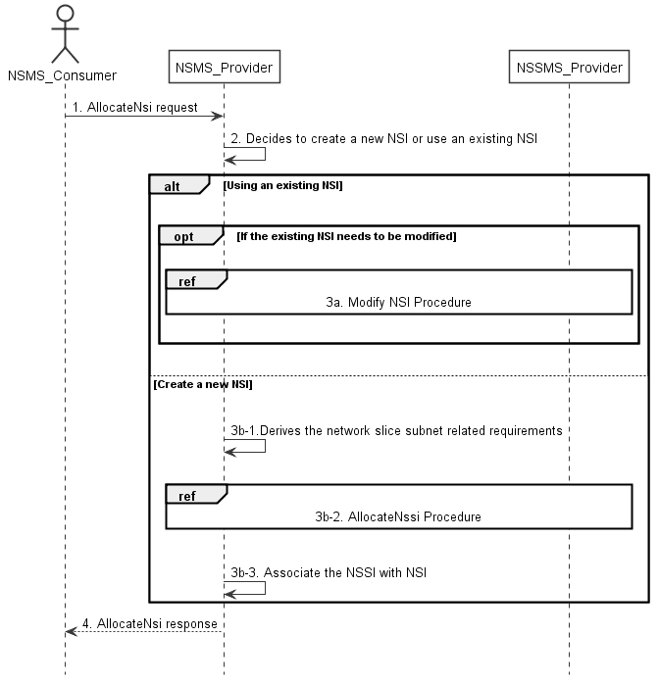

Figure 7.2-1: Network Slice Instance Allocation Request procedure

1) Network Slice Management Service Provider (NSMS_Provider) receives an AllocateNsi request (see AllocateNsi operation defined in clause 6.5.1) from Network Slice Management Service Consumer (NSMS_Consumer) with network slice related requirements (the network slice related requirements are defined as the attributes in the ServiceProfile see clause 6.3.3 in TS 28.541 [6]).

2) Based on the network slice related requiremen and the knowledge of the capabilities of existing deployed network slices, the NSMS_Provider compare/match the provided requirements against all the candidate NetworkSlice instances, and then decides whether to use an existing NSI or create a new NSI. If the network slice related requirements allow the requested NSI to be shared and if an existing suitable NSI can be reused, the NSMS_Provider may decide to use the existing NSI.

3a) If using an existing NSI and the existing NSI needs to be modified to satisfy the network slice related requirements, the NSMS_Provider invokes the procedure to modify the existing NSI as described in clause 7.6.

3b-1) If creating a new NSI, the NSMS_Provider derives the network slice subnet related requirements from the received network slice related requirements. Before NSMS_Provider derives the network slice subnet related requirements, NSMS_Provider may invoke corresponding network slice subnet capability information querying procedure as described in clause 7.8.

3b-2) The NSMS_Provider invokes the NSSI allocation procedure as described in clause 7.3.

3b-3) The NSMS_Provider creates the MOI for NSI and configures the MOI with the DN of MOI for the NSSI, other configuration information may be configured for the created MOI.

Note: The detailed configuration information is described in network slice NRM (see NetworkSlice IOC defined in clause 6.3.1 in TS 28.541 [6]).

4) The NSMS_Provider sends NSI allocation result (see AllocateNsi operation defined in clause 6.5.1) to the NSMS_Consumer. If an existing NSI is modified or a new NSI is created successfully to satisfy the network slice related requirements, the result includes the relevant network slice instance information (see NetworkSlice IOC defined in clause 6.3.1 in TS 28.541 [6]):

- DN of the MOI for NSI.

Otherwise the result may include the reason of failure, for example, the required latency or user number cannot be satisfied, or the physical resource is not enough.

## 7.3 Procedure of Network Slice Subnet Instance Allocation

The Figure 7.3-1 illustrates the procedure of creating a new network slice subnet instance or using an existing network slice subnet instance to satisfy the required network slice subnet related requirements.

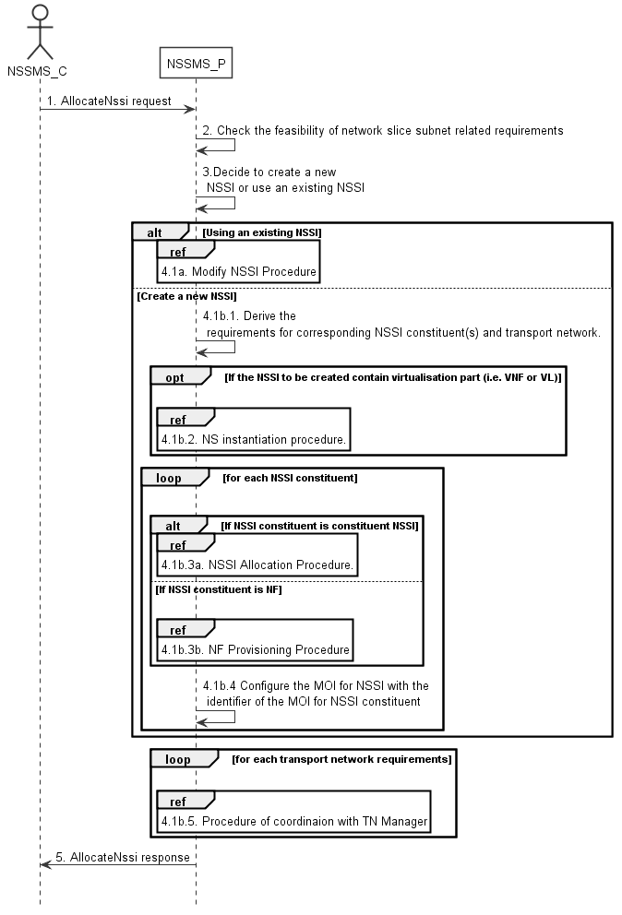

Figure 7.3-1: Network Slice Subnet Instance Allocation Request procedure

1) Network Slice Subnet Management Service Provider (NSSMS_P) receives an AllocateNssi request (see AllocateNssi operation defined in clause 6.5.2) from Network Slice Subnet Management Service Consumer (NSSMS_C) with network slice subnet related requirements (network slice subnet related requirements defined in SliceProfile see clause 6.3.4 in TS 28.541 [6]).

2) NSSMS_P check the feasibility of network slice subnet related requirements. If the network slice subnet related requirements can be satisfied, the following step 3) are needed, else go to step 5).

3) Based on the network slice subnet related requirements and the existing NSSI capabilities, NSSMS_P decides whether to use an existing NSSI or create a new NSSI. If the network slice subnet related requirements allow the requested NSSI to be shared and if an existing suitable NSSI can be reused, the NSSMS_P decides to use the existing NSSI.

4.1a) If using an existing NSSI and the existing NSSI needs to be modified to satisfy the network slice subnet related requirements, the NSSMS_P invokes the procedure to modify the existing NSSI as described in clause 7.7.

4.1b.1) If creating a new NSSI, the NSSMS_P creates the MOI for the NSSI to be created. NSSMS_P derives the corresponding network slice subnet constituent (i.e. NF, constituent NSS) related requirements and transport network related requirements (e.g. 3GPP endpoint information, latency requirements, bandwidth requirements, isolation requirements) from the received network slice subnet related requirements. Before NSSMS_Provider derives the constituent network slice subnet related requirements, NSMS_Provider may invoke corresponding network slice subnet capability information querying procedure as described in clause 7.8.2.

4.1b.2) If the NSSI to be created contains virtualisation part (i.e. VNF or VL), NSSMS_P derives the NS instance instantiation information (the NS instance instantiation information is described in clause 7.3.2.2 and clause 7.3.3.2 [3]) based on network slice subnet related requirements. NSSMS_P determines VNF instance(s) that need to be deployed according to the necessary network function(s) and then derives the profile of virtual link(s) according to the connection requirements between the network functions. NSSMS_P chooses a proper NSD deployment flavour and creates data concerning the SAPs of the NS instance. NSSMS_P invokes the NS instantiation procedures to create a NS instance. NSSMS_P configures the NSS MOI with the NS instance identifier.

Note: NS instantiation procedure is described in TS 28.526 [7].

4.1b.3) For each required NSSI constituent, the following step 4.1b.3a) and 4.1b.3b) are needed:

4.1b.3a) If the required NSSI constituent is constituent NSSI, NSSMS_P invokes NSSI Allocation Procedure.

4.1b.3b) If the required NSSI constituent is NF instance, NSSMS_P invokes NF Creation Procedure as described in clause 7.10 or NF Modification Procedure as described in clause 7.11.

4.1b.4) NSSMS_P configures the MOI for NSSI with the DN of the MOI for NSSI constituent (i.e. NF, constituent NSSI).

4.1b.5) For each required transport network related requirements, NSSMS_P invokes corresponding procedure of coordination with relevant TN Manager to handle the TN part as described in clause 7.9.

5) The NSSMS_P sends the NSSI allocation result (see AllocateNssi operation defined in clause 6.5.2) to the NSSMS_C. If the NSSI is created successfully, the result includes the relevant constituent network slice subnet instance information (see NetworkSliceSubnet IOC defined in clause 6.3.2 in TS 28.541 [6]):

- DN of the MOI for NSSI.

- NS instance Info (e.g. NSinstanceId)

Otherwise the result may include the reason of failure, for example, the required latency or user Number cannot be satisfied, or the physical resource is not enough.

## 7.4 Procedure of Network Slice Instance Deallocation

Figure 7.4-1 depicts the procedure of deallocating a network slice instance by the network slice management service provider to satisfy the NSI deallocation request received from an authorized consumer.

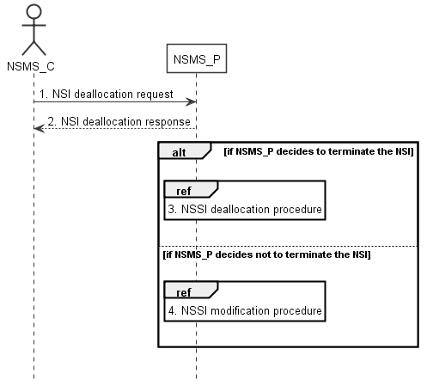

Figure 7.4-1: Network slice instance deallocation procedure

1) The network slice management service provider (NSMS_P) receives a NSI deallocation request (see DeallocateNsi operation defined in clause 6.5.3) from network slice management service consumer (NSMS_C) indicating that the NSI is no longer needed for the consumer.

2) The NSMS_P sends the NSI deallocation response (see DeallocateNsi operation defined in clause 6.5.3) to NSMS_C.

3) The NSMS_P may decide to terminate the NSI, then it invokes the NSSI deallocation procedure as described in clause 7.5.

4) The NSMS_P may decide not to terminate the NSI but to modify the NSI, then it invokes the NSI modification procedure as described in clause 7.6.

## 7.5 Procedure of network slice subnet instance deallocation

Figure 7.5-1 depicts the procedure of deallocating a network slice subnet instance by the network slice subnet management service provider to satisfy the NSSI deallocation request received from an authorized consumer.

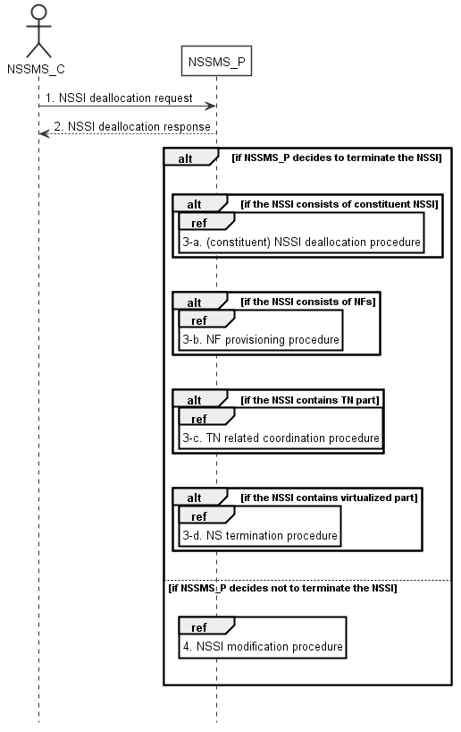

Figure 7.5-1: Network slice subnet instance deallocation procedure

1) The network slice subnet management service provider (NSSMS_P) receives NSSI deallocation request (see DeallocateNssi operation defined in clause 6.5.4) from network slice subnet management service consumer (NSSMS_C).

2) NSSMS_P sends response (see DeallocateNssi operation defined in clause 6.5.4) of NSSI deallocation service to NSSMS_C.

3-a) NSSMS_P may decide to terminate the NSSI, it invokes (constituent) NSSI deallocation procedure as described in clause 7.5 if the NSSI consists of constituent NSSI.

3-b) NSSMS_P invokes NF deletion procedure as described in clause 7.12 only if the NF is dedicated for this NSSI and not being used by any other NSSI in the network, otherwise, the NSSMS_P invokes NF modification procedure as described in clause 7.11.

3-c) NSSMS_P invokes TN related coordination procedure with responsible manager as described in clause 7.9 if the NSSI consists of TN part.

3-d) NSSMS_P invokes NS termination procedure if the NSSI contains virtualized part.

Note: NS termination procedure is described in TS 28.526 [7].

4) NSSMS_P may decide not to terminate the NSSI, it invokes NSSI modification procedure as described in clause 7.7.

## 7.6 Procedure of Network Slice Instance Modification

The Figure 7.6-1 illustrates the procedure of modifying an existing NSI.

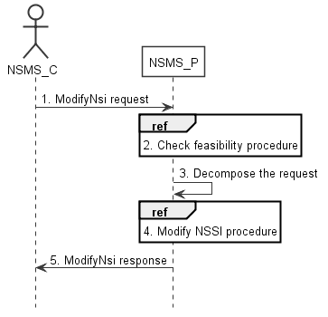

Figure 7.6-1: Network Slice Instance Modification Request procedure

1) Network Slice Management Service Provider (NSMS_P) receives a ModifyNsi request (see modifyMOIAttributes operation defined in TS 28.532 [8]) from Network Slice Management Service Consumer (NSMS_C) with the management identifier of NSI and the new network slice related requirements (see ServiceProfile defined in clause 6.3.3 in TS 28.541[6]).

2) Based on the new network slice related requirements, NSMS_P invokes the feasibility check procedure. If the modification requirements can be satisfied, go to step 3), else go to step 5).

3) NSMS_P decomposes the NSI modification request into NSSI modification request(s), i.e., generating the new network slice subnet related requirements for each NSSI if needed.

4) NSMS_P, as the role of Network Slice Subnet Management Service Consumer (NSSMS_C), invokes the NSSI modification procedure.

5) NSMS_P sends NSI modification result (see modifyMOIAttributes operation defined in TS 28.532 [8]) to NSMS_C.

## 7.7 Procedure of Network Slice Subnet Instance Modification

The Figure 7.7-1 illustrates the procedure of modifying an existing NSSI.

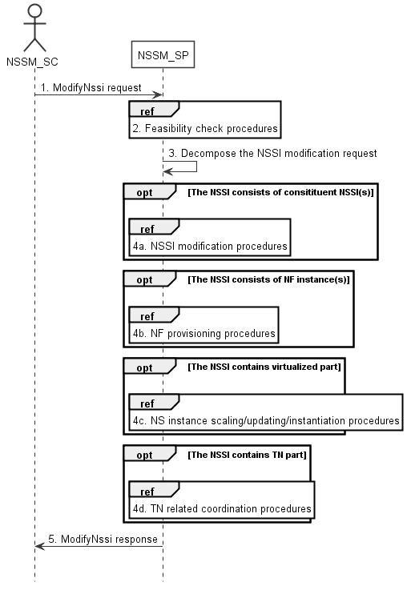

Figure 7.7-1: Network Slice Subnet Instance Modification Request procedure

1) Network Slice Subnet Management Service Provider (NSSM_SP) receives a ModifyNssi request (see modifyMOIAttributes operation defined in TS 28.532 [8]) from Network Slice Subnet Management Service Consumer (NSSM_SC) with the management identifier of NSSI and the new network slice subnet related requirements (see SliceProfile defined in clause 6.3.3 in TS 28.541[6]).

2) Based on the new network slice subnet related requirements, NSSM_SP invokes the feasibility check procedure. If the modification requirements can be satisfied, go to step 3), else go to step 5).

3) NSSM_SP decomposes the NSSI modification request into modification requests for each NSSI constituent.

4a) If the requested NSSI constituent is constituent NSSI, NSSM_SP invokes NSSI modification procedure as described in clause 7.7.

4b) If the requested NSSI constituent is NF instance, NSSM_SP invokes NF creation procedure as described in clause 7.10 or NF modification procedure as described in clause 7.11.

4c) If the NSSI contains the virtualized part, NSSM_SP invokes the NS instance scaling and/or NS instance updating and/or NS instance instantiation procedure as described in TS 28.526 [7].

4d) If the NSSI contains the TN part, NSSM_SP invokes the TN related coordination procedure as described in clause 7.9.

5) NSSM_SP sends NSSI modification results (see modifyMOIAttributes operation defined in TS 28.532 [8]) to NSSM_SC.

## 7.8 Procedure of Obtaining Network Slice Subnet Capability

### 7.8.1 Introduction

The clause illustrates possible procedures of obtaining network slice subnet capability information (e.g. supported maximum latency, supported capacity (e.g. maximum user number)) of network slice subnet instance(s) which can be provided by network slice subnet management service provider.

### 7.8.2 Querying Network Slice Subnet Capability Information

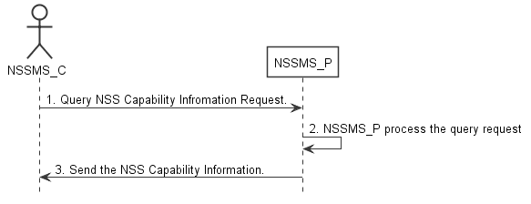

Figure 7.8-2: Procedure of querying network slice subnet capability information

1) Network Slice Subnet Management Service Consumer (NSSMS_C) wants to query the NSS capability information of the NSSI(s) which can be provided by corresponding Network Slice Subnet Management Service Consumer (NSSMS_P), NSSMS_C sends NSS capability querying request (see getMOIAttributes operation defined in TS 28.532 [8]) to NSSMS_P to obtain the NSS capability information of the NSSI(s) which can be provided by corresponding NSSMS_P.

2) NSSMS_P processes the NSS capability information querying request.

3) NSSMS_P sends the NSS capability information (e.g. supported maximum latency, supported capacity (e.g. user number)) of NSSI(s) that can be provided by itself (see getMOIAttributes operation defined in TS 28.532 [8]) to NSSMS_C.

### 7.8.3 Void

## 7.9 Procedure of TN coordination supporting network slicing

## 7.9.1 Introduction

This clause describes procedures of coordination with TN Manager to handle TN part supporting network slicing.

NOTE: The present document: addresses interactions with NFVO as TN manager,. interactions with other types of TN Manager (e.g. Optical, IP bearer transport network, etc.) have not been addressed.

## 7.9.2 Interaction with NFVO as TN Manager

This clause considers the procedure of interaction between the 3GPP management system and the NFVO, which behaves as TN Manager, to satisfy the TN related requirements for the virtual links used in NSSI. The procedure is applicable to creation and modification of the NSSI.

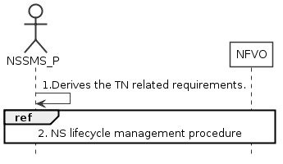

Figure 7.9.2-1: Interaction with NFVO as TN manager to support network slicing

1) Network Slice Subnet Management Service Provider (NSSMS_P) derives the TN related requirements (e.g. 3GPP endpoint information, latency requirements, bandwidth requirements, isolation requirements) for the TN part to be used in the NSSI.

2) To satisfy the TN related requirements NSSMS_P invokes the corresponding NS instance lifecycle management procedures as described in TS 28.526 [7].

3) After the NFVO executes the requested operation, it sends the corresponding notification to the NSSMS_P as described in TS 28.526 [7].

## 7.10 Procedure of NF instance creation

The Figure 7.10-1 illustrates the procedure of creating a new network function instance to satisfy the required network function related requirements.

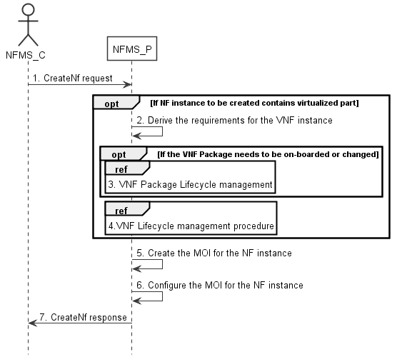

Figure 7.10-1: Network Function Instance Creation procedure

1) Network Function Management Service Provider (NFMS_P) receives a CreateNf request (see createMOI operation defined in TS 28.532 [8]) from Network Function Management Service Consumer (NFMS_C) with network function related requirements.

Note: The network function related requirements see information model definition for NR NRM in clause 4 and information model definition for 5GC NRM in clause 5 in TS 28.541[6] .

2) If NF instance to be created contains virtualized part, NFMS_P derives the requirements for VNF instance based on the network function related requirements.

3) If corresponding VNF Package needs to be on-boarded or changed, the NFMS_P invoke corresponding VNF Package management procedure as described in clause 4.3 in TS 28.526 [7].

4) The NFMS_P invokes VNF lifecycle management with requirements for VNF instance as described in clause 4.2.2 in TS 28.526 [7].

5) The NFMS_P creates the MOI for the NF instance to be created. If the NF instance contains virtualized part, the NFMS_P may send the request of creating the MOI to the NFMS_P in the NF.

6) The NFMS_P configures the new created MOI with corresponding configuration information (see information model definition for NR NRM in clause 4 and information model definition for 5GC NRM in clause 5 in TS 28.541[6]).

7) The NFMS_P sends the CreateNf response (see createMOI operation defined in TS 28.532 [8]) to NFMS_C with identifier of MOI and with identifier of NFMS_P which actually maintains the MOI for NF instance.

## 7.11 Procedure of NF instance modification

The Figure 7.11-1 illustrates the procedure of modify NF instance.

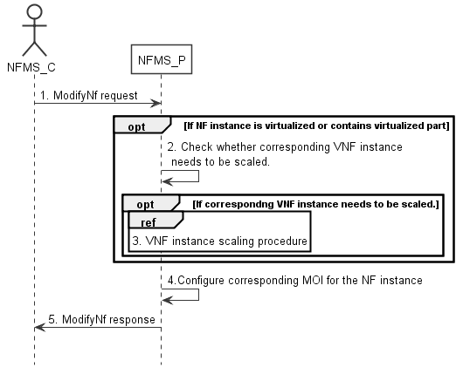

Figure 7.11-1: Network Function Instance Modify procedure

1) Network Function Management Service Provider (NFMS_P) receives a ModifyNf request (see modifyMOIAttributes operation defined in TS 28.532 [8])from Network Function Management Service Consumer (NFMS_C) with Identifier of MOI for NF instance and network function related requirements.

Note: The network funcation related requirements see information model definition for NR NRM in clause 4 and information model definition for 5GC NRM in clause 5 in TS 28.541[6].

2) If NF instance contains virtualized part, NFMS_P checks whether corresponding VNF instance needs to be scaled to satisfy the network function related requirements.

3) If corresponding VNF instance needs to be scaled, NFMS_P invokes corresponding VNF instance scaling procedure as described in clause 4.2.3 in TS 28.526 [7].

4) NFMS_P reconfigures corresponding MOI for the NF instance.

5) The NFMS_P sends the ModifyNf response (see modifyMOIAttributes operation defined in TS 28.532 [8]) to NFMS_C.

## 7.12 Procedure of NF instance deletion

The Figure 7.12-1 illustrates the procedure of deleting NF instance.

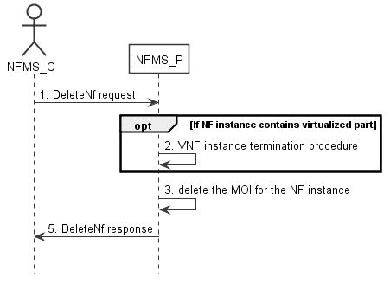

Figure 7.12-1: Network Function Instance Deletion procedure

1) Network Function Management Service Provider (NFMS_P) receives DeleteNf request (see deletetMOI operation defined in TS 28.532 [8]) from Network Function Management Service Consumer (NFMS_C) with Identifier of MOI for NF instance.

2) If the NF instance contains virtualized part, NFMS_P invokes VNF instance termination procedure as described in clause 4.2.4 in TS 28.526 [7].

3) NFMS_P deletes the MOI for the NF instance.

4) NFMS_P sends the DeleteNf response (see deleteMOI operation defined in TS 28.532 [8]) to NFMS_C.

## 7.13 Procedure of reservation and checking feasibility of NSI

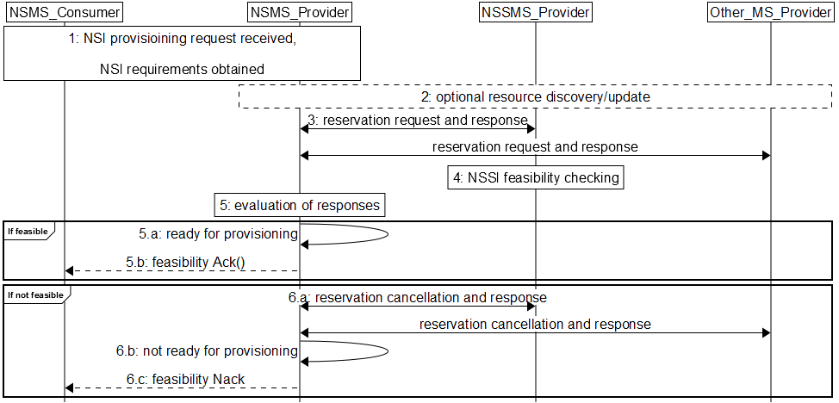

Figure 7.13-1 Network slice feasibility check procedure

1) Network Slice Management Service Provider (NSMS_Provider) receives a provisioning NSI request (e.g., AllocateNsi request (see AllocateNsi operation defined in clause 6.5.1), ModifyNsi request (see modifyMOIAttributes operation defined in TS 28.532 [8])) from Network Slice Management Service Consumer (NSMS_Consumer) with network slice related requirements (e.g. Area information, User Number, traffic demand, QoS Quality, whether the requested network slice instance could be shared).

2) [Optional] NSMS_Provider may request information and updates from NSSMS_Provider and Other_MS_Provider regarding the resources.

3) NSMS_Provider sends reservation requests to Network Slice Subnet Management Service Provider (NSSMS_Provider) and (if needed) Other Management Service Providers (Other_MS_Provider), e.g., MANO, TN manager. NSMS_Provider receives responses with information regarding allocated resources, e.g., their availability, identification information of reserved resources and so on.

4) A reservation request to NSSMS_Provider can trigger NSSI feasibility checking.

5) NSMS_Provider evaluates the responses to determine if the network slice requirements can be satisfied.

6) If feasible,

6.a) NSMS_Provider is ready for provisioning.

6.b) [Optional] Acknowledgement regarding reservation check results can be sent to NSMS_Customer.

7) If not feasible,

7.a) NSMS_Provider cancels reservations, optionally may receive acknowledgement.

7.b) NSMS_Provider is not ready for provisioning.

7.c) NSMS_Provider may send negative acknowledgement regarding results of reservation check to NSMS_Customer.

## 7.14 Procedure of reservation and checking feasibility of network slice subnet

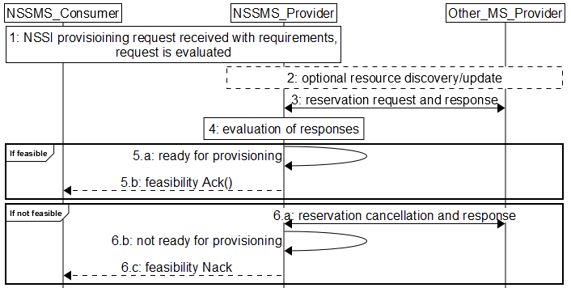

Figure 7.14-2 Network slice subnet feasibility check procedure

1) Network Slice Subnet Management Service Provider (NSSMS_Provider) receives a provisioning NSSI request (e.g., AllocateNssi request (see AllocateNssi operation defined in clause 6.5.2), ModifyNssi request (see modifyMOIAttributes operation defined in TS 28.532 [8])) from Network Slice Subnet Management Service Consumer (NSSMS_Consumer) with network slice subnet related requirements (e.g. Area information, User Number, traffic demand, QoS Quality, whether the requested network slice instance could be shared). The request is evaluated and initial resources to be allocated are identified.

2) [Optional] NSSMS_Provider may request information and updates from NSSMS_Provider and Other_MS_Provider regarding the resources.

3) NSSMS_Provider sends reservation requests to Other Management Service Providers (Other_MS_Provider), e.g., MANO, TN manager. NSSMS_Provider receives responses with information regarding reserved resources, e.g., their availability, identification information of reserved resources and so on.

4) NSSMS_Provider evaluates the responses to determine if the network slice subnet requirements can be satisfied.

5) If feasible:

5.a) NSSMS_Provider is ready for provisioning.

5.b) [Optional] Acknowledgement regarding reservation check results can be sent to NSSMS_Customer.

6) If not feasible,

6.a) NSSMS_Provider cancels reservations, optionally may receive acknowledgement.

6.b) NSSMS_Provider is not ready for provisioning.

6.c) NSSMS_Provider may send negative acknowledgement regarding results of reservation check to NSSMS_Customer.

## 7.15 Void

## 7.16 Procedure of allocating network with or without slicing for communication services

The Figure 7.16-1 illustrates the procedure of allocating network with or without slicing for communication services.

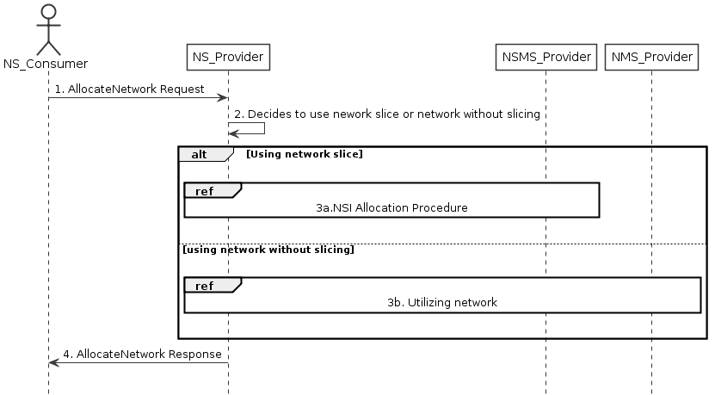

Figure 7.16-1 Allocating network with or without slicing for communication services

1) Network Service Provider (NS_Provider) receives AllocateNetwork request (see AllocateNetwork operation defined in clause 6.5.5) from Network Service Consumer (NS_Consumer). The received request includes network related service requirements (e.g. isolation, latency, coverage).

2) NS_Provider decides to use the network with or without slicing depending on these network related service requirements based on some internal admission control.

3) Based on the decision by NS_Provider:

3a) If NS_Provider decides to use a network with slicing, network slice instance allocation procedures in clause 7.2 follows. These procedures may result a new network slice to be created, or use an existing network slice with modification.

3b) If NS_Provider decides to use network without slicing, the network without slicing is utilized to satisfy the network related service requirements, there may be modification of the existing network or creation of a new network.

4) NS_Provider sends the AllocateNetwork response (see AllocateNetwork operation defined in clause 6.5.5) to NS_Consumer.

# 8 RESTful HTTP-based solution set of provisioning

## 8.1 Mapping of operations

### 8.1.1 Introduction

Table 8.1.1-1: Mapping of IS operations to SS equivalents

|  |  |  |  |
| --- | --- | --- | --- |
| **IS operation** | **HTTP Method** | **Resource URI** | **Qualifier** |
| allocateNsi | POST | ObjectManagement/NS/ServiceProfiles | M |
| allocateNssi | POST | ObjectManagement/NSS/SliceProfiles | M |
| deallocateNsi | DELETE | ObjectManagement/NS/ServiceProfiles/{ServiceProfileId} | M |
| deallocateNssi | DELETE | ObjectManagement/NSS/SliceProfiles/{SliceProfileId} | M |
| allocateNetwork | POST | ObjectManagement/ServiceProfiles | M |

### 8.1.2 Operation AllocateNsi

This operation is to allocate a network slice instance provided by the service provider, the network slice instance may be new or existing.

Table 8.1.2-1: Mapping of IS operation input parameters to SS equivalents (HTTP POST)

|  |  |  |  |  |
| --- | --- | --- | --- | --- |
| **IS operation parameter name** | **SS parameter location** | **SS parameter name** | **SS parameter type** | **Qualifier** |
| attributeListIn | request body | attributeListIn | LIST OF SEQUENCE< attribute name, attribute value > | M |

Table 8.1.2-2: Mapping of IS operation output parameters to SS equivalents (HTTP POST)

|  |  |  |  |  |
| --- | --- | --- | --- | --- |
| **IS operation parameter name** | **SS parameter location** | **SS parameter name** | **SS parameter type** | **Qualifier** |
| attributeListOut | response body | attributeListOut | LIST OF SEQUENCE< attribute name, attribute value > | M |
| status | response status codes | n/a | n/a | M |
| nSIId | response body | href | type:string, format: uri | M |

### 8.1.3 Operation AllocateNssi

This operation is to allocate a network slice subnet instance provided by the service provider, the network slice subnet instance may be new or existing.

Table 8.1.3-1: Mapping of IS operation input parameters to SS equivalents (HTTP POST)

|  |  |  |  |  |
| --- | --- | --- | --- | --- |
| **IS operation parameter name** | **SS parameter location** | **SS parameter name** | **SS parameter type** | **Qualifier** |
| attributeListIn | request body | attributeListIn | LIST OF SEQUENCE< attribute name, attribute value > | O |

Table 8.1.3-2: Mapping of IS operation output parameters to SS equivalents (HTTP POST)

|  |  |  |  |  |
| --- | --- | --- | --- | --- |
| **IS operation parameter name** | **SS parameter location** | **SS parameter name** | **SS parameter type** | **Qualifier** |
| attributeListOut | response body | attributeListOut | LIST OF SEQUENCE< attribute name, attribute value > | M |
| status | response status codes | n/a | n/a | M |
| nSSIId | response body | href | type:string, format: uri | M |

### 8.1.4 Operation DeallocateNsi

This operation is to deallocate a network slice instance provided by the service provider, the network slice instance may be terminated or modified.

This operation does not support any input parameters.

Table 8.1.4-1: Mapping of IS operation output parameters to SS equivalents (HTTP DELETE)

|  |  |  |  |  |
| --- | --- | --- | --- | --- |
| **IS operation parameter name** | **SS parameter location** | **SS parameter name** | **SS parameter type** | **Qualifier** |
| status | response status codes | n/a | n/a | M |

### 8.1.5 Operation DeallocateNssi

This operation is to deallocate a network slice subnet instance provided by the service provider, the network slice subnet instance may be terminated or modified.

This operation does not support any input parameters.

Table 8.1.5-1: Mapping of IS operation output parameters to SS equivalents (HTTP DELETE)

|  |  |  |  |  |
| --- | --- | --- | --- | --- |
| **IS operation parameter name** | **SS parameter location** | **SS parameter name** | **SS parameter type** | **Qualifier** |
| status | response status codes | n/a | n/a | M |

### 8.1.6 Operation AllocateNetwork

This operation is to allocate a network provided by the service provider.

Table 8.1.6-1: Mapping of IS operation input parameters to SS equivalents (HTTP POST)

|  |  |  |  |  |
| --- | --- | --- | --- | --- |
| **IS operation parameter name** | **SS parameter location** | **SS parameter name** | **SS parameter type** | **Qualifier** |
| attributeListIn | request body | attributeListIn | LIST OF SEQUENCE< attribute name, attribute value > | M |

Table 8.1.6-2: Mapping of IS operation output parameters to SS equivalents (HTTP POST)

|  |  |  |  |  |
| --- | --- | --- | --- | --- |
| **IS operation parameter name** | **SS parameter location** | **SS parameter name** | **SS parameter type** | **Qualifier** |
| serviceProfileId | response body | serviceProfileId | String | M |
| status | response status codes | n/a | n/a | M |

## 8.2 Resources

### 8.2.1 Resource definitions

#### 8.2.1.1 Resource ObjectManagement/NS/ServiceProfiles

##### 8.2.1.1.1 Description

This resource represents collects of network slice related requirement (i.e. ServiceProfiles).

##### 8.2.1.1.2 URI

Resource URI: {URI authority}/ObjectManagement/NS/ServiceProfiles

The URI authority is defined by the service provider.

##### 8.2.1.1.3 HTTP methods

8.2.1.1.3.1 POST

The POST method create a serviceProfile, the provider may create a NSI or using existing NSI to satisfy the serviceProfile.

This method shall support the request data structures, and the response data structures and response codes specified in the following tables.

Table 8.2.1.1.3.1-1: Data structures supported by the POST Request Body on this resource

|  |  |  |  |  |
| --- | --- | --- | --- | --- |
| **Name** | **DATA TYPE** | **P** | **Cardinality** | **Description** |
| attributeListIn | LIST OF SEQUENCE< attribute name, attribute value> | M | 1 | This parameter specifies the network slice related requirements or network related requirements defined in ServiceProfile in Clause 6.3.3 in TS 28.541 [6]. |

Table Y.2.1.1.3.1-2: Data structures supported by the POST Request Body on this resource

|  |  |  |  |  |
| --- | --- | --- | --- | --- |
| **Name** | **DATA TYPE** | **P** | **Cardinality** | **Description** |
| Href | URI | M | 1 | HTTP reference to an NSI or Network resource. |
| attributeListOut | LIST OF SEQUENCE< attribute name, attribute value> | M | 1 | For each returned NSI: A list of name/value pairs for NSI defined in Network Slice IOC. |
| status | HTTP response code | M | 1 | HTTP response code 200 indicates “OperationSucceeded”.  All other HTTP response codes indicate “OperationFailed”. |

#### 8.2.1.2 Resource ObjectManagement/NSS/SliceProfiles

##### 8.2.1.2.1 Description

This resource represents collects of network slice subnet related requirements (i.e. SliceeProfiles).

##### 8.2.1.2.2 URI

Resource URI: {URI authority}/ObjectManagement/NSS/SliceProfiles

The URI authority is defined by the service provider.

##### 8.2.1.2.3 HTTP methods

8.2.1.2.3.1 POST

The POST method create a SliceProfile, the provider may create a new NSSI or using existing NSSI to support the SliceProfile.

This method shall support the request data structures, and the response data structures and response codes specified in the following tables.

Table 8.2.1.2.3.1-1: Data structures supported by the POST Request Body on this resource

|  |  |  |  |  |
| --- | --- | --- | --- | --- |
| **Name** | **DATA TYPE** | **P** | **Cardinality** | **Description** |
| attributeListIn | LIST OF SEQUENCE< attribute name, attribute value> | M | 1 | This parameter specifies the network slice subnet related requirements defined in SliceeProfile in Clause 6.3.4 in TS 28.541 [6]. |

Table 8.2.1.2.3.1-2: Data structures supported by the POST Request Body on this resource

|  |  |  |  |  |
| --- | --- | --- | --- | --- |
| **Name** | **DATA TYPE** | **P** | **Cardinality** | **Description** |
| Href | URI | M | 1 | HTTP reference to an NSSI resource. |
| attributeListOut | LIST OF SEQUENCE< attribute name, attribute value> | M | 1 | For each returned NSSI: A list of name/value pairs for NSSI defined in Network Slice Subnet IOC. |
| status | HTTP response code | M | 1 | HTTP response code 200 indicates “OperationSucceeded”.  All other HTTP response codes indicate “OperationFailed”. |

#### 8.2.1.3 Resource ObjectManagement/ServiceProfiles

##### 8.2.1.3.1 Description

This resource represents collects of network related requirements (i.e. ServiceProfiles).

##### 8.2.1.3.2 URI

Resource URI: {URI authority}/ObjectManagement/ServiceProfiles

The URI authority is defined by the service provider.

##### 8.2.1.3.3 HTTP methods

8.2.1.3.3.1 POST

The POST method create a serviceProfile.

This method shall support the request data structures, and the response data structures and response codes specified in the following tables.

Table 8.2.1.3.3.1-1: Data structures supported by the POST Request Body on this resource

|  |  |  |  |  |
| --- | --- | --- | --- | --- |
| **Name** | **DATA TYPE** | **P** | **Cardinality** | **Description** |
| attributeListIn | LIST OF SEQUENCE< attribute name, attribute value> | M | 1 | This parameter specifies the network related requirements defined in ServiceProfile in Clause 6.3.3 in TS 28.541 [6]. |

Table 8.2.1.3.3.1-2: Data structures supported by the POST Request Body on this resource

|  |  |  |  |  |
| --- | --- | --- | --- | --- |
| **Name** | **DATA TYPE** | **P** | **Cardinality** | **Description** |
| status | HTTP response code | M | 1 | HTTP response code 200 indicates “OperationSucceeded”.  All other HTTP response codes indicate “OperationFailed”. |

Annex A (informative):  
A network slice journey example

The Generic Slice Template (GST) ([9]) provides a standardized list of attributes that can be used to characterise different types of network slice. GST is generic and is not tied to any:

- Type of network slice

- Agreement between a Network Slice Customer (NSC) and a Network Slice Provider (NSP).

A Network Slice Type (NEST) is a GST filled with (ranges of) values. There may be two kinds of NESTs:

- Standardized NESTs (S-NEST), i.e. NESTs which character attributes are assigned (ranges of) values by SDOs, working groups, foras, etc. such as e.g. 3GPP, GSMA, 5GAA, 5G-ACIA, etc.;

- Private NESTs (P-NEST), i.e. NESTs which character attributes are assigned (ranges of) values by the Network Slice Providers, which are different from those assigned in S-NESTs.

Network Slice Providers can build their network slice product offering based on S-NESTs and/or their P-NESTs. For example, a Standardized Network Slice Type (S-NEST) NST-A, for which the attribute ‘Packet delay budget’ (see [x] – clause 3.4.26) value range is between 1 ms and 100 ms, is specified by 3GPP. Netwok Slice Provider Y may offer e.g. 3 products based on NST-A:

- Platinum NST-A based network slice product, where the attribute ‘Packet delay budget’ (see [x] – clause 3.4.26) value range is between 1 ms and 10 ms;

- Gold NST-A based network slice product, where the attribute ‘Packet delay budget’ (see [x] – clause 3.4.26) value range is between 11 ms and 50 ms;

- Silver NST-A based network slice product, where the attribute ‘Packet delay budget’ (see [x] – clause 3.4.26) value range is between 51 ms and 100 ms.

NSP Y’s customers can then order network slice instances from Y’s product catalog, as depicted by Figure A.1.

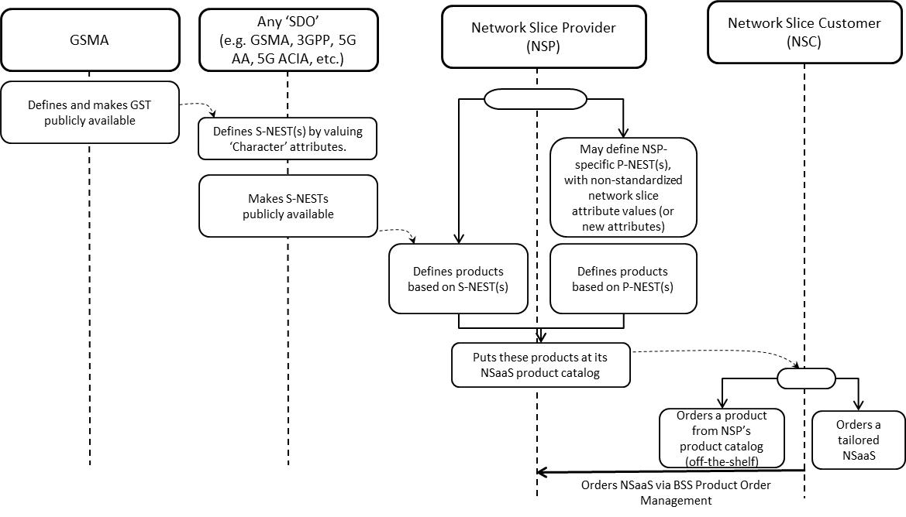

Figure A.1: From GST to S-(/P-)NEST based product ordering

1) A Network Slice Customer orders network slice instance to a Network Slice Provider, based on NSP’s product offering, by sending a request to NSP’ BSS

2) NSP’s BSS receives the request from NSC and translates NSC requirements into NSP technical parameter values

3) NSP’s BSS sends a request to NSP’s OSS to provide a network slice instance which fits NSC’s requirements (see Table 6.1-1)

4) NSP’s Network Slice Provisioning MnS either creates a new network slice instance or assigns an already existing network slice instance to NSC’s request

5) NSP’s Network Slice Provisioning MnS may have to request the Network Slice Subnet Provisioning MnS to provide a network slice subnet instance corresponding to the network slice instance (see Table 6.2-1)

6) NSP’s Network Slice Subnet Provisioning MnS may have to create one or more inner network slice subnet instances

7) NSP’s Network Function Provisioning MnS configures VNFs and/or PNFs (see Table 6.3-1).

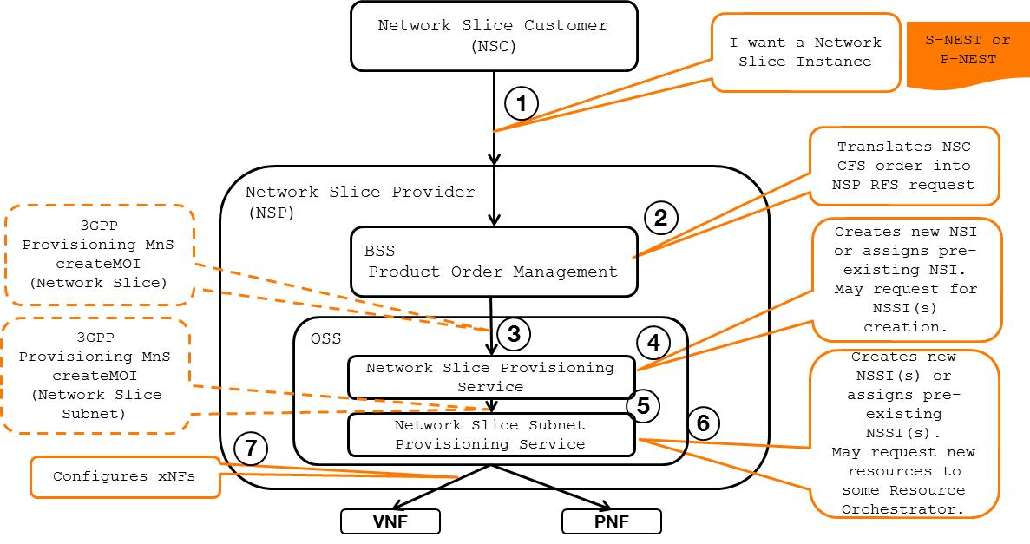

Figure A.2: Network Slice journey (NSaaS model) – high-level call flow

Depending on NSP’s product offering, NSC can order network slice instances spanning one or more network domains, e.g.:

- network slice instances composed of a RAN-only network slice subnet instance

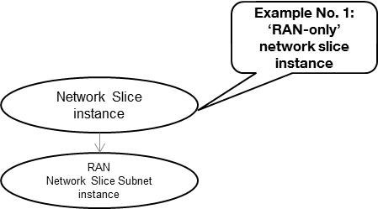

Figure A.3: RAN-only network slice subnet exposed as network slice

- network slice instances composed of a CN-only network slice subnet instance

- network slice instances composed of a RAN network slice subnet instance + Transport network slice subnet + CN network slice subnet instance

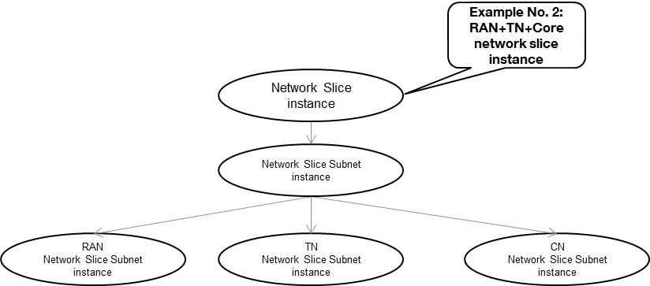

Figure A.4: RAN+TN+CN network slice subnets exposed as network slice

- network slice instances composed of a RAN network slice subnet instance + CN network slice subnet instance + IMS network slice subnet instance

- or more, as shown below..

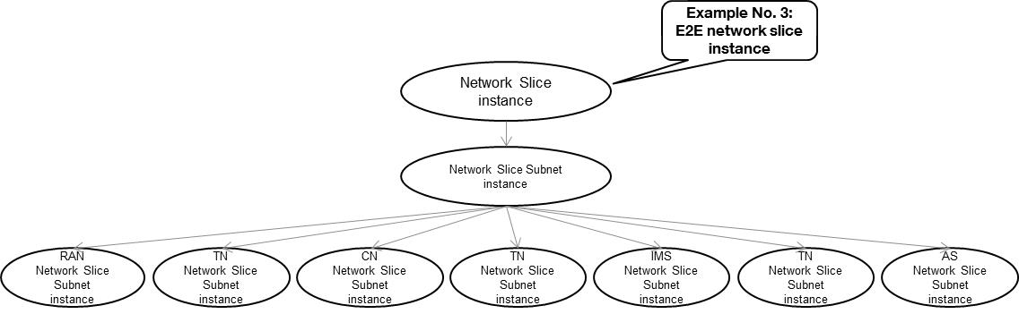

Figure A.5: RAN+TN+CN+TN+IMS+TN+AS network slice subnets exposed as network slice

Annex B (informative):  
General information for network slice related identifiers

The following network slice related identifiers serve different purposes:

|  |  |
| --- | --- |
| Identifier | Description |
| Identifiers for network slice management purpose | |
| NetworkSlice identifier | To identify a NetworkSlice instance defined in TS 28.530 (see [4]), it is DN of a managed object instance of NetworkSlice IOC, see TS 28.541 [6] |
| NetworkSliceSubnet identifier | To identify a NetworkSliceSubnet instance defined in TS 28.530 (see [4]), it is DN of a managed object instance of NetworkSliceSubnet IOC, see TS 28.541 [6] |
| **Identifiers for network slice signaling purpose** | |
| NSI ID | NSI ID is only for 5GC signaling use, i.e. to identify Core Network part of a Network Slice instance when multiple Network Slice instances of the same Network Slice are deployed, and there is a need to differentiate between them in the 5GC, see clause 3.1 of TS 23.501 [10]. The NRM attribute cNSIIdList of NRFFunction and NSSFFunction, see TS 28.541 [6], is a list for NSI ID(s). |
| S-NSSAI | To identify Network Slice defined in TS 23.501. Referred to TS 23.501 [10] and TS 38.300 [11]. NRM attribute sNSSAIList defines the S-NSSAI(s) supported by the corresponding managed object, see TS 28.541 [6]. |
| PLMN ID | Represent PLMN identifier. |

The NSI ID and S-NSSAI are configuration parameters of the management system.

Annex C (informative):  
Change history

|  |  |  |  |  |  |  |  |
| --- | --- | --- | --- | --- | --- | --- | --- |
| **Change history** | | | | | | | |
| **Date** | **Meeting** | **TDoc** | **CR** | **Rev** | **Cat** | **Subject/Comment** | **New version** |
| 2018-09 | SA#81 |  |  |  |  | Upgrade to change control version | 15.0.0 |
| 2018-12 | SA#82 | SP-181043 | 0001 | 1 | F | Complete the reference information and reword the note | 15.1.0 |
| 2018-12 | SA#82 | SP-181043 | 0002 | - | F | Update operation names in the procedures of NSI provisioning | 15.1.0 |
| 2018-12 | SA#82 | SP-181043 | 0003 | - | F | Update operation names in the procedures of NSSI provisioning | 15.1.0 |
| 2018-12 | SA#82 | SP-181043 | 0004 | 1 | F | Update operation names in the procedures of NF provisioning | 15.1.0 |
| 2018-12 | SA#82 | SP-181043 | 0005 | 1 | F | Remove release specific information from clause 7.9.1 | 15.1.0 |
| 2018-12 | SA#82 | SP-181043 | 0006 | 1 | F | Correct procedures with reference to TS 28.541 | 15.1.0 |
| 2018-12 | SA#82 | SP-181043 | 0009 | 1 | B | Add Network slice subnet management use case with assigned priority | 15.1.0 |
| 2018-12 | SA#82 | SP-181043 | 0010 | 2 | B | Add network slice management interactions with NFV MANO for network service priority | 15.1.0 |
| 2018-12 | SA#82 | SP-181044 | 0011 | 2 | D | Implement minor corrections | 16.0.0 |
| 2019-03 | SA#83 | SP-190123 | 0013 | - | A | Update management services tables | 16.1.0 |
| 2019-03 | SA#83 | SP-190123 | 0015 | - | A | Correction on procedure of Network Slice Subnet Instance Deallocation | 16.1.0 |
| 2019-03 | SA#83 | SP-190123 | 0017 | 1 | A | Correct management service term | 16.1.0 |
| 2019-05 | SA#84 | SP-190370 | 0019 | 1 | A | Editor's change for configuration management service | 16.2.0 |
| 2019-09 | SA#85 | SP-190754 | 0022 | - | A | Update the incorrect reference | 16.3.0 |
| 2019-09 | SA#85 | SP-190750 | 0024 | 1 | B | Add informative annex to describe a network slice journey | 16.3.0 |
| 2019-09 | SA#85 | SP-190754 | 0026 | 1 | A | Add the identifier description | 16.3.0 |
| 2019-09 | SA#85 | SP-190742 | 0028 | 1 | A | Fix inconsistencies related to service requirements | 16.3.0 |
| 2019-12 | SA#86 | SP-191175 | 0032 | 1 | A | Fix inconsistencies in feasibility check use cases and requirements | 16.4.0 |
| 2019-12 | SA#86 | SP-191159 | 0033 | 1 | F | Clean up for incosistence | 16.4.0 |
| 2020-03 | SA#87E | SP-200166 | 0039 | - | F | Replace occurences of Management Function by Management Service | 16.5.0 |
| 2020-07 | SA#88-e | SP-200498 | 0044 | 1 | A | Fix Network Slice subnet termination use case | 16.6.0 |
| 2020-07 | SA#88-e | SP-200484 | 0045 | 1 | F | Fix NSI activation and deactivation use cases | 16.6.0 |
| 2020-07 | SA#88-e | SP-200484 | 0047 | 1 | F | Clarification on network slice related identifiers | 16.6.0 |
| 2020-09 | SA#89-e | SP-200724 | 0053 | 1 | F | Editorial corrections to remove redundant text from use cases | 16.7.0 |
| 2020-09 | SA#89-e | SP-200735 | 0056 | - | A | Add clarifying note to ServiceProfile | 16.7.0 |
| 2020-09 | SA#89-e | SP-200724 | 0057 | - | F | Fix general information of network slice related identifiers | 16.7.0 |
| 2020-12 | SA#90e | SP-201053 | 0058 | 1 | F | Move service profile definition to 28530 | 16.8.0 |
| 2020-12 | SA#90e | SP-201050 | 0059 | 1 | F | Correction of allocateNsi operations and procedures | 16.8.0 |
| 2021-03 | SA#91e | SP-210146 | 0060 | - | F | Correction of URI of Resource | 16.9.0 |
| 2021-03 | SA#91e | SP-210146 | 0061 | 1 | F | Correction of NSI and NSSI Operations | 16.9.0 |
| 2021-06 | SA#92e | SP-210417 | 0064 | 1 | A | Clarify misleading information in network slicing use cases | 16.10.0 |
| 2021-09 | SA#93e | SP-210881 | 0068 | 1 | A | Correction of network slice subnet configuration | 16.11.0 |
| 2021-09 | SA#93e | SP-210881 | 0075 | - | A | Removing network slice capacity planning | 16.11.0 |
| 2021-09 | SA#93e | SP-210881 | 0078 | - | A | Removing Notify Network Slice Subnet Capability Information | 16.11.0 |
| 2021-09 | SA#93e | SP-210885 | 0081 | 1 | F | Updating NSSI deallocation | 16.11.0 |
| 2021-09 | SA#93e | SP-210885 | 0082 | 1 | F | Updating NSSI deactivation | 16.11.0 |
| 2021-09 | SA#93e | SP-210885 | 0083 | 1 | F | Updating NSSI allocation | 16.11.0 |
| 2021-12 | SA#94e | SP-211454 | 0086 | 1 | F | Technical errors in use case descriptions | 16.12.0 |
| 2022-09 | SA#97e | SP-220857 | 0132 | 1 | A | Remove example from network slice subnet instance modification --> nothing to implement (MCC) | 16.13.0 |
| 2022-09 | SA#97e | SP-220857 | 0134 | 1 | A | Remove example from network slice instance modification | 16.13.0 |
| 2022-09 | SA#97e | SP-220853 | 0136 | 1 | F | Correct roles in network slice subnet allocation use case | 16.13.0 |
| 2022-12 | SA#98e | SP-221173 | 0147 | 1 | A | Correct vocabulary | 16.14.0 |
| 2022-12 | SA#98e | SP-221178 | 0161 | 1 | A | Clarification and update of deallocation use case | 16.14.0 |
| 2023-01 | SA#98e |  |  |  |  | Previous version contained a corrupted file (MCC) | 16.14.1 |
| 2023-06 | SA#100 | SP-230671 | 0168 | 3 | A | Clarify network slicing provisioning use case | 16.15.0 |
| 2023-09 | SA#101 | SP-230940 | 0205 |  | F | Correct the description of network slice subnet instance | 16.16.0 |
| 2023-09 | SA#101 | SP-230940 | 0206 |  | F | Fix wrong clause reference | 16.16.0 |
| 2023-09 | SA#101 | SP-230971 | 0213 |  | A | Fix incomplete procedure for network function instance creation | 16.16.0 |