3GPP TS 28.537 V16.0.0 (2020-03)

Technical Specification

3rd Generation Partnership Project;

Technical Specification Group Services and System Aspects;

Management and orchestration;

Management capabilities

(Release 16)

** 

The present document has been developed within the 3rd Generation Partnership Project (3GPP TM) and may be further elaborated for the purposes of 3GPP..  
The present document has not been subject to any approval process by the 3GPPOrganizational Partners and shall not be implemented.  
This Specification is provided for future development work within 3GPPonly. The Organizational Partners accept no liability for any use of this Specification.  
Specifications and Reports for implementation of the 3GPP TM system should be obtained via the 3GPP Organizational Partners' Publications Offices.

***3GPP***

Postal address

3GPP support office address

650 Route des Lucioles - Sophia Antipolis

Valbonne - FRANCE

Tel.: +33 4 92 94 42 00 Fax: +33 4 93 65 47 16

Internet

http://www.3gpp.org

***Copyright Notification***

No part may be reproduced except as authorized by written permission.  
The copyright and the foregoing restriction extend to reproduction in all media.

© 2020, 3GPP Organizational Partners (ARIB, ATIS, CCSA, ETSI, TSDSI, TTA, TTC).

All rights reserved.

UMTS™ is a Trade Mark of ETSI registered for the benefit of its members

3GPP™ is a Trade Mark of ETSI registered for the benefit of its Members and of the 3GPP Organizational Partners  
LTE™ is a Trade Mark of ETSI registered for the benefit of its Members and of the 3GPP Organizational Partners

GSM® and the GSM logo are registered and owned by the GSM Association

Contents

Foreword 4

1 Scope 6

2 References 6

3 Definitions of terms, symbols and abbreviations 6

3.1 Terms 6

3.2 Symbols 6

3.3 Abbreviations 6

4 Heartbeat 6

4.1 Overview 6

4.2 Specification level requirements 7

4.2.1 Use cases 7

4.2.1.1 Configuring heartbeat notification periodicity 7

4.2.1.2 Requesting immediate heartbeat notification 7

4.2.1.3 Emitting periodic heartbeat notifications 8

4.2.2 Requirements 8

4.2.2.1 Requirements for controlling heartbeat 8

4.2.2.2 Requirements for notifying heartbeat 8

4.3 Procedures for heartbeat 8

4.3.1 Procedure for configuring heartbeat notification periodicity 8

4.3.2 Procedure for requesting immediate heartbeat notification 9

4.3.3 Procedure for notifying periodic heartbeat notifications 9

Annex A (informative): Heartbeat PlantUML source code 10

A.1 Procedure for configuring heartbeat notification periodicity 10

A.2 Procedure for requesting immediate heartbeat notification 11

A.3 Procedure for notifying periodic heartbeat notifications 11

Annex B (informative): Change history 13

# Foreword

This Technical Specification has been produced by the 3rd Generation Partnership Project (3GPP).

The contents of the present document are subject to continuing work within the TSG and may change following formal TSG approval. Should the TSG modify the contents of the present document, it will be re-released by the TSG with an identifying change of release date and an increase in version number as follows:

Version x.y.z

where:

x the first digit:

1 presented to TSG for information;

2 presented to TSG for approval;

3 or greater indicates TSG approved document under change control.

y the second digit is incremented for all changes of substance, i.e. technical enhancements, corrections, updates, etc.

z the third digit is incremented when editorial only changes have been incorporated in the document.

In the present document, certain modal verbs have the following meanings:

**shall** indicates a mandatory requirement to do something

**shall not** indicates an interdiction (prohibition) to do something

The constructions "shall" and "shall not" are confined to the context of normative provisions, and do not appear in Technical Reports.

The constructions "must" and "must not" are not used as substitutes for "shall" and "shall not". Their use is avoided insofar as possible, and they are not used in a normative context except in a direct citation from an external, referenced, non-3GPP document, or so as to maintain continuity of style when extending or modifying the provisions of such a referenced document.

**should** indicates a recommendation to do something

**should not** indicates a recommendation not to do something

**may** indicates permission to do something

**need not** indicates permission not to do something

The construction "may not" is ambiguous and is not used in normative elements. The unambiguous constructions "might not" or "shall not" are used instead, depending upon the meaning intended.

**can** indicates that something is possible

**cannot** indicates that something is impossible

The constructions "can" and "cannot" shall not to be used as substitutes for "may" and "need not".

**will** indicates that something is certain or expected to happen as a result of action taken by an agency the behaviour of which is outside the scope of the present document

**will not** indicates that something is certain or expected not to happen as a result of action taken by an agency the behaviour of which is outside the scope of the present document

**might** indicates a likelihood that something will happen as a result of action taken by some agency the behaviour of which is outside the scope of the present document

**might not** indicates a likelihood that something will not happen as a result of action taken by some agency the behaviour of which is outside the scope of the present document

In addition:

**is** (or any other verb in the indicative mood) indicates a statement of fact

**is not** (or any other negative verb in the indicative mood) indicates a statement of fact

The constructions "is" and "is not" do not indicate requirements.

# 1 Scope

The present document specifies use cases, requirements and procedures for management capabilities of 5G networks.

# 2 References

The following documents contain provisions which, through reference in this text, constitute provisions of the present document.

- References are either specific (identified by date of publication, edition number, version number, etc.) or non‑specific.

- For a specific reference, subsequent revisions do not apply.

- For a non-specific reference, the latest version applies. In the case of a reference to a 3GPP document (including a GSM document), a non-specific reference implicitly refers to the latest version of that document *in the same Release as the present document*.

[1] 3GPP TR 21.905: "Vocabulary for 3GPP Specifications".

[2] 3GPP TS 28.532: "Management and orchestration; Generic management services".

# 3 Definitions of terms, symbols and abbreviations

## 3.1 Terms

For the purposes of the present document, the terms given in 3GPP TR 21.905 [1] and the following apply. A term defined in the present document takes precedence over the definition of the same term, if any, in 3GPP TR 21.905 [1].

## 3.2 Symbols

Void.

## 3.3 Abbreviations

For the purposes of the present document, the abbreviations given in 3GPP TR 21.905 [1] and the following apply. An abbreviation defined in the present document takes precedence over the definition of the same abbreviation, if any, in 3GPP TR 21.905 [1].

MnS Management Service

# 4 Heartbeat

## 4.1 Overview

The communication between Management Service (MnS) producers and MnS consumers shall be monitored, and communication link breaks between them shall be discovered by MnS consumers as early as possible. The behaviour of the MnS consumers, after detection of communication failure, is outside the scope of the present document.

## 4.2 Specification level requirements

### 4.2.1 Use cases

#### 4.2.1.1 Configuring heartbeat notification periodicity

| Use case stage | Evolution/Specification | <<Uses>> Related use |
| --- | --- | --- |
| **Goal** | To configure the periodicity at which the management service producer shall emit heartbeat notifications to its authorized management service consumer. |  |
| **Actors and Roles** | An authorized consumer of the management service. |  |
| **Telecom resources** | The management service producer. |  |
| **Assumptions** | N/A |  |
| **Pre-conditions** | The periodicity requested by the management service consumer has a valid value. |  |
| **Begins when** | The management service consumer sends a request to the management service producer to set the periodicity at which it shall emit heartbeat notifications. |  |
| **Step 1** | The management service producer receives the request and sets its internal countdown timer to a value (which can be zero) equal to the periodicity requested by the management service consumer. |  |
| **Step 2** | The management service producer sends a heartbeat notification to all authorized management service consumer(s), provided they previously subscribed to heartbeat notifications. |  |
| **Ends when** | All the steps identified above are successfully completed. |  |
| **Exceptions** | One of the steps identified above fails. |  |
| **Post-conditions** | The notification periodicity has been configured according to the management service consumer request.  A heartbeat notification is sent out to all authorized management service consumer(s). |  |
| **Traceability** | REQ-HB-CTRL-FUN-2. |  |

#### 4.2.1.2 Requesting immediate heartbeat notification

| Use case stage | Evolution/Specification | <<Uses>> Related use |
| --- | --- | --- |
| **Goal** | To trigger the emission of an immediate heartbeat notification by the management service producer. |  |
| **Actors and Roles** | An authorized consumer of the management service. |  |
| **Telecom resources** | The management service producer. |  |
| **Assumptions** | N/A |  |
| **Pre-conditions** | N/A |  |
| **Begins when** | The soliciting management service consumer sends a request to the management service producer to emit immediately a heartbeat notification. |  |
| **Step 1** | The management service producer receives the request and sends immediately a heartbeat notification to all authorized management service consumer(s) who had previously subscribed to heartbeat notifications.  The management service producer count down timer is not impacted. |  |
| **Ends when** | All the steps identified above are successfully completed. |  |
| **Exceptions** | One of the steps identified above fails. |  |
| **Post-conditions** | The immediate heartbeat notification has been emitted according to the soliciting management service consumer request. |  |
| **Traceability** | REQ-HB-CTRL-FUN-3, REQ-HB-NOTIF-FUN-2. |  |

#### 4.2.1.3 Emitting periodic heartbeat notifications

| Use case stage | Evolution/Specification | <<Uses>> Related use |
| --- | --- | --- |
| **Goal** | To send periodic heartbeat notifications at the periodicity requested by the management service consumer. |  |
| **Actors and Roles** | An authorized producer of the management service. |  |
| **Telecom resources** | The management service consumer. |  |
| **Assumptions** | The heartbeat notification periodicity has been configured according to the management service consumer request. | Configuring heartbeat notification periodicity |
| **Pre-conditions** | N/A |  |
| **Begins when** | The internal countdown timer managed by the management service producer has reached the value 0. |  |
| **Step 1** | The management service producer sends a heartbeat notification to all authorized management service consumer(s), provided they previously subscribed to heartbeat notifications.. |  |
| **Step 2** | The management service producer resets its internal countdown timer to the value of the heartbeat notification periodicity. | Configuring heartbeat notification periodicity |
| **Ends when** | All the steps identified above are successfully completed. |  |
| **Exceptions** | One of the steps identified above fails. |  |
| **Post-conditions** | The periodic heartbeat notification has been emitted to all authorized management service consumer(s) at the requested periodicity. |  |
| **Traceability** | REQ-HB-NOTIF-FUN-1. |  |

### 4.2.2 Requirements

#### 4.2.2.1 Requirements for controlling heartbeat

REQ-HB-CTRL-FUN-1: The management service provider shall have the capability to allow its authorized consumer to read the heartbeat period.

REQ-HB-CTRL-FUN-2: The management service provider shall have the capability to allow its authorized consumer to set the heartbeat period.

REQ-HB-CTRL-FUN-3: The management service provider shall have the capability to allow its authorized consumer to request the emission of an immediate heartbeat notification.

#### 4.2.2.2 Requirements for notifying heartbeat

REQ-HB-NOTIF-FUN-1: The management service provider shall have the capability to send periodic heartbeat notifications to its authorized consumer at the frequency specified by the management service consumer.

REQ-HB-NOTIF-FUN-2: The management service provider shall have the capability to send immediate heartbeat notifications to its authorized consumer, upon request from the management service consumer.

## 4.3 Procedures for heartbeat

### 4.3.1 Procedure for configuring heartbeat notification periodicity

Figure 4.3.1-1 illustrates the procedure for configuring the periodicity of heartbeat notifications using operations and notifications of the provisioning MnS (see clause 11.1.1 of [2]).

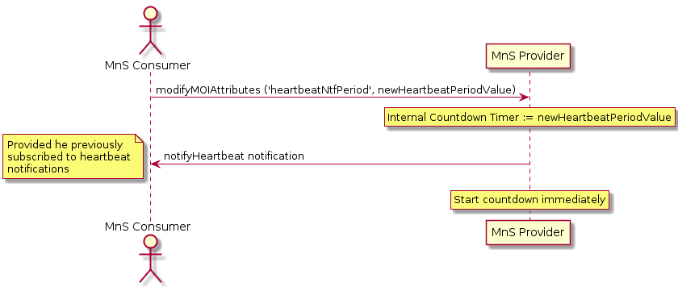

Figure 4.3.1-1: Procedure for configuring heartbeat notification periodicity

### 4.3.2 Procedure for requesting immediate heartbeat notification

Figure 4.3.2-1 illustrates the procedure for requesting immediate heartbeat notification using operations and notifications of the provisioning MnS (see clause 11.1.1 of [2]).

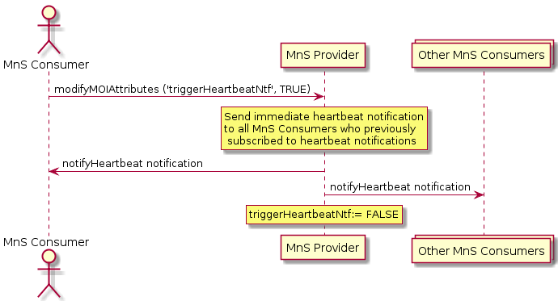

Figure 4.3.2-1: Procedure for requesting immediate heartbeat notification

### 4.3.3 Procedure for notifying periodic heartbeat notifications

Figure 4.3.3-1 illustrates the procedure for notifying periodic heartbeat notifications using operations and notifications of the provisioning MnS (see clause 11.1.1 of [2]).

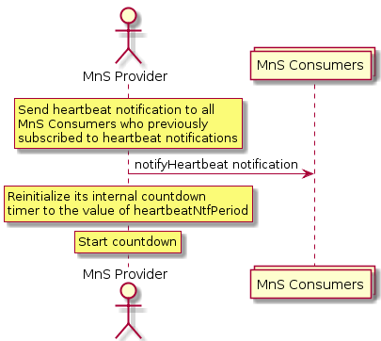

Figure 4.3.3-1: Procedure for notifying periodic heartbeat notifications

Annex A (informative):   
Heartbeat PlantUML source code

# A.1 Procedure for configuring heartbeat notification periodicity

The following PlantUML source code is used to describe the procedure for configuring heartbeat notification periodicity, as depicted by Figure 4.3.1-1:

@startuml

title "Configuring heartbeat notification periodicity"

actor "MnS Consumer" as CONS

participant "MnS Provider" as PROV

CONS -> PROV: modifyMOIAttributes ('heartbeatNtfPeriod', newHeartbeatPeriodValue)

rnote over PROV

Internal Countdown Timer := newHeartbeatPeriodValue

endrnote

PROV -> CONS: notifyHeartbeat notification

note left

Provided he previously

subscribed to heartbeat

notifications

end note

rnote over PROV

Start countdown immediately

endrnote

@enduml

# A.2 Procedure for requesting immediate heartbeat notification

The following PlantUML source code is used to describe the procedure for requesting immediate heartbeat notification, as depicted by Figure 4.3.2-1:

@startuml

title "Requesting immediate heartbeat notification"

actor "MnS Consumer" as CONS

participant "MnS Provider" as PROV

collections "Other MnS Consumers" as OTHER

CONS -> PROV: modifyMOIAttributes ('triggerHeartbeatNtf', TRUE)

rnote over PROV

Send immediate heartbeat notification

to all MnS Consumers who previously

subscribed to heartbeat notifications

endrnote

PROV -> CONS: notifyHeartbeat notification

PROV -> OTHER: notifyHeartbeat notification

rnote over PROV

triggerHeartbeatNtf:= FALSE

endrnote

@enduml

# A.3 Procedure for notifying periodic heartbeat notifications

The following PlantUML source code is used to describe the procedure for notifying periodic heartbeat notifications, as depicted by Figure 4.3.3-1:

@startuml

title "Notifying periodic heartbeat notifications"

actor "MnS Provider" as PROV

collections "MnS Consumers" as CONS

rnote over PROV

Send heartbeat notification to all

MnS Consumers who previously

subscribed to heartbeat notifications

endrnote

PROV -> CONS: notifyHeartbeat notification

rnote over PROV

Reinitialize its internal countdown

timer to the value of heartbeatNtfPeriod

endrnote

rnote over PROV

Start countdown

endrnote

@enduml

Annex B (informative):  
Change history

|  |  |  |  |  |  |  |  |
| --- | --- | --- | --- | --- | --- | --- | --- |
| **Change history** | | | | | | | |
| **Date** | **Meeting** | **TDoc** | **CR** | **Rev** | **Cat** | **Subject/Comment** | **New version** |
| 2020-02 | SA5#129-e | S5-201108 |  |  |  | First draft, including EditHelp comments | 0.1.0 |
| 2020-03 | SA#87-e | SP-200197 |  |  |  | Presented for approval | 1.0.0 |
| 2020-03 | SA#87-e |  |  |  |  | Upgrade to changecontrol version | 16.0.0 |