3GPP TS 28.612 V16.0.0(2020-07)

Technical Specification

3rd Generation Partnership Project;

Technical Specification Group Services and System Aspects;

Telecommunication management;

Evolved Packet Core (EPC) and non-3GPP access

interworking system Network Resource Model (NRM)

Integration Reference Point (IRP);

Information Service (IS)

(Release 16)

* *

The present document has been developed within the 3rd Generation Partnership Project (3GPP TM) and may be further elaborated for the purposes of 3GPP..  
The present document has not been subject to any approval process by the 3GPPOrganizational Partners and shall not be implemented.  
This Specification is provided for future development work within 3GPPonly. The Organizational Partners accept no liability for any use of this Specification.  
Specifications and Reports for implementation of the 3GPP TM system should be obtained via the 3GPP Organizational Partners' Publications Offices.

.

Keywords

Converged Management, WLAN, interworking, E-UTRAN, EPC, NRM IRP

***3GPP***

Postal address

3GPP support office address

650 Route des Lucioles - Sophia Antipolis

Valbonne - FRANCE

Tel.: +33 4 92 94 42 00 Fax: +33 4 93 65 47 16

Internet

http://www.3gpp.org

***Copyright Notification***

No part may be reproduced except as authorized by written permission.  
The copyright and the foregoing restriction extend to reproduction in all media.

© 2020, 3GPP Organizational Partners (ARIB, ATIS, CCSA, ETSI, TSDSI, TTA, TTC).

All rights reserved.

UMTS™ is a Trade Mark of ETSI registered for the benefit of its members

3GPP™ is a Trade Mark of ETSI registered for the benefit of its Members and of the 3GPP Organizational Partners

LTE™ is a Trade Mark of ETSI registered for the benefit of its Members and of the 3GPP Organizational Partners

GSM® and the GSM logo are registered and owned by the GSM Association

Contents

Foreword 4

Introduction 4

1 Scope 5

2 References 5

3 Definitions and abbreviations 6

3.1 Definitions 6

3.2 Abbreviations 6

4 Model 7

4.1 Imported information entities and local labels 7

4.2 Class diagram 7

4.2.1 Relationships 7

4.2.2 Inheritance 8

4.3 Class definitions 8

4.3.1 Link_3GPPAAAServer_PGW 8

4.3.1.1 Definition 8

4.3.1.2 Attributes 8

4.3.1.3 Attribute constraints 8

4.3.1.4 Notifications 8

4.3.2 Link_3GPPAAAServer_HSS 8

4.3.2.1 Definition 8

4.3.2.2 Attributes 8

4.3.2.3 Attribute constraints 9

4.3.2.4 Notifications 9

4.3.3 Link_3GPPAAAProxy_3GPPAAAServer 9

4.3.3.1 Definition 9

4.3.3.2 Attributes 9

4.3.3.3 Attribute constraints 9

4.3.3.4 Notifications 9

4.3.4 3GPPAAAProxyFunction 9

4.3.4.1 Definition 9

4.3.4.2 Attributes 9

4.3.4.3 Attribute constraints 9

4.3.4.4 Notifications 9

4.3.5 3GPPAAAServerFunction 9

4.3.5.1 Definition 9

4.3.5.2 Attributes 9

4.3.5.3 Attribute constraints 10

4.3.5.4 Notifications 10

4.4 Attribute definitions 10

4.4.1 Attribute properties 10

4.4.2 Constraints 10

4.5 Common notifications 10

4.5.1 Alarm notifications 10

4.5.2 Configuration notifications 10

Annex A (informative): Change history 11

# Foreword

This Technical Specification has been produced by the 3rd Generation Partnership Project (3GPP).

The contents of the present document are subject to continuing work within the TSG and may change following formal TSG approval. Should the TSG modify the contents of the present document, it will be re-released by the TSG with an identifying change of release date and an increase in version number as follows:

Version x.y.z

where:

x the first digit:

1 presented to TSG for information;

2 presented to TSG for approval;

3 or greater indicates TSG approved document under change control.

y the second digit is incremented for all changes of substance, i.e. technical enhancements, corrections, updates, etc.

z the third digit is incremented when editorial only changes have been incorporated in the document.

# Introduction

The present document is part of a TS-family covering the 3rd Generation Partnership Project Technical Specification Group Services and System Aspects, Telecommunication management; as identified below:

TS 28.611: "Evolved Packet Core (EPC) and non-3GPP access interworking system Network Resource Model (NRM) Integration Reference Point (IRP); Requirements";

**TS 28.612:** "**Evolved Packet Core (EPC) and non-3GPP access interworking system Network Resource Model (NRM) Integration Reference Point (IRP); Information Service (IS)**" ;

TS 28.616: " Evolved Packet Core (EPC) and non-3GPP access interworking system Network Resource Model (NRM) Integration Reference Point (IRP); Solution Set (SS) definitions".

The interface Itf-N, defined in 3GPP TS 32.102 [3], is built up by a number of Integration Reference Points (IRPs) and a related Name Convention, which realize the functional capabilities over this interface. The basic structure of the IRPs is defined in 3GPP TS 32.101 [2], 3GPP TS 32.102 [3] and 3GPP TS 32.103 [13].

# 1 Scope

The present document is an Integration Reference Point (IRP) named "Evolved Packet Core (EPC) and non-3GPP access interworking system Network resource Model (NRM) IRP; Information Service (IS)", through which an 'IRPAgent' (typically an Element Manager or Network Element) can communicate configuration management information to one or several 'IRPManagers' (typically Network Managers) concerning interworking network resources.

The present document specifies the semantics and behaviour of Information Object Class (IOC) attributes and relations visible across the reference point in a protocol and technology neutral way. It does not define their syntax and encoding.

It reuses relevant parts of the generic NRM in 3GPP TS 28.622 [6], either by direct reuse or sub-classing, and in addition to that defines specific IOCs in EPC and non-3GPP access interworking systems.

In order to access the information defined by this NRM, an interface IRP is needed, such as the Basic CM IRP IS (3GPP TS 32.602 [7]) or the Bulk CM IRP IS (3GPP TS 32.612 [8]). However, which interface IRP is applicable is outside the scope of the present document.

# 2 References

The following documents contain provisions which, through reference in this text, constitute provisions of the present document.

- References are either specific (identified by date of publication, edition number, version number, etc.) or non‑specific.

- For a specific reference, subsequent revisions do not apply.

- For a non-specific reference, the latest version applies. In the case of a reference to a 3GPP document (including a GSM document), a non-specific reference implicitly refers to the latest version of that document *in the same Release as the present document*.

[1] 3GPP TS 25.905: "Vocabulary for 3GPP Specifications".

[2] 3GPP TS 32.101: "Telecommunication management; Principles and high level requirements".

[3] 3GPP TS 32.102: "Telecommunication management; Architecture".

[4] 3GPP TS 32.600: "Telecommunication management; Configuration Management (CM); Concept and high-level requirements".

[5] 3GPP TS 23.402: "Architecture enhancements for non-3GPP accesses".

[6] 3GPP TS 28.622: "Telecommunication management; Generic Network Resource Model (NRM) Integration Reference Point (IRP); Information Service (IS)".

[7] 3GPP TS 32.602: "Telecommunication management; Configuration Management (CM); Basic Configuration Management Integration Reference Point (IRP): Information Service (IS)".

[8] 3GPP TS 32.612: "Telecommunication management; Configuration Management (CM); Bulk CM Integration Reference Point (IRP): Information Service (IS)".

[9] Void.

[10] 3GPP TS 28.708: "Telecommunication management; Evolved Packet Core (EPC) Network Resource Model (NRM) Integration Reference Point (IRP); Information Service (IS)".

[11] 3GPP TS 32.111-2: "Telecommunication management; Fault Management; Part 2: Alarm Integration Reference Point (IRP): Information Service (IS)".

[12] 3GPP TS 28.705: "Telecommunication management; IP Multimedia Subsystem (IMS) Network Resource Model (NRM) Integration Reference Point (IRP); Information Service (IS)".

[13] 3GPP TS 32.103: "Telecommunication management; Integration Reference Point (IRP) overview and usage guide".

[14] 3GPP TS 32.150: "Telecommunication management; Integration Reference Point (IRP) Concept and definitions".

[15] 3GPP TS 32.662: "Telecommunication management; Configuration Management (CM); Kernel CM Information Service (IS)".

[16] 3GPP TS 32.302: "Telecommunication management; Configuration Management (CM); Notification Integration Reference Point (IRP): Information Service (IS)".

# 3 Definitions and abbreviations

## 3.1 Definitions

For the purposes of the present document, the terms and definitions given in TR 21.905 [1], TS 32.101 [2], TS 32.102 [3], TS 32.150 [14], TS 28.622 [6], TS 32.600 [4] and the following apply.   
A term defined in the present document takes precedence over the definition of the same term, if any, in TR 21.905 [1].

## 3.2 Abbreviations

For the purposes of the present document, the abbreviations given in TR 21.905 [1] and the following apply.   
An abbreviation defined in the present document takes precedence over the definition of the same abbreviation, if any, in TR 21.905 [1].

DN Distinguished Name

IOC Information Object Class

# 4 Model

## 4.1 Imported information entities and local labels

|  |  |
| --- | --- |
| Label reference | Local label |
| 3GPP TS 28.622 [6], IOC, Link | Link |
| 3GPP TS 28.708 [10], IOC, PGWFunction | PGWFunction |
| 3GPP TS 28.705 [12], IOC, HSSFunction | HSSFunction |

## 4.2 Class diagram

### 4.2.1 Relationships

This clause depicts the set of classes (e.g. IOCs) encapsulating the information relevant for this IRP.   
This clause provides an overview of the relationships between relevant classes in UML.   
Subsequent clauses provide more detailed specification of various aspects of these classes.

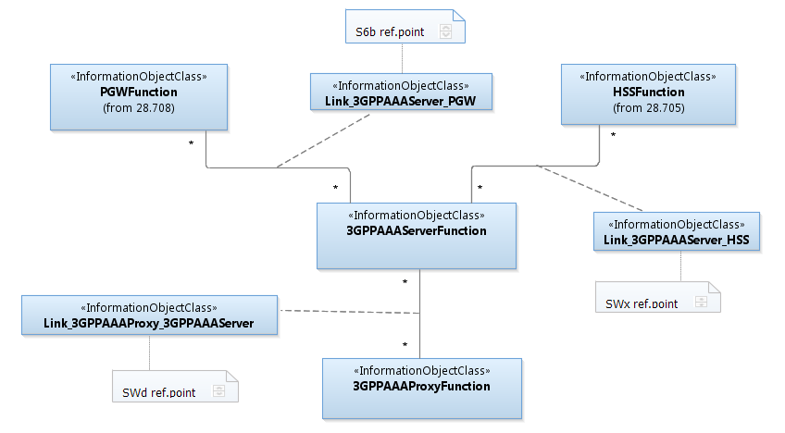

Figure 4.2.1.1 IOC containment and association diagram

### 4.2.2 Inheritance

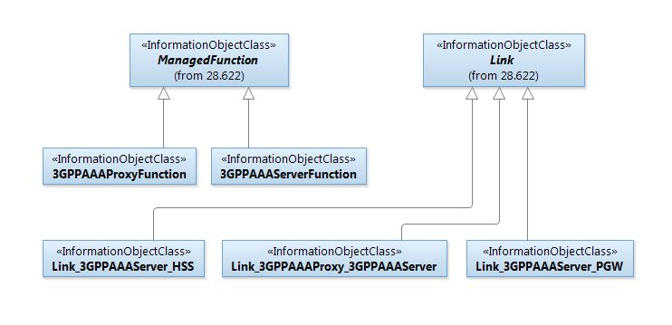

Figure 4.2.2.1: IOC inheritance diagram

## 4.3 Class definitions

### 4.3.1 Link_3GPPAAAServer_PGW

#### 4.3.1.1 Definition

This IOC represents the S6b reference point as defined in 3GPP TS 23.402 [5].

#### 4.3.1.2 Attributes

None.

#### 4.3.1.3 Attribute constraints

None.

#### 4.3.1.4 Notifications

The common notifications defined in clause 4.5 are valid without exceptions or additions for this IOC.

### 4.3.2 Link_3GPPAAAServer_HSS

#### 4.3.2.1 Definition

This IOC represents the SWx reference point as defined in 3GPP 23.402 [5].

#### 4.3.2.2 Attributes

None.

#### 4.3.2.3 Attribute constraints

None.

#### 4.3.2.4 Notifications

The common notifications defined in clause 4.5 are valid without exceptions or additions for this IOC.

### 4.3.3 Link_3GPPAAAProxy_3GPPAAAServer

#### 4.3.3.1 Definition

This IOC represents the SWd reference point as defined in 3GPP 23.402 [5].

#### 4.3.3.2 Attributes

None.

#### 4.3.3.3 Attribute constraints

None.

#### 4.3.3.4 Notifications

The common notifications defined in subclause 4.5 are valid without exceptions or additions for this IOC.

### 4.3.4 3GPPAAAProxyFunction

#### 4.3.4.1 Definition

This IOC represents the 3GPP Access, Authentication and Authorisation (AAA) Proxy functionality.   
For more information about the 3GPP AAA Proxy, see 3GPP TS 23.402 [5].

#### 4.3.4.2 Attributes

None.

#### 4.3.4.3 Attribute constraints

None.

#### 4.3.4.4 Notifications

The common notifications defined in clause 4.5 are valid without exceptions or additions for this IOC.

### 4.3.5 3GPPAAAServerFunction

#### 4.3.5.1 Definition

This IOC represents the 3GPP Access, Authentication and Authorisation (AAA) Server functionality. For more information about the 3GPP AAA server, see 3GPP TS 23.402 [5].

#### 4.3.5.2 Attributes

None.

#### 4.3.5.3 Attribute constraints

None.

#### 4.3.5.4 Notifications

The common notifications defined in subclause 4.5 are valid without exceptions or additions for this IOC.

## 4.4 Attribute definitions

### 4.4.1 Attribute properties

None.

### 4.4.2 Constraints

None.

## 4.5 Common notifications

### 4.5.1 Alarm notifications

This clause presents a list of notifications, defined in 3GPP TS 32.111-2 [11], that IRPManager can receive.   
The notification header attribute objectClass/objectInstance, defined in 3GPP TS 32. 302 [16], would capture the DN of an instance of an IOC defined in this IRP specification.

| Name | Qualifier | Notes |
| --- | --- | --- |
| notifyAckStateChanged | See Alarm IRP (3GPP TS 32.111-2 [11]) |  |
| notifyChangedAlarm | See Alarm IRP (3GPP TS 32.111-2 [11]) |  |
| notifyClearedAlarm | See Alarm IRP (3GPP TS 32.111-2 [11]) |  |
| notifyNewAlarm | See Alarm IRP (3GPP TS 32.111-2 [11]) |  |
| notifyComments | See Alarm IRP (3GPP TS 32.111-2 [11]) |  |
| notifyAlarmListRebuilt | See Alarm IRP (3GPP TS 32.111-2 [11]) |  |
| notifyPotentialFaultyAlarmList | See Alarm IRP (3GPP TS 32.111-2 [11]) |  |

4.5.2 Configuration notifications

This clause presents a list of notifications, defined in 3GPP TS 32. 662 [15], that IRPManager can receive.   
The notification header attribute objectClass/objectInstance, defined in 3GPP TS 32. 302 [16], would capture the DN of an instance of an IOC defined in this IRP specification.

| Name | Qualifier | Notes |
| --- | --- | --- |
| notifyAttributeValueChange | O |  |
| notifyObjectCreation | O |  |
| notifyObjectDeletion | O |  |

Annex A (informative):  
Change history

|  |  |  |  |  |  |  |  |
| --- | --- | --- | --- | --- | --- | --- | --- |
| **Change history** | | | | | | | |
| **Date** | **TSG #** | **TSG Doc.** | **CR** | **Rev** | **Subject/Comment** | **Old** | **New** |
| Feb 2012 |  |  | -- | -- | Initial draft | -- | 0.0.1 |
| Dec 2012 |  |  |  |  | Add IOCs definition | 0.0.1 | 0.1.1 |
| May 2013 |  |  |  |  | Revise the skeleton align with TS 28.622 according to the agreed S5-131062 | 0.1.1 | 0.1.2 |
| Jun 2013 |  |  |  |  | Add common notifications according to agreed pCR S5-131065 | 0.1.2 | 0.2.0 |
| Aug 2013 |  |  |  |  | Revise the NRM diagram to align with 28- series | 0.2.0 | 0.3.0 |
| Sep 2013 | SA#61 | SP-130449 |  |  | Presented for information | 0.3.0 | 1.0.0 |
| Sep 2013 | - | - |  |  | MCC clean-up | 1.0.0 | 1.0.1 |
| Nov 2013 |  |  |  |  | Align with IS template | 1.0.1 | 1.0.2 |
| Dec 2013 | SA#62 | SP-130634 |  |  | Presented for approval | 1.0.2 | 2.0.0 |
| Dec 2013 |  |  |  |  | Version after approval | 2.0.0 | 12.0.0 |
| Sep 2014 | SA#65 | SP-140614 | 001 | 1 | Move IOCs from discontinued TS 28.602 - align with TSG SA decision to remove I-WLAN | 12.0.0 | 12.1.0 |
| Dec 2014 | SA#66 | SP-140798 | 002 | 1 | Remove feature support statement | 12.1.0 | 12.2.0 |
| 2016-01 | - | - | - | - | Update to Rel-13 version (MCC) | 12.2.0 | 13.0.0 |
| 2017-03 | SA#75 | - | - | - | Promotion to Release 14 without technical change | 13.0.0 | 14.0.0 |
| 2018-12 | - | - | - | - | Update to Rel-15 version (MCC) | 14.0.0 | 15.0.0 |
| 2020-07 | - | - | - | - | Update to Rel-16 version (MCC) | 15.0.0 | 16.0.0 |