3GPP TS 28.702 V16.0.0(2020-07)

Technical Specification

3rd Generation Partnership Project;

Technical Specification Group Services and System Aspects;

Telecommunication management;

Core Network (CN)

Network Resource Model (NRM)

Integration Reference Point (IRP);

Information Service (IS)

(Release 16)

* *

The present document has been developed within the 3rd Generation Partnership Project (3GPP TM) and may be further elaborated for the purposes of 3GPP.   
The present document has not been subject to any approval process by the 3GPPOrganizational Partners and shall not be implemented.   
This Specification is provided for future development work within 3GPPonly. The Organizational Partners accept no liability for any use of this Specification.  
Specifications and reports for implementation of the 3GPP TM system should be obtained via the 3GPP Organizational Partners' Publications Offices.

Keywords

CN, NRM, IRP, Converged Management

***3GPP***

Postal address

3GPP support office address

650 Route des Lucioles - Sophia Antipolis

Valbonne - FRANCE

Tel.: +33 4 92 94 42 00 Fax: +33 4 93 65 47 16

Internet

http://www.3gpp.org

***Copyright Notification***

No part may be reproduced except as authorized by written permission.  
The copyright and the foregoing restriction extend to reproduction in all media.

© 2020, 3GPP Organizational Partners (ARIB, ATIS, CCSA, ETSI, TSDSI, TTA, TTC).

All rights reserved.

UMTS™ is a Trade Mark of ETSI registered for the benefit of its members

3GPP™ is a Trade Mark of ETSI registered for the benefit of its Members and of the 3GPP Organizational Partners  
LTE™ is a Trade Mark of ETSI registered for the benefit of its Members and of the 3GPP Organizational Partners

GSM® and the GSM logo are registered and owned by the GSM Association

Contents

Foreword 7

Introduction 7

1 Scope 8

2 References 8

3 Definitions and abbreviations 9

3.1 Definitions 9

3.2 Abbreviations 9

4 Model 11

4.1 Imported information entities and local labels 11

4.2 Class diagram 11

4.2.1 Relationships 11

4.2.2 Inheritance 15

4.3 Class definitions 18

4.3.1 MscServerFunction 18

4.3.1.1 Definitions 18

4.3.1.2 Attributes 18

4.3.1.3 Attribute constraints 18

4.3.1.4 Notifications 18

4.3.2 HlrFunction 18

4.3.2.1 Definitions 18

4.3.2.2 Attributes 18

4.3.2.3 Attribute constraints 18

4.3.2.4 Notifications 18

4.3.3 VlrFunction 19

4.3.3.1 Definitions 19

4.3.3.2 Attributes 19

4.3.3.3 Attribute constraints 19

4.3.3.4 Notifications 19

4.3.4 AucFunction 19

4.3.4.1 Definitions 19

4.3.4.2 Attributes 19

4.3.4.3 Attribute constraints 19

4.3.4.4 Notifications 19

4.3.5 EirFunction 19

4.3.5.1 Definitions 19

4.3.5.2 Attributes 19

4.3.5.3 Attribute constraints 19

4.3.5.4 Notifications 20

4.3.6 SmsIwmscFunction 20

4.3.6.1 Definitions 20

4.3.6.2 Attributes 20

4.3.6.3 Attribute constraints 20

4.3.1.4 Notifications 20

4.3.7 SmsGmscFunction 20

4.3.7.1 Definitions 20

4.3.7.2 Attributes 20

4.3.7.3 Attribute constraints 20

4.3.7.4 Notifications 20

4.3.8 GmscFunction 20

4.3.8.1 Definitions 20

4.3.8.2 Attributes 20

4.3.8.3 Attribute constraints 21

4.3.8.4 Notifications 21

4.3.9 SgsnFunction 21

4.3.9.1 Definitions 21

4.3.9.2 Attributes 21

4.3.9.3 Attribute constraints 21

4.3.9.4 Notifications 21

4.3.10 GgsnFunction 21

4.3.10.1 Definitions 21

4.3.10.2 Attributes 22

4.3.10.3 Attribute constraints 22

4.3.10.4 Notifications 22

4.3.11 BgFunction 23

4.3.11.1 Definitions 23

4.3.11.2 Attributes 23

4.3.11.3 Attribute constraints 23

4.3.11.4 Notifications 23

4.3.12 SmlcFunction 23

4.3.12.1 Definitions 23

4.3.12.2 Attributes 23

4.3.12.3 Attribute constraints 23

4.3.12.4 Notifications 23

4.3.13 GmlcFunction 23

4.3.13.1 Definitions 23

4.3.13.2 Attributes 23

4.3.13.3 Attribute constraints 23

4.3.13.4 Notifications 23

4.3.14 ScfFunction 24

4.3.14.1 Definitions 24

4.3.14.2 Attributes 24

4.3.14.3 Attribute constraints 24

4.3.14.4 Notifications 24

4.3.15 SrfFunction 24

4.3.15.1 Definitions 24

4.3.15.2 Attributes 24

4.3.15.3 Attribute constraints 24

4.3.15.4 Notifications 24

4.3.16 CbcFunction 24

4.3.16.1 Definitions 24

4.3.16.2 Attributes 24

4.3.16.3 Attribute constraints 24

4.3.16.4 Notifications 24

4.3.17 CgfFunction 25

4.3.17.1 Definitions 25

4.3.17.2 Attributes 25

4.3.17.3 Attribute constraints 25

4.3.17.4 Notifications 25

4.3.18 GmscServerFunction 25

4.3.18.1 Definitions 25

4.3.18.2 Attributes 25

4.3.18.3 Attribute constraints 25

4.3.18.4 Notifications 25

4.3.19 IwfFunction 25

4.3.19.1 Definitions 25

4.3.19.2 Attributes 25

4.3.19.3 Attribute constraints 25

4.3.19.4 Notifications 25

4.3.20 MnpSrfFunction 26

4.3.20.1 Definitions 26

4.3.20.2 Attributes 26

4.3.20.3 Attribute constraints 26

4.3.20.4 Notifications 26

4.3.21 NpdbFunction 26

4.3.21.1 Definitions 26

4.3.21.2 Attributes 26

4.3.21.3 Attribute constraints 26

4.3.21.4 Notifications 26

4.3.22 SgwFunction 26

4.3.22.1 Definitions 26

4.3.22.2 Attributes 26

4.3.22.3 Attribute constraints 26

4.3.22.4 Notifications 26

4.3.23 SsfFunction 27

4.3.23.1 Definitions 27

4.3.23.2 Attributes 27

4.3.23.3 Attribute constraints 27

4.3.23.4 Notifications 27

4.3.24 BsFunction 27

4.3.24.1 Definitions 27

4.3.24.2 Attributes 27

4.3.24.3 Attribute constraints 27

4.3.24.4 Notifications 27

4.3.25 IucsLink 27

4.3.25.1 Definitions 27

4.3.25.2 Attributes 27

4.3.25.3 Attribute constraints 28

4.3.25.4 Notifications 28

4.3.26 IupsLink 28

4.3.26.1 Definitions 28

4.3.26.2 Attributes 28

4.3.26.3 Attribute constraints 28

4.3.26.4 Notifications 28

4.3.27 IubcLink 28

4.3.27.1 Definitions 28

4.3.27.2 Attributes 28

4.3.27.3 Attribute constraints 29

4.3.27.4 Notifications 29

4.3.28 ALink 29

4.3.28.1 Definitions 29

4.3.28.2 Attributes 29

4.3.28.3 Attribute constraints 29

4.3.28.4 Notifications 29

4.3.29 GbLink 29

4.3.29.1 Definitions 29

4.3.29.2 Attributes 29

4.3.29.3 Attribute constraints 29

4.3.29.4 Notifications 29

4.3.30 CsMgwFunction 29

4.3.30.1 Definitions 29

4.3.30.2 Attributes 30

4.3.30.3 Attribute constraints 30

4.3.30.4 Notifications 30

4.3.31 BmScFunction 30

4.3.31.1 Definitions 30

4.3.31.2 Attributes 30

4.3.31.3 Attribute constraints 30

4.3.31.4 Notifications 30

4.3.32 Link_BmSc_Ggsn 30

4.3.32.1 Definitions 30

4.3.32.2 Attributes 30

4.3.32.3 Attribute constraints 30

4.3.32.4 Notifications 30

4.3.33 Link_Ggsn_Sgsn 31

4.3.33.1 Definitions 31

4.3.33.2 Attributes 31

4.3.33.3 Attribute constraints 31

4.3.33.4 Notifications 31

4.3.34 CircuitEndPointSubgroup 31

4.3.34.1 Definitions 31

4.3.34.2 Attributes 31

4.3.34.3 Attribute constraints 31

4.3.34.4 Notifications 31

4.3.35 MscPool 31

4.3.35.1 Definitions 31

4.3.35.2 Attributes 31

4.3.35.3 Attribute constraints 31

4.3.35.4 Notifications 32

4.3.36 MscPoolArea 32

4.3.36.1 Definitions 32

4.3.36.2 Attributes 32

4.3.36.3 Attribute constraints 32

4.3.36.4 Notifications 32

4.3.37 SgsnPool 32

4.3.37.1 Definitions 32

4.3.37.2 Attributes 32

4.3.37.3 Attribute constraints 32

4.3.37.4 Notifications 32

4.3.38 SgsnPoolArea 33

4.3.38.1 Definitions 33

4.3.38.2 Attributes 33

4.3.38.3 Attribute constraints 33

4.3.38.4 Notifications 33

4.4 Attribute definitions 34

4.4.1 Attribute properties 34

4.4.2 Constraints 37

4.5 Common notifications 38

4.5.1 Alarm notifications 38

4.5.2 Configuration notifications 38

Annex A (informative): Change history 39

# Foreword

This Technical Specification has been produced by the 3rd Generation Partnership Project (3GPP).

The contents of the present document are subject to continuing work within the TSG and may change following formal TSG approval. Should the TSG modify the contents of the present document, it will be re-released by the TSG with an identifying change of release date and an increase in version number as follows:

Version x.y.z

where:

x the first digit:

1 presented to TSG for information;

2 presented to TSG for approval;

3 or greater indicates TSG approved document under change control.

y the second digit is incremented for all changes of substance, i.e. technical enhancements, corrections, updates, etc.

z the third digit is incremented when editorial only changes have been incorporated in the document.

# Introduction

The present document is part of a TS-family covering the 3rd Generation Partnership Project Technical Specification Group Services and System Aspects, Telecommunication management; as identified below:

28.701: "Core Network (CN) Network Resource Model (NRM)Integration Reference Point (IRP); Requirements".

**28.702: "Core Network (CN) Network Resource Model (NRM) Integration Reference Point (IRP); Information Service (IS)".**

28.703: "Core Network (CN) Network Resource Model (NRM)Integration Reference Point (IRP); Solution Set (SS) definitions".

Configuration Management (CM), in general, provides the operator with the ability to assure correct and effective operation of the 3G network as it evolves. CM actions have the objective to control and monitor the actual configuration on the Network Elements (NEs) and Network Resources (NRs), and they may be initiated by the operator or by functions in the Operations Systems (OSs) or NEs.

CM actions may be requested as part of an implementation programme (e.g. additions and deletions), as part of an optimization programme (e.g. modifications), and to maintain the overall Quality of Service (QoS). The CM actions are initiated either as single actions on single NEs of the 3G network, or as part of a complex procedure involving actions on many resources/objects in one or several NEs.

# 1 Scope

The present document is part of an Integration Reference Point (IRP) named "Core Network NRM IRP", through which an 'IRPAgent' (typically an Element Manager or Network Element) can communicate Configuration Management information to one or several 'IRPManagers' (typically Network Managers) concerning CN resources.

The present document specifies the protocol neutral Core Network NRM IRP; Information Service. It reuses relevant parts of the generic NRM in 3GPP TS 28.622 [9], either by direct reuse or sub-classing, and in addition to that defines CN specific Information Object Classes.

Finally, in order to access the information defined by this NRM, an Interface IRP is needed, such as the Basic CM IRP 3GPP TS 32.602 [10]. However, which Interface IRP that is applicable is outside the scope of the present document.

# 2 References

The following documents contain provisions which, through reference in this text, constitute provisions of the present document.

- References are either specific (identified by date of publication, edition number, version number, etc.) or non‑specific.

- For a specific reference, subsequent revisions do not apply.

- For a non-specific reference, the latest version applies. In the case of a reference to a 3GPP document (including a GSM document), a non-specific reference implicitly refers to the latest version of that document *in the same Release as the present document*.

[1] 3GPP TS 32.101: "Telecommunication management; Principles and high level requirements".

[2] 3GPP TS 32.102: "Telecommunication management; Architecture".

[3] 3GPP TS 32.302: "Telecommunication management; Configuration Management (CM); Notification Integration Reference Point; Information Service (IS)".[4] ITU-T Recommendation X.710 (1991): "Common management information service definition for CCITT applications".

[5] 3GPP TS 32.111-2: "Telecommunication management; Fault Management; Part 2: Alarm Integration Reference Point: Information Service (IS)".

[6] 3GPP TS 32.300: "Telecommunication management; Configuration Management (CM); Name convention for Managed Objects".

[7] 3GPP TS 32.600: "Telecommunication management; Configuration Management (CM); Concept and high-level requirements".

[8] 3GPP TS 23.002: "Network architecture".

[9] 3GPP TS 28.622: "Telecommunication management; Generic Network Resource Model (NRM) Integration Reference Point (IRP); Information Service (IS)".

[10] 3GPP TS 32.602: "Telecommunication management; Configuration Management (CM); Basic Configuration Management Integration Reference Point (IRP): Information Service (IS)".

[11] 3GPP TS 23.060: "General Packet Radio Service (GPRS) service description; Stage 2".

[12] 3GPP TS 23.003: "Numbering, addressing and identification".

[13] 3GPP TS 28.625: "Telecommunication Management; State Management Data Definition Integration Reference Point (IRP): Information Service (IS)".

[14] 3GPP TS 28.652: "Telecommunication management; UTRAN Network Resource Model (NRM) Integration Reference Point (IRP); Information Service (IS)".

[15] 3GPP TS 28.655: "Telecommunication management; GERAN Network Resource Model (NRM)Integration Reference Point (IRP); Information Service (IS)".

[16] ITU-T Rec. M.3100: "Generic Network Information Model" (7/95).

[17] 3GPP TS 28.672: "Telecommunication management; Home Node B Subsystem (HNS) Network Resource Model (NRM) Integration Reference Point (IRP); Information Service (IS)".

[18] 3GPP TS 23.236: "Technical Specification Group Services and System Aspects; Intra-domain connection of Radio Access Network (RAN) nodes to multiple Core Network (CN) nodes".

[19] 3GPP TS 32.662: "Telecommunication management; Configuration Management (CM); Kernel CM; Information service (IS)".

# 3 Definitions and abbreviations

## 3.1 Definitions

For the purposes of the present document, the terms and definitions given in 3GPP TS 32.101 [1], 3GPP TS 32.102 [2], 3GPP TS 32.600 [7] and the following apply:

**Association:** See definition in TS 28.622 [9].

**Managed Element (ME):** See definition in TS 28.622 [9].

**Managed Object (MO):** See definition in TS 28.622 [9].

**Management Information Model (MIM):** also referred to as NRM - see the definition below.

**Network Resource Model (NRM):** See definition in TS 28.622 [9].

**Node B:** a logical node responsible for radio transmission/reception in one or more cells to/from the User Equipment  
It terminates the Iub interface towards the RNC.

## 3.2 Abbreviations

For the purposes of the present document, the following abbreviations apply:

AUC AUthentication Centre

AS Application Server

BG Border Gateway

BGCF Breakout Gateway Control Function

BS Billing System

CBC Cell Broadcast Center

CGF Charging Gateway Functionality

CN Core Network

DN Distinguished Name (see 3GPP TS 32.300 [6])

EIR Equipment Identity Register

EM Element Manager

FM Fault Management

FNR Flexible Number Register

GDMO Guidelines for the Definition of Managed Objects

GGSN Gateway GPRS Support Node

GMLC Gateway Mobile Location Center

GMSC Server Gateway MSC Server

GMSC Gateway MSC

GPRS General Packet Radio System

HNB GW Home NodeB Gateway

ICSCF Interrogating Call Session Control Function

IDL Interface Definition Language

IMS IP Multimedia Subsystem

IOC Information Object Class

IRP Integration Reference Point

ISO International Standards Organization

IWF InterWorking Function

ME Managed Element

MGCF Media Gateway Control Function

MGW Media GateWay

MIM Management Information Model

MNP-SRF Mobile Number Portability-Signalling Relay Function

MO Managed Object

MOI Managed Object Instance

MRFC Multimedia Resource Function Controller

MRFP Call Session Control Function Processor

MSC Server Mobile Services Switching Centre Server

MSC Mobile Services Switching Centre

NE Network Element

NM Network Manager

NPDB Number Portability DataBase

NR Network Resource

NRM Network Resource Model

OSI Open Systems Interconnection

PCSCF Proxy Call Session Control Function

PM Performance Management

RDN Relative Distinguished Name (see 3GPP TS 32.300 [6])

SCF Service Control Function

SCSCF Serving Call Session Control Function

SGSN Serving GPRS Support Node

SGW Signalling GateWay

SLF Subscription Locator Function

SMLC Serving Mobile Location Center

SMS Short Message Service

SMS-GMSC SMS Gateway MSC

SMS-IWMSC SMS InterWorking MSC

SRF Specialized Resource Function

SSF Service Switching Function

TMN Telecommunications Management Network

UML Unified Modelling Language

UMTS Universal Mobile Telecommunications System

UTRAN Universal Terrestrial Radio Access Network

VLR Visitor Location Register

# 4 Model

## 4.1 Imported information entities and local labels

|  |  |
| --- | --- |
| Label reference | Local label |
| TS 28.622 [9], information object class, Link | Link |
| TS 28.622 [9], information object class, ManagedElement | ManagedElement |
| TS 28.622 [9], information object class, ManagedFunction | ManagedFunction |
| TS 28.622 [9], information object class, VsDataContainer | VsDataContainer |
| TS 28.652 [14], information object class, RncFunction | RncFunction |
| TS 28.655 [15], information object class, BssFunction | BssFunction |
| TS 28.655 [15], information object class, ExternalBssFunction | ExternalBssFunction |
| TS 28.655 [15], information object class, ExternalGsmCell | ExternalGsmCell |
| TS 28.655 [15], information object class, GsmCell | GsmCell |
| TS 28.625 [13], attribute, proceduralStatus | proceduralStatus |

## 4.2 Class diagram

### 4.2.1 Relationships

This clause depicts the set of classes (e.g. IOCs) that encapsulates the information relevant for this IRP. This clause provides an overview of the relationships between relevant classes in UML. Subsequent clauses provide more detailed specification of various aspects of these classes.

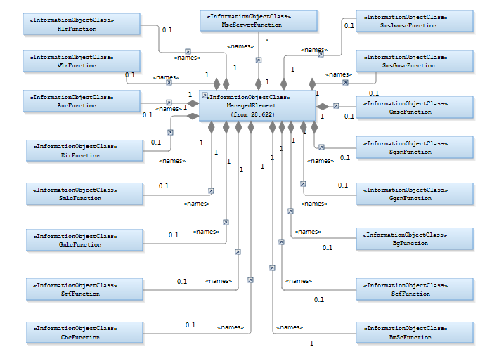

Figure 4.2.1.1: CN NRM Containment/Naming relationships 1

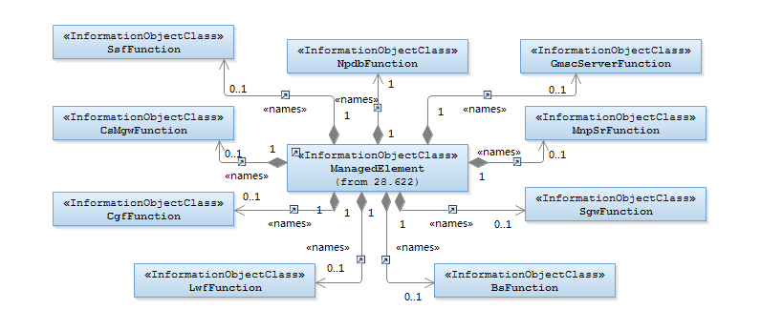

Figure 4.2.1.2: CN NRM Containment/Naming relationships 2

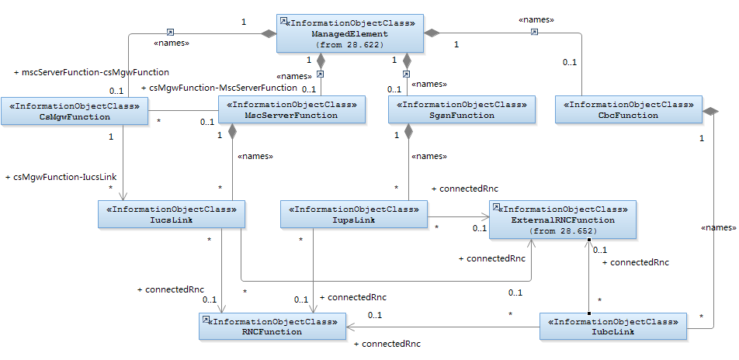

NOTE: The association between MscServerFunction and CsMgwFunction is optional and is only mandatory when they belong to different ManagedElements.

Figure 4.2.1.3: CN UTRAN NRM Containment/Naming and Association

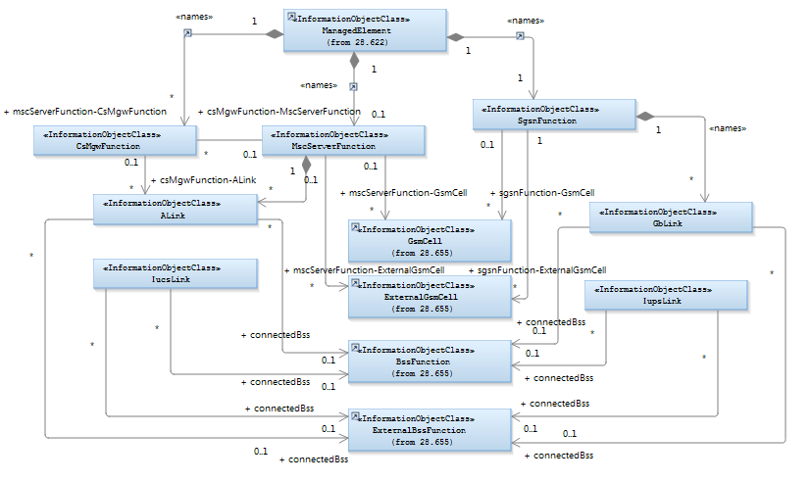

NOTE 1: The association between MscServerFunction and CsMgwFunction is optional and is only mandatory when they belong to different ManagedElements.

NOTE 2: The association between MscServerFunction and GsmCell, and SgsnFunction and GsmCell are optional. It may be valid if both the MscServerFunction and GsmCell, or SgsnFunction and GsmCell are managed by the same management node.

Figure 4.2.1.4: CN GERAN NRM Containment/Naming and Association

Each IOC is identified with a Distinguished Name (DN) according to 3GPP TS 32.300 [6] that expresses its containment hierarchy. As an example, the DN of an IOC representing a cell could have a format like:

SubNetwork=Sweden, MeContext =MEC-Gbg-1, ManagedElement =MSC-Gbg-1, MscServerFunction=MSC-1.

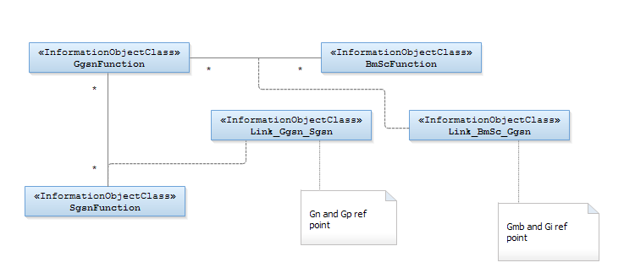

Figure 4.2.1.5: CN MBMS NRM Containment/Naming and Association

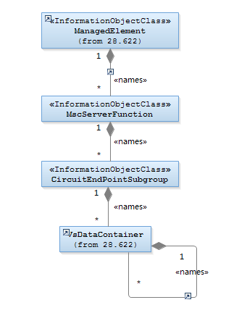

Figure 4.2.1.6: CN CircuitEndPointSubgroup related NRM Containment/Naming and Association

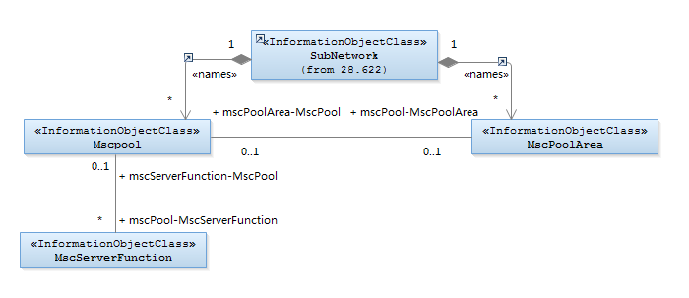

Figure 4.2.1.7: CN MscPool related NRM Containment/Naming and Association

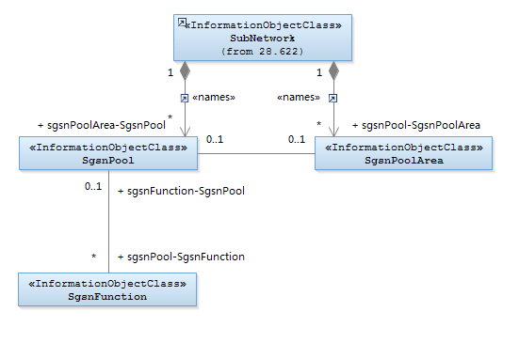

Figure 4.2.1.8: CN SgsnPool related NRM Containment/Naming and Association

### 4.2.2 Inheritance

This clause depicts the inheritance relationships that exist between IOCs.

The figures below show the inheritance hierarchy for the CN NRM.

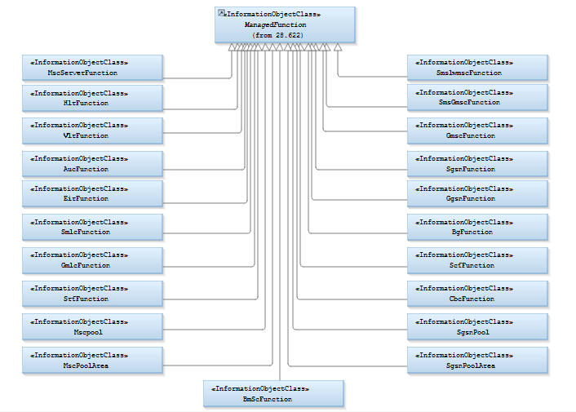

Figure 4.2.2.1: CN NRM Inheritance Hierarchy 1

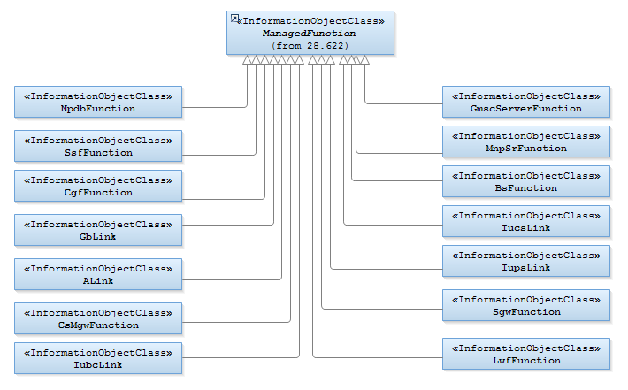

Figure 4.2.2.2: CN NRM Inheritance Hierarchy 2

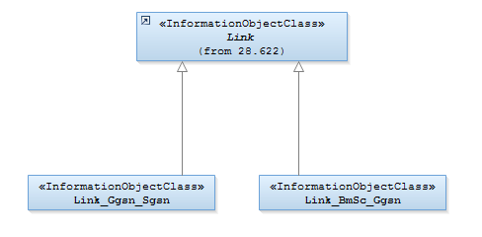

Figure 4.2.2.3: CN NRM Inheritance Hierarchy 3

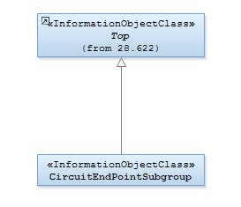

Figure 4.2.2.4: CN NRM Inheritance Hierarchy 4

## 4.3 Class definitions

### 4.3.1 MscServerFunction

#### 4.3.1.1 Definitions

This IOC represents MSCserver functionality. For more information about the MSC, see 3GPP TS 23.002 [8].

#### 4.3.1.2 Attributes

|  |  |  |  |  |  |
| --- | --- | --- | --- | --- | --- |
| Attribute name | Support Qualifier | isReadable | isWritable | isInvariant | isNotifyable |
| mccList | M | M | M | - | M |
| mncList | M | M | M | - | M |
| lacList | M | M | M | - | M |
| sacList | M | M | M | - | M |
| gcaList | O | M | M | - | M |
| mscId | M | M | M | - | M |
| nriList | M | M | - | - | M |
| defaultMsc | O | M | - | - | M |
| Attribute related to role |  |  |  |  |  |
| mscServerFunction-GsmCell | M | M | - | - | M |
| mscServerFunction-ExternalGsmCell | M | M | - | - | M |
| mscServerFunction-CsMgwFunction | M | M | - | - | M |
| mscServerFunction-MscPool | O | M | - | - | M |

#### 4.3.1.3 Attribute constraints

None.

#### 4.3.1.4 Notifications

The common notifications defined in subclause 4.5 are valid for this IOC, without exceptions or additions.

### 4.3.2 HlrFunction

#### 4.3.2.1 Definitions

This IOC represents HLR functionality. For more information about the HLR, see 3GPP TS 23.002 [8].

#### 4.3.2.2 Attributes

None.

#### 4.3.2.3 Attribute constraints

None.

#### 4.3.2.4 Notifications

The common notifications defined in subclause 4.5 are valid for this IOC, without exceptions or additions.

### 4.3.3 VlrFunction

#### 4.3.3.1 Definitions

This IOC represents VLR functionality. For more information about the VLR, see 3GPP TS 23.002 [8].

#### 4.3.3.2 Attributes

None.

#### 4.3.3.3 Attribute constraints

None.

#### 4.3.3.4 Notifications

The common notifications defined in subclause 4.5 are valid for this IOC, without exceptions or additions.

### 4.3.4 AucFunction

#### 4.3.4.1 Definitions

This IOC represents AUC functionality. For more information about the AUC, see 3GPP TS 23.002 [8].

#### 4.3.4.2 Attributes

None.

#### 4.3.4.3 Attribute constraints

None.

#### 4.3.4.4 Notifications

The common notifications defined in subclause 4.5 are valid for this IOC, without exceptions or additions.

### 4.3.5 EirFunction

#### 4.3.5.1 Definitions

This IOC represents EIR functionality. For more information about the EIR, see 3GPP TS 23.002 [8].

#### 4.3.5.2 Attributes

None.

#### 4.3.5.3 Attribute constraints

None.

#### 4.3.5.4 Notifications

The common notifications defined in subclause 4.5 are valid for this IOC, without exceptions or additions.

### 4.3.6 SmsIwmscFunction

#### 4.3.6.1 Definitions

This IOC represents SMS-IWMSC functionality. For more information about the SMS-IWMSC, see 3GPP TS 23.002 [8].

#### 4.3.6.2 Attributes

None.

#### 4.3.6.3 Attribute constraints

None.

#### 4.3.1.4 Notifications

The common notifications defined in subclause 4.5 are valid for this IOC, without exceptions or additions.

### 4.3.7 SmsGmscFunction

#### 4.3.7.1 Definitions

This IOC represents SMS-GMSC functionality. For more information about the SMS-GMSC, see 3GPP TS 23.002 [8].

#### 4.3.7.2 Attributes

None.

#### 4.3.7.3 Attribute constraints

None.

#### 4.3.7.4 Notifications

The common notifications defined in subclause 4.5 are valid for this IOC, without exceptions or additions.

### 4.3.8 GmscFunction

#### 4.3.8.1 Definitions

This IOC represents GMSC functionality. For more information about the GMSC, see 3GPP TS 23.002 [8].

#### 4.3.8.2 Attributes

None.

#### 4.3.8.3 Attribute constraints

None.

#### 4.3.8.4 Notifications

The common notifications defined in subclause 4.5 are valid for this IOC, without exceptions or additions.

### 4.3.9 SgsnFunction

#### 4.3.9.1 Definitions

This IOC represents SGSN functionality. For more information about the SGSN, see 3GPP TS 23.002 [8].

#### 4.3.9.2 Attributes

|  |  |  |  |  |  |
| --- | --- | --- | --- | --- | --- |
| Attribute name | Support Qualifier | isReadable | isWritable | isInvariant | isNotifyable |
| mccList | M | M | M | - | M |
| mncList | M | M | M | - | M |
| lacList | M | M | M | - | M |
| racList | M | M | M | - | M |
| sacList | M | M | M | - | M |
| sgsnId | M | M | M | - | M |
| proceduralStatus (see Note 1) | O | - | - | - | M (see Note 2) |
| nriList | M | M | - | - | M |
| **Attribute related to role** |  |  |  |  |  |
| sgsnFunction-GsmCell | M | M | - | - | M |
| sgsnFunction-ExternalGsmCell | M | M | - | - | M |
| sgsnFunction-SgsnPool | O | M | - | - | M |
| Note 1: No state propagation shall be implied.  Note 2: The attribute value change is conveyed by the notifyStateChange notification. | | | | | |

#### 4.3.9.3 Attribute constraints

None.

#### 4.3.9.4 Notifications

The common notifications defined in subclause 4.5 are valid for this IOC. In addition, the following set of notification, defined in 3GPP TS 32.662 [19], is also valid.

| Name | Qualifier | Notes |
| --- | --- | --- |
| notifyStateChange | O |  |

### 4.3.10 GgsnFunction

#### 4.3.10.1 Definitions

This IOC represents GGSN functionality. For more information about the GGSN, see 3GPP TS 23.002 [8].

#### 4.3.10.2 Attributes

|  |  |  |  |  |  |  |
| --- | --- | --- | --- | --- | --- | --- |
| Attribute name | Support Qualifier | isReadable | isWritable | isInvariant | isNotifyable |  |
| proceduralStatus (see Note 1) | O | - | - | - | M (see Note 2) |  |
| Note 1: No state propagation shall be implied.  Note 2: The attribute value change is conveyed by the notifyStateChange notification. | | | | | | |

#### 4.3.10.3 Attribute constraints

None.

#### 4.3.10.4 Notifications

The common notifications defined in subclause 4.5 are valid for this IOC. In addition, the following set of notification, defined in 3GPP TS 32.662 [19], is also valid.

| Name | Qualifier | Notes |
| --- | --- | --- |
| notifyStateChange | O |  |

### 4.3.11 BgFunction

#### 4.3.11.1 Definitions

This IOC represents BG functionality. For more information about the BG, see 3GPP TS 23.002 [8].

#### 4.3.11.2 Attributes

None.

#### 4.3.11.3 Attribute constraints

None.

#### 4.3.11.4 Notifications

The common notifications defined in subclause 4.5 are valid for this IOC, without exceptions or additions.

### 4.3.12 SmlcFunction

#### 4.3.12.1 Definitions

This IOC represents SMLC functionality. For more information about the SMLC, see 3GPP TS 23.002 [8].

#### 4.3.12.2 Attributes

None.

#### 4.3.12.3 Attribute constraints

None.

#### 4.3.12.4 Notifications

The common notifications defined in subclause 4.5 are valid for this IOC, without exceptions or additions.

### 4.3.13 GmlcFunction

#### 4.3.13.1 Definitions

This IOC represents GMLC functionality. For more information about the GMLC, see 3GPP TS 23.002 [8].

#### 4.3.13.2 Attributes

None.

#### 4.3.13.3 Attribute constraints

None.

#### 4.3.13.4 Notifications

The common notifications defined in subclause 4.5 are valid for this IOC, without exceptions or additions.

### 4.3.14 ScfFunction

#### 4.3.14.1 Definitions

This IOC represents SCF functionality (also referred to as gsmSCF). For more information about the SCF, see 3GPP TS 23.002 [8].

#### 4.3.14.2 Attributes

None.

#### 4.3.14.3 Attribute constraints

None.

#### 4.3.14.4 Notifications

The common notifications defined in subclause 4.5 are valid for this IOC, without exceptions or additions.

### 4.3.15 SrfFunction

#### 4.3.15.1 Definitions

This IOC represents SRF functionality (also referred to as gsmSRF). For more information about the SRF, see 3GPP TS 23.002 [8].

#### 4.3.15.2 Attributes

None.

#### 4.3.15.3 Attribute constraints

None.

#### 4.3.15.4 Notifications

The common notifications defined in subclause 4.5 are valid for this IOC, without exceptions or additions.

### 4.3.16 CbcFunction

#### 4.3.16.1 Definitions

This IOC represents CBC functionality. For more information about the CBC, see 3GPP TS 23.002 [8].

#### 4.3.16.2 Attributes

None.

#### 4.3.16.3 Attribute constraints

None.

#### 4.3.16.4 Notifications

The common notifications defined in subclause 4.5 are valid for this IOC, without exceptions or additions.

### 4.3.17 CgfFunction

#### 4.3.17.1 Definitions

This IOC represents CGF functionality. For more information about the CGF, see 3GPP TS 23.060 [11].

#### 4.3.17.2 Attributes

None.

#### 4.3.17.3 Attribute constraints

None.

#### 4.3.17.4 Notifications

The common notifications defined in subclause 4.5 are valid for this IOC, without exceptions or additions.

### 4.3.18 GmscServerFunction

#### 4.3.18.1 Definitions

This IOC represents GMSCServer functionality. For more information about GMSCServer, see 3GPP TS 23.002 [8].

#### 4.3.18.2 Attributes

None.

#### 4.3.18.3 Attribute constraints

None.

#### 4.3.18.4 Notifications

The common notifications defined in subclause 4.5 are valid for this IOC, without exceptions or additions.

### 4.3.19 IwfFunction

#### 4.3.19.1 Definitions

This IOC represents IWF functionality. For more information about IWF, see 3GPP TS 23.002 [8].

#### 4.3.19.2 Attributes

None.

#### 4.3.19.3 Attribute constraints

None.

#### 4.3.19.4 Notifications

The common notifications defined in subclause 4.5 are valid for this IOC, without exceptions or additions.

### 4.3.20 MnpSrfFunction

#### 4.3.20.1 Definitions

This IOC represents MNP-SRF functionality (also known as FNR). For more information about MNP-SRF, see 3GPP TS 23.002 [8].

#### 4.3.20.2 Attributes

None.

#### 4.3.20.3 Attribute constraints

None.

#### 4.3.20.4 Notifications

The common notifications defined in subclause 4.5 are valid for this IOC, without exceptions or additions.

### 4.3.21 NpdbFunction

#### 4.3.21.1 Definitions

This IOC represents NPDB functionality. For more information about NPDB, see 3GPP TS 23.002 [8].

#### 4.3.21.2 Attributes

None.

#### 4.3.21.3 Attribute constraints

None.

#### 4.3.21.4 Notifications

The common notifications defined in subclause 4.5 are valid for this IOC, without exceptions or additions.

### 4.3.22 SgwFunction

#### 4.3.22.1 Definitions

This IOC represents SGW functionality. For more information about SGW, see 3GPP TS 23.002 [8].

#### 4.3.22.2 Attributes

None.

#### 4.3.22.3 Attribute constraints

None.

#### 4.3.22.4 Notifications

The common notifications defined in subclause 4.5 are valid for this IOC, without exceptions or additions.

### 4.3.23 SsfFunction

#### 4.3.23.1 Definitions

This IOC represents SSF functionality. For more information about SSF, see 3GPP TS 23.002 [8].

#### 4.3.23.2 Attributes

None.

#### 4.3.23.3 Attribute constraints

None.

#### 4.3.23.4 Notifications

The common notifications defined in subclause 4.5 are valid for this IOC, without exceptions or additions.

### 4.3.24 BsFunction

#### 4.3.24.1 Definitions

This IOC represents BS functionality. For more information about BS, see 3GPP TS 23.060 [11].

#### 4.3.24.2 Attributes

None.

#### 4.3.24.3 Attribute constraints

None.

#### 4.3.24.4 Notifications

The common notifications defined in subclause 4.5 are valid for this IOC, without exceptions or additions.

### 4.3.25 IucsLink

#### 4.3.25.1 Definitions

This IOC represents an Iu-cs interface link connecting an MSCserver to the RNC, BSC and HNB GW. For more information about the Iu interface, see 3GPP TS 23.002 [8].

#### 4.3.25.2 Attributes

|  |  |  |  |  |  |
| --- | --- | --- | --- | --- | --- |
| Attribute name | Support Qualifier | isReadable | isWritable | isInvariant | isNotifyable |
| **Attribute related to role** |  |  |  |  |  |
| connectedRnc | O | M | - | - | M |
| connectedBss | O | M | - | - | M |
| connectedHNBGW | O | M | - | - | M |

#### 4.3.25.3 Attribute constraints

|  |  |
| --- | --- |
| Name | Definition |
| connectedRnc | shall be supported when the Iucs interface is between the MSCServer node and an RNC node |
| connectedBss | shall be supported when the Iucs interface is between the MSCServer node and a BSC node |
| connectedHNBGW | shall be supported when the Iucs interface is between the MSCServer node and a HNB GW node [17] |

Note: The attributes connectedRnc, connectedBss and connectedHNBGW are mutually exclusive.

#### 4.3.25.4 Notifications

The common notifications defined in subclause 4.5 are valid for this IOC, without exceptions or additions.

### 4.3.26 IupsLink

#### 4.3.26.1 Definitions

This IOC represents an Iu-ps interface link connecting a SGSN to the RNC, BSC and HNB GW. For more information about the Iu interface, see 3GPP TS 23.002 [8].

#### 4.3.26.2 Attributes

|  |  |  |  |  |  |
| --- | --- | --- | --- | --- | --- |
| Attribute name | Support Qualifier | isReadable | isWritable | isInvariant | isNotifyable |
| **Attribute related to role** |  |  |  |  |  |
| connectedRnc | O | M | - | - | M |
| connectedBss | O | M | - | - | M |
| connectedHNBGW | O | M | - | - | M |

#### 4.3.26.3 Attribute constraints

|  |  |
| --- | --- |
| Name | Definition |
| connectedRnc | shall be supported when the Iups interface is between the SGSN node and an RNC node |
| connectedBss | shall be supported when the Iups interface is between the SGSN node and a BSC node |
| connectedHNBGW | shall be supported when the Iups interface is between the SGSN node and a HNB GW node [17] |

Note: The attributes connectedRnc, connectedBss and connectedHNBGW are mutually exclusive.

#### 4.3.26.4 Notifications

The common notifications defined in subclause 4.5 are valid for this IOC, without exceptions or additions.

### 4.3.27 IubcLink

#### 4.3.27.1 Definitions

This IOC represents an Iu-bc interface link connecting a CBC to the RNC and HNB GW. For more information about the Iu interface, see 3GPP TS 23.002 [8].

#### 4.3.27.2 Attributes

|  |  |  |  |  |  |
| --- | --- | --- | --- | --- | --- |
| Attribute name | Support Qualifier | isReadable | isWritable | isInvariant | isNotifyable |
| **Attribute related to role** |  |  |  |  |  |
| connectedRnc | O | M | - | - | M |
| connectedHNBGW | O | M | - | - | M |

#### 4.3.27.3 Attribute constraints

None.

#### 4.3.27.4 Notifications

The common notifications defined in subclause 4.5 are valid for this IOC, without exceptions or additions.

### 4.3.28 ALink

#### 4.3.28.1 Definitions

This IOC represents the A interface link connecting a MSC to the GERAN. For more information about the GERAN, see 3GPP TS 23.002 [8].

#### 4.3.28.2 Attributes

|  |  |  |  |  |  |
| --- | --- | --- | --- | --- | --- |
| Attribute name | Support Qualifier | isReadable | isWritable | isInvariant | isNotifyable |
| **Attribute related to role** |  |  |  |  |  |
| connectedBss | O | M | - | - | M |

#### 4.3.28.3 Attribute constraints

None.

#### 4.3.28.4 Notifications

The common notifications defined in subclause 4.5 are valid for this IOC, without exceptions or additions.

### 4.3.29 GbLink

#### 4.3.29.1 Definitions

This IOC represents the Gb interface link connecting a SGSN to the GERAN. For more information about the GERAN, see 3GPP TS 23.002 [8].

#### 4.3.29.2 Attributes

|  |  |  |  |  |  |
| --- | --- | --- | --- | --- | --- |
| Attribute name | Support Qualifier | isReadable | isWritable | isInvariant | isNotifyable |
| **Attribute related to role** |  |  |  |  |  |
| connectedBss | O | M | - | - | M |

#### 4.3.29.3 Attribute constraints

None.

#### 4.3.29.4 Notifications

The common notifications defined in subclause 4.5 are valid for this IOC, without exceptions or additions.

### 4.3.30 CsMgwFunction

#### 4.3.30.1 Definitions

This IOC represents CS-MGW functionality. For more information about CS-MGW, see 3GPP TS 23.002 [8].

#### 4.3.30.2 Attributes

|  |  |  |  |  |  |
| --- | --- | --- | --- | --- | --- |
| Attribute name | Support Qualifier | isReadable | isWritable | isInvariant | isNotifyable |
| **Attribute related to role** |  |  |  |  |  |
| csMgwFunction-MscServerFunction | M | M | - | - | M |
| csMgwFunction-IucsLink | M | M | - | - | M |
| csMgwFunction-ALink | M | M | - | - | M |

#### 4.3.30.3 Attribute constraints

None.

#### 4.3.30.4 Notifications

The common notifications defined in subclause 4.5 are valid for this IOC, without exceptions or additions.

### 4.3.31 BmScFunction

#### 4.3.31.1 Definitions

This IOC represents BM-SC functionality. For more information about BM-SC see 3GPP TS 23.002 [8].

#### 4.3.31.2 Attributes

None.

#### 4.3.31.3 Attribute constraints

None.

#### 4.3.31.4 Notifications

The common notifications defined in subclause 4.5 are valid for this IOC, without exceptions or additions.

### 4.3.32 Link_BmSc_Ggsn

#### 4.3.32.1 Definitions

This IOC models the Gmb and Gi reference points as defined in TS 23.002 [8].

#### 4.3.32.2 Attributes

None.

#### 4.3.32.3 Attribute constraints

None.

#### 4.3.32.4 Notifications

The common notifications defined in subclause 4.5 are valid for this IOC, without exceptions or additions.

### 4.3.33 Link_Ggsn_Sgsn

#### 4.3.33.1 Definitions

This IOC models the Gn and Gp reference points as defined in TS 23.002 [8].

#### 4.3.33.2 Attributes

None.

#### 4.3.33.3 Attribute constraints

None.

#### 4.3.33.4 Notifications

The common notifications defined in subclause 4.5 are valid for this IOC, without exceptions or additions.

### 4.3.34 CircuitEndPointSubgroup

#### 4.3.34.1 Definitions

This IOC represents the Circuit End Point Subgroup, relating to definitions in ITU-T M.3100 (see [16]). A Circuit End Point Subgroup is a set of circuit end points that directly interconnect one network element with another (e.g. MSC, BSC). It is derived from Top.

#### 4.3.34.2 Attributes

None.

#### 4.3.34.3 Attribute constraints

None.

#### 4.3.34.4 Notifications

This IOC would not emit notification.

### 4.3.35 MscPool

#### 4.3.35.1 Definitions

This IOC represents the MSC server pool. For more information about the MSC server pool, see 3GPP TS 23.002 [8]

#### 4.3.35.2 Attributes

|  |  |  |  |  |  |
| --- | --- | --- | --- | --- | --- |
| Attribute name | Support Qualifier | isReadable | isWritable | isInvariant | isNotifyable |
| **Attribute related to role** |  |  |  |  |  |
| mscPool-MscServerFunction | M | M | - | - | M |
| mscPool-MscPoolArea | M | M | - | - | M |

#### 4.3.35.3 Attribute constraints

None.

#### 4.3.35.4 Notifications

The common notifications defined in subclause 4.5 are valid for this IOC, without exceptions or additions.

### 4.3.36 MscPoolArea

#### 4.3.36.1 Definitions

concepts related to MSC Pool Area are:

* An MSC Pool Area is defined as an area within which an UE may be served without the need to change the serving MSC. It is a collection of complete Location Areas (LAs).
* A particular LA can be a member of one or more MSC Pool Areas. In the latter case, the MSC Pool Areas involved are called " overlapping MSC Pool Areas".

#### 4.3.36.2 Attributes

|  |  |  |  |  |  |
| --- | --- | --- | --- | --- | --- |
| Attribute name | Support Qualifier | isReadable | isWritable | isInvariant | isNotifyable |
| lacList | M | M | - | - | M |
| pLMNIdList | O | M | - | - | M |
| **Attribute related to role** |  |  |  |  |  |
| mscPoolArea-MscPool | M | M | - | - | M |

#### 4.3.36.3 Attribute constraints

None.

#### 4.3.36.4 Notifications

The common notifications defined in subclause 4.5 are valid for this IOC, without exceptions or additions.

### 4.3.37 SgsnPool

#### 4.3.37.1 Definitions

This IOC represents the SGSN pool. For more information about the SGSN pool, see 3GPP TS 23.002 [8]

#### 4.3.37.2 Attributes

|  |  |  |  |  |  |
| --- | --- | --- | --- | --- | --- |
| Attribute name | Support Qualifier | isReadable | isWritable | isInvariant | isNotifyable |
| **Attribute related to role** |  |  |  |  |  |
| sgsnPool-SgsnFunction | M | M | - | - | M |
| sgsnPool-SgsnPoolArea | M | M | - | - | M |

#### 4.3.37.3 Attribute constraints

None.

#### 4.3.37.4 Notifications

The common notifications defined in subclause 4.5 are valid for this IOC, without exceptions or additions.

### 4.3.38 SgsnPoolArea

#### 4.3.38.1 Definitions

This IOC represents SGSN Pool Area. For more information about the SGSN Pool Area, see 3GPP TS 23.002 [8]. Key concept related to SGSN Pool Area is:

An SGSN Pool Area is defined as an area within which an UE may be served without the need to change the serving SGSN. It is a collection of complete Routing Areas (RAs).

#### 4.3.38.2 Attributes

|  |  |  |  |  |  |
| --- | --- | --- | --- | --- | --- |
| Attribute name | Support Qualifier | isReadable | isWritable | isInvariant | isNotifyable |
| racList | M | M | - | - | M |
| pLMNIdList | O | M | - | - | M |
| **Attribute related to role** |  |  |  |  |  |
| sgsnPoolArea-SgsnPool | M | M | - | - | M |

#### 4.3.38.3 Attribute constraints

None.

#### 4.3.38.4 Notifications

The common notifications defined in subclause 4.5 are valid for this IOC, without exceptions or additions.

## 4.4 Attribute definitions

### 4.4.1 Attribute properties

The following table defines the properties of attributes that are specified in the present document.

Table 4.4.1: Attributes

| Attribute Name | Documentation and Allowed Values | Properties |
| --- | --- | --- |
| defaultMsc | Whether this MSC Server is default CN node in MscPool or not (Ref. 3GPP TS 23.236 [18]).  A value of 0 represents that this MSC Server is not default CN node and a value of 1 represents that it is default CN node.  allowedValues: 0..1 | type: Integer  multiplicity: 1  isOrdered: N/A  isUnique: N/A  defaultValue: None  isNullable: True |
| gcaList | List of Group Call Area (Ref. 3GPP TS 23.003 [12]).  allowedValues: N/A | type: String  multiplicity: 1..*  isOrdered: N/A  isUnique: N/A  defaultValue: None  isNullable: True |
| lacList | List of Location Area Codes (Ref. 3GPP TS 23.003 [12]).  allowedValues: N/A | type: String  multiplicity: 1..*  isOrdered: N/A  isUnique: N/A  defaultValue: None  isNullable: True |
| mccList | List of Mobile Country Codes, MCC (part of the PLMN Id, Ref. 3GPP TS 23.003 [12]).  allowedValues: N/A | type: String  multiplicity: 1..*  isOrdered: N/A  isUnique: N/A  defaultValue: None  isNullable: True |
| mncList | List of Mobile Network Codes, MNC (part of the PLMN Id, Ref. 3GPP TS 23.003 [12]).  allowedValues: N/A | type: String  multiplicity: 1..*  isOrdered: N/A  isUnique: N/A  defaultValue: None  isNullable: True |
| mscId | Unique MSC ID (Ref. 3GPP TS 23.002 [8]).  allowedValues: N/A | type: String  multiplicity: 1  isOrdered: N/A  isUnique: N/A  defaultValue: None  isNullable: True |
| nriList | NRI shall be part of the TMSI. The NRI has a configurable length of 0 to 10 bits. (Ref. 3GPP TS 23.003 [12]).  allowedValues: N/A | type: String  multiplicity: 1..*  isOrdered: N/A  isUnique: N/A  defaultValue: None  isNullable: True |
| pLMNIdList | It is a list of PLMN-Id, PLMN-Id= Mobile Country Codes (MCC)|| Mobile Network Codes(MNC) (Ref. 3GPP TS 23.003[12])  The MscPoolArea.pLMNIdList purpose is to identify the PLMNs (related to MscFunction) the Msc Pool is serving.  The MscEunction.pLMNIdList purpose is as following. One operator may have several PLMN Ids and accordingly RAN broadcasts these Ids to enable UEs of different PLMN (i.e, UEs with different MNC in their IMSIs) to access its network. If CN node does not know this PLMN list, UEs of different PLMN than the one combined in Msc might be treated as UEs from other operators. This will affect Location Update and Inter-Msc handover procedures, and also the changing rate.  allowedValues: A list of at most six entries of PLMN Identifiers. The PLMN Identifier is composed of a Mobile Country Code (MCC) and a Mobile Network Code (MNC). | type: Integer  multiplicity: 1..*  isOrdered: N/A  isUnique: N/A  defaultValue: None  allowedValues: N/A  isNullable: True |
| proceduralStatus | See definition in 3GPP TS 28.625 [13] (State Management Data Definition IRP IS).  There are two cases resulting in a status change to be reported:   * Case 1: A notification may be generated to indicate that restart procedure is about to begin or has just begun but has not finished. - the value for this attribute indicates original state == "Not Initialized" and new state == "Initializing". * Case 2: A notification shall be generated to indicate that a restart procedure has completed successfully - the value for this attribute indicates original state == "Initializing" to new state == NULL (see [13]). | See 3GPP TS 28.625 [13]. |
| racList | List of Routeing Area Codes covered by MSC (Ref. 3GPP TS 23.003 [12]).  allowedValues: N/A | type: String  multiplicity: 1..*  isOrdered: N/A  isUnique: N/A  defaultValue: None  isNullable: True |
| sacList | List of Service Area Codes covered by MSC (Ref. 3GPP TS 23.003 [12]).  allowedValues: N/A | type: String  multiplicity: 1..*  isOrdered: N/A  isUnique: N/A  defaultValue: None  allowedValues: N/A  isNullable: True |
| sgsnId | Unique SGSN ID (Ref. 3GPP TS 23.002 [8]).  allowedValues: N/A | type: String  multiplicity: 1  isOrdered: N/A  isUnique: N/A  defaultValue: None  isNullable: True |
| Attribute related to role |  |  |
| mscServerFunction-GsmCell | This holds a set of DNs of GSMCell .  allowedValues: N/A | type: DN  multiplicity: 1..*  isOrdered: N/A  isUnique: N/A  defaultValue: None  isNullable: False |
| gsmCell-MscServerFunction | This holds the DN of an MscServerFunction.  allowedValues: N/A | type: DN  multiplicity: 1  isOrdered: N/A  isUnique: N/A  defaultValue: None  isNullable: False |
| mscServerFunction-ExternalGsmCell | This holds a set of DNs of ExternalGsmCell.  allowedValues: N/A | type: DN  multiplicity: 1..*  isOrdered: N/A  isUnique: N/A  defaultValue: None  isNullable: False |
| externalGsmCell-MscServerFunction | This holds the DN of an MscServerFunction.  allowedValues: N/A | type: DN  multiplicity: 1  isOrdered: N/A  isUnique: N/A  defaultValue: None  isNullable: False |
| mscServerFunction-CsMgwFunction | This holds a set of DNs of CsMgwFunction.  allowedValues: N/A | type: DN  multiplicity: 1..*  isOrdered: N/A  isUnique: N/A  defaultValue: None  isNullable: False |
| csMgwFunction-MscServerFunction | This holds the DN of an MscServerFunction.  allowedValues: N/A | type: DN  multiplicity: 1  isOrdered: N/A  isUnique: N/A  defaultValue: None  isNullable: False |
| sgsnFunction-GsmCell | This holds a set of DNs of GSMCell .  allowedValues: N/A | type: DN  multiplicity: 1..*  isOrdered: N/A  isUnique: N/A  defaultValue: None  isNullable: False |
| gsmCell-SgsnFunction | This holds the DN of an SgsnFunction.  allowedValues: N/A | type: DN  multiplicity: 1  isOrdered: N/A  isUnique: N/A  defaultValue: None  isNullable: False |
| sgsnFunction-ExternalGsmCell | This holds a set of DNs of ExternalGsmCell.  allowedValues: N/A | type: DN  multiplicity: 1..*  isOrdered: N/A  isUnique: N/A  defaultValue: None  isNullable: False |
| externalGsmCell-SgsnFunction | This holds the DN of an SgsnFunction.  allowedValues: N/A | type: DN  multiplicity: 1  isOrdered: N/A  isUnique: N/A  defaultValue: None  isNullable: False |
| csMgwFunction-IucsLink | This holds a set of DNs of IucsLink.  allowedValues: N/A | type: DN  multiplicity: 1..*  isOrdered: N/A  isUnique: N/A  defaultValue: None  isNullable: False |
| connectedRnc | This holds the DN of an RncFunction or an ExternalRncFunction.  allowedValues: N/A | type: DN  multiplicity: 1  isOrdered: N/A  isUnique: N/A  defaultValue: None  isNullable: False |
| csMgwFunction-ALink | This holds a set of DNs of ALink.  allowedValues: N/A | type: DN  multiplicity: 1..*  isOrdered: N/A  isUnique: N/A  defaultValue: None  isNullable: False |
| connectedBss | This holds the DN of an BssFunction or an ExternalBssFunction.  allowedValues: N/A | type: DN  multiplicity: 1  isOrdered: N/A  isUnique: N/A  defaultValue: None  isNullable: False |
| mscPool-MscServerFunction | This holds a set of DNs of MscServerFunction.  allowedValues: N/A | type: DN  multiplicity: 1..*  isOrdered: N/A  isUnique: N/A  defaultValue: None  isNullable: False |
| mscServerFunction-MscPool | This holds a set of DNs of MscPool.  allowedValues: N/A | type: DN  multiplicity: 1..*  isOrdered: N/A  isUnique: N/A  defaultValue: None  isNullable: False |
| mscPool-MscPoolArea | This holds the DN of an MscPoolArea.  allowedValues: N/A | type: DN  multiplicity: 1  isOrdered: N/A  isUnique: N/A  defaultValue: None  isNullable: False |
| mscPoolArea-MscPool | This holds the DN of an MscPool.  allowedValues: N/A | type: DN  multiplicity: 1  isOrdered: N/A  isUnique: N/A  defaultValue: None  isNullable: False |
| sgsnPool-SgsnFunction | This holds the DN of an SgsnFunction.  allowedValues: N/A | type: DN  multiplicity: 1  isOrdered: N/A  isUnique: N/A  defaultValue: None  isNullable: False |
| sgsnFunction-SgsnPool | This holds the DN of an SgsnPool.  allowedValues: N/A | type: DN  multiplicity: 1  isOrdered: N/A  isUnique: N/A  defaultValue: None  isNullable: False |
| sgsnPool-sgsnPoolArea | This holds the DN of an SgsnPoolArea.  allowedValues: N/A | type: DN  multiplicity: 1  isOrdered: N/A  isUnique: N/A  defaultValue: None  isNullable: False |
| sgsnPoolArea-SgsnPool | This holds the DN of an SgsnPool.  allowedValues: N/A | type: DN  multiplicity: 1  isOrdered: N/A  isUnique: N/A  defaultValue: None  isNullable: False |

### 4.4.2 Constraints

None.

## 4.5 Common notifications

### 4.5.1 Alarm notifications

This clause presents a list of notifications, defined in [5], that IRPManager can receive. The notification header attribute objectClass/objectInstance, defined in [3], would capture the DN of an instance of an IOC defined in this IRP specification.

|  |  |  |
| --- | --- | --- |
| Name | Qualifier | Notes |
| notifyAckStateChanged | See Alarm IRP (3GPP TS 32.111-2 [5]) |  |
| notifyAlarmListRebuilt | See Alarm IRP (3GPP TS 32.111-2 [5]) |  |
| notifyChangedAlarm | See Alarm IRP (3GPP TS 32.111-2 [5]) |  |
| notifyClearedAlarm | See Alarm IRP (3GPP TS 32.111-2 [5]) |  |
| notifyComments | See Alarm IRP (3GPP TS 32.111-2 [5]) |  |
| notifyNewAlarm | See Alarm IRP (3GPP TS 32.111-2 [5]) |  |
| notifyPotentialFaultyAlarmList | See Alarm IRP (3GPP TS 32.111-2 [5]) |  |

### Configuration notifications

This clause presents a list of notifications, defined in [19], that IRPManager can receive. The notification header attribute objectClass/objectInstance, defined in [3], would capture the DN of an instance of an IOC defined in this IRP specification.

|  |  |  |
| --- | --- | --- |
| Name | Qualifier | Notes |
| notifyAttributeValueChange | See Kernel CM IRP (3GPP TS 32.662 [19]) |  |
| notifyObjectCreation | See Kernel CM IRP (3GPP TS 32.662 [19]) |  |
| notifyObjectDeletion | See Kernel CM IRP (3GPP TS 32.662 [19]) |  |

Annex A (informative):  
Change history

|  |  |  |  |  |  |  |  |  |
| --- | --- | --- | --- | --- | --- | --- | --- | --- |
| Change history | | | | | | | | |
| Date | TSG # | TSG Doc. | CR | Rev | Subject/Comment | Cat | Old | New |
| 2013-03 | SA#63 | SP-140031 | 002 | 1 | Correction of reference and attribute properties | F | 11.0.0 | 11.1.0 |
| 2014-06 | SA#64 | SP-140360 | 003 | - | remove the feature support statements | F | 11.1.0 | 11.2.0 |
| 2014-09 | SA#65 | SP-140558 | 004 | - | Correction of proceduralStatus attribute definitions | F | 11.2.0 | 11.3.0 |
| 2014-10 | - | - | - | - | Update to Rel-12 version (MCC) |  | 11.3.0 | 12.0.0 |
| 2014-12 | SA#66 | SP-140797 | 006 | 2 | Correct proceduralStatus definition | A | 12.0.0 | 12.1.0 |
| 2016-01 | - | - | - | - | Update to Rel-13 version (MCC) |  | 12.1.0 | 13.0.0 |
| 2017-03 | SA#75 | - | - | - | Promotion to Release 14 without technical change |  | 13.0.0 | 14.0.0 |

|  |  |  |  |  |  |  |  |
| --- | --- | --- | --- | --- | --- | --- | --- |
| **Change history** | | | | | | | |
| **Date** | **Meeting** | **TDoc** | **CR** | **Rev** | **Cat** | **Subject/Comment** | **New version** |
| 2018-06 |  |  |  |  |  | Update to Rel-15 version (MCC) | 15.0.0 |
| 2020-07 | - | - | - | - | - | Update to Rel-16 version (MCC) | 16.0.0 |