3GPP TS 28.705 V16.0.0 (2020-07)

Technical Specification

3rd Generation Partnership Project;

Technical Specification Group Services and System Aspects;

Telecommunication management;

IP Multimedia Subsystem (IMS)

Network Resource Model (NRM)

Integration Reference Point (IRP);

Information Service (IS)

(Release 16)

* *

The present document has been developed within the 3rd Generation Partnership Project (3GPP TM) and may be further elaborated for the purposes of 3GPP.  
The present document has not been subject to any approval process by the 3GPPOrganizational Partners and shall not be implemented.   
This Specification is provided for future development work within 3GPPonly. The Organizational Partners accept no liability for any use of this Specification.  
Specifications and reports for implementation of the 3GPP TM system should be obtained via the 3GPP Organizational Partners' Publications Offices.

Keywords

NRM, IRP, Converged Management,IMS

***3GPP***

Postal address

3GPP support office address

650 Route des Lucioles - Sophia Antipolis

Valbonne - FRANCE

Tel.: +33 4 92 94 42 00 Fax: +33 4 93 65 47 16

Internet

http://www.3gpp.org

***Copyright Notification***

No part may be reproduced except as authorized by written permission.  
The copyright and the foregoing restriction extend to reproduction in all media.

© 2020, 3GPP Organizational Partners (ARIB, ATIS, CCSA, ETSI, TSDSI, TTA, TTC).

All rights reserved.

UMTS™ is a Trade Mark of ETSI registered for the benefit of its members

3GPP™ is a Trade Mark of ETSI registered for the benefit of its Members and of the 3GPP Organizational Partners  
LTE™ is a Trade Mark of ETSI registered for the benefit of its Members and of the 3GPP Organizational Partners

GSM® and the GSM logo are registered and owned by the GSM Association

Contents

Foreword 7

Introduction 7

1 Scope 8

2 References 8

3 Definitions and abbreviations 9

3.1 Definitions 9

3.2 Abbreviations 9

4 Model 11

4.1 Imported information entities and local labels 11

4.2 Class diagram 12

4.2.1 Relationships 12

4.2.2 Inheritance 16

4.3 Class definitions 20

4.3.1 ASFunction 20

4.3.1.1 Definition 20

4.3.1.2 Attributes 20

4.3.1.3 Attribute constraints 20

4.3.1.4 Notifications 20

4.3.2 BGCFFunction 20

4.3.2.1 Definition 20

4.3.2.2 Attributes 20

4.3.2.3 Attribute constraints 20

4.3.2.4 Notifications 20

4.3.3 CAMELIMSSFASFunction 21

4.3.3.1 Definition 21

4.3.3.2 Attributes 21

4.3.3.3 Attribute constraints 21

4.3.3.4 Notifications 21

4.3.4 CSCFFunction 21

4.3.4.1 Definition 21

4.3.4.2 Attributes 21

4.3.4.3 Attribute constraints 21

4.3.4.4 Notifications 21

4.3.5 HSSFunction 21

4.3.5.1 Definition 21

4.3.5.2 Attributes 21

4.3.5.3 Attribute constraints 22

4.3.5.4 Notifications 22

4.3.6 ICSCFFunction 22

4.3.6.1 Definition 22

4.3.6.2 Attributes 22

4.3.6.3 Attribute constraints 22

4.3.6.4 Notifications 22

4.3.7 IMSMGWFunction 22

4.3.7.1 Definition 22

4.3.7.2 Attributes 22

4.3.7.3 Attribute constraints 22

4.3.7.4 Notifications 22

4.3.8 MGCFFunction 23

4.3.8.1 Definition 23

4.3.8.2 Attributes 23

4.3.8.3 Attribute constraints 23

4.3.8.4 Notifications 23

4.3.9 MRFCFunction 23

4.3.9.1 Definition 23

4.3.9.2 Attributes 23

4.3.9.3 Attribute constraints 23

4.3.9.4 Notifications 23

4.3.10 MRFPFunction 24

4.3.10.1 Definition 24

4.3.10.2 Attributes 24

4.3.10.3 Attribute constraints 24

4.3.10.4 Notifications 24

4.3.11 OSASCSASFunction 24

4.3.11.1 Definition 24

4.3.11.2 Attributes 24

4.3.11.3 Attribute constraints 24

4.3.11.4 Notifications 24

4.3.12 PCSCFFunction 24

4.3.12.1 Definition 24

4.3.12.2 Attributes 24

4.3.12.3 Attribute constraints 24

4.3.12.4 Notifications 25

4.3.13 SCSFFunction 25

4.3.13.1 Definition 25

4.3.13.2 Attributes 25

4.3.13.3 Attribute constraints 25

4.3.13.4 Notifications 25

4.3.14 SIPASFunction 25

4.3.14.1 Definition 25

4.3.14.2 Attributes 25

4.3.14.3 Attribute constraints 25

4.3.14.4 Notifications 25

4.3.15 SLFFunction 25

4.3.15.1 Definition 25

4.3.15.2 Attributes 25

4.3.15.3 Attribute constraints 26

4.3.15.4 Notifications 26

4.3.16 ECSCFFunction 26

4.3.16.1 Definition 26

4.3.16.2 Attributes 26

4.3.16.3 Attribute constraints 26

4.3.16.4 Notifications 26

4.3.17 Link_AS_ICSCF 26

4.3.17.1 Definition 26

4.3.17.2 Attributes 26

4.3.17.3 Attribute constraints 26

4.3.17.4 Notifications 26

4.3.18 Link_AS_SCSCF 26

4.3.18.1 Definition 26

4.3.18.2 Attributes 26

4.3.18.3 Attribute constraints 27

4.3.18.4 Notifications 27

4.3.19 Link_AS_SLF 27

4.3.19.1 Definition 27

4.3.19.2 Attributes 27

4.3.19.3 Attribute constraints 27

4.3.19.4 Notifications 27

4.3.20 Link_BGCF_BGCF 27

4.3.20.1 Definition 27

4.3.20.2 Attributes 27

4.3.20.3 Attribute constraints 27

4.3.20.4 Notifications 27

4.3.21 Link_BGCF_MGCF 27

4.3.21.1 Definition 27

4.3.21.2 Attributes 27

4.3.21.3 Attribute constraints 28

4.3.21.4 Notifications 28

4.3.22 Link_BGCF_SCSCF 28

4.3.22.1 Definition 28

4.3.22.2 Attributes 28

4.3.22.3 Attribute constraints 28

4.3.22.4 Notifications 28

4.3.23 Link_HSS_ICSCF 28

4.3.23.1 Definition 28

4.3.23.2 Attributes 28

4.3.23.3 Attribute constraints 28

4.3.23.4 Notifications 28

4.3.24 Link_ICSCF_SCSCF 28

4.3.24.1 Definition 28

4.3.24.2 Attributes 28

4.3.24.3 Attribute constraints 29

4.3.24.4 Notifications 29

4.3.25 Link_ICSCF_MGCF 29

4.3.25.1 Definition 29

4.3.25.2 Attributes 29

4.3.25.3 Attribute constraints 29

4.3.25.4 Notifications 29

4.3.26 Link_ICSCF_PCSCF 29

4.3.26.1 Definition 29

4.3.26.2 Attributes 29

4.3.26.3 Attribute constraints 29

4.3.26.4 Notifications 29

4.3.27 Link_PCSCF_SCSCF 29

4.3.27.1 Definition 29

4.3.27.2 Attributes 29

4.3.27.3 Attribute constraints 30

4.3.27.4 Notifications 30

4.3.28 Link_CAMELIMSSFAS_HSS 30

4.3.28.1 Definition 30

4.3.28.2 Attributes 30

4.3.28.3 Attribute constraints 30

4.3.28.4 Notifications 30

4.3.29 Link_HSS_OSASCSAS 30

4.3.29.1 Definition 30

4.3.29.2 Attributes 30

4.3.29.3 Attribute constraints 30

4.3.29.4 Notifications 30

4.3.30 Link_HSS_SCSCF 30

4.3.30.1 Definition 30

4.3.30.2 Attributes 30

4.3.30.3 Attribute constraints 31

4.3.30.4 Notifications 31

4.3.31 Link_HSS_SIPAS 31

4.3.31.1 Definition 31

4.3.31.2 Attributes 31

4.3.31.3 Attribute constraints 31

4.3.31.4 Notifications 31

4.3.32 Link_ICSCF_SLF 31

4.3.32.1 Definition 31

4.3.32.2 Attributes 31

4.3.32.3 Attribute constraints 31

4.3.32.4 Notifications 31

4.3.33 Link_IMSMGW_MGCF 31

4.3.33.1 Definition 31

4.3.33.2 Attributes 31

4.3.33.3 Attribute constraints 32

4.3.33.4 Notifications 32

4.3.34 Link_MGCF_SCSCF 32

4.3.34.1 Definitions 32

4.3.34.2 Attributes 32

4.3.34.3 Attribute constraints 32

4.3.34.4 Notifications 32

4.3.35 Link_MRFC_MRFP 32

4.3.35.1 Definition 32

4.3.35.2 Attributes 32

4.3.35.3 Attribute constraints 32

4.3.35.4 Notifications 32

4.3.36 Link_MRFC_SCSCF 32

4.3.36.1 Definition 32

4.3.36.2 Attributes 32

4.3.36.3 Attribute constraints 33

4.3.36.4 Notifications 33

4.3.37 Link_SCSCF_SCSCF 33

4.3.37.1 Definition 33

4.3.37.2 Attributes 33

4.3.37.3 Attribute constraints 33

4.3.37.4 Notifications 33

4.3.38 Link_SCSCF_SLF 33

4.3.38.1 Definition 33

4.3.38.2 Attributes 33

4.3.38.3 Attribute constraints 33

4.3.38.4 Notifications 33

4.3.39 Link_PCSCF_ECSCF 33

4.3.39.1 Definition 33

4.3.39.2 Attributes 33

4.3.39.3 Attribute constraints 34

4.3.39.4 Notifications 34

4.3.40 Link_BGCF_ECSCF 34

4.3.40.1 Definition 34

4.3.40.2 Attributes 34

4.3.40.3 Attribute constraints 34

4.3.40.4 Notifications 34

4.3.41 Link_MGCF_ECSCF 34

4.3.41.1 Definition 34

4.3.41.2 Attributes 34

4.3.41.3 Attribute constraints 34

4.3.41.4 Notifications 34

4.4 Attribute definitions 34

4.4.1 Attribute properties 34

4.4.2 Constraints 35

4.5 Common notifications 35

4.5.1 Alarm notifications 35

4.5.2 Configuration notifications 35

Annex A (informative): Change history 36

# Foreword

This Technical Specification has been produced by the 3rd Generation Partnership Project (3GPP).

The contents of the present document are subject to continuing work within the TSG and may change following formal TSG approval. Should the TSG modify the contents of the present document, it will be re-released by the TSG with an identifying change of release date and an increase in version number as follows:

Version x.y.z

where:

x the first digit:

1 presented to TSG for information;

2 presented to TSG for approval;

3 or greater indicates TSG approved document under change control.

y the second digit is incremented for all changes of substance, i.e. technical enhancements, corrections, updates, etc.

z the third digit is incremented when editorial only changes have been incorporated in the document.

# Introduction

The present document is part of a TS-family covering the 3rd Generation Partnership Project Technical Specification Group Services and System Aspects, Telecommunication management; as identified below:

28.704: IP Multimedia Subsystem (IMS) Network Resource Model (NRM) Integration Reference Point (IRP): Requirements.

**28.705: IP Multimedia Subsystem (IMS) Network Resource Model (NRM) Integration Reference Point (IRP): Information Service (IS).**

28.706: IP Multimedia Subsystem (IMS) Network Resource Model (NRM) Integration Reference Point (IRP): Solution Set (SS) definitions.

# 1 Scope

The present document specifies the IP Multimedia Subsystem (IMS) network resource information that can be communicated between an IRPAgent and an IRPManager for telecommunication network management purposes, including management of converged networks.

This document specifies the semantics and behaviour of information object class attributes and relations visible across the reference point in a protocol and technology neutral way. It does not define their syntax and encoding.

The IMS NRM IRP comprises a set of specifications defining Requirements, a protocol neutral Information Service and one or more Solution Set(s).

The present document specifies the protocol neutral IMS NRM IRP: Information Service (IS). It reuses relevant parts of the Generic NRM IRP: IS in 3GPP TS 28.622 [9], either by direct reuse or sub-classing, and in addition to that defines IMS specific Information Object Classes.

Finally, in order to access the information defined by this NRM, an Interface IRP is needed, such as the Basic CM IRP in 3GPP TS 32.602 [10]. However, which Interface IRP that is applicable is outside the scope of the present document.

# 2 References

The following documents contain provisions which, through reference in this text, constitute provisions of the present document.

- References are either specific (identified by date of publication, edition number, version number, etc.) or non‑specific.

- For a specific reference, subsequent revisions do not apply.

- For a non-specific reference, the latest version applies. In the case of a reference to a 3GPP document (including a GSM document), a non-specific reference implicitly refers to the latest version of that document *in the same Release as the present document*.

[1] 3GPP TS 32.101: "Telecommunication management; Principles and high level requirements".

[2] 3GPP TS 32.102: "Telecommunication management; Architecture".

[3] 3GPP TS 32.662: "Telecommunication management; Configuration Management (CM); Kernel CM IRP Information Service (IS)".

[4] 3GPP TS 32.150: "Telecommunication management; Integration Reference Point (IRP) Concept and definitions".

[5] 3GPP TS 32.111-2: "Telecommunication management; Fault Management; Part 2: Alarm Integration Reference Point: Information Service (IS)".

[6] 3GPP TS 32.300: "Telecommunication management; Configuration Management (CM); Name convention for Managed Objects".

[7] 3GPP TS 32.600: "Telecommunication management; Configuration Management (CM); Concept and high-level requirements".

[8] 3GPP TS 23.002: "Network architecture".

[9] 3GPP TS 28.622: "Telecommunication management; Generic Network Resource Model (NRM) Integration Reference Point (IRP); Information Service (IS)”

[10] 3GPP TS 32.602: "Telecommunication management; Configuration Management (CM); Basic Configuration Management Integration Reference Point (IRP): Information Service (IS)".

[11] 3GPP TS 28.702: "Telecommunication management; Configuration Management (CM); Core Network (CN) Network Resource Model (NRM) Integration Reference Point (IRP); Information Service (IS)".

[12] 3GPP TS 32.156: "Telecommunication management; Fixed Mobile Convergence (FMC) Model Repertoire".

[13] ITU-T Recommendation X.710 (1991): "Common Management Information Service Definition for CCITT Applications".

[14] 3GPP TS 32.302: "Telecommunication management; Configuration Management (CM); Notification Integration Reference Point (IRP): Information Service (IS)".

# 3 Definitions and abbreviations

## 3.1 Definitions

For the purposes of the present document, the terms and definitions given in 3GPP TS 32.101 [1], 3GPP TS 32.102 [2], 3GPP TS 32.600 [7] and the following apply:

**Association**: See definition in TS 28.622 [9].

**Managed Element (ME)**: See definition in TS 28.622 [9].

**Managed Object (MO)**: See definition in TS 28.622 [9].

**Management Information Model (MIM)**: See definition in TS 28.622 [9].

**Network Resource Model (NRM)**: See definition in TS 28.622 [9].

## 3.2 Abbreviations

For the purposes of the present document, the following abbreviations apply:

AS Application Server

BGCF Breakout Gateway Control Function

CN Core Network

DN Distinguished Name (see 3GPP TS 32.300 [6])

E-CSCF Emergency Call Session Control Function

I-CSCF Interrogating Call Session Control Function

IM-SSF IP Multimedia Service Switching Function

IMS IP Multimedia Subsystem

IMS-MGW IMS Media Gateway

IOC Information Object Class

IRP Integration Reference Point

ISO International Standards Organization

ME Managed Element

MGCF Media Gateway Control Function

MO Managed Object

MOI Managed Object Instance

MRFC Multimedia Resource Function Controller

MRFP Multimedia Resource Function Processor

NE Network Element

NM Network Manager

NR Network Resource

NRM Network Resource Model

OSI Open Systems Interconnection

P-CSCF Proxy Call Session Control Function

RDN Relative Distinguished Name (see 3GPP TS 32.300 [6])

S-CSCF Serving Call Session Control Function

SLF Subscription Locator Function

TMN Telecommunications Management Network

UML Unified Modelling Language

UMTS Universal Mobile Telecommunications System

# 4 Model

## 4.1 Imported information entities and local labels

|  |  |
| --- | --- |
| Label reference | Local label |
| 28.622 [9], information object class, Link | Link |
| 28.622 [9], information object class, ManagedElement | ManagedElement |

## 4.2 Class diagram

### 4.2.1 Relationships

This clause depicts the set of classes (e.g. IOCs) that encapsulates the information relevant for this IRP. This clause provides the overview of the relationships of relevant classes in UML. Subsequent clauses provide more detailed specification of various aspects of these classes.The figures below show the containment/naming hierarchy and the associations of the information object classes defined in the present document.

NOTE: The listed cardinality numbers represent transient as well as steady-state numbers, and reflect all managed object creation and deletion scenarios in all figures.

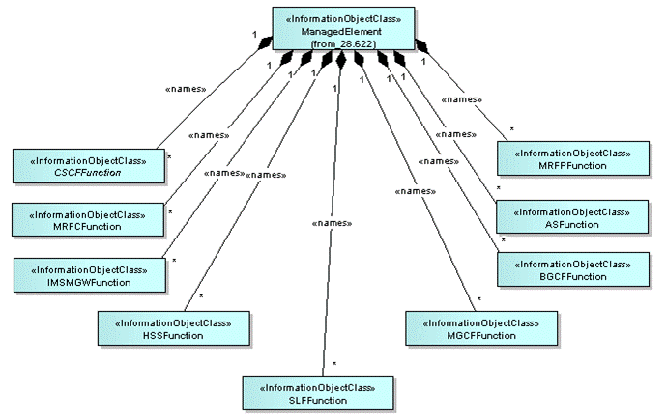

**Figure 4.2.1.1: IMS NRM Containment/Naming relationships**

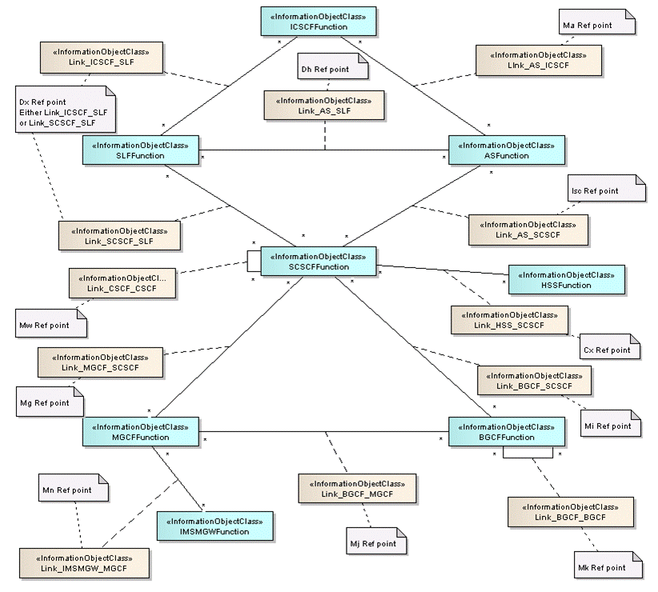

Note: If this NRM has interfaces (Link IOCs) modelled to IOCs in other NRM(s), the Link IOC definitions may be defined in the other NRM(s) and need to be considered in implementations.

**Figure 4.2.1.2: IMS NRM Link Associations 1**

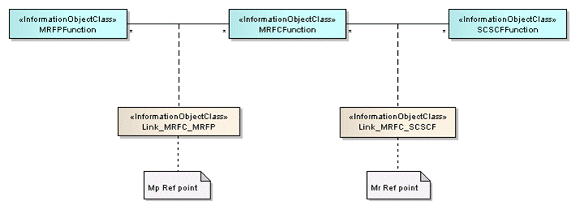

**Figure 4.2.1.3: IMS NRM Link Associations 2**

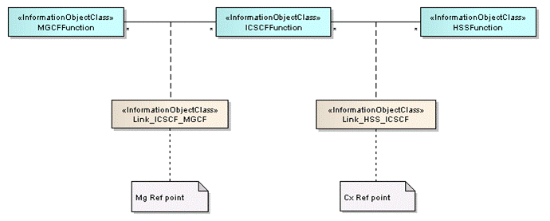

**Figure 4.2.1.4: IMS NRM Link Associations 3**

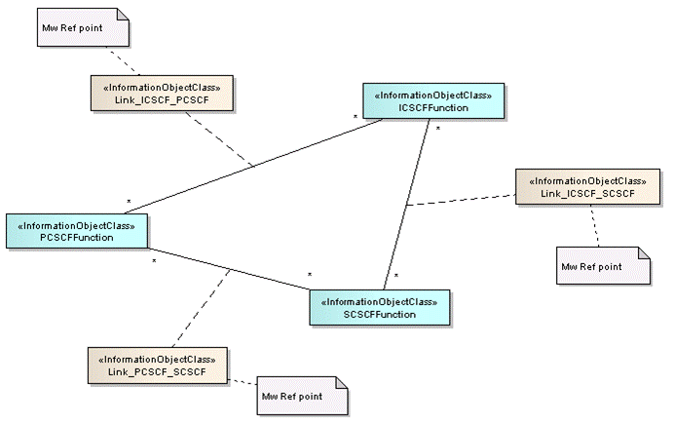

**Figure 4.2.1.5: IMS NRM Link Associations 4**

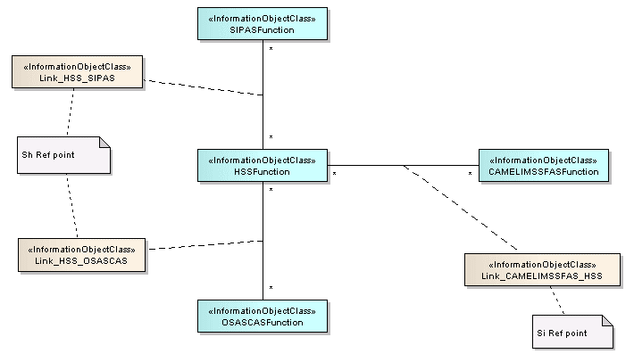

**Figure 4.2.1.6: IMS NRM Link Associations 5**

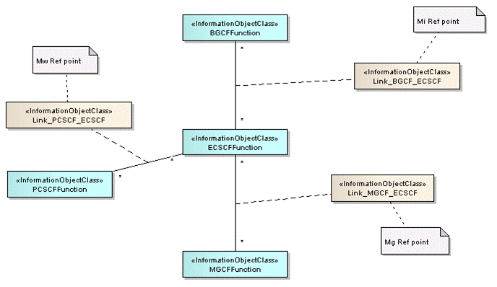

Figure 4.2.1.7: IMS NRM Link Associations 6

### 4.2.2 Inheritance

This clause depicts the inheritance relationships that exist between IOCs.

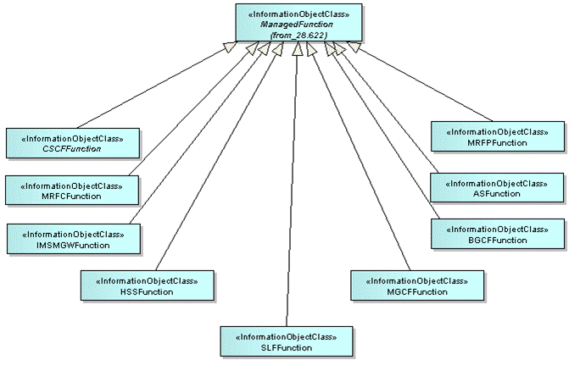

Figure 4.2.2.1: IMS NRM Inheritance Hierarchy 1

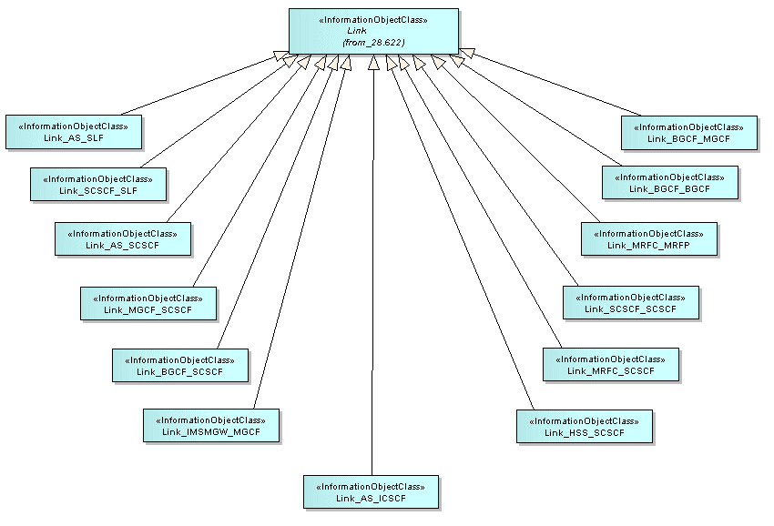

Figure 4.2.2.2: IMS NRM Inheritance Hierarchy 2

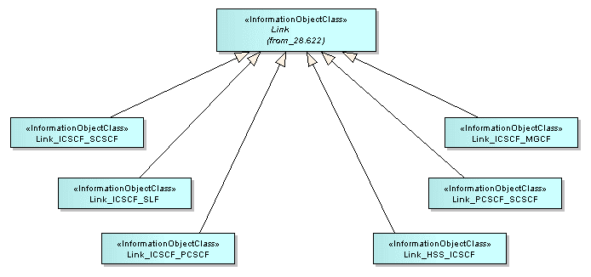

Figure 4.2.2.3: IMS NRM Inheritance Hierarchy 3

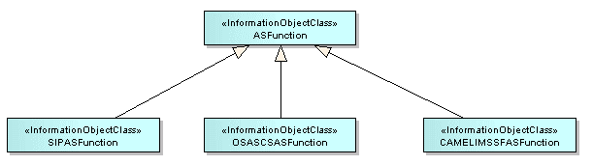

Figure 4.2.2.4: IMS NRM Inheritance Hierarchy 4

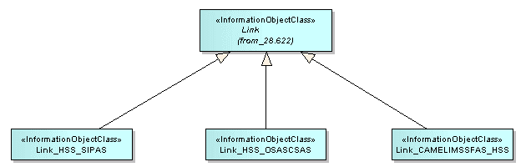

Figure 4.2.2.5: IMS NRM Inheritance Hierarchy 5

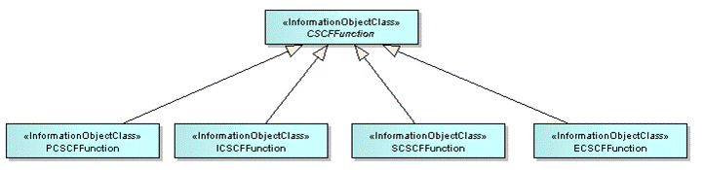

Figure 4.2.2.6: IMS NRM Inheritance Hierarchy 6

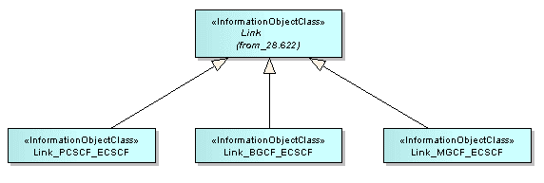

Figure 4.2.2.7: IMS NRM Inheritance Hierarchy 7

## 4.3 Class definitions

### 4.3.1 ASFunction

#### 4.3.1.1 Definition

This IOC represents AS functionality. For more information about the AS, see 3GPP TS 23.002 [8]. ASFunction may be instantiated when a specific Application Server type is not already represented with an IOC subclassed from this IOC in this specification. If the Application Server type is already represented by an IOC in this specification, then it should instead be used. In the case a subclassed IOC is utilized, the ASFunction relationships (including link objects) are carried forward to the sub-classed IOC through inheritance.

#### 4.3.1.2 Attributes

|  |  |  |  |  |  |
| --- | --- | --- | --- | --- | --- |
| Attribute Name | Support Qualifier | isReadable | isWritable | isInvariant | isNotifyable |
| linkList | O | M | - | - | M |

#### 4.3.1.3 Attribute constraints

There is no attribute constraint defined.

#### 4.3.1.4 Notifications

The common notifications defined in subclause 4.6 are valid for this IOC, without exceptions or additions.

### 4.3.2 BGCFFunction

#### 4.3.2.1 Definition

This IOC represents BGCF functionality. For more information about the BGCF, see 3GPP TS 23.002 [8].

#### 4.3.2.2 Attributes

|  |  |  |  |  |  |
| --- | --- | --- | --- | --- | --- |
| Attribute Name | Support Qualifier | isReadable | isWritable | isInvariant | isNotifyable |
| linkList | O | M | - | - | M |

#### 4.3.2.3 Attribute constraints

There is no attribute constraint defined.

#### 4.3.2.4 Notifications

The common notifications defined in subclause 4.6 are valid for this IOC, without exceptions or additions.

### 4.3.3 CAMELIMSSFASFunction

#### 4.3.3.1 Definition

This IOC represents CAMEL IM-SSF AS functionality. For more information about the CAMEL IM-SSF AS, see 3GPP TS 23.002 [8].

#### 4.3.3.2 Attributes

None.

#### 4.3.3.3 Attribute constraints

There is no attribute constraint defined.

#### 4.3.3.4 Notifications

The common notifications defined in subclause 4.6 are valid for this IOC, without exceptions or additions.

### 4.3.4 CSCFFunction

#### 4.3.4.1 Definition

This IOC represents CSCF functionality. For more information about the CSCF, see 3GPP TS 23.002 [8].

This IOC cannot be instantiated. It is defined for sub-classing purposes.

#### 4.3.4.2 Attributes

|  |  |  |  |  |  |
| --- | --- | --- | --- | --- | --- |
| Attribute Name | Support Qualifier | isReadable | isWritable | isInvariant | isNotifyable |
| linkList | O | M | - | - | M |

#### 4.3.4.3 Attribute constraints

There is no attribute constraint defined.

#### 4.3.4.4 Notifications

The common notifications defined in subclause 4.6 are valid for this IOC, without exceptions or additions.

### 4.3.5 HSSFunction

#### 4.3.5.1 Definition

This IOC represents HSS functionality. For more information about the HSS, see 3GPP TS 23.002 [8].

#### 4.3.5.2 Attributes

|  |  |  |  |  |  |
| --- | --- | --- | --- | --- | --- |
| Attribute Name | Support Qualifier | isReadable | isWritable | isInvariant | isNotifyable |
| linkList | O | M | - | - | M |

#### 4.3.5.3 Attribute constraints

There is no attribute constraint defined.

#### 4.3.5.4 Notifications

The common notifications defined in subclause 4.6 are valid for this IOC, without exceptions or additions.

### 4.3.6 ICSCFFunction

#### 4.3.6.1 Definition

This IOC represents I-CSCF functionality. For more information about the I-CSCF, see 3GPP TS 23.002 [8].

#### 4.3.6.2 Attributes

None.

#### 4.3.6.3 Attribute constraints

There is no attribute constraint defined.

#### 4.3.6.4 Notifications

The common notifications defined in subclause 4.6 are valid for this IOC, without exceptions or additions.

### 4.3.7 IMSMGWFunction

#### 4.3.7.1 Definition

This IOC represents IMS-MGW functionality. For more information about IMS-MGW, see 3GPP TS 23.002 [8].

#### 4.3.7.2 Attributes

|  |  |  |  |  |  |
| --- | --- | --- | --- | --- | --- |
| Attribute Name | Support Qualifier | isReadable | isWritable | isInvariant | isNotifyable |
| linkList | O | M | - | - | M |

#### 4.3.7.3 Attribute constraints

There is no attribute constraint defined.

#### 4.3.7.4 Notifications

The common notifications defined in subclause 4.6 are valid for this IOC, without exceptions or additions.

### 4.3.8 MGCFFunction

#### 4.3.8.1 Definition

This IOC represents MGCF functionality. For more information about the MGCF, see 3GPP TS 23.002 [8].

#### 4.3.8.2 Attributes

|  |  |  |  |  |  |
| --- | --- | --- | --- | --- | --- |
| Attribute Name | Support Qualifier | isReadable | isWritable | isInvariant | isNotifyable |
| linkList | O | M | - | - | M |

#### 4.3.8.3 Attribute constraints

There is no attribute constraint defined.

#### 4.3.8.4 Notifications

The common notifications defined in subclause 4.6 are valid for this IOC, without exceptions or additions.

### 4.3.9 MRFCFunction

#### 4.3.9.1 Definition

This IOC represents MRFC functionality. For more information about the MRFC, see 3GPP TS 23.002 [8].

#### 4.3.9.2 Attributes

|  |  |  |  |  |  |
| --- | --- | --- | --- | --- | --- |
| Attribute Name | Support Qualifier | isReadable | isWritable | isInvariant | isNotifyable |
| linkList | O | M | - | - | M |

#### 4.3.9.3 Attribute constraints

There is no attribute constraint defined.

#### 4.3.9.4 Notifications

The common notifications defined in subclause 4.6 are valid for this IOC, without exceptions or additions.

### 4.3.10 MRFPFunction

#### 4.3.10.1 Definition

This IOC represents MRFP functionality. For more information about the MRFP, see 3GPP TS 23.002 [8].

#### 4.3.10.2 Attributes

|  |  |  |  |  |  |
| --- | --- | --- | --- | --- | --- |
| Attribute Name | Support Qualifier | isReadable | isWritable | isInvariant | isNotifyable |
| linkList | O | M | - | - | M |

#### 4.3.10.3 Attribute constraints

There is no attribute constraint defined.

#### 4.3.10.4 Notifications

The common notifications defined in subclause 4.6 are valid for this IOC, without exceptions or additions.

### 4.3.11 OSASCSASFunction

#### 4.3.11.1 Definition

This IOC represents OSA Application Server (Service Capability Server) functionality. For more information about the OSA Service Capability Server, see 3GPP TS 23.002 [8].

#### 4.3.11.2 Attributes

None.

#### 4.3.11.3 Attribute constraints

There is no attribute constraint defined.

#### 4.3.11.4 Notifications

There is no notification defined.

### 4.3.12 PCSCFFunction

#### 4.3.12.1 Definition

This IOC represents P-CSCF functionality. For more information about the P-CSCF, see 3GPP TS 23.002 [8].

#### 4.3.12.2 Attributes

None.

#### 4.3.12.3 Attribute constraints

There is no attribute constraint defined.

#### 4.3.12.4 Notifications

The common notifications defined in subclause 4.6 are valid for this IOC, without exceptions or additions.

### 4.3.13 SCSFFunction

#### 4.3.13.1 Definition

This IOC represents S-CSCF functionality. For more information about the S-CSCF, see 3GPP TS 23.002 [8].

#### 4.3.13.2 Attributes

None.

#### 4.3.13.3 Attribute constraints

There is no attribute constraint defined.

#### 4.3.13.4 Notifications

The common notifications defined in subclause 4.6 are valid for this IOC, without exceptions or additions.

### 4.3.14 SIPASFunction

#### 4.3.14.1 Definition

This IOC represents SIP AS functionality. For more information about the SIP AS, see 3GPP TS 23.002 [8].

#### 4.3.14.2 Attributes

None.

#### 4.3.14.3 Attribute constraints

There is no attribute constraint defined.

#### 4.3.14.4 Notifications

There is no notification defined.

### 4.3.15 SLFFunction

#### 4.3.15.1 Definition

This IOC represents SLF functionality. For more information about the SLF, see 3GPP TS 23.002 [8].

#### 4.3.15.2 Attributes

|  |  |  |  |  |  |
| --- | --- | --- | --- | --- | --- |
| Attribute Name | Support Qualifier | isReadable | isWritable | isInvariant | isNotifyable |
| linkList | O | M | - | - | M |

#### 4.3.15.3 Attribute constraints

There is no attribute constraint defined.

#### 4.3.15.4 Notifications

The common notifications defined in subclause 4.6 are valid for this IOC, without exceptions or additions.

### 4.3.16 ECSCFFunction

#### 4.3.16.1 Definition

This IOC represents E-CSCF functionality. For more information about the E-CSCF, see 3GPP TS 23.002 [8].

#### 4.3.16.2 Attributes

None.

#### 4.3.16.3 Attribute constraints

There is no attribute constraint defined.

#### 4.3.16.4 Notifications

The common notifications defined in subclause 4.6 are valid for this IOC, without exceptions or additions.

### 4.3.17 Link_AS_ICSCF

#### 4.3.17.1 Definition

This IOC models the Ma reference point as defined in TS 23.002 [8].

#### 4.3.17.2 Attributes

None.

#### 4.3.17.3 Attribute constraints

There is no attribute constraint defined.

#### 4.3.17.4 Notifications

The common notifications defined in subclause 4.6 are valid for this IOC, without exceptions or additions.

### 4.3.18 Link_AS_SCSCF

#### 4.3.18.1 Definition

This IOC models the Isc reference point as defined in TS 23.002 [8].

#### 4.3.18.2 Attributes

None.

#### 4.3.18.3 Attribute constraints

There is no attribute constraint defined.

#### 4.3.18.4 Notifications

The common notifications defined in subclause 4.6 are valid for this IOC, without exceptions or additions.

### 4.3.19 Link_AS_SLF

#### 4.3.19.1 Definition

This models the Dh reference point as defined in TS 23.002 [8].

#### 4.3.19.2 Attributes

None.

#### 4.3.19.3 Attribute constraints

There is no attribute constraint defined.

#### 4.3.19.4 Notifications

The common notifications defined in subclause 4.6 are valid for this IOC, without exceptions or additions.

### 4.3.20 Link_BGCF_BGCF

#### 4.3.20.1 Definition

This models the Mk reference point as defined in TS 23.002 [8].

#### 4.3.20.2 Attributes

None.

#### 4.3.20.3 Attribute constraints

There is no attribute constraint defined.

#### 4.3.20.4 Notifications

The common notifications defined in subclause 4.6 are valid for this IOC, without exceptions or additions.

### 4.3.21 Link_BGCF_MGCF

#### 4.3.21.1 Definition

This models the Mj reference point as defined in TS 23.002 [8].

#### 4.3.21.2 Attributes

None.

#### 4.3.21.3 Attribute constraints

There is no attribute constraint defined.

#### 4.3.21.4 Notifications

The common notifications defined in subclause 4.6 are valid for this IOC, without exceptions or additions.

### 4.3.22 Link_BGCF_SCSCF

#### 4.3.22.1 Definition

This models the Mi reference point as defined in TS 23.002 [8].

#### 4.3.22.2 Attributes

None.

#### 4.3.22.3 Attribute constraints

There is no attribute constraint defined.

#### 4.3.22.4 Notifications

The common notifications defined in subclause 4.6 are valid for this IOC, without exceptions or additions.

### 4.3.23 Link_HSS_ICSCF

#### 4.3.23.1 Definition

This IOC models the Cx reference point as defined in TS 23.002 [8].

#### 4.3.23.2 Attributes

None.

#### 4.3.23.3 Attribute constraints

There is no attribute constraint defined.

#### 4.3.23.4 Notifications

The common notifications defined in subclause 4.6 are valid for this IOC, without exceptions or additions.

### 4.3.24 Link_ICSCF_SCSCF

#### 4.3.24.1 Definition

This models the Mw reference point as defined in TS 23.002 [8].

#### 4.3.24.2 Attributes

None.

#### 4.3.24.3 Attribute constraints

There is no attribute constraint defined.

#### 4.3.24.4 Notifications

The common notifications defined in subclause 4.6 are valid for this IOC, without exceptions or additions.

### 4.3.25 Link_ICSCF_MGCF

#### 4.3.25.1 Definition

This IOC models the Mg reference point as defined in TS 23.002 [8].

#### 4.3.25.2 Attributes

None.

#### 4.3.25.3 Attribute constraints

There is no attribute constraint defined.

#### 4.3.25.4 Notifications

The common notifications defined in subclause 4.6 are valid for this IOC, without exceptions or additions.

### 4.3.26 Link_ICSCF_PCSCF

#### 4.3.26.1 Definition

This models the Mw reference point as defined in TS 23.002 [8].

#### 4.3.26.2 Attributes

None.

#### 4.3.26.3 Attribute constraints

There is no attribute constraint defined.

#### 4.3.26.4 Notifications

The common notifications defined in subclause 4.6 are valid for this IOC, without exceptions or additions.

### 4.3.27 Link_PCSCF_SCSCF

#### 4.3.27.1 Definition

This models the Mw reference point as defined in TS 23.002 [8].

#### 4.3.27.2 Attributes

None.

#### 4.3.27.3 Attribute constraints

There is no attribute constraint defined.

#### 4.3.27.4 Notifications

The common notifications defined in subclause 4.6 are valid for this IOC, without exceptions or additions.

### 4.3.28 Link_CAMELIMSSFAS_HSS

#### 4.3.28.1 Definition

This IOC models the Si reference point between CAMEL Application Server (IM-SSF) and HSS as defined in TS 23.002 [8].

#### 4.3.28.2 Attributes

None.

#### 4.3.28.3 Attribute constraints

There is no attribute constraint defined.

#### 4.3.28.4 Notifications

The common notifications defined in subclause 4.6 are valid for this IOC, without exceptions or additions.

### 4.3.29 Link_HSS_OSASCSAS

#### 4.3.29.1 Definition

This IOC models the Sh reference point between OSA Application Server (Service Capability Server) and HSS as defined in TS 23.002 [8].

#### 4.3.29.2 Attributes

None.

#### 4.3.29.3 Attribute constraints

There is no attribute constraint defined.

#### 4.3.29.4 Notifications

The common notifications defined in subclause 4.6 are valid for this IOC, without exceptions or additions.

### 4.3.30 Link_HSS_SCSCF

#### 4.3.30.1 Definition

This IOC models the Cx reference point as defined in TS 23.002 [8].

#### 4.3.30.2 Attributes

None.

#### 4.3.30.3 Attribute constraints

There is no attribute constraint defined.

#### 4.3.30.4 Notifications

The common notifications defined in subclause 4.6 are valid for this IOC, without exceptions or additions.

### 4.3.31 Link_HSS_SIPAS

#### 4.3.31.1 Definition

This IOC models the Sh reference point between SIP Application Server and HSS as defined in TS 23.002 [8].

#### 4.3.31.2 Attributes

None.

#### 4.3.31.3 Attribute constraints

There is no attribute constraint defined.

#### 4.3.31.4 Notifications

The common notifications defined in subclause 4.6 are valid for this IOC, without exceptions or additions.

### 4.3.32 Link_ICSCF_SLF

#### 4.3.32.1 Definition

This models the Dx reference point as defined in TS 23.002 [8].

#### 4.3.32.2 Attributes

None.

#### 4.3.32.3 Attribute constraints

There is no attribute constraint defined.

#### 4.3.32.4 Notifications

The common notifications defined in subclause 4.6 are valid for this IOC, without exceptions or additions.

### 4.3.33 Link_IMSMGW_MGCF

#### 4.3.33.1 Definition

This models the Mn reference point as defined in TS 23.002 [8].

#### 4.3.33.2 Attributes

None.

#### 4.3.33.3 Attribute constraints

There is no attribute constraint defined.

#### 4.3.33.4 Notifications

The common notifications defined in subclause 4.6 are valid for this IOC, without exceptions or additions.

### 4.3.34 Link_MGCF_SCSCF

#### 4.3.34.1 Definitions

This models the Mg reference point as defined in TS 23.002 [8].

#### 4.3.34.2 Attributes

None.

#### 4.3.34.3 Attribute constraints

There is no attribute constraint defined.

#### 4.3.34.4 Notifications

The common notifications defined in subclause 4.6 are valid for this IOC, without exceptions or additions.

### 4.3.35 Link_MRFC_MRFP

#### 4.3.35.1 Definition

This IOC models the Mp reference point as defined in TS 23.002 [8].

#### 4.3.35.2 Attributes

None.

#### 4.3.35.3 Attribute constraints

There is no attribute constraint defined.

#### 4.3.35.4 Notifications

The common notifications defined in subclause 4.6 are valid for this IOC, without exceptions or additions.

### 4.3.36 Link_MRFC_SCSCF

#### 4.3.36.1 Definition

This IOC models the Mr reference point as defined in TS 23.002 [8].

#### 4.3.36.2 Attributes

None.

#### 4.3.36.3 Attribute constraints

There is no attribute constraint defined.

#### 4.3.36.4 Notifications

The common notifications defined in subclause 4.6 are valid for this IOC, without exceptions or additions.

### 4.3.37 Link_SCSCF_SCSCF

#### 4.3.37.1 Definition

This models the Mw reference point as defined in TS 23.002 [8].

#### 4.3.37.2 Attributes

None.

#### 4.3.37.3 Attribute constraints

There is no attribute constraint defined.

#### 4.3.37.4 Notifications

The common notifications defined in subclause 4.6 are valid for this IOC, without exceptions or additions.

### 4.3.38 Link_SCSCF_SLF

#### 4.3.38.1 Definition

This IOC models the Dx reference point as defined in TS 23.002 [8].

#### 4.3.38.2 Attributes

None.

#### 4.3.38.3 Attribute constraints

There is no attribute constraint defined.

#### 4.3.38.4 Notifications

The common notifications defined in subclause 4.6 are valid for this IOC, without exceptions or additions.

### 4.3.39 Link_PCSCF_ECSCF

#### 4.3.39.1 Definition

This IOC models the Mw reference point as defined in TS 23.002 [8].

#### 4.3.39.2 Attributes

None.

#### 4.3.39.3 Attribute constraints

There is no attribute constraint defined.

#### 4.3.39.4 Notifications

The common notifications defined in subclause 4.6 are valid for this IOC, without exceptions or additions.

### 4.3.40 Link_BGCF_ECSCF

#### 4.3.40.1 Definition

This IOC models the Mi reference point as defined in TS 23.002 [8].

#### 4.3.40.2 Attributes

None.

#### 4.3.40.3 Attribute constraints

There is no attribute constraint defined.

#### 4.3.40.4 Notifications

The common notifications defined in subclause 4.6 are valid for this IOC, without exceptions or additions.

### 4.3.41 Link_MGCF_ECSCF

#### 4.3.41.1 Definition

This IOC models the Mg reference point as defined in TS 23.002 [8].

#### 4.3.41.2 Attributes

None.

#### 4.3.41.3 Attribute constraints

There is no attribute constraint defined.

#### 4.3.41.4 Notifications

The common notifications defined in subclause 4.6 are valid for this IOC, without exceptions or additions.

## 4.4 Attribute definitions

### 4.4.1 Attribute properties

| Attribute Name | Documentation and Allowed Values | Properties |
| --- | --- | --- |
| linkList | An attribute containing all of the related link object Distinguished Names for the object instance, if any.  allowedValues: N/A | type: DN  multiplicity: 0..*  isOrdered: False  isUnique: True  defaultValue: No default value  isNullable: True |

### 4.4.2 Constraints

None.

## 4.5 Common notifications

### 4.5.1 Alarm notifications

This clause presents a list of notifications, defined in [5], that IRPManager can receive. The notification header attribute objectClass/objectInstance, defined in [14], would capture the DN of an instance of an IOC defined in this IRP specification.

| Name | Qualifier | Notes |
| --- | --- | --- |
| notifyAckStateChanged | See Alarm IRP (3GPP TS 32.111-2 [5]) |  |
| notifyChangedAlarm | See Alarm IRP (3GPP TS 32.111-2 [5]) |  |
| notifyClearedAlarm | See Alarm IRP (3GPP TS 32.111-2 [5]) |  |
| notifyNewAlarm | See Alarm IRP (3GPP TS 32.111-2 [5]) |  |
| notifyComments | See Alarm IRP (3GPP TS 32.111-2 [5]) |  |
| notifyAlarmListRebuilt | See Alarm IRP (3GPP TS 32.111-2 [5]) |  |
| notifyPotentialFaultyAlarmList | See Alarm IRP (3GPP TS 32.111-2 [5]) |  |

### Configuration notifications

This clause presents a list of notifications, defined in [3], that IRPManager can receive. The notification header attribute objectClass/objectInstance, defined in [14], would capture the DN of an instance of an IOC defined in this IRP specification.

| Name | Qualifier | Notes |
| --- | --- | --- |
| notifyAttributeValueChange | O |  |
| notifyObjectCreation | O |  |
| notifyObjectDeletion | O |  |

Annex A (informative):  
Change history

|  |  |  |  |  |  |  |  |  |
| --- | --- | --- | --- | --- | --- | --- | --- | --- |
| **Change history** | | | | | | | | |
| **Date** | **TSG #** | **TSG Doc.** | **CR** | **R** | **Subject/Comment** | **Cat** | **Old** | **New** |
| Jun-2013 | SA#60 | SP-130304 | 001 | 2 | Elimination of ambiguities in the TS | F | 11.0.0 | 11.1.0 |
| Jun-2014 | SA#64 | SP-140360 | 002 | - | remove the feature support statements | F | 11.1.0 | 11.2.0 |
| 2014-10 | - | - | - | - | Update to Rel-12 version (MCC) |  | 11.2.0 | **12.0.0** |
| 2016-01 | - | - | - | - | Update to Rel-13 version (MCC) |  | 12.0.0 | **13.0.0** |
| 2017-03 | SA#75 | - | - | - | Promotion to Release 14 without technical change |  | 13.0.0 | **14.0.0** |

|  |  |  |  |  |  |  |  |
| --- | --- | --- | --- | --- | --- | --- | --- |
| **Change history** | | | | | | | |
| **Date** | **Meeting** | **TDoc** | **CR** | **Rev** | **Cat** | **Subject/Comment** | **New version** |
| 2018-06 |  |  |  |  |  | Update to Rel-15 version (MCC) | 15.0.0 |
| 2020-07 | - | - | - | - | - | Update to Rel-16 version (MCC) | **16.0.0** |