3GPP TS 28.735 V16.0.0 (2020-07)

Technical Specification

3rd Generation Partnership Project;

Technical Specification Group Services and System Aspects;

Telecommunication management;

Signalling Transport Network (STN) interface

Network Resource Model (NRM)

Integration Reference Point (IRP);

Information Service (IS)

(Release 16)

* *

The present document has been developed within the 3rd Generation Partnership Project (3GPP TM) and may be further elaborated for the purposes of 3GPP.   
The present document has not been subject to any approval process by the 3GPPOrganizational Partners and shall not be implemented.   
This Specification is provided for future development work within 3GPPonly. The Organizational Partners accept no liability for any use of this Specification.  
Specifications and reports for implementation of the 3GPP TM system should be obtained via the 3GPP Organizational Partners" Publications Offices.

Keywords

UMTS, Network, Management, FMC

***3GPP***

Postal address

3GPP support office address

650 Route des Lucioles - Sophia Antipolis

Valbonne - FRANCE

Tel.: +33 4 92 94 42 00 Fax: +33 4 93 65 47 16

Internet

http://www.3gpp.org

***Copyright Notification***

No part may be reproduced except as authorized by written permission.  
The copyright and the foregoing restriction extend to reproduction in all media.

© 2020, 3GPP Organizational Partners (ARIB, ATIS, CCSA, ETSI, TSDSI, TTA, TTC).

All rights reserved.

UMTS™ is a Trade Mark of ETSI registered for the benefit of its members

3GPP™ is a Trade Mark of ETSI registered for the benefit of its Members and of the 3GPP Organizational Partners  
LTE™ is a Trade Mark of ETSI registered for the benefit of its Members and of the 3GPP Organizational Partners

GSM® and the GSM logo are registered and owned by the GSM Association

Contents

Foreword 5

Introduction 5

1 Scope 6

2 References 6

3 Definitions and abbreviations 7

3.1 Definitions 7

3.2 Abbreviations 8

4 Model 9

4.1 Imported information entities and local labels 9

4.2 Class diagram 9

4.2.1 Relationships 9

4.2.2 Inheritance 11

4.3 Class definitions 12

4.3.1 MtpSignPoint 12

4.3.1.1 Definition 12

4.3.1.2 Attributes 12

4.3.1.3 Attribute constraints 12

4.3.1.4 Notifications 12

4.3.2 SignLinkSetTp 12

4.3.2.1 Definition 12

4.3.2.2 Attributes 13

4.3.2.3 Attribute constraints 13

4.3.2.4 Notifications 13

4.3.3 SignLinkTp 13

4.3.3.1 Definition 13

4.3.3.2 Attributes 13

4.3.3.3 Attribute constraints 13

4.3.3.4 Notifications 13

4.3.4 SignRouteSetNePart 13

4.3.4.1 Definition 13

4.3.4.2 Attributes 13

4.3.4.3 Attribute constraints 14

4.3.4.4 Notifications 14

4.3.5 SignRouteNePart 14

4.3.5.1 Definition 14

4.3.5.2 Attributes 14

4.3.5.3 Attribute constraints 14

4.3.5.4 Notifications 14

4.3.6 M3UAEntity 14

4.3.6.1 Definition 14

4.3.6.2 Attributes 14

4.3.6.3 Attribute constraints 14

4.3.6.4 Notifications 14

4.3.7 M3UALinkSetTp 15

4.3.7.1 Definition 15

4.3.7.2 Attributes 15

4.3.7.3 Attribute constraints 15

4.3.7.4 Notifications 15

4.3.8 M3UALinkTp 15

4.3.8.1 Definition 15

4.3.8.2 Attributes 15

4.3.8.3 Attribute constraints 15

4.3.8.4 Notifications 15

4.3.9 M3UARouteSetNePart 15

4.3.9.1 Definition 15

4.3.9.2 Attributes 16

4.3.9.3 Attribute constraints 16

4.3.9.4 Notifications 16

4.3.10 M3UARouteNePart 16

4.3.10.1 Definition 16

4.3.10.2 Attributes 16

4.3.10.3 Attribute constraints 16

4.3.10.4 Notifications 16

4.4 Attribute definitions 17

4.4.1 Attribute properties 17

4.4.2 Constraints 19

4.5 Common notifications 19

4.5.1 Alarm notifications 19

4.5.2 Configuration notifications 19

Annex A (informative): Change history 20

# Foreword

This Technical Specification has been produced by the 3rd Generation Partnership Project (3GPP).

The contents of the present document are subject to continuing work within the TSG and may change following formal TSG approval. Should the TSG modify the contents of the present document, it will be re-released by the TSG with an identifying change of release date and an increase in version number as follows:

Version x.y.z

where:

x the first digit:

1 presented to TSG for information;

2 presented to TSG for approval;

3 or greater indicates TSG approved document under change control.

y the second digit is incremented for all changes of substance, i.e. technical enhancements, corrections, updates, etc.

z the third digit is incremented when editorial only changes have been incorporated in the document.

# Introduction

The present document is part of a TS-family covering the 3rd Generation Partnership Project: Technical Specification Group Services and System Aspects; Telecommunication management; as identified below:

28.734: Signalling Transport Network (STN) interface Network Resource Model (NRM) Integration Reference Point (IRP); Requirements

**28.735: Signalling Transport Network (STN) interface Network Resource Model (NRM) Integration Reference Point (IRP); Information Service (IS)**

28.736: Signalling Transport Network (STN) interface Network Resource Model (NRM) Integration Reference Point (IRP); Solution Set (SS) definitions

# 1 Scope

The present document is part of an Integration Reference Point (IRP) named "Signalling Transport Network (STN) interface NRM IRP", through which an "IRPAgent" (typically an Element Manager or Network Element) can communicate Configuration Management information to one or several "IRPManagers" (typically Network Managers) concerning Signalling Transport resources. This IRP comprises a set of specifications defining Requirements, a protocol neutral Network Resource Model (NRM) and corresponding Solution Set(s).

The present document specifies the protocol neutral STN interface NRM IRP. It reuses relevant parts of the generic NRM in TS 28.622 [6], either by direct reuse or sub-classing, and in addition to that defines Signalling Transport specific Managed Object Classes.

In order to access the information defined by this NRM, an IRP IS is needed, such as the Basic CM IRP: IS (TS 32.602 [7]) or the Bulk CM IRP: IS (TS 32.612 [8]). However, which IS is applicable is outside the scope of this document.

Finally, regarding the support of the State Management IRP: IS (TS 28.625 [3]), all NRMs of one release shall support the same State Management IRP version.

# 2 References

The following documents contain provisions which, through reference in this text, constitute provisions of the present document.

- References are either specific (identified by date of publication, edition number, version number, etc.) or non‑specific.

- For a specific reference, subsequent revisions do not apply.

- For a non-specific reference, the latest version applies. In the case of a reference to a 3GPP document (including a GSM document), a non-specific reference implicitly refers to the latest version of that document *in the same Release as the present document*.

[1] 3GPP TS 32.101: "Telecommunication Management, Principles and high level requirements".

[2] 3GPP TS 32.102: "Telecommunication management; Architecture".

[3] 3GPP TS 28.625: "Telecommunication management; State Management Integration Reference Point (IRP); Information Service (IS)".

[4] 3GPP TS 32.300: "Telecommunication management; Configuration Management (CM); Name convention for Managed Objects".

[5] 3GPP TS 32.600: "Telecommunication management; Configuration Management (CM); Concept and high-level requirements".

[6] 3GPP TS 28.622: " Telecommunication management; Generic Network Resource Model (NRM) Integration Reference Point (IRP); Information Service (IS)".

[7] 3GPP TS 32.602: "Telecommunication management; Configuration Management (CM); Basic CM Integration Reference Point (IRP); Information Service (IS)".

[8] 3GPP TS 32.612: "Telecommunication management; Configuration Management (CM); Bulk CM Integration Reference Point (IRP); Information Service (IS)".

[9] ITU-T Recommendation Q.700 (03/93): "Introduction to CCITT Signalling System No.7".

[10] ITU-T Recommendation Q.751.1 (10/95): "Network Element Management Information Model for The Message Transfer Part (MTP)".

[11] ITU-T Recommendation Q.704 (07/96): "Signalling network functions and messages".

[12] 3GPP TS 32.111-2: "Telecommunication management; Fault Management (FM); Part 2: Alarm Integration Reference Point (IRP); Information Service (IS)".

[13] ITU-T Recommendation Q.702 (11/88): "Signalling Data Link".

[14] 3GPP TS 29.202: "Signalling System No. 7 (SS7) signalling transport in core network; Stage 3".

[15] 3GPP TS 25.410: "UTRAN Iu Interface: General Aspects and Principles".

[16] 3GPP TS 25.420: "UTRAN Iur interface general aspects and principles".

[17] 3GPP TS 25.430: "UTRAN Iub interface: general aspects and principles".

[18] 3GPP TS 48.018: "Base Station System (BSS)-Serving GPRS Support Node (SGSN);BSS GPRS Protocol (BSSGP)".

[19] 3GPP TS 48.008: "Mobile Switching Centre-Base Station System (MSC-BSS) interface;Layer 3 specification".

[20] 3GPP TS 28.702: "Telecommunication management; Core Network Resources Integration Reference Point (IRP); Information Service (IS)".

[21] 3GPP TS 28.652: "Telecommunication management; UTRAN Network Resource Model (NRM) Integration Reference Point (IRP); Information Service (IS)".

[22] 3GPP TS 29.060: "GPRS Tunnelling Protocol (GTP) across the Gn and Gp interface".

[23] 3GPP TS 29.002: "Mobile Application Part (MAP) specification".

[24] 3GPP TS 29.018: "Serving GPRS Support Node (SGSN)-Visitors Location Register (VLR) Gs interface layer 3 specification".

[25] 3GPP TS 28.734: "Telecommunication management; Signalling Transport Network (STN) interface Network Resource Model (NRM) Integration Reference Point (IRP); Requirements".

[26] 3GPP TS 32.150: "Telecommunication management; Integration Reference Point (IRP) Concept and definitions".

[27] ITU-T Recommendation E.600 (03/93): "Terms and Definitions of traffic engineering".

[28] IETF RFC 3332: "Signaling System 7 (SS7) Message Transfer Part 3 (MTP3) - User Adaptation Layer (M3UA)".

[29] IETF RFC 2960: "Stream Control Transmission Protocol (SCTP)".

[30] IETF RFC 3873: "Stream Control Transmission Protocol (SCTP); Management Information Base (MIB)".

[31] 3GPP TS 28.620: "Fixed Mobile Convergence (FMC) Federated Network Information Model (FNIM) Umbrella Information Model (UIM)".

# 3 Definitions and abbreviations

## 3.1 Definitions

For the purposes of the present document, the terms and definitions in 3GPP TS 32.101 [1], 32.102 [2], 32.600 [5], 28.734 [25] and the following apply:

**Association**: See definition in TS 28.622 [6].

**Managed Element (ME)**: See definition in TS 28.622 [6].

**Managed Object (MO)**: See definition in TS 28.622 [6].

**Management Information Model (MIM)**: See definition in TS 28.622 [6].

**Network Resource Model (NRM)**: See definition in TS 28.622 [6].

## 3.2 Abbreviations

For the purposes of the present document, the following abbreviations apply:

CM Configuration Management

DN Distinguished Name

IOC Information Object Class

IRP Integration Reference Point

ITU-T International Telecommunication Union, Telecommunication Standardisation Sector

ME Managed Element

MIM Management Information Model

MO Managed Object

MTP Message Transfer Part

NE Network Element

NRM Network Resource Model

RDN Relative Distinguished Name

SLC Signalling Link Code

SLS Signalling Link Selection

SP Signalling Point

STN Signalling Transport Network

STP Signalling Transfer Point

TP Termination Point

UML Unified Modelling Language

# 4 Model

## 4.1 Imported information entities and local labels

|  |  |
| --- | --- |
| Label reference | Local label |
| TS 28.620 [31], information object class, *Top_* | *Top_* |
| TS 28.622 [6], information object class, ManagedElement | ManagedElement |
| TS 28.622 [6], information object class, *ManagedFunction* | *ManagedFunction* |
| TS 28.622 [6], information object class, VsDataContainer | VsDataContainer |

## 4.2 Class diagram

### 4.2.1 Relationships

This clause depicts the set of classes (e.g. IOCs) that encapsulates the information relevant for this IRP. This clause provides the overview of the relationships of relevant classes in UML. Subsequent clauses provide more detailed specification of various aspects of these classes.

The figure below shows the name-containment relation and other types of relations of the STN NRM.

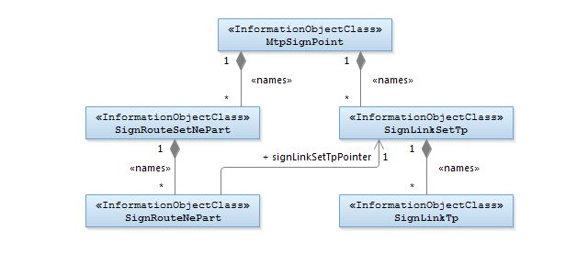

Figure 4.2.1-1 : Signalling Transport Network NRM Containment/Naming and Association diagram 1

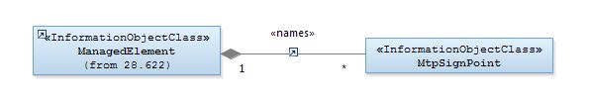

Figure 4.2.1-2 : Signalling Transport Network NRM Containment/Naming and Association diagram 2

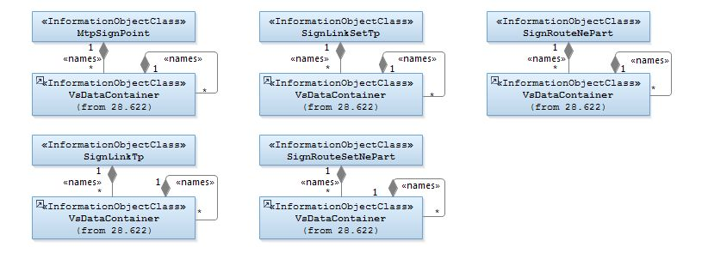

Figure 4.2.1-3 : VsDataContainer Containment/Naming and Association in STN NRM diagram

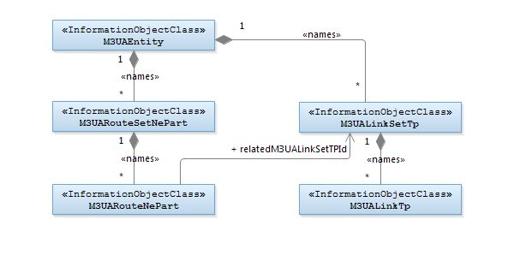

Figure 4.2.1-4: M3UA view of STN NRM Containment/Naming and Association diagram 1

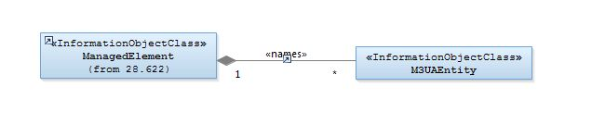

Figure 4.2.1-5: M3UA view of STN NRM Containment/Naming and Association diagram 2

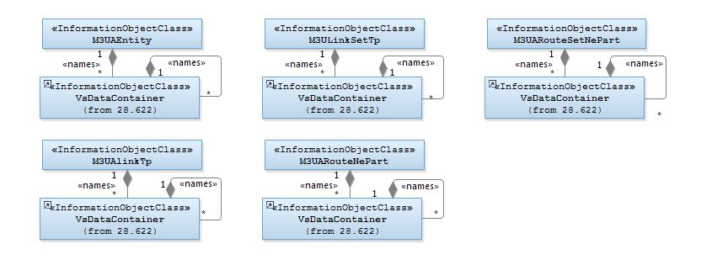

Figure 4.2.1-6: VsDataContainer Containment/Naming and Association in M3UA STN NRM diagram

### 4.2.2 Inheritance

This clause depicts the inheritance relationships that exist between IOCs.

The following figure shows the inheritance hierarchy for the STN NRM.

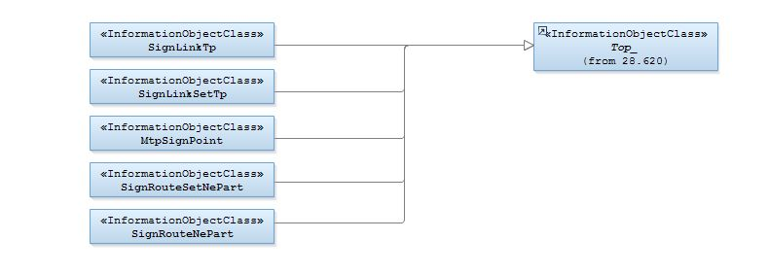

Figure 4.2.2-1 : Signalling Transport Network NRM Inheritance Hierarchy

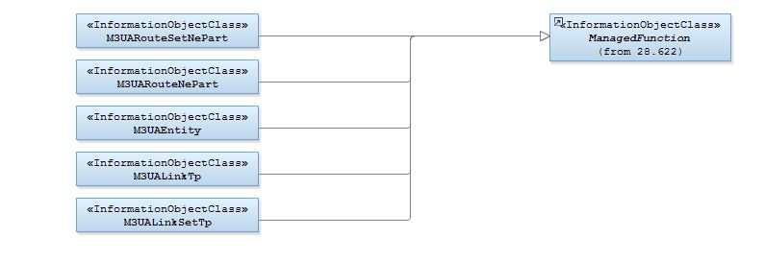

Figure 4.2.2-2: M3UA view of Signalling Transport Network Resource Model Inheritance Hierarchy

## 4.3 Class definitions

### 4.3.1 MtpSignPoint

#### 4.3.1.1 Definition

This IOC represents the Signalling Point functionality. For more information about the Signalling Point, see ITU‑T Q.700 [9] and ITU‑T Q.751.1 [10].

#### 4.3.1.2 Attributes

|  |  |  |  |  |  |
| --- | --- | --- | --- | --- | --- |
| Attribute Name | Support Qualifier | isReadable | isWritable | isInvariant | isNotifyable |
| pointCode | M | M | - | - | M |
| networkIndicator | M | M | - | - | M |
| pointCodeLength | M | M | - | - | M |
| spType | M | M | - | - | M |
| userLabel | M | M | M | - | M |

#### 4.3.1.3 Attribute constraints

None.

#### 4.3.1.4 Notifications

The common notifications defined in subclause 4.5 are valid for this IOC, without exceptions or additions.

### 4.3.2 SignLinkSetTp

#### 4.3.2.1 Definition

This IOC represents a bi-directional Signalling Link Set Termination Point functionality.   
For more information about the Signalling Link Set Termination Point, see ITU‑T Q.700 [9] and ITU‑T Q.751.1 [10].

#### 4.3.2.2 Attributes

|  |  |  |  |  |  |
| --- | --- | --- | --- | --- | --- |
| Attribute name | Support Qualifier | isReadable | isWritable | isInvariant | isNotifyable |
| adjPc | M | M | - | - | M |
| userLabel | M | M | M | - | M |
| maxCapacityLS | M | M | - | - | M |

#### 4.3.2.3 Attribute constraints

None.

#### 4.3.2.4 Notifications

The common notifications defined in subclause 4.5 are valid for this IOC, without exceptions or additions.

### 4.3.3 SignLinkTp

#### 4.3.3.1 Definition

This IOC represents a bi-directional Signalling Link Termination Point functionality.   
For more information about the Signalling Link Termination Point, see ITU‑T Q.700 [9] and ITU‑T Q.751.1 [10].

#### 4.3.3.2 Attributes

|  |  |  |  |  |  |
| --- | --- | --- | --- | --- | --- |
| Attribute name | Support Qualifier | isReadable | isWritable | isInvariant | isNotifyable |
| slCode | M | M | - | - | M |
| slsCodeNormalList | O | M | - | - | M |
| slsCodeCurrentList | M | M | - | - | M |
| linkTpStatus | M | M | - | - | M |
| maxCapacitySL | M | M | - | - | M |
| userLabel | M | M | M | - | M |
| signLinkType | M | M | - | - | M |

#### 4.3.3.3 Attribute constraints

None.

#### 4.3.3.4 Notifications

The common notifications defined in subclause 4.5 are valid for this IOC, without exceptions or additions.

### 4.3.4 SignRouteSetNePart

#### 4.3.4.1 Definition

This IOC represents a Signalling Route Set functionality. For more information about the Signalling Route Set Network Element Part, see ITU‑T Q.700 [9] and ITU‑T Q.751.1 [10].

#### 4.3.4.2 Attributes

|  |  |  |  |  |  |
| --- | --- | --- | --- | --- | --- |
| Attribute name | Support Qualifier | isReadable | isWritable | isInvariant | isNotifyable |
| destinationPc | M | M | - | - | M |
| userLabel | M | M | M | - | M |
| loadsharingInformationRouteSetNePart | M | M | - | - | M |

#### 4.3.4.3 Attribute constraints

None.

#### 4.3.4.4 Notifications

The common notifications defined in subclause 4.5 are valid for this IOC, without exceptions or additions.

### 4.3.5 SignRouteNePart

#### 4.3.5.1 Definition

This IOC represents a Signalling Route functionality. For more information about the Signalling Route Network Element Part, see ITU‑T Q.700 [9] and ITU‑T Q.751.1 [10].

#### 4.3.5.2 Attributes

|  |  |  |  |  |  |
| --- | --- | --- | --- | --- | --- |
| Attribute name | Support Qualifier | isReadable | isWritable | isInvariant | isNotifyable |
| fixedPriority | M | M | - | - | M |
| userLabel | M | M | M | - | M |
| Attribute related to role |  |  |  |  |  |
| signLinkSetTpPointer | M | M | - | - | M |

#### 4.3.5.3 Attribute constraints

None.

#### 4.3.5.4 Notifications

The common notifications defined in subclause 4.5 are valid for this IOC, without exceptions or additions.

### 4.3.6 M3UAEntity

#### 4.3.6.1 Definition

This IOC represents a functionality entity which processes M3UA signalling. For more information about M3UA, see [14] and [28].

#### 4.3.6.2 Attributes

|  |  |  |  |  |  |
| --- | --- | --- | --- | --- | --- |
| Attribute name | Support Qualifier | isReadable | isWritable | isInvariant | isNotifyable |
| m3UAEntityPointCode | M | M | - | - | M |
| m3UAEntityType | M | M | - | - | M |
| networkIndicator | M | M | - | - | M |
| pointCodeLength | M | M | - | - | M |

#### 4.3.6.3 Attribute constraints

None.

#### 4.3.6.4 Notifications

The common notifications defined in subclause 4.5 are valid for this IOC, without exceptions or additions.

### 4.3.7 M3UALinkSetTp

#### 4.3.7.1 Definition

This IOC represents a bi-directional termination point functionality of M3UA signalling link set which is the set of M3UA signalling links between M3UA_AS and SG or between M3UA_AS and M3UA_AS. For more information about M3UA_AS and SG, see [14] and [28].

#### 4.3.7.2 Attributes

|  |  |  |  |  |  |
| --- | --- | --- | --- | --- | --- |
| Attribute name | Support Qualifier | isReadable | isWritable | isInvariant | isNotifyable |
| adjPc | M | M | - | - | M |
| trafficMode | M | M | - | - | M |

#### 4.3.7.3 Attribute constraints

None.

#### 4.3.7.4 Notifications

The common notifications defined in subclause 4.5 are valid for this IOC, without exceptions or additions.

### 4.3.8 M3UALinkTp

#### 4.3.8.1 Definition

This IOC represents a termination point functionality of M3UA signalling link which is a bi-directional M3UA logical communication channel between the particular SCTP termination points of signalling gateway process (SGP) and application server process (ASP) or the logical communication channel between the particular SCTP termination points of two IP server processes (IPSPs).

For more information about M3UA and SCTP signalling information, see [14] and [28].

#### 4.3.8.2 Attributes

|  |  |  |  |  |  |
| --- | --- | --- | --- | --- | --- |
| Attribute name | Support Qualifier | isReadable | isWritable | isInvariant | isNotifyable |
| m3UALinkTPState | M | M | - | - | M |
| sCTPAssocLocalAddr | M | M | - | - | M |
| sCTPAssocRemoteAddr | O | M | - | - | M |

#### 4.3.8.3 Attribute constraints

None.

#### 4.3.8.4 Notifications

The common notifications defined in subclause 4.5 are valid for this IOC, without exceptions or additions.

### 4.3.9 M3UARouteSetNePart

#### 4.3.9.1 Definition

This IOC represents a set of the M3UA signalling route between M3UA local entity and M3UA destination entity. For M3UA signalling information, see [14] and [28].

#### 4.3.9.2 Attributes

|  |  |  |  |  |  |
| --- | --- | --- | --- | --- | --- |
| Attribute name | Support Qualifier | isReadable | isWritable | isInvariant | isNotifyable |
| destinationPc | M | M | - | - | M |

#### 4.3.9.3 Attribute constraints

None.

#### 4.3.9.4 Notifications

The common notifications defined in subclause 4.5 are valid for this IOC, without exceptions or additions.

### 4.3.10 M3UARouteNePart

#### 4.3.10.1 Definition

This IOC represents a path between local M3UA entity and destination M3UA entity. For more information about M3UA signalling, see [14] and [28].

#### 4.3.10.2 Attributes

|  |  |  |  |  |  |
| --- | --- | --- | --- | --- | --- |
| Attribute name | Support Qualifier | isReadable | isWritable | isInvariant | isNotifyable |
| fixedPriority | M | M | - | - | M |
| Attribute related to role |  |  |  |  |  |
| relatedM3UALinkSetTPId | M | M | - | - | M |

#### 4.3.10.3 Attribute constraints

None.

#### 4.3.10.4 Notifications

The common notifications defined in subclause 4.5 are valid for this IOC, without exceptions or additions.

## 4.4 Attribute definitions

### 4.4.1 Attribute properties

| Attribute Name | Documentation and Allowed Values | Properties |
| --- | --- | --- |
| adjPc | The signalling point code information of the signalling point adjacent to the signalling link set. (Ref ITU-T Q.704 [11], Ref ITU-T Q.751.1 [10])  allowedValues: N/A | type: Integer  multiplicity: 1  isOrdered: N/A  isUnique: N/A  defaultValue: None  isNullable: False |
| destinationPc | The signalling point code information of the destination signalling point of the signalling route set. (Ref ITU-T Q.704 [11], Ref ITU-T Q.751.1 [10])  allowedValues: N/A | type: Integer  multiplicity: 1  isOrdered: N/A  isUnique: N/A  defaultValue: None  isNullable: False |
| fixedPriority | This attribute determines, if the signallingRoute is used as current route. The signallingRoute instances contained in the same signallingRouteSet are chosen in ascending order as current routes (The lower the value, the higher the priority).  The priority is defined by means of assigning priorities to all involved route segments. If from a particular SP two or more route segments are used with the same priority, loadsharing between Signalling Routes may occur (Ref ITU-T Q.751.1 [10]).  allowedValues: 0…255, maximum value is implementation dependent | type: Integer  multiplicity: 1  isOrdered: N/A  isUnique: N/A  defaultValue: None  isNullable: False |
| linkTpStatus | This is a set-valued attribute. It contains the functional statuses as described in ITU-T Q.704 [11]. (Ref ITU-T Q.704 [11], Ref ITU-T Q.751.1 [10])  allowedValues:   * localBlocked, remoteBlocked, localInhibited, remoteInhibited, failed, deactivated * The absence of any value (i.e. Null) indicates a status of available. | type: <<enumeration>>  multiplicity: 1  isOrdered: N/A  isUnique: N/A  defaultValue: None  isNullable: True |
| loadsharingInformationRouteSetNePart | This attribute contains specific information for target specific loadsharing via the current routes working on a routeset basis via the current routes. (Ref ITU-T Q.751.1 [10])  allowedValues: N/A | type: String  multiplicity: 1  isOrdered: N/A  isUnique: N/A  defaultValue: None  isNullable: False |
| maxCapacityLS | The maximum capacity of a signalling linkset is the maximum load that should be placed on the linkset, when all links that could be active in the linkset are, and are working in service. Unit: Erlang (Ref ITU-T E.600 [27])  allowedValues: N/A | type: Real  multiplicity: 1  isOrdered: N/A  isUnique: N/A  defaultValue: None  isNullable: False |
| maxCapacitySL | This attribute describes the maximum capacity for the signLinkTp. The maximum capacity of a signalling link is the maximum load that should be placed on the signalling link.  Unit: Erlang (Ref ITU-T E.600 [27])  allowedValues: N/A | type: Real  multiplicity: 1  isOrdered: N/A  isUnique: N/A  defaultValue: None  isNullable: False |
| m3UAEntityPointCode | The M3UA signalling point code information of the signalling point. (Ref ITU-T Q.704[11],Ref ITU-T Q.751.1[10])  allowedValues: N/A | type: Integer  multiplicity: 1  isOrdered: N/A  isUnique: N/A  defaultValue: None  isNullable: False |
| m3UAEntityType | It identifies the M3UA entity Type.  allowedValues:  - M3UA Application Server (M3UA_AS), Signalling Gateway (SG)  Note: M3UA_AS is defined as AS in Ref.[28] | type: <<enumeration>>  multiplicity: 1  isOrdered: N/A  isUnique: N/A  defaultValue: None  isNullable: False |
| m3UALinkTPState | This attribute represents the state of M3UA signalling link.  allowedValues: Ref. [28], Ref. [29]  - UNESTABLISH (0): SCTP association of the m3ua link is not established.  - ESTABLISHED (1): SCTP association of the M3UA link is established, but the ASP state is down.  - INACTIVE (2): ASP state is up.  - ACTIVE (3): ASP state is active. | type: <<enumeration>>  multiplicity: 1  isOrdered: N/A  isUnique: N/A  defaultValue: None  isNullable: False |
| networkIndicator | The network indicator information of the signalling point, (Ref ITU-T Q.704 [11], Ref ITU-T Q.751.1 [10])  allowedValues: International, Spare, National, NationalSpare | type: <<enumeration>>  multiplicity: 1  isOrdered: N/A  isUnique: N/A  defaultValue: None  isNullable: False |
| pointCode | The signalling point code information of the signalling point. (Ref ITU-T Q.704 [11], Ref ITU-T Q.751.1 [10])  allowedValues: N/A | type: Integer  multiplicity: 1  isOrdered: N/A  isUnique: N/A  defaultValue: None  isNullable: False |
| pointCodeLength | The signalling point code length information of the signalling point. (Ref ITU-T Q.704 [11])  allowedValues: 14, 24 | type: <<enumeration>>  multiplicity: 1  isOrdered: N/A  isUnique: N/A  defaultValue: None  isNullable: False |
| sCTPAssocLocalAddr | This attribute represents the SCTP association local port and IP address (Ref.[30]).  portId:Unique identification of port (port number, integer)；  List of { AddrType(IPv4, IPv6), IPaddr (string)}.  allowedValues: N/A | type: <<datatype>>  multiplicity: 1  isOrdered: N/A  isUnique: N/A  defaultValue: None  isNullable: False |
| sCTPAssocRemoteAddr | This attribute represents the corresponding SCTP association port and IP address (Ref.[30]).  portId:Unique identification of port (port number, integer)；  List of { AddrType(IPv4, IPv6), IPaddr (string)}.  allowedValues: N/A | type: <<datatype>>  multiplicity: 1  isOrdered: N/A  isUnique: N/A  defaultValue: None  isNullable: False |
| signLinkType | This attribute represents the type of signalling link.  allowedValues: 64K, 2M | type: <<enumeration>>  multiplicity: 1  isOrdered: N/A  isUnique: N/A  defaultValue: None  isNullable: False |
| slCode | The Signalling Link Code (SLC) is used to distinguish signalling link in the signalling link set. It is the same value (between 0 and 15) at each end of the link, and is different from that of any other link between the same two adjacent signalling points. (Ref ITU-T Q.704 [11]), Ref ITU-T Q.751.1 [10])  allowedValues: 0…15 | type: Integer  multiplicity: 1  isOrdered: N/A  isUnique: N/A  defaultValue: None  isNullable: False |
| slsCodeCurrentList | This attribute represents the SLS-Code which is currently used on the signallingLinkTp. It may be different from the slsNormalList, in case some fault has occurred. (Ref ITU-T Q.751.1 [10])  SET SIZE (0..16) OF Sls  -- Each Sls value can occur at most once in a given SET  allowedValues: 0…15 | type: Integer  multiplicity: 0..16  isOrdered: False  isUnique: True  defaultValue: None  isNullable: False |
| slsCodeNormalList | This attribute indicates which SLS-Codes are initially administratively assigned to this signallingLinkTp for the normal operation. (Ref ITU-T Q.751.1 [10])  SET SIZE (0..16) OF Sls  -- Each Sls value can occur at most once in a given SET  allowedValues: 0…15 | type: Integer  multiplicity: 0..16  isOrdered: False  isUnique: True  defaultValue: None  isNullable: False |
| spType | The type of the signalling point. (Ref ITU-T Q.700[9], Ref ITU-T Q.751.1 [10])  allowedValues: SEP, STP, STEP | type: <<enumeration>>  multiplicity: 1  isOrdered: N/A  isUnique: N/A  defaultValue: None  isNullable: False |
| trafficMode | It identifies the selected mode of M3UA signalling link (Ref. [28]).  allowedValues: Override mode, Load share mode, Broadcast mode | type: <<enumeration>>  multiplicity: 1  isOrdered: N/A  isUnique: N/A  defaultValue: None  isNullable: False |
| userLabel | A user-friendly name of this object.  allowedValues: N/A | type: String  multiplicity: 1  isOrdered: N/A  isUnique: N/A  defaultValue: None  isNullable: True |
| Attribute related to role |  |  |
| relatedM3UALinkSetTPId | This role attribute represents a uni-directional relation between the M3UARouteNePart and M3UALinkSetTP. This role (when present) represents M3UARouteNePart capability to identify the connected M3UALinkSetTP.  When the role is present, the attribute shall carry the M3UALinkSetTP DN.  allowedValues: N/A | type: DN  multiplicity: 1  isOrdered: N/A  isUnique: N/A  defaultValue: None  isNullable: False  passedById: True |
| signLinkSetTpPointer | It references the signallingLinkSetTp which is intended to be used as first segment of the succession of linksets, which form the signalling route on the network level.  allowedValues: N/A | type: DN  multiplicity: 1  isOrdered: N/A  isUnique: N/A  defaultValue: None  isNullable: False  passedById: True |

### 4.4.2 Constraints

None.

## 4.5 Common notifications

### 4.5.1 Alarm notifications

This clause presents a list of notifications, defined in [5], that IRPManager can receive. The notification header attribute objectClass/objectInstance, defined in [14], would capture the DN of an instance of an IOC defined in this IRP specification.

| Name | Qualifier | Notes |
| --- | --- | --- |
| notifyAckStateChanged | See Alarm IRP (3GPP TS 32.111-2 [12]) |  |
| notifyChangedAlarm | See Alarm IRP (3GPP TS 32.111-2 [12]) |  |
| notifyClearedAlarm | See Alarm IRP (3GPP TS 32.111-2 [12]) |  |
| notifyNewAlarm | See Alarm IRP (3GPP TS 32.111-2 [12]) |  |
| notifyComments | See Alarm IRP (3GPP TS 32.111-2 [12]) |  |
| notifyAlarmListRebuilt | See Alarm IRP (3GPP TS 32.111-2 [12]) |  |
| notifyPotentialFaultyAlarmList | See Alarm IRP (3GPP TS 32.111-2 [12]) |  |

### Configuration notifications

This clause presents a list of notifications, defined in [3], that IRPManager can receive. The notification header attribute objectClass/objectInstance, defined in [14], would capture the DN of an instance of an IOC defined in this IRP specification.

| Name | Qualifier | Notes |
| --- | --- | --- |
| notifyAttributeValueChange | O |  |
| notifyObjectCreation | O |  |
| notifyObjectDeletion | O |  |

Annex A (informative):  
Change history

|  |  |  |  |  |  |  |  |  |
| --- | --- | --- | --- | --- | --- | --- | --- | --- |
| **Change history** | | | | | | | | |
| **Date** | **TSG #** | **TSG Doc.** | **CR** | **Rev** | **Subject/Comment** | **Old** | **New** |  |
| 2014-06 | SA#64 | SP-140358 | 001 | - | remove the feature support statements | 11.0.0 | 11.1.0 |  |
| 2014-10 | - | - | - | - | Update to Rel-12 version (MCC) | 11.1.0 | **12.0.0** |  |
| 2016-01 | - | - | - | - | Update to Rel-13 version (MCC) | 12.0.0 | **13.0.0** |  |
| 2017-03 | - | - | - | - | Update to Rel-14 version (MCC) | 13.0.0 | **14.0.0** |  |
| 2018-06 | - | - | - | - | Update to Rel-15 version (MCC) | 14.0.0 | **15.0.0** |  |
| 2020-07 | - | - | - | - | Update to Rel-16 version (MCC) | 15.0.0 | **16.0.0** |  |