3GPP TR 28.804 V16.0.1 (2019-10)

Technical Report

3rd Generation Partnership Project;

Technical Specification Group Services and System Aspects;

Telecommunication management;

Study on tenancy concept in 5G networks and network slicing management

(Release 16)

** 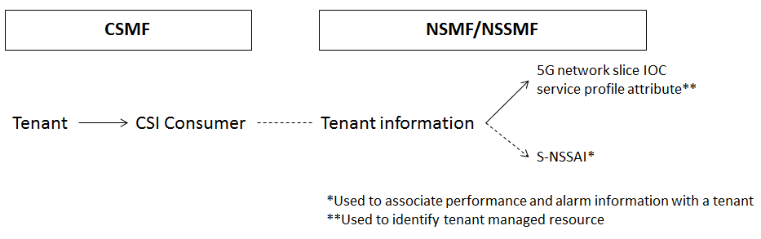

The present document has been developed within the 3rd Generation Partnership Project (3GPP TM) and may be further elaborated for the purposes of 3GPP.  
The present document has not been subject to any approval process by the 3GPPOrganizational Partners and shall not be implemented.  
This Report is provided for future development work within 3GPPonly. The Organizational Partners accept no liability for any use of this Specification.  
Specifications and Reports for implementation of the 3GPP TM system should be obtained via the 3GPP Organizational Partners' Publications Offices.

Keywords

Network slicing management, Tenancy

***3GPP***

Postal address

3GPP support office address

650 Route des Lucioles - Sophia Antipolis

Valbonne - FRANCE

Tel.: +33 4 92 94 42 00 Fax: +33 4 93 65 47 16

Internet

http://www.3gpp.org

***Copyright Notification***

No part may be reproduced except as authorized by written permission.  
The copyright and the foregoing restriction extend to reproduction in all media.

© 2019, 3GPP Organizational Partners (ARIB, ATIS, CCSA, ETSI, TSDSI, TTA, TTC).

All rights reserved.

UMTS™ is a Trade Mark of ETSI registered for the benefit of its members

3GPP™ is a Trade Mark of ETSI registered for the benefit of its Members and of the 3GPP Organizational Partners  
LTE™ is a Trade Mark of ETSI registered for the benefit of its Members and of the 3GPP Organizational Partners

GSM® and the GSM logo are registered and owned by the GSM Association

Contents

Foreword 4

1 Scope 6

2 References 6

3 Definitions of terms, symbols and abbreviations 6

3.1 Terms 6

3.2 Symbols 7

3.3 Abbreviations 7

4 Concepts and background 7

4.1 Sharing of same MnS 7

4.2 Key issues for tenant management 8

4.3 Management service consumed by tenant 8

4.4 Tenant categorization based on its management capability 9

4.5 Managed resource representation for a tenant 9

4.6 Management capabilities provided to a tenant in 3GPP management system 9

4.7 Management function providing management capabilities for multiple tenants 10

4.8 Relation to communication service instance 10

4.9 Fault supervision management for a tenant 11

4.10 Performance measurement for a tenant 11

5 Use cases and potential requirements 11

5.1 Management capabilities provided to tenant by network slice management 11

5.1.1 Description 11

5.1.2 Potential requirements 12

5.2 Management capabilities provided to tenant by network function management service 12

5.2.1 Description 12

5.2.2 Potential requirements 12

6 Potential management enhancements to support multiple tenants environment 12

6.1 Potential management enhancements for performance measurement of network slice management 12

6.2 Potential management enhancements for fault supervision 12

6.3 Potential management enhancements for performance measurement of network function 12

7 Conclusion and recommendations 12

Annex A: Change history 14

# Foreword

This Technical Report has been produced by the 3rd Generation Partnership Project (3GPP).

The contents of the present document are subject to continuing work within the TSG and may change following formal TSG approval. Should the TSG modify the contents of the present document, it will be re-released by the TSG with an identifying change of release date and an increase in version number as follows:

Version x.y.z

where:

x the first digit:

1 presented to TSG for information;

2 presented to TSG for approval;

3 or greater indicates TSG approved document under change control.

y the second digit is incremented for all changes of substance, i.e. technical enhancements, corrections, updates, etc.

z the third digit is incremented when editorial only changes have been incorporated in the document.

In the present document, certain modal verbs have the following meanings:

**shall** indicates a mandatory requirement to do something

**shall not** indicates an interdiction (prohibition) to do something

The constructions "shall" and "shall not" are confined to the context of normative provisions, and do not appear in Technical Reports.

The constructions "must" and "must not" are not used as substitutes for "shall" and "shall not". Their use is avoided insofar as possible, and they are not used in a normative context except in a direct citation from an external, referenced, non-3GPP document, or so as to maintain continuity of style when extending or modifying the provisions of such a referenced document.

**should** indicates a recommendation to do something

**should not** indicates a recommendation not to do something

**may** indicates permission to do something

**need not** indicates permission not to do something

The construction "may not" is ambiguous and is not used in normative elements. The unambiguous constructions "might not" or "shall not" are used instead, depending upon the meaning intended.

**can** indicates that something is possible

**cannot** indicates that something is impossible

The constructions "can" and "cannot" shall not to be used as substitutes for "may" and "need not".

**will** indicates that something is certain or expected to happen as a result of action taken by an agency the behaviour of which is outside the scope of the present document

**will not** indicates that something is certain or expected not to happen as a result of action taken by an agency the behaviour of which is outside the scope of the present document

**might** indicates a likelihood that something will happen as a result of action taken by some agency the behaviour of which is outside the scope of the present document

**might not** indicates a likelihood that something will not happen as a result of action taken by some agency the behaviour of which is outside the scope of the present document

In addition:

**is** (or any other verb in the indicative mood) indicates a statement of fact

**is not** (or any other negative verb in the indicative mood) indicates a statement of fact

The constructions "is" and "is not" do not indicate requirements.

# 1 Scope

The present document explores how 3GPP management system can provide management capabilities for fulfilling requirements derived from tenancy concepts and use cases, and it also explores how to those management capabilities are exposed to individual tenancy concepts consumers.

The present document investigates the evolution of management features and capabilities due to the identified potential requirements and solutions for tenancy concept.

# 2 References

The following documents contain provisions which, through reference in this text, constitute provisions of the present document.

- References are either specific (identified by date of publication, edition number, version number, etc.) or non‑specific.

- For a specific reference, subsequent revisions do not apply.

- For a non-specific reference, the latest version applies. In the case of a reference to a 3GPP document (including a GSM document), a non-specific reference implicitly refers to the latest version of that document *in the same Release as the present document*.

[1] 3GPP TR 21.905: "Vocabulary for 3GPP Specifications".

[2] 3GPP TS 28.530: "Management and orchestration; Concepts, use cases and requirements".

[3] 3GPP TS 28.531: "Management and orchestration; Provisioning".

[4] 3GPP TS 28.532: "Management and orchestration; Generic management services".

[5] 3GPP TS 28.533: "Management and orchestration; Architecture framework".

[6] 3GPP TS 28.541: "Management and orchestration; Network Resource Model (NRM); Stage 2 and stage 3".

[7] 3GPP TS 28.552: "Management and orchestration; Performance measurements".

[8] 3GPP TS 28.554: "Management and orchestration; 5G end to end key performance indicators (KPI)".

[9] 3GPP TR 28.805: "Telecommunication management; Study on management aspects of communication services".

# 3 Definitions of terms, symbols and abbreviations

## 3.1 Terms

For the purposes of the present document, the terms given in 3GPP TR 21.905 [1] and the following apply. A term defined in the present document takes precedence over the definition of the same term, if any, in 3GPP

**Tenant in 3GPP management system:** A group of 3GPP management system users associated with the management capabilities they are allowed to access and consume.

## 3.2 Symbols

Void.

## 3.3 Abbreviations

For the purposes of the present document, the abbreviations given in 3GPP TR 21.905 [1] and the following apply. An abbreviation defined in the present document takes precedence over the definition of the same abbreviation, if any, in 3GPP TR 21.905 [1].

# 4 Concepts and background

## 4.1 Sharing of same MnS

As described in Figure 4.1-1 and Figure 4.1-2, for fulfilling the tenancy concept, operators' can have different options to share their management resources between multiple tenants (e.g. operator's business customers):

Option 1 (Figure 4.1-1)

- Multiple tenants represented by single MnS Consumer instance

- Same management service is consumed by 3 different tenants (e.g. performance management service), from a single MnS Producer instance

- Tenancy related management data isolation is not currently provided by 3GPP management system

Note 1: MnS Consumer behaviour related to tenancy related management data isolation is operator BSS scope.

Note 2: MnS Producer behaviour related to tenancy management data isolation is 3GPP management system scope and it is FFS.

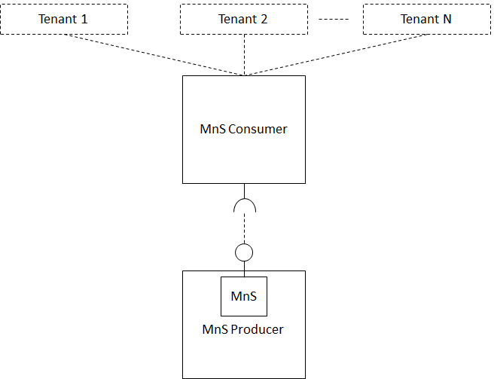

Figure 4.1-1: Multiple tenants represented by single MnS Consumer, while consuming the same MnS

Option 2 (Figure 4.1-2)

- Each tenant represented by dedicated MnS Consumer

- Same management service is consumed by 3 different tenants (e.g. performance management service), from a single MnS Producer

- Tenancy related management data isolation is partially provided by 3GPP management system (e.g. by dedicated MnS Consumer)

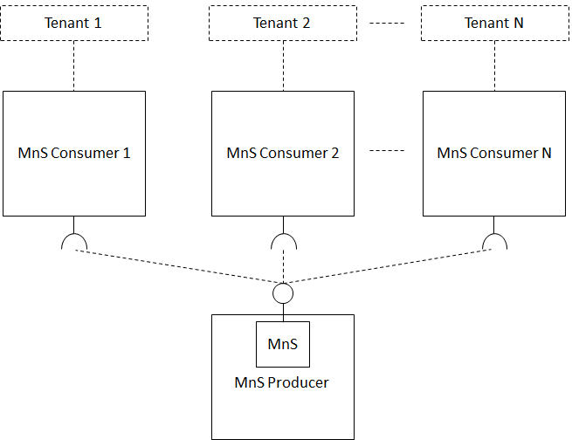

Figure 4.1-2: Each tenant represented by dedicated MnS Consumer, while consuming the same MnS

Editor's note: How utilize business roles defined in TS 28.530 into tenancy concepts is FFS.

Note 3: Same tenant can be represented by option 1, by option 2 or by combination of option 1 and option 2.

## 4.2 Key issues for tenant management

The non-exhaustive key issues for tenant management to be addressed in the present document are as following:

**Issue 1. Tenancy, tenant and tenant management key concepts**

Study the key concepts of tenancy, tenant and tenant related management.

**Issue 2. Different exposure of network management capabilities for different tenants**

Study scenarios, contents and behaviours of management capabilities exposure for different tenants.

**Issue 3. Relation of tenant management, communication service management and network management, including network slicing management**

Study the relation of tenant management, communication service management and network management, including network slicing management.

## 4.3 Management service consumed by tenant

Tenant concept can be considered as a group of user in software and virtualization context. The 3rd party consumer using 3GPP management capability can represent a tenant that use communication service (e.g. an enterprise user).

In 3GPP management system, management services are produced to offer management capabilities that provide management operation and management data access for specific management purposes. The management services are supported by 3GPP management system are as following:

- provisioning service;

- performance management service; and

- fault management service.

When the 3rd party consumer is represented as group of users, identified as tenants (e.g. enterprises that consume V2X service), tenants should be able to consume management services that are exposed to them.

The typical management data exposed to tenants are performance measurement KPIs and fault alarms. When 3GPP management system exposes management data to tenants, the management data should be provided by performance management service or fault management service.

NOTE: Only a subset of management service specified by 3GPP specification will be exposed to 3rd party management service consumer representing the tenant.

## 4.4 Tenant categorization based on its management capability

The following tenant types may exist in order to provide 5G communication services, the management capability for different tenant types may be different depending on the services the tenant obtains from the provider.

- Tenant type A: an entity uses its logical network (i.e. an instance of a network) provided by NOP, and performs lifecycle management of its logical network.

Tenant type A is categorized as below:

- Tenant type A1: an entity uses its logical network provided by NOP to provide CSIs to its customers (e.g., verticals), and performs lifecycle management of its logical network.

- Tenant type A2: an entity uses its logical network provided by NOP to provide CSIs to end users, and performs lifecycle management of its logical network.

- Tenant type B: an entity uses its logical network provided by NOP, and does not performs lifecycle management of its logical network. Any associated management capabilities are accessed and consumed by the NOP.

Tenant type B is categorized as below:

- Tenant type B1: an entity uses its logical network provided by NOP to provide CSIs to its customers (e.g., verticals), and does not performs lifecycle management of its logical network.

- Tenant type B2: an entity uses its logical network provided by NOP to provide CSIs to end users, and does not performs lifecycle management of its logical network.

## 4.5 Managed resource representation for a tenant

3GPP management system may provide management capabilities based on agreed requirements between a tenant and the network operator (e.g. performance report, alarm notification, provisioning service, etc.).

NRM IOC represents managed resource that can be created or deleted for multiple tenants in multiple tenant environment. For example, if NOP exposes NSI provisioning services to external MnS consumer, the IOC of NetworkSlice can be associated with authorized this external MnS consumer.

Editor's note: How to associate tenant information with NRM IOC is FFS.

MOI represents the managed resource that can be used by multiple tenants in multiple tenant environment. In one of the scenario, 5G Core AMF may support AMF measurement KPI reporting related to network slice instance supporting multiple tenants. In another scenario when a network slice instance supports multiple tenants, 3GPP management system may use an MOI to represent the management resource for multiple tenants.

NOTE: Tenant information may be part of a MOI to further identify management resource for a single tenant.

## 4.6 Management capabilities provided to a tenant in 3GPP management system

The tenant should be capable to consume MnS that provides management capabilities. It is proposed to use MOI (component type B) to identify the managed resource of the tenant. The 3GPP management system should be capable to authorize, identify and enforce exposure of specified management capabilities related to managed resource of a tenant.

## 4.7 Management function providing management capabilities for multiple tenants

The network slice subnet management function can provide management services that provide management capabilities in multiple tenant environment. For example, the network management function is optionally capable of handling a management data and monitor network measurement KPIs for multiple tenant. The management function supporting multiple tenant environment may act as MnS consumer and as MnS provider for tenants as shown in Figure 4.7-1.



Figure 4.7-1: Example of Management Function in multiple tenant environment

When tenant represents a group of CSI consumers in 3GPP management system, the tenant may consume a set of management capabilities. The exposure governance management function defined in TS 28.533 [5] may authorize the MnS consumer representing the tenant and apply exposure governance on management services.



Figure 4.7-2: Exposure governance in multiple tenant environment

It is illustrated in Figure 4.7-2 that exposed management services can be consumed by MnS consumers representing tenants. The MnS consumer should provide the identity information of the tenant when it consumes services provide by MnS producer. The EGMF should authenticate the identity information of the tenant and authorize the MnS consumer representing the tenant to access MnS and consume a specified set of management capabilities.

## 4.8 Relation to communication service instance

According to TR 28.805 [9], the vertical customer is authorized to obtain the allowed management capability from CSI service provider according to the pre-defined agreements between the CSI service provider and the CSI service consumer. As described in Figure 4.8-1, CSI Consumer in CSMF can be mapped into a MnS consumer associated with tenant information in 3GPP management system. The MnS provider can provide management capabilities for this tenant by using tenant information as following:

- 5G network slice NRM IOC attribute with tenant information, used to identify managed resource for the tenant

- S-NSSAI value, additionally used by 3GPP management system to associate NF performance measurement with a tenant



Figure 4.8-1: NSMF/NSSMF tenant information relation with CSI Consumer in CSMF

## 4.9 Fault supervision management for a tenant

When the MnS consumer subscribes or queries alarm information of managed resources, the alarm information of managed resource related to the tenant may be provided to the MnS consumer. The tenant information in Serviceprofile IOC is associated with S-NSSAI in sNSSAIList attributes or sub-attributes as defined in TS 28.541 [6]. S-NSSAI may be used for filtering the alarm information in subscribe or getAlarmList operation defined in TS 28.532 [4].

## 4.10 Performance measurement for a tenant

Tenant information in NRM IOCs may be used to distinguish performance measurement for different tenants. The MnS consumer representing the tenant may get the performance measurements of the network function. If the tenant information in Network Slice IOC ServiceProfile is associated with S-NSSAI in sNSSAIList attributes of MOI, the counter per S-NSSAI defined in TS 28.552 [7] may be set for the network function performance measurements.

# 5 Use cases and potential requirements

## 5.1 Management capabilities provided to tenant by network slice management

### 5.1.1 Description

3GPP management system supports network slice and network slice subnet management for 5G network according to TS 28.530 [2] and TS 38.531 [3]. 3GPP management system should support network slice and network slice subnet management for a tenant in multiple tenant environment.

According to TS 28.805 [9], when 3GPP management creates a CSI, 3GPP system may create MOI and corresponding managed resource to provide management capabilities to consumer of CSI and to identify the CSI consumer as a tenant in 3GPP management system.

Network slice management function may provide management services for a CSI consumer identified as a tenant in 3GPP management system.

### 5.1.2 Potential requirements

**REQ-TenM_Slice_MnS-01** The 3GPP management system may have capability to provide performance measurements and fault alarms for a network slice to MnS consumer associated with a tenant.

**REQ-TenM_Slice_MnS-02** The 3GPP management system may have capability to provide network slice and network slice subnet lifecycle management (e.g. creation, modification and termination) to MnS consumer associated with a tenant.

## 5.2 Management capabilities provided to tenant by network function management service

### 5.2.1 Description

Management service provider is capable to identify the MnS instance that provides the monitoring metrics and fault alarms for a tenant. Since the NF may be shared by multiple network slice instances, NF performance measurement and fault alarm for a tenant can be provided with the network slice instance information (e.g. S-NSSAI) by management service provider.

### 5.2.2 Potential requirements

**REQ-TenM_NFM_MnS-01** The 3GPP management system may have capability to provide NF performance measurements and NF fault alarms MnS consumer associated with a tenant.

# 6 Potential management enhancements to support multiple tenants environment

## 6.1 Potential management enhancements for performance measurement of network slice management

It is proposed to use tenant information (e.g. tenant identifier) in NRM IOCs, for purpose of identification to managed resource for the tenant.

## 6.2 Potential management enhancements for fault supervision

The alarm information of MOI may be provided to the management service consumer a tenant in multiple tenant environment. The tenant information may be used for filtering the alarm information associated with a tenant.

## 6.3 Potential management enhancements for performance measurement of network function

The use of counter per S-NSSAI associated to tenant information may be clarified for the network function performance measurements in TS 28.552 [7].

# 7 Conclusion and recommendations

Enhancement to management framework in TS 28.533 [5] is concluded for 3GPP management system to support multiple tenant environment in this study. When multiple tenants are consuming management capabilities, there is a need to provide management services (e.g. provisioning service, performance management service and fault management service) and managed resource for each tenant. For purpose of identification to managed resources and specified management capabilities for each tenant, tenant information should be included in Network Slice IOC ServiceProfile data type.

Following normative work for the enhancement of 3GPP management system for tenancy concept support in multiple tenant environment are recommended:

- Conceptual descriptions of multiple tenant environment support by management framework, added in TS 28.533 [5].

* Provisioning service MOI creation, modification and termination in multiple tenant environment, reused from TS 28.531 [3], TS 28.532 [4].
* Performance measurement in multiple tenant environment, reused from TS 28.552 [7] and TS 28.554 [8].
* Network slice fault supervision in multiple tenant environment reused from TS 28.532 [4].

- Network Slice IOC ServiceProfile data type extension with tenant information, added to TS 28.541 [6].

Annex A:   
Change history

|  |  |  |  |  |  |  |  |
| --- | --- | --- | --- | --- | --- | --- | --- |
| **Change history** | | | | | | | |
| **Date** | **Meeting** | **TDoc** | **CR** | **Rev** | **Cat** | **Subject/Comment** | **New version** |
| 2019-09 | SA#85 | SP-190768 |  |  |  | Presented for information and approval | 1.0.0 |
| 2019-09 | SA#85 |  |  |  |  | Change control version | 16.0.0 |
| 2019-10 |  |  |  |  |  | EditHelp review | 16.0.1 |