3GPP TR 32.972 V16.1.0 (2019-09)

Technical Report

3rd Generation Partnership Project;

Technical Specification Group Services and System Aspects;

Telecommunication management;

Study on system and functional aspects of energy efficiency in 5G networks

(Release 16)

** 

The present document has been developed within the 3rd Generation Partnership Project (3GPP TM) and may be further elaborated for the purposes of 3GPP.  
The present document has not been subject to any approval process by the 3GPPOrganizational Partners and shall not be implemented.  
This Report is provided for future development work within 3GPPonly. The Organizational Partners accept no liability for any use of this Specification.  
Specifications and Reports for implementation of the 3GPP TM system should be obtained via the 3GPP Organizational Partners' Publications Offices.

Keywords

energy efficiency, 5G, OAM

***3GPP***

Postal address

3GPP support office address

650 Route des Lucioles - Sophia Antipolis

Valbonne - FRANCE

Tel.: +33 4 92 94 42 00 Fax: +33 4 93 65 47 16

Internet

http://www.3gpp.org

***Copyright Notification***

No part may be reproduced except as authorized by written permission.  
The copyright and the foregoing restriction extend to reproduction in all media.

© 2019, 3GPP Organizational Partners (ARIB, ATIS, CCSA, ETSI, TSDSI, TTA, TTC).

All rights reserved.

UMTS™ is a Trade Mark of ETSI registered for the benefit of its members

3GPP™ is a Trade Mark of ETSI registered for the benefit of its Members and of the 3GPP Organizational Partners  
LTE™ is a Trade Mark of ETSI registered for the benefit of its Members and of the 3GPP Organizational Partners

GSM® and the GSM logo are registered and owned by the GSM Association

Contents

Foreword 5

1 Scope 6

2 References 6

3 Definitions and abbreviations 7

3.1 Definitions 7

3.2 Abbreviations 7

4 EE KPIs and metrics 8

4.1 Introduction 8

4.2 Existing EE KPI definitions 9

4.2.1 EE KPIs for Radio Access Networks 9

4.2.1.1 EE KPI definitions in ETSI ES 202 706 [2] 9

4.2.1.2 EE KPI definitions in ETSI ES 203 228 [4] 9

4.2.1.3 Network Energy Efficiency quantitative KPI 10

4.2.1.4 Deployment scenario based EE KPIs 11

4.2.2 EE KPIs for telecom sites 13

4.2.3 EE KPIs for Virtualized Network Functions (VNF) 13

4.2.3.1 Introduction 13

4.2.3.2 VNF resource efficiency 14

4.2.3.3 VNF energy efficiency 15

4.2.3.4 NFVI energy efficiency 15

4.3 Definition and collection of EE KPIs for 5G networks 15

5 Measurement methods 17

5.1 Existing measurement methods 17

5.2 Potential measurement methods for 5G networks 18

6 Potential mechanisms to improve energy efficiency 19

7 EE control framework 21

7.1 General EE control framework 21

7.2 Potential architectural options 22

7.2.0 Introduction 22

7.2.1 NM-Centralised architecture 23

7.2.2 EM-Centralised architecture 23

7.2.3 Distributed architecture 24

8 Potential use cases and requirements 25

8.1 Energy efficiency assessment 25

8.1.1 Potential use cases 25

8.1.1.1 Introduction 25

8.1.1.2 Creation of measurement job for collecting 5G NF EE measurement data 25

8.1.1.3 Reporting 5G NF EE measurements via file transfer 25

8.1.1.4 Reporting 5G NF EE measurement via streaming 25

8.1.2 Potential requirements 25

8.1.2.1 Collection of Data Volumes 25

8.1.2.1.1 Potential requirements for the creation of measurement job for collecting 5G NF DV measurement data 25

8.1.2.1.2 Potential requirements for 5G NF DV measurement data file reporting 25

8.1.2.1.3 Potential requirements for 5G NF DV measurement data streaming 26

8.1.2.2 Collection of Power, Energy and Environmental (PEE) parameters 26

8.1.2.2.1 Potential requirements for initiating / stopping the collection of PEE parameters 26

8.1.2.2.2 Potential requirements for reporting PEE parameters 26

8.1.2.2.3 Potential requirements for reporting PEE parameters related alarms 26

8.1.2.2.4 Potential requirements for reporting PEE parameters related configuration changes 26

8.2 Energy saving management 26

8.2.1 Potential use cases 26

8.2.1.1 Cell overlaid use case 26

8.2.1.2 Capacity limited network use case 26

8.2.2 Potential requirements 26

8.2.2.1 General requirements 26

8.2.2.2 Requirements for energy saving 27

9 Potential solutions 27

9.1 Energy efficiency assessment 27

9.2 Energy saving management 27

10 Conclusion 28

Annex A: Change history 29

# Foreword

This Technical Report has been produced by the 3rd Generation Partnership Project (3GPP).

The contents of the present document are subject to continuing work within the TSG and may change following formal TSG approval. Should the TSG modify the contents of the present document, it will be re-released by the TSG with an identifying change of release date and an increase in version number as follows:

Version x.y.z

where:

x the first digit:

1 presented to TSG for information;

2 presented to TSG for approval;

3 or greater indicates TSG approved document under change control.

y the second digit is incremented for all changes of substance, i.e. technical enhancements, corrections, updates, etc.

# 1 Scope

The present document studies energy efficiency aspects of 5G networks, at both network function level and at 3GPP system level. The study covers:

- energy efficiency KPI definitions, including already existing definitions from other 3GPP WGs and other SDOs and potentially new ones for 5G networks;

- measurement methods, including already existing measurement methods from other 3GPP WGs and other SDOs and potentially new ones for 5G networks;

- potential solutions to improve energy efficiency of 5G networks;

- energy efficiency control framework, as a SON-like framework for the control of energy efficiency of 5G networks.

The study also makes conclusions on the preferred solution(s), and provides recommendations for them.

# 2 References

The following documents contain provisions which, through reference in this text, constitute provisions of the present document.

- References are either specific (identified by date of publication, edition number, version number, etc.) or non‑specific.

- For a specific reference, subsequent revisions do not apply.

- For a non-specific reference, the latest version applies. In the case of a reference to a 3GPP document (including a GSM document), a non-specific reference implicitly refers to the latest version of that document *in the same Release as the present document*.

[1] 3GPP TR 21.905: "Vocabulary for 3GPP Specifications".

[2] ETSI ES 202 706 (V1.4.1) (2014-12): "Environmental Engineering (EE); Measurement method for power consumption and energy efficiency of wireless access network equipment".

[3] ETSI GS OEU 001 (V2.1.1) (2014-12): "Operational energy Efficiency for Users (OEU); Global KPIs for ICT Sites".

[4] ETSI ES 203 228 (V1.2.1) (2017-04): "Environmental Engineering (EE); Assessment of mobile network energy efficiency".

[5] ITU-T Recommendation L.1331 (2017-04): "Assessment of mobile network energy efficiency".

[6] 3GPP TR 38.913: "Study on scenarios and requirements for next generation access technologies".

[7] ETSI ES 203 539 (V1.1.1) (2019-06): "Environmental Engineering (EE); Measurement method for Energy efficiency of Network Function Virtualization (NFV) in laboratory environment".

[8] ETSI ES 202 336-12 (V1.1.1) (2015-06): "Environmental Engineering (EE); Monitoring and control interface for infrastructure equipment (power, cooling and building environment systems used in telecommunication networks); Part 12: ICT equipment power, energy and environmental parameters monitoring information model".

[9] 3GPP TS 38.401: "NG-RAN; Architecture description".

[10] ETSI ES 203 237 (V1.1.1) (2014-03): "Environmental Engineering (EE); Green Abstraction Layer (GAL); Power management capabilities of the future energy telecommunication fixed network nodes".

[11] 3GPP TS 28.550: "Management and orchestration; Performance assurance".

[12] 3GPP TS 32.551: "Telecommunication management; Energy Saving Management (ESM); Concepts and requirements".

[13] 3GPP TS 28.552: "Management and orchestration; 5G performance measurements".

[14] 3GPP TS 28.530: "Management and orchestration; Concepts, use cases and requirements".

[15] 3GPP TS 28.304: "Control and monitoring of Power, Energy and Environmental (PEE) parameters Integration Reference Point (IRP); Requirements".

[16] 3GPP TS 28.305: "Control and monitoring of Power, Energy and Environmental (PEE) parameters Integration Reference Point (IRP); Information Service (IS)".

[17] 3GPP TS 28.306: "Control and monitoring of Power, Energy and Environmental (PEE) parameters Integration Reference Point (IRP); Solution Set (SS) definitions".

[18] 3GPP TS 32.500: "Telecommunication Management; Self-Organizing Networks (SON); Concepts and requirements".

[19] Power Provisioning for a Warehouse-sized Computer, X. Fan, W-D. Weber, L. A. Barroso, Google Inc., 34th annual international symposium on Computer architecture, 2007.

[20] Real Time Traffic Base Station Power Consumption Model for Telcos in Ghana, J. D. Gadze, S. B. Aboagye, K.A.P. Agyekum, International Journal of Computer Science and Telecommunications [Volume 7, Issue 5, July 2016].

[21] 3GPP TS 28.622: "Telecommunication management; Generic Network Resource Model (NRM) Integration Reference Point (IRP); Information Service (IS)".

[22] 3GPP TS 28.531: "Management and orchestration; Provisioning".

[23] 3GPP TS 28.541: "Management and orchestration; 5G Network Resource Model (NRM); Stage 2 and stage 3".

[24] 3GPP TS 28.554: "Management and orchestration; 5G end to end Key Performance Indicators (KPI)".

# 3 Definitions and abbreviations

## 3.1 Definitions

For the purposes of the present document, the terms and definitions given in 3GPP TR 21.905 [1] and the following apply. A term defined in the present document takes precedence over the definition of the same term, if any, in 3GPP TR 21.905 [1].

## 3.2 Abbreviations

For the purposes of the present document, the abbreviations given in 3GPP TR 21.905 [1] and the following apply. An abbreviation defined in the present document takes precedence over the definition of the same abbreviation, if any, in 3GPP TR 21.905 [1].

5GC 5G Core Network

DM Domain Manager

EAS Energy Aware State

EE Energy Efficiency

EM Element Manager

CP Control Plane

DGU Data Gathering Unit

gNB-CU gNB Central Unit

gNB-DU gNB Distributed Unit

GSI Green Standard Interface

ICT Information and Communication Technology

KPI Key Performance Indicator

MANO Management and Orchestration

MNO Mobile Network Operator

NFV Network Functions Virtualization

PNF Physical Network Function

PUE Power Usage Effectiveness

SDO Standards Development Organization

UP User Plane

VNF Virtualized Network Function

VNFC VNF Component

VS-RMS Vendor-Specific Remote Management Server

XCU XML Control Unit

# 4 EE KPIs and metrics

## 4.1 Introduction

Telecommunication networks energy efficiency KPIs are defined by various SDOs / organizations and are of various natures. They can be applied to either:

- whole networks (i.e. end-to-end), or to

- sub-networks (e.g. the radio access network), or to

- single network elements, or to

- telecommunication sites, which contain network elements and site equipment.

NOTE 1: With the advent of NFV (Network Functions Virtualization), the definition of EE KPIs for Network Services (NS), Virtualized Network Functions (VNF) and Virtualized Network Function Components (VNFC) is a new area of investigation.

NOTE 2: Data centers used by network operators are considered in this document as telecommunication sites.

Moreover, EE KPIs can also be categorized according to the operator's network life cycle phase they may apply to, e.g.:

- during the Buy phase, mobile network operators may be willing to compare network elements from various vendors from an EE standpoint. Some EE KPIs and measurement methods have been specified for this purpose.

- during the Design / Build phase, mobile network operators are always faced to several design options, and may be willing to compare them from an EE standpoint. This may happen for the whole network, sub-networks and for telecom sites. For telecom sites, EE KPIs have been specified.

- during the Run phase, mobile network operators need to assess the energy efficiency of the live network, as a whole (i.e. end-to-end), or for sub-networks, or for single network elements or telecom sites. Some EE KPIs and measurement methods have also been specified for this purpose.

Generally, EE KPIs for network elements are expressed in terms of Data Volume divided by the Energy Consumption of the considered network elements. In the case of radio access networks, an EE KPI variant may also be used, expressed by the Coverage Area divided by the Energy Consumption of the considered network elements.

## 4.2 Existing EE KPI definitions

### 4.2.1 EE KPIs for Radio Access Networks

#### 4.2.1.1 EE KPI definitions in ETSI ES 202 706 [2]

ETSI ES 202 706 [2] defines methods to evaluate the power consumption and energy efficiency of base stations in static and dynamic mode respectively. These methods can be used by:

- telecom equipment manufacturers in their labs. Measured KPIs are generally captured in product specification datasheets;

- mobile network operators, during their Buy phase. MNOs may use such measurements to compare equipment from different vendors from an EE point of view. They can also make their own measurements in their own labs in order to check if they have the same results.

Under static test conditions, the Base Station (BS) average power consumption is based on measured BS power consumption data when the BS is loaded artificially in a lab for three different loads (low, medium and busy hour) under given reference configuration. The power consumption of integrated BS equipment in static method is defined for three different load levels as follows:

- PBH is the power consumption [W] with busy hour load;

- Pmed is the power consumption [W] with medium term load;

- Plow is the power consumption [W] with low load.

With this static method, the average power consumption [W] of BS equipment is defined as:

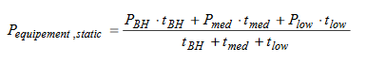

in which tBH, tmed and tlow [hour] are durations of the different load levels.

Under dynamic test conditions, the BS capacity is measured under dynamic traffic load provided within a defined coverage area and the corresponding power consumption is measured for given reference configurations. Dynamicity of measurements may be achieved thanks to dynamic load, activation / deactivation of radio network features, various user terminals performance and distribution.

#### 4.2.1.2 EE KPI definitions in ETSI ES 203 228 [4]

ETSI ES 203 228 [4] defines energy efficiency metrics and measurement procedures in operational radio access networks. Two high-level EE KPIs are defined:



in which Mobile Network data Energy Efficiency (EEMN,DV), expressed in bit/J, is the ratio between the performance indicator (i.e. Data Volume DVMN) and the energy consumption (ECMN), and



in which EEMN,CoA, expressed in m²/J, is the ratio between the coverage area (CoA-desMN) and the energy consumption ECMN.

In addition, ETSI ES 203 228 [4] gives a list of existing 3GPP performance measurements and network parameters to be used, per radio access technology (GERAN, UTRAN, E-UTRAN), for the calculation of aforementioned EE Run KPIs (cf. clause 4.1).

Finally, ETSI ES 203 228 [4] defines a method to define sub-networks from which these EE KPIs are calculated and to extrapolate them to the operator's whole radio access network. Various criteria may be used by MNOs to define their sub-networks, including demography, topography, climate zones, etc. For example, if demography is used by a MNO to compose its sub-networks, an averaged EE KPI per demography class can be obtained as follows:

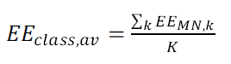

where "class" stands for one of the Demography Classes (Dense Urban, Urban, Sub-Urban, RUral or Unpopulated), k is an index that runs over the number K of sub-networks per each class.

Finally, the Total EE may be computed as a weighted sum of all the averages available, the weights being the percentage of each demography class versus the sum of the available classes percentages. The total EE KPI for the whole RAN of the MNO can be computed as follows:

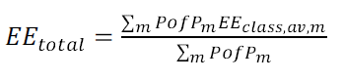

where PofPm is the percentage of presence of the m-th demography class in the network under test, m is an index spanning over the number of classes and EEclass,av,m is the m-th average as computed here above.

ITU-T Recommendation L.1331 [5] was developed jointly by ETSI TC EE and ITU-T Study Group 5 and published by ITU-T and ETSI as Recommendation ITU-T L.1331 [5] and ETSI ES 203 228 [4] respectively, which are technically equivalent.

#### 4.2.1.3 Network Energy Efficiency quantitative KPI

3GPP TR 38.913 [6] recommends that the following Network Energy Efficiency quantitative KPI (in bit per Joule) be used:

a) to compare different solutions or mechanisms directly related to energy efficiency, when their impact is not obvious from qualitative analysis. When qualitative evaluation provide clear conclusions for the comparison of different network EE solutions and the evaluation of their impact, the comparison through the proposed quantitative KPI is not required.

b) to compare the final NR system design with LTE to evaluate the overall improvement brought in terms of network EE.

Definition:



*bk* refers to the weights of every deployment scenario where the network energy efficiency is evaluated.



**V1=** Refers to the traffic per second served by a base station (in bits/s)

**EC1 =** Refers to thepower consumed by a base station to serve **V1** (in Watt = Joule/s).

**a1 =** Refers totheweight for each traffic load level.

For the calculation of the above KPIs, the following assumptions are made:

- Energy Efficiency Quantitative KPI should be evaluated by means of system level simulations at least in 2 deployment scenarios: one coverage limited environment (ex: Rural) AND one capacity limited environment (ex: Urban);

- Evaluation should not be for peak hour but based on a 24 hour daily traffic profile. It is recommended that at least 3 load levels should be evaluated.

In 3GPP TR 38.913 [6] clause 6.1, deployment scenarios for eMBB, mMTC, URLLC and eV2X are described:

- Indoor hotspot

- Dense urban

- Rural

- Urban macro

- High speed

- Extreme long distance coverage in low density areas

- Urban coverage for massive connection

- Highway scenario

- Urban grid for Connect Car

- Commercial Air to Ground scenario

- Light aircraft scenario

- Satellite extension to Terrestrial.

#### 4.2.1.4 Deployment scenario based EE KPIs

3GPP defines the energy efficiency per each deployment "*scenario i*" with a load level of l as follows:



where:

- *EEscenario* is calculated per deployment scenario: the sum of traffic load points over the Energy Consumption weighted by *ai* in consideration of the traffic load per each scenario. The traffic load measurement points with their corresponding weight for each traffic load point depend on the location of the system-wide EE control and measurement and network configurations.

- As an example, the traffic load measurement can be performed over the reference point between the based station and the core network such as S1 per those areas covered by each of MME and the corresponding SGW(s) in LTE/EPC and SGi between the core network and the external public data network for the total amount of traffic load supported by the EPC.

- Vl (in Mbps): the aggregated throughput served in the simulated or measured area for traffic level l, or equivalently served traffic volume divided by the simulation or measurement period. E.g. per each targeted area or deployment scenario at a load level l = x%, Vl is calculated as the peak target traffic throughput multiplied by x%. For example, the Vl with load level of 10% is calculated to be total network or node capacity multiplied by 0.1

- ECl (in Watt): sum of the average power consumption of all nodes in the simulated or the measurement area under the load level l: the weight for load level l; For example, for RAN Equipment Energy Efficiency testing (ETSI ES 202 706 [2]) three load levels can be taken into account: 10%, 30% and 50%, the weight can be calculated, based on a daily traffic model, as:

= 6/24 for 10% Load;

= 10/24 for 30% Load;

= 8/24 for 50% Load.

The total energy efficiency for the whole system including all the targeted scenarios is defined as:



Where:

- *EEglobal* is calculated as the sum of the *EEscenario* per each deployment scenario multiplied by the corresponding weight, *bi*, for each deployment scenario.

- *bi* is determined by summing the "rural/suburban" weights for the coverage-limited scenario and the "urban/dense urban" weights for the capacity-limited scenario.

To complement the definition and measurement EE KPI per specific throughput during the measurement interval, it is also useful to consider the size of the area covered by a network and the corresponding energy efficiency (ETSI ES 202 706 [2]):



where:

- coverage area in m² (ETSI ES 203 228 [4] or Sq.km (ETSI ES 202 706 [2])) is the size of the area covered by the network in deployment scenario *i*.

- *ECi*in Watt (ETSI ES 202 706 [2]) or J/Y (ETSI ES 203 228 [4]) is the sum of the average power consumption of all nodes in the simulated or the measurement area under the scenario *i*.

- *Ci* is the weight to be applied to each of the measured energy efficiency per each of the network deployment scenario by taking into account of the size of coverage per the deployment scenario, and the relevance of the deployment scenario to the total power consumption of a network, e.g. the percentage of total power consumptions in dense urban versus rural area.

Network load has some key impacts on the achievable energy efficiency. For a certain coverage area, the network load results from the traffic and connection densities which drive the user throughput and signalling traffic and the activated network capacity and performance to meet a set of minimum QoS requirements. In a real network, network load can vary with the geographical locations which have their own traffic profiles, e.g. busy hour periods in a business area are different from those in a residential area. This "spatial variation" of network load may increase the complexity in calculating and assessing the EE KPI in considerations of network load. For simplicity, this "spatial variation" can be taken into account by deciding appropriate coefficients as. For "temporal variations" of network load which varies according to the different time of a day, network load can be assumed uniform, network-wide distribution in a specific time period during which the energy consumption and EE KPI are monitored and measured. For example, the following can be used as a guideline in assessing the "temporal variation" of network load in measuring and calculating EE KPI.

- In 6/24th of the time:

- traffic density = 10% of max. traffic density, and

- connection density = 10% of max. connection density, and

- In 10/24th of the time:

- traffic density = 30% of max. traffic density, and

- connection density = 30% of max. connection density, and

- In 8/24th of the time:

- traffic density = 50% of max. traffic density, and

- connection density = 50% of max. connection density.

### 4.2.2 EE KPIs for telecom sites

ETSI GS OEU 001 [3] defines KPIs in relation to energy management for ICT sites including, but not limited to operator data centres and operator sites. These KPIs allow having a global vision about the technical environment impact on energy efficiency thanks to energy data collection, for any telecom site. ETSI GS OEU 001 [3] addresses the following objectives:

- energy consumption;

- task efficiency;

- energy reuse;

- renewable energy,

and defines:

- four KPIs addressing these objectives (Objective KPIs);

- one Global KPI which combines the four Objective KPIs.

The Objective and Global KPIs defined in ETSI GS OEU 001 [3] apply to ICT sites, including operators' radio access network sites, of any size from initial operation to end of life.

One Objective KPI is "Task Efficiency" (KPITE). KPITE is the ratio of the electricity consumption of all the components, whatever they are (i.e. all equipment downstream of the energy sources including, but not limited to: cooling, lighting, safety, security, power distribution, devices extracting heat for reusing energy, devices used to extract renewable energy), to that of the components that manage data, for calculation, storage or transport purposes (typically base stations).

KPITE is dimensionless and has the following properties:

- KPITE ≥ 1;

- KPITE = 1 is an ideal value;

- a KPITE of between 2 and 2,5 is frequently reached.

KPITE is very similar to PUE (Power Usage Effectiveness), defined by the Green Grid (https://www.thegreengrid.org/), which has emerged as the recognized standard to measure the energy efficiency of data centers, and is defined as follows:

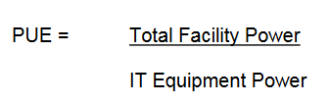

### 4.2.3 EE KPIs for Virtualized Network Functions (VNF)

#### 4.2.3.1 Introduction

ETSI ES 203 539 [7] defines energy efficiency metrics and measurement methods for NFV components including VNFs and NFVI. The energy efficiency of VNF is evaluated according to hardware energy consumption, resource consumption and utilization related with VNF. The measurement method described in the present document is intended to be used to assess and compare the energy efficiency of same functional components independently in lab testing and pre-deployment testing. Energy efficiency of co-located VNFs sharing same platform resources cannot be compared using the defined method in present document. The scope of ETSI ES 203 539 [7] is not to define a measurement method in operational NFV environment.

As shown in figure 2 of ETSI ES 203 539 [7], the NFV paradigm introduces a need to decompose traditional energy efficiency measurements and measurement methods.

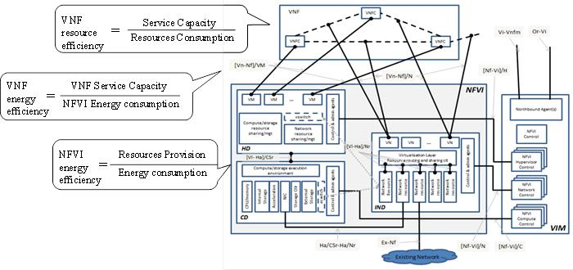

Figure 4.2.3.1.1: EE KPIs for Virtualized Network Functions

#### 4.2.3.2 VNF resource efficiency

The VNF's Resource Efficiency Rating (RER) metric can be defined as:

$${\text{VNF}}_{{\text{RER}}_{i}}=\frac{\text{Useful output}}{\text{Resource consumption}}=\frac{U_{i}}{{\left\{R_{\text{cpu}},R_{\text{memory}},R_{\text{storage}},R_{\text{network}}\right\}}_{i}}$$

$${\text{VNF}}_{\text{RER}}=\sum_{i=1}^{N}{({\text{VNF}}_{{\text{RER}}_{i}}×w_{i})}$$

where:

$U_{i}$ is the useful output of VNF under service capacity level *i*. Depending on the different type of VNFs, it can be throughput (e.g. bps, pps) for data plane VNF, or capacity (e.g. subscribers, sessions) for control plan VNF.

${\text{VNF}}_{{\text{RER}}_{i}}$ is resource efficiency of VNF under service capacity level *i*.

${\text{VNF}}_{\text{RER}}$ is weighted resource efficiency of all service capacity levels.

N is the total number of service capacity levels, and $w_{i}$ is the weight coefficient of level *i*.

The resource consumption of VMs allocated to the VNF under test, under service capacity level *i*, is decomposed as follows:

$R_{\text{cpu}}^{}$ is CPU resource consumption, defined as average CPU utilization multiplied by CPU frequency;

$R_{\text{memory}}^{}$ is memory resource consumption, defined as memory utilization multiplied by allocated memory;

$R_{\text{storage}}^{}$ is storage resource consumption, defined as the sum of average throughput of storage read and write;

$R_{\text{network}}^{}$ is network resource consumption, defined as the sum of average network throughput of bytes sent and received.

ETSI ES 203 539 [7] defines "useful output" as follows:

*"useful output: maximum capacity of the system under test which is depending on the different functions.*

*NOTE: It is expressed as the number of Erlang (Erl), Packets/s (PPS), Subscribers (Sub), or Simultaneously Attached Users (SAU).".*

#### 4.2.3.3 VNF energy efficiency

The VNF's Energy Efficiency Rating (EER) metric is defined as:

$${\text{VNF}}_{{\text{EER}}_{i}}=\frac{\text{Useful output}}{\text{Power consumption}}=\frac{U_{i}}{P_{i}}$$

$${\text{VNF}}_{\text{EER}}=\sum_{i=1}^{N}{({\text{VNF}}_{{\text{EER}}_{i}}×w_{i})}$$

where:

$U_{i}$ is the useful output of VNF under service capacity level *i*. Depending on the different type of VNFs, it can be throughput (e.g. bps, pps) for data plane VNF, or capacity(e.g. subscribers, sessions) for control plan VNF.

$P_{i}$ is power consumption of NFVI platform introduced by VNF deployed under service capacity level *i*.

${\text{VNF}}_{{\text{EER}}_{i}}$ is energy efficiency of VNF under service capacity level *i*.

${\text{VNF}}_{\text{EER}}$ is weighted energy efficiency of all service capacity levels.

N is the total number of service capacity levels, and $w_{i}$ is the weight coefficient of level *i*.

#### 4.2.3.4 NFVI energy efficiency

The NFVI's energy efficiency rating (EER) metric is defined as:

$${\text{NFVI}}_{{\text{EER}}_{{\text{VNF}}_{j}}}=\frac{{\text{Useful output of VNF}}_{j}}{{\text{Power consumption}}_{j}}=\sum_{i=1}^{N}{(\frac{U_{\text{i,j}}}{P_{\text{i,j}}}w_{i})}$$

$${\text{NFVI}}_{\text{EER}}=\left\{{\text{NFVI}}_{{\text{EER}}_{{\text{VNF}}_{j}}}\right\},j∈\left\{1,2,\text{.}\text{.}\text{.}\right\}$$

where:

$U_{i,j}$ is the useful output of ${\text{VNF}}_{j}$ under service capacity level *i*.

$P_{i,j}$ is power consumption of NFVI platform with ${\text{VNF}}_{j}$ deployed under service capacity level *i*.

${\text{NFVI}}_{{\text{EER}}_{{\text{VNF}}_{j}}}$ is energy efficiency of NFVI platform with ${\text{VNF}}_{j}$ deployed.

${\text{NFVI}}_{\text{EER}}$ is the aggregation of all energy efficiency of NFVI platform with different VNFs deployed.

## 4.3 Definition and collection of EE KPIs for 5G networks

Defining EE KPIs for 5G networks introduces new potential issues to be considered, including:

- At NG-RAN level:

- gNB CU-DU split (see 3GPP TS 38.401 [9] - clause 6.1)



Figure 4.3.1: NG-RAN overall architecture

According to 3GPP TS 38.401 [9] – clause 6.1:

- A gNB may consist of a gNB-CU and gNB-DUs.

- For resiliency, a gNB-DU may be connected to multiple gNB-CUs by appropriate implementation.

- Separation of Control and User Plane in the gNB-CU;

The figure 4.3.2 depicts the overall gNB architecture with CU-CP and CU-UP separation [9].



Figure 4.3.2: gNB overall split architecture

There is no justification for defining and calculating an EE KPI at a lower granularity than gNB, for a number of reasons, including:

- for alignment with how EE KPI is defined for GERAN, UTRAN and E-UTRAN,

- the architecture depicted in figure 4.3.2 is a logical architecture which may lead to various physical deployment architectures. The EE KPI definition for gNB should be independent from gNB physical architectures.

Consequently, both Data Volumes and Energy Consumption need to be calculated at gNB level.

Regarding the measurement method:

- for Data Volumes:

- it is proposed to collect Data Volumes at cell level, as for previous radio access technologies.

- for Energy Consumption:

- Energy Consumption of the whole gNB is to be measured. In case of a non-split gNB, the method for measuring and collecting EC can be as defined in ETSI ES 202 336-12 [8]. In case of a split gNB distributed on different sites, EC measurements need to be made and collected for each sub-part of the gNB.

- at 5GC level:

- Separation of Control and User Plane: EE KPI can be defined either per type of 5GC functions (e.g. one EE KPI for 5GC Control Plane functions, one other EE KPI for 5GC User Plane functions), or globally at 5GC level.

- at both NG-RAN and 5GC level:

- Some network functions pertaining to either NG-RAN or to 5GC may be virtualized, e.g. gNB-CU CP and/or 5GC network functions. Though measuring Data Volumes for Virtualized Network Functions (VNF) can use the same methods as for legacy equipment (PNF), measuring Energy Consumption of VNFs may require a new measurement method; the Energy Consumption of a VNF is the part of the Energy Consumption of the server (in the data centre) related to the virtual resources used by the subject VNF.

- Due to the separation of Control and User Plane in both NG-RAN and 5GC, the relevance of defining an EE KPI for Control Plane functions, based on Data Volumes (divided by Energy Consumption), may be questioned.

- at Network Slice level:

- Communication Service Providers may offer Network Slice as a Service (NSaaS) to their business customers (cf. 3GPP TS 28.530 [14]). CSPs' NSaaS offer catalog may then contain various types of NSaaSs characterized by certain features, among which Energy Efficiency may be one of them. NSaaS customers may have EE related requirements when ordering their Network Slice (Instance) to CSPs. Once their Network Slice Instance(s) is in operation, CSPs' NSaaS customers may also be willing to receive EE KPIs for those Network Slice Instance(s) to assess if the delivered Network Slice Instance(s) meets their requirements. Therefore, CSPs need to be ready to provide their NSaaS customers with Network Slice EE KPIs.

- Due to that Network Functions may be shared amongst network slice subnet instances, network slice subnet instances may be shared among network slice instances and that network slice instances may be shared among CSPs' customers, defining and collecting EE KPI per CSPs' customer and/or per network slice and/or per network slice subnet would certainly be complex.

# 5 Measurement methods

## 5.1 Existing measurement methods

Existing measurement methods for the calculation of EE KPIs for mobile networks (cf. ETSI ES 203 228 [4], ETSI ES 202 706 [2] and 3GPP TR 21.866 [7]) are based on the collection, on a per network node basis, of:

- Data Volume measurements, and

- Energy Consumption measurements.

In some deployment scenarios of radio access networks, Coverage Area measurements may be used instead of Data Volume measurements.

Data Volume measurements are collected via OAM, as performance measurements, e.g. as recommended in ETSI ES 203 228 [4] for radio access networks.

Energy Consumption information can be collected:

- using power meters or information from invoices provided by power suppliers,

- via built-in sensors, e.g. in case base stations (cf. ETSI ES 202 336-12 [8]), enabling the collection of energy consumption measurements via OAM,

- via external sensors and XCU/DGU, as specified in ETSI ES 202 336-12 [8].

The methodology may vary depending on whether the measurements are made in live networks or in testing laboratories.

- In laboratories, ETSI ES 202 706 [2] defines a two level assessment method to be used to both evaluate power consumption and energy efficiency of base stations. The two levels are:

- Base station equipment average power consumption for which it defines reference base station equipment configurations and reference load levels to be used when measuring base station power consumption.

- Base station equipment energy efficiency, defined as the measured capacity for a defined coverage area, divided by the simultaneously measured energy consumption.

- In live networks, ETSI ES 203 228 [4] recommends to split the total mobile network operator network into a small number of networks with limited size ("sub-networks"). These sub-networks are defined to represent some specific characteristics, for example:

- capacity limited networks representing urban and dense urban networks,

- sub-urban networks with high requirements for coverage and capacity,

- rural networks, which are usually coverage limited.

The size and scale of the sub-networks are defined by topologic, geographic or demographic boundaries.

The measurement method defined in ETSI ES 203 228 [4] for sub-networks provides the basis to estimate energy efficiency for large networks of one mobile network operator or within an entire country, applying extrapolation methods.

## 5.2 Potential measurement methods for 5G networks

The calculation of an EE KPI will rely on the collection of related measurement data of two types:

- Data volumes:

- the reporting method (reportingMethod) of data volumes for 5G network elements / functions will be specified in TS 28.550 [11] for stage 1, stage 2 and stage 3,

- the measurements (e.g. counters) will be defined in TS 28.552 [13] for the 5G radio access network and the 5G core network.

Note 1: as alternative to data volume measurements, other metrics could be envisaged, in particular for control plane network elements / functions, e.g. number of sessions, number of users, etc.

- Energy consumption:

- for non-virtualized parts of base stations, regardless of whether these base stations are equipped with built-in or external sensors, their energy consumption can potentially be collected via XCU/DGU and/or VS-RMS and/or their EM/DM (see Note 2), as specified in TS 28.304 [15], TS 28.305 [16] and TS 28.306 [17]. This potentially applies to non-virtualized core network elements as well;

- for virtualized parts of base stations, the energy consumption of the Virtualized Network Functions (VNFs) is the energy consumption of the server(s) on which the VNF(s) run, minus the energy consumption of the subject servers when they are in idle mode (cf. Pidle on figure 6.1). When multiple VNFs run simultaneously on a given server, how to measure their respective part in the overall energy consumption of the server is not specified. This potentially applies to virtualized core network functions as well.

NOTE 2: The measurement method described in ETSI ES 203 539 [7] is intended to be used to assess and compare the energy efficiency of VNFs in lab testing and pre-deployment testing; it aims not to define measurement method in operational NFV environment. In particular, it does not specify how the energy consumption of each server is measured individually in an operational environment.

NOTE 3: EM/DM is a component of the legacy 3GPP management architecture up to and including Rel-14. In the context of Rel-15, a service-based management architecture is being specified, in which EM/DM no longer appears.

# 6 Potential mechanisms to improve energy efficiency

Improving energy efficiency of mobile networks can be studied at various levels:

- network element / network function level

- sub-network level

- whole network level.

At network element / network function level, studies (cf. [19]) have shown that:

1. the power consumption of a server is the combination of the static power consumption (cf. Pidle at zero CPU utilization) and a dynamic load-dependent power consumption that increases linearly;

2. the maximum power consumption (Pbusy) of the server is reached when CPU utilization is 100%;

3. Pidle is a large fraction of Pbusy (about 50% in the figure below);

4. Pidle equal to zero is not reached.

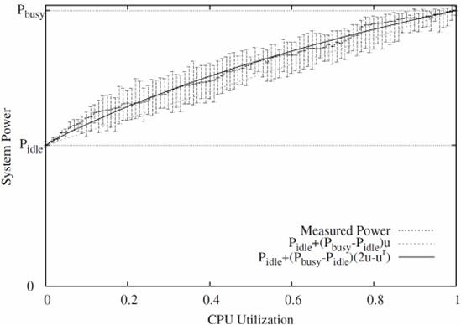

Figure 6.1: Power consumption of a server

In 5G networks, network functions virtualization is likely to be widely adopted, e.g. in 5GC and the CU part of NR. The power consumption of Network Function Virtualization Infrastructure (NFVI) servers supporting virtualized network functions which are part of 5GC or the CU part of NR will vary as shown in figure 6.1.

The power consumption of Physical Network Functions (PNF) will also vary as shown in figure 6.1.

As seen in clause 4, EE KPIs for base stations are defined by traffic over power consumption. Studies made on the power consumption of base stations (see e.g. [20]) have shown results which are comparable with those depicted by figure 6.1.

Figure 6.2 shows measurement results for a UMTS base station, in terms of power consumption (in Watts) over traffic (in Mega Bytes).

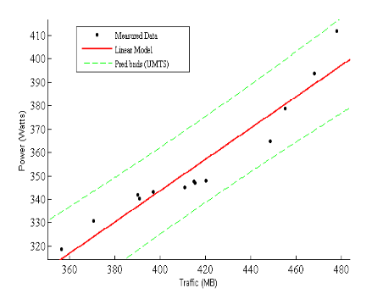

Figure 6.2: Power consumption of a UMTS Base Station

The power consumption of base stations varies according to (signalling and user plane) traffic load (which varies during the day / night) and depends on the radio access technology being used.

Based on this, energy efficiency of 5G base stations and other network elements / network functions may potentially be improved:

- By reducing as much as possible signalling traffic load on a base station serving no user.

- By deploying mechanisms enabling to tend towards zero power consumption at zero load (i.e. either zero CPU utilization or zero traffic load).

As shown by figure 6.1, Pidle, i.e. the power consumption of a server when its CPU load is null, is a large portion of Pmax, the power consumption of the server when CPU load is 100%. Based on this observation, and extrapolating it to the Network Function level of a 5G network, either PNF or VNF, smart mechanisms enabling to reduce Pidle of Network Functions are expected, possibly through introducing some standby modes in Network Functions when their load is zero.

ETSI ES 203 237 [10] - clause 6 - introduces Energy Aware States, modelled as pairs of "Primitive sub-States" (PsSes) related to the configuration of Power Scaling and Standby mechanisms.

EAS = {Pj, Sk} with 0 ≤ j ≤ J and 0 ≤ k ≤ K

where:

- Sk represents the k-th Primitive sub-State (PsS) related to the Standby techniques:

- S0 is the active state,

- in Sk, with k > 0, the entity is sleeping,

- in SK, the device is completely off.

- Pj represents the j-th Primitive sub-State (PsS) related to the Power Scaling techniques:

- P0 is the Power Scaling sub-state (P-PsS) for the highest network device performance (it also consumes the highest power),

- with j > 0, Pj is the Power Scaling sub-state (P-PsS) for the intermediate level where the entity is in reduced performance while still being active.

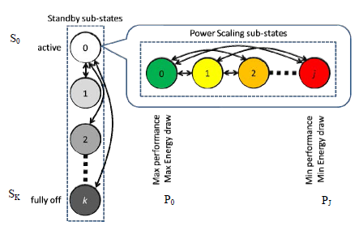

Figure 6.3: ETSI GAL Energy Aware States

Given the exclusive use of power scaling and standby capabilities, the J Power Scaling sub-State (P-PsSes) can be adopted only when the entity is active while the K Standby sub-State (S-PsSes) only when the entity is in standby mode.

In this way, when an entity provides internal automatic mechanisms for changing the operating mode (active or standby), the EAS P-PsS component represents the power scaling configuration used during the active mode, while the S-PsS component represents the standby configuration used during the standby mode.

The support of Energy Aware States in 5G Network Functions (PNFs and VNFs) in NG-RAN and 5GC will be implementation-dependent. Therefore, it is important, from an operator's perspective, to be able to discover Energy Aware States, if any, supported by the various Network Functions which compose its multi-vendor 5G network. ETSI ES 203 237 [10] – clause 5 – defines the Green Standard Interface (GSI), providing a set of commands to setup the power management and monitoring of energy-aware resources, which may include 5G Network Functions. The main functionalities offered by the GSI interface are:

- Discovery: used to retrieve information such as e.g. available power states and individually manageable components within the entity;

- Provisioning: allows the configuration of an entity into a certain power state;

- Monitoring: permits to monitor relevant parameters, incl. power states, etc.

- Etc.

In order for a network operator to be able to discover, control and monitor the Energy Aware States supported by its 5G Network Functions end-to-end, it would be useful if the GSI functionalities are made available to the NM layer via standardized management interfaces. Depending on use cases, the "provisioning" functionalities can be located at various layers.

In the context of Virtualized Network Functions, MANO functional blocks need to be involved.

# 7 EE control framework

## 7.1 General EE control framework

Figure 7.1.1 describes a general framework for EE control.



Figure 7.1.1: General framework for EE control

The key functions in self-managed automated energy efficiency control processes should include:

- **EE Policy Management:** defines and manages the energy efficiency control policies related to the energy consumption status and control operations at the network, equipment and site levels. It translates the policy information into configurations at the EE optimisation entities at network, equipment and site levels, where applicable. The policy may be adjusted according to achievable EE KPI and the variations of QoS/QoE.

- **EE Control and Coordination:** the energy efficiency control is designed to be a self-managed and automated process to control and coordinate the power saving operations across all the relevant elements at a network, equipment and site levels.

The operating conditionssuch as traffic load and density at the network and equipment levels and operational conditions such as temperature and humidity at the site level are monitored and reported. According to the energy efficiency control policy and the current status, energy efficiency control operations are activated/deactivated in each of the EE optimisation entities. The embedded energy metering function in each EE optimisation entity collects the necessary statistics such as EE KPI and QoS/QoE and then report the information to the EE Profiles Management. The energy efficiency optimisation entity can be a logical or physical component to execute the EE policies and the corresponding energy consumption optimisation operations.

- **EE Profiles Management:** monitors, collects, processes, stores and provides EE related information and statistics including the profiles for traffic, operating conditions, the corresponding achievable EE KPI, the variations of QoS/QoE in reference to the pre-fined QoS/QoE requirements from the embedded energy metering functions in each of the EE optimisation entities. The information is assessed and then sent to the EE Control and Coordination for adjusting the power saving control operations and possible policy adjustment by the EE Policy Control.

## 7.2 Potential architectural options

### 7.2.0 Introduction

TS 32.500 [18] clause 3.1 describes, based on 3GPP legacy management architecture, various potential architecture options for SON:

- Centralised SON: SON solution where SON algorithms are executed in the OAM system. Centralised SON has two variants:

- NM-Centralised SON: SON solution where SON algorithms are executed at the Network Management level.

- EM-Centralised SON: SON solution where SON algorithms are executed at the Element Management level.

- Distributed SON: SON solution where SON algorithms are executed at the Network Element level.

- Hybrid SON: SON solution where SON algorithms are executed at two or more of the following levels: NE or EM or NM.

Following this classification, various possible mappings of the EE control framework depicted in clause 7.1 are described in sub-clauses below, given that:

- due to that there is not yet a standardized policy management framework for the management and orchestration of 3GPP networks, the EE Policy Management functional block of figure 7.1.1 cannot be represented in the following sub-clauses;

- the EE Profiles Management can be split into two sub-parts:

- one is the network data collector which collects relevant EE related information from the network. Such functionality is generally together with the EE optimization entity;

- another one is the traffic profile management function which enables the operator to define traffic profiles, define EE KPIs per traffic profile and assess EE related data collected from the network with regard to traffic profiles. This functionality is out of scope of the present study.

### 7.2.1 NM-Centralised architecture

In this architecture, the multi-vendor EE optimization entity and EE control and coordination are at NM level.

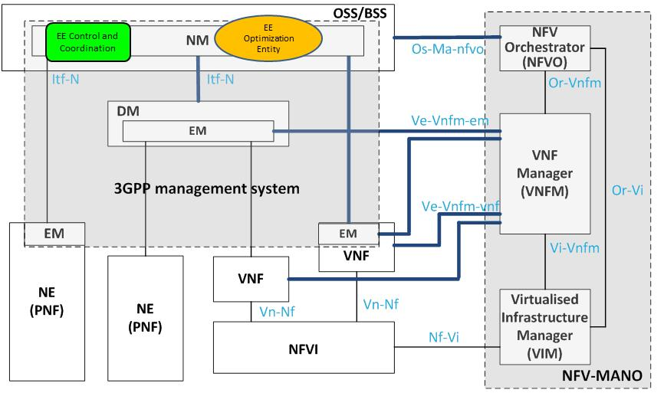

Figure 7.2.1.1: NM-centralised architecture

### 7.2.2 EM-Centralised architecture

In this architecture, the vendor-specific EE optimization entity and EE control and coordination are at EM/DM-level. NM provides multi-vendor EE control and coordination functionalities.

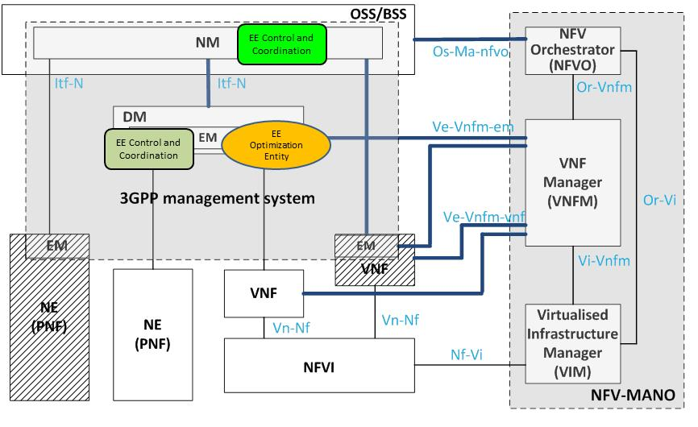

Figure 7.2.2.1: EM-centralised architecture

### 7.2.3 Distributed architecture

In this architecture, the EE optimization entity is at VNF / PNF level. DM and NM provide EE control and coordination functionalities. DM provides vendor-specific EE control and coordination functionalities, whereas NM provides multi-vendor EE control and coordination functionalities.

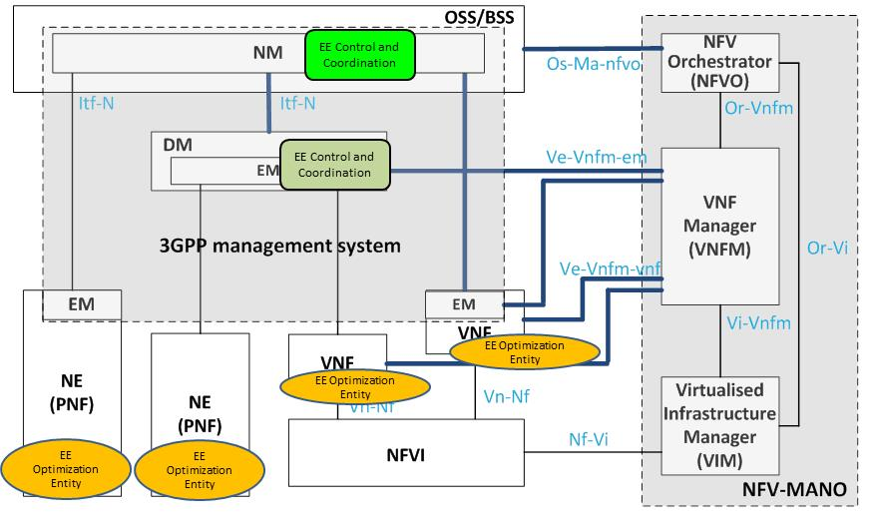

Figure 7.2.3.1: Distributed architecture

Note: Architecture options depicted in clauses 7.2.1, 7.2.2 and 7.2.3 are based on 3GPP legacy management architecture. From Rel-15 onwards, a service-based architecture will replace the legacy one.

# 8 Potential use cases and requirements

## 8.1 Energy efficiency assessment

### 8.1.1 Potential use cases

#### 8.1.1.1 Introduction

Power, Energy and Environmental (PEE) parameters related measurements, combined with data volume measurements, are valuable information for operators to measure the energy efficiency of their 5G network. It is then necessary to collect these measurements.

#### 8.1.1.2 Creation of measurement job for collecting 5G NF EE measurement data

This use case is about enabling an authorized consumer to create one or more measurement job(s) for collecting performance measurements on 5G network function(s) with the objective to of metering their energy efficiency.

For more information, see use case "Creation of measurement job for 3GPP NF" in 3GPP TS 28.550 [11] - clause 5.1.1.1.1.

It can be:

- one single measurement job for collecting the EE KPI of 5G NF(s);

- one single measurement job for collecting both data volume and power, energy and environmental parameters of 5G NF(s);

- separate measurement jobs for collecting separately data volume and power, energy and environmental parameters of 5G NF(s).

#### 8.1.1.3 Reporting 5G NF EE measurements via file transfer

This use case is about enabling authorized consumer(s) to get energy efficiency measurement data file(s) of 5G network function(s).

For more information, see use case "3GPP NF performance data file reporting" in 3GPP TS 28.550 [11] - clause 5.1.1.2.1.

#### 8.1.1.4 Reporting 5G NF EE measurement via streaming

This use case is about enabling authorized consumer(s) to get streamed energy efficiency measurement data of 5G network function(s).

For more information, see use case "3GPP NF performance data streaming" in 3GPP TS 28.550 [11] - clause 5.1.1.3.1.

### 8.1.2 Potential requirements

#### 8.1.2.1 Collection of Data Volumes

##### 8.1.2.1.1 Potential requirements for the creation of measurement job for collecting 5G NF DV measurement data

Requirements from TS 28.550 [11] – clause 5.2.1 apply.

##### 8.1.2.1.2 Potential requirements for 5G NF DV measurement data file reporting

Requirements from TS 28.550 [11] – clause 5.2.2 apply.

##### 8.1.2.1.3 Potential requirements for 5G NF DV measurement data streaming

Requirements from TS 28.550 [11] – clause 5.2.3 apply.

#### 8.1.2.2 Collection of Power, Energy and Environmental (PEE) parameters

##### 8.1.2.2.1 Potential requirements for initiating / stopping the collection of PEE parameters

The NF PEE measurement job control service producer shall support a capability allowing its authorized consumer(s) to initiate / stop the retrieval of power, energy and environmental parameters of selected 5G NF(s).

##### 8.1.2.2.2 Potential requirements for reporting PEE parameters

The NF PEE measurement information service producer shall support a capability allowing its authorized consumer(s) to periodically receive measured power, energy and environmental parameters values, for selected 5G NF(s).

##### 8.1.2.2.3 Potential requirements for reporting PEE parameters related alarms

The NF PEE measurement information service producer shall support a capability allowing its authorized consumer(s) to be notified in case of power, energy and environmental parameters related alarms, for selected 5G NF(s).

##### 8.1.2.2.4 Potential requirements for reporting PEE parameters related configuration changes

The NF PEE measurement information service producer shall support a capability allowing its authorized consumer(s) to be notified in case of power, energy and environmental parameters related configuration changes being detected by the NF PEE measurement information service producer, for selected 5G NF(s).

## 8.2 Energy saving management

### 8.2.1 Potential use cases

#### 8.2.1.1 Cell overlaid use case

In this use case described in [12], an en-gNB / ng-eNB can only enter into an energy saving state if there is radio coverage by other radio systems – be it another en-gNB / ng-eNB or an entity of another radio access technology - for the whole coverage area of the en-gNB / ng-eNB in question.

This use case applies both for Intra- and Inter-RAT Energy Saving.

This use case applies when the traffic is low.

#### 8.2.1.2 Capacity limited network use case

In this use case described in [12], the coverage area of a group of en-gNBs / ng-eNBs is taken care of by one or more of its en-gNBs / ng-eNBs while the others go into an energy saving state.

This use case applies for Intra-RAT Energy Saving and does not apply for Inter-RAT Energy Saving.

This use case applies when the traffic is low.

### 8.2.2 Potential requirements

#### 8.2.2.1 General requirements

The NF energy saving information service producer shall allow its authorized consumer(s) to query which energySaving state values are supported by cells or network functions of the 5G network.

The NF energy saving information service producer shall allow its authorized consumer(s) to query cells and/or network functions to know their energy saving state.

The NF energy saving information service producer shall support a capability to notify its authorized consumer(s) when a cell or network function goes into or out of an energy saving state.

The NF energy saving information service producer shall notify its authorized consumer(s) when a cell or network function fails to re-start as a result of going out of an energy saving state.

#### 8.2.2.2 Requirements for energy saving

The NF energy saving service producer shall support a capability allowing its authorized consumer(s) to initiate energy saving compensation activation to one or multiple cells or network functions.

The above requirement applies for the use case 'capacity limited network'.

The NF energy saving service producer shall support a capability allowing its authorized consumer(s) to initiate energy saving compensation deactivation to one or multiple cells or network functions.

The above requirement applies for the use case 'capacity limited network'.

The NF energy saving service producer shall support a capability allowing its authorized consumer(s) to initiate energy saving activation to one or multiple cells or network functions.

The above requirement applies for the use case 'cell overlaid' as well as for the use case 'capacity limited network'.

The NF energy saving service producer shall support a capability allowing its authorized consumer(s) to initiate energy saving deactivation to one or multiple cells or network functions.

The above requirement applies for the use case 'cell overlaid' as well as for the use case 'capacity limited network'.

# 9 Potential solutions

## 9.1 Energy efficiency assessment

The assessment of energy efficiency of 5G networks may be based on the following potential solutions:

- 5G base stations are assumed to be all equipped with built-in sensors (cf. ETSI ES 202 336-12 [8]);

- Object model definition: the attribute 'peeParametersList' of IOC ManagedFunction, defined in TS 28.622 [21], may be used to model the PEE related parameters;

- Management services for network function provisioning, defined in TS 28.531 [22], may apply to read / write PEE related parameters and notify PEE related parameters value changes;

- Data volume measurements required to calculate DV (Data Volume) are to be defined in TS 28.552 [13]. KPIs may have to be defined in TS 28.554 [24];

- Power, Energy and Environmental (PEE) measurements required to calculate EC (Energy Consumption) are to be defined in TS 28.552 [13];

- The 'Measurement job control services for NFs', defined in TS 28.550 [11], may apply for the collection of DV and EC performance measurements data;

- The 'Performance data file reporting services for NFs, defined in TS 28.550 [11], may apply for the file-based reporting of DV and EC performance measurements data.

## 9.2 Energy saving management

It is proposed to provide a solution for:

- energy saving management in NG-RAN only for the following reasons:

- the radio access network energy consumption represents the largest portion of the total operators' network energy consumption, thus the radio access network is the place where energy savings should be mainly achieved,

- use cases for energy saving in the 5G core network are not available;

- NM-centralized energy saving management only, for the following reason:

- no distributed energy saving functionality has been specified by 3GPP.

It is proposed that IOCs, such as e.g. GNBDUFunction, GNBCUFunction, NRCellDu, NRCellCU, etc., defined in TS 28.541 [23] name-contain a new IOC having attributes (e.g. energySavingState) to represent their energy saving properties.

It is proposed that the attribute energySavingState, which legal values are 'isNotEnergySaving' and 'isEnergySaving' for pre-5G radio access network technologies, may have an unrestricted number of vendor-specific values, as introduced in clause 6 of the present document, from 5G networks onwards.

# 10 Conclusion

The present document gives an overview of studies and/or normative works initiated by other SDOs / working groups on pre-5G and/or 5G radio access networks energy efficiency. It also inventories high-level EE KPIs defined by those SDOs / working groups and methods to collect required measurements.

The study identifies potential use cases and requirements for a) 5G network energy efficiency assessment and b) energy efficiency optimization (i.e. energy saving).

The group recommends starting normative work on the following aspects:

- Definition of concepts, use cases and requirements for 5G network energy efficiency assessment and optimization.

- Definition of performance measurements / KPIs enabling to assess the energy efficiency of 5G networks, for both aspects: data volumes and energy consumption.

- Specifying a solution to represent and manage power, energy and environment related parameters of 5G networks.

- Defining a solution for energy saving management in 5G networks.

Annex A:  
Change history

|  |  |  |  |  |  |  |  |
| --- | --- | --- | --- | --- | --- | --- | --- |
| **Change history** | | | | | | | |
| **Date** | **Meeting** | **TDoc** | **CR** | **Rev** | **Cat** | **Subject/Comment** | **New version** |
| 2018-12 | SA#82 | SP-181061 |  |  |  | Presented for approval | 2.0.0 |
| 2018-12 | SA#82 |  |  |  |  | EditHelp fix + Upgrade to change control version | 16.0.0 |
| 2019-09 | SA#85 | SP-190766 | 0001 | - | F | Correct external reference version number | 16.1.0 |