3GPP TR 38.866 V16.1.0 (2019-03)

Technical Report

3rd Generation Partnership Project;

Technical Specification Group Radio Access Network;

Study on remote interference management for NR

(Release 16)

** 

The present document has been developed within the 3rd Generation Partnership Project (3GPP TM) and may be further elaborated for the purposes of 3GPP.  
The present document has not been subject to any approval process by the 3GPPOrganizational Partners and shall not be implemented.  
This Report is provided for future development work within 3GPPonly. The Organizational Partners accept no liability for any use of this Specification.  
Specifications and Reports for implementation of the 3GPP TM system should be obtained via the 3GPP Organizational Partners' Publications Offices.

Keywords

<New Radio, RIM>

***3GPP***

Postal address

3GPP support office address

650 Route des Lucioles - Sophia Antipolis

Valbonne - FRANCE

Tel.: +33 4 92 94 42 00 Fax: +33 4 93 65 47 16

Internet

http://www.3gpp.org

***Copyright Notification***

No part may be reproduced except as authorized by written permission.  
The copyright and the foregoing restriction extend to reproduction in all media.

© 2019, 3GPP Organizational Partners (ARIB, ATIS, CCSA, ETSI, TSDSI, TTA, TTC).

All rights reserved.

UMTS™ is a Trade Mark of ETSI registered for the benefit of its members

3GPP™ is a Trade Mark of ETSI registered for the benefit of its Members and of the 3GPP Organizational Partners  
LTE™ is a Trade Mark of ETSI registered for the benefit of its Members and of the 3GPP Organizational Partners

GSM® and the GSM logo are registered and owned by the GSM Association

Contents

Foreword 5

Introduction 5

1 Scope 5

2 References 5

3 Definitions, symbols and abbreviations 6

3.1 Definitions 6

3.2 Symbols 6

3.3 Abbreviations 6

4 Introduction on atmospheric ducting phenomenon and remote interference in TDD network 6

4.1 Atmospheric ducting phenomenon 6

4.2 Characteristics of the remote interference 7

4.2.1 Characteristics of the IoT increase caused by remote interference 7

4.2.2 The distance that the remote interference impacts 8

5 Deployment Scenarios for RIM 8

6 Study on framework and mechanisms for RIM 9

6.1 RIM framework in current TD-LTE systems 9

6.2 Potential frameworks and workflows for NR RIM 10

6.3 Potential Reference signal designs for NR RIM 13

6.3.1 General requirement 13

6.3.2 RS sequence type and structure 14

6.3.3 RS resource pattern 14

6.4 Potential mechanisms for improving network robustness 15

6.4.1 Solutions by network implementation 15

6.4.1.1 Time-domain based solutions 15

6.4.1.2 Frequency-domain based solutions 15

6.4.1.3 Spatial-domain based solutions 16

6.4.1.4 Power-domain based solutions 16

6.4.1.5 Random access procedure enhancement 16

6.4.2 Solutions with specification impact 17

6.4.2.1 Time-domain based solutions 17

6.4.2.2 Frequency-domain based solutions 17

6.4.2.3 Spatial-domain based solutions 17

6.4.2.4 Power-domain based solutions 17

6.5 Backhaul-based coordination mechanisms for remote interference mitigation 17

6.5.1 gNB set configuration 17

6.5.2 Intra-set coordination in RIM 18

6.5.3 Inter-set coordination for RIM 18

6.5.3.1 Solutions for inter-set coordination 18

6.5.3.2 Conclusions for inter-set coordination 19

7 Evaluation of reference signals 19

7.1 Evaluation methodology 19

7.1.1 Evaluation cases 19

7.1.2 Detection algorithms 21

7.2 Performance metric 23

7.2.1 False alarm probability 23

7.2.2 Detection probability 23

7.2.3 Error detection probability 23

7.2.4 Minimum SNR 23

7.3 Evaluation results and observations 24

7.3.1 Case 1: Single sequence and single RS 24

7.3.2 Case 2-1: Single sequence and multiple RSs 25

7.3.3 Case 2-2A: Multiple sequences and single RS 26

7.3.4 Case 2-2B: Multiple sequences and multiple RSs 27

7.4 Conclusions based on evaluations 29

8 Conclusions 30

Annex A: Change history 31

# Foreword

This Technical Report has been produced by the 3rd Generation Partnership Project (3GPP).

The contents of the present document are subject to continuing work within the TSG and may change following formal TSG approval. Should the TSG modify the contents of the present document, it will be re-released by the TSG with an identifying change of release date and an increase in version number as follows:

Version x.y.z

where:

x the first digit:

1 presented to TSG for information;

2 presented to TSG for approval;

3 or greater indicates TSG approved document under change control.

y the second digit is incremented for all changes of substance, i.e. technical enhancements, corrections, updates, etc.

z the third digit is incremented when editorial only changes have been incorporated in the document.

# Introduction

In the 3GPP TSG RAN #80 meeting, a new SI "Study on remote interference management for NR" was agreed for Release 16 [2]. The study aims to investigate possible mechanisms for mitigating the impact of remote base station interference in unpaired spectrum focusing on synchronized macro cells with semi-static DL/UL configuration in co-channel.

# 1 Scope

The present document captures the findings and results from the study item "Study on remote interference management for NR" [2]. The objective of this SI is to investigate possible mechanisms for mitigating the impact of remote base station interference in unpaired spectrum focusing on synchronized macro cells with semi-static DL/UL configuration in co-channel, including:

- Study mechanisms for improving network robustness and addressing strong remote base station interference, including potential UE side's enhancement [RAN1]

- Study mechanisms for identifying which gNB(s) generate strong remote interference, including the following aspects:

- Potential Reference signal design for gNB to identify that it creates strong inter-gNB interference to some victim gNB [RAN1]

- Existing reference signals are starting points of discussion.

- Mechanism for gNB to start and terminate the transmission/detection of the reference signal(s) [RAN1, RAN3]

- Study the potential additional coordination among gNBs for mitigating remote interference [RAN3]

This document is a 'living' document, i.e. it is permanently updated and presented to TSG-RAN meetings.

# 2 References

The following documents contain provisions which, through reference in this text, constitute provisions of the present document.

- References are either specific (identified by date of publication, edition number, version number, etc.) or non‑specific.

- For a specific reference, subsequent revisions do not apply.

- For a non-specific reference, the latest version applies. In the case of a reference to a 3GPP document (including a GSM document), a non-specific reference implicitly refers to the latest version of that document *in the same Release as the present document*.

[1] 3GPP TR 21.905: "Vocabulary for 3GPP Specifications".

[2] 3GPP RP-181430: " New SI proposal: Study on remote interference management for NR "

# 3 Definitions, symbols and abbreviations

## 3.1 Definitions

For the purposes of the present document, the terms and definitions given in 3GPP TR 21.905 [1] and the following apply. A term defined in the present document takes precedence over the definition of the same term, if any, in 3GPP TR 21.905 [1].

## 3.2 Symbols

For the purposes of the present document, the following symbols apply:

<symbol> <Explanation>

## 3.3 Abbreviations

For the purposes of the present document, the abbreviations given in 3GPP TR 21.905 [1] and the following apply. An abbreviation defined in the present document takes precedence over the definition of the same abbreviation, if any, in 3GPP TR 21.905 [1].

RIM Remote Interference Management

# 4 Introduction on atmospheric ducting phenomenon and remote interference in TDD network

## 4.1 Atmospheric ducting phenomenon

Under certain weather conditions, lower densities at higher altitudes in the Earth's atmosphere causes reduced refractive index, bending signals back towards the earth. Under such circumstances, signals can propagate in a higher refractive index layer, i.e., the atmospheric duct, since the reflection and refraction are encountered at the boundary with a lower refractive index material. In this mode of propagation, which is dubbed as the atmospheric ducting, radio signals experience less attenuation, and are being guided over distances far greater than the normal radiate range. This phenomenon usually happens during the transition periods between spring and summer and between summer and autumn for inland areas, and during winter seasons for coastal areas. The frequency range which is usually influenced by this phenomenon is around 0.3 GHz - 30 GHz.

In a TDD network with the same configuration of uplink-downlink transmission direction, a gap is used to avoid the cross-link interference. However, when the atmospheric ducting phenomenon happens, radio signals can travel a relatively long distance, and the propagation delay goes beyond the gap. In this case, the downlink signals of an aggressor base station can travel a long distance and interfere with the uplink signals of a victim base station that is far away from the aggressor, as shown in Figure 4-1. Such interference is termed as 'remote interference' herein. The further the aggressor is to the victim, the more uplink symbols of the victim will be impacted.

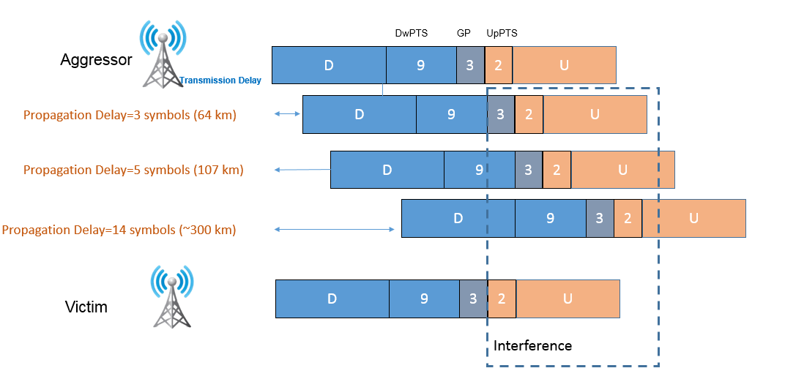

Figure 4-1: An illustration of how remote interference happens in TD-LTE network.

## 4.2 Characteristics of the remote interference

### 4.2.1 Characteristics of the IoT increase caused by remote interference

When atmospheric ducting phenomenon happens, the IoT of the victim base station demonstrates a "sloping" characteristic as shown in Figure 4-2. It can be seen that, the closer the uplink symbol is to gap, the higher interference it experienced.

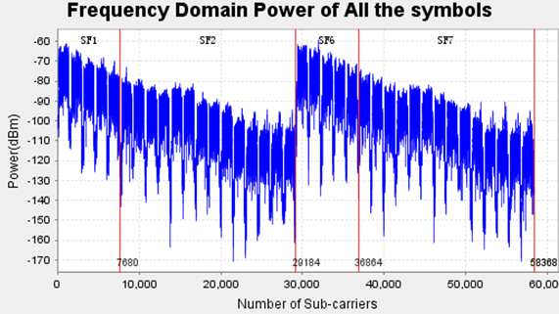

Figure 4-2: Illustration of IoT experienced at a victim base station in TD-LTE network.

The reason behind this is that, the remote interference is caused by accumulated signals from a number of remote base stations with different distances. Specifically, as illustrated in Figure 4-3, Aggressor 1, which is the closest aggressor to the victim, will only cause interference to the first uplink symbol after the gap of the victim. While for Aggressor 4, which is far away from the victim, its downlink signals will propagate over a much longer distance and impact more uplink symbols of the victim.

1) As seen in Figure 4-3, the first uplink symbol of the victim suffers from interference caused by Aggressor 1~4, while the 5th symbol only suffers from interference caused by Aggressor 4. Therefore, compared to the uplink symbols far away from the gap, those symbols close to the gap suffer from accumulated interference caused by more aggressors, resulting a sloping IoT in time domain.

2) Since Aggressor 1 is closer to the victim, the downlink signals of Aggressor1 will arrive at the victim with higher power compared to those of Aggressor 2~4. Therefore, the interference at uplink symbols closer to the gap should be higher than that at uplink symbols that are far away from the gap.

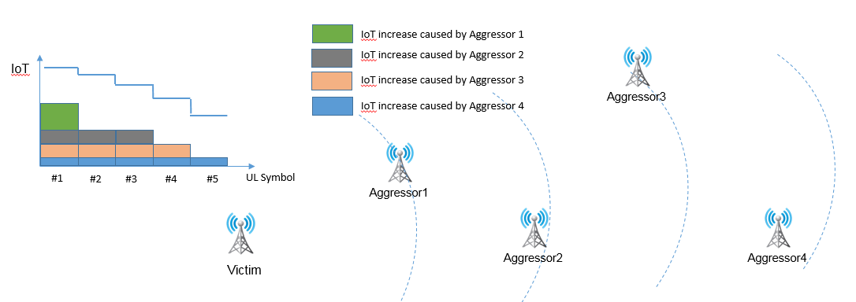

Figure 4-3: An illustration of why the victim of remote interference suffers from "sloping" IoT increase.

### 4.2.2 The distance that the remote interference impacts

Based on the field trial results in TD-LTE networks, a probability density function (PDF) of the distance that the remote interference can impact in the inland area is obtained and illustrated in Figure 4-4. It is seen that the distance between the victim and aggressor ranges from 64 km to 400 km, where a large percentage of samples are within 150 km.

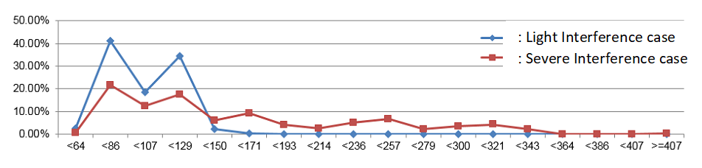

Figure 4-4: PDF of distance that the remote interference can impact in inland cities.

For coastal cities, the distance between the victim and aggressor can be as far as 300 km, or even farther.

# 5 Deployment Scenarios for RIM

In terms of the IoT (interference over thermal) increase between two sets of gNBs causing remote interference to each other, two scenarios should be considered for NR-RIM,

1) Scenario #1: IoT increases are detectable by one or more gNBs in both sets,

2) Scenario #2: IoT increase is detectable by one or more gNBs in only one set.

As shown in Figure 5-1, it is assumed in the RIM study that the whole network with synchronized macro cells has a common understanding on a DL transmission boundary (denoted as the 1st reference point) which indicates the ending boundary of the DL transmission, and an UL reception boundary (denoted as the 2nd reference point) which denotes the starting boundary of the first allowed UL reception within a DL-UL transmission periodicity.

- The boundary may be considered for RS design

- The 1st reference point locates before the 2nd reference point.



Figure 5-1. Illustration of DL and UL transmission boundaries within a DL-UL transmission periodicity

The gNB is not expected to receive RS before the DL transmission boundary, and not expected to transmit RS after the UL reception boundary.

# 6 Study on framework and mechanisms for RIM

Based on the study of different mechanisms, RIM is classified into two categories, i.e., static RIM and adaptive RIM.

- Static RIM rely on planning the network so that is inherently robust against RI

- Adaptive RIM rely on detecting that RI is present and adapting the configuration, which can be further classified into *centralized*, *distributed* or *localized*.

- Centralized RIM rely on a centralized coordinator to gather input from aggressor and victim gNBs, and based on the aggregate input, decide on appropriate RIM actions for each gNB and instruct the gNBs to apply this action.

- In a distributed RIM, the aggressor and victim exchange information / coordinate without the involvement of a centralized node, i.e., each pair of gNBs decides on the RI mitigation scheme based on only information exchange between each-other.

- Localized RIM do not involve transmission of reference signals or any form of coordination.

## 6.1 RIM framework in current TD-LTE systems

In current TD-LTE network, atmospheric duct phenomenon happens during certain period of time. A remote interference management depicted in Figure 6-1 has been used to cope with the remote interference.

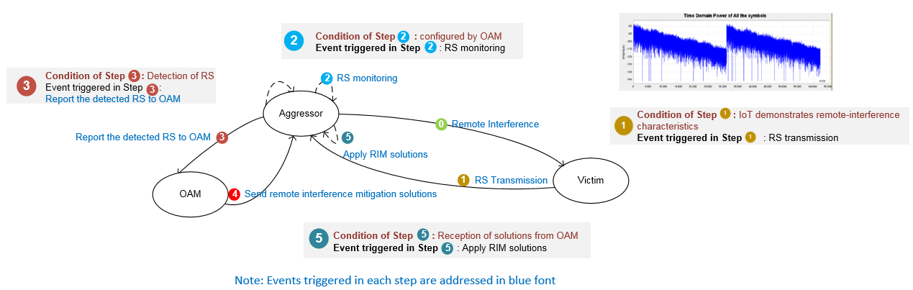

Figure 6-1: Current RIM framework in TD-LTE systems

As shown in Figure 6-1, current RIM framework is not self-adaptive. The stop of RS transmission, the triggering and stop of RS monitoring, the triggering and stop of applications of the remote interference mitigation solutions are all rely on manual intervention through OAM. Under this framework, the start and stop of the RIM and corresponding remote interference mitigation schemes cannot happen in time, causing degradation of both network performance and efficiency.

In order to minimize or eliminate manual intervention during the RIM process, and increase the effectiveness and efficiency of the RIM, as stated in the objective of the SI, mechanisms for gNB to start and terminate the transmission/detection of the reference signal(s) should be studied for NR-RIM framework. The functionalities and requirements of the corresponding reference signal should be clarified for the framework, so that the analysis and design of the reference signal can be carried out accordingly. Moreover, as mentioned in Section 5, the NR-RIM framework should be able to solve the remote interference issues for both Scenarios #1 and #2.

## 6.2 Potential frameworks and workflows for NR RIM

Framework-1, Framework-2.1, Framework-2.2 below are used as starting point for further study, using Framework-0 as basis for comparison.

Note that not all the steps need to be included when making use of a given framework. An aggressor may also be a victim (and vice versa) at least for Scenario #1. Information reporting to OAM from both aggressor and victim gNB is supported from RAN1 perspective.

**Framework-0**

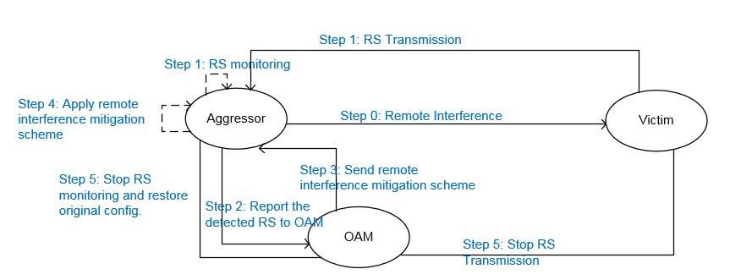

Figure 6-2: RIM Framework-0

Workflow of Framework-0

Step 0: Atmospheric ducting phenomenon happens and the remote interference appears

Step 1:

- Victim experiences "sloping" like IoT increase and start RS transmission

- Aggressor starts monitoring RS as configured by OAM

Step 2: Upon reception of RS, Aggressor reports the detected RS to OAM

Step 3: OAM sends remote interference mitigation scheme to Aggressor

Step 4: Aggressor applies remote interference mitigation scheme

Step 5: OAM stops RS monitoring and restores original config. at aggressor side and stop RS transmission at victim side.

**Framework-1**

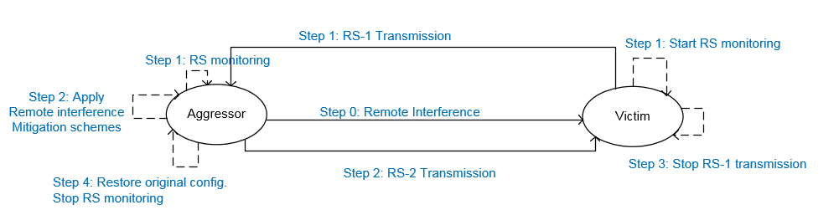

Figure 6-3: RIM Framework-1

Workflow of Framework-1 is described as follows:

Step 0: Atmospheric ducting phenomenon happens and the remote interference appears

Step 1:

- Victim experiences "sloping" like IoT increase and start RS transmission/monitoring

- This RS marked as RS-1 is used to assist aggressor(s) to recognize that they are causing remote interference to the victim and to detect/deduce how many UL resources of the victim are impacted by the aggressors.

- Aggressor starts monitoring RS as configured by OAM or when it experiences remote interference with "sloping" IoT increase.

Step 2: Upon reception of RS-1, Aggressor starts remote interference mitigation solutions such as muting some DL transmission symbols and transmits RS to inform victim that the atmospheric ducting phenomenon still exist

- This RS marked as RS-2 is used to assist the victim to decide whether the atmospheric ducting phenomenon still exist.

- It does not preclude the possibility of using RS-2 for other purposes, pending on further study.

Step 3: Victim continues RS-1 transmission if RS-2 is detected. Victim may stop RS-1 transmission if RS-2 is not detected and the IoT going back to certain level.

Step 4: Aggressor continue remote interference mitigation while receiving RS-1. Upon "disappearance" of RS-1, Aggressor restores original configuration when "disappearance" of RS-1.

Note: Although RS-1 and RS-2 carry different functionalities, it might be beneficial to achieve a common design for RS-1 and RS-2.

**Framework-2.1**

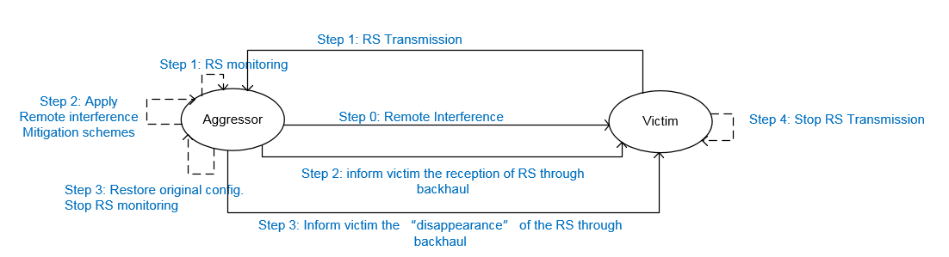

Figure 6-4: RIM Framework-2.1

Workflow of Framework-2.1

Step 0: Atmospheric ducting phenomenon happens and the remote interference appears

Step 1:

- Victim experiences "sloping" like IoT increase and start RS transmission

- A set of gNBs might use the same RS, which may carry the set ID.

- Aggressor starts monitoring RS as configured by OAM or when it experiences remote interference with "sloping" IoT increase.

Step 2: Upon reception of RS, Aggressor informs the set of victim gNB(s) the reception of RS through backhaul and apply interference mitigation scheme

- Message exchange in Step 2 could include other information, pending on further study.

Step 3: Upon "disappearance" of RS, Aggressor informs the set of Victim gNB(s) the "disappearance" of RS through backhaul and restore original configuration.

Step 4: Victim stop RS transmission upon the reception of the "disappearance of RS" info through backhaul

**Framework-2.2**

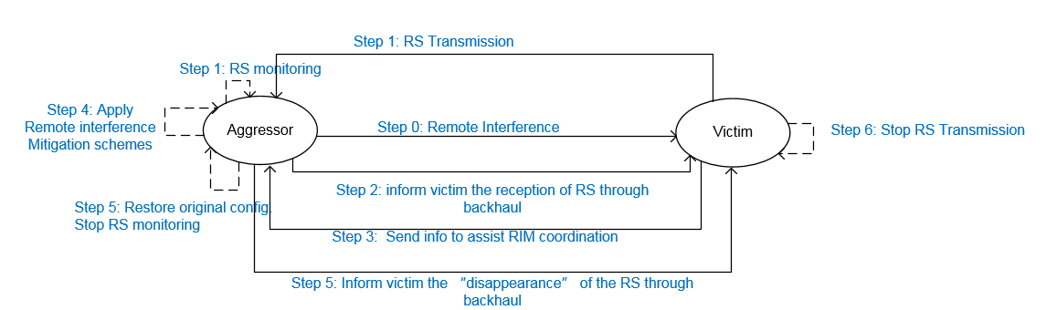

Figure 6-5: RIM Framework-2.2

Workflow of Framework-2.2 is described as follows:

Step 0: Atmospheric ducting phenomenon happens and the remote interference appears

Step 1:

- Victim experiences "sloping" like IoT increase and start RS transmission

- A set of gNBs might use the same RS, which may carry the set ID.

- Aggressor starts monitoring RS as configured by OAM or when it experiences remote interference with "sloping" IoT increase.

Step 2: Upon reception of RS, Aggressor informs the set of victim gNB(s) the reception of RS through backhaul

Step 3: Upon reception of the "reception of RS" info received in the backhaul, victim sends info to assist RIM coordination

Step 4: Aggressor applies remote interference mitigation scheme

Step 5: Upon "disappearance" of RS, Aggressor informs Victim the "disappearance" of RS through backhaul.

Step 6: Victim stop RS transmission upon the reception of the "disappearance of RS" info through backhaul

## 6.3 Potential Reference signal designs for NR RIM

### 6.3.1 General requirement

From the descriptions in section 6.2, in Framework 0, Framework 1, Framework 2.1 and 2.2, RIM RS(s) should be sent where the functionalities are summarized in Table 1.

Table 6-1. Basic functions of NR-RIM RS

|  |  |  |
| --- | --- | --- |
| Framework | RS type | Functions |
| Framework 0 | RS sent by victim | 1/ Being able to provide information whether the atmospheric ducting phenomenon exists  2/ Being able to assist the aggressor to identify how many UL OFDM symbols at victim it impacted. |
| Framework 1 | RS-1 sent by victim | 1/ Being able to provide information whether the atmospheric ducting phenomenon exists  2/ Being able to assist the aggressor to identify how many UL OFDM symbols at victim it impacted. |
| RS-2 sent by aggressor | 1/ Being able to provide information whether the atmospheric ducting phenomenon exists |
| Framework 2.1 and 2.2 | RS sent by victim | 1/ Being able to assist the aggressor to identify how many UL OFDM symbols at victim it impacted.  2/ Being able to carry enough information to enable the information exchange through backhaul (e.g.: set ID). |

In remote interference scenarios, the RIM RS(s) will experience extremely large propagation delay from transmitter side to receiver side. Therefore, RIM RS(s) should be well designed to handle large path delay.

Since the purpose and use case of RIM RS is quite different from existing RSs which are originally designed for UE demodulation and measurements, in order to avoid potential backward compatibility problem, the RIM RS should be distinguished from existing RSs used for other purposes, by resource configurations and/or RS sequence design.

The above RIM RS(s) can be designed in a unified way in terms of sequence type, time and frequency transmission pattern, irrespective of framework chosen, to convey information for gNB (or gNB group) identification, at the same time, victim gNB can also use RIM RS to convey information, e.g. either "Enough mitigation, no further actions needed" or "Not enough mitigation, further actions needed". However, the information conveyed in different frameworks does not need to be the same. For example, in framework 1, although it is not necessary to convey exactly the same gNB ID or set ID information as in framework 2.1 and 2.2, it is still beneficial if the RS resources can be distinguished so that different gNB(s) can transmit on different resources, e.g. to avoid causing too much interference at the aggressor side.

For all time occasion, the sequence candidates for detection should be the same, under unified design, and if RS-2 is configured, RS-1 and RS-2 are differentiable and are separately configured with respect to time occasion and RS sequence. The max number of sequences that one gNB needs to detect in one DL-UL period for interference identification is 8.

### 6.3.2 RS sequence type and structure

The pseudo-random sequence (length-31 Gold sequence) specified in NR is adopted as the RIM RS sequence. The RIM RS sequence $r(m)$ is defined by

$$r(m)=\frac{1}{\sqrt{2}}\left(1−2⋅c(2m)\right)+j\frac{1}{\sqrt{2}}\left(1−2⋅c(2m+1)\right)$$

where the pseudo-random sequence $c(i)$ is defined in TS38.211 clause 5.2.1.

Regarding the RS structure, time-domain circular characteristics should be satisfied for NR-RIM design to handle the large path delay. The following RS structures are considered for evaluation.

- Alt 1: 1 symbol RS, where existing CSI-RS with comb-like structure in frequency-domain is used. The comb factor is 2 and 4.

- Alt 2: 2 symbol RS, where two copies of the RS sequence are concatenated and one CP is attached at the beginning the concatenated sequences;

- Alt 3: 2 symbol RS, where the CP is separately added to the front of each OFDM symbol, but in frequency domain, the RIM-RS in different OFDM symbols need to be multiplied with different linear phase rotation factors.

Note that Alt 2 and Alt 3 may be identical in terms of performance. Alt 3 can share the same FFT module with concurrent PDSCH generation. Under proper CP design, Alt 2 can also share the same FFT module with concurrent PDSCH generation.

Jointly considering the implementation complexity and evaluation results based on implementation assumption, the 2OS RS with comb-1 is recommended as the basic RIM RS resource, wherein, the 2OS is corresponding to the RIM RS SCS. Furthermore, time-domain circular RS with 2 OFDM symbols is supported for RIM RS. Note that for Alt 2, the length of CP plus the length of the concatenated sequences equal to the length of 2 OFDM symbols. Comparing Alt 2 and Alt 3, Alt 2 is recommended as the basic RIM RS resource.

### 6.3.3 RS resource pattern

To convey information for gNB or gNB group identification (set ID), the RIM RS transmission resources should be distinguishable. At least one of the following methods is supported to distinguish RIM-RS resources:

- TDM method: different time-domain occasions are used to distinguish RIM-RS resource;

- FDM method: different frequency positions are used to distinguish RIM-RS resource;

- CDM method: different RS sequences are used to distinguish RIM-RS resource.

Regarding the time-domain pattern for RIM RS, an RS transmission periodicity is defined. The transmission periodicity can be semi-statically configured per network. Within the transmission periodicity, multiple time-domain RIM RS transmission occasions are defined. One or multiple transmission occasions can be semi-statically configured to distinguish one RIM-RS resource or convey set ID information per network.

A gNB can be configured with multiple RIM RS configurations in a configured periodicity, where, each RIM-RS configuration is referring to the configuration of the resource (including time and frequency resource, sequence) for transmission of a basic RIM RS resource. And, the RIM-RS transmission periodicity should be a multiple of the periodicity of the TDD DL/UL pattern, or a multiple of the combined periodicity, if two TDD DL/UL patterns are configured.

For each gNB, multiple configurations of RIM RS-1 share the same frequency resource and sequence; and also multiple configurations of RIM RS-2 share the same frequency resource and sequence, while the maximum number of configurations is to be decided in WI stage.

Furthermore, for all gNB, the configured RIM RS periodicity should be same.

Regarding the transmission position of each transmission occasion, for RIM RS-1 in framework 1 and RS in framework 2, the transmission position is fixed in the last X symbols before the DL transmission boundary, i.e., the ending boundary of the transmitted RIM-RS aligns with the 1st reference point, wherein, X is the number of symbols that RIM RS(s) are mapped to.

Regarding the frequency-domain pattern, RIM RS for a given functionality transmitted by a gNB or a gNB set are configured with frequency location(s) known to the receiving gNB.

If the carrier bandwidth is larger than 20MHz, the minimum bandwidth of the configured frequency resource is 20MHz, otherwise, the minimum bandwidth is equal to the carrier bandwidth. The maximum bandwidth is to be decided in WI stage

For different gNB, it is to be decided in WI stage that different frequency resource for RIM RS-1/RS-2 is allowed or not.

For each gNB, if the carrier bandwidth is smaller than 40MHz, the number of candidate frequency resource for RIM-RS detection is 1, otherwise, the number is up to Y, where, Y is to be decided in WI stage dependent on assumption in WI of the number of ID to be conveyed in a given duration.

Only one SCS is configured for RIM RS per carrier per network to reduce the gNB detection complexity, the candidate of SCS can be {15KHz,30KHz, [60KHz]}.

## 6.4 Potential mechanisms for improving network robustness

In this section, potential mechanism for improving network robustness are presented. In the RIM frameworks presented in section 6.2, remote interference mitigation schemes can be applied at aggressor after detecting RS(s) sent by the victim. Meanwhile, a victim cell may also take actions applying remote interference mitigation schemes.

### 6.4.1 Solutions by network implementation

#### 6.4.1.1 Time-domain based solutions

Time-domain RIM mitigation solutions may be applied at Aggressor-side, Victim-side or at both sides.

Solutions with network implementation:

- At Victim side, the victim can avoid scheduling on UL symbols suffering from remote interference or reconfigure slot format to reduce the number of UL symbols. The uplink throughput is sacrificed in this method. This solution does not have specification impact.

- At Aggressor side, the aggressor can mute/backoff or avoid scheduling on DL symbols that cause remote interference to the victim, or backs off DL symbols by reconfiguring the slot format. The downlink throughput is sacrificed in this method. In this solution, the mitigation scheme can be achieved through network implementation. However, the aggressor needs to know how many UL symbols it causes interference to at the victim gNBs, this can be estimated through the RIM-RS transmitted by the victim.

- Note that there is a chance that the DL symbols causing interference to victim would overlap with SSB (or other measurement RSs) at the aggressor, however, it can be up to network implementation to handle the case that DL symbols causing interference overlap with SSB (or other measurement RSs) symbols at the aggressor-side.

- Time-domain solution can also be in a static manner. The victim and the aggressor can be statically configured with a TDD pattern with long enough guard period to provide robustness against RI, instead of dynamic DL muting. This solution increases the overhead due to the guard period and therefore the throughput is sacrificed. The overhead of GP can be reduced by minimizing the number of DL/UL switching by using TDD DL/UL configuration with longer period. This solution does not have spec impact.

#### 6.4.1.2 Frequency-domain based solutions

Frequency-domain RIM mitigation solutions may be applied at Aggressor-side, Victim-side or at both sides.

Solutions by network implementation:

- Victim gNB can avoid scheduling in frequency resources that are interfered. In this solution, the victim can measure the interference per resource block and avoid use the frequency resources suffering from high interference. Note that if the uplink reception in the full bandwidth is interfered, frequency-domain based solutions only applied at the victim side cannot work. This solution does not have specification impact.

- The aggressor DL and the victim UL can be statically or semi-statically configured of orthogonal frequency resources. This can be achieved without specification impact:

- The victim UL and the aggressor DL can be statically configured to use non-overlapping bandwidth all the time. This solution sacrifices the spectral efficiency, even in absence of remote interference.

- The OAM can pre-configure the valid frequency-domain resource used for DL and UL to gNBs for the situation when remote interference is present. In this way, some UL resources can be protected for victim gNB, where critical UL resources, such as resources for initial access can be configured on.

Based on the detection of the RIM RS, the aggressor gNB can perform muting in partial frequency for bandwidth larger or equal to 40MHz.

#### 6.4.1.3 Spatial-domain based solutions

Spatial-domain RIM mitigation solutions may be applied at Aggressor-side, Victim-side or at both sides.

Solutions by network implementation:

- Mounting antennas at lower height. This is a static solution and it may sacrifice corresponding cell coverage, even in absence of remote interference.

- The victim gNB performs receive beam nulling or apply interference rejection combining receiver or beam selection to suppress the remote interference in the spatial domain.

- The victim gNB schedules UE transmission that will be received in spatial directions that are less interfered at the victim gNB.

- The victim gNB adjusts the down-tilt so that the remote interference level is tolerable. In this solution, the cell coverage at the victim may be sacrificed.

- The aggressor gNB adjusts the down-tilt in a pre-determined way. In this solution, the cell coverage at the aggressor may be sacrificed.

The aggressor uses beam directions that would cause minimal remote interference at the victim gNB in the resource adjacent to GP. This beam direction can be obtained according to reciprocity by choosing the beam direction which experiences minimal interference.

#### 6.4.1.4 Power-domain based solutions

Power-domain RIM mitigation solutions may be applied at Aggressor-side, Victim-side or at both sides.

Solutions by network implementation:

- The victim gNB increases the UE transmission power by increasing target receiver power P0, or fractional path-loss compensation factor α or using TPC command. This may cause more interference to neighbor cells and increase UE power consumption.

- The aggressor gNB reduces the DL transmission power on DL symbols potentially causing remote interference by a fixed step. This will impact on the cell coverage and may not ensure that remote interference is completely eliminated at the victim.

#### 6.4.1.5 Random access procedure enhancement

- For PRACH transmission, the configured PRACH resource in the victim cell may collide with UL time duration suffering from remote interference. To improve the PRACH robustness, the following network implementation solutions can be considered:

- RI mitigation solutions for improved PRACH robustness can be applied at the victim-side by zeroing out the interfered part of the received signal and only perform detection steps on the non-interfered part of the receive signal.

- Victim gNB can configure an appropriate PRACH configuration index to ensure that the valid PRACH occasions are always on the UL symbols with enough gaps to the GP. This is a static solution and it may sacrifice initial access latency, even in absence of remote interference.

- Victim gNB can reconfigure the PRACH configuration index to ensure that the valid PRACH occasions are on the UL symbols within a TDD DL/UL periodicity that are less interfered by remote interference when detecting the presence of RI. The PRACH reconfiguration is performed by network in SIB1. This may sacrifice initial access latency.

- Victim gNB can reconfigure the PRACH preamble target received power or power ramping step to ones that are more robust towards RI when detecting the presence of RI. The PRACH reconfiguration is performed by network in SIB1. This may sacrifice initial access latency and may cause more interference to neighbor cells.

It is identified that networking implementation, e.g., network reconfiguration of the parameters for random access, can improve the robustness of the random access of UEs, including legacy UEs.

- For PRACH part, PRACH robustness improvement for RIM can be achieved by network implementation only.

- It is also identified that some new proposals for random access mechanism can be beneficial for new UE with the cost of additional RACH resource

- It is recommended that no UE side's enhancement is to be introduced for RIM of R16.

### 6.4.2 Solutions with specification impact

#### 6.4.2.1 Time-domain based solutions

Null

#### 6.4.2.2 Frequency-domain based solutions

Null

#### 6.4.2.3 Spatial-domain based solutions

Null

#### 6.4.2.4 Power-domain based solutions

Null

## 6.5 Backhaul-based coordination mechanisms for remote interference mitigation

This section captures the studies, agreements and recommendations in RAN3 for mechanisms on coordination among gNBs for RIM frameworks.

### 6.5.1 gNB set configuration

A gNB participating in an RI scenario may be a victim, an aggressor or both. The gNBs involved in an RI scenario can be grouped into sets. Each set is assigned a set ID, and is configured with a RIM Reference Signal (RIM-RS) and the radio resources to send and receive the RIM-RS. The grouping of gNBs into sets, the set ID, the RIM-RS configuration and the associated RIM-RS radio resources for sending and/or receiving the RIM-RS are performed by the OAM system, and these resources may be assigned in static or a non-static manner. A gNB may be assigned several set IDs and RIM-RS configurations simultaneously. Every gNB may have pre-configured set ID(s).

Depending on the RI scenario and network deployment, a set can comprise one or more gNBs. The design of RIM-RS, the set IDs and the mechanism for grouping of gNBs into sets should be common for all RIM frameworks. A set ID is encoded inside the RIM-RS and sent over the air. The length of set ID is pending to RAN1 progress. A gNB set ID may be reused inside a PLMN.

Every gNB set ID is mapped to backhaul address for routing within the core network, which is used as the destination address for routing of RIM backhaul messages.

### 6.5.2 Intra-set coordination in RIM

RAN3 analysed the need for intra-set coordination based on the following assumptions:

- Victim gNB sets: A TDD network is synchronized, where RIM reference signals (RIM-RS) are sent at predefined symbol positions, as configured by the OAM system. Victims in a set individually decide whether to transmit the RS-1. The judgement on whether or not the remote interference (RI) has stopped should be per-cell and there is no need to coordinate in this case either.

- Aggressor gNB sets: Each aggressor cell individually concludes whether or not the applied RIM scheme has led to the cessation of RI, based on the RS-1 it receives.

For the normative phase, intra-set gNB-to-gNB coordination inside victim and aggressor gNB sets is not recommended by RAN3.

### 6.5.3 Inter-set coordination for RIM

#### 6.5.3.1 Solutions for inter-set coordination

The main options for inter-set backhaul signalling are via Xn interface or via the core network. Signalling through the core network is preferred for the following reasons:

- RI aggressor and victim nodes are per definition not direct neighbours, but located at distances up to 300 km apart, which could create issues for routing in Xn transport networks designed for local connections;

- RI aggressor and victim nodes may belong to different operators using the same frequency in e.g. different countries;

- In RI scenarios there is a high number of potential aggressor-victim combinations. Xn signalling requires the setup of an SCTP connection and may therefore not be scalable, while routing through the core network is performed in a connection-less manner.

RAN3 recommends to start the normative work on inter-set RIM backhaul signalling via the core network (CN). An end-to-end RIM backhaul communication path between an aggressor and a victim gNB consists of three segments:

- Source gNB set to Source gNB set AMF,

- Source gNB set AMF to destination gNB set AMF,

- Destination gNB set AMF to the destination gNB set.

For the RIM normative phase, RAN3 recommends the inter-set RIM backhaul signalling framework with the following properties:

- The RIM backhaul messages have the following content:

- Source ID,

- Destination ID,

- Information about the detection of the RIM-RS, or disappearance of the RIM-RS:

- If the AMF performs aggregation of outgoing messages from the gNBs in the set, the aggregated RIM backhaul message may contain the list of sending gNBs.

- The RIM backhaul messages can be sent by aggressors or victims.

The level of impact in the 5GC (AMF) and core network OAM system depends on the level of required functionality. Two alternative solutions are identified.

Solution 1:

The solution involves gNBs registering to the AMF using Set IDs configured by the OAM system. An AMF collects the outgoing RIM backhaul messages from the gNBs in the Source gNB set, aggregates these messages into a single RIM backhaul message, and forwards the aggregated message towards the AMF of the Destination gNB set. The aggregated RIM backhaul message contains the list of all the source gNBs whose messages were merged into the aggregated RIM message. Upon receiving a RIM backhaul message destined to its affiliated gNB set, the Destination AMF distributes the incoming RIM backhaul message to the gNBs constituting the receiving set.

The mapping between the gNB set IDs and their corresponding AMF IDs can be e.g. in the form of a mapping table stored at the CN. The mapping could be retrieved by the AMF from a database located in e.g. the core network (CN) (other methods are not precluded).

Solution 2:

An alternative solution avoiding CN impact uses routing functionality introduced for transfer of SON configuration information, where containers defined in NGAP are transparently transferred through the CN (including inter-AMF signalling). Specific information for NR RIM can be defined within this container without AMF impact. Routing in the CN is based on TAI and Global gNB ID. In this solution, some mechanism would have to enable mapping in gNBs from gNB set ID received in RIM-RS to one or more TAI / Global gNB ID pairs. In order to allow for "dynamically" updated gNB sets, the local RAN OAM system enables mapping in gNBs from received RIM-RS to a globally unique set ID, and a DNS solution (out of 3GPP scope) is used to retrieve TAI / Global gNB ID of one or more gNBs of the set.

#### 6.5.3.2 Conclusions for inter-set coordination

RAN3 recommends to specify inter-set RIM backhaul signalling via the core network for framework 2.1 in the normative work.

# 7 Evaluation of reference signals

## 7.1 Evaluation methodology

For RIM SI, the evaluation is to be carried out via link-level simulation to evaluate the performance of the reference signals in the NR-RIM frameworks.

For simulation evaluation of reference signals in the NR-RIM frameworks, following descriptions of the RS should be provided,

- RS sequence

- Length of RS sequence

- Time/frequency pattern of RS

- Time pattern (number of symbols)

- Frequency pattern

and the following analytical metrics of the RS should be provided,

- The complexity of reference signal detection at gNB

- Overhead

- Impact on UEs

- Others

### 7.1.1 Evaluation cases

To comprehensively evaluate the RS design in the NR-RIM frameworks, the following cases are examined.

**Case 1: Single sequence and single RS:** The number of total sequences in the network is only 1 and the number of RSs arriving within the window is also 1. This case is mainly used to compare and calibrate performance of same RS design.

**Case 2: Multiple RSs**

**- Case 2-1 (Single sequence and multiple RSs):** All RSs received within the detection window correspond to the same sequence. Number of total RS sequences is only 1.

**- Case 2-2A (Multiple sequences and single RS):** Each RS received within the detection window by the detector corresponds to a different sequence. Number of total RS sequences is more than 1.

**- Case 2-2B (Multiple sequences and multiple RSs):** The number of distinctive sequences received within the window is smaller than the number of RS copies. Multiple RSs copies may use the same sequence. Number of total RS sequences is more than 1.

The following table summarizes the simulation cases.

Table 7.1.1-1 Simulation cases for RIM RS design

|  |  |  |  |  |
| --- | --- | --- | --- | --- |
|  | Total number of sequences used same time-frequency resources (Nseq) | Number of sequences arriving within the window  (n) | Number of RS copies using the same sequence  (m) | Number of total RSs arriving within the window  (S) |
| Case 1 | 1 | 1 | 1 | 1 |
| Case 2-1 | 1 | 1 | 10 as starting point , other values are encouraged to be provided | m*n |
| Case 2-2A | 8 as starting point | 1,2,4,8 1 | 1 | m*n |
| Case 2-2B | 8 as starting point | 1,2,4,8 1 | 10 as starting point , other values are encouraged to be provided | m*n |
| NOTE 1: Separate simulation runs | | | | |

NOTE: the meaning of "arriving within the detection window" is arrival time of the RIM RS, is in [-L symbol, L symbol] with respect to the start of the detection window.

For the evaluation of reference signals in the NR-RIM frameworks, the following simulation parameters are also applied.

Table 7.1.1-2 Simulation parameters

|  |  |
| --- | --- |
| Parameter | Value |
| SCS | 30 kHz (mandatory) / 15 kHz (optional) |
| Bandwidth | 20 MHz |
| gNB MIMO configuration | 1T1R (mandatory) / 1T2R (optional) |
| Frequency offset | 0 Hz |
| RS sequence | pseudo random sequence in 38.211 section 5.2.1 |
| Length of RS sequence | to be provided |
| FFT size | to be provided |
| RS time-frequency pattern | Alt 1: 1OS CSI-RS  - Time pattern: 1 OFDM symbol, comb factor = 2 and 4  - Frequency pattern: RS sequence maps to frequency resources every 2 and 4 REs  Alt 2: 2OS RS  - Time pattern: 2 OFDM symbols, two copies of the RS sequence are concatenated and one CP is attached at the beginning the concatenated sequences  - Frequency pattern: RS sequence fully located at the centre of subcarriers  Alt 3: 2OS RS  - Time pattern: 2 OFDM symbols, where the CP is separately added to the front of each OFDM symbol, but in frequency domain, the RIM-RS in different OFDM symbols need to be multiplied with different linear phase rotation factors.  - Frequency pattern: RS sequence fully located at the centre of subcarriers |
| Length of detection window | to be provided |
| Detection algorithm | to be provided (symbol-level or sample-level detector) |
| Decision variable | to be provided |
| Channel model | Option 1: AWGN with random complex phase (mandatory)  Option 2: TDL-E with K-factor = [22] dB, DS = [30] ns, Doppler [0] Hz (optional) |
| Delay of received RS | When one or multiple RSs arrive in the detection window, the arrival time of the *i*th RS respect to the start of the detection window, △i , is uniformly distributed within [-Lsymbol, Lsymbol], where Lsymbol is the length of UL symbol based on the numerology of RS. |
| Power of received RS | For the single RS case (Case 1), the power of the received RS is set to the reference power P0 and hence is not varying over time.  For multiple RS case (Cases 2-1, 2-2A and 2-2B), the power of the *i*th received RS P*i* has a power offset with respect to the reference power P0, where the power offset is randomly selected from [-0.5 dB, 0.5 dB]. |
| Definition of SNR | Performance metrics are evaluated at reference SNR, the reference SNR is defined as follows:  *SNRref(dB)=P0(dBm)-N(dBm)*  where *P*0 is the reference receiver power and *N* is the noise power both within the length of 1 OFDM symbol. |

### 7.1.2 Detection algorithms

The detection algorithms used in contributions [ref] are summarized as follows.

Table 7.1.2-1 Detection algorithms

|  |  |  |  |  |
| --- | --- | --- | --- | --- |
| Source | Length of RS sequence | Length of detection window | Detector | Decision variable |
| Source 1 (R1-1812218) | 600, 150 | N-1 OFDM symbols, where N is the number of repetitions in time domain. 1  1 Note: For fair comparison, we only evaluate the one-shot detection performance of the 1st detection window. | symbol-level detector | PAPR |
| Source 2 (R1-1812439) | 612, 306, 153 | The length of the detection window is 2  - 1 OFDM symbol for Alt 1  - 2 OFDM symbols for 2OS RS for Alt 2  2 Note: 3 detection windows are used in detection. | symbol-level detector | PAPR |
| Source 3 (R1-1812498) | 600 | 1 OFDM symbol | symbol-level detector | Maximum peak assuming the interference-plus-noise power is known at the receiver |
| Source 4 (R1- 1813990) | 612, 306, 153 | The length of the detection window is 2  - 1 OFDM symbol for Alt 1  - 2 OFDM symbols for Alt 2 | symbol-level detector | Maximum peak  3 Note: Estimating the variance of the noise plus interference to scale the threshold to obtain the desired probability of false alarm for all SNRs assuming the detection window of length *W*det. |
| Source 5 (R1-1812625) | 612, 306 | 1 OFDM symbol | symbol-level detector | PAPR |
| Source 6 (R1-1812882) | 612, 153 | 1 OFDM symbol | symbol-level detector | - PAPR for all cases  - Maximum peak for Case 2-1. |
| Source 7 (R1-1813889) | 600 | 2 OFDM symbols | symbol-level detector | Maximum peak 3  3 Note: Estimating the variance of the noise plus interference to scale the threshold to obtain the desired probability of false alarm for all SNRs assuming the detection window of length *W*det. |
| Source 8 (R1-1813879) | 512 | 1 OFDM symbol | symbol-level detector | Maximum peak |
| Source 9 (R1-1813429) | 612 | 1 OFDM symbol | symbol-level detector | PAPR |
| Source 10 (R1-1813465) | 600, 300, 150 | The length of the detection window is 1OFDM symbol, and the simulation window of 3-OFDM-symbol-length is used. | symbol-level detector | Maximum peak |

## 7.2 Performance metric

### 7.2.1 False alarm probability

False alarm is defined based on detecting any sequences transmitted in the same time-frequency resource in the network with only AWGN input, i.e. only thermal noise is input to the receiver, and should be limited under [1]% over 2 symbols.

For evaluation, the detector (window length and sliding granularity) should be consistent when calculating the false alarm and detection probability. Note that for different detectors, the false alarm probability will be scaled proportionally over the detection duration:

- For the symbol-level detector, the detection duration is the length of the detection window

e. g., for the 1 OS symbol-level detection window, the false alarm rate is [0.5]%.

- For the sample-level detector, the detection duration is the number of symbols that the detection window is sliding over

e.g., for the 1 OS sample-level detection window sliding from symbol 0 to 1, the false alarm rate is [1]%.

### 7.2.2 Detection probability

The detection probability is defined as the probability of detecting a sequence in a detection window given that the sequence is present in the detection window, i.e,

P*d,k* = Prob{sequence k is detected in a detection window | sequence k is **present in** the detection window}.

- For symbol-level detection, only sequences present in the detection window are counted for detection probability. "Sequence k is present in the detection window" means that the power of at least one RS copy using sequence k captured in the detection window is no less than that captured in other detection windows.

- For sample-level sliding detection, all sequences arrived should be counted.

Two options of detection probability should be evaluated:

- Option 1: Worst case detection probability of all sequences, i.e.,  *Pd,k* .

- Option 2: Average detection probability of all the sequences *Pd,k* .

### 7.2.3 Error detection probability

The error detection probability is defined as the probability that the detected sequence IDs do not match with the sequence IDs actually arrived within the detection window. The metric is counted as

Pe = 

where Perr,n is the probability of detecting at least one sequence different from all the one(s) that actually **arrived** within the detection window, when then number of sequence actually arriving within the detection window is n as indicated in Table 7.1.1-1.

### 7.2.4 Minimum SNR

For Case 1, the metric is the minimum SNR required for one-shot detection with [90]% detection probability under [1]% false alarm requirement.

For Case 2-1, the metric is the minimum SNR required for one-shot detection with [90]% detection probability under [1]% false alarm requirement.

For Cases 2-2A and 2-2B, the metric is the minimum SNR required for one-shot detection with [90]% detection probability under [1]% false alarm and [1]% error detection requirement. For the case where [90]% detection probability cannot be achieved, the detection probability at [-10] dB should be provided.

## 7.3 Evaluation results and observations

The simulation results are taken manually from the contributions shown below [1] – [10]

### 7.3.1 Case 1: Single sequence and single RS

Table 7.3.1-1 Minimum SNR (in dB) required for one-shot detection with [90]% detection probability under [1]% false alarm rate.

|  |  |  |  |  |  |  |
| --- | --- | --- | --- | --- | --- | --- |
| Source | Alt 1: 1OS CSI-RS, comb factor = 1 | Alt 1: 1OS CSI-RS, comb factor = 2 | Alt 1: 1OS CSI-RS, comb factor = 4 | Alt 2/Alt 3Note 1: 2OS RS, comb factor = 1 | Alt 2: 2OS RS, comb factor = 2 | Alt 2: 2OS RS, comb factor = 4 |
| Source 1 (R1-1812218) | - | - | - | -17.0 | - | - |
| Source 2 Note 2 (R1-1812439) | -10.6 | -7.8 | -4.6 | -14.5 | -11.5 | -8.5 |
| Source 3 (R1-1812498) | - | - | - | -13.6 | - | - |
| Source 4 (R1-1813990) |  | -10.56 | -10.38 | -14.6 |  |  |
| Source 5 (R1-1814358) | - | -8.6 | - | -15.0 | - | - |
| Source 6 (R1-1812882) | - | - | -12 | -14.8 | - | - |
| Source 7 (R1-1813889) | -10.6 | -10.6 | -10.6 | -14.3 | - | - |
| Source 8 (R1-1814348) | - | - | - | -14 / -14 | - | - |
| Source 9 (R1-1813429) | - | -12.6 | -12.6 | -15 | - | - |
| Source 10 Note 2 (R1-1813465) | -13.3 | -9.8 | -6.5 | -14.6 | -11.3 | -8.0 |

Note 1: Alt 2 and Alt 3 are identical in terms of performance in all cases.

Note 2: For Case-1 evaluation results of source 2 and source 10, no power boosting is considered for 1OS CSI-RS with comb factor 2 and 4, which is the main reason for the differentiation of the detection SNR. However, this does not follow the definition of reference SNR in Table 7.1.1-2.

Observations:

- For the 2OS RS (Alt 2 and Alt 3) with comb factor = 1, the required SNRs to attain [90]% detection probability are [-13.6, -17] dB.

- The detection performance of the 2OS RS is better than that of the 1OS CSI-RS, no matter power boosting is used by the 1OS CSI-RS or not.

### 7.3.2 Case 2-1: Single sequence and multiple RSs

Table 7.3.2-1 Minimum SNR (in dB) required for one-shot detection with [90]% detection probability under [1]% false alarm rate. For the case when [90]% detection probability cannot be attained, the detection probability at [-10] dB is provided.

|  |  |  |  |  |  |  |  |
| --- | --- | --- | --- | --- | --- | --- | --- |
| Source | Number of copies  (S) | Alt 1: 1OS CSI-RS, comb factor = 1 | Alt 1: 1OS CSI-RS, comb factor = 2 | Alt 1: 1OS CSI-RS, comb factor = 4 | Alt 2/Alt 3: 2OS RS, comb factor = 1 | Alt 2: 2OS RS, comb factor = 2 | Alt 2: 2OS RS, comb factor = 4 |
| Source 1 (R1-1812218) | 10 | - | - | - | -23.5 | - | - |
| Source 2 Note 3 (R1-1812439) | 10 | -15.0 | -11.9 | -8.5 | -17.2 | -13.8 | -9.6 |
| [20] | -16.0 | -12.6 | -8.5 | -18.0 | -14.2 | -9.4 |
| [50] | -16.9 | -13.6 | -7.8 | -19.5 | -16.0 | -8.9 |
| Source 3 (R1-1812498) | 10 | - | - | - | -17.1 | - | - |
| [20] | - | - | - | -18.3 | - | - |
| [50] | - | - | - | -20.1 | - | - |
| [100] | - | - | - | -21.6 | - | - |
| Source 4 (R1-1813990) | 10 |  | -15.12 | -15.08 | -17.01 |  |  |
| Source 5 (R1-1814358) | 10 | - | -11.5 | - | -17.4 | - | - |
| [20] | - | -11.3 | - | -18.0 | - | - |
| [50] | - | NA, Pd=66.3% | - | -18.2 | - | - |
| [100] | - | NA, Pd=44.2% | - | -18.8 | - | - |
| Source 6 (R1-1812882) | 10 | - | - | -14.5 | -17.0 | - | - |
| [20] | - | - | - | -18.0 | - | - |
| [50] | - | - | - | -18.0 | - | - |
| [100] | - | - | - | -16.5 | - | - |
| Source 7 (R1-1813889) | 10 | - | - | - | -17.2 | - | - |
| [20] | - | - | - | -17.6 | - | - |
| [50] | - | - | - | -19.0 | - | - |
| [100] | - | - | - | -20.3 | - | - |
| Source 8 (R1-1814348) | 10 | - | - | - | -20 | - | - |
| Source 9 (R1-1813429) | 10 | - | - | - | -17.0 | - | - |
| [20] | - | - | - | -17.7 | - | - |
| [50] | - | - | - | -18.2 | - | - |
| [100] | - | - | - | -19.2 | - | - |

Note 3: For Case 2-1 evaluation results of source 2, no power boosting is considered for 1OS CSI-RS with comb factor 2 and 4, which is the main reason for the differentiation of the detection SNR. However, this does not follow the definition of reference SNR in Table 7.1.1-2.

Observations:

- When the number of copies per sequence increases from 1 to 50, the required SNR to achieve [90]% detection probability decreases.

- When the number of copies per sequence is 10, for the 2OS RS (Alt 2 and Alt 3) with comb factor = 1, the required SNRs to achieve [90]% detection probability are [-17, -23.5] dB.

### 7.3.3 Case 2-2A: Multiple sequences and single RS

Table 7.3.3-1 Minimum SNR required for one-shot detection with [90]% detection probability under [1]% false alarm probability and [1]% error detection probability. For the case when [90]% detection probability cannot be attained, the detection probability at [-10] dB is provided. Note 4

|  |  |  |  |  |  |  |  |
| --- | --- | --- | --- | --- | --- | --- | --- |
| Source | Number of sequences  arriving within the window  (n) | Alt 1: 1OS CSI-RS, comb factor = 1 | Alt 1: 1OS CSI-RS, comb factor = 2 | Alt 1: 1OS CSI-RS, comb factor = 4 | Alt 2/Alt 3: 2OS RS, comb factor = 1 | Alt 2: 2OS RS, comb factor = 2 | Alt 2: 2OS RS, comb factor = 4 |
| Source 1 (R1-1812218) | 1 | - | - | - | -15.2 | - | - |
| 2 | - | - | - | -15.0 | - | - |
| 4 | - | - | - | -14.7 | - | - |
| 8 | - | - | - | -14.1 | - | - |
| Source 2Note 5 (R1-1812439) | 1 | -10.6 | -7.8 | -4.6 | -14.5 | -11.5 | -8.5 |
| 2 | -10.5 | -7.6 | -4.2 | -14.4 | -11.2 | NA, Pd=58% |
| 4 | -10.3 | -6.8 | -3.2 | -14.2 | -10.9 | NA, Pd=48% |
| 8 | -9.4 | -5.7 | NA, Pd=14% | -13.8 | -9.7 | NA, Pd=30% |
| Source 3 (R1-1812498) | 1 | - | - | - | -12.8 | - | - |
| 2 | - | - | - | 0 | - | - |
| 4 | - | - | - | NA, Pd=72.9% | - | - |
| 8 | - | - | - | - NA, Pd=69.7% | - | - |
| Source 4 (R1-1813990) | 1 |  | -7.8 | -4.6 | -14.01 |  |  |
| 2 |  | -7.6 | -4.18 | -13.95 |  |  |
| 4 |  | -6.8 | -2.92 | -13.84 |  |  |
| Source 5 (R1-1814358) | 1 | - | -7.8 | - | -14.5 | - | - |
| 2 | - | -7.2 | - | -14.3 | - | - |
| 4 | - | -5.6 | - | -14.1 | - | - |
| 8 | - | NA, Pd=42.0% | - | -13.5 | - | - |
| Source 6 (R1-1812882) | 1 | - | - | -4.8 | -14.2 | - | - |
| 2 | - | - | -4.2 | -14.1 | - | - |
| 4 | - | - | -2.8 | -14.0 | - | - |
| 8 | - | - | 3.8 | -13.6 | - | - |
| Source 7 (R1-1813889) | 1 | - | - | - | -14.3 | - | - |
| 2 | - | - | - | -14.2 | - | - |
| 4 | - | - | - | -14.0 | - | - |
| 8 | - | - | - | -13.3 | - | - |
| Source 8 (R1-1814348) | 1 |  |  |  | -14 |  |  |
| 2 | - | - | - | -13.4 | - | - |
| 4 | - | - | - | -12 | - | - |
| 8 | - | - | - | -11 | - | - |

Note 4: Without otherwise noted, the average detection probability is summarized in Table 7.3.3-1 and Table 7.3.4-1, which shows little difference with the worst case detection probability.

Note 5: Resource 2 provides the worst case detection probability in Table 7.3.3-1 and Table 7.3.4-1.

Note that for Case 2-2A evaluation results, no power boosting is considered for 1OS CSI-RS with comb factor 2 and 4, which is the main reason for the differentiation of the detection SNR. However, this does not follow the definition of reference SNR in Table 7.1.1-2.

Observations:

- With the number of arrived sequences increases, the required SNR to achieve [90]% detection probability increases.

- When the number of sequences arrived within the detection window increases, the detection performance degradation of the 1OS CSI-RS is more severe than that of the 2OS RS.

### 7.3.4 Case 2-2B: Multiple sequences and multiple RSs

Table 7.3.4-1 Minimum SNR required for one-shot detection with [90]% detection probability under [1]% false alarm probability and [1]% error detection probability when the number of copies per sequence is 10. For the case when [90]% detection probability cannot be attained, the detection probability at [-10] dB is provided.

|  |  |  |  |  |  |  |  |  |
| --- | --- | --- | --- | --- | --- | --- | --- | --- |
| Source | Number of sequences arriving within the window  (n) | Number of copies (S) | Alt 1: 1OS CSI-RS, comb factor = 1 | Alt 1: 1OS CSI-RS, comb factor = 2 | Alt 1: 1OS CSI-RS, comb factor = 4 | Alt 2/Alt 3: 2OS RS, comb factor = 1 | Alt 2: 2OS RS, comb factor = 2 | Alt 2: 2OS RS, comb factor = 4 |
| Source 1 (R1-1812218) | 1 | 10 | - | - | - | -18.8 | - | - |
| 2 | 10 | - | - | - | -18.1 | - | - |
| 4 | 10 | - | - | - | -16.6 | - | - |
| 8 | 10 | - | - | - | NA, Pd=87% | - | - |
| Source 2 (R1-1812439) | 1 | 10 | -15.0 | -11.9 | -8.5 | -17.2 | -13.8 | -9.6 |
| [20] | -16.0 | -12.6 | -8.5 | -18.0 | -14.17 | -9.4 |
| [50] | -16.9 | -13.6 | -7.8 | -19.5 | -16.0 | -8.9 |
| 2 | 10 | -14.66 | -11.2 | -6.9 | -16.8 | -12.6 | NA, Pd=64% |
| [20] | -15 | -11.5 | -5.3 | -17 | -12.3 | NA, Pd=58% |
| [50] | -15.1 | -10 | NA, Pd=42% | -18 | -11.2 | NA, Pd=45.9% |
| 4 | 10 | -13.5 | -8.9 | NA, Pd=28% | -15.66 | -9.6 | NA, Pd=32% |
| [20] | -13.2 | -5.5 | NA, Pd=22% | -14.5 | -9.0 | NA, Pd=24.8% |
| [50] | -8.5 | NA, Pd=31% | NA, Pd=14% | -9.0 | NA, Pd=48% | NA, Pd=14.2% |
| 8 | 10 | -10.6 | NA, Pd=42% | NA, Pd=12% | -11.54 | NA, Pd=49% | NA, Pd=11% |
| [20] | NA, Pd=72% | NA, Pd=20% | NA, Pd=8% | NA, Pd=74% | NA, Pd=27% | NA, Pd=6% |
| [50] | NA, Pd=34% | NA, Pd=6% | NA, Pd=3% | NA, Pd=32.7% | NA, Pd=11.6% | NA, Pd=2.8% |
| Source 3 (R1-1812498) | 1 | 10 | - | - | - | -15.5 | - | - |
| [20] | - | - | - | -15.7 | - | - |
| [50] | - | - | - | -14.0 | - | - |
| [100] | - | - | - | NA, Pd=86.5% | - | - |
| 2 | 10 | - | - | - | -14.2 | - | - |
| [20] | - | - | - | -13.7 | - | - |
| [50] | - | - | - | NA, Pd=69% | - | - |
| [100] | - | - | - | NA, Pd=34.5% | - | - |
| 4 | 10 | - | - | - | -10.3 | - | - |
| [20] | - | - | - | NA, Pd=56.9% | - | - |
| [50] | - | - | - | NA, Pd=13.7% | - | - |
| [100] | - | - | - | NA, Pd=4.4% | - | - |
| 8 | 10 | - | - | - | NA, Pd=39.4% | - | - |
| [20] | - | - | - | NA, Pd=18.3% | - | - |
| [50] | - | - | - | NA, Pd=4.4% | - | - |
| [100] | - | - | - | NA, Pd=1.5% | - | - |
| Source 4 (R1-1813990) | 1 | 10 |  | -11.4 | -7.91 | -16.93 |  |  |
| 2 | 10 |  | -11.12 | -3.32 | -16.45 |  |  |
| 4 | 10 |  | -8.76 | @-10dB,Pd=0.23 | -15.26 |  |  |
| Source 5 (R1-1814358) | 1 | 10 | - | -10.2 | - | -16.5 | - | - |
| [20] | - | -9.0 | - | -16.9 | - | - |
| [50] | - | NA; Pd=40.6% | - | -16.2 | - | - |
| [100] | - | NA; Pd=24.7% | - | -16.3 | - | - |
| 2 | 10 | - | -3.94 | - | -15.8 | - | - |
| [20] | - | NA; Pd=31.1% | - | -15.3 | - | - |
| [50] | - | NA; Pd=10.4% | - | -5.3 | - | - |
| [100] | - | NA; Pd=4.1% | - | NA, Pd=71.9% | - | - |
| 4 | 10 | - | NA; Pd=17.1% | - | -13.4 | - | - |
| [20] | - | NA; Pd=6.3% | - | -4.1 | - | - |
| [50] | - | NA; Pd=1.6% | - | NA, Pd=32.6% | - | - |
| [100] | - | NA; Pd=0.6% | - | NA, Pd=15.8% | - | - |
| 8 | 10 | - | NA; Pd=3.1% | - | NA, Pd=56.4% | - | - |
| [20] | - | NA; Pd=1.0% | - | NA, Pd=19.0% | - | - |
| [50] | - | NA; Pd=0.27% | - | NA, Pd=5.6% | - | - |
| [100] | - | NA; Pd=0.16% | - | NA, Pd=1.7% | - | - |
| Source 6 (R1-1812882) | 1 | 10 | - | - | -7.5 | -16.4 | - | - |
| [20] | - | - | - | -16.4 | - | - |
| [50] | - | - | - | -16.0 | - | - |
| [100] | - | - | - | -12.6 | - | - |
| 2 | 10 | - | - | -3.0 | -15.5 | - | - |
| [20] | - | - | - | -15.0 | - | - |
| [50] | - | - | - | 0.0 | - | - |
| [100] | - | - | - | NA, Pd=44.8% | - | - |
| 4 | 10 | - | - | NA, Pd=10.6% | -13.2 | - | - |
| [20] | - | - | - | -4.0 dB | - | - |
| [50] | - | - | - | NA, Pd=20.9% | - | - |
| [100] | - | - | - | NA, Pd=6.4% | - | - |
| 8 | 10 | - | - | NA, Pd=2.4% | NA, Pd=56.1% | - | - |
| [20] | - | - | - | NA, Pd=15.4% | - | - |
| [50] | - | - | - | NA, Pd=2.6% | - | - |
| [100] | - | - | - | NA, Pd=0.8% | - | - |
| Source 7 (R1-1813889) | 1 | 10 | - | - | - | -17.2 | - | - |
| [20] | - | - | - | -17.6 | - | - |
| [50] | - | - | - | -19.1 | - | - |
| [100] | - | - | - | -20.2 | - | - |
| 2 | 10 | - | - | - | -16.4 | - | - |
| [20] | - | - | - | -16.2 | - | - |
| [50] | - | - | - | -15.5 | - | - |
| [100] | - | - | - | -12.0 | - | - |
| 4 | 10 | - | - | - | -14.2 | - | - |
| [20] | - | - | - | -4.5 | - | - |
| [50] | - | - | - | NA, Pd=45% | - | - |
| [100] | - | - | - | NA, Pd=17% | - | - |
| 8 | 10 | - | - | - | NA, Pd=60% | - | - |
| [20] | - | - | - | NA, Pd=23% | - | - |
| [50] | - | - | - | NA, Pd=5% | - | - |
| [100] | - | - | - | NA, Pd=1% | - | - |
| Source 8 (R1-1814348) | 1 | 10 |  |  |  | -20 / -20 |  |  |
| 2 | 10 | - | - | - | -18 / -18 | - | - |
| 4 | 10 | - | - | - | -17 / -17 | - | - |
| 8 | 10 | - | - | - | -12 / -12 | - | - |

Note that for Case 2-2B evaluation results, no power boosting is considered for 1OS CSI-RS with comb factor 2 and 4, which is the main reason for the differentiation of the detection SNR. However, this does not follow the definition of reference SNR in Table 7.1.1-2.

Observations:

- Increasing the number of copies does not necessarily improve the detection performance.

- For different number of arrived sequences, there exists optimal number of copies per sequences:

- When 1 sequence is arrived, the optimal number of copies per sequence is between 20 and 50 (source 3, 5, 6); the optimal number of copies per sequence is larger than 50 (source 2, 7). 6

- When 2 sequences are arrived, the optimal number of copies per sequence is between 10 and 20 (source 3, 5, 6, 7); the optimal number of copies per sequence is larger than 50 (source 2).

- When 4 sequences are arrived, the optimal number of copies per sequence is between 10 and 20 (source 2, 3, 7); the optimal number of copies per sequence is between 1 and 10 (source 5, 6).

- When 8 sequences are arrived, the optimal number of copies per sequence is between 1 and 10 (source 2, 3, 5, 6, 7).

- When 8 sequences arrived within the detection window and each sequence contains 10 copies, the detection probability barely attains [90]%.

- When 4 sequences with 20 copies per sequence are arrived within the detection (i.e., total 80 sequences are arrived), the detection probability is better than that when 8 sequences with 10 copies per sequence are arrived.

Note: The evaluation results of source 2 and source 7 are generally better than that from other sources. The possible reason may lie in that they use longer detection windows. For source 2, 3 detection windows are used to detect the 2OS RS, where each symbol within the window is detected separately, and each detection window is 2OS-length; source 7 uses a 2OS-length detection window, the detection is implemented twice, and a 1OS-length detection window is used for each time.

## 7.4 Conclusions based on evaluations

Based on the above evaluations, the following conclusions are drawn:

1) To ensure high detection probability, the number of RSs sharing the same sequence within a detection window should not be too large, i.e., the number of gNBs that share the same set ID should not be too large.

2) The detection probability of the 2OS RS outperforms that of the 1OS CSI-RS for Cases 1, 2-1, 2-2A, and 2-2B, which can be adopted as the RIM RS.

# 8 Conclusions

The following features and solutions are recommended to be specified as part of a Rel.16 RIM WI from a RAN1 perspective:

- Unified design on RIM RS-1/2 and RIM RS in terms of sequence type, time and frequency transmission pattern, applicable for all frameworks

- RS-1 and RS-2 are differentiable

- Each RIM-RS can convey information on gNB (or gNB set) identification,

- RIM RS can assist the aggressor to identify how many UL OFDM symbols at victim it impacted and/or provide information whether the atmospheric ducting phenomenon exists

- It is beneficial for RIM RS-1 or RIM RS-2 to be used by victim gNB to convey information that "Enough mitigation, no further actions needed" & "Not enough mitigation, further actions needed"

- Basic RIM-RS resource is recommended be designed based on the following

- Pseudo-random sequence (length-31 Gold sequence) as in NR Rel-15

- 2OS RS with comb-1, and time-domain circular RS with 2 OS

- Support candidate SCS set {15kHz, 30kHz, [60kHz]}

- Support max number of sequences in one DL-UL periodicity for interference identification is 8

RAN3 recommends to specify inter-cluster RIM backhaul signalling via the core network for framework 2.1 in the normative work.

Annex A: Change history

|  |  |  |  |  |  |  |  |
| --- | --- | --- | --- | --- | --- | --- | --- |
| **Change history** | | | | | | | |
| **Date** | **Meeting** | **TDoc** | **CR** | **Rev** | **Cat** | **Subject/Comment** | **New version** |
| 2018-08 | RAN1#94 | R1-1809872 |  |  |  | TR skeleton | 0.0.0 |
| 2018-10 | RAN1#94bis | R1-1811091 |  |  |  | Capture agreements from RAN1 #94 | 0.0.1 |
| 2018-10 | RAN1#94bis | R1-1812082 |  |  |  | MCC clean up based on the endorsed R1-1811091 | 0.1.0 |
| 2018-11 | RAN1#95 | R1-1814365 |  |  |  | Capture agreements from RAN1 #94bis, #95 (R1-1814291,  R1-1814360), and RAN3 #102 (R3-187276, R3-187277, R3-187240) | 0.2.0 |
| 2018-11 | RAN1#95 | R1-1814392 |  |  |  | MCC clean-up – version for one step approval | 1.0.0 |
| 2018-12 | RAN#82 |  |  |  |  | Following RAN#82 decision, Rel-16 specification goes under change control | 16.0.0 |
| 2019-03 | RAN#83 | RP-190304 | 0001 | - | F | Update of evaluation results on RIM | 16.1.0 |