3GPP TR 38.885 V16.0.0 (2019-03)
Technical Report
3rd Generation Partnership Project;
Technical Specification Group Radio Access Network;
NR;
Study on NR Vehicle-to-Everything (V2X)
(Release 16)


The present document has been developed within the 3rd Generation Partnership Project (3GPP TM) and may be further elaborated for the purposes of 3GPP.
The present document has not been subject to any approval process by the 3GPP Organizational Partners and shall not be implemented.
This Report is provided for future development work within 3GPP only. The Organizational Partners accept no liability for any use of this Specification.
Specifications and Reports for implementation of the 3GPP TM system should be obtained via the 3GPP Organizational Partners' Publications Offices.

Keywords
<keyword[, keyword]>
3GPP
Postal address

3GPP support office address
650 Route des Lucioles - Sophia Antipolis
Valbonne - FRANCE
Tel.: +33 4 92 94 42 00 Fax: +33 4 93 65 47 16
Internet
http://www.3gpp.org
Copyright Notification
No part may be reproduced except as authorized by written permission.
The copyright and the foregoing restriction extend to reproduction in all media.

© 2019, 3GPP Organizational Partners (ARIB, ATIS, CCSA, ETSI, TSDSI, TTA, TTC).
All rights reserved.

UMTS™ is a Trade Mark of ETSI registered for the benefit of its members
3GPP™ is a Trade Mark of ETSI registered for the benefit of its Members and of the 3GPP Organizational Partners
LTE™ is a Trade Mark of ETSI registered for the benefit of its Members and of the 3GPP Organizational Partners
GSM® and the GSM logo are registered and owned by the GSM Association
Contents
Foreword 5
1 Scope 6
2 References 6
3 Definitions, symbols and abbreviations 7
3.1 Definitions 7
3.2 Symbols 7
3.3 Abbreviations 7
4 Introduction 8
4.1 Operation scenarios 9
5 Sidelink (PC5) aspects 11
5.1 NR sidelink unicast, groupcast, and broadcast design 11
5.1.1 Physical layer structures 12
5.1.1.1 Subcarrier spacing and cyclic prefix 12
5.1.1.2 Channel coding 12
5.1.1.3 SL bandwidth parts and resource pools 12
5.1.1.4 Resource arrangements 13
5.1.1.5 Reference signals 13
5.1.2 Physical layer procedures 13
5.1.2.1 Multiplexing of physical channels 13
5.1.2.2 HARQ procedures 14
5.1.2.2.1 General HARQ procedure 14
5.1.2.2.2 HARQ procedure details for Mode 1 resource allocation 14
5.1.2.2.3 HARQ procedure details for Mode 2 resource allocation 14
5.1.2.3 CSI acquisition 15
5.1.2.4 Power control 15
5.1.2.5 Beam management 15
5.2 Synchronization 15
5.2.1 S-PSS, S-SSS, PSBCH 15
5.2.2 Synchronization procedure 15
5.3 Resource allocation 16
5.3.1 Resource allocation Mode 2 16
5.3.1.1 Sensing and resource (re-)selection 16
5.3.1.2 Mode 2(a) 16
5.3.1.3 Mode 2(c) 17
5.3.1.4 Mode 2(d) 17
5.4 L2/L3 protocols 17
5.4.1 MAC 17
5.4.2 RLC 18
5.4.3 PDCP 18
5.4.4 RRC 18
5.4.5 SDAP 19
6 Uplink and downlink (Uu) aspects 19
6.1 Advanced V2X use cases over Uu interfaces 19
6.1.1 LTE Uu 19
6.1.2 NR Uu 20
6.2 Uu-based SL resource allocation/configuration 20
6.2.1 Control of NR SL by NR 20
6.2.1.1 RRC 20
6.2.1.2 MAC 21
6.2.2 Control of NR SL by LTE 21
6.2.3 Control of LTE SL by NR 21
7 QoS management 21
8 RAT and interface selection 26
9 Coexistence 27
9.1 TDM solutions 27
9.2 FDM solutions 27
10 Network aspects 28
10.1 V2X service authorization 28
10.2 UE SL aggregate maximum bit rate 28
10.3 Impacts on the F1 interface 28
10.4 Slicing aspects 28
10.5 Resource coordination 28
11 Evaluations and measurement results 28
11.1 Latency 28
11.2 SL performance in FR2 29
11.3 Capacity analysis 30
11.3.1 Resource allocation Mode 1 30
11.3.2 Resource allocation Mode 2 32
11.4 Synchronization performance 35
11.4.1 S-SSB detection 35
11.4.2 PSBCH decoding 37
12 Conclusions 37
Annex A: Evaluation assumptions 38
A.1 Simulation profiles 38
A.2 Link-level simulation parameters 39
Annex B: Detailed evaluation results for resource allocation 41
B.1 Resource allocation Mode 1 41
B.1.1 Simulation assumptions 41
B.1.2 Detailed results 42
B.1.2.1 Unicast 42
B.1.2.2 Groupcast 47
B.1.2.3 Broadcast 54
B.2 Resource allocation Mode 2 61
B.2.1 Simulation assumptions 61
B.2.2 Detailed results 64
B.2.2.1 Unicast 64
B.2.2.2 Groupcast 77
B.2.2.3 Broadcast 90
Annex C: Detailed evaluation results for synchronization 109
C.1 S-SSB detection 109
C.1.1 Simulation assumptions 109
C.1.2 Detailed results 110
C.2 PSBCH decoding 117
Annex D: Change history 122

Foreword
This Technical Report has been produced by the 3rd Generation Partnership Project (3GPP).
The contents of the present document are subject to continuing work within the TSG and may change following formal TSG approval. Should the TSG modify the contents of the present document, it will be re-released by the TSG with an identifying change of release date and an increase in version number as follows:
Version x.y.z
where:
x the first digit:
1 presented to TSG for information;
2 presented to TSG for approval;
3 or greater indicates TSG approved document under change control.
y the second digit is incremented for all changes of substance, i.e. technical enhancements, corrections, updates, etc.
z the third digit is incremented when editorial only changes have been incorporated in the document.

1 Scope
The present document captures the findings of the study item, "Study on NR Vehicle-to-Everything" [2]. The purpose of this TR is to is to study how to support advanced V2X use cases identified in [3], among other matters. However, this does not imply that NR V2X capability is necessarily restricted to advanced services. It is up to the regional regulators and the stakeholders involved (i.e. car OEMs and the automotive ecosystem in general) to decide on the technology of choice for the services and use cases.
This document addresses NR SL design for V2X; Uu enhancements for advanced V2X use cases; Uu-based SL resource allocation/configuration by LTE and NR; RAT and interface selection; QoS management; and non-cochannel coexistence between NR and LTE SLs. The study addresses unlicensed ITS bands and licensed bands in FR1 and FR2, up to 52.6 GHz.
This document is a 'living' document, i.e. it is permanently updated and presented to TSG-RAN meetings.

2 References
The following documents contain provisions which, through reference in this text, constitute provisions of the present document.
- References are either specific (identified by date of publication, edition number, version number, etc.) or non-specific.
- For a specific reference, subsequent revisions do not apply.
- For a non-specific reference, the latest version applies. In the case of a reference to a 3GPP document (including a GSM document), a non-specific reference implicitly refers to the latest version of that document in the same Release as the present document.
[1] 3GPP TR 21.905: "Vocabulary for 3GPP Specifications".
[2] 3GPP RP-190224: "Revised SID: Study on NR V2X".
[3] 3GPP TR 22.186: "Enhancement of 3GPP support for V2X scenarios; Stage 1".
[4] 3GPP TR 38.913: "Study on Scenarios and Requirements for Next Generation Access Technologies".
[5] 3GPP TR 37.885: "Study on evaluation methodology of new Vehicle-to-Everything V2X use cases for LTE and NR".
[6] 3GPP TR 23.786: "Study on architecture enhancements for the Evolved Packet System (EPS) and the 5G System (5GS) to support advanced V2X services".
[7] 3GPP TR 37.910: "Study on self evaluation towards IMT-2020 submission".
[8] 3GPP TR 38.800: "NR and NG-RAN Overall Description; Stage 2".
[9] 3GPP R1-1901899: "Additional field trial results from 39GHz vehicle to vehicle communications", AT&T.
[10] 3GPP R1-1805914: "V2X sidelink channel model", Huawei, HiSilicon.
[11] R1-1901540: "Sidelink resource allocation mode 2", Huawei, HiSilicon.
[12] R1-1903166: "Resource allocation procedures for Mode 2", Ericsson.
[13] 3GPP R1-1902997: "Sidelink Resource Allocation Mechanism for NR V2X", Qualcomm Incorporated.
[14] 3GPP R1-1903337: "Discussion on sidelink resource allocation mechanism", vivo.
[15] 3GPP R1-1902484: "Resource allocation schemes for NR V2X sidelink communication", Intel Corporation.
[16] 3GPP R1-1901880: "Analysis of Mode 2 resource schemes on sidelink", ZTE, Sanechips.
[17] 3GPP R1-1902576: "On Sidelink Resource Allocation", Nokia, Nokia Shanghai Bell.
[18] 3GPP R1-1901945: "Geographic Information based Dynamic TFRP Resource Selection Procedure in NR-V2X", Fujitsu.
[19] 3GPP R1-1902389: "Discussion on UE autonomous RA in NR-V2X", OPPO.
[20] 3GPP R1-1902283: "System level evaluations for NR V2X sidelink resource allocation", Samsung.
[21] 3GPP R1-1902801: "Sidelink resource allocation mechanism for NR V2X", NTT DOCOMO, INC.
[22] 3GPP R1-1901933: "Discussion on resource allocation mechanism for NR V2X", LG Electronics.
[23] 3GPP R1-1901995: "Discussion on resource allocation mechanism in NR V2X", CATT.
[24] 3GPP TR 38.824: "Study on physical layer enhancements for NR ultra-reliable and low latency case (URLLC)".

3 Definitions, symbols and abbreviations

3.1 Definitions
For the purposes of the present document, the terms and definitions given in 3GPP TR 21.905 [1] and the following apply. A term defined in the present document takes precedence over the definition of the same term, if any, in 3GPP TR 21.905 [1].

3.2 Symbols
For the purposes of the present document, the following symbols apply:
<symbol> <Explanation>

3.3 Abbreviations
For the purposes of the present document, the abbreviations given in 3GPP TR 21.905 [1] and the following apply. An abbreviation defined in the present document takes precedence over the definition of the same abbreviation, if any, in 3GPP TR 21.905 [1].
5GC 5G Core Network
CBR Channel busy ratio
CE Control Element
CU Centralised unit
DU Distributed unit
EN-DC E-UTRA-NR Dual Connectivity
RLF Radio link failure
FR Frequency range
GNSS Global navigation satellite system
ITS Intelligent transport systems
MR-DC Multi-Radio Dual Connectivity
NE-DC NR-E-UTRA Dual Connectivity
NGEN-DC NG-RAN E-UTRA-NR Dual Connectivity
OLPC Open-loop power control
OS OFDM symbol
PSBCH Physical SL broadcast channel
PSFCH Physical SL feedback channel
PSCCH Physical SL control channel
PSSCH Physical SL shared channel
QFI QoS Flow Identifier
RE Resource element
RSU Road side unit
SCS Subcarrier spacing
SCI Sidelink control information
SDAP Service Data Adaptation Protocol
SFCI SL feedback control information
SL Sidelink
SLRB SL radio bearer
SN Secondary node
V2B Vehicle to base station
V2I Vehicle to infrastructure
V2P Vehicle to pedestrian
V2R Vehicle to road side unit
V2V Vehicle to vehicle
V2X Vehicle to everything

4 Introduction
Support for V2V and V2X services has been introduced in LTE during Releases 14 and 15, in order to expand the 3GPP platform to the automotive industry. These work items defined an LTE SL suitable for vehicular applications, and complementary enhancements to the cellular infrastructure.
Further to this work, SA WG1 have defined Stage 1 requirements for support of enhanced V2X use cases, which are broadly arranged into four use case groups [3]:
1) Vehicles Platooning enables the vehicles to dynamically form a platoon travelling together. All the vehicles in the platoon obtain information from the leading vehicle to manage this platoon. These information allow the vehicles to drive closer than normal in a coordinated manner, going to the same direction and travelling together.
2) Extended Sensors enables the exchange of raw or processed data gathered through local sensors or live video images among vehicles, road site units, devices of pedestrian and V2X application servers. The vehicles can increase the perception of their environment beyond of what their own sensors can detect and have a more broad and holistic view of the local situation. High data rate is one of the key characteristics.
3) Advanced Driving enables semi-automated or full-automated driving. Each vehicle and/or RSU shares its own perception data obtained from its local sensors with vehicles in proximity and that allows vehicles to synchronize and coordinate their trajectories or manoeuvres. Each vehicle shares its driving intention with vehicles in proximity too.
4) Remote Driving enables a remote driver or a V2X application to operate a remote vehicle for those passengers who cannot drive by themselves or remote vehicles located in dangerous environments. For a case where variation is limited and routes are predictable, such as public transportation, driving based on cloud computing can be used. High reliability and low latency are the main requirements.
In TSG RAN, a set of corresponding 5G RAN requirements, channel models, etc. for NR have been defined in TR 38.913 [4] and TR 37.885 [5].
This study investigates the RAN aspects of supporting these advanced use cases and requirements in NR, as phase 3 of V2X support in the 3GPP platform. This TR reports the study's findings on: NR SL design for V2X; Uu enhancements for advanced V2X use cases; Uu-based SL resource allocation/configuration by LTE and NR; RAT and interface selection; QoS management; and non-cochannel coexistence between NR and LTE SLs. The study addresses unlicensed ITS bands and licensed bands in frequency ranges below and above 6 GHz, i.e. FR1 and FR2, up to 52.6 GHz. As can be seen from these aspects, NR V2X will complement LTE V2X for advanced V2X services and support interworking with LTE V2X.
In the remainder of this document, the NR SL or the LTE SL may be referred to specifically. When no RAT is indicated, the NR SL is meant.

4.1 Operation scenarios
The scenarios considered in the study are captured in the following figures. The scenarios can be categorized into standalone and MR-DC scenarios regarding the architecture. The study prioritised Scenarios 1, 2 and 3, and MN controlling/configuring both NR SL and LTE SL in Scenarios 4, 5 and 6 which is covered by Scenarios 1, 2 and 3 respectively.
Figure 4.1-1, Figure 4.1-2 and Figure 4.1-3 illustrate the standalone scenarios to support V2X SL communication. Particularly:
1) In scenario 1, a gNB provides control/configuration for a UE's V2X communication in both LTE SL and NR SL;
2) In scenario 2, an ng-eNB provides control/configuration for a UE's V2X communication in both LTE SL and NR SL;
3) In scenario 3, an eNB provides control/configuration for a UE's V2X communication in both LTE SL and NR SL.
Figure 4.1-1: Scenario 1
Figure 4.1-2: Scenario 2
Figure 4.1-3: Scenario 3
Figure 4.1-4, Figure 4.1-5 and Figure 4.1-6 illustrate the MR-DC scenarios to support V2X SL communication. Particularly:
1) In scenario 4, a UE's V2X communication in LTE SL and NR SL is controlled/configured by Uu while the UE is configured with NE-DC;
2) In scenario 5, a UE's V2X communication in LTE SL and NR SL is controlled/configured by Uu while the UE is configured in NGEN-DC;
3) In scenario 6, a UE's V2X communication in LTE SL and NR SL is controlled/configured by Uu while the UE is configured in EN-DC.
Figure 4.1-4: Scenario 4

Figure 4.1-5: Scenario 5

Figure 4.1-6: Scenario 6

5 Sidelink (PC5) aspects

5.1 NR sidelink unicast, groupcast, and broadcast design
SL broadcast, groupcast, and unicast transmissions are supported for the in-coverage, out-of-coverage and partial-coverage scenarios.
The AS protocol stack for the control plane in the PC5 interface consists of at least RRC, PDCP, RLC and MAC sublayers, and the physical layer. The protocol stack of PC5-C is shown in Figure 5.1-1.
Figure 5.1-1: PC5 control plane (PC5-C) protocol stack.
The AS protocol stack for user plane in the PC5 interface consists of SDAP, PDCP, RLC and MAC sublayers, and the physical layer. The protocol stack of PC5-U is shown in Figure 5.1-2.
Figure 5.1-2: PC5 user plane (PC5-U) protocol stack.
For the purposes of physical layer analysis, it is assumed that higher layers decide if unicast, groupcast, or broadcast transmission is to be used for a particular data transfer, and they correspondingly inform the physical layer. When considering a unicast or groupcast transmission, it is assumed that the UE is able to establish which unicast or groupcast session a transmission belongs to, and that the following information is known to the physical layer:
- Identities:
- The layer-1 source and destination IDs, conveyed in SCI
- Additional layer-1 ID(s), conveyed via PSCCH, at least for the purpose of identifying which transmissions can be combined in reception when HARQ feedback is in use (see Section 5.1.2.2)
- HARQ process ID
For the purpose of Layer 2 analysis, it is assumed that upper layers (i.e. above AS) provide the information on whether it is a unicast, groupcast or broadcast transmission for a particular data transfer. For the unicast and groupcast transmission in SL, the following information is known to Layer 2:
- Identities:
- Unicast: destination ID, source ID
- Groupcast: destination Group ID, source ID
Any UE configured to receive a group destination Layer 2 ID is allowed to receive the groupcast transmission, whether it is within or beyond the "minimum communication range" provided by upper layers.
For AS-level link management in unicast, SL RLM/RLF declaration is supported. For RLC AM in SL unicast, RLF declaration is triggered by indication from RLC that the maximum number of retransmissions has been reached. The AS-level link status (e.g., failure) should be informed to upper layers. No RLM design specific to groupcast, different than the RLM procedure for unicast, is considered. There is no need for RLM/RLF declarations among group members for groupcast.
Discovery procedure and related messages for unicast and groupcast transmission are up to upper layers.

5.1.1 Physical layer structures
In this section, the design of a physical SL control channel (PSCCH), a physical SL shared channel (PSSCH), a physical SL feedback channel (PSFCH) and other matters related to physical layer structures are studied. In addition to what is discussed in this TR, at least aspects related to modulation, scrambling, RE mapping and rate matching would be included in normative work. For design of the physical SL broadcast channel (PSBCH), refer to Section 5.2.
The waveform supported in the study is CP-OFDM.

5.1.1.1 Subcarrier spacing and cyclic prefix
In FR1, 15 kHz, 30 kHz and 60 kHz SCS are supported with normal CP, and 60 kHz SCS with extended CP. In FR2, 60 kHz and 120 kHz SCS are supported with normal CP, and 60 kHz SCS with extended CP. In a given carrier, a UE is not required to receive simultaneously SL transmissions with more than one combination of SCS and CP, nor transmit simultaneously SL transmissions with more than one combination of SCS and CP. The numerology configuration is part of the SL BWP configuration (see Section 5.1.1.3).

5.1.1.2 Channel coding
The channel coding defined for data and control in NR Uu are respectively the starting points for data and control on the NR SL.

5.1.1.3 SL bandwidth parts and resource pools
BWP is defined for SL, and the same SL BWP is used for transmission and reception. In specification terms, in a licensed carrier, SL BWP would be defined separately, and have separate configuration signalling, from Uu BWP. One SL BWP is (pre-)configured for RRC IDLE and out-of-coverage NR V2X UEs in a carrier. For UEs in RRC_CONNECTED mode, one SL BWP is active in a carrier. No signalling is exchanged over SL for the activation or deactivation of a SL BWP.
In a carrier, only one SL BWP is configured for a UE, and the UE is not expected to use at the same time a different numerology in the SL BWP than an active UL BWP.
A resource pool is a set of time-frequency resources that can be used for SL transmission and/or reception. From the UE point of view, a resource pool is inside the UE's bandwidth, within a SL BWP and has a single numerology. Time domain resources in a resource pool can be non-contiguous. Multiple resource pools can be (pre-)configured to a UE in a carrier.

5.1.1.4 Resource arrangements
NR V2X may be deployed in a carrier dedicated to ITS services, or a carrier shared with cellular services. Therefore, resource arrangements where all the symbols in a slot are available for SL, and where only a subset of consecutive symbols in a slot (which are not dynamically indicated) are available for SL are supported. The latter case is not intended for use in ITS spectrum, if normative specification work does not find a forward compatibility issue.
Resource allocation for PSSCH is based on the concept of sub-channels in the frequency domain, and a UE performs either transmission or reception in a slot on a carrier. Blind retransmissions of a TB are supported, and resource allocation Mode 2 (see section 5.3.1) supports reservation of SL resources at least for such blind retransmission.
PSFCH (see section 5.1.2.2) supports at least a format which uses the last symbol(s) available for SL in a slot.

5.1.1.5 Reference signals
DM-RS associated with PSSCH are transmitted in one of several possible patterns in the time domain. In FR2, a PT-RS for PSSCH is also supported.
Other candidate reference signals are: CSI-RS (see section 5.1.2.3 for CSI procedure), SRS, and AGC training signal.

5.1.2 Physical layer procedures
In this section, physical layer procedures are studied. For procedures related to SL synchronization, refer to Section 5.2

5.1.2.1 Multiplexing of physical channels
For the purposes of this section, a PSSCH is said to be "associated" to a PSCCH when the PSCCH carries at least the SCI necessary to decode the PSSCH. The following options for multiplexing of a PSCCH and associated PSSCH are studied:
Option 1: PSCCH and the associated PSSCH are transmitted using non-overlapping time resources.
- Option 1A: The frequency resources used by the two channels are the same.
- Option 1B: The frequency resources used by the two channels can be different.
Option 2: PSCCH and the associated PSSCH are transmitted using non-overlapping frequency resources in the all the time resources used for transmission. The time resources used by the two channels are the same.
Option 3: Part of PSCCH and the associated PSSCH are transmitted using overlapping time resources in non-overlapping frequency resources, but another part of the associated PSSCH and/or another part of the PSCCH are transmitted using non-overlapping time resources.
Figure 1: Illustration of multiplexing options for PSCCH and associated PSSCH.
Of the options described above, at least Option 3 is supported. (Editor's note: this is a RAN1 working assumption).

5.1.2.2 HARQ procedures

5.1.2.2.1 General HARQ procedure
For SL unicast and groupcast, HARQ feedback and HARQ combining in the physical layer are supported. HARQ-ACK feedback for a PSSCH is carried in SFCI format(s) via PSFCH in resource allocation Modes 1 and 2.
When SL HARQ feedback is enabled for unicast, in the case of non-CBG operation the receiver UE generates HARQ-ACK if it successfully decodes the corresponding TB. It generates HARQ-NACK if it does not successfully decode the corresponding TB after decoding the associated PSCCH targeted to the receiver UE.
When SL HARQ feedback is enabled for groupcast, it is supported to use TX-RX distance and/or RSRP in deciding whether to send HARQ feedback. In the case of non-CBG operation, two options are supported: (Editor's note: This is a RAN1 working assumption)
Option 1: Receiver UE transmits HARQ-NACK on PSFCH if it fails to decode the corresponding TB after decoding the associated PSCCH. It transmits no signal on PSFCH otherwise.
Option 2: Receiver UE transmits HARQ-ACK on PSFCH if it successfully decodes the corresponding TB. It transmits HARQ-NACK on PSFCH if it does not successfully decode the corresponding TB after decoding the associated PSCCH which targets the receiver UE.

5.1.2.2.2 HARQ procedure details for Mode 1 resource allocation
The time between PSSCH and sending HARQ feedback on PSFCH is (pre-)configured. For unicast and groupcast, if retransmission is needed on the SL, this can be indicated to the gNB by an in-coverage UE using PUCCH. It is supported that the transmitter UE sends the indication to its serving gNB in a form such as SR/BSR, but not in the form of HARQ ACK/NACK.
The study considered an additional option of the receiver UE sending the indication to its serving gNB, as HARQ ACK/NACK, and assuming no inter-BS communication.
SL re-transmission resources can also be scheduled by the gNB without receiving such an indication.

5.1.2.2.3 HARQ procedure details for Mode 2 resource allocation
The time between PSSCH and sending HARQ feedback on PSFCH is (pre-)configured.

5.1.2.3 CSI acquisition
Examples of CSI information for V2X are CQI, PMI, RI, RSRP, RSRQ, pathgain/pathloss, SRI, CRI, interference condition, vehicle motion. For unicast communication, CQI, RI and PMI, or a subset among them, are supported with non-subband-based aperiodic CSI reports assuming no more than 4 antenna ports. The CSI procedure does not rely on a 'standalone' RS. CSI reporting can be enabled and disabled by configuration.

5.1.2.4 Power control
Open-loop power control procedures are supported for SL. When the transmitting UE is in-coverage, gNB can enable OLPC for a unicast, groupcast or broadcast transmission based on the pathloss between the transmitting UE and its serving gNB. This is in order to mitigate interference to the gNB's UL reception. Additionally, at least for unicast, (pre-)configuration can enable also using the pathloss between the transmitting and receiving UE. The transmitting UE derives the pathloss estimation from a SL RSRP reported by the receiving UE.
To support OLPC, long-term measurements, i.e. with L3 filtering, on SL are supported, at least for unicast.
The SL does not support TPC commands.

5.1.2.5 Beam management
RAN1 conducted a limited study on beam management, and concluded that it is beneficial for the SL. In FR1, it is feasible to support V2X use cases without SL beam management. In FR2, it is feasible to support some V2X use cases without SL beam management in some scenarios. To improve communication range in FR2, panel selection is necessary.

5.2 Synchronization
The V2X SL synchronization includes the following:
- SL synchronization signals: SL primary synchronization signal (S-PSS), SL secondary synchronization signal (S-SSS)
- Physical SL broadcast channel (PSBCH)
- SL synchronization sources and procedures
The use of other SL signals and channels for SL synchronization, such as reference signals and PSCCH/PSSCH is also studied.

5.2.1 S-PSS, S-SSS, PSBCH
S-PSS, S-SSS and PSBCH are structured in a block format (S-SSB) which supports periodic transmission. The S-SSB has the same numerology (i.e. SCS and CP length) as PSCCH/PSSCH in a carrier, transmission bandwidth is within the (pre-)configured SL BWP, and its frequency location is (pre-)configured. This leads to no need for the UE to perform hypothesis detection in frequency to find S-SSB in a carrier.
The sequence for S-PSS is an m-sequence, and the sequence for S-SSS is a Gold sequence. Note that these are respectively the same types of sequence as PSS and SSS.

5.2.2 Synchronization procedure
SL synchronization sources are GNSS, gNB, eNB, NR UE, each associated with a synchronization priority, as shown in Table 5.2.2-1.
Table 5.2.2-1: Synchronization source priority
Priority level | GNSS-based synchronization | gNB/eNB-based synchronization
P0 | GNSS | gNB/eNB
P1 | All UEs directly synchronized to GNSS | All UEs directly synchronized to gNB/eNB
P2 | All UEs indirectly synchronized to GNSS | All UEs indirectly synchronized to gNB/eNB
P3 | Any other UE | GNSS
P4 | N/A | All UEs directly synchronized to GNSS
P5 | N/A | All UEs indirectly synchronized to GNSS
P6 | N/A | Any other UE
(Editor's note: Table 5.2.2-1 is a RAN1 working assumption)
Whether GNSS- or gNB/eNB-based synchronization is used is (pre-)configured. In single-carrier operation, UE derives its transmission timing from the available synchronization reference with the highest priority.
An eNB can be a synchronization source only for NR UEs which support LTE Uu/PC5 or LTE Uu. Operation when the NR SL is synchronized with an LTE SL, and where the NR and LTE SL synchronization procedures operate independently are relevant to normative specification work.
On an unlicensed (ITS) carrier where no cellular network is present, it is also supported to use a SL RS for the purpose of synchronization. Such an RS is neither a part of S-PSS/S-SSS nor is it transmitted or designed specifically for this purpose.

5.3 Resource allocation
The study defines at least the following two SL resource allocation modes:
Mode 1: BS schedules SL resource(s) to be used by UE for SL transmission(s). See section 6.2.1.
Mode 2: UE determines, i.e. BS does not schedule, SL transmission resource(s) within SL resources configured by BS/network or pre-configured SL resources. See section 5.3.1.
The definition of SL resource allocation Mode 2 covers:
a) UE autonomously selects SL resource for transmission
b) UE assists SL resource selection for other UE(s), a functionality which can be part of a), c), d)
c) UE is configured with NR configured grant (Type-1 like) for SL transmission
d) UE schedules SL transmissions of other UEs

5.3.1 Resource allocation Mode 2
Resource allocation Mode 2 supports reservation of SL resources at least for blind retransmission.

5.3.1.1 Sensing and resource (re-)selection
Sensing- and resource (re-)selection-related procedures are supported for resource allocation Mode 2.
The sensing procedure considered is defined as decoding SCI(s) from other UEs and/or SL measurements. Decoding SCI(s) in this procedure provides at least information on SL resources indicated by the UE transmitting the SCI. The sensing procedure uses a L1 SL RSRP measurement based on SL DMRS when the corresponding SCI is decoded.
The resource (re-)selection procedure considered uses the results of the sensing procedure to determine resource(s) for SL transmission.

5.3.1.2 Mode 2(a)
The study considers SL sensing and resource selection procedures for Mode 2(a), in the context of a semi-persistent scheme where resource(s) are selected for multiple transmissions of different TBs and a dynamic scheme where resource(s) are selected for each TB transmission.
The following techniques are studied to identify occupied SL resources:
- Decoding of SL control channel transmissions
- SL measurements
- Detection of SL transmissions
The following aspects are studied for SL resource selection
- How a UE selects resource for PSCCH and PSSCH transmission (and other SL physical channel/signals that are defined)
- Which information is used by UE for resource selection procedure

5.3.1.3 Mode 2(c)
For out-of-coverage operation, Mode 2(c) assumes a (pre-)configuration of single or multiple SL transmission patterns, defined on each SL resource pool. For in-coverage operation, Mode 2(c) assumes that gNB configuration indicates single or multiple SL transmission patterns, defined on each SL resource pool. If there is a single pattern configured to a transmitting UE, there is no sensing procedure executed by UE, while if multiple patterns are configured, there is a possibility of a sensing procedure.
A 'pattern' is defined by the size and position(s) of the resource in time and frequency, and the number of resources.

5.3.1.4 Mode 2(d)
In the context of group-based SL communication, it supported for UE-A to inform its serving gNB about members UE-B, UE-C, and so on of a group, and for the gNB to provide individual resource pool configurations and/or individual resource configurations to each group member through UE-A. UE-A cannot modify the configurations, and there is no direct connection required between any member UE and the gNB. Higher-layer only signalling is used to provide the configurations. Such functionality is up to UE capability(ies).

5.4 L2/L3 protocols
V2X SL communication is supported for UEs in RRC_CONNECTED, RRC_IDLE and (in NR) RRC_INACTIVE modes.
UEs in RRC_INACTIVE or RRC_IDLE perform V2X SL communication by using the cell-specific configurations included in SIB(s) specific to V2X.

5.4.1 MAC
The MAC sublayer provides the following functions for SL:
- Layer 2 packet filtering (at least for broadcast, if it is concluded that full identification is not used in L1 control information)
- SL carrier/resource (re-)selection, at least for broadcast;
- SL HARQ transmissions without HARQ feedback and SL process, at least for broadcast;
- SL specific logical channel prioritization, at least for broadcast;
- SL Scheduling Request, for broadcast, groupcast and unicast;
- SL Buffer Status Reporting, for broadcast, groupcast and unicast;
- UL/SL TX prioritization, for broadcast, groupcast and unicast.
The study also investigates whether and how to enhance SR procedure/configuration, MAC PDU format, HARQ/CSI feedback/procedure for groupcast and unicast, and configured SL grant transmission for MAC.

5.4.2 RLC
The RLC sublayer provides the following functions for SL:
- Segmentation and reassembly of RLC SDUs, for broadcast, groupcast and unicast;
- RLC SDU discard function for broadcast, groupcast and unicast;
A UM RLC entity is configured to submit/receive RLC PDUs for user packets of SL broadcast, groupcast or unicast. If SBCCH is used for SL (see Section 5.2 for physical layer synchronization), a TM RLC entity is configured to submit/receive RLC PDUs for control information. RLC AM is supported for SL unicast, and is not supported for SL broadcast and groupcast.

5.4.3 PDCP
The PDCP sublayer provides the following functions for SL broadcast, groupcast and unicast:
- SL packet duplication and duplicated PDU discard, at least for broadcast and groupcast;
- Timer based SDU discard, for broadcast, groupcast and unicast.

5.4.4 RRC
RRC is used to exchange at least UE capabilities and AS layer configurations. For UE capability transfer, the information flow is triggered during or after PC5-S signalling for direct link setup, and can be done in a one-way manner, e.g. as shown in Figure 5.4.4-1, or a two-way manner, e.g. as shown in Figure 5.4.4-2.
Figure 5.4.4-1: One-way information flow for UE capability transfer
Figure 5.4.4-2: Two-way information flow for UE capability transfer
For AS layer configuration, the information flow is triggered during or after PC5-S signalling for direct link setup, and can be done in the two-way manner, e.g. as shown in Figure 5.4.4-3.
Figure 5.4.4-3: SL AS layer configuration information flow
There is no need for one-to-many PC5-RRC connection establishment among group members for groupcast.

5.4.5 SDAP
The SDAP sublayer provides the following functions for SL unicast which apply to the per-flow QoS model described in [6] in the upper layers:
- QoS flow to SLRB mapping for SL unicast.
The SDAP sublayer does not apply to SL broadcast or groupcast.

6 Uplink and downlink (Uu) aspects

6.1 Advanced V2X use cases over Uu interfaces

6.1.1 LTE Uu
LTE Rel-15 introduced the HRLLC feature which was designed based on the sTTI frame structure to fulfil the target that a packet of 32 bytes can be delivered within a 1 ms air interface latency with 10⁻⁵ BLER. The HRLLC feature supports K consecutive subslot-based PDSCH transmissions for improving reliability with the same resource allocation, MCS and HARQ process, where K ∈ {1, 2, 3, 4 or 6}, and is indicated in a single DCI. UE will not expect retransmission within the latency budget if the initial transmission decoding fails.
In addition, uplink SPS with repetition was introduced in the HRLLC feature in order to improve reliability and reduce latency. The number of repetitions K must not exceed the periodicity length P, but if new data arrives and misses the first transmission occasion within the repetition window, the UE has to wait for the next first sTTI of the transmission window. Therefore, in order to shorten the delay, the specifications allow multiple SPS configurations to be activated on the same serving cell.
The descriptions above show the basis of the HRLLC feature, however the specifications also include ways that higher performance can be achieved.
For downlink, UE can expect retransmission(s) when the initial transmission fails and improve performance by combining retransmission(s) and initial transmission given the air interface latency budget (3 ms) is larger for supporting remote driving via LTE Uu interface than the 1 ms that assumed in LTE HRLLC. Note this does not have impact on specifications.
For uplink, since the uplink packet size of 5220 bytes of remote driving is much larger than 32 bytes, using carrier aggregation for uplink can support large packet size transmission. This does not have impact on specifications assuming no increase in the maximum number of component carriers.
In general, the techniques introduced in Rel-15 NR URLLC and being discussed in Rel-16 NR URLLC can be considered potentially applicable to LTE as Uu enhancements. However, such enhancements would need significant LTE specification changes.
In terms of supporting advanced V2X uses cases over the LTE Uu interface, since there are options with no specification impact, the options with specification impact are not needed.

6.1.2 NR Uu
NR supports having multiple active UL configured grants in a given BWP in a given cell, of which not more than one is used simultaneously for transmission by UE. DCI is used to identify the type-2 UL configured grant to be activated or deactivated.
The UE can report assistance information to the gNB consisting of at least UE-related geographic information such as position and, at least for periodic traffic, reports of Uu and SL V2X traffic periodicity, timing offset, and message size.
Rel-15 NR does not support multicast/broadcast over the Uu interface. There are two technologies for Uu multicast/broadcast in 3GPP previously: multimedia broadcast single frequency network (MBSFN) and single-cell point-to-multipoint (SC-PTM), both supported in LTE. NR Uu multicast/broadcast are beneficial at least in terms of resource utilization for V2X use cases in some scenarios.

6.2 Uu-based SL resource allocation/configuration
The study considers how the NR and LTE Uu interfaces are used to control/configure SL resource allocation. If MR-DC is configured for a UE performing V2X sidelink communication, SN is not allowed to control/configure SL resources.

6.2.1 Control of NR SL by NR
The study considers how NR Uu can assign NR SL resources for the cases of (i) a licensed carrier shared between NR Uu and NR SL; and (ii) a carrier dedicated to NR SL. The following techniques are supported for resource allocation Mode 1:
- Dynamic resource allocation
- Configured grant Type 1 and Type 2
In the above, the level of network control is also studied, for example whether the UE may select other parameters (e.g., MCS) and/or the exact transmission resources, and whether the selection is autonomous or not.

6.2.1.1 RRC
To support V2X SL communication, the RRC layer provides at least the following functionalities in Uu:
- Acquisition of V2X-specific SIB(s);
- Establishment of RRC connection for V2X SL communication: For the UE configured by upper layers to transmit V2X SL communication, and having data to transmit, an RRC connection is established at least if the frequency on which the UE is configured to transmit for SL communication is included in the V2X-specific SIB(s), without the inclusion of transmission resource pool for that frequency;
- Configuration of resource allocation modes for V2X communication in SL:
- Resource allocation Mode 1 and Mode 2 can be configured at the same time for the UE;
- The network can provide pools of resources in which UE autonomously selects sidelink grant for 'sidelink unicast/groupcast/broadcast' via broadcast system information and/or dedicated signalling;
- Mode 2 resource configuration can be provided for a given validity area where UE does not need to acquire a new Mode 2 resource configuration while moving within the validity area, at least when this configuration is provided by SIB (e.g. reuse valid area of NR SIB);
- Mobility management:
- During handover, the transmission and reception of V2X SL communication are performed based on at least configuration of the exceptional transmission resource pool and reception resource pool of the target cell, which can be used by the UE during handover, are provided in the handover command;
- Cell selection and reselection for V2X SL communication are performed based on at least the following criteria and configurations:
- The carrier frequencies that may provide V2X SL resource configuration or inter-frequency configuration can be (pre-)configured;
- The frequencies providing inter-frequency V2X SL configurations are prioritized during cell (re-)selection;
- It is up to UE implementation how to minimize the interruption of V2X SL transmission and reception during cell reselection;
- Reporting of UE SL information;
- SL-related measurement and reporting, including:
- Measuring and reporting of CBR;
- Reporting of location information;
- Reporting of UE assistance information for traffic pattern(s) (periodicity, offset and packet size), at least for periodic traffic.

6.2.1.2 MAC
To support V2X SL communication, the MAC layer provides at least the following functionalities in Uu:
- Scheduling Request:
- Separate SR resources and configurations for UL and SL;
- Multiple SR resources and configurations for different SL logical channels;
- Sidelink Buffer Status Reporting:
- At least destination information, LCG information and SL Buffer Size are included in SL BSR MAC CE.

6.2.2 Control of NR SL by LTE
LTE can provide the necessary semi-static configurations for NR SL resource allocation Mode 1 and Mode 2. For Mode 1, the configuration is of a Type 1 configured grant with configuration limited to time-frequency resources and periodicity, without additional functions or procedures on the LTE Uu interface.

6.2.3 Control of LTE SL by NR
NR can provide the necessary semi-static configurations for LTE SL mode 4. For control of LTE SL SPS transmissions when the UE has the relevant capability, under the premise that there is sufficient time for coordination between the NR and LTE modules, it is supported from the physical layer point of view that Uu-RRC (and not DCI) delivers and releases the SPS grant configuration. In normative work, specification change to LTE is needed to support reception via Uu-RRC of a message containing LTE SL mode 3 grant content and timing.

7 QoS management
QoS management is relevant to V2X in the context of its use in resource allocation, congestion control, in-device coexistence, power control and SLRB configuration. Physical layer parameters related to QoS management are the priority, latency, reliability and minimum required communication range (as defined by higher layers) of the traffic being delivered. Data rate requirements are also supported in the AS. A SL congestion metric and, at least in resource allocation mode 2, mechanisms for congestion control are needed. It is beneficial to report the SL congestion metric to gNB.
For SL unicast, groupcast and broadcast, QoS parameters of V2X packets are provided by upper layers to the AS. For SL unicast, the SLRBs are (pre-)configured based on the signalling flows and procedures shown in Figures 7-1 and 7-2. The per-flow QoS model described in [6] is assumed in upper layers.
Figure 7-1: SLRB configuration for SL unicast (UE-specific)
In Step 0 of Figure 7-1, the PC5 QoS profile, i.e. a set of specific PC5 QoS parameters, and PC5 QoS rule for each PC5 QoS flow are provisioned to the UE in advance by service authorization and provisioning procedures as in [6]; similarly, PC5 QoS profile for each QoS flow is also provisioned to the gNB/ng-eNB in advance. Then, when packet(s) arrive, the UE can first derive the identifier of the associated PC5 QoS flow(s) (i.e. PC5 QFI) based on the PC5 QoS rules configured in Step 0, and may then report the derived PC5 QFI(s) to the gNB/ng-eNB in Step 3. The gNB/ng-eNB can derive the QoS profile(s) of these reported PC5 QFI(s) based on the provisioning from 5GC in Step 0, and may signal the configurations of the SLRB(s) associated with the PC5 QFI(s) UE reported via RRC dedicated signalling in Step 4. These SLRB configurations may include PC5 QoS flow to SLRB mapping, SDAP/PDCP/RLC/LCH configurations, etc. In Step 5, the UE in the AS establishes SLRB(s) associated with the PC5 QFI(s) of the packet(s) with the peer UE as per gNB/ng-eNB configuration, and maps available packet(s) to the SLRB(s) established. SL unicast transmission can then occur.
NOTE: How the PC5 QFI is defined is up to SA2 WG2.
Figure 7-2: SLRB configuration for SL unicast (pre-configuration based)
In Figure 7-2, both the PC5 QoS rules which are used in the upper layers for filtering and the SLRB configuration for each PC5 QoS flow in the AS layer are pre-configured as in Step 0 (either via CN signalling, pre-configured in UICC or pre-configured in ME [6]). In Step 1-3, the UE derives the identifier of the associated PC5 QoS flow(s) for the arriving packets, autonomously sets up associated SLRB(s) with the peer UE depending on the pre-configuration, and maps the packet(s) into corresponding SLRB(s) based on their associated PC5 QoS flow identifiers. SL unicast transmission can then occur.
For NR SL unicast, the PC5 QoS flow to SLRB mapping is performed in the SDAP layer of the UE. Some SLRB configurations (including at least SN length, RLC mode and PC5 QoS profile associated with each SLRB) for unicast need to be informed by one UE to the peer UE in SL, when they are (pre-)configured at the UE.
For V2X sidelink transmission in SL groupcast and broadcast, the SLRB configurations are (pre)configured based on the signalling flows and procedures shown in Figure 7-3, Figure 7-4 and Figure 7-5 below. For SL groupcast and broadcast, the per-packet QoS model described in [6] is assumed in the upper layers; particularly, PQI and other potential QoS parameters (if any) are set by the UE's upper layers to represent a set of per-packet PC5 QoS parameters, i.e. the PC5 QoS profile, which are tagged on each V2X packet submitted to the AS.
Figure 7-3: SLRB configuration for SL groupcast and broadcast (UE-specific)
In Figure 7-3, steps 1-2, the PC5 QoS profile of each arriving V2X packet is set by the upper layers and submitted to the AS. In Step 3, the UE may report the PC5 QoS profile(s) of the packet(s) to the gNB/ng-eNB, and requests the configuration of the SLRB(s) associated with these PC5 QoS profile(s) reported. In response, the gNB/ng-eNB may signal the configurations of the SLRB(s) associated with the PC5 QoS profile(s) reported via RRC dedicated signalling; these SLRB configurations may include PC5 QoS profile to SLRB mapping, PDCP/RLC/LCH configurations, etc. In Step 5, the UE in the AS establishes SLRB(s) associated with the QoS profile of the packet(s) as per gNB/ng-eNB configuration, and maps the packet(s) to the SLRB(s) established. SL groupcast or broadcast transmission can then occur.
Figure 7-4: SLRB configuration for SL groupcast and broadcast (cell-specific)
In Figure 7-4, the gNB/ng-eNB uses V2X specific SIB to broadcast the SLRB configuration associated with each possible PC5 QoS profile in Step 0. When packet(s) with specific PC5 QoS profile(s) arrive in Step 1-2, the UE establishes the SLRB(s) corresponding to these QoS profile(s) as per the cell-specific configurations broadcast in the SIB and maps the packet(s) to the established SLRB(s).
Figure7-5: SLRB configuration for SL groupcast and broadcast (pre-configuration based)
In Figure 7-5, the SLRBs associated with all PC5 QoS profiles are pre-configured to the UE (either via CN signalling, pre-configured in UICC, or pre-configured in ME [6]) as in Step 0. In the steps afterwards, the UE autonomously sets up SLRB(s) associated with the PC5 QoS profile(s) of the arriving packet(s) and maps the packet(s) to the associated SLRBs established based on the pre-configuration.

8 RAT and interface selection
It is assumed that the candidate RAT(s) for SL transmission are associated with a service type by upper layers. A given V2X service type may be associated with: 1) LTE RAT only, 2) NR RAT only, 3) LTE or NR RAT, or 4) LTE and NR RAT. RAT selection is performed by upper layers and applied only to V2X SL broadcast transmission. V2X SL unicast and groupcast transmissions can only be performed over NR. A Tx profile-based approach is the baseline for SL RAT selection.
For Uu/PC5 interface selection, the UE AS signals to UE upper layers the Uu/PC5 availability information, and UE upper layers select the radio interface.
In particular, for the Uu interface, the UE in-coverage/out-of-coverage status is used as the baseline to determine the Uu interface availability/unavailability for V2X communication. It is up to UE implementation how the UE AS signals the Uu interface availability/unavailability information to UE upper layers, i.e. when the signalling is triggered and what the content of the signalling is.

9 Coexistence
From the UE perspective, coexistence between LTE V2X and NR V2X SLs is studied in the scenarios when there are coordinated procedures between LTE and NR, and half-duplex constraints are assumed; and where LTE and NR SL do not have any coordinated procedures.
Solutions based on TDM or FDM between LTE and NR SLs are the focus of the study. TDM solutions are those that involve overlapping or simultaneous NR and LTE V2X SL transmissions. FDM solutions are those that involve simultaneous NR and LTE V2X SL transmissions, and define solutions for sharing the total power between the two. Solutions are studied for the following cases:
- Potential LTE V2X transmission and NR V2X transmission
- Potential LTE V2X transmission and NR V2X reception
- Potential LTE V2X reception and NR V2X transmission

9.1 TDM solutions
In this section, the LTE and NR V2X SLs are assumed to be synchronized to a certain degree. Subframe boundary alignment between the SLs is required, as well as both SLs being aware of the other's time resource index, e.g. DFN on the LTE SL. There can be:
1. Long-term timescale coordination, where potential transmissions in time of LTE and NR V2X are statically/quasi-statically determined; or
2. Short-term timescale coordination, where transmissions in time of LTE and NR V2X are known to each RAT.
For long-term timescale coordination, coexistence is feasible from the physical-layer point of view by (pre-)configuring resource pools which are non-overlapping in the time-domain, with no need to modify LTE specifications. This may have impacts on latency, reliability and data rate requirements for some V2X applications.
For short-term timescale coordination, coexistence is feasible between NR SL and LTE SL with SPS scheduling, when SL transmissions from both RATs overlap, or transmission from one overlaps with reception for the other, by prioritizing one of the RATs on each occurrence. This requires that the traffic load of LTE and NR is at or below an acceptable level, and needs information exchange within the UE between the SLs. It is expected that normative work on prioritization would cover high-level principles of prioritization, while details would be left to UE implementation.

9.2 FDM solutions
For dynamic and semi-static power allocation solutions, for physical layer purposes synchronization is assumed between NR and LTE V2X SLs in intra-band cases.
For inter-band FDM coexistence with static power assignment of P_{c, max} for each carrier, synchronization between the SLs is not assumed. Under these conditions, inter-band FDM coexistence is feasible when SL transmissions from both RATs overlap. When transmission from one SL overlaps with reception for the other, inter-band FDM coexistence under the above conditions is feasible if the inter-band separation is large enough, but it is not feasible otherwise.
For inter-band and intra-band FDM coexistence with dynamic power sharing, it is assumed that NR and LTE transmissions are fully overlapped in the time domain, i.e. NR transmissions span the entire LTE TTI such that the total power across the transmissions is constant. In addition, it is assumed that there is subframe boundary alignment between LTE and NR SLs and that both SLs are aware of the time resource index, e.g. DFN for LTE, in both carriers. Under these conditions, inter-band and intra-band FDM coexistence is feasible when SL transmissions from both RATs overlap. It is expected that normative work on prioritization would cover high-level principles of prioritization, while details would be left to UE implementation.
For inter-band and intra-band FDM coexistence, coexistence is feasible when SL receptions for both RATs overlap, and it is expected that normative work on prioritization would cover high-level principles, while details would be left to UE implementation.

10 Network aspects

10.1 V2X service authorization
Following similar principles as in LTE, the V2X service authorization information will be conveyed by 5GC to the NG-RAN node over NG interface and provided by Xn between NG-RAN nodes during mobility events. The V2X service authorization information is PC5 RAT specific. The cross-RAT PC5 control authorization information (implicit or explicit) is also necessary.

10.2 UE SL aggregate maximum bit rate
The assignment of UE SL AMBR follows similar principles as in LTE and will be conveyed by 5GC to the NG-RAN node over the NG interface and provided between NG-RAN nodes by the Xn interface during mobility events. The UE SL AMBR is PC5 RAT specific.

10.3 Impacts on the F1 interface
An impact on the F1 interface is whether the resource pool for side link communication is configured in the gNB-CU or gNB-DU. For resource allocation Mode 1 (dynamic case), gNB-DU is responsible for the scheduling of sidelink resource. gNB-DU transmits the V2X SL configuration information to the gNB-CU, which uses it to generate the RRC message and forwards it to the UE.

10.4 Slicing aspects
NR V2X shall support the use of slicing similarly to NG-RAN, i.e. the same general principles as captured in [8] shall apply.

10.5 Resource coordination
Resource pool coordination between NG-RAN nodes (e.g., ng-eNB and gNB) is considered beneficial.

11 Evaluations and measurement results
The methodologies and assumption in [5] are used here where appropriate, together with those in Annex A.

11.1 Latency
In this section, the overall radio latency incurred over NR Uu to support advanced V2X use cases is analysed. The analysis itself is based on the evaluation in [7] for UL and DL cases. The set of parameters considered for this evaluation is provided in Table 11.1-1:
Table 11.1-1: Parameter/configuration for this evaluation
Parameter/configuration | Value
Subcarrier spacing | 15 kHz, 30 kHz and 60 kHz
Initial transmission error probability | 0, 0.1
UL transmission scheme | Type 1 configured grant, type 2 configured grant (with 2 OS periodicity)

The following additional assumptions are made to obtain the results for the latency analysis:
- UE processing capability is adapted from [7] Tables 6.4-1 and 6.4-2 and this evaluation assumes UE processing capability 2.
- Non-slot based PDSCH/PUSCH allocation (transmission duration) of 2 OS is considered in order to meet the latency requirement for advanced V2X use cases
- Type 1 and type 2 configured grant based transmission are considered for the UL case.
Based on the above set of parameters/configurations and assumptions, the overall latency results are captured from [7] in Tables 11.1-2 and 11.1-3, corresponding to transmission error probabilities of 0% and 10% respectively.
Table 11.1-2: UP latency for different SCS assuming initial transmission error probability p=0 (ms)
UP latency assuming p=0 | SCS
 | 15 kHz | 30 kHz | 60 kHz
UL latency using type 1 configured grant transmissions | 0.52 | 0.30 | 0.24
UL latency using type 2 configured grant transmissions (with 2OS periodicity) | 0.59 | 0.33 | 0.26
DL latency using unicast transmission | 0.49 | 0.29 | 0.23
End-to-end latency assuming type 1 configured grant transmissions | 1.01 | 0.59 | 0.47
End-to-end latency assuming type 2 configured grant transmissions (with 2OS periodicity) | 1.08 | 0.62 | 0.49

Table 11.1-3: UP latency for different SCS assuming initial transmission error probability p=0.1 (ms)
UP latency assuming p=0.1 | SCS
 | 15 kHz | 30 kHz | 60 kHz
UL latency using type 1 configured grant transmissions | 0.62 | 0.36 | 0.28
UL latency using type 2 configured grant transmissions (with 2OS periodicity) | 0.69 | 0.39 | 0.30
DL latency using unicast transmission | 0.60 | 0.35 | 0.28
End-to-end latency assuming type 1 configured grant transmissions | 1.22 | 0.71 | 0.56
End-to-end latency assuming type 2 configured grant transmissions (with 2OS periodicity) | 1.29 | 0.74 | 0.58

The following observations are made:
1) Using type 1 configured grant transmissions, the end-to-end radio latency is below 2 ms, even when considering non-zero initial transmission error probability. For 30 and 60 kHz, the latency drops below 1 ms
2) Transmission using type 2 configured grant with 2 OFDM symbol periodicity increases the latency for all cases, while still remaining below 2 ms.
3) The maximum end-to-end user plane latency incurred (i.e. excluding CN delay) considering the set of parameters and assumptions above is within the overall end-to-end latency requirement of 5 ms for the remote driving V2X use case. Assuming that the CN delay can be bounded by 3 ms, the total end-to-end latency over NR Uu can be bounded by 5 ms.

11.2 SL performance in FR2
Field measurements have been performed in [9] and [10] to evaluate the SL performance on different frequencies. Figure 11.2-1 summarizes the RSRP values for FR2 as a function of Tx-Rx distance and using wide beam antenna panel with or without blocking vehicle (for details refer to [9]). The measurement results are based on laboratory equipment which is considerably better than production grade equipment. For example, the noise figure is 2.5 dB compared to 13 dB in Table 6.1.1-2 of [5], and it is observed that FR2 SL can support reasonably large coverage even without advanced beam management procedures.
Figure 11.2-1: RSRP as a function of Tx-Rx distance. Blocking vehicle is located 1 m from Tx.
In addition, Figure 11.2-2 shows the results of the channel sounding campaign reported in [10] in terms of the angular power profile in case of LOS and vehicle blockage (NLOSv). It is observed that received signal power is highly dependent on the beam direction, indicating that beamforming can further improve SL performance. Figure 11.2-2 also shows that the normalized channel response in different directions is similar for both frequencies, showing that similar beam management approaches can apply across frequencies.
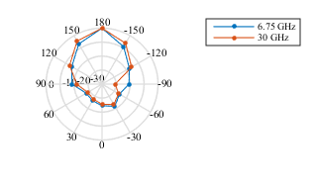
Figure 11.2-2a: Marginal power azimuth profile (dB) at Rx in LOS.
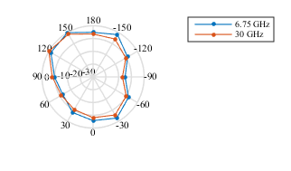
Figure 11.2-2b: Marginal power azimuth profile (dB) at Rx in NLOSv.

11.3 Capacity analysis
This section summarises the SL resource allocation Mode 1 and Mode 2 PRR evaluation results based on the simulation profiles defined in Table A.1-1. In each table, the average PRR is shown in the range (n×20, (n+1)×20) meters from the transmitter, where n=15 for the highway case and n=7 for the urban case. Details of the evaluation assumptions and results of each source can be found in Annex B. It is noted that no system-level calibration was performed.

11.3.1 Resource allocation Mode 1
Evaluation results for resource allocation Mode 1 are summarised in this section. Where a sourcing company provided results for more than one grant type, they appear in respective rows of a table.
Table 11.3.1-1: Average PRR for unicast V2V (a=n×20, b=(n+1)×20 m)
 | Grant type | SL frequency (GHz) | SCS (kHz) | Highway (n=15) |  | Urban grid (n=7)
 |  |  |  | Periodic traffic | Aperiodic traffic | Periodic traffic | Aperiodic traffic
Source 1 | Dynamic | 6 | 15 | 0.9988 | 0.9976 | 0.9824 | 0.9618
Source 1 | Dynamic | 6 | 30 | 0.9996 | 0.9984 | - | -
Source 1 | Dynamic | 6 | 60 | 0.9998 | 0.9974 | 0.9625 | 0.9416
Source 2 | Dynamic | 6 | 15 | 0.9996 | 0.9998 | 0.9381 | 0.9058
Source 2 | Dynamic | 6 | 30 | 0.9996 | 0.9997 | 0.9337 | 0.8803
Source 2 | Dynamic | 6 | 60 | 0.9995 | 0.9996 | 0.9134 | 0.8897
Source 3 | Dynamic | 6 | 15 | 0.9931 | 0.9966 | 0.9259 | 0.9637
Source 3 | Dynamic | 6 | 30 | 1.000 | 1.000 | 0.9157 | 0.9825
Source 4 | Dynamic | 6 | 15 | - | - | 0.9523 | -

Table 11.3.1-2: Average PRR for groupcast V2V (a=n×20, b=(n+1)×20 m)
 | Grant type | SL frequency (GHz) | SCS (kHz) | Highway (n=15) |  | Urban grid (n=7)
 |  |  |  | Periodic traffic | Aperiodic traffic | Periodic traffic | Aperiodic traffic
Source 1 | Dynamic | 6 | 15 | 0.9969 | 0.9965 | 0.9811 | 0.96
Source 1 | Dynamic | 6 | 30 | 0.9981 | 0.9985 | - | -
Source 1 | Dynamic | 6 | 60 | 0.9984 | 0.9977 | 0.9612 | 0.9335
Source 2 | Dynamic | 6 | 15 | 0.9991 | 0.9988 | 0.7428 | 0.7600
Source 2 | Dynamic | 6 | 30 | 0.9999 | 0.9988 | 0.6995 | 0.7313
Source 2 | Dynamic | 6 | 60 | 0.9991 | 0.9978 | 0.6636 | 0.7037
Source 3 | Dynamic | 6 | 15 | 0.9985 | 0.9485 | 0.7007 | -
Source 3 | Dynamic | 6 | 30 | 1.000 | 0.9928 | 0.7039 | 0.8251
Source 5 | Configured grant (TFRP-based) | 6 | 30 | 0.9671 | 0.9406 | - | -

Table 11.3.1-3: Average PRR for broadcast V2V (a=n×20, b=(n+1)×20 m)
 | Grant type | SL frequency (GHz) | SCS (kHz) | Highway (n=15) |  | Urban grid (n=7)
 |  |  |  | Periodic traffic | Aperiodic traffic | Periodic traffic | Aperiodic traffic
Source 1 | Dynamic | 6 | 15 | 0.9914 | 0.9942 | 0.9265 | 0.8336
Source 1 | Dynamic | 6 | 30 | 0.9919 | 0.9972 | - | -
Source 1 | Dynamic | 6 | 60 | 0.9904 | 0.9968 | 0.8477 | 0.74
Source 2 | Dynamic | 6 | 15 | 0.9989 | 0.9992 | 0.7139 | 0.7075
Source 2 | Dynamic | 6 | 30 | 0.9992 | 0.9993 | 0.6689 | 0.7028
Source 2 | Dynamic | 6 | 60 | 0.9996 | 0.9985 | 0.6192 | 0.693
Source 3 | Dynamic | 6 | 15 | 0.9985 | 0.9458 | 0.7007 | -
Source 3 | Dynamic | 6 | 30 | 1.000 | 0.9928 | 0.7039 | 0.8251

The following observations are made from the evaluation results:
- In the highway case at 320 m range, depending on the grant type and SCS, SL resource allocation Mode 1 achieves:
- In the range 99.88% - 100% PRR for unicast periodic traffic and 99.73%- 100% PRR for unicast aperiodic traffic at 6 GHz.
- In the range 99.69% - 100% PRR for groupcast periodic traffic and 94.85% - 99.88% PRR for groupcast with dynamic grants for aperiodic traffic at 6 GHz. Configured grant Type 1 performs within this range.
- In the range 99.04% - 100% PRR for broadcast periodic traffic and 94.58% - 99.93% PRR for broadcast aperiodic traffic at 6 GHz.
- In the urban grid case at 150 m range, depending on the grant type and SCS, SL resource allocation Mode 1 achieves:
- In the range 91.34% - 98.23% PRR for unicast periodic traffic and 88.03%- 98.25% PRR for unicast aperiodic traffic at 6 GHz.
- In the range 66.36%- 98.10% PRR for groupcast periodic traffic and 70.37% - 96.00% PRR for groupcast aperiodic traffic at 6 GHz.
- In the range 70.07% - 92.64% PRR for broadcast periodic traffic and 69.30% - 83.35% PRR for broadcast aperiodic traffic at 6 GHz.

11.3.2 Resource allocation Mode 2
Evaluation results for resource allocation Mode 1 are summarised in this section. Refer to the following notes for a summary of how each sourcing company has modelled Mode 2, and to the documents referenced in Annex B for full details. Where a sourcing company provided results for more than one version of Mode 2, they appear in respective rows of a table.
NOTE 1: Based on [12]: Mode 2c based on (pre-)configured TFRPs .
NOTE 2: Based on [11]: Long-term sensing similar to LTE-V2X Mode 4.
NOTE 3: Based on [11]: Short-term sensing based on listen before talk (LBT).
NOTE 4: Based on [12]: Reservation of both initial and retransmission of a TB.
NOTE 5: Based on Scheme 1 of [13]. With slot aggregation and up to 3 transmissions per TB. No reservation for initial transmission, and chained reservations for re-transmissions.
NOTE 6: Based on [14]: Mode 2d with resource coordination based on receiver sensing.
NOTE 7: Based on Scheme 2 of [15]. LBT-like short term sensing
NOTE 7a: Based on Scheme 1 of [15]. Long-term sensing similar to LTE-V2X Mode 4.

NOTE 7b: Based on Scheme 6 of [15]. Long term sensing similar to LTE-V2X Mode 4 plus short term sensing with double control channel capacity.
NOTE 8: Based on [16].
NOTE 9: Based on [17]: Sensing based resource selection (LTE V2V) with SPT for periodic traffic and forward SA based resource selection for aperiodic traffic.
NOTE 10: Based on [18]: Long-term sensing similar to LTE-V2X Mode 4
NOTE 11: Based on [18]: Mode 2c based on (pre-)configured TFRPs.
NOTE 12: Based on [19] (Option A): Short-term sensing (STS) baseline scheme based on LTE-sidelink mode 4 with sensing period and resource selection window both set to 50ms. Based on sensing results, an available PSSCH resource is randomly selected then a PSCCH resource is also randomly selected for the pre-emption indication message (SCI) within the resource selection window but before the selected PSSCH resource.
NOTE 13: Based on [19] (Option B): STS-5ms is based on the above STS-baseline scheme, where pre-emption indication message (SCI) is transmitted in an available PSCCH resource within 5ms.
NOTE 14: Based on [19] (Option C): STS-2PSCCH is based on the above STS-baseline scheme, where the PSCCH / pre-emption indication message is repeated and transmitted twice before the PSSCH to improve detection performance, instead of once in the baseline scheme.
NOTE 15: Based on [19] (Option D): STS-continuous sensing is based on the above STS-baseline scheme, where Tx UE continued to perform SA reading and sensing before the associated PSCCH / pre-emption SCI is transmitted. If potential Tx collision is detected, PSSCH resource is re-selected among the remaining available resources.
NOTE 16: Based on [19] (Option E): Sidelink resource sensing and (re)selection to transmit V2X packets is based on Rel-15 LTE-V2X mode 4 scheme.
NOTE 17: Based on [19] (Option F): Sidelink resources are randomly selected within a selection window for V2X packet transmissions.
NOTE 18: Based on [20]: Short term sensing based on LBT.
NOTE 19: Based on [20]: Long-term sensing similar to LTE-V2X Mode 4.
NOTE 20: Based on [20]: Random resource selection among 6 time-domain patterns.
NOTE 21: Based on [20]: Mode 2d.
NOTE 22: Based on [21]: LTE V2X Mode 4 for periodic traffic, random resource selection for aperiodic traffic.
NOTE 23: Based on [22]: Short-term sensing based on LBT.
NOTE 24: Based on [23]: Sensing with one shot for aperiodic traffic and sensing with SPS for periodic traffic.
NOTE 25: Long-term sensing similar to LTE-V2X Mode 4.

Table 11.3.2-1: Average PRR for unicast V2V (a=n×20, b=(n+1)×20 m)
 | NOTE | SL frequency (GHz) | SCS (kHz) | Highway (n=15) |  | Urban grid (n=7)
 |  |  |  | Periodic traffic | Aperiodic traffic | Periodic traffic | Aperiodic traffic
Source 1 | 1 | 6 | 60 | 0.9841 | 0.9845 | 0.9863 | 0.9756
Source 1 | 2 | 6 | 60 | 0.9603 | 0.9334 | 0.9497 | 0.9122
Source 1 | 3 | 6 | 60 | 0.9692 | 0.9435 | 0.9421 | 0.9064
Source 2 | 4 | 6 | 30 | 0.9951 | 0.9775 | 0.4126 | 0.4061
Source 3 | 5 | 6 | 60 | 0.9987 | 0.9994 | 0.9963 | 0.9973
Source 4 | 6 | 6 | 15 | 0.9987 | 0.9983 | - | -
Source 4 | 6 | 6 | 30 | 0.9978 | 0.9960 | - | -
Source 4 | 6 | 6 | 60 | 0.9882 | 0.9896 | - | -
Source 5 | 7 | 6 | 30 | 0.9929 | 0.9903 | 0.8703 | 0.7913
Source 6 | 8 | 6 | 15 | 0.971 | 0.9460 | 0.9033 | 0.9373
Source 6 | 8 | 6 | 30 | 0.9900 | 0.9556 | 0.9008 | 0.9086
Source 7 | 9 | 6 | 15 | 0.9782 | 0.9723 | 0.5732 | 0.3921

Table 11.3.2-2: Average PRR for groupcast V2V (a=n×20, b=(n+1)×20 m)
 | NOTE | SL frequency (GHz) | SCS (kHz) | Highway (n=15) |  | Urban grid (n=7)
 |  |  |  | Periodic traffic | Aperiodic traffic | Periodic traffic | Aperiodic traffic
Source 1 | 1 | 6 | 60 | 0.9934 | 0.9932 | 0.9893 | 0.9821
Source 1 | 2 | 6 | 60 | 0.9671 | 0.9528 | 0.9687 | 0.9305
Source 1 | 3 | 6 | 60 | 0.9614 | 0.9536 | 0.9366 | 0.9086
Source 2 | 4 | 6 | 30 | 0.9067 | 0.8466 | 0.3322 | 0.3201
Source 3 | 5 | 6 | 60 | 0.9991 | 0.9985 | 0.9450 | 0.9587
Source 4 | 6 | 6 | 15 | 0.9903 | 0.9988 | - | -
Source 4 | 6 | 6 | 30 | 0.9894 | 0.9832 | - | -
Source 4 | 6 | 6 | 60 | 0.9808 | 0.9531 | - | -
Source 5 | 7 | 6 | 30 | 0.9979 | 0.9974 | 0.9132 | 0.8983
Source 6 | 8 | 6 | 15 | 0.9283 | 0.9237 | 0.5403 | -
Source 6 | 8 | 6 | 30 | 0.9790 | 0.9055 | 0.5725 | 0.7253
Source 7 | 9 | 6 | 15 | 0.9389 | 0.9521 | - | -
Source 8 | 10 | 6 | 15 | 0.9267 | 0.8212 | - | -
Source 8 | 11 | 6 | 15 | 0.9571 | 0.9206 | - | -

Table 11.3.2-3: Average PRR for broadcast V2V (a=n×20, b=(n+1)×20 m)
Source | NOTE | SL frequency (GHz) | SCS (kHz) | Highway (n=15) |  | Urban grid (n=7)
 |  |  |  | Periodic traffic | Aperiodic traffic | Periodic traffic | Aperiodic traffic
Source 1 | 1 | 6 | 60 | 0.9938 | 0.9960 | 0.8357 | 0.7682
Source 1 | 2 | 6 | 60 | 0.9615 | 0.9481 | 0.8392 | 0.7750
Source 1 | 3 | 6 | 60 | 0.9577 | 0.9447 | 0.7973 | 0.7293
Source 2 | 4 | 6 | 30 | 0.9471 | 0.9232 | 0.1698 | 0.1818
Source 3 | 5 | 6 | 60 | 0.9969 | 0.9951 | 0.9279 | 0.9295
Source 4 | 6 | 6 | 15 | 0.9974 | 0.9985 | - | -
Source 4 | 6 | 6 | 30 | 0.9940 | 0.9896 | - | -
Source 4 | 6 | 6 | 60 | 0.9842 | 0.9733 | - | -
Source 5 | 7a | 6 | 30 | 0.9815 | 0.8972 | 0.6747 | 0.6155
Source 5 | 7b | 6 | 30 | 0.9893 | 0.9569 | 0.7873 | 0.7171
Source 6 | 8 | 6 | 15 | 0.8879 | 0.9226 | 0.5003 | -
Source 6 | 8 | 6 | 30 | 0.9471 | 0.8995 | 0.5542 | 0.7111
Source 7 | 9 | 6 | 15 | 0.9389 | 0.9520 | 0.4434 | 0.4050
Source 9 | 12 | 6 | 15 | - | 0.8607 | - | -
Source 9 | 13 | 6 | 15 | - | 0.9489 | - | -
Source 9 | 14 | 6 | 15 | - | 0.9026 | - | -
Source 9 | 15 | 6 | 15 | 0.9695 | 0.9670 | - | -
Source 9 | 16 | 6 | 15 | 0.9828 | 0.8081 | - | -
Source 9 | 17 | 6 | 15 | 0.8714 | 0.8219 | - | -
Source 10 | 18 | 6 | 15 | - | 0.8558 | - | 0.6486
Source 10 | 19 | 6 | 15 | - | 0.7458 | - | 0.6477
Source 10 | 20 | 6 | 15 | - | 0.6644 | - | 0.6997
Source 11 | 21 | 6 | 15 | 0.9590 | 0.9057 | 0.9014 | 0.8829
Source 11 | 22 | 6 | 15 | 0.8684 | 0.6737 | 0.8666 | 0.7281
Source 12 | 23 | 6 | 30 | - | 0.9494 | - | 0.6512
Source 13 | 24 | 6 | 30 | 0.8472 | 0.6060 | - | -
Source 14 | 25 | 6 | 15 | - | - | 0.6730 | -

Table 11.3.2-4: Average PRR for mixed traffic V2V (a=n×20, b=(n+1)×20 m)
Source | NOTE | SL frequency (GHz) | SCS (kHz) | Highway (n=15) | Urban grid (n=7)
Source 1 | 1 | 6 | 60 | 0.9908 | 0.9227
Source 1 | 2 | 6 | 60 | 0.9539 | 0.8959
Source 1 | 3 | 6 | 60 | 0.9550 | 0.8754
Source 2 | 4 | 6 | 30 | 0.9113 | 0.2721
Source 7 | 9 | 6 | 15 | 0.9548 | -

The following observations are made from the evaluation results, where a range of different versions of Mode 2 have been simulated according to the notes indicated in the preceding tables.
- In the highway case at 320 m range, depending on the design basis and SCS, SL resource allocation Mode 2 can achieve:
- In the range 96.03% - 99.87% PRR for unicast periodic traffic and 93.33% - 99.93% PRR for unicast aperiodic traffic at 6 GHz, respectively.
- In the range 90.69% - 99.91% PRR for groupcast periodic traffic and 82.12% - 99.87% PRR for groupcast aperiodic traffic at 6 GHz, respectively.
- In the range 84.72% - 99.73% PRR for broadcast periodic traffic and 60.6% - 99.84% PRR for broadcast aperiodic traffic at 6 GHz, respectively.
- In the range 91.13% - 99.08% PRR for mixed traffic at 6 GHz.
- In the urban grid case at 150 m range, depending on the design basis and SCS, SL resource allocation Mode 2 can achieve:
- In the range 41.26% - 99.62% PRR for unicast periodic traffic and 39.2% - 99.73% PRR for unicast aperiodic traffic at 6 GHz, respectively.
- In the range 33.22% - 98.93% PRR for groupcast periodic traffic and 32.01% - 98.93% PRR for groupcast aperiodic traffic at 6 GHz, respectively.
- In the range 16.98% - 92.78% PRR for broadcast periodic traffic and 18.18% - 92.94% PRR for broadcast aperiodic traffic at 6 GHz, respectively.
- In the range 27.21% - 92.27% PRR for mixed traffic at 6 GHz.

11.4 Synchronization performance

11.4.1 S-SSB detection
Link-level evaluations of the S-SSB design combinations in Table 11.4.1-1 are shown in this section. It is noted that no link-level calibration is performed. Tables 11.4.1-2 shows the one-shot joint detection probability of S-PSS/S-SSS is achieved at -6 dB SNR with a UE speed of 240 km/h. Details of the evaluation assumptions and results of each source, including other UE speeds, can be found in Annex C.1.
Table 11.4.1-1: S-SSB design combinations
Combination | Number of S-PSS symbols | S-PSS length | Number of S-SSS symbols | S-SSS length | Number of RBs | Bandwidth containing S-SSB (MHz)
 |  |  |  |  |  | 15 kHz SCS | 30 kHz SCS | 60 kHz SCS | 120 kHz SCS
1 | 2 | 127 | 2 | 127 | 11 or 12 | 2.5 | 5 | 10 | 20
2 | 2 | 127 | 2 | 127 | 20 | 5 | 10 | 20 | 40
3 | 1 | 127 | 1 | 127 | 20 | 5 | 10 | 20 | 40
4 | 1 | 255 | 1 | 255 | 24 | 5 | 10 | 20 | 40

Table 11.4.1-2.1: One-shot joint detection probability of S-PSS/S-SSS at -6 dB SNR of combination 1
 | S-SSB design combination | SL frequency (GHz) | SCS (kHz) | One-shot joint detection probability
Source 1 | 1 | 6 | 15 | 92.23%
Source 2 | 1 | 6 | 30 | 97.08%
Source 3 | 1 | 6 | 15 | 87.80%
Source 3 | 1 | 6 | 30 | 87.86%
Source 3 | 1 | 6 | 60 | 87.01%
Source 4 | 1 | 6 | 15 | 76.93%
Source 4 | 1 | 6 | 30 | 78%
Source 4 | 1 | 6 | 60 | 78.3%
Source 5 | 1 | 6 | 15 | 76.88%
Source 6 | 1 | 6 | 15 | 69.59%
Source 6 | 1 | 6 | 30 | 84.26%
Source 6 | 1 | 6 | 60 | 92.31%

Table 11.4.1-2.2: One-shot joint detection probability of S-PSS/S-SSS at -6 dB SNR of combination 2
 | S-SSB design combination | SL frequency (GHz) | SCS (kHz) | One-shot joint detection probability
Source 1 | 2 | 6 | 15 | 92.23%
Source 2 | 2 | 6 | 30 | 97.08%
Source 3 | 2 | 6 | 15 | 87.01%
Source 3 | 2 | 6 | 30 | 87.86%
Source 3 | 2 | 6 | 60 | 88.01%
Source 4 | 2 | 6 | 15 | 76.93%
Source 4 | 2 | 6 | 30 | 78%
Source 4 | 2 | 6 | 60 | 78.3%
Source 5 | 2 | 6 | 15 | 76.88%
Source 6 | 2 | 6 | 15 | 86%
Source 6 | 2 | 6 | 30 | 95.2%
Source 6 | 2 | 6 | 60 | 99.24%
Source 7 | 2 | 6 | 15 | 93.67%
Source 7 | 2 | 6 | 30 | 95.6%
Source 8 | 3 | 6 | 15 | 97.27%

Table 11.4.1-2.3: One-shot joint detection probability of S-PSS/S-SSS at -6 dB SNR of combination 3
 | S-SSB design combination | SL frequency (GHz) | SCS (kHz) | One-shot joint detection probability
Source 1 | 3 | 6 | 15 | 88.04%
Source 2 | 3 | 6 | 15 | 86.10%
Source 2 | 3 | 6 | 30 | 87.01%
Source 2 | 3 | 6 | 60 | 87.89%
Source 5 | 3 | 6 | 15 | 76.88%
Source 6 | 3 | 6 | 15 | 78.76%
Source 6 | 3 | 6 | 30 | 90.77%
Source 6 | 3 | 6 | 60 | 94.11%
Source 7 | 3 | 6 | 15 | 88.12%
Source 7 | 3 | 6 | 30 | 93.16%
Source 9 | 3 | 6 | 15 | 35.84%
Source 9 | 3 | 6 | 30 | 51.12%

Table 11.4.1-2.4: One-shot joint detection probability of S-PSS/S-SSS at -6 dB SNR of combination 4
 | S-SSB design combination | SL frequency (GHz) | SCS (kHz) | One-shot joint detection probability
Source 8 | 4 | 6 | 15 | 54.96%
Source 8 | 4 | 6 | 30 | 80.08%

The following observations are made from the evaluation results:
- S-SSB design combination 1 can have a one-shot joint detection probability of between 76.9% and 97.1% at -6 dB SNR.
- S-SSB design combination 2 can have a one-shot joint detection probability of between 76.9% and 99.2% at -6 dB SNR.
- S-SSB design combination 3 can have a one-shot joint detection probability of between 76.9% and 94.1% at -6 dB SNR according to most sources. One source found significantly lower detection probability.
- Although the ranges of detection probability are similar across design combinations 1-3, individual results show that S-SSB design combinations 1 and 2 offer higher detection probabilities than combination 3 for a given set of simulation assumptions.

11.4.2 PSBCH decoding
Link-level evaluations of the PSBCH decoding probability in the S-SSB design combinations in Table 11.4.1-1 are shown in this section. Tables 11.4.2-1, -2 and -3 show the SNR at which a 10⁻² BLER of one-shot decoding probability of PSBCH is achieved with a UE speed of 240 km/h. Details of the evaluation assumptions and results of each source, including other UE speeds, can be found in Annex C.2.
Table 11.4.2-1: SNR for 10⁻² BLER of one-shot decoding of PSBCH of combination 1
Source | S-SSB design combination | SL frequency (GHz) | SCS (kHz) | PSBCH bits | SNR (dB)
Source 1 | 1 | 6 | 15 | 56 | -5.0
Source 1 | 1 | 6 | 30 | 56 | -4.5
Source 1 | 1 | 6 | 60 | 56 | -4.5
Source 2 | 1 | 6 | 15 | 72 | -
Source 2 | 1 | 6 | 30 | 72 | -5.5
Source 2 | 1 | 6 | 60 | 72 | -
Source 3 | 1 | 6 | 15 | 40 | -3.5
Source 3 | 1 | 6 | 30 | 40 | -3.0
Source 3 | 1 | 6 | 60 | 40 | -2.0

Table 11.4.2-2: SNR for 10⁻² BLER of one-shot decoding of PSBCH of combination 2
Source | S-SSB design combination | SL frequency (GHz) | SCS (kHz) | PSBCH bits | SNR (dB)
Source 1 | 2 | 6 | 15 | 56 | -4.0
Source 1 | 2 | 6 | 30 | 56 | -3.5
Source 1 | 2 | 6 | 60 | 56 | -4.0
Source 4 | 2 | 6 | 15 | 40 | -2.5
Source 4 | 2 | 6 | 30 | 40 | -2.5
Source 4 | 2 | 6 | 60 | 40 | -3.0
Source 7 | 2 | 6 | 15 | 56 | 0.5
Source 7 | 2 | 6 | 30 | 56 | 1.0
Source 7 | 2 | 6 | 60 | 56 | -

Table 11.4.2-3: SNR for 10⁻² BLER of one-shot decoding of PSBCH of combination 3
Source | S-SSB design combination | SL frequency (GHz) | SCS (kHz) | PSBCH bits | SNR (dB)
Source 1 | 3 | 6 | 15 | 56 | -4.0
Source 1 | 3 | 6 | 30 | 56 | -3.5
Source 1 | 3 | 6 | 60 | 56 | -4.0
Source 7 | 3 | 6 | 15 | 56 | -2.5
Source 7 | 3 | 6 | 30 | 56 | -2.0
Source 7 | 3 | 6 | 60 | 56 | -

The following observation is made from the simulation results.
- Results for S-SSB design combination 1 suggest it operates at lower SNR than combinations 2 and 3. However, if S-SSB and physical channels are TDM'd, the EPRE of combination 1 is approximately 1.8 times higher than for combinations 2 and 3.

12 Conclusions
It is feasible to support advanced V2X services over the NR PC5 interface and the NR Uu interface. Study of the remote driving use case can be found in [24]. In particular for the PC5 interface, it is feasible to support unicast, groupcast, and broadcast operation in SL and coexistence among them in a carrier is feasible, as well as the coexistence between sidelink and other cellular transmissions in a carrier. In-coverage, partial coverage, and out-of-coverage operation are feasible.
To support sidelink unicast, sidelink groupcast, and sidelink broadcast, it is recommended to specify the following based on the descriptions in this TR:
- Waveform of CP-OFDM
- S-PSS, S-SSS, and PSBCH in S-SSB format, with associated synchronization source detection procedures
- PSCCH, PSSCH, PSFCH
- Reference signals
- Mode 1 resource allocation
- Mode 2 resource allocation
- Physical procedures to support sidelink transmission and reception for in-coverage, partial coverage, and out-of-coverage UEs
- Congestion control
- MAC, RLC, PDCP, SDAP, and RRC protocols over the PC5 interface
- QoS management
It is feasible to support NR sidelink in both FR1 and FR2 using a common design framework.
It is recommended to specify for NR Uu interface, based on the descriptions in this TR, support for multiple simultaneously active uplink configured grants, and reporting of UE assistance information to gNB. QoS management for these services is also needed. It is feasible to deliver advanced V2X use cases in some scenarios over the LTE Uu interface. Some possible enhancements were studied but none are recommended.
It is feasible to support LTE Uu managing NR SL in resource allocation Modes 1 and 2, and NR Uu managing LTE SL in Modes 3 and 4. Specification of the enhancements described to the respective Uu interfaces is recommended.
Additional enhancements have been identified for the network interfaces to support V2X service authorization, UE SL aggregate maximum bit rate, F1 signalling for support of NR V2X mode 1 and mode 2, resource coordination, and possibly network slicing.
It is recommended to support RAT and interface selection considering the outcome of related SA2 work.
Based on the study from physical layer specification perspective, in-device coexistence of LTE and NR sidelink is feasible for intra- and inter-band under the respective conditions, and solutions for TX/TX, TX/RX, and RX/RX coexistence have been identified in this TR.
The technical solutions identified in this TR can be used for public safety when the service requirements can be met.

Annex A: Evaluation assumptions

A.1 Simulation profiles
Simulation profiles are defined in Table A.1-1.
Table A.1-1: Simulation profiles
 | Unicast | Multicast | Broadcast | Mixture
SL frequency (GHz) | 6, 30 | 6, 30 | 6, 30 | 6, 30
Traffic models | Periodic: Medium intensity; [50] ms inter-packet arrival, [50]% vehicles generate packets.  Aperiodic: Medium intensity, 100% vehicles generate packets.  Periodic and aperiodic traffic are simulated separately. | Periodic: Medium intensity; [50] ms inter-packet arrival, [50]% vehicles generate packets.  Aperiodic: Medium intensity, 100% vehicles generate packets.  Periodic and aperiodic traffic are simulated separately. | Periodic: Medium intensity; [50] ms inter-packet arrival, [50]% vehicles generate packets  Aperiodic: Medium intensity, 100% vehicles generate packets.  Periodic and aperiodic traffic are simulated separately. | 33%, 33%, 34% vehicles generate unicast, multicast, broadcast packets, respectively. For each traffic type, 50% is periodic and 50% is aperiodic.  Periodic: Medium intensity; 100 ms inter-packet arrival  Aperiodic: Medium intensity
Simulation environment, UE drop and mobility | Highway: Option A  Urban: Option A | Highway: Option A  Urban: Option A | Highway: Option A  Urban: Option A | Highway: Option A  Urban: Option A
Number of Tx/Rx antenna elements for vehicle UE¹ | 2Tx/4Rx for 6 GHz  FFS for 30 GHz | 2Tx/4Rx for 6 GHz  FFS for 30 GHz | 2Tx/4Rx for 6 GHz  FFS for 30 GHz | 2Tx/4Rx for 6 GHz  FFS for 30 GHz
Antenna model for vehicle UE | Option 1 | Option 1 | Option 1 | Option 1
Channel model | As defined | As defined | As defined | As defined
SL simulation bandwidth (MHz) | 20 MHz for 6 GHz  100 MHz for 30 GHz | 20 MHz for 6 GHz  100 MHz for 30 GHz | 20 MHz for 6 GHz  100 MHz for 30 GHz | 20 MHz for 6 GHz  100 MHz for 30 GHz
NOTE 1: The number of antennas can be increased for the evaluations for transmissions using more than 2 layers.

The transmitter-receiver association model in [5] is used, with setting X and Y to [150 meters for Urban and 320 meters for Freeway] as baseline. Other values of X and Y are not precluded. When evaluating V2I based on Uu, it is assumed that the packet is generated at the location where UE-type RSU is placed.

A.2 Link-level simulation parameters
Link-level simulation parameters are defined in Table A.2-1.
Table A.2-1: Link-level simulation parameters
Parameter | Assumption
AGC settling time¹ | FR1: One symbol  FR2: One symbol
TX/RX switching time¹ | FR1: One symbol  FR2: One symbol
Timing error | Up to [0.4] μs between a UE and its synchronization source
Frequency error | Up to [0.1] ppm between a UE and its synchronization source
Initial frequency error for SL synchronization² | Uniformly distributed in ±[5] ppm
NOTE 1: Working assumption for RAN1 evaluation purposes only, pending RAN4 information. The symbol used for AGC settling time is not the same symbol as that used for TX/RX switching time.
NOTE 2: This is the error of the local oscillator for transmission and reception with respect to the absolute carrier frequency.

Simulation parameters for synchronization evaluat3ions are defined in Table A.2-2.
Table A.2-2: Simulation parameters for synchronization evaluations
 | Below 6GHz | Above 6GHz
Carrier Frequency | 6 GHz | 30 GHz
Channel Model | CDL channel models
Subcarrier Spacing(s) | 15, 30, 60 kHz | 60, 120 kHz
SNR Range | > -6 dB | > -6 dB
Relative UE Speed | 6 km/h, 240 km/h (mandatory)  60 km/h, 500 km/h (optional) | 6 km/h, 240 km/h (mandatory)
Interference model | Scenario 1: no interference  Scenario 2: effect of interference includes in the model | Scenario 1: no interference
Initial Frequency Offset | TX: Uniform distribution within [-5, 5] ppm of nominal carrier frequency  RX: Uniform distribution within [-5, 5] ppm of nominal carrier frequency

Annex B: Detailed evaluation results for resource allocation

B.1 Resource allocation Mode 1

B.1.1 Simulation assumptions
Table B.1.1-1: Simulation assumptions used in resource allocation Mode 1 evaluations
Description |  | Source 1 | Source 2 | Source 3 | Source 4 | Source 5
Carrier frequency (GHz) |  | 6 | 6 | 6 | 6 | 6
Bandwidth (MHz) |  | 20 | 20 | 20 | 20 | 20
Resource allocation |  | NR mode 1, dynamic | NR mode 1, dynamic | NR mode 1, dynamic | NR mode 1, dynamic | NR mode 1, configured grant
Number of antennas |  | 2Tx/4Rx | 2Tx/4Rx | 2Tx/4Rx | 2Tx/2Rx | 1Tx/4Rx
PHY packet size(bytes) |  | Periodic 800/1200  Aperiodic 200-2000 | Periodic 800/1200  Aperiodic 200-2000 | Periodic 800/1200  Aperiodic 200-2000 | 1672 or 2088 bits | Periodic 800/1200  Aperiodic 200-2000
Modulation and code rates | Highway-periodic | QPSK(0.34)-  16QAM(0.54) | QPSK(0.44-0.59) | QPSK(0.53-0.8) | - | 16 QAM (0.42-0.64)
Modulation and code rates | Highway-aperiodic | QPSK(0.085)-  64QAM(0.46) | QPSK(0.12)-  16QAM(0.48) | QPSK(0.667) | - | 16QAM (0.24-0.58)
Modulation and code rates | Urban-periodic | QPSK(0.34-0.54) | QPSK(0.44-0.59) | QPSK(0.53-0.8) | 16 QAM  0.42 for 1672 bits  0.54 for 2088 bits | -
Modulation and code rates | Urban-aperiodic | QPSK(0.085)-  16QAM(0.59) | QPSK(0.12)-  16QAM(0.48) | QPSK(0.667) | - | -
Waveform |  | CP-OFDM | CP-OFDM | CP-OFDM | CP-OFDM | CP-OFDM
CP length |  | Normal | Normal | Normal | Normal | Normal
Channel estimation |  | Ideal | Ideal | Ideal | Ideal | Ideal
Number of retransmission and combining |  | None | None | 1 transmission | Up to 3 retransmissions, chase combining | Initial + 1 re-transmission, chase combining
TX scheme (e.g. TxD scheme if applied) |  | SFBC | None | None | 1 layer precoding | Single antenna
UE receiver algorithm |  | MMSE-IRC | MMSE-IRC | MMSE | MMSE-IRC | -

B.1.2 Detailed results

B.1.2.1 Unicast
Highway periodic scenario
Source 1
Source 2
Source 3
Highway aperiodic scenario
Source 1
Source 2
Source 3

Urban periodic scenario
Source 1
Source 2
Source 3

Urban aperiodic scenario
Source 1
Source 2
Source 3

B.1.2.2 Groupcast
Highway periodic scenario
Source 1
Source 2
Source 3

Source 5

Highway aperiodic scenario
Source 1
Source 2
Source 3
Source 5
Urban periodic scenario
Source 1
Source 2
Source 3

Urban aperiodic scenario
Source 1
Source 2
Source 3

B.1.2.3 Broadcast
Highway periodic scenario
Source 1
Source 2
Source 3
Highway aperiodic scenario
Source 1
Source 2
Source 3

Urban periodic scenario
Source 1
Source 2
Source 3

Urban aperiodic scenario
Source 1
Source 2
Source 3

B.2 Resource allocation Mode 2

B.2.1 Simulation assumptions
Table B.2.1-1: Simulation assumptions used in resource allocation Mode 1 evaluations, sources 1-5
Description |  | Source 1 | Source 2 | Source 3 | Source 4 | Source 5
Number of antennas |  | 2Tx/4Rx | 2TX/4RX | 2TX/4RX | 2Tx/4Rx | 1TX/4RX, X-Pol
Subcarrier spacing |  | 60 kHz | 30 kHz | 60 kHz | 15/30/60kHz | 30KHz
PHY packet size | Aperiodic | 200-2000bytes | Medium intensity (as in TR 37.885, and following the profile agree in RAN1#94bis) | uniformly distributed between  [200, 400, 600, 800, 1000, 1200, 1400, 1600, 1800, 2000] bytes  100% of UEs generate packets  Latency requirement = 100ms | Uniformly random in the range between 200 bytes and 2000 bytes with the quantization step of 200 bytes | • Packet size: Uniformly random in the range between 200 bytes and 2000 bytes with the quantization step of 200 bytes  • Inter-packet arrival time: 50 ms + an exponential random variable with the mean of 50 ms  • Latency: 50 ms
PHY packet size | Periodic | 800/1200bytes |  | 1200 bytes with prob 0.2;  800 bytes with prob 0.8  50% of UEs generate packets | 1200 bytes with probability of 0.2 and 800 bytes with probability of 0.8 | • Packet size: 1200 bytes with probability of 0.2 and 800 bytes with probability of 0.8  • Inter-packet arrival time: 50 ms  • Latency: 50ms
Modulation and code rates | Aperiodic | 64QAM(0.5) | PSCCH: QPSK, R<0.1;  PSSCH: 16QAM, R<0.85 | Unicast and Groupcast:  16QAM  CR = 0.3 to 0.8  Broadcast:  16QAM  CR = 0.3 to 0.7 | QPSK(0.12) for 200 bytes  QPSK(0.19) for 400 bytes  QPSK(0.3) for 600 bytes  QPSK(0.44) for 800 bytes  QPSK(0.44) for 1000 bytes  QPSK(0.59) for 1200 bytes  QPSK(0.59) for 1400 bytes  16QAM(0.37) for 1600 bytes  16QAM(0.48) for 1800 bytes  16QAM(0.48) for 2000 bytes | Data packets:  • 200 Byte:QPSK (CR_TTI = 0.33)  • 400 Byte:QPSK (CR_TTI = 0.67)  • 600 Byte:16-QAM (CR_TTI = 0.5)  • 800 Byte: 16-QAM (CR_TTI = 0.66)  • 1000 Byte: 16-QAM (CR_TTI = 0.83)  • 1200 Byte: 16-QAM (CR_TTI = 1)  • 1400 Byte: 16-QAM (CR_TTI = 1.16)  • 1600 Byte: 16-QAM (CR_TTI = 1.33)  • 1800 Byte: 16-QAM (CR_TTI = 1.5)  • 2000 Byte: 16-QAM (CR_TTI = 1.67)  Control packets:  • 64 bit: QPSK (CR_TTI=0.26)
Modulation and code rates | Periodic | 64QAM(0.5) | PSCCH: QPSK, R<0.1;  PSSCH: 16QAM, R<0.85 | 16QAM  CR = 0.3 to 0.7 | QPSK(0.44) for 800 bytes  QPSK(0.59) for 1200 bytes | Data packets:  • 800 Byte: 16-QAM (CR_TTI = 0.66)  • 1200 Byte: 16-QAM (CR_TTI = 1)  Control packets:  • 64 bit: QPSK (CR_TTI=0.26)
Waveform |  | OFDM | CP-OFDM | CP-OFDM | CP-OFDM | SC-FDMA
CP length |  | NCP | NCP | ECP (4.16µs) | Normal | Normal CP
Channel estimation |  | non-ideal | Ideal | practical (MMSE-based) | ideal | Perfect channel estimation
Number of retransmission and combining | Aperiodic | 1retransmission | Unicast and Groupcast:  Up to 4, Incremental redundancy  Broadcast:  4, Incremental redundancy | Unicast and Broadcast:  3Tx  Groupcast:  4Tx | No retransmission | Number of data packet retransmissions:  • 200 Byte: 2 TTI  • 400 Byte: 2 TTI  • 600 Byte: 2 TTI  • 800 Byte: 2 TTI  • 1000 Byte: 3 TTI  • 1200 Byte: 3 TTI  • 1400 Byte: 4 TTI  • 1600 Byte: 4 TTI  • 1800 Byte: 5 TTI  • 2000 Byte: 5 TTI  Number of control packet retransmissions:  • Same as used for referred data packet  Retransmissions combining:  • Data: Incremental Redundancy  HARQ  • Control: No HARQ combining
Number of retransmission and combining | Periodic |  |  |  |  | Number of data packet retransmissions:  • 800 Byte: 3TTI  • 1200 Byte: 3TTI  Number of control packet retransmissions:  • Same as used for referred data packet  Retransmissions combining:  • Data: Incremental Redundancy  HARQ  • Control: No HARQ combining
TX scheme (e.g. TxD scheme if applied) |  | SFBC | none | SCDD | None | Single antenna port
UE receiver algorithm |  | MMSE-IRC | MRC | MMSE | MMSE-IRC | Receiver:  MMSE-IRC Receiver  Single SCI decoding at each SCI resource in slot  Single Data decoding per data resource in average per slot  Resource Selection:  Scheme 2 from R1-1902484

Table B.2.1-2: Simulation assumptions used in resource allocation Mode 1 evaluations, sources 6-10
Description |  | Source 6 | Source 7 | Source 8 | Source 9 | Source 10
Number of antennas |  | 2Tx4Rx(1, 2, 2, 1, 1) | 2T4R | 1T4R | 1T2R | 2Tx/2Rx
Subcarrier spacing |  | 30k | 15kHz | 15kHz | 15 kHz | 15kHz
PHY packet size | Aperiodic | Uniformly random in the range between 200 bytes and 2000 bytes with the quantization step of 200 bytes | 200~2000 bytes | 100ms inter-packet arrival, 100% vehicles generate packets (200, 400, 600, 800, 1000, 1200, 1400, 1600, 1800, 2000bytes) | -- | Model 1 (medium traffic intensity)
PHY packet size | Periodic | 1200 bytes with probability of 0.2 and 800 bytes with probability of 0.8 | 800 and 1200 bytes | 50ms inter-packet arrival, 50% vehicles generate packets (1200byte packet 20%、800byte packet 80%) | Option 1: 200 bytes  Option 2:  1200 bytes with probability of 0.2 and 800 bytes with probability of 0.8 | --
Modulation and code rates | Aperiodic | 16QAM, coderate 0.6667 | 16QAM, 1/2 LDPC | 18, 36, 54, 72[RBs], depending on the packet size. | -- | MCS:16QAM  CR:0.5
Modulation and code rates | Periodic | 16 QAM  Code Rate {0.44,0.67} for {800bytes, 1200 bytes } | 16QAM, 1/2 LDPC | 40[RBs], 800byte：  per CB, code length 14582bit, TBS 6144bit (16QAM)  40[RBs], 1200byte：  per CB, code length 9600bit, TBS 6144bit (16QAM) | QPSK (0.15) for 200 bytes  16QAM(0.44) for 1200 bytes  16QAM(0.3) for 800 bytes | --
Waveform |  | CP-OFDM | CP-OFDM | -- | CP-OFDM | OFDM
CP length |  | Normal CP | NCP | -- | normal | normal
Channel estimation |  | Ideal | Ideal | -- | Non-ideal | Ideal channel estimation
Number of retransmission and combining |  | 2 transmission | No retransmission | Repetition combining: chase combining with the same number of sub-channels as initial Tx | None | 1 transmission
TX scheme (e.g. TxD scheme if applied) |  | -- | None | -- | None | one layer precoding
UE receiver algorithm |  | MMSE | MRC | -- | MMSE | MRC

Table B.2.1-3: Simulation assumptions used in resource allocation Mode 1 evaluations, source 11-14
Description |  | Source 11 | Source 12 | Source 13 | Source 14
Number of antennas |  | 2TX/4RX | 2TX/4RX | 2TX/4RX | 2Tx/4Rx
Subcarrier spacing |  | 15 kHz | 30 kHz | 30KHz | 15kHz
PHY packet size | Aperiodic | Uniformly random in the range between 200 bytes and 2000 bytes with the quantization step of 200 bytes | Medium traffic intensity (according to TR 37.885 and simulation profile agreed in RAN1#94bis) | 400-2000bytes | --
PHY packet size | Periodic | 1200 bytes with probability of 0.2 and 800 bytes with probability of 0.8 | -- | 800/1200 bytes | 80% probability of 800 / 20% probability of 1200
Modulation and code rates | Aperiodic | 16QAM, 0.5 | PSCCH: QPSK w/ R=0.125  PSSCH: QPSK w/ 0.18≤R≤0.36 and 16QAM w/ 0.27≤R≤0.45 | SA: QPSK(0.125)  Data:16QAM(0.45/0.65) | --
Modulation and code rates | Periodic | 16QAM(0.5) for 1200 bytes packet | -- | SA: QPSK(0.125)  Data:16QAM(0.45/0.67) | QPSK (0.57) for 800-byte packet/ QPSK (0.38) for 1200 byte packet
Waveform |  | CP-OFDM | CP-OFDM | CP-OFDM | OFDM
CP length |  | Normal | Normal | Normal CP | Normal
Channel estimation |  | Practical | Ideal | Non-ideal | Ideal
Number of retransmission and combining |  | None | Up to 3 reTX (1 reTX for QPSK, 1/2/3 reTX for 16QAM) and IR combining | 1 retransmission | 1 blind retransmission
TX scheme (e.g. TxD scheme if applied) |  | None | None | None | precoder cycling
UE receiver algorithm |  | MMSE | MMSE | MMSE | MMSE

B.2.2 Detailed results

B.2.2.1 Unicast
Highway periodic scenario
Source 1

Source 2
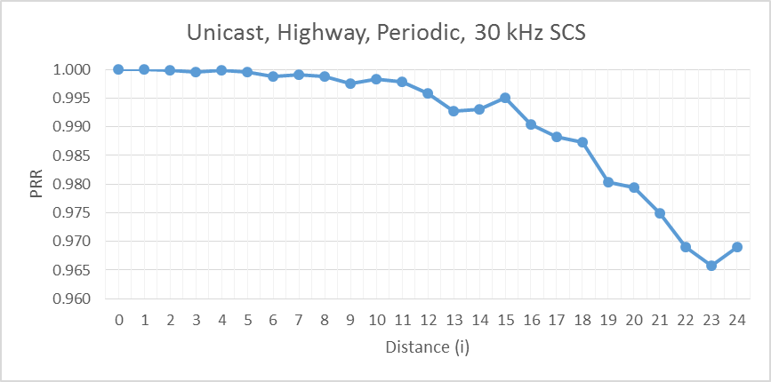
Source 3
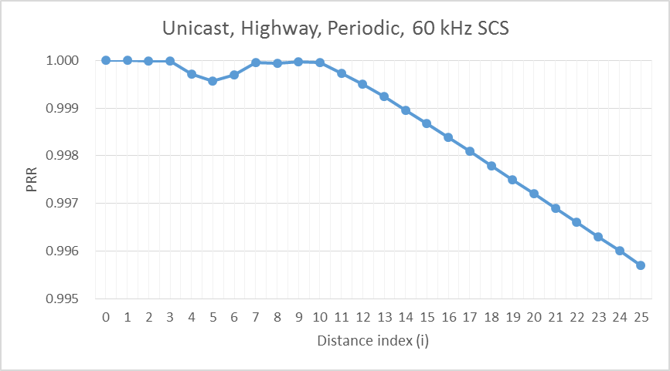
Source 4
Source 5
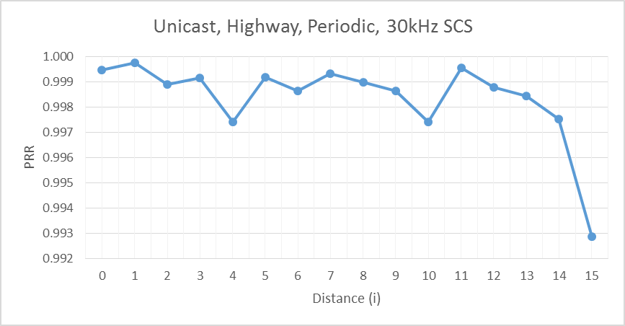
Source 6
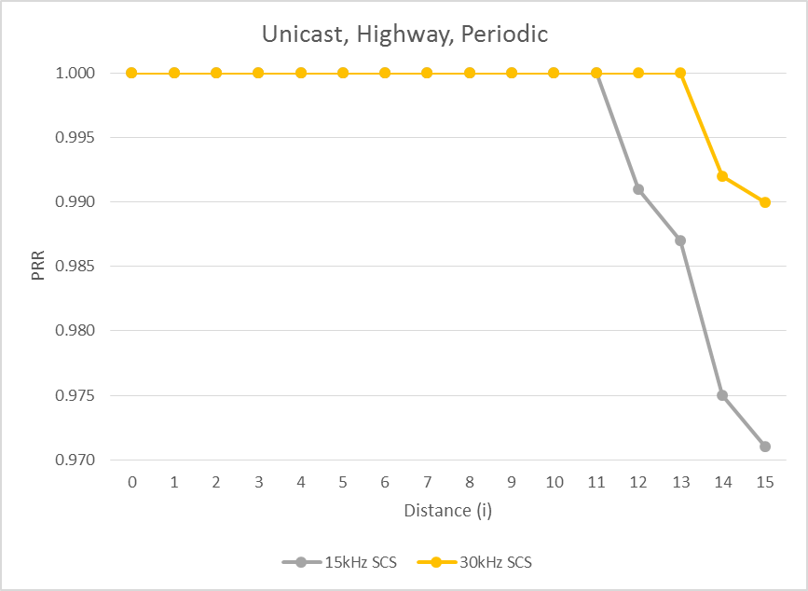
Source 7
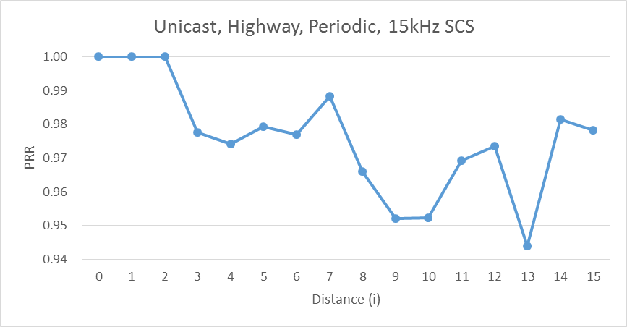
Highway aperiodic scenario
Source1

Source 2
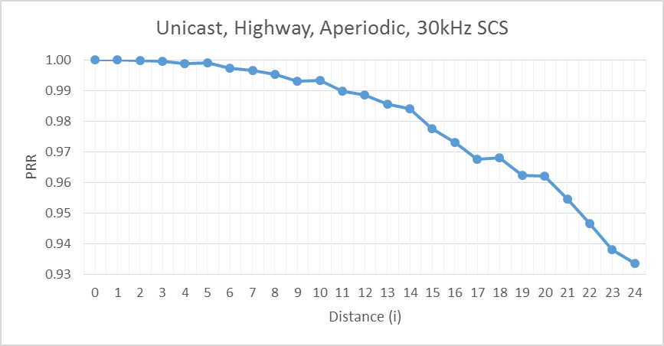
Source 3
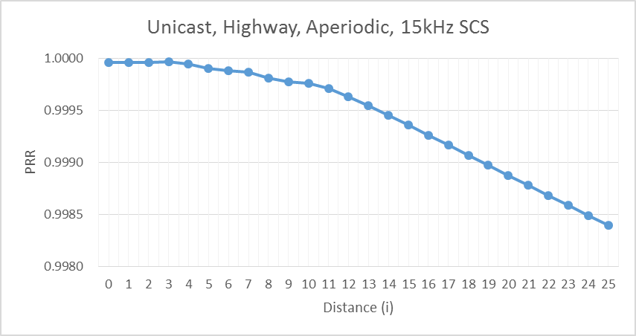
Source 4
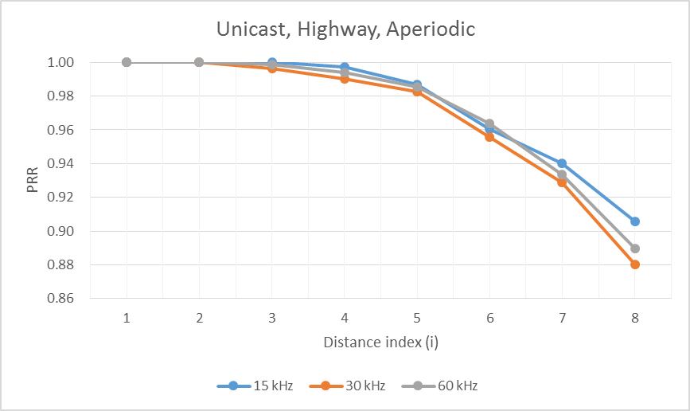
Source 5
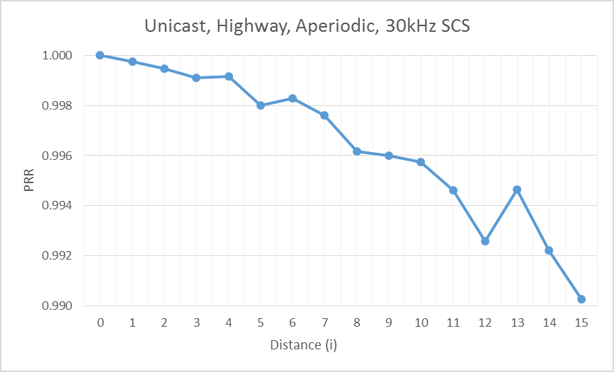
Source 6
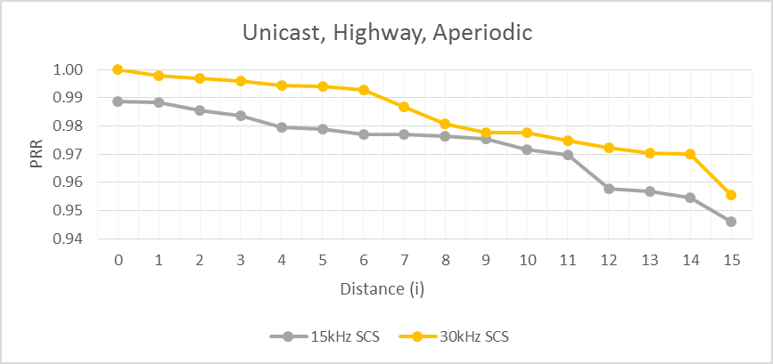
Source 7
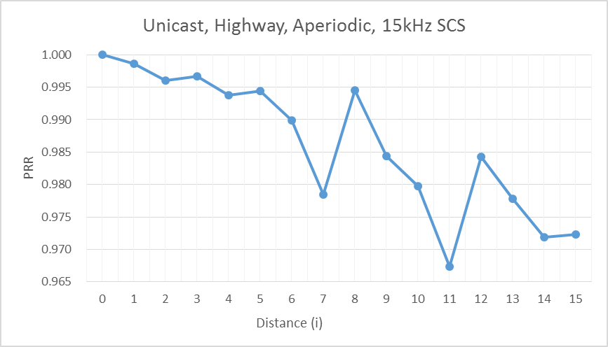
Urban periodic scenario
Source1

Source 2
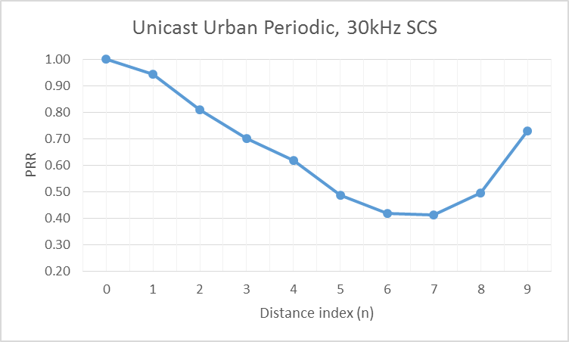
Source 3
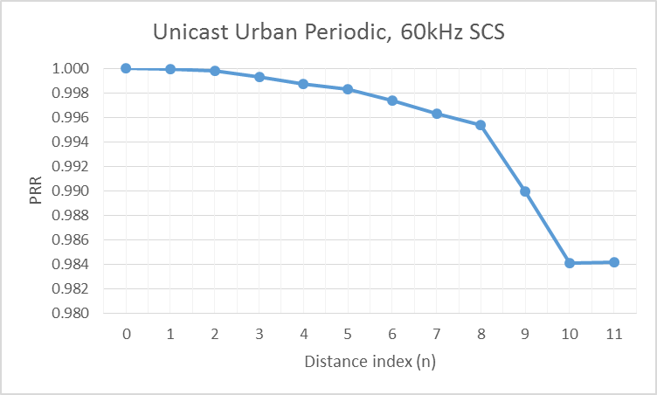
Source 5
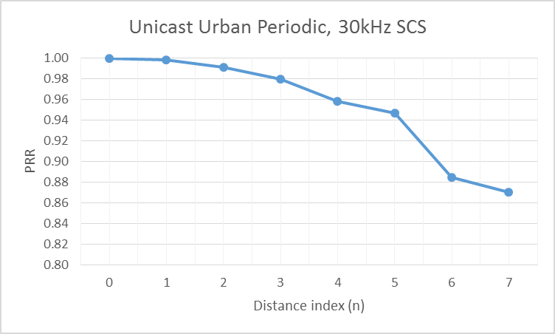
Source 6
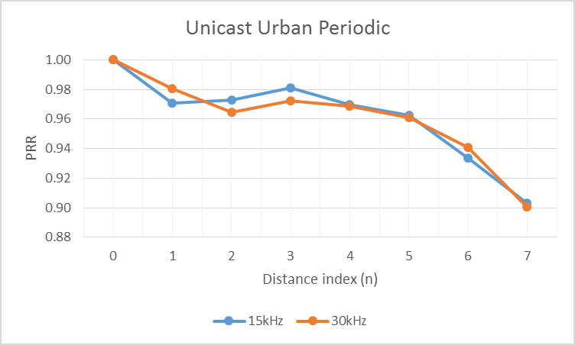
Source 7
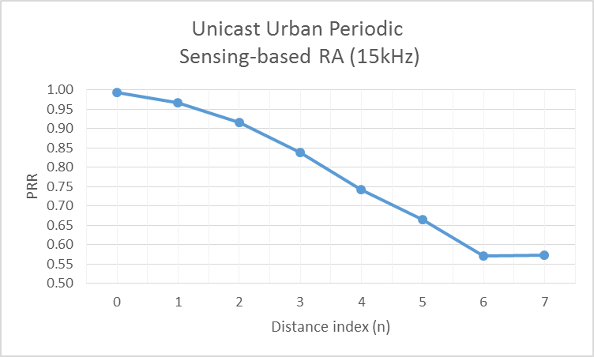
Urban aperiodic scenario
Source1

Source 2
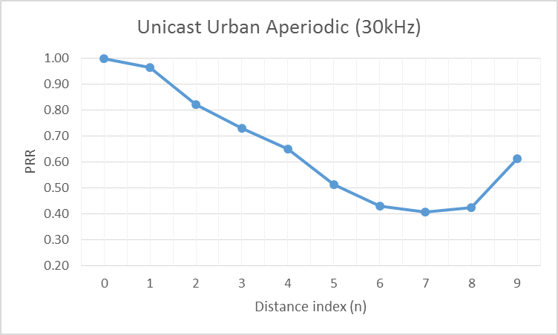
Source 3
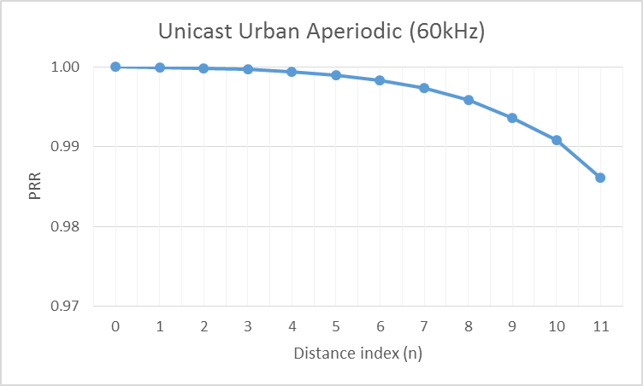
Source 5
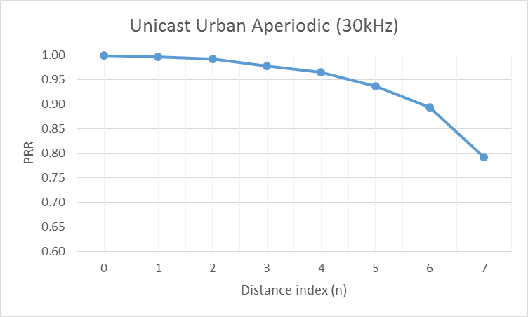
Source 6
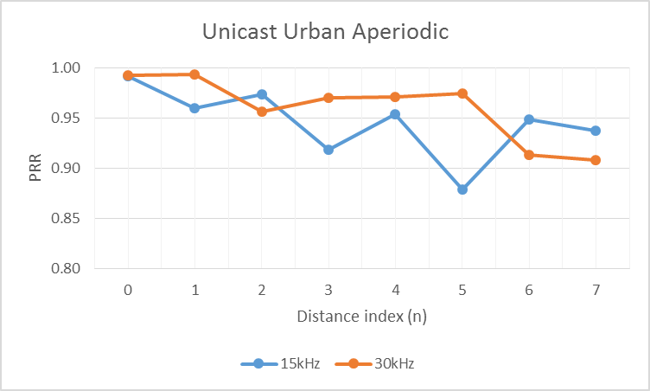
Source 7
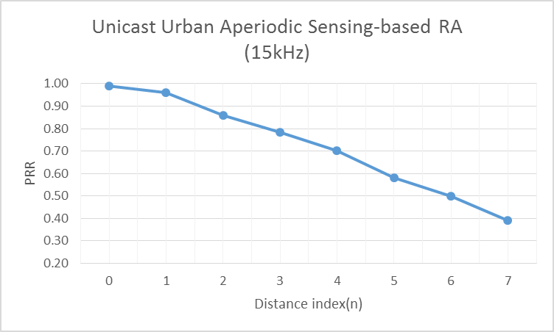

B.2.2.2 Groupcast
Highway periodic scenario
Source 1
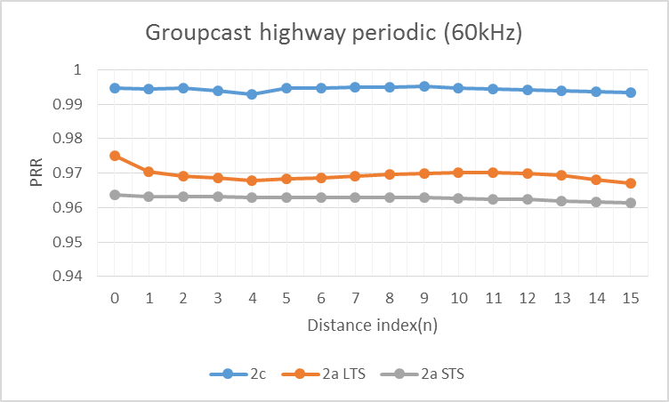
Source 2
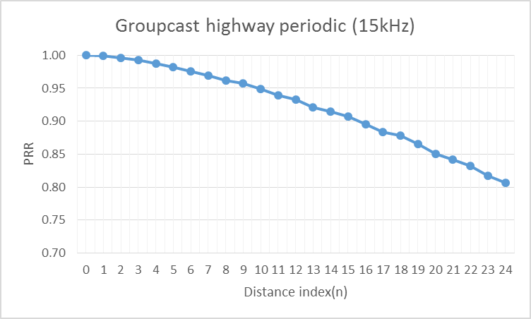
Source 3
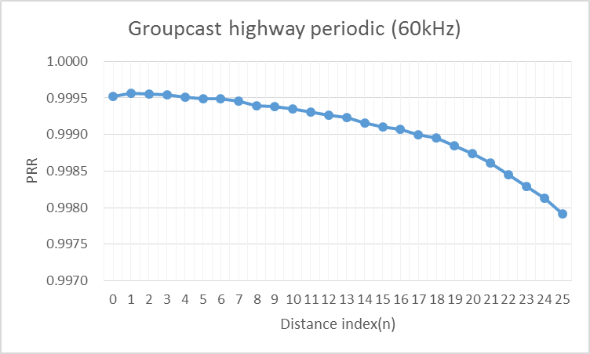
Source 4
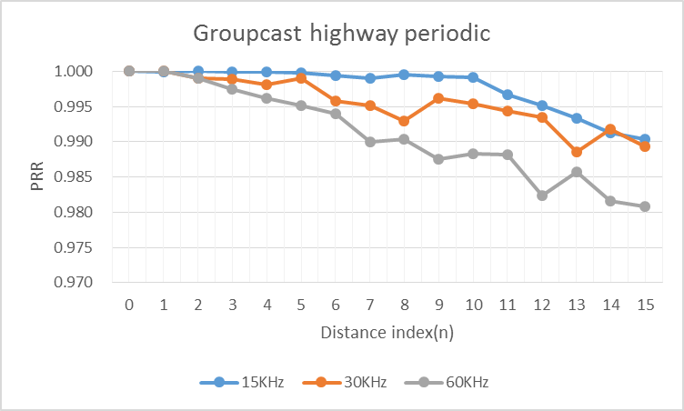
Source 5
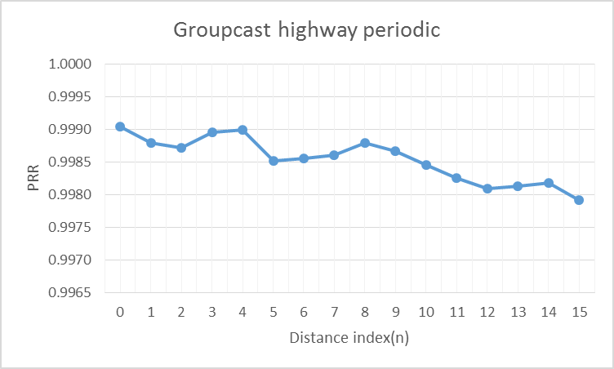
Source 6
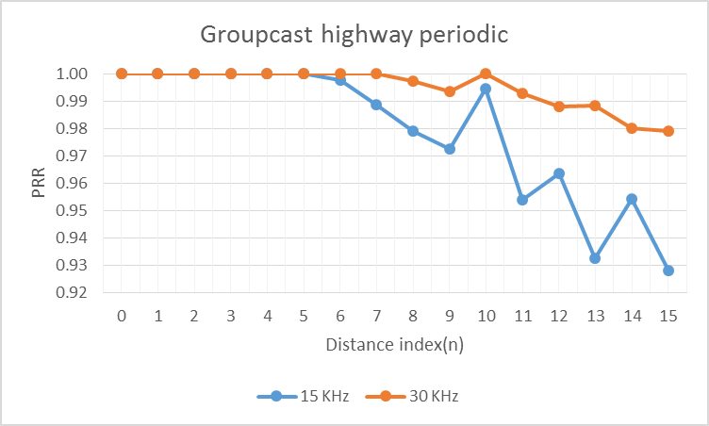
Source 7
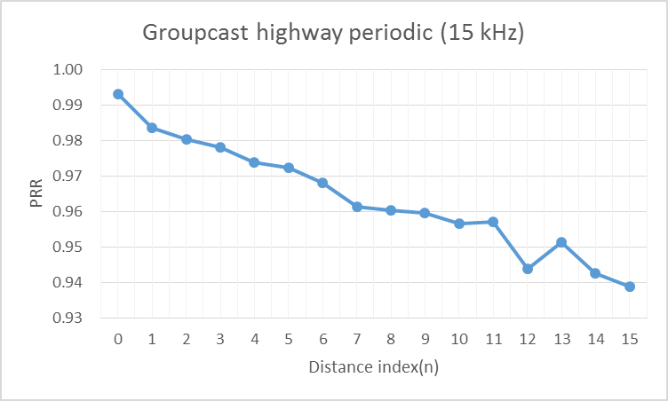
Source 8
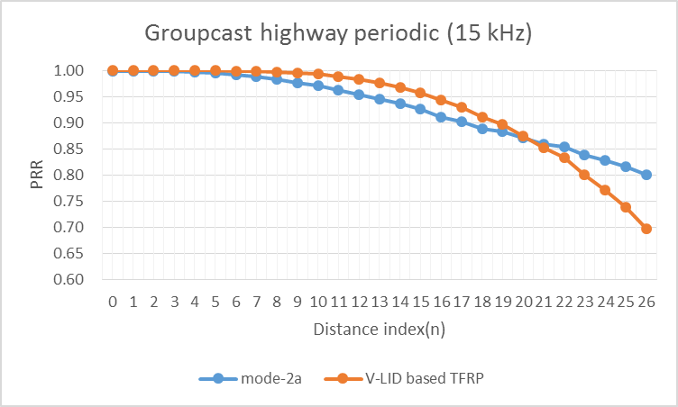
Highway aperiodic scenario
Source 1
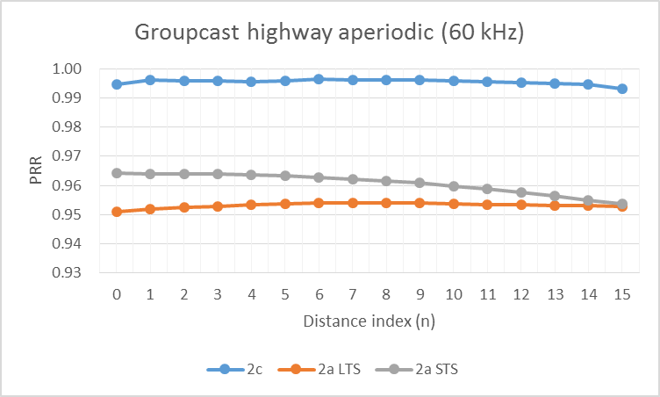
Source 2
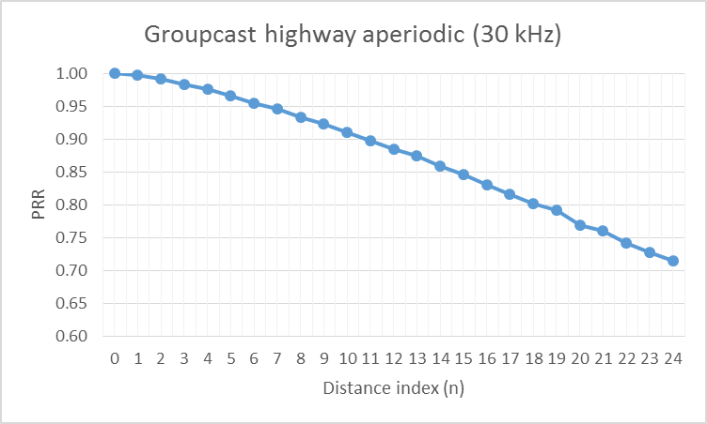
Source 3
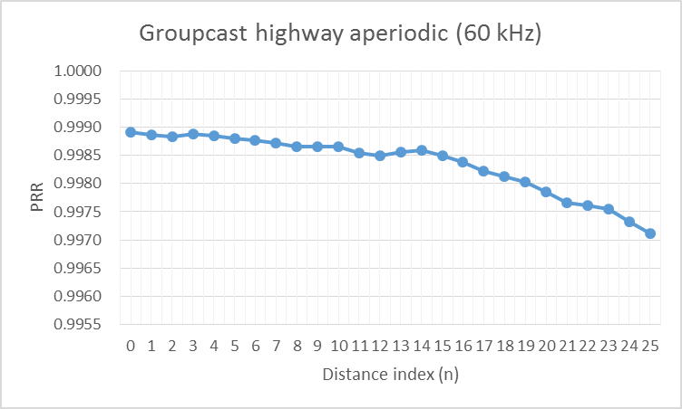
Source 4
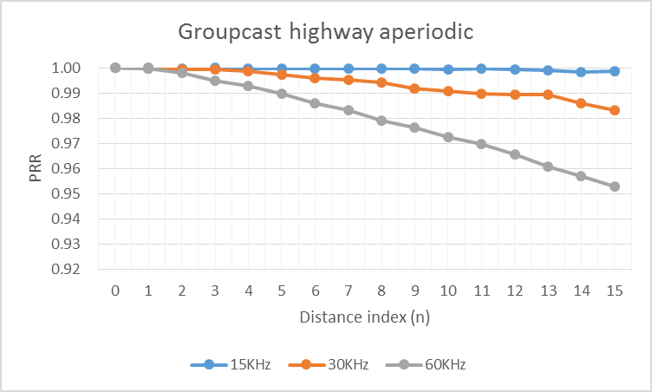
Source 5
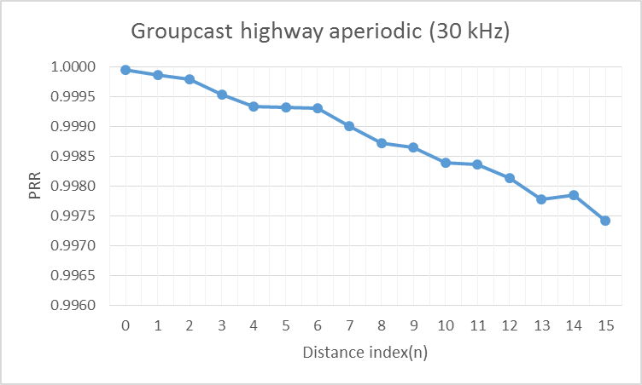
Source 6
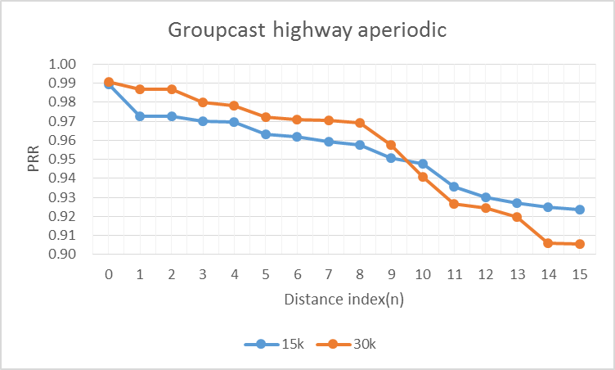
Source 7
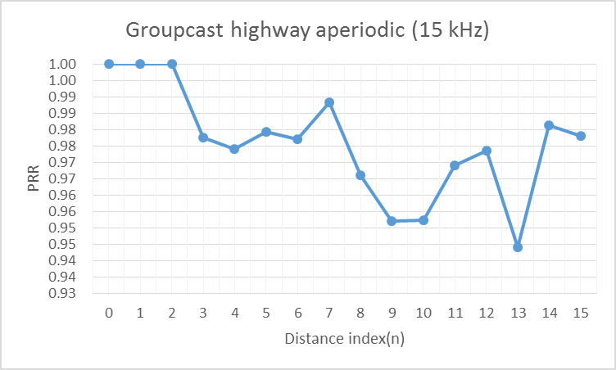
Source 8
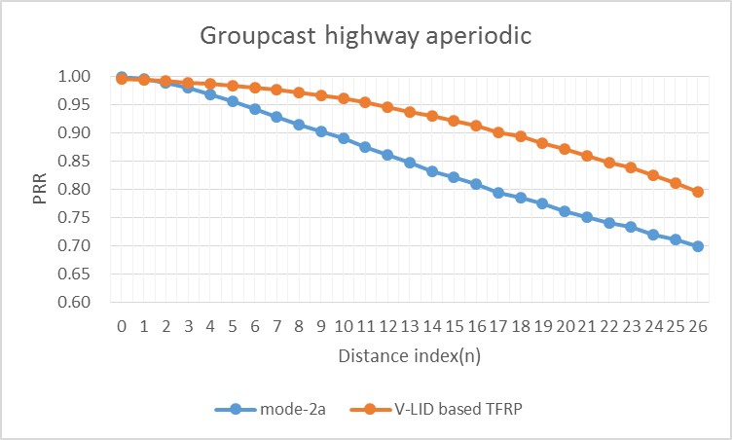
Urban periodic scenario
Source 1
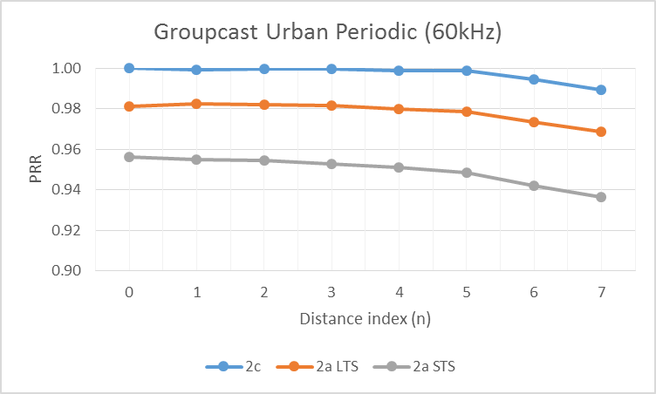
Source 2
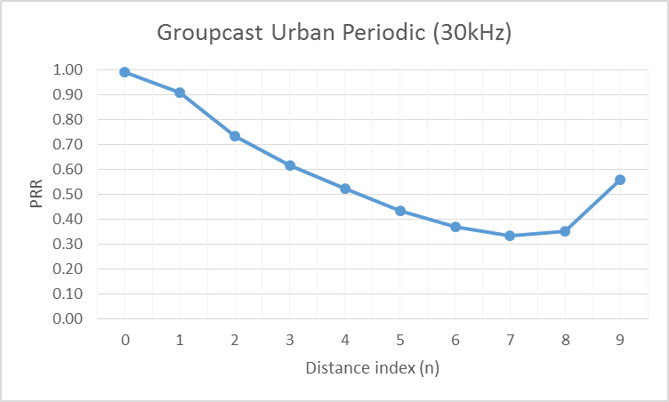
Source 3
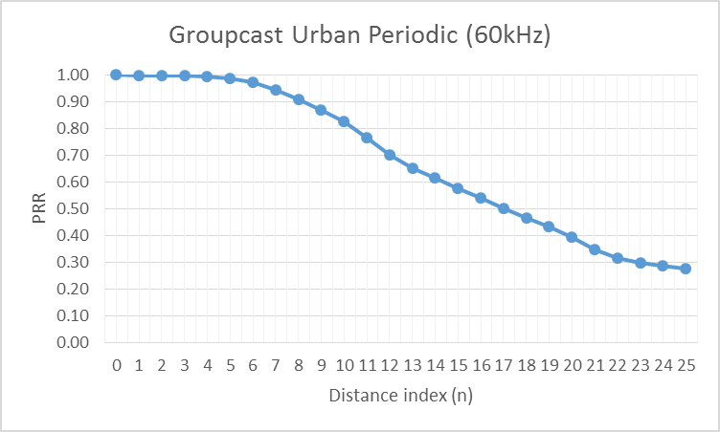
Source 5
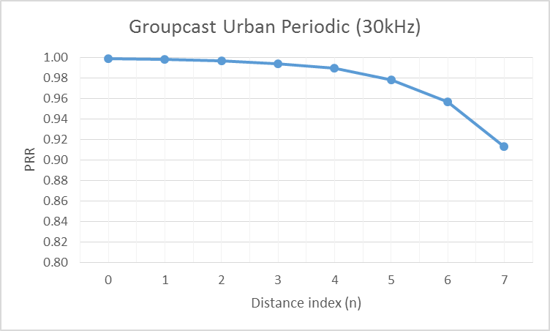
Source 6
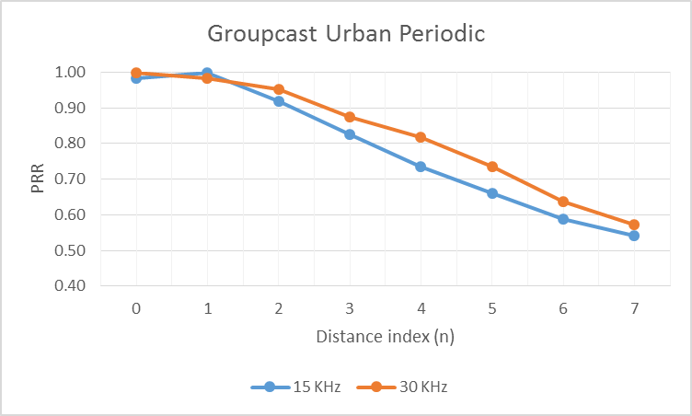
Urban aperiodic scenario
Source 1
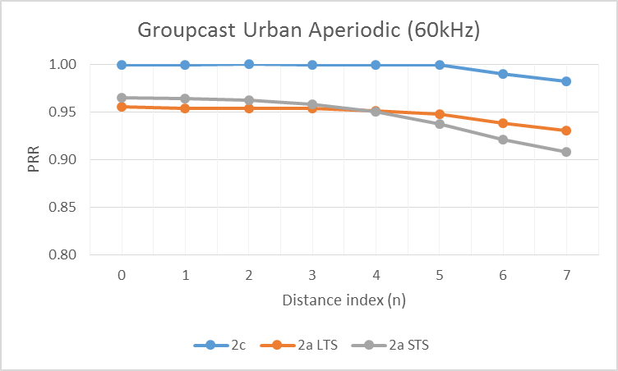
Source 2
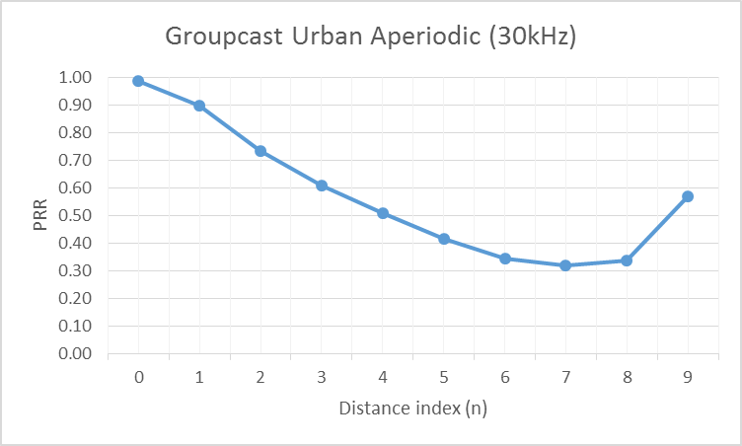
Source 3
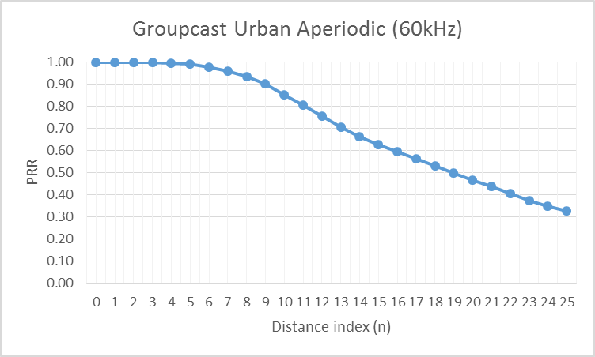
Source 5
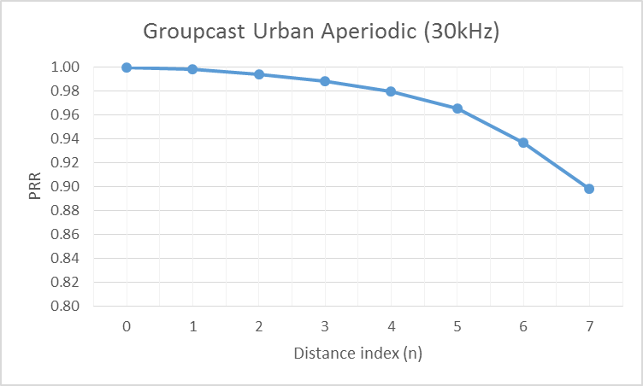
Source 6
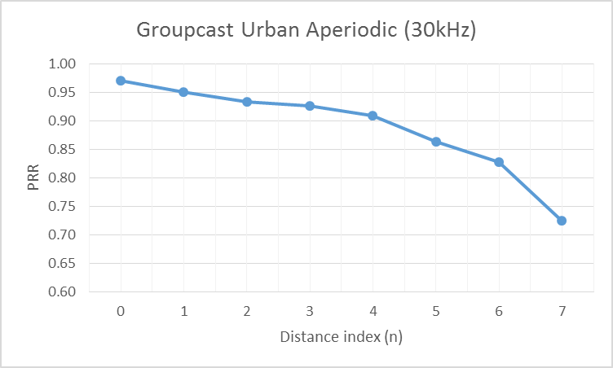

B.2.2.3 Broadcast
Highway periodic scenario
Source 1
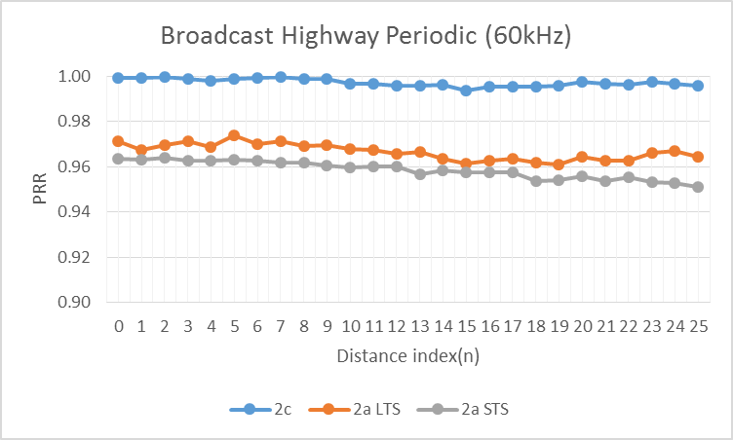
Source 2
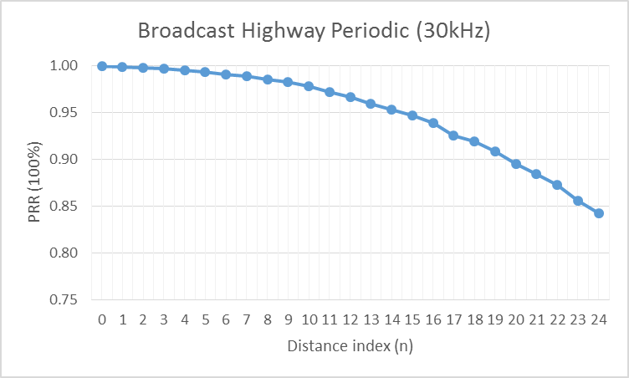
Source 3
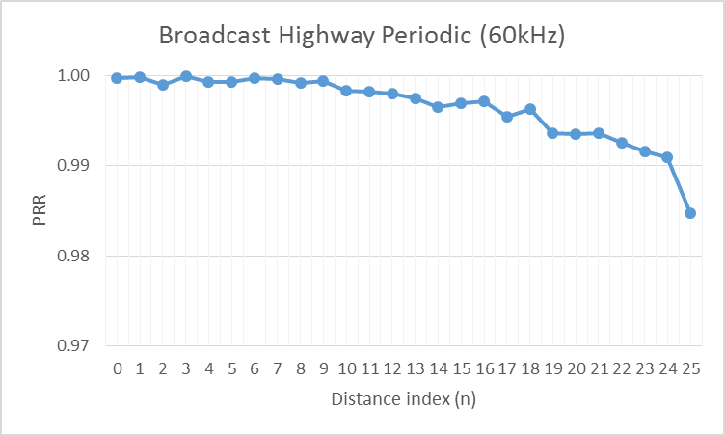
Source 4
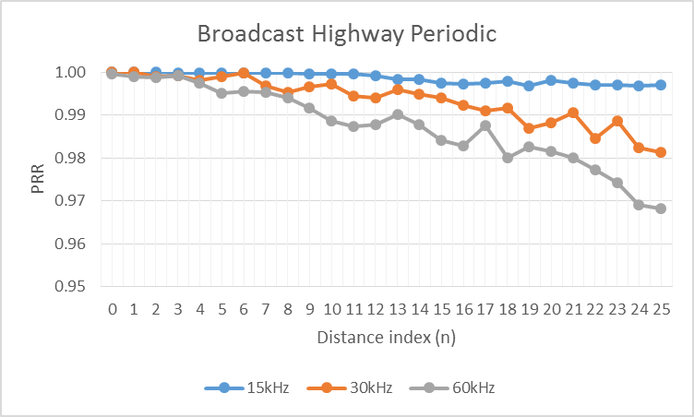
Source 5
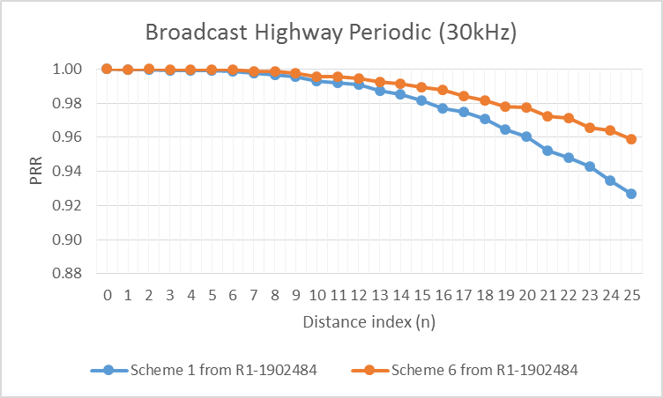
Source 6
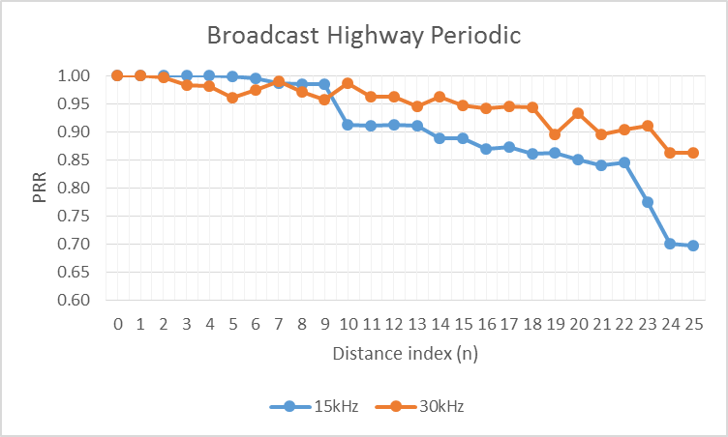
Source 7
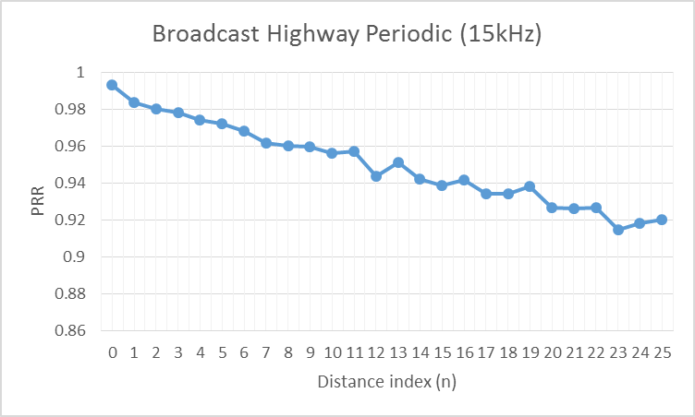
Source 9
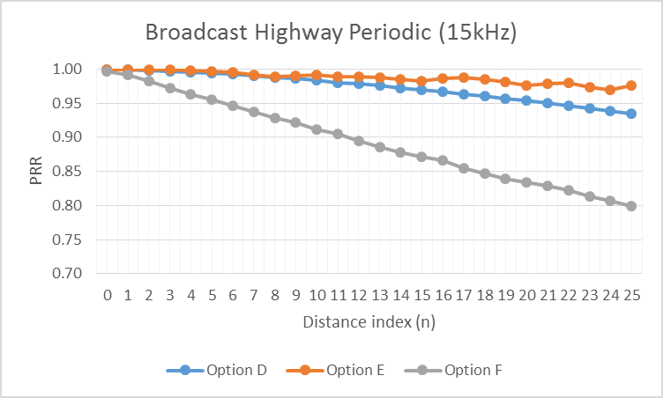
Source 11
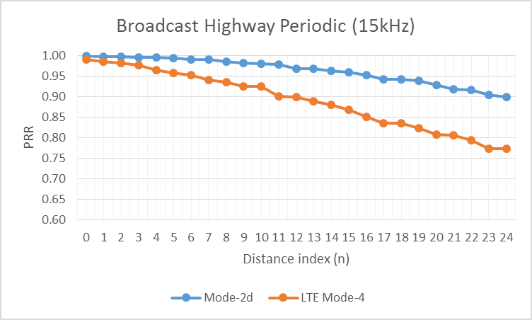
Source 13
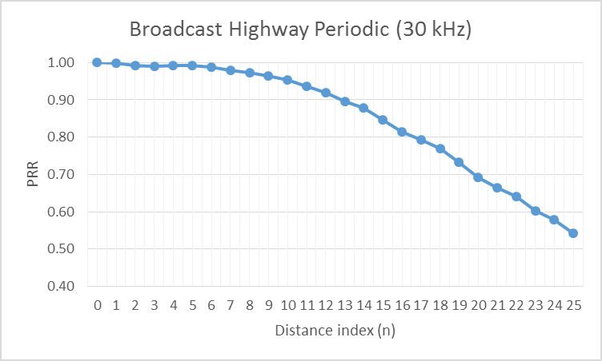
Highway aperiodic scenario
Source 1
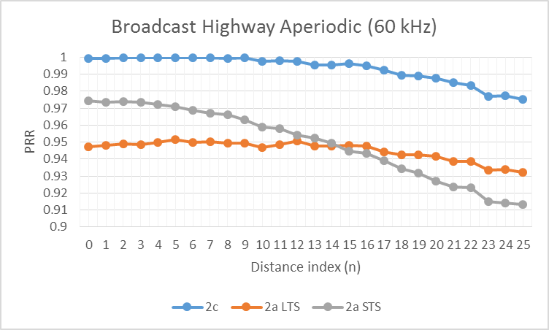
Source 2
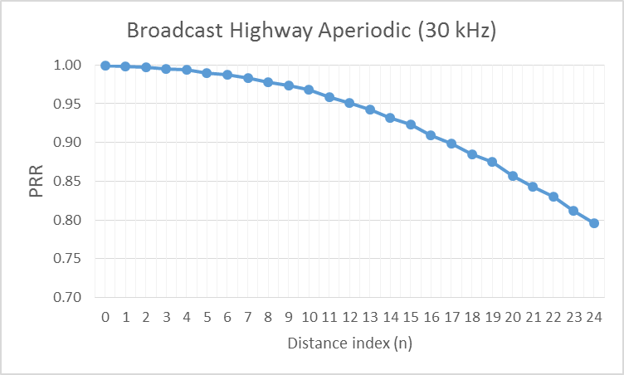
Source 3
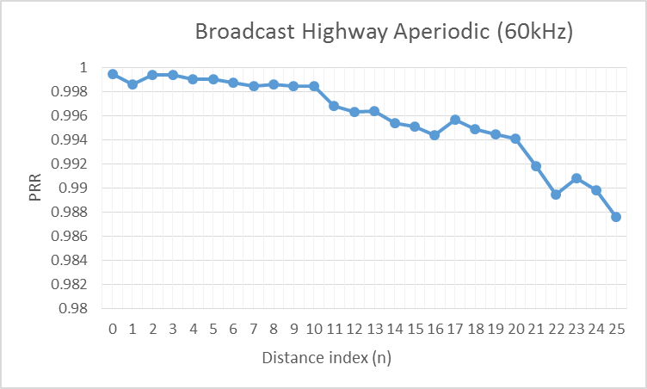
Source 4
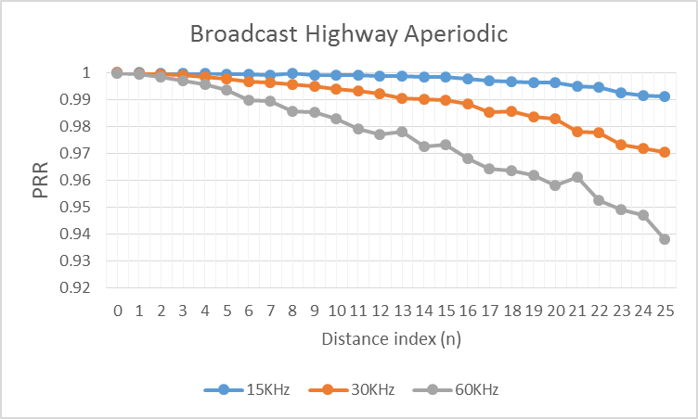
Source 5
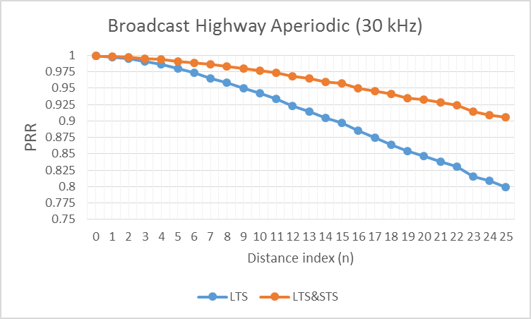
Source 6
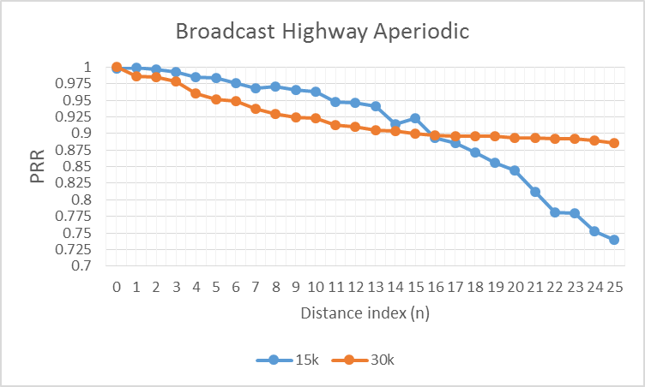
Source 7
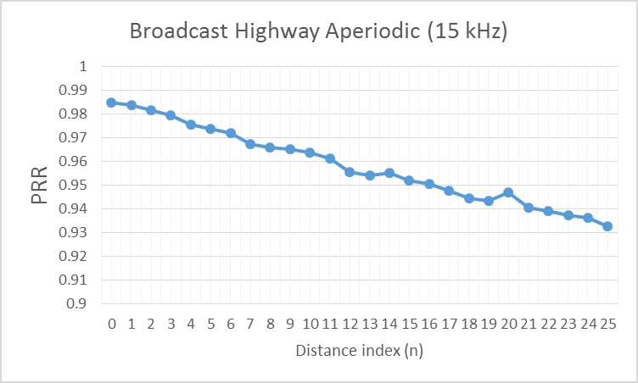
Source 9
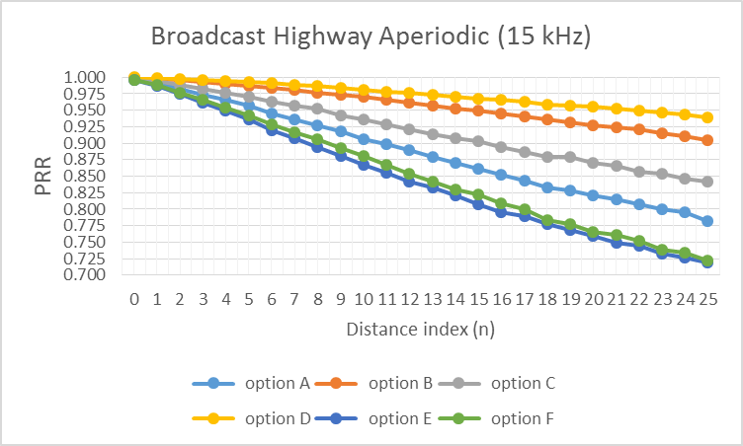
Source 10
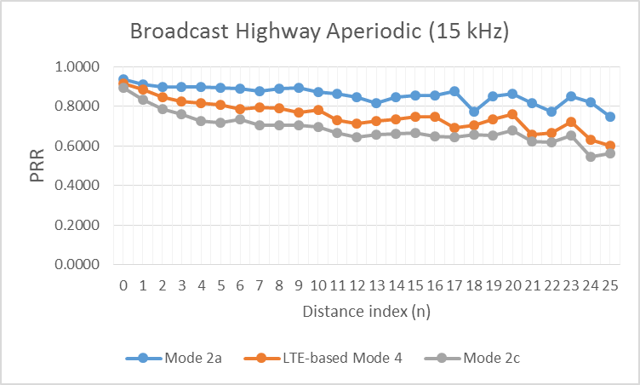
Source 11
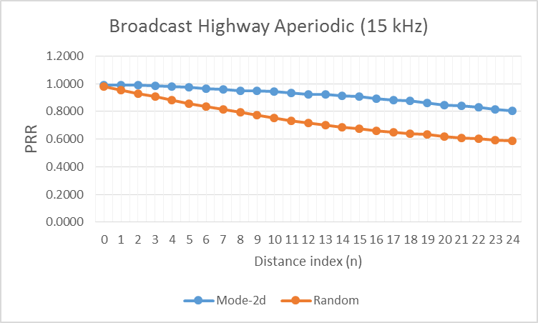
Source 12
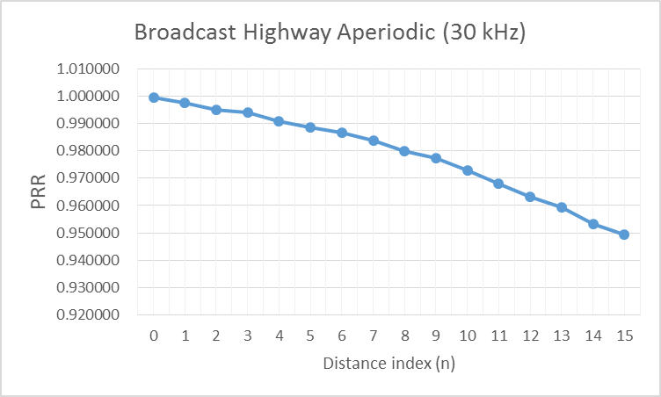
Source 13
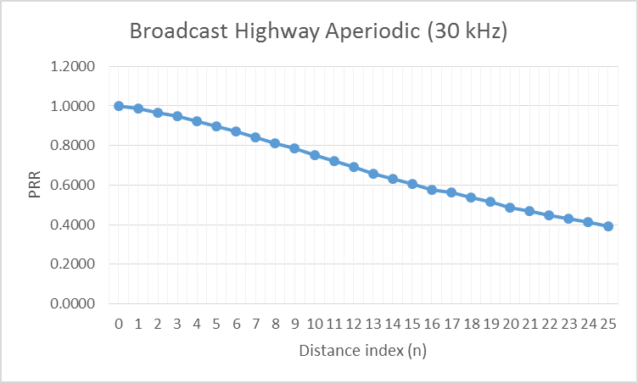
Urban periodic scenario
Source 1
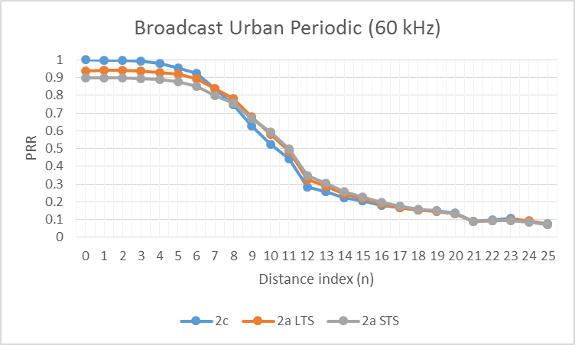
Source 2
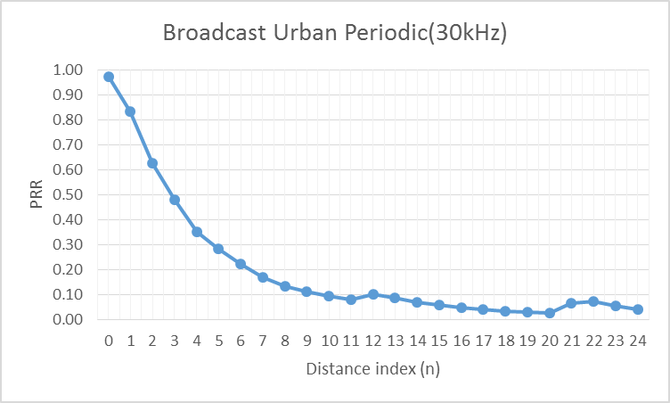
Source 3
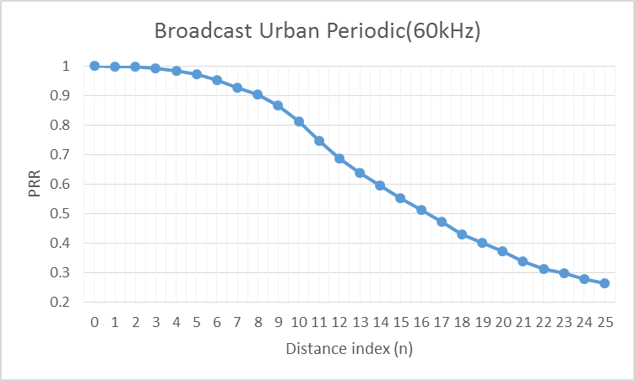
Source 5
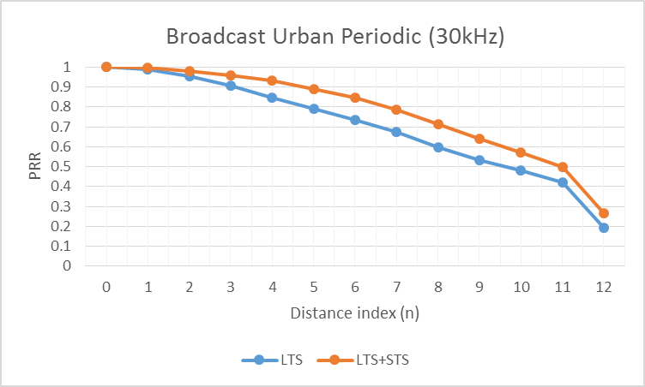
Source 6
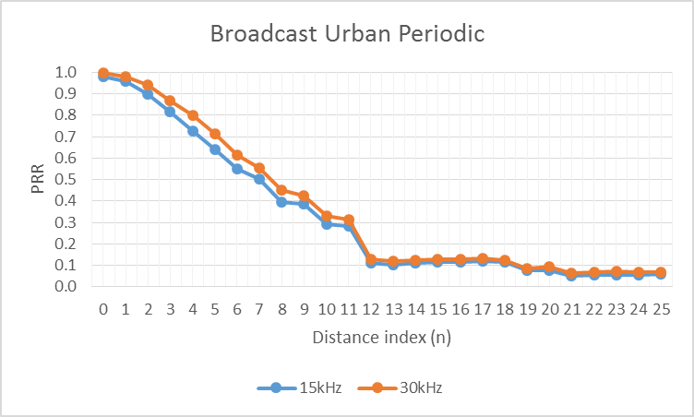
Source 7
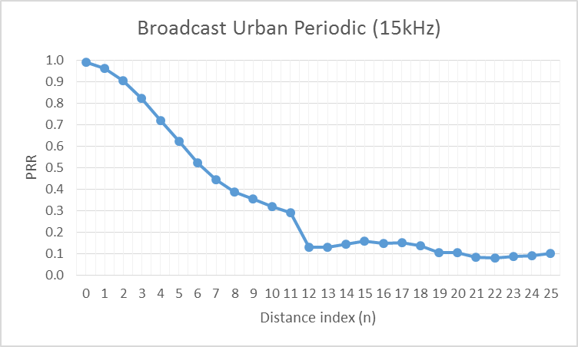
Source 11
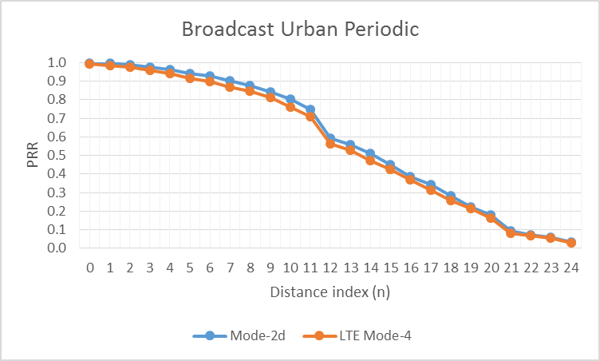
Source 14
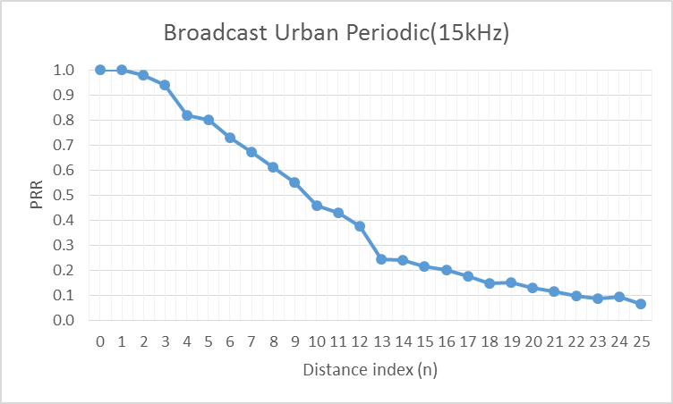
Urban aperiodic scenario
Source 1
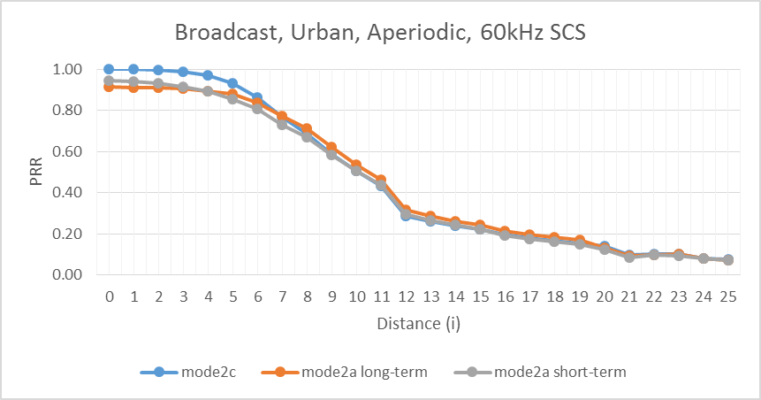
Source 2
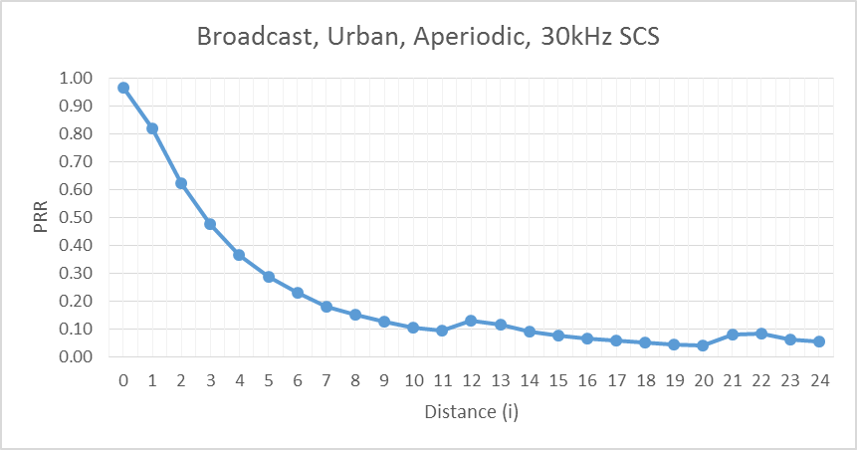
Source 3
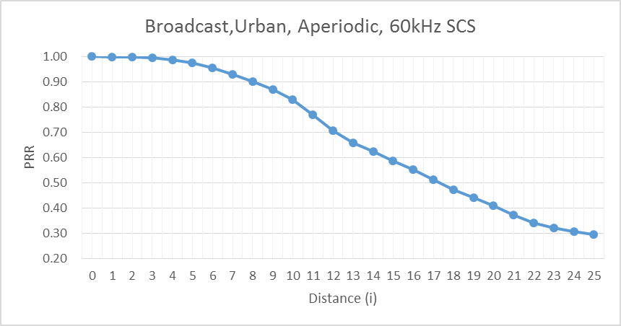
Source 5
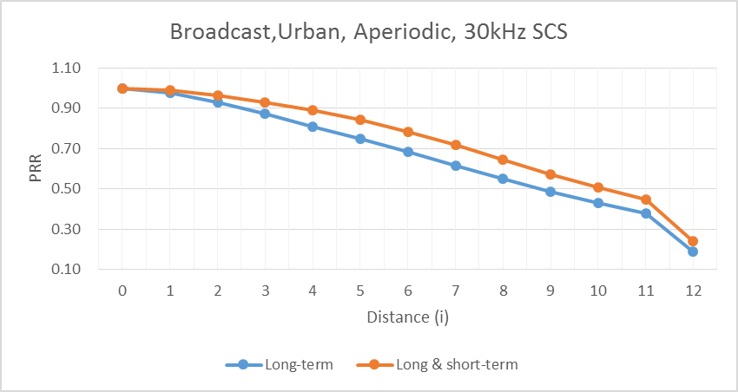
Source 6
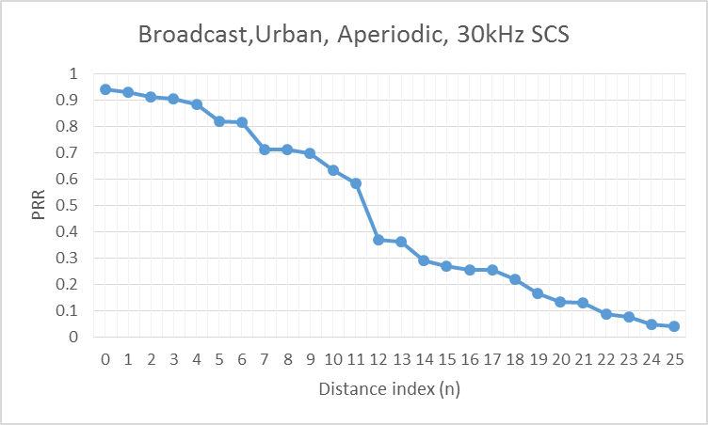
Source 7
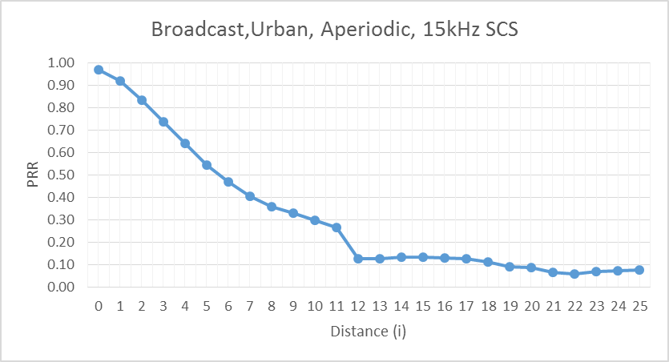
Source 10
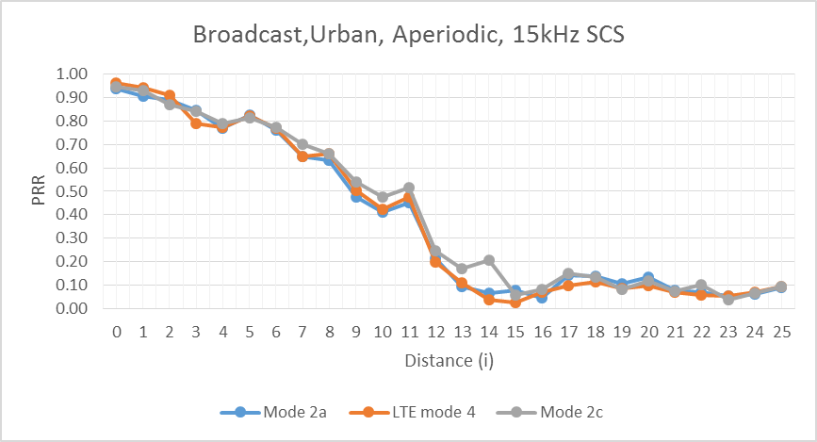
Source 11
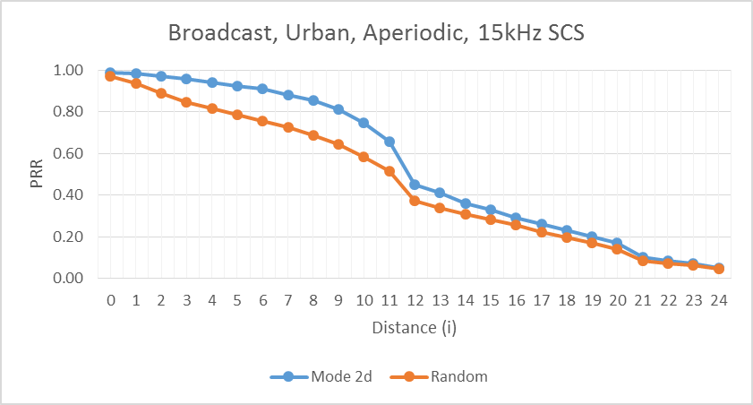
Source 12
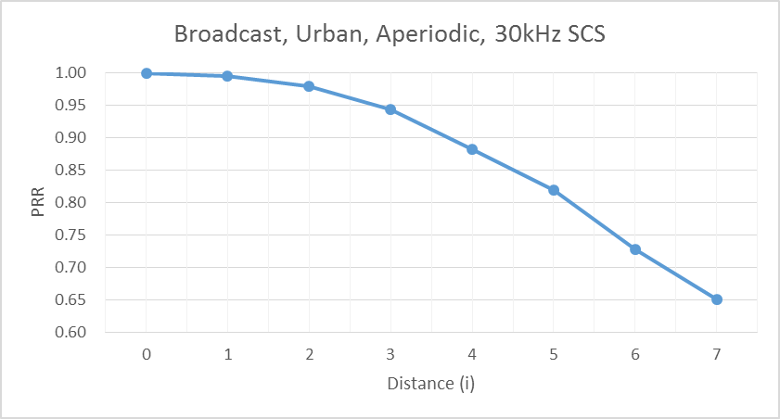

Annex C: Detailed evaluation results for synchronization

C.1 S-SSB detection

C.1.1 Simulation assumptions
This section shows the detailed results used to report the evaluations of S-SSB design combination performance in Section 11. Table C.1-1 shows the simulation assumptions used by each sourcing company.
Table C.1-1: S-SSB simulation assumptions
 | Source 1 | Source 2 | Source 3 | Source 4 | Source 5 | Source 6 | Source 7 | Source 8 | Source 9
Number of antennas | 2Tx*4Rx | 2Tx*2Rx | 2Tx*2Rx | 2Tx*2Rx | 2Tx*2Rx | 2Tx*2Rx | 2Tx*2Rx | 2Tx*2Rx | 2Tx*2Rx
CDL channel model | CDL V2X Urban NLOS | CDL V2X Urban NLOS | CDL-C | CDL V2X Urban NLOS | CDL V2X Urban NLOS | CDL V2X highway LOS/NLOSv | CDL V2X Urban LOS | CDL-C | CDL V2X Urban LOS
UE speed | 240 km/h | 240 km/h | 240 km/h | 240 km/h | 240 km/h | 240 km/h | 240 km/h | 240 km/h | 240 km/h
Interference scenario | 1 | 1 | 1 | 1 | 1 | 1 | 1 | 1 | 1

C.1.2 Detailed results
Source 1
Source 2
Source 3
Source 4
Source 5
Source 6

Source 7

Source 8
Source 9

C.2 PSBCH decoding
This section shows the detailed results used to report the evaluations of PSBCH performance in Section 11. Table C.1-1 shows the simulation assumptions used by each sourcing company.
Source 1
Source 2
Source 4
Source 7

Annex D:
Change history

Change history
Date | Meeting | TDoc | CR | Rev | Cat | Subject/Comment | New version
2018-08 | RAN1#94 | R1-1808942 |  |  |  | Skeleton TR | 0.0.0
2018-10 | RAN1#94bis | R1-1811096 |  |  |  | Endorsed version capturing the agreements reached in RAN1#94 | 0.0.1
2018-10 | RAN1#94bis | R1-1812081 |  |  |  | MCC clean-up based on endorsed R1-1811096 | 0.1.0
2018-11 | RAN1#95 | R1-1812252 |  |  |  | Addition of agreements from RAN1#94bis | 0.1.1
2018-11 | RAN1#95 | R1-1814389 |  |  |  | First version for information to RAN, inc. MCC clean-up | 1.0.0
2019-02 | RAN1#96 | R1-1902864 |  |  |  | Addition of agreements from RAN1-AH-1901 | 1.0.1
2019-02 | RAN1#96 | R1-1903593 |  |  |  | Updates to agreements from RAN1-AH-1901 | 1.0.2
2019-03 | RAN1#96 | R1-1903830 |  |  |  | Endorsed version post RAN1#96 agreements | 1.1.0
2019-03 | RAN#83 | RP-190142 |  |  |  | Version for approval to RAN | 2.0.0
2019-03 | RAN#83 |  |  |  |  | Spec under change control further to RAN decision and approval | 16.0.0

