3GPP TR 26.850 V16.0.0 (2018-09)
Technical Specification
3rd Generation Partnership Project;
Technical Specification Group Services and System Aspects;
MBMS for Internet of Things (IoT)
(Release 16)


The present document has been developed within the 3rd Generation Partnership Project (3GPP TM) and may be further elaborated for the purposes of 3GPP.
The present document has not been subject to any approval process by the 3GPP Organizational Partners and shall not be implemented.
This Specification is provided for future development work within 3GPP only. The Organizational Partners accept no liability for any use of this Specification.
Specifications and Reports for implementation of the 3GPP TM system should be obtained via the 3GPP Organizational Partners' Publications Offices.

Keywords
3GPP, MBMS, IoT

3GPP
Postal address

3GPP support office address
650 Route des Lucioles - Sophia Antipolis
Valbonne - FRANCE
Tel.: +33 4 92 94 42 00 Fax: +33 4 93 65 47 16
Internet
http://www.3gpp.org
Copyright Notification
No part may be reproduced except as authorized by written permission.
The copyright and the foregoing restriction extend to reproduction in all media.

© 2018, 3GPP Organizational Partners (ARIB, ATIS, CCSA, ETSI, TSDSI, TTA, TTC).
All rights reserved.

UMTS™ is a Trade Mark of ETSI registered for the benefit of its members
3GPP™ is a Trade Mark of ETSI registered for the benefit of its Members and of the 3GPP Organizational Partners
LTE™ is a Trade Mark of ETSI registered for the benefit of its Members and of the 3GPP Organizational Partners
GSM® and the GSM logo are registered and owned by the GSM Association
Contents
Foreword 5
1 Scope 6
2 References 6
3 Definitions, symbols and abbreviations 7
3.1 Definitions 7
3.2 Abbreviations 7
4 Use cases 8
4.0 General 8
4.1 Use case 1 - Periodic and/or planned data delivery 8
4.1.1 Description 8
4.1.2 Recommended Requirements 8
4.2 Use case 2 – Initially Unplanned data delivery 8
4.2.1 Description 8
4.2.2 Recommended requirements 9
4.3 Use case 3 – Initially Unplanned data delivery for critical data 9
4.3.1 Description 9
4.3.2 Recommended requirements 9
5 IoT device analysis 9
5.0 General 9
5.1 Classes of constrained devices 9
5.2 3GPP device categories 10
5.3 Device classification for MBMS IoT reception 10
6 MBMS for NB-IoT device categories 11
6.1 MBMS User Service Announcement Profile 11
6.2 MBMS IoT profiles for file download delivery method 11
6.2.0 Introduction 11
6.2.1 Common FDT-Instance and File attributes for MBMS IoT profiles 12
6.2.2 FDT-Instance specific Elements and Attributes for MBMS IoT profiles 12
6.2.3 FDT File specific Elements and Attributes for MBMS IoT profiles 12
6.2.4 3GPP-defined FDT extensions for MBMS IoT profiles 13
7 Solutions 14
7.1 Overview of CoAP 14
7.1.0 General 14
7.1.1 Comparison to HTTP 15
7.1.2 Logical Architecture Model 15
7.1.2.0 General 15
7.1.2.1 CoAP Messaging Model 15
7.1.2.2 Methods and Response Codes 16
7.1.3 Message Format 17
7.1.4 Options 18
7.1.5 Caching 19
7.1.6 Proxying 19
7.1.7 Security and DTLS 19
7.1.8 Block-wise transfers 19
7.1.8.0 General 19
7.1.8.1 Structure of a Block Option 20
7.2 Overview of LwM2M 21
7.3 Solutions for File Repair using CoAP 23
7.3.0 General 23
7.3.1 Byte-Range Request based File Repair 24
7.3.1.0 General 24
7.3.1.1 Option 1: use Uri-Query option in CoAP 24
7.3.1.2 Option 2: define a new CoAP option Range 25
7.3.2 Block Request based File Repair 27
7.3.2.0 General 27
7.3.2.1 Option 3: Block request for repair data after broadcast transmission of source and repair symbols 27
7.3.2.2 Option 4: Block request for repair data after broadcast transmission of only repair symbols 29
7.3.2.3 Comparison of Block Request based File Repair Options 30
7.3.3 Solution evaluation 30
7.4 Binary data formats 31
7.4.0 General 31
7.4.1 Efficient Extensible Interchange or Efficient XML Exchange (EXI) 31
7.4.2 Well-known binary formats 32
7.4.3 Ad-hoc binary format 33
7.4.4 Key-Length-Value (KLV) format 36
7.4.5 Performance comparison of binary data formats 36
7.4.5.1 General considerations 36
7.4.5.2 Performance comparison 37
7.4.5.3 Summary 40
7.4.5.4 Recommendation 40
7.5 Solution for announcement during wake-up periods 40
7.6 Solution for announcement with critical data delivery 41
7.7 Solution for reception report procedures 42
7.8 Solution for service announcement procedures 44
7.8.1 Unicast delivery of service announcement using CoAP 44
7.8.2 Service announcement profiles for IoT devices 44
7.9 ASN.1 PER binary FDT instance definition 53
8 Conclusions 54
Annex A: Change history 56

Foreword
This Technical Report has been produced by the 3rd Generation Partnership Project (3GPP).
The contents of the present document are subject to continuing work within the TSG and may change following formal TSG approval. Should the TSG modify the contents of the present document, it will be re-released by the TSG with an identifying change of release date and an increase in version number as follows:
Version x.y.z
where:
x the first digit:
1 presented to TSG for information;
2 presented to TSG for approval;
3 or greater indicates TSG approved document under change control.
y the second digit is incremented for all changes of substance, i.e. technical enhancements, corrections, updates, etc.
z the third digit is incremented when editorial only changes have been incorporated in the document.

1 Scope
The present document studies and evaluates the enhancements at the service layer to support massive file delivery for IoT devices. Devices and network entities operating in the typically constrained environment associated with IoT communications (e.g., processing power, storage, battery life, bandwidth) might support the simplified mechanisms and protocols for MBMS and associated unicast procedures as described in the present document, as opposed to the regular MBMS operations as defined in 3GPP TS 26.346. An IoT device described in the present document could be for instance a NB-IoT device or an eMTC device.
The study considers the enhancements/simplifications in the following areas:
- Define the requirements and constraints for different IoT device categories.
- Review the existing multicast/broadcast service architecture in support of MBMS delivery to IoT devices.

2 References
The following documents contain provisions which, through reference in this text, constitute provisions of the present document.
- References are either specific (identified by date of publication, edition number, version number, etc.) or non-specific.
- For a specific reference, subsequent revisions do not apply.
- For a non-specific reference, the latest version applies. In the case of a reference to a 3GPP document (including a GSM document), a non-specific reference implicitly refers to the latest version of that document in the same Release as the present document.
[1] 3GPP TR 21.905: "Vocabulary for 3GPP Specifications".
[2] 3GPP TS 26.346: "Multimedia Broadcast/Multicast Service (MBMS); Protocols and codecs".
[3] IETF RFC 3926 (October 2004): "FLUTE - File Delivery over Unidirectional Transport", T. Paila, M. Luby, R. Lehtonen, V. Roca, R. Walsh
[4] 3GPP TS 36.101: "User Equipment (UE) radio transmission and reception".
[5] 3GPP TS 36.306: "User Equipment (UE) radio access capabilities".
[6] 3GPP TR 22.861: "FS_SMARTER - massive Internet of Things".
[7] IETF RFC 7252 (June 2014): "The Constrained Application Protocol (CoAP)", Z. Shelby, K. Hartke, C. Bormann.
[8] IETF RFC 6347 (January 2012): "Datagram Transport Layer Security Version 1.2", E. Rescorla, N. Modadugu.
[9] OMA-TS-LightweightM2M-V1_0-20170208-A: "Lightweight Machine to Machine Technical Specification".
[10] IETF RFC 7228 (May 2014): "Terminology for Constrained-Node Networks", C. Bormann, M. Ersue, A. Keranen.
[11] 3GPP TR 45.820: "Cellular system support for ultra-low complexity and low throughput Internet of Things (CIoT)"
[12] IETF RFC 4919 (August 2007): "IPv6 over Low-Power Wireless Personal Area Networks (6LoWPANs): Overview, Assumptions, Problem Statement, and Goals", N. Kushalnagar, G. Montenegro, C. Schumacher.
[13] IETF RFC 7959 (August 2006): "Block-Wise Transfers in the Constrained Application Protocol (CoAP)", C. Bormann, Z. Shelby.
[14] https://www.w3.org/XML/EXI/
[15] http://www.xfront.com/EXI/EXI.zip
[16] https://www.itu.int/en/ITU-T/asn1/Pages/asn1_project.aspx
[17] https://thrift.apache.org/
[18] https://github.com/google/protobuf
[19] http://www.oss.com/asn1/resources/asn1-made-simple/encoding-rules.html
[20] N. Gligorić, I. Dejanović and S. Krčo, "Performance evaluation of compact binary XML representation for constrained devices," 2011 International Conference on Distributed Computing in Sensor Systems and Workshops (DCOSS), Barcelona, 2011, pp. 1-5.
[21] 3GPP TS 36.331: "Evolved Universal Terrestrial Radio Access (E-UTRA); Radio Resource Control (RRC); Protocol specification".
[22] https://www.w3.org/TR/2009/WD-exi-evaluation-20090407/
[23] https://www.w3.org/WoT/IG/wiki/images/4/44/2016-04_EXI_for_WoT-1.pdf
[24] Sebastian Bittl, Arturo A. Gonzalez, Michael Spahn, and Wolf A. Heidrich, "Performance Comparison of Data Serialization Schemes for ETSI ITS Car-to-X Communication Systems", International Journal on Advances in Telecommunications, vol 8 no 1 & 2, 2015.

3 Definitions, symbols and abbreviations

3.1 Definitions
For the purposes of the present document, the terms and definitions given in 3GPP TR 21.905 [1] and the following apply. A term defined in the present document takes precedence over the definition of the same term, if any, in 3GPP TR 21.905 [1].

3.2 Abbreviations
For the purposes of the present document, the abbreviations given in 3GPP TR 21.905 [1] and the following apply. An abbreviation defined in the present document takes precedence over the definition of the same abbreviation, if any, in 3GPP TR 21.905 [1].
ADPD Associated Delivery Procedure Description
CoAP Constrained Application Protocol
DASH Dynamic Adaptive Streaming over HTTP
eMBMS Evolved Multimedia Broadcast Multicast Services
eMTC enhanced Machine Type Communication
FLUTE File deLivery over Unidirectional Transport
IoT Internet of Things
MPD Media Presentation Description
NB-IoT NarrowBand IoT
RTOS Real-Time Operating System
RTP Real-Time Transport Protocol
USBD User Service Bundle Description
USD User Service Description
UTC Universal Time Coordinated
XML Extensible Markup Language

4 Use cases

4.0 General
3GPP TR 22.861 [6] identifies the use case families, traffic scenarios and potential requirements for massive IoT. However, the use case families in 3GPP TR 22.861 do not address the data delivery from the network to a large amount of UEs. The following use cases present the data delivery using MBMS User Services with additional requirements compared to 3GPP TR 22.861.

4.1 Use case 1 - Periodic and/or planned data delivery

4.1.1 Description
This use case represents a periodic and/or planned file delivery to a large number of devices. Smart water-metering devices are installed in deep indoor and wake up once or twice a day to send the consumption reports to the water-metering network that is regularly extended. The payload size for uplink transmission is in the range of 12 to 100 bytes. Based on growing amount of data, the system configuration is adjusted, requiring the delivery of small configuration updates to all metering devices. Moreover, the water-metering manufacturer regularly provides non-critical software updates for bug fixes, performance improvements, or new features/functionalities. For example, the clause E.2.4 of 3GPP TR 45.820 [11] estimates a periodic inter-arrival time of 180 days between software update events. This frequency is equivalent to twice per year. Depending on the application, the update frequency can be lower or higher. These devices require a battery lifetime of approximate 15 years and are significantly resource-constrained (processing and storage).

4.1.2 Recommended Requirements
The following recommended requirements are considered:
- The 3GPP system supports the reliable delivery and associated procedures to ensure data integrity.
- The 3GPP system supports the report on successful delivery.
- The 3GPP system supports eMBMS delivery mechanisms and procedures for devices with very limited capabilities (e.g. limited battery life of 15 years, limited processing and limited storage).
- The 3GPP system supports a mechanism to inform the scheduled delivery session to the devices that enables the UE to download the file at the planned schedule time.- The 3GPP system supports a mechanism to acknowledge a successful reception and action required (e.g. successful file update).
In addition, the following recommended requirements are not directly related to 3GPP system but necessary for IoT software update:
- The update needs to be robust. An update does not make the device unusable.
- The update needs to be atomic. An update needs to be completely installed or not at all.
- The update needs to be fail-safe. There is a fall-back mode if the update has failed.

4.2 Use case 2 – Initially Unplanned data delivery

4.2.1 Description
This use case represents the unplanned data delivery to a large number of devices. A device manufacturer wants to distribute a software/firmware update after some bug fixes. These devices may wake up periodically (e.g., every 12 hours to upload measurement data), or dynamically, for instance, when the buffer which contains measurement data is about to be full. The information that a new software/firmware update is available is transmitted during these wake-up periods. The device recommended requirements and constraints are similar to the use case 1.

4.2.2 Recommended requirements
In addition to the recommended requirements in clause 4.1.2, the following additional recommended requirement is considered:
- The 3GPP system supports a mechanism to inform the UE during its wake-up periods about any newly scheduled download delivery sessions.

4.3 Use case 3 – Initially Unplanned data delivery for critical data

4.3.1 Description
This use case represents the unplanned critical data delivery to a large number of devices. A bug in software could be a target for exploitation or is being exploited by unwanted people to perform a massive attack if the devices are connected to the Internet. To solve the issue, a device manufacturer wants to distribute as soon as possible a critical software/firmware update. The device recommended requirements and constraints are similar to the use case 1. But in contrast to use case 2, the device manufacturer wants to speed up the update mechanism such that devices can obtain information on a newly scheduled download delivery session, as opposed to having to wait until the next wake-up period to obtain such information.

4.3.2 Recommended requirements
In addition to the recommended requirements in clause 4.1.2, the following additional recommended requirement is considered:
- The 3GPP system supports a mechanism to page the UE in order to inform the UE about a newly schedule download delivery session.

5 IoT device analysis

5.0 General
In IoT devices, there are two separate parts: connectivity and application. The connectivity part is responsible for the connectivity between the IoT device and the network (e.g. LTE modem) while the application part is used for a specific application/use case. Each part may have its own software/firmware/OS. The clause 5.1 specifies the classes of devices at the application, the clause 5.2 presents the device categories for LTE connectivity.

5.1 Classes of constrained devices
RFC 7228 [10] defines constrained devices as small devices with limited CPU, memory, and power resources. The devices are often used as sensors/actuators, smart objects, or smart devices. RFC 7228 [10] identifies 3 classes of constrained devices as in table 5.1-1 to provide rough indications of device capabilities.
Table 5.1-1: Classes of constrained devices (KiB = 1024 bytes) [12]
Name | Data size (e.g. RAM) | Code size (e.g. Flash)
Class 0, C0 | << 10 KiB | << 100 KiB
Class 1, C1 | ~ 10 KiB | ~ 100 KiB
Class 2, C2 | ~ 50 KiB | ~ 250 KiB

NOTE: RFC 7228 uses the term KiB and this term is only applied in the clause 5.1 of the present document.
The description of each class is extracted from RFC 7228 [10] as follows:
"Class 0 devices are very constrained sensor-like motes. They are so severely constrained in memory and processing capabilities that most likely they will not have the resources required to communicate directly with the Internet in a secure manner (rare heroic, narrowly targeted implementation efforts notwithstanding). Class 0 devices will participate in Internet communications with the help of larger devices acting as proxies, gateways, or servers. Class 0 devices generally cannot be secured or managed comprehensively in the traditional sense. They will most likely be preconfigured (and will be reconfigured rarely, if at all) with a very small data set. For management purposes, they could answer keepalive signals and send on/off or basic health indications.
Class 1 devices are quite constrained in code space and processing capabilities, such that they cannot easily talk to other Internet nodes employing a full protocol stack such as using HTTP, Transport Layer Security (TLS), and related security protocols and XML-based data representations. However, they are capable enough to use a protocol stack specifically designed for constrained nodes (such as the Constrained Application Protocol (CoAP) over UDP) and participate in meaningful conversations without the help of a gateway node. In particular, they can provide support for the security functions required on a large network. Therefore, they can be integrated as fully developed peers into an IP network, but they need to be parsimonious with state memory, code space, and often power expenditure for protocol and application usage.
Class 2 devices are less constrained and fundamentally capable of supporting most of the same protocol stacks as used on notebooks or servers. However, even these devices can benefit from lightweight and energy-efficient protocols and from consuming less bandwidth. Furthermore, using fewer resources for networking leaves more resources available to applications. Thus, using the protocol stacks defined for more constrained devices on Class 2 devices might reduce development costs and increase the interoperability.
Constrained devices with capabilities significantly beyond Class 2 devices exist. They are less demanding from a standards development point of view as they can largely use existing protocols unchanged. The present document therefore does not make any attempt to define classes beyond Class 2. These devices can still be constrained by a limited energy supply."

5.2 3GPP device categories
3GPP TS 36.306 [5] defines categories for NB-IoT and MTC devices: Cat-NB1, Cat-NB2, Category M1, Category M2. 3GPP TS 36.306 clauses 4.1A and 4.1C specify uplink and downlink capability for MTC and NB-IoT categories, respectively. However, 3GPP TS 36.306 does not specify whether NB-IoT or MTC devices support certain MBMS operations and capabilities (e.g. XML parsing and processing).

5.3 Device classification for MBMS IoT reception
The classification in clause 5.1 is applied for the application part while the 3GPP device categories is applied for the connectivity part. Depending on the application, use case, and device capabilities, multiple combinations from the classification in clause 5.1 and the 3GPP device categories are possible. For example, a smart water-metering device may use Cat-NB1 for the connectivity and Class 1 for the application with finite battery power. The MBMS client is between the applications and the connectivity functions. Classification and dimensioning provided by RFC 7228 [10] and by 3GPP TS 36.306 [5] cannot be applied directly to the MBMS client. Consequently, 2 classification categories are here proposed for the MBMS reception point of view: low-end and high-end; depending on the application and/or use case.
The low-end IoT category represents the devices with limited capabilities such as processing, memory, battery etc. The MBMS User Services for this category have to be simplified as much as possible to address a wide range of devices, applications, and use cases. For example, Class 1 devices do not recommend full XML processing [12].
The high-end IoT category represents the devices with moderate or good capabilities (e.g., smart endpoints, IoT gateways). This device category may have additional capabilities (e.g. XML parsing/processing) compared to the low-end IoT category.
The low-end IoT category may support reduced MBMS processing (e.g. no XML). The high-end IoT category may support an MBMS profile without requirements for multimedia services (e.g. neither RTP nor DASH).

6 MBMS for NB-IoT device categories

6.1 MBMS User Service Announcement Profile
3GPP TS 26.346 [2] defines different procedures, mechanisms and protocols for MBMS User Services. The table 6.1-1 shows the profiling for each IoT category:
Table 6.1-1: List of supported procedures and methods for low-end and high-end IoT categories
 |  | Recommended for Low-end IoT category Profile | Recommended for High-end IoT category Profile
Service Announcement | MBMS bearer | Yes (Note 1) | Yes
Service Announcement | Interactive Announcement Function | No | Yes
Service Announcement | Point-to-Point push bearer | Yes | Yes
Associated delivery procedure | File Repair – Byte Range based | Yes (Note 3) | Yes
Associated delivery procedure | File Repair – Symbol based | No | No
Associated delivery procedure | Reception Report | Yes (Note 3) | Yes
Associated delivery procedure | Consumption Report | No | No
Delivery method | Download | Yes | Yes
Delivery method | Streaming | No | No
Delivery method | Group communication | No | No
Delivery method | Transparent | No | No
NOTE 1: In clause 5.2.3.1 of 3GPP TS 26.346, the possibility to download session parameters from an HTTP server resolved from the Service Announcement may not be applicable for low-end IoT category. A CoAP based solution instead of HTTP may be more efficient.
NOTE 2: In clause 5.2.4 of 3GPP TS 26.346, the HTTP URL used by the UE to obtain USD via unicast may not be applicable to low-end IoT category. A CoAP based solution for Interactive Announcement Function instead of HTTP may be more appropriate.
NOTE 3: File repair and reception report messages using HTTP protocol in a single TCP connection (3GPP TS 26.346 clauses 9.3 and 9.4) is not desirable in the low-end IoT category. Simplified file repair and reception report procedures are preferable - (e.g. file repair and reception report based on CoAP, according to the methods described in clauses 7.3.1 and 7.3.2 in the present document).
NOTE 4: The point-to-point push bearer in the present document indicates the unicast delivery of service announcement which is described in the clauses 7.5 and 7.6.

6.2 MBMS IoT profiles for file download delivery method

6.2.0 Introduction
Clause L.4 in 3GPP TS 26.346 specifies the MBMS download profile for both non-real-time (NRT) file delivery services as well as DASH-formatted streaming services, using the FLUTE protocol. FLUTE uses FDT instance to indicate the attributes and elements required for the delivery. The FDT attributes and elements are categorized at the FDT-Instance level (i.e., the FDT-Instance element of the FDT) and at the File level (i.e., the File element of the FDT). The high-end IoT category may reuse the MBMS download profile but does not require the functionalities for multimedia services (e.g. DASH). Table 6.1-1 shows the supported high-level capabilities in download delivery method for IoT devices.
Table 6.2.0-1: Supported capabilities in download delivery method
 | Recommended for Low-end IoT category profile | Recommended for High-end IoT category profile | MBMS profile in Annex L 3GPP TS 26.346
FLUTE session setup and control with RTSP | No (Note 1) | No (Note 1) | Optional
SDP for Download Delivery Method | FFS (Note 3) | Yes | Yes
XML schema and processing | No (Note 2) | FFS (Note 4) | Yes
NOTE 1: 3GPP TS 26.346 clause L.4.6 specifies "FLUTE session setup and control with RTSP" as an option supported by the UE, IoT devices do not require this functionality.
NOTE 2: In clause 5.3, low-end IoT category does not recommend full XML processing. A binary/json format may be defined for any XML data.
NOTE 3: A solution for Low-end IoT profile could allow either the direct parsing of the fields and attributes in the SDP file or the embedding of necessary fields and attributes in the SDP in the service announcement using binary format
NOTE 4: A solution for High-end IoT category profile could support either XML format or binary format.

6.2.1 Common FDT-Instance and File attributes for MBMS IoT profiles
Annex L4.2 in 3GPP TS 26.346 specifies the FDT attributes defined for both the FDT-Instance and File levels. Table 6.2.1-1 shows the profiling for each IoT category.
Table 6.2.1-1: Common FDT-Instance and File attributes for MBMS IoT profiles
Attributes/Parameters | Recommended for Low-end IoT category profile | Recommended for High-end IoT category profile | MBMS profile in Annex L 3GPP TS 26.346
Content-type | Yes | Yes | Yes
FEC-OTI-FEC-Encoding-ID | Yes | Yes | Yes
FEC-OTI-Maximum-Source-Block-Length | Yes | Yes | Yes
FEC-OTI-Encoding-Symbol-Length | Yes | Yes | Yes
FEC-OTI-Scheme-Specific-Info | Yes | Yes | Yes
Content-Encoding | No | No | No
FEC-OTI-FEC-Instance-ID | No | No | No
NOTE: The indicators YES and NO are specified for FLUTE sender.

6.2.2 FDT-Instance specific Elements and Attributes for MBMS IoT profiles
Table 6.2.2-1 shows the profiling for each IoT category on FDT-Instance specific elements and attributes.
Table 6.2.2-1: FDT-Instance Specific Elements and Attributes for MBMS IoT profiles
Parameters | Recommended for Low-end IoT category profile | Recommended for High-end IoT category profile | MBMS profile in Annex L 3GPP TS 26.346
Expires | Yes | Yes | Yes
Complete | No | No | No
mbms2008:FullFDT | No | No | No
mbms2012:Base-URL-1 | Yes (Note 1) | Yes (Note 1) | No
mbms2012:Base-URL-2 | Yes (Note 1) | Yes (Note 1) | No
MBMS-Session-Identity-Expiry | No | No | No
NOTE 1: The "Base-URL-1" or "Base-URL-2" elements are used for byte-range-based file repair.
NOTE 2: The indicators YES and NO are specified for FLUTE sender.

6.2.3 FDT File specific Elements and Attributes for MBMS IoT profiles
Table 6.2.3-1 shows the profiling for each IoT category on FDT File specific elements and attributes.
Table 6.2.3-1: FDT File specific Elements and Attributes for MBMS IoT profiles
Parameters | Recommended for Low-end IoT category profile | Recommended for High-end IoT category profile | MBMS profile in Annex L 3GPP TS 26.346
Content-Location | Yes | Yes | Yes
TOI | Yes | Yes | Yes
Content-Length | Yes | Yes | Yes
Content-MD5 | Yes | Yes | Yes
mbms2007:Cache-Control | No (Note 2) | Yes | Yes
Content-type | Yes | Yes | Yes
FEC-OTI-FEC-Encoding-ID | Yes | Yes | Yes
FEC-OTI-Maximum-Source-Block-Length | Yes | Yes | Yes
FEC-OTI-Encoding-Symbol-Length | Yes | Yes | Yes
FEC-OTI-Max-Number-of-Encoding-Symbols | Yes | Yes | Yes
FEC-OTI-Scheme-Specific-Info | Yes | Yes | Yes
Transfer-Length | No (Note 1) | Yes (Note 1) | No (Note 1)
mbms2009:Decryption-KEY-URI | No | No | No
mbms2012:FEC-Redundancy-Level | No | No | No
mbms2012:Alternate-Content-Location-1 | Yes | Yes | No
mbms2012:Alternate-Content-Location-2 | Yes | Yes | No
MBMS-Session-Identity | No | No | No
NOTE 1: IoT devices may not use gzip content encoding, Transfer-Length may not be useful.
NOTE 2: eMBMS client can ignore any cache-control directive. For instance, an eMBMS client may remove from its cache any file received as soon as the MBMS application has acquired the file.
NOTE 3: The indicators YES and NO are specified for FLUTE sender.

Signalling of parameters with basic ALC/FLUTE headers or FLUTE extension headers for IoT device categories is the same as specified in clauses 7.2.7 and 7.2.8 of 3GPP TS 26.346.

6.2.4 3GPP-defined FDT extensions for MBMS IoT profiles
3GPP TS 26.346 defines various FDT elements and attributes specified for 3GPP MBMS User Services that are not in the FLUTE specified in RFC 3926 [3]. Table 6.2.4-1 shows the profiling of these elements and attributes for MBMS IoT profiles.
Table 6.2.4-1: 3GPP-defined FDT extension elements for MBMS IoT profiles
Parameters | Recommended for Low-end IoT category profiles | Recommended for High-end IoT category profiles | MBMS profile in Annex L 3GPP TS 26.346
mbms2005:MBMS-Session-Identity-Type | No | No | No
mbms2005:MBMS-Session-Identity-Expiry-Type | No | No | No
mbms2005:groupIdType | No | No | No
mbms2007:Cache-Control | No | No | No
mbms2008:FullFDT | No | No | No
mbms2009:Decryption-KEY-URI | No | No | No
mbms2012:Base-URL-1 | No | No | No
mbms2012:Base-URL-2 | No | No | No
mbms2012:FEC-Redundancy-Level | No | No | No
mbms2012:Alternate-Content-Location-1 | No | No | No
mbms2012:Alternate-Content-Location-2 | No | No | No
mbms2012:File-ETag | Yes (Note 1) | Yes | Yes
mbms2015:IndependentUnitPositions | No | No | No
MBMS-Session-Identity-Expiry | No | No | No
NOTE 1: CoAP supports Etag option.
NOTE 2: The indicators YES and NO are specified for FLUTE sender.

For Low-end IoT category profile, the attributes and elements in the FDT described in the Tables 6.2.1-1, 6.2.2-1, 6.2.3-1 and 6.2.4-1 could be embedded in the service announcement.

7 Solutions

7.1 Overview of CoAP

7.1.0 General
This clause provides an overview of CoAP, whose design was motivated for IoT-related communications. As described in RFC 7252 [7], it is a specialized content transfer protocol for the Internet for use with constrained endpoints and constrained networks (e.g. low-power Tx/Rx and bandwidth). CoAP supports a request/response interaction model between application endpoints and includes key Web concepts in HTTP such as RESTful client-server architecture, use of URIs for resource identification and location, and Internet media types. In fact, CoAP is designed to interface easily with HTTP for Web integration while meeting specific requirements such as very low overhead, simplicity for constrained application, device and network environments (such as in IoT communications). It also contains built-in support for service and resource discovery, as well as multicast distribution (since it runs over UDP, it also supports the use of multicast IP destination addressing). The key characteristics and features of CoAP can be summarized as follows:
- Web protocol which fulfils IoT/M2M requirements in constrained environments;
- Binding to UDP transport with optional reliable delivery;
- Support for both unicast and multicast requests;
- Asynchronous message exchanges;
- Small, simple header < 10 bytes;
- URI-based resource location/addressing and content type support;
- Simple proxy and caching capabilities;
- Stateless HTTP mapping, enabling both the use of proxies to provide access to CoAP resources using HTTP in a uniform way, and simple HTTP interfaces to be alternatively implemented over CoAP;
- Security binding to DTLS (Datagram Transport Layer Security;
- Optional observation, block transfer and discovery.
The relationship between the use of and interworking between HTTP and CoAP as Web transfer protocols in the REST-based architecture environment is shown in Figure 7.1.0-1 below:
Figure 7.1.0-1: Interworking between HTTP and CoAP

7.1.1 Comparison to HTTP
Like HTTP, CoAP was designed with the REST architecture popular in the Web in mind in support of the ubiquitous use on the Internet of Web services/Web APIs by applications. As opposed to simply employing compression of HTTP, the design of CoAP intended to realize a subset of REST common with HTTP but optimized for IoT or M2M applications. The interaction model of CoAP is similar to the client/server model in HTTP. A CoAP request, as in HTTP, is sent by a client to a server to request an action, via a Method Code on the server-resident resource. Subsequently, the server returns a response (with associated Response Code) which may include a payload containing a representation of the requested resource. However, unlike HTTP, such interactions operate asynchronously in CoAP, over the datagram-based transport offered by UDP. Other similarities in features to HTTP as offered in CoAP include:
a) signalling of additional metadata in both request or responses in the form of Options carried in the CoAP message header, similar to the use of Header fields in HTTP;
b) support for proxying and caching as in HTTP;
c) enables securing the message exchange between CoAP endpoints by use of DTLS, which functions like TLS in HTTPS.

7.1.2 Logical Architecture Model

7.1.2.0 General
CoAP can be considered logically as a two-layer operational model comprising: i) request/response interaction layer using Method and Response codes, and whose contents are carried by messages and ii) a message layer that addresses the underlying UDP transport and the asynchronous nature of the client-server interactions. This model is shown below in Figure 7.1.2.0-1.
Figure 7.1.2.0-1: Logical Layered Model of CoAP

7.1.2.1 CoAP Messaging Model
CoAP messages uses a short fixed-length binary header (4 bytes) that may be followed by compact binary options and a payload. This message format is shared by requests and responses. Each CoAP message contains a Message ID for duplicate-detection and support of optional reliability. CoAP defines four types of messages:
- Confirmable (CON),
- Non-confirmable (NON),
- Acknowledgement (ACK), and
- Reset (RST).
Requests can be carried in either Confirmable or Non-confirmable messages, and responses can be carried in these or could be piggybacked in Acknowledgement messages. The use of Confirmable messages adds reliability to UDP transport, since messages marked as such (CON) will be retransmitted (using a default time-out and exponential back-off between retransmissions) until the recipient returns an ACK message with the same Message ID. An example of reliable CoAP messaging is shown in Figure 7.1.2.1-1.
Figure 7.1.2.1-1: Reliable Message Transmission in CoAP
The response to a CON message could be sent initially as an empty ACK message (as shown by the second step of the call flow in the right-hand side diagram in Figure 7.1.2.1-1), and later, when the resource becomes available, it can be carried as the payload of a second response via a separate CON message (as shown by the third step of the call flow in the right-hand side diagram in Figure 7.1.2.1-1). This is referred to as a "separate response". The latter response can be linked to the original request using a Token in both the request and response messages to identify their correlation independently from the underlying message exchanges. An example of piggybacked and separated responses (separated delivery of ACK from payload) is show in Figure 7.1.2.1-2.
Figure 7.1.2.1-2: Piggybacked vs. Separated Response for Reliable Messaging in CoAP
Should a recipient be unable to process a CON message, it will reply with a Reset message (RST) instead of an ACK. Messages not requiring reliable delivery can be sent as Non-Confirmable (NON) messages. Such message will not be acknowledged, but will contain a Message ID for duplicate detection. If a request is sent in a NON message, its response may be returned in a new NON message, an example of which is shown in Figure 7.1.2.1-3, or a CON message can be returned (requiring the peer to return an ACK). A recipient that is unable to process a NON message may reply with a RST message.
Figure 7.1.2.1-3: Request and Response via Separate Non-Confirmable Messages

7.1.2.2 Methods and Response Codes
CoAP makes use of GET, PUT, POST, and DELETE methods in a manner similar to HTTP, with the semantics described below:
- GET: retrieves a representation for the information that currently corresponds to the resource identified by the request URI.
- PUT: requests that the resource identified by the request URI be updated or created with the attached representation.
- POST: requests processing of the enclosed representation in the request.
- DELETE: requests that the resource identified by the request URI be deleted.
Methods beyond the basic four types can be added to CoAP in separate IETF specifications. URI support in a server is simplified as the client already parses the URI and splits it into host, port, path, and query components, making use of default values for efficiency. Response Codes relate to a small subset of HTTP status codes along with a few CoAP-specific codes, with some examples as shown in Clause 7.1.3.
After receiving and interpreting a request, a server responds with a CoAP response that is matched to the request by the client-generated token whose purpose is different from the Message ID (the latter is used to match a Confirmable message to its Acknowledgement). A response is identified by the Code field in the CoAP header as defined in Clause 7.1.3. Like the HTTP Status Code, the CoAP Response Code indicates the result of the target endpoint's attempt to understand and satisfy the request.

7.1.3 Message Format
CoAP features the delivery of compact message delivery over UDP. CoAP messages are encoded in a simple binary format. The message format starts with a fixed-size 4-byte header. This is followed by a variable-length Token value, which can be between 0 and 8 bytes long. After the Token is a sequence of zero or more CoAP Options in Type-Length-Value (TLV) format, optionally followed by a payload that occupies the data clause of the datagram. The CoAP message format is shown below in Figure 7.1.3-1.
Figure 7.1.3-1: CoAP Message Header
- Ver (V): message Version number
- Type (T): message Type – CON (00), NON (01), ACK (10), RST (11)
- Token Length (TKL): length of (variable-length) Token field whose value is a sequence of 0 to 8 bytes. The Token value, acting effectively as a "request ID" is used to correlate requests and responses, as every request will contain a client-generated Token that the server will echo (without modification) in any resulting response.
- Code: A 3-digit code in the form c.dd, where 'c' is 3-bit 'class' representing a single decimal digit from 0-7, and 'dd' is a 5-bit 'detail' representing two decimal digits from 00 to 31. The class can indicate a Request (0), a Success response (2), a Client Error response (4), or a Server Error response (5). As example values of the 'Code' field, the following Success and Client Error codes are defined:
Success codes (2.xx):
- 2.01 Created: similar to HTTP 201 "Created", but only used in response to POST and PUT requests. The payload returned with the response, if any, is a representation of the action result.
- 2.02 Deleted: similar to HTTP 204 "No Content" but only used in response to a request that causes the resource to be no longer available, such as DELETE and, in certain circumstances, POST requests.
- 2.03 Valid: similar to HTTP 304 "Not Modified", but is only used to indicate that the response identified by the entity-tag identified by the included ETag Option is valid.
- 2.04 Changed: similar to HTTP 204 "No Content" but only used in response to POST and PUT requests.
- 2.05 Content: similar to HTTP 200 "OK" but only used in response to GET requests.
Client Error codes (4.xx):
- 4.00 Bad Request: Equivalent meaning to HTTP 400 "Bad Request".
- 4.01 Unauthorized: the client is not authorized to perform the requested action.
- 4.02 Bad Option: the request could not be understood by the server due to one or more unrecognized or malformed options.
- Each of the following error codes 4.03 Forbidden, 4.04 Not Found, 4.05 Method Not Allowed, 4.06 Not Acceptable, 4.12 Precondition Failed, 4.13 Request Entity Too Large, and 4.15 Unsupported Content-Format has similar semantics to its HTTP 4.xx error code counterpart with the same 'xx' value.
- Message ID: use for matching response type ACK/RST to request type CON/NON, as well as for message duplicate detection.
While the CoAP specification [7] itself only defines an upper bound to the message size. Messages larger than an IP packet would result in undesirable packet fragmentation. Therefore, [7] recommends that when appropriately encapsulated, a CoAP message can fit within a single IP packet and which fits into one UDP packet payload, i.e. within a single IP datagram.

7.1.4 Options
Either a request or response message may contain one or more options, a common set of which is defined in CoAP for both message types:
- Content-Format
- ETag
- Location-Path
- Location-Query
- Max-Age
- Proxy-Uri
- Proxy-Scheme
- Uri-Host
- Uri-Path
- Uri-Port
- Uri-Query
- Accept
- If-Match
- If-None-Match
- Size1
As can be seen, many of these options have the same name and similar semantics as header fields defined in HTTP. Options belong to one of two classes: "critical" or "elective". The difference is how an unrecognizable option is handled by the message recipient, namely according to the following rules:
- Unrecognized options of class "elective" will be silently ignored;
- Unrecognized options of class "critical" that occur in a CON request will cause the return of a 4.02 (Bad Option) response;
- Unrecognized options of class "critical" that occur in a CON response, or piggybacked in an ACK response, will cause the response to be rejected;
- Unrecognized options of class "critical" that occur in a NON message will cause the message to be rejected.
Additionally, options are also classified based on how a proxy is to deal with an option it does not recognize it. For this purpose, an option can either be considered 'Unsafe-to-Forward' (UnSafe is set to 1) or 'Safe-to-Forward' (UnSafe is set to 0).

7.1.5 Caching
CoAP endpoints may be able to cache responses to reduce the response time and network bandwidth consumption on future, equivalent requests. Unlike HTTP, the cache ability of a CoAP response does not depend on the request method, but instead on the Response Code. A "freshness" mechanism is used for this purpose by making of the 'Max-Age' Option code, which indicates the cache lifetime. The 'ETag' Option allows for validity checking whereby the payload of a prior response can be reused to satisfy a new request. RFC 7252 [7] indicates that Response Codes used to indicate success but are unrecognized by an endpoint will not be cached.

7.1.6 Proxying
As possible in HTTP, CoAP supports the use of proxies which are CoAP devices typically used by clients to perform requests on their behalf. Both forward-proxy and reverse-proxy functionality are possible. In the former, the proxy can be explicitly selected by the client in serving the client's request, whereas in the latter, the proxy serves as stand-in for an origin server. A proxy can map an incoming CoAP request to an outgoing CoAP request (CoAP-to-CoAP proxy), or translate from/to a different protocol ("cross-proxy"), for example, between CoAP and HTTP. An instance of such CoAP-to-HTTP cross proxy is shown in Figure 7.1-1.

7.1.7 Security and DTLS
The delivery of CoAP messages can be secured by using DTLS (Datagram Transport Layer Security) as defined in RFC 6347 [8], in a similar fashion to securing HTTP over TCP by using TLS. The CoAP protocol stack model with the (optional) inclusion of DTLS was shown in Figure 7.1.2-1.

7.1.8 Block-wise transfers

7.1.8.0 General
The CoAP base protocol works well for small payload. However, in case of larger payload which exceeds the maximum size for fragmentation at different layers (e.g. IP, UDP), RFC 7959 [13] extends basic CoAP with a pair of "Block" options for transferring multiple blocks of information from a resource representation in multiple request-response pairs. RFC 7959 [13] suggests to limit the size of datagrams in constrained networks:
- by the maximum datagram size (~ 64 KiB for UDP)
- by the desire to avoid IP fragmentation (MTU of 1280 bytes for IPv6)
- by the desire to avoid adaptation-layer fragmentation (60-80 bytes for 6LoWPAN [12])
NOTE: KiB = 1024 bytes.
The block-wise specification adds a pair of Block options (Block1 and Block2) to CoAP that can be used for block-wise transfers. Both options can be present in both the request and response messages. In either case, the Block1 Option pertains to the request payload, and the Block2 Option pertains to the response payload. Benefits of using these options include:
- Transfers larger than what can be accommodated in constrained-network link-layer packets can be performed in smaller blocks.
- No hard-to-manage conversation state is created at the adaptation layer or IP layer for fragmentation.
- The transfer of each block is acknowledged, enabling individual retransmission if required. Both sides have a say in the block size that actually will be used.
- The resulting exchanges are easy to understand using packet analyser tools, and thus quite accessible to debugging.
- If needed, the Block options can also be used (without changes) to provide random access to power-of-two sized blocks within a resource representation.

7.1.8.1 Structure of a Block Option
Three items of information may need to be transferred in a Block (Block1 or Block2) option:
- the size of the block (SZX);
- whether more blocks are following (M);
- the relative number of the block (NUM) within a sequence of blocks with the given size.
The value of the Block option is a variable-size (0 to 3 byte) unsigned integer. This integer value encodes these three fields, see Figure 7.1.8.1-1.
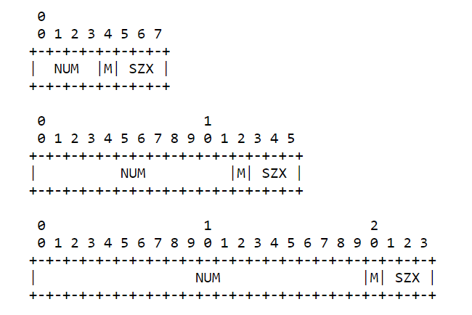
Figure 7.1.8.1-1: Block Option Value
The block size is encoded using a three-bit unsigned integer (0 for 2**4 bytes to 6 for 2**10 bytes), called the "SZX" ("size exponent"); the actual block size is then "2**(SZX + 4)".
The bit M or "more" bit, indicates whether more blocks are following or if the current block-wise transfer is the last block being transferred.
The option value divided by sixteen (the NUM field) is the sequence number of the block currently being transferred, starting from zero. The current transfer is, therefore, about the "size" bytes starting at byte "NUM << (SZX + 4)".
More specifically, within the option value of a Block1 or Block2 Option, the meaning of the option fields is defined as follows:
NUM: Block Number, indicating the block number being requested or provided. Block number 0 indicates the first block of a body (i.e., starting with the first byte of the body).
M: More Flag ("not last block"). For descriptive usage, this flag, if unset, indicates that the payload in this message is the last block in the body; when set, it indicates that there are one or more additional blocks available. When a Block2 Option is used in a request to retrieve a specific block number ("control usage"), the M bit will be sent as zero and ignored on reception. (In a Block1 Option in a response, the M flag is used to indicate atomicity, see below.)
SZX: Block Size. The block size is represented as a three-bit unsigned integer indicating the size of a block to the power of two. Thus, block size = 2**(SZX + 4). The allowed values of SZX are 0 to 6, i.e., the minimum block size is 2**(0+4) = 16 and the maximum is 2**(6+4) = 1024. The value 7 for SZX (which would indicate a block size of 2048) is reserved, the detailed behaviour is referred to RFC 7959 [13].
NOTE: The bit order (e.g. most or least significant bits) are specified in RFC 7959 [13].Table 7.1.8.1-1 shows the CoAP options including Block1 and Block2 with numbers 27 and 23, respectively.
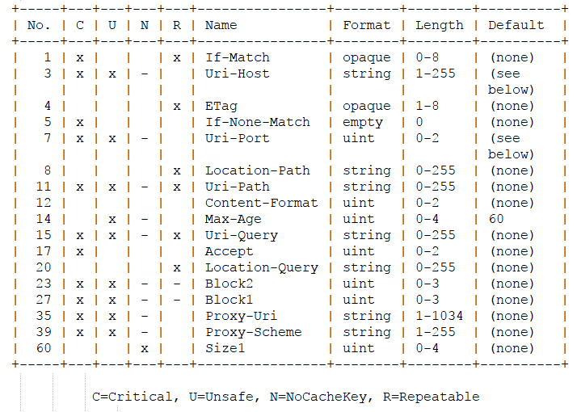
Table 7.1.8.1-1: Block Option Numbers

7.2 Overview of LwM2M
Lightweight M2M (LwM2M) [9] is a system standard defined by Open Mobile Alliance (OMA). As with other device management standards (e.g. OMA DM), LwM2M solution is called an Enabler. LwM2M Enabler defines the application layer communication protocol between a LwM2M Server and a LwM2M Client. The LwM2M Server resides in a private or public data centre and can be hosted by the M2M Service Provider, Network Service Provider or Application Service Provider while the LwM2M Client resides on the device. The target LwM2M Devices are mainly resource constrained devices. The key features of LwM2M 1.0 Enabler can be summarized as follows:
- Simple resource model with the core set of objects and resources defined in the present document.
- Operations for creation, update, deletion, and retrieval of resources.
- Asynchronous notifications of resource changes.
- Support for several serialization formats, namely TLV, JSON, Plain Text and binary data formats and the core set of LightweightM2M Objects.
- UDP and SMS transport support.
- Communication security based on the DTLS protocol supporting different types of credentials.
- Queue Mode offers functionality for a LwM2M Client to inform the LwM2M Server that it may be disconnected for an extended period and when it becomes reachable again.
- Support for use of multiple LwM2M Servers.
- Provisioning of security credentials and access control lists by a dedicated LwM2M bootstrap-server.
LwM2M employs a client-server architecture plus CoAP with UDP/SMS transport binding as shown in Figure 7.2-1 while the protocol stack is shown in Figure 7.2-2. The LwM2M Enabler has two components, LwM2M Server and LwM2M Client. Four interfaces are designed between these two components as shown below:
- Bootstrap: is used to provision essential information into the LwM2M Client to enable the LwM2M Client to perform the operation "Register" with one or more LwM2M Servers. Bootstrap interface also allows LwM2M Bootstrap Server to manage the keying, access control and configuration of a device.
- Client Registration: is used by a LwM2M Client to register its capabilities with one or more LwM2M Servers, maintain each registration and de-register from a LwM2M Server.
- Device management and service enablement: allows the LwM2M Server to perform device management and M2M service enablement by sending operation to the Client and to get corresponding response from the LwM2M Client.
- Information Reporting: is used by a LwM2M Server to observe any changes in a Resource on a registered LwM2M Client, receiving notifications when new values are available.
Figure 7.2-1: The overall architecture of the LwM2M Enabler
Figure 7.2-2: The protocol stack of the LwM2M Enabler
The LwM2M Enabler defines a simple resource model where each piece of information made available by the LwM2M Client is a Resource. The Resources are further logically organized into Objects, and each Resource is given a unique identifier within that Object.
Figure 7.2-3 illustrates the relationship between Resources, Objects and the LwM2M Client. The LwM2M Client can have any number of Resources, each of which belongs to an Object. For example, the Firmware Object contains all the Resources used for firmware update purposes.
Figure 7.2-3: Relationship between LwM2M Client, Object, and Resources
OMA LwM2M Enabler version 1.0 also specifies a set of 8 Device Management‐oriented Objects:
0: Security Object ‐ handles security aspects between LwM2M Client and Server
1: Server ‐ defines data and functions related to the LwM2M Server
2: Access Control ‐ defines the access rights which can be granted on Client Objects for a given Server
3: Device ‐ details device specific information
4: Firmware ‐ details resources on the device useful for firmware upgrades
5: Location ‐ groups resources providing information about the device current location
6: Connectivity Monitoring ‐ groups resources that assist in monitoring the status of a network connection
- 7: Connection Statistics ‐ groups resources that hold statistical information about an existing network connection

7.3 Solutions for File Repair using CoAP

7.3.0 General
3GPP TS 26.346 clause 9.3 describes two file repair procedures for MBMS User Services: the symbol-based procedure and the byte-range-based procedure. In byte-range-based message format, the MBMS UE uses the conventional HTTP/1.1 GET or partial GET requests as defined in RFC 2616 to request all or a subset of source symbols of the referenced resource, respectively. Low-end IoT device category may not equipped with HTTP stack to keep a small code size. This clause describes the solutions for File Repair based on CoAP. It comprises two categories of file repair mechanisms which are similar in the use of a generic CoAP server that is AL-FEC unaware, as the file repair server. From that standpoint (i.e., AL-FEC unawareness of the CoAP file repair server), both categories, as described below in sub-clauses 7.3.1 and 7.3.2, could be considered as representing byte-ranged based file repair mechanisms according to the semantics in TS 26.346, since the requests for repair data from the CoAP client are devoid of FEC symbol semantics. They differ in the way the MBMS receiver/CoAP client performs the CoAP requests for repair data:
1) Requests for byte ranges, whereby the CoAP client specifies a byte range of the original file stored on the CoAP server to be returned by the server;
2) Requests for CoAP Blocks, whereby the CoAP client specifies one or more blocks of data, in the manner of block-wise transfer in CoAP as defined in RFC 7959 [13].

7.3.1 Byte-Range Request based File Repair

7.3.1.0 General
The CoAP base protocol [7] does not define the option that has an equivalent functionality as Range in HTTP header. This solution provides two alternative options to address the byte-range request based file repair.
The byte-range request based solutions comprise the following two options:
- The option 1 provides a solution using the existing Uri-Query option defined in CoAP. It can be done without any changes in the CoAP IETF standard.
- The option 2 defines a new CoAP option Range. This solution requires a change in the CoAP IETF standard

7.3.1.1 Option 1: use Uri-Query option in CoAP
This alternative relies on the use of Uri-Query option in CoAP to send a byte-range request message. This solution uses the special defined keywords "bytefrom" and "byteto" inside Uri-Query option to indicate the byte-range.
NOTE 1: The special defined keywords could be different than "bytefrom" and "byteto" if this option is adopted.
As an example, the FLUTE receiver partially receives the transport object with file name "firmware.bin" having the "File-Etag" attribute set to "df69d20220cb1ff4" in the FDT instance. It issues a repair request to the host server to fetch the missing bytes. The request message from the CoAP client is as follows:
Input:
Destination IP Address = 198.51.100.1
Destination UDP Port = 5683
Uri-Host = "mbmsrepair1.example.com"
Etag = "df69d20220cb1ff4"
Uri-Path = "path"
Uri-Path = "repair_script"
Uri-Query = "bytefrom=500;byteto=627"
Output:
coap://mbmsrepair1.example.com:5683/path/repair_script/?bytefrom=500;byteto=627
NOTE 2: The Etag option does not appear in the CoAP URI but in the CoAP payload.
Upon reception of the GET request message, the CoAP server parses the special keywords "bytefrom", "byteto" to extract the byte-range the CoAP client wants to fetch. Figure 7.3.1.1-1 shows the request and response CoAP messages.
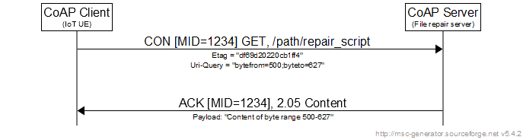
Figure 7.3.1.1-1: Request and response CoAP messages using Uri-Query option
NOTE 3: MID is the message ID in CoAP header.
In 3GPP TS 26.346, multiple byte-ranges or multiple symbols in different block number can be put in a single HTTP based file repair request message. However, there is no benefits to combining multiple requests in a single request message in CoAP since transfer of each block is acknowledged [13]. If the missing data in a response message is large, or if the CoAP server wants to use multiple small data payloads in response messages, the block-wise transfer is used. Table 7.3.1.1-1 shows different cases for byte-range request:
Table 7.3.1.1-1: Different cases for CoAP byte-range request message
Single byte-range | Single response CoAP message for file repair if possible  Otherwise use block-wise transfer
Multiple byte-ranges | Split into multiple of single byte-range requests

Figure 7.3.1.1-2 shows the case where the CoAP server wants to use block-wise transfer to deliver the missing bytes.
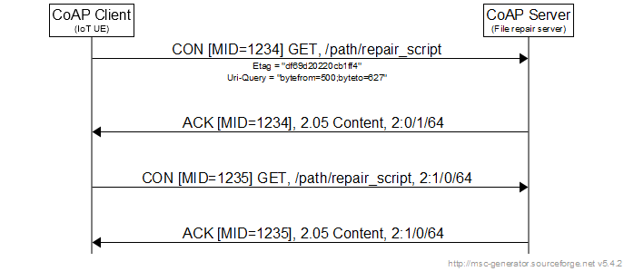
Figure 7.3.1.1-2: Request response CoAP messages using block-wise
NOTE 4: MID is the message ID in CoAP header.

7.3.1.2 Option 2: define a new CoAP option Range
A new CoAP option "Range" with a new allocated number 21 is defined in this solution. Table 7.3.1.2-1 shows an example where the "Range" option resides in the ordered options in CoAP.
Table 7.3.1.2-1: New defined "Range" option within CoAP options
No. | C | U | N | R | Name | Format | Length | Default
1 | x |  |  | x | If-Match | opaque | 0-8 | (none)
3 | x | x | - |  | Uri-Host | string | 1-255 | (see below)
4 |  |  |  | x | ETag | opaque | 1-8 | (none)
5 | x |  |  |  | If-None-Match | empty | 0 | (none)
7 | x | x | - |  | Uri-Port | unit | 0-2 | (see below)
8 |  |  |  | x | Location-Path | string | 0-255 | (none)
11 | x | x | - | x | Uri-Path | string | 0-255 | (none)
12 |  |  |  |  | Content-Format | unit | 0-2 | (none)
14 |  | x | - |  | Max-Age | unit | 0-4 | 60
15 | x | x | - | x | Uri-Query | string | 0-255 | (none)
17 | x |  |  |  | Accept | unit | 0-2 | (none)
20 |  |  |  | x | Location-Query | string | 0-255 | (none)
21 |  | x |  | x | Range | string | 0-255 | (none)
35 | x | x | - |  | Proxy-Uri | string | 1-1034 | (none)
39 | x | x | - |  | Proxy-Scheme | string | 1-255 | (none)
60 |  |  | x |  | Size1 | unit | 0-4 | (none)
C=Critical, U=Unsafe, N=NoCacheKey, R=Repeatable

NOTE 1: This solution uses the option number 21 to demonstrate the feasibility of the solution. If this solution using "Range" option is adopted as an extension of CoAP protocol, the allocated number could be different.
With the new defined CoAP option, the query message from the CoAP client is as follows:
Input:
Destination IP Address = 198.51.100.1
Destination UDP Port = 61616
Uri-Host = "mbmsrepair1.example.com"
Etag = "df69d20220cb1ff4"
Uri-Path = "path"
Uri-Path = "repair_script"
Range = "bytes=500-627"
Output:
coap://mbmsrepair1.example.com:5683/path/repair_script/
NOTE 2: The Etag and Range options do not appear in the CoAP URI but in the CoAP payload since these options are not in the process of the clause 6.5 of RFC 7252.
Figure 7.3.1.2-1 shows the request response CoAP messages using the new defined "Range" option.
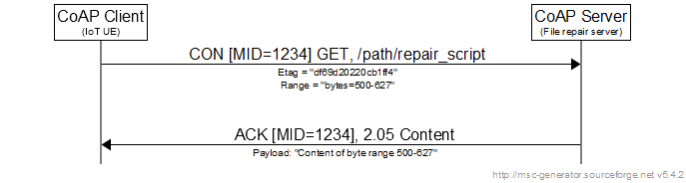
Figure 7.3.1.2-1: Request and response CoAP messages using defined "Range" option
Similarly, Figure 7.3.1.2-2 shows the case where the CoAP server wants to use block-wise transfer to deliver the missing bytes.
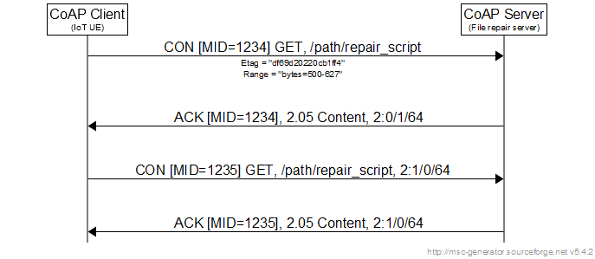
Figure 7.3.1.2-2: Request and response CoAP messages using defined "Range" option and block-wise

7.3.2 Block Request based File Repair

7.3.2.0 General
Two alternatives for block request based file repair via CoAP are described in this clause. They are motivated by and modeled after similar options in byte-range based file repair, as described in 3GPP TS 26.346, clause 9.3.6.2. Specifically, they are based on the two options available to the BM-SC for delivering FEC encoding symbols using the download delivery method:
- Sending of source symbols followed by repair symbols, and
- Sending of repair symbols exclusively.
For the sake simplicity in the following examples, it is assumed that sub-blocking is not used in the broadcast transmission of FEC symbols. Also, it is assumed that the original file object is stored on a standard CoAP server that supports file repair, and which is FEC-unaware.

7.3.2.1 Option 3: Block request for repair data after broadcast transmission of source and repair symbols
In the example as shown below in Figure 7.3.2.1-1, broadcast delivery of the file object comprises sending of the source symbols followed by repair symbols. It is assumed that the file object for broadcast delivery to MBMS-capable IoT devices is a firmware update file whose size is 6.7 Kbytes. The BM-SC will apply AL-FEC in the transmission of the file object, encoded as source symbols, along with the repair symbols generated from the file, as a sequence of ALC/ FLUTE packets, each with payload size of 1024 bytes.
Figure 7.3.2.1-1: MBMS download delivery of 6.7-kByte file employing 256-byte FEC symbols carried in FLUTE packets with payload size of 1024 bytes; sending of source + repair symbols
In FLUTE delivery of the file, an integer number of FEC encoding symbols are contained in the 1024-byte packet payload – in this example, four 256-byte FEC symbols are carried in each FLUTE packet. Loss in reception of any FLUTE packet, due to for example transmission errors, would result in a loss of four symbols (for packets not containing padding bytes). The UE will track the number of symbols it has successfully acquired, and determine the specific additional symbols needed for successful FEC decoding. As shown in the above example, FEC symbols which map logically to Blocks 1, 5 and 6 of the source file (along with some repair symbols) were not received, corresponding to the loss of source symbols with ESIs (Encoded Symbol IDs) 4-7 and 20-26. Suppose that in this example, eleven additional symbols are needed to enable full file recovery. The MBMS client will determine that source symbols with ESIs 4-7, 20-23, and 24-26, corresponding to Blocks 1 and 5, and a portion of Block 6, will need to be acquired via unicast file repair. Subsequently, the UE will employ CoAP's Block2 option to request, via the GET method, block-wise transfer from the server of those symbols, as shown in Figure 2.
Figure 7.3.2.1-2: Block-wise transfer request and response for retrieval of FEC symbols contained in Blocks 1 and 5 at repair server
Note that in the example message flow in Fig. 7.3.2.1-2, and according to the semantics in RFC 7959 [13], the third line of the request indicates, by 'B2', the use of the 'Block2' option in the request, and whereby the notation '1/0/6' correspond to the triplet [NUM/M/SZX]. The NUM field represents the block number of the payload requested for return in the response ('1', '5' and '6' in this example), the M bit has no meaning and is set to zero, and SZX = 6 is a variable for use in computing the actual block size for use in block-wise transfer, as given by 2^{(SZX + 4)}, or 1024 bytes. Due to the use of the Confirmable (CON) message in the request with message ID as shown inside the bracket [ ], reliability is ensured for the associated UDP transport by the returned ACK message, with the same Message ID, in which the requested resource is piggybacked.

7.3.2.2 Option 4: Block request for repair data after broadcast transmission of only repair symbols
In the example as shown below in Figure 7.3.2.2-1, only repair symbols are sent in the broadcast delivery of the file object. As in the previous case, a 6.7 Kbyte file is broadcast to (IoT) UEs, the BM-SC applies AL-FEC in the transmission of the file object, and the encoded repair symbols are sent as a sequence of ALC/ FLUTE packets, each with payload size of 1024 bytes.
Figure 7.3.2.2-1: MBMS download delivery of 6.7-kByte file employing 256-byte FEC symbols carried in FLUTE packets with payload size of 1024 bytes; sending of repair symbols only
In this example, it can be seen that FEC symbols which map logically to Blocks 1, 5, 6 and 7 were not received, resulting in the loss of repair symbols with ESIs (Encoded Symbol IDs) 4-7 and 20-31. Similar to the previous example, it is assumed that eleven additional symbols are needed to enable full file recovery, but since only repair symbols were transmitted/received, file recovery can be achieved at the UE by acquiring any eleven source symbols, ensured to be distinct from the already-received repair symbols. In this case, it would the simplest for the MBMS client, acting as the CoAP client, to request the first eleven source symbols, i.e., the initial 2048 bytes of the file stored in the repair server. In other words, the UE will employ CoAP's Block2 option to request, via the GET method, block-wise transfer by the server of the first three 1024-byte blocks (Blocks 0, 1 and 2), from the repair server, as shown in Figure 7.3.2.2-2.
Figure 7.3.2.2-2: Block-wise transfer request and response for retrieval of FEC symbols contained in Blocks 0, 1 and 2 at repair server

7.3.2.3 Comparison of Block Request based File Repair Options
The Option 3 vs. Option 4 methods for block request based file repair, as described in Clauses 7.3.2.1 and 7.3.2.2, bear resemblance to the broadcast delivery of source and repair symbols vs. repair symbols only methodologies, respectively, and associated unicast procedures for byte-range based file repair as specified in 3GPP TS 26.346. Broadcast transmission of source and repair symbols is shown below in Fig. 7.3.2.3-1, and broadcast transmission of only the repair symbols is shown in Fig. 7.3.2.3-2.
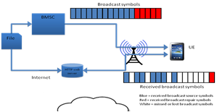
Figure 7.3.2.3-1: Broadcast delivery of source and repair symbols
Figure 7.3.2.3-2: Broadcast delivery of repair symbols only
The Block options ('Block1' and 'Block2' as defined in RFC 7959 [3] and [13]) enable the repair server to be stateless, i.e. it does not maintain state on what the client has previously retrieved, nor is it aware of the status of the file repair process – e.g., when the client has finished, whether the client has decided to abort the file repair procedure (for example, due to change in the ETag value of the file resource), etc. Complexity of server operation in support of file repair requests from the UE is the same, regardless of whether the client is retrieving contiguous or non-contiguous blocks, or the relative position of the requested repair data within the source file stored at the server (for example, at the beginning or near the end of the file, or somewhere in between). The reason being that the server is handling the request/response for one block at a time, and it maintains no state information on prior transactions.
On the other hand, broadcast transmission of only repair symbols makes the MBMS client's processing task a little easier, as it need not track which source symbols are missing in generating request for that specific set, which would be required if source symbols were broadcast. However, the client still has to make two separate CoAP requests, as done in Option 3. Another potential advantage of repair-only broadcast, as compared to broadcast of source symbols, is the expected better caching efficiency (higher "hit ratio') in case that proxy caches are employed in the unicast network, since every client that performs file repair can be designed to request repair data (as contiguous symbols) starting with the very first CoAP Block of the source file.

7.3.3 Solution evaluation
The following points are observed from four solutions described in clauses 7.3.1 and 7.3.2.
- The Option 1 requires that the CoAP server (i.e. File Repair server) understands the request range using defined keywords included in the Uri-query from the CoAP client (i.e. IoT UE). The CoAP client can request arbitrary byte range(s), i.e., a single range or multiple ranges.
- The Option 2 is similar to the Option 1. In addition, this option requires the registration with IANA for the new CoAP option Range.
- The Options 3 and 4 avoid the need for file repair servers with an understanding of defined keywords included in the Uri-query as with the Options 1 and 2. The Options 3 and 4 work with the requested byte-range having 2^{(SZX + 4)} discrete values and the maximum requested range is 1024 octets since the SZX field occupies three-bit unsigned integer and the value 7 for SZX is reserved.

7.4 Binary data formats

7.4.0 General
MBMS protocols, codecs and procedures often use XML as a format for exchanging metadata (e.g. FDT, service announcement). However, the use of XML stack can be costly for IoT devices, especially for low-end IoT profile. Binary data formats may be more appropriate for IoT devices to exchange metadata. One can define a particular binary format for each specific purpose (e.g. FDT, service announcement, reception report). However, it is desirable to have a common binary format for all procedures, formats in the context of MBMS IoT.

7.4.1 Efficient Extensible Interchange or Efficient XML Exchange (EXI)
EXI is a way for one system to send to another system a highly compressed sequence of parse events. The recipient can build data structures directly from the parse events without having to reconstitute a textual representation (such as a JSON file, an XML file, JavaScript, HTML and so forth) [14]. It was developed by W3C's Efficient Extensible Interchange Working Group. EXI provides multiple benefits as follows (non exhaustive list):
- EXI provides better compression than other XML compression techniques, and can deliver compression ratios of up to 100 to 1 (Figure 7.4.5.2-1) [15];
- Using EXI format reduces the verbosity of XML documents as well as the cost of parsing;
- When using EXI, XML parsers consume EXI directly. XML applications, such as XML Schema validators and XSLT processors, will process the EXI exactly as they've always processed XML, i.e., no changes to the XML applications are required and XML applications are completely unaware that the format of the data is binary, not text (Figure 7.4.1-2);
- EXI format specification does not make particular assumption about the platform architecture;
- EXI was designed to integrate well into the XML stack, neither duplicating nor requiring changes to functionality at other layers in the XML stack.
Figure 7.4.1-1 shows the diagram which uses EXI to exchange data between sender and receiver.
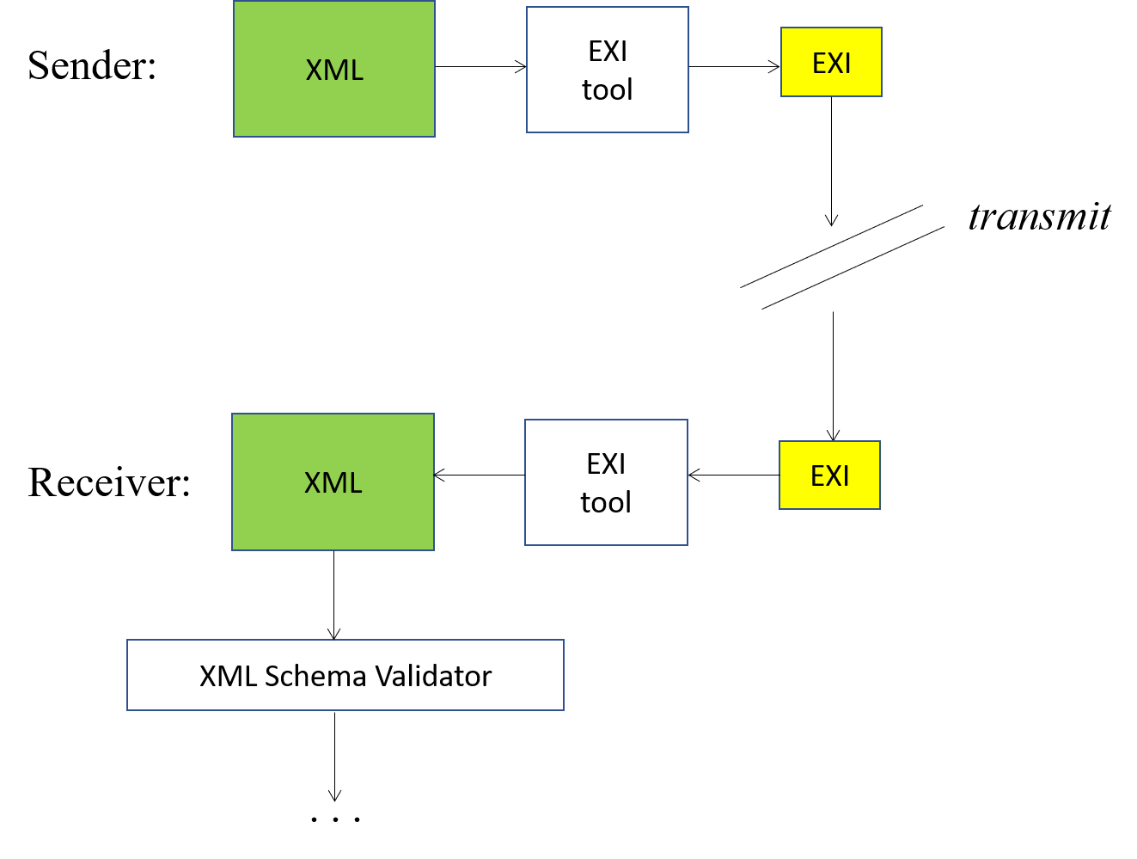
Figure 7.4.1-1: Data exchange using EXI [15]
Figure 7.4.1-2 shows the interaction between EXI, XML parser and XML application. The parser converts the EXI to an XML infoset and XML applications operate on the infoset. Thus, the applications are unaware that EXI is being used.
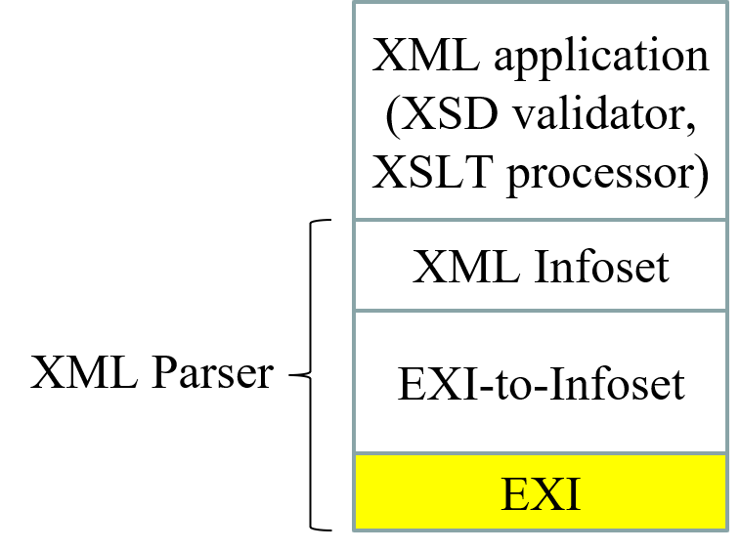
Figure 7.4.1-2: Interaction between EXI, XML parser and XML application [15]
EXI defines two types of encoding: schema-less and schema-informed. The schema-less encoding is generated directly from the XML data and can be decoded by any EXI entity without any prior knowledge about the data. The schema-informed encoding assumes that the two EXI processors share an XML Schema before actual encoding and decoding can take place. In schema-informed, the available schema information is used to improve compactness and performance.

7.4.2 Well-known binary formats
A number of well-known binary formats for representing data are available such as ASN.1 [16], Thrift [17], Protobuf [18].
The Abstract Syntax Notation One (ASN.1) is a well-known binary format used in many applications, especially in telecommunications (3G, LTE). The notation describes data structures for representing, encoding, transmitting, and decoding data. Data structures transfer syntax can be encoded using different encoding rules, providing schema notation even for representing XML in binary form - XER (XML Encoding Rules). The standard ASN.1 encoding rules include:
- Distinguished Encoding Rules (DER)
- Basic Encoding Rules (BER)
- Canonical Encoding Rules (CER)
- XML Encoding Rules (XER)
- Canonical XML Encoding Rules (CXER)
- Extended XML Encoding Rules (E-XER)
- Packed Encoding Rules (PER, unaligned: UPER, canonical: CPER)
- Octet Encoding Rules (OER, canonical: COER)
- JSON Encoding Rules (JER)
- Generic String Encoding Rules (GSER)
Unaligned PER is commonly used in 3GPP cellular technologies such as UMTS (3G) or LTE (4G) for protocols like RANAP, NBAP or RRC [19]. It is noted that the bit ordering is defined and automatically handled by the ASN.1 PER compiler generated code.
Thrift is an interface definition language and binary communication protocol that is used to define and create services for numerous languages. Thrift is used as a remote procedure call (RPC) framework and was developed at Facebook. Although developed at Facebook, it is now an open source project in the Apache Software Foundation.
The Protocol Buffers (Protobuf) is a method of serializing structured data. It is useful in developing programs to communicate with each other over a wire or for storing data. Protobuf were initially developed at Google to address the problem of large number of requests and responses to/from the index server. This protocol uses binary encoding which makes serialized data more compact. The design goals for Protobuf emphasized simplicity and performance. In particular, it was designed to be smaller and faster than XML.
Table 7.4.2-1 shows the comparison between these binary formats [20].
Table 7.4.2-1: Comparison of binary formats
 | Binary formats
 | ASN.1 | Thrift | Protobuf
Licence | Open source | Open source | Open source
Language compatibility | Java, C++, C, Python... | C++, Java, Python, PHP | Java, C++, Python
Parsing speed | Fast | Medium | Fast
Memory usage | Low | Medium | Medium
Debugging complexity | High | Low | Medium
Implementation | Medium | Medium | Low
Documentation | Very good | Less than good | Very good

NOTE: The implementation indicates the implementation complexity. ASN.1 demands external (third-party) tool for reading encoded message, and it is more complex to deploy [20]. Protobuf has some built-in features, i.e. to String() method that returns human-readable representation of message.

7.4.3 Ad-hoc binary format
Besides the well-known binary formats presented in clause 7.4.2 (ASN.1, Thrift, Protobuf), one can define a customized binary format for a given data structure requirement.
For instance, Figure 7.4.3-1 shows an example of an Ad-hoc binary format for FDT.

Bits |  |  |  |  |  |  |  |  |  | Number of Octets
7 | 6 | 5 |  | 4 |  | 3 | 2 | 1 | 0 | Number of Octets
HET = 194 |  |  |  |  |  |  |  |  |  | 1 | Header part
FLUTE Version = 1 |  |  |  |  |  | FDT Instance ID |  |  |  | 1 | Header part
FDT Instance ID continue |  |  |  |  |  |  |  |  |  | 2 | Header part
Binary FDT Version = 1 |  |  |  |  |  | Expires | Base-URL-1 | Base-URL-2 | FEC Information bit (NOTE 6) | 1 (NOTE 5) | Binary FDT descriptor
Length of FDT descriptor (NOTE 7) |  |  |  |  |  |  |  |  |  | 2 | Binary FDT descriptor
Content-type (NOTE 1) |  |  |  |  |  |  |  |  |  | 1 | Binary FDT descriptor
Length of Expires |  |  |  |  |  |  |  |  |  | 2 | Binary FDT descriptor
Expires |  |  |  |  |  |  |  |  |  | 0-m | Binary FDT descriptor
Length of Base-URL-1 |  |  |  |  |  |  |  |  |  | 2 | Binary FDT descriptor
Base-URL-1 |  |  |  |  |  |  |  |  |  | 0-m | Binary FDT descriptor
Length of Base-URL-2 |  |  |  |  |  |  |  |  |  | 2 | Binary FDT descriptor
Base-URL-2 |  |  |  |  |  |  |  |  |  | 0-m | Binary FDT descriptor
FEC-OTI-FEC-Encoding-ID |  |  |  |  |  |  |  |  |  | 1 | Binary FDT descriptor
FEC-OTI-Maximum-Source-Block-Length |  |  |  |  |  |  |  |  |  | 2 or 4  (NOTE 2) | Binary FDT descriptor
FEC-OTI-Encoding-Symbol-Length |  |  |  |  |  |  |  |  |  | 2 | Binary FDT descriptor
Length of FEC-OTI-Scheme-Specific-Info |  |  |  |  |  |  |  |  |  | 2 | Binary FDT descriptor
FEC-OTI-Scheme-Specific-Info |  |  |  |  |  |  |  |  |  | 0-m | Binary FDT descriptor
Number of files (NOTE 3) |  |  |  |  |  |  |  |  |  | 1 | Binary FDT descriptor
Reserved bits for extension of FDT descriptor (NOTE 7) |  |  |  |  |  |  |  |  |  | 0-m | Binary FDT descriptor
Length of the N^{th} file (NOTE 4) |  |  |  |  |  |  |  |  |  | 2 | Binary FDT content
Content Length | Content Type |  | Content MD5 |  | FEC-OTI-FEC-Encoding-ID | FEC Information bit (NOTE 6) | mbms2012:Alternate-Content-Location-1 | mbms2012:Alternate-Content-Location-2 | mbms2012:File-ETag | 1 (NOTE 5) | Binary FDT content
Transport Object Identifier (TOI) of the N^{th} file |  |  |  |  |  |  |  |  |  | 2 | Binary FDT content
Length of Content-location of the N^{th} file |  |  |  |  |  |  |  |  |  | 2 | Binary FDT content
Content-location of the N^{th} file |  |  |  |  |  |  |  |  |  | 0-m | Binary FDT content
Length of Content-Length of the N^{th} file |  |  |  |  |  |  |  |  |  | 2 | Binary FDT content
Content-Length of the N^{th} file |  |  |  |  |  |  |  |  |  | 0-m | Binary FDT content
Content-Type of the N^{th} file |  |  |  |  |  |  |  |  |  | 1 | Binary FDT content
Length of Content-MD5 of the N^{th} file |  |  |  |  |  |  |  |  |  | 2 | Binary FDT content
Content-MD5 of the N^{th} file |  |  |  |  |  |  |  |  |  | 0-m | Binary FDT content
FEC-OTI-FEC-Encoding-ID of the N^{th} file |  |  |  |  |  |  |  |  |  | 1 | Binary FDT content
FEC-OTI-Maximum-Source-Block-Length of the N^{th} file |  |  |  |  |  |  |  |  |  | 2 or 4  (NOTE 2) | Binary FDT content
FEC-OTI-Encoding-Symbol-Length of the N^{th} file |  |  |  |  |  |  |  |  |  | 2 | Binary FDT content
FEC-OTI-Max-Number-of-Encoding-Symbols of the N^{th} file |  |  |  |  |  |  |  |  |  | 2 | Binary FDT content
Length of FEC-OTI-Scheme-Specific-Info of the N^{th} file |  |  |  |  |  |  |  |  |  | 2 | Binary FDT content
FEC-OTI-Scheme-Specific-Info of the N^{th} file |  |  |  |  |  |  |  |  |  | 0-m | Binary FDT content
Length of mbms2012:Alternate-Content-Location-1 of the N^{th} file |  |  |  |  |  |  |  |  |  | 2 | Binary FDT content
mbms2012:Alternate-Content-Location-1 of the N^{th} file |  |  |  |  |  |  |  |  |  | 0-m | Binary FDT content
Length of mbms2012:Alternate-Content-Location-2 of the N^{th} file |  |  |  |  |  |  |  |  |  | 2 | Binary FDT content
mbms2012:Alternate-Content-Location-2 of the N^{th} file |  |  |  |  |  |  |  |  |  | 0-m | Binary FDT content
Length of mbms2012:File-ETag of the N^{th} file |  |  |  |  |  |  |  |  |  | 2 | Binary FDT content
mbms2012:File-ETag |  |  |  |  |  |  |  |  |  | 0-m | Binary FDT content
Reserved bits for extension of the N^{th} file (NOTE 4) |  |  |  |  |  |  |  |  |  | 0-m | Binary FDT content

Figure 7.4.3-1: Example of AD-hoc binary FDT Instance format
NOTE 1: Content-type of 8 bits could be sufficient for IoT applications.
NOTE 2: 2 octets for FEC Encoding IDs 0, 128, and 130; 4 octets for FEC Encoding ID 129.
NOTE 3: A maximum of 255 files delivered in a single FLUTE session could be sufficient since multiple FLUTE sessions are possible.
NOTE 4: If the length value of the N^{th} file in the binary FDT is higher than the actual length, the reserved bit for extension are present. The content and values of the extension fields are FFS.
NOTE 5: A list of flags indicates whether the element appears in the FDT or N^{th} file. The value '0' indicates that the flag is not appeared, the corresponding length and content fields of this flag are not appeared in the binary FDT. The value '1' indicates that the flag is present. The order of the flag content follows the order in the list of flags. For the elements which have a specific length such as FEC related information, there is no length field.
NOTE 6: The FEC Information bit is set to '0' if compact no-code FEC is used. Otherwise, this flag is set to '1', the corresponding fields (FEC-OTI-Maximum-Source-Block-Length, FEC-OTI-Encoding-Symbol-Length, Length of FEC-OTI-Scheme-Specific-Info, FEC-OTI-Scheme-Specific-Info) related to FEC are present.
NOTE 7: If the value of the length of FDT descriptor is higher than the actual length, the reserved bits for extension are present. The content and values of extension fields are FFS.

7.4.4 Key-Length-Value (KLV) format
Clause 7.4.3 presents the ad-hoc binary format where each data representation requires a customized binary format. Another possible solution is to use a special Key-Length-Value for all formats and procedures for MBMS IoT. In this KLV format, each data type is associated to a key value while the Length field indicates the actual length of the Value field. For instance, one can define up to 255 keys for MBMS IoT as shown in Table 7.4.4-1.
Table 7.4.4-1: Example table for KLV format
Key | Data type | Length | Value
1 | Content-Location | 2
2 | Content-Type | 1
3 | mbms2012:File-ETag | 2
…
255

This KLV solution can be considered as a subset of ASN.1 solution using BER, PER or OER encoding rules.

7.4.5 Performance comparison of binary data formats

7.4.5.1 General considerations
There are important aspects to consider when comparing different data representation schemes [24]. Some of the most relevant are,
- how are optional fields within messages handled, i.e., how is a field's presence or absence represented,
- possibility of future backward compatibility when extending a message, i.e., adding of new mandatory or optional data fields,
- byte alignment,
- providing the functionality of data compression, for example variable length representation of integers.
Table 7.4.5.1-1 show the properties of different schemes from the general considerations [24]. The properties of ASN.1 UPER, Protobuf and EXI are extracted from [24].
Table 7.4.5.1-1: Overview of basic properties for different binary schemes
 | ASN.1 UPER (NOTE 7) | Protobuf (NOTE 7) | EXI (NOTE 7) | KLV | Ad-hoc binary format
Presence of optional fields | Encoded | Encoded | Encoded | Not encoded | Encoded (NOTE 4)
Extendibility | No (NOTE 1) | Yes | Yes | Yes (NOTE 3) | Yes (NOTE 5)
Byte alignment (NOTE 6) | No (NOTE 2) | Yes | No | Yes | No
Compression | Yes | Yes (byte blocks) | Yes (byte blocks) | Yes | Yes

NOTE 1: Other ASN.1 encoding rules (e.g. BER) satisfy this property.
NOTE 2: The aligned PER encoding rule satisfies this property.
NOTE 3: The extendibility of KLV format is limited to the pre-defined maximum number of keys (e.g. 255 keys if 8 bits are used).
NOTE 4: Optional fields are presented by a list of flags.
NOTE 5: If reserved bits for extension are used.
NOTE 6: Byte alignment indicates that the fields are aligned to 8-bit octet boundaries by inserting padding bits.
NOTE 7: The assessment of ASN.1 UPER, Protobuf and EXI reflects the view of the authors in [24].

7.4.5.2 Performance comparison
Figure 7.4.5.2-1 shows better compactness of EXI compared to both XML and ASN.1 PER [22]. However, the comparison between EXI and ASN.1 PER in terms of processing efficiency is not shown in the evaluation performed by W3C.
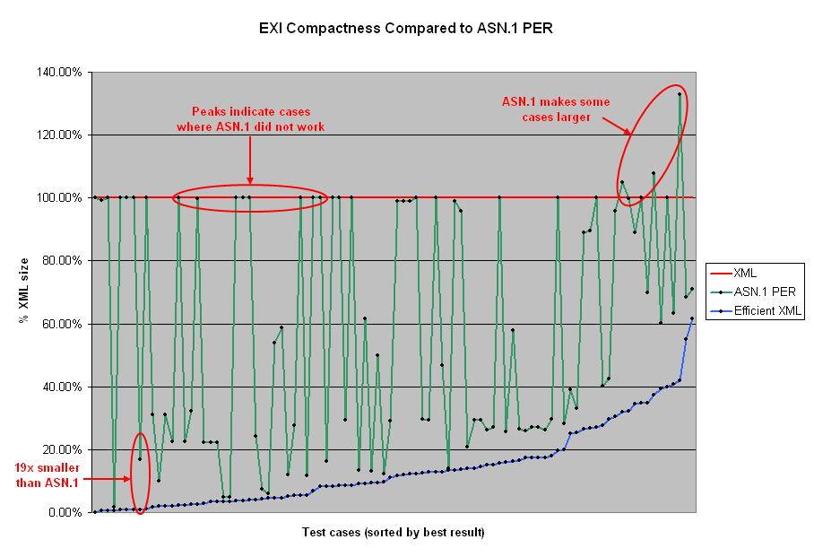
Figure 7.4.5.2-1: EXI compactness compared to ASN.1 PER
NOTE 1: Whenever a schema is available, EXI uses the schema-informed for the test cases [22].
Table 7.4.5.2-1 also confirms the better compactness of EXI compared to ASN.1 PER [23]. In this evaluation, EXI uses schema-informed and no-compression.
Table 7.4.5.2-1: Comparison in terms of compactness between XML, ASN.1 PER and EXI
 | JTLM Data (360 bytes) |  | Location Data (103 bytes)
Format | Size (bytes) | Ratio | Size (bytes) | Ratio
XML | 360 | 100% | 103 | 100%
ASN.1 PER | 105 | 29% | 27 | 26%
EXI | 39 | 11% | 17 | 17%

NOTE 2: The compactness performance of EXI may be different when schema-less is used.
Table 7.4.5.2-2 shows the processing efficiency for both encoding and decoding [23]. ASN.1 PER shows better processing efficiency with Location Data (103 bytes).
Table 7.4.5.2-2: Comparison in terms of processing efficiency between XML, ASN.1 PER and EXI
 | Encode |  | Decode
Format | TPS | Ratio | TPS | Ratio
XML | 15858 | 1 | 9216 | 1
EXI | 185029 | x11.7 | 277409 | x30.0
ASN.1 PER | 310862 | x19.6 | 318419 | x34.6

NOTE 3: TPS stands for transactions per second.
The evaluation between Protobuf, EXI and ASN.1 UPER is performed in the context of wireless Car-to-X communication [24]. The performance metrics considered in this evaluation are:
- Computation time
- Memory footprint on computation
- Encoded data length.
Tables 7.4.5.2-3 and 7.4.5.2-4 show the encoding and decoding performance results for CAM (Cooperative Awareness Message) and DENM (Decentralized Environmental Notification Message) messages with Protobuf, ASN.1 UPER and EXI.
Table 7.4.5.2-3: Encoding performance results for CAMs and DENMs [24]
 | CAM |  |  | DENM
Encoding type | Protobuf | ASN.1 UPER | EXI | Protobuf | ASN.1 UPER | EXI
Heap / Stack | 242 / 1864 | 66 / 3112 | 62656 / 210 | 126 / 1752 | 75 / 2792 | 61608 / 175
Encoded length | 165 | 41 | 64 (opt: 61) | 114 | 43 | 52 (opt: 51)

Table 7.4.5.2-4: Memory related decoding performance results for CAMs and DENMs [24]
 | Protobuf | ASN.1 UPER | EXI
CAM: heap / stack | 242 / 1800 | 370 / 2968 | 3850 / 210
DENM: heap / stack | 126 / 1624 | 816 / 2872 | 3630 / 135

NOTE 4: Size of encoded messages is one of the key parameters in the evaluation in [24], data optimized schemes are used for EXI.
The following conclusions are drawn from the evaluation in [24]:
- ASN.1 UPER outperforms Protobuf and EXI in terms of required encoding delay and runtime (Figure 7.4.5.2-2).
- EXI showed to be the most expensive in terms of memory footprint (Tables 7.4.5.2-3 and 7.4.5.2-4).
- ASN.1 UPER encoding performs better compared to EXI and Protobuf in terms of encoding length for CAM and DENM messages (Tables 7.4.5.2-3 and 7.4.5.2-4).
In terms of runtime, binary encoding performs significantly better than ASN.1 UPER in all studied cases (Figure 7.4.5.2-2).
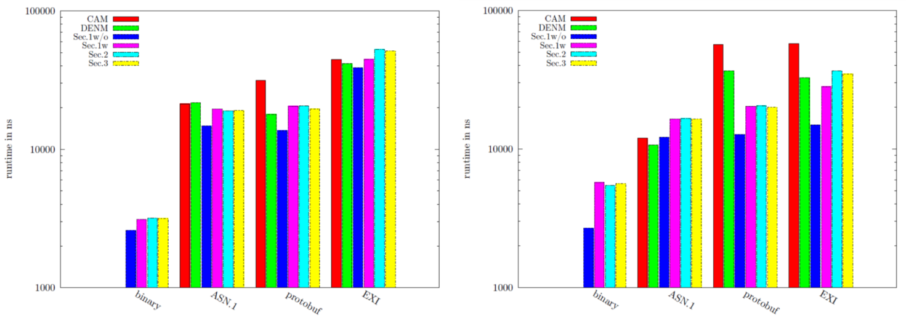
Figure 7.4.5.2-2: Encoding (left) and decoding (right) runtime performance of ETSI ITS CAM, DENM and security envelope encoding on an Intel Core i7 processor [24]
NOTE 5: Sec. 1w/o indicates security profile 1 for CAM message without certificate. Sec. 1w indicates security profile 1 for CAM message with certificate. Sec. 2 indicates security profile 2 for DENM message. Sec. 3 indicate security profile 3 for generic message.
NOTE 6: The binary format is specialized for CAM and DENM messages.

7.4.5.3 Summary
The following conclusions are drawn from the performance comparison in clause 7.4.5.2:
- Binary data formats (e.g. EXI, ASN.1, Protobuf) significantly outperform the XML data representation in terms of both compactness, encoding/decoding processing efficiency and memory usage.
- ASN.1 UPER is better than EXI in terms of processing efficiency and memory footprint [24].
- ASN.1 PER is better than EXI in terms of processing efficiency [23].
- EXI is better than ASN.1 (UPER or PER) in terms of compactness in the evaluation performed by W3C. In the evaluation performed by [24], ASN.1 UPER performs better than EXI for CAM and DENM messages in terms of encoded data length.
- Binary encoding specialized for CAM and DENM messages significantly better than ASN.1 UPER and EXI in terms of run time.

7.4.5.4 Recommendation
According to previous results, it is recommended to use ASN.1 PER as basis for binary format for IoT.

7.5 Solution for announcement during wake-up periods
This solution addresses the recommended requirement in clause 4.2.2. IoT devices use eDRX (Extended Discontinuous Reception) and PSM (Power Saving Mode) to save battery consumption. When a software/firmware update is required, the service announcement using continuous/carousel broadcast delivery of SACH (Service Announcement Channel) may not be efficient from the network perspective since IoT devices are not expected to be awake throughout the day, but only infrequently. Furthermore, they do not wake-up at the same time and more importantly, they are not reachable while being in power saving mode. This solution proposes to inform the IoT devices about a newly scheduled download delivery session during their wake-up periods when the devices are reachable.
For initially unplanned data delivery use case described in clause 4.2, when a new MBMS schedule containing the new software/firmware update for IoT devices becomes available, the network will send a message to inform the IoT UEs about the new schedule when they wake up, but before returning to power saving mode.
Such message to inform IoT UEs about a new MBMS schedule can either/
- Indicate the time at which service announcement based on SACH will be sent;
- Contain the service announcement including the Schedule Description if the size is small.
The time interval from when a new file delivery schedule is announced to when the actual MBMS file delivery session as announced by that schedule will start is larger than the maximum PSM period of all IoT devices. This constraint ensures that all IoT devices are informed about the new file delivery schedule.
According to 3GPP TS 23.682 clause 4.5.4, a UE using PSM is available for mobile terminating services only for the period of an Active Time after a mobile originated event like data transfer or signalling, e.g. after a periodic TAU/RAU procedure (Tracking Area Update/Routing Area Update). Figure 7.5-1 shows an example when the IoT UE #1 has available data to send to the network and the network takes advantage of this reachable period to inform the UE about a newly scheduled download delivery session. The IoT UE #2 receives an announcement later when it wakes up to send data. Due to some reasons (e.g. lost connectivity), the IoT UE #3 does not wake up periodically to send data. The IOT UE #3 wakes up to update its tracking area due to the expiration of TAU timer, it also receives the announcement from the network.
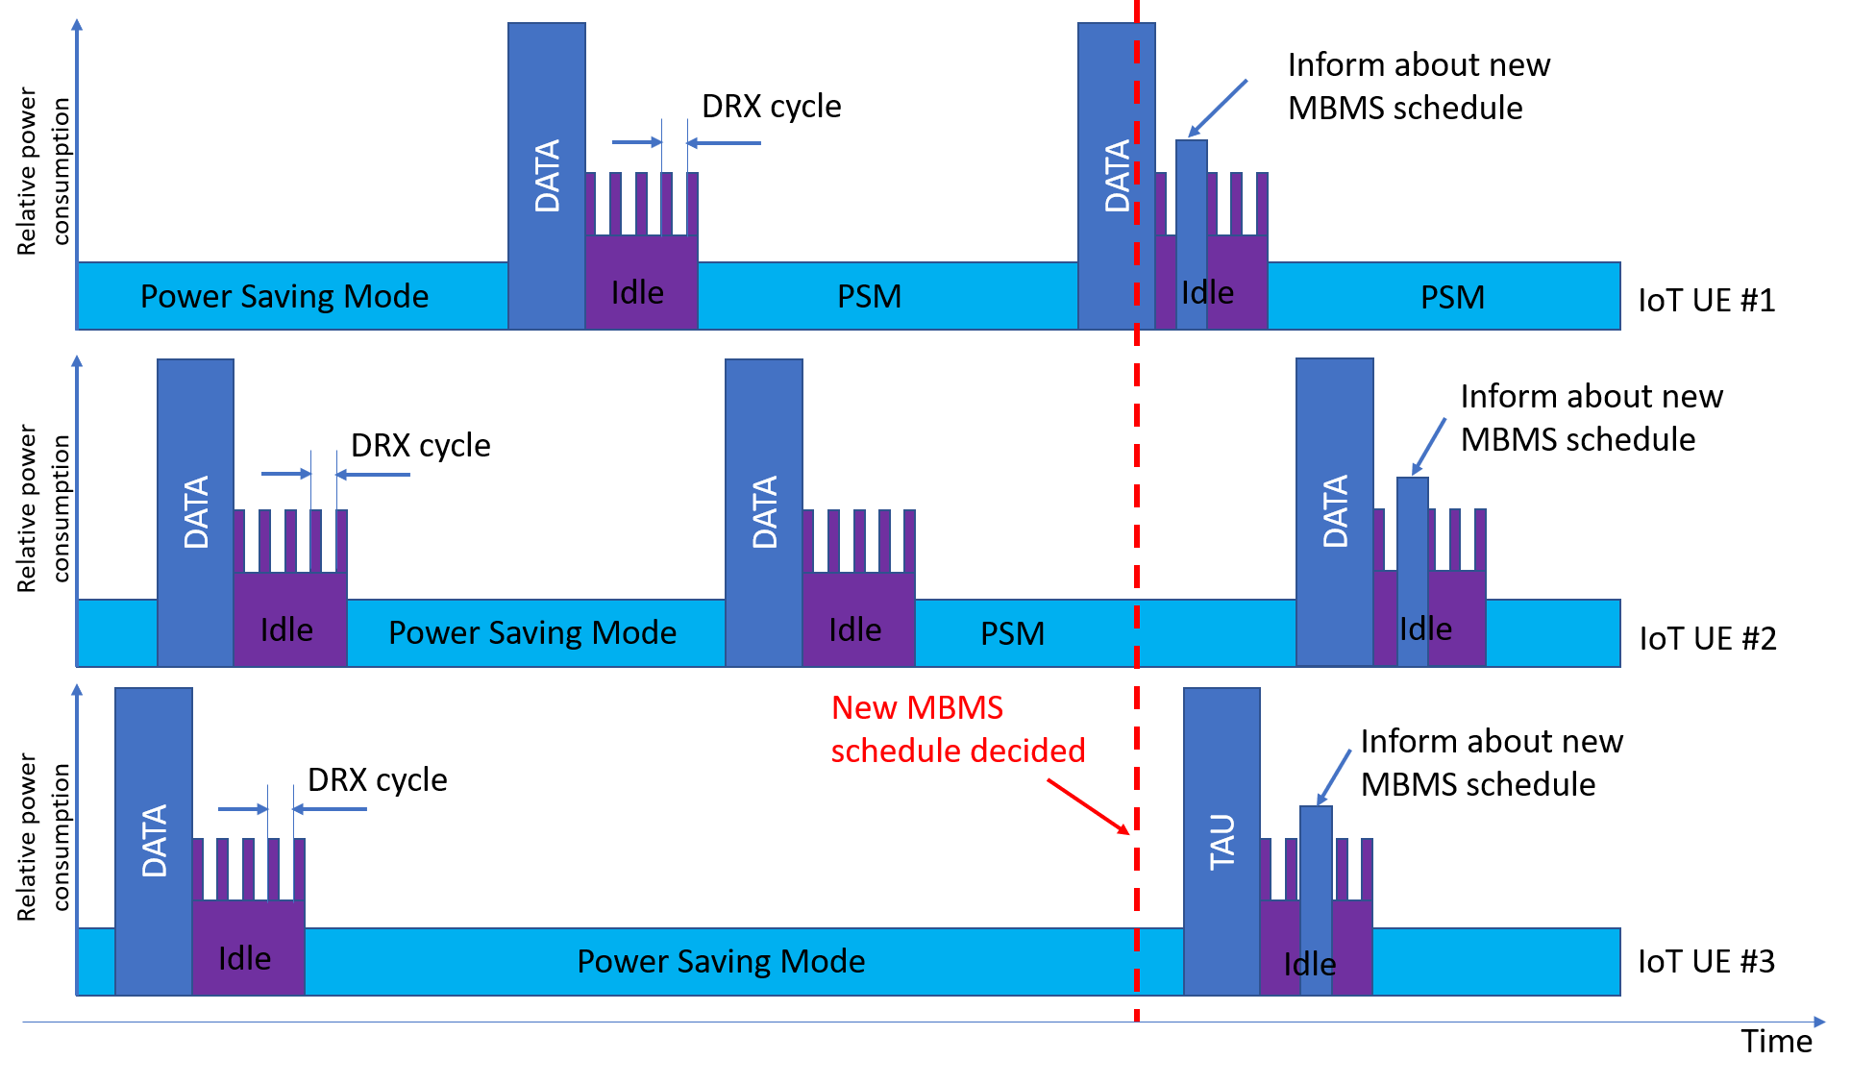
Figure 7.5-1: Inform about a new schedule during UE wake-up periods
NOTE 1: Waking up due to expiration of TAU timer is not common for battery-constrained IoT applications. In practice, to optimize the battery usage in IoT devices, periodic TAU timer is configured to be longer than the periodic time when the devices wake up to send data to the network.
The network may use PUT CoAP method with Content-Format option to deliver the information about a new MBMS schedule (Figure 7.5-2). In this example, ID 42 is used to indicate an octet-stream data type.
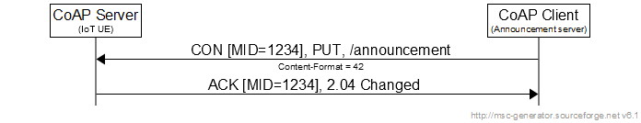
Figure 7.5-2: Example use of CoAP PUT method to inform about a new schedule
NOTE 2: The message content is out of scope of this solution and is addressed in other solutions.
NOTE 3: If the content carried in PUT method is larger than the maximum CoAP message size preferred by IoT UEs, block-wise transfer as described in RFC 7959 can be applied.

7.6 Solution for announcement with critical data delivery
This solution addresses the recommended requirement in clause 4.3.2. The solution for service announcement when a critical software/firmware update is required is as follows:
- When a new MBMS schedule containing a critical software/firmware update for IoT devices becomes available, the network will send a message to inform the IoT UEs about the new schedule when they are reachable;
- The network may schedule multiple critical delivery sessions where the time between two consecutive delivery sessions is considered as critical interval;
- The time interval from when a critical file delivery schedule is announced to when the first MBMS file delivery session as announced by that schedule will start can be shorter than the minimum PSM period of all IoT devices.
The IoT UEs using PSM and/or eDRX can be reachable in the following possible cases:
- In connected mode if the IoT UEs have just sent data to the network;
- In active state after PSM;
- In idle state and listen for paging (DRX or eDRX)
NOTE 1: Other possible cases where the IoT devices are reachable are out of scope of this study.
NOTE 2: The IoT UEs which do not use neither PSM nor eDRX follows the paging procedures as regular UEs.
NOTE 3: The details how the network pages the IoT devices are out of scope of this study.
Similar to the solution in clause 7.5, a message to inform IoT UEs about a critical MBMS schedule can either
- Indicate the time at which service announcement based on SACH will be sent;
- Contain the service announcement including the Schedule Description.
Figure 7.6-1 shows an example when the IoT UE #1 wakes up and has available data to send to the network. Since the IoT UE #1 has switched to Idle state at the time a new MBMS schedule has been created and is sent over the MBMS bearer (as represented by the left-most vertical dashed line), the network will page the device and inform the UE about a newly scheduled download delivery session for critical data. The IoT UE #2 receives the announcement later when it wakes up to send data. Both IoT UE #1 and #2 wake up at the scheduled time (First repetition of broadcast delivery of files according to the schedule) to receive the software/firmware update from the network. The IoT UE #3 wakes up after the first repetition of broadcast delivery of files is completed, it also receives the announcement from the network for the next download delivery session (Second repetition of broadcast delivery of files according to the schedule). During the next wake up periods of IoT UE #1 or #2, the network does not inform about the download delivery session since they already received the software/firmware update. The process continues until all IoT devices receive a critical software/firmware update and have appropriate action (e.g. successful update).
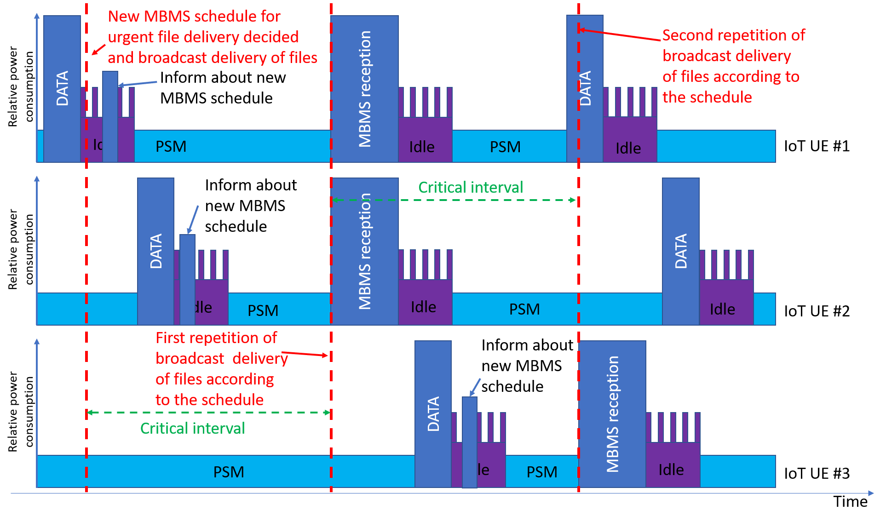
Figure 7.6-1: Announcement of broadcast schedule for a critical download delivery session during UE wake-up from PSM to send data and subsequent broadcast delivery/reception of the associated file

7.7 Solution for reception report procedures
This solution addresses the recommended requirements in clause 4.1.2. There are 4 reportType defined in 3GPP TS 26.346, Table 7.7-1 shows the supported reportType for IoT devices.
Table 7.7-1: supported reportType for IoT devices
reportType | IoT profiles
Rack-IoT | Yes (NOTE 1)
StaR | No (NOTE 2)
StaR-all | No (NOTE 2)
StaR-only | Yes (NOTE 2)

NOTE 1: reportType Rack-IoT is an extension of Rack (defined in 3GPP TS 26.346) in order to fulfil the requirements for IoT. According to 3GPP TS 26.346 clause 9.4.3, "The samplePercentage attribute is optional and behaviour shall default to 100 (%) when it is not present. The samplePercentage attribute may be used with StaR, StaR-only and StaR-all, but shall not be used with RAck". For IoT devices, this samplePercentage attribute can be useful to save battery consumption in the device for non-critical software delivery. For critical software delivery, this attribute will be set to 100.
NOTE 2: StaR-only might not be desirable for Low-end IoT profile. However, StaR-only can be useful for High-end IoT profile while other statistical report variants are not necessary.
Table 7.7-1 show the fields that could be contained in the reception report message for RAck-IoT reportType.
Table 7.7-1: Fields contained in binary reception report message for RAck-IoT reportType
Field name | Presence (Mandatory/Optional)
IoT ID (NOTE 1) | M
Number of files (NOTE 2) | M
Status of the file (NOTE 3) | M
ID of the file (NOTE 4) | M

NOTE 3: IoT ID can be clientId or deviceId, or both. According to clause 9.4.6 of TS 26.346, the deviceId attribute is a unique identifier for the receiver device, e.g. an IMEI of the UE while the clientId attribute is unique identifier for the receiver, e.g. an MSISDN of the UE. For IoT applications, the deviceId attribute could be more important than clientId.
NOTE 4: A maximum of 255 files delivered in a single FLUTE session could be sufficient since multiple FLUTE sessions are possible.
NOTE 5: The status value addresses the recommended requirement where the 3GPP system supports a mechanism to acknowledge a successful reception and action required (e.g. successful file update). For example, the status value is set to '0' for "acknowledged", '1' for "acknowledged with successful action", '2' for "acknowledged with unsuccessful action". Other values are reserved.
NOTE 6: ID of the file can be fileURI, Content-MD5 or File-Etag. fileURI could be mandatory while Content-MD5 and File-Etag could be optional.
A proposal of ASN.1 PER definition for reception report message for RAck-IoT type is depicted as follows
-- ASN1START

MBMSIoT-ReceptionReport-Message-RAck-IoT ::= SEQUENCE {
identifier IoT-ID-IEs,
fileReporting SEQUENCE (SIZE(1..255)) OF ReceptionReport-File-RAck-IoT-IEs,
locationType ENUMERATED{cgi, ecgi, sai, ...} OPTIONAL,
nonCriticalExtension ReceptionReportMessage-RAck-IoT-Extension-IEs OPTIONAL
}

IoT-ID-IEs ::= SEQUENCE {
deviceId OCTET STRING (SIZE(1..255)),
clientId OCTET STRING (SIZE(1..255)) OPTIONAL
}

ReceptionReportMessage-RAck-IoT-Extension-IEs ::= SEQUENCE {
lateNonCriticalExtension OCTET STRING OPTIONAL,
nonCriticalExtension SEQUENCE {} OPTIONAL
}

ReceptionReport-File-RAck-IoT-IEs ::= SEQUENCE {
status ENUMERATED {acknowledged, acknowledgedAndSuccessfulAction, acknowledgedAndUnsuccessfulAction, ...},
identifier File-ID-IEs,
nonCriticalExtension ReceptionRepot-File-RAck-IoT-Extension-IEs OPTIONAL
}

File-ID-IEs ::= SEQUENCE {
fileURI OCTET STRING (SIZE(1..255)),
contentMD5 BIT STRING (SIZE(128)) OPTIONAL,
fileEtag OCTET STRING (SIZE(1..255)) OPTIONAL
}

ReceptionRepot-File-RAck-IoT-Extension-IEs ::= SEQUENCE {
lateNonCriticalExtension OCTET STRING OPTIONAL,
nonCriticalExtension SEQUENCE {} OPTIONAL
}

-- ASN1STOP

NOTE 7: ASN.1 defines multiple character string types (e.g. BMPString, IA5String, GeneralString, GraphicString, NumericString, PrintableString, TeletexString, UniversalString, UTF8String, VideotexString, VisibleString, etc.). The encoding does not matter for Low-end IoT devices without user interface, OCTET STRING type can represent an identifier, a URL or URI.
NOTE 8: The string size is limited to 255 in order to occupy only 1 octet for the field description.
In 3GPP TS 26.346, reception report is sent in a single HTTP POST request carrying XML formatted metadata for each reported received content (file). However, IoT devices, especially low-end profile, might not have HTTP and TCP stacks. Figure 7.7-2 shows the solution for reception report using POST CoAP method. In this example, ID 42 for Content-Format is used to indicate an octet-stream data type.
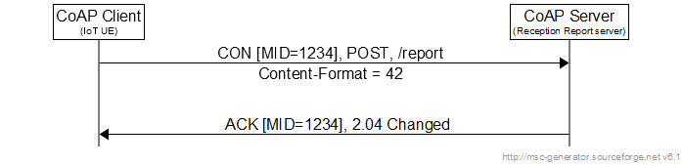
Figure 7.7-2: Example use of CoAP POST method to send reception report
NOTE 9: If the content carried in POST method is larger than the maximum CoAP message size preferred by the CoAP client and server, block-wise transfer as described in RFC 7959 can be applied.

7.8 Solution for service announcement procedures

7.8.1 Unicast delivery of service announcement using CoAP
3GPP TS 26.346 clause 5.2.5 specifies the user service announcement over point-to-point push bearers where SMS or HTTP push bearers are used for delivery of metadata envelope and metadata fragments. As indicated in the clause 6.1, a CoAP based solution for Interactive Announcement Function instead of HTTP could be more appropriate. The solutions in the clauses 7.5 and 7.6 indicate that a unicast delivery of service announcement using CoAP is possible. The unicast delivery of service announcement using CoAP could be used for the use cases described in clauses 4.2 and 4.3.
NOTE: The broadcast schedule using SACH could be used for the use case 3 described in clause 4.3.

7.8.2 Service announcement profiles for IoT devices
The Service announcement for IoT devices might be kept as small and simple as possible. The profiling for IoT applications is based on the MBMS User Service Discovery / Announcement Profile 1a specified in the Annex L.2 of 3GPP TS 26.346.
3GPP TS 2.346 clause 11.1 specifies the MBMS metadata envelope. To reduce the service announcement size (i.e. reduce battery consumption), the software update for each Low-end IoT device type (e.g. smart water-metering, smart electric-metering) might be carried in different MBMS sessions. Thus, a metadata envelope based on ASN.1 PER binary encoding for Low-end profile contains only one USBD fragment, one Session Description fragment, one Schedule Description fragment, and optionally one Associated Delivery Procedure Description (ADPD) fragment. A USBD contains only one instance of USD fragment.
Clause 11.1.4 of 3GPP TS 26.346 indicates that a metadata fragment can be embedded or referenced within a metadata envelope. For IoT applications, it's desirable to use the embedded metadata fragments within the metadata envelope.
Table 7.8.1-1 shows the list of supported metadata fragment in a metadata envelope.
Table 7.8.1-1: List of metadata fragments in a metadata envelope.
Metadata fragment | Recommended for Low-end profile | Recommended for High-end profile
USBD | M | M
Session Description | M | M
Schedule Description | M | M
Associated Delivery Procedure Description | O | O
MPD | No | O
Initialization Segment Description (ISD) | No | O
NOTE: MPD and ISD are not required for IoT devices.

Clause L.2.4 in 3GPP TS 26.346 specifies that the validFrom and validUntil attributes in each item of the metadata envelope are identical for all fragments of a given MBMS User Service. Therefore, a single (validFrom, validUntil) attribute couple for a metadata envelope in binary format is required for IoT devices to reduce the size (i.e. reduce battery consumption). The time is expressed as UTC timestamp.
Clause L.2.5 in 3GPP TS 26.346 specifies the list of supported attributes and elements for a USBD fragment. Table 7.8.1-2 shows the profiling of USBD fragment for IoT devices.
Table 7.8.1-2: List of supported attributes and elements for USBD fragment used by IoT service providers
Attribute or element | Recommended for Low-end IoT category profile | MBMS profile 1a in Annex L.2 3GPP TS 26.346
bundleDescription.sv:schemaVersion | No (NOTE 1) | M
bundleDescription.userServiceDescription | M | M
bundleDescription.userServiceDescription.serviceId | M | M
bundleDescription.userServiceDescription.r7:serviceClass | O | M
bundleDescription.userServiceDescription.deliveryMethod | M | M
bundleDescription.userServiceDescription.deliveryMethod@sessionDescriptionURI | M | M
bundleDescription.userServiceDescription.deliveryMethod@associatedProcedureDescriptionURI | M | M
bundleDescription.userServiceDescription.deliveryMethod@accessPointName | O | O
bundleDescription.userServiceDescription.deliveryMethod.sv:delimiter | No (NOTE 1) | M
bundleDescription.userServiceDescription.requiredCapabilities | M (NOTE 2) | M
bundleDescription.userServiceDescription.requiredCapabilities.feature | M (NOTE 2) | M
bundleDescription.userServiceDescription.r9:schedule | M | M
bundleDescription.userServiceDescription.sv:delimiter | No (NOTE 1) | M
bundleDescription.userServiceDescription.r9:mediaPresentationDescription | No (NOTE 3) | M
bundleDescription.userServiceDescription.name | No (NOTE 3) | O
bundleDescription.userServiceDescription.serviceLanguage | No (NOTE 3) | O
bundleDescription.userServiceDescription.r9:availabilityInfo | O | O
bundleDescription.userServiceDescription.r9:availabilityInfo.infoBinding.serviceArea | O | O
bundleDescription.userServiceDescription.r9:availabilityInfo.infoBinding.radioFrequency | O | O
NOTE 1: The schemaVersion and delimiter elements are only applied for XML data format.
NOTE 2: "MBMS User Service Discovery / Announcement Profile 1a" specifies the value '22' to the feature element.
NOTE 3: The r9:mediaPresentationDescription, name and serviceLanguage elements are not necessary for IoT devices.

NOTE 1: The list of non-supported attributes and elements specified in the clause L.2.5 of 3GPP TS 26.346 are not supported for IoT devices.
Clause L.2.6 in 3GPP TS 26.346 specifies the list of supported attributes and elements for Schedule Description fragment. Table 7.8.1-3 shows the list of supported attributes and elements of the Schedule Description fragment for IoT devices.
Table 7.8.1-3: List of supported attributes and elements for Schedule Description fragment used by IoT service providers
Attribute or element | Recommended for Low-end IoT category profile | MBMS profile 1a in Annex L.2 3GPP TS 26.346
scheduleDescription.sv:schemaVersion | No | M
scheduleDescription.serviceSchedule.sessionSchedule | M | M
scheduleDescription.serviceSchedule.sessionSchedule.start | M | M
scheduleDescription.serviceSchedule.sessionSchedule.stop | M | M
scheduleDescription.serviceSchedule.sessionSchedule.index | M | M
scheduleDescription.serviceSchedule.sessionScheduleOverride | O | O
scheduleDescription.serviceSchedule.sessionScheduleOverride@index | O | O
scheduleDescription.serviceSchedule.sessionScheduleOverride@cancelled | O | O
scheduleDescription.serviceSchedule.fileSchedule | O | O
scheduleDescription.serviceSchedule.fileSchedule.fileURI | O | O
scheduleDescription.serviceSchedule.fileSchedule.fileURI@cancelled | O | O
scheduleDescription.serviceSchedule.deliveryInfo | O | O
scheduleDescription.serviceSchedule.deliveryInfo@start | O | O
scheduleDescription.serviceSchedule.deliveryInfo@stop | O | O
NOTE: The schemaVersion is only applied for XML data format.

NOTE 2: The list of non-supported attributes and elements specified in the clause L.2.6 of 3GPP TS 26.346 are not supported for IoT devices. The time is expressed in UTC timestamp.
Clause L.2.7 in 3GPP TS 26.346 specifies the list of supported attributes and elements for Associated Delivery Procedure Description fragment. Table 7.8.1-4 shows the list of supported attributes and elements of the ADPD fragment for IoT devices.
Table 7.8.1-4: List of supported attributes and elements for ADPD fragment for IoT service providers
Attribute or element | Recommended for Low-end IoT category profile | MBMS profile 1a in Annex L.2 3GPP TS 26.346
associatedProcedureDescription.postFileRepair | O | O
associatedProcedureDescription.postFileRepair@offsetTime | O | O
associatedProcedureDescription.postFileRepair@randomTimePeriod | O | O
associatedProcedureDescription.postFileRepair.serviceURI | O | O
associatedProcedureDescription.postReceptionReport | O | O
associatedProcedureDescription.postReceptionReport@offsetTime | O | O
associatedProcedureDescription.postReceptionReport@randomTimePeriod | O | O
associatedProcedureDescription.postReceptionReport@samplePercentage | O | O
associatedProcedureDescription.postReceptionReport@forceTimeIndependence | O | O
associatedProcedureDescription.postReceptionReport@reportType | O | O
associatedProcedureDescription.postReceptionReport.serviceURI | O | O

NOTE 3: The list of non-supported attributes and elements specified in the clause L.2.7 of 3GPP TS 26.346 are not supported for IoT devices.
The parameters for Session Description fragment of an MBMS download session is specified in the clause 7.3.2 of 3GPP TS 26.346. The non-recognized, non-supported or invalid parameters are ignored by the IoT devices.
Clause 7.3.2 of TS 26.346 describes the SDP for Download Delivery Method, Table 7.8.1-5 shows the fields and attributes applied for IoT applications when SDP is embedded in the service announcement.
Table 7.8.1-5: List of supported attributes and elements for SDP
Parameters | Presence (Mandatory/Optional  Or No) | Maximum number of occurrences
The sender IP address | M | 1
The number of channels in the session | No (Note 1) | 0
The destination IP address and port number for each channel in the session per media | M | 1
The Transport Session Identifier (TSI) of the session | M | 1
The start time and end time of the session | M | 1
The protocol ID (i.e. FLUTE/UDP) | No (Note 2) | 0
Media type(s) and fmt-list | No | 0
Data rate using existing SDP bandwidth modifiers | No | 0
Mode of MBMS bearer per media | No (Note 3) | 0
FEC capabilities and related parameters | O | 0
Service-language(s) per media | No | 0
QoE Metrics (as defined in sub-clauses 8.3.2.1 and 8.4) | No | 0
NOTE 1: The clause 7.3.2.2 of TS 26.346 indicates "Only one FLUTE channel is allowed per FLUTE session in the present document and thus there is no further need for a descriptor of the number of channels".
NOTE 2: It is not necessary to describe this element as FLUTE is the unique protocol for MBMS IoT applications.
NOTE 3: Since resource-constrained IoT devices (e.g. NB-IoT) use SC-PTM delivery mode, it's not necessary to describe the mode of MBMS bearer for IoT applications.

An example of ASN.1 PER definition for Service Announcement is depicted as follows. This definition uses the embedded mode for all metadata fragments except the Session Description fragment. The Session Description fragment is referenced by the SDP file.
-- ASN1START

MBMSIoT-ServiceAnnouncement ::= SEQUENCE {
validFrom UTCTime,
vaidUntil UTCTime,
usbd USBD-Fragment-IEs,
sessionDescription OCTET STRING (SIZE(1..255)),
scheduleDescription ScheduleDescription-Fragment-IEs,
adpd ADPD-Fragment-IEs OPTIONAL,
nonCriticalExtension ServiceAnnouncement-Extension-IEs OPTIONAL
}

ServiceAnnouncement-Extension-IEs ::= SEQUENCE {
lateNonCriticalExtension OCTET STRING OPTIONAL,
nonCriticalExtension SEQUENCE {} OPTIONAL
}

USBD-Fragment-IEs ::= SEQUENCE {
serviceID OCTET STRING (SIZE(1..255)),
r7ServiceClass OCTET STRING (SIZE(1..255))OPTIONAL,
deliveryMethod DeliveryMethod-IEs,
requiredCapabilities INTEGER(0..255),
availabilityInfo AvailabilityInfo-IEs OPTIONAL,
nonCriticalExtension USBD-Fragment-Extension-IEs OPTIONAL
}

USBD-Fragment-Extension-IEs ::= SEQUENCE {
lateNonCriticalExtension OCTET STRING OPTIONAL,
nonCriticalExtension SEQUENCE {} OPTIONAL
}

DeliveryMethod-IEs ::= SEQUENCE {
sessionDescriptionURI OCTET STRING (SIZE(1..255)),
associatedProcedureDescriptionURI OCTET STRING (SIZE(1..255)),
accessPointName OCTET STRING (SIZE(1..50)) OPTIONAL,
nonCriticalExtension DeliveryMethod-Extension-IEs OPTIONAL
}

DeliveryMethod-Extension-IEs ::= SEQUENCE {
lateNonCriticalExtension OCTET STRING OPTIONAL,
nonCriticalExtension SEQUENCE {} OPTIONAL
}

AvailabilityInfo-IEs ::= SEQUENCE {
serviceArea INTEGER (0..65535) OPTIONAL,
radioFrequency INTEGER (0..4294967295) OPTIONAL,
nonCriticalExtension AvailabilityInfo-Extension-IEs OPTIONAL
}

AvailabilityInfo-Extension-IEs ::= SEQUENCE {
lateNonCriticalExtension OCTET STRING OPTIONAL,
nonCriticalExtension SEQUENCE {} OPTIONAL
}

ScheduleDescription-Fragment-IEs ::= SEQUENCE {
serviceSchedule SEQUENCE (SIZE(1..8)) OF ServiceSchedule-IEs
}

ServiceSchedule-IEs ::= SEQUENCE {
sessionSchedule SEQUENCE (SIZE(0..255)) OF SessionScheduleDescription-IEs OPTIONAL,
fileSchedule SEQUENCE (SIZE(0..255)) OF FileScheduleDescription-IEs ,
sessionScheduleOverride SessionScheduleOverride-IEs OPTIONAL,
nonCriticalExtension ServiceSchedule-Extension-IEs OPTIONAL
}

ServiceSchedule-Extension-IEs ::= SEQUENCE {
lateNonCriticalExtension OCTET STRING OPTIONAL,
nonCriticalExtension SEQUENCE {} OPTIONAL
}

SessionScheduleDescription-IEs ::= SEQUENCE {
start UTCTime,
stop UTCTime,
index INTEGER (0..4294967295),
nonCriticalExtension SessionScheduleDescription-Extension-IEs OPTIONAL
}

SessionScheduleDescription-Extension-IEs ::= SEQUENCE {
lateNonCriticalExtension OCTET STRING OPTIONAL,
nonCriticalExtension SEQUENCE {} OPTIONAL
}

FileScheduleDescription-IEs ::= SEQUENCE {
fileURI FileURI-IEs OPTIONAL,
deliveryInfo DeliveryInfo-IEs OPTIONAL,
nonCriticalExtension FileScheduleDescription-Extension-IEs OPTIONAL
}

FileScheduleDescription-Extension-IEs ::= SEQUENCE {
lateNonCriticalExtension OCTET STRING OPTIONAL,
nonCriticalExtension SEQUENCE {} OPTIONAL
}

FileURI-IEs ::= SEQUENCE {
fileURI OCTET STRING (SIZE(1..255)),
cancelled BOOLEAN,
nonCriticalExtension FileURI-Extension-IEs OPTIONAL
}

FileURI-Extension-IEs ::= SEQUENCE {
lateNonCriticalExtension OCTET STRING OPTIONAL,
nonCriticalExtension SEQUENCE {} OPTIONAL
}

SessionScheduleOverride-IEs ::= SEQUENCE {
index INTEGER (0..4294967295),
cancelled BOOLEAN,
nonCriticalExtension SessionScheduleOverride-Extension-IEs OPTIONAL
}

SessionScheduleOverride-Extension-IEs ::= SEQUENCE {
lateNonCriticalExtension OCTET STRING OPTIONAL,
nonCriticalExtension SEQUENCE {} OPTIONAL
}

DeliveryInfo-IEs ::= SEQUENCE {
start UTCTime OPTIONAL,
stop UTCTime OPTIONAL,
nonCriticalExtension DeliveryInfo-Extension-IEs OPTIONAL
}

DeliveryInfo-Extension-IEs ::= SEQUENCE {
lateNonCriticalExtension OCTET STRING OPTIONAL,
nonCriticalExtension SEQUENCE {} OPTIONAL
}

ADPD-Fragment-IEs ::= SEQUENCE {
postFileRepair PostFileRepair-IEs OPTIONAL,
postReceptionReport PostReceptionReport-IEs OPTIONAL
}

PostFileRepair-IEs ::= SEQUENCE {
offsetTime INTEGER (0..4294967295) OPTIONAL,
randomPeriodTime INTEGER (0..4294967295) OPTIONAL,
serviceURI OCTET STRING (SIZE(1..255)) OPTIONAL,
nonCriticalExtension PostFileRepair-Extension-IEs OPTIONAL
}

PostFileRepair-Extension-IEs ::= SEQUENCE {
lateNonCriticalExtension OCTET STRING OPTIONAL,
nonCriticalExtension SEQUENCE {} OPTIONAL
}

PostReceptionReport-IEs ::= SEQUENCE {
offsetTime INTEGER (0..4294967295) OPTIONAL,
randomPeriodTime INTEGER (0..4294967295) OPTIONAL,
samplePercentage INTEGER(0..100) OPTIONAL,
forceTimeIndependence BOOLEAN OPTIONAL,
reportType INTEGER(0..3) OPTIONAL,
serviceURI OCTET STRING (SIZE(1..255)) OPTIONAL,
nonCriticalExtension PostReceptionReport-Extension-IEs OPTIONAL
}

PostReceptionReport-Extension-IEs ::= SEQUENCE {
lateNonCriticalExtension OCTET STRING OPTIONAL,
nonCriticalExtension SEQUENCE {} OPTIONAL
}
-- ASN1STOP

NOTE 4: It is not necessary to have the compression (e.g. gzip) in SA file using ASN.1 PER definition.
NOTE 5: The maximum URL/URI length for IoT applications could be limited to 255.
NOTE 6: ServiceArea element type is unsigned short. RadioFrequency element type is unsigned integer.
NOTE 7: If an ASN.1 PER IE contains less than 7 elements, adding a nonCriticalExtension element does not occupy an additional octet for the bitmap element descriptor which describes the presence or absence of the elements. It's up to the implementation to handle or ignore the nonCriticalExtension elements.
An example of ASN.1 PER definition for Service Announcement is depicted as follows when all metadata fragments are embedded including the Session Description fragment. In this example, the necessary elements and attributes in the FDT instance are also embedded in the Service Announcement.
-- ASN1START

MBMSIoT-ServiceAnnouncement ::= SEQUENCE {
validFrom UTCTime,
vaidUntil UTCTime,
usbd USBD-Fragment-IEs,
sessionDescription SessionDescription-Fragment-IEs,
scheduleDescription ScheduleDescription-Fragment-IEs,
adpd ADPD-Fragment-IEs OPTIONAL,
nonCriticalExtension ServiceAnnouncement-Extension-IEs OPTIONAL
}

ServiceAnnouncement-Extension-IEs ::= SEQUENCE {
lateNonCriticalExtension OCTET STRING OPTIONAL,
nonCriticalExtension SEQUENCE {} OPTIONAL
}

USBD-Fragment-IEs ::= SEQUENCE {
serviceID OCTET STRING (SIZE(1..255)),
r7ServiceClass OCTET STRING (SIZE(1..255))OPTIONAL,
deliveryMethod DeliveryMethod-IEs,
requiredCapabilities INTEGER(0..255),
availabilityInfo AvailabilityInfo-IEs OPTIONAL,
nonCriticalExtension USBD-Fragment-Extension-IEs OPTIONAL
}

USBD-Fragment-Extension-IEs ::= SEQUENCE {
lateNonCriticalExtension OCTET STRING OPTIONAL,
nonCriticalExtension SEQUENCE {} OPTIONAL
}

DeliveryMethod-IEs ::= SEQUENCE {
sessionDescriptionURI OCTET STRING (SIZE(1..255)),
associatedProcedureDescriptionURI OCTET STRING (SIZE(1..255)),
accessPointName OCTET STRING (SIZE(1..50)) OPTIONAL,
nonCriticalExtension DeliveryMethod-Extension-IEs OPTIONAL
}

DeliveryMethod-Extension-IEs ::= SEQUENCE {
lateNonCriticalExtension OCTET STRING OPTIONAL,
nonCriticalExtension SEQUENCE {} OPTIONAL
}

AvailabilityInfo-IEs ::= SEQUENCE {
serviceArea INTEGER (0..65535) OPTIONAL,
radioFrequency INTEGER (0..4294967295) OPTIONAL,
nonCriticalExtension AvailabilityInfo-Extension-IEs OPTIONAL
}

AvailabilityInfo-Extension-IEs ::= SEQUENCE {
lateNonCriticalExtension OCTET STRING OPTIONAL,
nonCriticalExtension SEQUENCE {} OPTIONAL
}

SessionDescription-Fragment-IEs ::= SEQUENCE {
senderIPAddress IP-Address-IE,
tmgi TMGI-IE,
ipDestinationAddress IP-Address-IE,
destinationPortNumber INTEGER (0..65535),
tsi BIT STRING (SIZE(16)),
startTime UTCTime OPTIONAL,
endTime UTCTime OPTIONAL,
fecRedundancyLevel INTEGER (0..100) OPTIONAL,
nonCriticalExtension SessionDescription-Fragment-Extension-IEs OPTIONAL
}

IP-Address-IE ::= CHOICE {
ipv4 BIT STRING (SIZE(32)),
ipv6 BIT STRING (SIZE(128))
}

TMGI-IE ::= SEQUENCE {
plmn-Id PLMN-Identity,
serviceId OCTET STRING (SIZE (3))
}

PLMN-Identity ::= SEQUENCE {
mcc MCC OPTIONAL,
mnc MNC
}

MCC ::= SEQUENCE (SIZE(3)) OF MCC-MNC-Digit
MNC ::= SEQUENCE (SIZE(3)) OF MCC-MNC-Digit
MCC-MNC-Digit ::= INTEGER(0..9)

SessionDescription-Fragment-Extension-IEs ::= SEQUENCE {
lateNonCriticalExtension OCTET STRING OPTIONAL,
nonCriticalExtension SEQUENCE {} OPTIONAL
}

ScheduleDescription-Fragment-IEs ::= SEQUENCE {
serviceSchedule SEQUENCE (SIZE(1..8)) OF ServiceSchedule-IEs
}

ServiceSchedule-IEs ::= SEQUENCE {
sessionSchedule SEQUENCE (SIZE(0..255)) OF SessionScheduleDescription-IEs OPTIONAL,
fileSchedule SEQUENCE (SIZE(0..255)) OF FileScheduleDescription-IEs ,
sessionScheduleOverride SessionScheduleOverride-IEs OPTIONAL,
nonCriticalExtension ServiceSchedule-Extension-IEs OPTIONAL
}

ServiceSchedule-Extension-IEs ::= SEQUENCE {
lateNonCriticalExtension OCTET STRING OPTIONAL,
nonCriticalExtension SEQUENCE {} OPTIONAL
}

SessionScheduleDescription-IEs ::= SEQUENCE {
start UTCTime,
stop UTCTime,
index INTEGER (0..4294967295),
nonCriticalExtension SessionScheduleDescription-Extension-IEs OPTIONAL
}

SessionScheduleDescription-Extension-IEs ::= SEQUENCE {
lateNonCriticalExtension OCTET STRING OPTIONAL,
nonCriticalExtension SEQUENCE {} OPTIONAL
}

FileScheduleDescription-IEs ::= SEQUENCE {
fileURI FileURI-IEs OPTIONAL,
deliveryInfo DeliveryInfo-IEs OPTIONAL,
expires INTEGER (0..4294967295) OPTIONAL,
baseURL1 OCTET STRING(SIZE(1..255)) OPTIONAL,
baseURL2 OCTET STRING(SIZE(1..255)) OPTIONAL,
nonCriticalExtension FileScheduleDescription-Extension-IEs OPTIONAL
}

FileScheduleDescription-Extension-IEs ::= SEQUENCE {
lateNonCriticalExtension OCTET STRING OPTIONAL,
nonCriticalExtension SEQUENCE {} OPTIONAL
}

FileURI-IEs ::= SEQUENCE {
fileURI OCTET STRING (SIZE(1..255)),
toi BIT STRING (SIZE(16)),
contentLength INTEGER (0..4294967295) OPTIONAL,
contentMD5 OCTET STRING (SIZE(1..255)) OPTIONAL,
mbms2012AlternateContentLocation1 OCTET STRING(SIZE(1..255)) OPTIONAL,
mbms2012FileEtag OCTET STRING(SIZE(1..255)) OPTIONAL,
cancelled BOOLEAN,
nonCriticalExtension FileURI-Extension-IEs OPTIONAL
}

FileURI-Extension-IEs ::= SEQUENCE {
lateNonCriticalExtension OCTET STRING OPTIONAL,
nonCriticalExtension SEQUENCE {} OPTIONAL
}

SessionScheduleOverride-IEs ::= SEQUENCE {
index INTEGER (0..4294967295),
cancelled BOOLEAN,
nonCriticalExtension SessionScheduleOverride-Extension-IEs OPTIONAL
}

SessionScheduleOverride-Extension-IEs ::= SEQUENCE {
lateNonCriticalExtension OCTET STRING OPTIONAL,
nonCriticalExtension SEQUENCE {} OPTIONAL
}

DeliveryInfo-IEs ::= SEQUENCE {
start UTCTime OPTIONAL,
stop UTCTime OPTIONAL,
nonCriticalExtension DeliveryInfo-Extension-IEs OPTIONAL
}

DeliveryInfo-Extension-IEs ::= SEQUENCE {
lateNonCriticalExtension OCTET STRING OPTIONAL,
nonCriticalExtension SEQUENCE {} OPTIONAL
}

ADPD-Fragment-IEs ::= SEQUENCE {
postFileRepair PostFileRepair-IEs OPTIONAL,
postReceptionReport PostReceptionReport-IEs OPTIONAL
}

PostFileRepair-IEs ::= SEQUENCE {
offsetTime INTEGER (0..4294967295) OPTIONAL,
randomPeriodTime INTEGER (0..4294967295) OPTIONAL,
serviceURI OCTET STRING (SIZE(1..255)) OPTIONAL,
nonCriticalExtension PostFileRepair-Extension-IEs OPTIONAL
}

PostFileRepair-Extension-IEs ::= SEQUENCE {
lateNonCriticalExtension OCTET STRING OPTIONAL,
nonCriticalExtension SEQUENCE {} OPTIONAL
}

PostReceptionReport-IEs ::= SEQUENCE {
offsetTime INTEGER (0..4294967295) OPTIONAL,
randomPeriodTime INTEGER (0..4294967295) OPTIONAL,
samplePercentage INTEGER(0..100) OPTIONAL,
forceTimeIndependence BOOLEAN OPTIONAL,
reportType INTEGER(0..3) OPTIONAL,
serviceURI OCTET STRING (SIZE(1..255)) OPTIONAL,
nonCriticalExtension PostReceptionReport-Extension-IEs OPTIONAL
}

PostReceptionReport-Extension-IEs ::= SEQUENCE {
lateNonCriticalExtension OCTET STRING OPTIONAL,
nonCriticalExtension SEQUENCE {} OPTIONAL
}
-- ASN1STOP
NOTE 8: It is not necessary to have the compression (e.g. gzip) in SA file using ASN.1 PER definition.
NOTE 9: The maximum URL/URI length for IoT applications could be limited to 255.
NOTE 10: ServiceArea element type is unsigned short. RadioFrequency element type is unsigned integer.
NOTE 11: The "Content-Location", "Content-Length", "Content-MD5", "Alternative-Content-Location-1", and "File-Etag" elements in the FDT instance are described in the FileURI-IEs. The "Alternative-Content-Location-2" element is not necessary as the "Alternative-Content-Location-1" element could be enough.
NOTE 12: The "Expires" element in the FDT instance is described in the FileScheduleDescription-IEs.
NOTE 13: If the fecRedundancyLevel element is present, the Raptor FEC scheme is applied. The FEC related parameters ("FEC-OTI-FEC-Encoding-ID", "FEC-OTI-Maximum-Source-Block-Length", "FEC-OTI-Encoding-Symbol-Length", "FEC-OTI-Scheme-Specific-Info", "FEC-OTI-Max-Number-of-Encoding-Symbols") could take a fixed value, they are not present in this example.
NOTE 14: A strict convention for file name extension could be used to recognize the "Content-type" (e.g. file.bin), this attribute is not present in this example.
NOTE 15: If an ASN.1 PER IE contains less than 7 elements, adding a nonCriticalExtension element does not occupy an additional octet for the element bitmap descriptor which describes the presence or absence of the elements. It's up to the implementation to handle or ignore the nonCriticalExtension elements.

7.9 ASN.1 PER binary FDT instance definition
ASN.1 PER is recommended as a binary data format for IoT devices. An example of ASN.1 PER definition for binary FDT instance is depicted as follows:
-- ASN1START

MBMSIoT-BinaryFDT-Instance ::= SEQUENCE {
headerExtensionType INTEGER (0..255),
version BIT STRING (SIZE(8)),
fdtInstanceID BIT STRING (SIZE(20)),
contentType INTEGER (0..255),
expires INTEGER (0..4294967295) OPTIONAL,
baseURL1 OCTET STRING(SIZE(1..255)) OPTIONAL,
baseURL2 OCTET STRING(SIZE(1..255)) OPTIONAL,
fecInformation FECInformation-IEs OPTIONAL,
fileDescription SEQUENCE(SIZE(1..255)) OF FileDescription-IEs,
nonCriticalExtension BinaryFDT-Instance-Extension-IEs OPTIONAL
}

BinaryFDT-Instance-Extension-IEs ::= SEQUENCE {
lateNonCriticalExtension OCTET STRING OPTIONAL,
nonCriticalExtension SEQUENCE {} OPTIONAL
}

FileDescription-IEs ::= SEQUENCE {
transportObjectIdentifier INTEGER (0..65535),
contentLocation OCTET STRING(SIZE(1..255)),
contentLength INTEGER (0..4294967295) OPTIONAL,
contentType INTEGER (0..255) OPTIONAL,
contentMD5 OCTET STRING (SIZE(1..255)) OPTIONAL,
fecInformation FECInformation-IEs,
transferLength INTEGER (0..4294967295) OPTIONAL,
mbms2012AlternateContentLocation1 OCTET STRING(SIZE(1..255)) OPTIONAL,
mbms2012AlternateContentLocation2 OCTET STRING(SIZE(1..255)) OPTIONAL,
mbms2012FileEtag OCTET STRING(SIZE(1..255)) OPTIONAL,
mbms-IoT-mbms007CacheControl CacheControl-IEs OPTIONAL,
nonCriticalExtension FileDescription-Extension-IEs OPTIONAL
}

FileDescription-Extension-IEs ::= SEQUENCE {
lateNonCriticalExtension OCTET STRING OPTIONAL,
nonCriticalExtension SEQUENCE {} OPTIONAL
}

CacheControl-IEs ::= CHOICE {
cachingDirective BIT STRING (SIZE(2)),
expires INTEGER (0..4294967295)
}

FECInformation-IEs ::= SEQUENCE {
fecEncodingID INTEGER (0..255),
maximumSourceBLockLength INTEGER (0..4294967295),
encodingSymbolLength INTEGER (0..4294967295),
schemeSpecificInfo OCTET STRING (SIZE(1..255)),
nonCriticalExtension FECInformation-Extension-IEs OPTIONAL
}

FECInformation-Extension-IEs ::= SEQUENCE {
lateNonCriticalExtension OCTET STRING OPTIONAL,
nonCriticalExtension SEQUENCE {} OPTIONAL
}

-- ASN1STOP
NOTE 1: In mbms-IoT-Version, the4 significant bits indicate the FLUTE version (RFC 3926), the 4 least significant bits indicate the binary FDT version.
NOTE 2: Content type of 8 bits could be sufficient for IoT applications.
NOTE 3: The Expires attribute defined in RFC 3926 and TS 26.346 is string. The Expires attribute defined for ASN.1 PER is unsigned integer to reduce the message size.
NOTE 4: The maximum URL/URI length for IoT applications could be limited to 255.
NOTE 5: A maximum of 255 files delivered in a single FLUTE session could be sufficient since multiple FLUTE sessions are possible.
NOTE 6: TOI is defined as positive integer in RFC 3926 and TS 26.346. 16 bits could be sufficient for IoT applications.
NOTE 7: OCTET STRING is used to replace base64binary.
NOTE 8: FEC Encoding ID is defined in 8 bits in RFC 3926.
NOTE 9: Clause 7.2.13 of 3GPP TS 26.346 defines three caching directives: no-cache, max-stale, and Expires. The two caching directives "no-cache" and "max-stale" are represented by a BIT STRING to avoid decoding ambiguity as they have the same BOOLEAN data type. The first significant bit represents the caching directive, the least significant bit indicates the value of caching directive (e.g. "11" for "no-cache" having TRUE value, "10" for "no-cache" having FALSE value, "01" for "max-stale" having TRUE value, and "00" for "max-stale" having FALSE value).

8 Conclusions
During the study on MBMS usage for IoT applications, multiple solutions have been provided for simplified procedures and protocols to address the software update for IoT devices using MBMS User Services.
- Different use cases where the network wants to deliver the software update to IoT devices have been identified.
- An analysis on IoT device capabilities has been performed. IoT devices having constrained resources (e.g. battery, computing, memory, storage) are then classified into two categories for MBMS reception: Low-end and High-end.
- A simplified profile for MBMS file download delivery method has been documented. The subsequent simplified procedures for this profile (e.g. file repair, reception report, service announcement) have been also documented.
Instead of using HTTP, CoAP is used for message exchange between IoT devices and server (e.g. file repair and reception report messages). As per the evaluation and comparison of binary data formats (e.g. EXI, ASN.1, Protobuf) in clause 7.4, it is recommended to use ASN.1 PER as binary format for IoT applications using MBMS User Services. As a result, the following messages and procedures could use the ASN.1 PER definition if necessary:
- FDT instance;
- Reception report message format for both RAck-IoT and StaR-only reportType;
- Fields and attributes in the SDP embedded in the service announcement;
- Service announcement using embedded mode.
Depending on the complexity and requirements, a solution for High-end category profile could use either XML or ASN.1 PER. A solution for Low-end category profile could exclusively use ASN.1 PER for data format. In addition, the fields and attributes in the FDT instance and SDP could be embedded in the service announcement if more stringent resource constrains are required for Low-end category profile.

Annex A:
Change history

Change history
Date | Meeting | TDoc | CR | Rev | Cat | Subject/Comment | New version
2017-12 | 78 | SP-170830 |  |  |  | Presented to TSG SA#78 for information | 1.0.0
2018-09 | 81 | SP-180660 |  |  |  | Presented to TSG SA#81 for approval | 2.0.0
2018-09 | 81 |  |  |  |  | Approved at TSG SA#81 | 16.0.0

