DS 413/613 CLASSWORK/LAB Week 4

Instructions: Generate and email an Rmarkdown file and a Word file that shows code script and all required output.

x <- list(2, 4, 5, 9, 1)

y <- list(8, 7, 2, 8, 3)

z <- list(1, 8, 5, 4, 2)

**1)** For the lists given above, show and use R code (a map function) to iteratively

find the square of the sums across the vectors

tribble( ~Student, ~Gender, ~Salary,

"John", "Male", 65000,

"Alice", "Female", 73000,

"Juan", "Male", 66000,

"Beth", "Female", 71500,

"Denise", "Female", 82000

) -> table

table

**2)** Using the data table above, use and show R code that will output a statement that

is descriptive for all rows of the data table.

The first row is given below. Your code should produce the other specific statements.

**John who is Male, has a salary that is 65000 dollars per year.**

**3)** Write a nested loop that will produce a 5 by 5 matrix that whose matrix elements

are sums of the corresponding columns and rows.

Your code should produce the matrix below:

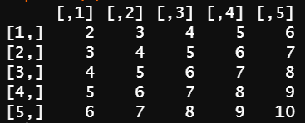

**4)** Use *for loop coding* to produce the number sequence shown below:

Note that the numbers 5 and 10 are missing

1

2

3

4

6

7

8

9

11

12

13

14

15

16

17

18

19

20