ITEC 621 Exercise 1 - R Refresher

Johnson ODEJIDE

February 03, 2023

Table of Contents

General Instructions 1

R Markdown Overview (please read carefully) 1

1. Basic R Concepts 2

2. Data Manipulation 3

3. Basic Descriptive Analytics 5

4. Basic Predictive Analytics 9

## General Instructions

Download the R Markdown template for this exercise **Ex1_R_YourLastName.Rmd** and save it with your own last name **exactly**. Then open it in R Studio and complete all the exercises and answer the questions below in the template. Run the code to ensure everything is working fine. When done, knit your R Markdown file into a **Word document** and submit it. No need to submit the **.Rmd**, file just the Word knitted file. If for some reason you can’t knit a Word file, you can knit to a PDF file, or to an HTML file and then save it as a PDF. Some LMS systems don’t accept HTML submissions.

This exercise is similar to HW0 in KSB-999, which you were required to complete before starting this course. So, if you already did that, this should be an easy exercise and a good warm up refresher. If you didn’t do it, this is you opportunity to catch up. This course moves fast and it assumes that you have some familiarity with R.

## R Markdown Overview (please read carefully)

R Markdown is a package that allows you to write R code and prepare an analytics report in a single file. To use R Markdown, you first need to install it in your computer using the command install.packages("rmarkdown"). If you have not done this yet, go to the **R Console** and install R Markdown. Once you have done this, you can create R Markdown files from the File -> New File menu.

When you create an R Markdown file, it will look like text comingled with R code. You will see a button option named **Knit** in your tool bar (if you don’t, then R Markdown is not installed). Once you are done with all the coding, click on the **Knit** button and R Markdown will knit a Word, HTML, PDF or PowerPoint document for you, depending on the output type you specified, with all your typed text and R results.

**Important:** This is a business course and, as such you are required to submit all exercises, homework and project reports with a professional, businesslike appearance, free of grammatical errors and typos, and with well articulated interpretation narratives. **No knitting, improper knitting and submissions with writing and formatting issues will have up to 3-point (out of 10) deductions for exercises and up to 10-point (out of 100) deductions for homework.**

R Markdown contains three main types of content:

1. The **YAML** (YAML Ain’t Markup Language) header, which is where you place the title, author, date, type of output, etc. It is at the top of the R Markdown file and starts and ends with ---. I suggest using an output type word_document. HTML works well, but blackboard will not read HTML files submitted by students (for security reasons).
2. **Markup** sections, which is where you type any text you wish, which will show up as typed text. You will learn these later.
3. **Code chunks**: which is where you write your R code. An R code chunk starts with a **```{r}** and ends with a **```**.

I recommend that you first write your R code in an R Script file to try your R code first. Once you are satisfied that the R code is working fine, then you can copy/paste the respective code segments to the corresponding R Markdown code chunks.

Your knitted file must:

* Display all your R commands (leave echo=T in the global options; echo=F suppresses the R code)
* Display the resulting **R output results**
* Contain any necessary text and explanations, as needed; and
* Be formatted for good readability and in a business-like manner
* Be in the same order as the questions and with the corresponding question numbers

## 1. Basic R Concepts

**1.1** Write a simple R function named **area()** that takes 2 values as parameters (x and y, representing the two sides of a rectangle) and returns the product of the two values (representing the rectangle’s area). Then use this function to display the area of a rectangle of sides 6x4. Then, use the functions paste(), print(), and area() to output this result: **The area of a rectangle of sides 6x4 is 24**, where 24 is calculated with the area() function you just created

# Area of a rectangle  
area <- function(length, breadth){  
 return(length * breadth)  
}  
  
# Using the function to calculate a rectangle with length of 6 and breadth of 4  
print(paste("The area of a rectangle of sides 6x4 is ", area(6, 4)))

## [1] "The area of a rectangle of sides 6x4 is 24"

**1.2** Write a simple **for loop** for i from 1 to 10. In each loop cycle, compute the area of a rectangle of sides i and i*2 (i.e., all rectangles have one side double the length than the other) and for each of the 10 rectangles display “The area of an 1 x 2 rectangle is 2” for i=1, “The area of an 2 x 4 rectangle is 8”, and so on.

for(i in 1:10){  
 print(paste("The area of a rectangle of a ", i,   
 "x", (i*2), " rectangle is ", area(i, i*2)))  
}

## [1] "The area of a rectangle of a 1 x 2 rectangle is 2"  
## [1] "The area of a rectangle of a 2 x 4 rectangle is 8"  
## [1] "The area of a rectangle of a 3 x 6 rectangle is 18"  
## [1] "The area of a rectangle of a 4 x 8 rectangle is 32"  
## [1] "The area of a rectangle of a 5 x 10 rectangle is 50"  
## [1] "The area of a rectangle of a 6 x 12 rectangle is 72"  
## [1] "The area of a rectangle of a 7 x 14 rectangle is 98"  
## [1] "The area of a rectangle of a 8 x 16 rectangle is 128"  
## [1] "The area of a rectangle of a 9 x 18 rectangle is 162"  
## [1] "The area of a rectangle of a 10 x 20 rectangle is 200"

## 2. Data Manipulation

**2.1** Copy the **Credit.csv** data file to your working directory (if you haven’t done this yet). Then read the **Credit.csv** data file into a data frame object named **Credit** (Tip: use the read.table() function with the parameters header=T, sep=",", row.names=1). Then, list the first 5 columns of the top 5 rows (Tip: use Credit[1:5,1:5])

# Read CSV from the root folder which has 3 subfolders to access the Dataset subfolder in which the Credit.csv file is located.  
Credit <- read.table("../../Dataset/Credit.csv", header = T, sep = ",", row.names = 1)  
  
# Get the top 6 rows of the table using the head function  
head(Credit)

## Income Limit Rating Cards Age Education Gender Student Married Ethnicity  
## 1 14.891 3606 283 2 34 11 Male No Yes Caucasian  
## 2 106.025 6645 483 3 82 15 Female Yes Yes Asian  
## 3 104.593 7075 514 4 71 11 Male No No Asian  
## 4 148.924 9504 681 3 36 11 Female No No Asian  
## 5 55.882 4897 357 2 68 16 Male No Yes Caucasian  
## 6 80.180 8047 569 4 77 10 Male No No Caucasian  
## Balance  
## 1 333  
## 2 903  
## 3 580  
## 4 964  
## 5 331  
## 6 1151

# Get the top 5 columns of the top 5 rows. The first range in the square bracket is left blank because the 5 in the head function already generated the 5 rows needed. Hence, we only need the second range of values in the square bracket which represents the columns  
# head(Credit, 5)[, 1:5] This does the same thing as the code below.  
  
Credit[1:5, 1:5]

## Income Limit Rating Cards Age  
## 1 14.891 3606 283 2 34  
## 2 106.025 6645 483 3 82  
## 3 104.593 7075 514 4 71  
## 4 148.924 9504 681 3 36  
## 5 55.882 4897 357 2 68

**2.2** Using the class() function, display the object class for the Credit data set, and for Gender (i.e., Credit$Gender), Income and Cards

# The class function is used to display the type of class that the object represents.  
  
class(Credit)

## [1] "data.frame"

class(Credit$Gender)

## [1] "character"

class(Credit$Income)

## [1] "numeric"

class(Credit$Cards)

## [1] "integer"

**2.3** Create a vector named **income.vect** with data from the Income column. Then use the head() function to display the first 6 values of this vector.

# A vector with data from the Income column  
income.vect <- Credit$Income  
  
# Display the first 6 values  
head(income.vect)

## [1] 14.891 106.025 104.593 148.924 55.882 80.180

## 3. Basic Descriptive Analytics

**3.1** Compute the mean, minimum, maximum, standard deviation and variance for all the values in this income vector. Store the respective results in variables name mean.inc, min.inc, etc. Then, use the c() function to create a vector called **income.stats** with 5 values you computed above. Then use the names() function to give the corresponding names “Mean”, “Min”, “Max”, “StDev”, and “Var”. Then display Income.stats vector, but wrap it within the round() function with a parameter digits = 2 to display only 2 decimals.

**Technical Note:** The names() needs to create a vector with the respective names above, which need to correspond to the values in **income.vect**. Therefore, you need to use the c() function to create a vector with these 5 names.

# Mean Income  
mean.inc <- mean(income.vect)  
  
# Minimum Income  
min.inc <- min(income.vect)  
  
# Maximum Income  
max.inc <- max(income.vect)  
  
# Standard Devition of Income  
stdev.inc <- sd(income.vect)  
  
# Variance of Income  
var.inc <- var(income.vect)  
  
# Vector of all the statistics  
income.stats <- c(mean.inc, min.inc, max.inc, stdev.inc, var.inc)  
  
names(income.stats) <- c("Mean", "Min", "Max", "StDev", "Var")  
  
round(income.stats, digits = 2)

## Mean Min Max StDev Var   
## 45.22 10.35 186.63 35.24 1242.16

**3.2** Display a boxplot for the predictor Income. Tip: you can do this 2 ways. First you can attach() the Credit data set (which loads the data set in the work environment) and then do a boxplot() for **Income**. Or, do it without attaching, but using the table prefix (i.e., Credit$Income). Use the **xlab** attribute to name include the label “Income”. Then display similar boxplots but this time broken down by **Gender** (i.e., Credit$Income ~ Credit$Gender ).

boxplot(Credit$Income, xlab = "Income")

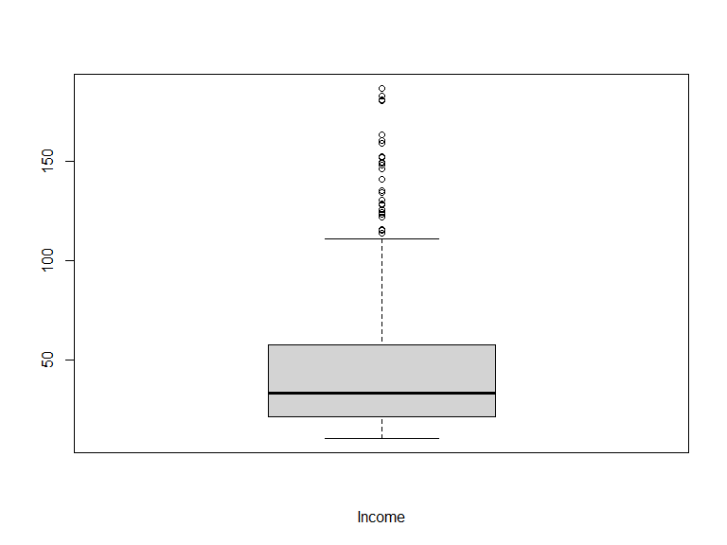

boxplot(Credit$Income ~ Credit$Gender, xlab = "Gender", ylab = "Income")

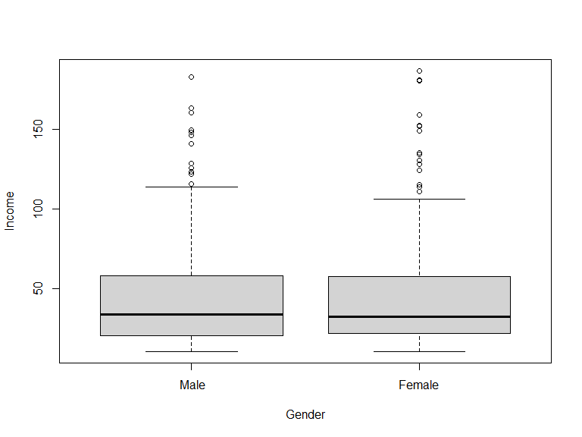

**3.3** Display a histogram for the variable **Rating**, with the main title “Credit Rating Histogram” (main=) and X label “Rating” (xlab=). Then draw a QQ Plot for **Rating** (Tip: use the qqnorm() function first to draw the data points and then use the qqline() function to layer the QQ Line on top).

hist(Credit$Rating, main = "Credit Rating Histogram", xlab = "Rating")

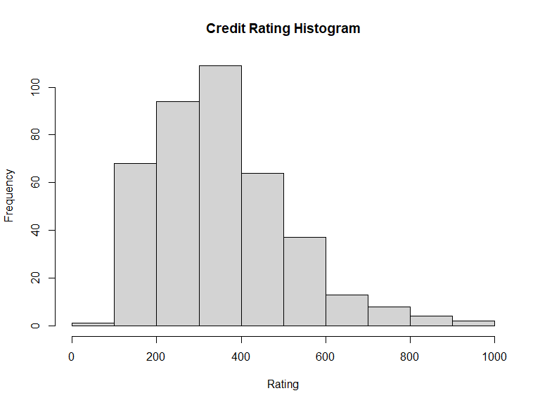

qqnorm(Credit$Rating)  
qqline(Credit$Rating)

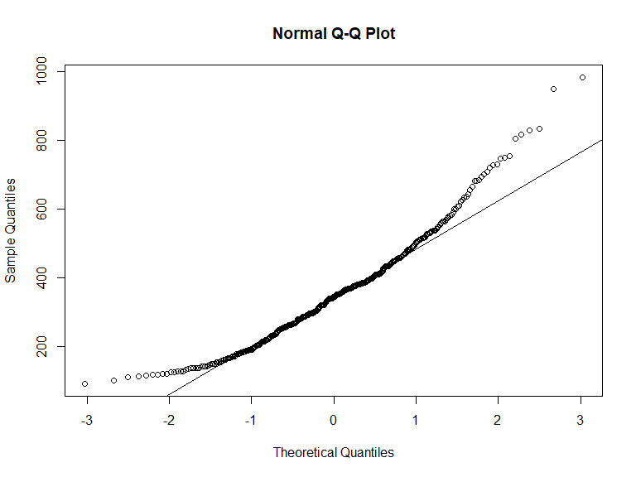

**3.4** Briefly answer **in your own words**: Do you think that this data is somewhat normally distributed? Why or why not? In your answer, please refer to both, the Histogram and the QQ Plot.

*A look at the histogram shows that the data is skewed right although it looks normal to some extent before it started to become skewed. Furthermore, the qqplot reveals some form of normality in the middle until some point when it began to deviate from the line thereby showing some form of non-normality. This is consistent with what was observed on the histogram.*

## 4. Basic Predictive Analytics

**4.1** First, enter the command options(scipen = 4) to minimize the display values with scientific notation. Then, create a simple linear regression model object with the lm() function to fit Credit **Rating** as a function of **Income** and save the results in an object named **lm.rating**. Then display the model summary results with the summary() function. Tip: use the formula Rating ~ Income, data = Credit inside the lm() function.

options(scipen = 4)  
  
# linear model for Credit rating as a function of Income  
lm.rating <- lm(Rating ~ Income, data = Credit)  
  
# display the model summary results  
summary(lm.rating)

##   
## Call:  
## lm(formula = Rating ~ Income, data = Credit)  
##   
## Residuals:  
## Min 1Q Median 3Q Max   
## -173.855 -79.417 -0.384 79.747 171.955   
##   
## Coefficients:  
## Estimate Std. Error t value Pr(>|t|)   
## (Intercept) 197.8411 7.7089 25.66 <2e-16 ***  
## Income 3.4742 0.1345 25.83 <2e-16 ***  
## ---  
## Signif. codes: 0 '***' 0.001 '**' 0.01 '*' 0.05 '.' 0.1 ' ' 1  
##   
## Residual standard error: 94.71 on 398 degrees of freedom  
## Multiple R-squared: 0.6263, Adjusted R-squared: 0.6253   
## F-statistic: 667 on 1 and 398 DF, p-value: < 2.2e-16

**4.2** Now, plot Credit Rating (Y axis) against Income (X axis), with respective labels “Income” and “Credit Rating”. Tip: feed the same formula you used in the lm() function above, but using the plot() function instead. Then draw a regression line by feeding **lm.rating** into the abline() function.

**Note:** see how I added the fig.width and fig.height parameters in the {r code chunk header below to control the size of the figures.

plot(Credit$Rating ~ Credit$Income, xlab = "Income", ylab = "Credit Rating")  
abline(lm.rating)

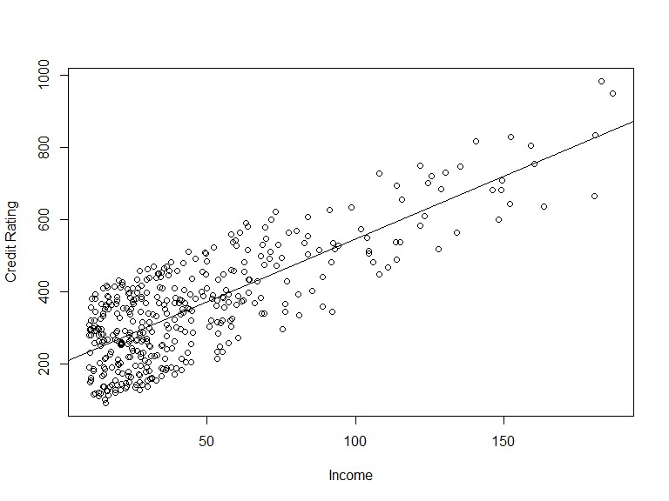

4.3 Write a simple linear model to predict Credit ratings using these predictors: **Income**, **Limit**, **Cards**, **Married** and **Balance**. Name the resulting model **lm.rating.5**. Then display the regression using the summary() function. No need to answer, but what do you think are the most influential predictors of Credit rating?

lm.rating.5 <- lm(Rating ~ Income + Limit + Cards + Married + Balance, data = Credit)  
  
summary(lm.rating.5)

##   
## Call:  
## lm(formula = Rating ~ Income + Limit + Cards + Married + Balance,   
## data = Credit)  
##   
## Residuals:  
## Min 1Q Median 3Q Max   
## -24.0051 -7.0024 -0.9291 6.3789 26.2751   
##   
## Coefficients:  
## Estimate Std. Error t value Pr(>|t|)   
## (Intercept) 27.1070066 2.1867611 12.396 < 2e-16 ***  
## Income 0.0975008 0.0335195 2.909 0.00383 **   
## Limit 0.0641536 0.0009004 71.247 < 2e-16 ***  
## Cards 4.7108256 0.3762419 12.521 < 2e-16 ***  
## MarriedYes 2.1217503 1.0441007 2.032 0.04281 *   
## Balance 0.0084355 0.0031308 2.694 0.00735 **   
## ---  
## Signif. codes: 0 '***' 0.001 '**' 0.01 '*' 0.05 '.' 0.1 ' ' 1  
##   
## Residual standard error: 10.14 on 394 degrees of freedom  
## Multiple R-squared: 0.9958, Adjusted R-squared: 0.9957   
## F-statistic: 1.85e+04 on 5 and 394 DF, p-value: < 2.2e-16