Appendix

Kogod School of Business

Table of Contents

knitr::opts_chunk$set(echo = T, warning = F, message = F)

## Read Data In

library(tidyverse)  
MxMH <- read_csv("mxmh_survey_results.csv", show_col_types = F)

## Check for Missing Values and Drop NA’s

colSums(is.na(MxMH))

## Timestamp Age   
## 0 1   
## Primary streaming service Hours per day   
## 1 0   
## While working Instrumentalist   
## 3 4   
## Composer Fav genre   
## 1 0   
## Exploratory Foreign languages   
## 0 4   
## BPM Frequency [Classical]   
## 107 0   
## Frequency [Country] Frequency [EDM]   
## 0 0   
## Frequency [Folk] Frequency [Gospel]   
## 0 0   
## Frequency [Hip hop] Frequency [Jazz]   
## 0 0   
## Frequency [K pop] Frequency [Latin]   
## 0 0   
## Frequency [Lofi] Frequency [Metal]   
## 0 0   
## Frequency [Pop] Frequency [R&B]   
## 0 0   
## Frequency [Rap] Frequency [Rock]   
## 0 0   
## Frequency [Video game music] Anxiety   
## 0 0   
## Depression Insomnia   
## 0 0   
## OCD Music effects   
## 0 8   
## Permissions   
## 0

MxMH <- subset(MxMH,select=-c(BPM))  
MxMH <- drop_na(MxMH)

## Visual Inspection of Response Variable, Anxiety Level on scale of 0 to 10

par(mfrow=c(1,2))  
  
hist(MxMH$Anxiety,main="Anxiety Histogram",xlab="Anxiety")  
  
qqnorm(MxMH$Anxiety,main="Anxiety QQ Plot")  
qqline(MxMH$Anxiety)

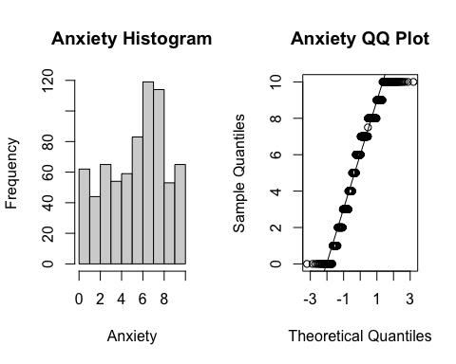

par(mfrow=c(1,1))

## Transformations to Variables

MxMH <- MxMH %>%  
 mutate(`Primary streaming service`=as.factor(`Primary streaming service`)) %>%  
 mutate(`While working`=as.factor(`While working`)) %>%  
 mutate(Instrumentalist=as.factor(Instrumentalist)) %>%  
 mutate(Composer=as.factor(Composer)) %>%  
 mutate(`Fav genre`=as.factor(`Fav genre`)) %>%  
 mutate(Exploratory=as.factor(Exploratory)) %>%  
 mutate(`Foreign languages`=as.factor(`Foreign languages`)) %>%  
 mutate(`Music effects`=as.factor(`Music effects`))

## Count of Different Genres from Favorite Genre Predictor

MxMH %>%  
 group_by(`Fav genre`) %>%  
 count() %>%  
 arrange(desc(n))

## # A tibble: 16 × 2  
## # Groups: Fav genre [16]  
## `Fav genre` n  
## <fct> <int>  
## 1 Rock 184  
## 2 Pop 114  
## 3 Metal 87  
## 4 Classical 51  
## 5 Video game music 43  
## 6 EDM 36  
## 7 R&B 35  
## 8 Hip hop 34  
## 9 Folk 29  
## 10 Country 24  
## 11 Rap 22  
## 12 K pop 21  
## 13 Jazz 20  
## 14 Lofi 10  
## 15 Gospel 6  
## 16 Latin 2

## Quantitative Analysis of Hours Per Day

library(psych)  
describe(MxMH)[4,1:9]

## vars n mean sd median trimmed mad min max  
## Hours per day 4 718 3.58 3.02 3 3.08 1.48 0 24

par(mfrow=c(1,2))  
  
hist(MxMH$`Hours per day`,main="Hours per Day Histogram",xlab="Hours per Day")  
  
qqnorm(MxMH$`Hours per day`,main="Hours per Day QQ Plot")  
qqline(MxMH$`Hours per day`)

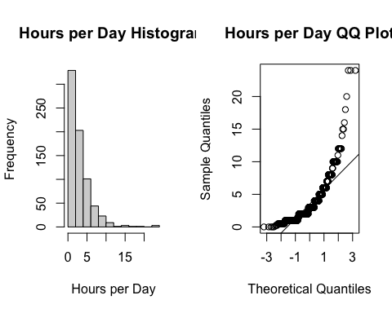

par(mfrow=c(1,1))

## Correlation Analysis for Quantitative/Binary Predictors:

MxMH_1 <- MxMH %>%  
 mutate(`While working`=as.numeric(`While working`)) %>%  
 mutate(Instrumentalist=as.numeric(Instrumentalist)) %>%  
 mutate(Composer=as.numeric(Composer)) %>%  
 mutate(Exploratory=as.numeric(Exploratory)) %>%  
 mutate(`Foreign languages`=as.numeric(`Foreign languages`))  
selected_columns <- c("Age", "Hours per day","While working","Instrumentalist","Composer","Exploratory","Foreign languages","Anxiety")  
subset_data <- MxMH_1[, selected_columns]  
MxMH.cor <- cor(subset_data)  
library(corrplot)  
corrplot(MxMH.cor,order='hclust',method='number')

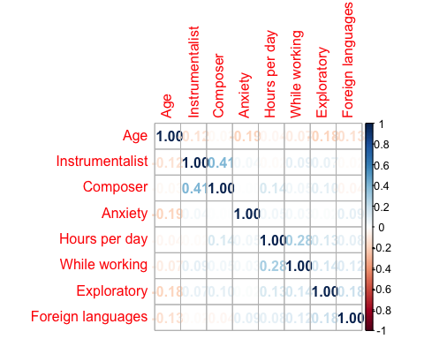

corrplot(MxMH.cor,order='hclust',method='ellipse')

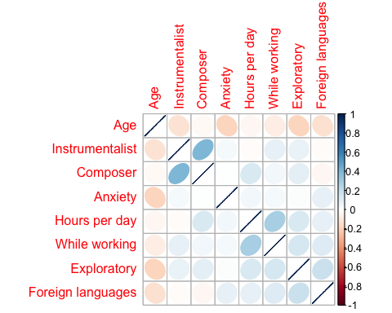

## Boxplots of Categorical Predictors and Response Variable, Anxiety

library(ggplot2)  
par(mfrow=c(1,2))  
  
ggplot(MxMH, aes(x=`Primary streaming service`, y=Anxiety)) +   
 geom_boxplot() +  
 theme(legend.position="none") +  
 coord_flip()

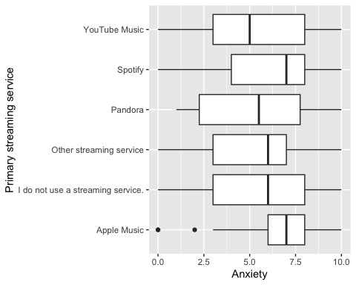

ggplot(MxMH, aes(x=`Fav genre`, y=Anxiety)) +   
 geom_boxplot() +  
 theme(legend.position="none") +  
 coord_flip()

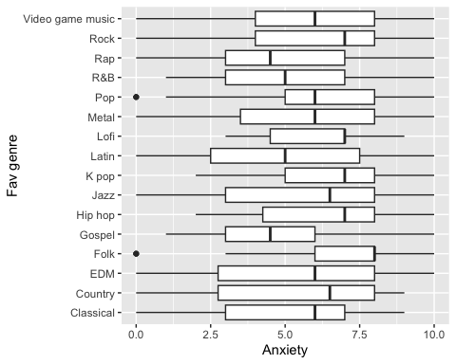

par(mfrow=c(1,1))

## ANOVA test between Categorical Predictors and Response Variable, Anxiety

aov.streaming <- aov(Anxiety ~ `Primary streaming service`,data=MxMH)  
aov.genre <- aov(Anxiety ~ `Fav genre`,data=MxMH)  
  
summary(aov.streaming)

## Df Sum Sq Mean Sq F value Pr(>F)   
## `Primary streaming service` 5 93 18.599 2.423 0.0343 *  
## Residuals 712 5466 7.677   
## ---  
## Signif. codes: 0 '***' 0.001 '**' 0.01 '*' 0.05 '.' 0.1 ' ' 1

summary(aov.genre)

## Df Sum Sq Mean Sq F value Pr(>F)  
## `Fav genre` 15 154 10.24 1.33 0.178  
## Residuals 702 5406 7.70

## Run OLS Model with initial set of predictors

# Change reference level for primary streaming service  
MxMH$`Primary streaming service`<- relevel(MxMH$`Primary streaming service`,ref="I do not use a streaming service.")  
  
fit.ols <- lm(Anxiety ~ Age + `Primary streaming service` + `Hours per day` +  
 `While working` + Instrumentalist + Composer +`Fav genre` +   
 Exploratory + `Foreign languages`, data =MxMH)  
summary(fit.ols)

##   
## Call:  
## lm(formula = Anxiety ~ Age + `Primary streaming service` + `Hours per day` +   
## `While working` + Instrumentalist + Composer + `Fav genre` +   
## Exploratory + `Foreign languages`, data = MxMH)  
##   
## Residuals:  
## Min 1Q Median 3Q Max   
## -6.7565 -1.9455 0.4919 1.8992 5.5824   
##   
## Coefficients:  
## Estimate Std. Error t value  
## (Intercept) 5.64818 0.63189 8.939  
## Age -0.04497 0.00965 -4.660  
## `Primary streaming service`Apple Music 1.27122 0.52905 2.403  
## `Primary streaming service`Other streaming service 0.17501 0.52102 0.336  
## `Primary streaming service`Pandora 0.83231 0.97317 0.855  
## `Primary streaming service`Spotify 0.17821 0.38122 0.467  
## `Primary streaming service`YouTube Music -0.10870 0.44833 -0.242  
## `Hours per day` 0.04629 0.03689 1.255  
## `While working`Yes -0.01965 0.26715 -0.074  
## InstrumentalistYes 0.26468 0.25425 1.041  
## ComposerYes -0.04443 0.30380 -0.146  
## `Fav genre`Country 0.39945 0.68781 0.581  
## `Fav genre`EDM 0.23018 0.61375 0.375  
## `Fav genre`Folk 1.92164 0.64850 2.963  
## `Fav genre`Gospel 1.08852 1.22770 0.887  
## `Fav genre`Hip hop 1.11934 0.62607 1.788  
## `Fav genre`Jazz 0.89226 0.73608 1.212  
## `Fav genre`K pop 1.14383 0.73051 1.566  
## `Fav genre`Latin -1.09725 1.98352 -0.553  
## `Fav genre`Lofi 0.95738 0.96095 0.996  
## `Fav genre`Metal 0.80548 0.49635 1.623  
## `Fav genre`Pop 1.07827 0.47488 2.271  
## `Fav genre`R&B 0.13518 0.61815 0.219  
## `Fav genre`Rap -0.18761 0.71848 -0.261  
## `Fav genre`Rock 1.37821 0.44590 3.091  
## `Fav genre`Video game music 0.82914 0.57558 1.441  
## ExploratoryYes -0.30966 0.24663 -1.256  
## `Foreign languages`Yes 0.36482 0.21795 1.674  
## Pr(>|t|)   
## (Intercept) < 2e-16 ***  
## Age 3.79e-06 ***  
## `Primary streaming service`Apple Music 0.01653 *   
## `Primary streaming service`Other streaming service 0.73705   
## `Primary streaming service`Pandora 0.39271   
## `Primary streaming service`Spotify 0.64031   
## `Primary streaming service`YouTube Music 0.80849   
## `Hours per day` 0.20991   
## `While working`Yes 0.94140   
## InstrumentalistYes 0.29822   
## ComposerYes 0.88376   
## `Fav genre`Country 0.56159   
## `Fav genre`EDM 0.70774   
## `Fav genre`Folk 0.00315 **   
## `Fav genre`Gospel 0.37558   
## `Fav genre`Hip hop 0.07423 .   
## `Fav genre`Jazz 0.22586   
## `Fav genre`K pop 0.11786   
## `Fav genre`Latin 0.58032   
## `Fav genre`Lofi 0.31946   
## `Fav genre`Metal 0.10509   
## `Fav genre`Pop 0.02348 *   
## `Fav genre`R&B 0.82696   
## `Fav genre`Rap 0.79408   
## `Fav genre`Rock 0.00208 **   
## `Fav genre`Video game music 0.15017   
## ExploratoryYes 0.20969   
## `Foreign languages`Yes 0.09461 .   
## ---  
## Signif. codes: 0 '***' 0.001 '**' 0.01 '*' 0.05 '.' 0.1 ' ' 1  
##   
## Residual standard error: 2.716 on 690 degrees of freedom  
## Multiple R-squared: 0.08447, Adjusted R-squared: 0.04865   
## F-statistic: 2.358 on 27 and 690 DF, p-value: 0.0001439

## Testing for OLS Assumption: Errors are Normally Distributed (EN)

# Testing Residuals  
fit.ols <- lm(Anxiety ~ Age + `Primary streaming service` + `Hours per day` +  
 `While working` + Instrumentalist + Composer +`Fav genre` +   
 Exploratory + `Foreign languages`, data = MxMH)  
hist(fit.ols$residuals)

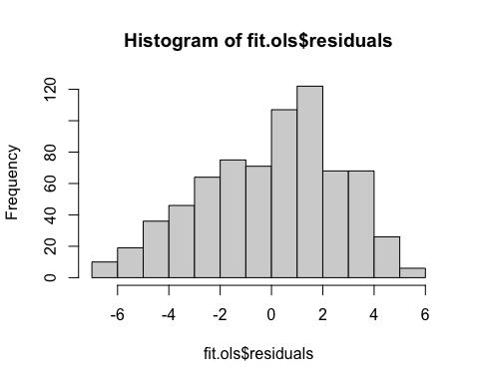

plot(fit.ols,which=2)

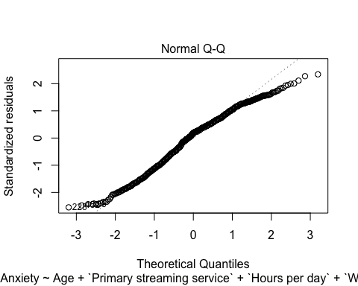

## Testing for OLS Assumption: X’s are Independent (XI)

library(klaR)  
library(car)  
ci <- cond.index(fit.ols, data = MxMH)  
ci

## [1] 1.000000 2.328502 2.412038 2.436032 2.475838 2.536228 2.623122  
## [8] 2.647161 2.656703 2.661704 2.662349 2.664233 2.665182 2.665337  
## [15] 2.665337 2.821676 2.833563 2.930659 2.989275 3.121231 3.974213  
## [22] 4.478205 4.819463 5.471155 6.609435 7.698636 10.268667 18.792884

ci[length(ci)]

## [1] 18.79288

vif(fit.ols)

## GVIF Df GVIF^(1/(2*Df))  
## Age 1.293337 1 1.137250  
## `Primary streaming service` 1.539158 5 1.044067  
## `Hours per day` 1.204502 1 1.097498  
## `While working` 1.153696 1 1.074102  
## Instrumentalist 1.366756 1 1.169083  
## Composer 1.283560 1 1.132943  
## `Fav genre` 1.853214 15 1.020777  
## Exploratory 1.204204 1 1.097362  
## `Foreign languages` 1.144315 1 1.069727

## Testing for OLS Assumption: Linearity (LI)

plot(MxMH$Age,MxMH$Anxiety)  
abline(lm(Anxiety ~ Age, data =MxMH), col = "red")

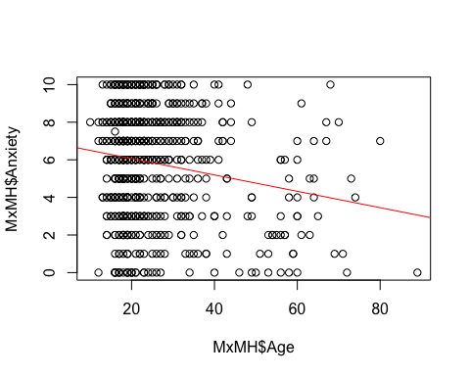

plot(MxMH$`Hours per day`,MxMH$Anxiety)  
abline(lm(Anxiety ~ `Hours per day`, data=MxMH), col = "red")

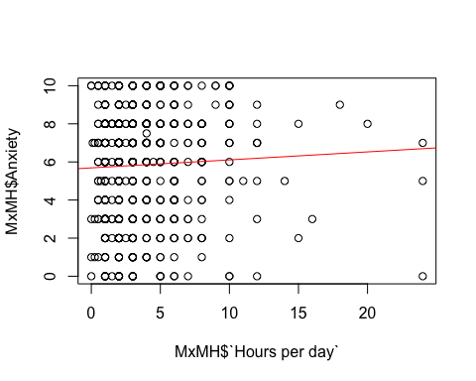

## Testing for OLS Assumption: Average Error of Residuals (EA)

mean(fit.ols$residuals)

## [1] 3.080765e-17

## Testing for OLS Assumption: Error Variance is Constant (EV)

plot(fit.ols,which=1)

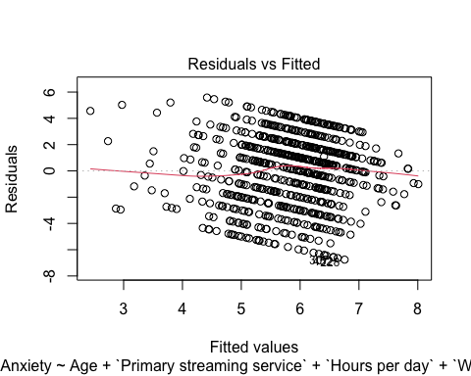

library(lmtest)  
bptest(fit.ols)

##   
## studentized Breusch-Pagan test  
##   
## data: fit.ols  
## BP = 37.696, df = 27, p-value = 0.0828

## Interaction Model

Interaction between age and hours per day,interaction between explanatory and while working as added predictors

Anxiety_Model_Interaction <- lm(Anxiety ~ Age + Age*`While working` + `Primary streaming service` + `Hours per day` +`Hours per day`*Exploratory+`While working` + Instrumentalist + Composer +`Fav genre` + Exploratory + `Foreign languages`, data = MxMH)  
summary(Anxiety_Model_Interaction)

##   
## Call:  
## lm(formula = Anxiety ~ Age + Age * `While working` + `Primary streaming service` +   
## `Hours per day` + `Hours per day` * Exploratory + `While working` +   
## Instrumentalist + Composer + `Fav genre` + Exploratory +   
## `Foreign languages`, data = MxMH)  
##   
## Residuals:  
## Min 1Q Median 3Q Max   
## -7.0924 -1.9617 0.4426 1.9365 5.5421   
##   
## Coefficients:  
## Estimate Std. Error t value  
## (Intercept) 6.57825 0.80950 8.126  
## Age -0.06828 0.02019 -3.382  
## `While working`Yes -0.85941 0.64244 -1.338  
## `Primary streaming service`Apple Music 1.30045 0.52799 2.463  
## `Primary streaming service`Other streaming service 0.24343 0.52056 0.468  
## `Primary streaming service`Pandora 0.62547 0.98045 0.638  
## `Primary streaming service`Spotify 0.23719 0.38172 0.621  
## `Primary streaming service`YouTube Music -0.06322 0.44853 -0.141  
## `Hours per day` -0.08392 0.07333 -1.144  
## ExploratoryYes -0.81630 0.35851 -2.277  
## InstrumentalistYes 0.30086 0.25402 1.184  
## ComposerYes -0.03260 0.30394 -0.107  
## `Fav genre`Country 0.34298 0.68674 0.499  
## `Fav genre`EDM 0.22839 0.61221 0.373  
## `Fav genre`Folk 1.88135 0.64752 2.905  
## `Fav genre`Gospel 0.83434 1.23410 0.676  
## `Fav genre`Hip hop 1.09296 0.62450 1.750  
## `Fav genre`Jazz 0.86464 0.73528 1.176  
## `Fav genre`K pop 1.17696 0.72880 1.615  
## `Fav genre`Latin -1.22791 1.98011 -0.620  
## `Fav genre`Lofi 0.95652 0.95847 0.998  
## `Fav genre`Metal 0.81059 0.49503 1.637  
## `Fav genre`Pop 1.09079 0.47371 2.303  
## `Fav genre`R&B 0.16086 0.61658 0.261  
## `Fav genre`Rap -0.16624 0.71839 -0.231  
## `Fav genre`Rock 1.36434 0.44475 3.068  
## `Fav genre`Video game music 0.87499 0.57449 1.523  
## `Foreign languages`Yes 0.33789 0.21807 1.549  
## Age:`While working`Yes 0.03334 0.02230 1.495  
## `Hours per day`:ExploratoryYes 0.16605 0.08213 2.022  
## Pr(>|t|)   
## (Intercept) 2.05e-15 ***  
## Age 0.000761 ***  
## `While working`Yes 0.181429   
## `Primary streaming service`Apple Music 0.014021 *   
## `Primary streaming service`Other streaming service 0.640203   
## `Primary streaming service`Pandora 0.523725   
## `Primary streaming service`Spotify 0.534563   
## `Primary streaming service`YouTube Music 0.887956   
## `Hours per day` 0.252851   
## ExploratoryYes 0.023099 *   
## InstrumentalistYes 0.236678   
## ComposerYes 0.914611   
## `Fav genre`Country 0.617628   
## `Fav genre`EDM 0.709215   
## `Fav genre`Folk 0.003785 **   
## `Fav genre`Gospel 0.499225   
## `Fav genre`Hip hop 0.080541 .   
## `Fav genre`Jazz 0.240028   
## `Fav genre`K pop 0.106784   
## `Fav genre`Latin 0.535384   
## `Fav genre`Lofi 0.318649   
## `Fav genre`Metal 0.101992   
## `Fav genre`Pop 0.021596 *   
## `Fav genre`R&B 0.794262   
## `Fav genre`Rap 0.817063   
## `Fav genre`Rock 0.002242 **   
## `Fav genre`Video game music 0.128201   
## `Foreign languages`Yes 0.121733   
## Age:`While working`Yes 0.135263   
## `Hours per day`:ExploratoryYes 0.043587 *   
## ---  
## Signif. codes: 0 '***' 0.001 '**' 0.01 '*' 0.05 '.' 0.1 ' ' 1  
##   
## Residual standard error: 2.709 on 688 degrees of freedom  
## Multiple R-squared: 0.09202, Adjusted R-squared: 0.05375   
## F-statistic: 2.404 on 29 and 688 DF, p-value: 6.213e-05

## Testing for OLS Assumption: Errors are Normally Distributed (EN) on Interaction Model

hist(Anxiety_Model_Interaction$residuals)

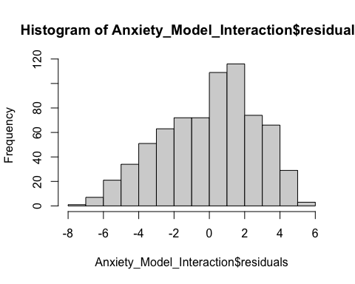

plot(Anxiety_Model_Interaction,which=2)

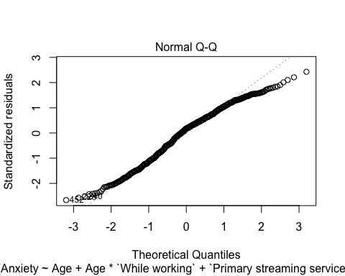

## Testing for OLS Assumption: X’s are Independent (XI) on Interaction Model

library(klaR)  
library(car)  
ci <- cond.index(Anxiety_Model_Interaction, data = MxMH)  
ci

## [1] 1.000000 2.468759 2.615825 2.647338 2.667313 2.754344 2.839446  
## [8] 2.856459 2.882980 2.892807 2.893523 2.894644 2.897305 2.897444  
## [15] 2.897496 3.058650 3.063054 3.156647 3.236322 3.392056 3.717637  
## [22] 4.411999 4.638302 5.192473 6.123009 7.451114 11.038132 14.802983  
## [29] 16.631522 32.661272

ci[length(ci)]

## [1] 32.66127

vif(Anxiety_Model_Interaction)

## GVIF Df GVIF^(1/(2*Df))  
## Age 5.693276 1 2.386059  
## `While working` 6.707905 1 2.589962  
## `Primary streaming service` 1.601266 5 1.048205  
## `Hours per day` 4.785217 1 2.187514  
## Exploratory 2.558412 1 1.599504  
## Instrumentalist 1.371692 1 1.171193  
## Composer 1.291661 1 1.136513  
## `Fav genre` 1.938066 15 1.022301  
## `Foreign languages` 1.151739 1 1.073191  
## Age:`While working` 10.530415 1 3.245060  
## `Hours per day`:Exploratory 6.435271 1 2.536784

## Testing for OLS Assumption: Average Error of Residuals (EA) on Interaction Model

mean(Anxiety_Model_Interaction$residuals)

## [1] 1.043039e-16

## Testing for OLS Assumption: Error Variance is Constant (EV) on Interaction Model

plot(Anxiety_Model_Interaction,which=1)

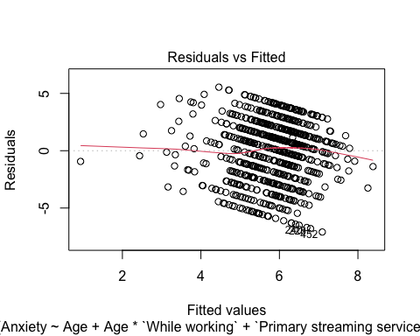

library(lmtest)  
bptest(Anxiety_Model_Interaction)

##   
## studentized Breusch-Pagan test  
##   
## data: Anxiety_Model_Interaction  
## BP = 38.201, df = 29, p-value = 0.1179