I want to develop a web-based tool, aiming to provide model organisms selection strategy for IMDs research mainly based on the orthologues (on R, based on a R package call “shiny”.
- The beginning interface should look like what is shown below:
  - In the first part, there should be a search window where user can use Human Symbol / ICIEM Name / Alternative Names / Disease Abbreviation (supports fuzzy search) as input (From “IMDs_Info_With_Category” and “IMDs_Others”). Enter multiple queries separated by line breaks.
  - Then, below the searching window, a summary section is needed, which should contain all the IMDs data from the tools. Users could enter the single IMDs disease page by simply click big category (such as Disorders of amino acid metabolism) then click the subcategories, and finally they can click the specific diseases page under that category.
  - Beside each big category, there is a label of disease coverage for each model organism, which mean within all human IMDs causing genes in each big categories, how many percentages of genes have orthologous across models (Mouse, Zebrafish, Fly, Worm, Fission Yeast) and shown in a define gradient of color from red to blue. In this process, The program should look into the “Gene” column (Also considering which category these genes belongs to) in both “IMDs_Info_With_Category” and “IMDs_Others”, and compared these genes with genes in the column “Human Symbol” in files “Human_To_Model_Orthology_State” to get the percentages. And based on different percentages, allocate the color to model organisms.
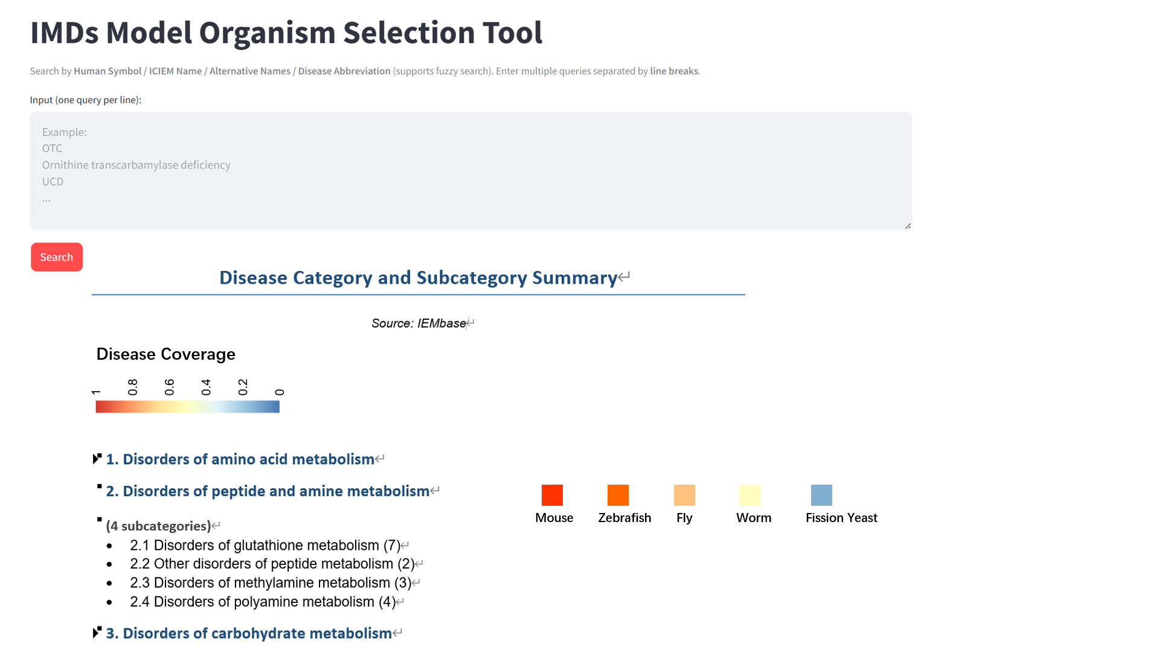

- The decision for model selection is made under the logic below:
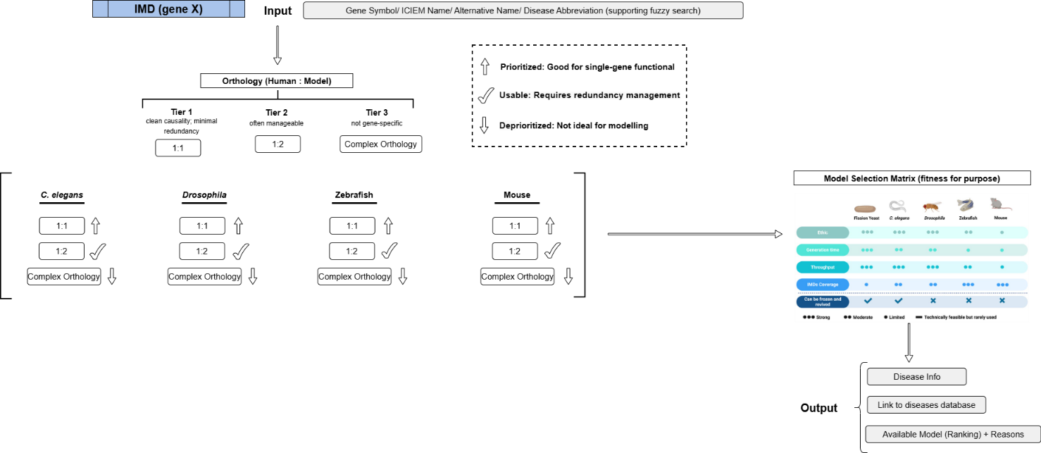
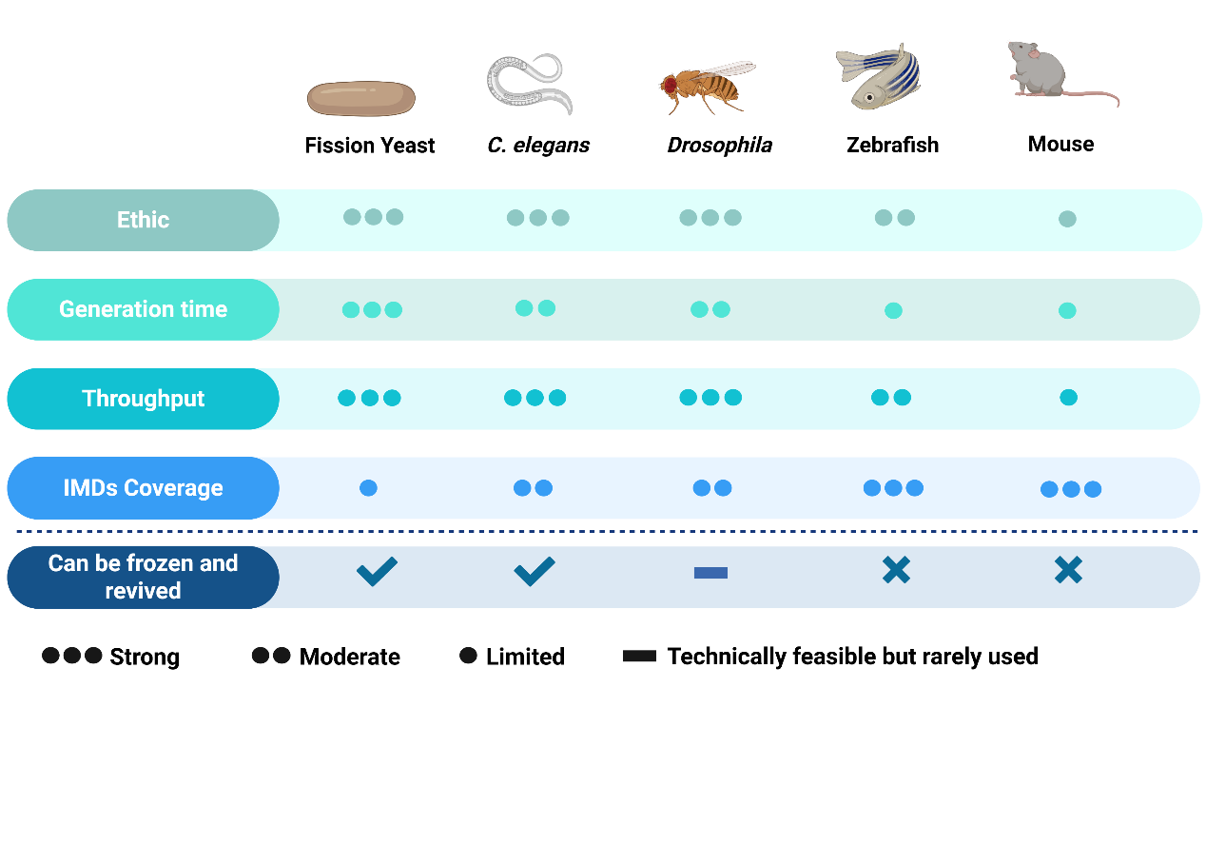
The orthologue of a gene for specific IMDs was first been investigated. If there is a 1:1 (1 human gene : 1 model gene) Orthologues exist in a model, then this model is prioritized; If there is a 1:2 Orthologues, change nothing; If there is a complex orthologue relationship (neither 1:1 or 1:2), then the model is deprioritized).
Then if 2 or more models were prioritized, then these models were process to the model selection matrix and were given weight based on the model selection matrix.

- The output page
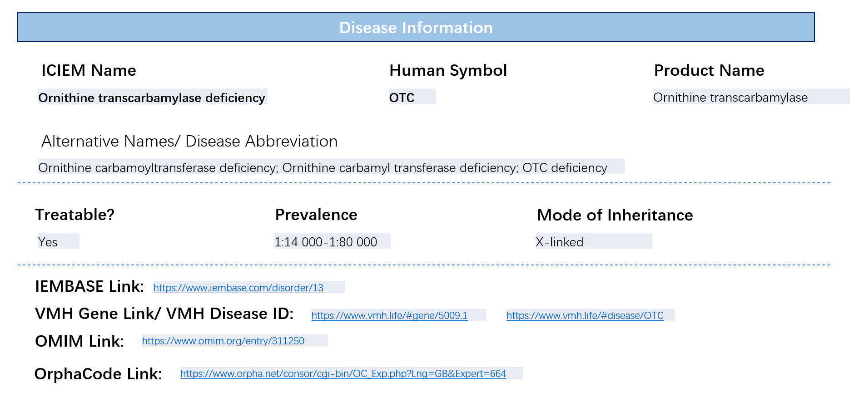 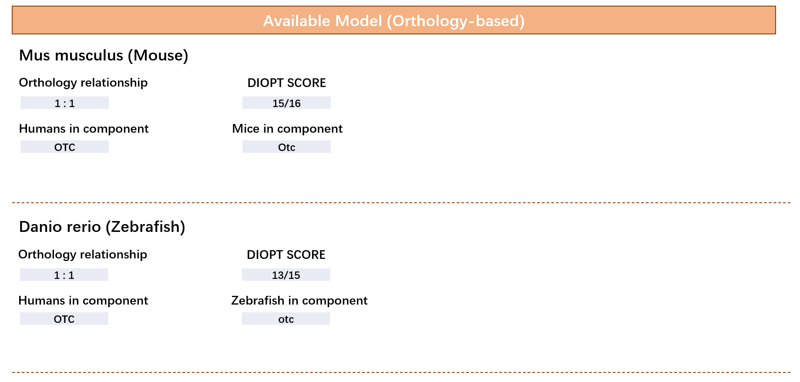 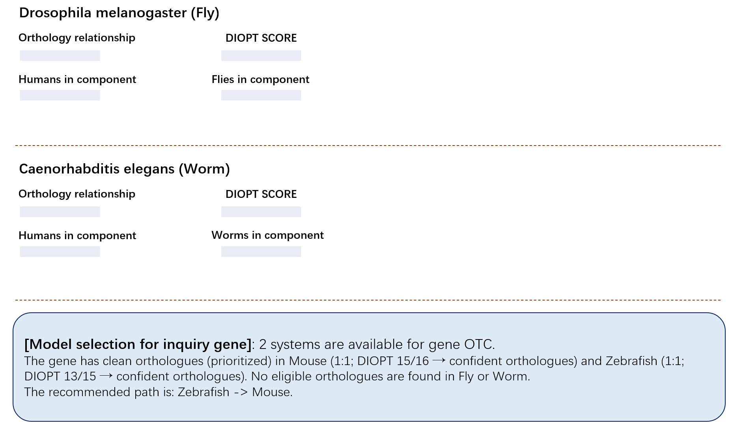
in the output page, give the information just like what is shown in the example. If the info is missing, then leave it empty. For the link, it should be direct to that page just by clicking the link.

