Crowdfunding Analysis

Based on the following data provided by xEd Boot Camps, LLC, we can see that the average crowdfunded campaign was only slightly more successful than those campaigns that failed. However, the lower medians shown would lead us to believe that there are major outliers in the distribution of both the failed and successfully backed campaigns.



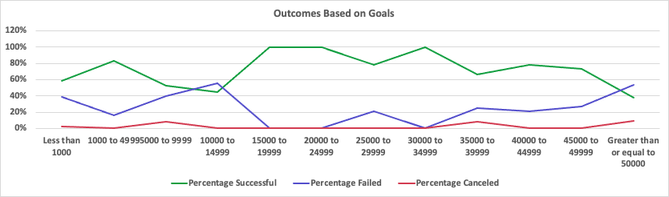

As is shown in the visual above, there does not seem to be a correlation between the goal amount and the success or failure of a campaign.

Crowdfunding campaigns appear to be more popular to back if they are arts based, but not necessarily mean they are more successful.

Evidence shows that there seems to be times when when campaigns suffer loss and/or cancel and even successful camapigns suffer accordingly.

The given data excludes ages of backers. Ages of campaign backers would be interesting to investigate to see if there are trends among young or older backers.

Not shown, but again would worth looking at is the duration each campaign was open for funding. Obviously, those whose campaign had a longer timeframe to contribute would have a greater chance of attracting backers. In addition, age again might play a part in the quantity of backers and the dollar volume pledged.

Furthermore, it would also be interesting to know more about the campaigns themselves to determine their success, failure or otherwise, such as how did they attract those who pledged.

**Data sourced from edX Boot Camps, LLC**