**Colab:** [**https://colab.research.google.com/drive/1DudkjSkoPPLOhQQf8AFCMn4Kdwu43FIG?usp=sharing**](https://colab.research.google.com/drive/1DudkjSkoPPLOhQQf8AFCMn4Kdwu43FIG?usp=sharing)

**GitHub:**

[**https://github.com/johnsonlarryl/csce_5210/tree/main/traffic_simulator**](https://github.com/johnsonlarryl/csce_5210/tree/main/traffic_simulator)

**Design Approach:**

The software implementation I used was the same as [outlined in my design](https://github.com/johnsonlarryl/csce_5210/tree/main/traffic_simulator#readme). The lower-level implementation used an Object-Oriented Design (OOD) and Object-Oriented Programming (OOP) approach from a design pattern perspective. This resulted in a cohesive software architecture where classes and methods performed very specific functions where objects collaborated with one another for city map generation, trip simulation, and traffic analysis. This provided a clean separation between objects and clearly defined contracts or interfaces between objects.

The software's skeleton was composed of a series of classes, each delegated with distinct responsibilities. For example, the [CityMap](https://github.com/johnsonlarryl/csce_5210/blob/main/traffic_simulator/traffic_simulator/city_map.py#L31) class was dedicated to the representation and manipulation of the urban layout, while the [TripSimulator](https://github.com/johnsonlarryl/csce_5210/blob/main/traffic_simulator/traffic_simulator/traffic_simulation.py#L13) class focused on the enactment and analysis of journey patterns within this environment. Similarly, the [TrafficAnalyzer](https://github.com/johnsonlarryl/csce_5210/blob/main/traffic_simulator/traffic_simulator/traffic_analysis.py) class took on the role of interpreting and providing insights into the flow and congestion of vehicular movement. Figure shows the collaboration of objects from my original design.

Figure 1 - System (Agent/Environmental) Sequence Diagram

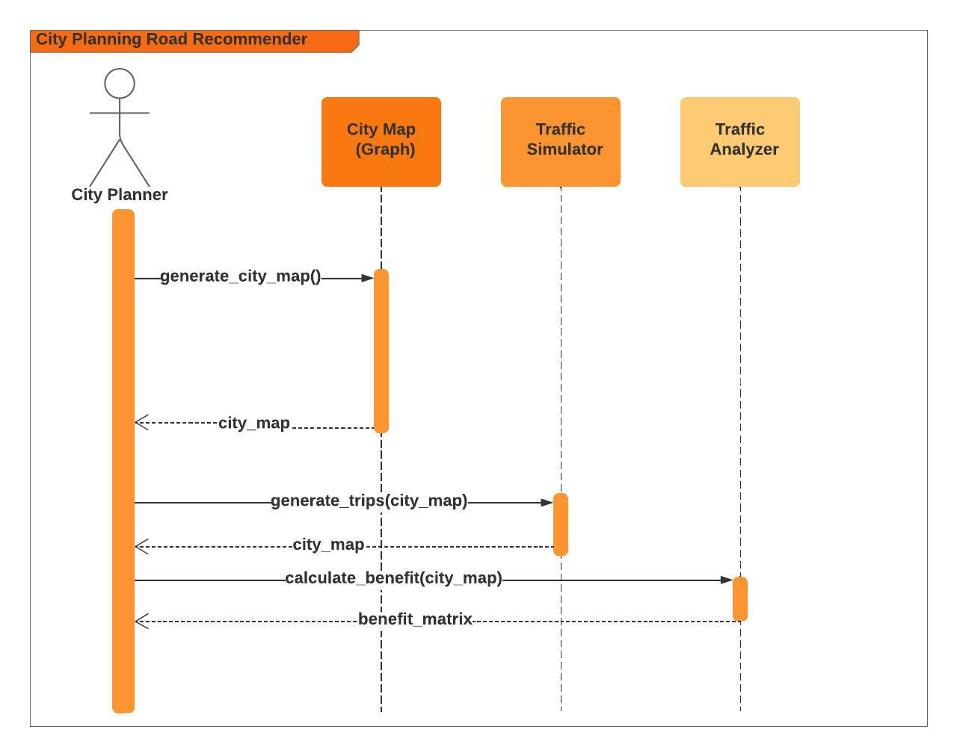

In addition, the algorithmic approach used dynamic programming (DP) to iterate through various states for calculating the benefit matrix. Using simple algebraic calculations allowed road segments along with the respective trips to be calculated efficiently and accurately to produce the resultant road benefit matrix. This was accomplished by iterating through each state and updating the matrix accordingly. As a result, as new road segments were added to the city map, as potential new roads were being re-calculated, existing road candidates were dropped off the road candidate matrix that was previously considered.

**Assumptions:**

* All traffic along each road segment was treated equally. Meaning, we did not account for roads that were busier than others, but rather just using trips from beginning to end.
* We only accounted for trips occurring between 10 AM – 6 PM during normal operations (eg. M-F). In other words, trips outside of these times were not accounted for (nights, weekends, etc…).
* Roads did not have any elevation. Meaning, we assumed the roads were flat.

**R2:**

Based on the traffic analyzer the roads to be built for construction are in the following order:

1. Road segment **(2, 3)** since it has the highest benefit to the city with a benefit score of 38.6.
2. Road segment **(0,2)** since it has the second highest benefit to the city after constructing road segment (2,3) in the city. It has a benefit score of 26.6.

**R3:**

Based on the traffic analyzer the roads to be built for construction are in the following order:

1. Road segment **(36, 45)** since it has the highest benefit to the city with a benefit score of 1912.80.
2. Road segment **(37,45)** since it has the second highest benefit to the city after constructing road segment (36,45) in the city. It has a benefit score of 1511.36.
3. Road segment **(38,45)** since it has the third highest benefit to the city after constructing road segment (37,45) in the city. It has a benefit score of 1729.40.

**R4:**

Using the same data that you gathered in R3, now set f at 0.8 and display:

Based on the traffic analyzer the roads to be built for construction are in the following order:

1. Road segment **(36, 45)** since it has the highest benefit to the city with a benefit score of 890.80.
2. Road segment **(45,46)** since it has the second highest benefit to the city after constructing road segment (36,45) in the city. It has a benefit score of 657.80.
3. Road segment **(22,45)** since it has the third highest benefit to the city after constructing road segment (45,46) in the city. It has a benefit score of 682.76.

Have your recommendations changed from R3? If so, why do you think they have changed?

The road recommendations changed because the shrinkage factor was less than the value in R3. As a result, the benefit of adding new roads is less because the commute is longer for travelers along various road segments within the city map.

**R5:**

R5 Now double the connectivity you used in R3. You will need to re-run the simulation as the network has changed. By how much has the benefit values changed for the top 3 roads to be constructed? Why do you think these values have changed?

Based on the traffic analyzer the roads to be built for construction are in the following order:

1. Road segment **(36, 45)** since it has the highest benefit to the city with a benefit score of 2274.40.
2. Road segment **(45,55)** since it has the second highest benefit to the city after constructing road segment (36,45) in the city. It has a benefit score of 1930.72.
3. Road segment **(55,55)** since it has the third highest benefit to the city after constructing road segment (45,55) in the city. It has a benefit score of 1994.80.

The road benefit is approximately (2274.40 - 1912.80)/ 1912.80 or 18% greater when the road connectivity doubles within the city map. As a result, more connectivity positively impacts new road benefits. Meaning, travelers can more easily get around in the city because there are more roads connected for their commute.