Machine Learning - Exoplanet Exploration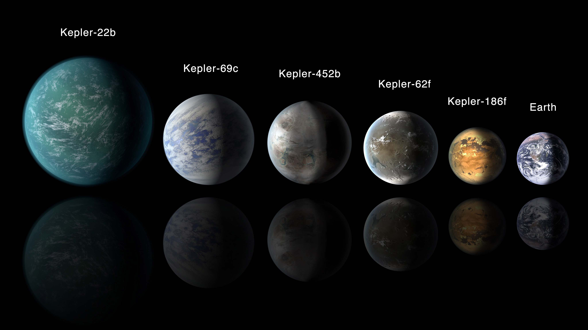

|  |
| --- |
|  |

**Summary:**

|  |
| --- |
|  |

**Support Vector Machine**

|  |  |  |
| --- | --- | --- |
|  | Before Tuning | After Tuning |
| Training Score | 0.850 | 0.878 |
| Test Score | 0.833 | 0.867 |

|  |  |  |  |  |
| --- | --- | --- | --- | --- |
|  | precision | Recall | f1-score | Support |
|  |  |  |  |  |
| CANDIDATE | 0.83 | 0.58 | 0.68 | 422 |
| CONFIRMED | 0.7 | 0.88 | 0.78 | 450 |
| FALSE POSITIVE | 0.99 | 1 | 0.99 | 876 |
|  |  |  |  |  |
| accuracy |  |  | 0.87 | 1748 |
| macro avg | 0.84 | 0.82 | 0.82 | 1748 |
| weighted avg | 0.87 | 0.87 | 0.86 | 1748 |

**Random RainForest**

|  |  |  |
| --- | --- | --- |
|  | Before Tuning | After Tuning |
| Training Score | 0.999 | 0.898 |
| Test Score | 0.891 | 0.867 |

|  |  |  |  |  |
| --- | --- | --- | --- | --- |
|  | precision | Recall | f1-score | Support |
|  |  |  |  |  |
| CANDIDATE | 0.83 | 0.70 | 0.76 | 422 |
| CONFIRMED | 0.77 | 0.86 | 0.81 | 450 |
| FALSE POSITIVE | 0.98 | 1.00 | 0.99 | 876 |
|  |  |  |  |  |
| accuracy |  |  | 0.89 | 1748 |
| macro avg | 0.86 | 0.85 | 0.85 | 1748 |
| weighted avg | 0.89 | 0.89 | 0.89 | 1748 |