Pablo Johnson (No team)
Advanced Data Structures and Algorithms
Homework 5
11.13.17

Wire routing with BFS

With this paper, I will teach the reader what a graph is and how it is used, to implement the graph advanced data type using multiple internal representations, and how graphs can be applied to solve problems.
Graphs are a data type that represent data or systems by having different “nodes.” These nodes can specify different connections with weights, and serve the purpose of modeling different systems and problems. An example of a graph is shown below.
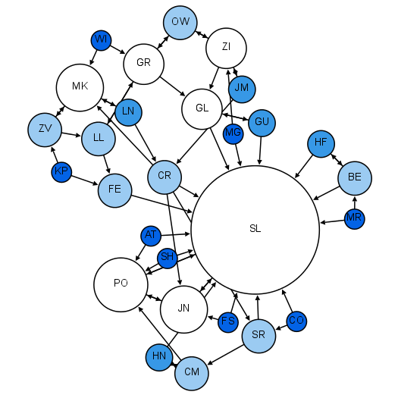

Graph theory in sociology: Moreno Sociogram (1953) (Wikipedia)
As you can see from the graph above, there are different types of connections. These connections are either unidirectional or bidirectional. This variance of connections allow us to better model a system.
Graphs allow us to solve problems by using different analysis tools such as the breadth first search, depth first search, and Dijkstra's algorithm. For example, Dijkstra’s algorithm will return the shortest path between two nodes, which is useful if our graph were a model of a map of cities as nodes and roads with different distances represented as edges or connections.
The breadth first search (BFS) is a searching algorithm that is used to search trees or graph data structures. It searches through the neighbor nodes, and then moves on to the next level neighbors. The BFS has many applications, such as copying garbage collection and wire routing. Garbage collection is used in many programming languages and operating systems, as it us used to free up memory that was being used, but is no longer. Wire routing relates to electronic design automation, and is the generation of a wiring layout that fits the requirements for the circuit. Because I am majoring in electrical engineering and often deal with field programmable gate arrays (FPGAs) and integrated chips (ICs), I will be exploring the use of the BFS in wire routing.
The goal of wire routing is to generate a set of wire routes that connect pins together while retaining correctness of connections, timing requirements, and to avoid crosstalk and antenna effects. Before we can go into routing, placement is done. Placement creates the graph that we will pass to our router, with each node consisting of each active element or component. The router will also be given a list of “polygons,” which contain pins and possibly some preroutes. Each polygon is linked to a net, which contains information about the polygon. From this we have a netlist, which is referenced during wire routing. The polygons represent the nodes in our graph. Other than the correct pins being connected, timing requirements must be met, along with crosstalk and antenna effects. In wire routing, these designs are not usually optimized, but made to meet design requirements.
For our implementation, we are going to have a graph representing different pins connected to each other. These will be represented as vertices ‘a’ through ‘h’. We will use BFS to check if a specific pin is connected to another either directly, or going through a connection from one pin and then to another. Our traverse function also will show the shortest path from a specific pin to the root pin that we specified with our BFS. When we define our edges, we define the edge twice to show that the connection is bidirectional, as connections in a printed circuit board would be bidirectional. Note that I imported graph,vertex, and queue from pythonds. This is because the graph and vertex function we defined in class doesn’t include the functionality of “coloring” nodes. The source we used for the BFS search also imports these.
The tasks for this assignment were all completed by myself. I really enjoyed learning about the wire routing in electronic design automation. It took me some time to realize that the addEdge function only created unidirectional connections and that the graph and vertex classes shown in the BFS slides didn’t have the functionality to work with the BFS function that was defined in the slides.

