- The articles/news section is not working when you click on it from the homepage. Pictures are not displaying.
- On the homepage – That 99.7% there cant it be replaced with the IATA Aand GCAA logos? If you cant put the ogos there then remove the 99.7% there, it doesn’t communicate anything actually.
- When you click on the About Us to read the full biography portion, the picture should be his new image I shared with you the other day. See below:

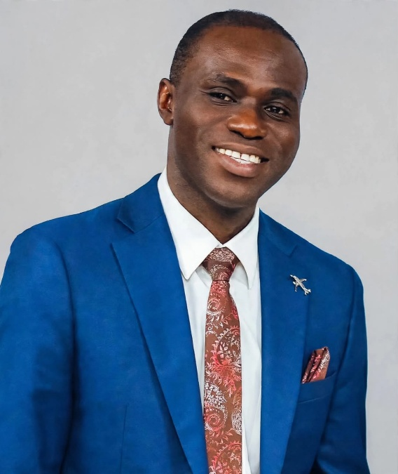

- For the events tab, the photos are not showing again. Also remember that what was available the last time, the images had been mixed up and the titles/labels used were wrong. I can send them again if you want.

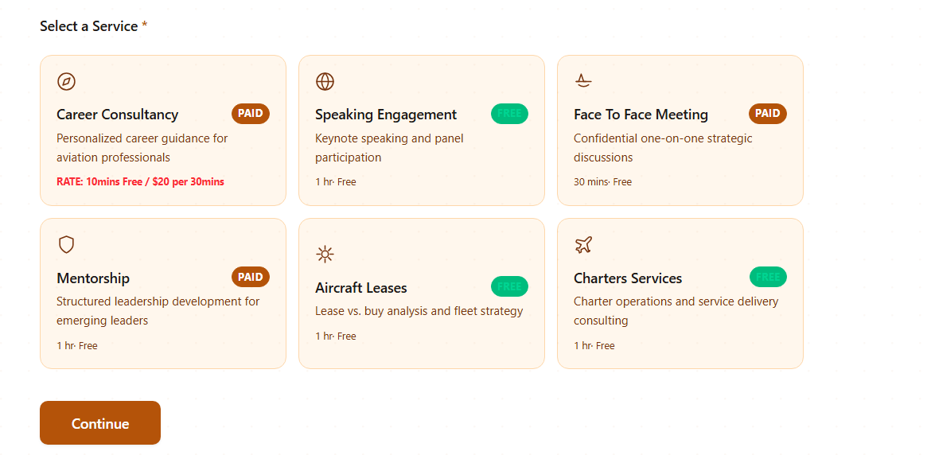
- Speaking Engagement the free in green there make it (Free/Paid). Remove the 1hr free down there and put Negotiable in red over there
- Face to Face Meeting, the 30 mins free down, change it to the same thing under career consultancy.
- Mentorship also, change the 1hr free to the same rate under Career consultancy
- Aircraft Leases and Charters Services, remove the Free in green and make all paid. The 1hr free down there too, put negotiable in red there.

