**03: Linear Algebra - Review**

[Previous](http://www.holehouse.org/mlclass/01_02_Introduction_regression_analysis_and_gr.html) [Next](http://www.holehouse.org/mlclass/04_Linear_Regression_with_multiple_variables.html) [Index](http://www.holehouse.org/mlclass/index.html)

**Matrices - overview**

* Rectangular array of numbers written between square brackets
  + 2D array
  + Named as capital letters (A,B,X,Y)
* Dimension of a matrix are [Rows x Columns]
  + Start at top left
  + To bottom left
  + To bottom right
  + R[r x c] means a matrix which has r rows and c columns  
    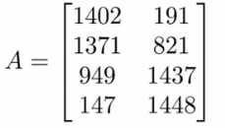
    - Is a [4 x 2] matrix
* Matrix elements
  + A(i,j) = entry in ith row and jth column

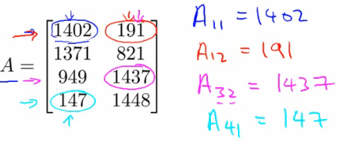

* Provides a way to organize, index and access a lot of data

**Vectors - overview**

* Is an n by 1 matrix
  + Usually referred to as a lower case letter
  + n rows
  + 1 column
  + e.g.

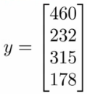

* Is a 4 dimensional vector
  + Refer to this as a vector R4
* Vector elements
  + vi = ithelement of the vector
  + Vectors can be 0-indexed (C++) or 1-indexed (MATLAB)
  + In math 1-indexed is most common
    - But in machine learning 0-index is useful
  + Normally assume using 1-index vectors, but be aware sometimes these will (explicitly) be 0 index ones

**Matrix manipulation**

* ***Addition***
  + Add up elements one at a time
  + Can only add matrices of the *same dimensions*
    - Creates a new matrix of the same dimensions of the ones added

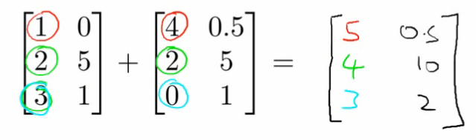

* ***Multiplication by scalar***
  + Scalar = real number
  + Multiply each element by the scalar
  + Generates a matrix of the same size as the original matrix

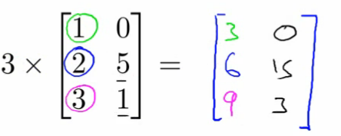

* ***Division by a scalar***
  + Same as multiplying a matrix by 1/4
  + Each element is divided by the scalar
* ***Combination of operands***
  + Evaluate multiplications first

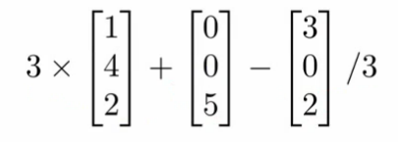

* **Matrix by vector multiplication**
  + [3 x 2] matrix * [2 x 1] vector
    - New matrix is [3 x 1]
      * More generally if [a x b] * [b x c]
        + Then new matrix is [a x c]
    - How do you do it?
      * Take the two vector numbers and multiply them with the first row of the matrix
        + Then add results together - this number is the first number in the new vector
      * The multiply second row by vector and add the results together
      * Then multiply final row by vector and add them together

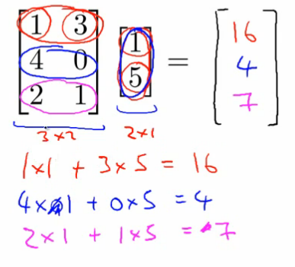

* Detailed explanation
  + A * x = y
    - A is m x n matrix
    - x is n x 1 matrix
    - n must match between vector and matrix
      * i.e. inner dimensions must match
    - Result is an m-dimensional vector
  + To get yi - multiply A's ithrow with all the elements of vector x and add them up
* Neat trick
  + Say we have a data set with four values
  + Say we also have a hypothesis hθ(x) = -40 + 0.25x
    - Create your data as a matrix which can be multiplied by a vector
    - Have the parameters in a vector which your matrix can be multiplied by
  + Means we can do
    - Prediction = Data Matrix * Parameters  
      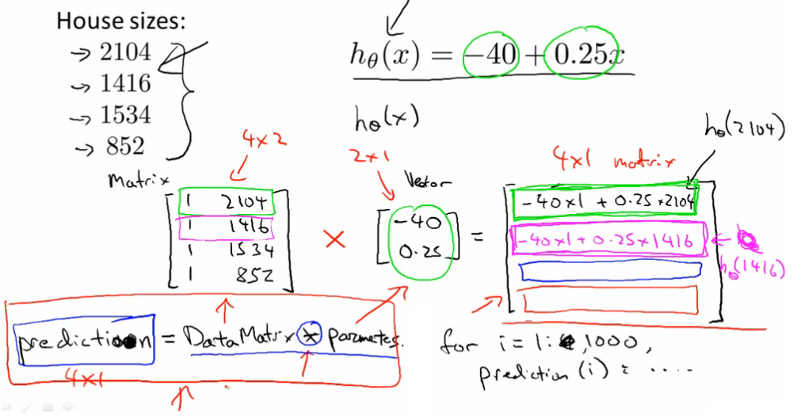
    - Here we add an extra column to the data with 1s - this means our θ0values can be calculated and expressed
* The diagram above shows how this works
  + This can be far more efficient computationally than lots of for loops
  + This is also easier and cleaner to code (assuming you have appropriate libraries to do matrix multiplication)
* ***Matrix-matrix multiplication***
  + General idea
    - Step through the second matrix one column at a time
    - Multiply each column vector from second matrix by the entire first matrix, each time generating a vector
    - The final product is these vectors combined (not added or summed, but literally just put together)
  + Details
    - A x B = C
      * A = [m x n]
      * B = [n x o]
      * C = [m x o]
        + With vector multiplications o = 1
    - Can only multiply matrix where columns in A match rows in B
  + Mechanism
    - Take column 1 of B, treat as a vector
    - Multiply A by that column - generates an [m x 1] vector
    - Repeat for each column in B
      * There are o columns in B, so we get o columns in C
  + Summary
    - *The i thcolumn of matrix C is obtained by multiplying A with the i thcolumn of B*
  + Start with an example
  + A x B

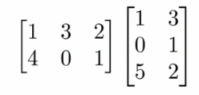

* Initially
  + Take matrix A and multiply by the first column vector from B
  + Take the matrix A and multiply by the second column vector from B

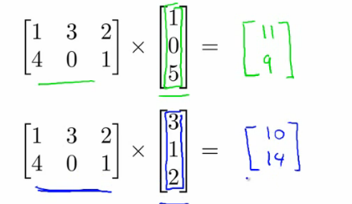

* 2 x 3 times 3 x 2 gives you a 2 x 2 matrix

**Implementation/use**

* House prices, but now we have three hypothesis and the same data set
* To apply all three hypothesis to all data we can do this efficiently using matrix-matrix multiplication
  + Have
    - Data matrix
    - Parameter matrix
  + Example
    - Four houses, where we want to predict the prize
    - Three competing hypotheses
    - Because our hypothesis are one variable, to make the matrices match up we make our data (houses sizes) vector into a 4x2 matrix by adding an extra column of 1s

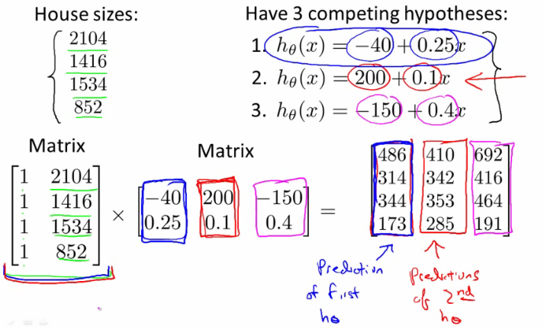

* What does this mean
  + Can quickly apply three hypotheses at once, making 12 predictions
  + Lots of good linear algebra libraries to do this kind of thing very efficiently

**Matrix multiplication properties**

* Can pack a lot into one operation
  + However, should be careful of how you use those operations
  + Some interesting properties
* **Commutativity**
  + When working with raw numbers/scalars multiplication is commutative
    - 3 * 5 == 5 * 3
  + This is not true for matrix
    - A x B != B x A
    - **Matrix multiplication is not commutative**
* **Associativity**
  + 3 x 5 x 2 == 3 x 10 = 15 x 2
    - Associative property
  + **Matrix multiplications is associative**
    - A x (B x C) == (A x B) x C
* **Identity matrix**
  + 1 is the identity for any scalar
    - i.e. 1 x z = z
      * for any real number
  + In matrices we have an identity matrix called *I*
    - Sometimes called *I*{n x n}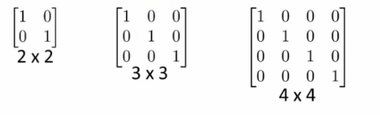
* See some identity matrices above
  + Different identity matrix for each set of dimensions
  + Has
    - 1s along the diagonals
    - 0s everywhere else
  + 1x1 matrix is just "1"
* Has the property that any matrix A which can be multiplied by an identity matrix gives you matrix A back
  + So if A is [m x n] then
    - A * I
      * I = n x n
    - I * A
      * I = m x m
    - (To make inside dimensions match to allow multiplication)
* Identity matrix dimensions are implicit
* Remember that matrices are not commutative AB != BA
  + Except when B is the identity matrix
  + Then AB == BA

**Inverse and transpose operations**

* **Matrix inverse**
  + How does the concept of "the inverse" relate to real numbers?
    - 1 = "identity element" (as mentioned above)
      * Each number has an inverse
        + This is the number you multiply a number by to get the identify element
        + i.e. if you have x, x * 1/x = 1
    - e.g. given the number 3
      * 3 * 3-1 = 1 (the identity number/matrix)
    - In the space of real numbers **not everything has an inverse**
      * e.g. 0 does not have an inverse
  + What is the inverse of a matrix
    - If A is an m x m matrix, then A inverse = A-1
    - So A*A-1 = *I*
    - Only matrices which are m x m have inverses
      * Square matrices only!
  + Example
    - 2 x 2 matrix  
      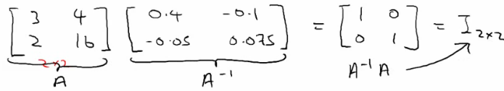
    - How did you find the inverse
      * Turns out that you can sometimes do it by hand, although this is very hard
      * Numerical software for computing a matrices inverse
        + Lots of open source libraries
  + If A is all zeros then there is no inverse matrix
    - Some others don't, intuition should be matrices that don't have an inverse are a singular matrix or a degenerate matrix (i.e. when it's too close to 0)
    - So if all the values of a matrix reach zero, this can be described as reaching singularity
* **Matrix transpose**
  + Have matrix A (which is [n x m]) how do you change it to become [m x n] while keeping the same values
    - i.e. swap rows and columns!
  + How you do it;
    - Take first row of A - becomes 1st column of A*T*
    - Second row of A - becomes 2nd column...
  + A is an m x n matrix
    - B is a transpose of A
    - Then B is an n x m matrix
    - A(i,j) = B(j,i)

