**04: Linear Regression with Multiple Variables**

[Previous](http://www.holehouse.org/mlclass/03_Linear_algebra_review.html) [Next](http://www.holehouse.org/mlclass/05_Octave.html) [Index](http://www.holehouse.org/mlclass/index.html)

**Linear regression with multiple features**

*New version of linear regression with multiple features*

* Multiple variables = multiple features
* In original version we had
  + X = house size, use this to predict
  + y = house price
* If in a new scheme we have more variables (such as number of bedrooms, number floors, age of the home)
  + x1, x2, x3,x4are the four features
    - x1 - size (feet squared)
    - x2 - Number of bedrooms
    - x3 - Number of floors
    - x4 - Age of home (years)
  + y is the output variable (price)
* More notation
  + **n**
    - number of features (n = 4)
  + **m**
    - number of examples (i.e. number of rows in a table)
  + **xi**
    - vector of the input for an example (so a vector of the four parameters for the ithinput example)
    - i is an index into the training set
    - So
      * x is an n-dimensional feature vector
      * x3 is, for example, the 3rd house, and contains the four features associated with that house
  + **xji**
    - The value of feature j in the ith training example
    - So
      * x23is, for example, the number of bedrooms in the third house
* Now we have multiple features
  + What is the form of our hypothesis?
  + Previously our hypothesis took the form;
    - hθ(x) = θ0 + θ1x
      * Here we have two parameters (theta 1 and theta 2) determined by our cost function
      * One variable x
  + Now we have multiple features
    - hθ(x) = θ0 + θ1x1 + θ2x2 + θ3x3 + θ4x4
  + For example  
    - hθ(x) = 80 + 0.1x1 + 0.01x2 + 3x3 - 2x4
      * An example of a hypothesis which is trying to predict the price of a house
      * Parameters are still determined through a cost function
  + For convenience of notation, x0 = 1
    - For every example i you have an additional 0th feature for each example
    - So now your **feature vector** is n + 1 dimensional feature vector indexed from 0
      * This is a column vector called x
      * Each example has a column vector associated with it
      * So let's say we have a new example called "X"
    - **Parameters** are also in a 0 indexed n+1 dimensional vector
      * This is also a column vector called θ
      * This vector is the same for each example
  + Considering this, hypothesis can be written
    - hθ(x) = θ0x0 + θ1x1 + θ2x2 + θ3x3 + θ4x4
  + If we do
    - hθ(x) =θ*T* X
      * θ*T*is an [1 x n+1] matrix
      * In other words, because θis a column vector, the transposition operation transforms it into a row vector
      * So before
        + θwas a matrix [n + 1 x 1]
      * Now
        + θ*T*is a matrix [1 x n+1]
      * Which means the inner dimensions of θ*T* and X match, so they can be multiplied together as
        + [1 x n+1] * [n+1 x 1]
        + = hθ(x)
        + So, in other words, the transpose of our parameter vector * an input example X gives you a predicted hypothesis which is [1 x 1] dimensions (i.e. a single value)
    - This x0 = 1 lets us write this like this
  + This is an example of multivariate linear regression

**Gradient descent for multiple variables**

* Fitting parameters for the hypothesis with gradient descent
  + Parameters are θ0 to θn
  + Instead of thinking about this as n separate values, think about the parameters as a single vector (θ)
    - Where θ is n+1 dimensional
* Our cost function is

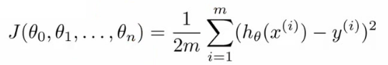

* Similarly, instead of thinking of J as a function of the n+1 numbers, J() is just a function of the parameter vector
  + J(θ)
* **Gradient descent**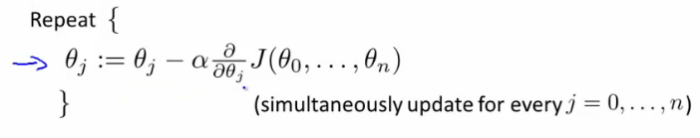
* Once again, this is
  + θj = θj - learning rate (α) times the partial derivative of J(θ) with respect to θJ(...)
  + We do this through a **simultaneous update** of every θj value
* Implementing this algorithm
  + When n = 1

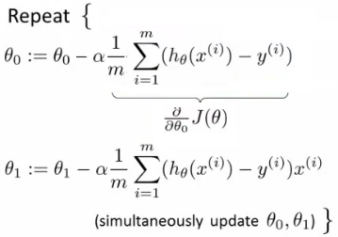

* Above, we have slightly different update rules for θ0 and θ1
  + Actually they're the same, except the end has a previously undefined x0(i) as 1, so wasn't shown
* We now have an almost identical rule for multivariate gradient descent

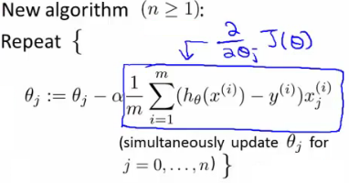

* What's going on here?
  + We're doing this for each j (0 until n) as a simultaneous update (like when n = 1)
  + So, we re-set θj to
    - θj minus the learning rate (α) times the partial derivative of of the θ vector with respect to θj
    - In non-calculus words, this means that we do
      * Learning rate
      * Times 1/m (makes the maths easier)
      * Times the sum of
        + The hypothesis taking in the variable vector, minus the actual value, times the j-th value in that variable vector for EACH example
  + It's important to remember that  
    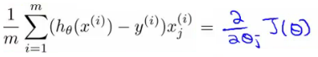
* These algorithm are highly similar

**Gradient Decent in practice: 1 Feature Scaling**

* Having covered the theory, we now move on to learn about some of the practical tricks
* Feature scaling
  + If you have a problem with multiple features
  + You should make sure those features have a similar scale
    - Means gradient descent will converge more quickly
  + e.g.
    - x1 = size (0 - 2000 feet)
    - x2 = number of bedrooms (1-5)
    - Means the contours generated if we plot θ1 vs. θ2 give a very tall and thin shape due to the huge range difference
  + Running gradient descent on this kind of cost function can take a long time to find the global minimum

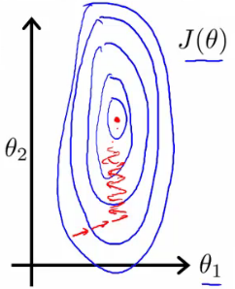

* Pathological input to gradient descent
  + So we need to rescale this input so it's more effective
  + So, if you define each value from x1 and x2 by dividing by the max for each feature
  + Contours become more like circles (as scaled between 0 and 1)
* May want to get everything into -1 to +1 range (approximately)
  + Want to avoid large ranges, small ranges or very different ranges from one another
  + Rule a thumb regarding acceptable ranges
    - -3 to +3 is generally fine - any bigger bad
    - -1/3 to +1/3 is ok - any smaller bad
* Can do **mean normalization**
  + Take a feature xi
    - Replace it by (xi - mean)/max
    - So your values all have an average of about 0

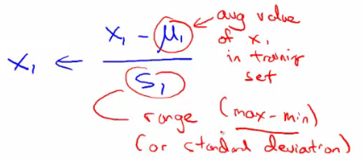

* Instead of max can also use standard deviation

**Learning Rate α**

* Focus on the learning rate (α)
* Topics
  + Update rule
  + Debugging
  + How to chose α

**Make sure gradient descent is working**

* Plot min J(θ) vs. no of iterations
  + (i.e. plotting J(θ) over the course of gradient descent
* If gradient descent is working then J(θ) should decrease after every iteration
* Can also show if you're not making huge gains after a certain number
  + Can apply heuristics to reduce number of iterations if need be
  + If, for example, after 1000 iterations you reduce the parameters by nearly nothing you could chose to only run 1000 iterations in the future
  + Make sure you don't accidentally hard-code thresholds like this in and then forget about why they're their though!
* 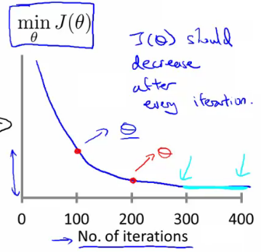
  + Number of iterations varies a lot
    - 30 iterations
    - 3000 iterations
    - 3000 000 iterations
    - Very hard to tel in advance how many iterations will be needed
    - Can often make a guess based a plot like this after the first 100 or so iterations
  + Automatic convergence tests
    - Check if J(θ) changes by a small threshold or less
      * Choosing this threshold is hard
      * So often easier to check for a straight line
        + Why? - Because we're seeing the straightness in the context of the whole algorithm
        + Could you design an automatic checker which calculates a threshold based on the systems preceding progress?
  + Checking its working
    - If you plot J(θ) vs iterations and see the value is increasing - means you probably need a smaller α
      * Cause is because your minimizing a function which looks like this

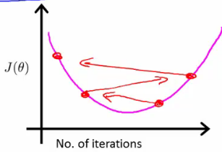

* + But you overshoot, so reduce learning rate so you actually reach the minimum (green line)

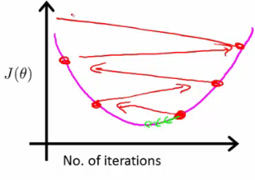

* + So, use a smaller α
* Another problem might be if J(θ) looks like a series of waves
  + Here again, you need a smaller α
* However
  + If α is small enough, J(θ) will decrease on every iteration
  + BUT, if α is too small then rate is too slow
    - A less steep incline is indicative of a slow convergence, because we're decreasing by less on each iteration than a steeper slope
* Typically
  + Try a range of alpha values
  + Plot J(θ) vs number of iterations for each version of alpha
  + Go for roughly threefold increases
    - 0.001, 0.003, 0.01, 0.03. 0.1, 0.3

**Features and polynomial regression**

* Choice of features and how you can get different learning algorithms by choosing appropriate features
* Polynomial regression for non-linear function
* Example
  + House price prediction
    - Two features
      * Frontage - width of the plot of land along road (x1)
      * Depth - depth away from road (x2)
  + You don't have to use just two features
    - **Can create new features**
  + Might decide that an important feature is the land area
    - So, create a new feature = frontage * depth (x3)
    - h(x) = θ0 + θ1x3
      * Area is a better indicator
  + Often, by defining new features you may get a better model
* Polynomial regression
  + May fit the data better
  + θ0 + θ1x + θ2x2 e.g. here we have a quadratic function
  + For housing data could use a quadratic function
    - But may not fit the data so well - inflection point means housing prices decrease when size gets really big
    - So instead must use a cubic function

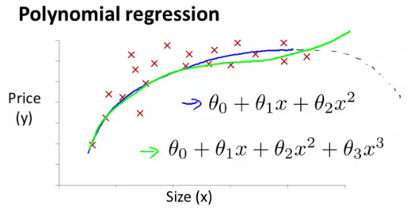

* How do we fit the model to this data
  + To map our old linear hypothesis and cost functions to these polynomial descriptions the easy thing to do is set
    - x1 = x
    - x2 = x2
    - x3 = x3
  + By selecting the features like this and applying the linear regression algorithms you can do polynomial linear regression
  + Remember, feature scaling becomes even more important here
* Instead of a conventional polynomial you could do variable ^(1/something) - i.e. square root, cubed root etc
* Lots of features - later look at developing an algorithm to chose the best features

**Normal equation**

* For some linear regression problems the normal equation provides a better solution
* So far we've been using gradient descent
  + Iterative algorithm which takes steps to converse
* Normal equation solves θ analytically
  + Solve for the optimum value of theta
* Has some advantages and disadvantages

**How does it work?**

* Simplified cost function
  + J(θ) = aθ2+ bθ + c
    - θ is just a real number, not a vector
  + Cost function is a quadratic function
  + How do you minimize this?
    - Do
      * http://www.holehouse.org/mlclass/04_Linear_Regression_with_multiple_variables_files/Image%20%5b11%5d.png
        + Take derivative of J(θ) with respect to θ
        + Set that derivative equal to 0
        + Allows you to solve for the value of θ which minimizes J(θ)
* In our more complex problems;
  + Here θ is an n+1 dimensional vector of real numbers
  + Cost function is a function of the vector value
    - How do we minimize this function
      * Take the partial derivative of J(θ) with respect θjand set to 0 for every j
      * Do that and solve for θ0 to θn
      * This would give the values of θ which minimize J(θ)
  + If you work through the calculus and the solution, the derivation is pretty complex
    - Not going to go through here
    - Instead, what do you need to know to implement this process

**Example of normal equation**

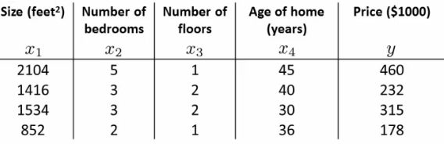

* Here
  + m = 4
  + n = 4
* To implement the normal equation
  + Take examples
  + Add an extra column (x0 feature)
  + Construct a matrix (X - **the design matrix**) which contains all the training data features in an [m x n+1] matrix
  + Do something similar for y
    - Construct a column vector y vector [m x 1] matrix
  + Using the following equation (X transpose * X) inverse times X transpose y  
    http://www.holehouse.org/mlclass/04_Linear_Regression_with_multiple_variables_files/Image%20%5b13%5d.png

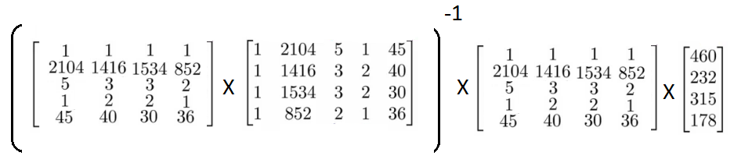

* If you compute this, you get the value of theta which minimize the cost function

**General case**

* Have m training examples and n features
  + The **design matrix** (X)
    - Each training example is a n+1 dimensional feature column vector
    - X is constructed by taking each training example, determining its transpose (i.e. column -> row) and using it for a row in the design A
    - This creates an [m x (n+1)] matrix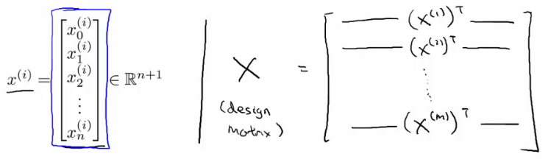
  + **Vector y**
    - Used by taking all the y values into a column vector

http://www.holehouse.org/mlclass/04_Linear_Regression_with_multiple_variables_files/Image%20%5b16%5d.png

* What is this equation?!
  + (X*T* * X)-1
    - What is this --> the inverse of the matrix (X*T*\* X)
      * i.e. A = X*T*X
      * A-1= (X*T*X)-1
* In octave and MATLAB you could do;  
    
  **pinv(X'*x)*x'*y**
  + - X' is the notation for X transpose
    - pinv is a function for the inverse of a matrix
* In a previous lecture discussed feature scaling
  + If you're using the normal equation then no need for feature scaling

**When should you use gradient descent and when should you use feature scaling?**

* + ***Gradient descent***
    - Need to chose learning rate
    - Needs many iterations - could make it slower
    - Works well even when *n* is massive (millions)
      * Better suited to big data
      * What is a big *n* though
        + 100 or even a 1000 is still (relativity) small
        + If n is 10 000 then look at using gradient descent
  + ***Normal equation***
    - No need to chose a learning rate
    - No need to iterate, check for convergence etc.
    - Normal equation needs to compute (X*T*X)-1
      * This is the inverse of an n x n matrix
      * With most implementations computing a matrix inverse grows by O(n3)
        + So not great
    - Slow of *n* is large
      * Can be much slower

**Normal equation and non-invertibility**

* Advanced concept
  + Often asked about, but quite advanced, perhaps optional material
  + Phenomenon worth understanding, but not probably necessary
* When computing (X*T*X)-1 * X*T*\* y)
  + What if (X*T*X) is non-invertible (singular/degenerate)
    - Only some matrices are invertible
    - This should be quite a rare problem
      * Octave can invert matrices using
        + pinv (pseudo inverse)

This gets the right value even if (X*T*X) is non-invertible

* + - * + inv (inverse)
  + What does it mean for (X*T*X) to be non-invertible
    - Normally two common causes
      * **Redundant features** in learning model
        + e.g.

x1 = size in feet

x2 = size in meters squared

* + - * **Too many features**
        + e.g. m <= n (m is much larger than n)

m = 10

n = 100

* + - * + Trying to fit 101 parameters from 10 training examples
        + Sometimes work, but not always a good idea
        + Not enough data
        + Later look at *why* this may be too little data
        + To solve this we

Delete features

Use **regularization** (let's you use lots of features for a small training set)

* + If you find (X*T*X) to be non-invertible
    - Look at features --> are features linearly dependent?
      * So just delete one, will solve problem