**06: Logistic Regression**

[Previous](http://www.holehouse.org/mlclass/05_Octave.html) [Next](http://www.holehouse.org/mlclass/07_Regularization.html) [Index](http://www.holehouse.org/mlclass/index.html)

**Classification**

* Where y is a discrete value
  + Develop the logistic regression algorithm to determine what class a new input should fall into
* Classification problems
  + Email -> spam/not spam?
  + Online transactions -> fraudulent?
  + Tumor -> Malignant/benign
* Variable in these problems is Y
  + Y is either 0 or 1
    - 0 = negative class (absence of something)
    - 1 = positive class (presence of something)
* Start with **binary class problems**
  + Later look at multiclass classification problem, although this is just an extension of binary classification
* How do we develop a classification algorithm?
  + Tumour size vs malignancy (0 or 1)
  + We *could* use linear regression
    - Then threshold the classifier output (i.e. anything over some value is yes, else no)
    - In our example below linear regression with thresholding seems to work

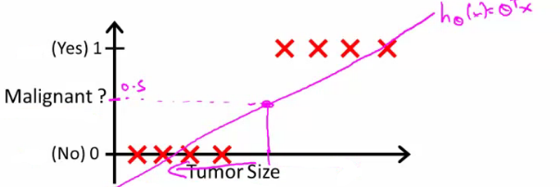

* We can see above this does a reasonable job of stratifying the data points into one of two classes
  + But what if we had a single Yes with a very small tumour
  + This would lead to classifying all the existing yeses as nos
* Another issues with linear regression
  + We know Y is 0 or 1
  + Hypothesis can give values large than 1 or less than 0
* So, logistic regression generates a value where is always either 0 or 1
  + Logistic regression is a **classification algorithm** - don't be confused

**Hypothesis representation**

* What function is used to represent our hypothesis in classification
* We want our classifier to output values between 0 and 1
  + When using linear regression we did hθ(x) = (θ*T* x)
  + For classification hypothesis representation we do hθ(x) = g((θ*T* x))
    - Where we define g(z)
      * z is a real number
    - g(z) = 1/(1 + e*-z*)
      * This is the **sigmoid function**, or the **logistic function**
    - If we combine these equations we can write out the hypothesis as  
      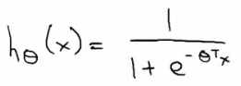
* What does the sigmoid function look like
* Crosses 0.5 at the origin, then flattens out]
  + Asymptotes at 0 and 1

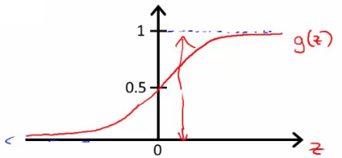

* Given this we need to fit θ to our data

**Interpreting hypothesis output**

* When our hypothesis (hθ(x)) outputs a number, we treat that value as the estimated probability that y=1 on input x
  + Example
    - If X is a feature vector with x0 = 1 (as always) and x1 = tumourSize
    - hθ(x) = 0.7
      * Tells a patient they have a 70% chance of a tumor being malignant
  + We can write this using the following notation
    - hθ(x) = P(y=1|x ; θ)
  + What does this mean?
    - Probability that y=1, given x, parameterized by θ
* Since this is a binary classification task we know y = 0 or 1
  + So the following must be true
    - P(y=1|x ; θ) + P(y=0|x ; θ) = 1
    - P(y=0|x ; θ) = 1 - P(y=1|x ; θ)

**Decision boundary**

* Gives a better sense of what the hypothesis function is computing
* Better understand of what the hypothesis function looks like
  + One way of using the sigmoid function is;
    - When the probability of y being 1 is greater than 0.5 then we can predict y = 1
    - Else we predict y = 0
  + When is it exactly that hθ(x) is greater than 0.5?
    - Look at sigmoid function
      * g(z) is greater than or equal to 0.5 when z is greater than or equal to 0  
        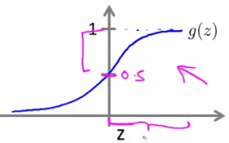
    - So if z is positive, g(z) is greater than 0.5
      * z = (θ*T* x)
    - So when
      * θ*T* x >= 0
    - Then hθ >= 0.5
* So what we've shown is that the hypothesis predicts y = 1 when θ*T* x >= 0
  + The corollary of that when θ*T* x <= 0 then the hypothesis predicts y = 0
  + Let's use this to better understand how the hypothesis makes its predictions

**Decision boundary**

* hθ(x) = g(θ0 + θ1x1+ θ2x2)

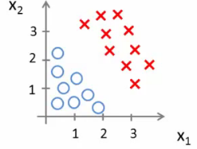

* So, for example
  + θ0 = -3
  + θ1 = 1
  + θ2 = 1
* So our parameter vector is a column vector with the above values
  + So, θ*T* is a row vector = [-3,1,1]
* What does this mean?
  + The z here becomes θ*T* x
  + We predict "y = 1" if
    - -3x0 + 1x1 + 1x2 >= 0
    - -3 + x1 + x2 >= 0
* We can also re-write this as
  + If (x1 + x2 >= 3) then we predict y = 1
  + If we plot
    - x1 + x2 = 3 we graphically plot our **decision boundary**

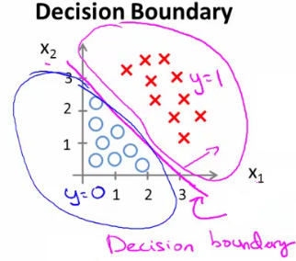

* Means we have these two regions on the graph
  + Blue = false
  + Magenta = true
  + Line = decision boundary
    - Concretely, the straight line is the set of points where hθ(x) = 0.5 exactly
  + The decision boundary is a property of the hypothesis
    - Means we can create the boundary with the hypothesis and parameters without any data
      * Later, we use the data to determine the parameter values
    - i.e. y = 1 if
      * 5 - x1 > 0
      * 5 > x1

**Non-linear decision boundaries**

* Get logistic regression to fit a complex non-linear data set
  + Like polynomial regress add higher order terms
  + So say we have
    - hθ(x) = g(θ0 + θ1x1+ θ3x12 + θ4x22)
    - We take the transpose of the θ vector times the input vector
      * Say θT was [-1,0,0,1,1] then we say;
      * Predict that "y = 1" *if*
        + -1 + x12 + x22 >= 0  
          or
        + x12 + x22 >= 1
      * If we plot x12 + x22 = 1
        + This gives us a circle with a radius of 1 around 0

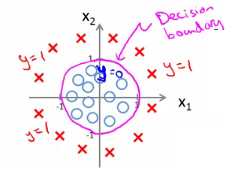

* Mean we can build more complex decision boundaries by fitting complex parameters to this (relatively) simple hypothesis
* More complex decision boundaries?
  + By using higher order polynomial terms, we can get even more complex decision boundaries

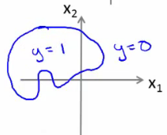

**Cost function for logistic regression**

* Fit θ parameters
* Define the optimization object for the cost function we use the fit the parameters
  + Training set of *m* training examples
    - Each example has is n+1 length column vector

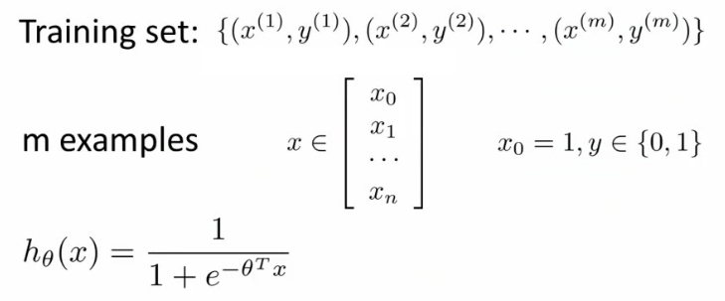

* This is the situation
  + Set of m training examples
  + Each example is a feature vector which is n+1 dimensional
  + x0 = 1
  + y ∈ {0,1}
  + Hypothesis is based on parameters (θ)
    - Given the training set how to we chose/fit θ?
* Linear regression uses the following function to determine θ

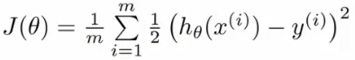

* Instead of writing the squared error term, we can write
  + If we define "cost()" as;
    - cost(hθ(xi), y) = 1/2(hθ(xi) - yi)2
    - Which evaluates to the cost for an individual example using the same measure as used in linear regression
  + We can **redefine J(θ) as**  
    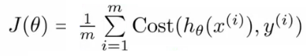
    - Which, appropriately, is the sum of all the individual costs over the training data (i.e. the same as linear regression)
* To further simplify it we can get rid of the superscripts
  + So  
    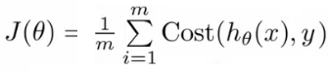
* What does this actually mean?
  + This is the cost you want the learning algorithm to pay if the outcome is hθ(x) and the actual outcome is y
  + If we use this function for logistic regression this is a **non-convex function** for parameter optimization
    - Could work....
* What do we mean by non convex?
  + We have some function - J(θ) - for determining the parameters
  + Our hypothesis function has a non-linearity (sigmoid function of hθ(x) )
    - This is a complicated non-linear function
  + If you take hθ(x) and plug it into the Cost() function, and them plug the Cost() function into J(θ) and plot J(θ) we find many local optimum -> *non convex function*
  + Why is this a problem
    - Lots of local minima mean gradient descent may not find the global optimum - may get stuck in a global minimum
  + We would like a convex function so if you run gradient descent you converge to a global minimum

**A convex logistic regression cost function**

* To get around this we need a different, convex Cost() function which means we can apply gradient descent

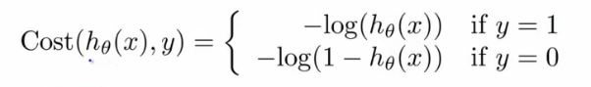

* **This is our logistic regression cost function**
  + This is the penalty the algorithm pays
  + Plot the function
* Plot y = 1
  + So hθ(x) evaluates as -log(hθ(x))

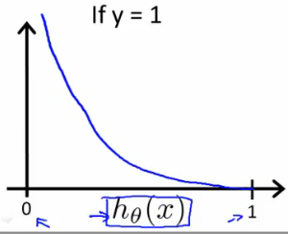

* So when we're right, cost function is 0
  + Else it slowly increases cost function as we become "more" wrong
  + X axis is what we predict
  + Y axis is the cost associated with that prediction
* This cost functions has some interesting properties
  + If y = 1 and hθ(x) = 1
    - If hypothesis predicts exactly 1 and thats exactly correct then that corresponds to 0 (exactly, not nearly 0)
  + As hθ(x) goes to 0
    - Cost goes to infinity
    - This captures the intuition that if hθ(x) = 0 (predict *P*(y=1|x; θ) = 0) but y = 1 this will penalize the learning algorithm with a massive cost
* What about if y = 0
* then cost is evaluated as -log(1- hθ( x ))
  + Just get inverse of the other function

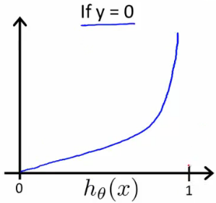

* Now it goes to plus infinity as hθ(x) goes to 1
* With our particular cost functions J(θ) is going to be convex and avoid local minimum

**Simplified cost function and gradient descent**

* Define a simpler way to write the cost function and apply gradient descent to the logistic regression
  + By the end should be able to implement a fully functional logistic regression function
* Logistic regression cost function is as follows

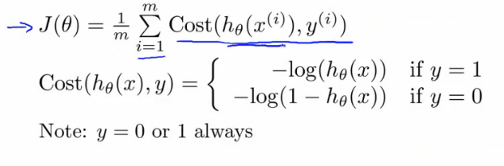

* This is the cost for a single example
  + For binary classification problems y is always 0 or 1
    - Because of this, we can have a simpler way to write the cost function
      * Rather than writing cost function on two lines/two cases
      * Can compress them into one equation - more efficient
  + Can write cost function is
    - **cost(hθ,(x),y) = -ylog( hθ(x) ) - (1-y)log( 1- hθ(x) )**
      * This equation is a more compact of the two cases above
  + We know that there are only two possible cases
    - y = 1
      * Then our equation simplifies to
        + -log(hθ(x)) - (0)log(1 - hθ(x))

-log(hθ(x))

Which is what we had before when y = 1

* + - y = 0
      * Then our equation simplifies to  
        + -(0)log(hθ(x)) - (1)log(1 - hθ(x))
        + = -log(1- hθ(x))
        + Which is what we had before when y = 0
    - Clever!
* So, in summary, our cost function for the θ parameters can be defined as



* Why do we chose this function when other cost functions exist?
  + This cost function can be derived from statistics using the principle of **maximum likelihood estimation**
    - Note this does mean there's an underlying Gaussian assumption relating to the distribution of features
  + Also has the nice property that it's convex
* To fit parameters θ:
  + Find parameters θ which minimize J(θ)
  + This means we have a set of parameters to use in our model for future predictions
* Then, if we're given some new example with set of features x, we can take the θ which we generated, and output our prediction using  
          http://www.holehouse.org/mlclass/06_Logistic_Regression_files/Image%20%5b17%5d.png
  + This result is
    - p(y=1 | x ; θ)
      * Probability y = 1, given x, parameterized by θ

**How to minimize the logistic regression cost function**

* Now we need to figure out how to minimize J(θ)
  + Use gradient descent as before
  + Repeatedly update each parameter using a learning rate

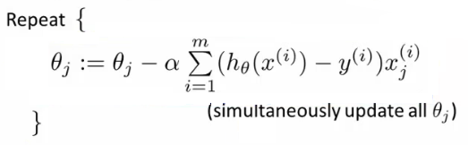

* If you had *n*features, you would have an n+1 column vector for θ
* This equation is the same as the linear regression rule
  + The only difference is that our definition for the hypothesis has changed
* Previously, we spoke about how to monitor gradient descent to check it's working
  + Can do the same thing here for logistic regression
* When implementing logistic regression with gradient descent, we have to update all the θ values (θ0 to θn) simultaneously
  + Could use a for loop
  + Better would be a vectorized implementation
* Feature scaling for gradient descent for logistic regression also applies here

**Advanced optimization**

* Previously we looked at gradient descent for minimizing the cost function
* Here look at advanced concepts for minimizing the cost function for logistic regression
  + Good for large machine learning problems (e.g. huge feature set)
* *What is gradient descent actually doing?*
  + We have some cost function J(θ), and we want to minimize it
  + We need to write code which can take θ as input and compute the following
    - J(θ)
    - Partial derivative if J(θ) with respect to j (where j=0 to j = n)

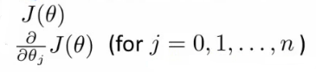

* Given code that can do these two things
  + Gradient descent repeatedly does the following update

**http://www.holehouse.org/mlclass/06_Logistic_Regression_files/Image%20%5b20%5d.png**

* So update each j in θ sequentially
* So, we must;
  + Supply code to compute J(θ) and the derivatives
  + Then plug these values into gradient descent
* Alternatively, instead of gradient descent to minimize the cost function we could use
  + **Conjugate gradient**
  + **BFGS** (Broyden-Fletcher-Goldfarb-Shanno)
  + **L-BFGS** (Limited memory - BFGS)
* These are more optimized algorithms which take that same input and minimize the cost function
* These are *very*complicated algorithms
* Some properties
  + **Advantages**
    - No need to manually pick alpha (learning rate)
      * Have a clever inner loop (line search algorithm) which tries a bunch of alpha values and picks a good one
    - Often faster than gradient descent
      * Do more than just pick a good learning rate
    - Can be used successfully without understanding their complexity
  + **Disadvantages**
    - Could make debugging more difficult
    - Should not be implemented themselves
    - Different libraries may use different implementations - may hit performance

**Using advanced cost minimization algorithms**

* How to use algorithms
  + Say we have the following example

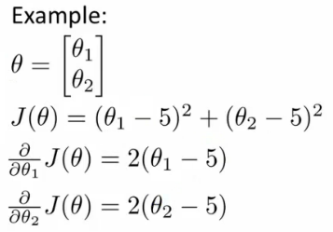

* Example above
  + θ1 and θ2 (two parameters)
  + Cost function here is J(θ) = (θ1 - 5)2 + ( θ2 - 5)2
  + The derivatives of the J(θ) with respect to either θ1 and θ2 turns out to be the 2(θi - 5)
* First we need to define our cost function, which should have the following signature

**function [jval, gradent] = costFunction(THETA)**

* Input for the cost function is **THETA**, which is a vector of the θ parameters
* Two return values from **costFunction** are
  + **jval**
    - How we compute the cost function θ (the underived cost function)
      * In this case = (θ1 - 5)2 + (θ2 - 5)2
  + **gradient**
    - 2 by 1 vector
    - 2 elements are the two partial derivative terms
    - i.e. this is an n-dimensional vector
      * Each indexed value gives the partial derivatives for the partial derivative of J(θ) with respect to θi
      * Where i is the index position in the **gradient** vector
* With the cost function implemented, we can call the advanced algorithm using

**options**= optimset('GradObj', 'on', 'MaxIter', '100'); **% define the options data structure**

**initialTheta**= zeros(2,1); # set the initial dimensions for theta **% initialize the theta values**

**[optTheta, funtionVal, exitFlag]**= fminunc(@costFunction, initialTheta, options); **% run the algorithm**

* Here
  + **options** is a data structure giving options for the algorithm
  + **fminunc**
    - function minimize the cost function (**f**ind **min**imum of **unc**onstrained multivariable function)
  + **@costFunction** is a pointer to the costFunction function to be used
* For the octave implementation
  + **initialTheta** must be a matrix of at least two dimensions
* How do we apply this to logistic regression?
  + Here we have a vector

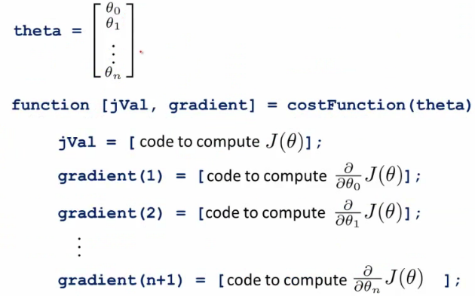

* Here
  + theta is a n+1 dimensional column vector
  + Octave indexes from 1, not 0
* Write a cost function which captures the cost function for logistic regression

**Multiclass classification problems**

* Getting logistic regression for multiclass classification using **one vs. all**
* Multiclass - more than yes or no (1 or 0)
  + Classification with multiple classes for assignment

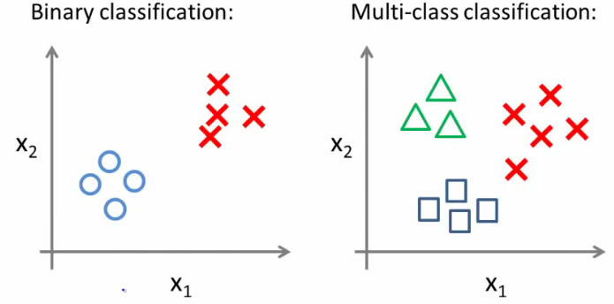

* Given a dataset with three classes, how do we get a learning algorithm to work?
  + Use one vs. all classification make binary classification work for multiclass classification
* **One vs. all classification**
  + Split the training set into three separate binary classification problems
    - i.e. create a new fake training set
      * Triangle (1) vs crosses and squares (0) hθ1(x)
        + P(y=1 | x1; θ)
      * Crosses (1) vs triangle and square (0) hθ2(x)
        + P(y=1 | x2; θ)
      * Square (1) vs crosses and square (0) hθ3(x)
        + P(y=1 | x3; θ)

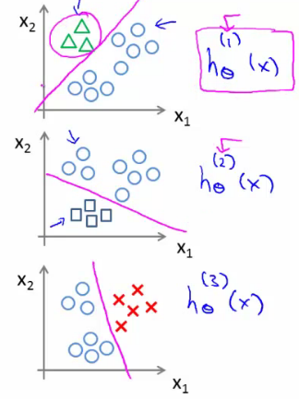

* **Overall**
  + Train a logistic regression classifier hθ(i)(x) for each class i to predict the probability that y = i
  + On a new input, *x* to make a prediction, pick the class *i* that maximizes the probability that hθ(i)(x) = 1