**The problem of overfitting**

* So far we've seen a few algorithms - work well for many applications, but can suffer from the problem of overfitting
* What is overfitting?
* What is regularization and how does it help

**Overfitting with linear regression**

* Using our house pricing example again
  + Fit a linear function to the data - not a great model
    - This is **underfitting** - also known as **high bias**
    - Bias is a historic/technical one - if we're fitting a straight line to the data we have a strong preconception that there should be a linear fit
      * In this case, this is not correct, but a straight line can't help being straight!
  + Fit a quadratic function
    - Works well
  + Fit a 4th order polynomial
    - Now curve fit's through all five examples
      * Seems to do a good job fitting the training set
      * But, despite fitting the data we've provided very well, this is actually not such a good model
    - This is **overfitting** - also known as **high variance**
  + Algorithm has high variance
    - High variance - if fitting high order polynomial then the hypothesis can basically fit any data
    - Space of hypothesis is too large

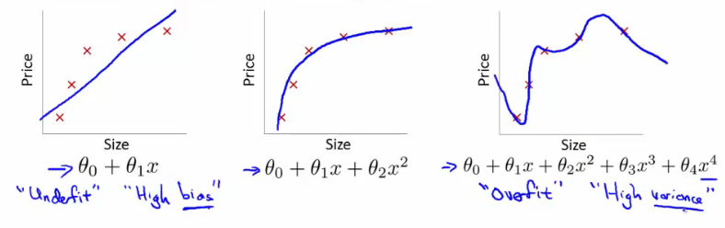

* To recap, if we have too many features then the learned hypothesis may give a cost function of exactly zero
  + But this tries too hard to fit the training set
  + Fails to provide a *general* solution - **unable to generalize** (apply to new examples)

**Overfitting with logistic regression**

* Same thing can happen to logistic regression
  + Sigmoidal function is an underfit
  + But a high order polynomial gives and overfitting (high variance hypothesis)

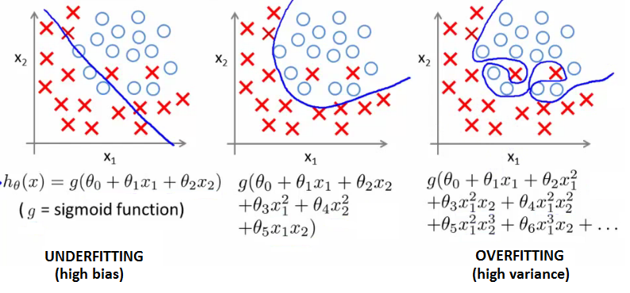

**Addressing overfitting**

* Later we'll look at identifying when overfitting and underfitting is occurring
* Earlier we just plotted a higher order function - saw that it looks "too curvy"
  + Plotting hypothesis is one way to decide, but doesn't always work
  + Often have lots of a features - here it's not just a case of selecting a degree polynomial, but also harder to plot the data and visualize to decide what features to keep and which to drop
  + If you have lots of features and little data - overfitting can be a problem
* How do we deal with this?
  + 1) **Reduce number of features**
    - Manually select which features to keep
    - Model selection algorithms are discussed later (good for reducing number of features)
    - But, in reducing the number of features we lose some information
      * Ideally select those features which minimize data loss, but even so, some info is lost
  + 2) **Regularization**
    - Keep all features, but reduce magnitude of parameters θ
    - Works well when we have a lot of features, each of which contributes a bit to predicting y

**Cost function optimization for regularization**

* Penalize and make some of the θ parameters really small
  + e.g. here θ3 and θ4

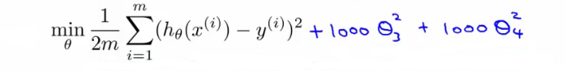

* The addition in blue is a modification of our cost function to help penalize θ3 and θ4
  + So here we end up with θ3 and θ4 being close to zero (because the constants are massive)
  + So we're basically left with a quadratic function

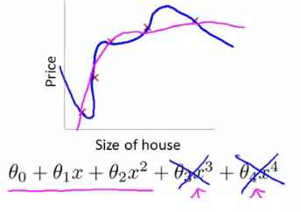

* In this example, we penalized two of the parameter values
  + More generally, regularization is as follows
* Regularization
  + Small values for parameters corresponds to a simpler hypothesis (you effectively get rid of some of the terms)
  + A simpler hypothesis is less prone to overfitting
* Another example
  + Have 100 features x1, x2, ..., x100
  + Unlike the polynomial example, we don't know what are the high order terms
    - How do we pick the ones to pick to shrink?
  + With regularization, take cost function and modify it to shrink all the parameters
    - Add a term at the end
      * This regularization term shrinks every parameter
      * By convention you don't penalize θ0 - minimization is from θ1 onwards

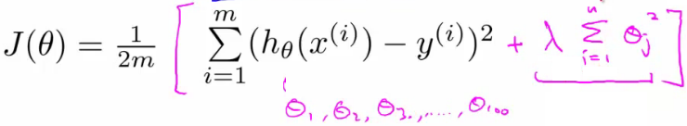

* In practice, if you include θ0 has little impact
* **λ**is the **regularization parameter**
  + Controls a trade off between our two goals
    - 1) Want to fit the training set well
    - 2) Want to keep parameters small
* With our example, using the **regularized objective** (i.e. the cost function with the regularization term) you get a much smoother curve which fits the data and gives a much better hypothesis
  + If **λ** is very large we end up penalizing ALL the parameters (θ1, θ2 etc.) so all the parameters end up being close to zero
    - If this happens, it's like we got rid of all the terms in the hypothesis
      * This results here is then underfitting
    - So this hypothesis is too biased because of the absence of any parameters (effectively)
* So, **λ**should be chosen carefully - not too big...
  + We look at some automatic ways to select **λ**later in the course

**Regularized linear regression**

* Previously, we looked at two algorithms for linear regression
  + Gradient descent
  + Normal equation
* Our linear regression with regularization is shown below

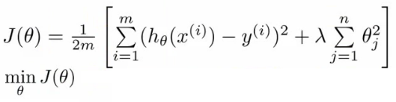

* Previously, gradient descent would repeatedly update the parameters θj, where j = 0,1,2...n simultaneously
  + Shown below

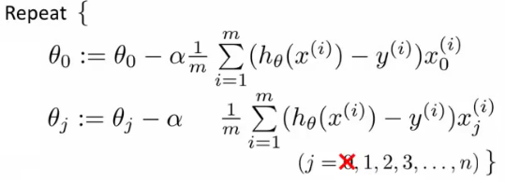

* We've got the θ0 update here shown explicitly
  + This is because for regularization we don't penalize θ0so treat it slightly differently
* How do we regularize these two rules?
  + Take the term and add λ/m * θj
    - Sum for every θ (i.e. j = 0 to n)
  + This gives regularization for gradient descent
* We can show using calculus that the equation given below is the partial derivative of the regularized J(θ)

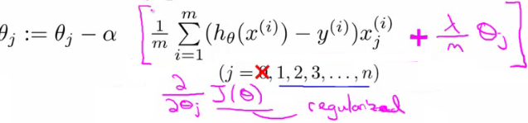

* The update for θj
  + θj gets updated to
    - θj- α * [a big term which also depends on θj]
* So if you group the θjterms together

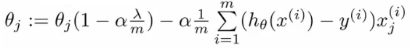

* The term   
      http://www.holehouse.org/mlclass/07_Regularization_files/Image%20%5b9%5d.png
  + Is going to be a number less than 1 usually
  + Usually learning rate is small and m is large
    - So this typically evaluates to (1 - a small number)
    - So the term is often around 0.99 to 0.95
* This in effect means θjgets multiplied by 0.99
  + Means the squared norm of θja little smaller
  + The second term is exactly the same as the original gradient descent

**Regularization with the normal equation**

* Normal equation is the other linear regression model
  + Minimize the J(θ) using the normal equation
  + To use regularization we add a term (+ λ [n+1 x n+1]) to the equation
    - [n+1 x n+1] is the n+1 identity matrix

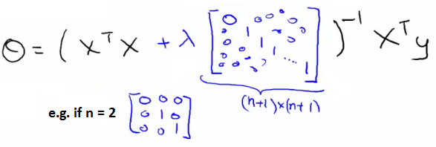

**Regularization for logistic regression**

* We saw earlier that logistic regression can be prone to overfitting with lots of features
* Logistic regression cost function is as follows;

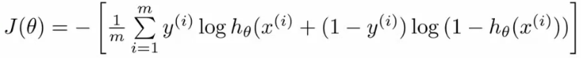

* To modify it we have to add an extra term  
  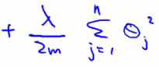
* This has the effect of penalizing the parameters θ1, θ2 up to θn
  + Means, like with linear regression, we can get what appears to be a better fitting lower order hypothesis
* How do we implement this?
  + Original logistic regression with gradient descent function was as follows  
    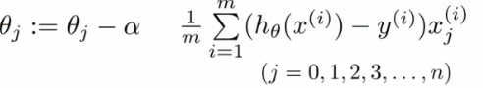
* Again, to modify the algorithm we simply need to modify the update rule for θ1, onwards
  + Looks cosmetically the same as linear regression, except obviously the hypothesis is very different  
    

**Advanced optimization of regularized linear regression**

* As before, define a costFunction which takes a θ parameter and gives jVal and gradient back

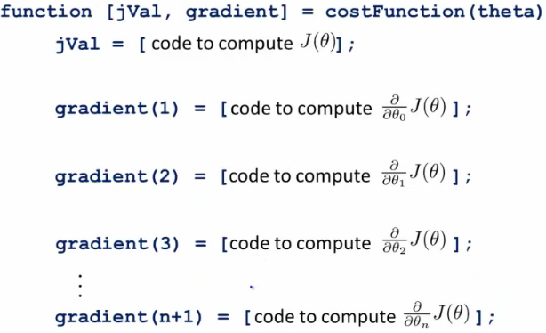

* use **fminunc**
  + Pass it an **@costfunction** argument
  + Minimizes in an optimized manner using the cost function
* **jVal**
  + Need code to compute J(θ)
    - Need to include regularization term
* Gradient
  + Needs to be the partial derivative of J(θ) with respect to θi
  + Adding the appropriate term here is also necessary

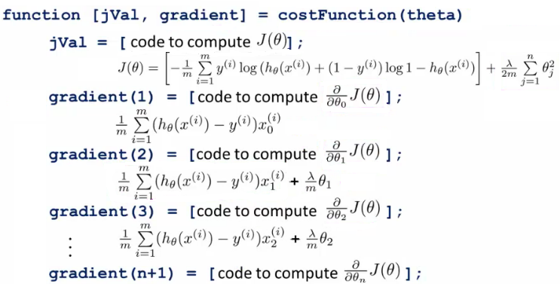

* Ensure summation doesn't extend to to the lambda term!
  + It doesn't, but, you know, don't be daft!