**Support Vector Machine (SVM) - Optimization objective**

* So far, we've seen a range of different algorithms
  + With supervised learning algorithms - performance is pretty similar
    - What matters more often is;
      * The amount of training data
      * Skill of applying algorithms
* One final supervised learning algorithm that is widely used - **support vector machine (SVM)**
  + Compared to both logistic regression and neural networks, a SVM sometimes gives a cleaner way of learning non-linear functions
  + Later in the course we'll do a survey of different supervised learning algorithms

**An alternative view of logistic regression**

* Start with logistic regression, see how we can modify it to get the SVM
  + As before, the logistic regression hypothesis is as follows  
    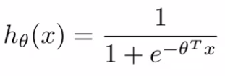
  + And the sigmoid activation function looks like this  
    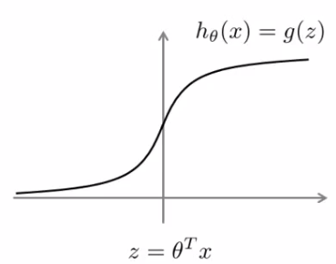
  + In order to explain the math, we use z as defined above
* What do we want logistic regression to do?
  + We have an example where y = 1
    - Then we hope hθ(x) is close to 1
    - With hθ(x) close to 1, (θ*T* x) must be **much larger** than 0  
      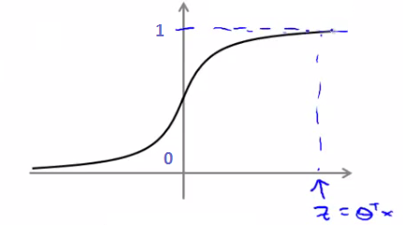
  + Similarly, when y = 0
    - Then we hope hθ(x) is close to 0
    - With hθ(x) close to 0, (θ*T* x) must be **much less** than 0
  + This is our classic view of logistic regression
    - Let's consider another way of thinking about the problem
* Alternative view of logistic regression
  + If you look at cost function, each example contributes a term like the one below to the overall cost function  
    http://www.holehouse.org/mlclass/12_Support_Vector_Machines_files/Image%20%5b3%5d.png
    - For the overall cost function, we sum over all the training examples using the above function, and have a 1/m term
* If you then plug in the hypothesis definition (hθ(x)), you get an expanded cost function equation;  
  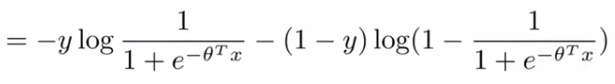
  + So each training example contributes that term to the cost function for logistic regression
* If y = 1 then only the first term in the objective matters
  + If we plot the functions vs. z we get the following graph  
    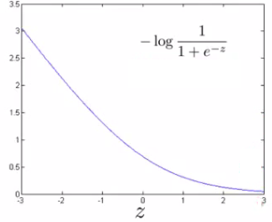
    - This plot shows the cost contribution of an example when y = 1 given z
      * So if z is big, the cost is low - this is good!
      * But if z is 0 or negative the cost contribution is high
      * This is why, when logistic regression sees a positive example, it tries to set θ*T* x to be a very large term
* If y = 0 then only the second term matters
  + We can again plot it and get a similar graph  
    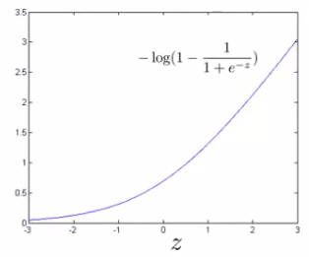
    - Same deal, if z is small then the cost is low
      * But if s is large then the cost is massive

**SVM cost functions from logistic regression cost functions**

* To build a SVM we must redefine our cost functions
  + When y = 1
    - Take the y = 1 function and create a new cost function
    - Instead of a curved line create two straight lines (magenta) which acts as an approximation to the logistic regression y = 1 function  
      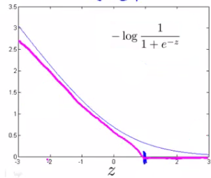
      * Take point (1) on the z axis
        + Flat from 1 onwards
        + Grows when we reach 1 or a lower number
      * This means we have two straight lines
        + Flat when cost is 0
        + Straight growing line after 1
    - So this is the new y=1 cost function
      * Gives the SVM a computational advantage and an easier optimization problem
      * We call this function **cost1(z)**
* Similarly
  + When y = 0
    - Do the equivalent with the y=0 function plot  
      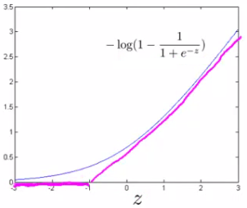
    - We call this function **cost0(z)**
* So here we define the two cost function terms for our SVM graphically
  + How do we implement this?

**The complete SVM cost function**

* As a comparison/reminder we have logistic regression below  
  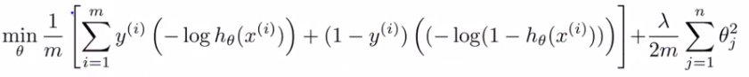
  + If this looks unfamiliar its because we previously had the - sign outside the expression
* For the SVM we take our two logistic regression y=1 and y=0 terms described previously and replace with
  + cost1(θ*T* x)
  + cost0(θ*T* x)
* So we get  
  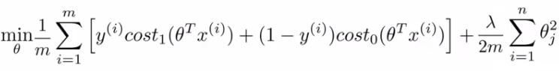

**SVM notation is slightly different**

* In convention with SVM notation we rename a few things here
* 1) Get rid of the 1/m terms
  + This is just a slightly different convention
  + By removing 1/m we should get the same optimal values for
    - 1/m is a constant, so should get same optimization
    - e.g. say you have a minimization problem which minimizes to u = 5
      * If your cost function * by a constant, you still generates the minimal value
      * That minimal value is different, but that's irrelevant
* 2) For logistic regression we had two terms;
  + Training data set term (i.e. that we sum over m) = **A**
  + Regularization term (i.e. that we sum over n) = **B**
    - So we could describe it as A + λB
    - Need some way to deal with the trade-off between regularization and data set terms
    - Set different values for λ to parametrize this trade-off
  + Instead of parameterization this as A + λB
    - For SVMs the convention is to use a different parameter called C
    - So do CA + B
    - If C were equal to 1/λ then the two functions (CA + B and A + λB) would give the same value
* So, our overall equation is  
  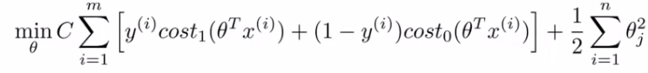
* Unlike logistic, hθ(x) doesn't give us a probability, but instead we get a direct prediction of 1 or 0
  + So if θ*T* x is equal to or greater than 0 --> hθ(x) = 1
  + Else --> hθ(x) = 0

**Large margin intuition**

* Sometimes people refer to SVM as **large margin classifiers**
  + We'll consider what that means and what an SVM hypothesis looks like
  + The SVM cost function is as above, and we've drawn out the cost terms below  
    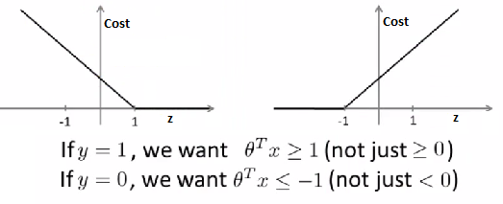
  + Left is cost1 and right is cost0
  + What does it take to make terms small
    - If y =1
      * cost1(z) = 0 only when z >= 1
    - If y = 0
      * cost0(z) = 0 only when z <= -1
  + Interesting property of SVM
    - If you have a positive example, you only really *need* z to be greater or equal to 0
      * If this is the case then you predict 1
    - SVM wants a bit more than that - doesn't want to *just* get it right, but have the value be quite a bit bigger than zero
      * Throws in an extra safety margin factor
* Logistic regression does something similar
* What are the consequences of this?
  + Consider a case where we set C to be huge
    - C = 100,000
    - So considering we're minimizing CA + B
      * If C is huge we're going to pick an A value so that A is equal to zero
      * What is the optimization problem here - how do we make A = 0?
    - Making A = 0
      * If y = 1
        + Then to make our "A" term 0 need to find a value of θ so (θ*T* x) is greater than or equal to 1
      * Similarly, if y = 0
        + Then we want to make "A" = 0 then we need to find a value of θ so (θ*T* x) is equal to or less than -1
    - So - if we think of our optimization problem a way to ensure that this first "A" term is equal to 0, we re-factor our optimization problem into just minimizing the "B" (regularization) term, because
      * When A = 0 --> A*C = 0
    - So we're minimizing B, under the constraints shown below  
      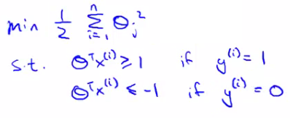
  + Turns out when you solve this problem you get interesting decision boundaries  
    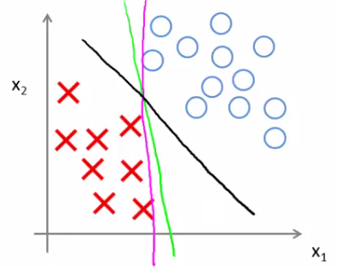
  + The green and magenta lines are functional decision boundaries which could be chosen by logistic regression
    - But they probably don't generalize too well
  + The black line, by contrast is the the chosen by the SVM because of this safety net imposed by the optimization graph
    - More robust separator
  + Mathematically, that black line has a larger minimum distance (margin) from any of the training examples  
    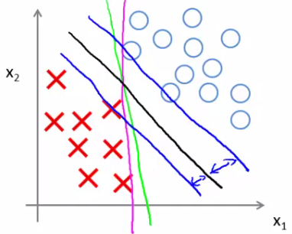
  + By separating with the largest margin you incorporate robustness into your decision making process
* We looked at this at when C is very large
  + SVM is more sophisticated than the large margin might look
    - If you were just using large margin then SVM would be very sensitive to outliers   
      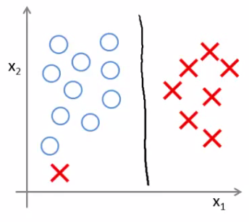
    - You would risk making a ridiculous hugely impact your classification boundary
      * A single example might not represent a good reason to change an algorithm
      * If C is very large then we *do* use this quite naive maximize the margin approach  
        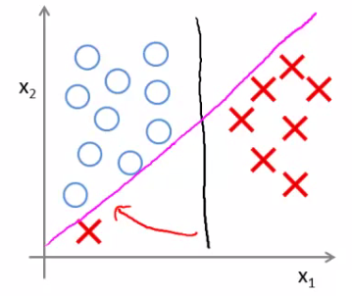
      * So we'd change the black to the magenta
    - But if C is reasonably small, or a not too large, then you stick with the black decision boundary
  + What about non-linearly separable data?
    - Then SVM still does the right thing if you use a normal size C
    - So the idea of SVM being a large margin classifier is only really relevant when you have no outliers and you can easily linearly separable data
  + Means we ignore a few outliers

**Large margin classification mathematics (optional)**

**Vector inner products**

* Have two (2D) vectors u and v - what is the inner product (*uT* *v*)?  
  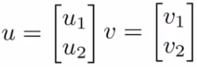  
  + Plot *u* on graph
    - i.e *u*1 vs. *u*2  
      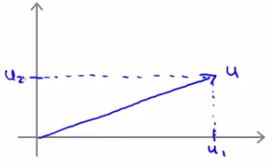
  + One property which is good to have is the **norm** of a vector
    - Written as ||u||
      * This is the euclidean length of vector u
    - So ||u|| = SQRT(*u*1*2* + *u*2*2*) = real number  
      * i.e. length of the arrow above
      * Can show via Pythagoras
  + For the inner product, take *v* and orthogonally project down onto u
    - First we can plot v on the same axis in the same way (*v*1vs *v*1)
    - Measure the length/magnitude of the projection  
      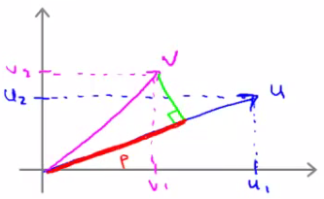
    - So here, the green line is the projection
      * p = length along u to the intersection
      * p is the magnitude of the projection of vector *v* onto vector *u*
  + Possible to show that
    - *uT* *v* = p * ||u||
      * So this is one way to compute the inner product
    - *uT* *v = u*1*v*1+ *u*2*v*2
    - So therefore
      * **p * ||u|| = *u*1*v*1+ *u*2*v*2**
      * This is an important rule in linear algebra
    - We can reverse this too
      * So we could do
        + *vT* *u = v*1*u*1+ v2*u*2
        + Which would obviously give you the same number
  + p can be negative if the angle between them is 90 degrees or more  
    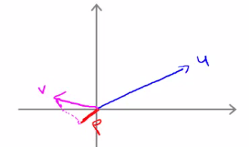
    - So here p is negative
* Use the vector inner product theory to try and understand SVMs a little better

**SVM decision boundary**  
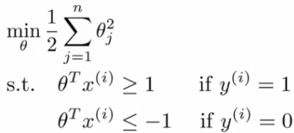

* For the following explanation - two simplification
  + Set θ0= 0 (i.e. ignore intercept terms)
  + Set n = 2 - (x1, x2)
    - i.e. each example has only 2 features
* Given we only have two parameters we can simplify our function to  
  http://www.holehouse.org/mlclass/12_Support_Vector_Machines_files/Image%20%5b23%5d.png
* And, can be re-written as   
  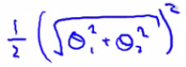
  + Should give same thing
* We may notice that  
  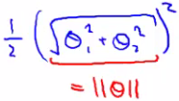
  + The term in red is the norm of θ
    - If we take θ as a 2x1 vector
    - If we assume θ0 = 0 its still true
* So, finally, this means our optimization function can be re-defined as   
  http://www.holehouse.org/mlclass/12_Support_Vector_Machines_files/Image%20%5b26%5d.png
* So the SVM is minimizing the squared norm
* Given this, what are the (θ*T* x) parameters doing?
  + Given θ and given example x what is this equal to
    - We can look at this in a comparable manner to how we just looked at u and v
  + Say we have a single positive training example (red cross below)  
    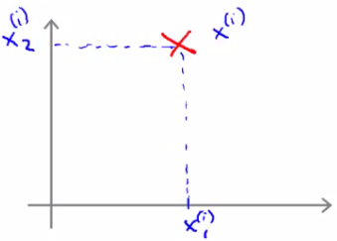
  + Although we haven't been thinking about examples as vectors it can be described as such  
    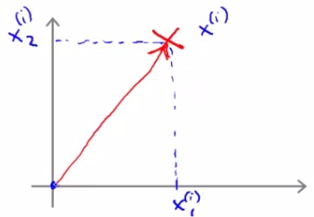
  + Now, say we have our parameter vector θ and we plot that on the same axis  
    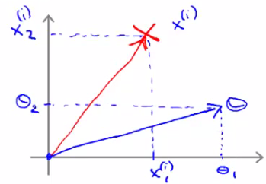
  + The next question is what is the inner product of these two vectors  
    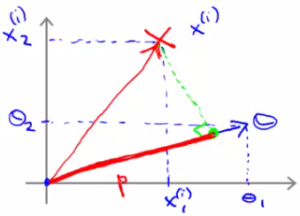
    - p, is in fact pi, because it's the length of p for example i
      * Given our previous discussion we know   
        (θ*T* xi) = pi* ||θ||  
                   = θ1xi1 + θ2xi2
      * So these are both equally valid ways of computing θ*T* xi
* What does this mean?
  + The constraints we defined earlier
    - (θ*T* x) >= 1 if y = 1
    - (θ*T* x) <= -1 if y = 0
  + Can be replaced/substituted with the constraints
    - pi* ||θ|| >= 1 if y = 1
    - pi* ||θ|| <= -1 if y = 0
  + Writing that into our optimization objective   
    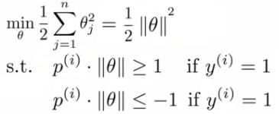
* So, given we've redefined these functions let us now consider the training example below  
  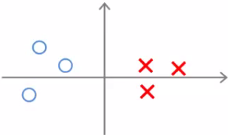
  + Given this data, what boundary will the SVM choose? Note that we're still assuming θ0 = 0, which means the boundary has to pass through the origin (0,0)
    - Green line - small margins  
      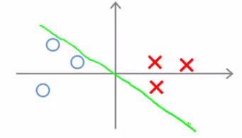  
      * SVM would not chose this line
        + Decision boundary comes very close to examples
        + Lets discuss *why* the SVM would **not** chose this decision boundary
  + Looking at this line
    - We can show that θ is at 90 degrees to the decision boundary  
      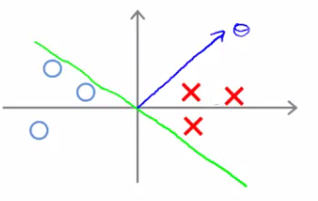
      * **θ is always at 90 degrees to the decision boundary** (can show with linear algebra, although we're not going to!)
* So now lets look at what this implies for the optimization objective
  + Look at first example (x1)  
    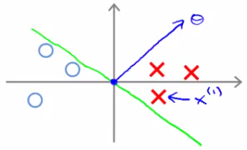
  + Project a line from x1on to to the θ vector (so it hits at 90 degrees)
    - The distance between the intersection and the origin is (**p1**)
  + Similarly, look at second example (x2)
    - Project a line from x2 into to the θ vector
    - This is the magenta line, which will be **negative**(**p2**)
  + If we overview these two lines below we see a graphical representation of what's going on;  
    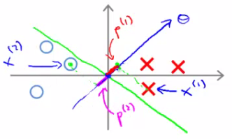
  + We find that both these p values are going to be pretty small
  + If we look back at our optimization objective
    - We know we need p1 * ||θ|| to be bigger than or equal to 1 for positive examples
      * If p is small
        + Means that ||θ|| must be pretty large
    - Similarly, for negative examples we need p2 * ||θ|| to be smaller than or equal to -1
      * We saw in this example p2 is a small negative number
        + So ||θ|| must be a large number
  + Why is this a problem?
    - The optimization objective is trying to find a set of parameters where the norm of theta is small
      * So this doesn't seem like a good direction for the parameter vector (because as p values get smaller ||θ|| must get larger to compensate)
        + So we should make p values larger which allows ||θ|| to become smaller
* So lets chose a different boundary  
  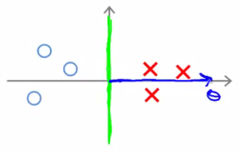
  + Now if you look at the projection of the examples to θ we find that p1becomes large and ||θ|| can become small
  + So with some values drawn in  
    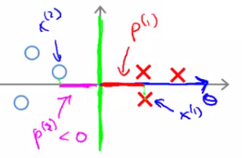
  + This means that by choosing this second decision boundary we can make ||θ|| smaller
    - Which is why the SVM choses this hypothesis as better
    - This is how we generate the large margin effect  
      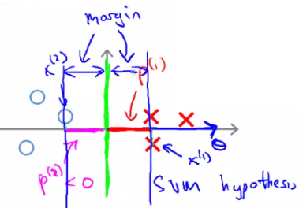
    - The magnitude of this margin is a function of the p values
      * So by maximizing these p values we minimize ||θ||
* Finally, we did this derivation assuming θ0 = 0,
  + If this is the case we're entertaining only decision boundaries which pass through (0,0)
  + If you allow θ0 to be other values then this simply means you can have decision boundaries which cross through the x and y values at points other than (0,0)
  + Can show with basically same logic that this works, and even when θ0 is non-zero when you have optimization objective described above (when C is very large) that the SVM is looking for a large margin separator between the classes

**Kernels - 1: Adapting SVM to non-linear classifiers**

* What are kernels and how do we use them
  + We have a training set
  + We want to find a non-linear boundary  
    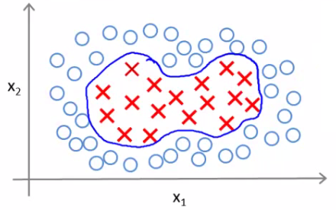
  + Come up with a complex set of polynomial features to fit the data
    - Have hθ(x) which
      * Returns 1 if the combined weighted sum of vectors (weighted by the parameter vector) is less than or equal to 0
      * Else return 0
    - Another way of writing this (new notation) is
      * That a hypothesis computes a decision boundary by taking the sum of the parameter vector multiplied by a **new feature vector f**, which simply contains the various high order x terms
      * e.g.
        + hθ(x) = θ0+ θ1f1+ θ2f2+ θ3f3
        + Where

f1= x1

f2= x1x2

f3= ...

i.e. not specific values, but each of the terms from your complex polynomial function

* + - Is there a better choice of feature f than the high order polynomials?
      * As we saw with computer imaging, high order polynomials become computationally expensive
* New features
  + Define three features in this example (ignore x0)
  + Have a graph of x1vs. x2(don't plot the values, just define the space)
  + Pick three points in that space  
    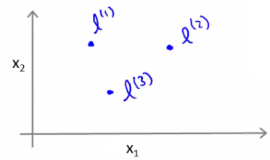
  + These points l1, l2, and l3, were chosen manually and are called **landmarks**
    - Given x, define f1 as the similarity between (x, l1)
      * = exp(- (|| x - l1||2 ) / 2σ2)  
        = 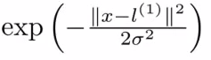
      * **|| x - l1||** is the euclidean distance between the point x and the landmark l1squared
        + Disussed more later
      * If we remember our statistics, we know that
        + σ is the **standard deviation**
        + σ2is commonly called the **variance**
    - Remember, that as discussed  
      http://www.holehouse.org/mlclass/12_Support_Vector_Machines_files/Image%20%5b43%5d.png
  + So, f2 is defined as  
    - f2 = similarity(x, l1) = exp(- (|| x - l2||2) / 2σ2)
  + And similarly
    - f3 = similarity(x, l2) = exp(- (|| x - l1||2) / 2σ2)
  + This similarity function is called a **kernel**
    - This function is a **Gaussian Kernel**
  + So, instead of writing similarity between x and l we might write
    - f1 = k(x, l1)

**Diving deeper into the kernel**

* So lets see what these kernels do and why the functions defined make sense
  + Say x is close to a landmark
    - Then the squared distance will be ~0
      * So  
        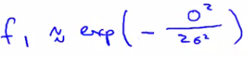
        + Which is basically e-0

 Which is close to 1

* + - Say x is far from a landmark
      * Then the squared distance is big
        + Gives e-large number

Which is close to zero

* + - Each landmark defines a new features
* If we plot f1 vs the kernel function we get a plot like this
  + Notice that when x = [3,5] then f1 = 1
  + As x moves away from [3,5] then the feature takes on values close to zero
  + So this measures how close x is to this landmark  
    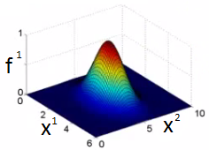

**What does σ do?**

* **σ2**is a parameter of the Gaussian kernel
  + Defines the steepness of the rise around the landmark
* Above example σ2 = 1
* Below σ2 = 0.5  
  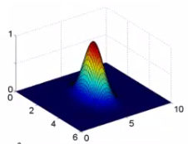
  + We see here that as you move away from 3,5 the feature f1 falls to zero much more rapidly
* The inverse can be seen if σ2 = 3  
  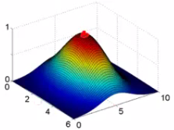
* Given this definition, what kinds of hypotheses can we learn?
  + With training examples x we predict "1" when
  + θ0+ θ1f1+ θ2f2+ θ3f3 >= 0
    - For our example, lets say we've already run an algorithm and got the
      * θ0= -0.5
      * θ1= 1
      * θ2= 1
      * θ3= 0
    - Given our placement of three examples, what happens if we evaluate an example at the **magenta dot** below?  
      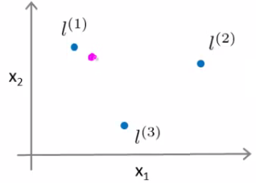
    - Looking at our formula, we know f1 will be close to 1, but f2 and f3 will be close to 0
      * So if we look at the formula we have
        + θ0+ θ1f1+ θ2f2+ θ3f3 >= 0
        + -0.5 + 1 + 0 + 0 = 0.5

0.5 is greater than 1

* + - If we had **another point** far away from all three  
      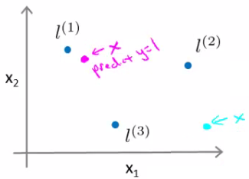
      * This equates to -0.5
        + So we predict 0
  + Considering our parameter, for points near l1 and l2 you predict 1, but for points near l3you predict 0
  + Which means we create a non-linear decision boundary that goes a lil' something like this;  
    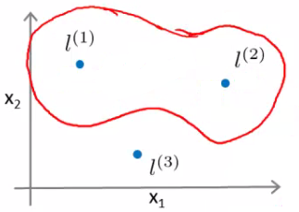
    - Inside we predict y = 1
    - Outside we predict y = 0
* So this show how we can create a non-linear boundary with landmarks and the kernel function in the support vector machine
  + But
    - How do we get/chose the landmarks
    - What other kernels can we use (other than the Gaussian kernel)

**Kernels II**

* Filling in missing detail and practical implications regarding kernels
* Spoke about picking landmarks manually, defining the kernel, and building a hypothesis function
  + Where do we get the landmarks from?
  + For complex problems we probably want lots of them

**Choosing the landmarks**

* Take the training data
* For each example place a landmark at exactly the same location
* So end up with m landmarks
  + One landmark per location per training example
  + Means our features measure how close to a training set example something is
* Given a new example, compute all the f values
  + Gives you a feature vector f (f0 to fm)
    - f0 = 1 always
* A more detailed look at generating the f vector
  + If we had a training example - features we compute would be using (xi, yi)
    - So we just cycle through each landmark, calculating how close to that landmark actually xi is
      * f1i, = k(xi, l1)
      * f2i, = k(xi, l2)
      * ...
      * fmi, = k(xi, lm)
    - Somewhere in the list we compare x to itself... (i.e. when we're at fii)
      * So because we're using the Gaussian Kernel this evalues to 1
    - Take these m features (f1, f2 ... fm) group them into an [m +1 x 1] dimensional vector called f
      * fi is the f feature vector for the ith example
      * And add a 0th term = 1
* Given these kernels, how do we use a support vector machine

**SVM hypothesis prediction with kernels**

* Predict y = 1 if (θ*T* f) >= 0
  + Because θ = [m+1 x 1]
  + And f = [m +1 x 1]
* So, this is how you make a prediction assuming you already have θ
  + How do you get θ?

**SVM training with kernels**

* Use the SVM learning algorithm  
  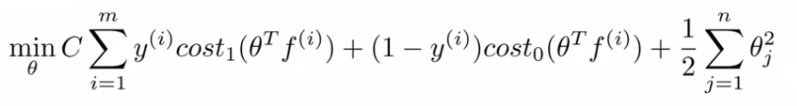
  + Now, we minimize using f as the feature vector instead of x
  + By solving this minimization problem you get the parameters for your SVM
* In this setup, m = n
  + Because number of features is the number of training data examples we have
* One final mathematic detail (not crucial to understand)
  + If we ignore θ0 then the following is true  
    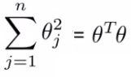
  + What many implementations do is   
    http://www.holehouse.org/mlclass/12_Support_Vector_Machines_files/Image%20%5b53%5d.png
    - Where the matrix M depends on the kernel you use
    - Gives a slightly different minimization - means we determine a rescaled version of θ
    - Allows more efficient computation, and scale to much bigger training sets
    - If you have a training set with 10 000 values, means you get 10 000 features
      * Solving for all these parameters can become expensive
      * So by adding this in we avoid a for loop and use a matrix multiplication algorithm instead
* You can apply kernels to other algorithms
  + But they tend to be very computationally expensive
  + But the SVM is far more efficient - so more practical
* Lots of good off the shelf software to minimize this function
* **SVM parameters (C)**
  + Bias and variance trade off
  + Must chose C
    - C plays a role similar to 1/LAMBDA (where LAMBDA is the regularization parameter)
  + Large C gives a hypothesis of **low bias high variance** --> overfitting
  + Small C gives a hypothesis of **high bias low variance** --> underfitting
* **SVM parameters (σ2)**
  + Parameter for calculating f values
    - Large σ2 - f features vary more smoothly - higher bias, lower variance
    - Small σ2 - f features vary abruptly - low bias, high variance

**SVM - implementation and use**

* So far spoken about SVM in a very abstract manner
* What do you need to do this
  + Use SVM software packages (e.g. liblinear, libsvm) to solve parameters θ
  + Need to specify
    - Choice of parameter C
    - Choice of kernel

**Choosing a kernel**

* We've looked at the **Gaussian kernel**
  + Need to define σ (σ2)
    - Discussed σ2
  + When would you chose a Gaussian?
    - If n is small and/or m is large
      * e.g. 2D training set that's large
  + If you're using a Gaussian kernel then you may need to implement the kernel function
    - e.g. a function  
      fi = kernel(x1,x2)
      * Returns a real number
    - Some SVM packages will expect you to define kernel
    - Although, some SVM implementations include the Gaussian and a few others
      * Gaussian is probably most popular kernel
  + NB - make sure you perform **feature scaling** before using a Gaussian kernel
    - If you don't features with a large value will dominate the f value
* Could use no kernel - **linear kernel**
  + Predict y = 1 if (θ*T* x) >= 0
    - So no f vector
    - Get a standard linear classifier
  + Why do this?
    - If n is large and m is small then
      * Lots of features, few examples
      * Not enough data - risk overfitting in a high dimensional feature-space
* Other choice of kernel
  + Linear and Gaussian are most common
  + Not all similarity functions you develop are valid kernels
    - Must satisfy **Merecer's Theorem**
    - SVM use numerical optimization tricks
      * Mean certain optimizations can be made, but they must follow the theorem
  + **Polynomial Kernel**
    - We measure the similarity of x and l by doing one of
      * (x*T* l)2
      * (x*T* l)3
      * (x*T* l+1)3
    - General form is
      * (x*T* l+Con)D
    - If they're similar then the inner product tends to be large
    - Not used that often
    - Two parameters
      * Degree of polynomial (D)
      * Number you add to l (Con)
    - Usually performs worse than the Gaussian kernel
    - Used when x and l are both non-negative
  + **String kernel**
    - Used if input is text strings
    - Use for text classification
  + **Chi-squared kernel**
  + **Histogram intersection kernel**

**Multi-class classification for SVM**

* Many packages have built in multi-class classification packages
* Otherwise use one-vs all method
* Not a big issue

**Logistic regression vs. SVM**

* When should you use SVM and when is logistic regression more applicable
* If n (features) is large vs. m (training set)
  + e.g. text classification problem
    - Feature vector dimension is 10 000
    - Training set is 10 - 1000
    - Then use logistic regression or SVM with a linear kernel
* If n is small and m is intermediate
  + n = 1 - 1000
  + m = 10 - 10 000
  + Gaussian kernel is good
* If n is small and m is large
  + n = 1 - 1000
  + m = 50 000+
    - SVM will be slow to run with Gaussian kernel
  + In that case
    - Manually create or add more features
    - Use logistic regression of SVM with a linear kernel
* Logistic regression and SVM with a linear kernel are pretty similar
  + Do similar things
  + Get similar performance
* A lot of SVM's power is using diferent kernels to learn complex non-linear functions
* For all these regimes a well designed NN should work
  + But, for some of these problems a NN might be slower - SVM well implemented would be faster
* SVM has a convex optimization problem - so you get a global minimum
* It's not always clear how to chose an algorithm
  + Often more important to get enough data
  + Designing new features
  + Debugging the algorithm
* SVM is widely perceived a very powerful learning algorithm